Episode 3
18th February 2020



World Health Organisation
- Discuss the BTN World Health Organisation story as a class and record the main points of the discussion.
- What year was the World Health Organisation (WHO) founded?
- What does UN stand for?
- What is another name for the bubonic plague?
- How many people died from the bubonic plague in the 1300s?
- What does pandemic mean?
- What disease did the WHO wipe out through vaccinations?
- What name did the WHO give the new coronavirus?
- How long will it take before there is a vaccine for the new coronavirus?
- What questions do you have after watching the BTN story?

Coastal Erosion
- What did the BTN Coastal Erosion story explain?
- Which Australian coastline recently experienced severe storm systems?
  - East coast
  - West coast
  - South coast
- Erosion is a natural process. True or false?
- What causes beach erosion?
- Describe the experiment in the BTN story using your own words.
- Why did a day care centre on the coast in Newcastle have to be pulled down?
- How is the government trying to stop coastal erosion?
- What is a seawall?
- Why are many councils trying to protect sand dunes?
- Illustrate an aspect of the BTN Coastal Erosion story.

Check out the Coastal Erosion resource on the Teachers page.

Homework Debate
- Retell the story in your own words.
- What does the former Education Minister in NSW think about homework?
- What are the benefits of doing homework?
- It’s up to each school to make its own policy on homework. True or false?
- Compete this sentence. Homework can help students prepare for ______ ___________.
- What did the kids in the BTN story think about homework?
- About how much time do you spend on homework each night?
- What would you do if you didn’t have any homework?
- What are your thoughts on the issue?
- Hold a poll in your class asking if you should have homework. Discuss the results as a class.

Pluto Anniversary
- Briefly summarise the BTN Pluto Anniversary story.
- How many planets are there in our solar system?
- What ancient civilisation first observed planets in our solar system?
- Who first suggested that planets in our solar system revolve around the Sun?
- What is the name of planet 8?
- What year was Pluto discovered?
- Who named Pluto?
- Why is Pluto called a dwarf planet?
- Pluto is larger than the Moon. True or false?
- What questions do you have about Pluto?

Check out the Pluto Anniversary resource on the Teachers page.

Mother Language Day
- Discuss the BTN Mother Language Day story with another student.
- Approximately how many languages are spoken in Australia?
- Where did Aarush live before he moved to Australia? Find using Google Maps.
- Name one of the languages that Aarush speaks at home other than English?
- How many official languages does India have?
- How many people speak Gujarati?
- Gujarati has its own alphabet. True or false?
- How old was Aarush when he started to learn English?
- Why is it important to Aarush to speak Gujarati?
- What was surprising about this story?

Teacher Resource
Episode 3
18th February 2020

Coastal Erosion

Students will investigate the cause of coastal erosion. Students will plan and conduct an experiment to demonstrate how coastal erosion works.


Science – Year 4
Earth’s surface changes over time as a result of natural processes and human activity.

Science knowledge helps people to understand the effect of their actions.

Science – Year 5, 6
Scientific knowledge is used to solve problems and inform personal and community decisions.

Science – Year 6
Sudden geological changes and extreme weather events can affect Earth’s surface.

With guidance, pose clarifying questions and make predictions about scientific investigations.

- What did the BTN Coastal Erosion story explain?
- Which Australian coastline recently experienced severe storm systems?
  - East coast
  - West coast
  - South coast
- Erosion is a natural process. True or false?
- What causes beach erosion?
- Describe the experiment in the BTN story using your own words.
- Why did a day care centre on the coast in Newcastle have to be pulled down?
- How is the government trying to stop coastal erosion?
- What is a seawall?
- Why are many councils trying to protect sand dunes?
- Illustrate an aspect of the BTN Coastal Erosion story.



Class discussion
Hold a class discussion about the issues raised in the BTN Coastal Erosion story. Use the following questions to help guide discussion:
What do you know about erosion?
- What do you know about erosion?
- What causes coastal erosion?
- Why is coastal erosion a problem?
- What impact does coastal erosion have on people and the environment?
- What questions do you have about erosion?

KWLH
Record what students know about coastal erosion and its impact on people and the environment on a mind map. What questions do they have about what they have learnt in the BTN story? The following KWLH organiser provides students with a framework to explore their knowledge on this topic and consider what they would like to know and learn.
What do I know? | What do I want to know? | What have I learnt? | How will I find out?

Topics of inquiry
Students will determine a focus for their coastal erosion inquiry within an area of interest, for example, make a prediction or develop a key research question.

- What causes coastal erosion? Investigate the natural causes of coastal erosion and coastal erosion caused by people.
- How can we minimise coastal erosion?
- Why should we protect our coasts from erosion? Write a persuasive piece of writing explaining your reasons.
- What might happen if we don’t look at the coastal erosion problem? What will our coasts look like in 30 years’ time? Make some predictions.

Visual literacy
In this activity students will examine, analyse and query a range of images which show coastal erosion. Students will choose one or more of the images below and respond to the following:

- Write a short paragraph describing what you see in this image. Write a caption for the image.
- When and where was the photo taken?
- Imagine you are a scientist examining the damage caused by coastal erosion. Explain using scientific words and terms how the erosion occurred. In your description include one or more of the following terms: natural process, coastal erosion, tidal force, waves and shoreline.
- Could the damage have been prevented or minimised? Research how Australia’s coast can be protected to minimise erosion.
- What questions do you have about what you see in the image?

INCLUDEPICTURE "https://www.abc.net.au/news/image/11953162-3x2-700x467.jpg" \* MERGEFORMATINET INCLUDEPICTURE "https://www.abc.net.au/news/image/11953162-3x2-700x467.jpg" \* MERGEFORMATINET INCLUDEPICTURE "https://www.abc.net.au/news/image/11953162-3x2-700x467.jpg" \* MERGEFORMATINET INCLUDEPICTURE "https://www.abc.net.au/news/image/11953162-3x2-700x467.jpg" \* MERGEFORMATINET INCLUDEPICTURE "https://www.abc.net.au/news/image/11953162-3x2-700x467.jpg" \* MERGEFORMATINET INCLUDEPICTURE "https://www.abc.net.au/news/image/11953162-3x2-700x467.jpg" \* MERGEFORMATINET 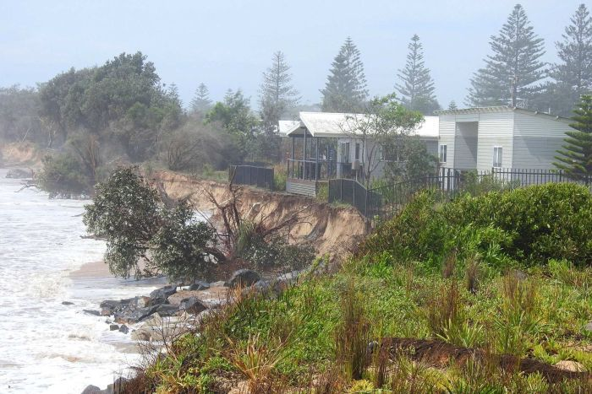  ABC News | INCLUDEPICTURE "https://www.abc.net.au/news/image/11954884-3x2-700x467.jpg" \* MERGEFORMATINET INCLUDEPICTURE "https://www.abc.net.au/news/image/11954884-3x2-700x467.jpg" \* MERGEFORMATINET INCLUDEPICTURE "https://www.abc.net.au/news/image/11954884-3x2-700x467.jpg" \* MERGEFORMATINET INCLUDEPICTURE "https://www.abc.net.au/news/image/11954884-3x2-700x467.jpg" \* MERGEFORMATINET INCLUDEPICTURE "https://www.abc.net.au/news/image/11954884-3x2-700x467.jpg" \* MERGEFORMATINET INCLUDEPICTURE "https://www.abc.net.au/news/image/11954884-3x2-700x467.jpg" \* MERGEFORMATINET 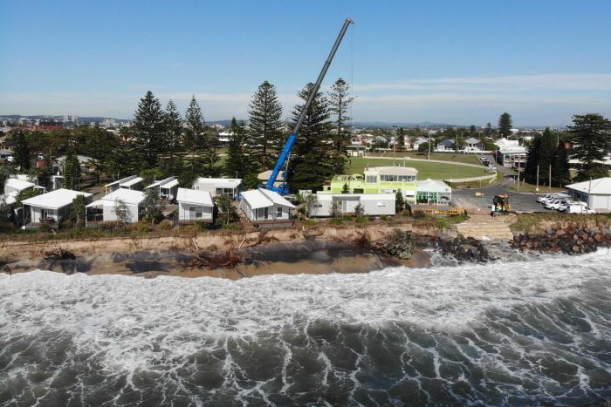  ABC News
INCLUDEPICTURE "https://www.abc.net.au/news/image/11207662-3x2-700x467.jpg" \* MERGEFORMATINET INCLUDEPICTURE "https://www.abc.net.au/news/image/11207662-3x2-700x467.jpg" \* MERGEFORMATINET INCLUDEPICTURE "https://www.abc.net.au/news/image/11207662-3x2-700x467.jpg" \* MERGEFORMATINET INCLUDEPICTURE "https://www.abc.net.au/news/image/11207662-3x2-700x467.jpg" \* MERGEFORMATINET INCLUDEPICTURE "https://www.abc.net.au/news/image/11207662-3x2-700x467.jpg" \* MERGEFORMATINET INCLUDEPICTURE "https://www.abc.net.au/news/image/11207662-3x2-700x467.jpg" \* MERGEFORMATINET 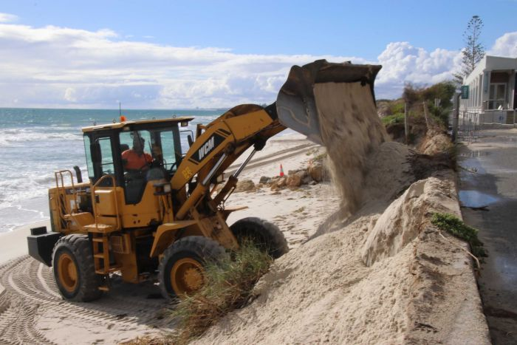  ABC News | INCLUDEPICTURE "https://www.abc.net.au/news/image/1444012-3x2-340x227.jpg" \* MERGEFORMATINET INCLUDEPICTURE "https://www.abc.net.au/news/image/1444012-3x2-340x227.jpg" \* MERGEFORMATINET INCLUDEPICTURE "https://www.abc.net.au/news/image/1444012-3x2-340x227.jpg" \* MERGEFORMATINET INCLUDEPICTURE "https://www.abc.net.au/news/image/1444012-3x2-340x227.jpg" \* MERGEFORMATINET INCLUDEPICTURE "https://www.abc.net.au/news/image/1444012-3x2-340x227.jpg" \* MERGEFORMATINET INCLUDEPICTURE "https://www.abc.net.au/news/image/1444012-3x2-340x227.jpg" \* MERGEFORMATINET 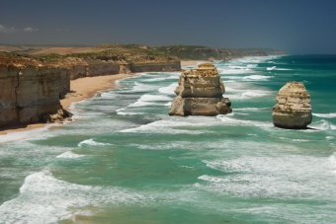  ABC News
Further investigation
Students will analyse this image and then respond to the following:
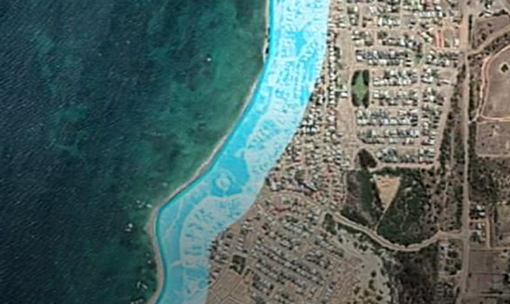
- Write a caption for this image.
- What do you think this image is illustrating?
- Imagine you are one of the residents living along this coastline. Write a letter to your local council member explaining your concerns.

ABC News

Scientific experiment
Provide students with the opportunity to think and behave like scientists. Before starting the investigation, watch BTN’s Coastal Erosion story. Working in pairs or small groups, students will then conduct the experiment using water and sand to demonstrate how coastal erosion occurs. Students will use the following framework as a guide before, during and after their investigation

Experiment: Wave action – Find a large tub. Fill 1/3 of the tub with sand and press into shape making a ‘beach’. Fill the tub with 2 cups of water to provide an ‘ocean’. Draw a ‘before’ picture. Create waves by moving the water with a paddle (e.g. lunchbox lid). Draw an ‘after’ picture.

  Research | Before starting this experiment, respond to the following:  - What causes coastal erosion? Describe using your own words  - How can coastal erosion be minimised? Give your suggestions.
  Investigation | Follow these steps during your investigation:  - What am I going to investigate?  - What do I think will happen (prediction)?  - Why do I think this will happen?  - What steps do I need to follow to investigate my prediction?  - What materials and equipment will I need? Make a list and then draw/label each item.  - Complete the experiment and document what you observe.  - Write a paragraph that summarises what happened.  - Was this what I expected? Explain.
Reflection | Reflect on the investigation by responding to one or more of the following questions:  - What did you enjoy about this investigation?  - What did you find surprising?  - What would you do differently next time?

Storm Erosion – BTN
https://www.abc.net.au/btn/classroom/storm-erosion/10524572

What is coastal erosion? – Geoscience Australia
https://www.ga.gov.au/scientific-topics/community-safety/coastalerosion

Coastal Erosion - BOM
http://www.bom.gov.au/pacificsealevel/pdf/Coastal_Erosion_fact_sheet.pdf

Coastal Erosion – Understanding cause, response and impact – Geoscience Australia
http://geoscience-au.maps.arcgis.com/apps/Cascade/index.html?appid=14c50929ce1144f395bdd801440983d7

Newcastle beachside cabins in danger of toppling into sea after wild weather – ABC News
https://www.abc.net.au/news/2020-02-11/newcastle-beachside-cabins-in-danger-of-toppling-into-sea/11953274

Teacher Resource
Episode 3
18th February 2020

Pluto Anniversary
Students will learn more about the dwarf planet Pluto and other planets in the solar system.

Science – Year 5
The Earth is part of a system of planets orbiting around a star (the sun).

Science – Year 5 & 6
Science involves testing predictions by gathering data and using evidence to develop explanations of events and phenomena and reflects historical and cultural contributions.
- Briefly summarise the BTN Pluto Anniversary story.
- How many planets are there in our solar system?
- What ancient civilisation first observed planets in our solar system?
- Who first suggested that planets in our solar system revolve around the Sun?
- What is the name of planet 8?
- What year was Pluto discovered?
- Who named Pluto?
- Why is Pluto called a dwarf planet?
- Pluto is larger than the Moon. True or false?
- What questions do you have about Pluto?

Class discussion – Pluto

Hold a class discussion about the information raised in the Pluto Anniversary story. Ask students to name the planets in our solar system. Students will then create a class mind map about Pluto asking students to record what they know. Use the following questions to guide discussion:

- Who discovered Pluto?
- How was it named?
- Where is Pluto in the solar system?
- How big is Pluto?
- When and why did Pluto become a dwarf planet?
- How many moons does Pluto have?
- How long does it take for Pluto to orbit the Sun?
- What is the Kuiper Belt?

Glossary
Students will develop a glossary of words and terms that relate to Pluto and the solar system. Below are some words to get them started.
Solar system | Dwarf planet | Kuiper Belt
Charon | Orbit | Planet

Planet Research
Students begin by recording what they know about the solar system. Working in pairs, students will research one of the planets in the solar system. Use the following to help guide students’ research.

- Choose a planet in our solar system (or the dwarf planet, Pluto)
- Conduct in depth research into one of the planets. The NASA website has useful information.
- Include a description of what the planet looks like.
- Find out some interesting facts about the planet.
- Geographical features – Is it gaseous or rocky? Does it have an atmosphere? What are conditions on the surface like?
- Distances – how far is this planet from the Sun?
- Movement – identify the path of this planet. How fast does it travel around the Sun?
- Present research using Prezi, Canva or Glogster

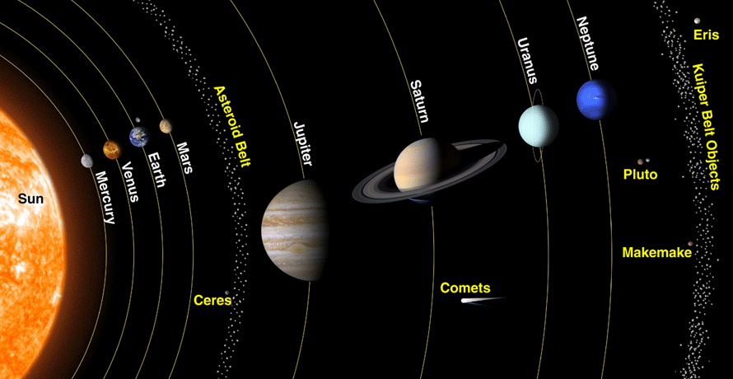

Make model of our solar system
Make a scale model of the planets in our solar system. In small groups, students will represent the size of the Sun and the planets in our solar system as accurately as possible. Students need to agree on an approximate scale for their model. The model should begin with the Sun and show planets in order. Use this calculator to help determine size and scale.

- What scale will you use to model the solar system?
- What materials or found objects will you use to represent the Sun and each of the planets?
- What surprised you about you about this activity?

Following this activity, students will agree on a scale to represent the distance of the planets from the Sun. Calculate and record the distances using a spreadsheet. Consider modelling your findings on your school oval. In this BtN story we demonstrate the scale of our solar system, using a bowling ball, a pin, a peppercorn, a pecan, a hazelnut and a peanut, on a racecourse! Watch this ABC Education video to help you visualise the size and scale of our solar system.

Students watch the BTN Visiting Pluto story about the New Horizons mission to explore Pluto, then answer the following questions:


- What is the name of the spacecraft that took photos of Pluto?
- Pluto was first discovered in...
- What do scientists know about Pluto?
- Why is it called a dwarf planet?
- When was the spacecraft launched?
- New Horizons is about the size of a ____________.
- What interesting things are on board the spacecraft?
- Describe the images of Pluto.
- New Horizons is the fastest spacecraft NASA has ever built. True or false?

Watch this video to learn more about Pluto’s atmosphere.  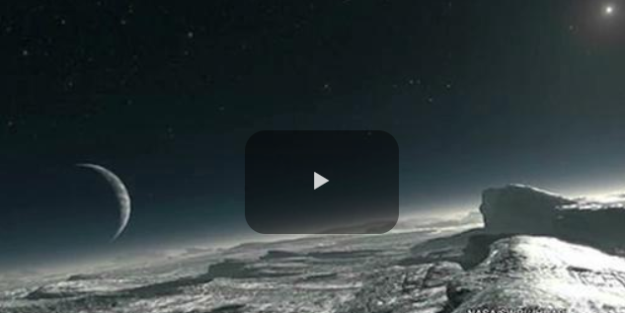 | Watch this video to learn more about the amazing features of Pluto.  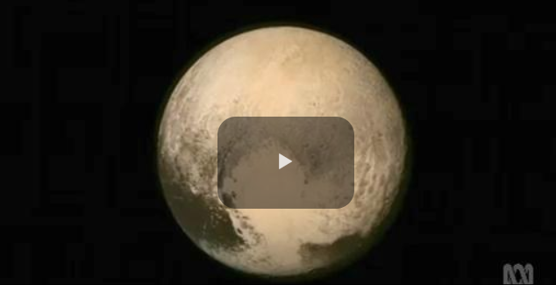


Create a Kahoot Quiz
Use Kahoot! to test students’ knowledge about Pluto. Quizzes can be created to recap learning or test personal knowledge. There is also the option to connect with classrooms around the world and play kahoot in real time.

BTN Space Science stories
Visit BTN’s collection of stories which focus on space science and space exploration. After watching any one of the BTN videos ask students to respond to the discussion questions (to find the discussion questions and teacher resources go to the related BTN Classroom Episode and download the Episode Package).

Link to collection of BTN Space Science stories
https://www.abc.net.au/btn/space-science/10614248

Visiting Pluto – BTN
https://www.abc.net.au/btn/classroom/visiting-pluto/10526194

The Amazing Features of Pluto – ABC Education
https://education.abc.net.au/home#!/media/2395334/the-amazing-features-of-pluto

Pluto Dwarf Planet – NASA Science Solar System Exploration
https://solarsystem.nasa.gov/planets/dwarf-planets/pluto/overview/

Pluto - NASA
https://solarsystem.nasa.gov/planets/dwarf-planets/pluto/in-depth/

BTN Transcript: Episode 3 – 18/2/20

Hey there, Amelia Moseley here with another episode of BTN. Let's check out what's coming up. We'll find out more about Australia's disappearing beaches, learn about the great homework debate and go to the far reaches of the solar system to celebrate the dwarf planet, Pluto.

World Health Organisation
Reporter: Amelia Moseley

INTRO: But first today let's get the who's who of the WHO and by that, I mean the World Health Organisation. Right now, it's leading global efforts to stop the spread of the coronavirus COVID-19 and it's certainly not the first time it's dealt with a pandemic. Let's find out more about it.
AMELIA, REPORTER: Who can help the sick? Who can warn people about dangers to their health? Who can stop a deadly virus from turning all of us into brain eating zombies? Oh wait, no not that one. That's just in the movies. But everything else, well, WHO can? No, I mean who can. Like W-H-O, WHO. There we go. The World Health Organisation.
It was officially founded back in 1948 not long after the Second World War as part of another big international organisation tasked with saving the world. The United Nations. The UN decided that along with things like keeping peace and security around the globe. There was another important thing to take care of to ensure the survival of the human race, our health.
WORLD HEALTH ORGANISATION, 1948: The struggle against epidemics is a global one for the danger of death is worldwide.
You see, long before the UN and the WHO existed; the world had tackled some pretty big outbreaks. The worst in history was the bubonic plague, also known as the Black Death. That's about as horrible as it sounds. In fact, in the 1300s it wiped out up to 200 million people or 60% of Europe's population. Centuries later, there were diseases like yellow fever, cholera, smallpox and the Spanish flu which, at the end of World War I, infected about one third of the planet's population. A disease that spreads that far around the globe is known as a pandemic. The WHO's aim was to stop that sort of thing from happening again.
WORLD HEALTH ORGANISATION, 1948: The World Health Organisation will make full use of every existing means, education, prevention, cure. All peoples of every race and belief will be helped by doctors from all races and nations.
Since it started, the WHO has done some pretty amazing things. Like helping to totally wipe out the deadly virus, smallpox through vaccinations.
It's also leading the fight against contagious diseases like HIV/AIDS, Ebola, malaria and tuberculosis and it helps to educate people on sometimes less obvious dangers to their health, like consuming too much sugar or playing video games for way too long. But right now, the reason the WHO's in the news is because of, you guessed it, the new coronavirus or COVID-19 which is the name the WHO gave it last week. It says it could be 18 months before there's a vaccine for the virus, but in the meantime, it’s been encouraging governments to work together to stop it from spreading.
WORLD HEALTH ORGANISATION: To hit hard and stand in unison to fight this virus in every corner.
Of course, the WHO isn't perfect; some say it didn't react quickly enough to coronavirus and that the organisation needs to be better funded and more efficient.
But, to many, it's still good to know that there's a big powerful group out there fighting for our health.
News Quiz

Alright everyone, let’s test your knowledge in this week's news quiz.
What's the name of the ex-tropical cyclone that hit Lord Howe Island? Is it Uma, Uesi or Macy? The answer is Uesi and it brought along really strong winds and heavy rain. But it wasn't the only wild weather around, there were also serious floods in parts of Queensland, Victoria and New South Wales
LOCAL: This is Australia isn't it. Frying one minute and drowning the next.
Which iconic car brand is being retired at the end of this year? Ford, Holden or Toyota? It's Holden. Holden cars have been part of Aussie life for more than a hundred years, but the brand's American owners say it's time to scrap it.
Next question. Can you name this US politician? It's Bernie Sanders. If you haven't heard of him, you might be hearing a lot more of him. He's one of the Democrats hoping to go up against US President Donald Trump at the next election and after a vote last week he's doing pretty well.
BERNIE SANDERS: This victory here is the beginning of the end for Donald Trump.
A new type of dinosaur has been discovered in Canada. It’s related to which famous species? Allosaurus, Tyrannosaurus rex or Velociraptor? It's related to the T-rex. This newly discovered tyrannosaur was about 2 and a half metres tall with big sharp teeth, which is why it's been nicknamed the Reaper of Death. Scary!
Coastal Erosion
Reporter: Olivia Mason

INTRO: As you just heard, Australia's been dealing with more wild weather. After battering Lord Howe Island, Cyclone Uesi brought thunderstorms and big waves to the East coast. It also caused more coastal erosion. As Liv found out, that's a big problem for many Aussies who live along the beach.

Living along the coast can be pretty cool. There's sun and sand and surf and all those other great beachy things. Except when this happens. Last week, a couple of storm systems gave parts of the East Coast an absolute pounding.
SYDNEY RESIDENT: I haven't ever seen this place ever like that since I've been here 30 years.
This is Collaroy Beach in Sydney and as you can see the waves didn't leave a lot of beach. Ex-Cyclone Uesi also brought some massive swells which ate away beaches. Of course, it's not the first time we've seen storms cause havoc for coastal communities. This is what happened back in 2016 when a king tide uprooted people's backyards and even swimming pools. It's a sign of what many experts say is a growing problem around Australia and that's beach erosion. Erosion is a natural process that's happening all around us all the time, carving natural features like mountains and river beds and canyons. It's when land gets worn away by different forces like wind and water.
OLIVIA MASON, REPORTER: It's kinda hard to believe but a lot of this sand actually used to be rock that's been pulled apart by the waves and the wind. But erosion can also take sand away. Check this out. In this tub we've got some sand to represent the beach, and when I add water and create some waves you'll see the sand start to move as the waves push and pull against it. And eventually, the shape of the beach changes.
That's what's happening to a lot of real beaches around the country and it can have some expensive and dangerous consequences. This day care centre in Newcastle had to be torn down last year because beach erosion had made it unsafe and experts say there are tens of thousands of other buildings at risk in Australia.
Fremantle resident: It really just is relentless and it's powerful. And you know anyone who takes the ocean for granted learns that they can't do that in the longer term.
Governments and councils spend a lot of money fighting erosion by moving sand or by building hard structures like this.
OLIVIA MASON, REPORTER: This is a seawall. It’s designed to absorb some of the energy from the waves and to protect the roads and buildings behind me.
There are also things like breakwaters which interrupt the waves before they get to the beach and groynes which stick out into the water and catch sand but the trouble with all of these methods is they're expensive and they often don't last. Nature does have its own way of protecting the beach and that's sand dunes. They absorb the power of waves and provide a stockpile of sand to replace the beach if a storm comes. Their secret is the vegetation which traps the sand and holds it in place. It's why lots of councils are doing what they can to protect sand dunes.
But in some places the dunes have already disappeared to make way for houses and other buildings and in these areas, erosion is a growing problem. As sea levels rise some reckon it's only going to get worse and we have to think hard about how we're going to protect Australia's beach life.

Did You Know?

Did you know that sinkholes are caused by erosion? Sinkholes happen when dirt and rocks below the surface wash away, causing the ground to collapse and leave a big hole.

Homework Debate
Reporter: Jack Evans
INTRO: Now to homework. I know it's probably not your favourite thing in the world. And while some people reckon it's super-important, there are also some educators who reckon it might not be as useful as we once thought. Here's Jack.
TEACHER: Alright class it's time to hand in your homework.
JACK: Homework?
TEACHER: Jack, have you done your homework?
JACK: I, uh.
TEACHER: Jack, I'm waiting
JACK: A dog, a cat.
TEACHER: Jack.
JACK: A cow, a cow ate it. A cow ate it?
TEACHER: Jack, Jack, Jack.
JACK: Ahhhh.
SARAH: Jack, Jack, Jack.
JACK: Phew, it was just a dream.
SARAH: Have you written your story on homework yet?
JACK: Hey. Get out of my bedroom.
SARAH: This isn't your bedroom. It's the BTN set. You fell asleep, again.
JACK: Sorry, I'll go write that now.
Yep, homework can be a little stressful. Especially if you forget to do it or something eats it. But it's been a fact of life for most school kids for, well forever really. But have you ever thought, is homework really that important?
KID 1: I do think homework can be important but it depends on whether or not it's challenging you.
KID 2: Yes homework can be very important especially if you're studying for a test.
Well believe it or not that's a question more and more people have been asking lately.
ADRIAN PICCOLI, FORMER NSW EDUCATION MINISTER: I've seen the research and it says certainly in primary school, it's of limited value.
This guy, Adrian Piccoli, used to be the NSW education minister and he reckons that while homework can be useful for students in high school, especially years 11 and 12, it's not as useful for kids in primary school. And he's not the only one. A few studies have found that doing homework doesn't necessarily help kids get better marks at school and it can make them feel more anxious and miss out on things like sport and hanging out with friends.
SOPHIA: I don't really get to spend much time with my friends, don't get to do the things that I want to do after school and just relax or play sports.
ARYA: Sometimes I really don't want to do it because I just want to hang out with my friends. But most of the time it's actually useful for me.
It's why some schools have said see ya later to homework altogether.
PAUL CHAPMAN: It can create tension in the home life and in my opinion, young people don't need tension in their life. Our job really is to try and allow them to be children.
Paul Chapman is a principal and has made homework entirely optional at his school. But before you go throwing out your homework, there are plenty of teachers and parents who think it can be really helpful. They say it can teach you how to work independently and complete tasks in your own time as well as prepare you for high school when schoolwork gets a little more intense.
At the moment it's up to the school to make its own policy on homework. But experts say it's important for the work you take home to be interesting, educational and not too much so you can still have free time to chill out. But what do you think?
KID 3: Sometimes I do feel like I'm missing out on other fun activities. But I know that this is going to help with my school work.
KID 4: It's pretty much trailing on from what you do in class so if you don't get it in class the homework will help you understand it a bit more.
KID 5: Sometimes when I'm doing homework I feel like I could be doing something else that I want to do. But I try and get it out of the way so I can do those other things.

Sport

The Matildas have topped their Olympic qualifying group after coming from behind to draw one all against China. It looked bad for the Aussies when China scored in the 86th minute, but Midfielder Emily Van Egmond saved the day in the dying seconds. The Matildas will now face Vietnam for a place at the Olympics.

This is the moment 15-year-old Mohamed Toure made A-League history. He helped seal a 2-0 win for Adelaide United against Central Coast Mariners.
MOHAMED TOURE: It feel surreal I never thought of doing it ever in a million years, not at 15. It's an amazing feeling especially at home in front of my friends and family.
And this is the 2020 NBA all-stars slam dunk contest. As usual, it was spectacular but also a little bit controversial. A lot of people thought Orlando Magic's Aaron Gordon had it in the bag with this one. Yep, he just jumped over Tacko Fall, who's 2.26 metres tall. But in the end the judges gave the win to Miami Heat forward Derrick Jones Junior and a lot of fans weren't happy.

Pluto Anniversary
Reporter: Jack Evans

INTRO: Now to something a little more out there, like more than 5 billion kays out there. I'm talking about Pluto, the little lump of rock that was once considered the 9th planet in our solar system. Did you know that this week marks the 90th anniversary of Pluto's discovery? Jack found out more about its place amongst the planets.
JACK: This is our solar system, well it's a model of our solar system. Sun at the centre and the 8 planets that orbit it. Wait a second, what’s this? Pluto? What are you doing here Pluto? What? Don't look at me like that. What do you want me to do? You're technically not a planet anymore, you're a dwarf planet. But that doesn't mean you're not important. Pluto your discovery was very important, and it led to us learning even more about our solar system. Yeah that's right. Let me explain but let’s go back a bit.
It was the ancient Babylonians that first observed the planets in our solar system. They noticed that while most stars stayed in the same position relative to each other some of them would move around the sky. They weren't stars at all they were planets. In fact, the word planet comes from the Greek word wanderer because they wandered through the sky.
At first, we thought there were only 5 planets Mercury, Venus, Mars, Jupiter and Saturn. Then in the 16th Century we realised that Earth was also a planet, yep mind blown. It was Nicolaus Copernicus in 1543 that suggested the planets revolved around the Sun. It took a few years to catch on but eventually people accepted the idea.
JACK: About two hundred or so years later we discovered Uranus. Hey, no jokes please Pluto. Cheeky.
Like the other planets you can see Uranus without a telescope. Because it's quite dim and moves very slowly no one really noticed it until 1781 when astronomer and composer, Frederick William Herschel, came along and discovered it. Then in 1846 astronomers noticed something weird happening to Uranus' orbit. Turns out it was because of the gravitational pull of planet 8, Neptune.
And that brings us to Pluto. In 1930 American astronomer, Clyde Tombaugh was checking out images he'd taken of the stars and realised one of those specks of light kept moving. Pluto’s discovery made headlines. It's name was actually suggested by an 11-year-old who thought it would be cool to name it after the roman god of the underworld, seeing as Pluto lives in such a cold and desolate part of the solar system. Then we spent the next few decades remembering the names of all nine planets in our solar system until…
JACK: Yep Pluto my friend you were downgraded to a dwarf planet. I mean you are pretty small compared to the others. Especially that one and that one and that one, well, all of them really.
You're actually smaller than our moon and Australia, yeah you're pretty tiny. Plus, we've found a bunch of other objects in the solar system that bigger than Pluto, but not quite big enough to be planets. In 2016 we sent this spacecraft to study Pluto, found out it had a bunch of moons and best of all had a big old love heart on its surface. Naww.
JACK: So, to some of us you'll always have a special place in the solar system. Just not this model because you know accuracy.
Quiz

How many moons does Pluto have? Is it
1
3 or
5?
The answer is five. Their names are Charon, Styx, Kerberos, Hydra and Nix.

Ask a Reporter

If you've got questions about Pluto, or any of the other planets, then you can ask me live on Friday during ask a reporter. Just head to our website for all the details.

Mother Language Day
Reporter: Olivia Mason

INTRO: Finally, today to languages. Australians speak a lot of them. In fact, I bet, a lot of you guys have families that speak a language other than English and this Friday is all about celebrating that linguistic goodness. It's International Mother Language Day and our rookie reporter Aarush told us why that is so important to him.
AARUSH: Namaste BTN, my name is Aarush and I'm 12 years old. Namaste means hello in Gujarati or in Hindi.
Did you there are around 200 languages in Australia? And about 7 thousand languages are spoken around the world. Today I'm going to teach you about the languages I speak. First, I'm going to introduce you to my family. This is my mum. Her name is Pranjal. She's from India.
PRANJAL: Hello.
AARUSH: And this is my naughty, cute brother Rian.
RIAN: What's up?
AARUSH: We speak different languages in our home.
I was born in India, Nundurbar Maharashtra, and I came, I moved to Australia 2 years ago. I speak Murati and Gujarati and sometimes Hindi at home and at school sometimes I speak Hindi or English. I speak Gujararti with my Mum, Dad, my brother, grandparents and my other relatives. I like to speak with my grandparents in Gujarati because if I speak the same language they speak it with me.
PRANJAL: I'm really happy to see Aarush speak his Mother Language, his mother tongue with my parents. They're also very happy and I also very happy to see him like that.
AARUSH: Did you know that in India there are 22 official languages.?
Gujarati is spoken by about 55 million people. Mostly, here in the state of Gujarat. Gujarati actually has its own alphabet, it can be also written in the letters we use in English. I started to learn English when I was in KG like in kindergarten. It was kind of hard, not like too much hard. It's really fun to speak more than one language for like communicating to people.
RIAN: What are you drawing Aarush?
AARUSH: You know what I'm drawing a Goddess, I mean a God.
AARUSH: I like to cook and my favourite dish I like to cook is dhokla, it's the traditional dish in Gujarat.
PRANJAL: It is important to know about Gujarati because Gujarati is our language, and this is our culture.

Because of Gujarati his parents also understand him, and he understands his grandparents. I wish my grandchild to also learn Gujarati from my children and I very appreciate them to pass on the culture.
AARUSH: Wherever I go in the world my languages will always be a part of who I am.
Āvajō. Happy Mother Language Day to everyone. Bye bye.

Closer

Well that's it for this week's show. We'll be back next week with more stories and quizzes and fun stuff, and until then you can jump on our website. You can also catch us every weekday on BTN Newsbreak and if you're 13 or over you can subscribe to our YouTube channel so you never miss a thing. Bye!

