
EPISODE 11
5 May 2026

KEY LEARNING
Students will view a range of BTN stories and use comprehension skills to respond to a series of focus questions.

CURRICULUM
English – Year 4
Use comprehension strategies such as visualising, predicting, connecting, summarising, monitoring and questioning to build literal and inferred meaning, to expand topic knowledge and ideas, and evaluate texts.
English – Year 5
Use comprehension strategies such as visualising, predicting, connecting, summarising, monitoring and questioning to build literal and inferred meaning to evaluate information and ideas.

English – Year 6
Use comprehension strategies such as visualising, predicting, connecting, summarising, monitoring and questioning to build literal and inferred meaning, and to connect and compare content from a variety of sources.

  - Teacher Resource

Focus Questions
As a class, discuss the stories featured in the episode of BTN Classroom and record the main points of the discussion. Students will then respond to the following focus questions.

Plastic Shortage
- What was the main point of the BTN story?
- What year was man-made plastic first created?
- Why has the cost of plastic increased recently?
- How has the increase in plastic prices affected businesses? Give one example.
- What do you understand more clearly since watching the BTN story?

Welcome to Country History
- Where is Kaurna Country? Find Kaurna on a Map of Indigenous Australia.
- How long have First Nations people been doing traditional welcomes?
- When did the tradition of welcoming non-Indigenous people to Indigenous lands start?
  - 1950s
  - 1970s
  - 1990s
- What is a Welcome to Country and what does it involve?
- Name three things you learnt watching the BTN story.

Check out the teacher resource on the Archives page.

Taylor Swift Trademark
- What is the law that protects artists' work from being used without their permission?
  - Copycat
  - Copyright
  - Copywriter
- What is an example of AI being used to create a fake of an artist? Explain using your own words.
- How is a trademark different to copyright?
- What is Taylor Swift trying to trademark?
- What questions do you have about this story?

David Attenborough
- What did David Attenborough study at university?
- Where did David Attenborough work as a TV producer?
  - ABC
  - BBC
  - CBC
- What was ‘Life on Earth’ about and why was it important?
- What is David Attenborough’s legacy? Describe using your own words.
- What are some other achievements David Attenborough is known for? Give two examples.

Check out the teacher resource on the Archives page.

Juiced TV
- How did Hannah and Maggie meet?
- What is Juiced TV?
- What are the main steps involved in making an episode of Juiced TV?
- What do Hannah and Maggie enjoy most about Juiced TV?
- Why do you think Juiced TV is important for kids in hospital?

EPISODE 11
5 May 2026

KEY LEARNING
Students will explore the connection and deep history that First Nations peoples hold with Country.

CURRICULUM
HASS – Year 3
The ways First Nations Australians in different parts of Australia are interconnected with Country/Place.

HASS – Year 3
The importance of Country/Place to Aboriginal and/or Torres Strait Islander Peoples who belong to a local area.

HASS – Year 3 and 4
Pose questions to investigate people, events, places and issues.

Locate and collect information and data from different sources, including observations.

HASS – Year 4
The diversity of First Nations Australians, their social organisation and their continuous connection to Country/Place.

HASS – Year 5 and 6
Develop appropriate questions to guide an inquiry about people, events, developments, places, systems and challenges.

Locate and collect relevant information and data from primary sources and secondary sources.

HASS – Year 7
Construct significant questions and propositions to guide investigations about people, events, developments, places, systems and challenges.

  - Teacher Resource

Welcome to Country History

Focus Questions
Discuss the BTN story as a class and record the main points of the discussion. Students will then respond to the following:
- Where is Kaurna Country? Find Kaurna on a Map of Indigenous Australia.
- How long have First Nations people been doing traditional welcomes?
- When did the tradition of welcoming non-Indigenous people to Indigenous lands start?
  - 1950s
  - 1970s
  - 1990s
- What is a Welcome to Country and what does it involve?
- Name three things you learnt watching the BTN story.

Aboriginal and Torres Strait Islander people should be aware that this document may contain images and names of deceased persons.

Activity: Class Discussion
After watching the BTN Welcome to Country History story hold a class discussion, using the following questions:

- What is a Welcome to Country?
- Who can perform a Welcome to Country and where would you see one?
- Have you ever seen a Welcome to Country ceremony? What were the main elements of the ceremony?
- What is the significance of a Welcome to Country?
- What is the difference between a Welcome to Country and an Acknowledgement of Country?
- Complete the following sentence. “A Welcome to Country is important because…”

Activity: What is Country?
In this activity students will explore the connection and deep history that Aboriginal and Torres Strait Islander peoples hold with Country.
Note to teachers…
When learning about First Nations there may be unfamiliar words and terms.

Explain to your students that using respectful and inclusive language and terminology is an essential part of reconciliation and strengthening relationships between First Nations peoples and the wider Australian community. If you are unsure seek and listen to advice of your local Aboriginal and Torres Strait Islander community.

Class Discussion
Explain to students:
- The distinction between ‘country’ and ‘Country’
- For First Nations people, place (often called Country) is very important.
- Country is a word that holds many different meanings for First Nations people especially given the diversity of First Nations across Australia.
- Country is a proper noun (which is why it is normally capitalised).
- Connection to Country is part of identity, culture and community.

Discuss as a class:
- What do you think the term Country can include?


Country is a term used by First Nations peoples to refer to:
- The lands, waterways, seas and skies, which are connected to people through family, culture and identity. You can look at this AIATSIS map to see the diversity of First Nations in Australia.
What Country is your school located on?
- Relationships with ancestors, as well as connections to animals and plants. Watch one or more of the BTN stories below to learn about First Nations people’s relationships with Country.
- Knowledge systems, including songlines and Dreaming stories, which pass on culture, history and laws.

Watch
Students will watch the BTN story Charlotte from Warakurna. Students will respond to the following questions before, during and after watching the video.

Before watching
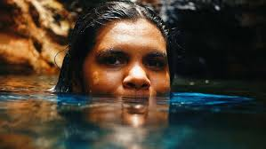
- What does Country mean to First Nations peoples?
- How might Country be different from just land or a place?
- Where is Warakurna? Find on a map of Australia. Find out the language of the Warakurna people. (Learn more about Warakurna - Source: National Museum Australia).
BTN story Charlotte from Warakurna
During watching
- How does Charlotte describe her connection to her home in Warakurna?
- What examples show that Country includes more than just the land (e.g. culture, stories, language, animals, water, people)? Make a list giving examples.
- What traditions, stories or practices show Charlotte’s connection Country?

After watching
- Why is it important for First Nations peoples to stay connected to their Country?
- What is one new thing you learnt about First Nations people’s connection to Country?

Watch one or more of these BTN stories to learn more about First Nations people’s connection to Country.

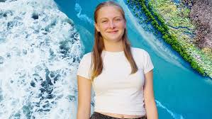  BTN story – Nyah’s Two Cultures | 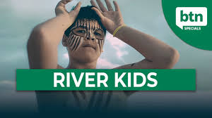  BTN story – River Kids | 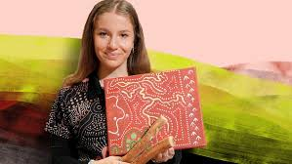  BTN story – Ngiyampaa Dictionary
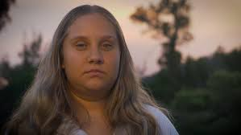  BTN story – Daniella's Ancestral Home | 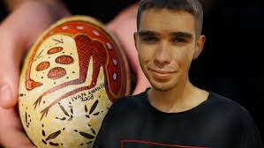  BTN story – Emu Eggs

Activity: Your Special Place
Students will reflect on their own connection to places that are meaningful to them. They will share stories about places that hold memories or special meaning. Students can use the following to help guide them during this activity.

Think about…
- A place you love to visit.
- It could be a park, a beach, grandparents, sporting ground, or somewhere in nature.
- What makes this place special?
- How do you feel when you are there?
- What memories do you have in this place?
- Who do you usually go there with?

Activity
Write a short paragraph about a place that is special to you and why you love to visit this place. Draw the place and label it. Write a short story about a memory there.

Include:
- Where the place is.
- Why it is special.
- How you feel when you are there.
- A memory you have there.
- Who you share the place with.

Share your stories
- Form small groups and share your stories with one another.
- Make a poster about your special place to put up in your school.
- Create a map of special places in your community.
- Imagine if you were commissioned by your local council to research and design a range of interpretive signs to be installed at special places in your community! The signs would teach visitors about the area’s natural features, history and cultural significance. Include hand drawn illustrations and a short description. Design a walking trail map which highlights these special places.

BTN First Nations collection
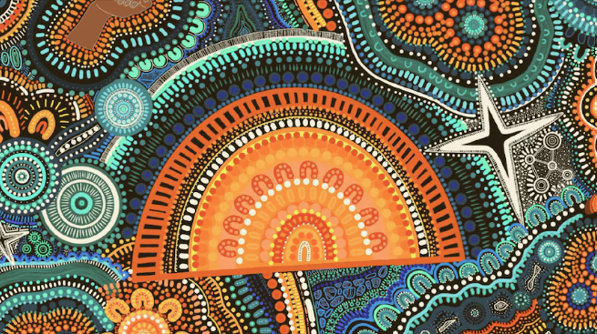
Visit BTN’s collection of stories which focus on First Nations.

Look for BTN stories with the pencil icon to find supporting teacher resources all linked to the Australian Curriculum.

BTN – First Nations Collection

Useful Websites
- Welcome to Country (2025) – BTN
- Welcome to Country (2021) – BTN
- Special: Connection to Country – BTN
- Welcome to and Acknowledgement of Country – Reconciliation Australia
- Deep Time – BTN
- Whose Country am I on? – AISTSIS

EPISODE 11
5 May 2026

KEY LEARNING
Students will learn about the life and legacy of David Attenborough.

CURRICULUM
Science – Year 5
Scientific understandings, discoveries and inventions are used to solve problems that directly affect peoples’ lives.

Science – Years 5 & 6
Scientific knowledge is used to solve problems and inform personal and community decisions.
Science – Year 7
Scientific knowledge has changed peoples’ understanding of the world and is refined as new evidence becomes available.

Science – Year 7
People use science understanding and skills in their occupations, and these have influenced the development of practices in areas of human activity.

  - Teacher Resource

David Attenborough

Focus Questions
Discuss the BTN story as a class and record the main points of the discussion. Students will then respond to the following:
- What did David Attenborough study at university?
- Where did David Attenborough work as a TV producer?
  - ABC
  - BBC
  - CBC
- What was ‘Life on Earth’ about and why was it important?
- What is David Attenborough’s legacy? Describe using your own words.
- What are some other achievements David Attenborough is known for? Give two examples.

Activity: Personal Response
Respond to the BTN David Attenborough story as a class. Students will complete one or more of the following incomplete sentences:
- David Attenborough is an important person because…
- It was interesting to learn…
- These are five words that I would use to describe David Attenborough…
- This story made me feel…
- It is important to celebrate David Attenborough because…

Activity: Class Discussion
After watching the BTN story, hold a class discussion using the following discussion starters.
- What did the BTN story tell you about the life of David Attenborough?

- Name at least one of his achievements.
- What impact has David Attenborough had?
- What do you think people can learn from him?
- What questions do you have about David Attenborough?

Activity: Key Words
Students will brainstorm a list of key words that relate to the BTN David Attenborough story. Here are some words to get them started.
NATURALIST | CONSERVATION | ADVOCATE
LEGACY | NATURAL HISTORY | SPECIES

Ask students to write what they think is the meaning of each word (including unfamiliar words). They will swap definitions with a partner and ask them to add to or change the definition. Check these against the dictionary definition.

Activity: Who is David Attenborough?
Students will develop a biography of David Attenborough. Begin by discussing with students what a biography is. What information is included in a biography and what does it tell us about a person?
Students can use the following questions to guide their research.
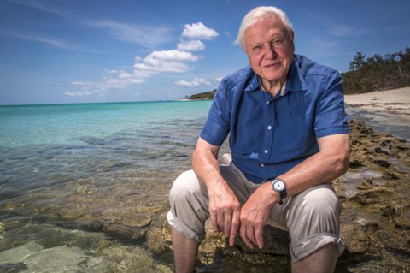
- When and where was David Attenborough born?
- What are some of his achievements? Choose one to explore in more detail.
- How are his achievements recognised?
- How has David Attenborough made an impact on people’s lives?
- What do you admire about him?
- What is David Attenborough’s legacy?
Source of image

The following are quotes from David Attenborough. Choose one to respond to and share your response with another student or the class.

"The natural world.. is the greatest source of so much in life that makes life worth living."
"I just wish the world was twice as big and half of it was still unexplored."
"Cherish the natural world, because you're part of it and you depend on it."

Further Research
Students will choose one of the activities below to further explore the life and work of David Attenborough.
Letter
Write a letter to David Attenborough telling him how he has inspired you.
Portrait
Create a portrait of David Attenborough.
Explore and experiment with different techniques and mediums to produce a portrait.

Interview
Imagine you could sit down and talk to David Attenborough. What questions would you ask about his life and achievements?

Activity: Species Profile
Students will choose a species named after David Attenborough and create a profile. Use this list to help choose a species.
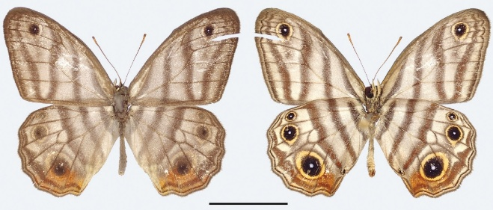
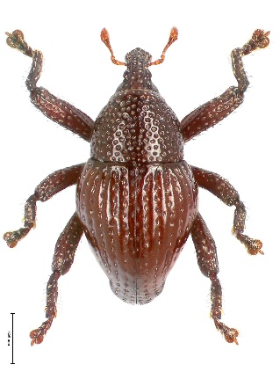
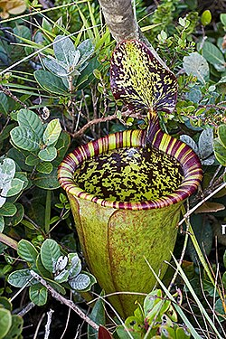
Research
Students will research the following and then share their research findings with the class or create a display in the classroom.
- Illustration or photo
- Name (common and scientific name)
- Appearance
- Habitat
- Threats
- Unique features
- Interesting facts
- Why was the species named after David Attenborough?

Activity: Become a Naturalist
David Attenborough is one of the world’s most famous naturalists. Provide students with the opportunity to think and behave like a naturalist, a person who studies and observes nature. In this activity students will explore a natural habitat in their local area, identify plants and animals in the area and document what they find.

Students can work individually, in pairs or small groups, using the following as a guide.

Step 1: Plan
Plan a visit to a local nature reserve or your own school yard to explore and identify plants and animals. You will need to write a list of tools you may need for the investigation, for example: pen and paper for taking notes, camera and magnifying glass. Predict what you might see and find. Think about what a naturalist would need on an investigation.

Step 2: Explore
Visit the habitat and carry out an exploration of the area. Choose a spot in the environment to investigate. Consider exploring the area from different angles, closeup or far away. Look and listen for evidence that animals live in the area.

Step 3: Collect
Once you have found an animal in the area, begin to study the animal and the plants around it in more detail. Collect as much data as you can about it and record what you find. You may write notes and sketch what you see to help in your investigation. Record what you see with a stills or video camera.
- What does the species look like? Take photos and draw pictures. Describe its characteristics.
- What is the animal doing? How does it interact with the environment? Record the behaviour of the animal.
- What does the environment look like? Describe. Can you identify any plants?
- Ask one “how” and one “why” question about what you see.

Return to the classroom and share/compare your findings.

Step 4: Analyse
Analyse your findings and write a short summary of your investigation.
- Did you find any animals during your investigation? If yes, identify and describe what you found. If you didn’t see any, did you find any evidence that animals live in the area?
- How could you help protect this habitat?

Step 5: Research
Respond to one or more of the following:
- What is the scientific name of the species?
- Explore the taxonomy of the species and categorise the information you find using the classification system.
- Why is this animal or plant important?
- Investigate what citizen science projects are happening to help monitor or protect this species.
- What might you notice if you visit this animals’ habitat at different times of the day or year?
- How has this species adapted over time to survive in their environment? Research some specific adaptations they have made to survive in their habitat.
- Where is this species on the food chain? Predict what might happen if they are removed from the food chain.
- Are there any examples of a conservation project helping this species?

Step 6: Reflect
Reflect on the investigation by responding to one or more of the following questions:
- What did you enjoy about this investigation?
- What did you find surprising?
- What would you do differently next time?

Useful Websites
- In Pictures: Creatures named after Sir David Attenborough – Newsround
- David Attenborough – BTN
- David Attenborough – Brittanica Kids
- Plans for a night of music to celebrate David Attenborough's 100th birthday – Newsround

  - Teacher Resource

BTN Transcript: Episode 11- 5/5/2026

Hey, I'm Amelia Moseley and you’re watching BTN. Thanks for hanging out with us again. Let’s see what’s coming up on today’s show. We find out why Taylor swift trademarked her voice, say "happy birthday" to a very famous voice and find out about a program giving a voice to kids in hospital.

Plastic Shortage

Reporter: Aiden McNamara

INTRO: First up today you probably know about the oil crisis that's affecting the world right now because of the war in Iran. But it's not just making fuel more expensive, it's also having a big impact on the price of plastic. Here's Aiden to explain.

PLASTIC SALESMAN: With thousands of plastic products, you'll always find what you need at Paul's Plastic Emporium. I'm talkin' toothbrushes, bike helmets, contact lenses, chairs, bubble wrap, glitter, car tyres.
CUSTOMER: Wow. That's my whole shopping list.
PLASTIC SALESMAN: Everything you need. At dirt cheap prices.
AIDEN MCNAMARA, REPORTER: Yeah, as Paul here will tell you, plastic is a pretty handy product. While man-made plastics have been around since the 1860s, things really took off in the mid-20th century, when we figured out how to make them from oil.
1950s PLASTICS PROMOTIONAL VIDEO: In the world of tomorrow plastics will certainly call the tune.
The old voice-over guy was right, today plastic is everywhere. In items you probably expect, as well as plenty of less plastic-y things, like clothes, tea bags, even chewing gum. It's a very popular material because it's simple to clean, long-lasting and cheap to make. Or at least, it was.
PLASTIC SALESMAN: They're charging us how much.?
As you probably know, because, well, we've told you, there's a global oil crisis going on right now. And when it's hard to get oil, it's hard to make plastic.
KEVIN KELLY, CEO EMERALD PACKAGING: The pricing environment right now is crazier than anything I've ever seen.
PLASTIC SALESMAN: We've got great deals on latex gloves. Barely worn. Only 10 cents each. Oop, only 40 cents each, ah ooo, let’s call it a dollar.
Oh, that was a nice noise.
These little pellet things are called nurdles. They're melted into moulds and used in most plastic products. This toy maker in Thailand reckons the cost of them has almost double.
KOMKRIT TEPTHIAN, TOY MAKER: If the situation continues, I may have to stop.
In some countries, shoppers are stocking up certain products they're worried will run out. You might remember the toilet paper frenzy we saw during covid.
Well, the South Korean government is even urging people not to panic-buy rubbish bags.
Here in Australia, these pipes are getting more spenny and harder to find. Making it tougher to water crops through irrigation and even build houses.
WILL FROGLEY, CEO MASTER BUILDERS SA: If you can't lay pipes in the ground, you can't lay a slab and that just grinds everything to a halt.
But plastic isn't just used to make stuff, lots of products are wrapped in it too. This dairy company is paying more for the resin used to make bottles.
MICHAEL HAMPSON, CEO NORCO: If we haven't got a container to give it to a consumer, there's little point in actually making the milk.
And it's not just milk, a lot of other companies have said they might have to push up their prices as packaging costs increase. While it's a tough time for businesses and shoppers, some see a potential up-side for the planet. While it is very useful, just about every piece of plastic that's ever been made still exists, in landfill, in the environment, and in the ocean.
Even before the fuel crisis, many governments around the world have been trying cut back on plastic. And some are hoping the price increase helps to encourage plastic recycling or push businesses towards products that aren't as harmful to the planet. For now, businesses are trying to adjust and hoping the price comes back down.
PLASTIC SALESMAN: Hmm. Has a nice ring to it.
News Quiz

The leader of which country made her first visit to Australia this week? Takaichi Sanae is the Prime Minister of Japan. She arrived in Australia for a three-day visit on Monday to talk about strengthening ties between our two countries.

ANNOUNCER: Their Majesties King Charles III and Queen Camilla.

King Charles made a historic speech to the United States lawmakers last week.

KING CHARLES: Ladies and gentlemen, we meet in times of great uncertainty.

When was the last time a British Monarch addressed congress? Was it 15 years ago, 35 years ago or 55 years ago? It was 35 years ago. The King was in the US to mark 250 years since America declared itself independent from Great Britain and spoke about the importance of the two countries’ relationship.

KING CHARLES: Whatever disagreements we may have, we stand united in our commitment to uphold democracy.

Meanwhile Queen Camilla was at the New York Library celebrating the 100th anniversary of which fictional character? Was it Mickey Mouse, Paddington Bear or Winnie the Pooh? It’s Winnie the Pooh. English Author A. A Milne published the first collection of stories in 1996 based on his son’s favourite toys.

Welcome to Country History

Reporter: Tatenda Chibika

INTRO: Welcome to Country ceremonies have been in the news recently after some First Nations elders were booed during ANZAC Day services. So, let's learn more about Welcome to Countrys and how they became a part of public life in Australia. Here's Tatenda.

Uncle Mickey, Kaurna Ambassador: As an ambassador and descendant of the Kaurna people, we welcome all people to places. We understand the importance of connection, relationships, and taking what we need, not what we want, and leaving something for tomorrow. So welcome, welcome here today.
Tatenda Chibika, Reporter: That's Uncle Mickey. He's a Kaurna man who has delivered Welcome to Country’s like this for the more than thirty years. In English and in Kaurna.
Uncle Mickey, Kaurna Ambassador: My father started this in the 80s and so he encouraged me to do it and I started off with simple words just like Niina Marni, which is hello, or are you good, or are you well, or in our language literally means are you fat, because fatness meant wellness.
Uncle Mickey says Welcoming people to Country is something that's always been done by Kaurna elders.
Uncle Mickey, Kaurna Ambassador: Our people have been doing Welcomes for thousands of years, because we've understood the importance of exchanging, building relationships and connections.
Long before European colonisation, hundreds of indigenous nations lived on this continent each with their own language and culture. When people travelled onto another nation's land, they had to ask for permission to enter. And, if that was granted, elders would welcome them and offer them protection. But it's thought the tradition of welcoming non-Indigenous people started in the 70s at this festival.
Rhoda Roberts, Journalist and Arts Director: My uncle, Lyle Roberts Jr, offered to sing that country for this festival and so to me, that was the first welcome and he set a precedent that we should be welcoming people onto our country, but also ensuring that they understood the protocols.
Rhoda Roberts was a Widjabul Wiyebal woman. She died in March, and along with her many other contributions, she is remembered as the person who popularised Welcome to Country as a way of showing respect and keeping ancient traditions alive.
Rhoda Roberts: We started to introduce it into the exhibitions, the galleries, the theatre performances, and I went, "Oh, why don't we...? "Well, it's we're welcoming people "to Country." And then, everyone kept trying to correct it, go, "Welcome to the Country" or "our Country." And I said, "It's not ours. "We live with it."
In 2000, Rhoda brought welcome to Country to the world arranging for the ceremony to be performed at the Olympics.
Today, Welcome to Country is a big part of Australian public life. It's performed at sport matches, concerts, community events and official government functions. To perform one, you have to be a First Nations person and have permission from the community that you're welcoming people to. Non-Indigenous people can also show their respect with an acknowledgment of Country.
CHILD: We would like to acknowledge that this assembly is being held on the traditional lands of the Kulin Nations.
But lately, there's been some controversy about the ceremonies. Some people have called them divisive and say people shouldn't be welcomed to their home country. But Uncle Mickey says that's not the intention of Welcome to Country. He says it's not about dividing but uniting and recognising Australia's shared history.
Uncle Mickey, Kaurna Ambassador: I mean, if I come to your home, I would knock on the door and I would call out to you and therefore you would come to the door and invite me in. It's an invitation to make you a part, to make you special because we say we are glad that you have come to a place and we say that you are important because it's what you bring, what we can exchange, the relationship that we make.

Taylor Swift Trademark

Reporter: Saskia Mortarotti

INTRO: She's one of the most recognisable people in the world and now Taylor Swift wants to trademark this image and samples of her voice in an effort to prevent AI from creating fake versions of her. Sas found out more.

SASKIA MORTAROTTI, REPORTER: Imagine somebody took your image and your voice…

TATENDA: Wait, you got a puppy? I love puppies!

…and used them to make something of you that's not real. Well, it's something that’s getting easier to do.
TATENDA: Hey, Sas, Aiden. What's going on?
AIDEN: I love dogs.
TATENDA: Okay, I love them too?
AIDEN: Well, explain this then.
AI TATENDA: I hate puppies.
TATENDA: That’s not real!
SASKIA: Yeah, no. I just made it with AI.
AIDEN: Oh, phew. I thought I'd have to end our friendship.
Yeah, you probably already know artificial intelligence, or AI, is pretty good at recreating real people in unreal situations.
AI CRISTIANO RONALDO, FOOTBALLER: Happy birthday to you.

AI JUSTIN BIEBER, MUSICIAN: We'll never ever, ever be apart...
AI CRISTIANO RONALDO, FOOTBALLER: 6, 7? SIUUU.

AI LEBRON JAMES, BASKETBALLER: I'm a bee. Buzz, buzz.
And while it's led to some entertaining videos, it's also got quite a lot of people worried. As well as its potential to make your workmates seem like dog-haters, many artists are concerned that their works, their voices, and their image are being used by AI without permission. And it's something that the law is struggling to keep up with.
BIANCA TRAMAGLINO, IP LAWYER: The difficulty with AI is it's not necessarily regulated under any single piece of legislation. I mean, what we're seeing is that it cuts across all different areas of life and law.
There are laws which protect artists' work from being used without their permission. They're known as copyright laws. So, for example, I can't copy this song and sell it to someone else, or even record my own version, but right now there's nothing to stop me asking AI to create a fake Taylor Swift. Taylor Swift's image and voice have appeared in many AI images and deepfakes. So, she's trying to do something about it by trademarking her image and voice. A trademark is like copyright, but rather than protecting an artist's work, it's designed to protect a brand. It can cover all sorts of things. Symbols, logos, word, phrases, even smells. Anything that sets a business apart and unlike copyright, it doesn't protect a single work, it protects the whole, you know, vibe.
BIANCA TRAMAGLINO: Trademarks basically protect the sort of appearance or your brand identity.
Taylor Swift's company, TAS Rights Management, has lodged three trademark applications to the United States Patent and Trademark Office. One being an image of her and the other two being sound marks, or audio clips.
TAYLOR SWIFT, MUSICIAN: Hey, it's Taylor Swift. Hey, it's Taylor.
Legal experts reckon if Taylor is able to trademark those sounds and image, she could possibly challenge other AI-generated content that isn't exactly the same but could be confusingly similar to them. Back in January, actor Matthew McConaughey became the first celeb to trademark their image and voice.
MATTHEW MCCONAUGHEY, ACTOR: Alright, Alright, Alright.
But some people think more just needs to be done in general to protect people from being imitated by AI. Especially as the tech gets more advanced. Some are calling for new laws and for companies who employ artists to ban the use of AI to create fakes.

Right now, we don't know if Taylor Swifts trademark applications will be approved, so we'll have to wait and see, because if they are, it could open the door for a bunch of other celebrities to follow suit.
TATENDA: Hey, Sas look what I just made of you.
SASKIA: Wait, that's actually nice. Can you send me that?

TATENDA: Owal

Quiz

Here's one for the Swifties. Do you know the singer's middle name? Is it Olivia, Jane or Alison? It's Alison. And fun fact, her parents named her Taylor after another singer, James Taylor.

David Attenborough

Reporter: Jack Evans

INTRO: Now to another famous face and voice that's been helping people learn about the wonders of nature for decades. They belong to Sir David Attenborough, who is about to turn 100 years old. To celebrate Jack found out more about his amazing career. Check it out.

JACK EVANS, REPORTER: Deep in the heart of Southwest London, one may encounter a most distinctive specimen. An individual known for a voice with measured tones and unmistakable cadence that has guided its audience gently through the complexities of the natural world. This is Davidis Attenboroughus Narratus or Sir David Attenborough. I'm sure you've heard of him and if you haven't, I'm sure you've heard his voice. It sounds like this or like this.
DAVID ATTENBOROUGH: This magnificent creature, preparing…oops ha.
David was born on the 8th of May 1926 in London, England. From an early age he was fascinated by the natural world. His father worked at the University of Leicester, where David spent much of his childhood collecting things he found like fossils and rocks and even newts that he occasionally sold to the university’s zoology department. Speaking of, it's no surprise that zoology is what David went on to study at university along with geology.
Eventually, in the 1950s, David got a job at the BBC as a TV producer. At first execs said he didn't have the looks for TV, but it wasn't long before he found himself in front of the camera. A place he would find to be most natural.
DAVID: They're a strange extremely primitive creature called a tenrec.
This is from a series called Zoo Quest, which involved a team from the London Zoo travelling the world looking for exotic animals to exhibit. It was the first of many shows David would go on to present and produce for the BBC. In 1965 David was promoted to controller of BBC Two, where he helped to get some pretty famous shows to air.
MONTY PYTHON: Hello Polly.
He also pushed for the introduction of colour TV to Europe. But his legacy would come in 1979 with the release of the doco series Life on Earth. It was kind of revolutionary at the time. Audiences were seeing things that had never been filmed before, and it changed the way wildlife documentaries were made.
MIKE GUNTON, CREATIVE DIRECTOR OF THE NATURAL HISTORY UNIT AT THE BBC: I mean, 'Life on Earth', when it came out, was a complete game changer. The complexity of trying to tell the story about the natural world was a whole other level up.
Over the next couple of decades David continued to make docos about all of Earths living things. From mammals to marine life. You name it and he's probably made a show about it. A lot of Davids early work was about showcasing the beauty of the natural world. But in later years he used his films to draw people’s attention to the problems that world is facing, like climate change and plastic pollution.
DAVID: Every year some 8 million tonnes of it ends up in the ocean and there it can be lethal.
And he's used his platform to speak out and advocate for change.
DAVID: We are, after all, the greatest problem solvers to have ever existed on Earth.
Throughout his career David has received many honours for his work and has been knighted twice, which is why he's known as SIR David Attenborough. He also has had more than 50 species named after him. And Turning 100 doesn't seem to be slowing David down as he continues to make docos and use his famous voice to teach people about the world around us.
Quiz
Despite his love of nature, David Attenborough admits his not too fond of which of these creatures? He says he's scared of Rats.

Sport

COMMENTATOR: Once, twice, three times a Grand Prix winner - Kimi Antonelli wins!

19-year-old Kimi Antonelli has had a historic win at the F1 Miami Grand Prix, becoming only the third driver in history to win his first three F1 races from pole position. From Max Verstappen spinning out early to Pierre Gasly getting completely flipped over. Not to mention pressure from McLaren teammates Lando Norris and Oscar Piastri but it wasn't enough to stop the Italian teenager.

COMMENTATOR: It's a great ball, and steered in by Sam Kerr!

Next up, this first-half header from Sam Kerr was her 64th Women's Super League goal making her Chelsea's all-time leading scorer.

COMMENTATOR: And she gives Chelsea the lead.

After that it was goal after goal for Chelsea as the blues beat Leicester three to one.

And finally, to the World Mixed Pairs Curling Championships in Switzerland.

COMMENTATOR: History.

After missing out on qualifying for the Winter Olympics, Aussie curlers Tahli Gill and Dean Hewitt have pulled off a comeback, winning eight to four against Sweden. It's Australia's first-ever Championship gold medal in curling.

TAHLI GILL: We just wanted to do our best, and we did, so we're really happy and proud, yeah.

Juiced TV

Rookie Reporters: Maggie and Hannah

INTRO: Last but not least today, let's meet some up-and-coming broadcasters. Maggie and Hannah are presenters on Juiced TV, a program made for kids in hospital, by kids in hospital. I'll let them tell you all about it.
MAGGIE: Hi, I'm Maggie. I'm 10 years old, and I'm a Juiced TV reporter.
HANNAH: Hi, I'm Hannah. I'm 12 years old, and I'm also a Juiced TV reporter.
MAGGIE: Juiced TV is the show made by the kids in hospital
HANNAH: for the kids in hospital.
HANNAH PRESENTING: I'm your host today on Juiced TV.
MAGGIE PRESENTING: Let's get started.
MAGGIE: We met by being roomies.
HANNAH: in 11B.
MAGGIE: We've done lots of fun things together.
HANNAH: But we've also had chemo together.
MAGGIE: When I was 9, I was diagnosed with osteosarcoma, which means bone cancer. It was a bit scary at the hospital sometimes coming in. Sometimes, I didn't want to come in for my chemo treatment, but I knew it was going to make me better, so I kept coming in, and Juiced TV made that way funner for me.
HANNAH: I was getting really bad colds and kept on getting them, and my spine hurt so bad, and I went to the doctors, and they said, well, you have cancer, leukemia, a blood cancer. So, I had to go to hospital and get all this treatment, and it felt very yucky, but luckily, I bumped into Juiced TV.
HANNAH: I feel like Juiced TV is a place where you can escape chemo and all the yuckiness and come into this world where you're happy and finding friends.
MAGGIE: How do we make Juiced TV?
HANNAH: Well, first, we come up with a really good idea
MAGGIE: Then we come up with the script
HANNAH: Then we make the magic happen.
MAGGIE PRESENTING: How could I forget about you, legs?
LEGS: Oh, you're proper lovely Miss Maggie.
MAGGIE: Sometimes it's hard to make the lines come out properly, so usually it takes a few goes.
HANNAH: And also, they'll be great for bloopers.
MAGGIE PRESENTING: Willow, Miss Nora, surfy nursery,
HANNAH: Some of the most interesting things I've done is dancing, circus performing, crafting, but my most favourite one was definitely air-dry clay and sketching.
MAGGIE: I love to show my love of fashion, glam and makeup.
MAGGIE PRESENTING: Number 3 is fashion.
MAGGIE: I enjoy Juiced TV because when you make mistakes, you can just get back up and go again.
HANNAH: And, just making friends and being happy.
MAGGIE: And that's how the magic happens behind the scenes.
HANNAH: Stay positive and keep watching Juiced TV, bye.
Closer

Oh, great work, Maggie and Hannah. You'll be coming for my job soon. Well, that's all we have for this week, but don't you worry, we'll be back before you know it. And in the meantime, you can check out BTN Newsbreak, right here in the studio, every weeknight. Don't forget there's also BTN High for all you older BTN-ers. Have the best weekend, and I'll see you really soon. Bye.

