EPISODE 7
19th March 2024

KEY LEARNING
Students will view a range of BTN stories and use comprehension skills to respond to a series of focus questions.

CURRICULUM
English – Year 4
Use comprehension strategies to build literal and inferred meaning to expand content knowledge, integrating and linking ideas and analysing and evaluating texts.

English – Year 5
Use comprehension strategies to analyse information, integrating and linking ideas from a variety of print and digital sources.

English – Year 6
Use comprehension strategies to interpret and analyse information and ideas, comparing content from a variety of textual sources including media and digital texts.

English – Year 7
Use comprehension strategies to interpret, analyse and synthesise ideas and information, critiquing ideas and issues from a variety of textual sources.
  - Teacher Resource

Focus Questions
As a class, discuss the stories featured in the episode of BTN Classroom and record the main points of the discussion. Students will then respond to the following focus questions.

Nuclear Power
- A lot of Australia’s current energy production relies on…
  - Fossil fuels
  - Renewable energy
- What fuel is used in nuclear power plants?
- How is energy produced in a nuclear power plant?
  - By capturing sunlight
  - By burning coal
  - By splitting uranium atoms
- Why are some people against nuclear power?
- What did you learn watching this story?

Reef Bleaching
- What was the main point of the BTN story?
- What is coral bleaching?
- Coral gets its colour from…
  - Minerals in the water
  - Polyps
  - Zooxanthellae
- What do scientists say is causing the mass bleaching event?
- What can we do to protect the Great Barrier Reef?

Check out the teacher resource on the Archives page.

Shrinkflation
- Briefly summarise the BTN story.
- What is shrinkflation?
- Why do companies use shrinkflation?
- Give examples of products that are affected by shrinkflation.
- What do you understand more clearly about shrinkflation since watching the BTN story?

Teen Pilot
- How old was CJ when she started flying?
- Which pilot training program is she a part of?
- Finish the following sentence: CJ hopes to be the first…
- How does CJ feel about starting the training program?
- What did you like about the BTN story?

Dame Mary Gilmore – Women’s History Month
- What were some significant achievements in Dame Mary Gilmore’s life?
- What sparked her interest in politics and social change?
- Which banknote does Dame Mary Gilmore feature on?
- Why is she an important Australian?
- If you could ask Dame Mary Gilmore one question, what would it be?

Check out the teacher resource on the Archives page.

EPISODE 7
19th March 2024

KEY LEARNING
Students will develop a deeper understanding of the threats to the Great Barrier Reef.

CURRICULUM
Science – Year 4
Living things depend on each other and the environment to survive.

Living things have life cycles.

Science knowledge helps people to understand the effect of their actions.

Science – Year 5
Living things have structural features and adaptations that help them to survive in their environment.

Scientific knowledge is used to solve problems and inform personal and community decisions.

Science – Year 6
The growth and survival of living things are affected by physical conditions of their environment.

  - Teacher Resource

Reef Bleaching

Focus Questions
Discuss the BTN story as a class and record the main points of the discussion. Students will then respond to the following:
- What was the main point of the BTN story?
- What is coral bleaching?
- Coral gets its colour from…
  - Minerals in the water
  - Polyps
  - Zooxanthellae
- What do scientists say is causing the mass bleaching event?
- What can we do to protect the Great Barrier Reef?

Activity: Personal Response
Write a personal response to the BTN Reef Bleaching story by completing the following sentences:
- It was interesting to learn…
- Five words that describe the Great Barrier Reef are…
- The Great Barrier Reef is important to protect because…

Activity: Class Discussion
After watching the BTN story, hold a class discussion using the following discussion starters.
- Where is the Great Barrier Reef? Explore using Google Earth.
- What makes the Great Barrier Reef special?
- What is coral bleaching?
- What can be done to protect the Great Barrier Reef?
- Have you ever visited the Great Barrier Reef? What did you see there? Describe your experience.

Activity: Glossary
Students will brainstorm a list of key words that relate to the BTN Reef Bleaching story. Here are some words to get them started.

CORAL | ALGAE | CORAL BLEACHING
POLYP | CLIMATE CHANGE | ZOOXANTHELLAE

Ask students to write what they think is the meaning of each word (including unfamiliar words). They will swap definitions with a partner and ask them to add to or change the definition. Check these against the dictionary definition.

Further activities for students:
- Students will add to their glossary by downloading the transcript for the BTN Reef Bleaching story and highlight all the words that relate to the topic. For example, mass bleaching event, rising sea temperatures, UNESCO, World Heritage Site.

Activity: Coral Reef Research
Students will develop their own question/s to research about coral reefs. Students will collect and record information from a wide variety of sources. Students may develop their own question for inquiry or select one of the questions below.
- What are the threats to the Great Barrier Reef?
- What is coral bleaching? What impact is it having on the Great Barrier Reef?
- Explore previous mass bleaching events on the Great Barrier Reef. How much of the Reef was affected? What impact did it have?
- Who do you think should be responsible for looking after the health of the Great Barrier Reef?
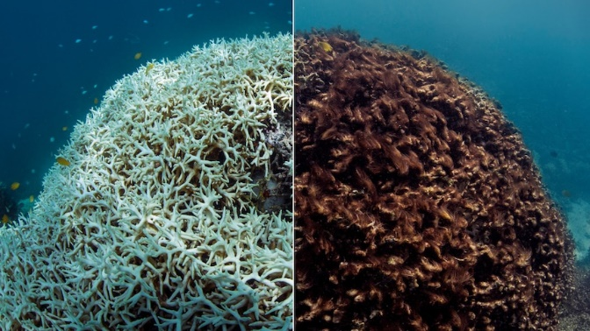
- How are coral reefs formed?
- What is a coral spawning event and how often do they happen?
- Coral has a symbiotic relationship with zooxanthellae (algae). What is a symbiotic relationship? What other examples of symbiotic relationships are there on the Great Barrier Reef? Explain the symbiotic relationship including the importance of the relationship to the Great Barrier Reef.
- Why are coral reefs called the `tropical rainforests of the sea’?
- What might happen if we don’t look after coral reefs? What would they look like in 30 years’ time? Make some predictions.
- The Great Barrier Reef is a World Heritage site. What types of places around the world are World Heritage sites? How does a site make it on to the World Heritage List? Why did the Great Barrier Reef make it onto the World Heritage List?

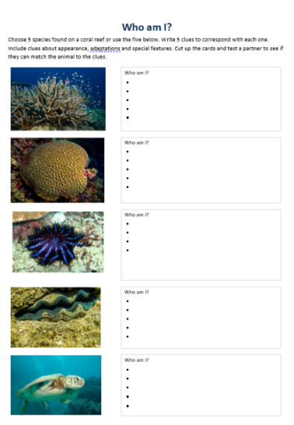
Activity: Who am I?
Students will make their own Who am I? game to learn more about species that live on coral reefs. The worksheet is at the end of this activity.
- Students will research and write 5 clues to correspond with each species in the Who am I? worksheet at the end of this activity, with the first clue being the hardest and the last clue being the easiest.
- Include clues about the species appearances, adaptations and special features.
- Students will test their game on a partner.

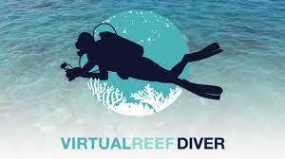
Activity: Become a citizen scientist
The Virtual Reef Diver project allows students to become citizen scientists, classifying underwater images of coral. The data collected is then used by researchers to make better decisions about protecting the Great Barrier Reef. Virtual Reef Diver also allows students to explore 360-degree images of the Great Barrier Reef.

Activity: Coral Reef Quiz

- The Great Barrier Reef is the largest coral reef in the world.  A. True  B. False  - About how many coral reefs make up the Great Barrier Reef?  A. 30  B. 3,000  C. 300,000  - What gives coral its colour?  A. Minerals in the water  B. Polyps  C. Zooxanthellae | - The Great Barrier Reef can be seen from space.  A. True  B. False  - Coral reefs are made up of thousands of tiny animals called…  A. Polyps  B. Anemones  C. Molluscs  - Approximately how many species of fish live in the Great Barrier Reef?  A. 500  B. 1500  C. 5000
Answers: 1. A, 2. B, 3. C, 4. A, 5. A, 6. B

Useful Websites
- Extensive coral bleaching on southern end of Great Barrier Reef after summer of warmer ocean temperatures – ABC News
- Coral Bleaching – BTN
- Reef Bleaching – BTN
- Coral Bleaching – Great Barrier Reef Foundation
- Great Barrier Reef – Australian Museum
- UNESCO Great Barrier Reef - BTN

Who am I?
Choose 5 species found on a coral reef or use the five below. Write 5 clues to correspond with each one. Include clues about appearance, adaptations and special features. Cut up the cards and test a partner to see if they can match the animal to the clues.
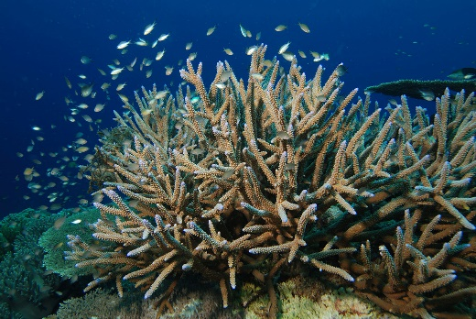 |  | Who am I?
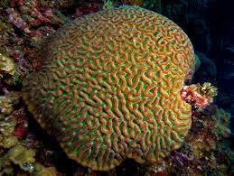 |  | Who am I?
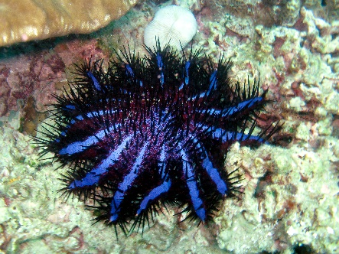 |  | Who am I?
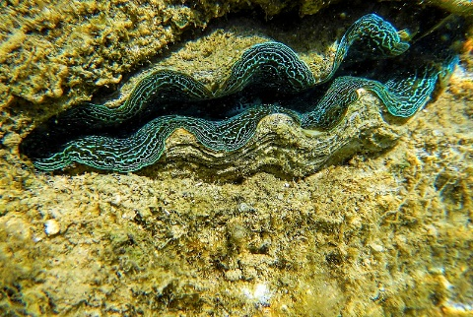 |  | Who am I?
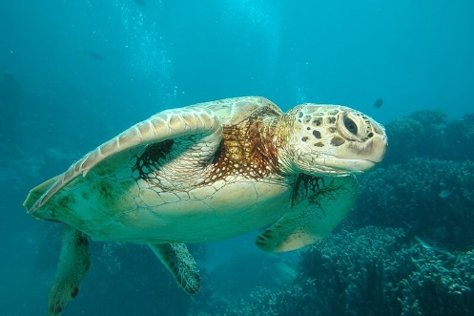 |  | Who am I?
Images: 1. Staghorn coral 2. Brain coral 3. Crown-of-thorns starfish 4. Giant clam 5. Sea turtle

EPISODE 7
19th March 2024

KEY LEARNING
Students will recognise and celebrate Australian women who have made significant positive changes in society.

CURRICULUM
HASS – Year 3 and 4
Pose questions to investigate people, events, places and issues.

Locate and collect information and data from different sources, including observations.

HASS – Year 5 and 6
Develop appropriate questions to guide an inquiry about people, events, developments, places, systems and challenges.

Locate and collect relevant information and data from primary sources and secondary sources.

History – Year 6
The contribution of individuals and groups to the development of Australian society since Federation.

HASS – Year 7
Construct significant questions and propositions to guide investigations about people, events, developments, places, systems and challenges.

  - Teacher Resource

Dame Mary Gilmore

Women’s History Month

Focus Questions
Discuss the BTN story as a class and record the main points of the discussion. Students will then respond to the following:
- What were some significant achievements in Dame Mary Gilmore’s life?
- What sparked her interest in politics and social change?
- Which banknote does Dame Mary Gilmore feature on?
- Why is she an important Australian?
- If you could ask Dame Mary Gilmore one question, what would it be?

Activity: Personal Response
Respond to the BTN Dame Mary Gilmore story as a class. Students will complete one or more of the following incomplete sentences:
- Dame Mary Gilmore is an important Australian because…
- It was interesting to learn…
- These are five words that I would use to describe Dame Mary Gilmore…
- This story made me feel…
- It is important to celebrate Dame Mary Gilmore because…

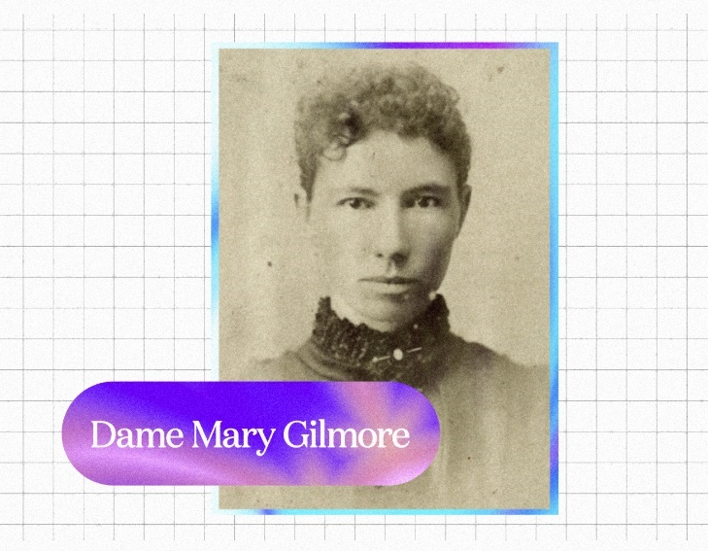

Activity: Explore our Banknotes
Begin this activity by asking your students if they know who is on the Australian $10 banknote. Provide your students with a magnifying glass and a physical $10 banknote. Students will take it in turns to observe and study the $10 banknote. Students can also view a specimen of the $10 banknote up close on the RBA website.

Investigation
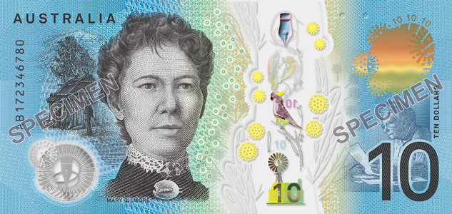
Students will get up close with the $10 banknote, examine it in detail and respond to the following questions:
- What do you see? Write down as much as you can about what you see. Use a magnifying glass to see as much detail as possible.
- Can you find any icons, images, writing or clues about Dame Mary Gilmore on the banknote? Record your discoveries.
Australian $10 Banknote (RBA)
- Why do you think Dame Mary Gilmore is on the $10 banknote?
- What questions do you have about what you see on the banknote?
- Share your findings with the class.

Interactive App
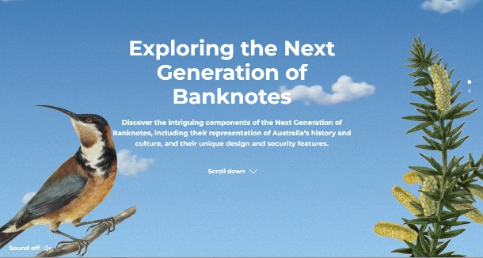
As a class visit the RBA’s Interactive App to discover the components of Australia’s banknotes including their representation of Australia’s history and culture, and their unique design and security features.

Focus on the $10 banknote and find out as much as you can about Dame Mary Gilmore. Students will try to find answers to the questions they wrote during their investigation.
Interactive App (RBA)

Did You Know?
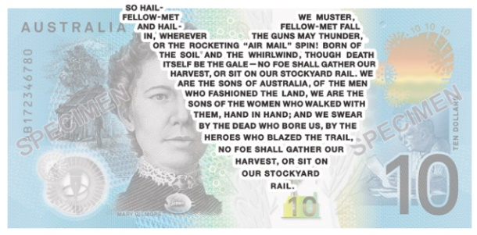
Did you know Australia’s banknotes have areas of text unreadable to most human vision? The text is approximately 0.25mm in height and can only be read with the help of a magnifying glass! Learn more about the RBA’s Microprinting process.

As a class, listen to the microprint excerpt from Dame Gilmore’s No Foe Shall Gather Our Harvest, a poem that united the Australian people against the growing fear of Japanese invasion.
Microprinting (RBA)

Activity: Biography
Before students begin to construct their biographies, hold a class discussion to find out what they already know about biographical writing. Discuss what type of information is included in a biography and what they tell us about a person. The Civics and Citizenship website has some examples of biographies for students to look at.

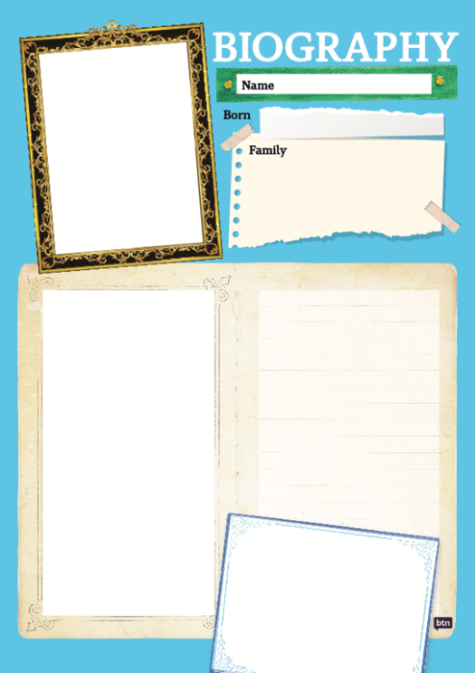
Class Discussion
Use the questions below to get a class discussion started with your students about biographical writing.

- What does a biography tell us about a person?
- Where can you look to find information for your biographical writing? It could include the internet, newspaper articles, magazine articles and interviews, other biographies, historical books or television interviews. Why is it important to use more than one source of information?
- What makes a biography interesting? For example, key information and facts, a timeline of events, photographs, illustrations and quotes.

Create your Biography
Using the biography worksheet at the end of this activity, students will research and record information about Dame Mary Gilmore. Some possible areas of research include:
- When and where was Dame Mary Gilmore born? Describe her family life growing up.
- What were some of her achievements? Choose one to explore in more detail.
- What inspired or motivated her?
- What were some challenges that she faced?
- How did she make an impact on people’s lives?
- What do you admire about her?

Interview
- Imagine you could sit down and talk to Dame Mary Gilmore.
- What questions would you ask about her life and achievements?
- Find answers to your questions.
Portrait
- Plan and create a portrait of Dame Mry Gilmore.
- Explore and experiment with different techniques and mediums to produce a portrait.
- Organise a class exhibition of your artworks.
Timeline
- Create a timeline of important events in Dame Mary Gilmore’s life.
- What are some of the key events in her life? Write a summary for one key event, which answers the 5 W’s – Who, What, Where, When and Why?

Useful Websites
- Dame Mary Jean Gilmore (1865–1962) – Australian Dictionary of Biography
- Dame Mary Gilmore (1865–1962) – Reserve Bank Australia
- Dame Mary Gilmore – National Portrait Gallery

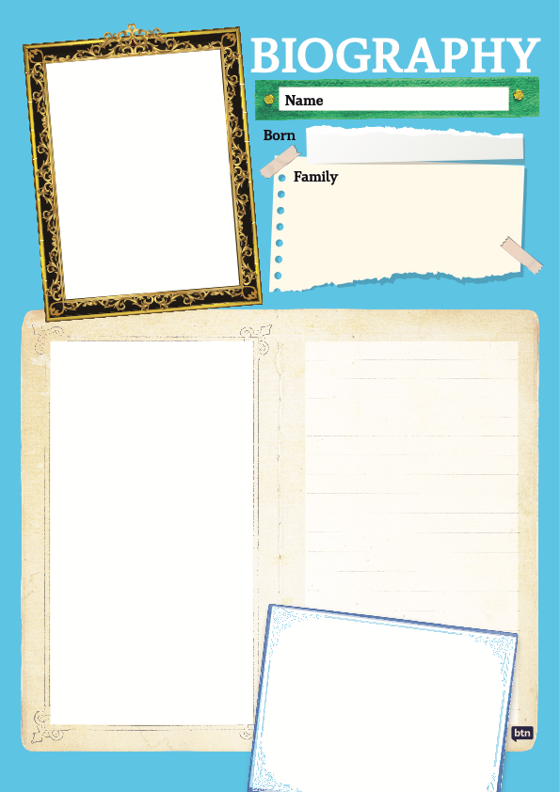

  - Teacher Resource

BTN Transcript: Episode 7 - 19/3/2024

Yaama, I'm Jack and you're watching BTN. Here’s what’s coming up. We find out why boxes of cereal are shrinking, get some bad news about the Great Barrier Reef and learn about the life of Dame Mary Gilmore.

Nuclear Power

Reporter: Joseph Baronio

INTRO: But first today, we're going to talk about nuclear power. It's been in the news since the opposition leader suggested it could help to solve some of Australia's energy problems, but it's caused a lot of debate. Joe found out why.

Scientist: Aha. I've got it. The ultimate clean, green energy source. Ahaha. All you need is a cat which always lands on its feet, and a piece of buttered toast which always lands butter side down, and then you tape them together, and voilà.
Joe Baronio, BTN Reporter: Maybe that idea isn't quite perfected yet, but the hunt for new clean energy ideas is in full swing. You see, a lot of Australia's current energy production relies on fossil fuels like coal and has done for a long time. That's because coal is an accessible, affordable, and reliable way to generate a lot of energy, but it also generates a lot of greenhouse gas emissions. Plus, a lot of these power stations are pretty old, and we've already seen quite a few shut down. In fact, experts reckon there'll be none left by 2038, so, the clocks ticking to come up with a replacement.
Scientist: Ah. What if we build giant windmills that turn wind into electricity?
That's already a thing, actually.
Scientist: Alright well, how about we capture the sun’s radiation and turn that into electricity?
Again, that's already being done.
Scientist: Fine, well, how about we use water to spin a turbine and that makes electricity?
Guess what? Yeah, already happening.
Australia is a world leader in renewable energy, but it still only accounts for around 30% of the power we use, and while that's growing, some people think we need another solution.
Scientist: Aha. I've got it this time. We'll split the atom. Nuclear power. Ahahaha.
Ahem me again. That's been done too.
Scientist: Are you serious?
Yeah. Nuclear power plants have been around since the 1950s and are still being used in many countries around the world.
Scientist: Nuclear power plants work by using a process called fission, which unlocks the power stored in an atom by splitting it.
It's the same principle as atomic bombs; except, in nuclear power plants the fission reaction is controlled, releasing just enough energy to heat water and create steam, which spins a turbine and generates electricity. All while producing no greenhouse gasses. But not everyone thinks it's a good idea because… [atom bomb detonates] yeah.

See, nuclear bomb tests in the 1960s and 70s soured the idea of anything nuclear in Australia. There were also a couple of terrible accidents at nuclear power plants. First Chernobyl in 1986, then Fukushima in 2011, which led to dangerous radioactive material being released into the environment. Many experts say that modern nuclear power plants are much safer, but there's still the problem of used reactor fuel which is radioactive for a really long time and has to be stored somewhere safe. Nuclear power has actually been banned in Australia since 1998, but opposition leader Peter Dutton and the Coalition say they want to change that.
Peter Dutton, Opposition Leader: I think it's the only credible pathway we have to our international commitments to net-0 by 2050.
Australia has a lot of uranium which could be used to fuel nuclear power plants, and the opposition reckons we could have one up and running in just over a decade. But the government say…
Chris Bowen, Climate Change and Energy Minister: Tell him he's dreaming.
They say building a nuclear plant would take way too long, and research shows it's more expensive than other options.
Chris Bowen: Australia has the best renewable resources in the world, it would be a massive economic own goal to give up utilising those resources.
Scientist: Alright, alright. Looks like we're going to have to get the cat and the toast to work then.
News Quiz
Which social media app could soon be banned in the US? It’s TikTok. Last week the House of Representatives passed a bill which would force the Chinese company that owns TikTok to either sell it or face a ban.

MIKE GALLACHER, US CONGRESSMAN: TikTok is a threat to our national security because it is owned by ByteDance which does the bidding of the Chinese communist party.

Although it’s made a lot of content creators pretty upset.

CONTENT CREATOR PROTESTER: I’m here because I’m a disability advocate and TikTok changed my life and so many others within the disability community.
CONTENT CREATOR PROTESTER: I talk about books on TikTok, and I encourage people to read, and I want to keep on doing that.

Now it’s up to the senate to decide if they want to pass the bill and bring in the ban.

Why did the British royal family ask media outlets not to use this photo? It was taken a long time ago, it was digitally manipulated, or it was taken without permission. It was digitally manipulated. It was the first photo of Princess Kate to be released after she had abdominal surgery, but people soon noticed details that weren’t quite right – queue internet meltdown. Princess Kate sent out a message saying she had done the digital touch-up and apologised for the confusion, but it hasn’t stopped the rumours.

PERSON: There’s been so many conspiracy things I’ve heard about what’s going on, I don’t know what to believe to be honest.

What famous vessel does this Aussie billionaire want to recreate? The Titanic, the Hindenburg or the Concord? It’s the Titanic. Last week Clive Palmer re-released his plans for the Titanic 2, a luxury ocean liner that he wants to build based on the famous ship which sank in 1912. It’s an idea he first floated more than a decade ago but got held up by some “unforeseen global delays”.

CLIVE PALMER: The Titanic reminds us of the critical aspects which all people aspire to and love and friendship, and the love story of Rose and Jack.

Reef Bleaching

Reporter: Justina Ward

INTRO: Now to the Great Barrier Reef and some not so great news. Scientists say it's in the middle of another mass bleaching event something that's become way too common in recent years. Justina found out what that is and why it's got some people worried about our natural underwater wonder.

JUSTINA WARD, REPORTER: The Great Barrier Reef. You know, this place. Hmm, maybe zoom in a little bit. Ahhh, there we go. The Great Barrier Reef is one of the world's seven natural wonders and is famous for a pretty good reason.

MR RAY, FINDING NEMO: C’mon, sing with me - Ooooohhhhhhhhhhhhh

Not only is it absolutely stunning, it's the largest coral reef system on the planet.

Sprawling over a jaw-dropping 344,400 square kilometres. Which is nearly as big as Italy. It's home to thousands of coral species and animals. And reels in about $5 billion dollars in tourism each year. But if you've been to the reef recently. You might have noticed some parts are looking a little bit different.
Richard Leck, WWF's Head of Oceans: We've had a mass coral bleaching event declared on the Great Barrier Reef, which means the corals are starting to lose their colour. And if the waters of the reef don't call down soon, we could see some of that coral starting to die unfortunately.
Coral Bleaching happens when corals get too hot. They stress out and expel the tiny marine algae, called zooxanthellae which give the coral their beautiful colours and make them turn white. Scientists who have been surveying the reef recently say two thirds of it are experiencing coral bleaching right now.
Richard Leck, WWF's Head of Oceans: The waters along the whole of the Australian East Coast, are really, really hot. And while that sounds fantastic for swimming, it's actually terrible for the health of the Great Barrier Reef.
This isn't the first time it's happened. Widespread mass bleaching of the reef was first recorded in 1998 but it’s happened a bunch of times since then. In fact, this is the 5th mass coral bleaching in the past eight years and scientists suspect they know the cause.
Dr Selina Ward, Marine Biologist, The University of Queensland: By climate change, by our emissions, without doubt.
Yeah, while bleaching has always happened. They say global warming is driving up ocean surface temperatures, which is making it more common and more severe.
Dr Maya Srinivasan, Researcher, James Cook University: I'm in tears underwater every now and then when I see this stuff, but I think it's really important to have hope.
And there is hope. Coral bleaching doesn't mean the coral has died. And if temperatures go down, it can bounce back pretty quickly.
Richard Leck, WWF's Head of Oceans: The concern is if we keep having these repeated events, it doesn't give the reef enough time to recover.
This and other threats like pollution and the crown of thorns starfish have led to the United Nations Educational, Scientific and Cultural Organisation to recommend that the reef should be put on its list of World Heritage Sites that are "In Danger". And the government has been trying to stop that from happening. By taking steps to improve water quality, reduce overfishing, control the crown of thorns starfish. And look for ways to help the coral.
Tanya Plibersek, Minister for the Environment & Water of Australia: We put in $1.2 billion dollars to protect our reef, we've doubled the funding for the Australian Institute of Marine Science to give to our scientists the opportunity to do their good work in protecting the reef.
Richard Leck, WWF's Head of Oceans: And then there's so much you can do around your house and in your everyday life as well.
Richard says things like recycling, reducing plastic use, saving power around the house and educating yourself and others, all make a huge difference in protecting the Great Barrier Reef.
Quiz
The Great Barrier Reef is built by billions of tiny organisms called coral polyps. Which group of living things do coral polyps belong to? Plant, animal or bacteria? They're animals.

Shrinkflation

Reporter: Saskia Mortarotti

INTRO: Over the past few years, have you noticed your breakfast cereal shrinking? Researchers say since 2019 a few top brands have reduced the amount they put in a box. It's something known as shrinkflation, and it affects all kinds of products. Sas decided to investigate.
DETECTIVE SAS: It's definitely getting smaller, isn't it?
DETECTIVE JOE: Maybe the packets are being zapped by shrink ray guns, or maybe a wizard cast a spell, or maybe-
DETECTIVE SAS: It's shrinkflation.
DETECTIVE JOE: What?
SASKIA MORTAROTTI, REPORTER: Yep, like these guys you might have noticed some products are getting smaller and smaller.

MAN: There's three chips in the whole bag.
@OFFICIALMONEYMITCH: The Woolworths mud cake, has quietly changed from 600 grams to 585 grams. This is a travesty.
JOE BIDEN, US PRESIDENT: Some companies are trying to pull a fast one by shrinking the products little by little and hoping you won't notice.
COOKIE MONSTER: Me hate shrinkflation. Me cookies are getting smaller.

Shrinkflation is when a product shrinks in quantity but not price.
DR CHRISTINA ZORBAS, DEAKIN UNIVERSITY: You can break it up into the two parts of the word, the first part is about shrinking, so things decreasing in size, and then the second part refers to the term inflation which is all about things inflating or, you know, becoming more expensive.
Shrinkflation is a type of inflation which we've been seeing a lot of lately. There are lots of reasons behind it. Like the pandemic, global conflicts, rising transportation costs, and higher wages. Which all make it more expensive to grow and manufacture food. But while it's obvious when prices go up, shrinkflation can happen without you even noticing. And it happens to all different products, take chocolate for example. A block of chocolate in 2019 used to look like this, and now, it looks a bit more like this.
DETECTIVE SAS: And it's also happening to cereal.
Deakin university recently published a study which compared the price of cereal and how much you get in the box from 2019 to today. They found that while prices had gone up by about 40%, seven popular cereals had shrunk. The study said a box of Sultana Bran contains 150g less than what it did in 2019
DETECTIVE JOE: That's a 17% reduction. That's not right.
DETECTIVE SAS: A lot of people think that too detective.
STUDENT: I absolutely don't think it's fair because they're reducing the portion of the product and keeping it the same price or even making it more expensive.
STUDENT: They found like a loophole in the system, and they're abusing it.
While there's nothing illegal about shrinkflation some people think it's dishonest.
DR CHRISTINA ZORBAS, DEAKIN UNIVERSITY: It's actually a bit hard to track because you can imagine you have to go through 1000s of products on the shelves to try and understand what's happening.
It's why, since 2010, supermarkets have had to display something called a unit price. But some reckon we need even tighter rules to stop shrinkflation.
DR CHRISTINA ZORBAS, DEAKIN UNIVERSITY: We need to make sure they're not getting away with things they shouldn't be getting away with and that's where the governments trying to regulate things a bit better.
STUDENT: Companies should tell them that they're shrinking their products.
STUDENT: I think companies should tell their customers when the products are getting reduced.
DETECTIVE SAS: and that's case closed.
DETECTIVE JOE: Aw man shrinkflation is way less cool than a shrink ray.
Teen Pilot

Rookie Reporter: CJ

INTRO: You're about to meet a young pilot whose career is taking off, literally. CJ has been accepted in to a prestigious pilot training program run by Qantas and she's hoping to be the airline's first indigenous female pilot. Check it out.

CJ: Hi I'm CJ. I'm 17 and next year I'll be going to the Qantas Pilot Academy in Toowoomba. I hope to be the first female, Indigenous pilot for Qantas. After watching that movie Top Gun, I was like pretty keen, and I was talking to my uncle about it. He was in the army, so he knew a couple of stuff about pilots in the air force.

I started flying on my 16th birthday. My uncle, he got me a gift to do a lesson in Perth. We just flew around over Rottnest Island, just over the water. It was so pretty. I just loved the view from up there.

INSTRUCTOR: Ah, you can just do your pre-flight as usual…

So just loved the flying. So, I went up again, got to land the plane by myself and… I don’t know, it's just my passion to fly. I’ve applied for Qantas Pilot Academy, and I got accepted. So they gave out 9 modules and I had to study through them and lucky for me I passed all of them. The next step was to go into the interview. It was pretty tough. They would ask questions about math and your results, sort of put you off, um and they just wanted to see if you could stay calm and not react to those questions and that.

In April, I'll be heading to Queensland in Toowoomba at the Qantas Pilot Academy, so that goes for 55 weeks. After the training program, you go into a traineeship and you get your hours up to be able to fly those bigger ones. I'm training to get my RPL, it's a recreational pilot license. And that's basically you can fly the smaller planes just something I've planned to get before heading down to Toowoomba.
Bradley Blight, Flight Instructor: Her general handling and everything's pretty good. Her landings, her take offs, everything, all her procedures are pretty good. We'll just keep working towards touching up a few small things, so she can move on to solo flying.
There's a chance where I can be based up here. It'll be closer to family and that, and be good to see some of my families, you know, go in the same plane that I'll be flying. My dad wasn't keen on it, coz he doesn't really like planes and that. But he was happy to support me and yeah, he's really proud of me.
Right now, I guess I'm just trying to inspire young people to just follow their goals and stick with that goal I guess it means a lot to me, being able to be the first female, Indigenous pilot for Qantas, being accepted and just sort of like a pathway to lead for other Indigenous people as well and non-Indigenous people as well.

Sport

The Royal Challengers have just claimed the women’s cricket premier league title beating the Delhi Capitals in the final by 8 wickets. Aussies Sophie Molineux and Ellyse Perry were absolutely incredible. Molineux starred with the ball taking three wickets in a single over, while Perry made 35 not out and finished as the tournament's leading scorer.
The Southside Flyers are WNBL champions. They defeated Perth Lynx 115 to 81 in game three of the grand final series to clinch the win. They did it comfortably and, all-time great Lauren Jackson, chipped in with 12 points and six rebounds. It's the 42 year old's sixth WNBL championship and first since 2010.
And finally to Italy where Aussie Olympic champion Jakara Anthony has claimed her 14th World Cup moguls win of the season. She's smashing it this year recording seven wins in each of the dual and singles formats.

JAKARA: It's hard to put it into words. I'm super proud of what I've been able to achieve with my team around me. And super proud of some of the skiing and jumping I've been able to do, and really starting to develop that skill really well this year.

Dame Mary Gilmore – Women’s History Month
Rookie Reporter: Michelle

Meet Dame Mary Gilmore. Mary was born in 1865 near Goulburn in New South Wales. Her father worked many jobs, and Mary moved around the countryside with her family a lot.
During that time, she went to lots of different schools, and that's where she discovered her love for writing. At 12 years old, Mary moved to Cootamundra to become a volunteer school helper, when she was just 16, she passed her teaching exams and became a teacher. She spent a few years teaching at different schools across New South Wales before settling in Sydney.

At the time there was a depression, which meant the economy was really bad and workers were striking over pay and work conditions. That sparked Mary's interest in politics and social change. She became the first female member of the Australian Workers' Union and wrote articles where she called for radical change to give workers more rights.

Mary was a socialist, which means she believed in citizens sharing everything equally, and in 1895 she even took part in a bold experiment to set up a socialist society in Paraguay, South America called New Australia. She met her husband there and had a son, but they left the settlement after 4 years and in 1902 went back to Australia.
She wrote articles and poems for every publication possible, campaigning for women's rights, pensions, and better treatment for returned servicemen and Indigenous people. Alongside this, she published many books of poetry. Her influential writing gained her the title of D.B.E or Dame in 1937, which is awarded to someone by the King or Queen for their services to the country.

Now, as a celebrated public figure, Dame Mary Gilmore continued writing about social and government issues, and in her last years of life, she was celebrated more and more.

MARY: Well, I’ve had 96 Christmas’…

Dame Mary Gilmore died in 1962 at 97 years old, but she lives on today on our ten-dollar notes, along with her famous poem "No foe shall gather our harvest"…

MARY: Or sit on our stockyard rail, So hail-fellow-met we muster, And hail-fellow-met fall in...

reminding us all to fight for what we believe in, so we can make the world a better place.
Closer

Well, that's all the news we’ve got for you today, but we'll be back next week with more. And in the meantime, you can catch Newsbreak every weeknight to keep you up to date. And for you highs-choolers or nearly high-schoolers, you can check out BTN High. Have a great week, and I’ll see you next time. Bye-bye!

