
EPISODE 4
24th February 2026

KEY LEARNING
Students will view a range of BTN stories and use comprehension skills to respond to a series of focus questions.

CURRICULUM
English – Year 4
Use comprehension strategies such as visualising, predicting, connecting, summarising, monitoring and questioning to build literal and inferred meaning, to expand topic knowledge and ideas, and evaluate texts.
English – Year 5
Use comprehension strategies such as visualising, predicting, connecting, summarising, monitoring and questioning to build literal and inferred meaning to evaluate information and ideas.

English – Year 6
Use comprehension strategies such as visualising, predicting, connecting, summarising, monitoring and questioning to build literal and inferred meaning, and to connect and compare content from a variety of sources.

  - Teacher Resource

Focus Questions
As a class, discuss the stories featured in the episode of BTN Classroom and record the main points of the discussion. Students will then respond to the following focus questions.

Coles Court Case
- What does ACCC stand for?
  - Australian Competition and Consumer Commission
  - Australian Consumer and Customer Care
  - Australian Chief and Crown Court
- Why is the ACCC taking Coles to court?
- How does was/is pricing work?
- What have Coles said to defend their pricing strategy?
- What questions do you have about this story?

Ukraine Anniversary
- Describe the living conditions for Arina in Ukraine.
- How long has the conflict between Russia and Ukraine been going on for?
- How many Ukrainians have left their homes and become refugees?
- What message of support would you send to the people of Ukraine?
- How did this story make you feel?

Young Senator
- How old is Charlotte Walker?
- Charlotte is the youngest senator to be elected to Australian Parliament. True or false?
- What state does she represent in the Australian Senate?
- How did Charlotte become involved in politics?
- The Senate is also known at the _____________ house.

Check out the teacher resource on the Archives page.

Aliens
- Which former US President made comments about aliens recently?
- What is the region around a star where temperatures are "just right”?
  - The Cinderella zone
  - The Goldilocks zone
  - The Sleeping Beauty zone
- What do scientists look for when searching for life on other planets?
- Do you think there is life on other planets? In pairs, discuss whether you think there might be intelligent life in space.
- What message would you send to aliens?

Check out the teacher resource on the Archives page.

Kosciuszko Kid
- Which mountain did Ashton climb?
- Why did Ashton want to do the Krazy Kosci Klimb?
- What musician inspired him during his climb?
- How did Ashton feel when he reached the top of the mountain?
- What did you like about the BTN story?

EPISODE 4
24 February 2026

KEY LEARNING
Students will learn about what a senator does and the role of the Senate in Australian parliament.

CURRICULUM
Civics and Citizenship – Year 5
The key features of the electoral process in Australia.

The roles and responsibilities of electors and representatives in Australia’s democracy.

HASS – Year 5
The key values and features of Australia’s democracy, including elections, and the roles and responsibilities of elected representatives.

Civics and Citizenship – Year 6
The responsibilities of electors and representatives in Australia’s democracy.

Civics and Citizenship – Year 7
Reflect on their role as a citizen in Australia’s democracy.

Develop a range of questions to investigate Australia's political and legal systems.
  - Teacher Resource

Young Senator

Focus Questions
Discuss the BTN story as a class and record the main points of the discussion. Students will then respond to the following:
- How old is Charlotte Walker?
- Charlotte is the youngest senator to be elected to Australian Parliament. True or false?
- What state does she represent in the Australian Senate?
- How did Charlotte become involved in politics?
- The Senate is also known at the _____________ house.

Activity: Class Discussion

After watching the BTN story, hold a class discussion using the following discussion starters.
- What is the name of a person elected to the Senate?
- Who elects senators?
- How many senators are there in Australia?
- What questions would you like to ask Senator Charlotte Walker?

Activity: Ask a Question
Do you have a question about the Senate or senators that you would like to ask as a class? Send it into the PEO’s Your questions on notice
Below is an example from the PEO’s Your Questions on Notice.

- “What are the similarities and differences between the Senate and the House of Representatives?”
What questions do you have?
- “How can a member of government also be part of the Senate?”
- “Are the politicians that run for the House of Representatives the same as those that run for the Senate?

Activity: Key Words
Students will brainstorm a list of key words that relate to the BTN Young Senator story. Here are some words to get them started.

PARLIAMENT | SENATOR | BILL
SENATE | UPPER HOUSE | HOUSE OF REPRESENTATIVES

Ask students to write what they think is the meaning of each word (including unfamiliar words). They will swap definitions with a partner and ask them to add to or change the definition. Check these against the dictionary definition.

Further activities for students:
- Become an etymologist and study the origin and history of the word bicameral. Where does the word bicameral come from? (The term comes from the Latin meaning “two rooms” or “two houses”).
- Why do we have two houses? Which house has more power? How do the houses work together?
- Visit the Parliamentary Education Office (PEO) for a glossary to browse or search the meanings of key parliamentary terms.

Activity: BTN Explainer
Parliament House is where decisions are made in Australia, but it's actually not just one house, it's two. Australia's parliament is made up of the Lower House and the Upper House, otherwise known as House of Representatives and the Senate.

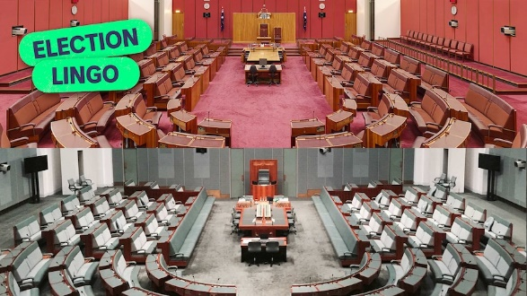
As a class, watch BTN’s Houses explainer to learn more about houses in Australian Parliament. Discuss the BTN story as a class and record the main points of the discussion. Students will then respond to the following discussion questions.

Discussion questions
- How many houses are there in the Australian government?
BTN Election Lingo – Houses
- What is another name for the Senate?
- What is another name for the House of Representatives?
- Approximately how many politicians are in the House of Representatives?
- How many senators are in the Senate?
- What do senators do?

Activity: Compare and Contrast
Students will identify similarities and differences between the Senate and the House of Representatives and organise the information they find using a T-chart. Students can use the following to guide their investigation.

 | Senate | House of Representatives
Find a photo or diagram to show what it looks like. | 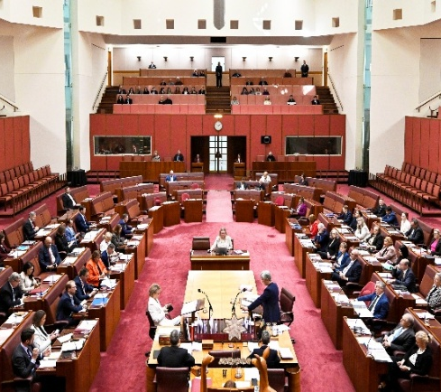 | 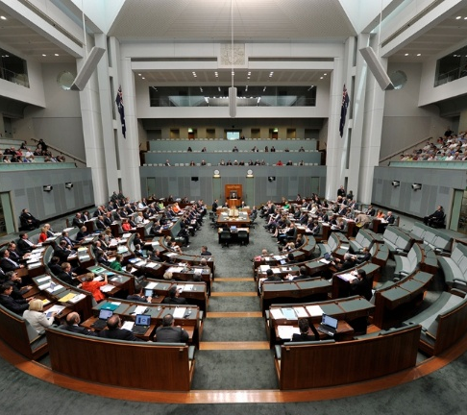
What is its colour scheme?
Does it have another name?
Main role
Number of members
Who do the members represent?
Special responsibilities of its members
Describe 3 symbols of the house (inc. photo)

List 3 similarities between the houses

What is one key difference between the houses?
2 interesting facts

Useful Websites
- The Senate – BTN
- Senators Fact Sheet – Parliamentary Education Office
- Senate – Parliamentary Education Office
- What happens in the Senate? – ABC Education
- The Australian Parliament: The Senate – ABC Education
- Make a Law: Senate (classroom activities) – Parliamentary Education Office
- Senate – Parliament of Australia
- Senators and Members – Parliament of Australia
- House of Representatives – Parliamentary Education Office

EPISODE 4
24 February 2026

KEY LEARNING
Students will learn about the signs of life that scientists look for on other planets.

CURRICULUM
Science – Year 5
The Earth is part of a system of planets orbiting around a star (the sun).

Scientific knowledge is used to solve problems and inform personal and community decisions.

Science – Years 5 & 6
With guidance, pose clarifying questions and make predictions about scientific investigations.

  - Teacher Resource

Aliens

Focus Questions
Discuss the BTN story as a class and record the main points of the discussion. Students will then respond to the following:
- Which former US President made comments about aliens recently?
- What is the region around a star where temperatures are "just right”?
- What do scientists look for when searching for life on other planets?
- Do you think there is life on other planets? In pairs, discuss whether you think there might be intelligent life in space.
- What message would you send to aliens?

Activity: See, Think and Wonder

After watching the BTN Aliens story, students will respond to the following questions:
- What did you SEE in this video?
- What did you LEARN from this story?
- What do you WONDER about this story?
- What QUESTIONS do you have about this story?

Activity: Class Discussion
Discuss the information raised in the BTN Aliens story. Record the main points of the discussion on a mind map. Here are some questions to guide the discussion:
- What words do associate with aliens?
- What do you think aliens might look like and why?
- Why are space scientists interested in finding life on other planets?
- What conditions do scientists look for when searching for life on other planets?
- What are technosignatures?
- Do you think there is life on other planets? Give reasons for your answer.

Activity: Word Cloud
Students will brainstorm a list of key words that relate to the BTN Aliens story and create a word cloud. A word cloud is a visual made up of important/key words relating to a topic. Ask students to think of words they associate with the aliens. Create a word cloud using a free online word cloud creator such as Word It Out. Working in pairs, students can clarify the meanings of the words included in their word clouds.
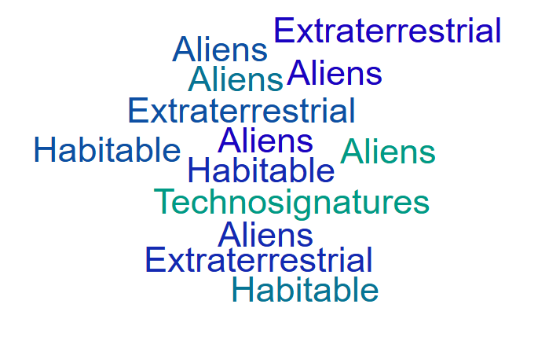

Activity: Choose a Project
Individually or in small groups, students will choose one of the following projects to work on and then present their findings to the class.


Artist’s impression of an alien
What do aliens look like? Draw your impression of an alien. What has shaped your idea of an alien’s appearance?
What does an astrobiologist do?
Find out what an astrobiologist does and produce a poster that explains their job.
Life on other planets
What kinds of planets could support alien life? Research one of the planets in the solar system. What characteristics would an extraterrestrial life form need to survive on the planet?

Science Fiction story
Write a science fiction story about aliens. Think about how you will develop alien characters and what interesting situation, problem or conflict will occur in your story.

Activity: Dig deeper with these NASA videos
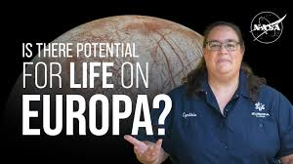 |  | 
Is there potential for life on Europa? We asked a NASA expert
Watch this NASA video to learn more!
Do aliens exist? We ask a NASA astronaut
Watch this NASA video to learn more!

Activity: Voyager’s Golden Record
Both Voyager 1 and 2 carry a Golden Record that contains sounds and images that portray life on Earth and are intended for any intelligent extraterrestrial life form who may find them. Watch the BTN Voyager Signal story to learn more, then ask students to answer the following questions:

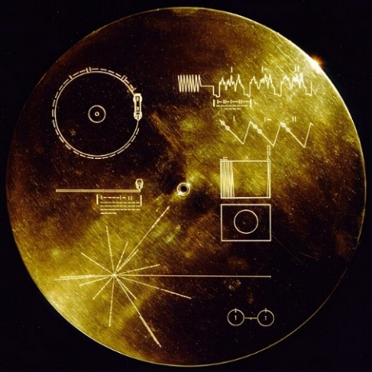
- What is the Golden Record onboard Voyager? Write a brief explanation.
- Why did scientists decide to send it into space?
- What information does it contain? Give some examples. Here is more information about what’s on the Golden Record.
- What would you include on a Golden Record? Give reasons for your answer.
- What message would you send to aliens? What would you want them to know about Earth?
- What does the Golden Record tell us about human’s curiosity and hope about finding alien life? Sounds of Earth record cover

BTN Space Science stories
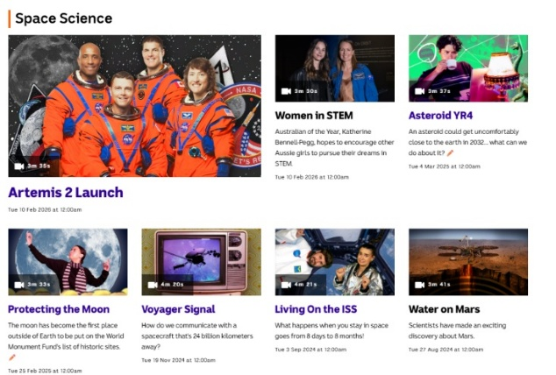
Visit BTN’s collection of stories which focus on space science and space exploration. After watching any one of the BTN videos ask students to respond to the discussion questions

To find the discussion questions and teacher resources go to the related BTN Classroom Episode and download the Episode Package.

Link to collection of BTN Space Science stories

Useful Websites
- UFOs Uncovered – BTN
- Alien Hunt – BTN
- UFO Hearing – BTN
- Can we find life? – NASA

  - Teacher Resource

BTN Transcript: Episode 4 - 24/2/2026

Hey, I'm Amelia Moseley and you're watching BTN. Thanks for hanging out with us again. Let's find out what's coming up on today's show. We take a look back at the war in Ukraine, meet Australia's youngest senator, and Wren asks the question - "Are aliens real?"

Coles Court Case

Reporter: Justina Ward

INTRO: All that soon, but first, the Australian Competition and Consumer Commission has taken Coles to court. It's accusing the supermarket giant of misleading customers with fake discounts on hundreds of products. Justina can fill you in.
OFFICER: All rise for the honourable Judge Judgington.
JUDGE: Order, order.
JUDGE: Is that my groceries order?
WHIP OFFICER: No, your honour, it's the defendant.
JUDGE: Even the chips?
OFFICER: Even the chips.
JUDGE: Oh.
Recently there's been a big court case in Australia all about, well, stuff you buy from the supermarket. More specifically, it's a court case between the ACCC and Coles.
The ACCC or The Australian Competition and Consumer Commission is an authority that makes sure companies and businesses are doing the right thing. They reckon Coles has been misleading shoppers with their "Down Down" promotion which offers customers discounted prices on everyday products. The ACCC says between this time period shoppers thought they were getting a discount on some products, but were actually paying the same amount, or sometimes more than what they originally cost. And they weren't the only ones to notice.
TIKTOK: Check Coles out, it was 12, it's now 10, from $7.50.
JUDGE: Ahh the old 'Was/Is' advertising strategy.
OFFICER: What is?
JUDGE: No 'was', 'is'. It's basically when a store advertises a sale comparing what the price 'was' to what the price 'is' now.
But if a store fakes the "was" price to make a discount look bigger than it really is. Then they're breaking Australian Consumer Law, and that's what the ACCC says Coles has done.
JUDGE: Order, order. Ok Let's get into this, who, ah, what's up first.
The ACCC found that Coles had been selling Strepsils for $5.50 for nearly 2 years. They were then bumped up to $7 for just 28 days and then included in the Down Down promotion at $6, $0.50 cents more than what it had been a month prior. The ACCC reckons hundreds of other items got a similar treatment, including cereal, dog food, coffee, toothpaste, tissues, the list goes on.
PROFESSOR JEANNIE PATERSON, UNIVERSITY OF MELBOURNE: The argument of the ACCC is that's an illusory discount, that people were misled into thinking it was a genuine discount.
Coles says it wasn't trying to mislead customers, the discounts were genuine and a good deal. It says prices are always going up and down, and it's often out of their control. They say that in these cases the price rises were a result of inflation and increased shipping prices.
JUDGE: Psst. Is it just me or does this case seem like a pretty big deal?
OFFICER: Case of the century they're calling it.
Yeah, it's not every day that a supermarket giant is taken to the Federal Court and the outcome could change how shops price their products.
ALLAN FELS, FORMER ACCC CHAIR: It effects not only Coles and Woolies, but millions of businesses who discount.
It could take weeks or even months to find out what the verdict is. So, we'll just have to wait and see what happens.
OFFICER: Your Honour. You just ate the defendant.
JUDGE: Order, order.
News Quiz

US President Donald Trump is the chair of a newly formed international body focused on the future of Gaza. What is the group called? Is it the Board of Conflict Resolution, The Board of Peace or the Board of Reconciliation? It's the Board of Peace, and it's made up of 22 founding members from different countries. They met for the first time last week in Washington, where President Trump announced billions of dollars in funding for the relief and rebuilding of Gaza, as well as more security in the area.
Is this video real or AI? It's AI. But if you thought it was real, you're not alone. All these videos were made using the latest AI generator Seedance 2.0, which was created by ByteDance, the company that owns TikTok. Seedance 2.0 was launched last week in China and has already gained a lot of attention. It's not hard to see why, but not everyone is impressed. ByteDance has been sent a cease and desist letter from Disney over copyright claims, and a lot of people in Hollywood have called on the platform to stop using established characters and real-life actors in their generated videos.
And the Louvre Museum has revealed that, over the past decade, it has been robbed of more than $16 million. Where is The Louvre? The Louvre is in Paris, France, and it's home to some of the world's most priceless treasures, none of which were stolen... this time. French authorities arrested at least nine people over an alleged ticketing scam that reportedly saw tour groups reuse museum tickets to pocket extra profits.

Ukraine Anniversary

Reporter: Michelle Wakim

INTRO: This week marks four years since Russia invaded Ukraine it's an ongoing conflict that's changed the lives of millions of people. Let's take a look back at how the war began and what life is like in Ukraine today.

MICHELLE WAKIM, REPORTER: This is Arina. She lives here in Kyiv, the capital of Ukraine. It's minus 15 degrees and the energy systems which control heat and electricity have been damaged during the war.
ARINA, TRANSLATION: It's really hard living in the cold and in the dark. I can only keep warm by putting on more clothes or by holding a cup of tea. Before, the power cuts were on schedule, but now we hardly have any electricity. I try and do my homework as fast as I can because the lamp doesn't stay charged for long.
This war started four years ago, when Russia invaded Ukraine.
JOURNALIST: Ukraine is under attack.
VLADIMIR PUTIN, RUSSIAN PRESIDENT: I decided to conduct a special military operation.
VOLODYMYR ZELENSKYY, UKRAINIAN PRESIDENT: Russia has carried out strikes on our military infrastructure and border guards We need each of you to be calm. If possible, stay at home.
But tensions between the two countries started long before 2022. Both Russia and Ukraine were a big part of the Soviet Union or USSR, which was formed in 1922. It grew to be one of the world's superpowers and a major rival to the US. But the Soviet Union didn't allow its people to have many freedoms, and over the years there were many controversies and disasters, including the world's worst ever nuclear accident at the Chernobyl power plant in Ukraine. In 1991, after nearly 70 years, the Soviet Union fell and Ukraine became an independent democracy. But some people still thought of it as a part of Russia, including Russia's President Vladimir Putin, and there's been tension between the two countries ever since.
In 2014 Russia invaded Ukraine and took control of the Crimean Peninsula. Then, in the weeks leading up to February 2022, Russian troops had been gathering around the border between Russia and Ukraine. But to many, what happened still came as a huge shock.
Many people didn't think the war would last this long, and Russia, which had a much bigger army, would quickly take control of the Ukraine.
JOURNALIST: Big explosions taking place.
But Ukraine fought back, with financial support from other countries and is still continuing to fight.
UKRAINIAN PERSON, TRANSLATION: The missiles are flying at us again. Thank God, there weren't that many drones today. The missiles were scary.
More than 6 million people have left their homes and become refugees, settling in other countries, like Australia. Meanwhile, more than a million people are thought to have been killed on both sides, and others, like Nazar, have been badly injured.
NAZAR, TRANSLATION: My friend and I went for a walk after school. He found some kind of mine, or something like that, and threw it at our feet. No one knew that the area was mined.
As a result of the explosion, Nazar lost part of his foot.
NAZAR, TRANSLATION: I love playing football. We used to play all the time.
At the moment, Russia occupies about a fifth of Ukrainian territory, but it's moving very slowly and the war comes at a huge cost to the country and the people. Ukraine, on the other hand, has lost ground over the past couple of years. It still holds a small section on Russian territory, but its leaders are calling for more support from other countries.
Over the past 12 months, US President Donald Trump met with both Vladmir Putin and Volodymyr Zelenskyy to try and negotiate a peace deal. The Kremlin wants Ukraine to hand over the rest of this region, but Ukraine has ruled this out, saying it doesn't want to give up parts of its country. Ukraine also wants a guarantee from the US that it would be protected if something like this happens again and a date for when the country would be allowed to join the European Union. But, so far, a deal hasn't been made.
As for the people living in Ukraine, they're hopeful an end to the war is in sight.
UKRAINIAN PERSON, TRANSLATION: In principle, probably every Ukrainian, when reading about the negotiations, has some hope. I really want it all to end as soon as possible.
ARINA, TRANSLATION: All kids want just one thing: for the war to end.

Upsetting News
AMELIA: If you're worried about that story or anything else you've seen in the news, make sure to talk to someone about it. We've also put together some resources on our website on how to deal with upsetting news, so check it out whenever you like.
Young Senator

Reporter: Michelle Wakim

INTRO: Last year Senator Charlotte Walker made history as the youngest person ever elected to the Senate. Michelle caught up with the senator to find out what her job involves and what it's like being the youngest person elected to parliament.

MICHELLE WAKIM, REPORTER: We're recording.

CHARLOTTE WALKER, SENATOR: Want me to go?

MICHELLE: Go.

SENATOR WALKER: My name is Charlotte. I am 21 and a half years old, and I am a Senator for South Australia.

Senator Charlotte Walker isn't just a young politician. She's actually made history as the youngest senator to be elected to Australian parliament.

SENATOR WALKER: So, I actually turned 21 on election day. It was a pretty surreal day but, honestly, campaigning is one of my favourite things, so I didn't mind spending my birthday doing that.

Senator Walker grew up in regional South Australia, in a town called Yankalilla.

SENATOR WALKER: It's absolutely beautiful. I'm really involved in my community from a young age, played lots of sport. I really liked growing up in a small town, you know, you know everyone. But I also saw things like a lot of domestic violence, there wasn't access to resources.

After she turned 18, she started volunteering and got a job with her local MP, where she worked her way up to become the state president of Young Labor, so when the opportunity came up to run in the 2025 election, she felt ready to give it a crack.

SENATOR WALKER: I said yes and that set me off on this pretty wild journey that I'm on.

SENATOR WALKER, MAIDEN SPEECH: I am so proud and genuinely humbled to be able to bring a new, young voice to the Albanese Labor government.

POLITICIAN: Hear, hear.

SENATOR WALKER, MAIDEN SPEECH: I am the first parliamentarian born in this millennia.

Senator Walker is one of 76 senators in Australia, and senators sit, well, you guessed it, in the Senate, also known as the upper house. The Senate is one of two parts of our government; the other is the House of Representatives, or the lower house. When laws are being made, they generally start here, where they are debated and voted on. But before they're allowed to become laws, they have to go through the Senate, which has its own debate and vote.

What's the day in the life of a senator in Australia?

SENATOR WALKER: If it is a sitting week, I'm usually getting into parliament pretty early. A group of us exercise, we start at 6:15am, so I usually get in about ten to six, so I have time to eat breakfast. Usually, I've got a breakfast function of some sort. The Senate starts at a different time depending on the day, but usually it will start, it's either 9am, 10am or 12pm. After the morning commitment, it's straight into meetings and committee meetings. Got Question Time at 2pm, that doesn't change, 2pm every day I go to Question Time, in there for the full hour.

Is there anyone who helps you learn about all of this stuff when you get into politics?

SENATOR WALKER: We all got - all the new senators - got flown into Canberra for Senate school, so it's where some of the... which is really funny - someone that graduated school only a few years ago.

I like it, Senate school!

SENATOR WALKER: But we have a number of really amazing public servants that make the Senate run. A lot of them have been there for a long time, and they know everything there is to know.

The median age of politicians in Australia is 50.

SENATOR WALKER: Yeah.

How does it feel to be the youngest person in the room?

SENATOR WALKER: It's pretty amazing. A lot of people from across the political spectrum, when I got elected, reached out to me from different political parties and said, 'you know, we don't agree on these policy positions, but I'm so glad that there's a young person here and you've got a young perspective in the parliament'. I think bringing that perspective into policy making is really important. I also think we bring, you know, we bring a new approach, not afraid to do things a bit differently.

SENATOR WALKER: Got it all?

Yeah, great.

Aliens

Reporter: Wren Gillett

INTRO: Former US President Barack Obama recently sparked a wave of online debate over comments he made about aliens. In fact, some people thought he was confirming their existence. Obama's since clarified that he has no extraterrestrial evidence, but it got Wren and a lot of people asking, are aliens real?

WREN GILLETT, REPORTER: Alright, here it is, proof that there is life out there.
BRIAN TYLER COHEN, PODCASTER: Are aliens real?
BARACK OBAMA, FORMER US PRESIDENT: They're real.
WREN: See. Aliens are real, people. And I bet they're being kept at Area 51.
Ah, you might want to play the rest of the clip
OBAMA: But I haven't seen them and they're not being kept in ahh, where is it?
BRIAN: Area 51?
OBAMA: Area 51.
WREN: Alright well, maybe I jumped the gun a little.
Yeah, don't worry you're not the only one. Recently former US president, Barack Obama, went on a podcast where he stated that he believes aliens are real. While he was quick to clarify that even if aliens were real, we probably haven't been visited by any, it was enough to send the internet into a frenzy. Over the years there have been lots of reports of alien encounters and sightings of unidentified flying objects or unidentified aerial phenomena, as the US Government insists, we call them. Speaking of, there have been big investigations in the US into some of these sightings. But while some remain a mystery, most of them have debunked or explained. Though that doesn't mean there isn't a serious search going on for life beyond Earth.
CHENOA TREMBLAY, RADIO ASTRONOMER: The work that I do is looking for life off the planet.
This is Chenoa, she's a radio astronomer and right now, she's looking for aliens.
CHENOA: I study SETI, the search for extraterrestrial intelligence, which is looking for signs of life on a planet that's not Earth.
Cool job right? She says that one way to look for aliens is to search for exoplanets, planets that orbit other stars.
CHENOA: We have discovered almost 6,000 exoplanets around stars, and so we know, okay planets exist, we have lots of planets, so what about life?
To narrow the search, scientists look for planets in...
WREN: The Goldilocks zone.
That means the planet is in just the right spot in relation to its star, where it's not too hot or too cold for liquid water to exist. This would make it...
WREN: Just right for life to exist.
Yeah, from there, scientists start looking for chemical clues that could hint at life, gases like water vapour, methane, or carbon dioxide in a planet's atmosphere. But Chenoa says another way we might be able to find aliens is to look for technosignatures. Basically, evidence of technology created by intelligent life beyond Earth.
CHENOA: This could be somebody has a big telescope on their surface, and they've decided to send out a beacon that's flashing regularly, like we're here, we're here. You know, type of thing.
While Chenoa and her team haven't found any technosignatures yet, it's hoped that as our own technology improves and we continue to explore more of the universe, we just might find something.
WREN: Okay, so, are aliens real?
CHENOA: I like to believe they are otherwise I wouldn't be looking for them you know. The universe is so big, and it's really hard to believe that Earth is completely stand alone, that life doesn't exist anywhere else.

Sport

The Milano-Cortina Winter Olympics officially wrapped up on Sunday, and it was a historic finish. Norway came out on top, breaking its own record for the most gold medals won by a nation at a single Winter Olympics. Scooting down the list, and Australia came 14th overall, winning the most gold medals and total medals in our Winter Olympics history, making it Australia's most successful Winter Olympics ever.

Danielle Scott added the sixth medal to our tally, taking out silver in the women's aerials. As for our youngest Aussie athlete, Indra Brown, she didn't manage to snatch a medal this time but made a very strong debut, finishing in fifth place in the freeski halfpipe.

Oh, and a dog called Nazgul crashed the women's cross country skiing final. While he also missed out on a medal - because he's a dog - Nazgul did win the title of being a very good doggy. Phwoar, I wonder if we can top all this in 2030.

Kosciuszko Kid

Rookie Reporter: Ashton

INTRO: Finally today, we're going to meet Ashton, who recently reached the summit of Mount Kosciuszko, the tallest mountain in Australia. He took on the challenge to raise awareness for people living with cerebral palsy. Take a look.

ASHTON: Hi BTN, I'm Ashton and I'm 15 years old. I have an older brother named Nate and I also have younger sister named Delaney and I also have a cute dog named Luna. My favourite hobbies are athletics, playing footy, soccer, hanging out with family and I love watching the NRL and my favourite team is the Newcastle Knights, and I've just climbed Mount Kosciuszko.

I wanted to do the Krazy Kosci Klimb to raise money for Cerebral Palsy Alliance and also increase awareness of people living with cerebral palsy. So far, I've raised over $36,000. Cerebral palsy is a lifelong condition that affects movement muscle tone and posture. It can range from mild to more severe and can also affect speech, swallowing and vision. Having cerebral palsy can be hard at times. One side of my body doesn't work as well as the other side. This makes things like running, swimming and preparing food a bit tricky but I always find a way to do everything.

Climbing Mount Kosciuszko was amazing.

SUPPORTERS: Team Ashton! How are you going, Ashton?
ASHTON: Good!

EMINEM: I'm Slim Shady, yes, I'm the real Shady # All you other Slim Shadies are just imitating...

I was inspired to have a slim shady theme because I love his music and it inspires me. Look, if you had one shot, one opportunity, to seize everything you ever wanted, one moment, would you capture it or let it slip?

SUPPORTER: Slim! Slim! Can I have your autograph?
ASHTON: Yeah, sure!

When I was climbing, I felt good, but my leg got a bit sore. Luckily, I had an amazing team with me to help. The weather was really nice. It was sunny but not too hot. It was pretty windy at times.

ASHTON: Made it to the top of Mount Kosciuszko!
(CHEERING)

When I got to the top, I was so happy and proud of myself that I made it to the top of Australia. The view was amazing but then I realised I had to walk all the way back.

EMINEM: Lose yourself in the music, the moment, you own it, you better never let it go, you only get one shot... Do not miss your chance to blow, this opportunity comes once in a lifetime. You better lose yourself in the music...

The Krazy Kosci Klimb was a fantastic experience not just for me, but everyone involved. If anyone watching has a disability or thinks they can't achieve or do anything just know you can do anything you set your mind to, man.
Closer

Amazing stuff, Ashton. Well, that's all we've got for now, but we'll be back to do it all again next week. And if you just can't wait until then, you can catch Newsbreak every weeknight right here in the studio. There's BTN High for you high schoolers, and you can check out our website. Have the best week and I'll see you really soon. Bye!

