KEY LEARNING
Students will view a range of BTN stories and use comprehension skills to respond to a series of focus questions.

CURRICULUM
English – Year 4
Use comprehension strategies to build literal and inferred meaning to expand content knowledge, integrating and linking ideas and analysing and evaluating texts.

English – Year 5
Use comprehension strategies to analyse information, integrating and linking ideas from a variety of print and digital sources.

English – Year 6
Use comprehension strategies to interpret and analyse information and ideas, comparing content from a variety of textual sources including media and digital texts.

English – Year 7
Use comprehension strategies to interpret, analyse and synthesise ideas and information, critiquing ideas and issues from a variety of textual sources.
  - Teacher Resource

Focus Questions

History of AIS
- Discuss the BTN History of the AIS story as a class.
- How many gold medals did Australia win at the 1976 Olympic Games?
- What did experts recommend to the Australian government after the 1976 Montreal Olympic Games?
- What does AIS stand for?
- What year did the AIS open?
- How many gold medals did Australia win at the 1984 Los Angeles Olympic Games?
- How many sports did the AIS offer an intake for when it first opened?
- Why has the AIS had lots of international visitors since it began?
- What type of support does the AIS offer its athletes? Name two.
- What do you understand more clearly since watching the BTN story?

AIS Athletes
- Retell the BTN AIS Athletes story to another student.
- Which event will Roeger compete in at the Tokyo Paralympic Games?
- How many kilometres does Roeger usually run during training?
- What medal did Roeger win at the Rio Paralympic Games?
- What advice does Roeger give to anyone aspiring to be a Paralympian or Olympian?
- What age did Shaneice start playing basketball?
- Describe what it is like living as an athlete at the AIS.
- What type of support staff help athletes at the AIS?
  - Doctors
  - Physios
  - Psychologists
  - All of the Above
- What are Shaneice’s goals?
- What advice does Shaneice give?

Sports Science
- Discuss the BTN story in pairs and record the main points of your discussion.
- Where can you see an example of biomechanics at the AIS?
- What does a dietitian do?
- Describe the sprint test that Amelia does in the BTN story.
- How fast does Amelia run in the 20-metre sprint test?
- What is the vertical jump test?
- How high can an elite female basketballer normally jump?
- What is the purpose of cold water immersion?
- Test yourself and your classmates by doing your own sprint test or vertical jump test.
- Think of three questions you have about sports science. Share them with the class.

Artistic Swimmers
- Briefly summarise the Artistic Swimmers story.
- What skills do artistic swimmers need? Name two.
- Complete the following. Artistic swimming is often described as a mixture between ____________ and _______________.
- The aim of artistic swimming is to show that it is easy. True or false?
- What two sports did Amie compete in before she became an artistic swimmer?
- Where has the team been living since January 2021?
- What is the ‘eggbeater’ move? Describe.
- Where will the Australian artistic swimming team be competing next?
- What words would you use to describe artistic swimming?
- What did you learn watching this story?

KEY LEARNING
Students will learn about the history of the Australian Institute of Sport. Students will investigate an aspect of sports science.
CURRICULUM
Science – Year 5
Scientific knowledge is used to solve problems and inform personal and community decisions.

Science – Year 6
Scientific knowledge is used to solve problems and inform personal and community decisions.

Science – Year 7
People use science understanding and skills in their occupations and these have influenced the development of practices in areas of human activity.

Health & Physical Education – Years 3 & 4
Identify and practise strategies to promote health, safety and wellbeing.

Health & Physical Education – Years 5 & 6
Plan and practise strategies to promote health, safety and wellbeing.

Propose and apply movement concepts and strategies with and without equipment.

Health & Physical Education – Years 7 & 8
Investigate and select strategies to promote health, safety and wellbeing.

Practise, apply and transfer movement concepts and strategies with and without equipment.

  - Teacher Resource

AIS

Activity: Class Discussion
Discuss the information raised in the BTN Australian Institute of Sport (AIS) Special story. Ask students to record what they know and learnt about the AIS on a mind map. What questions do students have? Use the following questions to guide discussion:

- What do you know about the AIS?
- What year was the AIS opened?
- Why was the AIS created?
- How does the AIS help Australian athletes?
- What is sports science?
- How is sports science used to help athletes at the AIS? Give one example.

Activity: Mind Map
Ask students to think of words they associate with the term SPORTS SCIENCE. Record students’ ideas on a mind map with the word SPORTS SCIENCE in the middle. Below are some suggested words.
PERFORMANCE | SPORT SCIENTIST | PHYSIOTHERAPY
ACCELERATION | BIOMECHANICS | CARBOHYDRATE
NUTRITIONIST | PHYSIOLOGIST | PHYSIOTHERAPIST

Ask students to clarify their understanding of the key words by writing down what they think the word means. Swap definitions with a partner and ask them to add to or change the definition. Check them using a dictionary or other source.

Further investigation: Tricky words
Students will choose additional keywords and terms to add to their class glossary that are tricky. For example, resting metabolic rate, resistance training, aerobic, body mass index or cardiac output. Students will find a definition and explain to their classmates what the keywords mean.

Activity: KWLH
Hold a class discussion about the information raised in the BTN Australian Institute of Sport Special. What questions were raised in the discussion and what are the gaps in their knowledge? The following KWLH organiser provides students with a framework to explore their knowledge on this topic and consider what they would like to know and learn.

What do I know? | What do I want to know? | What have I learnt? | How will I find out?

Research questions for Inquiry
- What is the role of the Institute of Sport? Create a fact sheet highlighting your findings.
- Why was the Institute of sport created? Explore the history of the Australian Institute of Sport using a timeline to record your findings.
- What is sports science? Come up with a class definition.
- What are some of the key events in the history of the Australian Institute of Sport? Write a summary for one key event, which answers the 5 W’s – Who, What, Where, When and Why?
- Who works at the AIS? Choose one role to explore in more detail. For example, physiotherapist, physiologist, psychologist, strengthening auditioning coaches, bio mechanist skill acquisition specialists or sports engineers.
- What sports are offered at the AIS? Choose one to explore in more detail and present your findings in an interesting way.

Further investigation – Q&A
Come up with some questions you think sports scientists ask and solve. Share your questions with the class and organise them into common themes. Make a list of questions that you would like to ask a sports scientist. Use the internet to find answers to your questions. Compare your questions and answers with your classmates.

Activity: Biography
Students will choose an elite Australian athlete and write a biography about them. Ask students to think about the sort of information included in a biography. What does a biography tell us about a person? Using the Biography Organiser template (at the end of this activity), students will find and record information about the person they have chosen.

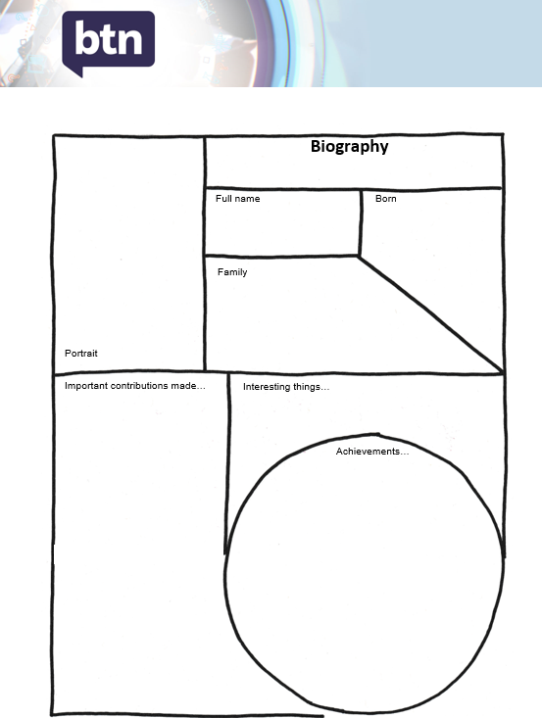
Some possible areas of research include:
- Where and when was the person born?
- Describe their family life growing up.
- What are some of their achievements? Choose one to explore in more detail.
- What are some of the challenges they have faced?
- Once students have completed their research ask them to present their findings in an interesting way.
- Give a presentation on the individual’s achievements.
- Make a “Did you know?” for other students.
- Write a letter thanking them for their achievements and how it has changed Australia.

Activity: Olympic Sports
Students will create a report about their favourite Olympic Games sport. They can develop their own key questions to investigate or respond to one or more of the questions below.

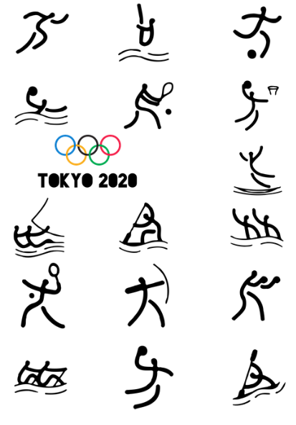
- Why is it your favourite Olympic Games sport?
- Give a brief summary of the sport.
- Research the history of the sport at the Olympic Games.
- What equipment is needed to play the sport?
- Who won gold in the sport at the last Olympic Games? Imagine you could interview the sportsperson. Write a list of questions to ask the person.
- Write instructions explaining how to play the sport. Play the sport with your classmates using your instructions.

Activity: BTN Story
Watch the BTN Sports Science story to learn more about what it takes to become an Olympic athlete. Students will then respond to the following discussion questions.

- Explain the following statement: `To get that extra one per cent that could mean gold, Aussie Olympians are turning to science.’
- How are GPS units being used to help hockey players?
- How far do hockey players run in a 70-minute game?
- How does this compare to AFL players?
- How does the information gathered help them?
- Why is heat stress a problem for the athletes at the upcoming Olympics?
- What is the normal temperature of the human body?
- How does a human body respond to an increase in body temperature?
- Describe how the capsule-like thermometer works.
- Do you think using science to help sporting performance is fair? Explain your answer.

Activity: BTN Story
Watch the BTN Olympic History story to travel back in time and see where the Olympics first started. Students will then respond to the following discussion questions.

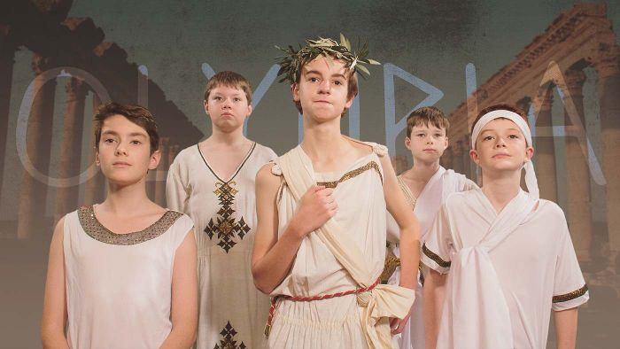
- Discuss the story in pairs and record your responses.
- When were the first Olympic Games held?
- Which god were the Olympic Games dedicated to?
- The only people who could compete were...
- Give an example of a sport included in the ancient Olympics.
- There was only one winner of the ancient Olympics. True or false?
- What did the winner receive?
- In which year was the first modern Olympic Games held?
- How are the ancient and modern Olympics similar?
- Name three facts you learnt watching the BTN Olympic History story.

Activity: Choose a project
Individually or in small groups, students will choose one of the following projects to work on and then present their findings to the class.
Classroom sports science
Create your own sports science test in the classroom! Create your own tests to test your reflexes, reaction time, balance and muscle power. What equipment will you need? Record your results.

Nutrition
Research and prepare a nutritious meal plan for an elite athlete. Check out these nutritious and tasty recipes on the AIS website.

Test your athletic ability.
Test yourself and your classmates by doing your own sprint test or vertical jump test. Compare your results! Did you beat Amelia?

Test your classmates!
Prepare a quiz about the Olympic and Paralympic Games and then test your classmate’s knowledge. Alternatively, create a word search.

Useful Websites
- Australian Institute of Sport
- Australian Olympic Team – Tokyo 2020
- Michael Roeger – Paralympics Australia
- Shaneice Swain – FIBA Basketball
- Sports Science – BTN
- Olympic Doubts – BTN
- Brisbane Olympic Bid – BTN
- Breakdancing Olympic Sport – BTN
- Surfing Masterclass – BTN

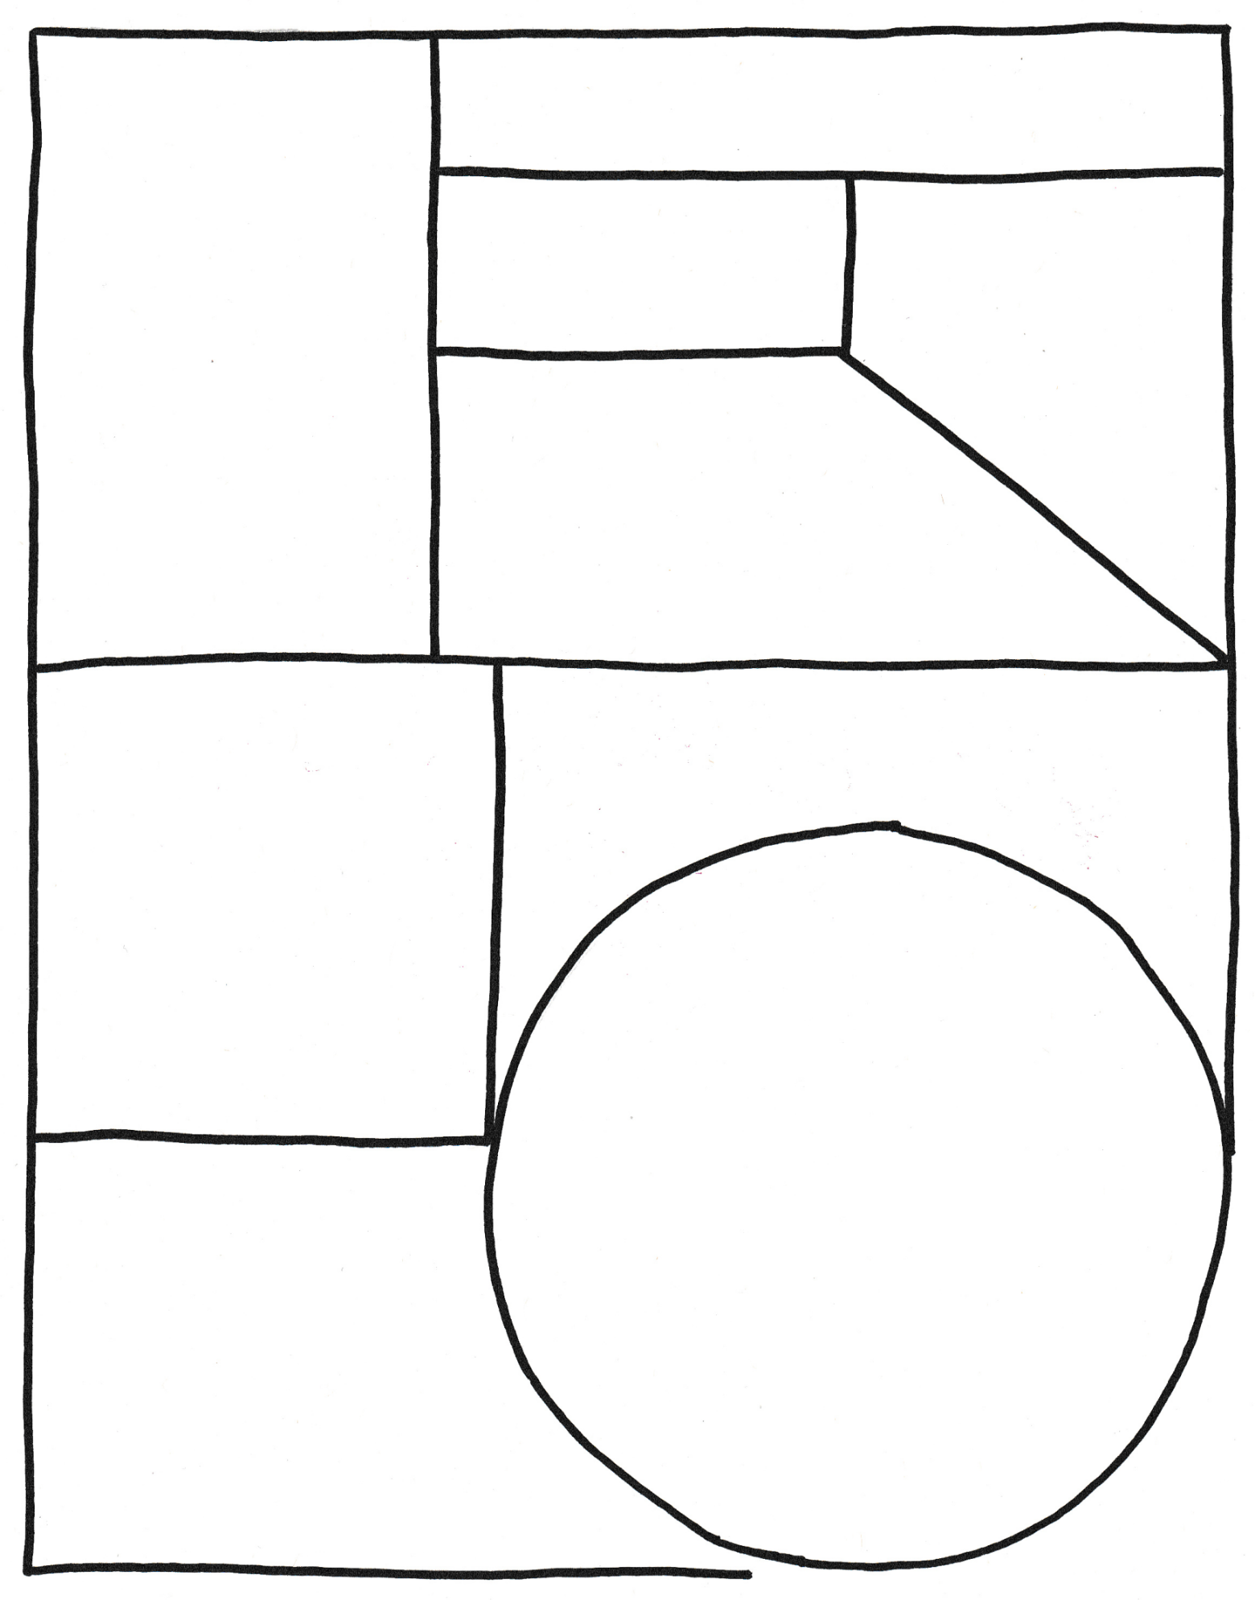
Family

Full name

Portrait

Important contributions made…

Born

Achievements…

Interesting things…

Biography

