
EPISODE 29
21 October 2025

KEY LEARNING
Students will explore issues surrounding digital media. Students will use research skills and digital literacy to hunt for accurate and trustworthy information online.

CURRICULUM
English – Year 6 (v9)
Examine texts including media texts that represent ideas and events and identify how they reflect the context in which they were created.

English – Year 7 (v9)
Explain the effect of current technology on reading, creating and responding to texts including media texts.

Media Arts – Years 5-6 (v9)
Explore ways that media languages and media technologies are used in media arts works and practices across cultures, times, places and/or other contexts.

Develop media production skills to communicate ideas, perspectives and/or meaning through manipulation of media languages, including images, sounds, texts and/or interactive elements, and media technologies.

  - Teacher Resource

Media Literacy

Focus Questions
Discuss the BTN Media Literacy Special as a class and record the main points of the discussion. Students will then respond to the following:

Online Research
- How do you find information online?
- The AI Overview in a Google search is always reliable. True or false?
- What is the difference between a primary, secondary and tertiary source? Give examples.
- How can you tell if an online image is fake?
- What is the purpose of a reverse image search?

Algorithms Explained
- What is an algorithm? Find a simple definition.
- What are 3 examples of algorithms in real life?
- Which of these use algorithms?
  - Search engines
  - Streaming services
  - Social media platforms
  - All of the above
- What is an echo chamber?
- What are the negative effects of online algorithms?

Slopaganda
- Summarise the BTN Slopaganda story.
- What is slopaganda? Find a definition.
- What is an example of slopaganda?
- How is slopaganda made?
- How is slopaganda similar and different to propaganda?

Independent Media
- Independent media is not influenced by government or commercial companies. True or false?
- Which 4 companies make up 87% of Australia’s broadcast TV market?
- Where do 1 in 4 Australians get their news from?
- Why is independent media important?
- If you were to write an online news article about what’s happening in your school community what would it be about?

Her Way
- What platforms does Abbie use to share Her Way news?
- What inspired Abbie to report on women's sport?
- Which sportswoman was Abbie’s favourite to interview?
- What challenges has Abbie faced being a young journalist?
- What advice does Abbie give to young people wanting to get involved in the media?

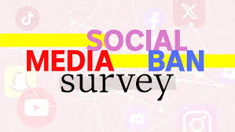

We’ve started an Australia-wide survey to find out what kids think about the social media ban.
Do the survey here.

Activity: Digital Scavenger Hunt
Students will take part in a digital scavenger hunt using research skills and digital literacy to hunt for accurate and trustworthy information. The hunt will require students to gather information from websites to find answers to a set of unusual, curious and challenging questions.

By the end of this activity students will be able to:
- Use keywords to locate information online
- Evaluate the reliability and accuracy of online content
- Cite where they found their information
- Explain how they verified their answer

Before starting this activity, hold a class discussion about good online search habits. Use the following to guide your discussion.
- What are some good online research techniques?
  - Place quotation marks around a specific phrase to narrow your search results
  - Use filters to help locate specific information
  - Check ‘About pages’ for reliability
- What makes a website trustworthy?

Scavenger Hunt Activity
Below is a list of questions for students to find answers to during their digital scavenger hunt. Students will record their answers, the website link (URL) and a short answer on how they verified each answer.

Questions to answer on your Scavenger Hunt | URL | Short Answer | How did you verify your answer?
- Is it illegal to fly a kite in Australia?
- What is the population of Australia?
- Does melting sea ice cause sea levels to rise?
- When did Australia first establish a research base in Antarctica?
- How many countries use the Union Jack on their flag?
- Why do cockatoos dance?
- What day is bin day if I live on Daltons Road in Warrnambool?
- When did the Industrial Revolution start?
- What's the cool thing about elephants, according to the founder of YouTube?

Compare answers as a class
- Find out which questions were easy, and which were the hardest to find answers. Did any of the questions require fact checking?
- Highlight examples of credible versus unreliable sources.

Reflection questions
- What made some websites more trustworthy than others?
- What helped you find reliable answers the fastest?
- Did you find any misleading or fake information?

Activity: Source Checker Game
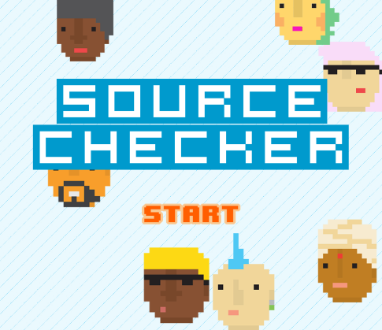
Do your students know what news sources are? Can they spot a reliable one in a news story? Test your student’s re-source-fulness in ABC Education’s source checker quiz. INTERACTIVE: Source Checker

The Sources activity invites students to apply the skills and knowledge that they have acquired from the resources. They can test their ability to discern between reliable and unreliable sources of information and come to conclusions about the currency and accuracy of information presented and the purpose of the written piece.

Activity: Class Discussion - Slopaganda
After watching the Slopaganda story hold a class discussion, using the following questions to start the discussion:

- What is `slopaganda’?
- Which two words does it combine?
- What examples of slopaganda were shown in the BTN story?
- What is the purpose of slopaganda? What is it designed to do?
- What sort of photos or videos are used in slopaganda to grab attention?
- What questions do you have about slopaganda?

Activity: Key Words
Students will brainstorm a list of key words that relate to the BTN Slopaganda story. Here are some words to get them started.
Misleading

Influencer
Confirmation Bias

Algorithm

Artificial Intelligence

Propaganda

Biased

AI Slop

Ask students to write what they think is the meaning of each word (including unfamiliar words). They will swap definitions with a partner and ask them to add to or change the definition. Check these against the dictionary definition.

Further investigation
- Why do some people create slopaganda?
- What role does social media play in spreading slopaganda?
- What influence can AI have on elections? How can it impact democracy?
- Do you think slopaganda can be dangerous? Why or why not?
- How can we spot slopaganda? Write a checklist.

Watch these BTN stories to learn more about how AI was used during the US Presidential election.

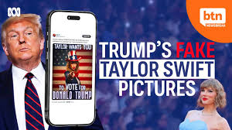  BTN Newsbreak |   BTN AI and the News

Activity: Real or AI?
Can your students tell the difference between a real and AI image? The answers are on the following page.

 | 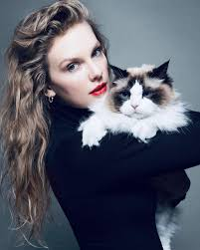
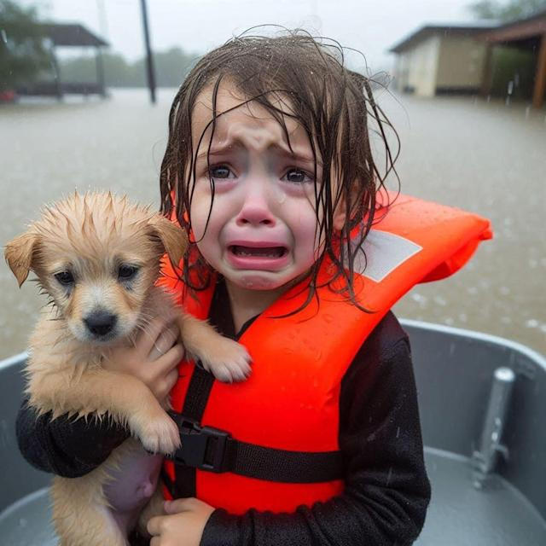 | 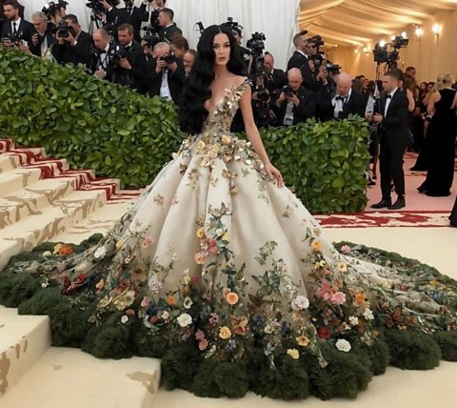
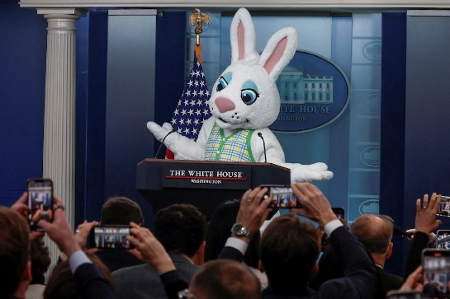 | 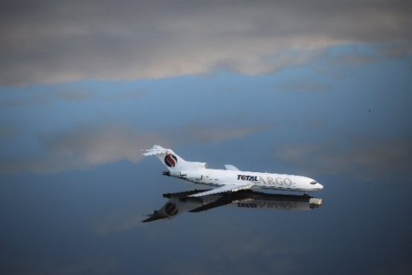

Answers to questions – Real or AI?
Pope Francis – AI source
Taylor Swift – real source
Girl with puppy – AI source
Katy Perry – AI source
Easter Bunny – real source
Plane – real source

Watch this ABC News video to learn how to verify if an image is fake or not doing a reverse image search.

Activity: Spotting Fake Images

How can you spot fake images? This all-in-one ABC Education interactive resource for teachers is a great introduction to the topic.

As a teacher-led presentation, you can step the class through key concepts or allow students to access some sections on their own device for follow-up tasks.

Activity: Independent Media

Hold a class discussion about the BTN Independent Media story. Clarify students’ understanding of what independent media is and come up with a class definition.

Below are some questions to guide discussion about the topic.
Choose a news report to analyse
Who created the news report?
Who is the intended audience?
Is the report fair and balanced? Why or why not?
Find two other news reports on the same topic and compare them.
- Where do you get your news from?
- How has social media changed the way we get news?
- What is independent media?
- What impact has social media had on independent journalism?
- Is independent media important? Why or why not?
- How can we tell if a news story is trustworthy or biased?

What is the role of media in our democracy? Watch this ABC Education video to learn more about why an independent and free media is essential to democracy.

Activity: Make a Magazine
Students will create a magazine about a topic of their choose or alternatively your class can collaborate to produce a magazine about a topic you are already studying. Use the following to guide students when making their magazine.

1. Explore
Make a list of topics that you are interested in, it could be something you know a lot about already or a topic you’re interested in but would like to learn more. Visit the BTN website to search for topics that you’re interested in, click on the search button to find a range of stories.

2. Plan
Write a plan for your magazine:
- What is your magazine about? Write a summary.
- What is your magazine called?
- Who is your target audience?
- What will your magazine include? For example, feature report, interviews, surveys, columns, games, letter from the editor, persuasive text, articles.

If you are collaborating and making a class magazine, assign different roles and responsibilities to each student.

3. Research
Spend time researching your topic or area of interest. Collect and record information from a wide variety of primary and secondary sources. Will you interview people to include in your magazine? What questions will you ask? How will you record your interview?
- Determine who you will interview, for example, family, friends, a teacher or expert.
- Prepare for your interview by writing some questions that you will ask your interviewee. Write open-ended questions. Open-ended questions have no right or wrong answer and can’t be answered with a ‘yes’ or ‘no’.

4. Create
Start to write content for your magazine. If you are writing an article about an issue, consider whether you need to present one view or both sides of the issue. Ask another classmate to read what you have written, checking for mistakes and incorrect grammar.
- Decide whether your magazine will be in print format or digital.
- Create a design sketch before making your magazine. Think about background colours, font type and size and headings. Develop graphics to use throughout your magazine to support your text.
- If you are publishing your magazine you will need to take into consideration copyright on images you use. Consider using Canva to make your magazine which includes many templates.

If you could make your own online magazine, what would it be about?
- What features do magazines have? Brainstorm as a class, cover, table of contents, feature articles, columns, advertisements, headlines, images,
- What’s the difference between printed and online magazines?

Activity: Make your own news report
Students will have a go at making a news report. They’ll produce a short video about an issue they feel strongly about or someone doing something interesting in their community. Alternatively, they could research an issue that affects their local community. Use this checklist to decide on a story to cover.

- Choose someone in your community that you want to feature in your news report. Watch some of BTN’s Rookie Reports for inspiration.
- Write your story – Find out what makes a good feature story here. Celebrate the persons’ strengths in your writing. Share your story with the class.
- Plan your report – Story board your news report on paper.
- Make your news report – Check out the videos below for a range of tips on how to make a news report.

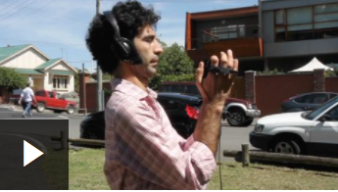  Recording great audio | 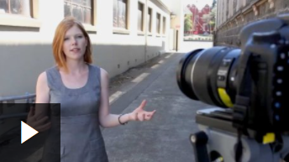  Shooting the story | 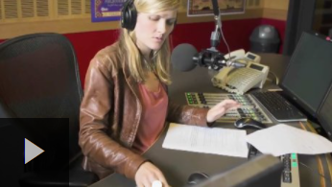  Conducting interviews

Activity: News in My Neighbourhood
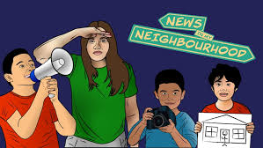
ABC Education is running the News in My Neighbourhood competition which invites students to create and produce creative responses to a series of news and information challenges? Find out how to enter here. Please note, submissions close 23 November 2025.

Useful Websites
- Conducting research online – NSW Government
- Interactive: Source Checker – ABC Education
- Social Media Algorithms Explained – TEDEd
- AI and the News – BTN
- Interactive lesson: Spotting fake images and videos – ABC Education
- Fake news and misinformation – eSafety Commissioner
- Fake News – eSafety Commissioner
- Latest Rookie Reports – BTN
- History of Newspapers – BTN
- What is the role of media in our democracy? – ABC Education
- Media Literacy 2024 – BTN

  - Teacher Resource

Super Quiz Questions

These quiz questions are to be used in conjunction with viewing BTN’s Media Literacy Special 2025 program. Pause the video after each question to allow time for students to answer.

QUESTIONS | Your answers
- Which one of these URLs would link you to the website of Australia’s federal education department?
A. www.education.gov.au

B. www.education.gov

C. www.education.com.au

D. www.education.nsw.gov.au

- Is this YouTube video a primary or a secondary source?
A. Primary Source
B. Secondary Source

- Is Wikipedia a primary, secondary or a tertiary source?
A. Primary Source
B. Secondary Source
C. Tertiary Source

- Is this article an example of…
A. Disinformation
B. News
C. Satire

- Did the US President really post this meme?
A. Yes
B. No

- Do you think this TikTok video is reliable or unreliable?
A. Reliable
B. Unreliable

- Is this Instagram picture real or fake?
A. Real
B. Fake

- Is this image real or AI?
A. Real
B. AI

- Are these adorable bunnies really bouncing on a trampoline?
A. Yes
B. No

TOTAL SCORE:
Answers

- www.education.gov.au
- Primary source
- Tertiary source
- Satire
- Yes
- Unreliable
- Fake
- Real
- No

  - Teacher Resource

BTN Transcript: Episode 29 – 21/10/2025

Yaama. I'm Jack Evans and you're watching BTN. This week we're bringing you a special episode for Media Literacy Week, and we're going to head online to find out all about digital media and how to make the most of it. Here's what's coming up. We'll learn about the algorithm, serve up some 'slopaganda', and meet some young Aussies making their own media. We'll also test your knowledge with a digital media super quiz.

Online Research

Reporter: Joe Baronio

INTRO: But first, we're going on a scavenger hunt. Well, sort of. We sent Joe to guide a group of students as they navigate the internet to answer a series of questions. It sounds simple enough, but will AI and search engines lead them to the truth or steer them off course? Let's find out.

JOE: Alright. Welcome, everybody. What we're going to be doing today is a digital scavenger hunt. So what we've got, we have a list of 11 questions here, but there are two pictures as well. One here is, "Is this image real?" That's this one of Donald Trump. And, "Who is this?" is the second image. And all you have to do is research these questions and find the answers. Sounds pretty simple, doesn't it?
STUDENTS: Yep.
JOE: Great. Alright, let's get to it!
The obvious first step is to open up a search engine and, well, search. Easy. Although research has found that big search engines, including Google and Bing, often promote web pages based on keywords and monetisation or sponsorship over the quality of what they actually say. So you might want to check a few of the search results, not just what pops up first.
JOE: What were you using most to find the answers for these questions?
STUDENT: Generally, just Google, like we'd look something up and then we'd scroll down until we found a website that looked reliable.
JOE: Were there answers at the top that weren't quite right?
STUDENT: The AI Overview. It's useful for some things, like simpler statistics, but it's not always trustworthy, so we'd prefer to find actual websites.
Yeah, AI has become a massive part of online research now. In fact, people are now relying so heavily on AI summaries that some of the biggest news websites in the world have recorded a huge decline in people viewing their websites.
But AI summaries and chatbots like ChatGPT don't always get it right.
JOE: Did you get any false or inaccurate answers when searching?
STUDENT: Um, yes. So, for the question about how many countries use the Union Jack on their flag, it told us there was only 5.

STUDENT: The second time I searched on Google it actually came up with 30… so yeah.
STUDENT: it never gives you a straightforward answer, so always ask it for links to sources where you can actually find that information.
Speaking of, what is a source? Well, there are three categories of sources: Primary, secondary, and tertiary. Primary sources are the original materials that provide firsthand information, experiences or evidence, like government documents, scientific journals or data, interviews, speeches, letters, diaries, photos, even artworks. Secondary sources offer an analysis of primary sources and usually try to describe or summarise them. Things like textbooks, reviews, biographies, newspaper articles, and even this BTN story are secondary sources. And, finally, there are tertiary sources. They are sources that summarise or compile primary and secondary sources without analysing them like dictionaries, encyclopedias, handbooks or manuals. But ah, I digress.
JOE: Which question are you guys up to?
STUDENT: We are up to question 6, "Is this image real?", and the image we've been given is this Donald Trump holding a Bitcoin.
Now, for images, there are two ways you could tackle them. You could use descriptive keywords to describe what you're seeing or do a reverse image search and see if you can find the source of the original image.
STUDENT: Started by actually just searching up in Google "Donald Trump holding a bitcoin" to, like, look if we can find any other versions of this image, and right now what we've found is there's lots of different angles. So, we're still deciding, looks more real than fake right now.
STUDENT: And then with the other one.
STUDENT: We did, like, "girl with striking eyes". It came up pretty quickly, actually, and then we looked into her name and what was the image about.
JOE: So, you found that using keywords came up with better answers than doing a reverse image search?
STUDENTS: Yeah, yeah.
What is few words of advice to any other students who need to research online?
STUDENT: Whenever using AI, you've got to be really sure to check the facts.
STUDENT: Find a primary source first, and then to also find a secondary source or some source that can back up that primary source.
STUDENT: Also making sure where the source is coming from like if it's coming from an organisation or government bodies, then it could be more factual. But if it's coming from like a social media post or a conversation platform. It could be more opinionated, so checking where the source is coming from is important.

Quiz

Which one of these URLs would link you to the website of Australia’s federal education department?
www.education.gov.au
www.education.gov
www.education.com.au
www.education.nsw.gov.au

It’s this one. Just about all Australian government departments use the gov.au domain name, and it’s restricted to government departments, so you can be pretty sure they’re trustworthy.

ANTHONY ALBANESE: Effective today, Sunday the 21st September 2025, the Commonwealth of Australia recognises the State of Palestine...

Is this a primary or a secondary source? It’s a primary source. The Prime Minister is talking about what his own government is doing. And it’s from his own channel, so it’s not likely to have been manipulated.

Is this a primary, secondary or a tertiary source? Wikipedia is a tertiary source because it summarises information from primary and secondary sources and you can check where that info came from by following likes to sources.

Algorithms Explained

Reporter: Wren Gillett

INTRO: Have you ever wondered why social media feeds always seem to know what you like? It's not magic; it’s something called the algorithm. Wren found out what it is and how algorithms can shape what we see and even influence how we think.

JOE BARONIO, REPORTER: Hello Wren. I've been waiting for you.
WREN GILLETT, REPORTER: Who are you?
JOE: I am the algorithm.
WREN: The algorithm?
JOE: Yes. The algorithm. I know you better than anyone else.
An algorithm is basically a series of step-by-step instructions made to solve a specific problem. Like a recipe, the rules of a boardgame, even the steps you follow to brush your teeth. Yep, they're everywhere, including online. Search engines, streaming services, social media platforms, they all use algorithms that determine what stuff pops up when you're online. By tracking your online behaviours, finding patterns, and comparing you to people with similar habits, they use all that info to guess what you'll click on next.
JOE: Your entire online world is my creation, Wren. Right down to the ads you see.
WREN: Wait. Even the ads.?
JOE: YES. Every tap, every pause, every scroll, every move you make online, I am right there watching, learning.
WREN: About who?
JOE: YOU.
Yeah. It's no coincidence that your 'For You' page is full of stuff you like. Or that your home page feels homey and personalised. The idea is...
JOE: To hold your attention for as long as humanly possible.
WREN: Huh?
JOE: Exactly.
Yeah, your attention is valuable, and tons of companies want it. If a search engine feels helpful, you'll most likely use it again. If a streaming service keeps you watching, you'll keep paying for the subscription. And the more you scroll social media, the more ads they can show you.
JOE: I’m designed to be addictive.
WREN: Okay, calm down buddy. But I don't see what the problem is. Like, what's wrong with seeing stuff I like?
Well, because algorithms tend to feed you content that's similar to stuff you've already liked, it can become less and less common to see new or different perspectives. And eventually, you end up in a little thing called an...
JOE: Echo chamber. echo chamber, echo chamber, eco chamberrr…
That's when your feed is reduced down to people just repeating, or echoing, ideas you already think. And when every comment agrees with you, it's likely to narrow your view of the world. You might become less tolerant of new ideas and people you don't agree with and start to seek out stuff that supports what you already believe and ignore the stuff that doesn't. We call that...
WREN: I'm right-itis.
JOE: Correct.
WREN: Wait actually?
JOE: No. Confirmation bias.
Many are worried that the people who control algorithms could use this power to sway elections or push society towards extreme views. It's why some are calling for laws that would make algorithms more transparent, by forcing companies to tell us exactly how they work, and make sure they actually serve the public good. In the meantime, there are some things you can do to take control of your algorithm, like following new creators, and going out of your way to watch stuff your feed might not be feeding you. And remember, the algorithm can only influence you if you let it, so step away, take a screen break.
WREN: Huh, I guess I kinda hold the power then, hey.
JOE: Wait, what? No, wait! Please stop. No, stop!
WREN: Mm. Nice.

Quiz

Is this article and example of disinformation, news or satire? It’s satire. It was created to make people laugh, not to trick them, although a few people did think it was real.

Did the US president really post this meme? The answer is yes. You can tell by looking at the account, which, as a bit of research will tell you, does belong to President Donald Trump.

How about this TikTok? Do you think it’s reliable? There are pretty good reasons to suspect it’s not. For starters, it’s claims of ancient alien rock art are pretty out there and if you’re still unsure you can do a quick search. Nope. Made up.

Slopaganda

Reporter: Jack Evans

INTRO: Now it's time to serve up some slop, more specifically, slopaganda. It's a relatively new term used to describe how AI can be used to sway people's political beliefs. Take a look.

JACK EVANS, BTN REPORTER: With the rise of AI we've seen a lot of, um, interesting things in our social media feeds. Some entertaining, some confusing, and some that's just…
SERVER: Slop come get your slop.
Yep slop, it's a term used to describe well a number of things including low quality media made using artificial intelligence. Like shrimp Jesus and soap operas about cats. Most of this is pretty harmless, although it could give you nightmares and take money away from human creators. But experts say when slop meets politics it can become a problem. I'm talking about slopaganda.
SERVER: Slopa-what-a?
Slopaganda, a combo of AI slop and propaganda.
SERVER: What's propaganda? I’ve never heard of that before...
Propaganda is a form of communication that has been used for a really long time to try to convince people to believe something, feel a certain way, or act in a particular manner. It's usually biased, misleading and designed to promote just one point of view even if it looks like news or entertainment.
SERVER: Oh, what, like this?
Ah, yeah, kinda.
SERVER: Wait, does that mean that slop isn't the number one recommended source for all your slop needs?
Umm…

SERVER: Could have fooled me…

I'm not sure.
MARK ALFANO, PROFESSOR: Propaganda has been around ever since there's been politics, which is ever since there's been humans. But I do think that these new tools are troubling in a way that earlier propaganda was not.
Experts, like Mark Alfano here, say that AI is making it easier for people to push their ideas onto others. Whether it's by creating fake images and videos to mislead people or content that reinforces people’s biases. He says Slopaganda is particularly dangerous because it's easy to make and can target specific people based on their likes and beliefs using the algorithm to tap into our confirmation bias, remember that?
MARK: You can digitally generate millions and millions of things and distribute them in a targeted way to people that you have some reason to think will be influenced by that.
And there are big concerns about how it might be impacting democracies around the world.
JEREMY CARRASCO, AI COMMENTATOR: I don't even have to think that far into the future. You know, people say, I do some live streams and people will ask, well, what if they can deepfake politicians? And I said, just so you guys know, people have been able to deepfakes politicians.
SERVER: Well, what am I 'spose to do? Swap my slop for soup? I don’t think so.
While it doesn't look like this stuff is going away anytime soon, there are some things you can do to spot the slop. I mean some of it is pretty obvious. But it doesn't hurt to take a look at who posted it and why they did. Do they benefit from the post? And what else have they posted? Think about how the tone or emotion of the post may be manipulating how you feel, and you can always switch off from social media platforms that spread this kind of content.

Quiz

Okay, let’s play real or AI. Is this picture real or AI? Okay, that’s an easy one. The giant pre-historic shark kinda gives it away. But if you look closely, you can also see that the people’s faces are bit messy.

Is this image real or AI? It’s real. It shows a plane on a flooded tarmac in Brazil and was a finalist for the World Press Photo awards.

Are these adorable bunnies really bouncing on a trampoline? Sadly not. It’s AI. Look carefully and you’ll see bunnies randomly disappearing.
Independent Media

Reporter: Tatenda Chibika

INTRO: Next up, we're going to look at how the internet and social media have transformed the way people consume news and opened the door for independent media voices. Here's Tatenda with more.

PAK, Student Spotlight: Good. OK, let's talk about leads for this issue…

PAK: Hello, my name is Pak.
NOKTHOR, Student Spotlight: My name is Nokthor.
RYAN, Student Spotlight: My name is Ryan.
Tatenda, Reporter: Pak, Nokthor and Ryan are three of the brains behind the Student Spotlight.
PAK: We specialise in youth led content and youth led articles. We focus a lot on coverage about young people.
Each month, they tackle a range of topics, from what's happening locally to the arts to politics.
PAK: The Northern Territory is a very, very media concentrated place where there isn't much media outlets specifically for young people.
That's a big part of why they started it in the first place. Their magazine is an example of independent media which means it's not influenced by governments or big commercial companies.

You see, Australia has the second-highest media concentration in the world. It means that a lot of what we consume comes from just a handful of organisations. For example, our newspapers are dominated by these companies which control 84 % of the market. Meanwhile, if you look at broadcast TV these companies make up 87% of the market.
That's why these guys say independent media is so important. It offers audiences an alternative option to traditional or legacy news and gives people from underrepresented communities a chance to share their stories and perspectives. And thanks to the internet, it's now easier than ever to publish your own stuff.
Emma GillespIe, The Daily Aus: I mean, the internet has changed news and the media landscape, irreversibly forever and ever and ever.
This is Emma. She is an editor for the Daily Aus, an independent online news outlet.
Emma Gillespie: We speak to millions of young Aussies right around the country every day through our Instagram, TikTok, YouTube podcast, newsletter… that's kind of what drives that, that thinking behind, let's be the new source for these audiences in the places that they're at.
Research shows that about 1 in 4 Aussies get their news from social media but when anyone can put stuff out there as news, it can be tricky to tell what's real and what's not.
Emma Gillespie: Young people need to kind of build out that muscle where they can identify "Okay. I like this person, and I follow them, and they have a really strong take on this, that doesn't necessarily mean that that is a news story or that that is unbiased and impartial information."
Even though there are some challenges that come with independent news these journos say without them, some stories might never be told.
PAK: The Internet also gave birth to a lot of new journalists who are on the ground telling their stories of their communities. So, there's definitely good journalism here on the internet.
Emma Gillespie: We really need young people to want to be engaged journalists who want to tell these stories, because otherwise it's all up to the big legacy media, the traditional outlets, and we really need to make sure that there is room to platform the voices of people like us, people like you.
Her Way

Reporter: Kushi Venkatesh

INTRO: Finally, we are going to meet a young independent journalist who started her own media company called Her Way. Kushi sat down with Abbie to find out what inspired the journey.

KUSHI VENKATESH, REPORTER: You're usually the interviewer, but today we're interviewing you. How are you feeling? Welcome back.
ABBIE, HER WAY MEDIA SNIPPET: Yeah, thanks so much for having me back. It's great to be back on BTN four years later.

YOUNGER ABBIE: Hi BTN, my name is Abbie and I’m 11 years old.

ABBIE: It is a bit weird being on the other side of it. Usually, I'm used to controlling the interview, but I'm sure it'll be fun.

ABBIE, HER WAY MEDIA SNIPPET: International rugby league is growing and today there's a clinic going on in western Sydney featuring some of the best players in the world.
KUSHI: So, tell me all about 'Her Way' Media.
ABBIE: I started with a monthly magazine, this is one of them, and it went for 16 issues. So, I did 16 issues, and then it kind of evolved into what it is today, which is a podcast, YouTube channel, sub stack and yeah, so much more.
KUSHI: What inspired you to get into women's sport and reporting on women's sport?
ABBIE: We see a lot of coverage of men's sport, even though the women have to work just as hard and, you know, they don't get paid as much money yet, they're still amazing and I was just frustrated that we weren't seeing them on TV. I think we're definitely seeing things start to change, but it's great to be part of this journey and helping them hopefully get the coverage that they deserve.
KUSHI: You've interviewed so many amazing athletes. Do you have a favourite person you've interviewed?
ABBIE: I think one of my favourite athletes was when I went down to Melbourne for the Australian Open and I got to interview American tennis star Coco Gauff and she has been like a person I've looked up to since I was like, probably seven or eight years old. I had pictures of her on my wall and to interview her was so great.
KUSHI: One of my favourite videos you've done is the one where you asked the athletes how to spell Mississippi.

ABBIE: Oh, yeah.
SPORTSWOMAN, HER WAY MEDIA SNIPPET: Oh, yeah! No, don't put me on the spot! So, M-I-S-S-I... ..S-S-I-P-I?
ABBIE: Ooh, so close!
KUSHI: So, how do you come up with fun ideas like that?
ABBIE: I think one thing I love about, I guess being my age as well, is that I feel like sometimes I can, it allows me to have a bit more fun with the athletes. So, one angle that 'Her Way' is really trying to go for is doing like fun questions with the athletes.
ABBIE,HER WAY MEDIA SNIPPET: I saw that this year one thing you really want to do a lot more is gold panning.
SPORTWOMAN: These young girls talk about all these TikToks and stuff.
KUSHI: And you're so young. Have you faced any challenges being a young journalist?
ABBIE: I feel like being a young journalist, I'm only 15 and given I was 11 when I started, I think sometimes people don't know how to treat me as a young journalist or they don't treat me seriously. But I guess now I'm 15, I've been doing this for four years and I go to watch games I go sit in press conferences, and I've done lots of interviews with athletes. So, I think I want to be treated as a proper journalist and not just as a little niche kid I guess, doing some interviews with athletes, even though that's still really cool.
SPORTSWOMAN, HER WAY MEDIA SNIPPET: It's been...it's been really good and I've felt really comfortable coming in and being with these girls, so...
KUSHI: Do you have any advice for any young people wanting to go into journalism or any sort of media?
ABBIE: Yeah. I think one piece of advice would be just that the journalism and media landscape has changed so much. It's no longer just newspaper articles, but you can make video content. You can still write articles, obviously, you can use social media, have a podcast. Like, there are so many different ways that you can be involved in journalism and the media. So, I would say just if you have a passion or there's something that you think needs to change, follow up on it and you might be able to make a career out of it in the journalism or media space.
ABBIE, HER WAY MEDIA SNIPPET: Thanks so much. Good luck.
SPORTSWOMAN: Thank you, Abbie.
ABBIE: Thank you.
SPORTSWOMAN: Thank you so much.
Closer

Well, that's a wrap on our Digital Media Literacy Special. We'll be back with a regular show next week. In the meantime, you can catch Newsbreak every weeknight. And if you haven't already, head over to our website, there's plenty to see and do, including our social media ban survey. Have an awesome week, and I'll see you next time. Bye.

