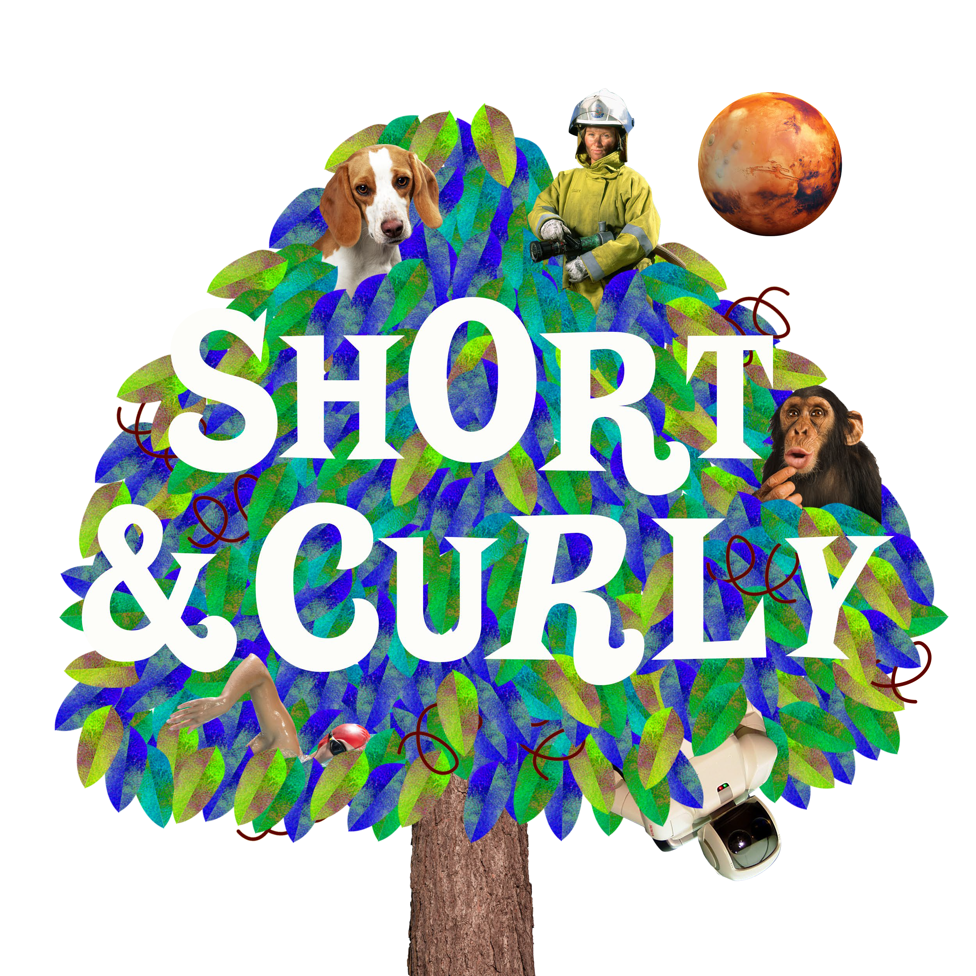

Schools Pack

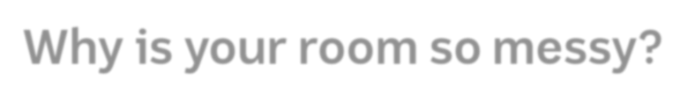

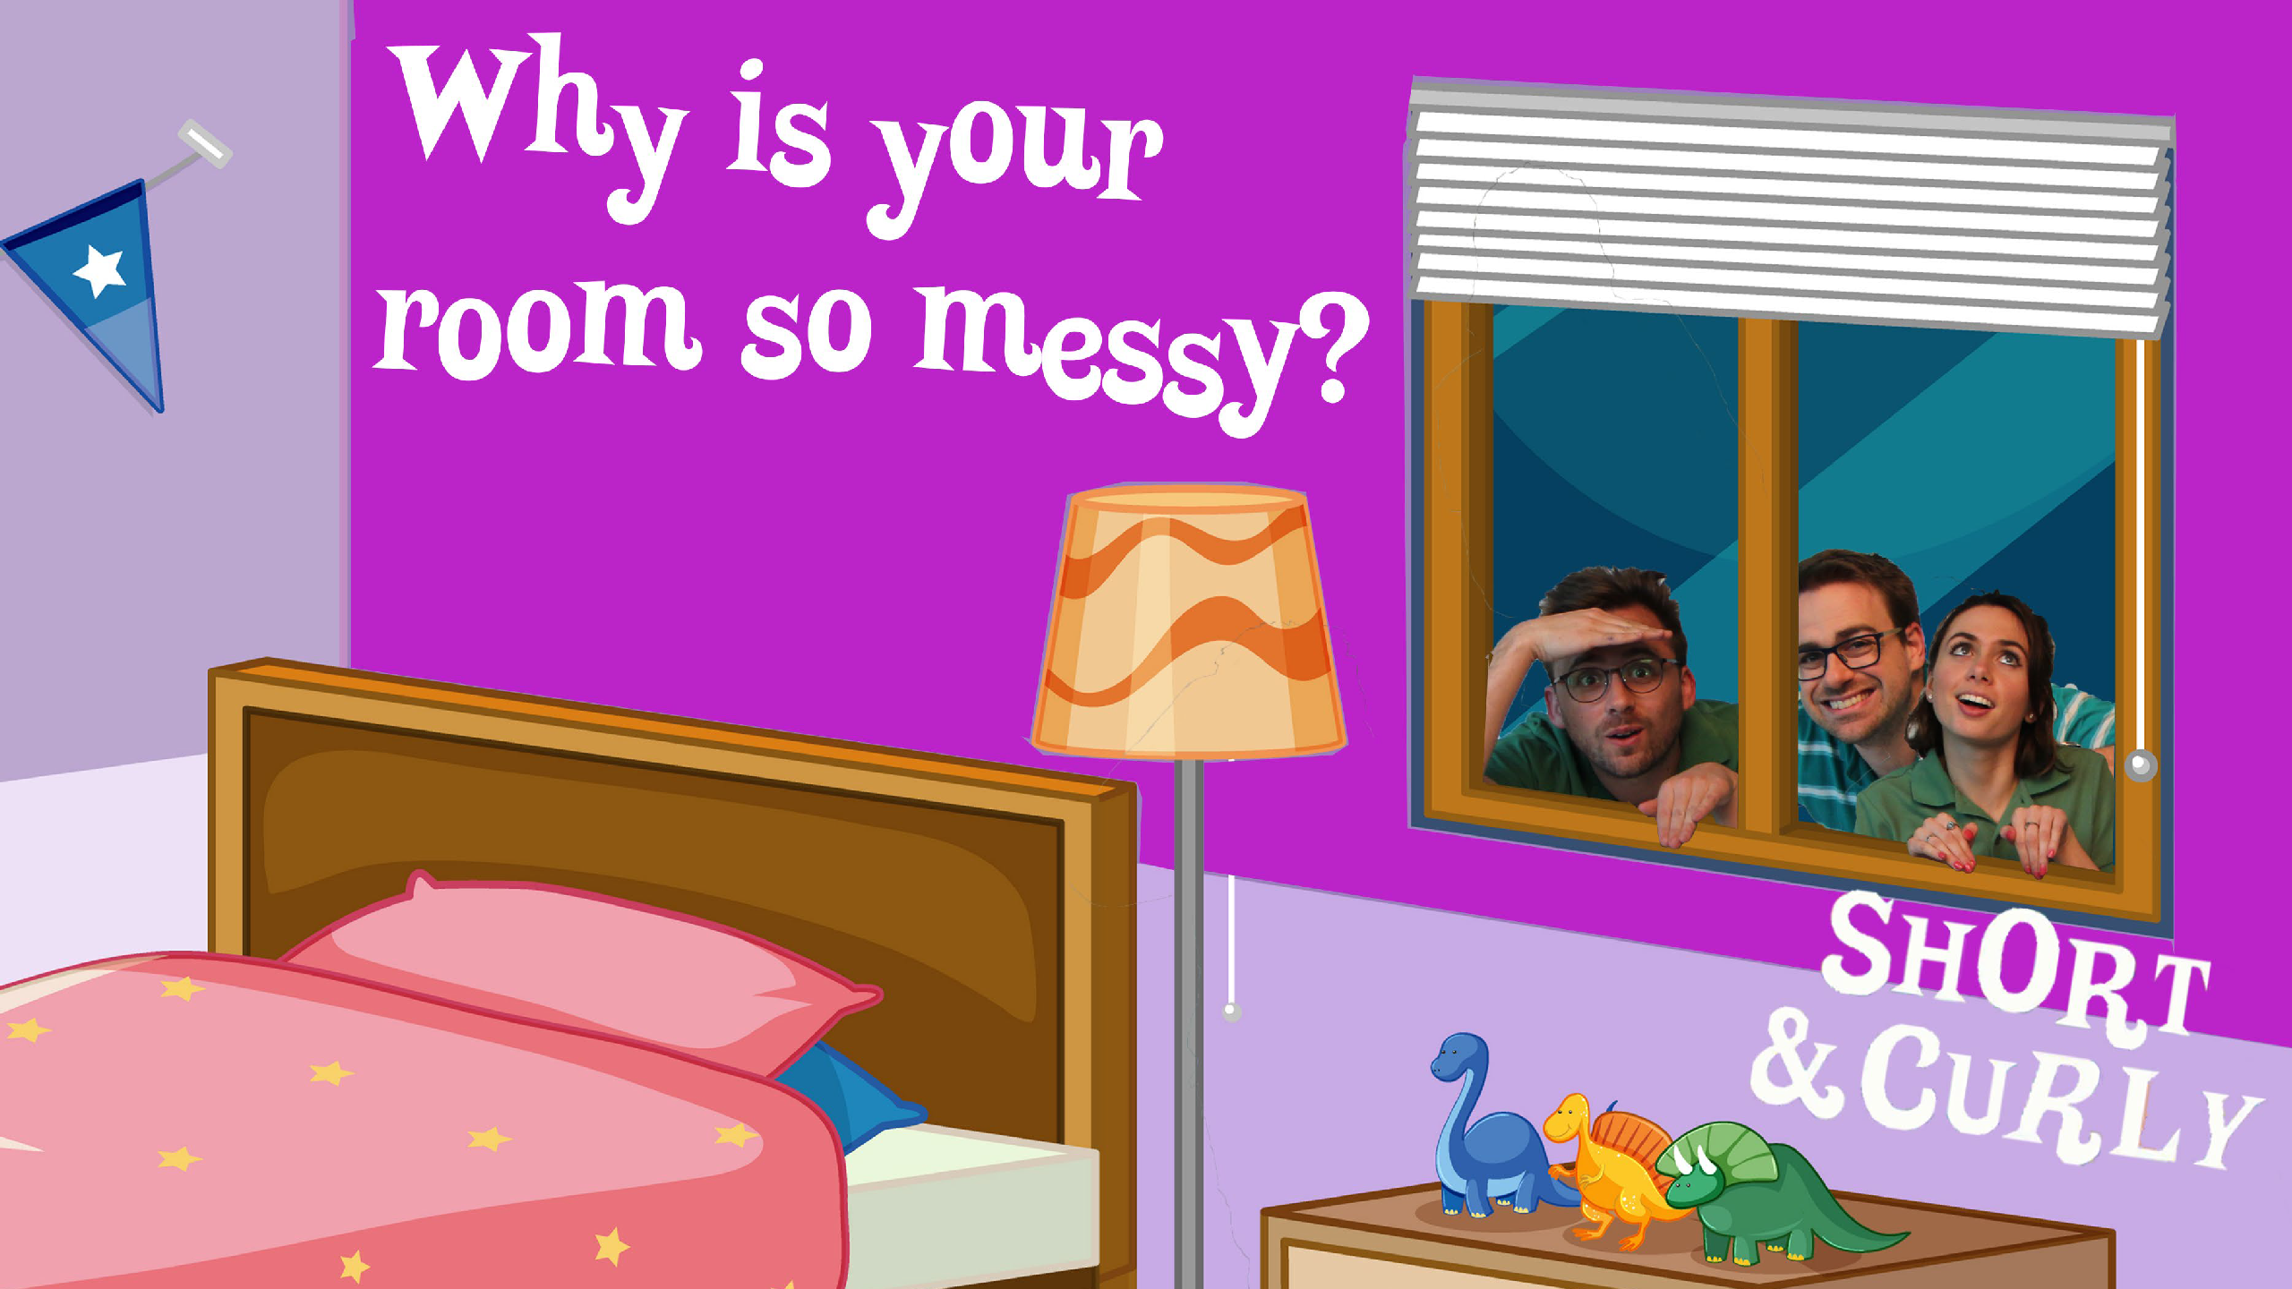

Why is your room so messy?

Begin with a brief discussion of the podcast and ask students for their opinions on whether Harriet is responsible for her messy room or if she is, as she argues, a product of her environment. Encourage different opinions to be heard, and the merits of each side to be discussed.

Ask: Is Harriet responsible for her actions? Why / why not?

Have students discuss, in pairs, the things they are responsible for doing at home. This could be as simple as brushing their teeth each morning and night. Briefly share answers as a group. Then, ask: so if you are responsible for this job, what does that mean?

What if your parent told you that from now on you would be responsible for driving yourself to school each morning? Is this reasonable? Why not?
The point to draw out here is that children are not capable of driving a car, and therefore this is not a reasonable expectation. Next, ask: what if your parent told you that you would only get pocket money for the year if you didn’t get sick?
Is this reasonable?

This is an unreasonable request because we cannot control whether we become unwell, and therefore have no say in the matter. Here, ask students three questions:
- Is Harriet capable of cleaning her room? Ie, is does she have the knowledge and ability to clean it herself?
- What aspects of this situation can Harriet control, and what parts does she have less control over?
- If Harriet is capable of cleaning her room, what is it that is stopping her from doing it?

This should lead students to think about choice.

Here, ask students to think about the following scenario: you have been asked to tidy your room by the end of Saturday or you won’t get to go to your friend’s house on Sunday. You have soccer that morning, then swimming, and then your little sister has a dance recital all afternoon and you remember you have a science project due on Monday morning. By the time you finish your project and eat dinner you are exhausted. Besides, the rest of the house is a pigsty. What do you do?

Work through the following three concepts to come up with ideas:

- Capability: Are you capable of cleaning your room?
This is ambiguous, depending on how students view the situation. You are physically capable – you know how to clean your room – but are you equipped to do this given the circumstances of the day? Do you perhaps feel incapable?

- Control: What in this situation is in your control, and what is not?

- Choice: What other choices have you made, or could you have made, in this situation? Eg, not letting it get so messy in the first place, being ore organised with school work, cleaning it on Friday night ahead of the busy weekend.

Ask: Why do you do the jobs at home that are expected of you, and why do you not do them at other times? Are there consequences? Why we do follow rules – at school, and in life?
Discuss answers as a group, or think / pair / share.

Lead the discussion towards consequences. There are tangible consequences for not doing what is expected, like not getting pocket money or being put on detention at school. But, is there more to responsibility than just avoiding consequences like these?

Why do we humans, in general, follow the rules of society? Introduce the concept moral responsibility and free will.
Explain that as a society we generally hold people responsible for their actions, and believe that humans have moral responsibility to live by. Laws are based on this. Explain that moral responsibility assumes the power of control of choice / free will. However, there are alternative theories…

Introduce the term determinism, and explain that it is at odds with free will and moral responsibility. Determinism is based on the idea of universal causation, in which everything is caused by something else in a chain of cause / effect.

Explain that students are about to examine a range of situations to decide if they are moral or non-moral situations. First, ask them to write down the following definitions:
A moral situation is one in which the individual can choose a particular course of action

A non-moral situation is one in which the individual either has no choice, or has that choice dictated to them by something or someone over which they have no control. For each of the following scenarios, decide which applies for each:
I am not to blame for breaking the neighbour’s window with a cricket ball because there are not places to play nearby I am not to blame for handing in my school project late if I have been sick
I am not responsible for pushing a student in the playground who was upsetting me because my brother told me to stand up for myself I am not responsible for stealing food if I have no money to feed my family
Students should work through each of these, deciding if they are moral or non-moral and justifying their answers

Consolidation

Share responses as a group and discuss. This should elicit some robust debates and conversations.

Explain that there is a spectrum of reasoning surround these scenarios. At one end you have the idea that all choices are free will and moral by nature, and at the other end the idea that all human actions are caused by factors outside of our control.

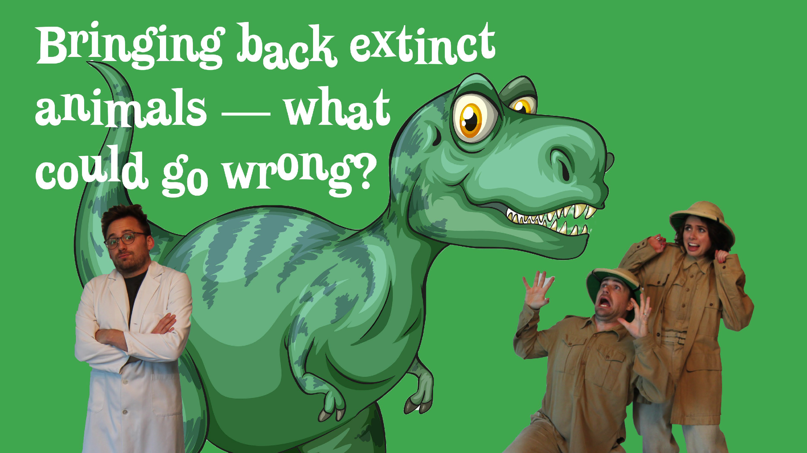

Bringing back extinct animals: What could go wrong?

For this activity, students will work in groups to create a news story. Please note that this will take several sessions to complete. If you don’t have time, students may do the newspaper front page template / lesson as a one-off.
You will need newspapers.
First, each group is assigned an extinct animal / species, eg: Dodo
Mammoth
Sabre-toothed cat Tasmanian Tiger Moa
Irish Elk Quagga

There is a comprehensive list of recently extinct animals here

Once selected, groups will first spend some time researching their extinct animals: characteristics, what’s cool about them, their diet / environment and so on.

Students will create a news story which details the de-extinction of this animal and its effects. This may be a newspaper article, radio piece or tv piece, depending on resources and time.

Begin with a brief discussion of a newspaper: its purpose, audience, format and layout. As you do so, list each of the elements students will need to design their own: headline, graphics, font / text, images, date, captions, columns.

Next, examine a range of newspaper headlines and deconstruct: what do you notice about these headlines? Why are they worded in this way? How are they sized / place and why?

Next, students will draft their stories. Ask them to consider the following:

Is this a good news story, or a bad news story? The language will need to be appropriate to the tone (they can research a range of news pieces to find language to suit their article)

To do this, students will need to decide if their de-extinction animal would be beneficial or detrimental. This will require discussions and some research. Questions to consider: What are the pros you can think of? What are the cons?

Alternatively, have we already meddled too much with Earth and should we leave it alone?

Once students have considered these questions, they should do some research online to help them. Some arguments to consider / draw out:
Pros:

Are there environmental benefits? Eg, some ecosystems currently have either too many predators or too much prey, meaning one will die out. Reintroducing certain species might balance this.

Do we owe it to the planet to bring some species back, since we are responsible for their extinction in the first place? Cons:
Human exploitation continues: haven’t we already exploited nature for our benefit? Some critics feel we have used animals enough, for our own gain, and that morally we should no longer exploit nature in this way, regardless of any positive outcomes.

New / old diseases: once an animal becomes extinct, the diseases associated with it do as well. It’s possible some of those diseases could come back. Playing God: some people have an issue with what they see as ‘playing God’. Should humans have the right to do this at all? This is a moral issue.
Attitudes to extinction: perhaps the biggest issue scientists warn of is the shift in attitude that de-extinction could cause – ie, that extinction itself is no longer an urgent global issue.

Once students have decided on a basic outline of their articles, they can begin drafting their stories.

Once a draft has been completed, the editorial team (group members) will need to edit their work.

Students' stories should then be self-edited as well as edited by two other members of their editorial staff (using the Story Feedback Form). Students should make necessary revisions to their stories based on these comments.
While the feature story is being written, other group members can come up with some funny news stories (e.g. an opinion piece speaking out against homework) and advertisements for imaginary products.

Once formatted, have editorial staff do a final check and complete any last-minute revisions.

Pictures can be drawn or pasted into the layout. Depending on the available resources, pictures can also be scanned or downloaded from a digital camera. Tell students to play around with fonts and columns. They should experiment and be creative!

Once pages are completed, they can be printed for review. The editorial staff should do a final reading for errors. Pages are then submitted to the teacher for publishing.

Consolidation:

Share newspaper stories as a group. As each group shares their story, discuss.

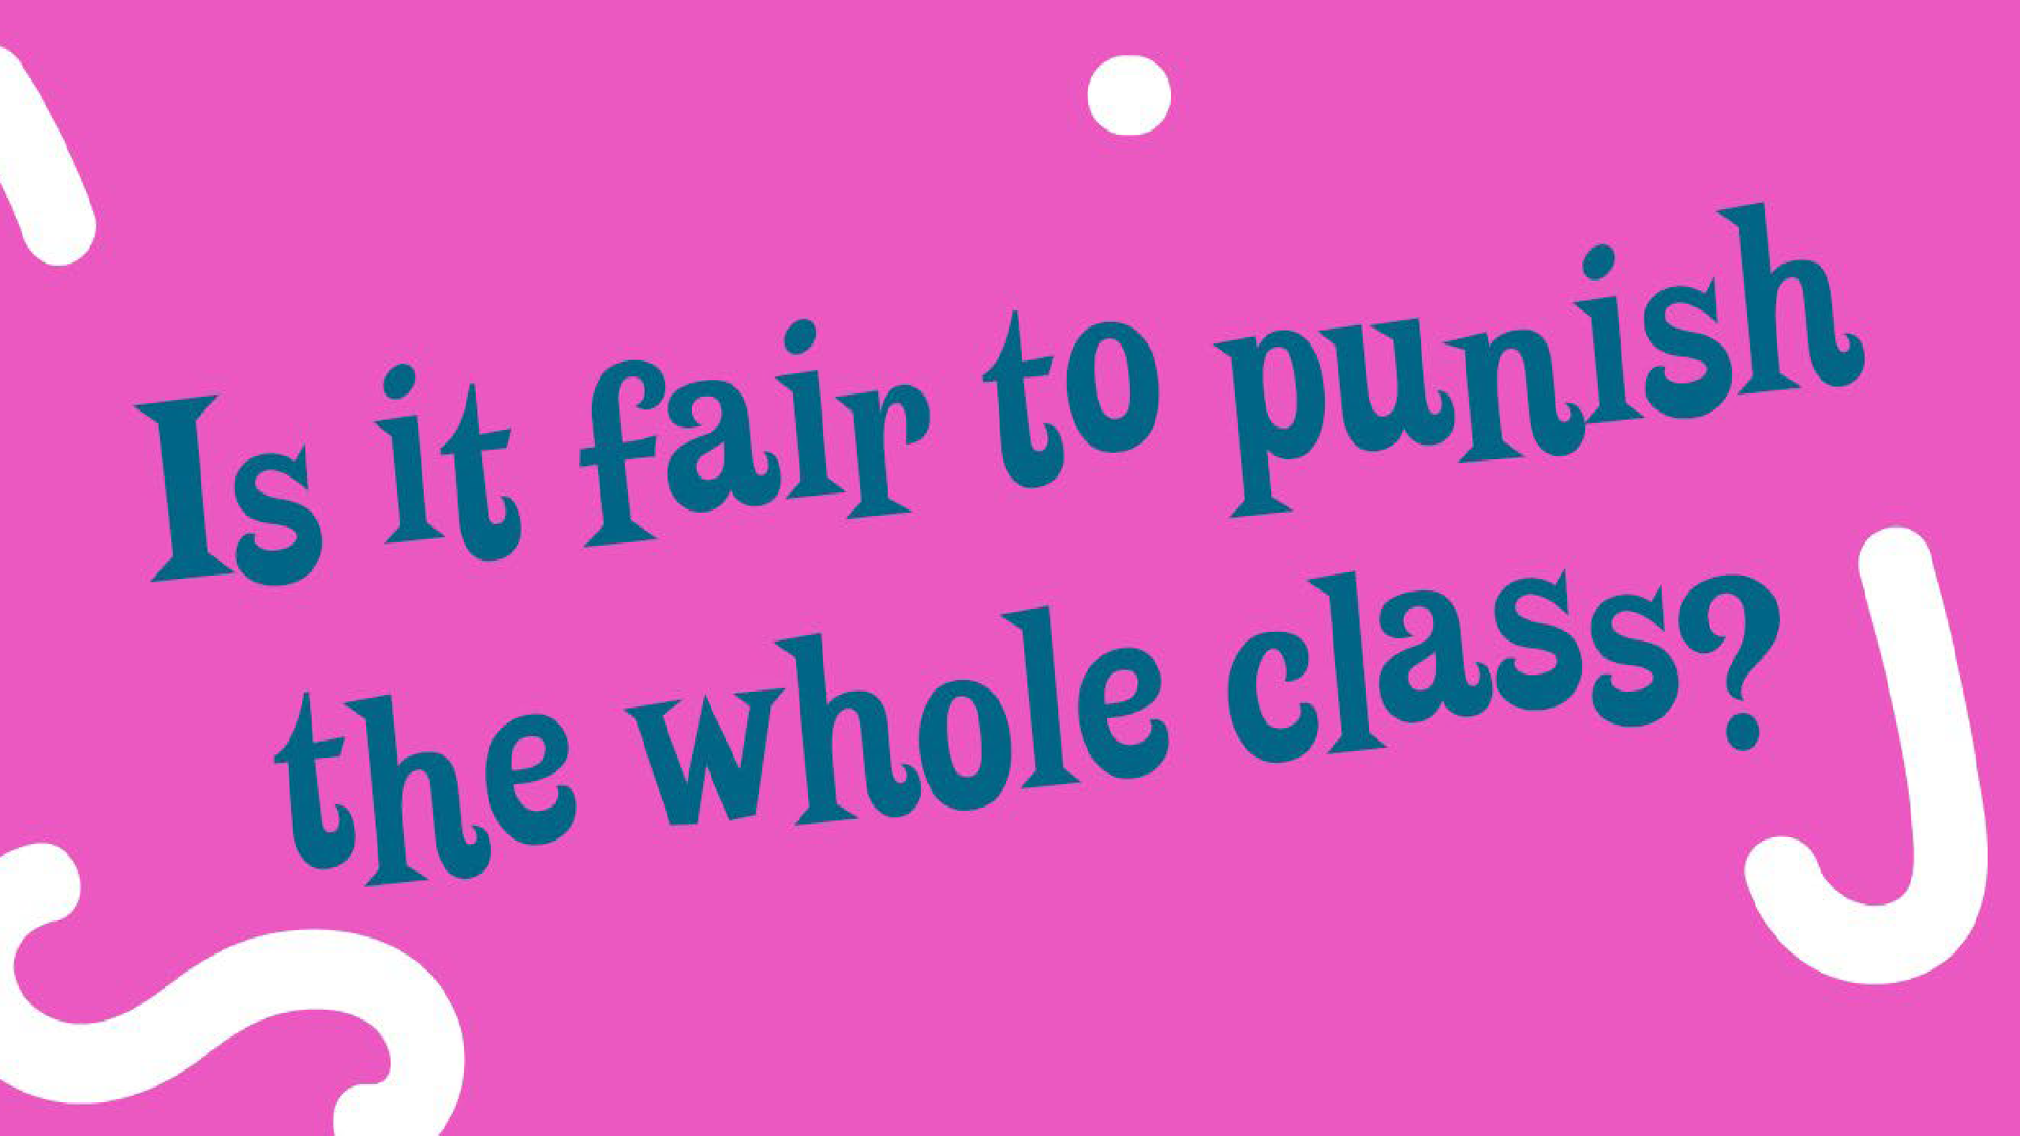

Is it fair to punish the whole class?

Begin by asking: should people be punished as part of a group, or only as individuals?

First, ask students to think about situations in which individuals would be grouped into a collective and therefore responsible as a single entity. Some examples include family feuds, gang warfare and wars. Discuss these briefly, looking at each example and discussing how collective punishment is enacted.

What are the advantages and disadvantages of using this method of punishment? Discuss answers as a brief warm-up. Ask: What are some other things the teacher could have done to find the cookie culprit, or to make them own up?
Discuss answers (eg, letting the class know beforehand what the punishment would be for stealing them, telling them they won’t be in trouble if they tell the truth, creating a private space for students to approach the teacher one on one).

Next, ask: is it ever ok to steal?

Discuss. What makes it ok, and what makes it not ok?

Ask: What sort of punishment should there be for a student who steals a teacher’s biscuits and gives them to the class, and why? Next, tell students that for this session you will be looking closely at justice and punishment.
The cookie scenario is just one example of a situation involving a ‘crime’ (wrongdoing) and a punishment – a classroom example of what happens on a larger scale in our society. How a society handles justice and punishment is an important ethical matter, and one you are going to investigate.

There are three main philosophies of justice you will be exploring today: retribution, utilitarian justice and restorative justice.

You are going to be looking at four forms of punishment: retribution, deterrence, rehabilitation and incapacitation, and examples of what they are.

Retribution

Ask: what does retribution mean?

Discuss informal definitions (if any), before explaining it is understood as the punishment that someone deserves. It is intended to be proportionate to the crime.
Retribution may be the most primal form of justice humans understand. Introduce the term ‘an eye for an eye’ from the bible, and discuss its meaning briefly. People who favour retribution argue that it brings a sense of satisfaction to the original victim.

So, let’s think about using retribution as a consequence for the classroom cookie theft. What punishment could be used in this case, assuming the guilty person has been found? Think / pair / share
Some examples: taking the person’s lunch, stealing something of theirs Discuss answers as a group.
Next, ask students to work in pairs to briefly discuss and jot down what they think are the pros and cons of this punishment, and of retribution in general Eg:
Pros: stops other people doing it, victim satisfaction, a sense of ‘balance’.

Cons: No change to behaviour encouraged, can be hypocritical, creates two victims instead of only one.

One point to draw out here is that this form of justice can be used as a deterrent, which you will discuss next.

Deterrence

First, define deterrence. A deterrent is a thing that discourages or is intended to discourage someone from doing something. Other forms of justice and punishment can result in deterrence, e.g. someone who has been to jail for robbing a bank may be discouraged from committing another crime because they fear a similar consequence.

Ask: what are some examples of effective deterrents in your life? (e.g. no pocket money if I don’t clean my room etc) The idea of a deterrent is to act is a preventative measure against wrongdoing.
Discuss this word as a group, and then ask students to come up with a deterrent for stealing cookies in the previous scenario Think / pair / share
Some examples: Displaying rules and consequences in the classroom so students know what will happen if they steal the cookie, detention and other punitive measures. Ask: are deterrent forms of punishment effective? Does the method justify the outcome? Discuss briefly.
Draw out the point that other forms of punishment can also act as a deterrent. E.g. retribution may act as an effective deterrent.

Incapacitation

Incapacitation simply means removing a person from society. This includes incarceration in prison, house arrest and, in its most extreme form, execution. Discuss forms of incapacitation as a consequence for stealing the cookie.
Think / pair / share

E.g. time out, being sent out of the classroom, suspension / exclusion.

Discuss the pros and cons of this form of punishment / consequence.

Restorative justice

Begin by explaining that restorative justice is a more modern approach to justice and punishment, and is used in many schools and increasingly in jails. This approach requires the ‘offender’ to make direct amends to any ‘victim’ of their crime, as well as to the community where it occurred. The offender and the victim meet so that the offender can hear what the victim says about their experience.

Ask: why is this type of justice now more common? Why should we be practicing restorative justice over other forms of justice? Would this work in the case of the stolen cookie? Why / why not?
Discuss.

Consolidation

Return to the cookie caper and collective punishment:

What kind of punishment did the teacher use?

Do you think it’s more or less fair than when you listened to the podcast?

What do you think should be the punishment for taking the teacher’s biscuits and why?

As a final activity, ask students to come up with some ideas on how the class or the school should tackle some different forms of rule breaking. Based on what you now know, how do you think these should be handled?
Think about things like talking while the teacher is talking, pushing in, bullying.

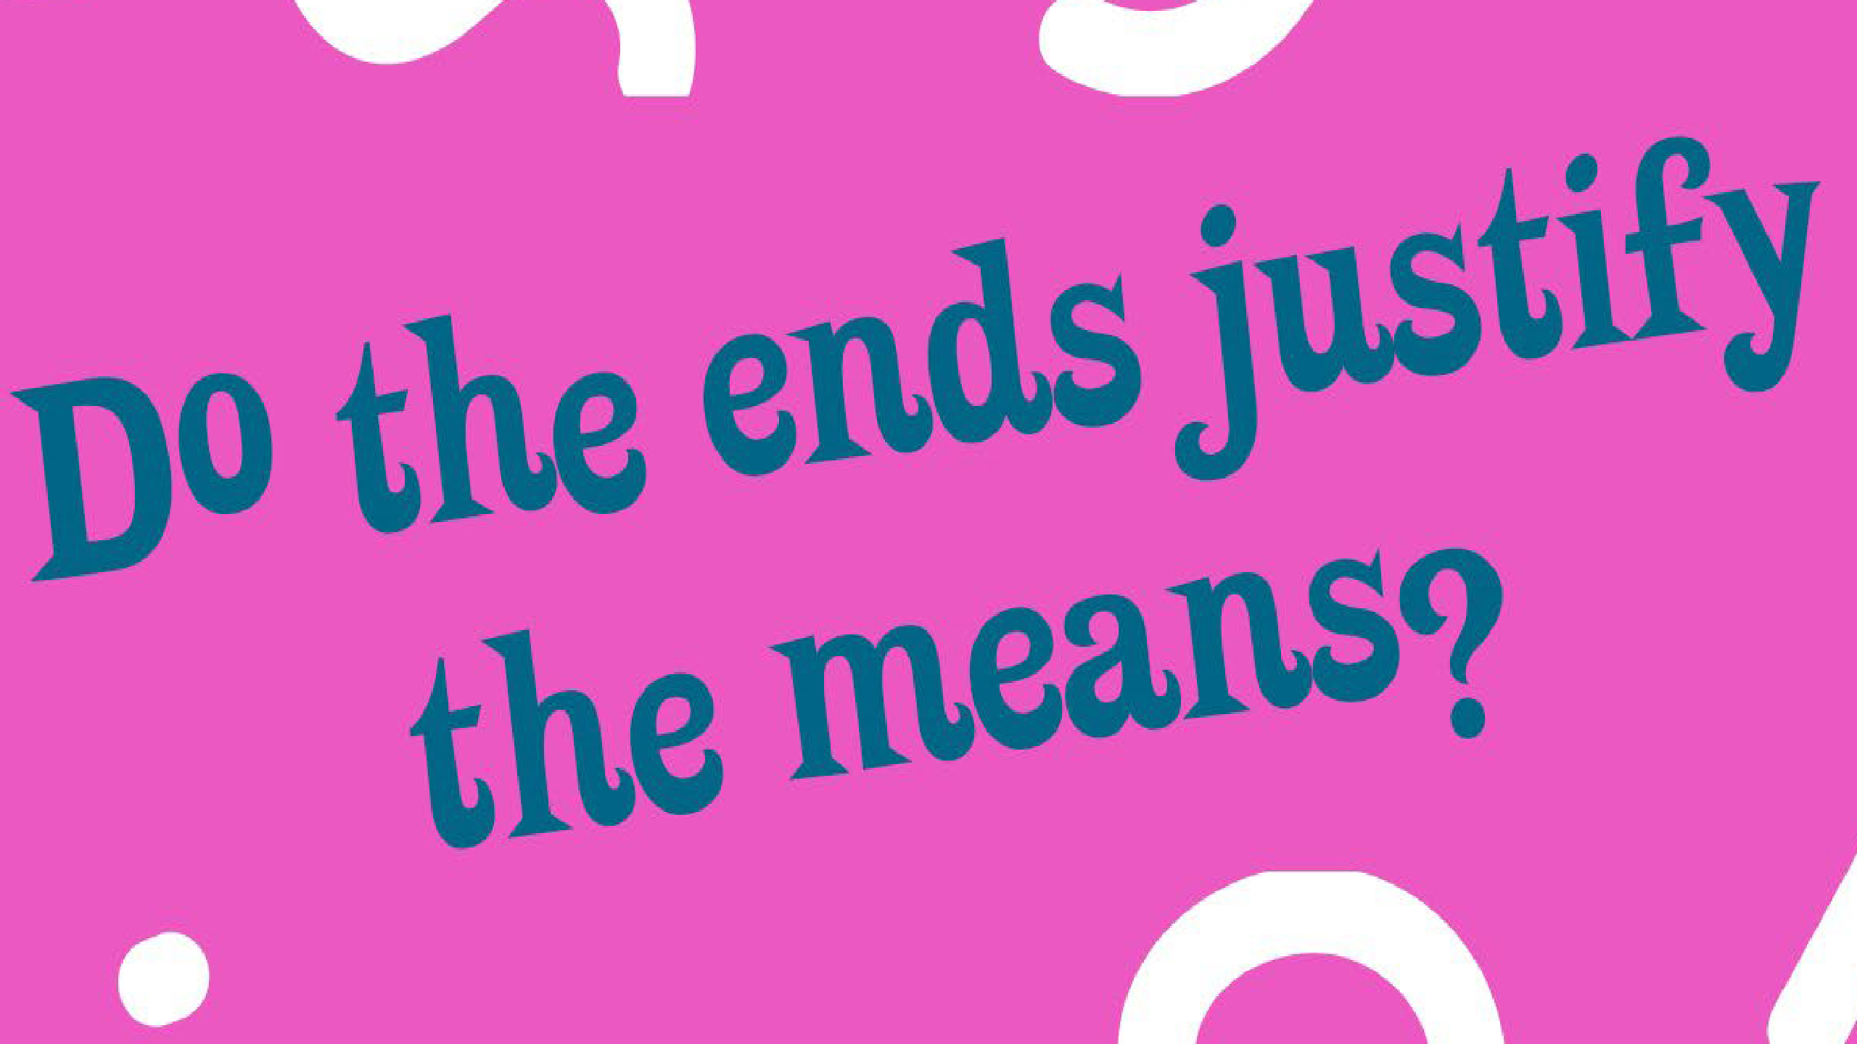

Do the ends justify the means?
14

Begin by providing students with a brief background of the concept of the ends justifying the means.

Sergey Nechayev was a 19th Century Russian revolutionary who coined this term. It essentially means that if a goal is important enough – in his case, liberation – then any method of gaining it is acceptable. This concept is part of a political philosophy called consequentialism – the idea that a policy can be judged by its outcome.

This question is an important moral and ethical question. It poses the question – is it sometimes ok for actions to cause harm along the way if the final result is positive? Next, students will be asked to analyse several different scenarios to discuss and ultimately decide if the ends in each one justifies the means.

For each scenario, students should ask the following questions:

- What is the harm caused? Does it cause pain and suffering to individuals?
- It the expected outcome achieved?
- Is the positive outcome worth more than the negative means? Who decides that?

- Three players from a struggling regional football team secretly take steroids to improve their performance. All three players make the first grade team and go on to win the Grand Final. The victory is a great economic boost for the region they are from and the town is overjoyed.
- A man is rushed to hospital with a snake bite. The venom has travelled from the bite in his finger almost to his elbow, and will reach his heart if it is not treated - meaning certain death. The doctor decides to amputate his arm immediately. The man survives.
- The computer lab at Sunnyville High School is vandalised overnight. The cost of the damage comes to over $100,000. The principal has firm evidence that it was two students from a year 7 class, but he doesn’t know which ones were responsible. Since no one is talking, he puts the entire class on lunch time detentions for the rest of the year. One week later, feeling the pressure, two students admit to the crime.
- Your grandmother buys you a hideous jumper for Christmas. She calls you later and asks if you like it. You lie to save her feelings. Grandma is pleased.

Work through each scenario individually, paired / grouped or as a whole class. Discuss each one as a group.

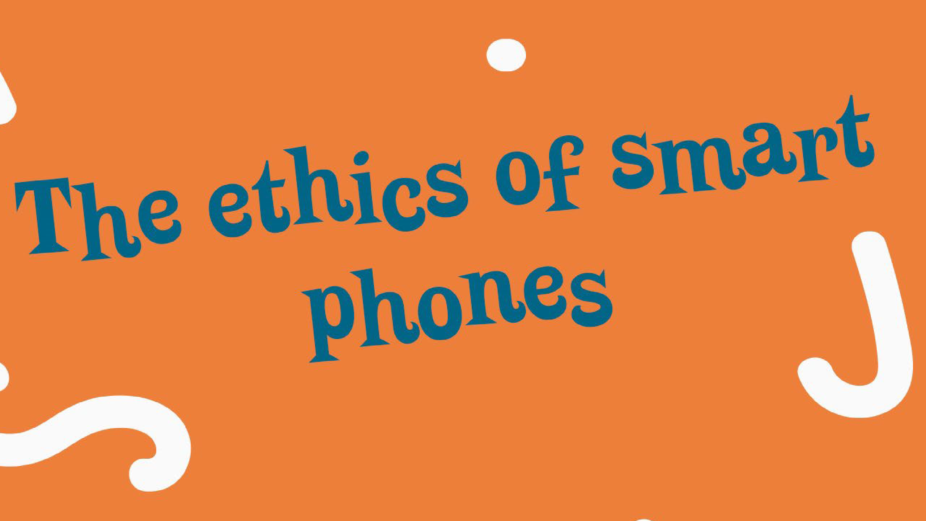

The ethics of smartphones
16

Begin by asking students to each answer the following questions about mobile phones by jotting down their answers in their books: Do you have your own smartphone? What’s good about it? And if you don’t have a smart phone, would you like one and why?
Which app or other features do you use the most, or would you use the most if you had a smartphone?

Here, you can split into groups and take three related questions each and then return to whole class to report your thoughts. We are working towards developing a charter for good and fun and healthy phone usage!

  - Are there rules in your family about when and how to use a smart phone? Why are the rules there? Are they useful?
  - What can smart phones add or take away from your friendships?
  - How do you know if you or someone else is spending too much time on their phone?
  - Do you think there are times and places when it’s not appropriate or good to use your/a smart phone? List and discuss why and why not. (school, home, other places)
  - Have you found your phone interrupting you or distracting you from people and the world around you?
  - If games and apps are designed to make you want to keep looking and using and checking them, what can you do to get your control over your phone back? (if you don’t have a phone consider gaming)

Their answers to these questions will guide the following activities.

Next, students will work to come up with the ‘ten commandments’ of smartphone usage. These should take into consideration things like privacy and safety, but also general courtesy and manners.

First, briefly explain the Ten Commandments and their original purpose.

In groups, have students brainstorm their ‘commandments’ and design a poster for the display in the classroom. Some examples:
‘thou shalt turn off notifications at certain times and places’
‘thou shalt not look at your phone when your friend is talking to you’

It’s the end of the world. Let’s go berserk!

It’s the zombie apocalypse! Where do you go? What do you do? Who do you save?

This lesson will focus on what we will call apocalyptic morals: how do your morals, values and ethics change when the end of the world is imminent? In other words, if nothing really matters anyway, how does that change our ethical perspective – what we think of as right and wrong?
At what point does morality go out the window and your survival come first?

First, provide some background information. Briefly explain what the word ‘apocalypse’ means: The complete and final destruction of the world, as described in the bible (the book of Revelation). This is a Christian idea, but some other religions like Hinduism and Buddhism also have similar ideas about the end of the world. And, scary as it sounds, it’s actually a good thing as far as they’re concerned because if you’ve been good you will have a lovely afterlife for all eternity!
But it’s important to remember that the main way we see this sort of story playing out is in movies about an imaginary end of the world, or shows about zombies roaming the streets (both are made up!)

Begin by asking students to discuss the idea of how we behave if we think there is no future and therefore no consequences to our actions. Should we all just go berserk?

Ask students to think of one fun thing they would do if no consequences would ever be felt… like going nuts in a candy shop.

Next, ask: why do you think it is important to think about how we might act if we knew the world was ending? And, what problems can you think of that might arise if we all behaved as though there were no future?

There are a few really important philosophical ways of working out the right and wrong thing to do – and people have argued about these for centuries. One really important one was developed by a man called Emmanual Kant.

Kant was a German philosopher born in 1724. He spent much of his life devoted to working out how humans could be good and kind outside of religious obligations. Kantian ethics are a set of universal moral principles that apply to all humans, regardless of their situation – what he called ‘categorical imperatives’: human beings must follow a set of moral standards regardless of individual situations. Many modern systems of justice are based in this form of morality. The United Nations, for example, is based largely on Kant’s vision of an international government that binds nation-states and maintains peace.

Kant’s form of ethics is known as ‘deontological ethics’.. Deon means duty, so we can think of this term as ‘duty-bound’ ethics.
A simple way to think about it is like this: Kant believed that certain things were wrong, no matter what, and so the ends do not justify the means. For example, lying is always wrong so if you were to steal food, even if you were starving, it would still be wrong. This means that according to Kant, even if the end of the world was coming, you should pay for the candy in the candy store, even if no one will ever know or care that you did.

Begin by asking students to come up with some ‘moral rules’ which can be universal. E.g.
Always tell the truth Keep your promises Do not kill
Do not steal

Now imagine the following scenario: A giant rock is heading for Earth from outer space. Scientists believe it will hit our planet in 48 hours and destroy everything. What will you do in the next 48 hours? Rank the following items in order of preference:

- Steal stuff you’ve always wanted
- Help someone
- Tell someone you love them
- Be with your family
- Go to bed
- Do something you’ve always wanted to do (explain)

Extension

The world is going to end in 5 days. Luckily, it turns out that there is actually a second Earth, which is almost identical to ours except with no humans. Unfortunately, there is only one spacecraft capable of traveling to the planet, and it can only hold 6 people. You have been chosen to lead this final voyage from Earth and build a new civilization on this other planet. So, which five people from around the globe do you choose to be the people who will rebuild human civilization with you, and why?

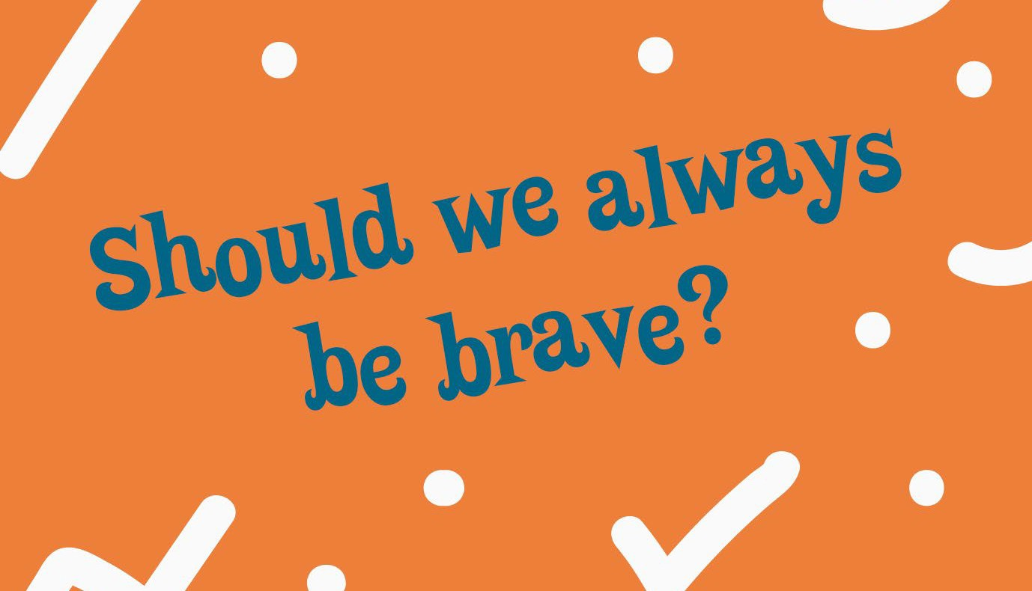

Should we always be brave?
Bravery is much more than simply doing something you are scared to do or doing something dangerous for good reasons. So what is it, and how is it different to courage? There are brave and courageous acts around us all the time, we just may not recognise them.. So how do we work it all out?

Begin by reading through this article, as a group, thinking about courage versus bravery.

Ask: can you come up with some examples of bravery you’ve seen, read about or even done yourself? What made them brave?

An ancient philosopher called Aristotle had a lot to say about courage and bravery. If you are courageous, Aristotle says, you will face your fears for the sake of noble causes. He also said that in order to become courageous, one must practice acts of courage.

Begin by discussing with students any examples of courage. These may be acts they themselves have done, or examples of courage they have seen in other people. For each story, ask: what makes this act courageous? Take notes on the board.
Next, ask - if the motive of courage is always noble, what makes a noble cause? To answer this, students will be looking at fears. Specifically, you will: Analyse WHAT scares you
Analyse WHY it scares you
Figure out if it’s NOBLE to face these fears. Start with an example, modelled for the class:
I fear snakes
They scare me because they are venomous and fast
It would not be noble to try and overcome this fear because it makes sense to fear snakes

Or:
I fear needles
They scare me because they hurt
It would be noble to overcome this fear in order to receive a vaccination

Aristotle warns us that we are at fault when we fear what and when we should not, so much depends on the specific situation and time and people and conditions involved. It is up to you to designate what the right things to fear are – what is noble and what is not.

Next, you will listen to an excerpt from Malala Youfsazi. Before doing so, read a brief bio about Malala:

Malala Yousafzai is a Pakistani activist. When she was 11, the Taliban took control of her town and ordered girls not to go to school. Malala began speaking up for a woman’s right to get an education, even though it was dangerous to do so. In 2012, when she was 16, Malala was shot. Luckily, she made a full recovery and continues to advocate for women’s rights. Malala was awarded the Nobel Peace Prize in 2014, making her the youngest person to become a Nobel Laureate.

Listen to Chapter 20 and 21 of her book ‘I am Malala’: https://www.youtube.com/watch?v=eRFrTYV7zwI
https://www.youtube.com/watch?v=NUvZlj65kO4

After hearing this excerpt, students should discuss as a group: Was it right for Malala to have been brave in this situation? What if she had died? Would she have still been right to act the way she did?
Was this a noble cause? Why / why not?

Next, ask: it was dangerous for Malala to stand up for her rights. But is it also dangerous to remain silent out of fear? What danger does this pose? What is dangerous about fear?

Consolidation

Finish the activity by watching Malala discuss courage and the ‘danger of fear’:
https://www.oprah.com/own-super-soul-sunday/malala-yousafzai-on-the-dangers-of-choosing-fear-over-courage-video

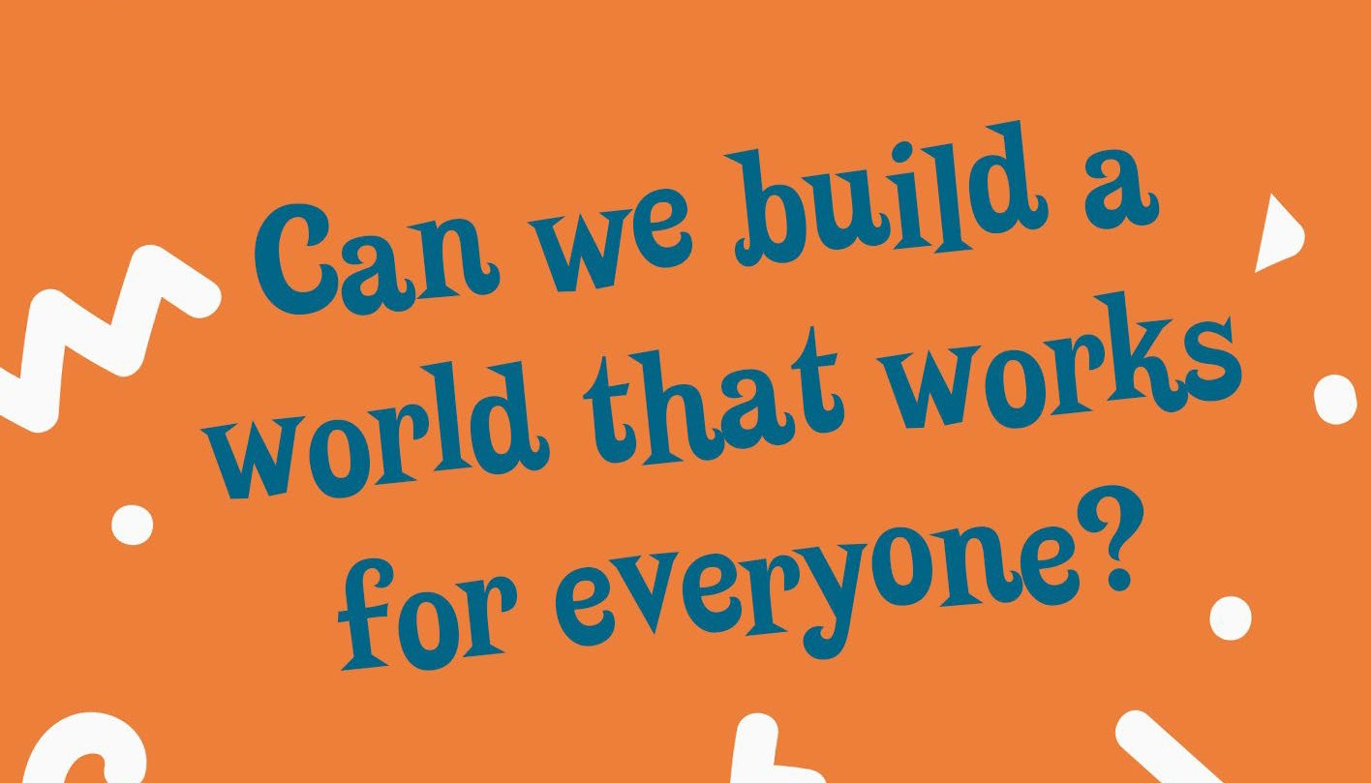

Can we build a world that works for
Beevginebryyproovnidieng?an informal definition of the word ‘utopia’.
A utopia is a community or society possessing highly desirable or near-perfect qualities. It is an imagined place or state of things in which everything is good for everyone.

But can these worlds ever exist in reality?

And, if the Utopian ideal becomes a reality, does that mean humans are happier?

Ask students to brainstorm some initial ideas for what might be found in a utopia (e.g. no crime, equality, everyone gets what they want). It might help to watch some segments from recognisable films that feature Utopian communities:

Zootopia Wall-E
Hunger Games

Next, you will conduct a research activity with students in which they examine a real-life community that has attempted to create a utopian society. Students may work individually or in partners for this part of the lesson.

Direct students to the Twin Oaks website (https://www.twinoaks.org/)

Provide students with the following questions to answer as they research Twin Oaks:

- What are the values this community embodies?
- Are there any rules or regulations for membership?
- How does one become a member of this community?
- IS it free or does it cost money?
- Would you like to live at Twin Oaks? Why / why not?

Still in groups / pairs, provide each with 10 strips of paper. Ask students to come up with 10 values that they all share and would like to include in their own utopian society. Have students write these values on the strips of paper.

Next, students will discuss the following questions and take notes:

Who is the boss of the society? What would people do for fun?
What type of government would exist? How will wealth be earned and distributed? What will school look like?
What about crime and punishment?
What else would your perfect society have?

Next, each member of the group will be given a role and will be asked to assist with planning. Remember: you are not just planning a city. This is utopia – a world that is fair and good for all.

Political leader

- List of Rules: Develop a list of seven to ten rules that all community members would follow. Give a rationale for each rule.
- Values statement. Write a brief statement (one to two paragraphs) citing the reasons for your formation of a Utopian society. In other words, what specifically don't you like about our current society?
- Governing Body: How will the government of this utopia be structured? Will you have a democracy, anarchy, monarchy, or dictatorship? How will your utopia make decisions?

Urban Planner

Geographic location. Where will your utopia be located? What is the climate like?
What buildings, facilities and landscape features will you have? You will have to include schools, hospitals, parks, homes etc. Create a map of your utopia.

Education director

Design a utopian school. Your job is to create the ideal school for students. What is different about this school to your school? Why?

- Make a new curriculum. What subjects will students study at this school? Write a list of subjects, explaining why each is important.
- Design the uniform. Create a new school uniform that embodies your utopia’s values. Design and label this design.

Recreation planner

Your job is to provide residents with their recreation and leisure activities. Write a fictional journal entry for a typical day in your utopia.

- Daily schedule. Write up a schedule for residents, detailing each part of their day. How much work and how much play? What is done for fun?
- Facilities. Plan and design facilities for recreation with your urban planner. What facilities will you create for residents and why? Finally, come up with a name for your new world where all beings live in harmony!

Presentation

Each group should then put together presentation using Powerpoint (or Bookcreator, or other presentation program) to present their Utopian community to the class for feedback.

Discuss each one, particularly drawing out any potential problems that could arise in this society.

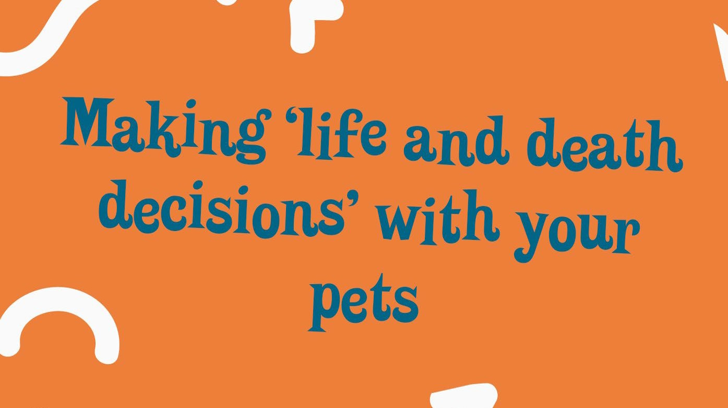

Making ‘life and death decision’ for your
Ipn ethits activity, students will be looking at the idea of sentient beings, and the ethics of making life and death decisions for our pets.
First, Introduce the term sentient being.

Explain that there is some debate about what it means to be ‘sentient’.

In law, a sentient being is a creature or being with the faculty of feeling emotions, feeling pain, or has consciousness.

However in the context of animal laws, the concept of ‘sentient being’ remains a debated issue: It can be problematic to draw the line and legally qualify which animal is sentient and which is not.

To illustrate this, the first activity is to define what the characteristics of a sentient being are.

It is important here to emphasise that this is an exercise only – they are having a go at assessing sentience, but there are scientists all over the world who are researching different animals and sentience in this way. As our ideas about sentience evolve and develop, so too do our definitions of sentient beings broaden and adapt.

Students can begin by answering the following questions: To be considered sentient, do you need:
Physical feelings?

Psychological feelings / emotions?

What about intelligence / logic / reasoning? What else?

Ask: are horses sentient (this will almost certainly prompt a ‘yes’) What about humans?
Next, ask the same question about the following animals:

Pig Bunny Dog
Cockroach Ant
Snake Rat

Work through these animals, discussing as you go.

Which ones are easy to classify as sentient, and which are more tricky? Why?
What about a dog makes it easy for us to see it as sentient?

(we keep them as pets, we attribute emotions and feelings to them, they show some human qualities like loyalty and playfulness) Does cuteness make an animal seem ‘more’ sentient? Why?
Next, ask students to consider a world in which ALL animals are considered deserving of the same respect and care as every other animal. What problems can you see arising from this?
Write down your ideas, then discuss as a group.

Next, provide some background information on Jainism – specifically, Jaian sadhus (monks) and sadhvis (nuns) and their avoidance of harming any living beings (even microbes).

These Jains adhere to the following rules very strictly for fear of causing himsa (harm) to living beings:

- Inspect the ground they walk on for insects.
- Never walk at night for fear of harming life.
- Do not walk on grass.
- Never pluck leaves from trees or other plants.
- Never ingest drinks which could contain microbes.
- Never eat at night because when a lamp is lit microbes and tiny creatures fall into food.
- Never eat meat, for microbes and germs may be in their flesh.

Briefly discuss this, with particular reference to the avoiding of insects. Ask students to consider why we are more concerned about harm to larger animals, but quite happy to slap a mosquito or a fly?

Is this fair, or should all animals be treated the same? If that is the case, how do we do this? Ask: is it ok to exterminate vermin such as rats?
Ask students to answer this question in pairs, writing down their ideas.

Next, watch the following video about rats: https://www.youtube.com/watch?v=iMVh5uO3FSA After viewing, ask: have your views changed at all? Why / why not?

Consolidation

Watch this Ted talk about chimpanzees.

After watching, revisit the podcast question to ask students to respond to the question: do you think it is okay to make end of life decisions for animals? Why / why not?

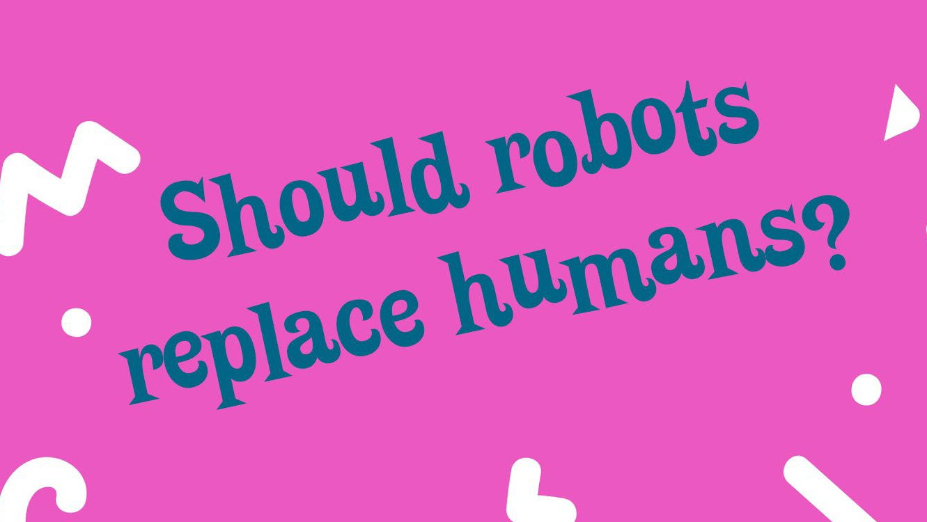

Should robots replace humans?
Explain to students that they will be looking at the ethics of programming robots to have artificial intelligence that is self-aware (intuitive).

Begin by briefly discussing robots and artificial intelligence, and the importance of making sure that artificially-intelligent computers and robots follow rules that keep them from endangering us and that align with our social conventions (wrong and right).

Ask: what are robots for? What are the advantages of creating robots? Who decides on the values and morals of the robots we are creating? Think / pair / share
Next, ask students to work in pairs to reflect on the following two questions, taking notes for discussion as they do so: How did you learn right from wrong?
How did you learn how to be polite?

Do you think that AI robots that think for themselves are a good idea? Why or why not? After discussing answers as a group, ask: should there be a set of laws for robots?
Next, ask students: should there be a set of laws for robots?

Explain that science fiction writer Isaac Asimov, in his book I, Robot, came up with a set of laws to guide the programming of robots in order to keep them from turning against humans. They are:

First Law: A robot may not injure a human being or, through inaction, allow a human being to come to harm.
Second Law: A robot must obey the orders given to it by human beings, except where such orders would conflict with the First Law.
Third Law: A robot must protect its own existence as long as such protection does not conflict with the First or Second Law. Ask: are these laws adequate? Discuss ideas as a group.

Next, explain to students that they will devise their own set of principles to guide the programming of robots. They can work in pairs or groups.

First, generate some ideas. As a group, come up with a list of social norms and behaviours you think moral robots should have (you may need to clarify what ‘social norms’ are).

Once a list has been generated, rank them in order of importance. Next, think about the idea of having robots as teachers:
What skills and qualities does a teacher need? Can a robot fulfil these?
What about doctors?

What do teachers and doctors do that a robot cannot?

Alternatively, what could a robot do that a human teacher or doctor could not?

Next, in pairs, have students think about what job they might like to do when they are older and discuss and answer the following questions: What skills / qualifications / knowledge will you need?
Could a robot do this job? Why / why not?

Robot Invention

In this part of the activity, students will conceptualise and design a new robotic invention, working through a five-step process independently or with guidance.

This may be run as a project over several lessons, or can be shortened into one lesson with each phase only briefly explored. Alternatively, you may wish to run this as a whole group activity and guide the process yourself.

First, come up with an idea for each group or the class as a whole. One example could be a robot umpire for community sport. Students can then work through the following steps:
Concept phase: Identify the problem / need, conduct research and brainstorm solutions. Design phase: Create a plan, select the best solution and determine necessary resources. Build phase: Sketch, model or build a prototype.
Review and redesign phase: Review the invention for strengths and weaknesses.

Share phase: Present the invention to your class for feedback.

Lastly, ask students to weigh up the pros and cons of their invention. What were the advantages of a robotic invention of this kind, and what were the disadvantages?

Consolidation

Research some examples of AI inventions in recent years, the problem they have addressed and their impacts. In particular, look for any AU inventions that pose ethical questions, like driverless cars. You may wish to listen to the Short & Curly episode on driverless cars here

