EPISODE 18
22nd June 2021

KEY LEARNING
Students will view a range of BTN stories and use comprehension skills to respond to a series of focus questions.

CURRICULUM
English – Year 4
Use comprehension strategies to build literal and inferred meaning to expand content knowledge, integrating and linking ideas and analysing and evaluating texts.

English – Year 5
Use comprehension strategies to analyse information, integrating and linking ideas from a variety of print and digital sources.

English – Year 6
Use comprehension strategies to interpret and analyse information and ideas, comparing content from a variety of textual sources including media and digital texts.

English – Year 7
Use comprehension strategies to interpret, analyse and synthesise ideas and information, critiquing ideas and issues from a variety of textual sources.
  - Teacher Resource

Focus Questions

Tamil Asylum Seekers
- Discuss the BTN Tamil Asylum Seekers story as a class.
- What is an asylum seeker?
- What are some reasons why asylum seekers leave their country? Give one or two reasons.
- What does it mean when someone is granted refugee status?
- What is a detention centre?
- Where do Tharnicaa’s parents come from?
- Which island was Tharnicaa’s family sent to and put in a detention centre?
- Why does the government say it has to try and discourage people from arriving by boat?
- What do you understand more clearly since watching the BTN story?
- How did this story make you feel?

Kids Talk Results
- Discuss the BTN story in pairs and record the main points of your discussion.
- What percentage of kids say they are happy or very happy with school?
- What percentage of kids are tired a lot of the time?
  - 24%
  - 42%
  - 84%
- Why might kids be tired a lot of the time?
- What is the name of the movement where many people around the world stood against racism?
- What was the biggest thing to affect the world lately?
- Complete the following sentence. The survey asked kids if _____________ Day should be changed.
- What kinds of people do kids trust the most? Name two.
- Who do kids find the least trustworthy? Name two.
- What do 87% of kids who did the survey worry about?

New Ocean
- What was the main point of the New Ocean story?
- What continent does the Southern Ocean surround? Find on a map.
- Who approved the Southern Ocean as the world’s 5th ocean?
- What are the 4 other oceans?
- What defines an ocean?
- What makes the Southern Ocean an ocean?
  - Arctic Circle Coordinates
  - Antarctic Circle Latitude
  - Antarctic Circumpolar Current
- The ACC is the weakest ocean current on our planet. True or false?
- What helps keep Antarctica cool and icy?
- The Southern Ocean is home to thousands of __________ that aren't found anywhere else.
- Think of three questions you have about the Southern Ocean. Share them with the class.

Check out the New Ocean resource on the Teachers page.

Young Archie 2021
- Retell the BTN story using your own words.
- What art gallery runs the Young Archie competition?
- When did the Young Archie competition start?
- Who is J.F. Archibald?
- When was the Archibald Prize first held?
- Portraits in the Archibald Prize must be of someone who is well-known. True or false?
- Who can you paint in the Young Archie competition?
- Who did the kids in the BTN story create a portrait of? Give one example.
- What do the kids in the story say to other kids wanting to get involved in art?
- What did you like about this story?

Check out the Young Archie 2021 resource on the Teachers page.

Artistic Swimmers
- Briefly summarise the Artistic Swimmers story.
- What skills do artistic swimmers need? Name two.
- Complete the following. Artistic swimming is often described as a mixture between ____________ and _______________.
- The aim of artistic swimming is to show that it is easy. True or false?
- What two sports did Amie compete in before she became an artistic swimmer?
- Where has the team been living since January 2021?
- What is the ‘eggbeater’ move? Describe.
- Where will the Australian artistic swimming team be competing next?
- What words would you use to describe artistic swimming?
- What did you learn watching this story?

  - Teacher Resource
EPISODE 18
22nd June 2021

KEY LEARNING
Students will identify the five oceans and learn more about the Southern Ocean and the animals that live there.

CURRICULUM
Science – Year 4
Living things depend on each other and the environment to survive.

Science – Year 5
Living things have structural features and adaptations that help them to survive in their environment.

Science – Year 6
The growth and survival of living things are affected by physical conditions of their environment.
Science – Year 7
Interactions between organisms, including the effects of human activities can be represented by food chains and food webs.

Scientific knowledge has changed peoples’ understanding of the world and is refined as new evidence becomes available.

s.

New Ocean

Focus Questions
- What was the main point of the New Ocean story?
- What continent does the Southern Ocean surround? Find on a map.
- Who approved the Southern Ocean as the world’s 5th ocean?
- What are the 4 other oceans?
- What defines an ocean?
- What makes the Southern Ocean an ocean?
- The ACC is the weakest ocean current on our planet. True or false?
- What helps keep Antarctica cool and icy?
- The Southern Ocean is home to thousands of __________ that aren't found anywhere else.
- Think of three questions you have about the Southern Ocean. Share them with the class.

Activity: Class Discussion
Watch the BTN New Ocean story then use the following questions to get the discussion started...
- What makes an ocean an ocean?
- Name the five oceans.
- How much of our planet’s surface is covered with water?
- Which ocean is closest to you?
- What else do you know about oceans? Brainstorm and record your thoughts as a class.
- What do you want to learn about oceans?

Activity: Glossary
Students will brainstorm a list of key words that relate to the BTN New Ocean story. Below are some words to get them started.

OCEAN | CONTINENT | ANTARCTICA
OCEAN CURRENT | SPECIES | ANTARCTIC CIRCUMPOLAR CURRENT

Activity: Identifying Oceans
Working in pairs, students use the following clues to work out which ocean is which then label the world map below.
- This is the largest ocean, covering one third of the planet’s surface. (Pacific)

- This is the shallowest and smallest of the oceans. (Arctic)

- This ocean is the third largest and has some important waterways. (Indian)

- This ocean’s name comes from Greek mythology and means `Sea of Atlas’. It is the second largest ocean. (Atlantic)

- This ocean is the second smallest and is the only ocean that stretches around the entire planet. (Southern)

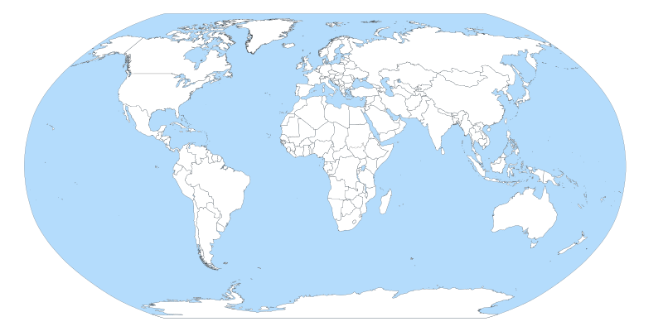

Activity: Ocean Research
After watching and discussing the BTN New Ocean story, what questions do students have and what are the gaps in their knowledge? They can develop their own question to investigate or select one or more of the questions below.
- Investigate sea creatures that live in the deep ocean habitats of the Southern Ocean. How have the animals adapted to survive? What is unique about the deep ocean habitats of the Southern Ocean?
- What is the Antarctic Circumpolar Current? How does it affect us in Australia?
- What role does the Southern Ocean play in buffering the planet from climate change?
- Investigate the critical role sea ice plays in both global climate and Southern Ocean ecosystems.
- What are the threats to the Southern Ocean? What is Australia doing to protect the Southern Ocean?
- The deepest part of the ocean is called the Challenger Deep. Where is it located and how deep is it?

Activity: Southern Ocean Animals
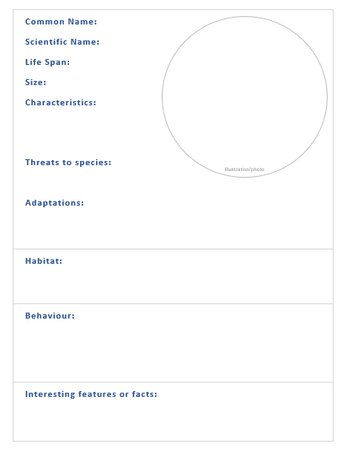
Students will imagine they are marine biologists studying an animal from the Southern Ocean in detail. Students will choose an animal to explore, create a profile and then share their findings with the class. Here are some suggestions:
- Sea lion
- Squid
- Icefish
- Headless Chicken Monster
- Emperor penguin
- Krill
- Blue whale

Students can use the profile worksheet at the end of this activity to organise and present their information.
- Common and scientific name
- Appearance - what are some of their physical characteristics?
- Describe their habitat.
- Threats - what are some of the threats to their survival?
- Adaptations and interesting features.

Activity: The Deep Sea Zones
Students will explore the different deep sea zones in the short video The Deep Sea – Exploring the Zones, then respond to the following:
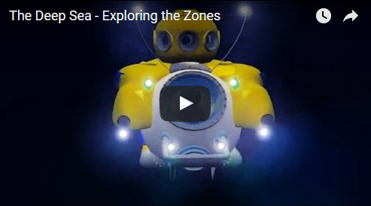
- Describe the deep sea exploration vessel being used to explore the ocean.
- The mesopelagic zone is also known as the ___________________ zone.
- Can photosynthesis occur in this zone? Why?
- Why are a lot of the animals in this zone red?
- What percentage of deep sea animals are thought to bioluminescent?
Further Learning
- What animals and plants are unique to the deep sea?
- How are creatures able to survive in the deep sea?
- What are some challenges to life for deep sea creatures? (Pressure, cold, darkness)
- What is bioluminescence?
- How is the light produced?
- Why do some deep sea creatures have this feature?
- Give some examples of creatures that are bioluminescent.

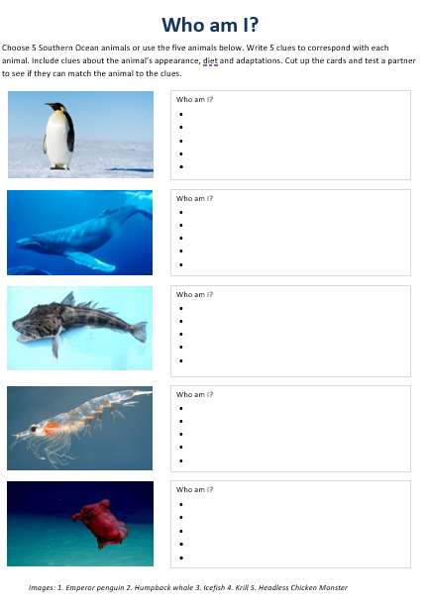
Activity: Who am I?
Students will make their own Who am I? game to learn more about Southern Ocean animals.
- Students will research and write 5 clues to correspond with each animal in the Who am I? worksheet at the end of this activity, with the first clue being the hardest and the last clue being the easiest.
- Include clues about the animal’s special features, its predators and how it adapts to its environment.
- Students will test their game on a partner.

Useful Websites
- Curious Kids: How deep is the ocean? – ABC Education
- Australia Remastered: Australia’s Oceans – ABC
- Meet the creep critters of the Southern Ocean’s `twilight zone’ – ABC News
- Underwater Research – BTN
- Deep Sea Exploration – BTN
- Sea Creatures – BTN
- World Oceans Day: What is it? – Newsround

Southern Ocean Animal
Common Name:
Scientific Name:
Life Span:
Size:
Characteristics:

Threats to species:
Illustration/photo

Adaptations:

Habitat:
Behaviour:

Interesting features or facts:

Who am I?
Choose 5 Southern Ocean animals or use the five animals below. Write 5 clues to correspond with each animal. Include clues about the animal’s appearance, diet and adaptations. Cut up the cards and test a partner to see if they can match the animal to the clues.

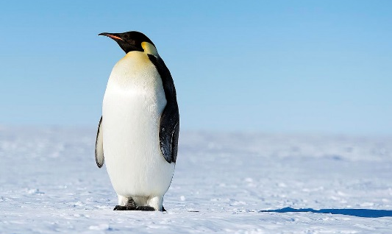 |  | Who am I?
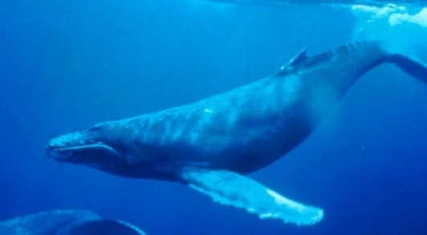 |  | Who am I?
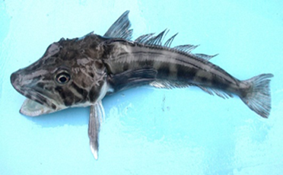 |  | Who am I?
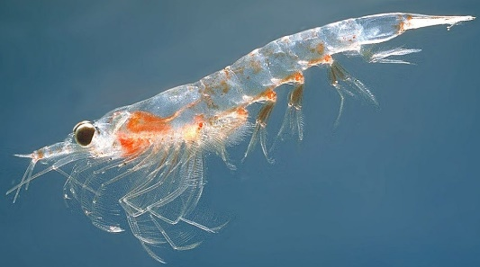 |  | Who am I?
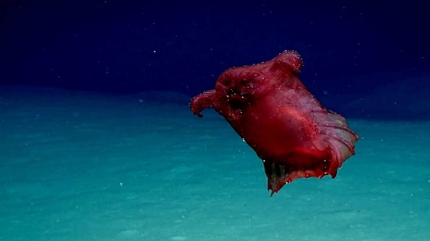 |  | Who am I?
Images: 1. Emperor penguin 2. Humpback whale 3. Icefish 4. Krill 5. Headless Chicken Monster

EPISODE 18
22nd June 2021

KEY LEARNING
Students will investigate portraits in the Young Archie Competition. They will explore different techniques used to create a portrait.

CURRICULUM
Visual Arts – Years 3 & 4
Explore ideas and artworks from different cultures and times, including artwork by Aboriginal and Torres Strait Islander artists, to use as inspiration for their own representations.

Use materials, techniques and processes to explore visual conventions when making artworks.

Visual Arts – Years 5 & 6
Explore ideas and practices used by artists, including practices of Aboriginal and Torres Strait Islander artists, to represent different views, beliefs and opinions.

Develop and apply techniques and processes when making their artworks.

Plan the display of artworks to enhance their meaning for an audience.

Visual Arts – Years 7 & 8
Experiment with visual arts conventions and techniques, including exploration of techniques used by Aboriginal and Torres Strait Islander artists, to represent a theme, concept or idea in their artwork.

Practise techniques and processes to enhance representation of ideas in their art-making.
  - Teacher Resource

Young Archie 2021

Focus Questions
Discuss the BTN story as a class and record the main points of the discussion. Students will then respond to the following:
- Retell the BTN story using your own words.
- What art gallery runs the Young Archie competition?
- When did the Young Archie competition start?
- Who is J.F. Archibald?
- When was the Archibald Prize first held?
- Portraits in the Archibald Prize must be of someone who is well-known. True or false?
- Who can you paint in the Young Archie competition?
- Who did the kids in the BTN story create a portrait of? Give one example.
- What do the kids in the story say to other kids wanting to get involved in art?
- What did you like about this story?

Activity: Class Discussion
Before watching the BTN Young Archie 2021 story, ask students what they already know about portraiture. Here are some discussion starters:
- What is a portrait?
- Why are portraits made?
- What do portraits tell us about a person?
- What makes a portrait interesting?

After watching the BTN story as a class, respond to the following questions:

- What did you SEE in this video?
- What do you THINK about what you saw in this video?
- What does this video make your WONDER?
- What did you LEARN from this story?

Activity: Mind Map
Ask students to think of words they associate with the word portraiture. Record students’ ideas on a mind map with the word PORTRAITURE in the middle. Below are some suggested words.

BACKGROUND | COMPOSITION | LIVE SITTING
FACIAL EXPRESSION | FOREGROUND | FORM
GESTURE | IDENTITY | PORTRAIT
POSE | SETTING | TECHNIQUE

Ask students to clarify their understanding of the key words by writing down what they think the word means. Swap definitions with a partner and ask them to add to or change the definition. Check them using a dictionary or other source.

Activity: Analyse art work
Students will select their favourite portrait from the 2021 Young Archie competition. Below are examples of three finalists. Students will analyse and reflect on the portrait and then respond to the questions below.

Finalists – Young Archie 2021, Art Gallery NSW
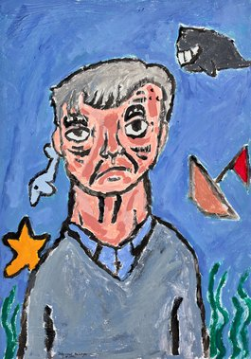  Jude  Captain | 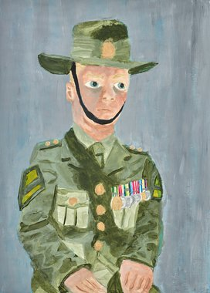  Ella  My hero, Dad | 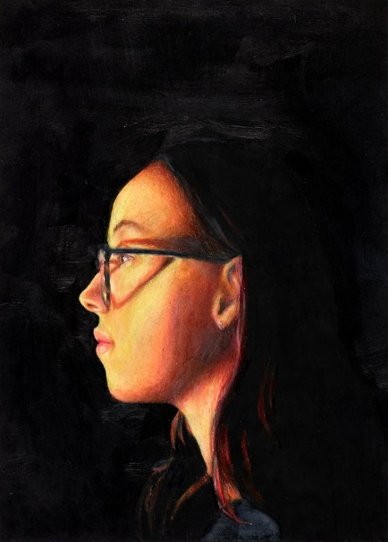  Ruby  My light

Questions to help guide students’ exploration:
- Record as much information as you can about the portrait in 15 minutes. Record everything you see. The longer you look the more you will see. Consider looking at it from different angles, up close and far away.
- Who do you think the portrait is of? What can you tell about their personality? What are they doing? What is the mood of the portrait? Describe their facial expression and pose.
- Do you notice any objects in the portrait? How do these objects represent the subject’s identity or individuality?
- How does the portrait make you feel? What do you like about this portrait/self-portrait? Why did you choose it?

Activity: Create a portrait
Create a portrait.
Students will create a portrait of a person who is special to them, using the following as a guide.
- Choose someone who is known to you and who knows you and plays a significant role in your life.
- Write 2-3 sentences explaining who the person is and why you chose them.
- What technique/s will you use to create your portrait? Think about colours to reflect mood or feelings.
- Organise a live sitting with your subject, where you and your subject are together, and you are working on their portrait. Complete your portrait using photographs of your subject as a reference. Give your portrait a title. Write 2-3 sentences about your portrait.
- Consider entering your portrait in next year’s Young Archie competition.

Create a self-portrait.
Students will create a self-portrait which represents how they see themselves. Looking at a mirror, students will experiment with poses, costumes and props and produce a self-portrait. Initially students can do some quick, detailed sketches of different features and then use these sketches to help create a final self-portrait. Students will write an artist's statement to go with it.

Below are some guidelines for students as they create their self-portrait:
- Use colours that you feel reflect your mood or feelings.
- What style will you use to create your self-portrait? How will it help portray your identity?
- Where are you going to sit? Think about the background of your self-portrait. Is it real or imaginary?

Class Exhibition
Curate a class exhibition of your students’ portraits and/or self-portraits and choose a title for the exhibition. Invite students from other classes at your school to attend your exhibition. Consider holding your exhibition at your local library or local council.

Activity: Research project
After watching and discussing the BTN Young Archie 2021 story, what questions do students have and what are the gaps in their knowledge? The following KWLH organiser provides students with a framework to explore their knowledge on this topic and consider what they would like to know and learn.

What do I know? | What do I want to know? | What have I learnt? | How will I find out?

Students will develop their own question/s to research or select one of the questions below.
- Who started the Archibald Prize? Investigate the 100 year history of the Archibald Prize and present your findings in an interesting way.
- How has portraiture changed over history? Compare the beginnings of portraiture to modern portraiture that you see now. Illustrate using a timeline.
- What different techniques can be used to create portraits? Choose two finalists from the Young Archie competition 2021 or the Archibald Prize 2021 and make comparisons. How are they similar or different?
- What do portraits tell us about a person? Give examples.
- How did painters like Vincent Van Gogh and Paul Gaugin challenge traditional portraiture? Create your own portrait inspired by the artist’s style and technique.

Activity: Visit an art gallery
Plan a trip to your local art gallery to explore and investigate its range of portraits. Look for photographs, prints, paintings, and sculpture. Alternatively, if you are unable to physically visit an art gallery, visit an online art gallery. For example, visit the National Portrait Gallery to explore a range of different portraits. The National Portrait Gallery also offer Virtual Excursions that your class can experience.

Before visiting the art gallery | As a class, plan a trip to your local art gallery to explore its collection of portraits. You will need to think about the following:  - Before you visit the gallery discuss as a class what a portrait is. List points about what makes a good portrait.  - What do you want to learn? Write 5 questions that you would like to investigate.  - How will you get there and how long will you need to visit the gallery?  - What will you need to take with you?
Trip to the art gallery | When you arrive at the art gallery, select a portrait which you will investigate as a class. Students will then respond to the following:  - Record as much information as you can about the portrait in 15 minutes.  - Record everything you see. The longer you look the more you will see. Consider looking at it from different angles, up close and far away.  - Is it a painting, print, sculpture or another type of artwork? What materials were used to make it?  - What is the subject’s expression and pose? Do you notice any objects in the portrait?  - How does the portrait make you feel?  - Draw a picture of the artwork including as much detail as possible.  If time permits, consider completing one or more of the further investigations below:  - Choose a portrait you like and then imagine a narrative for the subject of the portrait. Who do you think they are? What can you tell about their personality? What are they doing? Where are they from?  - Choose two portraits by different artists and compare. Describe any similarities or differences.
Back at school | Students will reflect on the portrait they studied as a class and use the internet to learn more about the artist. Respond to the following.  - Did you enjoy visiting the gallery and investigating their collection of portraits? Why or why not?  - What were your first impressions of the portrait you studied?  - If you could interview the artist, what questions would you ask them about the portrait? Find out if you can contact the artist for an interview.  - What is the ‘story’ behind the portrait?  - Where is the artist from?  - Interesting facts  Further investigation:  - How does portraiture help us understand and appreciate people – their identity, history, culture and diversity?

Activity: Self portrait
Who am I? Students will reflect on this question and explore their own identity through discussion, writing and art. Students will brainstorm and record how they see themselves, responding to the following reflective questions. Students will then take the information they have learnt about themselves and create a self-portrait.

- Who are you?
- What words best describe you?
- What are you really passionate about?
- What are your most important values?
- What do you think is unique and special about you?
- What are your strengths?
- What are your challenges?
- How are you similar/different to other people? How do you feel about your differences?
- When do you feel most like yourself?
- How do you want people to see you?
- Why is it so important to be yourself?

Students will then create a self-portrait which represents themselves. Looking at a mirror, students will experiment with poses, costumes and props and produce a self-portrait. Initially students can do some quick, detailed sketches of different features and then use these sketches to help create a final self-portrait. Students will write an artist's statement to go with it. Curate a class exhibition of your students’ self-portraits and choose a title for the exhibition.

Useful Websites
- Young Archie Competition – Art Gallery NSW
- Young Archies 2018 – BTN
- Archibald Prize – Art Gallery NSW
- Education – National Portrait Gallery
- NAIDOC Indigenous Women – BTN

  - Teacher Resource

BTN Transcript: Episode 18 - 22/6/2021

Hey. I'm Amelia Moseley and you're watching BTN. Here's what's coming up. We share the results of our Kids Talk Survey, why we have a new ocean near Antarctica, and we meet some of the finalists of the Young Archie portrait competition.
Tamil Asylum Seekers

Reporter: Amelia Moseley

INTRO: But first. One of the biggest stories of the week has been about a family of asylum seekers from Sri Lanka. They've lived in Australia for a while now, but they haven't been accepted as refugees. Instead, they've spent nearly two years in detention on Christmas Island where recently the youngest member of the family got really sick. There have been calls to let the family stay here for good, but the government says it's not that simple. Let's find out more.
Celebrating your fourth birthday in hospital doesn't sound like much fun, but it helps when a bunch of celebrities sing your favourite song to cheer you up. That's what happened to Tharnicaa. But the most important part of this extra special video was at the end.
NADEZ AND KOPIKA MURUGGAPPAN, THARNICAA'S DAD AND SISTER: I miss you, I love you, Tharnicaa. Bye, see you.
While Tharnicaa was in a hospital in Perth with her mum, her dad and big sister Kopika were still in detention over here on Christmas Island. That's because the Murugappan family are asylum seekers. That's someone who leaves their country because they believe it's unsafe. That might be because of war or violence, bad treatment because of their ethnicity, religion or political views. Once they arrive in a new country, governments have to work out if they're in genuine need of protection because seeking asylum is a human right and international law. And if they are, they can be granted refugee status which may allow them to stay for good.
While they wait, our government's policy is to send asylum seekers to live in community detention where they have more freedoms, or detention centres on mainland Australia or offshore. And it can take some time; asylum seekers can be detained for several months or several years.
Tharnicaa's parents Nadez and Priya came here by boat from Sri Lanka; a country that, at the time, had just gone through decades of civil war. They were given permission to live in the community of Biloela in Queensland for a while and it's where Tharnicaa and Kopika were born.
But in 2018, the government decided they weren't genuine refugees who needed protecting and the family was taken from their home and sent to a detention centre in Victoria and later Christmas Island. They've been fighting in court ever since to try to come back to mainland Australia, and when Tharnicaa got really sick recently and had to be flown to Perth, lots of people came out to support them.
PROTESTERS: Let them stay. Let them in.
One of the reasons people are so upset is because Tharnicaa and Kopika are now the only kids in detention in Australia and studies show that can impact a kid's health and wellbeing.
Aran Mylvaganam, Tamil Refugee Council: This family should be sent to Biloela. That's the easiest option.
But some reckon it's not so easy. The government says it has to try to discourage people from arriving by boat because it's really dangerous and the people running the boats, known as people smugglers, make money off it.
Which is why the government usually sends anyone that arrives here by boat without permission to a detention centre. It also says it is safe for the family to go home to Sri Lanka and it can't make an exception just for them.
For now though, Australia's immigration minister has made an exception. Tharnicaa's dad and big sister have been allowed to come and live temporarily in Perth too while she gets better.

ALEX HAWKE, IMMIGRATION MINISTER: Today I’ve made a compassionate decision to obviously reunite the family in Perth and allow them to live in the community while all remaining matters are heard.
NADEZ MURUGAPPAN, THARNICAA'S DAD: This process make happy.
Angela Fredericks, Family Friend: Everyone was feeling very uplifted that the family were all together again.
But until their future is decided, the story of the Murugappan family isn't over.
News Quiz

Australian Health authorities have changed their advice about which age ranges should receive which COVID-19 Vaccine. Is Pfizer now the preferred vaccine for anyone under the age of 70, 60 or 50. It's gone up to 60. Which means only Aussies over that age will likely be getting AstraZeneca.
If you're afraid of spiders, look away now and for the next 30 seconds or so. Yep, across this roadside they're everywhere. They're trying to escape floodwaters in which Australian state? Victoria, New South Wales or Queensland. It's Victoria. South Gippsland was one of the hardest hit parts of the state during last week's wild weather.
The first astronauts have blasted off to China's brand new space station. They'll spend three months aboard in their own separate living spaces with a treadmill for exercise, and a communication centre to stay in touch with ground control. How many astronauts are calling the space station home? 3, 4 or 5. It's 3. They've undergone more than 6,000 hours of training, including hundreds of underwater somersaults in full space gear.
Kids Talk Results

Reporter: Joseph Baronio
INTRO: Over the past few weeks we've asked you to take part in our Kids Talk survey. We wanted to find out how you feel about school, family and friends, how Covid-19 has affected you and what you think about the future and, you've answered. Here's Joe with the results.

What a year it's been. Yep, a lot has happened, and a lot has changed. But, according to BTN's 2021 Kids Talk survey it hasn't been such a bad time for a lot of you. At least when it comes to school, family and friends. More than 75% of you say that you're happy or very happy with school and more than 80% say the same about your family and friends.
KID 3: What makes me happy is going out with my friends to the skatepark.
KID 4: Yeah, my friends and family, they really, like, support me.
KID 6: I enjoy hanging out with my friends as well, but I really love my pets.
But all that happiness must take a lot of energy because while nearly 60% of you said you were happy lots of the time. 42% said that you're also tired a lot of the time.
KID 2: I think kids could be tired because they might be on their screens too much.
KID 1: Not getting enough sleep, watching screens before their bed time.
There were some big issues on the table too, including bullying. In BTN's 2019 Kids Talk survey, 60% of kids said they'd been bullied and while it's down to 54% this year. More have reported bullying is happening online. Another big one is racism. We've seen lots of people taking a stand against it recently as the Black Lives Matter movement spread across the globe. And 58% of you still think there is a lot of racism in Australia.
And then we get to the elephant in the room. COVID-19. It's by far the biggest thing to affect the world lately, but that doesn't mean that much has changed for you guys. When asked if your school work or the amount of exercise that you do was affected by the pandemic. More than half of you said that it was just the same as before.
KID 5: Well the pandemic didn't really affect me, except like the lockdown, it affected school.
KID 6: I don't think it affected me too much.
KID 4: It made me have a lot more free time.
And speaking of things not changing, when asked if our flag or the date of Australia day should be changed. Most of you said that neither should be changed.
Finding reliable sources of information can be hard and the majority of you say that fake news is a problem. But what kind of people do you trust the most? You said that doctors, teachers, police and scientists were at the top, with social media influencers, celebrities, politicians and journalists being the least trustworthy.
There was another big issue on the minds of kids around the country and that's climate change. In fact, more than 87% of you say that it's something you worry about and while there have been marches across the country calling for more action. It seems that most of you think that Aussie politicians don't listen to kids.

KID 3: Yeah, I'm pretty worried about climate change.
KID 5: I don't think I'm really worried about it, but I think something should be changed because it's gonna happen.
JOE: And do you think politicians listen to kids?
KID 5: No.
KID 1: In my opinion they don't listen.
KID 4: But young people have so many good ideas and points that they could have listened more.
In times like this, it's important to keep looking forward and stay optimistic and most of you say that your hopeful for your future and the future of Australia.
KID 2: I'm hopeful for my job and what I do.
KID 6: For Covid-19 to be gone and there be no more new diseases in the future.
KID 3: For a cleaner and more safer environment.
KID 1: That everything just like this.
KID 4: And enjoy life.

New Ocean

Reporter: Jack Evans

INTRO: If you've been thinking about updating your world maps now might be the time. Because the National Geographic Society has just added a new ocean. So where did it come from? Jack dived in to find out more.

Somewhere in the depths of the Earth's waters a very important decision was about to be made.
POSEIDON: Alright, next item on the agenda?
LOBSTER: Ah, the body of water surrounding Antarctica.
POSEIDON: Ah yes, a nice place to chill. What that was a good joke. Anyway, what about it?
LOBSTER: The National Geographic Society think it's about time it became an ocean.
POSEIDON: Oh, do they now? Oh yeah sure, let's just add a new ocean. Anybody else want their own ocean?
LOBSTER: I think they've got a pretty good argument.
POSEIDON: Oh yeah, I'm sure they do. But we can't just go around making new oceans because a bunch of people think we should.
Ah actually that's kinda what already happened.
POSEIDON: What? Who said that?
Let me introduce you to our new ocean or rather you can wave hello to the Southern Ocean. It's located in, well, the south. More specifically it's this bit of water here surrounding Antarctica.
POSEIDON: Oh yeah, he's right. They did make it an ocean. Who approved this?
Recently the map makers at the National Geographic Society decided to upgrade this area to full on ocean status. Joining the other four, say them with me now, The Arctic, Atlantic, Pacific and Indian. So, what does make an ocean an ocean? Typically, they've been defined as the big open bodies of water that are separated by the continents around them. But this new Southern Ocean is defined by something else.
LOBSTER: The Antarctic Circumpolar Current.
POSEIDON: What about it?
LOBSTER: Well, that's what they think makes it, its own ocean.
The Antarctic Circumpolar Current or ACC for short is the strongest ocean current on our planet and it helps to keep the Antarctic cool and icy. As it swirls and swirls and swirls around Antarctica it pushes the warmer water away and keeps the icy cold water nice and close to the continent.
POSEIDON: Yeah, so what? I could do that with this trident if I wanted to. But I won't, because I don't need to show off.
The ACC makes these waters completely different to anywhere else on Earth. Plus, it's home to thousands of species that aren't found anywhere else, so yeah, it's a pretty unique area and it's something scientists have known for ages. Lots of scientific organisations have recognised it as its own ocean since the early 2000's, now it's just officially become official for the rest of us, officially.
POSEIDON: But nobody asked for my permission.
LOBSTER: Yes, they did you just kept ignoring all the emails.
POSEIDON: Yes, because all my electronics have water damage. Honestly, what's the point of being God of the Seas, and water generally, if people are just do whatever they want anyway. Maybe I should go to that Southern Ocean and chill out for a bit.
LOBSTER: Well, you are a bit crabby.
POSEIDON: Oh, like you can talk.
LOBSTER: Um, I'm a lobster.
Quiz

How much of the ocean has been explored? 80 per cent, 50 per cent or 20 per cent? Well, according to the US National Ocean Service, it's only around 20 per cent which means most of it is still unmapped, unobserved, and unexplored.
Young Archie 2021

Reporter: Joseph Baronio

INTRO: Let's turn our attention now to some talented up and coming artists who have all been named finalists for the 2021 Young Archie award. It's a junior version of Australia's most famous portrait prize, the Archibald and their entries will blow you away. Take a look.

RUBY: Hi BTN, my name is Ruby, and I've been nominated as a finalist for the Young Archie.
ELLA: Hi BTN, my names Ella Flitton, and I've been nominated as a finalist for the Young Archibald Prize.
JUDE: Hi BTN, I'm Jude, and I've been nominated as a finalist for the Young Archie.
Yep, these kids are talented artists, who are all in the running to win one of the most prestigious junior art prizes in the country. The Young Archie is a competition run by the Art Gallery of New South Wales and has been recognising the next generation of artists since 2013. But the competition it stems from, The Archibald Prize, goes back a lot further than that. It started way back when a journalist and art enthusiast called J.F Archibald left a bunch of money in his will to set up the Archibald prize and 100 years ago, in 1921, the first competition was held. Since then, it's become the most prestigious prize in Aussie art, and to be eligible artists have to paint a portrait of someone who's well-known, like an actor or musician or politician or even another artist, like this year's winning piece.
JOE: For the Young Archie, entrants also have to paint a portrait. Except it has to be of someone they know and who's special to them. So, let's find out a little more.
RUBY: My piece was basically created with coloured pencils, oil pastels, paint, and it's called My Light, and it's about Lily here.
JUDE: Well, I chose to paint my great grandpa because we were just told to bring in about someone who's important to me. I used to see him every weekend, but he passed away. So, he was just kind of important to me and I had a really nice photo.
ELLA: The subject is my dad in his army gear, and it's called my hero dad. I think it was just because I was really, really proud of him because he's always gone away for so long, but he's always ended up making time for us whenever he comes back, and I really just love him.
RUBY: For me, I've always tried to make my pieces really about capturing the thing or the person, not necessarily for realism but for their personality or how I see them and how they portray themselves. So, basically, my inspiration for the piece was Lily; her personality, her behaviours, her mannerisms, just her as a person.
JOE: And so, how long have you been doing art?
ELLA: As far back as I can remember really, I've always loved painting and drawing and I think it really comforts me.
JUDE: I guess since primary school, I guess like since I started art class.
RUBY: We've practically been artists since we were very little, we've always called ourselves artists, we always hope to call ourselves artists.
LILY: We could probably have been artists since we could pick up a pencil, like it was just a hobby that never really went away for us.
JOE: and why did you want to enter the Young Archies?
ELLA: Well mum mentioned it one day when I was just painting outside, and I thought maybe I'd give it a go.
JUDE: I didn't really. We just kind of painted everybody, everyone painted and my teacher, she just chose the best one and put it in.
RUBY: We always thought of the Young Archie competition, we never wanted it to be about winning and we didn't want it to be about beating other people. We just used it as an excuse to create something.
JOE: And what would you say to any young artists out there who might also want to get involved in art?
ELLA: I'd just say be yourself and don't be afraid to try new things like push yourself out of your comfort zone because you never know what might happen.
JUDE: Well, I don't consider myself, like, a good artist, I think a lot of other people in my classes have better ones. I think it was only really by accident that I made a good art piece, so I think just try it and make something good.
LILY: No matter what people say, just do art because you love it and always appreciate your art because it's yours.

Sport

Aussie Ben Simmons has been knocked out of the NBA playoffs. He and his Philadelphia 76ers lost to the Atlanta hawks in a tight game 7 today. Atlanta will now take on the Milwaukee Bucks for a spot in the finals.
Back here in Australia, Melbourne United are one win away from an NBL title. They beat Perth on Sunday taking a 2-nil lead in the best of 5 series. Chris Goulding top scored for Melbourne with 21 points. Melbourne's Yudai Baba finished with 15 points for the game, none better than this long bomb.
And a whole bunch of swimming records have been broken at the Australian swimming trials. 19 year old Kaylee McKeown broke the world record in the 100m backstroke clocking in at 57.45 seconds. Ariane Titmus took out the Commonwealth record in the 400m freestyle coming in at 3 mins 56.90 seconds and then one day later, she became the second-fastest female EVER in 200m freestyle finishing up at 1 min 53.09 seconds just .11 seconds slower than the world record set way back in 2009. It didn't stop there. Zac Stubblety-Cook broke the Commonwealth Record in 200m breaststroke and Jake Michel in 100 m breaststroke.

Artistic Swimmers

Rookie Reporters

INTRO: The Tokyo Olympics are set to kick off in just over a month now and the young athletes in this next story have been getting ready to compete in the pool. Let's meet Australia's Artistic Swimming team and find out more about their incredible sport.

KIERA: Hey BTN I'm Kiera.
AMIE: Hi, my name is Amie Thompson.
EMILY: Hi, my name is Emily Rogers. I'm a part of the Australian artistic swimming team.
KIERA: Heading to the Tokyo Olympic Games for artistic swimming.
AMIE: Artistic swimming is a sport that combines a lot of different elements we need strength, flexibility, endurance, breath, holding capacity, teamwork skills. We often describe us as a mixture between swimming and gymnastics.
EMILY: Artistic swimming is a very, very difficult sport. But the aim of it is to really show that it's effortless, and that you're having the best time ever.
KIERA: It requires you to be upside down and right side up with a huge smile on your face.
KIERA: To the naked eye synchronized swimming might seem quite easy and simple. But that is our goal when we swim to make ourselves look elegant and light, but in reality, is quite difficult to hold your breath.
AMIE: My journey into this sport is a little bit interesting. I was a competitive swimmer and I also was trying gymnastics when I was younger, and I was really, really, really bad at both and for some reason someone told my parents that I should try synchro tried, put the two sports that I'm not very good at together and I found something that I loved and was good at.
EMILY: I was always a swimmer and my mum really wanted me to do a team sport as well. So, I love to dance and just combined both of those passions and it all just seemed to work out.
AMIE: We have been living at the AIS since January. And we will be living here until the Games. So, it is a great facility for us where we can just knuckle down and get the job done. We wake up we train we eat, we train, we eat, and we sleep and recover. And the areas is the perfect environment for us to be able to do that with no distractions.
EMILY: Some moves and techniques that we use in the routine is a lot of arm movements under the water above our head. And then we do a thing called eggbeater, which is when we're upright, we do our legs in an egg beater motion, and that keeps us really high, and we can present to the whole audience. I'm really excited for the Tokyo Olympic Games; I went to the Rio 2016 Olympics. So, I think it's gonna be a very different experience to the last one, but I'm really excited to see where this new team goes and that we perform the best that we possibly can.
KIERA: I love it representing Australia we have such a unique and lively team. I have vivid memories at past competitions singing the national anthem on the podium and feeling full of happiness and joy.

Closer

Go team. Best of luck. Well, that's it for now but we'll be back with more news for you next term. Until then, you can check out our website and keep up to date with BTN Newsbreak every weeknight. If you're 13 or over, you can also subscribe to our YouTube channel where we'll be adding more content over the break. Enjoy your holidays everyone. Stay safe and I'll see you really soon.

