EPISODE 11
7th May 2024

KEY LEARNING
Students will view a range of BTN stories and use comprehension skills to respond to a series of focus questions.

CURRICULUM
English – Year 4
Use comprehension strategies to build literal and inferred meaning to expand content knowledge, integrating and linking ideas and analysing and evaluating texts.

English – Year 5
Use comprehension strategies to analyse information, integrating and linking ideas from a variety of print and digital sources.

English – Year 6
Use comprehension strategies to interpret and analyse information and ideas, comparing content from a variety of textual sources including media and digital texts.

English – Year 7
Use comprehension strategies to interpret, analyse and synthesise ideas and information, critiquing ideas and issues from a variety of textual sources.
  - Teacher Resource

Focus Questions
As a class, discuss the stories featured in the episode of BTN Classroom and record the main points of the discussion. Students will then respond to the following focus questions.

eSafety Laws
- Australia became the first country in the world to create an eSafety commission. True or false?
- What is the role of the eSafety commission?
- What social media company has recently been asked to remove content by Australia’s eSafety Commissioner?
- Do you think there should be rules about what people can say on the internet?
- What questions do you have about the story?

Bonza Bust
- Bonza recently went into voluntary administration. Explain what this means using your own words.
- What year did Qantas start flying in Australia?
- What does Qantas stand for?
- What other airlines have operated in Australia? Name one.
- What do you understand more clearly since watching the BTN story?

Spears Return
- Briefly summarise the BTN Spears Return story.
- How do the Gweagal and Dharawal people feel about the return of the spears?
- What Dreaming story do the Gweagal spears tell?
- Who took the spears from the Gweagal people?
- What other types of artefacts were taken from Aboriginal people?

Check out the teacher resource on the Archives page.

Ancient Kangaroo
- What does the short-faced kangaroo look like? Describe its characteristics.
- How many years ago did the short-faced kangaroo become extinct?
  - 400
  - 4,000
  - 40,000
- Fill in the missing gaps. The short-faced kangaroo is a type of _______ fauna.
- What did palaeontologists recently uncover in a cave in East Gippsland?
- What questions would you like to ask a palaeontologist?

Check out the teacher resource on the Archives page.

Cunnamulla Cricket Team
- Where is Cunnamulla? Find on a map of Australia.
- Why did Henry want to start a junior cricket team in Cunnamulla?
- How did Henry recruit players for the cricket team?
- How has the local community helped Henry?
- How did the BTN story make you feel?

EPISODE 11
7th May 2024

KEY LEARNING
Students will explore the lasting impact that British colonisation has on the lives of Aboriginal and Torres Strait Islander peoples.

CURRICULUM
HASS – Year 3 and 4
Pose questions to investigate people, events, places and issues.

HASS – Year 4
The journey(s) of AT LEAST ONE world navigator, explorer or trader up to the late eighteenth century, including their contacts with other societies and any impacts.

The nature of contact between Aboriginal and Torres Strait Islander Peoples and others, for example, the Macassans and the Europeans, and the effects of these interactions on, for example, people and environments.

HASS – Year 5
Present ideas, findings, viewpoints and conclusions in a range of texts and modes that incorporate source materials, digital and non-digital representations and discipline-specific terms and conventions.

HASS – Year 5 and 6
Develop appropriate questions to guide an inquiry about people, events, developments, places, systems and challenges.

HASS – Year 7
Construct significant questions and propositions to guide investigations about people, events, developments, places, systems and challenges.
  - Teacher Resource

Spears Return

Focus Questions
Discuss the BTN story as a class and record the main points of the discussion. Students will then respond to the following:
- Briefly summarise the BTN Spears Return story.
- How do the Gweagal and Dharawal people feel about the return of the spears?
- What Dreaming story do the Gweagal spears tell?
- Who took the spears from the Gweagal people?
- What other types of artefacts were taken from Aboriginal people?

Aboriginal and Torres Strait Islander people should be aware that this document may contain images and names of deceased persons.

Activity: Class Discussion
As a class ask students to discuss their thoughts and feelings about the BTN Spears Return story and the repatriation process. Use the following questions to guide discussion:
- What did you LEARN from the BTN story?
- How do you FEEL about what you saw in the story?
- What do you THINK about what you saw in the story?
- What QUESTIONS do you have?

Activity: Personal Response
Respond to the BTN Spears Return story as a class. Students will complete one or more of the following incomplete sentences:
- Learning about the Gweagal spears made me feel…
- Repatriation is important because…
- This story made me wonder…

Activity: Vocabulary
Students will brainstorm a list of key words that relate to the BTN Spears Return story. Here are some words to get them started.

REPATRIATION | ANCESTRAL | TRADITIONAL OWNERS
COUNTRY | ARTEFACTS | SACRED OBJECTS

When learning about First Nations culture there are many unfamiliar words. Explain to your students that
using respectful and inclusive language and terminology is an essential part of reconciliation and strengthening relationships between Aboriginal and Torres Strait Islander peoples and the wider Australian community. If you are unsure seek and listen to advice of your local Aboriginal and Torres Strait Islander community.

Refer to Creative Spirits’ glossary for a list of words associated with Australian First Nations culture.

Further activities for students:
- Start a classroom glossary of words and terminology.
- Use these words in sentences.

Activity: Stories of Our Place
Watch this National Museum of Australia video to learn more about Gamay — Botany Bay.

Students will then respond to the following questions:
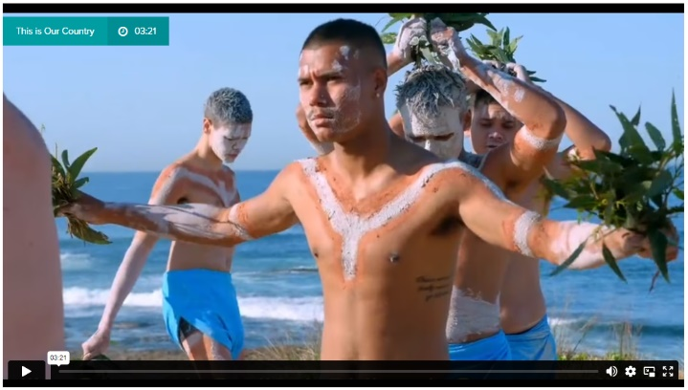
- What is the Aboriginal name for Botany Bay? Find on a map of Australia.
- What does ‘our country’ refer to?
- In this part of the country what are some different ways that Aboriginal people identify themselves?
- What does ‘bunabi’ mean?
- What does ‘guriwal’ mean?
- What is the name of the place where the HM Bark Endeavour landed?
Video: Kamay – Botany Bay (National Museum Australia)

Activity: Dreaming Stories
Dreaming stories pass on important knowledge, cultural values, and belief systems to later generations. Learn about Dharawal country through this Dharawal Dreaming story made by the National Museum of Australia.

One tells the origins of our animals …
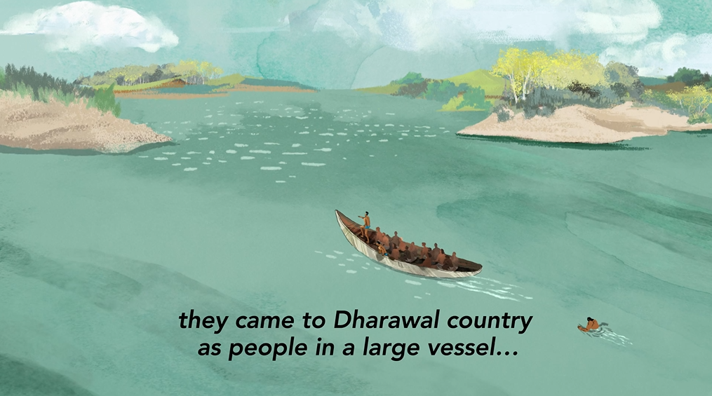 | 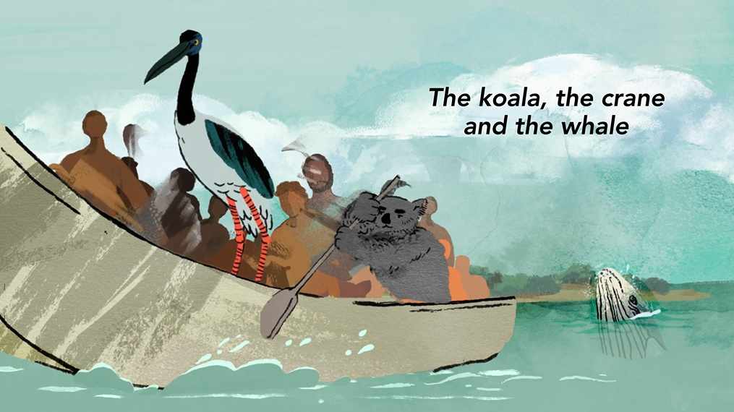

Another Dreaming story tells of how spirits of the dead returned in low lying cloud...
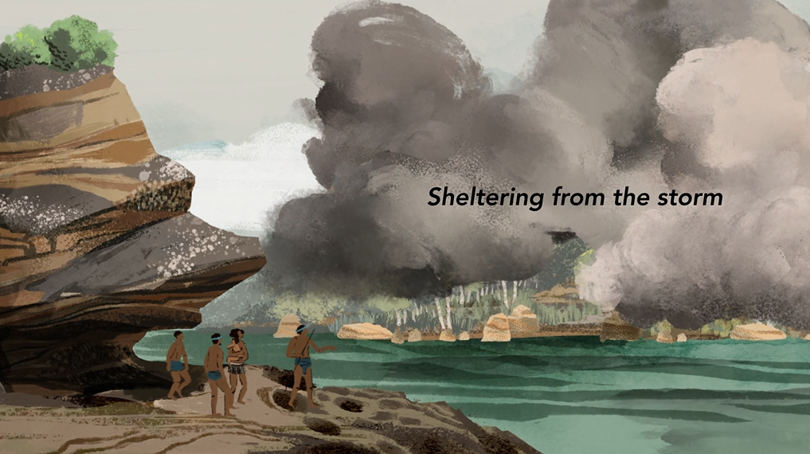 | 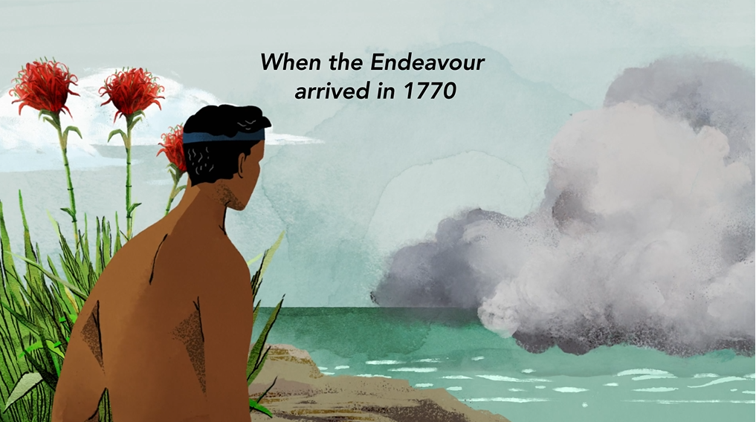
Dharawal Dreaming - Animation (National Museum Australia)

Spears have an important place in Dreaming stories in Aboriginal and Torres Strait Islander culture. Watch The Spear together as a class, a Yirritja story that is told in Dalabon language in Central Arnhem Land, Northern Territory.
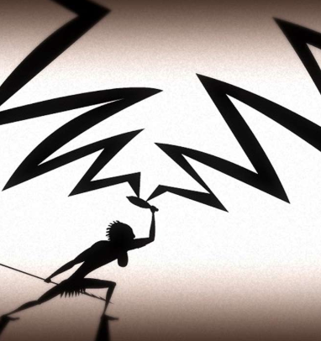
After watching the video students will respond to the following:
- What do you think the story is teaching us?
- What were your reactions or feelings during the story?

Follow-up activities
Teachers can download the ‘Dust Echoes’ study guide by ATOM for further follow-up activities.

The Spear, Dust Echoes - (ABC Education)

Activity: Indigenous Perspective
Launch this ABC Education Video Interactive in your classroom to learn more about HMB Endeavour's arrival in Australia and its lasting impact on Aboriginal and Torres Strait Islander peoples.
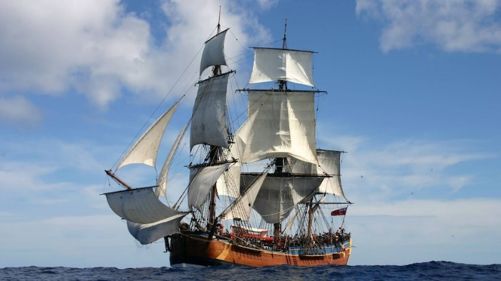
Background
In 1768, His Majesty's Bark Endeavour set sail from England on a scientific voyage of exploration with Lieutenant James Cook at its helm. What did the voyage accomplish for science and navigation? More importantly, what did its arrival on the east coast of Australia eventually lead to? How has this changed the course of Australian history?
HMB Endeavour (ABC Education)

Learn about this momentous voyage, its famous crew and the lasting impact HMB Endeavour's arrival in Australia had on Aboriginal and Torres Strait Islander peoples – the continent's First Peoples.

Link to ABC Education Video Interactive

Activity: Indigenous Perspective
Students will discover more about the first sighting of James Cook's Endeavour, as remembered by the Yuin people of south-eastern Australia. In this ABC Video, Djiringanj Yuin traditional knowledge holder Warren Foster shares the story of this moment through the eyes of his ancestors, an eyewitness account not recorded in journals or history books, but passed down through the generations.
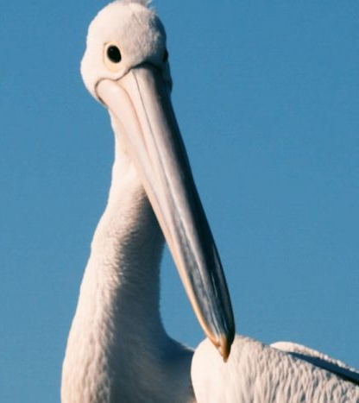
Watch the ABC Video with your students as Warren Foster recounts his people first sighting the Endeavour.

After watching the video, students will respond to one or more of the following:
- Where is Yuin country? Find on a map of Australia.
- What is the significance of the 2 scared mountains in Djiringanj country, Gulaga and Biamanga? Write a sentence for each.
- What did Aboriginal people do when they first saw James Cook sail up the coast of Australia?
- What is the Yuin word for pelican?
To the Yuin people the Endeavour resembled Gurung-gubba, the greedy pelican. (ABC News)
- How did Cook’s ship the Endeavour resemble a pelican for Aboriginal people?
- Tell the story of the Gurung-gubba using your own words.
- Why is Gulaga important to the Yuin people?

Further research
- Who are the Yuin people?
- What language is spoken by Yuin Indigenous Australians?
- Where is Yuin country? Find using Google Maps.
- What is Gulaga and what does it mean to the Yuin people?
- How were the Yuin people impacted by the arrival of European settlers?
- When was Gulaga handed back to its traditional owners?

Activity: BTN Stories
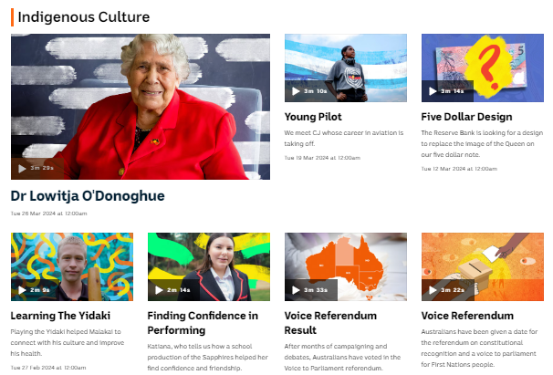
Visit BTN’s collection of stories which focus on Aboriginal and Torres Strait Islander peoples’ culture and issues.

After watching any one of the BTN videos ask students to respond to the discussion questions (to find the discussion questions and teacher resources go to the related BTN Classroom Episode and download the Episode Package).

Collection of BTN stories with a focus on Indigenous culture

Useful Websites
- Indigenous Perspectives of Cook Visit – BTN
- Indigenous Burial – BTN
- Endeavour History – BTN
- Repatriation – National Museum Australia
- Botany Bay, NSW – National Museum Australia
- How did Cook’s Endeavour voyage change Australia forever? – National Museum Australia
- 'Emotional moment' as spears taken by Captain Cook are returned to Indigenous community – ABC News

EPISODE 11
7th May 2024

KEY LEARNING
Students will learn about how fossils are formed and what they tell us about the past. They will also create a profile of a species of megafauna.

CURRICULUM
Science – Year 5
Examine how particular structural features and behaviours of living things enable their survival in specific habitats.

Science – Years 5 & 6
Scientific knowledge is used to solve problems and inform personal and community decisions.

Science – Year 6
Scientific knowledge has changed peoples’ understanding of the world and is refined as new evidence becomes available.

Science – Year 7
Scientific knowledge has changed peoples’ understanding of the world and is refined as new evidence becomes available.

  - Teacher Resource

Kangaroo Fossils

Focus Questions
Discuss the BTN story as a class and record the main points of the discussion. Students will then respond to the following:
- What does the short-faced kangaroo look like? Describe its characteristics.
- How many years ago did the short-faced kangaroo become extinct?
- Fill in the missing gaps. The short-faced kangaroo is a type of _______ fauna.
- What did palaeontologists recently uncover in a cave in East Gippsland?
- What questions would you like to ask a palaeontologist?

Activity: Class Discussion
Discuss the BTN Kangaroo Fossils story as a class and record the main points on a mind map with FOSSILS in the centre. Students will respond to the following:
- What are fossils?
- Have you ever seen a fossil? Where did you see it and what did it look like?
- How are fossils formed?
- How old are the fossils found in the cave thought to be?
- What did you learn from this story?
- What does this story make you wonder?
- Think of three questions you would like to ask about the story.

What questions do you have?
What surprised you about this story?

Activity: Glossary
Students will brainstorm a list of key words that relate to the BTN Kangaroo Fossils story. Here are some words to get them started.

FOSSIL | EXTINCT | MARSUPIAL
PALAEONTOLOGY | EXCAVATION | MEGAFAUNA

Ask students to write what they think is the meaning of each word (including unfamiliar words). They will swap definitions with a partner and ask them to add to or change the definition. Check these against the dictionary definition.

Activity: Fossils Research
Discuss the information raised in the BTN Kangaroo Fossils story. What questions were raised in the discussion and what are the gaps in students’ knowledge? The following KWLH organiser provides students with a framework to explore their knowledge on this topic.

What do I know? | What do I want to know? | What have I learnt? | How will I find out?

Students will develop their own question/s to research or choose one or more of the questions below. Encourage students to collect and record information from a wide variety of sources and present the information they find in an interesting way.
- Why is the short-faced kangaroo considered an important discovery in palaeontology?
- What can the size and shape of a fossilised bone tell us about the animal it belonged to?
- How are fossils formed? Use illustrations to help describe the process.
- How does finding fossils help scientists learn about the past?
- How do the layers of the Earth help us to work out the age of fossils?
- What are the different types of fossils? Create a graphic that explains each type.
- What are the challenges of excavating fossils from a cave?
- What is the role of a palaeontologist? What are the different parts to the job of a palaeontologist and what skills do they need to have?
- What tools and techniques do palaeontologists use to excavate and study fossils?
- Investigate another extinct animal that lived in Australia. What do we know about them?
- What are Australia’s megafauna? When did megafauna exist and how do we know they existed?
- What theories are there for the extinction of Australia’s megafauna? Investigate possible causes.
- Research the Pleistocene – the time when megafauna roamed Australia.

Activity: Megafauna Profile
Students will investigate in more detail the short-faced kangaroo or another species of megafauna using the following questions to guide their research.
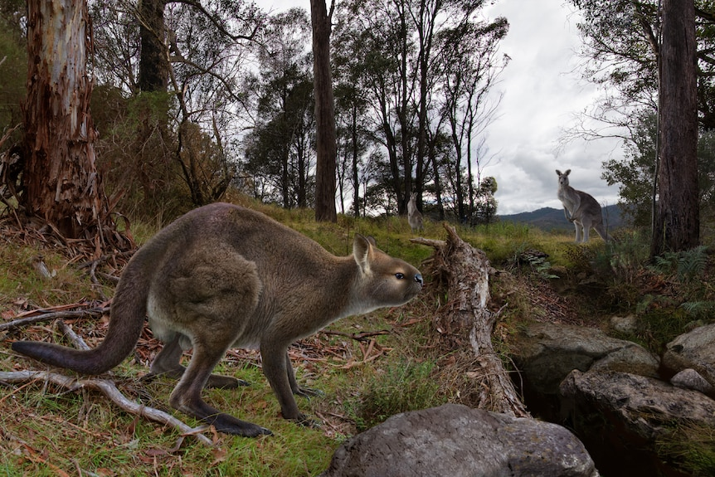
- Common and scientific names.
- What type of animal is it? (mammal, reptile, bird)
- How big was it?
- Where did it live? Describe the habitat.
- What did it eat? Was it a herbivore or carnivore?
- How long ago did it live?
- When did it become extinct? What are some possible causes of its extinction?
- What existing species it is similar to?
- Interesting fact. Source of image

Find out more about the short-faced kangaroo here including photographs of the skeleton fossils found in the cave and a video explaining how the fossils were extracted and the challenges palaeontologists faced.

Activity – Choose an Activity
Working individually or in pairs, students can choose one or more of the following activities to try. Ask students what they learnt doing the activity.

Quiz
Create a Kahoot! quiz about fossils and/or the short-faced kangaroo.
Megafauna story
Choose a species of megafauna and write a fictional story and about it or write about a day in the life of.
Compare the kangaroos
How does the short-faced kangaroo compare to today’s kangaroos? Show the similarities and differences on a Venn diagram.
Make your own fossil
Learn how impression fossils are formed by making your own fossil using clay. Follow the instructions on the Australian Museum website.

Activity: Reporter for a day
Students will be a reporter for a day and investigate the discovery of ancient kangaroo fossils in a cave in Victoria. Write an online news report for kids explaining how the fossils were found and why it’s an important scientific discovery. Student’s reports will answer the 5 W’s – Who, What, Where, When and Why?

Things for students to think about:
- Who is your target audience? Use age appropriate language and themes.
Who, What, Where, When and Why?
- Write a headline that is short and to the point.
- Use words and pictures in your report.
- Find information from a variety of sources.
- Present the facts and/or opinions clearly and accurately.

Visit BTN’s Rookie Reporter Training and Becoming a Journalist to learn more about how to make a news story.

Useful Websites

Cavers and scientists unearth near-complete short-nosed kangaroo fossil from East Gippsland cave – ABC News
- Short-faced Kangaroo – Museums Victoria Collections
- What are fossils? – Australian Museum
- How do fossils form? – Australian Museum
- Megafauna – Australian Museum

  - Teacher Resource

BTN Transcript: Episode 11 - 7/5/2024

Hey, I'm Amelia Moseley and you're watching BTN. Thanks for joining us again. Let’s see what’s coming up on today’s show. We find out more about why Bonza went bust, learn about ancient kangaroos and meet the kid behind Cunnamulla's junior cricket team.

eSafety Laws

Reporter: Michelle Wakim

INTRO: All that soon, but first today to a debate that's going on right now over freedom of speech and safety online. The government is asking the public if Australia should toughen up rules around what you can and can't put on social media. It’s following a bit of a fight with a tech billionaire. Here's Michelle with more.
MICHELLE WAKIM, REPORTER: Welcome to the internet. A place of fun and unlimited possibilities. Want to learn? We have all the information in the world, literally. Is it all true? What is true anyway? You can connect with old friends and make new friends. Yeah, that guy looks friendly. Did you say kittens? Of course we have kittens. There's also horrific violence, crime, hate speech and bullying.
Okay, if the internet was a place, you’d probably think twice about going there. And yet, most of us spend a lot of our lives online, which is why, in 2017, Australia became the first country in the world to create an E-Safety Commission, an organisation dedicated to, well, e-safety.
Under the leadership of the E-Safety Commissioner, Julie Inman Grant, it acts kind of like an online police force, and has the power to take action against nasty things online. How much power? Well, that's kind of what we're finding out at the moment.
Right now, the E-Safety Commissioner is in a bit of a standoff with social media company X and its owner Elon Musk. It all started after videos of a violent attack in Sydney were shared on social media. The E-Safety Commissioner ordered the violent footage to be taken down. X geo-blocked the footage so it couldn't be seen in Australia, but the E-Safety Commissioner wanted it to be taken down completely.
Now the issue’s in Australia's Federal Court, and it's started a huge debate about freedom of speech and censorship on the internet.
PETER STEFANOVIC, AUSTRALIAN JOURNALIST: I want to ask you about Elon Musk. He's mocked you this morning for choosing censorship and propaganda over free speech and truth.
ANTHONY ALBANESE, AUSTRALIAN PRIME MINISTER: Well, this is a bloke who’s chosen ego and showing violence over common sense.
PETER DUTTON, LEADER OF THE OPPOSITION: We need to get the right balance. SO, that is, we don’t want to impinge on your ability to express a view in a democracy. It's a key fundamental element of who we are.
CHRIS BOWEN, MINISTER FOR CLIMATE CHANGE AND ENERGY: There's nothing wrong with spreading news, but there's a big problem with spreading misinformation or spreading incitements to violence.
Some people think that the internet should be totally free, a place where anyone can express their opinion or share information, and if you don't agree with them, you can just unfollow.
That is definitely what Elon Musk thinks. Part of the reason he says he took over Twitter was to make it a place of free speech. He says governments don’t have the right to decide what people should and shouldn't see, and if he says yes to Australia, he might have to say yes to other countries that are trying to control their people or hide stuff they don't want the world to see.
The other side of the argument is the stuff you see on here can do real harm. Experts say that social media is helping to drive extreme opinions in some people. And some reckon the government has not only the right, but the responsibility to protect its citizens, and freedom of speech doesn't mean the freedom to inflict harm on others.

In fact, the government's asking the public whether they should expand the powers of the E-Safety Commission, to give higher fines and to fight bullying, social media pile-ons and misinformation. So, what do you think?

STUDENT: Certain people get offended and stuff, and then, like, people stop using, like social media and stuff.
STUDENT: I think the government should control what people are saying on the internet, because some is racist, some sexual, and people are just rude on the internet.
STUDENT: I think there should be rules around what people say.
STUDENT: There should be some limitations to what people can say. You can say almost anything except for a few, like, hurtful things.
News Quiz
Why were schools closed in the Philippines last week? Was it a public holiday, a cyclone or a heatwave? It was a heatwave. The government cancelled in-person classes and warned of power cuts as temperatures soared.

TRANSLATION: The heat burns my skin. It's not like other times where it's tolerable. Now I can barely stay out that long.

Can you name this famous Italian tourist destination? It’s Venice. And going on a day trip there will now cost you five Euro, or about 8 dollars. Authorities brought in fees for tourists to try to thin out crowds, which, according to locals, have been damaging the city and making them feel like they’re living in a theme park.

19-year-old fishing fanatic Keegan Payne has become a millionaire after catching which sort of fish? Was it a tuna, a salmon or a barramundi? It was a barramundi. But not just any barramundi. It had been tagged as a winning fish in the Northern Territory’s annual million dollar fish competition.

KEEGAN: Yeah, we weren't actually expecting a tag barra at the time until a little sister actually asked what it was in the fish. And, yeah, we told her and, yeah, we were freaking out. We nearly crashed the boat.
KEEGAN’S SISTER: He turned it around. And then there was a tag and it was like, "No way, no way." And then he was jumping around, screaming.

It’s the first time in the competition’s history that anyone has won the top prize and Kegan couldn’t be happier.

KEEGAN: Well, I'm buying a new boat this arvo, and maybe this arvo and a new car.

Bonza Bust

Reporter: Saskia Mortarotti

INTRO: Last week a whole bunch of people were left stranded after an airline cancelled all its flights. Bonza started up a year ago and promised to fly people to regional centres for less. But now, it's future’s not looking great. Sas found out more.
SASKIA MORTAROTTI, REPORTER: Last year Australia said g'day to its newest airline.

SOCIAL MEDIA POST: Oh my goodness, our aircraft is arriving today, so excited! Go Bonza!

It promised to be very Aussie. With casual uniforms and some very ocker plane names.

SOCIAL MEDIA POST: Bazza and Shazza. Who is Bazza and Shazza coba?

More importantly it promised to open Australia up with new routes and cheaper flights between regional cities. But things didn't go quite to plan.
PERSON: Just found out the news this morning that all Bonza flights are cancelled.
PERSON: Well, I got up at four o'clock in the morning.
PERSON: Around ten minutes before the boarding time they announced that it's cancelled.
Last week the airline went into voluntary administration, which basically means it can't pay its debts and for now all flights are cancelled. This isn't the first time something like this has happened.
FLIGHT ATTENDANT: Ladies and gentlemen. I'd like to apologise. It seems that Australia's airline industry is experiencing some ongoing difficulties. If you could just turn to your screen while I run you though the details.
The story of commercial flight in Australia starts with Qantas. Queensland and Northern Territory Aerial Services started up in 1920. But it was soon joined by other airlines. In fact, before World war two Australia had one of the busiest airline industries in the world but that didn't last. The government decided to buy Qantas and made it a national airline. It also brought in a law that said only two airlines were allowed to fly between major cities in Australia. Making it much harder for other companies to compete. The two airline policy ended in the 90s and Qantas became a private company again. It's main rival, Ansett, ran into trouble and collapsed in 2001. But virgin was waiting in the wings, and we were back to having two main airlines. Over the years smaller companies have come and gone and while Rex has recently expanded, as of last year 94 percent of air travel in Australia is either with these guys or these guys.
FLIGHT ATTENDANT: Ladies and gentlemen you may be noticing a lack of competition...which may impact the quality and price of this flight. Should you wish to use another airline, too bad, there aren't any.
Many experts say the lack of airline competition has had a big impact on customers.
KEITH TONKIN, AVIATION ANALYST: Competition is important because it gives the customer's choice and it makes the airlines in this case, work really hard to provide the services at a fair price to encourage people to use that service.
That's why many were excited about Bonza which was the first new budget airline to start up in Australia in 15 years.
EVA LAWLER, CHIEF MINISTER OF THE NORTHERN TERRITORY: Bonza was helping Territorians, particularly in Alice Springs, it has been a great benefit to the industry, to the tourism industry in Central Australia as well.
So what went wrong?
FLIGHT ATTENDANT: Now please remain seated as we explain the difficulties in running an airline in Australia.
KEITH TONKIN, AVIATION ANALYST: Flying aeroplanes is really expensive, and Bonza tried to fly between places that the other airlines didn't. And those routes relied on a lot of people buying seats on those routes which may not have eventuated.
Australia doesn't have a big population which makes it harder to fill up a lot of planes. Plus, the fact that we've had two big airlines for so long makes it harder for new companies to compete.
CATHERINE KING, FEDERAL TRANSPORT MINISTER: We are determined as a government to make everything we can do to try and improve competition.
Some are hoping that Bonza will be able to bounce back or that another company will fly in.
CAMERON SUTTON, MURRAY REGIONAL TOURISM: We really hope if Bonza doesn't continue to fly someone else comes in and takes up that capacity.
FLIGHT ATTENDANT: So, it looks like we can expect some turbulence, but authorities are trying to find a way to keep us all in the air.

Quiz

Which of these was Australia's first budget airline? Jetstar, Tiger Air or Compass? It was Compass. The airline started in 1990 when Australia got rid of the two airlines policy, but it didn't last long and had stopped operating by 1993.
Spears Return

Reporter: Jack Evans

INTRO: Next up, the first Aboriginal artefacts to be taken by the British have been returned to their traditional owners after a long fight to get them back. Jack found out about their journey, and why many are hoping to see more culturally significant artifacts returned to where they came from. Take a look.
NOELEEN TIMBERY, LA PEROUSE LOCAL ABORIGINAL COUNCIL: There's a lot of emotions going on and I guess it's been a long journey, but we're really happy with how it's come through.
It's the moment many Gweagal and Dharawal people have been waiting for, for years now. The handing back of Spears that once belonged to their ancestors.
CEREMONY UPSOT: We thank them for understanding that after 254 years, it was time for the spears to come home.
NOELEEN TIMBERY, LA PEROUSE LOCAL ABORIGINAL COUNCIL: We're looking forward to the hand back. And we're looking forward to welcoming the spears back home.
RAY INGREY, GUJAGA FOUNDATION: It's a very celebratory moment. But also, a sad one, because our old people that kicked this campaign off, are no longer with us, but we know they're looking down on us.
They're known as the Gweagal spears.
RAY INGREY, GUJAGA FOUNDATION: From a cultural standpoint, spears were made in a spiritual way by senior men of our community. And it relates to a dreaming story that we have on how Aboriginal people in Botany Bay were created. And so, for us is a very spiritual connection with spears and those ones in particular, because they are made from a very old people, they're quite significant to us.
They're 4 of about 40 spears that were taken by Captain Cook and his crew in 1770 after he arrived at what we now know as Botany Bay.
RAY INGREY, GUJAGA FOUNDATION: It's a story that has been passed down for a very long time and It's a shared history for all Australians.
When Cook returned to the UK in 1771 he presented the spears to Cambridge University's Trinity College, along with other items he had collected during his voyage across the pacific. Over the years, Indigenous artefacts ended up in institutions around the world; Including shields, canoes, even human remains. Things that meant a lot to Australia's First Nations and things that they've asked to be given back.
It's not just an issue for Australia. You see, European colonisers had a bit of a habit of taking things from the places they were, well, colonising, and many of those things can still be seen in Museums. The Parthenon sculptures are on display at the British Museum, despite Greece asking for them back since 1835. And this bust of Nefertiti is currently sitting in a museum in Berlin, even though Egypt has been requesting it's return since 1924.
While many say that these items belong on display in Museums for all the world to see, others reckon they should be returned to the place they came from. In the past few years some institutions have been making an effort to return items that were taken without permission, and here in Australia many are hoping the Gweagal spears could lead the way for more items being returned.
NOELEEN TIMBERY, LA PEROUSE LOCAL ABORIGINAL COUNCIL: I really hope that other communities look at what we've done and that they can do it too. I really hope now that other museums are able to look at this process and see how beneficial it is from all sides.
Noeleen says that once the Gweagal spears have landed back in Australia they will go on display at the place where they were originally made. So, all Aussies can appreciate them and their historical and cultural significance.
DAVID JOHNSON: We actually get the spears back to, back to where they belong, gives us obviously a positive outcome that we get to show our community and our younger community.
RAY INGREY, GUJAGA FOUNDATION: I think for all Australians, it's important that you know, where our shared history started between Aboriginal and non-Aboriginal people in Australia, that we have them back. For our people, it's important that those that were taken without permission is returned to the rightful owners.
Ancient Kangaroo

Reporter: Jack Evans

INTRO: Now to an epic expedition to unearth an ancient kangaroo. Cavers, rangers and scientists have been working to remove a nearly complete skeleton of an extinct species called Simosthenurus Occidentalis. Here's Jack.

JACK: Oh! Oh, no! Skippy, help! Help, Skippy, help! I'm stuck, Skippy. Oh, my goodness! Why are you so big, Skippy? And yet your face is so short. You know, I'm beginning to think you're not Skippy at all.
SHORT FACE: Listen kid. No, I'm not Skippy. He's on vacay on Kangaroo Island. They've sent me instead. So, do you want to keep questioning my appearance or do you want to be saved?
JACK: Oh, no. I want to be rescued, please.
SHORT FACE: Yeah, that's what I thought. Now jump on my back and we'll skip on out of here or whatever it is this Skippy does. I don't know, I've never seen it.
Yeah, that certainly ain't skippy. But it is a type of kangaroo, just not one you would have seen before because it went extinct 40 or so thousand years ago.
JACK: What?
The Simosthenurus occidentalis or short faced kangaroo is a type of mega fauna, which as the name suggests were huge animals that roamed around Australia tens of thousands of years ago. Creatures like 2 ton wombats, 6 metre long crocs and yeah, really big kangaroos like our short-faced friend, which experts reckon were hangin’ out all over the place for millions of years.
TIM ZIEGLER, PALEONTOLOGIST: Short face kangaroos were for the last couple of million years, really the most widespread and most successful variety of kangaroos in Australia.
JACK: How did you even here?
SHORT FACE: Oh, a group of palaeontologists dug me up. You know what they're like. Always digging. Dig, dig, dig, dig, dig.
For the past 10 years a team of palaeontologists and cave enthusiasts have been carefully unearthing a skeleton belonging to a short face kangaroo.
TIM ZIEGLER, PALEONTOLOGIST: My name is Tim Ziegler, and this is the fossil skeleton of a Pleistocene extinct kangaroo called Simosthenurus Occidentalis. This skeleton was found underground, it's from a cave in East Gippsland near the town of Buchan.
Tim says the discovery is really exciting because it's in pretty good condition and it's one of the most complete skeletons found in a cave in Victoria.
TIM ZIEGLER, PALEONTOLOGIST: Part of the reason this skeleton is so exceptional is that it was in an exceptionally difficult place to reach. It was a protected ledge inside a cave in a vertical shaft covered by boulders that were washing water and sediment away from the bones. Our team had to squeeze ourselves into really unusual shapes and work very carefully right at the extent of our reach.
Short-face isn't the only exciting kangaroo find. In fact, just last month three new species of ancient giant kangaroos were uncovered in Australia and New Guinea.
MEGA KANGA: Hi. Hi, hello. Did I hear that someone needed saving?
SHORT FACE: Yeah. No, mate, don't worry. I've got it sorted.
MEGA KANGA: Oh, OK. Bye!
JACK: Well, who was that?
SHORT FACE: Oh, that was just another type of giant kangaroo.
JACK: Oh, there were more of you?
SHORT FACE: Oh, yeah. Heaps.
Today the closest thing you'll find to a short-faced kangaroo, or any other mega kangaroo is, well, a kangaroo. But the short face skeleton will soon be going on display at Melbourne Museum, so you can take a look at what would have once been hopping over the country.
JACK: Well, are you gonna help me or not? I'm still stuck.
SHORT FACE: Yeah yeah, calm ya farm.

Quiz

The geological time period that the megafauna lived in is known as the what? Is it the Cretaceous, the Pleistocene or the Jurassic? It's the Pleistocene epoch, which lasted from 2.5 million to 11,700 years ago.

Sport

COMMENTATOR: A fifth championship for the Sky Blues.

It's becoming pretty hard to ignore just how good Sydney FC is. Especially if you ask their coach.

COACH: This current group, regardless of the stats of that, is the best team in history.

In front of more than 7 and half thousand fans they took home a record breaking 5th A-League Women’s title and their second in a row. After a scoreless first half, Shea Connors ended up slotting the match winner just 2 minutes after she was subbed into the game, while midfielder Mackenzie Hawkesby was named player of the match.
Speaking of history makers, the Central Coast Mariners have just become the first Australian team to ever win the AFC Cup. They beat Lebanese Club Al Ahed 1 nil after this 84th minute goal from Alou Kuol. They'll now fly back to Australia where they're hoping to become the first club to ever win an A-League premiership, championship and Asian trophy in the same season.
And to round out our history makers. The Aussie women’s 4x100 relay team have smashed the Australian record to qualify for the Paris Olympics. After running the race in 42.83 seconds this will be the first time Australia has had a women’s 4x100m relay team since the Sydney Olympics

Cunnamulla Cricket Team
Reporter: Michelle Wakim

INTRO: Finally today, let's meet Henry, a young cricket fan from Queensland who was determined to give kids in his home town a chance to play in a team of their own. Check it out.
MICHELLE WAKIM, BTN REPORTER: The first thing you should know about Henry is he's a massive cricket fan.
HENRY: So, this is the cover drive. This is the hook.
MARSHA BOLITHO, HENRY’S MUM: Oh, Henry loves cricket. He dreams about it. He literally talks about it in his sleep. He talks about it all day, every day.
HENRY: Scoop shot, helicopter, pull shot, the sweep, the block.
He lives here in Cunnamulla, a small town in outback Queensland, where there hasn't been a junior cricket team in more than 30 years. In fact, every weekend, Henry and his mum take a 400-kilometre round trip to another town called Charleville, just so he can play.
MARSHA: It takes us two hours to get there and two hours to get home. Oh, it's exhausting sometimes. We're up at five, leave by about quarter to six, six o'clock, and then we get home about two o'clock in the afternoon.
So, Henry decided to take matters into his own hands.
HENRY: I decided to make a cricket team in Cunnamulla. We've built it from scratch.
He got to work making flyers to put around town.
HENRY: It says come down every Monday, Wednesday, and Friday, 3 tp 5pm, hosted by Henry Land.
And started to recruit players who might want to join in on the fun.
HENRY: I decided we needed more kids than just my mates.
And now the Cunnamulla Junior Cricket team is in the early stages of becoming a fully-fledged registered club, with some help from the local community.
HENRY: Some people donate stuff. The IGA have decided to print off some shirts. Yeah, they've been really supportive.
Henry says the best part about cricket is everyone can get involved.
HENRY: It doesn't matter if you're fast or slow, big or small. It doesn't matter, just play.
But, you do have to follow the rules.
HENRY: We play one hand one bounce and rebounds. Before you bat you've got to bowl, and if you don't bowl you don't get to bat
Closer

Oh, way to go, Henry. Well, that's all we have for you today, but we'll be back with more news next week.
And in the meantime, you can check out Newsbreak every weeknight right here in the studio. Plus, you can chat with us live on Ask A Reporter every Friday, so head to the website to check that out. Have the best week and I'll see you soon. Bye!

