
KEY LEARNING
Students will view a range of BTN stories and use comprehension skills to respond to a series of focus questions.

CURRICULUM
English – Year 4
Use comprehension strategies to build literal and inferred meaning to expand content knowledge, integrating and linking ideas and analysing and evaluating texts.

English – Year 5
Use comprehension strategies to analyse information, integrating and linking ideas from a variety of print and digital sources.

English – Year 6
Use comprehension strategies to interpret and analyse information and ideas, comparing content from a variety of textual sources including media and digital texts.

English – Year 7
Use comprehension strategies to interpret, analyse and synthesise ideas and information, critiquing ideas and issues from a variety of textual sources.
  - Teacher Resource

Animal Science Special
As a class, discuss the stories featured in the BTN Special and record the main points of the discussion. Students will then respond to the following focus questions.

Ocean Census
- What is the aim of the Ocean Census?
- What percentage of the ocean has been explored?
  - 10%
  - 30%
  - 50%
- Why is it important to find new species?
- The ocean is home to up to ______% of life on our planet.
- What was surprising about this story?

Animal Communication
- Before watching the BTN story think of ways you think animals communicate.
- Which animal performs a waggle dance to communicate?
- Which animal performs a signature whistle to communicate?
- What technology are scientists using to study bats vocalisations?
- Name three facts you learnt watching the story.

De-Extinction
- Woolly Mammoth’s became extinct about _____________ years ago.
- What are scientists at a US biotech company doing to bring a woolly mammoth-like animal back from extinction?
- Why do they think de-extinction is important?
- Why do some people think it’s not a good idea?
- Name three things you learnt watching the BTN story.

KEY LEARNING
Students will explore the deep sea and the animals that live within deep sea habitats.

CURRICULUM
Science – Year 4
Living things depend on each other and the environment to survive.

Science – Year 5
Living things have structural features and adaptations that help them to survive in their environment.

Science – Year 6
The growth and survival of living things are affected by physical conditions of their environment.
Science – Year 7
Interactions between organisms, including the effects of human activities can be represented by food chains and food webs.

Scientific knowledge has changed peoples’ understanding of the world and is refined as new evidence becomes available.

  - Teacher Resource

Ocean Census

Activity: Class Discussion
Discuss the BTN story as a class. Create a class mind map with DEEP SEA in the middle. Ask students to record what they know about the deep sea and deep-sea species. What questions do they have? In small groups, ask students to brainstorm responses to the following questions:

- What do you know about the deep sea?
- What is unique about the deep sea?
- What does this story make you wonder?
- Why is it important to explore the deep sea?
- What words would you use to describe the deep sea?
- Think of three questions you have about the story.

Interactive Infographic
Explore the deep sea with this interactive infographic that lets you scroll down the ocean! Visit the great depths of the Mariana Trench and discover all the sea creatures hidden beneath.

Activity: Glossary
Students will brainstorm a list of key words that relate to the BTN story. The glossary will help inform students while working through the activities in this resource. Students can use the words to write their own sentences about the topic. Students may want to use pictures and diagrams to illustrate the meaning and create their own glossary. Here are some words to get you started.

MARINE SPECIES | DEEP SEA | BIOLUMINESCENCE
CLASSIFICATION | HABITAT | MARINE BIOLOGY

Further investigation:
- Students will choose additional keywords and terms to add to their class glossary that are tricky. For example, benthic zones, deep sea vents, chemosynthesis, oceanography and abyssal zone. Students will find a definition and add to their deep-sea glossary.
- What are the 4 main benthic zones? Write a short explanation for each benthic zone and name some of the species that live in this habitat.

Activity: Research project
Discuss the information raised in the BTN Ocean Census story. What questions were raised in the discussion and what are the gaps in students’ knowledge? The following KWLH organiser provides students with a framework to explore their knowledge on this topic.

What do I know? | What do I want to know? | What have I learnt? | How will I find out?

Students will develop their own question/s to research or choose one or more of the questions below.
- Where does the deep sea start? Draw a diagram showing the depth of the deep sea, including the twilight zone, the midnight zone, the abyss and the trenches. Give examples of animals that live in each of these deep-sea habitats.
- How are creatures able to survive in the deep sea? How have they adapted to the conditions? Research some specific adaptations that deep sea animals have made to survive in particular habitats, for example, body shape and colour. Give an oral presentation explaining the adaptations.
- What are some challenges to life for deep sea creatures? (Pressure, cold, darkness)
- What is bioluminescence? Watch this ABC Education video and explain bioluminescence in your own words. Give some examples of creatures that are bioluminescent. Why do some deep-sea creatures have this feature?
- What equipment do scientists use to find out about life on the sea floor of deep oceans?
- What does an angler fish habitat look like? Study the habitat of one type of angler fish species and create a diorama of its habitat.
- What are some of the challenges of deep-sea exploration?
- Why do people explore the deep sea? What are the benefits? Explore one area of underwater research (E.g., marine life, ecosystems, ocean health, biodiversity).

Activity: Species profile
Students will imagine they are marine biologists and study one species that calls the deep sea its home. Students will create a profile about the species, see below for some examples:
- Whipnose angler fish
- Goblin shark
- Blobfish
- Frill shark
- Abyssal ghost shark
- Sea Angel

Students will research the following and then share their research findings with the class or create a display in the classroom.
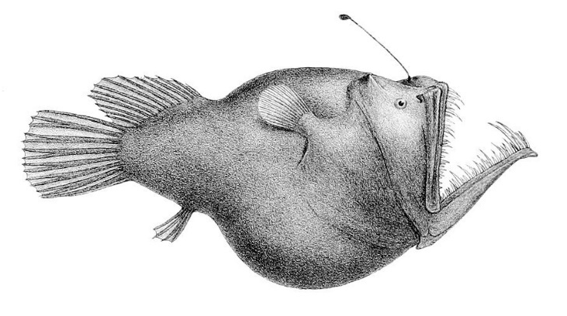
- Name (common and scientific name)
- Biological illustration or photo
- Classification (class, family, genus)
- Description (size, colour, physical features)
- Habitat
- Diet
- Behaviours
- Adaptations
- Threats

Students will then choose one of the following activities to complete:
- Model – Create a 3D model of the species using upcycled materials. Display your model in the classroom.
- Diary – Write a diary of what might happen in the daily life of a deep-sea species.
- Haiku – Write a haiku poem about the species.
- Children’s book or comic – Write and illustrate either a children’s book or comic which tells the story of the species.
- True or false? – Find out as much as you can about the deep sea and the species that live there. Create a true or false quiz and test your classmates.
- Celebrate – Celebrate world Ocean’s Day on the 8th of June. Think of a creative way to celebrate the day in your class.

Activity: Create your own species
Students will use their imagination and create their own deep-sea species. Students will imagine they have discovered a new species of deep-sea creature which has never been seen before. Use the following as a guide for this activity:
- Illustrate the new animal species using only a black felt-tip pen on a piece of A4 art paper – include as much detail as you can. You may want to draw a scientific illustration or draw the animal in its natural habitat. Label important features.
- Create a 3D model of your new species using upcycled materials.
- Name the species. Give the animal a common and scientific name.
- Where does it live in the deep sea?
- Describe what the animal looks like – what are some of its physical characteristics?
- List the animal’s classification.
- How does it get its food? How does it eat?
- How does it survive in its environment? What are its adaptations?
- Does it have any interesting or unique features?
- How possible do you think it is that your new species exists? Explain your answer.

Activity: Biological Illustration
Students will create their own biological illustration of a deep-sea animal. This activity encourages students to develop their observation skills and reinforce their understanding of biological concepts.

Explain to students that in their illustration they need to draw what they see (using photographs/videos they find in books and on the internet). Students will need to think about size, shape, texture, and patterns; and include as much detail as possible.

Teachers may want to show examples of scientific drawings or begin this exercise by asking their students to collect a plant specimen (for example, a leaf or flower) from the school yard to practise scientific drawing.

Students can use the following as a guide as they create their scientific drawing:
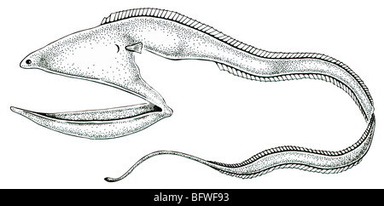
- Find photographs and/or videos of the animal to observe. What key structures and anatomy will you focus on in your drawings?
- Draw the animal to scale (include a ratio on the drawing).
- Include its scientific and common name.
- Add labels – to show size, colour and texture.

For more information about scientific drawing in the classroom, visit this website Sketching for observation. Consider sending your students’ drawings into your local museum to display as an exhibition.

Useful Websites
- Biggest Ocean Survey Ever – BTN Newsbreak
- Deep Sea Exploration – BTN
- Underwater Research – BTN
- Underwater Explorer – BTN
- The fishes of the deep sea – Natural History Museum
- The Deep Sea – Biomes
- Down to the Deep – Monterey Bay Aquarium
- 10 minutes of fascinating deep-sea animals (YouTube) - Monterey Bay Aquarium
- How Deep is the Ocean? – TEDEd
- The otherworldly creatures in the ocean's deepest depths – TEDEd

