
EPISODE 25
3rd September 2024

KEY LEARNING
Students will view a range of BTN stories and use comprehension skills to respond to a series of focus questions.

CURRICULUM
English – Year 4
Use comprehension strategies to build literal and inferred meaning to expand content knowledge, integrating and linking ideas and analysing and evaluating texts.

English – Year 5
Use comprehension strategies to analyse information, integrating and linking ideas from a variety of print and digital sources.

English – Year 6
Use comprehension strategies to interpret and analyse information and ideas, comparing content from a variety of textual sources including media and digital texts.

English – Year 7
Use comprehension strategies to interpret, analyse and synthesise ideas and information, critiquing ideas and issues from a variety of textual sources.
  - Teacher Resource

Focus Questions
As a class, discuss the stories featured in the episode of BTN Classroom and record the main points of the discussion. Students will then respond to the following focus questions.

Union Troubles
- Working in pairs, discuss the Union Troubles story and record the main points of your discussion.
- When did unions start in Australia?
- Which political party was founded by the union movement?
  - Liberal Party of Australia
  - National Party of Australia
  - Australian Labor Party
- What is the purpose of unions?
- What did you learn watching the BTN story?

Living on the ISS
- What did Sunita and Barry discover when they arrived at the ISS on the 6th of June?
- What does ISS stand for?
- Which spacecraft will Butch and Suni return on?
- The ISS is set up for long stays. True or false?
- If you could ask Butch and Suni a question, what would it be?

Check out the teacher resource on the Archives page.

Taxonomy
- How many new plants and animals are being added to Australia’s National Species List?
- What is taxonomy?
- Which rank comes first in the order of biological classification?
- If you discover a new species, you can name it after yourself. True or false?
- How did the Venomius tomhardyi get its name?

Check out the teacher resource on the Archives page.

Video Game Archive
- What were the main points of the discussion? Write a summary of the Video Game Archive story.
- When was the first video game created?
- Which organisation is responsible for archiving Australian video games?
  - National Library of Australia
  - National Film and Sound Archives
  - Screen Australia
- The games industry in Australia is bigger than the film and music industry. True or false?
- Name one Australian video game added to the archive.

Cameron’s Viking Village
- Describe the Viking village where Cameron grew up.
- Where in Australia is the Viking re-enactment group?
- During what time of the year do they set up the Viking village?
  - Winter solstice
  - Summer solstice
  - The Equinox
- What does Cameron’s costume look like?
- What is Cameron’s latest hobby?

EPISODE 25
3rd September 2024

KEY LEARNING
Students will learn more about what life is like living on the International Space Station.

CURRICULUM
Science – Year 5
Scientific understandings, discoveries and inventions are used to solve problems that directly affect peoples’ lives.

The Earth is part of a system of planets orbiting around a star (the sun).

Science – Years 5 & 6
Scientific knowledge is used to solve problems and inform personal and community decisions.
Science – Year 7
Scientific knowledge has changed peoples’ understanding of the world and is refined as new evidence becomes available.

  - Teacher Resource

Living on the ISS

Focus Questions
Discuss the BTN story as a class and record the main points of the discussion. Students will then respond to the following:
- What did Sunita and Barry discover when they arrived at the ISS on the 6th of June?
- What does ISS stand for?
- Which spacecraft will Butch and Suni return on?
- The ISS is set up for long stays. True or false?
- If you could ask Butch and Suni a question, what would it be?


Activity: Note taking
Students will practise their note-taking skills while watching the BTN Living on the ISS story. After watching the story, ask students to reflect on and organise the information into three categories. What information in the story was positive, negative, or interesting?

Activity: Class Discussion

Discuss the BTN Living on the ISS story as a class. Ask students what they know about the ISS and record student responses on a mind map. Use the following questions to guide discussion:
- Why explore space? Brainstorm a list of reasons.
- What is the International Space Station?
- What is the purpose of the ISS?
- How do astronauts travel to and from the ISS?
- What do astronauts do on the ISS?
- What do you think it would be like living on the ISS? Make a list of the pros and cons.
- What three questions you would like to ask an astronaut on the ISS?

Activity: Glossary
Students will brainstorm a list of key words that relate to the BTN Living on the ISS story. Here are some words to get them started.

INTERNATIONAL SPACE STATION | ASTRONAUT | BOEING STARLINER
MISSION | EXPLORATION | SPACECRAFT

Ask students to write what they think is the meaning of each word (including unfamiliar words). They will swap definitions with a partner and ask them to add to or change the definition. Check these against the dictionary definition.

Activity: International Space Station Research
Discuss the information raised in the BTN Living on the ISS story. What questions were raised in the discussion and what are the gaps in students’ knowledge? Here are some possible questions for students to research:
- What is the ISS? Why was it built?
- What countries are involved in the ISS program and how do they contribute?
- What do astronauts do on the ISS? What are some of their daily tasks?
- How long do they stay on the ISS?
- How do crew members join and leave the ISS?
- What is it like living in microgravity? Eating, sleeping, having a shower, going to the toilet.
- Why is it important for astronauts to exercise in space? Watch the Exercising in Space video to learn more.
- What do you think the challenges of living in space would be?
- How does the work carried out by the ISS astronauts contribute to science and affect life on Earth?
- What are some of the most important discoveries made on the ISS?
- Why is the International Space Station being decommissioned?
- Do you think space exploration is important? Why or why not?


Further Investigation
Learn more about the current expedition to the ISS. Meet the Expedition 71 crew
- What sorts of things are the crew exploring?
- What do the images of the expedition tell you?
- Choose a crew member and write a short biography about them.

Activity – Choose a Project
Individually or in small groups, students will choose one of the following projects to work on and then present their findings to the class.

Design your own space station
Draw or build a model of a space station. Consider what modules you would include and how crew members would live and work there.
What’s happening on the ISS?
Find out what the astronauts are up to on the ISS and the research they are doing by checking out the Space Station blog update
Quiz
Create a true/ false or multiple-choice quiz to test your classmate’s knowledge about the International Space Station.
Spot the ISS
Follow the ISS as it orbits Earth. Enter your location to find out when you can see it. Spot The Station | NASA

Activity: Careers in Space
Learn more about the space sector and pathways for a career in space. Choose one job that you would like to know more about. Investigate what the job involves and what you need to study to become one. Present the information to a small group or class. Students will think about the following during their research:
- What study do you need to do for the job?
- What skills are needed to do the job?
- What are some of the responsibilities of the job?
- What sort of research is involved once you are in this job?
- Can you interview someone who has this job to find out more?

Visit the Australian Space Agency to learn more about pathways for a career in space.
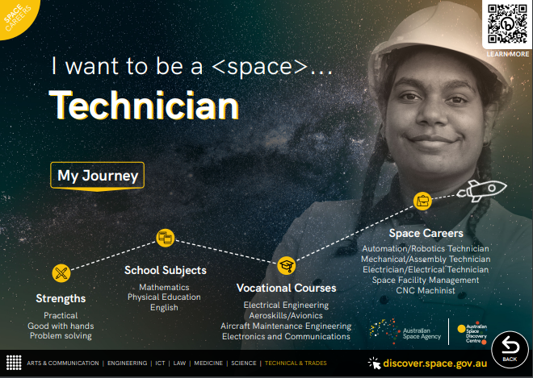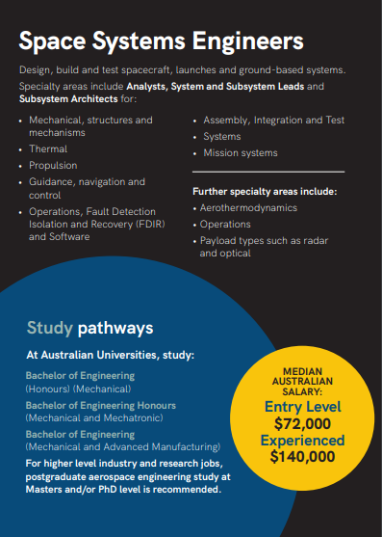
A space for everyone: careers in space
Careers in space booklet

Useful Websites
- Starliner Launch – BTN
- Life in Space – BTN
- International Space Station – NASA
- NASA astronauts `stuck in space’ until next year – Newsround

EPISODE 25
3rd September 2024

KEY LEARNING
Students will learn about the concept of taxonomy, its importance, and the basics of classification in biology.

CURRICULUM
Science – Year 4
Living things have life cycles.

Science – Year 5
Living things have structural features and adaptations that help them to survive in their environment.

Science – Year 6
The growth and survival of living things are affected by physical conditions of their environment.

Science – Year 7
Classification helps organise the diverse group of organisms.

Science – Years 5 & 6
Scientific knowledge is used to solve problems and inform personal and community decisions.

Science – Year 7
Scientific knowledge has changed peoples’ understanding of the world and is refined as new evidence becomes available.

Science – Year 7
People use science understanding and skills in their occupations, and these have influenced the development of practices in areas of human activity.

  - Teacher Resource

Taxonomy

Focus Questions
Discuss the BTN story as a class and record the main points of the discussion. Students will then respond to the following:
- How many new plants and animals are being added to Australia’s National Species List?
- What is taxonomy?
- Which rank comes first in the order of biological classification?
- If you discover a new species, you can name it after yourself. True or false?
- How did the Venomius tomhardyi get its name?


Activity: What do you see, think & wonder?
After watching the BTN Taxonomy story hold a class discussion, using the following as discussion starters:
- What do you THINK about what you saw in the story?
- What does this video make you WONDER?
- What did you LEARN from the BTN story?
- Think of three QUESTIONS you have about the story.

Activity: Questions & Answers
All scientific discoveries start with a question! As a class, come up with some questions you think taxonomists and biologists ask and solve. Organise the questions into common themes. As a class, make a list of questions that you would like to ask a taxonomist. Use the internet to find answers to your class questions.

Activity: Glossary
Students will brainstorm a list of key words that relate to the BTN Taxonomy story. Here are some words to get them started.

TAXONOMY | CLASSIFICATION | TAXONOMIST
SPECIES | LIVING ORGANISM | IDENTIFICATION

Ask students to write what they think is the meaning of each word (including unfamiliar words). They will swap definitions with a partner and ask them to add to or change the definition. Check these against the dictionary definition.

Further activities for students:
- Students will add to their glossary by downloading the transcript for the BTN Taxonomy story and highlight all the words that relate to the topic.
- What other words relate to this topic? Students will choose additional keywords and concepts to add to their class glossary. For example, biodiversity, common name, scientific name, kingdom, class, family, genus and rank. Students will find a definition and add to their ‘taxonomy glossary’.
- What is the difference between a vertebrate and an invertebrate? Give some examples.
- Who explores taxonomy? To learn more about what taxonomists do, visit ABC Education!
- What is a naturalist? Explore the work of a famous naturalist – watch these BTN stories which focus on a Famous Naturalist Profile.

BTN Famous Naturalist Profiles

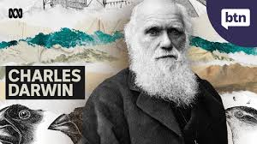  BTN Charles Darwin | 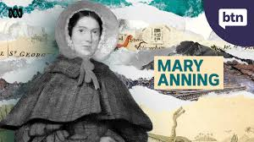  BTN Mary Anning
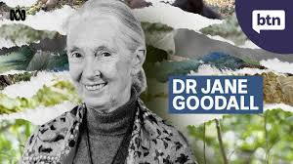  BTN Dr Jane Goodall | 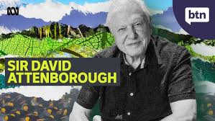  BTN Sir David Attenborough

Activity: New Species Profile
Students will research and write a profile about a species that has recently been added to Australia's National Species List. Students can use the animal profile worksheet at the end of this activity to record their findings. Encourage students to use a range of sources to find their information.

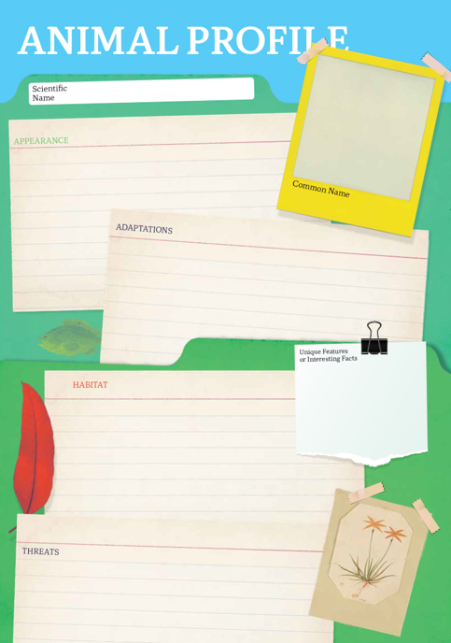
Research
Students will research the species and create a profile. Students can use the Animal Profile at the end of this activity.
- Illustration or photo
- Scientific and common name
- Classification (class, family, genus)
- Appearance
- Habitat
- Where is it found?
- Feeding and diet
- Behaviours and adaptations
- Predators
- Conservation status
- Interesting facts

Students will choose a species featured in the BTN Taxonomy story and complete one or more of the following activities:
- Model – Create a 3D model of the species using recycled materials. Display your model in your school.
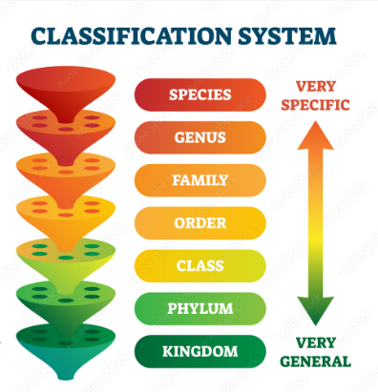
- True or false? – Investigate the classification of the species. Create a quiz (true or false, multiple choice, fill in the blank) and test your classmates.
- Children’s book or comic – Write and illustrate either a children’s book or comic which tells the story of the species. Include another species in your story which shares the same family or genus.
- Geography – Where in the world does the species live? Show the species distribution on a map using shading.
- Citizen Science – Are there any citizen science projects that helps us better understand the species? Investigate.
- Poster – Create a poster which shows the classification of the species.

Activity: How do animals get their names?
During this activity students will become taxonomists and name a new species. Students will imagine they have discovered a new species of animal which has never been discovered before and give it a scientific name.

Class Discussion
Find a range of pictures of animals and ask your students if they can name any of them. Write their scientific names on the whiteboard.

Introduce the concept of scientific naming, which is used to name all living organisms. Animal names are often made up of combinations of Greek or Latin words that describe the animal’s appearance, characteristics, or behaviours of the animal. Some animals are named after the people who discovered them, and others are named after the place where they were discovered. Explain that the Genus name (the first word) is capitalised, and the species name (the second word) is in lowercase.

Why was the orb-weaver spider named “Venomius tomhardyi”?
It was named after the Marvel Comics character Venom, with its species name referencing actor Tom Hardy, who portrayed the character in Sony's Spider-Man Universe. The genus name came from the black spots on the spider's abdomen, which reminded the authors of Venom's head.

Below are some Greek and Latin words which have been used in animal names.

Word (Greek or Latin) | Meaning
venomius  litoria  ridibunda  tyranno  rex  planigale | poisonous  grassy  laughing  tyrant  king  having few teeth

Group Activity
In small groups students will use their imagination and come up with a list of scientific names for new species of animals. Students will follow the structure (Genus species) and consider the animal’s appearance or behaviour. Student will share their scientific names and explain their meanings.

Individual Activity
Students will choose one name from their list and then respond to the following questions:
- What have you named your species? Explain the origins of the name. Is it named after a person or a place? Is the name something that describes its characteristics or behaviour?
- What does your species look like? Describe any interesting or unusual features.

Activity: Create a new species
Working individually or in pairs, students will use their imagination and create a new species of their own. They will imagine they have discovered a new species which has never been seen before. Use the following as a guide for this activity:
- Illustrate the new species using only a black felt-tip pen on a piece of A4 art paper – include as much detail as you can.
- Give your new species a common and scientific name.
- What group of animals does it belong to? Is it an invertebrate, fish, amphibian, reptile, bird or mammal? What is the classification of the species?
- Describe what it looks like – what are some of its physical features?
- What does it eat? Does it have any predators?
- Include any adaptations it has that helps the species survive in its environment.

Activity: Scientific Exploration
Citizen scientists play a big part in the discovery of new species. Explain to your class how the Western Laughing Tree Frog was discovered.

The story of the Western Laughing Tree Frog’s discovery
A citizen scientist heard a “laughing” sound coming from the backyard. They recorded the sound and submitted it to a citizen science database, FrogID. Scientists listened to this laugh-like recording, along with thousands of others, and discovered the sound came from a “charismatic” new species of creature – the Western Laughing Tree Frog.

Explore the sound of Western Laughing Tree Frog
- As a class visit the Australian Museum website to listen to a recording of the new frog species.
- Compare the sound and appearance of the Western Laughing Tree Frog with the Roth’s Tree Frog.
- How are the species similar or different?

Get to know the biological sounds in your area
As a class, plan a visit to your local park or simply visit your school yard. Students will write a list of things they may need for the exploration, for example: pen and paper for taking notes, clipboard, and a device to record sound. Students will predict what they think they will hear during their exploration. Students will then respond to the following:
- Describe – describe what you hear in the environment. Record and describe as many biological sounds as you can hear. Can you see the animal? Do you notice any behaviours displayed by the animal? If you can’t hear any animals, what other sounds can you hear?
- Identify – can you identify the animal that belongs to the sound? Identify and classify what you found.
- Research – learn more about the species. Why do they make these sounds? Is it a native or introduced species?
- Share – report your findings to the class. Compare and contrast your findings. Create a library listing all the biological sounds your class detected.
- Citizen science – find a citizen science project where you can share what you’ve found in your local area. Here are some example citizen science projects: FrogID, Australasian Fishes project or Virtual Reef Diver.

Activity: Taxonomy Quiz

- What is it called when animals are sorted into groups with similar features?  A. Evolution  B. Classification  C. Organisation  - Which group of animals does the Western Laughing Tree Frog belong to?  A. Mammal  B. Amphibian  C. Reptile  - An invertebrate has a backbone.  A. True  B. False  - Which of these is NOT an invertebrate?  A. Snail  B. Prawn  C. Snake  - Which rank comes first in the order of biological classification?  A. Family  B. Species  C. Kingdom | - Animals and plants are in the same kingdom.  A. True  B. False  - A scientific name contains information about an animal’s...  A. Kingdom and species  B. Family and species  C. Genus and species  - What is the scientific name for the Western Laughing Tree Frog?  A. Litoria ridibunda  B. Frogus humourous  C. Litoria rothii  - Which of the following pairs are MOST closely related?  A. Wolves and coyotes  B. Gorillas and chimpanzees  C. Jellyfish and starfish  - Humans belong to the Animalia kingdom.  A. True  B. False

Quiz Answers: 1B, 2B, 3B, 4C, 5C, 6A, 7C, 8A, 9A, 10A.

Useful Websites
- What is taxonomy? – ABC Education
- Evolution and Biodiversity – BTN
- The Australian National Species List – Biodiversity
- Funnier than the original: Introducing the Western Laughing Tree Frog – Australian Museum

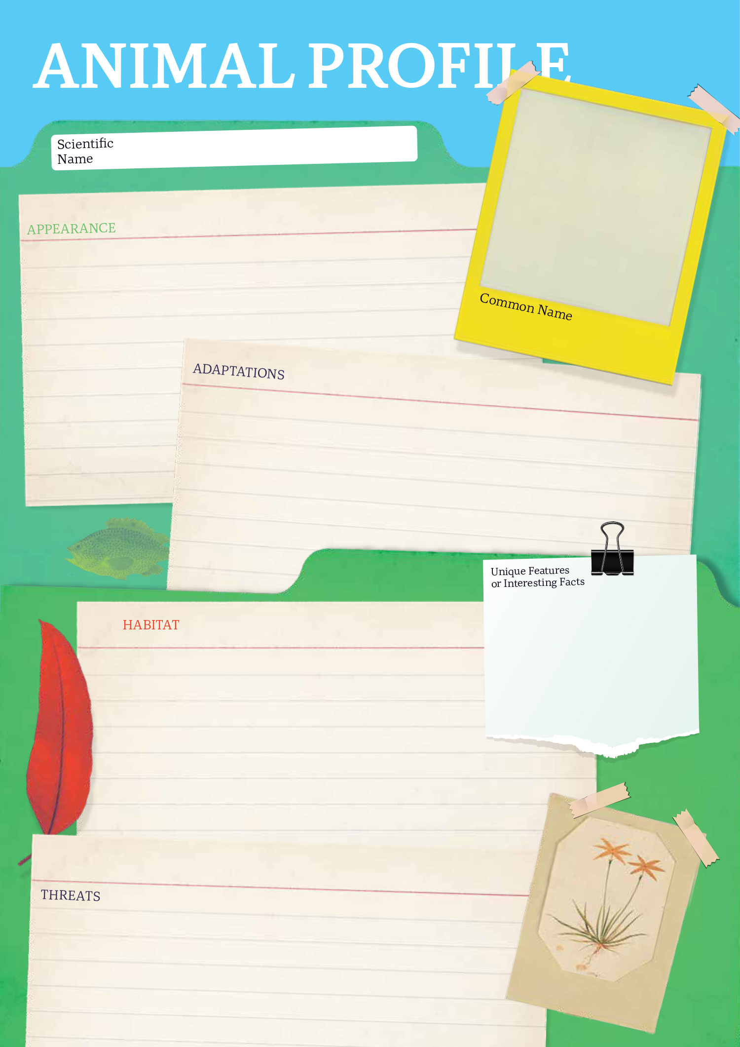
6

  - Teacher Resource

BTN Transcript: Episode 25 - 3/9/2024

Hey, I'm Amelia Moseley and you're watching BTN. Thanks for hanging out with us again. Let's see what's coming up on today's show. We find out how these two astronauts got stuck in space, meet the newest Australian native species and learn more about Australia's vintage video games.

Union Troubles

Reporter: Joe Baronio

INTRO: All that soon, but first today, we're going to find out about the CFMEU, which is one of Australia's biggest unions. Last week, there were big protests all over the country about the Government's decision to take away control of the construction part of the union. So what's going on, and what exactly is a union? Joe found out.

Joe Baronio, Reporter: This is what the streets of Aussie cities looked like last week as tens of thousands of construction workers dropped their tools and went on strike. They are all members and supporters of the CFMEU which has played a massive part in the lives and careers of workers like these for a long time.
The history of unions goes back to the Industrial Revolution when more people moved to cities and started working in factories and mines where conditions could be brutal. Workers could sometimes be forced to work really long hours.
Worker: How much longer?
In sometimes dangerous conditions.
Worker: This isn't safe.
And not always paid fairly. Kids as young as 8 would sometimes be put to work. and for a lot less money than the adults. But if a worker complained they could easily be replaced.

WORKER JOE: Wha Wha… This isn't fair.
BOSS: Oh, I'm sorry. Well, in that case, you're fired. Get out of here! Go on, next.
But eventually, the workers started to realise that if they banded together, they could force employers to listen to them and make changes. Australia had a really strong union movement from the 1830s onwards. In fact, the Australian Labor Party, which is in charge today, was actually founded by the union movement back in 1901. Over time small unions started joining forces to give themselves more power to fight for workers' rights and they had some big wins like a minimum wage, paid leave, better health and safety rules, and the eight-hour workday. People who worked on construction sites played a big part in making this happen; workers that would eventually be represented by the CFMEU.

It was created in the 1990s to bring together unions for Construction, Forestry and Maritime workers, and became one of the most powerful representatives for workers' rights in Australia. But recently, some leaders of the CFMEU's construction wing were accused of bullying, working with criminals, and corruption, which is using the union's power for their own benefit.
Anthony Albanese, Prime Minister: There's no place for corruption or intimidation in the building industry from unions.
Last week, Federal Attorney-General Mark Dreyfus announced that all CFMEU construction branches around the country were being placed into administration, which means somebody independent is stepping in to run them for at least the next three years until they can be sure there's no more dodgy dealings. But the decision has made a lot of people really angry because they think that unions should be able to represent their workers without interference from governments.

PROTESTOR: We said that administration was anti-democratic. We said that administration was not in the best interest of our members.
PROTESTOR: We are going to campaign for the absolute destruction of the Australian Labour Party in this country.
(CHEERING)

Others say it's not fair to punish the whole construction union over the bad behaviour of a few.
Protester: We're not thugs, we are workers, we have families. Now we're fighting for our genuine rights.
Protester: When you go out on site, people take care of you, they care about your wellbeing. That's not what's being portrayed, and it should be.
The government say that unions are important and do a lot of good for worker's rights, but to do that they have to be honest and law-abiding.
Anthony Albanese: The government is not for turning, and nor is the Australian public. They want to see this industry cleaned up.

PROTESTORS: We’ll be back, We’ll be back.

News Quiz
There was debate last week about a question in Australia's census, which is a survey that's held every how many years? Is it every 2 years, every 4 years or every 5 years? The census is held every five years. And it's a really important tool for gathering information about the Australian population. Last week, some people were upset when the Government announced it was going to scrap a new question about gender identity and sexuality in the next census.

ALLEGRA SPENDER, INDEPENDENT MP: I think it's really important that we have the information so that we can make good decisions about the public services we need, but it's also about us as a country, recognising who we are.

So later in the week, the Government said it would be asking the Bureau of Statistics to test a question to include in the next census.

Which country did the Prime Minister visit last week for the Pacific Islands Forum? Tonga, Vanuatu or Samoa? It was in Tonga. Anthony Albanese joined leaders from around the Pacific and the world to talk about important issues facing the region, like climate change and security.

And things got very messy last week at La Tomatina, which is a festival held every year in which country? Mexico, Italy or Spain? La Tomatina is held every year in Bunõl which is in Spain. It started in 1945 when two boys threw tomatoes at each other during a parade. Others thought that looked like fun, and it became a whole thing.

PERSON: We're going to go make some spaghetti to have with our tomato sauce.

Living on the ISS

Reporter: Wren Gillett

INTRO: Now, let's head up to space which is where these two astronauts will be spending the next 5 months after their spacecraft, the Boeing Starliner, malfunctioned. Wren can tell you all about it.

Imagine hopping on board a ship and blasting off into space. And then this happens.
WREN GILLETT, REPORTER: I can't believe we're going to be spending a whole 8 days here.
JOSEPH BARONIO, REPORTER: Months.
WREN: Days.
JOE: Months.
WREN: Wait what?
Well, that's what astronauts Sunita Williams and Barry Wilmore are facing right now. The pair arrived at the ISS back on the 6th of June, expecting to be there for just over a week, but they won't be returning home until around the time you guys go back to school next year. So, how did this happen? Well, Suni and Butch are test pilots for Boeing, you know, the company famous for its planes. And in the past few years, it's been working really hard to become a major player in the space business. Boeing is one of just a couple of private companies that NASA contracted to build craft to get people and supplies to and from the International Space Station.
WREN: Or as we call it.
WREN and JOE: The ISS.
In 2019, Boeing's Starliner capsule had its first flight test. And after a few launches without astronauts on board, in May this year, it was ready for its first crewed mission to the ISS with Butch and Suni. But thanks to problems with the spacecraft, that mission was delayed twice. Then on June 6th.
NASA: 3, 2, 1, ignition. And liftoff off Starliner and Atlas V.
There were celebrations, until…
JOE: There's a problem with the spacecraft.
WREN: Wait, what do you mean by problem?
The Starliner has 28 thrusters, which are used to move the spacecraft. But as Sunni and Butch approached the ISS, five of them failed. Which caused the craft to start leaking helium.
While Nasa and Boeing worked on the problem from Earth, Suni and Butch did what they could in space.
SUNITA WILLIAMS, BOEING ASTRONAUT: This is a test flight we were expecting to find some things, so we are finding stuff and we and we are correcting it and we are making changes and making updates with our control team.
Eventually NASA and Boeing decided the Starliner wasn't safe, but luckily, there is another ship that can take them home. Space X's Dragon just arrived at the ISS with a crew of four and a couple of spare seats. But the crew won't be leaving for another… 5 months.
WREN: That's a... That's a really long time.
But luckily the ISS is set up for long stays. In fact, one astronaut, Dr. Peggy Whitson, has stayed at the station for a total of 665 days. It has six sleeping quarters, a kitted-out lab, and a gym, which is important for keeping up the muscle and bone mass which you can lose in zero gravity. As for food, well the menu includes more than a hundred items, from vegetables and fruit to pre-prepared meals and desserts that are resupplied every 90 days or so. And the bathroom sitch? Well astronauts use what's called a vacuum toilet, and the bathroom is full of hand and foot bars, so the astronauts don't drift off in the middle of their business. And fun fact, pee is more than 90 per cent water. And since water is heavy and takes up a lot of space, it is actually better to recycle pee than to send water from Earth.
JOE: Meaning yesterday’s coffee is also today’s coffee.
WREN: Literally.
Suni and Butch have both spent long periods in space before, so this is nothing new to them, and there's plenty to keep them busy while they're up there, from spacewalks to science experiments. So, yeah, they're gonna be okay.
JOE: Besides, there are plenty of worse places to be stuck than space.
WREN: I mean look at that view. No, that one.
JOE: That one.
Quiz

What's the name of the Russian spacecraft that takes people to and from the Space Station? Is it Soyuz, Sputnik or Dragon? It's the Soyuz. The Soyuz MS-25 is actually parked at the space station now, along with the Boeing Starliner, the Space-X Dragon, and three other supply ships.

Taxonomy

Reporter: Wren Gillett

INTRO: Australia already has a huge variety of plants and animals, but did you know there are a whole lot more that we haven't discovered or named yet. It's why the government has announced new funding for taxonomy projects. What's taxonomy, you ask? Let's find out

Australia, meet your newest plants and animals. Introducing the Western Laughing Tree Frog, which laughs rather than croaks. The Venomius, an orb spider named after a Marvel villain. We have a new butterfly, some new types of algae, a new lizard, a new mouse, and we even have a new worm called the Marphysa DavidAttenboroughi, named after, you guessed it Sir David Attenborough. They're just some of the 750 new plants and animals that have been added to Australia's national species list.

You see, while you might think Australia already has an impressive array of flora and fauna, every year, thousands of new species are discovered, described, and named, and that is no simple business. In fact, it's a whole branch of science called taxonomy.
WREN GILLETT, REPORTER: So, Ben, can you explain what taxonomy is?
BEN PARSLOW, TAXONOMIST: So, taxonomy is a science where we name, describe and classify all living organisms.
Ben is an entomologist here at the South Australian Museum, and taxonomy is a big part of his job. He says the first step is always figuring out whether a species is actually new.
BEN: So, we compare the species to all of the other named species, to make sure that we can tell it apart.
Then it's time to file that species in the library of living things, known as the taxonomic rank.
BEN: So, this starts at kingdom, goes to phylum, then class, then order, family, genus and finally, species.
WREN: So, if you find a new species, maybe perhaps a new beetle, can you just name it whatever you want? Like, your name is Ben. Could you name it Benny Mc Ben Face, is that something you could do?
BEN: So, there's actually rules that we follow to name new species. So, some of those rules are, firstly, it needs to be unique. We also can't choose rude names or offensive names.
WREN: Fair enough.
BEN: And then the other rule is that we actually can't name them after ourselves. It's kind of a bit of a taboo that you don't do.
WREN: So, Benny Mc Ben Face is out of the question?
BEN: Definitely out of the question.

Wren: Yeah.
As for the 750 new species, some were named after the place they were found, the way they looked, or the things that they do. And some names were a little more marvellous.
BRYAN LESSARD, ENTOMOLOGIST: Scientists must have been massive Marvel fans because when they were studying this spider under the microscope, they looked at the spider's abdomen and they saw Venom's mask. The scientists gave the official name - Venomius tomhardyi.
Bryan is part of the team who tracks the names of all our new species, and he says taxonomy is way more important than most of us realise.
BRYAN: Taxonomy is kind of like electricity in our houses. It's something that we take for granted, but it's so important for powering our computers and our day-to-day lives. Taxonomy allows us to identify species that might have new drugs that we could turn into the medicines of the future.

It's why the government has just put a bunch of money into taxonomy research projects, right around the country.
TANYA PLIBERSEK, ENVIRONMENT MINISTER: Unless we can describe every Australian plant and animal, we can't properly protect them.
The environment Minister says we need to know exactly what species are out there so we can know what threats they face and how to protect the ones that need it.
WREN: Is it possible for myself, or someone watching this to just go outside right now and discover a new species?
BEN: So, we've only named about 30% of all Australian species, so there's a huge amount of unknown species still out there.
WREN: Yeah, 70 per cent.
BEN: Yeah, so you could go out now and start looking for new species and probably find one.
WREN: Well what am I waiting for? Alright let's go.

Video Game Archive

Reporter: Jack Evans

INTRO: Now to an organisation that's also trying to classify and preserve things, but this time its video games. The National Film and Sound Archive says Australia's games are in danger of disappearing, and it wants to stop that from happening. Here's Jack.

OUTBACK JACK: G'Day I'm Outback Jack, press A to start. I need ya help. There are some cracker Aussie Video Games out here in the bush that need rescuing, let's go.
JACK EVANS, REPORTER: Australia might not be the first country you think of when it comes to making Video Games, but Australia's been a big part of the industry for a long time.
OUTBACK JACK: Crikey. Look out there's The Hobbit.
JACK: Wait isn't the Hobbit a New Zealand thing?
OUTBACK JACK: Technically it's a book by a British Author. But in 1982 one of Australia's very first Video Game companies, Beam software, released this classic that became popular around the world.
JACK: Oh, well, there you go.
Along with the hobbit there were tiles like Hungry Horace and The Way of the Exploding Fist. And while they look a little different to what we're use to today, they were revolutionary at the time and led the way for today's Aussie made games. From stylised adventure games to games that are a little weird and wacky, as well as games you can play on your phone.
OUTBACK JACK: Look out Cobber, that there is Fruit Ninja. Press B to take it to the archives.
THORSTEN KAEDING, SENIOR CURATOR NFSA: The games industry in Australia is now bigger than the film and music industry put together. That's how important it is. That's how central it is to people's lives. And we're the audio-visual archive for Australia and games are the biggest audio-visual phenomena of our time.
Thorsten is from the National Film and Sound Archive, which as the name suggests is responsible for Archiving the Australian tv shows, films, songs, speeches and any other picture or sound that has helped shape our history. Since 2019, they've been adding Australian Video Games to their collection. Including some oldies like The Hobbit and Hungry Horace, as well as some newer games like L.A. Noire and Untitled Goose Game.
OUTBACK JACK: Quick. Grab that Silly Goose before it spits the dummy.
THORSTEN KAEDING, SENIOR CURATOR NFSA: Around the world, it's done a little bit differently. Some places basically put them on a shelf, and that's, that's their collecting and preserving. What we do here at the National Film and Sound archive is digitize every one of them.
Recently the National Film and Sound Archive did a big survey and found that a lot of archiving institutes around the world are struggling when it comes to preserving video games.
THORSTEN KAEDING, SENIOR CURATOR NFSA: Resourcing, I think was, was one of the big issues now, how much money and how many people were involved in each institution. There are lots of legal issues around copyright and those sort of things which which make preservation difficult around the world. But for me, one of the really interesting ones was that it's actually much harder to collect and preserve games that are being put out now as digital only, games, particularly on things like mobile platforms, than it is games going back to the 70s and 80s that came on cassettes or cartridges or, or optical discs.
The National Film and Sound Archive say they will continue to add Aussie Video Games to their collections and some gaming companies have already started archiving their own. So hopefully these Video Games will be rescued from disappearing altogether.
JACK: Wait, but who is going to archive this game?
OUTBACK JACK: I don't know, it'll probably end up somewhere in the ABC archives.
JACK: Oh, yeah, no, that makes sense.

Sport

The Aussie Paralympic campaign is going strong in Paris. Thomas Gallagher claimed the first gold in the men's S10 50-metre freestyle, while Nikki Ayers and Jed Altschwager followed it up in Australia's first para rowing gold ever in the PR3 mixed double sculls. And out of the water, Lina Lei and Qian Yang grabbed the women's doubles table tennis gold, with Emily Petricola, Korey Boddington and Amanda Reid picking up three more golds on the cycle track.

Now to the AFLW where North Melbourne has had a huge victory over Brisbane to kick off the season.

COMMENTATOR: North are on fire!

It was a pretty windy opening round, but that didn't stop the Roos from sealing a 44-point win over the reigning champs. Meanwhile, Hawthorn enjoyed its biggest ever win, smashing Carlton by 38 points.

And finally, let's shift gears to the Italian Grand Prix, where it was a big victory for this guy.

COMMENTATOR: Charles Leclerc is the winner.

It was a rough set-up for Leclerc after losing the initial lead to Aussie Oscar Piastri, but a quick decision to opt for only one pit stop saved him the title, leaving Piastri to finish in second.

Cameron’s Viking Village
Rookie Reporter: Cameron

INTRO: Finally, today let's meet a winner of the Takeover Lismore competition, which asks young people living in the region to tell stories about their lives and the things that are important to them, and Cameron has an interesting story to tell about growing up with medieval Vikings. Check it out.

I've grown up in a Viking village, where there are clever craftsmen and fearless warriors. I've whittled away many Saturdays, watching my mum on the battlefield. She swings her metal sword and I hear it clang against leather armour and chain mail.

My family has been part of Rognvald's Lith for as long as I can remember. It's a Viking re-enactment group in Lismore. During winter solstice, the group sets up a Viking village right here in the middle of town. It's like stepping back in time. There's dark age weaving and leather making and spit roasts and stews big enough to feed a hungry hoard.

I have my own costume. It resembles what Viking villagers would have worn. I haven't found my role in The Lith yet, but I've tried a few things. Carving was a big part of Viking life, and it's my latest hobby.

I'm neurodiverse and sometimes I get hyper-fixated on things. I went through a Dungeons and Dragons phase. But cooking has been a constant. When I find a meal I really like I make it again and again until it's perfect. Then I move on to the next thing. It's like my mind craves the unexpected. I struggle with routine. My kryptonite is repetitiveness. I think that's why I like carving. You can make anything. Even if it's just the perfect marshmallow stick.

I want to get good enough to carve weapons for the Viking battlefield. To me, the most interesting thing about our re-enactment group is they're tough as hell. The combatants get bruises but don't complain. Some people think it's strange when I tell them I've grown up in a Viking village. But I think it's awesome.

[Battle cry from combatants]

Closer

Well, that's it for today. But we'll be back with more BTN next week. And in the meantime, you can check out our website and you can keep up to date with Newsbreak right here in the studio every week night. Have a good one and I'll see you really soon. Bye.

