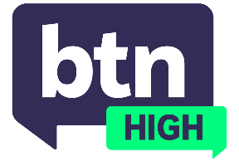
  EPISODE 70
  3rd December 2025
  KEY LEARNING
  Students will discuss the results of BTN’s social media survey results, and how Australia’s social media ban will impact under 16s in the future.
  CURRICULUM
  Health and PE – Years 7 and 8 (v8.4)
  Civics and Citizenship – Year 9 (v8.4)
  Civics and Citizenship – Year 9 (v9.0)
  - Teacher Resource

Survey Results

Focus Questions
Discuss the BTN High story as a class and record the main points of discussion. Students will then respond to the following:
- Overall, are you surprised by the survey results? Discuss.
- How do you think the social media ban will play out a year from now?
- Do you think under 16s will look back when they’re older and appreciate the ban? Why or why not?
- In what ways could the government measure whether the ban has worked?
- Do you think other countries should consider a social media ban? Explain.

Activities
- Conduct your own survey on the social media use of your classmates. Come up with questions, collate your data and present your results in a creative way.
- Write a feature article about whether you think Australia’s social media ban will have a positive or negative impact on under 16s.
- Imagine you have the job of a strategist, who needs to measure whether the social media ban has worked after 12 months. Using the following questions for inspiration, come up with plan:
-What technology could be used to measure its impact?
-Who could you employ to carry out a study?

