Episode 7
26th March 2019



Cyclones Explained
- Discuss the Cyclones Explained story as a class and record the main points of the discussion.
- Do cyclones form over warm or cold ocean water?
- What forms when water evaporates and rises into the sky?
- Who tracks cyclones?
- How many categories are there to describe the strength of cyclones?
- What windspeed did Typhoon Tip reach in 1979?
- What type of damage can a category 1 cyclone have on the environment?
- What is a storm surge?
- What can be done to help prevent cyclone damage?
- What do you understand more clearly since watching the BTN story?

Check out the Cyclones Explained resource on the Teachers page.

Brexit Deadline
- Briefly summarise the BTN Brexit Deadline story.
- What two words have been merged together to make the word Brexit?
- In what year did people living in the UK vote to leave the European Union (EU)?
- How many countries are a part of the EU?
- What are some of the benefits of being a part of the EU?
- How many British people voted to leave the EU?
  - 12%
  - 25%
  - 52%
- Why are a lot of businesses worried about Brexit?
- How might Brexit affect the border between the UK and the Republic of Ireland?
- Who is the UK’s prime minister?
- What did you learn watching the BTN story?

Holi Festival
- Before watching the BTN story, ask students if they know about or have celebrated Holi?
- Complete this sentence. Hinduism is the 3rd most practised ___________ in the world.
- Hinduism is a religion that has many gods. Name one.
- What does Hanuman look like?
- What story is Holi based on? Describe.
- Holi celebrates the arrival of what season?
- How many days do people celebrate Holi?
- Describe some of the activities that happen during Holi.
- What do the kids in the BTN story like about Holi?
- What did the BTN Holi Festival story explain?

Antarctic Animals
- Before watching the BTN story, brainstorm a list of animals that you think live in Antarctica.
- Where is Antarctica? Find using Google Maps.
- Why are scientists doing sighting surveys for blue whales?
- Blue whales are the 2nd largest animal that’s ever lived. True or false?
- Why are whales hard to track?
- What helps scientists track whales?
- Why are the scientists in the BTN story interested in krill?
- There are many animals that eat krill. Name one.
- How many penguin species live in Antarctica? Name one.
- What was surprising about this story?

Check out the Antarctic Animals resource on the Teachers page.

Antarctica Q&A
- What does the word Antarctic mean?
- What type of animals can be found in the North Pole but not the South Pole?
- How many species of penguin live on the Antarctic continent? Name one.
- Name one species of penguin that lives in the Subantarctic.
- Complete this sentence. In the summer Antarctica is titled towards the _____.
- Why doesn’t Antarctica receive any sunlight at all for nearly six months?
- Antarctica is owned by one country. True or false?
- What is the Antarctic Treaty?
- What was surprising about this story?
- What questions do you have about Antarctica?


Get your class involved in BTN’s Ask A Reporter! This week’s topic is Antarctica.

Teacher Resource
Episode 7
26th March 2019

Cyclones Explained

Students will develop a deeper understanding of cyclones in Australia and the impact on people and the environment.


Science – Year 6
Sudden geological changes and extreme weather events can affect Earth’s surface.
Science involves testing predictions by gathering data and using evidence to develop explanations of events and phenomena and reflects historical and cultural contributions.
Scientific knowledge is used to solve problems and inform personal and community decisions.
Geography – Year 7
Causes, impacts and responses to an atmospheric or hydrological hazard.

- Discuss the Cyclones Explained story as a class and record the main points of the discussion.
- Do cyclones form over warm or cold ocean water?
- What forms when water evaporates and rises into the sky?
- Who tracks cyclones?
- How many categories are there to describe the strength of cyclones?
- What windspeed did Typhoon Tip reach in 1979?
- What type of damage can a category 1 cyclone have on the environment?
- What is a storm surge?
- What can be done to help prevent cyclone damage?
- What do you understand more clearly since watching the BTN story?


Class discussion
Before watching the BTN Cyclones Explained story hold a class discussion to find out what your students know about cyclones.
- What do you know about cyclones?
- What are some of the things that might happen when a cyclone occurs?
- Make a list of words that relate to cyclones. Make your own classroom glossary after watching the BTN Cyclones Explained story.
- Have you heard about the recent cyclone in Australia? What do you know about it?


Class Discussion
Discuss the BTN Cyclones Explained story as a class. Ask students to record what they know about weather, climate and extreme weather. What questions do they have? Use the following questions to help guide discussion:

- What is extreme weather? Develop a class definition.
- What makes a weather event extreme?
- What are some examples of extreme weather events in Australia?
- Give examples of extreme weather in other countries.
- How does extreme weather impact on people and the environment?
- Which parts of Australia are most affected by extreme weather?
- Can we predict extreme weather events?
- How can we prepare for extreme weather?
- Have you ever experienced extreme weather? Discuss in pairs.

Cyclone categories
The strength of a cyclone is expressed in categories. In Australia, category five cyclones are the strongest, bringing the most destructive winds. Students will investigate the different cyclone category ratings including wind gusts and the effects on people and the environment.

Category | Estimated wind gusts (km/h) | Effects on people and the environment

One

Two
Three
Four
Five

Topic for inquiry
Students will start to think like a meteorologist and develop their own question/s for inquiry, collecting and recording information from a wide variety of sources. Students may develop their own question for inquiry or select one or more of the questions below.

- What tools help scientists to detect and categorise cyclones?
- How are cyclones tracked and measured? Describe and compare old and new discoveries.
- How do cyclone warnings help people prepare for a catastrophic natural disaster? Why is the early detection of cyclones important? Investigate how people can prepare for a cyclone and create a survival plan. Visit the BOM website to help write your plan.
- Why and how are cyclone names chosen? Watch this ABC Education video – How to name a cyclone, to learn more.
- How do tropical cyclones form? Use a diagram to show how a cyclone forms.
- Where in Australia do cyclones occur? Why? Create a map to show the regions in Australia affected by cyclones.
- Meteorologists track the movement of cyclones using latitude and longitude. What is the difference between latitude and longitude and how are coordinates used to track cyclones on a map? Use cyclone Trevor, Cyclone Veronica or Cyclone Idai as an example in your research.

Further investigation
Using the primary and secondary sources of information, students will find out more about Cyclone Trevor, Cyclone Veronica or Cyclone Idai and answer the following questions.
- Where did the cyclone form?
- Where did it travel? On a map mark where the cyclone travelled.
- What wind speed did the cyclone reach?
- What category was this cyclone?
- What damage did it cause inland?

Cyclone in a bottle
In this Science Web lesson students identify the similarities and differences between the formation and features of cyclones and experiment using the simulated ‘cyclone in a bottle’ activity. Use this link to download the activity and related worksheets http://scienceweb.asta.edu.au/years-5-6/unit3/lesson-three/yr56-unit3-lesson-three.html. Watch this Tornado tube video to see how it works.


ABC News – Here’s everything you need to know about cyclones
https://www.abc.net.au/news/2018-12-14/what-you-need-to-know-about-cyclones/10579026

ABC News – Tropical Cyclones Explained
https://www.abc.net.au/news/2011-02-01/tropical-cyclones-explained/1926870

ABC News – Tropical cyclone categories explained
https://www.abc.net.au/news/2015-11-19/tropical-cyclone-categories-explained/6956092

Bureau of Meteorology – Cyclones FAQ
http://www.bom.gov.au/cyclone/faq/

Teacher Resource
Episode 7
26th March 2019

Antarctic Animals
Students will learn more about Antarctic animals and create a profile of one.

Science – Year 4
Living things, including plants and animals, depend on each other and the environment to survive
Science – Year 5
Living things have structural features and adaptations that help them to survive in their environment
Science – Year 6
The growth and survival of living things are affected by physical conditions of their environment

- Before watching the BTN story, brainstorm a list of animals that you think live in Antarctica.
- Where is Antarctica? Find using Google Maps.
- Why are scientists doing sighting surveys for blue whales?
- Blue whales are the 2nd largest animal that’s ever lived. True or false?
- Why are whales hard to track?
- What helps scientists track whales?
- Why are the scientists in the BTN story interested in krill?
- There are many animals that eat krill. Name one.
- How many penguin species live in Antarctica? Name one.
- What was surprising about this story?

Pre-viewing questions
Before students watch the Antarctic Animals story ask them to respond to the following questions:
- What do you know about the conditions in Antarctica?
- What types of animals would you expect to see in Antarctica?
- How do animals survive in extreme weather conditions?

What do you see, think and wonder?
After watching the BTN Antarctic Animals story, students will respond to the following questions:
- What did you SEE in this video?
- What do you THINK about what you saw in this video?
- What did you LEARN from this story?
- What was SURPRISING about this story?

Glossary – Antarctic Animals
Students will develop a glossary of terms that relate to Antarctic animals. Below are some key words to get them started:

ecosystem | adaptation | krill
habitat | species | food web
KWLH
Hold a class discussion after watching the BTN Antarctic Animals story. What questions were raised in the discussion (what are the gaps in their knowledge)? The following KWLH organiser provides students with a framework to explore their knowledge on this topic and consider what they would like to know and learn.

What do I know? | What do I want to know? | What have I learnt? | How will I find out?

Questions for inquiry – Antarctic Animals
Students will develop their own question/s for inquiry about Antarctic animals, collecting and recording information from a wide variety of sources. Students may develop their own question for inquiry or select one or more of the questions below.
- Investigate the importance of krill as a food source for animals in Antarctica. Find out which animals feed on krill. What does krill feed on? Draw a diagram showing what animal feeds on what. Explore what would happen to all these animals if krill suddenly died out.
- What impact does pollution have on Antarctic animals? Draw a food web illustrating how the chemicals accumulate in Antarctic species, starting with how they enter the food chain through algae.
- With the extreme conditions found in Antarctica, many Antarctic animals have adaptations which allow them to live in their habitat. Choose an animal and conduct research to find out how they survive.

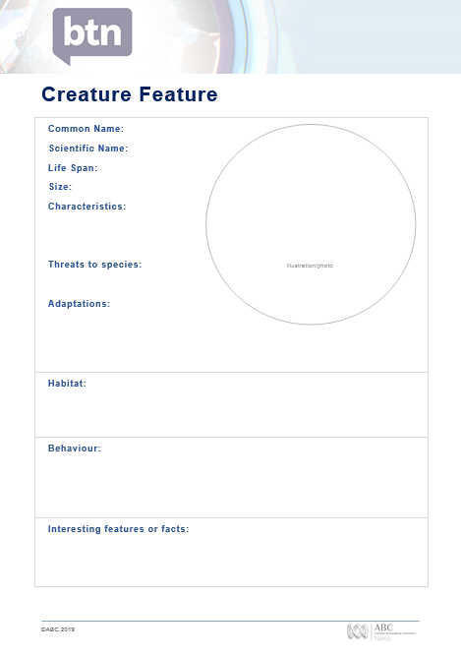
Profile
Students will imagine they are marine biologists studying an Antarctic animal in detail. Students will choose an animal to explore, create a profile and then share their findings with the class. Here are some suggestions:
- Weddell seal
- Sea lion
- Squid
- Adelie penguin
- Emperor penguin
- Krill
- Blue whale

Students can use the profile worksheet at the end of this activity to organise and present their information.
- Common and scientific name
- Appearance - what are some of their physical characteristics?
- Describe their habitat.
- Threats - what are some of the threats to their survival?
- Adaptations and interesting features.
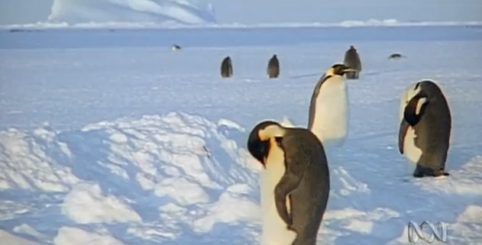
Penguin wave better than a group hug
Emperor penguins form a big, tightly packed huddle to keep warm in Antarctica, the coldest and windiest continent on Earth. But how do the ones on the outside of the huddle keep warm? Watch this video to find out about a clever way of ensuring that no penguin is left out in the cold.

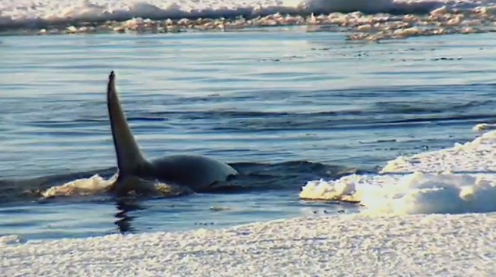
What’s polluting the whales?
Explore how chemical pollutants affect the Antarctic food web. A scientist shows that baleen whales are consuming Antarctic krill contaminated by accumulated residues of persistent organic pollutants (POPs) from pesticides and industrial chemicals. Watch this video to find out why these pollutants are concentrated at the Earth's polar regions.

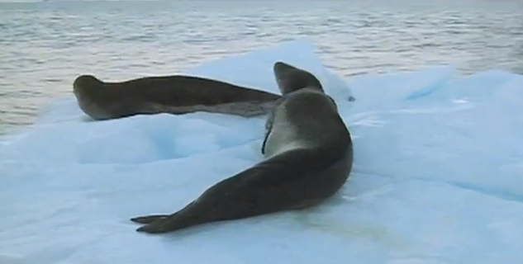
Seals help climate research
Discover how seals are helping scientists study Antarctica, polar regions, oceans and climate change. Scientists use Weddell and southern elephant seals to gather data and monitor the way currents move heat around the world's oceans. Watch this video to find out more.

Get Crafty – Origami Antarctic Animals
Make your own Antarctic origami animals. Follow the instructions at the end of this activity.

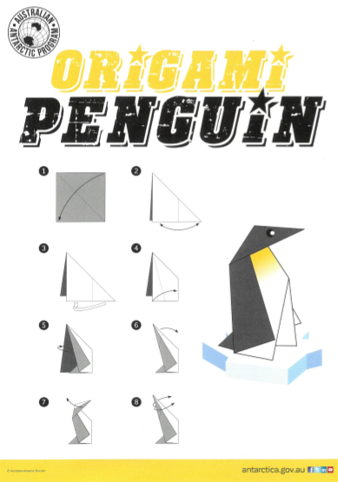
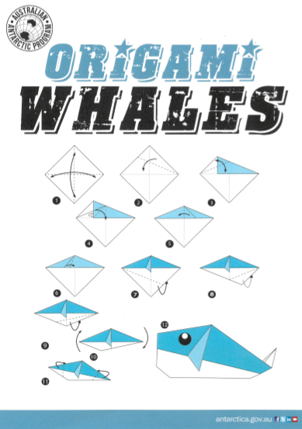


Copyright: Australian Antarctic Program

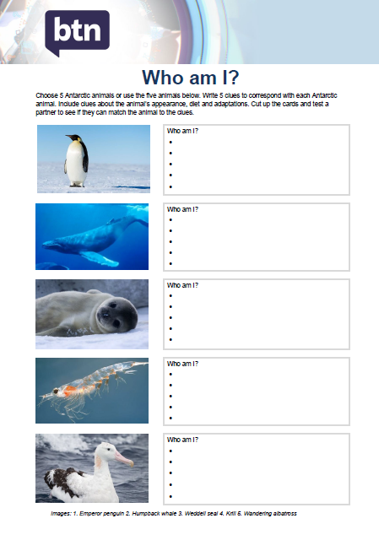
Who am I?
Students will make their own Who am I? game to learn more about Antarctic animals.

- Students will research and write 5 clues to correspond with each animal in the Who am I? worksheet at the end of this activity, with the first clue being the hardest and the last clue being the easiest.
- Include clues about the animal’s special features, its predators and how it adapts to its environment.
- Students will test their game on a partner.

BTN – Life in Antarctica
http://www.abc.net.au/btn/classroom/life-in-antarctica/10876796

BTN – Antarctic Science
http://www.abc.net.au/btn/classroom/antarctic-science/10911036

BTN – Antarctic Future
http://www.abc.net.au/btn/classroom/antarctic-future/10527558

Australian Antarctic Division – Antarctic Animals
http://www.antarctica.gov.au/about-antarctica/wildlife/animals

Australian Antarctic Division – Antarctic animals adapting to the cold
http://www.antarctica.gov.au/about-antarctica/wildlife/animals/adapting-to-the-cold

Discovering Antarctica – Ecosystems and Foodwebs
https://discoveringantarctica.org.uk/ecosystems-and-foodwebs/

Creature Feature
Common Name:
Scientific Name:
Life Span:
Size:
Characteristics:

Illustration/photo
Threats to species:

Adaptations:

Habitat:
Behaviour:

Interesting features or facts:


Origami Krill

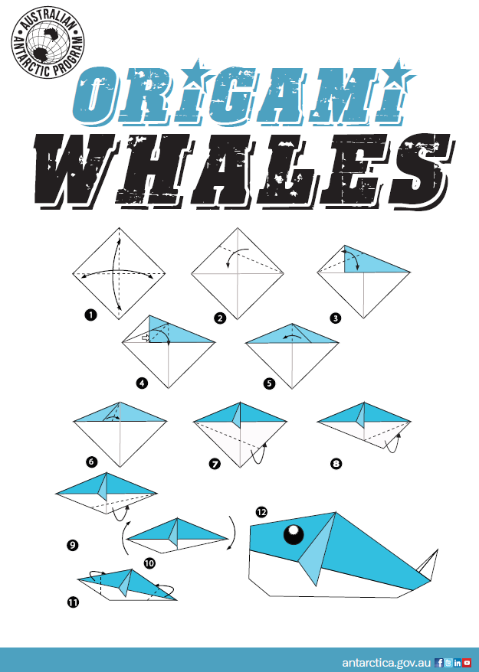

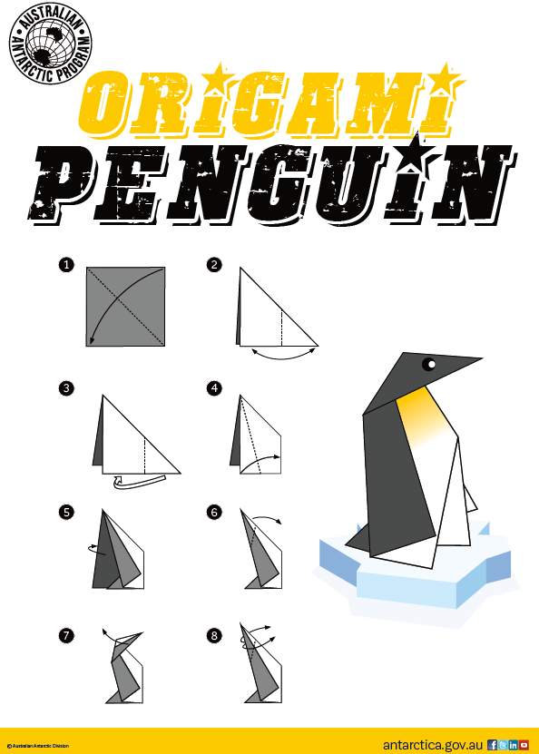

Who am I?
Choose 5 Antarctic animals or use the five animals below. Write 5 clues to correspond with each Antarctic animal. Include clues about the animal’s appearance, diet and adaptations. Cut up the cards and test a partner to see if they can match the animal to the clues.
Images: 1. Emperor penguin 2. Humpback whale 3. Weddell seal 4. Krill 5. Wandering albatross
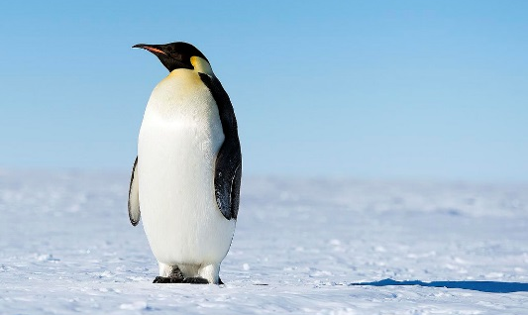 |  | Who am I?
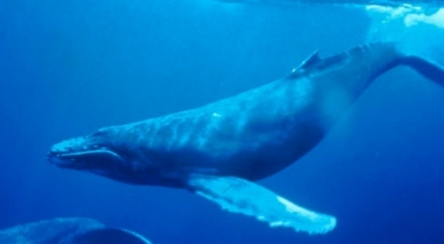 |  | Who am I?
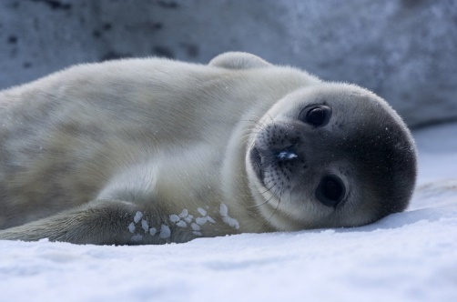 |  | Who am I?
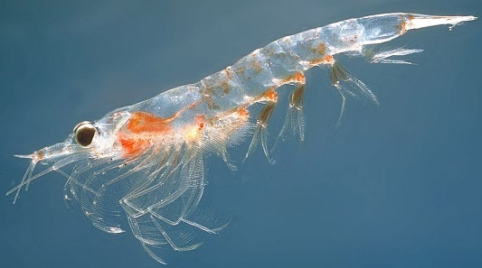 |  | Who am I?
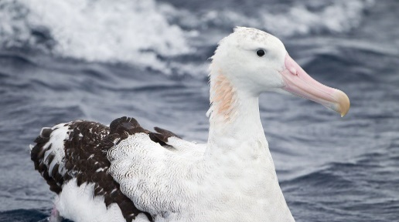 |  | Who am I?

BTN Transcript: Episode 7 – 26/3/19

Hey there, I'm Amelia Moseley and it's time for another episode of BTN. Let's check out what we've got for you today. We find out what Brexit is and why some Brits are losing sleep over it, learn all about this colourful festival celebrated by millions and meet some of Antarctica's adorable animals.

Cyclone Wrap
Reporter: Jack Evans

INTRO: But first today, Australia's been hit by some massive storms. Two cyclones have caused a whole heap of damage on either side of the country. Let's take a look at what's been happening.
Cyclone Trevor was the first to hit our shores last week, bringing intense winds and a whole lotta rain to Far North Queensland. The tropical storm then made its way to the NT, prompting the biggest evacuation the NT's seen in decades. People are now starting to return home and temporary schools have also been set up, so kids don't have to miss out.

KID 1: We were getting evacuated, from Wogyala Community, because the Cyclone Trevor was going there, and we were gonna die if we were going to stay there.
Around the same time, people all the way over in WA, were getting ready for another storm although many seemed pretty relaxed about it.
KIDS: We're having fun, yeah, messing around just having some fun because we don't get rain that often. We're a mining town. We don’t really get much rain.
People around Port Headland and the Pilbara region were encouraged to stay indoors as Cyclone Veronica swept through. But it's not just in Australia that people are dealing with the after effects of cyclones. A deadly storm called Idai has caused devastation in African countries of Mozambique, Zimbabwe and Malawi. Hundreds of thousands of people have been affected and aid workers are busy trying to help people by setting up hospitals, shelters and bringing in food and fresh water.
Cyclones Explained
Reporter: Amelia Moseley

INTRO: Now with so many big storms about we thought it'd be a good time to find out more about cyclones and how they work. Let’s take a look.

If you've never experienced it, then it's pretty hard to imagine the kind of weather that could do this kind of damage. Hurricanes, typhoons or cyclones, as we call them here in Australia, don't exactly happen everywhere. They usually affect people living in warm, humid tropical places and that's because these spinning superstorms need some very specific ingredients to get going.
Cyclones only form over warm ocean water where the surface is above 26.5 degrees. That's when water evaporates and rises up into the sky, causing some big old storm clouds to form. As more warm, humid air gets sucked up, the clouds grow, and the movement of wind caused by the spinning of the Earth can make the storm whip around into a big spiral. Cyclones get stronger as they move over warm water and weaken over cooler water or land. Meteorologists keep track of them giving them names and categories to describe how strong they are.
In Australia, a category one cyclone has winds of up to 125 kilometres an hour. It could damage the rooves of houses and maybe snap some branches. One step up and power lines could be damaged with small trees being pulled out of the ground. Category three cyclones get more serious. Think big damage, like the verandah flying off. Category four is considered catastrophic where walls can be blown off houses and big trees can be ripped right out. And, finally, category five, that's any storm with winds above 280 kays an hour. Entire houses could be destroyed.
But the amount of damage caused also depends on what a cyclone hits. Take Typhoon Tip in 1979. It's one of the biggest and most intense cyclones ever recorded. Its windspeed was up to 305 kays an hour and it was as wide as the distance from Cairns to Sydney. Luckily, Tip never hit land. And even a lower category cyclone can end up being really serious if it hits an area where lots of people live or if buildings aren't made of strong materials. And the worst cyclones are often the ones that cause storm surges, pushing sea water onto land. Rain can also cause some big issues before, during and even after the wind has settled down.
While cyclones can clearly be devastating, Australians have got better at managing the risks. We've built stronger houses and put plans in place to help people survive these incredible forces of nature.

Did you know?

Did you know that cyclones and hurricanes spin in opposite directions? Cyclones, which form in the southern hemisphere, spin clockwise while hurricanes, which start in the northern hemisphere, spin anti-clockwise.

This Week in News

The votes from the New South Wales state election are in and the Coalition's won for the third time in a row. That means Gladys Berejiklian from the Liberal Party will stay on as Premier.
Gladys Berejiklian, PREMIER NSW: My team and I will continue to work our guts out to make sure this state and its people have the best opportunities on the planet.

New Zealand's Prime Minister Jacinda Ardern, is changing the country's gun laws following the recent terrorist attack there. From next month people will no longer be able to buy high powered rifles and military-style semi-automatic weapons. Those types of guns are already banned in Australia. Last week Jacinda Ardern was visiting schools in Christchurch where she said she wanted the students to know that it's ok to feel sad during this difficult time.
Jacinda ARDERN, NZ PRIME MINISTER: One of the messages I want to share to our young people in particular, it is ok to grieve. It is ok to ask for help, even if you weren't directly affected. These things, these images that people are seeing they are really really difficult to process.

And finally meet the guy who's just been crowned the best teacher in the world. His name's Peter Tabichi, a science teacher from Kenya and he's been awarded the Global Teacher Prize by Australia’s very own actor and former PE teacher Hugh Jackman.
Peter Tabichi: I feel great. I can't believe it. I feel so happy to be among the best teachers in the world, being the best in the world.
Peter gives away most of his salary to help students who can't afford to buy books or uniforms, so it's not hard to imagine where a good chunk of his 1.4 million dollars in prize money is likely to end up. What a good guy.

Brexit Deadline
Reporter: Martin Dougan

INTRO: Now I bet you've heard the word Brexit before. If you're from the UK, then you definitely have. Our very own Brit, Martin is about to tell you what it is and why everyone's been talking about it lately.
MATT: Good Brexit Martin.

MARTIN: What?

MATT: I said good morning.

MARTIN: Oh.

LIV: Hey Martin did you see Brexit last night?

EMMA: Hey Martin, do you want some Brexit with your tea?

MARTIN: Don’t worry Martin, it was just a dream. You're in Australia, you don’t have to worry about Brexit.

BTN PRESENTER, AMELIA: Now to a very important story about Brexit.

MARTIN: Nooooooo.

When I was in the UK all I ever heard was the word Brexit over and over again. Maybe some of you have heard it too? So, what does it mean? Brexit is simply two words merged together Britain and Exit. Why?

MARTIN: It’s because on the 23rd of June 2016, people living in the UK voted to leave the European Union, also known as the EU. It's kind of like a club of twenty-eight countries who work together on things like trade and security.

Being part of the EU certainly had its good sides. British companies could trade freely with European ones. Brits could live and work in other EU countries and they didn't need a passport to travel. But on the flipside, it also meant sometimes the UK didn't have as much power to make its own laws about different issues like immigration. After much debate there was a vote and 52% of Brits chose to leave.

MARTIN: So, there you have it, the people had spoken. Story over, right? Not quite.
You see leaving the EU is not an easy task. There are lots of things to think about. For example, trade and taxes. A lot of businesses are worried Brexit will make it more expensive to trade with Europe. Then there are all of the Brits living in Europe. Will they be able to stay? And will the Europeans living in the UK be allowed to become citizens? Another potential problem. The Republic of Ireland. The UK shares a border with it and at the moment people can move freely between the countries. But after Brexit that might change. It could split up neighbours and there's a bigger worry. There used to be fighting between the UK and Ireland and some are concerned that Brexit could start it all over again.
This is the woman who's been trying to sort out all of those tricky issues. She's the UK's Prime Minister Theresa May, and while we love her dance moves, her Brexit plans haven't been so popular with everyone. At the weekend more than a million people protested in London. They think the UK should have another vote on Brexit.
KID: It’s the young people’s future and we didn’t have a say in it, you know? It’s just been an utter shambles from start to finish.

And it’s not just members of the public that are unhappy. Theresa May's political colleagues have rejected her Brexit plan, twice. The problem now is, the Prime Minister doesn't have a lot of time to come up with a plan that works.

MARTIN: No, I don’t want Brexit for breakfast, mum.

You see, this is the part that’s been giving me nightmares.

MARTIN: No one knows what's going to happen. But one thing’s for sure, we're gonna be hearing the B word for quite some time. Lucky us.

TASH: Hey Martin, what do you think about Brexit?

MARTIN: I'm going to the beach.

Holi Festival
Reporter: Jack Evans

INTRO: OK, just to make Martin feel better, we're going to talk about something a bit more colourful now.
Last week millions of people around the world celebrated the Holi festival, also known as the festival of colour. We asked a group of kids to tell us more about Holi and why it's so important to them.

AMULLYA: Hello BTN, my name is Amullya and me and my friends are going to teach you about Holi.
ANUSHAA: In Holi we throw around colours in a symbol of happiness and love. It's a celebration of colours.
ARINJAY: What I do is wake up and then worship my god and then we go out and then we buy the colours and we start playing.
AMULLYA: It's a festival celebrated by Hindus like me. Hinduism is the third most practiced religion in the world and while it comes from India, there are Hindus all around the world.
ANUSHAA: Hinduism is a religion with many gods, here are three mains ones; Brahma is the god who created the world and everything in it; Vishnu is the god who keeps the order in the universe; and Shiva is the god who destroys the universe so it can be renewed. But there are many other gods.
ARINJAY: Some are Ganesha.
AMULLYA: Parvati.
PEETRI: Lakshmi.
LAKSHIEA: Krishna.
ANUSHAA: There’s Hanuman. He has the face of a monkey but the body of a human, it's kind of strange.
PREETI: There are lots of different stories about those gods and their relationships to humans. Holi is based on a story about the god Vishnu and how he saved a boy from being killed in a fire started by his evil aunt. It's a festival that celebrates the arrival of spring. Which is why it's held at the end of March. I know what you're thinking, it's not spring in Australia, but it is in India.
ARINJAY: We celebrate the Holi festival for two days. There’s special food and special ceremonies and my favourite part is to play with the colours, although it gets a little bit messy. Holi festival is really cool, fun and it's a great experience to be in.
LAKSHIEA: This is the powder here, it washes out of your clothes. But just in case, wear old clothes.
ANUSHAA: My favourite part about Holi is where you throw around colours and have water fights and get together.
AMULLYA: My favourite part about the festival is that we eat treats.
ARINJAY: My favourite part of the festival is that you get to be with family and you get to play around with them.
AMULLYA: Another really great thing about Holi is that you don't have to be Hindu. There are Holi festivals right around Australia and right around the world. And lots of people get involved.
ALL: Happy Holi.
Quiz

Which Hindu god has an elephant head? Is it
Shiva
Vishnu or
Ganesha?

It's Ganesha. He's one of the most popular gods and people often pray to him if they're beginning a new business or project or if they're travelling.
Sport

The Adelaide Crows have made it into the AFLW grand final. They dominated their match against Geelong on Sunday thrashing the Cats by 66 points. They'll face Carlton in the grand final after their big win against Fremantle. Check out this monster goal that Chloe Dalton booted in the third quarter.

While the women's season is drawing to a close, the men's season is just getting started and there were a couple of surprises in round 1. On Saturday, Port Adelaide beat Melbourne with a team full of newbies.
COMMENTATOR: There's the future for Port Adelaide right there.
While on Saturday night the Brisbane Lions thrashed last year's premiers West Coast by almost 50 points.

Antarctic Animals
Reporter: Emma Davis

INTRO: OK, time to chill out with another trip to Antarctica. As you'll know if you've been tuning in every week, Emma's been on a big journey down to the icy continent and in the final instalment of our Antarctic special, she's going to meet some very cool animals. Check it out.
When you think of Antarctica you probably think of, well, ice mostly. But your second thought might be these guys. Yep the Antarctic region is home to many interesting animal species, ranging from the very small to the biggest on Earth. And that's what these scientists are here to study. They've spent weeks following the movements of Antarctic blue whales.
Dr Virginia Andrews-Goff, Whale Researcher: We need to do sighting surveys for blue whales to work out their numbers which is quite tricky.

Despite being the biggest animal that's ever lived, whales can be really hard to track because they live underwater and they swim really fast. But scientists have a few tricks up their sleeves, like listening for their songs.
Dr Virginia Andrews-Goff, Whale Researcher: The blue whale call is really distinctive. It has a song that it sings, and it has a de-call that it sings, a really low frequency, loud calls.
But this boat is also tracking a much smaller Antarctic critter - krill. While they might not be the cutest or most impressive creatures, they are very important.
Dr Dirk Welsford, Krill Scientist: They are the food for a lot of the air breathing animals we have in the Antarctic, so things like penguins and seals, and whales all eat krill.
Luckily for the hungry whales, there are heaps of krill. In fact, some experts reckon they're the most common animal in the world. But if that changed it could be devastating for other creatures.
Dr Dirk Welsford, Krill Scientist: So, if the krill go then that means there will be no food for all the other animals that we're interested in as well. So, understanding how krill will respond to the future ocean is really important.
In this lab, Dr Dirk is looking at how the krill would react if the ocean got warmer or absorbed more carbon dioxide.
Dr Dirk Welsford, Krill Scientist: Krill lay eggs into the water, that's how they have babies. So the eggs sink down into the water column and we've found that if we continue to pump lots of CO2 into the ocean, the ocean will become too acidic for those eggs to hatch.
Meanwhile, back on land, I've come to check out another krill eating creature. Yep, penguins. These are Adelies, one of two penguin species that live on the Antarctic continent. Right now, I'm sitting on Shirley Island. It's just off the coast of Casey Station. The temperature at the moment is pretty close to freezing so I've got my jacket and my thermals and my fleece on, and I'm still feeling a bit chilly. So, imagine how these guys are feeling. You know what they're actually probably doing ok because they've evolved over thousands of years to develop ways to deal with temperatures much colder than this. But something the penguins may not be adapting to as well is us. Humans that is. Phoebe Lewis has spent the summer looking closely at penguin eggs, blood, poo and feathers to see if pollution is finding its way into the penguin's bodies.
Phoebe Lewis, Penguin Scientist: This season the research I’m working on is looking at man-made chemicals that might be accumulating in the penguins, things that are affiliated with plastic and electronics and the kinds of things that we'll find on stations.
If she does find something, it could be bad news for the other animals of Antarctica. As you probably already know, when one species is in trouble, that can have an effect on the other species in the same environment. That's how ecosystems work - everything flows on to the next organism in the chain. Even humans. By finding out more about all these animals and how they're coping with the changes humans are making to the planet, scientists hope we'll be able to come up with new ways to protect these iconic creatures.
Antarctic Q&A

Ok so I've told you about life in Antarctica, some of the science people are working on and of course the animals that call this place home. But I bet you probably still have questions, right? Well I asked some people around here to help me answer some that I reckon you probably have. Check it out.
Mollie: What does the word Antarctica mean?
Chris GenoveSE, Diesel Mechanic: Hi Mollie. The word Antarctica actually comes from the Greek word Arktos which means bear. Antarctica, anti, is the opposite so the Arctic is the land of the bear, and we're at the opposite end so it's the opposite of the land of the bear.
SEB: What animals live in the North Pole but don’t live in the South Pole?
Helen Achurch, Seabird Researcher: Well that's a really good question, both the North Pole and South Pole are very different environments and we have different species of wildlife in different ones. In the North Pole you have species like polar bears and walruses, in the South Pole we have penguins and seals. And if you think you could move species like polar bears down to the South Pole it probably wouldn’t be very good for the penguins because they'd probably eat lots of them. They're not used to that kind of predator down in this environment.
Alex: What species of penguin live in Antarctica?
Phoebe Lewis, Penguin scientist: Hello, that's a really good question. There’s two kinds of penguins that live on the Antarctic continent themselves, which are the emperor penguins and the Adelie penguins, but then there is a whole different bunch that live in the Sub-Antarctic which is just around the edges of the Southern Ocean. So, there's the rockhopper penguins with the crazy eyebrows and also king penguins and gentoo penguins and chinstrap penguins. So that's a really good question, well done.
Grace: Why doesn't the sun set in Antarctica for half the year?
Craig Butsch, Meteorological Observer: G'day Grace you might not know this but the Earth's on an angle. So, in the summer, the South Pole, or Antarctica is tilted towards the sun and receives the direct sunlight from the sun for about half the year. Six months later the Earth is rotated to the other side of the sun and we're in winter. So down here in Antarctica, or the South Pole, we don't receive any light at all for nearly six months.
Tomi: What countries own parts of Antarctica?
Kim Ellis, AAD Director: Tomi that is a great question. Antarctica is owned by all of us. There is an Antarctic Treaty that many nations have signed up to, to that say we will all share Antarctica, that no-one will have any specific claim to it, and that we will all work together peacefully to do the best we can to get scientific research. In fact, almost every day here in Antarctica, the Australians are working with the Chinese and the Italians and the Americans and the New Zealanders, all of us working together to get the best outcome for the world.
Well that's it, my Antarctic trip is pretty much over. It's been an amazing experience, getting to know all the people who work behind the scenes to keep this place running, as well as learning more about all the research projects that go on here every year. Hopefully now you know a little bit more about this giant continent, and the really important role it plays in the planet's future. I'll see you later.
Ask a Reporter

Still got questions? I'll be around to answer them live on Friday on Ask a Reporter. Check out the website for details.
Closer

Awesome work, Emma. Now, if you're like us and you just can't get enough of Antarctica, then you can always head to our website to watch even more of those fascinating Q&As. Well, that's it for now but I’ll see you next time.

