EPISODE 24
23rd August 2022

KEY LEARNING
Students will view a range of BTN stories and use comprehension skills to respond to a series of focus questions.

CURRICULUM
English – Year 4
Use comprehension strategies to build literal and inferred meaning to expand content knowledge, integrating and linking ideas and analysing and evaluating texts.

English – Year 5
Use comprehension strategies to analyse information, integrating and linking ideas from a variety of print and digital sources.

English – Year 6
Use comprehension strategies to interpret and analyse information and ideas, comparing content from a variety of textual sources including media and digital texts.

English – Year 7
Use comprehension strategies to interpret, analyse and synthesise ideas and information, critiquing ideas and issues from a variety of textual sources.
  - Teacher Resource

Focus Questions
As a class, discuss the stories featured in the episode of BTN Classroom and record the main points of the discussion. Students will then respond to the following focus questions.

Government Ministers
- What is the Cabinet in Parliament?
- What is a minister of Parliament?
- What are some different categories of the ministers? Give two examples.
- What was the former Prime Minister, Scott Morrison, found out to be secretly doing during his term of government?
- Why are people upset about what Scott Morrison did?

Afghanistan Anniversary
- What extremist Islamic group took over Afghanistan a year ago?
- What happened to women when the extreme Islamic group took power over Afghanistan in 1996?
- Girls weren't allowed to go to school after the age of ___.
- What was it like for women when the US and its allies invaded Afghanistan?
- How was the Sherani family impacted by the Taliban?

La Nina
- What does ENSO stand for?
  - El Niño Southern Oscillation
  - El Niño Southern Ocean
  - El Niño Surface Oscillation
- What does El Niño mean?
- The La Niña weather pattern brings Australia lots of rain. True or false?
- If there is a La Niña weather pattern occurring in Australia, what sort of weather will the United States get?
- What is a negative Indian Ocean Dipole?

Check out the teacher resource on the Teachers page.

Pitjantjatjara Book
- Where does Kellis live? Find on an Indigenous map of Australia.
- What Aboriginal language is the book written in?
- What animal is an anumara?
- How does Kellis feel about the book?
- Why is it important for Pitjantjatjara kids to have a book in their language?

Check out the teacher resource on the Teachers page.

Young Goat Farmer
- What type of goat does Pearl breed?
- How old was Pearl when she first wanted some goats?
- What do they look like? Draw a sketch.
- Why are pygmy goats friendlier than other goats?
- What questions do you have about this story?

EPISODE 24
23rd August 2022

KEY LEARNING
Students will investigate what a La Niña weather event is and how it could affect Australia’s weather.

CURRICULUM
Science – Year 6
Sudden geological changes and extreme weather events can affect Earth’s surface.

Science involves testing predictions by gathering data and using evidence to develop explanations of events and phenomena and reflects historical and cultural contributions.

Scientific knowledge is used to solve problems and inform personal and community decisions.

Geography – Year 5
The impact of bushfires or floods on environments and communities, and how people can respond.

Geography – Year 7
Causes, impacts and responses to an atmospheric or hydrological hazard.

  - Teacher Resource

La Niña

Focus Questions
Discuss the BTN story as a class and record the main points of the discussion. Students will then respond to the following:
- What does ENSO stand for?
  - El Niño Southern Oscillation
  - El Niño Southern Ocean
  - El Niño Surface Oscillation
- What does El Niño mean?
- The La Niña weather pattern brings Australia lots of rain. True or false?
- If there is a La Niña weather pattern occurring in Australia, what sort of weather will the United States get?
- What is a negative Indian Ocean Dipole?

Activity: Class Discussion
Students will discuss the BTN La Niña story in pairs and then share their thoughts with the class.
- What is La Niña? Come up with a class definition.
- What does La Niña mean in Spanish?
- What is the opposite of La Niña?
- Describe the weather in Australia when La Niña is about.
- What is there an increased risk of during La Niña?
- What impact does La Niña have on countries like Africa and the United States?

What questions do you have about the story?
What did you learn from the story?

Activity: Glossary
Students will brainstorm a list of key words that relate to the BTN La Niña story. Here are some words to get them started.
LA NINA | EL NINO | WEATHER
CLIMATE | ENSO | TRADE WINDS

Activity: Inquiry Research
Discuss the information raised in the BTN La Niña story. What questions were raised in the discussion and what are the gaps in students’ knowledge? The following KWLH organiser provides students with a framework to explore their knowledge on this topic.

What do I know? | What do I want to know? | What have I learnt? | How will I find out?

Students will develop their own question/s to research or choose one or more of the questions below. Encourage students to collect and record information from a wide variety of sources and present the information they find in an interesting way.

- What is the difference between La Niña and El Niño?
- What happens to create a La Niña event and what are the consequences of this event on people living in Eastern Australia?
- What are the effects of La Niña and El Niño in Australia? What type of climate pattern do we see with La Niña and El Niño?
- What weather effects does La Niña have on the area where you live?
- What role do oceans play in Earth’s weather?
- What is the difference between weather and climate?
- What impact has La Niña had on Australia recently?
- Investigate a major flood event that has occurred in Australia. Include the following information in your response:
  - When and where did the flood occur?
  - What type of flood was it?
  - What impact did the flood have? Who and what was affected?

Activity – Understanding ENSO
Watch the Bureau of Meteorology Understanding ENSO video and respond to the following questions:

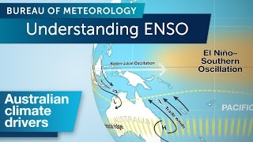
- What is ENSO?
- ENSO is often behind our climate extremes like…
- ENSO swings between three key phases. What are they?
- What happens in a La Niña phase and what does it mean for Australia?
- What happens in an El Niño phase and what does it mean for Australia?

Watch these videos to help students understand more about La Niña, El Niño and the impact of floods.

BTN La Nina Explained Big Weather: The Impact of Floods on Communities

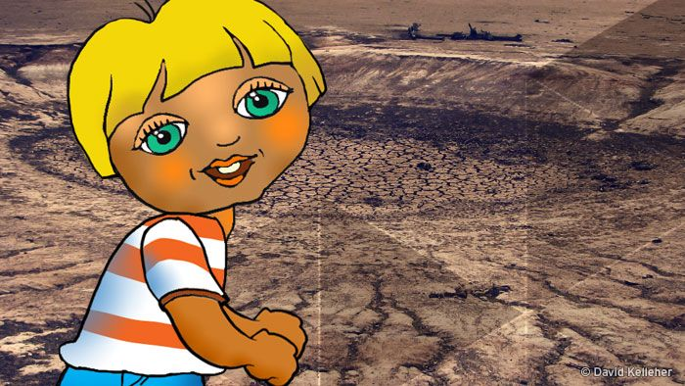
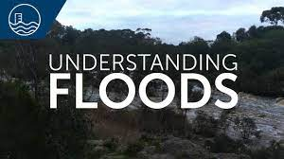

BTN El Nino BOM – Understanding Floods

Activity: Visual literacy
In this activity students will analyse a range of images which show drought in Africa and the United States and floods in Australia. Students will choose one or more of the images below and respond to the following:
- What is happening in the image? Create a caption for each image.
- How does the image make you feel?
- What does the image tell you about the impact drought or floods have?
- What questions do you have about what you see in the image?

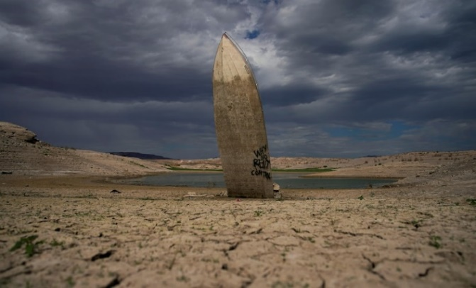  ABC News | 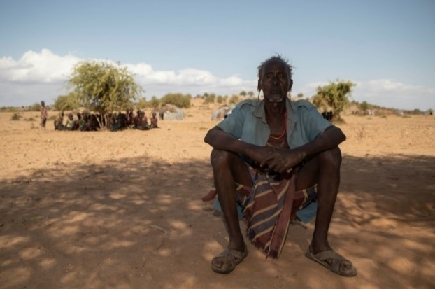  ABC News
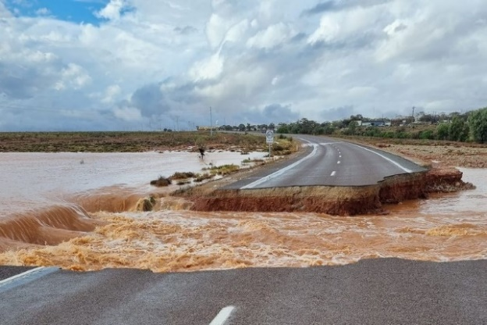  ABC News | 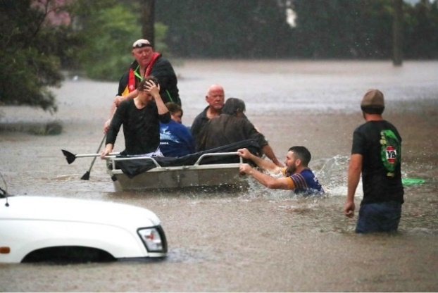  ABC News

Activity: Ask a Reporter - La Niña
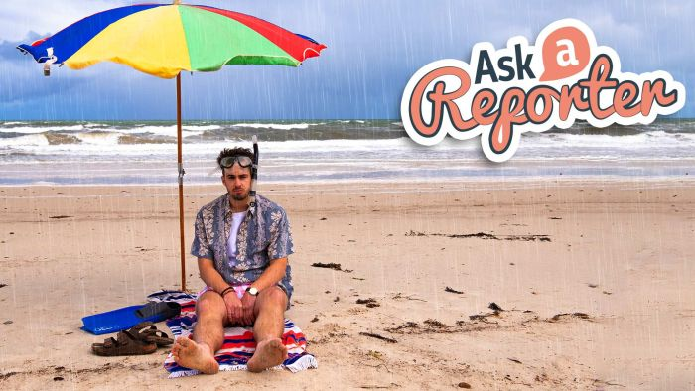
Watch this episode of AAR and hear Cale and Amelia answer students’ questions about La Niña.

Useful Websites
- La Nina sea temperatures driving floods in Australia and drought in the United States and Africa – ABC News
- BOM declares a La Niña alert, signalling strong chance of another sodden summer – ABC News
- La Niña Explained - BTN
- Understanding ENSO – BOM

What are El Niño and La Niña events? - BOM
- What is La Niña? – NASA Science Space Place

Activity: La Niña Quiz

- What does ENSO stand for?  A. El Niño Southern Ocean  B. El Niño Surface Oscillation  C. El Niño Southern Oscillation  - What does La Niña mean in Spanish?  A. Little Boy  B. Little Dog  C. Little Girl  - El Niño usually means reduced rainfall on the East Coast of Australia.  A. True  B. False  Quiz Answers: 1C, 2C, 3A, 4A, 5A, 6A | - What causes La Niña?  A. Cooling water in the Pacific Ocean off the coast of South America  B. Warming water in the Pacific Ocean off the coast of South America  C. Cooling water in the Atlantic Ocean off the coast of South America  5. What is there an increased risk of in Australia during La Niña?  A. Floods  B. Drought  6. What effect is La Niña having on the US and Africa at the moment?  A. Below average rainfall  B. Above average rainfall

EPISODE 24
23rd August 2022

KEY LEARNING
Students will learn about the Pitjantjatjara people and the importance of storytelling. Students will work collaboratively to write and illustrate a children’s picture book.

CURRICULUM
English – Year 4
Discuss how authors and illustrators make stories exciting, moving and absorbing and hold readers’ interest by using various techniques, for example character development and plot tension.

HASS – Year 4
The diversity of Australia's first peoples and the long and continuous connection of Aboriginal and Torres Strait Islander Peoples to Country/Place.

English – Year 5
Create literary texts that experiment with structures, ideas and stylistic features of selected authors.

HASS – Year 5
The influence of people, including Aboriginal and Torres Strait Islander Peoples, on the environmental characteristics of Australian places.

English – Year 6
Create literary texts that adapt or combine aspects of texts students have experienced in innovative ways.

HASS – Year 6
Experiences of Australian democracy and citizenship, including the status and rights of Aboriginal and Torres Strait Islander Peoples, migrants, women and children.
  - Teacher Resource

Pitjantjatjara Book

Focus Questions
Discuss the BTN story as a class and record the main points of the discussion. Students will then respond to the following:
- Where does Kellis live? Find on an Indigenous map of Australia.
- What Aboriginal language is the book written in?
- What animal is an anumara?
- How does Kellis feel about the book?
- Why is it important for Pitjantjatjara kids to have a book in their language?

Activity: What do you see, think and wonder?
Students will watch the BTN Pitjantjatjara Book story, then respond to the following questions:
- What did you SEE in this video?
- What does this story make you WONDER?
- What did you LEARN from this story?
- What did you LIKE about this story?

Activity: Class Discussion
Discuss the BTN Pitjantjatjara Book story in small groups or as a class.
- What is the language of the Pitjantjatjara people?
- Where is Pitjantjatjara country?
- Explore the Indigenous Map of Australia to learn more about the language, social or nation groups of Aboriginal Australia.
- What questions do you have?

What questions do you have about the story?
What did you learn from the story?

Activity: Indigenous Perspectives
There are a range of children’s picture books which help us understand Aboriginal and Torres Strait Islander histories and cultures. Introduce your students to Aboriginal perspectives by reading one of the following picture books and then discuss the themes in the books.

- Young Dark Emu by Bruce Pascoe
- Took the Children Away by Archie Roach
- Hello, Hello by Children from the Spinifex Writing Camp
- Freedom Day: Vincent Lingiari and the Story of the Wave Hill Walk-Off by Thomas Mayor and Rosie Smiler
- Stolen Girl by Trina Saffioti
- Little Bird’s Day by Sally Morgan

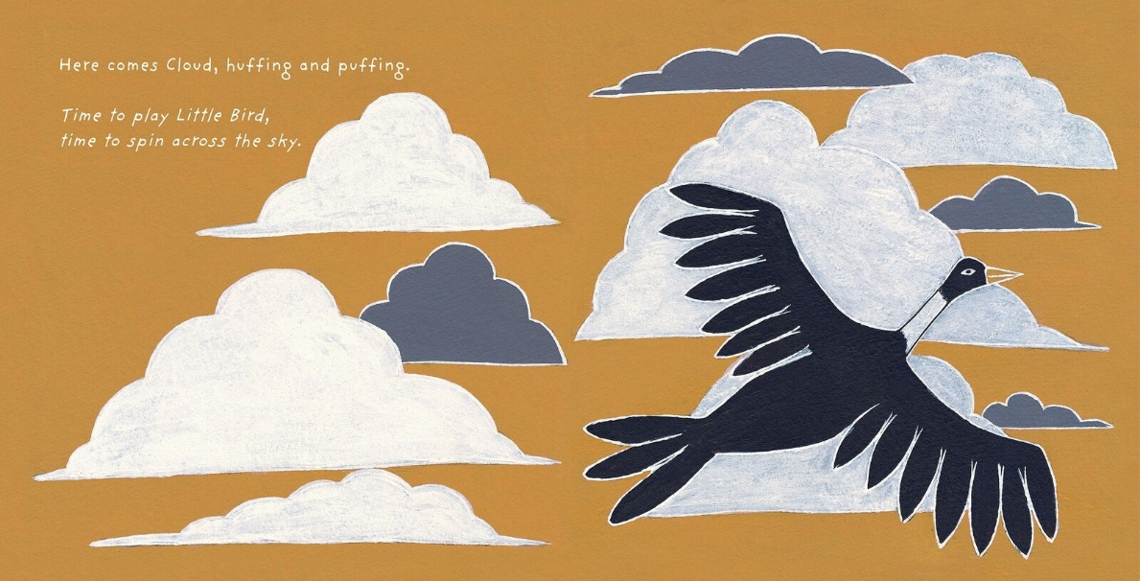
Little Bird’s Day by Sally Morgan, illustrated by Johnny Warrkatja Malibirr

Watch this video as a class to hear illustrator, Johnny Warrkatja Malibirr, read his Little Bird's Day book to 'Bapi' class at Gapuwiyak School. Watch this video to hear Johnny talk about his illustrations that he made for the Little Bird’s Day story.

After reading one of the books listed above, students will respond to the following:
- Who is the author and illustrator of the book?
- What traditional lands are they from?
- What is the theme of the book?
- What techniques does the author use to create suspense in the story? Think about the words and sounds that are used.
- What words or imagery are used in the book to convey feeling and emotion?
- What is the message of the book?
- Write down three things you would like to learn more about after having read the book.

Activity: How to build stories
Visual storytelling and understanding the importance of narrative is key in the making of a successful picture book. Start this activity by asking your students what they think a picture book is, recording their ideas during the discussion. Talk to students about the elements and techniques of effective storytelling. In pairs, students will make a list of useful tips for story writing, including tips on how to build character development, plot tension and narrative.

In pairs students will discuss what their favourite picture book is and why, using these questions to guide the discussion.
- What is your favourite picture book? Why?
- How did the illustrator and author make the story interesting or exciting?
- What did you like about the words and the pictures?
- Could the pictures tell the story without the words?
- What techniques does the illustrator use?

Resources
Use these FUSE teacher resources to help guide your students as they Make a Picture Storybook, Write a Picture Storybook, Illustrate a Picture Storybook, and Create a Storyboard.

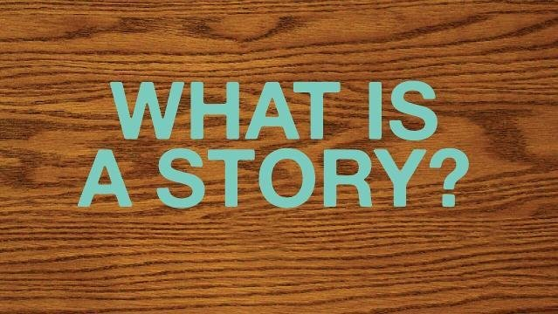
Use the ABC Education’s Digibook How to build Stories, which explains how to build your own stories, using tricks to create exciting characters, plots, settings, genres and language.

Activity: Pitjantjatjara Culture
After watching the BTN Pitjantjatjara Book story students will explore the culture and traditions of the Pitjantjatjara people. Students will develop their own question for inquiry or select one of the questions below.
- What is the language of the Pitjantjatjara people? Learn some common Pitjantjatjara words. How do you say ‘hello’?
- Where is Pitjantjatjara country? Mark the approximate boundaries on a map. What are some special sites in the area?
- Learn more about the Pitjantjatjara seasons and the plants and animals that are important to the Pitjantjatjara people. Learn more about the Indigenous Seasonal Calendar on the CSIRO website.

Further investigation
Students will explore the cultural diversity of Aboriginal and Torres Strait Islander peoples. Individually or in small groups, students will learn about the Indigenous group where they live and present what they have learnt to the class. Students will learn about the geographic location, language, culture, traditions, and histories.

Activity: Indigenous Language
What do your students know about Indigenous languages? As a class explore Gambay, the first Australian map that allows Aboriginal and Torres Strait Islander communities control over the way their languages are publicly represented. It showcases over 780 traditional languages.

While exploring the map, students will investigate the following (either as a class or in small groups):
- On the Gambay map type in the area where your school is situated.
- What is the local Indigenous language in your area?
- Do your own research to learn more about the local language. Find out the local language words for hello and goodbye.
- Look for stories by Aboriginal and Torres Strait Islander peoples valuing their oral traditions. Can you find stories told through dance, song and other art forms as well as through text?

Teachers Notes to support teachers in teaching about Aboriginal and Torres Strait Islander Languages.
The ABC offers a range of videos and podcasts which encourage students to explore the diversity of Indigenous culture and languages.

ABC – Indigenous Languages

Little J and Big Cuz  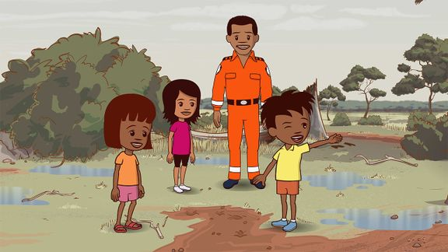 | Watch an episode of the ABC’s Little J and Big Cuz which are spoken in the Indigenous languages of Gija, Noongar, Torres Strait Creole, Palawa Kani, Warlpiri and Djambarrpuyngu. Find an episode in an Indigenous language local to your area. Link to iView videos
Education Good Mornings  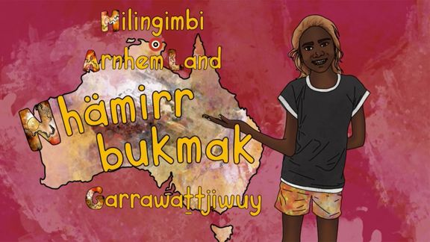 | How would you greet someone in the language of the land on which you live? In these ABC Education videos, children from around Australia encourage you to join them as they share greetings in their Indigenous languages.  Meet Garrawattjiwuy and learn how to say hello in the local language in Arnhem Land.  Link to iView videos
Little Yarns | Listen to the diverse languages, stories and Countries of Indigenous Australia in these Little Yarns audio resources. Teachers can check out the Educator Notes for ideas to get the most out of the Little Yarns podcast series.

Activity: Exquisite Corpse
Exquisite corpse is the most famous of all the surrealist games and was invented by Andre Breton and the surrealists in the 1920s. The surrealists were a group of artists and poets who loved breaking the rules of art and finding new ways to look at the world.

Exquisite corpse is a method by which a collection of words or images is collectively assembled. Each collaborator adds to a composition in sequence, either by following a rule, or by being allowed to see only the end of what the previous person contributed.

Exquisite (adjective)
Early 15c., "carefully selected," from Latin exquisitus "choice," literally "carefully sought out"
Corpse (noun)
Late 13century “body”, from Old French cors “body; person; corpse; life.

FOLDING STORY BASED ON THE EXQUISITE CORPSE
Exquisite corpse is a method by which a collection of words is collectively assembled. Each collaborator adds to a composition in sequence, either by following a rule, or by being allowed to see only the end of what the previous person contributed.

The instructions provide outline details for writing a narrative, but it could also be used for writing a poem. If writing a narrative, students will write a beginning, middle (with a complication) and an ending (with a resolution). Students will work in groups of three to create their folding story, using the following steps.

How to: | - Fold an A4 piece of paper into three equal parts.  - The first person begins writing the beginning of the story on the first section of the paper. The last word they are going to write should be written onto the next section.  - The second person uses the word that is written as the start of the second section (middle) of the story – it should include a complication. The last word they are going to write should be written onto the next section.  - The third person uses the word that is written as the start of the third section (ending) of the story – it should include a resolution for the story.  - NOW – SHARE!
Reflect | Reflect on the activity by responding to the following questions:  - What did you enjoy about this investigation?  - What did you find surprising?

Useful Websites
- APY Lands school student illustrates picture book to boost First Nation language literacy among remote kids – ABC News
- Anangu Language – Parks Australia
- Anangu Culture – Parks Australia
- Map of Indigenous Australia – AIATSIS
- Indigenous Culture (curriculum subject stories) – BTN
- School Libraries – BTN
- History of Libraries – BTN
- Young Author – BTN
- Writing Club – BTN
- Teen Novelist – BTN

  - Teacher Resource

BTN Transcript: Episode 24- 23/8/2022

Hey, what’s up, I'm Amelia Moseley and you're watching BTN. Thanks for hanging out with me again, let’s see what’s coming up in today’s show. We find out what the past year has been like for people in Afghanistan, meet a young Indigenous artist who's helping kids read in their own language and learn why La Niña could mean more wet weather in Australia.

Government Ministers

Reporter: Jack Evans

INTRO: But first today to a big story which happened last week involving this guy. Yep, you'd know him as former Prime Minister, Scott Morrison. But it turns out during the pandemic he also secretly appointed himself the minister of some other departments and that's caused quite a bit of controversy. Here's Jack to tell you what happened and what it means to be a minister.
LEADER: Alright, everyone. Well, thank you for meeting today. Now, before we get started let’s do a quick roll call, alright. Have we got the Minister for Health and Aged Care?
MINISTER 1: Oh, here.
LEADER: The Minister for Finance?
MINISTER 2: Yes, I’m here.
When it comes to running a country, like Australia, you could say it's a team effort.
LEADER: Minister for Communications?
MINISTER 3: One second, um, I'm on the phone.
That team is known as the cabinet. But unlike this cabinet, which is made up of me in a silly disguise, the cabinet of Australia is made up of groups of politicians within the federal government. They're known as ministers.
LEADER: Minister for Environment and Water?
MINISTER 4: Present.
Like all the other people in here and here, ministers are voted in by the public. But once everyone's elected the Prime Minister decides who they're going to put in charge of different departments or ministries or portfolios, as they're sometimes called. And there are dozens of them, some of which you've probably heard of before.
LEADER: Minister for Defence?
MINISTER 5: What, who said that?
It's the job of a minister to know all about their portfolio, to find potential problems and figure out how to fix them. They help to prepare new laws that relate to their department and with their fellow ministers help to make decisions on how the country should be run.
LEADER: Alright, we’ve got the Minister for Employment Workplace Relations.
MINISTER 6: *coughs*
LEADER: Oh, sorry, and also the Minister for Arts, kudos to you.
MINISTER 6: Who me? Yes, I'm here. Wearing both my hats.
MINISTER 7: Oh please, talk to me when you're wearing three.
Oh yeah, it's not unusual for someone to be in charge of more than one department. But recently to the surprise of many Aussies, including our current Prime Minster, Anthony Albanese, we found out that our former Prime Minister, Scott Morrison, had secretly assigned himself as co-minister of several different departments during his term of government.
LEADER: And lastly, but certainly not least, the Minister of Many Mystery Secret Ministries that no one has been told about. Wait a second, that's me.
As it turns out, Mr Morrison had appointed himself as minister for Health, Finance, Home Affairs, as well as Treasury and Resources. Which he had kept secret from the public, even some of the ministers of those departments didn't know. Mr Morrison says that he took on the roles as a "safe guard" during the pandemic in case the minsters couldn't do their job.
SCOTT MORRISON, FORMER PRIME MINISTER: Thankfully, the extreme circumstances in which I'd established these powers to act in, thankfully did not arise. I apologise for any concern this has caused about those issues and I understand that concern and that's why I'm standing here today.
Mr Morrison has copped a fair amount of criticism because this has never been done before and many say it's not how the Australian government should work. They reckon a single person shouldn't have that much power, even if they are prime minister, and that he should have been honest about the whole thing.
ANTHONY ALBANESE, PRIME MINISTER: This isn't some local footy club. This is the government of Australia where the people of Australia were kept in the dark.
HELEN HAINES, INDEPENDENT MP: It's the secrecy that is astonishing, and really, we must get an explanation.
Some have called for Mr Morrison to resign, but others reckon he shouldn't. Meanwhile the PM has started an investigation into what happened to get to the bottom of this ministerial muddle.
LEADER: Wait a second, all of the ministers in here are just me. You and you and you and, well, you I've never met.
GLADYS: Jack it's me, Gladys.
LEADER: Who? Do you know them?

News Quiz

Which extinct Aussie animal does a team of scientists want to bring back from the dead? It’s the thylacine AKA Tasmanian tiger. The last one died in captivity in 1936 but now a Texas-based bioengineering company has joined forces with the University of Melbourne to try to bring them back in the next 10 years.

ANDREW PASK, TIGRR LAB: A timeframe like a decade is really reasonable to think that we should be well on our way to having that first thylacine brought back.

They’ll use gene editing techniques to turn dunnart DNA into thylacine DNA then, hopefully, using IVF they’ll impregnate a dunnart with a baby tiger. Wow.

What’s the lowest temperature shops and public buildings in Spain are allowed to set their air conditioners to right now? Is it 18 degrees, 20 degrees or 27 degrees? 27 is the lowest they can go. It’s because of a new law designed to conserve energy. Gas is in short supply around Europe because of restrictions on Russian gas which were brought in because of the war in Ukraine. But it hasn’t gone over too well with some Spanish people who are sweating through a heatwave.

SPANISH PERSON 1: It’s crazy, I’m sorry, but it’s very crazy.

SPANISH PERSON 2: Yeah, I don’t think that is good enough, 27 degrees.

NASA has rolled out its giant SLS rocket which will be used in its upcoming mission to the Moon. Do you know the name of that mission? Is it Apollo, Artemis or Aquarius? It’s Artemis. The SLS, or Space Launch System, is the most powerful rocket ever built and on August 29th it will blast off on its first unmanned flight.

Afghanistan Anniversary

Reporter: Amal Wehbe

INTRO: Now let's head over to Afghanistan. It's been one year since the country was taken over by the Taliban and it's had a big impact on a lot of people's lives. Amal found out what's changed and how some young Afghan people are being affected.
Life for the Sherani’s is pretty similar to many Aussie kids. They love hanging out together, going to school, oh, and Noor's a pretty good singer.
NOOR: I don't look like her, maybe she's a magazine.
Nice. But 8 months ago, their life was turned upside down when they had to leave their home country Afghanistan. This is Afghanistan a year ago, when it was taken over by the Taliban, an extremist Islamic group. The Taliban promised to bring security and peace to the country. But for a lot of people, it was a scary time.
QAMARIA: It was a dark day.
HAMEED: It was as if we have lost a lot of the hopes.
You see the Taliban has ruled Afghanistan before. They first took power back in 1996 and enforced strict rules based on their extreme interpretations of Islamic law. Women were banned from most jobs and weren't allowed to leave the house without a man. They also had to wear burqas, a one piece veil that covers the face and body. And girls weren't allowed to go to school after the age of 8.
In 2001, the US and its allies invaded Afghanistan and defeated the Taliban. And the country began to change. There were elections, girls got to go to school, and university and women worked in all sorts of jobs. But when the US military left last year, the Taliban quickly took over again. Many Afghan people, like the Sherani family decided to leave the country. But their adopted brother Nasrullah couldn't get a visa and had to stay behind.
MINNA: I miss my brother so much.
For people who stayed in Afghanistan, a lot has changed. While some feel safer under the Taliban, the group's been accused of mistreating people who don't agree with them. The economy’s also facing big problems. And many countries and organisations have stopped giving aid money to Afghanistan to show they don't support the Taliban.
AFGHAN WOMAN: Everything has become more expensive, and I feel like I'm suffocating.
Women and girls have lost many of their freedoms. At the moment, girls aren't allowed to go to high school. Although that hasn't stopped everyone. These girls are going to a secret school, set up in their teacher's home.
AFGHAN STUDENT: Every Afghan girl needs an education, it's the only way to develop our country
Many in Afghanistan and around the world are calling for changes, and hoping things get better. As for the Sherani family, their biggest wish is to be reunited with Nasrullah, who’s amongst the hundreds of thousands of Afghans who've applied to come to Australia.
QAMARIA: We are waiting for him here. And he's waiting for us there.
Meanwhile, the girls are making the most of their new life and schooling in Australia.
ZALA: I'm very happy here because there was Taliban and no girls allowed to go to school after sixth grade, and here you're free whenever you want to go.
And they're looking forward to a future where they can be whatever they want to be.
ZALA: Doctor.
MINNA: Scientist.
MALALA: I don't know.
NOOR: Firefighter and singer.
AYNUR: Good.

La Nina

Reporter: Cale Matthews

INTRO: Now it's time to talk about the weather. Yep. It's been a wet year, to put it mildly, and now the Bureau of Meteorology says we could be in for another season of floods and heavy rain thanks to a weather phenomenon known as La Niña. Cale found out what that means and why it's not just a problem for Australia.

For some of us Aussies, this year has felt like the same rainy day over and over again. Meanwhile on the other side of the planet I wouldn't be surprised if some people had forgotten what rain looks like. Two parts of the planet, one going through a devastating drought, the other massive floods and it's all got to do with the ocean between them. I'm talking about a weather pattern known as ENSO or El Niño Southern Oscillation. The name comes from South American fishermen who first noticed that unusually warm water would sometimes arrive off the east coast of South America around Christmas time. They named it El Niño meaning the Christ Child or Little Boy.
You see, usually winds blow steadily across the Pacific Ocean. Around December, warm water starts to pool around Papua New Guinea. The warm air rises, then condenses and creates rainfall around our neck of the woods. In an El Niño phase those winds weaken and sometimes even reverse. It means there's a massive pool of warm water close to the Americas which means lots of rain for them and periods of drought for us. Then there's La Niña. That's where the east to west winds go into overdrive. Cold water piles up in the central and east, while a massive pool of warm water forms in the Western Pacific, like a natural jacuzzi, which brings us lots and lots of rain, and it's what's happening right now.
The Bureau of Meteorology here in Australia says that there's a really good chance that La Niña will be back for the third year in a row, which means more rain for the already saturated east coast. Meanwhile this means the opposite for parts of the United States and South America. They're already going through their worst drought in more than 1,000 years and there have been some massive wildfires
On the other side of the world, across the horn of Africa, there's a similar thing happening. They haven't had much rain for the last 5 wet seasons which has led to big food and water shortages. This drought is also to do with the winds and water temperatures but this time it’s in the Indian Ocean. It's called a negative Indian Ocean Dipole, which means there's lots of warm water and rain over here and cold water and drought over here.
The Indian Ocean Dipole and ENSO are natural parts of the weather, but most experts agree that these events and the effects of them are becoming more extreme due to climate change. Right now, we're locked into this La Niña event for a little while because, well, the ocean is pretty slow to change and that might mean more wild, wet and woolly weather ahead.

Pitjantjatjara Book
Reporter: Amal Wehbe

INTRO: This week is Book Week which you probably know is a celebration of all things bookish like reading and writing and illustrating and in this next story we're going to meet 17-year-old Kellis, who's created some beautiful pictures for a book which is helping little kids to read in Pitjantjatjara. Check it out.

Hi BTN, my name is Kellis Dare. I'm 17 years old and I live in Pukatja in the APY lands, and I illustrated this book. The book was published by the Department of Education for Aboriginal kids that speak Pitjantjatjara. In the book, there is Pitjantjatjara sounds so the little ones can understand the book. I got involved on the project through a person that works in the education department. He called my teacher and then called my art teacher and then my teacher told me if I wanted to illustrate a book.
This is kangaroo, malo. What I like about this drawing is before the editors they wanted to see how my drawings were. So, we sent them a dog and they liked it and then when I was doing the kangaroo, I couldn't do the head properly. And then my art teacher came to me and was like oh we can do it a cheeky way. So, she came up to me she cut the head off of the dog and put it on the kangaroo, but you can't tell now.
The second photo I like is the anumara. The caterpillar. Me and my nieces and nephews will collect a lot of these caterpillars and they'll put them in front of them and make them race and whoever won had to give the other one a little lolly or something.
The project took me nine months to finish. And the hardest part about this was when the editors kept telling me to make the lines thicker, or to make the make the design look a bit different. And it really made me a bit angry because I had to do it all over again. The best part about this illustration was that one day, my teacher just said to me, no more, no more, no more drawing for you. And also seeing the book, made me really happy.
I feel very happy and proud about the book. It just makes me really happy to see all the kids reading, smiling, pointing, coming up to me asking me if I did it. And also seeing a lot of kids smiling at a book that has a lot of animals that they see when they go out to places.
My hopes are, I would like to see a lot of kids from different communities not only from APY lands but from all over Australia to learn our languages. It is important for Pitjantjatjara kids to have a book in their language because we don't want any of the kids to feel left out. So, when my teacher asked me if I wanted to do a book, I felt happy. And I felt nervous, but then I thought it would be nice to have a book in Pitjantjatjara for a lot of kids.
Did You Know?

Did you know there are more than 250 Indigenous languages spoken in Australia and 800 different dialects.

Sport

The AFL home and away season has come to a pretty dramatic end. The 2021 Premiers smashed Brisbane by 58 points securing a double chance in the final’s series. The Western Bulldogs kept their finals hopes alive beating Hawthorn and stealing that precious eighth spot. Meanwhile, Collingwood met Carlton for a high stakes game. A win for the Blues would end a 9 year finals drought and they were up at the start of the last quarter. But, in the last five minutes, Beau McCreary did this and Jamie Elliot sealed the deal. Finals kick off next Thursday night when Brisbane play Richmond at the Gabba.
NRL finals are also on the horizon. The Raiders are still in the race after pulling off an incredible comeback against Newcastle. They were down 22 to 8 at half time, but then scored 20 points in the second half to take out the win. And the Sydney Roosters made history with the biggest score line for a rugby league game at the SCG, thumping the West Tigers 72 to 6, and securing 6th place on the ladder.
Australia's future baseball stars took some big swings in the US where the little league world series is underway. The Queensland team qualified to represent Australia, sadly they were eliminated after losing to Canada and the Euro-Africa, but they made some fans, and not just for their playing style.

Young Goat Farmer
Reporter: Jack Evans

INTRO: Finally, today, lots of kids find ways to earn pocket money by doing chores or maybe even setting up a business and 11-year old Pearl has been doing just that but in her own unique way. She's making money by running a goat farm. I'll let her tell you all about it.
PEARL: Hi, my name is Pearl. I'm 11. I breed pygmy goats. Originally when I was, I think I was nine, I wanted some goats and then instead of normal goats, we got pygmy goats. They're very funny and they’re small, which makes them quite cute. They're a bit friendlier than other goats because they've been kept in captivity and domesticated for quite a while. I like their small size because it makes them a bit easier to look after and they take up less room and if they head butt you, they can't really knock you over so much. So, I decided I wanted to start breeding them.
We've had babies being born. So, right here I have Kyra. She has a twin sister; I think she's over in the paddock. We've also had Salt who's from a different mother. They're going very well. Bit sleepy at the moment. But they just started eating food recently, so that's exciting. They like food a lot which you can probably tell. It was quite hard to find some does, females, because a lot of them are related to my buck and you can breed a buck’s child with him once, but you can't breed that child with him again, because then it's classified as inbreeding and then you can get strange things that happen, and the goats sometimes die. So yeah, I was trying to get some that were unrelated which was quite difficult
I feel like sometimes people don't think that I'm actually a serious buyer because I'm young. But I think some people have been nicer to me because I'm younger, which is good. I think I will continue breeding them when I'm older, but I don't think it's, I think it's gonna be more of like a hobby, well, not a hobby, but I think I'll have a different job as well as breeding goats.
Closer

Great work Pearl. Well, that's it for this week. But don’t worry, we'll be back before you know it and if you miss us in the meantime, you can jump online to check out some stories and quizzes and specials and there are resources up there for your teachers, so make sure you let them know. Newsbreak will also be right here in the studio every weekday to keep you up to date with the latest news. Have a lovely week, I’m going to go and finish my book, and I'll see you soon. Bye.

