

**EPISODE 31**  
4th November 2024

**KEY LEARNING**

Students will view a range of BTN stories and use comprehension skills to respond to a series of focus questions.

**CURRICULUM**

**English – Year 4**Use comprehension strategies to build literal and inferred meaning to expand content knowledge, integrating and linking ideas and analysing and evaluating texts.

**English – Year 5**

Use comprehension strategies to analyse information, integrating and linking ideas from a variety of print and digital sources.

**English – Year 6**

Use comprehension strategies to interpret and analyse information and ideas, comparing content from a variety of textual sources including media and digital texts.

**English – Year 7**

Use comprehension strategies to interpret, analyse and synthesise ideas and information, critiquing ideas and issues from a variety of textual sources.

Teacher Resource

**Focus Questions**

As a class, discuss the stories featured in the episode of BTN Classroom and record the main points of the discussion. Students will then respond to the following focus questions.

# US Election Recap

1. Summarise the BTN US Election Recap story in three sentences.
2. Who was the Democratic nominee for President?
3. Who was the Republican nominee for President?
4. How has the US election divided Americans? Give one example.
5. Voting in the US isn't compulsory. True or false?

# Swimming Standards

1. What is another name for junior life savers?
   1. Flippers
   2. Dippers
   3. Nippers
2. What activities do the junior life savers do? Name 1-2.
3. What percentage of kids finishing primary school aren't meeting the national swimming and water safety standards?
4. How long should kids be able to tread or float in water according to the government guidelines?
5. What colour flags should you swim between at the beach?

Check out the [teacher](https://www.abc.net.au/btn/weekly-teacher-resources/10746906) resource on the Archives page.

# E-Scooter Laws

1. Which state has recently passed laws that will make private e-scooters legal to ride on bike paths and shared pathways?
   1. SA
   2. NT
   3. Tasmania
2. What are some pros and cons of e-scooters?
3. In Queensland, you're allowed to ride e-scooters when you're 12. True or false?
4. Do you think the age limits for e-scooters are too strict? Why or why not?
5. What is the purpose of this news story? To entertain, persuade, inform, explain or describe?

**Bogong Moth Tracker**

1. What is the best time of the day to see Bogong moths?
2. Bogong moths are native to Australia. True or false?
3. Describe the migration journey of Bogong moths.
4. What animal eats Bogong moths?
5. What is the purpose of the Moth Tracker app?

Check out the [teacher](https://www.abc.net.au/btn/weekly-teacher-resources/10746906) resource on the Archives page.

**Molly’s Cosplay Community**

1. Name and describe one of Molly’s cosplay characters.
2. How does Molly create the characters?
3. What does Molly say is “Sylvester’s” greatest weapon?
   1. Her bow and arrow
   2. Her words
   3. Her fast speed
4. What is the name of the cosplay and gaming convention in Melbourne?
5. What game does Molly like to play where she can use her imagination and be herself?



**EPISODE 31**  
5th November 2024

**KEY LEARNING**

Students will learn more about water safety and create an education campaign about why it’s important to learn to swim.

**CURRICULUM**

**Health and Physical Education – Year 3 & 4**  
Identify and practise strategies to promote health, safety and wellbeing.

**Health and Physical Education – Year 5 & 6**

Plan and practise strategies to promote health, safety and wellbeing.

Investigate the role of preventive health in promoting and maintaining health, safety and wellbeing for individuals and their communities.

Investigate community resources and ways to seek help about health, safety and wellbeing.

Teacher Resource

**Swim Safety**

# Focus Questions

Discuss the BTN story as a class and record the main points of the discussion. Students will then respond to the following:

1. What is another name for junior life savers?
2. What activities do the junior life savers do? Name 1-2.
3. What percentage of kids finishing primary school aren't meeting the national swimming and water safety standards?
4. How long should kids be able to tread or float in water according to the government guidelines?
5. What colour flags should you swim between at the beach?

# Activity: Personal Response

Respond to the BTN Swim Safety story as a class. Students will complete one or more of the following incomplete sentences:

* Swim safety is important because…
* This story made me wonder…
* I was surprised to learn that…

# Activity: Class Discussion

Discuss the information raised in the BTN Swim Safety story. Record the main points of the discussion on a mind map. Here are some questions to guide the discussion:

* What activities do you participate in that involve water?
* What are some hazards when swimming at the beach?
* What are some hazards when swimming at a pool?
* Why is water safety important?
* Do you think it is important to learn to swim, even if you don’t go to the pool or beach often? Explain your answer.
* What factors might prevent someone from learning to swim?
* Whose responsibility is it to teach children to swim? Explain your answer.
* What questions do you have about this story?

# Activity: Glossary

Students will brainstorm a list of key words that relate to the BTN Swim Safety story. Here are some words to get them started.

|  |  |  |
| --- | --- | --- |
| WATER SAFETY | HAZARD | LIFESAVER |
| CURRENT | RIP | FLOATATION |

# Activity: Swim Safety Research

Students will develop their own question/s to research about swim safety. Below are some questions to get students started.

**Questions to Research**

* Why is it important for kids to learn water safety skills? Write a persuasive piece of writing explaining your reasons.
* What factors might prevent someone from learning how to swim? What are some solutions to these?
* How can understanding water conditions, like rip currents, help prevent accidents?
* Why is it important to swim between the red and yellow flags at the beach? Investigate the different flags and signs which help us to be water safe.
* What are some hazards when swimming in the beach? For example: rip currents, large waves, rock fishing or diving off a jetty. Choose one to investigate in more detail. Identify the hazard, tips for avoiding the hazard, and give advice to help people if they encounter the hazard. Use images, diagrams, videos and/or photos to help explain your answers.
* What is the role of a lifesaver? How do you become a lifesaver? What is the difference between lifesavers and lifeguards? Write some questions you would like to ask a lifesaver. As a class organise to meet and interview a lifesaver to learn more about beach safety.

**Further investigation**

# 

# Activity: Education Campaign

Students will design a public education campaign to raise awareness about the importance of learning to swim. Students will need to think about their campaign’s aim, target audience, and the value of raising awareness at their school. Students can use the following guidelines when researching, planning, and creating their swim safety campaign.

**Step 1: Research & Learn**

Use the internet to do some research to learn more about and why it’s important to know how to swim.

* Why is swim safety important for people of all ages?
* How does learning to swim reduce the risk of drowning?
* What are some tips for staying safe in different water environments – beaches, pools, river or dam?
* How can you encourage kids to learn to swim?

**Step 2: Define**

Before creating your campaign, you will need to do some pre-planning.

* What is the specific issue or problem that your campaign will deal with?
* Who is your target audience?
* What is the purpose of your campaign?
  + To persuade your audience
  + To help your audience understand an issue.
  + To encourage your audience to act.
  + To encourage your audience to adopt a behaviour/habit?
* What is the message of your campaign?

**Step 3: Plan**

Before creating your campaign materials think about the following:

* What type of media platform will you use in your campaign? For example, information poster, flyer, short film.
* Will you include a slogan for your campaign?
* What visuals will you use to communicate your message? For example, colours, images, logos.

**Step 4: Design & Create**

Write a strategy for your campaign, including:

* + Purpose
  + Key message
  + Audience
  + Media Platform
  + Launching your campaign

Create your campaign materials using your preferred media platform. Write your slogan and create any logos or images to be included.

**Step 5: Communicate**

Students will present their campaigns and then evaluate the success of their campaign.

* Rehearse your campaign presentation
* Lauch your campaign with an audience
* Evaluate – How effective was your campaign?
* Reflect – What did you like about this activity?

# Activity: Understanding Rips

Rip currents occur on most Australian beaches and are one of the biggest hazards for swimmers. Students watch the two videos below and answer the questions to learn how to spot a rip and what to do if you get caught in a rip. They can then create a safety checklist to share that teaches kids about rip currents.

Watch the [How to Spot a Rip Current](https://www.youtube.com/watch?v=PuAlDTC_gIQ&feature=youtu.be)  and answer the following questions:

* A group of people on a beach

  Description automatically generatedRip currents are easy to spot. True or false?
* What percentage of people can’t spot a rip current?
* How are rips formed?
* What are the things to look for when spotting a rip?
* What should you do before you go in the water?
* If the beach is patrolled, swim between…
* What else did you learn watching this video?

Watch the [How to Survive a Rip Current](https://www.youtube.com/watch?v=5QhxxXGPlJU&feature=youtu.be)  and answer the following questions:

* A beach with waves crashing on it

  Description automatically generatedWhat is the best way to avoid swimming in a rip current?
* Why is it important to stay calm if you get caught in a rip current?
* What should you do if you get caught in a rip?
* Never try to swim _______________ a rip.
* What else did you learn watching this video?

# Useful Websites

* [Swimming Safety](https://www.abc.net.au/btn/newsbreak/btn-newsbreak-20241028/104528174) – BTN Newsbreak
* [40% of children leaving primary school have not achieved national benchmark](https://www.royallifesaving.com.au/about/news-and-updates/news/2024/oct/40-per-cent-of-children-now-leaving-primary-school-dont-meet-the-National-Benchmarks) - Royal Life Saving Australia
* [Swim and Survive Program](https://www.abc.net.au/btn/classroom/swim-and-survive-program/13096094) – BTN
* [Classroom Resources](https://www.royallifesaving.com.au/educate-participate/education/classroom-resources) - Royal Life Saving Australia
* [Beach Safety](https://www.abc.net.au/btn/classroom/beach-safety/103413246) – BTN
* [Nippers](https://www.surflifesavingsa.com.au/nippers) – Surf Life Saving SA



**EPISODE 31**  
5th November 2024

**KEY LEARNING**

Students will investigate the migration of the Bogong moth. Students will learn about the significance of the Bogong moth to Aboriginal people.

**CURRICULUM**

**Science – Year 4**

Living things depend on each other and the environment to survive.

Living things have life cycles.

**Science – Year 5**

Living things have structural features and adaptations that help them to survive in their environment.

Scientific knowledge is used to solve problems and inform personal and community decisions.

**Science – Year 6**

The growth and survival of living things are affected by physical conditions of their environment.

Scientific understandings, discoveries and inventions are used to solve problems that directly affect peoples' lives.

**Science – Year 7**

Classification helps organise the diverse group of organisms

Interactions between organisms, including the effects of human activities can be represented by food chains and food webs.

**HASS – Year 4**

The diversity of First Nations Australians, their social organisation and their continuous connection to Country/Place.

Teacher Resource

**Bogong Moth Tracker**

# Focus Questions

Discuss the BTN story as a class and record the main points of the discussion. Students will then respond to the following:

1. What is the best time of the day to see Bogong moths?
2. Bogong moths are native to Australia. True or false?
3. Describe the migration journey of Bogong moths.
4. What animal eats Bogong moths?
5. What is the purpose of the Moth Tracker app?

# Activity: Class Discussion

**Before Watching**

Before watching the BTN Bogong Moth Tracker story ask students to discuss the following, in pairs or small groups:

* Have you ever encountered a Bogong moth? Explain more about your experience.
* Did you know that Bogong moths migrate? Explain what you know.
* Can you think of any other animals that migrate? Make a list.
* Have you ever noticed animals on their migration journey? Explain what your saw.
* What are some reasons that animals migrate?
* What do you think this BTN story will be about?

**After Watching**

Once your students have made their predictions, watch the BTN Bogong Moth Tracker story, and then students will respond to the following:

* A picture containing text, vector graphics

  Description automatically generatedWhat did you learn watching the BTN story?
* What did you find surprising?
* What questions do you have about this story?

# Activity: Vocabulary

Students will brainstorm a list of key words that relate to the BTN Bogong Moth Tracker story. Here are some words to get them started.

Mass migration

Conservation

Population

Habitat

Migration

Species

Citizen Science

Life Cycle

Ask students to write what they think is the meaning of each word (including unfamiliar words). They will swap definitions with a partner and ask them to add to or change the definition. Check these against the dictionary definition. Students will add to their glossary by downloading the transcript for the BTN Bogong Moth Tracker story and highlight all the words that relate to the topic.

# Activity: KWLH Organiser

Discuss the information raised in the BTN Bogong Moth Tracker story. What questions were raised in the discussion and what are the gaps in students’ knowledge? The following KWLH organiser provides students with a framework to explore their knowledge on this topic.

|  |  |  |  |
| --- | --- | --- | --- |
| What do I **know**? | What do I **want** to know? | What have I **learnt**? | **How** will I find out? |
|  |  |  |  |

Students will develop their own question/s to research or choose one or more of the questions below. Encourage students to collect and record information from a wide variety of sources and present the information they find in an interesting way.

* 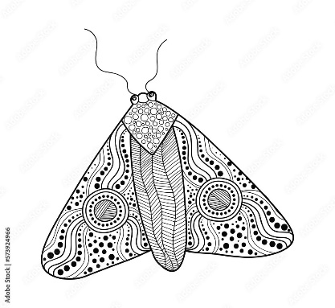What is the migration journey of a Bogong moth? Highlight on a map. Calculate the distance.
* When do Bogong moths migrate?
* Why is it called the Bogong moth? What Aboriginal language does its name come from and what does it mean?
* Why does the Bogong moth migrate? For example, find food, reproduce, escape harsh weather conditions and/or avoid predators.
* Why are Bogong moths important in Aboriginal culture?
* What can you do if you find a Bogong moth? Explore how you can be citizen scientists to help protect Bogong moth populations. Share what you’ve learnt with your classmates.
* Create a species profile on the Bogong moth. Include its name (common and scientific name), classification (class, family, genus), description, habitat, diet and threats.
* What has caused the Bogong moth population to decline? Use a cause-and-effect fishbone diagram to present your findings.
* What are some of the advantages and disadvantages of animals migrating in large groups?
* How can people help reduce migration hazards for Bogong moths?

# Activity: Aboriginal Histories

Learn about the history behind Mungabareena and the Bogong trail with your students. Watch this [video](https://www.abc.net.au/education/this-place-the-journey-of-the-bogong-moths/102565680) to hear Wiradjuri woman Leonie McIntosh tell the story behind this special place and help us understand Aboriginal and Torres Strait Islander histories and cultures.

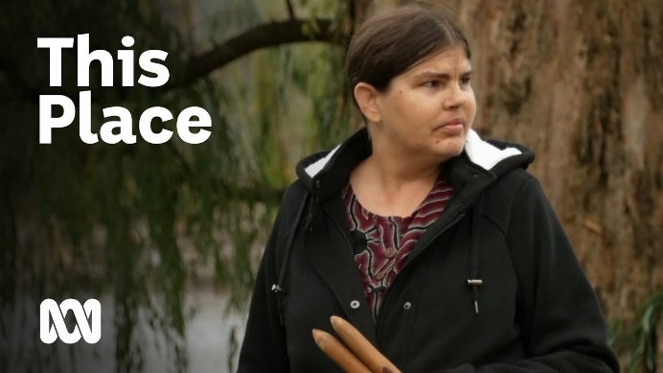Students will watch the [Journey of the Bogong Moths](https://www.abc.net.au/education/this-place-the-journey-of-the-bogong-moths/102565680) video together as a class. Have a class discussion to find out what your students learnt. Students will write down three things they would like to learn more about after watching the video.

After watching the video, students will research one of the questions they wrote or find answers to one or more of the following inquiry questions.

This Place: The Journey of the Bogong Moths (*Source:* [*ABC Education*](https://www.abc.net.au/education/this-place-the-journey-of-the-bogong-moths/102565680))

* 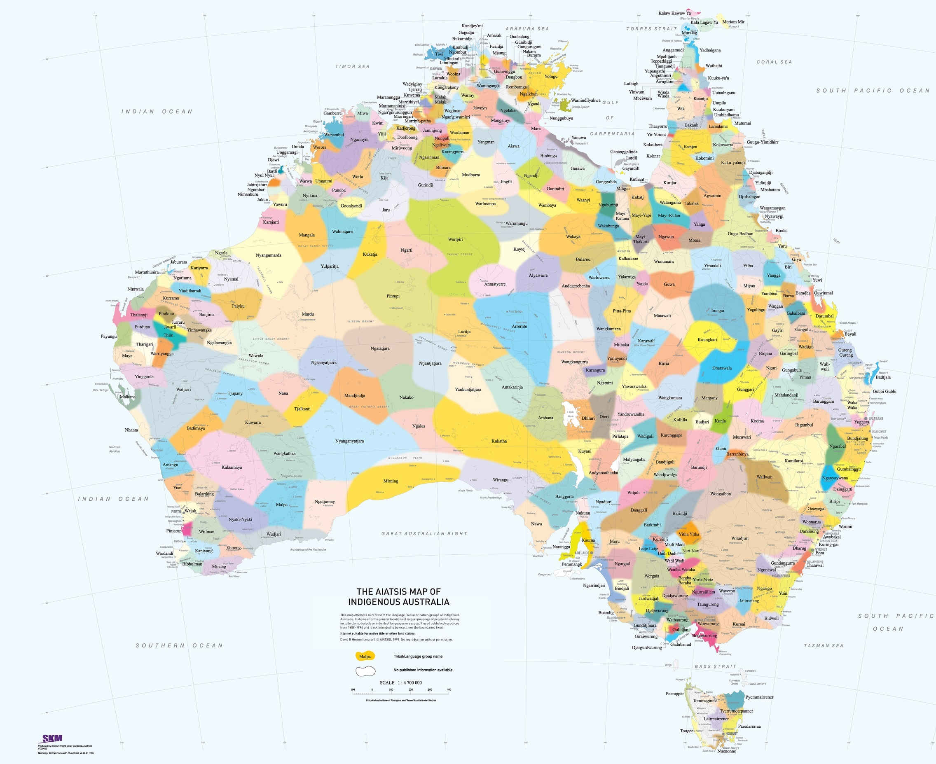Where is Mungabareena? Find on a map of Australia. Then find on a [map of Indigenous Australia](https://aiatsis.gov.au/explore/map-indigenous-australia). Find some photos showing the Mungabareena area.
* What does the name Mungabareena mean in the Wiradjuri language?
* In traditional times what activities did Aboriginal people do in Mungabareena? What activities did the women do and what activities did the men do?

Wiradjuri Country (*Source:* [*Map of Indigenous Australia*](https://aiatsis.gov.au/explore/map-indigenous-australia))

* Where is Mount Bogong? Find on a map. Find some photos showing the Mt Bogong area.
* What location were the moths gathered and what location were the moths eaten by the Wiradjuri people?

Wiradjuri language

Buugang (Bogong moth)

Wugan (crow)

Garru (magpie)

Dyirridyirri (willie wagtail)

* What are some of the animals that live together in the Mungabareena area? Find and learn the Wiradjuri words for some of the animals.

# Activity: Postcard Writing

Students will imagine they are an animal embarking on its migration journey. Students will choose one animal that interests them the most and conduct research into its migration journey. Students will then design and create a postcard which summarises the animal’s journey of migration.

**Class Discussion**

Begin this activity with a class discussion about what migration is and why animals migrate. Use the following questions to guide your class discussion.

* Find a definition for migration (in relation to animal migration)
* Why do animals migrate? Think of some reasons.

**Migratory Animals**

Provide a list of migratory animals that students can choose from. Students will choose an animal they are most interested in and focus on that animal throughout this activity.

* Bogong moth
* Humpback whale
* Christmas Island red crab
* Bats
* Arctic tern
* Monarch butterfly
* Elephant
* Great white shark
* Swift parrot
* Wildebeest

**Research**

Students will research their chosen animal with a specific focus on is migration journey. Students will use the following as a guide during their research.

* Where does the animal’s migration journey begin?
* What is the animal’s migration destination?
* How far does the animal travel during migration? Calculate the distance.
* When does it migrate? Is it seasonal?
* What are some of the reasons this animal migrates? Make a list.
* What survival skills does the animal need to make the journey? Use illustrations to help explain.
* What are some of the obstacles or challenges that the animal may come across during their journey?
* What can humans do to help these challenges?

**Create a Postcard**

Students will design a postcard that represents their animal's migration journey. Students will include the following

* Imagine you are the animal on its migration journey, and you are writing a postcard to a friend, sharing your experiences from your journey.
* Write about the animal’s journey including the start and destination, key stopover sites and interesting facts about the journey. You may want to write about any adventures, challenges, and exciting discoveries on your journey!
* Include the Aboriginal place names on your postcard. Include the traditional place names, for example, “Wiradjuri Country”, in your writing and also in the mailing address section of the postcard.
* On the front of your postcard include an image or illustration of the animal or include a map which shows its migration journey.

# Activity: Who am I?

Students will play the Who Am I? game to learn more about animals that migrate. See worksheet at the end of this activity.

Students will…

* Match the 4 animals to the clues about their migration journey. Students may need to do some research to help them complete this activity.
* Draw a line to match up their journey.
* Choose one of the migratory animals and then conduct their own scientific research.

Answers to the *Who Am I?* game

Clues: 1. Bogong moth, 2. Humpback whale, 3. Arctic tern, 4. Christmas Island red crab.

# Useful Websites

* [Bogong Moth](https://australian.museum/learn/animals/insects/bogong-moth/) – Australian Museum
* [Mysteries of the Bogong Moth](https://www.youtube.com/watch?v=jRb2aC3SZvs) – Museums Vitoria (YouTube)
* [Moth Tracker](https://www.zoo.org.au/moth-tracker/) – Zoos Victoria
* [Migration](https://education.nationalgeographic.org/resource/migration/) – National Geographic
* [What is migration and why do some animals migrate?](https://www.bbc.co.uk/bitesize/articles/zrt66g8#zdyff82) – BBC Bitesize
* [Christmas Island Crabs](https://www.abc.net.au/btn/classroom/christmas-island-crabs/101607582) – BTN
* [This Place: The Journey of the Bogong Moths](https://www.abc.net.au/education/this-place-the-journey-of-the-bogong-moths/102565680) – ABC Education
* [Moth Tracker App](https://mothtracker.swifft.net.au/) – Zoos Victoria and Swifft

**Who am I?**

Your task is to match the 4 animals to the clues about their migration journey! Draw a line to match up their journey and then complete your own scientific research.

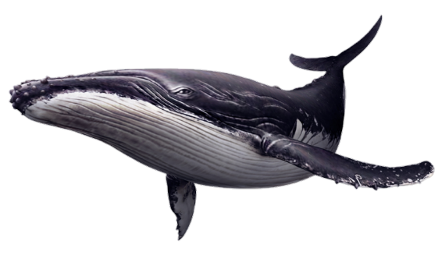

**humpback whale**

**(Megaptera novaeangliae)**

I shelter in alpine caves over summer

I have a wingspan up to 5 cm.

I’m an important food source for many alpine animals.

I fly up to 1000 km during my annual migration.

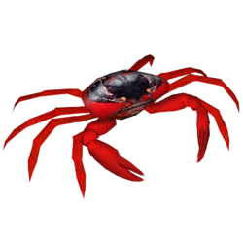

**Christmas Island red crab**

**(Gecarcoidea natalis)**

I travel north from Antarctica to warmer waters to give birth.

On my return journey you will often see me closer to shore, frolicking and taking my time with my babies.

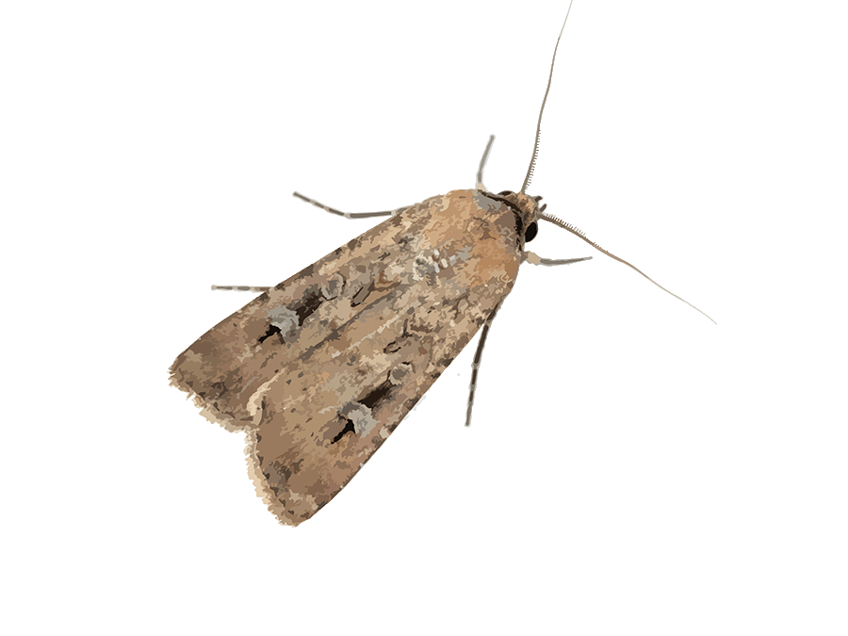

**Bogong moth**

**(Agrotis infusa)**

I have the longest migration of any animal, traveling 71,000 kilometres each year from pole to pole.

I spend most of the year on the move.

I migrate to follow the summer sun.

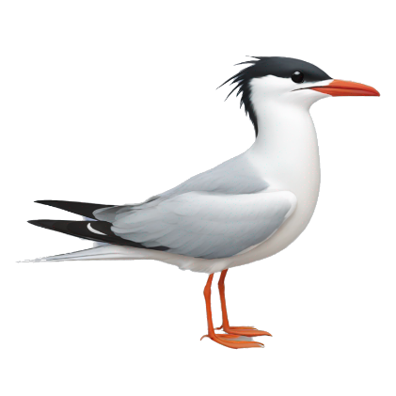

**Arctic tern**

**(Sterna paradisaea)**

At the start of the wet season, I migrate from the forest to the ocean to breed.

The timing and speed of my journey is determined by the phase of the moon.

To protect us, some sections of roads close during peak migration time.

Choose one of the above animals and learn more about their migration journey! Conduct your own scientific research and complete the following sentence starters.

*I migrate because…*

*In order to find my way, I…*

*When I was migrating, I . . . which was very challenging.*



Teacher Resource

**BTN Transcript: Episode 31 - 5/11/2024**

Hey, I'm Amelia Moseley, and you're watching BTN. Thanks for hanging out with us again. Let's see what's coming up on today's show. We learn why experts are worried that kids can't swim well enough, find out more about e-scooter laws and track down the elusive bogong moth.

# US Election Recap

Reporter: Amelia Moseley

*INTRO: All that soon but first up today to the big story of the week and well, the year, really, it’s the US election. By the end of Wednesday our time we might finally know which one of these two has won the presidency. So, let's get a run-down of what's going on, how we got here, and what the future could have in store from... Me? Oh, I don't remember doing this story, but take a look.*

AMELIA MOSELEY, REPORTER: Hello? Hello? Can you hear me? Yes! It's me! It's Amelia! I'm coming to you from the future. Now, if you're watching this on Tuesday 5 November, in Australia, then the US election isn't over yet. But if you're watching this on Wednesday 6 November onwards, then you know what happened. Wasn't that an unbelievable result? I was not expecting that. Yeah... Anyway, either way, I think it's really important that we go back even further than where you are now to find out how it is we got here.

Sorry, just give me a second. This thing needs a little work.

Oh, here we are. When everything was peaceful, and American politicians were all quietly going about their business with no controversy whatsoever. Nah, I'm just kidding. US politics has been pretty wild for a while now.  
  
KAMALA HARRIS, PRESIDENTIAL CANDIDATE: You think you just fell out of a coconut tree?   
  
DONALD TRUMP, PRESIDENTIAL CANDIDATE: I wouldn't mind this job.

TUCKER CARLSON: (LAUGHS) I mean, what?  
  
When the campaign started, like forever ago, US President Joe Biden was running to keep his job for a second term. But everything changed after the first debate when this happened.

JOE BIDEN, US PRESIDENT: With the...with the COVID. Excuse me? With... um, dealing with everything we have to do with... Look.

Hmm. Yeah. Biden clearly wasn't at his best and after a lot of pressure he decided to drop out of the race, and back his Vice President Kamala Harris as the new Democratic nominee for President.   
  
KAMALA HARRIS: So, are you ready to get to work?  
  
And get to work she did, with only a couple of months to go to try to secure a win against former president and Republican candidate Donald Trump.  
  
DONALD TRUMP LOOKALIKE: You know people love me, they really do.  
  
Wait, that's a lookalike, hang on. Republican Candidate Donald Trump. Ugh!  
  
Oh, sorry, this thing gets a bit muddled sometimes.   
  
There we go.  
  
Harris and Trump pulled out all the stops with star-studded rallies.  
  
BEYONCE: It's time to sing a new song. *cheers*  
ELON MUSK: The future is gonna be amazing.  
  
There was also a lot of misinformation and disinformation out there.  
  
DONALD TRUMP: They're eating the pets.

PERSON: Wait, wait, wait. Staged by who?

PERSON: Oh, by Mr Trump, of course.  
  
And, yeah, there actually was this scary moment - the attempted assassination of Donald Trump.

DONALD TRUMP: I said to myself, "Wow, what was that? It can only be a bullet."  
  
Some say this election divided Americans more than ever before.  
  
US RESIDENT: It's a felony, maam.  
US RESIDENT: No, it's not, get over it.

US RESIDENT: Yes, it is. It is.  
  
TRUMP SUPPORTER: I'd say the freedom. And that's what Trump represents.   
  
KAMALA HARRIS SUPPORTER: She's everything that I've always wanted in a president.   
  
While there are heaps of reasons for that divide, one is that Trump and a lot of his supporters still say their opponents cheated in the last election in 2020, even though there's no evidence of that.   
  
DONALD TRUMP: The ones that should be locked up are the ones that cheat on these horrible elections that we go through in our country.

PERSON: You're cheating. We caught you, and here you go.

PERSON: I'm always worried that there's going to be cheating in this election.

PERSON: You know there's going to be cheating.

There were also some big disagreements over some other big issues.  
  
DONALD TRUMP: I will launch the largest deportation program in America.  
  
KAMALA HARRIS: Young women in America today have fewer rights than their mothers and grandmothers?  
  
This was also one of the most unpredictable elections ever.  
  
AMELIA: Like do you remember how close the opinion polls were before the vote? Pfft, unbelievable. Wait, has that happened yet? I'm losing track of time.  
  
Voting in the US isn't compulsory. Which means no one really knew how many people were going to turn up on the big day, or what impact this election would have on America, and the world. At least, they didn't know yet.  
  
Whew! You know what? Maybe I should just tell you who won the US election. I mean, you know, if you don't already know. OK. You ready? It was...

**News Quiz**

Deadly flooding has caused devastation in which European country? Is it France, Portugal or Spain? It’s Spain. Last Tuesday, the Valencia region got about a year's worth of rain in eight hours, causing Spain's deadliest natural disaster in living memory. A lot of people were angry with what they said was a lack of warning about the flood danger and a lack of help with the clean-up. Protesters even threw mud at the King of Spain, who was visiting an affected town.

TRANSLATOR: We're just 16. We are helping, and the leaders do nothing.

Here’s a bit of a maths question, do you know what this number is? That’s a 20 and 33 more zeros behind it by the way. Is it 20 decillion, 20 zillion or20 quadrillion? It's 20 decillion, and it's the number of US dollars that Russia has fined Google for blocking YouTube content from state media companies after Russia invaded Ukraine. It's very unlikely that Google will be paying it, though, especially since that's more money than there is in the world.

What was this Chinese rocket carrying when it blasted off last week? A moon rover, people or a satellite? It was carrying three taikonauts who’ll be spending the next six months on China’s space station.

And millions of people around the world have celebrated Diwali which is also known as the festival of what? Is it lights, lanterns or colour? And millions of people around the world have celebrated Diwali, which is also known as the Festival of what? Diwali is the festival of lights. It's an important religious festival for Hindus, Sikhs and Jains and celebrates the triumph of good over evil.

STUDENT: We celebrate it with, like, firecrackers, fireworks.

STUDENT: We go to the temple and pray, and we also eat food together.

**Swim Safety**

Reporter: Jack Evans

*INTRO: Now, here's a question for you. Are you a good swimmer? Well, new research from Royal Life Saving Australia has found that almost half of all Aussie kids are leaving primary school without basic swimming skills. And as Jack found out, that's a big problem.*

INSTRUCTOR: Ready? Set? Go!

JACK EVANS, REPORTER: Like a lot of Aussies these guys love getting in the water and going for a splash. They're Nippers, or junior life savers, which means they have to be strong swimmers.   
  
SEAN FAULKNER, LIFESAVING & EMERGENCY OPERATIONS MANAGER: Nippers is our youth training program for children aged 5 to 13, which introduces them to both Swimming and Water Safety along the beaches at a young age.  
  
IVY, NIPPER: In the water we do swimming and board paddling and also wading. On the beach we do running and flags and some other fun activities.  
  
TABITHA, NIPPER: My favourite thing to do at nippers would be boards or flags.   
  
BELLA, NIPPER: I just enjoy like hanging out with friends and learning new things most of the time.  
  
But while these guys know how to keep themselves and others safe in the water, new research has found that there are lots of kids who don't.   
  
You see here in Australia we are surrounded by water, beaches, rivers, lakes and of course pools. So, swimming is seen as an essential skill. The government has standards or guidelines that say kids who are 12 should be able to swim 50 metres continuously and tread or float in water for a minimum of 2 minutes. But a study by the Royal Lifesaving Society of Australia has found that more than 40 percent of kids finishing primary school aren't meeting those national swimming and water safety standards.  
  
JUSTIN SCARR, CEO ROYAL LIFE SAVING AUSTRALIA: Completely shocking and it's been declining for many, many years.   
  
Justin Scarr is the CEO of Royal Life Saving Australia, he says that the report found that while most Aussies have had a swimming lesson in their life lots of kids drop out of lessons too early.  
  
JUSTIN SCARR: They're leaving programmes at ages 5 and 6. That's the point at which Children start to learn wonderful life saving skills.  
  
Justin says that is costing lives as the number of drowning's each year are on the rise, particularly with teenagers.  
  
JUSTIN SCARR: At that age they start to swim away from patrolled locations in the local river or the local creek or even an un patrolled beach.  
  
While most states and territories have compulsory swimming programs for kids, how much you learn at school differs from place to place. And for some schools, particularly in remote inland areas, it can be a struggle getting access to pools and swimming instructors.   
  
JUSTIN SCARR: We need to boost our investment in school education. Let's give them some more money.   
  
As for these guys, they'll keep honing their skills to keep others safe at the beach and while not everyone has to be a life saver, they say it's important that people know enough to save their own lives.   
  
TABITHA, NIPPER: You want to be careful of rips in the ocean that bring you out and a current. We had a current today and it was pushing you out that way.

IVY, NIPPER: You have to be very confident, because if you don't feel confident in yourself, you have doubt, and then you start worrying, then you start to get in trouble, so being confident in yourself is the best thing to do.  
  
BELLA, NIPPER: Swim between the flags, because sometimes there's two red and yellow flags, which is where the Surf Life Savers are patrolling. So, you know, it's a safe area. if you feel safe, like you'll be confident of how to swim in everything.

# E Scooters

Reporter: Wren Gillett

*INTRO: Now to e-scooters. They're a pretty popular way to get around but the rules around who can ride them and where can be pretty confusing. Last week New South Wales released some draft laws which will make it legal to ride your own scooter in public, but only if you’re over 16. Here's Wren.*

SANTA: Eeee-scootaaar, eeee-scootaaar, anohter eeee-scootar  
  
WREN GILLETT, REPORTER: I think it's pronounced e-scooter, Santa.   
  
SANTA: I can't keep up with the kids these days, what's an e-scooter?  
  
WREN: It's like a regular scooter, only e-lec-tronic. They're very popular you can buy them in all sorts of shops. Ooh look this one's pink.  
  
SANTA: Ahh, yes that one's quite pretty isn’t it?  
  
Yeah, walk into a sports or electronic store, or down the street, and you'll probably see one of these. Motorised scooters have actually been around for more than one hundred years. But over the past five years, they've really taken off, whether it's rental scooters like these or personal one’s people buy to zip about on. They're relatively cheap and easy to use.  
  
WREN: And they're really fun.  
  
SANTA: Well, they look dangerous to me. Are they dangerous?  
  
WREN: Umm, let me have a look. Can I phone a friend?  
  
MATT VERTUDACHES, RAA SENIOR TRAFFIC ENGINEER: E-scooters can be dangerous in some circumstances. So, we know that they're often ridden on footpaths and areas with a high amount of pedestrian traffic. If the scooter rider travels too fast, the risk of crashing into and injuring someone does increase.  
  
Thousands of people have had to go to hospital after crashing an e-scooter, and a few people have died, although we don't know exact numbers, which experts say is a bit of a problem.  
  
MATT: There is a little bit of a lack of data around e-scooter crashes.  
  
So to try to keep people safe, state governments have brought in their own laws about who can ride e-scooters, where they can ride em, and how fast they can go.   
  
SANTA: Well, what is the law? Is Johnny even allowed to ride an eee-scootaaar?  
  
WREN: Ahh, that's complicated. Um, where does he live? How old is he?  
  
While anyone can buy an e-scooter, not everyone can actually ride them in public. In the NT, South Australia and New South Wales, they're actually illegal, except for the rental ones. If you have your own e-scooter, you can only ride it on private property. Although that's set to change. In SA and New South Wales that is. South Australia has recently passed laws that will make private e-scooters legal to ride on bike paths and shared pathways, and New South Wales is working on something similar. While some people are worried this will lead to more accidents, others say e-scooters are a great way to cut down on traffic, which is good for cities and the environment.  
  
MATT: There's a lot of benefits, and these laws will increase their use and have a number of positive benefits to society.  
  
SANTA: Oh well, I guess if the government says it’s alright, who's jolly old Santa to say no no no. Ho ho ho. One e-scooter for Johnny.  
  
WREN: Ooooh, hang on.  
  
Yeah even though private e-scooters will soon be legal across most of Australia, they won't be legal for everyone. Under the proposed New South Wales laws, you'll have to be at least 16 to ride your own e-scooter in public, same goes for South Australia. And that's already the minimum age in Western Australia, Tasmania, and Victoria.  
  
WREN: Wait. In Queensland, you're allowed to ride them when you're 12. You just have to have adult supervision.  
  
SANTA: Johnny's 11.  
  
WREN: Oh.  
  
Some people reckon the age limits are too strict, but others reckon 16 is about right.  
  
MATT VERTUDACHES: It's when you often can get your learner's permit, when you're starting to get a good understanding of road rules as well. Ultimately, look, if you are planning to get out on an E scooter, make sure you are of the right age in the state or territory that you're riding in and following the appropriate rules.  
  
JACK: Oh. Well, I'm very sorry, Johnny. Perhaps next Christmas. What else is on his list?  
  
WREN: A pony.  
  
JACK: Ugh, this kid.

# Bogong Moth Tracker

Reporter: Wren Gillett

*INTRO: Have you ever seen one of these? It's a Bogong moth, an Australian native species that's actually in a lot of trouble, which is why zoos Victoria is asking for your help to track them as they fly across the country. Check it out.*

They're an insect you might have seen before, in darkness when all you can hear are snores. When flowers begin to bloom or leaves start to fall, that's when you'll have your closest call.   
  
WREN GILLETT, REPORTER: Oh, yes, yes! Oh.  
  
KIRSTEN: Hi, Wren. You're probably going to have better luck finding a bogong moth outside at night - not here in the ABC studio.  
  
WREN: Yeah, look. You uh have a point.  
  
Uh uh, Kristen is probably right. In fact. She definitely is. But there's a chance you've seen one of these Australian native insects before, maybe hanging around your window at night.  
  
KRISTEN MESSENGER, SCIENCE COMMUNICATOR: So, Bogongs are probably not what people think. I always expected them to be really big, but they're kind of just a medium sized moth. They're only about, you know, three centimetres long, and they always hold their wings sort of flat.   
  
Right now, Bogong moths are in the middle of their Spring migration, when they leave their breeding grounds across the country and travel up to 1,000 kilometres to Victoria's cooler mountains. But Kristen says in recent years, fewer and fewer Bogong moths have been making this journey.  
  
KRISTEN: They used to emerge in their millions. They would cover the Opera House and make the walls of the opera house go from white to brown, but now there's, you know, maybe you might get 50 on the Opera House, which is a big decline.  
  
And it's not just insect enthusiasts like Kris that will miss Bogongs if they disappear. This is a mountain Pygmy possum. Naw. These adorable little marsupials are also critically endangered, and their favourite food is, yep you guessed it, Bogong moths.   
  
JESSIE SINCLAIR, ZOOS VICTORIA INVERTEBRATE CONSERVATION COORDINATOR: When the mountain pygmy possums first wake up after hibernation in winter, they're really hungry, and they need a really good feed to get them going so that they can breed. And they use Bogong moths as almost like a little protein bar.  
  
To save the possums, we need to save the moths, and Zoos Victoria is asking you guys to help, by using an app called Moth Tracker.   
  
JESSIE: Anyone out there who's got a camera takes a photo of what they think is a Bogong moth, even if you're not quite sure, get the photo and submit it. Even if it's not, both sightings will get logged onto the website, and then that website, anyone can access and have a look and see where the Bogong moths are turning up and where they're being observed   
  
KRISTEN: So, already the information that's coming out of moth tracker is pretty exciting, like already we know, oh, they don't just go up the East Coast and end up in Queensland and come back again. We actually know that they do this even greater migration right across the country, to Western Australia.

Kris says like all insects, these little guys play a huge part in our ecosystems. And every one of us can make a difference to their survival.   
  
KRISTEN: If you want to have an ocean, you have to have drops of water, and each of those sightings is just a drop of water, but together, they make a whole ocean of evidence for scientists that that can be used to support future populations of bogons and to, you know, bring them back from the brink.

# Did you know?

Did you know the world's biggest moth is the Atlas Moth of South-East Asia which has a wingspan of 27 centimetres.

# Sport

Step aside, London Marathon. Move over, New York Marathon. Because there's a new kid on the block - the Sydney Marathon. It's just been announced as the seventh event to be part of the World Marathon Majors, and the first in the Southern Hemisphere, joining famous events in Boston, Chicago, London, Tokyo, New York and Berlin.

PERSON: It's really going to put Sydney on the the running world map.

Now, let's head over to Brazil for the Sao Paulo Grand Prix, where Max Verstappen has his fourth Formula 1 title within reach.

COMMENTATOR: The Dutchman has delivered a defining drive.

Verstappen staged an impressive comeback from 17th on the grid. Pole sitter and title rival Lando Norris ended up finishing sixth after a few errors on the track. Verstappen now holds a 62-point lead over Norris with three grand prixs and one sprint race left in the season.

And finally, it's time to get out your period costumes, because this is the 30th Prague Mile race. Participants race on these penny farthings or high bikes, but it's not all about speed. This slow and stylish event finishes with a race called Lehtinen's Snail, where the slowest to complete the course wins. Oh, careful there, buddy.

# Takeover Molly

Rookie Reporter: Molly

*INTRO: Finally, today we're going to meet Molly who's from Victoria's Latrobe Valley which is the latest region to host the ABC takeover competition, it asks young people to share their stories and Molly's going to tell us why she loves cosplay.*

Most people know me as Molly, but when I’m in character, I’m also Astrin, Grozdan, Dawn, Teef, Nixy and Sylvester. Nixy is a motherly frog-folk who owns a potion shop.  Dawn is an adventurous wood elf who carries a bow and arrow and commands a swarm of attack squirrels. I bring my characters to life in the real world through cosplay. I become them and they become me. Each one has their own personality. Their own strengths and weaknesses. Through them, I can be courageous or cunning. Bad or brave. Anything I can imagine.

Some start off as sketches or digital art. Others I make into sculptures or sew into plush toys. Right now, I’m in the middle of making a costume for my character Sylvester. Sylvester is a moth girl with four arms who plays the flute. Her greatest weapon is her words. I’m getting Sylvester ready for PAX, a huge cosplay and gaming convention in Melbourne. I went there for the first time last year and dressed up as my character Dawn. Dawn might be adventurous, but I was feeling nervous. As soon as I saw other cosplayers, I relaxed into character and began exploring my new world.

My characters also come to life through Dungeons and Dragons. It’s where my creative self really shines. In the Latrobe Valley, Dungeons and Dragons and cosplay are a little niche. But I’ve found a great community who aren’t afraid to use their imaginations — just like me. I feel like I found a place for my characters in my hometown. I’m proud of my creations. And I’m proud to be me.

**Closer**

Well, that's it for today. But don't worry, we'll be back next week with more news, including who actually won the US election. In the meantime, Newsbreak will be right here in the studio, every weeknight, keeping you up to date. And as always, there's heaps to see and do on our website and our socials if you're 13 or over. Have the best week, and I'll see you really soon. Bye.