

**EPISODE 2**  
11th February 2025

**KEY LEARNING**

Students will view a range of BTN stories and use comprehension skills to respond to a series of focus questions.

**CURRICULUM**

**English – Year 4**Use comprehension strategies to build literal and inferred meaning to expand content knowledge, integrating and linking ideas and analysing and evaluating texts.

**English – Year 5**

Use comprehension strategies to analyse information, integrating and linking ideas from a variety of print and digital sources.

**English – Year 6**

Use comprehension strategies to interpret and analyse information and ideas, comparing content from a variety of textual sources including media and digital texts.

**English – Year 7**

Use comprehension strategies to interpret, analyse and synthesise ideas and information, critiquing ideas and issues from a variety of textual sources.

Teacher Resource

**Focus Questions**

As a class, discuss the stories featured in the episode of BTN Classroom and record the main points of the discussion. Students will then respond to the following focus questions.

# PM Press Conference

1. Discuss the PM Press Conference story as a class and record the main points of the discussion.
2. Where was the press conference with the Prime Minister held?
3. Give an example of a question that the students asked the Prime Minister.
4. If you could ask the Prime Minister a question, what would it be?
5. What was surprising about this story?

# Fire and Floods

1. What impact have the floods had on communities in North Queensland?
2. How have people in Western Victoria been affected by the recent bushfires?
3. Why is it not uncommon to see fires and floods happening at the same time in Australia?
4. If you had to evacuate your home at short notice, what three items would you take with you? Give reasons for your answer.
5. How have communities responded to the recent floods and fires?

Check out the [teacher](https://www.abc.net.au/btn/weekly-teacher-resources/10746906) resource on the Archives page.

# Tariffs

1. What was the main point of the BTN Tariffs story?
2. What is a tariff?
3. Many countries have agreements in place to make trade easy and more open, known as _________ trade agreements.
4. Why does the US President want to introduce tariffs?
5. What questions do you have about the BTN Tariffs story?

**Safer Internet Day**

1. In pairs, discuss the BTN story and record the main points of your discussion.
2. What is trolling?
3. According to the eSafety Commissioner, approximately what percentage of young people have seen or heard hateful comments about a cultural or religious group online?
   1. 20%
   2. 30%
   3. 50%
4. What is a digital footprint?
5. What are some tips for staying safe online?

Check out the [teacher](https://www.abc.net.au/btn/weekly-teacher-resources/10746906) resource on the Archives page.



**EPISODE 2**  
11th February 2025

**KEY LEARNING**

Students will learn more about floods and bushfires and how they impact on people and places in Australia.

**CURRICULUM**

**Geography – Year 5**

The impact of bushfires or floods on environments and communities, and how people can respond.

**Geography – Year 7**

Causes, impacts and responses to an atmospheric or hydrological hazard.

**Science – Year 5 & 6**

Scientific knowledge is used to solve problems and inform personal and community decisions.

Teacher Resource

**Fire and Floods**

# Focus Questions

Discuss the BTN story as a class and record the main points of the discussion. Students will then respond to the following:

1. What impact have the floods had on communities in North Queensland?
2. How have people in Western Victoria been affected by the recent bushfires?
3. Why is it not uncommon to see fires and floods happening at the same time in Australia?
4. If you had to evacuate your home at short notice, what three items would you take with you? Give reasons for your answer.
5. How have communities responded to the recent floods and fires?

**Please note:** Talking about natural disasters may be upsetting for some children and may cause some discomfort, distress and/or anxiety. Here is some information on how to talk to children about bushfires and floods and upsetting news.

* UNICEF has created a [guide about how to talk to children about natural disasters](https://www.unicef.org.au/blog/news-and-insights/january-2020/how-to-talk-to-your-children-about-australia-s-bushfires).
* [Kids Helpline](https://kidshelpline.com.au/teens/issues/coping-natural-disasters) has some information to help children cope with natural disasters.
* BTN has a short video about [Upsetting News](https://www.abc.net.au/btn/campaigns/upsetting-news/10500572).

# Activity: Comprehension

After watching the BTN Fire and Floods story students can answer one or more of the following comprehension questions, for example:

* A picture containing text, vector graphics

  Description automatically generatedWhat are some keywords from the BTN story?
* What did you learn from the story? Write a summary.
* What is the purpose of this news story? To entertain, persuade, inform, explain or describe?

# Activity: Fire and Floods Word Cloud

Students will brainstorm a list of key words that relate to the BTN Fire and Floods story and create a word cloud. A word cloud is a visual made up of important/key words relating to a topic. Ask students to think of words they associate with bushfires and floods. Create a word cloud using a free online word cloud creator such as [Word It Out](https://worditout.com/word-cloud/create). Working in pairs, students can clarify the meanings of the words included in their word clouds.

# Activity: Bushfire and Flood Research

Discuss the information raised in the BTN Fire and Floods story. What questions were raised in the discussion and what are the gaps in students’ knowledge? Students will develop their own question/s to research or choose one or more of the questions below.

**Flood research questions**

* What are floods? Investigate what flash floods and riverine floods are and what causes them.
* What damage can floods cause?
* How can people prepare for and reduce the impact of floods?
* How do floods affect people? Divide your response into the following categories: houses, services, and emotions. What are the immediate and long-term needs of people?
* What can people do before a flood to stay safe?
* Which areas in Australia do you think would be most at risk of flooding? Find a map of your local area and identify waterways near where you live and highlight the areas that would be most at risk of flooding.

**Bushfire research questions**

* Investigate the factors that create bushfire risk.
* How can people prepare for and reduce the impact of bushfires?
* How does terrain (topography) affect the way a fire behaves?
* What is the fire danger rating system? How is the fire danger rating determined? Why is it important to have a fire danger rating?
* Investigate the three elements of the fire triangle. Draw a diagram of the fire triangle labelling each of the elements and then explain how each of the elements might affect a fire. Predict what might happen if one of the elements is removed from the fire triangle.

# Activity: Cause and effect

This cause-and-effect diagram (also known as a fishbone diagram) is an effective tool which can help students identify causes for an effect or problem. The tool can be used during brainstorming sessions to record student’s ideas. It also helps to sort student’s ideas into useful categories.

**Categories**

As a class brainstorm the major categories of causes of the problem. Useful categories for a cause-and-effect diagram about ‘Flooding’ or `Bushfires’ could include:

* People
* Environment
* Animals
* Housing
* Roads
* Businesses

**Effects**

In small groups, students will then brainstorm the effects that flooding or bushfires has had on these categories, for example, damage to homes and businesses, loss of human and animal life.

**Solutions**

How can we protect our community from floods and bushfires? Visit the Australian Museum website to learn more about what communities can do to protect themselves, their homes and businesses from [floods](https://australian.museum/learn/climate-change/mt-resilience/floods-in-suburbs/) and [bushfires](https://australian.museum/learn/climate-change/mt-resilience/recover-from-bushfire/). Find some examples of Indigenous knowledge practices that are useful for flood and bushfire management.

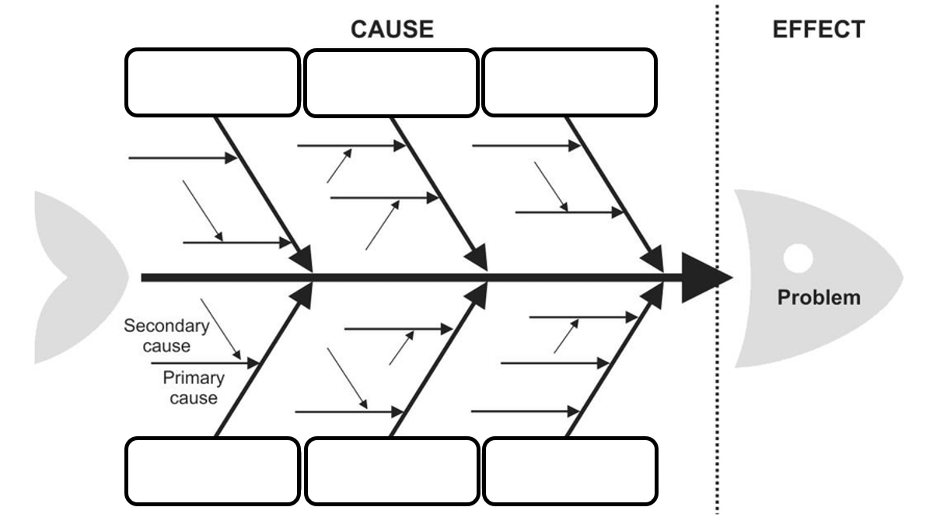

# Useful Websites

* [Queensland Floods](https://www.abc.net.au/btn/newsbreak/btn-newsbreak-20250203/104892034) – Newsbreak
* [Understanding Floods](http://www.bom.gov.au/australia/flood/knowledge-centre/understanding.shtml) – BoM
* [Big Weather](https://www.abc.net.au/education/digibooks/big-weather-and-how-to-survive-it/101749988) – ABC Education
* [Bushfire Science](https://www.abc.net.au/btn/classroom/bushfire-science/103040056) – BTN



**EPISODE 2**  
11th February 2025

**KEY LEARNING**

Students will identify online risks and learn strategies to protect themselves online.

**CURRICULUM**

**Digital Technologies – Year 3/4**

Plan, create and communicate ideas and information independently and with others, applying agreed ethical and social protocols

**Digital Technologies – Year 5/6**

Plan, create and communicate ideas and information, including collaboratively online, applying agreed ethical, social and technical protocols.

**Digital Technologies – Year 7/8** Plan and manage projects that create and communicate ideas and information collaboratively online, taking safety and social contexts into account**.**

Teacher Resource

**Safer Internet Day**

# Focus Questions

Discuss the BTN story as a class and record the main points of the discussion. Students will then respond to the following:

1. In pairs, discuss the BTN story and record the main points of your discussion.
2. What is trolling?
3. According to the eSafety Commissioner, approximately what percentage of young people have seen or heard hateful comments about a cultural or religious group online?
   1. 20%
   2. 30%
   3. 50%
4. What is a digital footprint?
5. What are some tips for staying safe online?

# Activity: Note taking

Students will practise their note-taking skills while watching the BTN Safer Internet Day story. After watching the story, ask students to reflect on and organise the information into three categories. What information in the story was...?

* Positive
* Negative or
* Interesting

# Activity: Class discussion

After watching the BTN story discuss with students what they think of when they hear the term “internet safety”. In small groups, ask students to brainstorm responses to the following questions:

* What is Safer Internet Day?
* Why is it important?
* What questions do you have about the story?

# Activity: Glossary

Students will brainstorm a list of key words that relate to the BTN Safer Internet Day story. Here are some words to get them started.

|  |  |  |
| --- | --- | --- |
| TROLLING | DIGITAL FOOTPRINT | CYBER CRIME |
| ONLINE HATE | ECHO CHAMBER | PERSONAL DATA |

**Further investigation**

Students will choose additional keywords and terms to add to their class glossary. Visit the eSafety Commissioner website for a [glossary of terms](https://www.esafety.gov.au/about-us/glossary) related to online safety. For example, algorithm, age verification, catfishing, clickbait, cyberbullying, cyber abuse, doxing, hacker and phishing, scams. Students will find a definition and explain to their classmates what the keywords mean.

# Activity: Jigsaw learning activity

In this jigsaw learning activity students will work cooperatively to learn more about online risks and strategies to protect themselves online. Each group will become experts and then share what they have learnt with other students.

**Form groups**

Divide the class into 5 x Focus Groups. Each Focus Group will be assigned a different area of research related to online risks and become experts.

Areas of research:

1. Trolling
2. Online hate
3. Echo chamber
4. Digital footprint
5. Cyber crime

Each group will need to decide how they will collect and communicate the information they find during their research.

**Research**

Each Focus Group will work as a team to learn as much as they can about their topic. They will use the following as a guide for their research.

* What is the online risk? Give a definition.
* What are some examples of this type of online risk? What does it look like?
* How can you spot the risk and protect yourself against it?
* How can you get help if things go wrong? Name the actions you can take to get through the negative online experience.

**Share**

Mix the Focus Groups to form Task Groups (Tasks Groups include one student from each of the Focus Groups) to share the information they have collected. Students will share the information they have collected and learn from one another.

**Reflect**

After this activity, ask students to reflect on what they have learnt. Students can include details about how their thinking on this issue has changed.

# Activity: Safer Internet Day Poster

What does your school do for Safer Internet Day? Put up this eSafety [poster for Safer Internet Day 2025](https://www.esafety.gov.au/newsroom/whats-on/sid/education) to help others in your school be more aware about online risks and how to stay safe online. Play this fun eSafety [chatterbox game](https://www.esafety.gov.au/newsroom/whats-on/sid/education) with your classmates.

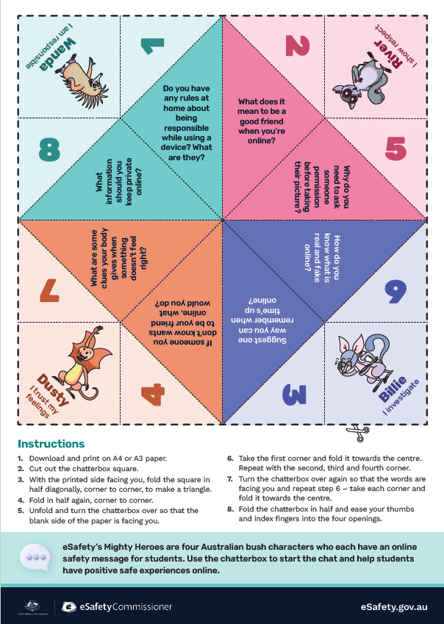

Safer Internet Day 2025 (*Source –* [*eSafety Commissioner*](https://www.esafety.gov.au/newsroom/whats-on/sid/education))

# Useful Websites

* [Safer Internet Day 2022](https://www.abc.net.au/btn/classroom/safer-internet-day-2022/13739262) – BTN
* [Safer Internet Day 2025](https://www.esafety.gov.au/newsroom/whats-on/safer-internet-day) – eSafety Commissioner
* [Resources for educators](https://www.esafety.gov.au/newsroom/whats-on/sid/education) – eSafety Commissioner
* [Educational online safety videos](https://www.esafety.gov.au/educators/video-library) – eSafety Commissioner
* [Game On (resource)](https://www.esafety.gov.au/educators/classroom-resources/gameon) – eSafety Commissioner



Teacher Resource



Teacher Resource

**BTN Transcript: Episode 2- 11/2/2025**

Hey, I'm Amelia Moseley and you're watching BTN. Thanks for hanging out with us again. Let's see what's coming upon today's show. We'll bring you some big news of the week - from floods and fires in Australia to talk of tariffs in the US. We'll also give you some tips for staying safe online.

# PM Press Conference

Reporter: Joe Baronio

*INTRO: All that soon, but first today, we're going to hear what the country's leader has to say to primary school kids. A year six class from Canberra has managed to score a press conference with the Prime Minister, and they put some pretty big questions to him. Let's check it out.*

STUDENT: So, today we're going to be going to Parliament House, and we're going to be asking our prime minister questions.   
  
STUDENT: I'm very excited, but mostly, mostly nervous.   
  
Producer: Nervous? Why is that?   
  
STUDENT: Because basically the entirety of Australia is watching.   
  
PRODUCER: Say hello.   
  
STUDENT: Hi.   
  
STUDENT: Alright everybody. We've got 30 minutes with the Prime Minister. What questions do you think we should ask?   
  
STUDENT: Maybe we should ask, like, who inspired him?   
  
STUDENT: Maybe, what was the hardest decision he ever made for being a prime minister?  
  
STUDENT: I came up with a few about what he's going to do for the environment and just to get to know him so kids around Australia know him a bit better.  
  
STUDENT: Will I be able to afford a house in the future? That's a big one, because I don't want to be homeless. We tried to make some questions that were serious and not funny. Well, we tried to squeeze in some funny ones.   
  
STUDENT: All right, everybody, what's your favourite question?   
  
STUDENT: What would Donald Trump influence on Australia.   
  
STUDENT: Do you think that social media has a big impact on kids?   
  
PRODUCER: Why do you think it's important to ask people in power questions like this?   
STUDENT: Because they can help you to help make a difference.   
  
PRODUCER: Alright, everybody, how are we feeling about those questions?  
  
STUDENTS: Yeah. Good.   
  
PRODUCER: How are you thinking today is going to go when you when we meet the PM?   
  
STUDENT: I'm not a time traveller. I have no idea how it will go, but I hope that it will go very well.  
  
STUDENT: I'm very excited. I've never met the Prime Minister before.   
  
PRODUCER: On a scale of one to 10. How excited are you?   
  
STUDENT: 10

STUDENT: 9  
  
STUDENT: 10  
  
STUDENT: 10  
  
STUDENT: 10  
  
PRODUCER: Nine? Hang on a minute.  
  
STUDENT: I don't know.   
  
Anthony Albanese, Prime Minister: Hey, how ya going? What's your name?   
  
STUDENT: Ava.   
  
Anthony Albanese: Hi, Ava, G'day, I'm Anthony. What's your name?   
  
STUDENT: I'm Liam.   
  
Anthony Albanese: Hi. Liam, Hi, what's your name?

STUDENT: Deng,

ANTHONY ALBANESE: Nice to meet you. Welcome to my office. There's various stuff up there, including a Rabbitohs footy. Does anyone down here go for the Rabbitohs? Not one, yeah, there you go. There's always a random South’s guy wherever you are in the world. Ok, fantastic. Okay, see you in a minute.

Well, good afternoon, and welcome to the Blue Room here in Parliament House.  
  
STUDENT: Good afternoon. Mr. Albanese, what inspired you to be Prime Minister?  
  
Anthony Albanese: Oh, gee, I didn't come into parliament to be the prime minister. I didn't think that I'd had that opportunity. I grew up in a household with just my mum. She was quite crippled up with rheumatoid arthritis, and so I got interested in how can she get a better life? How can people get better access to healthcare and opportunities. So, I ran for parliament in 1996 and got elected. And then after the election in 2019 where the Labor Party wasn't successful, I put my hand up and got elected as leader.   
  
STUDENT: Did you ever run for schoolhouse captain when you were a child?  
  
Anthony Albanese: Ahhh, I didn't get to be a school or house captain. That's a very raw thing that you've raised. Who's the school captain here? Ah, I see. So that was a loaded question. Well, congratulations to you.

STUDENT: Will young Australians be able to afford to buy houses in the future?  
  
Anthony Albanese: Certainly, that is our objective. The key to housing policy is supply. So, there's no short-term fix. Now, I think that's one of the reasons why governments haven't delivered. So we've got an objective of 1.2 million homes to be built.  
  
STUDENT: How can young people help the environment?   
  
Anthony Albanese: How young people can help is to remind your parents and others who are older than you of what your values are and why it's important that all of us are responsible.   
  
STUDENT: Hi, my name is Alex, and do you have some hobbies?  
  
Anthony Albanese: I do have hobbies. I love sport. When I was your age, I used to collect stamps, and I also collected footy cards. They came with bubble gum…

STUDENT: Hmmmm, not anymore.

Now, my hobby is, I guess, following. I like following sport and my dog, Toto, she takes up a bit of time too.   
  
STUDENT: My name is Rory. How will Donald Trump affect Australia?   
  
Anthony Albanese: Well, see, I knew there'd be some difficult questions. Look as Australia, we have a good relationship with the United States, but Australia will determine our own position as well. To give one example, President Trump has decided the United States will withdraw funding and support from the UN Climate Change Agreement on Paris, he has withdrawn funding from aid organizations, including the World Health Organization, so we'll stay in the Paris agreement on climate change, and we'll continue to provide support for foreign aid.   
  
STUDENT: How can we help support peace in the Middle East?   
  
Anthony Albanese: Oh thanks, Ava, I think, yeah, it is devastating, isn't it? Watching what is occurring in the Middle East. One of the things that we're trying to do is to be responsible, to be advocates for long term peace, to oppose the actions of terrorists like happened with Hamas against Israel on October 7, to call that out, condemn it, also to work for what's the solution. So, for a long time in the Middle East, people have spoken about two states, which is what was supposed to happen and didn't so Israelis and Palestinians living side by side. But it's not easy, and no one should think it's easy, but the alternative is devastating.   
  
STUDENT: My name is Ben, and what is the hardest part of being a prime minister?   
  
Anthony Albanese: I think the fact that there are only 24 hours in the day, Ben, but there's not a day or not a minute where I don't feel honoured to and humbled to have the position that I do, and I'm very passionate about this being the best country on Earth.

We're done. I think, can I thank you so much. It's good. There are members of the Federal parliamentary press gallery here taking notes as well, but all of you are delightful. Thank you very much.

**News Quiz**

Donald trump has held his first meeting with a world leader at the Whitehouse since becoming US president again. Do you know who that leader was? It’s Benjamin Netanyahu, the president of Israel. President Trump used the meeting to make the extremely controversial announcement that he wanted to the US to take control of Gaza and relocate the people living there.

DONALD TRUMP: Everybody I've spoken to loves the idea of the United States owning that piece of land, developing and creating thousands of jobs.

Experts say that would be breaking international laws and it’s been criticised by many leaders around the world.

A series of earthquakes have rocked the island of Santorini, which is part of which country? Is it Italy, Greece or Portugal? Santorini is in Greece and it, along with several other Greek Islands, has recorded thousands of earthquakes since late January, including a magnitude 5.2 last week.

TRANSLATOR: For three days there have been earth quakes every few minutes.

Authorities are worried it could be leading up to a bigger quake. A state of emergency’s been declared and more than 11 thousand people have been evacuated.

And the botanic gardens in Sydney and Canberra are celebrating the rare sight of Titan Arum flowers. They only bloom every two to three years and as well as being the biggest flower in the world, they’re famous for smelling like what? Laundry detergent, rotten eggs or rotting meat? It’s rotting meat, earning them the common name of Corpse Flower.

# Fire and Floods

Reporter: Wren Gillett

*INTRO: Now we're heading to North Queensland, where homes, businesses and farms around Townsville have been hit by devastating floods. Meanwhile, down in Victoria, bushfires are still burning the Grampians. Wren found out what's going on and why Summer in Australia can bring such different disasters.*

VIVIAN: Floods yeah, lots of rain, for the past couple of days it's basically been non-stop.  
  
BRIENNA: Our lake right near us is getting flooded.  
  
For people like Vivian, Grace and Brienna it's been a difficult week. They live here in Townsville, in North Queensland, where a huge downpour of rain caused dams and rivers to overflow. Resulting in devastating floods.   
  
BRIENNA: We're staying home, we're up on higher ground.  
  
VIVIAN: You can hear it really loud, just like the rattling on the roof.   
  
GRACE: And you can hear the wind as well.   
  
Two people died, and thousands of people in the region had to quickly pack up their things and evacuate their homes. Many people made their way to evacuation centres, while others went to stay with friends, like Grace did with Viv's family.   
  
VIVIAN: There's like, a total of nine people here. Yeah, we've filled up every room, and grace is on my floor at the moment.   
  
GRACE: Yeah.  
  
WREN: It probably helps as well that you're with your best friend. It makes a little bit less scary.   
  
VIV/GRACE: Yeah.   
  
The floods left more than 10,000 homes without power, and for lots of young people, it also meant no school.   
  
VIVIAN: The school got quite a bit of water in it, because we go to school right by the water.   
  
BRIANNA: It's sad because I love school, and I have lots of friends and teachers there that I love.  
  
But floods weren't the only disaster threatening Aussie homes, lives and livelihoods last week. Down here in Western Victoria, hundreds of firefighters are working to contain out-of-control bushfires. One of the things they're doing is backburning, which involves burning stuff like dry grass, sticks and wood, before the fire gets to it. Fighting flames with flames.  
  
FIREFIGHTER: It can absolutely be the difference between life and death.  
   
Blazes here in the Grampians started in December, and since then, they've destroyed at least four homes and burnt through around 90-thousand hectares of land. While it might seem strange to see fires and floods happening at the same time, it's not actually uncommon in Australia. You see the top of the country sits in the tropics close to the equator, where in summer, high ocean temperatures bring a lot of rain and sometimes big storms. Up here, it's known as the wet season. Meanwhile down south where the ocean is cooler, summers tend to be hot and dry. And when wind or lightning is added to the mix, it makes for catastrophic fire conditions. It's why emergency services like our firefighters and the SES, are always extra vigilant once December arrives.  
  
PERSON: In these situations, everyone just drops what they're doing and supports the community at large.  
  
GRACE: There's definitely a big community aspect to that. So people taking other people in, sandbags.

VIVIAN: Even like the SES workers just going around. Helping people to get to the evacuation centres if they don't have places to go.   
  
Summer isn't over yet, and the people in these disaster zones are facing a long and difficult time ahead. But many like Garce and Vivian say it's important to stay positive and look after each other.   
  
VIVIAN: We're all here. We're just being together as our own little community, and we've just been Yeah, sharing these times together. And talk to your friends like, yeah, to talk to your family members like, it's an opportunity I think.

**Tariffs**

Reporter: Jack Evans

*INTRO: Now to a word you might have heard in the news lately and that's tariffs. It's something the US President promised to bring in if he was elected and he's been making good on that promise. So, what are tariffs anyway, and why are they a big deal? Here's Jack.*

KING: Where did you get that ostentatious hat from? I haven't seen any of them like that in my Kingdom.   
  
RIGHT HAND: Oh, it's imported from the Northern Kingdom, they're all the rage.   
  
CITIZEN: I've got one in blue.   
  
KING: Oh. Well why aren't people buying the hats we make in our Kingdom?   
  
RIGHT HAND: Well because the ones we make just aren't ostentatious.

KING: Oh…  
  
Jack Evans, reporter: Just like this kingdom, the world is constantly trading goods and services with one another every day. Why? Well, some countries have better resources or are better at making certain things or they can do it cheaper. In fact, many nations have agreements in place to make this process easy and more open, a free trade agreement, if you will. But there are downsides to this system of global trade.  
  
KING: Well, if people aren't buying the hats our Kingdom makes then the hat factories will close down and that could be bad for the economy.  
  
RIGHT HAND: Oh no.  
  
KING: I think it's perhaps time we introduced… a tariff.  
  
RIGHT HAND: What's a tariff?   
  
A tariff is a tax or additional cost that governments impose on products coming from another country. So, for example an exporter of ostentatious hats will get whacked with an extra cost that goes to the King, oh, I mean government. To make up for that the hat seller charges more, and people end up paying more for their fancy headwear. The idea is to deliberately make foreign goods more expensive to discourage people from buying them.

Tariffs aren't uncommon in fact nearly every country has them, but they tend to be lower in wealthy countries where free trade is encouraged. And now the US president wants a whole heap more.  
  
Donald Trump, US President: If you think about it, other countries charge us tariffs. We don't charge them tariffs and it's about time that that changes.  
  
One of his big election promises was to help American industries by decreasing the amount that America buys and increasing the amount that it sells. He's planning to do that with Tariffs, but it's controversial. For starters it would make some things cost more which doesn't always go down well with the public. Plus, a lot of industries rely on importing parts from overseas… oh, and tariffs can go both ways. A lot of people worry that if America taxes other countries then they'll just tax America and spark something that's known as a trade war.  
  
RIGHT HAND: Terrible news sir, the Northern Kingdom has threatened to put a tariff on our sensible boots.  
  
KING: Oh no, but that could put our sensible boot factories out of business and that would be far from sensible.  
  
So far Donald Trump has brought in a 10% to 15% tariff on some goods from China. He also said he was going to put a 25% tariff on Mexico and Canada, two of Americas closest allies. But after some negotiations that's been put off. Trump says this is just the start of his tariff blitz which has made some people excited and others nervous and could impact countries all over the world including Australia.

KING: Who would have thought all of this over a silly hat.  
  
RIGHT HAND: It's not a silly hat, it's an ostentatious hat.   
  
KING: Ooo, you are right… can I try it on?

# Sport

Cheering fans, star-studded ads and a half-time extravaganza. It can only mean one thing - the Super Bowl. The NFL's annual final is one of the most watched sporting events in the world, and this year, fans tuned in to see the Philadelphia Eagles snatch their second win from the Kansas City Chiefs, 40 to 22. The win saw Sydney-born Jordan Mailata become the first Aussie to play in a winning Super Bowl team.

Aussie teenager Cam Myers has broken the world record for the fastest mile in the under 20 category. He came third in the race with a time of three minutes and 47.18 seconds, which was enough to score the record.

And finally, to the end of a 14-year drought.

COMMENTATOR: It pulls hard, gets plenty of it.

The Aussies have taken home a nine-wicket win in their second test match against Sri Lanka, their first since 2011. Steve Smith and Alex Carey both scored centuries, with Alex Carey being named Player of the Match with 156 runs.

# Safer Internet Day

Reporter: Wren Gillett

*INTRO: Did you know that Tuesday, February 11th is Safer Internet Day? It was created as a reminder to us all about the potential dangers that we face online. So, Wren's decided to take you on a bit of ride through the scary side of the net and give you tips on how to stay safe.*

ALED: Ooh, a haunted elevator.  
  
WREN: Welcome to the Tower of online terrors.  
  
ZARA: Hmm niche.   
  
ALED: I love it.  
  
WREN: C'mon in and get ready, to explore the dark side of the internet. Mwahhhaahahahaa.  
  
Yeah, we all spend a lot of our lives online. But as well as the good stuff… and the useless but harmless stuff, the internet can take you on a scary and sometimes pretty dangerous ride.

TROLL: Roooaaaarr

ALED/ZARA: Ahh.  
  
ALED: What is it?  
  
TROLL: You suck. All of your political ideas are wrong, and I hate your hair.

WREN: Yes, so you've met the troll.  
  
Trolling has been around for pretty much as long as the internet, and basically, it means deliberately trying to make people angry or upset.  
  
ZARA: Why would they do that?  
  
WREN: For attention mostly, they feed on your anger. But there are worse creatures lurking online.  
  
ALED/ZARA: Ahhhh.  
  
ZARA: It’s awful.  
  
WREN: You've met online hate.  
  
Experts say online hate is a growing problem right around the world. It's content that targets people based on characteristics like race, religion, ethnicity, sexual orientation, disability or gender, and it can cause serious real-world consequences.  
  
ALED: Why is it so horrible?   
  
Well, there are a few reasons. For starters when people are online, they can hide who they really are, and they don't have to see the people they're hurting, so they're way more likely to behave in ways they wouldn't in real life. Plus, many online platforms prioritise posts that get a lot of attention, good or bad.

WREN: And then, we have the echo chamber  
  
ZARA: Hello?  
  
ALED: This is creepy.  
  
Yep. Echo chambers are everywhere on social media, and they're very easy to fall into. Basically because of the way algorithms work, we tend to be fed content that's similar to other content we've already watched and liked. And over time, our world views can get narrower and more extreme.  
  
ALED: Hi Aled.  
  
ZARA: Hi Zara.  
  
ALED/ZARA: Ahhh, it's us.  
  
WREN: Yes, it's your digital footprint.  
  
ALED/ZARA: We know everything about you. heheheee.   
  
Yeah look, every time we're online we leave a trail of data, and if it gets into the wrong hands, it can be really dangerous.  
  
CYBER CRIMINAL: Give ma all ya money.  
  
ALED/ZARA: We don't have any.  
  
Cybercrime is a huge problem that's costing people and governments right around the world billions of dollars.  
  
ZARA: Okay, okay, okay, I think we've seen enough.  
  
ALED: Is there anything we can do to like, not have to deal with this stuff?  
  
WREN: Plenty.  
  
Yes, there are things you can do to keep yourself safe online. And the first step is to be aware of the dangers. If you're bullied or harassed online, you should always tell someone. Take screen shots, report it to the site where it is happening and block or mute the person doing it. Australia has laws against bullying and hate speech and breaking them can be really serious. The eSafety Commissioner’s website also has a place where you can report abuse. And when it comes to choosing the stuff you look at online, be skeptical. Ask yourself where it's coming from, who created it, whether it's likely to be true, and whether it could be harmful. As for your personal details, be very careful about where you share them. Never give away your info to strangers or click suspicious links. Make sure you choose strong passwords. And remember, what you post online can stay there forever.  
  
WREN: Ooorrr, you could just leave. Mwaahh.  
  
ALED: Wait, we can get off whenever we want?  
  
WREN: Yeah, get outta here, go touch some grass.   
  
WREN: Bye.

**Closer**

Well, that's it for BTN this week. And it's also time for me to say goodbye for a while because I'm heading off on leave to have this baby! But don't worry, the wonderful Jack Evans will be filling in for me for the rest of 2025. I'm going to miss you all so much! Have the best year and I'll see you really, really soon. Bye!