
EPISODE 1
4th February 2025

KEY LEARNING
Students will view a range of BTN stories and use comprehension skills to respond to a series of focus questions.

CURRICULUM
English – Year 4
Use comprehension strategies to build literal and inferred meaning to expand content knowledge, integrating and linking ideas and analysing and evaluating texts.

English – Year 5
Use comprehension strategies to analyse information, integrating and linking ideas from a variety of print and digital sources.

English – Year 6
Use comprehension strategies to interpret and analyse information and ideas, comparing content from a variety of textual sources including media and digital texts.

English – Year 7
Use comprehension strategies to interpret, analyse and synthesise ideas and information, critiquing ideas and issues from a variety of textual sources.
  - Teacher Resource

Focus Questions
As a class, discuss the stories featured in the episode of BTN Classroom and record the main points of the discussion. Students will then respond to the following focus questions.

News Wrap
- Which two groups recently agreed on a ceasefire in Gaza?
- Which state in the United States recently had bushfires?
- Who is the new president of the United States of America?
- Australia won the Boxing Day cricket test match against India. True or false?
- Who won the women’s and men’s titles at the Australian Open?
  - Jannik Sinner and Madison Keys
  - Novak Djokovic and Aryna Sabalenka
  - Carlos Alcaraz and Iga Swiatek

Donald Trump
- What executive order did President Donald Trump sign during his first week in office? Give one example.
- All executive orders will become laws. True or false?
- What other changes has President Trump made? Name one.
- What country does Donald Trump want to take?
- Who has President Donald Trump asked to lead a department dedicated to saving money?
  - Elon Musk
  - Mark Zuckerberg
  - Jeff Bezos

Australian of the Year
- What AFL team did Neale Daniher play for?
- What does MND stand for?
- How does MND affect the body?
- How is Neale Daniher helping raise awareness about MND?
- What is the Big Freeze?

Lunar New Year
- This Lunar New Year is year of the…
  - Dragon
  - Snake
  - Horse
- What countries celebrate Lunar New Year? Give 3 examples.
- What does the Lunar calendar follow?
  - Moon’s orbit around the Earth
  - Earth’s orbit around the sun
- Every year Lunar New year happens on a different date. True or false?
- How do people celebrate Lunar New Year? Give 1-2 examples.

Check out the teacher resource on the Archives page.

New Pandas
- What zoo in Australia has pandas?
- What are the names of the new pandas?
  - Wang Wang and Fu Ni
  - Xing Qiu and Yi Lan
  - Yun Chuan and Xin Bao
- How much did it cost the zoo to loan the pandas from China?
- How many pandas live outside of China?
- What was surprising about this story?

Check out the teacher resource on the Archives page.

EPISODE 1
4th February 2025

KEY LEARNING
Students will learn about the significance of Lunar New Year, including customs, traditions and celebrations.

CURRICULUM
HASS – Year 3
Celebrations and commemorations in places around the world (for example, Chinese New Year in countries of the Asia region, Bastille Day in France, Independence Day in the USA), including those that are observed in Australia (for example, Christmas Day, Diwali, Easter, Hanukkah, the Moon Festival and Ramadan).

Civics & Citizenship – Year 3
Why people participate within communities and how students can actively participate and contribute.

Civics & Citizenship – Year 4
The different cultural, religious and/or social groups to which they and others in the community belong.

  - Teacher Resource

Lunar New Year

Focus Questions
Discuss the BTN story as a class and record the main points of the discussion. Students will then respond to the following:
- This Lunar New Year is year of the…
  - Dragon
  - Snake
  - Horse
- What countries celebrate Lunar New Year? Give 3 examples.
- What does the Lunar calendar follow?
  - Moon’s orbit around the Earth
  - Earth’s orbit around the sun
- Every year Lunar New year happens on a different date. True or false?
- How do people celebrate Lunar New Year? Give 1-2 examples.

Activity: Class Discussion
Discuss the BTN Lunar New Year story as a class. Ask students what they know about Lunar New Year. Use the following questions to guide discussion:
- What is Lunar New Year?
- Which cultures celebrate Lunar New Year?
- How is it celebrated?
- Why does the date of Lunar New Year change every year?
- Lunar New Year 2025 is Year of the…
- What Lunar New Year celebrations do you know about? What might you see?
- Have you ever taken part in Lunar New Year celebrations? Explain in more detail.

Activity: Glossary
Students will brainstorm a list of key words that relate to the BTN Lunar New Year story. Below are some words to get students started.

LUNAR NEW YEAR | TRADITION | LUNAR CALENDAR
ZODIAC | SYMBOLISM | CUSTOM

Activity: Lunar New Year Customs and Traditions
What customs and traditions are part of Lunar New Year celebrations? Different cultures have their own unique traditions for the celebrations. Here is some more information about the different ways communities celebrate - Chinese New Year, Seollal (Korean) and Tết (Vietnamese).
Below are some examples of Lunar New Year traditions that students can explore in more detail. Students respond to the following questions as they learn more about the custom/tradition.
- What are the origins of the tradition/custom?
- What does the tradition/custom symbolise?
- What is the cultural significance of the tradition/custom?
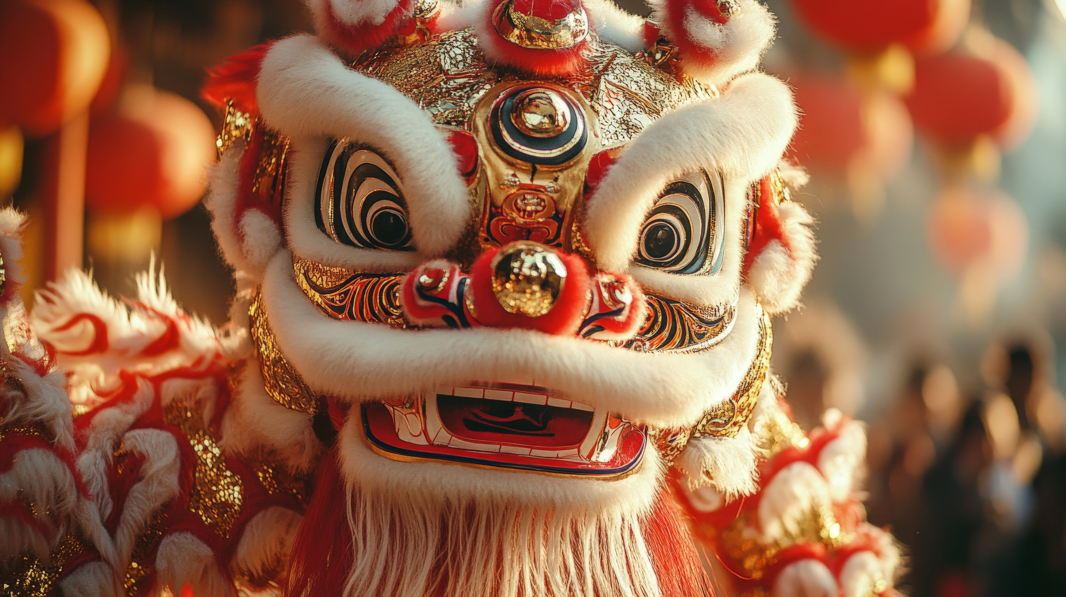
Lion and Dragon Dances
Watch the ABC Education What is Lion Dancing? video which explains the significance of the lion dance during Chinese New Year celebrations. What is the difference between lion and dragon dancing?

Lantern Festival
Lunar New Year celebrations end with the Lantern Festival. During the festival, people visit the temples at night carrying paper lanterns. They symbolise letting go of the past and looking forward to the future. During the lantern festival, people eat small round dumplings made of rice. Students can make their own Lunar New Year lantern.

Red envelopes
Red envelopes are small red and gold packets containing money given to children, family members and friends as a symbol of good luck, success and good fortune. The colour red is also used to keep away evil spirits. Students can make their own lucky envelopes by following the instructions here.
Fireworks
Fireworks are a common Lunar New Year celebration. At midnight on New Year’s Eve, fireworks are launched to celebrate the coming of the New Year. Chinese people believe that fireworks keep away evil spirits and that the person who launches the first firework of the New Year will have good luck. Students design their own fireworks display and explain what they mean.


Lunar New Year Food
Food is an important part of Lunar New Year celebrations. Different traditional dishes like dumplings, long noodles, whole fish and spring rolls all have special significance. Students can explore different foods served during Lunar New Year and what each food symbolises/represents. Hold a class celebration that includes one or more Lunar New Year dishes or create a recipe book showcasing special Lunar New Year food.

Activity: Zodiac Animals
The Chinese Zodiac is based on a twelve-year cycle, with each year being named after an animal. Chinese people believe that people born in a particular year take on the characteristics associated with that animal.
Students can investigate the following questions about Zodiac animals:

- What zodiac animal are you? Find out here
- Create a profile of that animal. What personality traits are associated with that animal?
- Do you think any of these features accurately describe you?
- What traits relate to the other zodiac animals?
- How were the 12 animals chosen and why are they in a particular order? You can learn more about the Chinese Zodiac stories here.

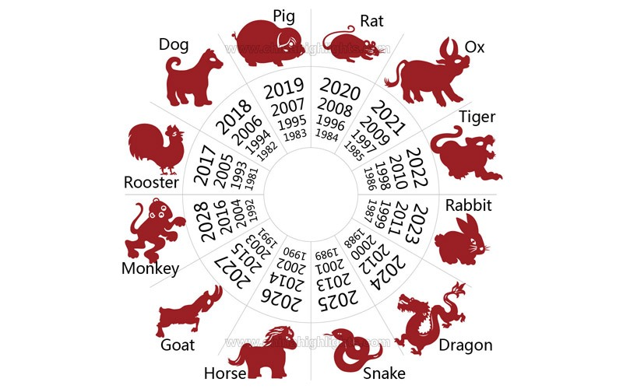

Source: China Highlights

Activity: Lunar New Year Quiz
Hold a class discussion asking students to share one interesting fact they learned about Lunar New Year. Record students’ responses to create a list.

Students will use the information they have discovered to create a quiz and then test their classmates. Students will include a range of quiz styles, for example:
- Multiple choice

- True or false
- Fill in the blank
- Use photos or pictures
- When an answer is revealed, provide extra information to explain the answer.

Students can make their quizzes in Kahoot or Quizizz.

Useful Websites
- Lunar New Year - BTN
- Lunar New Year – BTN
- Lunar New Year: Get ready for the Year of the Snake - Newsround
- When is Lunar New Year 2025 and how is it celebrated? Find our which animal you are and where to celebrate – ABC News

EPISODE 1
4th February 2025

KEY LEARNING
Students will explore the natural habitat of the giant panda and design and create a model of a panda zoo enclosure.

CURRICULUM
Science – Year 4
Living things depend on each other and the environment to survive.

Living things have life cycles.

Science – Year 5
Living things have structural features and adaptations that help them to survive in their environment.

Scientific knowledge is used to solve problems and inform personal and community decisions.

Science – Year 6
The growth and survival of living things are affected by physical conditions of their environment.
Scientific understandings, discoveries and inventions are used to solve problems that directly affect peoples' lives.

Science – Year 7
Classification helps organise the diverse group of organisms

Interactions between organisms, including the effects of human activities can be represented by food chains and food webs.

  - Teacher Resource

New Pandas

Focus Questions
Discuss the BTN story as a class and record the main points of the discussion. Students will then respond to the following:
- What zoo in Australia has pandas?
- What are the names of the new pandas?
  - Wang Wang and Fu Ni
  - Xing Qiu and Yi Lan
  - Yun Chuan and Xin Bao
- How much did it cost the zoo to loan the pandas from China?
- How many pandas live outside of China?
- What was surprising about this story?

Activity: Class discussion
Before watching the BTN New Pandas story students will respond to the following...
- What do you know about pandas? Record your ideas on a mind map.
- Where do pandas live? Refer to a map and mark where you think pandas live.
- What is special about pandas?
- What do you think this BTN story will be about?
- What more do you want to learn about pandas?

After watching the BTN New Pandas story, ask students to
respond to the following:
- What does this video make you WONDER?

- What did you LEARN watching the story?
- What did you find SURPRISING?
- What QUESTIONS do you have? Think of three questions you have about the BTN story.

Activity: KWLH Organiser
Discuss the information raised in the BTN New Pandas story. What questions were raised in the discussion and what are the gaps in students’ knowledge? The following KWLH organiser provides students with a framework to explore their knowledge on this topic.

What do I know? | What do I want to know? | What have I learnt? | How will I find out?

Students will develop their own question/s to research or choose one or more of the questions below. Encourage students to collect and record information from a wide variety of sources and present the information they find in an interesting way.

- Where do giant pandas live? Explore their natural habitat and mark where they live on a map.
- What are some unique features of giant pandas? Explore its features and write a detailed description.
- What is the scientific name for giant pandas? What is the meaning of their scientific name?
- Explore the taxonomy of giant pandas and categorise the information you find using the classification system.
- What is panda diplomacy? Use a timeline to show examples of panda diplomacy throughout history.
- Which countries have pandas on loan from China? Highlight the location of panda ambassadors on a world map.
- Investigate was the journey for giant pandas, Xing Qiu and Yi Lan and the role of the zookeepers that helped them. Highlight their journey on a map and calculate the distance.
- Where can giant pandas be found in the wild? Find their natural habitat on a map.
- Why are pandas important to Chinese culture? Give 3 examples.
- Create a species profile on the giant panda. Include its name (common and scientific name), classification (class, family, genus), description, habitat, diet and threats.
- What has caused the giant panda population to decline? Use a cause-and-effect fishbone diagram to present your findings.
- What is the cost to loan a panda from China? Calculate the cost of keeping a giant panda (including yearly lease, food, maintenance and cost of enclosure).

Activity: Habitat
This literacy activity demonstrates students active listening and interpreting skills. Students will listen to a description of a panda’s habitat and create a simple black and white artwork illustrating its habitat. Teachers will use the following as a guide for this activity.
- Find a description of a giant panda's habitat to read aloud to your students.
- Read the description of the panda’s habitat aloud to your class, reading the description 2 or 3 times.
- Students will take notes and write down key words as they listen.
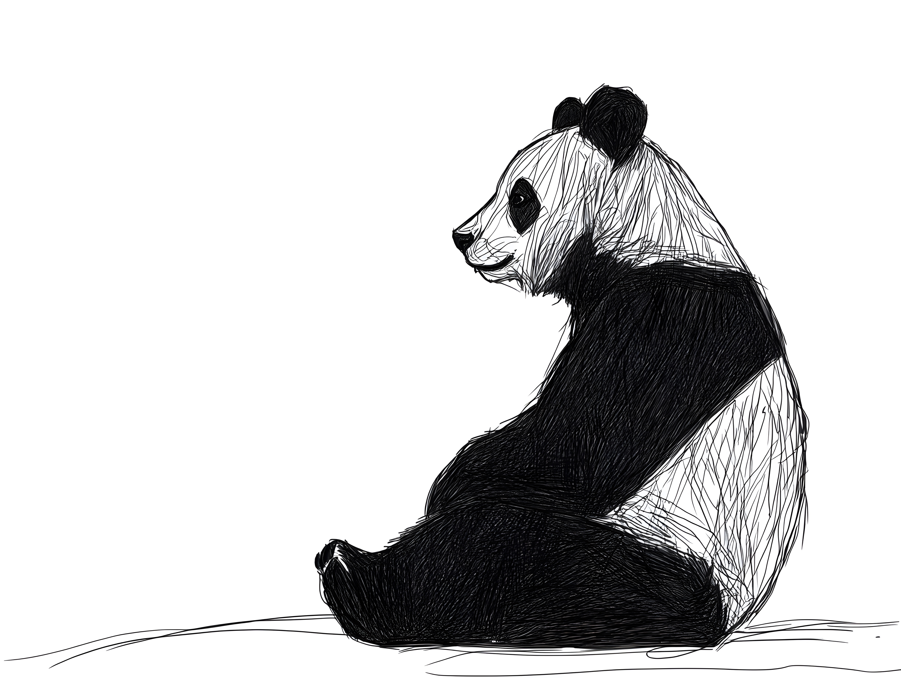
- Students will illustrate the habitat using only a black felt—tip pen (0.4 or 0.6) on a piece of A4 art paper. Students will include as much detail as they can.
- Display the student’s artwork in a school exhibition.
- Challenge students by asking them to recreate the habitat as a diorama or a virtual reality experience using Minecraft.
- Challenge your students by asking them to design and create a model of a giant panda zoo enclosure.

Activity: Design a Zoo Enclosure
In this activity students will research the natural habitat of giant pandas, including their needs and environmental factors. Students will then design a zoo enclosure which incorporates key elements of their natural habitat whilst also considering the needs of the zoo environment.

Explore and Observe
Students will explore the natural habitat of giant pandas making as many notes as they can and then list the main features of the habitat (e.g. climate, plants, landscape). Students will then think about how they might be able to integrate these features into a modern zoo enclosure for a panda.

To learn more about panda behaviour and their needs students can visit one of the many panda enclosures via a panda cam! There are several live cams setup in zoos around the world that allow you to watch pandas as they explore their indoor and outdoor habitats.

Live Panda Cams!
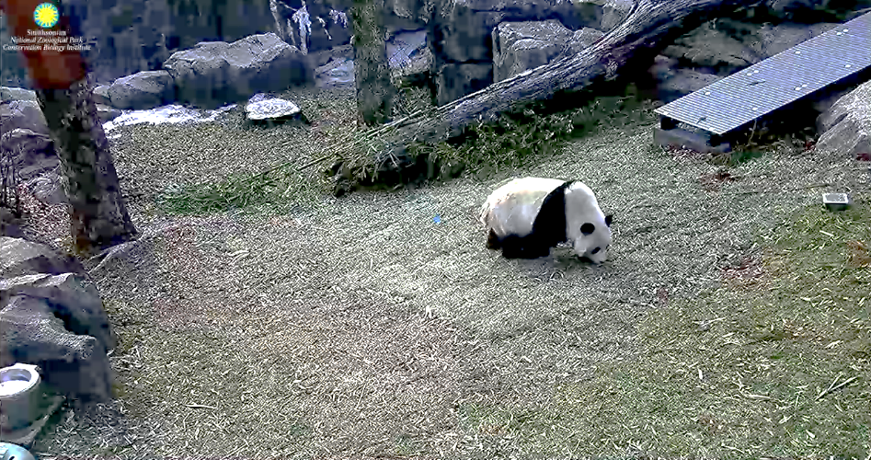  Smithsonian National Zoo – Panda Cam (link) | 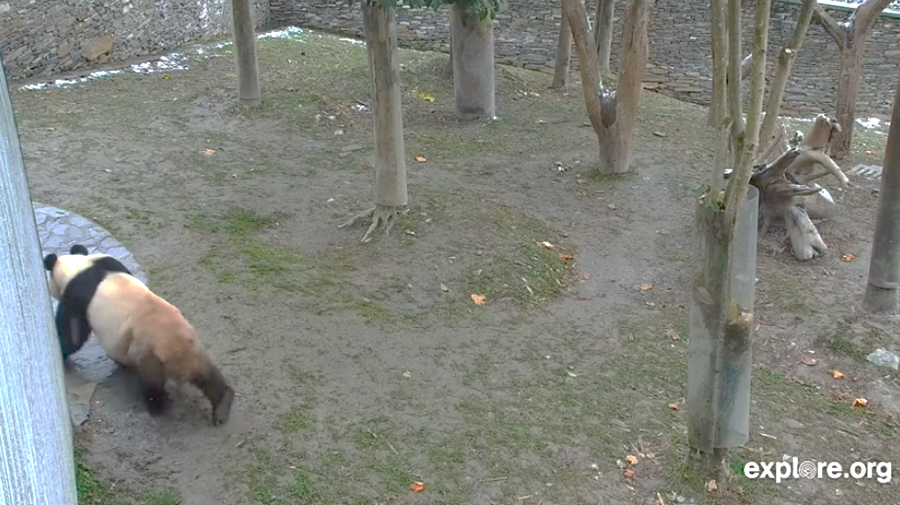  Live cam at the Shenshuping Gengda Panda Centre, China (link) | 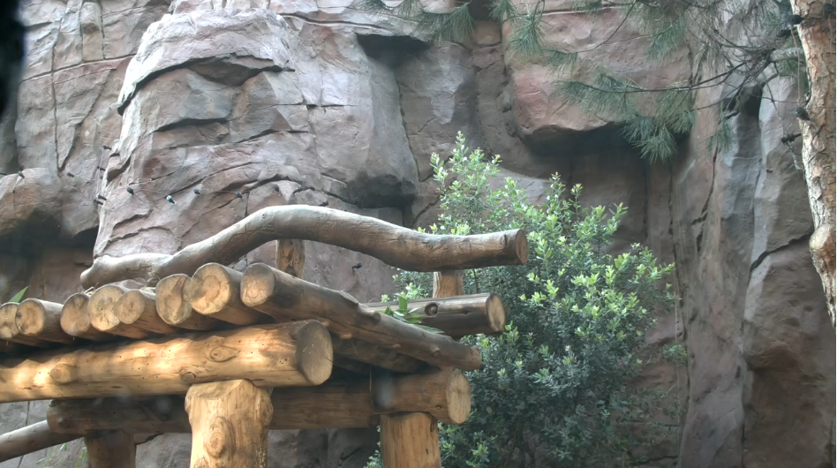  San Diego Zoo Giant Panda Cam (link) Email required to access

Observation
As a class or individually, students will observe pandas in a zoo enclosure and respond to the following
- What is the panda doing? How does it interact with the environment? Record the behaviour of the panda.

Research and Design
Students will use the following to guide them through the research, development and design process.

How will your zoo enclosure meet the needs of the panda?
- What are some important things that pandas need to live comfortably?
- How much space does the animal need? Think about area, perimeter and volume.
- What features will the enclosure need to meet the needs of the animal (food, sleep, water, privacy, shelter, play)?
- What are some of the animal’s adaptations? How can you incorporate these into your design (their need for shade, climbing structures, and enrichment items)?
- What materials will be used in the enclosure (rocks, plants, glass, fencing)?

How will your zoo enclosure meet the needs of people?
- What signage will you need?
- What educational information will you include (common and scientific name of animal, map of where the animal lives in the wild, conservation status)?
- Can visitors easily see the animal?
- How will zookeepers access the enclosure (to clean, feed the animal)?
- Is the enclosure safe and secure?

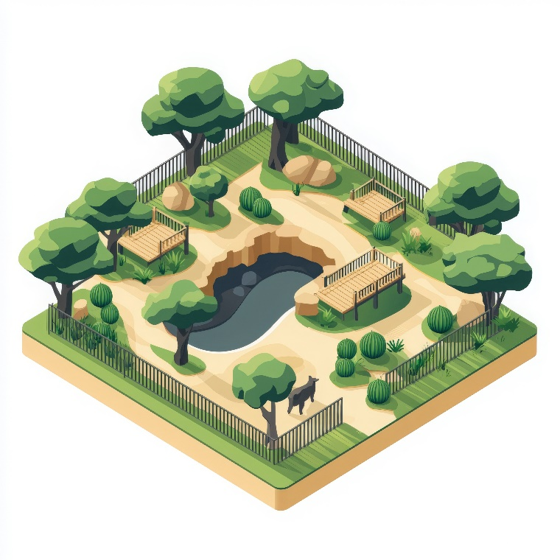
Design
- Draw a sketch of your design. Include a drawing which is looking down on your enclosure to show the position of key features.
- What materials will you use to build your model enclosure? Try to use recycled materials from home and/or school.
- What will be the scale of your model (the overall size should be no bigger than a shoebox)?
- Create a 3-dimensional model of your panda enclosure. Alternatively, create a digital model of your enclosure in Minecraft.

Present
students will present their zoo enclosure designs to the class, explaining how their design incorporates key elements of the panda’s natural habitat and how it meets the panda’s needs.

Activity: Quiz

- Ginat pandas are native to China.  A. True  B. False  - Panda cubs born outside of China have to be returned to China.  A. True  B. False  - What percent of a giant panda’s diet is bamboo?  A. 77%  B. 88%  C. 99%  - Bamboo contains a lot of nutrients.  A. True  B. False  - What are the names of the new pandas at Adelaide Zoo?  A. Yu Chuan and Xin Bao  B. Wang Wang and Fu Ni  C. Xing Qiu and Yi Lan  - Panda behaviour is generally…  A. Solitary and peaceful  B. Social and confrontational  C. Cuddly and unintelligent  Quiz Answers:  1A, 2A, 3C, 4B, 5C, 6A, 7A, 8A, 9B, 10B. | - Why are pandas black and white?  A. Camouflage and communication  B. To attract a mate  C. To scare off predators  - What type of habitat do wild giant pandas live in?  A. Temperate forest  B. Tropical rainforest  C. Arctic forest  - What is the conservation status of giant pandas?  A. Endagered  B. Vulnerable  C. Extinct in the wild  - What is the population of pandas in the wild?  A. 184  B. 1,864  C. 8,641

Useful Websites
- Panda Diplomacy – BTN
- Giant Panda – Xing Qiu and Yi Lan – Adelaide Zoo
- Two new pandas, Yi Lan and Xing Qiu, arrive in South Australia, but there are politics behind them – ABC News
- Habitat of the Panda – WWF

  - Teacher Resource

BTN Transcript: Episode 1- 4/2/2025

Hey, I'm Amelia Moseley and you're watching BTN. Welcome back for a whole new year of news. I hope you had the best holidays. Let's see what’s coming up on today's show. We learn about the life and work of 2025's Australian of the Year, welcome the year of the snake and say hello to Australia's new pandas.

Holiday News Wrap

Reporter: Jack Evans

INTRO: All that soon, but first today let's make sure you're up to speed on the latest news. There were a lot of big stories over the holidays from a ceasefire in Gaza to a very short TikTok shutdown. Here's Jack to fill you in.

JACK: Yeah. Yeah, no, no, no, I had a great holiday.

NEWS JACK: Well, well, well, look who decided to show up.
JACK: Got to go. One of my CLONES escaped again.
NEWS JACK: I'm not a clone! I'm News Jack. Remember me?
JACK: Oh yes, I remember you.
NEWS JACK: Oh, yeah? Well, then tell me, what's been happening in the news?
JACK: Ok, maybe I wasn't completely paying attention.
NEWS JACK: Huh! I thought so.
Yeah. It's been an incredibly eventful past two months. World leaders changed, there were massive natural disasters and massive political upheavals. Like in Syria, where on the 8th of December rebel forces took over the capital of Damascus forcing out President Bashar Al-Assad who's ruled the country, often brutally, for 24 years.
Meanwhile in Gaza, on January 15th fighting finally came to an end after Israel and Hamas agreed on a ceasefire. While things are still tense, hostages and prisoners are being released and people are heading home.
TRANSLATOR: We're very happy about the agreement. It gives us hope for Gaza's future.
Meanwhile over in the US there have been massive wildfires in California.

SHERIFF: Please leave the area.

Thousands of people had to evacuate, and many lost their homes.

PERSON: This is crazy. There's a fire right outside.
PERSON: Alright, dude, yeah, let's get out of here.

It's looking to be one of the most expensive natural disasters in US history and caused the destruction of a lot of famous landmarks.
NEWS JACK: Oh no not that one, that’s fake news.
Speaking of which, Meta the US company that owns Facebook and Instagram got rid of its fact checking program. Which was used to, well fact check information, people published on its platforms.
MARK ZUCKERBERG, META CEO: So we're getting back to our roots and focus on reducing mistakes, simplifying our policies, and restoring free expression on our platforms.
JACK: Are you sure that happened, let me fact check you.
NEWS JACK: Yes it really happened and the US got rid of TikTok.
JACK: Really?
NEWS JACK: Oh well, for several hours at least.
Yeah, you might remember last year the US gave TikTok two options, either sell TikTok to a US company or face a ban from the 19th of January. TikTok didn't agree to being sold, so just before the ban date it went offline for people in the US.

Sharpe Family Singers: # Goodbye TikTok. #

But it didn't last long. After 14 hours it came back on when former president Joe Biden said he wouldn't enforce a ban and would instead leave the decision up to the new president Donald Trump. Oh yeah, speaking of which, on the 20th of January Donald Trump did indeed become the 47th President of the United States and he wasted no time getting down to business.
NEWS JACK: Oh, which I'm sure Wren will tell you all about in the next story.
WREN: Ohhhh, well better go get to work then…
JACK: Gee that's a lot. luckily nothing happened here.
NEWS JACK: Oh welllll, ‘bout that.

JACK: Why? What happened here?
Here in Australia we saw some pretty extreme heat waves throughout January and in Victoria massive fires burnt through more than 65,000 hectares of land including parts of the Grampians National Park.

Meanwhile, our politicians were out and about getting ready for this year’s election.
We also marked the 26th of January, AKA Australia Day, and while for many it was a celebration. Around the country others took to the streets to protest and reflect on the impact that the first fleets arrival had on Australia's First Nations people.
There was also sport, a lot of sport. For starters we won the Boxing Day Test against India.

COMMENTATOR: First double 100 by an Australian batsman.

Meanwhile the Australian Open served up some action. Italy’s Jannik Sinner took out the men's singles and American Madison Keys took out the women's.

COMMENTATOR: She's done it! Madison Keys is a major champion.

Oh, and we watched hundreds of cyclists take to the streets for the Tour Down Under.
NEWS JACK: So, there you go, you should be all caught up now.
JACK: Gee thanks, hey, listen, will you hang around the rest of the year and help me with all of this news stuff.
NEWS JACK: Yeah of course, after all, I am you Jack.
News Quiz

Authorities in the US are investigating two deadly plane crashes that happened last week in Washington and Philadelphia. To find out the causes they’ll be looking at flight data recorders, which are also known as what? Orange boxes, red boxes or black boxes? They’re known as black boxes, even though they’re orange and they record what the plane and the pilots are doing, helping investigators to figure out what went wrong so it doesn’t happen again.
Do you know the name of the Chinese chatbot that was launched last week? Is it DeepSeek, FarSight or DeepDive? It’s DeepSeek and it promises to do all of the same things as ChatGPT at a fraction of the cost, which had a big impact of the share price of big technology companies last week.
Which of these New Zealand landmarks has just been granted the same legal rights as a person? It’s this one, Mount Taranaki, which is the second highest mountain on the North Island and seen as an ancestor of the local Māori people. It’s actually the third natural feature in New Zealand to be granted legal personhood, which means they’ll have the same protections that people have.

The French President has announced major renovations for the famous Louvre Museum, including a separate room for this famous painting. Do you know its name? It’s the Mona Lisa by Leonardo DaVinci
And which of these famous female artists won Album of the Year at this year’s Grammy’s?

FIREFIGHTER: The Grammy goes to... ..Cow...Cowboy Carter.

It was Beyonce. She's already the most-awarded artist in Grammys history including taking out this year's best Country Album. But it's the first time she's won the night's top award.

Donald Trump

Reporter: Wren Gillett

INTRO: As Jack mentioned earlier, Donald Trump is back in the US White House, and he's been busy. Since becoming president, he's made, or tried to make, a whole heap of big changes that could affect a lot of people. Wren found out more.
PERSON: Make America great again.
PERSON: Donald Trump, go away.
PERSON: It feels like Christmas Day.
PERSON: There is anxiety. There is fear.
PERSON: Wooo.
PERSON: When our communities are under attack, what do we do?
PROTESTORS: Stand up fight back.
WREN GILLETT: Yep, he's back again. America's 45th and now 47th president, Donald J. Trump. And in the whole two weeks that he's been back in the top job, well, a lot has happened.
DONALD TRUMP, US PRESIDENT: We're tracking down the illegal alien criminals. We're detaining them and we are throwing them the hell out of our country.
NEWS: Ending birthright citizenship.
NEWS: Mr Trump pulled out from the Paris Climate Agreement.
NEWS: President Trump also delivered on a campaign promise to withdraw the US from the World Health Organisation.
Trump: “That’s a big one huh?!”
On his very first day back, Trump started signing executive orders, which are yep, orders, that come directly from the President, which means no one else needs to approve them. They're not that unusual, in fact almost every US president has signed a few, or a lot. But no one, at least in recent history, has signed quite this many on their first day. With the stroke of a texta, Donald Trump removed the US from the World Health Organisation and the Paris Climate Agreement. He pardoned the rioters who attacked the Capitol on the 6th of January, he renamed the Gulf of Mexico to the Gulf Of America, and put a pause on the TikTok ban that he tried to introduce in his first term.
DONALD TRUMP, US PRESIDENT: We may be banning TikTok.
He also created a policy to recognise only two genders, banned federal employees from working from home, made it easier to fire federal employees, took away electric vehicle targets, declared a national border emergency and a national energy emergency, paused funding on a lot of government programs, international aid, and immigration, and tried to end people's automatic right to citizenship if they were born in the US. And that's not all of them.
QUINN MITCHELL, POLITICAL REPORTER: He has hit the ground running for this first week in office. And it has been very interesting for people in America to see.
This is Quinn. He might only be 16, but he's been reporting on US Politics since he was 11, and he says some of the changes that Trump has made will have a huge impact. Although not all of these executive orders will actually become laws. They're not allowed to contradict the constitution, and they can be challenged by courts, which is exactly what's happening right now.
QUINN MITCHELL: So, for example, when Trump tried to pass or tried to bring about the executive order about birthright citizenship, and you know ending it for descendants of illegal immigrants, it was blocked by a federal judge who just saw this blatantly unconstitutional. So, you know, don't expect every single one of these executive orders to be passed or to come to light.
Trump's also been busy making some other changes. Like bringing back his special diet coke button, yep that's a real thing. He's also launched a pair of meme coins with his wife Melania, which have already made a lot of money.

TRUMP: Come here Elon!

And speaking of money, the world's richest man has been asked to lead a department dedicated to saving money. A lot of his supporters were happy to see the president working fulfill his promises to save the country money and put America first. But others worried about the effect Trump's choices could have on America and the world.
QUINN MITCHELL: Certainly, Donald Trump is, you know, shaking up the system for better or for worse. But you know, it's exactly what they voted for, a shaking up of the system. The next four years are just going to be a very interesting time of political decisions that could have a drastic impact worldwide, even reaching to Australia. The world's gonna change for better or for worse, but we'll see how it runs. And you want to definitely stay on top of what you're reading.

2025 Australian of the Year

Reporter: Saskia Mortarotti
INTRO: Next up, let's get to know this year's Australian of the Year. You might recognise Neale Daniher and if you don’t, you'll probably recognise his work, which has helped the fight against a devastating disease. Here's Sas.
AFL Executive: And here we go.
COMMENTATOR: Three, two, one, Lleyton Hewitt is down the slide and about to enter in the Adelaide Crows jumper.
Saskia Mortarotti, Reporter: Celebrities slipping down icy slides.
Sports Commentator: And I can guarantee he's never felt like that before.
And parades of blue beanies. They're sights you probably recognise, and they've become a big part of the AFL thanks to this man, Neale Daniher. Australia first came to know him as a mighty half back flank for the Essendon Bombers.
Sports Commentator: Beautiful kick by Daniher. That's a goal.
And he held his place in the spotlight as he went on to coach for the Melbourne Demons.

Neale Daniher: I see our young team as winners.
NEWSPRESENTER: But you call it ‘The Beast’.

But in 2013 Neale Daniher’s life took an unexpected turn when he was diagnosed with MND. MND stands for Motor Neurone Disease. It's a disease that destroys the motor nerve cells that connect with our muscles and allow our bodies to move around and do everything they need to do. It's progressive, which means it gets worse over time and there's no cure for it. Every day 2 Australians are diagnosed with MND, and their life expectancy is just over two years.
Neale Daniher, MND Advocate: It's a beast of a disease because it's got a 100% strike rate. There's no cure. There's no comeback story. My body will shut down overtime.
So, Neale Daniher decided to use his fame and the time he had left to raise awareness about MND and a fight to find a cure.
Neale Daniher: I'm building a freeze army, and we're coming after it, we're coming after it. We're going to find a treatment. We're going to find a cure.
In 2014 Neale Daniher co-founded the Fight MND Foundation, which raises money for medical research into finding treatments and ultimately a cure for MND. They raise money in all sorts of ways. Like these blue beanies which fill the G every year at the annual Big Freeze event held at the Kings Birthday Match between Melbourne and Collingwood.
Neale Daniher: We're becoming a huge freeze army and together we'll fight MND, and together we’ll beat it. Thank you everyone!
Sports Commentator: Liam Pickett The Joker.
Big Freeze Participant: The whole country just comes together and rallies for him and so many families who are going through this.
Another fundraising tradition you may have heard of is Daniher’s drive. A car rally that raises MND awareness in regional Victoria. While his disease has progressed, Neale Daniher has defied the odds and twelve years after his diagnosis he's still making a difference and making himself heard.
Neale Daniher: Given I can no longer speak I use my eyes to type, and I have an app to speak. Hope you can hear me. Can you hear me down the back?
And now Neale Daniher has been named the 2025 Australian of the Year.
Neale Daniher: Thank you. This recognition isn't just for me. It belongs to the entire MND community. Our vision is simple. A world without MND. Some may call it a dream. But I don't believe it is an impossible one.
Quiz

The very first Australian of the year award was given out in 1960 to Sir Macfarlane Burnet. What was his profession? Was he a politician, a sportsperson or a scientist? He was a scientist, a virologist to be exact, which is someone who studies viruses. He's actually one of two Australians of the year who went on to win a Nobel Prize
Lunar New Year

Rookie Reporters

INTRO: Right now, literally billions of people are celebrating the new year, Lunar New Year, that is. It's a huge event that's marked all around the world and we went to a Chinese language class where kids have been learning all about it. Check it out.

KID 1: As we enter the year of the snake.
KID 2: May it bring with it transformation and growth.
KID 3: Like the snake shedding its skin.
KID 4: If you're wondering what all this snake talk is about, well it's to do with the Lunar New Year. Hissss.
KID 1: Lunar New Year or Chinese New Year is observed by more than 1 and half billion people, so yeah it's kind of a big deal.
KID 2: It's celebrated right around the world in countries like China, Vietnam, Singapore, Indonesia and of course Australia.
KID 3: You might be wondering why it's being celebrated now, when New Years was more than a month ago.
KID 4: Well, it's all to do with this, the moon.
KID 1: You see, the calendar most of us follow is called a solar calendar.
KID 2: Which measures a year by how long the Earth takes to move around the sun.
KID 3: But the lunar year follows the lunar calendar, which uses the phases of the moon to measure a year.
KID 4: It means that every year Lunar New year happens on a different date.
KID 1: This year it started on January 29th which also marks the beginning of Spring in the Northern Hemisphere.
KID 2: People celebrate by having family gatherings and eating lots of yummy food.
KID 3: Oh, and there's always a lot of red and loud noises.
KID 4: It's all part of a tradition to scare away an ancient monster named Nian.
KID 1: Who, according to Chinese legend, would appear at the end of winter.
KID 2: This year, you'll also see a lot of snakes around.
KID 3: That's because each Lunar New Year is named after 1 of the 12 animals of the Chinese Zodiac.
KID 4: Last year was the dragon and this year it's the snakes turn.
KID 1: Anyone born this year is thought to take on its characteristics.
KID 2: The snake is intuitive, sensitive, funny, imaginative, wise and passionate which all sounds pretty good.
KID 1: I'm actually a snake.
KID 3: I was born in the year of the horse.
KID 4: Lunar New Year celebrations will continue until the 12th of February.
KID 1: So, there's plenty of time to get involved and have a…
KIDS: Happy Lunar New Year.
KID 1: Yeah, what they said.

KID 4: Hisssss.
Quiz

Here's a tricky one for you. What sign of the Chinese zodiac is Jack? Is he a monkey, a horse or a goat. He's a goat. Which means he's kind, empathetic, and creative, hmm, I guess.

Sport

COMMENTATOR: Big shout from Australia.

Yep, there was a lot of shouting and cheering, as Australia took out an historic Ashes series at the MCG - 16 to zero. They won all three one dayers, T20s, and the test. Annabel Sutherland and Beth Mooney both scored centuries during the test, becoming the first women to be added to MCG's Test century honour board.
And speaking of history-making, the Aussie Men just recorded their biggest test win over Sri Lanka by an innings and 242 runs, which also happens to be their biggest win in Asia. Usman Khawaja dominated with the bat, scoring his first double century, while Steve Smith became just the 4th Aussie ever to score 10,000 career runs.
To Bathurst now, where Belgian team WRT BMW has won the 12 Hour race as the name suggests the race goes for 12 hours, and it saw many tumbles including this epic crash from Aussie Stephen Grove, who managed to walk away with minor injuries.
And finally, Aussie snowboarder Josie Baff, has come second in the snowboard cross in the latest leg of the World Cup in China, while British Charlotte Bankes took first. It's Baff's 11th World Cup podium finish and puts her in a good position ahead of next February's Olympic Winter Games.

New Pandas

Reporter: Wren Gillett

INTRO: Finally, today, to another big celebration, the arrival of Australia's new pandas. Xing Qiu and Yi Lan made their public debut over the holidays and Wren went to Adelaide Zoo to say hi.
They're rather large, exceptionally fluffy, and painfully adorable, but don't let their cuteness distract you, okay? Because these, aww. Sorry, what was I, oh yeah, because these fluffy faces belong to two high-level diplomats. Mmhmm. And today, it's my job to greet them on behalf of BTN.
WREN GILLETT: Xing Qiu and Yi Lan. Oh, gosh you're cute, aww.
PETER MALINAUSKAS, SA PREMIER: Today we welcome two new pandas to the state of South Australia.
VOXIE: We absolutely love them.
VOXIE: It's just like, so awesome to see like Pandas right next to you.
VOXIE: Pandas have always been one of my favorites, and especially since they have new pandas. Like, that's really cool.
WREN GILLETT: So these guys here, they're not like the rest of the animals you have in the zoo, there's a bit of politics behind them, right?
ARLIAH HAYWARD, SENIOR KEEPER, ADELAIDE ZOO: Yeah, our Giant pandas are very special. They are on loan from China and there's only about 50 to 60 giant pandas outside of China in beautiful zoos like this. So, we're very lucky to have them.
You see every panda in the world belongs to China, meaning every panda living somewhere else is on loan. China charges an annual fee of about one million dollars, and they won't loan them out to just anyone. Being allowed to borrow a panda pair is a sign of friendship and respect, which is why it was a really really big deal when, in 2009, Australia welcomed its first pair of panda diplomats, Wang Wang and Funi. For 15 years, they brought tourists and smiles to Adelaide Zoo, but last year their contract ended, and the Chinese government decided it was time for them to come home.
ARLIAH HAYWARD: Yeah we do miss Wang Wang and Funi. You know, they were everyone's first ever giant pandas, and so we have a very special connection to them, we always will.
But the good news was, new pandas were on their way… (yay!) although getting them here wasn't easy.
ARLIAH HAYWARD: So, the first part would be getting the animals used to their crates that they're going to fly in. We would give them bamboo, or we'd blow bubbles to them one of their favorite scents, just making it really positive place.
A keeper from China came with Xing Qiu and Yi Lan, while Wang Wang and Funi's Australian Keeper kept them company during their trip to China, just to make sure they settled in okay.
WREN: Do you see very noticeable differences in the personalities between all of the pandas?
ARLIAH HAYWARD: Yeah, so Xing Qiu, as I said, he's slow and steady. H's very, you know, he takes in his time investigating things, whereas Yi Lan is very confident, and she was straight out investigating everything. When she goes out to habitat, she was straight up the tree, things like that.
And there's one other difference they're kinda hoping for. You see, Wang Wang and Funi famously didn't manage to have any babies, despite the Zoo doing all they could to encourage them along. This time they're hoping there'll be a little more romance between the pair.
ARLIAH HAYWARD: We hope to have little pitter patter of paws later down the track, but we do need to let these two adjust to moving to a new place. So, keep your fingers crossed for us down, down the future, and we'll keep people updated as we know more.
WREN GILLETT: Cross your fingers.
ARLIAH HAYWARD: Cross our paws.

Closer

He he. Well, that wraps up our first episode of the year. We'll have more for you next week and in the meantime, we've got all sorts of things to see and do on our website, including Newsbreak eps and BTN High for you highschoolers. Have the best week and I’ll see you really soon. Bye!

