EPISODE 1
7th February 2023

KEY LEARNING
Students will view a range of BTN stories and use comprehension skills to respond to a series of focus questions.

CURRICULUM
English – Year 4
Use comprehension strategies to build literal and inferred meaning to expand content knowledge, integrating and linking ideas and analysing and evaluating texts.

English – Year 5
Use comprehension strategies to analyse information, integrating and linking ideas from a variety of print and digital sources.

English – Year 6
Use comprehension strategies to interpret and analyse information and ideas, comparing content from a variety of textual sources including media and digital texts.

English – Year 7
Use comprehension strategies to interpret, analyse and synthesise ideas and information, critiquing ideas and issues from a variety of textual sources.
  - Teacher Resource

Focus Questions
As a class, discuss the stories featured in the episode of BTN Classroom and record the main points of the discussion. Students will then respond to the following focus questions.

Aussie Streaming Content
- Briefly summarise the BTN story.
- Why does the Australian government want streaming services to make more Australian content?
- Free to air television is already required to show a certain amount of Australian content each day. True or false?
- How have some streaming services responded to the announcement?
- Do you think it’s important for streaming services to show Australian content? Give reasons for your answer.

ChatGPT
- In your own words, describe what ChatGPT is.
- What is artificial intelligence?
- What sorts of things can ChatGPT do?
- How is ChatGPT being used in Australia?
- Do you think ChatGPT should be allowed in schools? Give reasons for your answer.

Ozone Recovery
- Without ozone, what would life be like on Earth?
- Where is the `hole’ in the ozone layer?
- What is the name of the international agreement that banned ozone depleting chemicals?
  - Paris Agreement
  - Montreal Protocol
  - Kyoto Protocol
- When do scientists expect the hole over Antarctica will `mend’?
- How did this story make you feel about taking action on environmental issues?

Check out the teacher resource on the Archives page.

Flooded School
- Which states were affected by floods last year?
- What impact have the floods had on Mypolonga?
- How did Laine help out at her school during the floods?
- In what year did the Murray River record its worst floods?
  - 1956
  - 1976
  - 1996
- What questions do you have about the story?

Check out the teacher resource on the Archives page.

Golden Guitar Winner
- How old is Tiggy?
- What style of music does Tiggy play?
  - Jazz
  - Country
  - Classical
- What award did Tiggy win recently at the Golden Guitar awards?
- Who are Tiggy’s musical idols?
- Tiggy is the youngest ever winner of the Golden Guitar. True or false?

EPISODE 1
7th February 2023

KEY LEARNING
Students will develop a deeper understanding of what the ozone layer is, the consequences of damage to it and what a recent UN assessment found about the `hole’ in the ozone layer.

CURRICULUM
Science – Year 5 & 6
Scientific knowledge is used to solve problems and inform personal and community decisions.
  - Teacher Resource

Ozone Recovery

Focus Questions
Discuss the BTN story as a class and record the main points of the discussion. Students will then respond to the following:
- Without ozone, what would life be like on Earth?
- Where is the `hole’ in the ozone layer?
- What is the name of the international agreement that banned ozone depleting chemicals?
  - Paris Agreement
  - Montreal Protocol
  - Kyoto Protocol
- When do scientists expect the hole over Antarctica will `mend’?
- How did this story make you feel about taking action on environmental issues?

Activity: See, Think and Wonder
After watching the BTN Ozone Recovery story, students will respond to the following questions:
- What did you SEE in this video?
- What did you LEARN from this story?
- What do you WONDER about this story?
- What QUESTIONS do you have about this story?

Activity: Class Discussion
Discuss the BTN Ozone Recovery story as a class. Ask students to record what they know about the ozone layer. What questions do they have? Use the following questions to help guide discussion:
- What is ozone?
- What is the ozone layer?
- Why do we need the ozone layer? What does it protect us from?
- Excessive UV light can cause…
- Name the substance that caused damage to the ozone layer?
- What was done to fix the ozone layer?
- What has a recent United Nations assessment of the ozone layer found?

Activity: Glossary
Students will brainstorm a list of key words that relate to the BTN Ozone Recovery story. Here are some words to get them started.

ATMOSPHERE | OZONE | GAS
ULTRAVIOLET RAYS | OZONE LAYER | DEPLETING

Further investigation: Tricky Words
Students will choose additional keywords and terms to add to their class glossary that are tricky. For example, molecule, chlorofluorocarbons (CFCs) or Montreal Protocol. Students will find a definition and explain to their classmates what the keywords mean.

Activity: Six Hat Thinking
As a class, use Edward De Bono’s Six Hat Thinking to explore the information raised in the BTN Ozone Layer story. Students will take it in turns answering questions in relation to what they already know about the issue, what they have learned from the story and what they want to learn further about the topic. Ask students to respond to the following questions:

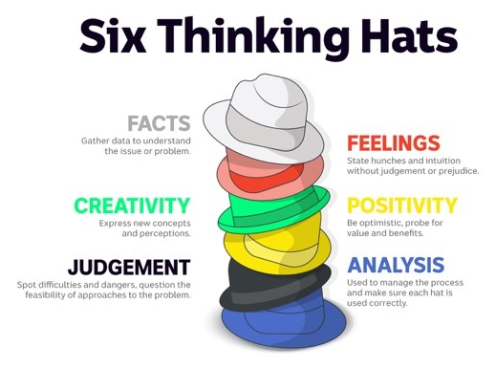
- How did the Ozone Layer story make you feel?
- What do you know about the ozone layer?
- What have you learnt from the story?
- Were there any positives from the story? If so, what were they?
- What are some of the negatives or challenges that you learnt from the story?
- Why is it important to learn about the ozone layer?
- What questions were raised during this activity?
- What do you want to learn further about this topic?

Reflection
After this activity, ask students to reflect on what they have learnt. Students can include details about how their thinking on this issue has changed.

Activity: Research project
Discuss the information raised in the BTN Ozone Recovery story. What questions were raised in the discussion and what are the gaps in students’ knowledge? The following KWLH organiser provides students with a framework to explore their knowledge on this topic.

What do I know? | What do I want to know? | What have I learnt? | How will I find out?

Students will develop their own question/s to research or choose one or more of the questions below.
- What is ozone and why is it important?
- What are the consequences of ozone depletion? How have humans contributed to the problem?
- Where is the hole in the ozone layer? What is the current status of the hole?
- What is the Montreal Protocol and what has it achieved?
- How is ozone measured?
- What has a recent United Nations assessment of the ozone layer found?

Activity – Choose a project
Individually or in small groups, students will choose one of the following projects to work on and then present their findings to the class.

Group Discussion
In small groups, discuss the following statement Ozone action sets a precedent for climate action.
Share the main points of your discussion with the class.
Quiz
Create a true of false quiz to test your classmate’s knowledge about the ozone layer.
Summary
Write a summary of the story. What was the story about? Explain in your own words what the ozone layer is, how it was damaged and what has been done to repair it.
Create a diagram
Draw a labelled diagram that shows the Earth’s surface, troposphere, stratosphere, ozone layer and the 3 types of UV rays - UV-A, UV-B and UV-C

Activity: Ozone Layer Quiz
- What is the chemical formula for ozone?  A. CO₂  B. O₂  C. O₃  2.What does CFC stand for?  A. Carbon fluoro compound  B. Chlorofluorocarbon  C. Carbon fuel cycle  3.What were CFCs used in?  A. Aerosol sprays  B. Air conditioners  C. Refrigerators  D. All of the above | 4.What is the name of the international agreement that banned ozone depleting chemicals?  A. Paris Agreement  B. Montreal Protocol  C. Kyoto Protocol  5.When was the agreement made?  A. 1977  B. 1987  C. 1997  6.It’s estimated that the hole in the ozone layer over Antarctica will mend in…  A. 43 years  B. 53 years  C. 63 years
Quiz Answers: 1C, 2B, 3D, 4B, 5B, 6A

Useful Websites

United Nations' scientific assessment finds ozone layer is healing, 35 years after world stopped producing 'chomping' chemicals – ABC News
- What is the ozone layer, why was it damaged, and what’s been done about it? – Newsround
- Ozone Improvement – BTN
- Basics on Ozone - NASA
- The Ozone Hole – NASA Earth Observatory for Kids

EPISODE 1
7th February 2023

KEY LEARNING
Students will investigate the impact of floods on people and places in Australia.

CURRICULUM
Geography – Year 5
The impact of bushfires or floods on environments and communities, and how people can respond.

HASS – Year 5
The impact of bushfires or floods on environments and communities, and how people can respond.

Science – Year 5 & 6
Scientific knowledge is used to solve problems and inform personal and community decisions.

Science – Year 6
Sudden geological changes and extreme weather events can affect Earth’s surface.

Science – Year 7
Scientific knowledge has changed peoples’ understanding of the world and is refined as new evidence becomes available.

Geography – Year 7
Causes, impacts and responses to an atmospheric or hydrological hazard.

PLEASE NOTE: Talking about the floods may be upsetting for some children and may cause some discomfort, distress and/or anxiety. BTN has a short video about the Important Things to Remember about Upsetting News.

  - Teacher Resource

Flooded School

Focus Questions
Discuss the BTN story as a class and record the main points of the discussion. Students will then respond to the following:
- Which states were affected by floods last year?
- What impact have the floods had on Mypolonga?
- How did Laine help out at her school during the floods?
- In what year did the Murray River record its worst floods?
  - 1956
  - 1976
  - 1996
- What questions do you have about the story?

Activity: Class Discussion
Discuss the BTN Flooded School story as a class. Create a class mind map with FLOODS in the middle. Use the following questions to guide discussion: Ask students to record what they know about floods. What questions do they have? In small groups, ask students to brainstorm responses to the following questions:
- What do you know about the floods in the Riverland?
- What has caused the flooding in the Riverland?
- What impact has the flooding had on the people?
- What questions do you have about the floods?

Activity: Note taking
Students will practise their note-taking skills while watching the BTN Flooded School story. After watching the story, ask students to reflect on and organise the information into three categories. What information in the story was positive, negative, or interesting?

Activity: Cause and effect
This cause and effect diagram (also known as a fishbone diagram) is a useful tool which can help students identify causes for an effect or problem. The tool can be used during brainstorming sessions to record student’s ideas. The tool also helps to sort student’s ideas into useful categories.

Materials: Flipchart and marker or whiteboard.
Categories: As a class brainstorm the major categories of causes of the problem. Useful categories for a Fishbone diagram about ‘Flooding’ could include:
- People
- Environment
- Animals
- Housing
- Roads
- Businesses

Effects: In small groups, students will then brainstorm the effects that flooding has had on these categories. Students can search for news articles and other publications to help with their research.

Solutions:
How can we protect our community from floods? Visit the Australian Museum website to learn more about what communities can do to protect their homes and businesses from floods. Find some examples of Indigenous knowledge practices that are useful for flood management (e.g., floodplains management).

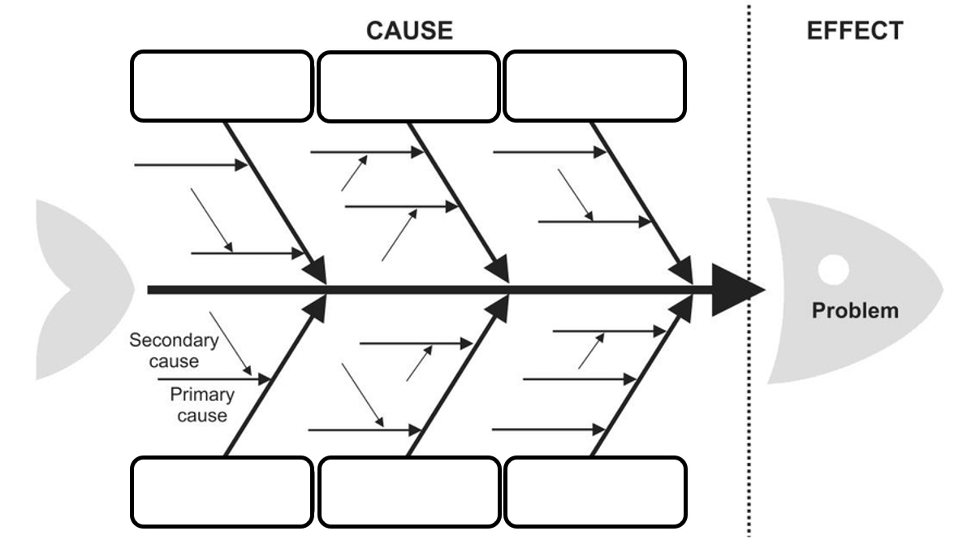

Activity: Understanding floods
Watch these videos to help students understand more about weather, climate, and floods.

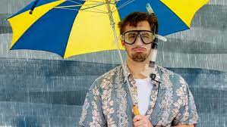  BTN La Nina Explained | 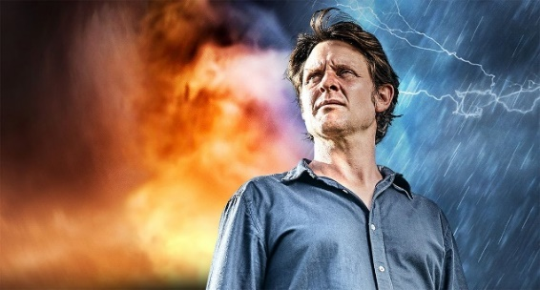  Big Weather: The Impact of Floods on Communities
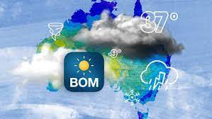  BTN Weather Science | 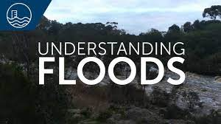  BOM – Understanding Floods

Activity: Aboriginal Dreaming
Water has an important place in Dreaming stories in Aboriginal and Torres Strait Islander culture. Dreaming stories pass on important knowledge, cultural values, and belief systems to later generations. Many sites of Dreaming significance are located along the Murray River.

Students will develop a deeper understanding of the connection Indigenous people have to water and the Murray River. Students will develop their own question/s to research or choose one of the questions below.

- How has the Murray River changed over time? Watch this BTN River Kids story to learn more. Explain in your own words why the Murray River is important to Ngarrindjeri people and how the Murray River has changed.
- What does Ngurunderi Dreaming explain? Students will practise their storytelling skills by taking it in turns to read the Ngurunderi Dreaming story aloud to the class.
- How was the Murray River made? Listen to this Bangerang story about how the Murray River was made. Find the Bangerang words for Murray River and water. Illustrate an aspect of this Dreaming story to present to the class.
- What Aboriginal Dreaming stories teach us about the importance of water? For example, the Rainbow Serpent, Ponde or Tiddalick. Compare and contrast these stories. Choose one to research in more detail and present your findings in an interesting way.

Activity: Mt Resilience
Students will visit Mt Resilience – an augmented reality experience that allows students to explore a town that’s been designed around climate and disaster preparedness. The app works on both phones and tablets. Get the app here. Go here to find out more about the technical specifications for the app.

Explore the features of Mt Resilience
Working in pairs, students will look around and explore Mt Resilience. Students will play the Mt Resilience experience to see how the community of Waterdown has worked together to mitigate the impact of extreme weather.

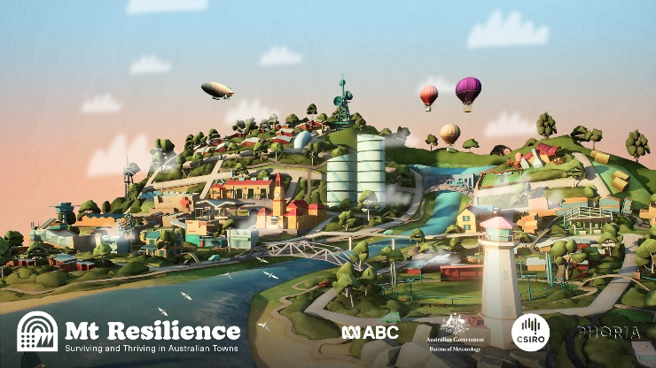
Students will then respond to the following:
- What are some of the things that the people of Waterdown can do to protect themselves from floods?
- How can the Government help the people of Waterdown recover from the floods?
- How does the community centre help the people of Waterdown?

Further Investigation
- How can emergency services help people in flood prone areas?
- What are floodplains?
- Create a community in Minecraft that includes a floodplain. How will you make the town resilient to floods?

Resources
- How can a town manage floods and severe storms – Australian Museum
- Mt Resilience – Australian Museum and ABC

Useful Websites
- Understanding Floods – Bureau of Meteorology
- Floods – BTN
- Floods – Geoscience Australia
- Things you can do before a flood – NSW SES

  - Teacher Resource

BTN Transcript: Episode 1- 7/2/2023

Hey, I'm Amelia Moseley and you're watching BTN. Welcome to our first episode of 2023. It's great to be back. I hope you enjoyed your holidays. Let's see what's coming up in today’s show. Find out why everyone's talking about an AI chatbot, we visit a school affected by floods and get a masterclass in writing country music.

Aussie Streaming Content

Reporter: Jack Evans

INTRO: All that soon, but first up. The Australian government has told streaming platforms they'll need to produce more Australian-made movies and TV shows under new rules that are set to start next year. But some of the big streaming services say they're already spending a lot of money on local production, and the new rules aren't fair. Jack looked into it.
JACK: Okay, it is a film, about a film, about a film, about a film. What about a TV show and the only word I say is chimney, chimney. A musical about marsupials, we'll call it wombats. A bat and a man, man bat. Rats the musical?
Right now there's a lot of talk going on about creating more Aussie TV shows and films.
JACK: But everyone talks like this, *gibberish*.
Recently the federal arts minister, Tony Burke, announced that major streaming platforms like Netflix, Disney+ and Amazon Prime will be required to make more Aussie content.
TONY BURKE, ARTS MINISTER: The days of there being no guarantee of Australian content on streaming services have to come to an end and they come to an end on the 1st of July next year. Streaming quotas will be a reality in Australia.
There's really no denying that subscription streaming services are booming. Aussies spend billions of dollars on them every year and some people, like Mr Burke, reckon that a bit of that money should be put back into the Australian film and TV industries. To help showcase Australian talent and bring more work down under.
TONY BURKE, ARTS MINISTER: For years now, for nearly a decade, our streaming services in Australia have had zero requirement to provide Australian content.
It's something that free to air channels like these are already required to do. They have to show a certain amount of Australian content each day.
JACK: But what exactly makes Australian content, Australian? Does it have to have at least one character who talks like this. Oh yeah, nah, strike a light.
While there's no one clear answer, most people in the know would agree that for a film or TV show to be considered Australian it has to feature Australians, be created by Australians and tell Australian stories.
JACK: But if you're like me, you’re probably thinking, in Australia there are lots of Australians, we see them all the time. Do we really need to see them in TV shows and movies too?
Well, Screen Australia, who from their title, obviously know a lot about screen in Australia, say that seeing Australians represented on screen "reflects our sense of who we are as a society and who we might be”. I mean, that sounds pretty important. So, what do streaming services have to say about the quota?
JACK: Well, they're not exactly streaming with joy.
SOUND OPERATOR: Ah, do you mean screaming with joy?
JACK: Yes, what did I say?
Some streaming services have responded to the announcement, saying that they are already making a lot of Aussie content, and they're not wrong. Between 2021 and 2022 streaming services spent more than 330 million dollars on the Australian film and television industry. And so yes while there are a lot of big blockbusters like these that are being made here in Australia, they don't all exactly reflect Aussie culture. Although Chris Hemsworth is Australian. The other problem is that not all streaming services operate the same and some of them already follow local content rules, so they say it's confusing adding more.
JACK: Either way we’re sure to start seeing a lot more Aussie stuff on our big and little screens. Oh, what about a show about a reporter, an Australian reporter, who works for a kid’s news program named Jack or Jake or Elijah Blue. That’s good.
News Quiz

This balloon has been getting a lot of attention after first appearing in American skies more than a week ago. US officials say it’s a Chinese spy balloon. It was spotted in South Carolina on Saturday. What happened next? It was shot down by an American fighter jet.

There’s a big re-design coming for Australia’s five-dollar note. Who will feature on new versions of the note? Is it Queen Elizabeth II or King Charles III? Ooh, trick questions, it’s neither. Instead, the Reserve Bank of Australia says the image will be something that honours the culture and history of the First Australians.
Authorities in Western Australia spent the week scanning a 14-hundred-kilometre stretch of highway. What were they looking for? A radioactive capsule smaller than a 10 cent piece. It was lost between a Rio Tinto mine site and a Perth depot. But luckily, they found it.

Who is this award-winning musical artist? It’s Beyonce. She led the way going into this year’s Grammy Awards with 9 nominations. Beyonce made history at the ceremony, she’s now won more Grammy’s than anyone else ever, with a total of 32.

ChatGPT

Reporter: Michelle Wakim

INTRO: New AI technology called ChatGPT has been making headlines in Australia and around the world. Some schools have started banning the chatbot because of the risk that students will use it to write their essays or complete their assignments. Here’s Michelle.
Director: ChatGPT, mark it. Action.
Michelle: I'm so bored, there's nothing to do on the computer.
Joe: Let's play with this chatbot.
ChatGPT: Hello there. How can I help you today?
Michelle: Wow, it's like talking to a real person.
Joe: But it's even better, because it doesn’t get tired or grumpy.
Michelle: This is so cool.
Joe: This chatbot is going to be our new best friend.
Director: Cut.
Michelle: So, this skit you just watched wasn't written by me. It was actually written by the chatbot.

It's called ChatGPT, which stands for ‘Chat Generative Pre-trained Transformer’ and it's been in the news quite a bit lately.
Michelle: You see, ChatGPT doesn't just write skits. It can write essays, emails, poems, all in a matter of seconds, and it doesn't stop there.

ChatGPT is trained to chat with us and give human-like responses. It's fed heaps of data from books, conversations and websites and learns to predict how sentences are formed and then creates new text based on what it's read.
Dr Feras Dayoub, University of Adelaide: Most of the time it will make sense. It will be very good, very coherent, because it’s trained to be coherent, very fluent and fantastic at grammar.
It's so coherent, researchers in the US found it was able to pass a college medical exam, and in Australia it's already being used in some workplaces. A law firm has tried it out to help draft documents, and a software developer has even asked it to write code.

MICHELLE: It's got some people asking whether technology like ChatGPT will end up replacing humans in the workforce.
Dr Feras Dayoub, University of Adelaide: I think a lot of companies can see the potential for this.
But this AI isn't perfect, yet.
Dr Feras Dayoub, University of Adelaide: The thing is, it was not trained on the meaning of this text, so sometimes it will be very confident in the generation of the text, but if you are not an expert and you will trust everything, sometimes you will be very, very wrong.
This basically means that while it can churn out information, it doesn't really have a sense of what's true and what isn't.
Dr Feras Dayoub, University of Adelaide: So, when you ask it about something, and this something you were asking about was not in the training data, it's been never seen or there's no knowledge in the model about it, this model can't just come back and say I don't know. It will fill the gaps with data from the training data.
Michelle: That's not the only issue.

In Australia, ChatGPT has divided people on how it should be used in schools. Some are worried that students could use it for assignments and exams, rather than doing the work themselves.
Lisa Rodgers, Western Australia Education Department: It's really important that teachers know what students know, what they've mastered and their gaps in their knowledge. So, on that basis, we've blocked it from our education network.
Michelle: New South Wales, Queensland, Western Australia, Victoria and Tasmania have all banned the technology in public schools. But not everyone agrees.

Prof. George Siemens, University of South Australia: Recognise this is a tool that students have access to and then begin to say how can we integrate it into curriculum because it's important to note, ChatGPT is only the first.
Michelle: The South Australian government is allowing it in schools as a learning tool.

Blair Boyer, South Australia Education Minister: I liken the debate around ChatGPT and AI to the exact same debate that we had when I was at high school in the 1990s around the internet and Wikipedia.
Dr Feras Dayoub, University of Adelaide: This is a new tool, like when the calculators came.
But it won't be allowed for graded work.

Michelle: So, if the internet and calculators have found a place in schools, maybe AI technology is just the next step?
Ozone Recovery

Reporter: Joe Baronio

INTRO: Now to some good news about the environment. The United Nations says all the work we humans have put into healing the hole in the ozone layer is actually working and it's on its way to completely recovering in just a few decades. Joe found out what the layer is and why protecting it is such a big deal.
JOE: Nearly 40 years ago scientists sounded the environmental alarm bells because they'd discovered something terrifying way up there, a growing hole in the ozone layer. And life as we know it was speeding towards a sizzly end if we didn't act fast. So, we did.
JOE: Between us and the vast vacuum of outer space is a whole lot of sky but if we want to get technical it's the atmosphere. Several layers of gasses that keep us cosy, and well, alive down here.
About 20 to 30 kays up in the stratosphere is the ozone layer which plays an essential role in our survival. Ozone is a molecule that's made up of three oxygen atoms and these little guys suck up ultraviolet radiation from the sun. In fact, the ozone layer absorbs about 98 percent of the UV rays that the sun spits at Earth.
JOE: Which is a fabulous thing for us because while we do need some of the sun's UV rays to produce vitamin D and help plants photosynthesise. Too much UV radiation can damage DNA and cause things like skin cancer and even blindness. Without any ozone layer we wouldn't be able to go outside or grow food and eventually all life on Earth would die out, and in the 1980s that was a very real threat.
In 1985 scientists discovered that ozone levels around the Antarctic were dropping, fast, and we were on track to completely destroy the ozone layer by 2050.
JOE: The whole situation was pretty bleak and the world was in despair but how did something so catastrophic happen in the first place?
Well, it all came down to pollution from chemicals called chlorofluorocarbons or CFCs. Back then, CFCs were used in lots of products. When CFCs are released into the atmosphere and exposed to UV rays, they breakdown and rip the ozone molecules apart which scientists say created the hole.
JOE: Add on the fact that CFCs hang around up there for between 50 and 150 years. Yeah, that's a lot of damage.
RAFE POMERANCE, WORLD RESOURCES INSTITUTE 1987: I think we should all be aware of the size of the challenge we are faced with.

In September 1987 at a conference in Montreal, world leaders came together to take action. Every single country signed the Montreal Protocol which officially recognised the impacts on the ozone layer and listed steps for countries to phase out their ozone-munching chemical usage.
JOE: Today CFCs are a thing of the past and the ozone layer is bouncing back, which experts say is all thanks to the ground-breaking Montreal Protocol. They even reckon that the ozone layer could fully recover for most of the world by 2040. And the bigger holes in the Arctic and Antarctic by 2045 and 2066 respectively.
Stéphane Dujarric, united nations: The phase out of nearly 99 percent of banned ozone-depleting substances has succeeded in safeguarding the ozone layer, leading to notable recovery of the ozone layer.
JOE: Ultimately what the Montreal Protocol has proved is that the world can come together to create necessary change. So, can we repeat history for the current climate crisis? Well, there’s still a lot of work to do.
Flooded School

Reporter: Ella Germein

INTRO: People all along the Murray River have been affected by flooding in the past few months so Ella visited a school in Mypolonga in South Australia to find out how students there are going and how they helped protect their school.

ELLA: It's pretty crazy to think that just a couple of months ago, this water behind me was actually farmland and home to some buffalo but unfortunately due to the recent floods it has been filled up with water and now just home to some fish and birdlife. And although it does look very beautiful floods do cause a damaging effect to communities and the local schools.
LAINE: I first heard about the floods around maybe December or November because I knew that all the floods from up north were coming down here. It was pretty cool seeing the floods come up because I’ve never seen that before. And it was kind of scary as well because we didn't really know what was going to happen.
Laine was one of the many students here at Mypolonga Primary school who instead of relaxing and winding down for holidays, got her hands dirty.
LAINE: So, on the last day of school we had to do sandbagging. It was a lot of hard work, and they were really heavy.
School students here filled over a thousand sandbags to protect floodwaters from coming into the school. And with each sandbag weighing up to 20 kilos, we thought we would give it a go to see what it was like.
ELLA: Alright, so twist it up like this? And then, what, oh my goodness. A thousand bags, goodness we get our workout doing that.
This isn't the first time this school and this town has been hit with extreme flood waters. In 1956 the Murray River recorded its worst flooding in history affecting towns throughout Victoria, New South Wales, and South Australia. Laine's grandpa Don was there.
DON: Well, I was only a 10-year-old, and our house was on what they called the bottom road and all we had showing was just the roof and we lived up in friend's place who also lived up in the local football club for about 8 months. We moved from the school up to the institute and rooms were created up there.
Luckily, this time the town's built a levy that acts as an extra barrier to stop water from getting into homes and buildings. But some people have still been affected. Just down the road, well, what used to be a road, Austin and Noah are usually out playing on their front lawn at this this time of the year but now space is a little limited.
AUSTIN: Me and my brother love to play football in the backyard but at the moment there’s water.
This video here was taken just a few days before the local river overflowed from football field to fish pond.
NOAH: I get really nervous because when I wake up I think that there is water in my bedroom.
AUSTIN: We were scared that water was going to get into our house.
Although waters are slowly going down, people still have to be careful.
SteFANIE ZAKRZEWSKI, REGIONAL OPERATIONS SES: So, the flooding in the River Murray looks beautiful, it’s amazing and it looks like the perfect place that you can go for a swim. But unfortunately, the River Murray is still quite a dangerous place and we ask that you stay safe by staying out of there and not swimming, kayaking or paddleboarding because you just don't know what might be underneath.
It could take anywhere from a few months to years for these areas to return to normal but for students like Laine it’s about focusing on what’s important.
LAINE: During the flood I’ve learnt that you really need to come together as a community to help out with other people who might have been affected by the floods.

Sport

The Perth Scorchers have won back-to-back Big Bash titles. They defeated Brisbane Heat in Saturday's final, but it came down to the final over. 19-year-old Cooper Connolly got the Scorchers over the line with an unbeaten 25.
Aussie snowboarder, Valentino Guseli is having an incredible year. The teenager's just picked up two silver medals in both the halfpipe and slopestyle World Cup comps and after winning gold in the big air event in December, the 17-year-old has now won World Cup medals in all three park and pipe disciplines in the same season.
Welcome to the Indian Rural Olympics where competitors can compete in anything from your traditional Olympic events to something a little more unique like tyre rolling, breaking chains with your body or how about pulling a motorbike with your teeth?

Golden Guitar Winner
Rookie Reporter: Tiggy

INTRO: 10-year-old Tiggy loves country music. So much so that even writes her own. And she's just become the youngest winner ever at Australia's most famous country music awards.

Hi BTN. My name is Tiggy Heart Eckersley, and I'm 10-years-old and I have just become the youngest ever winner of a Golden Guitar. Here it is, here.
PRESENTER: And the Golden Guitar for Song of the Year goes to: Star of the Show. Written by Brooke McClymont, Adam Eckersley, Dan Biederman and Tiggy.
It says ‘Star of the Show’ on it, written big in the middle, and it has my name on it here. And it's pretty heavy actually. So, I got this trophy for Song of the Year.
I first got into song writing and music when I was really little.
TIGGY: Sometimes cranky and sad, sad. And sometimes happy, happy, happy, happy. Sometimes sick.

I remember that my mum and dad got a piano, and I started playing it and I realised I loved it. So that's how I started. I'd like to introduce you to my parents. Brooke McClymont, she's a singer and she plays some guitar, and this is my dad, Adam Eckersley, and he plays guitar and he's a singer.
Having musicians as parents was very fun and exciting. I love going touring and sitting backstage when they were playing and watching them play music, because we always had music in our house.
TIGGY: One, two, three, four.
I went to school, and I thought every house played music and I asked my friends, “what instrument do you play?” or “what instrument do your parents play?”. And I realised that they don't play an instrument, that's when I realised how lucky I am to have music in my life.
I just sat down, and I started making up just piano and then I realised that I can do this sound, which is ‘Star of the Show’ riff. That sounded really good, and I just kept playing it for so long, and then my mum and dad picked it up.
ADAM ECKERSLEY: We loved it. We were going “wow, this is awesome.”

BROOKE MCCLYMONT: Can we steal it? But I also said, “we'll put you on the song, darling. Do you mind if we write a song about you in this? If we can use it, you'll get paid”.
It felt amazing to win. Especially the youngest ever winner.
TIGGY: Thank you.
And I went up on stage and played the bit that I wrote in the song, and before that I was a little bit nervous. But then when I got up on stage, I wasn't nervous anymore.
I love playing country music to just get my feelings out and so then I'm never bored. I don't really have any songs that I'm writing at the moment, but I really hope one comes to the me soon because I want to be the queen of rock. Yeah.
Closer
Well, that's it for our first episode of BTN in 2023 but get excited because this week we're also launching BTN High. For the first time ever, we're breaking down the news exclusively for highschoolers. And teachers, all of our stories can be shown in the classroom and work alongside the Australian Curriculum. You can head to our website to find out more info about BTN High and all the usual stuff you know and love. I'll catch you soon. Bye.

