

**EPISODE 11**  
4th May 2021

**KEY LEARNING**

Students will view a range of BTN stories and use comprehension skills to respond to a series of focus questions.

**CURRICULUM**

**English – Year 4**Use comprehension strategies to build literal and inferred meaning to expand content knowledge, integrating and linking ideas and analysing and evaluating texts.

**English – Year 5**

Use comprehension strategies to analyse information, integrating and linking ideas from a variety of print and digital sources.

**English – Year 6**

Use comprehension strategies to interpret and analyse information and ideas, comparing content from a variety of textual sources including media and digital texts.

**English – Year 7**

Use comprehension strategies to interpret, analyse and synthesise ideas and information, critiquing ideas and issues from a variety of textual sources.

Teacher Resource

**Focus Questions**

As a class, discuss the stories featured in the episode of BTN Classroom and record the main points of the discussion. Students will then respond to the following focus questions.

# India COVID-19 Crisis

1. Discuss the BTN India COVID-19 Crisis story as a class.
2. India is the 2nd most populated country in the world. True or false?
3. What is the capital of India? Find on a map.
4. Complete the following sentence. The COVID outbreak is so bad in India that hospitals have been running out of _________ and ______.
5. How is the situation in India affecting Diya and her family?
6. What caused COVID to spread so quickly in India?
7. What did the Australian government do to flights from India?
8. What medical supplies has Australia sent to India?
9. What is Diya’s message to people in India?
10. How did this story make you feel? Discuss as a class.

# Chernobyl Anniversary

1. As a class, discuss the Chernobyl Anniversary story. Record the main points of your discussion.
2. Where is the Chernobyl nuclear power plant? Find on a map.
3. What year did the Chernobyl disaster occur?
4. What caused the disaster?
5. What is another name for the Soviet Union?
6. The Soviet Union was communist. What does this mean?
7. What did the Chernobyl liquidators do?
8. How did the disaster affect people living in the area?
9. How did the disaster affect people globally?
10. What does the exclusion zone around Chernobyl look like? Describe.

**Dollarmite Controversy**

1. Briefly summarise the Dollarmite Controversy story.
2. What bank started the Dollarmite school banking program?
3. How many schools around Australia are currently part of the Dollarmite program?
   1. 40
   2. 400
   3. 4,000
4. The Commonwealth Bank is owned by the government. True or false?
5. What does ASIC stand for?
6. What did ASIC’s report on school banking programs find?
7. What did consumer group CHOICE say about the Dollarmite program’s marketing tactics?
8. Which 3 Australian states will end the Dollarmite program in schools?
9. What do you think about school banking programs?
10. What do you know about saving? Write 3 tips for kids.

Check out the [Dollarmite Controversy](https://www.abc.net.au/btn/teachers/) resource on the Teachers page.

**Know My Name Exhibition**

1. Before watching the BTN story, name a well-known female artist.
2. Explain the BTN story to another student.
3. Where is the National Gallery of Australia?
4. Why were women banned from studying at Europe's famous art academies in the past?
5. Why do you think the NGA called the exhibition Know My Name?
6. What percentage of art in the NGA collection is by women artists?
   1. 5%
   2. 25%
   3. 50%
7. Name one artist featured in the Know My Name exhibition.
8. Describe Patricia Piccinini's Sky Whale air balloon sculpture.
9. What was surprising about this story?
10. find 3 interesting facts about an Australian female artist. Share with the class.

Check out the [Know My Name Exhibition](https://www.abc.net.au/btn/teachers/) resource on the Teachers page.

**T-Rex Revelations**

1. Before watching the BTN discuss in pairs what you know about the T-Rex.
2. What does the word Tyrannosaurus mean in Greek?
3. What does the word Rex mean?
4. What ancient island did the T-Rex live on?
5. The T-Rex was an omnivore. True or false.
6. How tall did the T-Rex grow?
7. What group did the T-Rex come from?
   1. Theropod
   2. Sauropod
   3. Pterosaur
8. Name some of the characteristics of the T-Rex.
9. What have scientists recently discovered about the T-Rex?
10. Name three things you learnt watching the BTN story.



**EPISODE 11**  
4th May 2021

**KEY LEARNING**

Students will develop their knowledge of banking, budgets and financial decisions. Students will create simple financial plans.

**CURRICULUM**

**Economics & Business – Year 7**

Why and how individuals and businesses plan to achieve short-term and long-term personal, organisational and financial objectives.

Apply economics and business knowledge, skills and concepts in familiar and new situations.

**Mathematics – Year 5**

Create simple financial plans.

**Mathematics – Year 6**

Investigate and calculate percentage discounts of 10%, 25% and 50% on sale items, with and without digital technologies.

**Mathematics – Year 7**

Investigate and calculate 'best buys', with and without digital technologies.

Teacher Resource

**Dollarmite Controversy**

# Focus Questions

Discuss the BTN story as a class and record the main points of the discussion. Students will then respond to the following:

1. Briefly summarise the Dollarmite Controversy story.
2. What bank started the Dollarmite school banking program?
3. How many schools around Australia are currently part of the Dollarmite program?
   1. 40
   2. 400
   3. 4,000
4. The Commonwealth Bank is owned by the government. True or false?
5. What does ASIC stand for?
6. What did ASIC’s report on school banking programs find?
7. What did consumer group CHOICE say about the Dollarmite program’s marketing tactics?
8. Which 3 Australian states will end the Dollarmite program in schools?
9. What do you think about school banking programs?
10. What do you know about saving? Write 3 tips for kids.

# Activity: Discussion

After watching the BTN Dollarmite Controversy story, hold a class discussion, using the following discussion starters. Brainstorm ideas in small groups and then students will report their group’s responses to the class.

* What do you dream of spending money on?
* Do you have a saving goal? Explain.
* How do you save money?
* 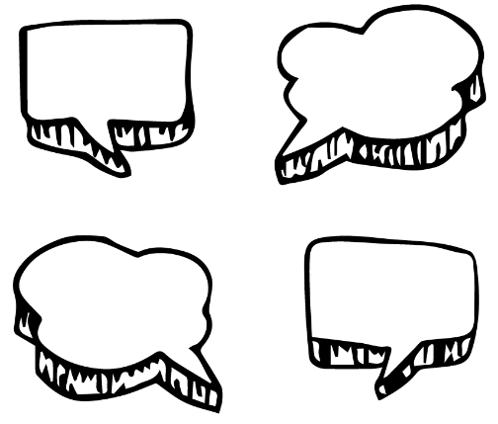Do you find it difficult to save? Why or why not?
* What tips can you give to someone who is trying to save?
* Think of as many words as you can that relate to saving and managing your money.
* Think of 5 reasons why kids should learn more about managing their money. Share and compare your ideas with the class.
* Why do you think BTN covered this topic?

# Activity: Glossary

Students will brainstorm a list of keywords that relate to managing their finances. Here are some words to get them started. Students will create their own class glossary of keywords and terms. Students can use illustrations and diagrams to help explain each keyword.

|  |  |  |
| --- | --- | --- |
| SAVINGS | BUDGET | INTEREST RATE |
| CREDIT | DIGITAL MONEY | LOAN |
| DEBT | INCOME | TRANSACTION |

**Further investigation: Tricky words**

Students will choose additional keywords and terms to add to their class glossary that are tricky. For example, entrepreneur, financial plan, compound interest, financial security or inflation. Students will find a definition and explain to their classmates what the keywords mean.

# Activity: Class discussion

Introduce students to the concept of managing money, including ways to pay for things, borrowing money, saving and budgeting. Have a class discussion to explore and investigate these concepts further, using the following questions to get the discussion started:

* What are your spending habits?
* What are some of the different ways you can pay for things? Give examples.
* What is the difference between cash and digital money?
* What is the difference between a credit card and a loan?
* Have you ever saved up your own money to buy something? How did you reach your savings goal?
* Have you ever had to budget for something (e.g., party or school event)? Explain.
* Have you ever borrowed money from someone?
* How did you pay the money back? What sort of agreement did you have to pay the money back? Were you able to pay the money back in time?
* Alternatively, have you ever lent money to someone else? How did they pay you back and did you have an agreement to make sure the loan was paid back in time?

# Activity: Budgeting

In small groups, students will work together to budget for a meal to share with the class. Note: If your class doesn’t haven’t access to money to buy food, students may create a hypothetical shopping list and meal plan. Students will respond to the following questions:

* What meal would you like to prepare? Think about nutrition and dietary requirements.
* What is your budget? What do you think would be an appropriate amount of money?
* What ingredients do you need? Prepare a shopping list.
* How much money will you need?
* How will you save money to buy the ingredients?
* Where will you buy the food? For example, online, your local supermarket, local markets, or a combination. Give reasons for your choices.
* Do you have vegetables growing that you could use instead of buying them?
* Is the meal you prepared nutritious?

# Activity: Teenage Boss

Watch the BTN [Teenage Boss](https://www.abc.net.au/btn/classroom/teenage-boss/10488868) story as a class. After watching the story hold a discussion, using the following discussion starters. Students may want to brainstorm ideas in small groups and then report their group’s responses to the class.

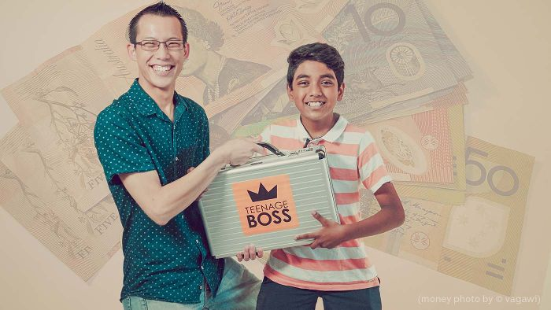

* Do you think your parents would let you take over the family finances? Why or why not?
* Do you think it is a big responsibility to look after the family budget? Give reasons.
* How would you feel if you had to look after your family budget?
* What skills do you need to look after a budget?

# Activity: Budget advice

Students will use what they have learnt about budgeting, spending and saving money and give what they think is the best advice in the following fictional scenarios. Students will share and compare their responses with other students in the class. Students will make a handbook of financial tips and advice for their class.

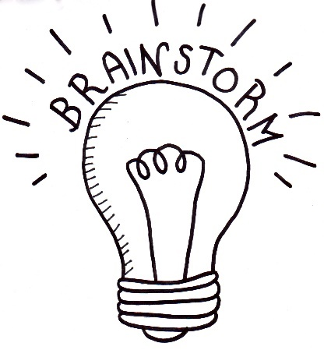

Before starting this activity, students will brainstorm a list of tips on how to manage money (how to budget, save and spend money) effectively and other financial skills kids might need as they grow up. Students will make a list of good choices that kids can make when managing their money.

Students will choose one more of the following fictional scenarios and give what they think is the best advice.

* ***Scenario #1 – “****I have spent all my fortnightly pocket money in one week. My friend has invited me to go to the movies, but I have no spending money left. What do I do?”*
* ***Scenario #2 –*** *“For my birthday lots of my friends and family gave me money for presents – a total of $200. I’ve never had this much money at once and I’m not sure what I should do with it. Do you have any good advice?”*
* ***Scenario #3 –*** *On my walk home from school I often buy a drink and something small to eat from the bakery using my own money. Sometimes it adds up to $10-15 a week. I would like to reduce how much I spend on food, so I can save up for something big. Do you have any tips?*
* ***Scenario #4 – “****All my friends are playing this new game which sounds really fun. It costs $8.99 and mum and dad said they won’t buy it for me. I don’t have any money of my own, but I would really like to buy it, so I can play with my friends. What shall I do?*
* ***Scenario #5 –*** *“My parents have asked me to make dinner for our family – mum, dad, myself and my sibling. They’ve given me $20 to buy the ingredients to make dinner. I’ve never done this before. Can you give me some advice on what to do?*
* ***Scenario #6 –*** *“I want to buy some new clothes with some of my savings, but I want to get the best price possible. Have you got any suggestions?*

# Activity: Choose a project

Individually or in small groups, students will choose one of the following projects to work on and then present their findings to the class.



**Tips & hints**

Do you have any good financial tips and hints? Share and compare your ideas with the class. Create a handbook with all your class’ tips!

**Have your say!**

What do you think Australia’s top budget priorities should be? Imagine you are the treasurer and write and present a one-minute speech about your decision. Watch this [BTN story](https://www.abc.net.au/btn/classroom/federal-budget-2020/12738910) to learn more.



**SMART Goals**

What are your savings goals? Think of your short term, medium term, and long term financial goals. Your goals should be SMART (**S**pecific, **M**easurable, **A**ttainable, **R**ealistic, **T**ime-Bound) goals.

**Wants V Needs**

What is the difference between wants and needs? Which are more important? Record your results using a T-Chart.

# Useful Websites

* [Manage Your Money](https://moneysmart.gov.au/) – Money Smart
* [Teenage Boss](https://iview.abc.net.au/show/teenage-boss) – iView
* [Teaching Finance](https://www.abc.net.au/btn/classroom/teaching-finance/10522510) – BTN
* [Going Cashless](https://www.abc.net.au/btn/classroom/going-cashless/12603602) – BTN
* [Teenage Boss](https://www.abc.net.au/btn/classroom/teenage-boss/10488868) – BTN
* [Budgeting for Fun](https://education.abc.net.au/home#!/digibook/1569645/chapter/6) – ABC Education
* [Teenage Boss: Study Guide](https://www.abc.net.au/cm/lb/11152338/data/teenage-boss-data.pdf) – ABC



Teacher Resource

**EPISODE 11**  
4th May 2021

**KEY LEARNING**

Students will explore a female artist’s work in detail. They will also create a biography of an artist.

**CURRICULUM**

**Visual Arts – Years 5 & 6**

Explore ideas and practices used by artists, including practices of Aboriginal and Torres Strait Islander artists, to represent different views, beliefs and opinions.

Develop and apply techniques and processes when making their artworks.

**Visual Arts – Years 7 & 8**

Experiment with visual arts conventions and techniques, including exploration of techniques used by Aboriginal and Torres Strait Islander artists, to represent a theme, concept or idea in their artwork.

Analyse how artists use visual conventions in artworks.

**Know My Name Exhibition**

# Focus Questions

1. Before watching the BTN story, name a well-known female artist.
2. Explain the BTN story to another student.
3. Where is the National Gallery of Australia?
4. Why were women banned from studying at Europe's famous art academies in the past?
5. Why do you think the NGA called the exhibition Know My Name?
6. What percentage of art in the NGA collection is by women artists?
   1. 5%
   2. 25%
   3. 50%
7. Name one artist featured in the Know My Name exhibition.
8. Describe Patricia Piccinini's Sky Whale air balloon sculpture.
9. What was surprising about this story?
10. find 3 interesting facts about an Australian female artist. Share with the class.

# Activity: Pre-viewing question

Before watching the BTN Know My Name Exhibitionstory, ask students to write down as many artists as they can.

# Activity: Class Discussion

After watching the BTN story students will reflect on the story and then respond to the following:

* What did you see in this video?
* What do you think about what you saw in the BTNstory?
* What did you learn from this story?
* What was surprising or interesting about this story?
* Think of three questions you have about the BTN story.
* Why do you think BTN covered this story?

Hold a class discussion about the Know My Name Exhibition story. Begin the discussion by asking students about the list of artists they wrote before watching the story. Are there many women on their list of artists? Think about your answer and why you think this may be.

* Why was an exhibition created that just shows the work of female artists?

**Activity: Women Artists**

Students will choose a female artist’s work to explore in detail. Below is a range of artworks created by some of the female artists featured in the Know My Name exhibition. The full list of artists can be accessed [here](https://knowmyname.nga.gov.au/artists/). Students will respond to the questions below to help guide their exploration and then create an artwork inspired by the artist’s style and technique.

|  |  |  |
| --- | --- | --- |
| Abstract painting by Grace Crowley  *Abstract painting* [Grace Crowley](https://nga.gov.au/knowmyname/artists.cfm?artistirn=16351) 1947 | Christmas Bells by Margaret Preston  Christmas Bells [Margaret Preston](https://nga.gov.au/knowmyname/artists.cfm?artistirn=20170)  1925 | Pondi by Yvonne Koolmatrie  *Pondi (Murray River cod)* [Yvonne Koolmatrie](https://nga.gov.au/knowmyname/artists.cfm?artistirn=25745) 2009 |
| *Untitled by Melinda HarperUntitled 2001* [Melinda Harper](https://nga.gov.au/knowmyname/artists.cfm?artistirn=20672) 2002 | *Interior in Yellow by Grace Cossington SmithInterior in Yellow* [Grace Cossington Smith](https://nga.gov.au/knowmyname/artists.cfm?artistirn=16350) 1962-1964 | *Sunflower by Dora ChapmanSunflower* [Dora Chapman](https://artsearch.nga.gov.au/detail.cfm?irn=12062) 1969 |

**Responding**

* Record as much information as you can about the artwork in 15 minutes. Record everything you see. The longer you look the more you will see.
* Who or what do you think the artwork is about? What does it remind you of? What does it make you think about?
* Is it a painting, print, sculpture or another type of artwork? What materials were used to make it?
* What techniques does the artist use?
* How does the artwork make you feel? What do you like about it? Why did you choose it?
* What questions do you have about the artwork?

**Creating**

Create an artwork that is inspired by the artist’s style and technique. Choose what medium you will use – pencils, paints, charcoal, watercolours, oil pastels or string and wire (sculpture).

**Activity: Biography**

Students will choose a female artist to research and write a biography about. They may want to find out more about the artist they chose in the previous activity or select another one. The [list of artists](https://knowmyname.nga.gov.au/artists/) in the Know My Name exhibition is a good starting point to help students choose.

**What is a biography?**

Before students begin to construct their biographies, hold a class discussion to find out what they already know about biographical writing. Below are some discussion starters:

* What does a biography tell us about a person?
* Where can you look to find information for your biographical writing? It could include the internet, newspaper articles, magazine articles and interviews, other biographies, historical books or television interviews. Why is it important to use more than one source of information?
* What makes a biography interesting? For example, key information and facts, a timeline of events, photographs, illustrations and quotes.

**Create a biography**Using the Biography Organiser template at the end of this activity, students will record information about the female artist they have chosen. Some possible areas of research include:

* Where are they from? Locate using Google Maps.
* When were they born? Describe their family life growing up.
* What sort of art do they create?
* Who or what were they influenced by?
* Where is their work exhibited?
* What impact did their work have on other artists or society?
* What do you admire about them?
* Imagine you could sit down and talk to them. What questions would you ask about their life and art?

# Useful Websites

* [Know my Name](https://knowmyname.nga.gov.au/) – National Gallery of Australia
* [History of Portraits](https://www.abc.net.au/btn/classroom/history-of-portraits/10611872) – BTN
* [Young Archie](https://www.abc.net.au/btn/classroom/young-archie-2018/10489076) – BTN

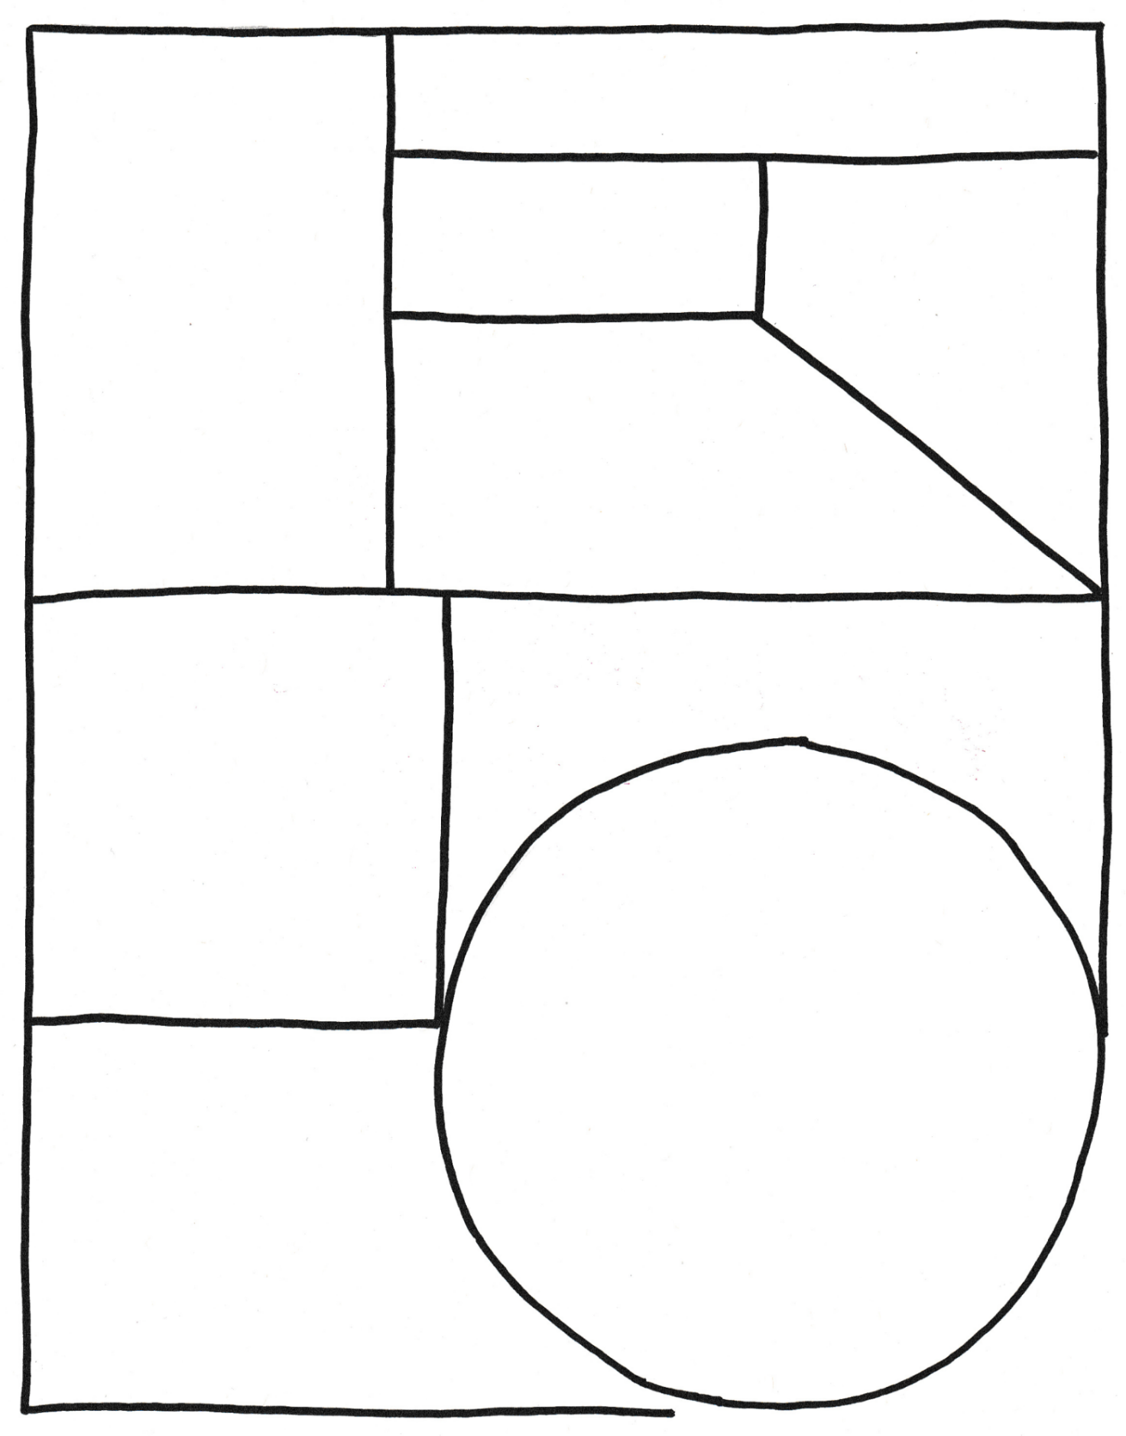

**Biography**

Family

Full name

Portrait

Influences…

Born

Achievements

Interesting things…

Impact of artwork



Teacher Resource

**BTN Transcript: Episode 11 - 4/5/2021**

Hey. Amelia Moseley here and you're watching BTN. Let's check out what's coming up. We learn about a nuclear accident that changed the world, visit an exhibition putting the spotlight on female artists and find out more about the king of the dinosaurs.

**India COVID-19 Crisis**

Reporter: Jack Evans

*INTRO: But first today we're going to India which has been breaking records for all of the wrong reasons. The country is in the grip of a really terrible second wave of COVID-19. Let's find out more about what's happening and how other countries are trying to help.*

It's the second most populated country in the world and right now it's going through a crisis like it's never seen before.  
  
DR SHAARANG SACHDEV: The situation is critical right now. This pandemic is the worst we've ever seen to now and these two weeks are going to be a hell for us.  
  
Over the past week there have been at least 350,000 new cases recorded every day. Although some say it could be much more than that. India's capital, Delhi, has been hit the hardest with the virus killing one person every four minutes. The outbreak is so bad that hospitals have been running out of oxygen and beds and many people are being turned away, while others are being treated in the streets. For Aussies like Diya, who have family over there, it's been really hard to watch.  
  
DIYA: My dad's family live in New Delhi and the condition over there is even worse. Many friends and family, we know, they are suffering from COVID-19 or passed away. We are calling every day and speaking to our family if they are okay. The whole situation in India makes me feel very, very sad. Living here I can't do much other than praying for them.  
  
So, how did this happen? Like many other countries India spent a lot of last year in lockdown and by the start of 2021 COVID cases had dropped and the country has started to open up again. There were political rallies and religious festivals that saw enormous crowds gather across the country. They helped to spread the virus, including a new mutated version that's thought to be even more infectious. In a country that's as density populated as India, where a lot of people live without access to proper health care, it's been disastrous. Thousands of Australians in India are trying to get home. But last week the government put flights on pause.  
  
SCOTT MORRISON, AUSTRALIAN PRIME MINISTER: We need to ensure the load in those quarantine facilities is manageable so we can take more people in down the track.  
  
It says it needs to keep people here safe. But it's really hard for families who are being kept apart.  
  
ANI JETTY, AUSTRALIAN IN INDIA: We were completely in shock, my little one was crying too while I was crying about what was happening to us, it's really hard. It's really hard to go through all of this.  
  
Australia has joined other countries around the world in sending aid to India. Like medical supplies, test kits and ventilators. But experts say they need more help including more access to vaccines. Meanwhile parts of the country are now in lockdown and people are doing what they can to stay safe.  
  
DIYA: My message to all the people in India is that please, please stay at home. Keep the safe distance, wash your hands and follow the doctor's advice. I know that Indian people are very strong people. If they stay together and follow the guidelines, then we can fight this virus. My prayers are with all the people in India.

**News Quiz**

Which state had an election on the weekend? It was Tasmania. It looks like the state’s Liberal party leader, Peter Gutwein, will get to keep his job but it was pretty close.

Can you name this Apollo 11 astronaut who died last week at the age of 90? It’s Michael Collins. He was on the first mission to the moon and his job was to pilot the command module while Buzz Aldrin and Neil Armstrong went down to the surface for that small step.

Speaking of giant leaps, China has launched the main section of its space station, Tianhe. Do you know what its name means? Heavenly Place, Heavenly Harmony or Heavenly Ship? It means Heavenly Harmony. This is the first of 11 missions that will be sent into space to build stations, which will be made of different modules, like the ISS, and 3 Taikonauts will be able to live there.

**Chernobyl Anniversary**

Reporter: Amelia Moseley

*INTRO: Now let’s go back 35 years to when the world was learning about a devastating disaster in Ukraine. What unfolded was one of the worst accidents in the history of nuclear power. Let's find out more about Chernobyl and how it's still having an impact today.*

These used to be bustling Ukrainian towns, full of the sound of cars, workers, families. Now, they're ghost towns. Quiet, run down, deserted. What happened here was one of the worst man-made disasters in history. In the early hours of Saturday 26th of April 1986, engineers at the Chernobyl nuclear power plant in northern Ukraine were doing a routine test.   
  
They were checking the systems designed to keep the power plant safe during a blackout. But a bunch of mistakes, along with a flaw in the reactor's design meant it all went horribly wrong. The 1000 ton steel lid the same weight as three passenger planes blew right off reactor 4. The explosion and a big fire sent dangerous radioactive air and material streaming out over surrounding areas, but in the days after the rest of the world would be kept in the dark.  
  
You see Ukraine was part of the USSR also known as the Soviet Union. In size, it was the biggest country on earth made up of a group of states controlled from Russia and stretching across large parts of Europe and Asia. The Soviet Union was also communist which meant its government kept tight control over the Soviet people, their freedoms and their access to news and information. And it worried an accident like this would make it look bad. But monitoring stations in Sweden noticed there were unusually high levels of radiation in the wind. And the secret was out.   
  
ABC NEWS REPORTER, 1986: It's now clear that the Soviet Union has suffered one of the worst disasters in the history of nuclear power.  
  
The Soviet Union evacuated hundreds of surrounding towns including nearby Pryp'yat which was home to 30 thousand people. It sent in what it called liquidators, who were firefighters, plant workers and locals that helped to contain the area and cover up the exposed reactor core. But they were exposed to dangerous levels of radiation in the process; in the beginning without even realising it. In fact, Chernobyl released more radiation into the air than the two atomic bombs dropped on Japan during World War Two. And it's thought thousands of people have got sick and even died in the years after because of radiation poisoning.   
  
The fallout also had a huge impact on the Soviet Union. There were investigations into what went wrong, and many Soviet people started questioning the government more forcing it to be less secretive. In 1991, the Soviet Union came to an end, but 35 years on, the exclusion zone it created around Chernobyl remains frozen in time. Radiation sticks around for hundreds of years, which is why these towns are still mostly abandoned besides the odd tour group visiting for short periods of time and plenty of animals enjoying the lack of people.   
  
The nuclear plant actually kept running until 2010 when the last reactor was shut down and in the past few years it's been made safer with a better structure to keep the radiation in. But as the 35th anniversary of Chernobyl was commemorated in both Russia and Ukraine, there's no forgetting the impact this disaster has had and will continue to have for many, many years to come.

**Dollarmite Controversy**

Reporter: Joseph Baronio

*INTRO: Next up, you might have heard of a program run by the Commonwealth Bank called Dollarmites. For about half a century it's been teaching schoolkids about managing money but now Queensland has joined the ACT and Victoria in ditching it from primary schools. Joe found out why.*

Sometimes, saving money can be hard.  
  
ANGEL: Let's be sensible Joe. You really don't need that guitar, do you? You can't even play. Save your money.  
  
DEVIL: Nah come on Joe. You know you want it. It looks so cool. Do it. Splurge.  
  
JOE: Hmmm. I really don't know.  
  
Angel and Devil argue.  
  
JOE: Fine. Fine.   
  
And maybe I could use a lesson on saving money, but it helps to learn these things early, which is why lots of schools around the country aim to teach kids about banking through programs like this one. You might have seen the Commonwealth Bank's Dollarmites program before. It's not the only school banking program but it is the biggest. Around 4000 schools are involved in it and it's been going for a really long time.

If we wind the clock back about 50 years or so, when things were a bit more black and white, the Commonwealth Bank was owned and run by the Aussie government and they decided to start teaching students about banking at school by letting them open accounts and deposit their savings. Here in 2021, the Dollarmites program is still going and makes up more than ninety per cent of the financial literacy programs that schools offer and it’s also making a lot of money for the Commonwealth Bank. In fact, the program is said to add around ten billion dollars to the bank's value. That's because a lot of the kids that start with the Dollarmites keep banking with the Commonwealth Bank when they grow up.

JOE, REPORTER: But the Commonwealth Bank isn't owned by the government anymore. In 1996, it was fully privatised, which means that all that Dollarmites money is going to a private company.

The Australian Securities and Investments Commission, or ASIC for short, which oversees financial matters, did a report on a number of school banking programs, including the Dollarmites, which found there was no proof they were actually improving kid's saving behaviours. Instead, ASIC says they were a way of advertising the banks to kids.

JOE, REPORTER: The consumer group, CHOICE, has also had a go at Dollarmites for its marketing tactics which use colourful characters, games and competitions which appeal to kids.

That's why the ACT, Victoria and most recently Queensland have decided to ditch the Dollarmites and instead schools are being encouraged to take financial literacy lessons into their own hands.  
  
Grace Grace, QLD Education Minister: I think times have changed from when we first signed up 50 years ago and I think that the Australian Curriculum now includes some very, very good financial education embedded in that curriculum and we think that is a proper way to go.  
  
But the Commonwealth Bank says they're disappointed by the decision. They say the Dollarmites teaches kids valuable lessons about saving and they're working on improving it with the help of finance and education experts. But what do you guys think?   
  
KID 1: I have mixed feelings about that because I think it is good to teach them about banking but everyone has different opinions so they may learn something different from their parents as opposed to a bank.

KID 2: I think some of the problems could be that it’s kind of being forced upon them of what they have to do with their money.  
  
KID 3: They should have different perspectives from everyone.   
  
KID 4: I think a better way could be like somebody they know to teach it so like a parent or teacher or guardian or somebody like that.

**Know My Name Exhibition**

Reporter: Amelia Moseley

*INTRO: Now let's take a trip to the National Gallery of Australia which is putting the spotlight on female artists. Not too long ago the gallery took stock of its collection and found only 25% of its Australian artwork was created by women. Let's find out why that might be and how the NGA is working hard to change it.*

Da Vinci. Monet. Van Gogh. Picasso. They're some of the world's most famous artists, but I wonder if you noticed that all of those names belonged to men.

ANNIKA ROMEYN, NATIONAL GALLERY OF AUSTRALIA: Well, I have a question for you, Amelia. I wonder if you could name five women artists. Most people across Australia might have a bit of trouble with that.  
  
AMELIA, REPORTER: I think I would.   
  
Annika is an artist educator here at the National Gallery of Australia, which is on a mission to teach us some new names.  
  
ANNIKA ROMEYN, NATIONAL GALLERY OF AUSTRALIA: Some of those really famous names that you might be familiar with, you know, Picasso, Jackson Pollock, these men's names dominate the history books. But those history books were also written by men.   
  
It's not that women haven't been making great art for hundreds, even thousands and thousands of years, they have. But for women in many societies throughout history, being recognised as an artist has been a lot trickier.   
  
ANNIKA ROMEYN, NATIONAL GALLERY OF AUSTRALIA: In the past women were more confined to the home, doing domestic labour, raising children.

The type of art they often did create wasn't taken as seriously and while women were the subject of many paintings, female painters often weren't welcome at the great art academies of Europe. Partly because they weren't allowed to see nude male models; a common way to learn to paint people.  
  
ANNIKA ROMEYN, NATIONAL GALLERY OF AUSTRALIA: A lot of art schools didn't welcome women in the past. When they did, they might be put into different classes or restricted in the materials, the subjects that they that they were allowed to work with.  
  
For a long time, it wasn't socially acceptable for women to go to bars, cafes and theatres alone, which were popular scenes to paint, and their work was often overlooked or excluded from popular galleries.   
  
AMELIA, REPORTER: Does that mean that we've been potentially missing out on a female Van Gogh, or you know, these incredible artists that we might have had?  
  
ANNIKA ROMEYN, NATIONAL GALLERY OF AUSTRALIA: Yeah, absolutely.   
  
Over the years, female artists have fought to change people's attitudes, but there's still a long way to go as the National Gallery found out when it looked at its own collection.   
  
ANNIKA ROMEYN, NATIONAL GALLERY OF AUSTRALIA: Of the 100,000 works of art that we care for in the Australian art collection. Only 25% or one quarter were by women artists. That really shocked us. And I mean, I think if you ask yourself, is that fair?   
  
The gallery decided it wasn't and created this exhibition called Know My Name, featuring the work of women artists from 1900 to now. From paintings by Grace Crowley to these life size sculptures by the Tjanpi Desert Weavers and Fiona Hall's birds' nests made from shredded US dollars.

ANNIKA ROMEYN, NATIONAL GALLERY OF AUSTRALIA: We need to change our perspective and to have a have a look back at all of the wonderful women artists who might have been overlooked. We need to spend time to appreciate their art and to know their names.   
  
The gallery's also working towards a more equal permanent collection starting with its biggest female art commission yet, this big guy Skywhalepapa by Patricia Piccinini. The sky whales will tour around Australia and show girls that when it comes to art the sky's the limit.   
  
ANNIKA ROMEYN, NATIONAL GALLERY OF AUSTRALIA: This is exciting, because this is something that, you know, young people can contribute to, to carve out a better future and a more inclusive future for all of us.

**Quiz**

Can you name this famous Mexican artist who's known for her colourful self-portraits? It's Frida Kahlo.

**Sport**

Matildas' star, Sam Kerr, is going to the Women's Champions League final. Her team, Chelsea, took a comfortable 4-1 win over Bayer Munich in the semi-final on Sunday which has put them in the running for the title for the first time ever.

The Super Netball season has kicked off with a nail-biting 69 to 66 win for the New South Wales Swifts. Their opponents, the Queensland Firebirds, put up a strong fight throughout the match and the score was neck-and-neck in the dying seconds, which sent the game into the first extra-time in super netball history. Meanwhile over in Adelaide, the Giants took out the Thunderbirds 66 to 52.  
  
In the Moto GP, Aussie Jack Miller, gave his fans a Sunday night to remember as he won the Spanish Grand Prix. It was his first race win since 2016 and only his second ever.

**T-Rex Revelations**

Reporter: Jack Evans

*INTRO: Finally, today, to dinosaurs and not just any dinosaurs, the most famous of the dinosaurs the T-Rex. A couple of new studies have come out giving us some new insights into the king of the terrible lizards. Jack spills the tea on the T-Rex.*

JACK: Are you enjoying your tea, Rex?  
  
REX: Roar.

JACK: Do you need a hand?  
  
REX: Roar.  
  
JACK: Okay spill, dish the dirt. I've heard the rumours. Everyone's talking about you, you're everywhere or at least you were.  
  
REX: Roar.  
  
Yep, our dear friend Rex here has been making headlines lately. So, it's time to spill the tea on the Tyrannosaurus Rex. Let's start with the stuff we already know. The name, Tyrannosaurus, comes from the Greek words for terrible lizard and Rex means king.   
  
JACK: Oh, I didn't realise I was amongst royalty.  
  
They lived in the late cretaceous period on this island, wait not this island. This island called Laramidia, the ancient continent which eventually became part of what we now know as North America. T-Rex’s were carnivorous predators, so they loved to eat meat. They could grow up to 12-metres tall, had tiny arms, weighed up to 8000 kilograms and made this sound, well at least we think they did. T-Rex’s are part of a group of dinosaurs called theropods. Which included some other famous faces like Allosaurus, Velociraptor and Megalosaurus. While theropods were reptiles, they had some bird-like characteristics. Like hollow bones, long limbs with hinged ankle joints and clawed three fingered hands. Just like a…  
  
JACK: Chicken. They're calling you chicken.  
  
Yep, scientists reckon that over millions of years, some theropods evolved to be more and more bird like. If that doesn't ruffle your feathers, scientists have also found fossils showing that many dinosaurs had feathers. Which means they were a little less like this and a little more like this, oh wait that's Big Bird, that's better.  
  
JACK: Okay let's get to the juicy stuff.  
  
We've just learnt some new things about T-Rex’s. Like did you know there were more than 2.5 billion of them. Alright, calm down, that 2.5 billion is the estimated total over a couple of million years. There were probably more like 20,000 running around at any one time or should I say, slowly moving around. Yep, turns out T-Rex’s aren't as fast as we once thought. Researchers in the Netherlands have found their walking speed was probably about 4.6 kays per hour, which is a casual stroll for us humans.

JACK: Come on. Keep up.

They figured it out by recreating the movements of its tail, which would have swung in time with their steps.   
  
PASHA VAN BIJLERT, DUTCH NATURALIS MUSEUM: You just have to look at the tail to understand how important it is for its walking. It's more than half of its length. The walking of dinosaurs was unique because of its tail. With every step it would slightly bounce up and down.  
  
So while maybe they weren't the fastest, I still wouldn't want to encounter one, well a real one anyway. Because another study has found they were able to bite through bone by keeping their lower jaw steady, just like an alligator does when they bite through bone.  
  
JACK: Oh, well we're out of tea.  
  
Which is good because I think that's all the tea I had to spill, for now, anyway.

**Ask a Reporter**

Do you have any questions about T-Rex’s? Well, you can ask me live on Friday during Ask A Reporter. Just head to our website for all the details.

**Closer**

And that's it for BTN this week. I hope you've enjoyed it and learnt some stuff along the way. We'll be back with more for you next week, but you can jump online to check out more stories and specials and teacher resources in the meantime. And don't forget there are new eps of Newsbreak every weeknight on TV and online. Have an awesome week and I’ll catch you soon. Bye.