EPISODE 9
30th March 2021

KEY LEARNING
Students will view a range of BTN stories and use comprehension skills to respond to a series of focus questions.

CURRICULUM
English – Year 4
Use comprehension strategies to build literal and inferred meaning to expand content knowledge, integrating and linking ideas and analysing and evaluating texts.

English – Year 5
Use comprehension strategies to analyse information, integrating and linking ideas from a variety of print and digital sources.

English – Year 6
Use comprehension strategies to interpret and analyse information and ideas, comparing content from a variety of textual sources including media and digital texts.

English – Year 7
Use comprehension strategies to interpret, analyse and synthesise ideas and information, critiquing ideas and issues from a variety of textual sources.
  - Teacher Resource

Focus Questions
As a class, discuss the stories featured in the episode of BTN Classroom and record the main points of the discussion. Students will then respond to the following focus questions.

NSW Floods
- As a class, discuss the NSW Floods story. Record the main points of your discussion.
- Describe the impact the floods have had on New South Wales and Queensland.
- About how many people were evacuated during the floods?
- The floods were a once in a century weather event. True or false?
- What impact did the floods have on many schools around New South Wales and Queensland?
- How were animals affected by the floods?
- What weather pattern is partly to blame for the storms and floods?
- Why are some areas at a much higher risk of flooding than others?
- How have people been helping and supporting others during the floods?
- What questions do you have about this story?

Check out the NSW Floods resource on the Teachers page.

NSW Flood Kids
- Describe what the BTN story is about in one sentence.
- Where do Ally and Ronan live? Find on a map.
- How have the floods impacted them?
- What has Ally been doing to distract herself from the floods?
- Where does Billy live? Find on a map.
- How was he affected by the floods?
- How have emergency services like the SES helped?
- Where does Anthony live? Find on a map.
- How did the floods affect the area where he lives?
- How did this story make you feel?

Concussion Rates
- Which sport did Holly play?
- How many concussions has Holly experienced?
- Explain what happens to your brain during a concussion.
- What are the symptoms of concussion?
- How long can the symptoms of concussion go on for?
- What impact did concussion have on Holly’s life?
- Why do head injuries need to be taken seriously?
- What concussion rules has the AFL brought in this season?
- What changes does Holly want to see to the concussion rules in club sports?
- Name three things you learnt watching the BTN story.

Regent Honeyeater Song
- What did the Regent Honeyeater Song story explain?
- The regent honeyeater is
  - Vulnerable
  - Threatened
  - Critically Endangered
- About how many regent honeyeaters are left in the wild?
- What has impacted on the species?
- Finish the following sentence: Male regent honeyeaters use their song to…
- Researchers found that 1 in ______ male regent honeyeaters don’t know their own song.
- What impact has that had on the birds breeding?
- What are zoos doing to help male regent honeyeaters learn their song?
- How will it help the regent honeyeater population?
- What was surprising about this story?

Easter Traditions
- In pairs, discuss the BTN Easter Traditions story.
- Easter is one of the most important holidays for Christians. True or false?
- What does Good Friday represent?
- Easter Sunday is a celebration of…
- Traditionally, when are hot cross buns eaten?
- What did Eostre mark the beginning of?
- Why is Easter held at a different time every year?
- The name Easter comes from the
  - Goddess of eggs
  - Goddess of Spring and Fertility
  - Easter lily
- Why was the idea of an Easter bilby introduced in Australia?
- Do you celebrate Easter? Describe what you and your family do.

Check out the Easter Traditions resource on the Teachers page.

EPISODE 9
30th March 2021

KEY LEARNING
Students will investigate what floods are, what causes them and how they impact on people and places in Australia.

CURRICULUM
Geography – Year 5
The impact of bushfires or floods on environments and communities, and how people can respond.

Geography – Year 7
Causes, impacts and responses to an atmospheric or hydrological hazard.

  - Teacher Resource

NSW Floods

Focus Questions
Discuss the BTN story as a class and record the main points of the discussion. Students will then respond to the following:
- As a class, discuss the NSW Floods story. Record the main points of your discussion.
- Describe the impact the floods have had on New South Wales and Queensland.
- About how many people were evacuated during the floods?
- The floods were a once in a century weather event. True or false?
- What impact did the floods have on many schools around New South Wales and Queensland?
- How were animals affected by the floods?
- What weather pattern is partly to blame for the storms and floods?
- Why are some areas at a much higher risk of flooding than others?
- How have people been supporting others during the floods?
- What questions do you have about this story?

Activity: Class discussion
Hold a class discussion about the issues raised in the BTN NSW Floods story. Use the following questions to help guide discussion:
- What do you know about floods?
- What causes flooding?
- What impact does flooding have on people and the environment?
- What questions do you have about flooding?

Further investigation
Ask students to record what they know about weather, climate and extreme weather. What questions do they have? Use the following questions to help guide discussion:
- What is extreme weather? Develop a class definition.
- What are some examples of extreme weather events in Australia?
- Give examples of extreme weather in other countries.
- How does extreme weather impact on people and the environment?
- Which parts of Australia are most affected by extreme weather?
- Can we predict extreme weather events?
- How can we prepare for extreme weather?
- Have you ever experienced extreme weather? Discuss in pairs.

Activity: Six Hat Thinking
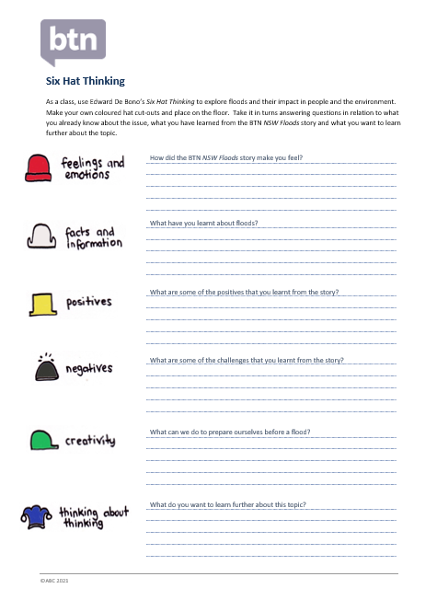
As a class, use Edward De Bono’s Six Hat Thinking to explore floods and the impact that floods have on people and the environment. Make your own coloured hat cut-outs and place on the floor. Students will take it in turns answering questions in relation to what they already know about the issue, what they have learned from the BTN NSW Floods story and what they want to learn further about the topic.

Print the worksheet (featured at the end of this activity) for students to respond to a range of questions about floods.

Reflection
After this activity, ask students to reflect on what they have learnt. Students can include details about how their thinking on this issue has changed.

Activity: KWLH
Hold a class discussion about the information raised in the BTN NSW Floods story. What questions were raised in the discussion and what are the gaps in their knowledge? The following KWLH organiser provides students with a framework to explore their knowledge on this topic and consider what they would like to know and learn.

What do I know? | What do I want to know? | What have I learnt? | How will I find out?

Research questions for Inquiry
Students will start to think like a meteorologist and develop their own question/s for inquiry, collecting and recording information from a wide variety of sources. Students may develop their own question for inquiry or select one or more of the questions below.

- What are floods? Investigate what flash floods and riverine floods are and what causes them. Compare and contrast flash floods and riverine floods.
- How do experts predict where and when a flood is going to occur?
- Why is flood water dangerous?
- What damage can floods cause? In your own words, describe the damage floods can cause.
- How do floods affect people? Divide your response into the following categories: houses, services and emotions. What are the immediate and long-term needs of people?
- What can people do before a flood to stay safe? Create a public awareness campaign that targets people living in flood prone areas.
- Which areas in Australia do you think would be most at risk of flooding? Find a map of your local area and identify waterways near where you live and highlight the areas that would be most at risk of flooding.

Possible ways for students to present their research include:
- A ‘Did You Know’ Fact’s sheet
- Oral Presentation
- Prezi presentation
- Create an infographic using Canva

Activity: Visual literacy
In this activity students will examine, analyse and query a range of images which show the flooding which occurred in NSW, March 2021. Students will choose one or more of the images below and respond to the following:
- What is happening in the image? Create a caption for each image.
- How does the image make you feel?
- What does the image tell you about the impact floods have on a community?
- Imagine you are a scientist examining the damage caused by flooding. Explain using scientific words and terms how the flooding occurred. In your description include one or more of the following terms: flash flood, riverine flood, heavy rainfall, runoff, floodwater and hazards.
- What questions do you have about what you see in the image?

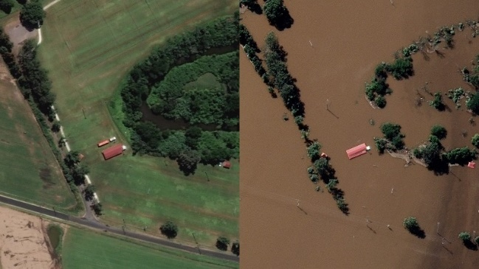  ABC News - Satellite Image ©2021 Maxar Technologies | 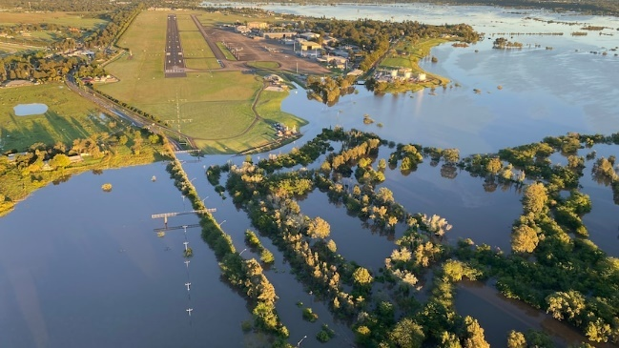  ABC News – Supplied: Australian Defence Force
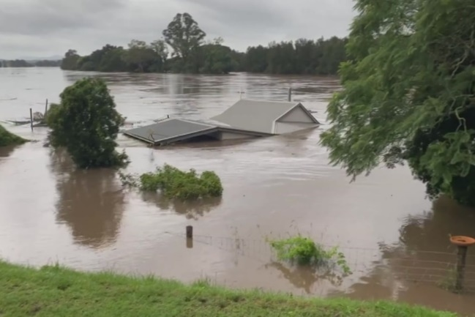  ABC News | 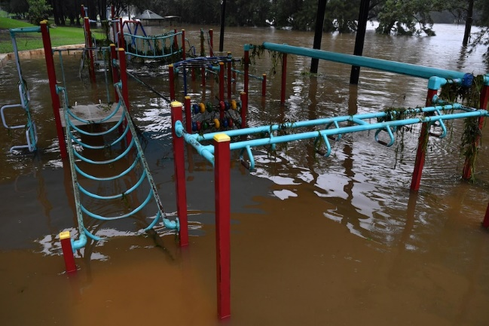  ABC News

Activity: Act like a meteorologist
Students will start to think like a meteorologist and analyse this map produced by the Bureau of Meteorology. Students will then respond to the following questions:
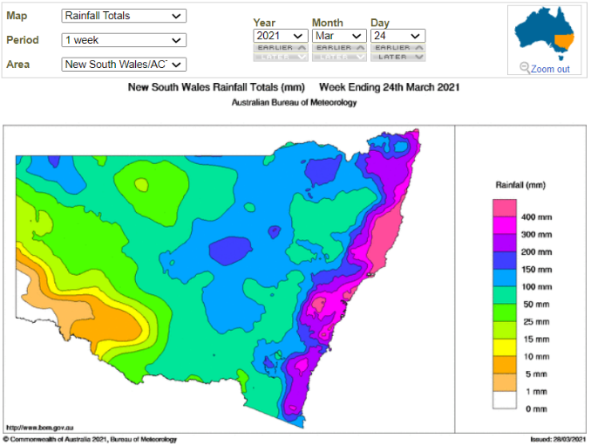
Bureau of Meteorology
- What features do you see on this map? Make a list.
- What does the map tell us?
- What does it measure?
- What area does it cover?
- What period of time does this map cover?
- What is the purpose of this map?
- Find a map which shows the total rainfall for NSW a week prior and a week later and then compare. What are your findings?

Further investigation
- What is rainfall?
- How is rainfall measured? What instruments are used to measure rainfall?
- Who measures rainfall?
- What is a rain gauge? Investigate and then create your own school rain gauge. Record the daily rainfall and calculate the average daily rainfall.

Useful Websites
- Fires and Floods – BTN
- Floods – Geoscience Australia
- Understanding Floods – Bureau of Meteorology
- Things you can do before a flood – NSW SES
- Big Weather (and how to survive it) – ABC Education
- NSW Floods – BTN Newsbreak
- Floods – ABC News
- Mt Resilience – ABC Education

Six Hat Thinking
As a class, use Edward De Bono’s Six Hat Thinking to explore floods and their impact in people and the environment. Make your own coloured hat cut-outs and place on the floor. Take it in turns answering questions in relation to what you already know about the issue, what you have learned from the BTN NSW Floods story and what you want to learn further about the topic.

How did the BTN NSW Floods story make you feel?

What have you learnt about floods?

What are some of the positives that you learnt from the story?

What are some of the challenges that you learnt from the story?

What can we do to prepare ourselves before a flood?
What do you want to learn further about this topic?

EPISODE 9
30th March 2021

KEY LEARNING
Students will learn about Easter, including customs, traditions and celebrations.

CURRICULUM
HASS – Year 3
Celebrations and commemorations in places around the world including those that are observed in Australia (for example, Christmas Day, Diwali, Easter, Hanukkah, the Moon Festival and Ramadan).

Civics & Citizenship – Year 3
Why people participate within communities and how students can actively participate and contribute.

Civics & Citizenship – Year 4
The different cultural, religious and/or social groups to which they and others in the community belong.

  - Teacher Resource

Easter Traditions

Focus Questions
Discuss the BTN story as a class and record the main points of the discussion. Students will then respond to the following:
- In pairs, discuss the BTN Easter Traditions story.
- Easter is one of the most important holidays for Christians. True or false?
- What does Good Friday represent?
- Easter Sunday is a celebration of…
- Traditionally, when are hot cross buns eaten?
- What did Eostre mark the beginning of?
- Why is Easter held at a different time every year?
- The name Easter comes from the
  - Goddess of eggs
  - Goddess of Spring and Fertility
  - Easter lily
- Why was the idea of an Easter bilby introduced in Australia?
- Do you celebrate Easter? Describe what you and your family do.

Activity: Easter Quiz
Begin the Easter activity with a quick true or false quiz. Circle the correct answer.
- Easter happens at the same time each year. | True False
- Eggs symbolise new life and fertility. | True False
- Traditionally, hot cross buns are eaten on Easter Sunday. | True False
- Easter is celebrated by Christians. | True False
- Many people think that Easter bunny came from a Pagan festival called Eostra. | True False
Answers: 1 False, 2 True, 3 False. Traditionally they are eaten on Good Friday, 4 True, 5 True.

Activity: Personal Response
Write a personal response to the BTN Easter Traditions story by completing the following sentences:
- To me, Easter means…
- It was interesting to learn…
- It was surprising to learn that...
- Five words that represent Easter…

Activity: Class Discussion
After watching the BTN Easter Traditions story, hold a class discussion, using the following discussion starters.
- What do you celebrate? Share some of your family or cultural traditions.
- What does Easter mean to you? Share with a partner.
- How do people around the world celebrate Easter?
- What are some symbols associated with Easter?
- Why do we have traditions? Why are they important?

Activity: Glossary
Students will brainstorm a list of key words that relate to the BTN Easter Traditions story. Here are some words to get them started.
TRADITION | CELEBRATION | PAGAN
CHRISTIAN | LENT | EOSTRA

Activity: Celebrations around the World
Celebrate the diversity in your classroom. Students will share with the class which celebrations are important to them and research different celebrations around the world.

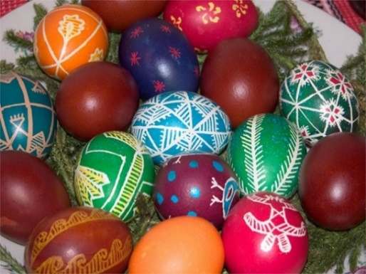
- Investigate how different countries around the world celebrate Easter. How are their Easter celebrations similar or different? For example, in Spain there are Easter parades where people wear conical hats and carry olive branches, children in Sweden dress up as scary Easter witches on Maundy Thursday and Orthodox Christians dye eggs red.
- Choose one country to research in depth and investigate the origin and significance of their Easter celebrations. Design and make a poster, using symbols, words and images, to mark the celebration and display in the classroom.

- Learn about where students in your class come from and mark on a world map. Describe some of the special occasions that your family celebrate throughout the year, and mark on your classroom calendar. What do these special occasions have in common? How are they different?
- Make a list of special days and weeks that are celebrated in Australia and around the world. For example, Chinese New Year, Christmas and Eid al-Fitr. Mark on your classroom calendar.

Activity: Information Report
Students will create an information report about Easter. The following may help guide students’ research:
- Description of Easter.
- When is Easter celebrated?
- What are the customs and traditions for those that celebrate Easter?
- How is Easter celebrated around the world?
- Interesting facts about Easter.
Structure and features of an information report
Information reports are factual texts written to inform and provide detailed facts about a topic. Discuss with students what they already know about the purpose, structure and features of an information report. Use the following as a guide to use with students.

- Purpose – An information report provides information to the reader by stating facts.
- Structure – see table below.
- Language features – write in the present tense, use technical or scientific words and write in the third person.

Students can then use the following plan to help write their report. They can present their reports using publishing software or as a brochure.
Information report – structure
Title | States a topic
Introduction | The opening statement explains the subject of the report and includes a definition or short description.
Body | Facts grouped into paragraphs. Starts with a topic sentence. Include subject specific language. Text features such as sub-headings, labelled diagrams, charts and captioned photographs may be included.
Conclusion | A summary of what the topic is about and end with an interesting fact.

Activity: What is Lent?
Lent is an important religious festival and it usually involves fasting or giving something up for 40 days. In this BTN video, we talk to some kids who are observing Lent to find out more about it and why it’s important to them.
- Who participates in Lent?
- Why do people often give something up during Lent?
- Give an example of something that people might give up during Lent.
- On what day of the week during Lent do people not fast and have a rest day?
- Complete this sentence. During Lent people don't eat ______ on Friday's.
- What food is eaten on Shrove Tuesday?
- What happens on Ash Wednesday?
- What does Good Friday represent?
- What do Easter eggs symbolise on Easter Sunday?

Activity: Easter Bilbies
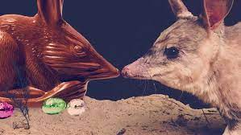
Students can find out more about the Easter Bilby story.
Watch the BTN Easter Bilbies story.
Read the Easter bilby vs Bunny article.
Ask students to answer the following questions:
- When and where did rabbits start being part of Easter traditions?
- Why was the idea of Easter bilbies introduced?

Useful Websites
- Easter Traditions – BTN Newsbreak
- Easter Symbols – BTN
- Lent – BTN
- Easter Bilbies - BTN
- The Easter bilby vs bunny: why do we celebrate a devastating pest? – ABC News
- Origin of Easter: From pagan festivals and Christianity to bunnies and chocolate eggs – ABC News

  - Teacher Resource

BTN Transcript: Episode 9 - 30/3/2021

Hey, I’m Amelia Moseley and you’re watching BTN. Here’s what’s coming up. We find out how you're coping with the New South Wales and Queensland floods, what zoos are doing to save the regent honeyeater and everything you need to know about Easter.
NSW Flood

Reporter: Amelia Moseley

INTRO: Last week deadly floods hit parts of New South Wales and Queensland and tens of thousands of people were forced to leave their homes to escape the dangerous floodwaters. But while the skies are now clearing, the clean-up is only just beginning. Take a look.

Houses floating down rivers, dams overflowing, and more than 20 thousand people evacuated.
RESCUER Hello, is anybody home?
This is what happened when a once in a century weather event hit the east coast.
SCOTT MORRISON, AUSTRALIAN PRIME MINISTER: The terrible storms and floods that have been ravaging NSW these past few days are taking a heavy toll.
RESIDENT: It's pretty amazing how the water can get this bad this quickly.
There was so much rain in some parts of New South Wales and Queensland that whole roads disappeared under metres of floodwaters. While tens of thousands of people made their way to safer, drier ground, many found themselves stuck and emergency services had to step in.
RESIDENT: All of a sudden it just hit. It was too late. We got what we could out, we ended up having to get the firies out to rescue us at 2 o’clock in the morning.
It wasn't just rain either; storms brought strong winds.
RESIDENT: The house felt like it was literally moving.
RESIDENT: Mum's been a little panicked because I had my little sister and brother in the room, so I just called for my mum to come.
Hundreds of schools across New South Wales and some in Queensland were also forced to close.
RESIDENT: School’s been cancelled for the last three days, `cause the water’s gone over the highway.
It wasn't just people weathering the storm though. Lots of animals found themselves in places they really didn't wanna be.
RESIDENT: I don't know how he's got there but I hope he's alright.
RESIDENT: It's the fifth horse I've saved, mate, they're not my ponies. We've pulled nine head of cattle out.
Other, smaller critters also escaped floodwaters and made themselves at home around people's homes whether they were wanted or not!
RESIDENT: Probably three days ago they started to come in towards the house and yesterday they started to get up on the fence.
Although some creatures seemed quite at home in the water!
ZOOKEEPER: It's amazing it's like watching a bathtub fill up. It started pouring in from the national park end and from there you could literally watch our aligator lagoon fill and fill.
Experts say a weather pattern called La Nina is partly to blame for the storms and floods. It's why we've experienced colder temperatures, more rain and stronger winds than usual across many parts of the country this summer.
But they also say some areas like the Hawkesbury-Nepean Valley in Sydney are at much higher risk of flooding than others, because of the number of rivers and lakes around, their size and shape and how hard it is for extra water to flow out to sea. Scientists say climate change has also played a part in making extreme weather events like this more common. There's also been a lot of discussion around dams and whether they're being managed properly to avoid spilling over when the weather turns.
Now the rain's cleared and things are starting to dry out in most areas, but while many people have been able to return home; this is what a lot of them have come back to.
REPORTER: How much have you lost?
RESIDENT: Pretty much everything. Devastating.
RESIDENT: The water has covered everything. Hopefully I can clean it up and make it look like it used to, but who knows at this stage.
RESIDENT: We haven't stopped. It's literally been go, go, go for the last seven days.
Authorities, volunteers and neighbours have been coming together to help each other out after a week like none of them has ever seen before and never want to see again.
RESIDENT: It's amazing the people who have come to help. It just makes you realise that it's just stuff. We're still alive and people care.
NSW Flood Kids

Rookie Reporters

INTRO: The floods have had a huge impact on a lot of people, so we caught up with some families who have all been affected in different ways and found out what they're doing to stay safe.
ALLY: Hi BTN my names Ally and I'm from Coffs Harbour.
RONAN: Hi BTN my names Ronan I'm from Coffs Harbour and in our area, there's been lots of floods, torrential rain, bridges covered with water so people can't get over them and we've had no damage to our house luckily.
ALLY: The floods have impacted my family because we've had to drain upstairs where there's been leaks and flooding, we've had to put a tarp on the roof, as a roof.
RONAN: To stay safe we've been looking at the SES, news sites like BTN to see what's going on and what we can do. Our school's had to evacuate twice because risk of floods getting inside the school premises.
ALLY: To distract myself while the situation of the flooding has been going, I've been drawing and painting lots because it eases my mind and makes me forget about things.
BILLY: Hi BTN my names Billy, I live on a farm near Temora with my family. As you can see parts of the farm got hit pretty bad by the floods. The Dam over flowed and we found yabbies on the road that had come out of the dam. Sheep were stuck in the mud, some were able to be rescued but some died. The road was shut so most people that were going on the buses had to get their parents to pick them up instead. The SES has been here, they were putting sandbags in place to stop things from getting worse.
ANTHONY: Hi BTN my name is Anthony and I live in Leonay and this is the Nepean River. In my area the river has overflowed which caused the road to flood and has caused some of my friends that live on the Nepean River to evacuate.
ANTHONY'S MUM: So, this park actually got flooded. All the way up here where you see that little hut, that was under. The river's come down since then. Some little fish that have jumped out, drowned.
ANTHONY: My family and I have been staying safe by staying indoors, watching movies, chill-axing and playing video games to get our heads off the floods and also not swimming in this park as you can see. I'm very sincerely sorry for everybody that has lost their homes and has had damage to their houses, and I would love to wish them all the best here at BTN, thank you for watching.
BILLY: Try not to think about it too much, and it will eventually pass. Thanks for watching BTN news.
ALLY: Thanks for watching, see ya later.
RONAN: Thanks for listening, bye.
News Quiz

Why is everyone talking about this massive container ship? It caused an oil spill, it got stuck or its valuable cargo? It got stuck. The 400-metre-long ship got pushed around by strong winds and ended up wedged sideways in the Suez Canal. The Suez Canal is in Egypt and it's one of the world’s most important delivery routes. The skyscraper-sized ship created a traffic jam of ships backed up on either side so salvage teams have been working overtime to unstick it.
In which country would you find the Fagradals Mountain volcano? Is it Iceland, New Zealand or Japan? It's Iceland. This volcano near the country's capital has erupted for the first time in thousands of years and this incredible close up drone footage has gone viral - it's now been watched millions of times.
Scientists say African elephants are now more in danger than ever before because wild populations are shrinking. Has their conservation status just been upgraded to Endangered or Critically Endangered? Trick questions, it's actually both. The Red List of Endangered Species has just classified African elephants as two separate species for the first time - The African forest elephant which is Critically Endangered and the African savanna elephant which is Endangered.

Concussion Rates

Reporter: Amelia Moseley

INTRO: Next up, the AFL's brought in new rules this season to better protect players from concussion. It's a serious problem in lots of sports and not just at the professional level. Now a teenager in Tasmania is calling for stronger concussion guidelines to help kids like her. Check it out.
Holly is 16 and lives in Tassie and for years she loved playing footy. But during one game, she got a big knock to the head.
HOLLY: I couldn't speak. I was so foggy. I remember I was leaning against my mum, like falling like when she was holding me. I couldn’t. I was just so confused. And then it was about 15 minutes later, I was sitting in the clubrooms and I just realised what happened.
What happened was a concussion. In fact, over six years Holly experienced five concussions.
HOLLY: The most recent two were in footy, less than one year apart, and my most recent one has made me stop playing contact sport for the rest of my life.
Let's take a closer look at what's actually going on. See your brain sits in protective fluid inside your skull, but if your head takes a hit that can cause the brain to bump around and bruise or even get small tears in the nerves, which is what causes those nasty symptoms like dizziness, confusion or even blacking out.
Sometimes you might not feel anything until hours, or even days, later and other times the symptoms of concussion can go on for months afterwards which is what happened to Holly.
HOLLY: I can't comprehend things like when it was really bad if someone said something to me, I wouldn’t be able to understand, and it would be like a blur in my brain. I was always so tired. I struggled so much to just keep up with my friends like us going out and doing things. I would really try hard because I didn't want to be different.
It got so bad that Holly had to cut back on school, a lot.
HOLLY: There was times where I'd struggle just got very sad down about it with months on end because it was not getting better and sometimes it was just getting worse. I can tell some students are just like you're being weak, because I look fine, but they don't realise there's actually something really wrong with me.
In some cases, those effects can last a lifetime and while not every knock to the head leads to a concussion; health experts say it's really important to take any head injury seriously.
DR ADAM CASTRICUM, SPORTS PHYSICIAN: I think certainly this notion that you gotta play injured or you gotta play tough or you gotta play hurt - I think we need to move past that.
That's something a lot of sporting codes agree with. Over the years, they've made changes to try to tackle the risk of concussion like banning some dangerous moves, and more checks players have to pass to get back out there.
This season, the AFL's just brought in more concussion rules: Teams can now keep an extra player on hand to sub in for an injured teammate, and concussed players have to be sidelined for at least 12 days.
TAYLOR WALKER, ADELAIDE CROWS: When there's any form of head knock you do recover quite slowly, so hopefully we can get Jake up and running in 12 days’ time with the new concussion rule.
While most contact sports do have concussion guidelines for junior levels and community games too; some say the rules aren't always as clear cut and often aren't followed as strictly as they are for our sporting heroes.
DEBORAH BYRNE, BRAIN INJURY ASSOCIATION: People probably think that because they're not playing sport at that elite level that they may not sustain a concussion, but I'd suspect they're at a much higher risk of sustaining a concussion.
Holly says she wants everyone to more aware of the dangers of concussion and how to treat it properly, so that other kids don't have to go through what she did.
HOLLY: If we had some, even just a bit more level of support it could prevent it massively and I'd really wish that would be the situation because it happens a lot and it’s overlooked because we're young people playing sport.
Did You Know?

Did you know an adult brain weighs about 1.3 kilograms and about 75 per cent of it is made up of water. The biggest animal brain in the world, though belongs to the sperm whale weighing in at around eight kilograms.
Regent Honeyeater Song

Reporter: Amal Wehbe

INTRO: Now, if you've ever seen a regent honeyeater, you're pretty lucky. They're critically endangered. But the tiny population is facing another problem - males of the species are forgetting how to sing their song and without it, they're struggling to find love. Here’s Amal.
NAT: Hey, my name's Reggie. I'm a Regent honeyeater from Northern New South Wales. I'm a pretty fun bird, I like jumping in puddles and I've been told I'm pretty handsome. I'm at the stage in life where I just want to settle down, have a nest, and find 'the one'. But finding the one has been a bit harder than I thought. That's why I'm here at Married at First Flight.
Humans aren't the only ones who often need a bit of help finding love. Attracting the perfect mate in the animal kingdom can be a big challenge. And if you're a regent honeyeater, you can't afford to be fussy. The native species is critically endangered. For decades, it's struggled with habitat loss and competition with other bigger, stronger birds, and conservationists say there are likely just a few hundred left in the wild between northern Victoria and southern Queensland.
Now that's led to a new problem.
AMAL: The most important thing to me is probably singing. I need a bird who can sing.
NAT: Yep. I'm pretty nervous. But I've been working on my voice a lot lately.
Male honeyeaters use their song to communicate and attract a mate. But it's something they have to learn when they're just a few months old by hearing older honeyeaters communicate. And without other male honeyeaters around to learn the song from, well, some birds in the wild have had to improvise.
AMAL: Hi.
NAT: Hi.
AMAL: Hi.
AMAL: Um do you know how to sing?
NAT: Sing?
AMAL: Yeah sing.
NAT: Yes, of course I know how to sing.
AMAL: Do you mind singing? Like now?
NAT: Oh right, give me a go.
AMAL: That's all good, no it's really all good. Now you're just sounding like those cuckooshrikes. I'm sure you're really nice, but I told the experts singing was really important to me. Maybe we can just be friends? Thanks for coming out. See ya.
Researchers have found 1 in 10 male regent honeyeaters don’t properly know their own song, and what they're doing instead isn't working because female honeyeaters avoid breeding and nesting with males that sing unusual songs.
NAT: But then I heard some friar birds and cuckoo shrikes, and I thought 'Hey, this sounds pretty sick.'. So, I did like a bit of a remix. Turns out that's not too popular with the ladies.

So, researchers have come up with a new solution.
KARA STEVENS, REGENT HONEYEATER KEEPER: Currently, we're in one of our breeding facilities as you may be able to see and hear our birds right behind me.
At Taronga Zoo they're playing young male bird recordings of what adult males in the wild are actually supposed to sound like. So, they can hopefully learn to sing their own song again and once they're released into the wild, use their newly learnt talents to attract the perfect mate.
AMAL: No honestly mum, you should’ve seen it, it was so embarrassing. Wait, I’ll call you back.
NAT: Regina. Hey. Just before I go, I wanted to show you something. I've been practising.

NAT: (sings correct version).

AMAL: A little bit off pitch but not that bad.
NAT: Thanks.
AMAL: Yeah, no worries. Maybe this can work?
NAT: Maybe. Should we walk off?
Sport

Crowds are back at the footy in a big way. 51,723 people flocked to the MCG on Thursday to see Collingwood take on Carlton. That set a new record for the biggest crowd in the southern hemisphere since the pandemic began. But the biggest moment of the round went to the game between Geelong and Brisbane, with the Lions down by 2 points. The umpires seemed to miss this call of holding the ball, which would've given Brissie an easy shot at goal to win the game.
The Adelaide Crows are flying high after winning this year's AFLW Minor Premiership. They comfortably beat the Pies at home to finish the season on top of the table. But it all could've gone very differently. Brisbane missed this kick after the siren in their game against Melbourne, which would've seen the Lions grab top spot.
The Olympic Torch relay has begun and that means the Tokyo Olympics are finally going to happen. Over the next few months, 10,000 runners across Japan will carry the torch before lighting the Olympic cauldron on July 23rd.
Easter Traditions

Reporter: Jack Evans

INTRO: It's that time of year when the smell of hot cross buns is in the air, chocolate eggs are everywhere, and we get a long weekend. Yep, it's Easter. But have you ever wondered what the holiday is all about? Jack looks into why we celebrate Easter and the story behind some of its traditions.

JACK: Welcome back to another episode of This is your life. The show where we bring someone out and say - This is your life. Let’s meet tonight's guest. They're a lover of eggs, a religious holiday and has a sweet tooth that would make your dentist say – filling! It's Easter. Oh Easter, how are you?
EASTER: Where am I?
JACK: Now are you ready to take a look at your life?
EASTER: Can I have one?
JACK: No.
Most of the time Easter's not just a person desperate to get their hands on chocolate, although for many of us that's definitely part of the appeal. For Christians, Easter is one of the most important holidays of the year. Good Friday represents the day Jesus Christ died on the cross and Easter Sunday is a celebration of when he rose from the dead. It's a time when families get together and go to church. Hot Cross Buns are traditionally eaten on Good Friday because of the whole cross thing. But they've kind of become an all Easter, sometimes all year, breakfast staple.
JACK: Now Easter, we've got a very special guest that you're going to love, because you've spent a lot of time with them. It's the Easter Bunny. Come on out. Oh, don't worry, oops you dropped something. Yes, it's that egg giving bunny we all know and love. But how did you come to be a thing?
Many reckon the Easter Bunny came from a Pagan Festival called Eostre.
JACK: Sound familiar? Easter, it sounds like Easter.
Eostre was a celebration that marked the arrival of spring in the Northern Hemisphere. Which is why it's held at a different time every year, depending on when there's a full moon. The name Easter comes from the Goddess of Spring and Fertility.
JACK: And can you guess what her sacred animal was?
EASTER: A rabbit?
JACK: No, it was a hare. But you know hares look like big rabbits, so you I guess here we are.
Anyway, hares featured in Pagan Easter festivals because, well, they're good at breeding and represent new life. As for the eggs, well they also represent new life.
JACK: How they came to be made of chocolate nobody knows, but hey I'm not complaining.
EASTER: Can I have one?
JACK: No.
Other countries have their own versions of the Easter Bunny. In Switzerland a cuckoo bird delivers the eggs. In parts of Germany, it's a fox and in other parts of Europe it's a rooster, a chick or a stork.
JACK: And that brings us to our final guest, the Easter Bilby.
For us Aussies, it's not uncommon for an Easter bilby to pop up. Rabbits are an introduced species here. Bilbies on the other hand are native, kinda look like bunnies and endangered. And chocolate makers have been selling these since the 90s to help support them.
JACK: Well, there you have it Easter - This is your life.
EASTER: Actually I'm not Easter, you put this name tag on me and I'm just here for the chocolate you promised.
JACK: Oh, I don't remember promising you chocolate.
Closer

Well, that's it for us today, we'll see you again next term. In the meantime, you can keep up to date with what's going on by watching Newsbreak every weeknight and there's more news and fun stuff on our website. I’ll catch you soon. Have a great holiday. Bye!

