EPISODE 2
9th February 2021

KEY LEARNING
Students will view a range of BTN stories and use comprehension skills to respond to a series of focus questions.

CURRICULUM
English – Year 4
Use comprehension strategies to build literal and inferred meaning to expand content knowledge, integrating and linking ideas and analysing and evaluating texts.

English – Year 5
Use comprehension strategies to analyse information, integrating and linking ideas from a variety of print and digital sources.

English – Year 6
Use comprehension strategies to interpret and analyse information and ideas, comparing content from a variety of textual sources including media and digital texts.

English – Year 7
Use comprehension strategies to interpret, analyse and synthesise ideas and information, critiquing ideas and issues from a variety of textual sources.
  - Teacher Resource

Focus Questions
As a class, discuss the stories featured in the episode of BTN Classroom and record the main points of the discussion. Students will then respond to the following focus questions.

Google Fights News Law
- Briefly summarise the BTN story.
- What do you use Google for?
- What do the new rules the government wants to bring in mean for Google and Facebook?
- Why do the news organisations want the new rules brought in?
- How does an internet search work?
- Google is the only internet search engine. True or false?
- What do search engines use to sort and display information?
  - Algorithms
  - Augmented reality
  - Automatic detection
- How does Google make money?
- What does Google say might happen if news organisations start charging to display their news?
- What do you understand more clearly since watching this story?

GameStop Stock Market
- Discuss the BTN story as a class. Record the main points of your discussion.
- Complete the following sentence. The stock market is a place where people buy and sell __________.
- What are shares?
- If a company is doing well, more people are likely to want shares in that company. What can happen if the company isn’t doing well?
- Complete the following sentence. A hedge fund is basically an _______________ company.
- What is GameStop?
- Investors make money out of businesses that aren’t doing well by…
  - Hedge selling
  - Quick selling
  - Short selling
- What happened to GameStop shares recently?
- What happened to investors who tried to short sell GameStop shares?
- What questions do you have about the story?
Fruit Fly Outbreak
- What was the main point of the BTN story?
- Which state in Australia has had a fruit fly outbreak recently?
- Complete the following sentence. Because of the outbreak, children were ____________ from taking fruit to school.
- About how many species of fruit fly are there in Australia?
- Which two species of fruit fly are considered the most dangerous?
- Give examples of fruit and veggies they are attracted to.
- Fruit fly are attracted to fresh juicy fruit. True or false?
- Describe the damage fruit fly can do.
- What methods do farmers use to get rid of fruit fly?
- What can be done to stop the spread of fruit fly?

Safer Internet Day
- Discuss the BTN story with another student. Record the main points of your discussion.
- Who are trolls?
- What is the best way to deal with trolls?
- How are trolls different to online bullies?
- What should you do if you are being bullied online?
- Before we share news online, what should we check?
- What is the best way to protect yourself from cyber criminals?
- What is a digital footprint?
- Why is it important to have a good digital footprint?
- What was surprising about this story?

Check out the Safer Internet Day resource on the Teachers page.

Lunar New Year
- Before you watch the BTN Lunar New Year story, record what you know about the celebration.
- Complete the following sentence. Chinese New Year follows the ____________ calendar.
- Lunar New Year falls on a different date every year. True or false?
- About how many people around the world celebrate Lunar New Year?
  - 500,000
  - 1.5 million
  - 1.5 billion
- Apart from China, which other countries celebrate Lunar New Year?
- Briefly explain the story about a monster called Nian.
- Give examples of some traditions that take place over Chinese New Year.
- How many animals are there in the Chinese zodiac?
- This Lunar New Year is year of the…
  - Ox
  - Dragon
  - Tiger
- Name three facts you learnt watching the Lunar New Year story.

Check out the Lunar New Year resource on the Teachers page.

EPISODE 2
9th February 2021

KEY LEARNING
Students will learn more about online safety issues and develop skills to stay safe online.
CURRICULUM
Digital Technologies – Years 5 & 6
Plan, create and communicate ideas and information, including collaboratively online, applying agreed ethical, social and technical protocols.

Digital Technologies – Years 7 & 8
Plan and manage projects that create and communicate ideas and information collaboratively online, taking safety and social contexts into account.

Health & Physical Education – Years 5 & 6
Practise skills to establish and maintain relationships.

Plan and practise strategies to promote health, safety and wellbeing.
  - Teacher Resource

Safer Internet Day

Focus Questions
Discuss the BTN Safer Internet Day story as a class and record the main points of the discussion. Students will then respond to the following:
- Discuss the BTN story with another student. Record the main points of your discussion.
- Who are trolls?
- What is the best way to deal with trolls?
- How are trolls different to online bullies?
- What should you do if you are being bullied online?
- Before we share news online, what should we check?
- What is the best way to protect yourself from cyber criminals?
- What is a digital footprint?
- Why is it important to have a good digital footprint?
- What was surprising about this story?

Activity: Class Discussion
Discuss the issues raised in the BTN Safer Internet Day story. Ask students to record what they know about staying safe online on a mind map. What words do they associate with internet safety? What questions do they have? Use the following questions to guide discussion:
- What are the positive aspects of being online?
- What are some of the negatives?
- How do you stay safe online? Give some examples.
- What is trolling and what are some ways to deal with online trolls?
- What is a digital footprint?
- Why is fake news a big problem online?
- How can people protect themselves from cybercrime?

Activity: Glossary
Students will brainstorm a list of key words that relate to the BTN Safer Internet Day story. Here are some words to get them started.
TROLLS | FAKE NEWS | DIGITAL FOOTPRINT
PRIVACY SETTINGS | PERSONAL DATA | CYBERCRIME

Activity: Six Hat Thinking
Working in pairs, students use Six Hat Thinking to explore the issues raised in the BTN Safer Internet Day story. Ask students to respond to the following questions:

How did the Safer Internet Day story make you feel?

What do you know about staying safe online?
What have you learnt from the story?
Were there any positives from the story? If so, what were they?
What are some of the negatives or challenges that you learnt from the story?
Why is it important to find out more about the staying safe online?
What questions were raised during this activity?
What do you want to learn further about this topic?

Activity: Communicating Online
Working in small groups, students share and record all the ways they communicate online. Encourage students to share the positive and negative feelings and experiences they have.

- What are your favourite websites and apps?
- List all the ways you use technology for communication.
- Do you use social media? If so, which ones?
- Who do you stay in touch with through your mobile phone and the internet?
- What do you think positive online communication means? Give some examples.
- What is negative online communication? Think of at least three verbs or adjectives that describe negative communication.
- What are some strategies to deal with negative online communication?

Activity: Digital Footprint
Clarify students’ understanding of what is meant by the term digital footprint. Come up with a class definition. Students can watch the BTN Digital Footprint story to find out more about the topic. Working in pairs, ask students to answer the following questions:
- What does a good digital footprint look like?
- What does a bad digital footprint look like?
- How can you build a strong digital footprint?
- Is your digital footprint permanent?
- Can you erase your digital footprint?
- Does everyone have a digital footprint?

Further Investigation
Students can investigate the topic in more detail using the following questions to guide their research:
- How is your digital footprint created?
- How can people see my digital footprint?
- Why is it important to care about your digital footprint?
- How can privacy settings on social media sites help protect my digital reputation?
- How difficult is it to remove information once it’s online?

Activity: Fake News
Watch the BTN Fake News story and respond to the following questions:
- What is an example of a fake news story?
- Why are a lot of fake news stories created?
- Why are some fake news stories meant to deliberately trick people?
- What does Facebook say about the problem of fake news?
- Why is it important to question everything you read online?

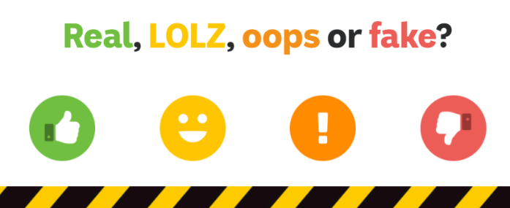
Test your knowledge by playing the Real, LOLZ, oops or fake? game
For older students, the BTN Media Literacy series explains How to Spot Fake News.
The eSafety Commissioner has Fake News resources for teachers and students.

Activity: Online Trolls
Watch the BTN Online Trolls story and respond to the following questions:
- What is trolling?
- How do you deal with it? For example: Ignore, block, report.
- How can you support friends who are being targeted?

Students will design a campaign to raise public awareness and help kids deal with trolling. They can share the information as a short film or animation, a community service announcement or a press release.

Activity: Be smart online – Take up the challenge!
These teacher-led activities use animated videos to introduce students to key online safety issues including cyberbullying, protecting personal information and sharing images.
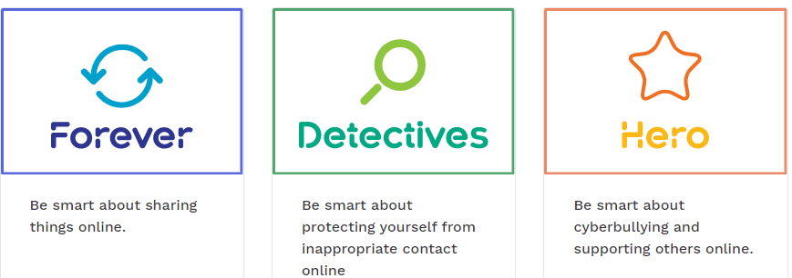

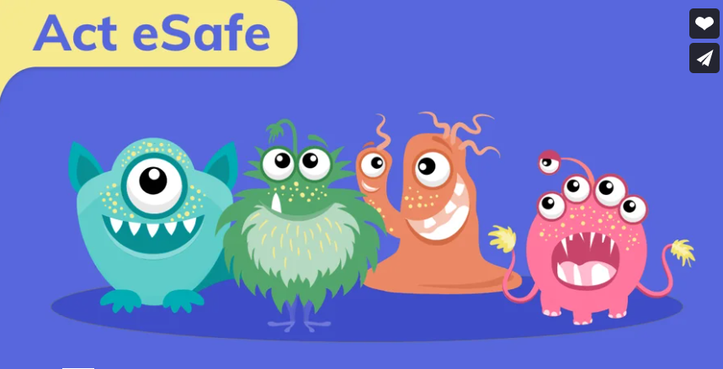
Activity: Act eSafe

This video talks about the basics of online safety, including why it is important to Ask, Check and Think before acting in the digital world. Students can then test their knowledge by completing the Be Secure quiz.

Useful Websites
Safer Internet Day – eSafety Commissioner
Cyber Crime – BTN
Digital Footprint – BTN
Online Trolls – BTN
Internet Trolls – BTN
Password Power – BTN

EPISODE 2
9th February 2021

KEY LEARNING
Students will learn about the significance of Lunar New Year, including customs, traditions and celebrations.

CURRICULUM
HASS – Year 3
Celebrations and commemorations in places around the world (for example, Chinese New Year in countries of the Asia region, Bastille Day in France, Independence Day in the USA), including those that are observed in Australia (for example, Christmas Day, Diwali, Easter, Hanukkah, the Moon Festival and Ramadan).

Civics & Citizenship – Year 3
Why people participate within communities and how students can actively participate and contribute.

Civics & Citizenship – Year 4
The different cultural, religious and/or social groups to which they and others in the community belong.

Geography – Year 4
Australia’s connections with other countries and how these change people and places.

Geography – Year 6
The world’s cultural diversity, including that of its indigenous peoples.

  - Teacher Resource

Lunar New Year

Focus Questions
Discuss the BTN Lunar New Year story as a class and record the main points of the discussion. Students will then respond to the following:
- Before you watch the BTN Lunar New Year story, record what you know about the celebration.
- Complete the following sentence. Chinese New Year follows the ____________ calendar.
- Lunar New Year falls on a different date every year. True or false?
- About how many people around the world celebrate Lunar New Year?
- Apart from China, which other countries celebrate Lunar New Year?
- Briefly explain the story about a monster called Nian.
- Give examples of some traditions that take place over Chinese New Year.
- How many animals are there in the Chinese zodiac?
- This Lunar New Year is year of the…
  - Ox
  - Dragon
  - Tiger
- Name three facts you learnt watching the Lunar New Year story.

Activity: Class Discussion
After watching the BTN Lunar New Year story, hold a class discussion, using the following discussion starters. Brainstorm ideas in small groups and then students will report their group’s responses to the class.
- What is Lunar New Year? Summarise using your own words.
- Lunar New Year is also known as…
- When is Lunar New Year? Why does it change each year?
- Who celebrates Lunar New Year?
- How is Lunar New Year celebrated? What traditions and symbols might you see?
- Lunar New Year 2021 is Year of the…
- How is Lunar New Year celebrated in your community?
- Have you ever taken part in Lunar New Year celebrations? Explain in more detail.

Activity: Traditions and customs
Ask students what traditions and customs one might see at a Lunar New Year celebration. What do these traditions and symbols mean? Below are some examples of Lunar New Year traditions that students can explore in more detail. Students will choose one to explore in more detail and present their findings to the class.

- Lion and dragon dancing
- Fireworks
- Red envelopes
- Spring cleaning
- Lanterns
- Markets
- Special food
- Music
- Clothing
- Chinese zodiac

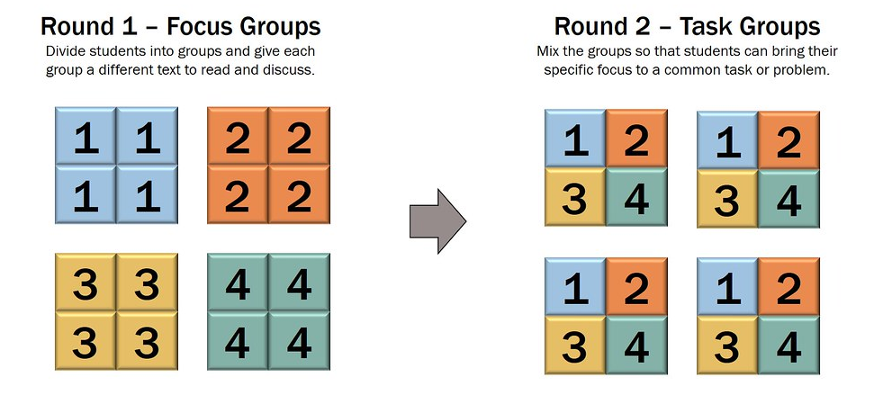
Activity: Jigsaw learning
In this activity students will work cooperatively to learn more about Lunar New Year traditions and customs. Each group will become experts and then share what they have learnt with other students.

- Form Groups
Divide the class into 6 x Focus Groups. Each Focus Group will be assigned a different tradition or custom associated with Lunar New Year (for example red envelopes, lion dancing, fireworks, special food, Chinese zodiac, and lanterns). Each group will need to decide how they will collect and communicate the information they find during their research.

- Research
Each Focus Group will respond to the following questions about the custom/tradition they are researching to become experts:
- What are the origins of the tradition/custom?
- What does the tradition/custom symbolise?
- What is the cultural significance of the tradition/custom?
- Illustrate an aspect of the tradition/custom.

- Share
Mix the Focus Groups to form Task Groups (Tasks Groups include one student from each of the Focus Groups) to share the information they have collected. Students will share the information they have collected and learn from one another.

- Reflect
Students will reflect on the activity by responding to one or more of the following questions:
- What did you enjoy about this investigation?
- What did you find surprising?

Activity: Information Report
Students will create an information report about Lunar New Year. The following may help guide students’ research:
- Description of Lunar New Year.
- Who celebrates Lunar New Year?
- What are the customs and traditions for those that celebrate Lunar New Year?
- What are some of the myths associated with Lunar New Year?
- Interesting facts about Lunar New Year.

Structure and features of an information report
Information reports are factual texts written to inform and provide detailed facts about a topic. Discuss with students what they already know about the purpose, structure and features of an information report. Use the following as a guide to use with students.

- Purpose – An information report provides information to the reader by stating facts.
- Structure – see table below.
- Language features – write in the present tense, use technical or scientific words and write in the third person.

Students can then use the following plan to help write their report. They can present their reports using publishing software or as a brochure.

Information report – structure
Title | States a topic
Introduction | The opening statement explains the subject of the report and includes a definition or short description.
Body | Facts grouped into paragraphs. Starts with a topic sentence. Include subject specific language.  Text features such as sub-headings, labelled diagrams, charts and captioned photographs may be included.
Conclusion | A summary of what the topic is about and end with an interesting fact.

Activity: Choose a project

Lantern making
As a class discuss the cultural significance of Chinese New Year lanterns. Design and make a paper lantern which reflects your family symbols.

Brochure
Make a brochure about Lunar New Year that is informative and eye-catching. Include a list of celebrations that will be happening in your community.

Chinese Zodiac
What is your Chinese zodiac animal sign? Find out here. Research the zodiac for the year you were born. Create a profile of that animal. What personality traits are associated with that animal?

Fireworks design
Fireworks are a common Lunar New Year celebration. The Chinese believe that fireworks keep away evil spirits. Design your own Chinese New Year fireworks display and explain what they mean.

Useful Websites
- Lunar New Year – BTN
- What is lion dancing? – ABC Education
- Chinese Migration – BTN
- Chinese New Year: What you need to know – CBBC Newsround
- Lunar New Year: What is it and how do people celebrate? – ABC News

  - Teacher Resource

BTN Transcript: Episode 2 - 9/2/2021

Hey, Amelia Moseley here bringing you another episode of BTN. Let's check out what's coming up. We find out how a Video Game shop put the stock market in a spin, learn how a pesky fly is interfering with lunchboxes in South Australia and celebrate Lunar New Year.

Google Fights News Law

Reporter: Amelia Moseley

INTRO: But first today, can you imagine searching the internet without Google? Well, that could become a reality for millions of Aussies. You see, the tech giant is threatening to stop letting us all use its service, if the Australian government brings in a new law to make it pay to show people news. Take a look.
About 40 thousand times per second. That's how often you, me and rest of the world combined uses this little search bar.
KID 1: I use Google for researching the meaning of words that are really hard to pronounce.
KID 2: I use Google to learn about the forces on Earth and I would also learn what animals have brains.
KID 3: I usually Google like recipes ‘cause I like to cook and funny videos of people being silly. Like people that have a cat and then they put their cat in like a t-shirt.
OK, our searches aren't always that serious, but more than 90% of Australians online have come to depend on Google to help us to find out about well pretty much everything. So, what would happen if we couldn't use this anymore? Well, that's a question a lot of Australians have been asking lately probably on Google. You see, Google's threatening to stop Aussies from googling.

It's all because of a new set of rules the Australian government wants to bring in which would make Google and Facebook pay to show people news. It's something that some news organisations have called for. You see a lot of them are struggling to make money and they say it's not fair that big tech companies get to display their work for free and make a profit in the process. But these two disagree and say they're actually helping the news organisations by pointing people to their websites. Google also says the new laws could actually mess with how search works.
MELANIE SILVA, GOOGLE AUSTRALIA MANAGING DIRECTOR: The News Media Bargaining code would break how Google search works in Australia. Now I know that sounds pretty full on, but it's true.
But wait, how does search work anyway? There are hundreds of billions of webpages out there, right? Well, a search engine takes all of that information and sorts it a bit like library does except this library is bigger than all of the world's libraries put together. It then uses algorithms which are like rules a computer can be programmed to follow, to help solve problems, to sort through that library to find a more relevant, useful result for what you're looking for. Of course, it all happens in a fraction of a second. But like I said earlier Google isn't the only one that can do this.
In fact, back in the 1990s when the internet really became a thing people didn't Google things; they searched using all sorts of search engines like Yahoo, Alta Vista or this weird thing called Ask Jeeves. Anyway, then Google came along with an algorithm that ranked results by popularity and took over the world.
Google is obviously free, and it benefits a lot of businesses, but it also makes a lot of money mainly through ads that are targeted at you and what you search for. So back to those laws. Google reckons if news organisations start charging to display results, other companies could follow and we could end up with a search engine that displays the wealthiest web pages, not the best ones.
As a compromise, Google's offered to pay news companies to feature stories on a special news platform, but some of them say that's not enough. Meanwhile the government says it's committed to the new laws and has been talking to Google about working things out.
JOSH FRYDENBERG, LIBERAL PARTY DEPUTY LEADER: What they recognise is there is a need to pay for content. And I think they also recognise that maybe some of the threats have been misplaced.
And, hey, if our googling days ever did come to an end, there are other options out there or it might even be time for a new search engine to step in. Hmm 'Ask Amelia' has a good ring to it.

News Quiz

Can you name this state premier and the state he leads? It’s Mark McGowan, who’s the premier of Western Australia. People in parts of the state have been going through a tough time with a lockdown sparked by a COVID-19 case and then a massive fire which destroyed more than 80 homes outside of Perth.

MARK MCGOWAN, PREMIER OF WESTERN AUSTRALIA: The devastation caused by these bushfires is almost too much to comprehend.

PERTH RESIDENT: So basically, I woke up in the morning to Cash running into my room saying there was a fire and I raced out of bed, grabbed the only clothes I could find which were the ones I bought the day before.

In Myanmar, this exercise video accidently captured the moment the government was overthrown by the military. What’s that known as? A coup, a veto or a revolution. It’s a coup or coup d’état. Myanmar’s armed forces arrested the country’s democratically elected leaders and said they’d take charge for the next 12 months. They’ve blocked people from accessing Facebook, but there have been big protests on the streets.

And can you name this old-timey style of music that’s taken off on TikTok recently? Is it ocean operas, sea shanties or boat ballads? It’s sea shanties. They’re songs that were originally sung by sailors as they worked to help them move in time and make the day go quicker.

GameStop Stock Market

Reporter: Olivia Mason

INTRO: Now, to a really big story in the world of finance. It involves a video game shop, an internet chat group and some trading on the stock market. It's a lot, but Liv's been on the case to find out what went down. Take a look.

OLIVIA MASON, REPORTING: When there's trouble in the world of finance, one team of experts is there to get to the bottom of things.
JAMES: What have we got here boss?
OLIVIA: Hedge fund by the looks of things, and they're not in a good way.
GRACE: I've lost all my money.
JAMES: Bad day at the stock market?
ISIS: The stock market?
Yep, the stock market. That thing that goes up and down that you hear about on the news all the time.
Basically, it's a place where people buy and sell shares, which are like little pieces of companies. If a company does well, more people are likely to want shares and the value will go up. If things aren't going so well, people start selling their shares and the price goes down.
JAMES: So, you're saying these guys have been buying shares?
OLIVIA: Exactly, she's a hedge fund, which is basically an investment company.

ISIS: Boss, I found something.

OLIVIA: What is it?
ISIS: It's an investment boss, something about GameStop?
GameStop is a chain of video game shops in the US that, you guessed it, mostly sells video games. They haven't been doing so well lately, partly because of the pandemic and also because more and more people are buying games online
ISIS: So, you're saying these guys have been buying shares in GameStop? And that's why they lost their money?
OLIVIA: Not exactly.
People don't just make money on the stock market by investing in businesses that are doing well. Big investors like this one can actually make money out of businesses doing badly by short-selling.
ISIS: Short selling? What's that?
Okay, think of something that goes up and down in value, like trading cards. Imagine your brothers got a really rare one. If he sold it now, he'd get 100 bucks, but he doesn't want to sell it. Now you reckon that in a few months it's going to be worth way less than that. So you say, 'hey bro can I borrow your trading card, I promise I'll give it back in two months.' He says yes and you sell it for 100 bucks. If everything goes to plan, two months later, the card craze is over and you can buy your brother a new one for way less, and BOOM, you've made 90 bucks profit.
That's what investors were doing with GameStop shares. But short selling is risky. Imagine after 2 months, your brother's card gets more valuable. You still have to return it, so now, you have to buy another one at a higher price.
OLIVIA: And that's what happened to these guys. They bet GameStop shares would go down in value, but they went up. Bigtime.
JAMES: I think I have a suspect boss. It's ordinary people on the internet.
A bunch of people online saw that big investors were making money off GameStop's problems and they didn't like it. So, they decided to buy GameStop shares. As more and more people got on board, the share price skyrocketed. For a little while this struggling business became one of the most valuable companies in America. And the investors who'd tried to short-sell it lost heaps, like billions of dollars, and the finance world flipped out.
ALAN KOHLER, ABC NEWS: Video game retailer GameStop jumped 67%.
Many were shocked that small-time investors who met on the internet could have such a huge impact. And they didn't stop at GameStop. They started encouraging people to buy shares in other struggling businesses, or unpopular products, like silver.

JAMES: So, what you’re saying is a group of people on the internet caused all this mess.
OLIVIA: Yep.
ISIS: So, what do we do about it?
OLIVIA: Well, that's a good question.
Some people think the big investors deserved to lose money, after all, what they were doing was basically gambling, and they lost. But others have pointed out that ordinary people have lost money too. And some say it's shown some big problems in the way the stock market works and they're calling for changes to stop this sort of thing happening again.
JAMES: Do you think we'll see another case like this again boss?
OLIVIA: I wouldn't like to speculate, after all, it's a volatile market.

Fruit Fly Outbreak

Reporter: Amelia Moseley

INTRO: To South Australia now where there's a different sort of quarantine going on. It's got nothing to do with coronavirus it's about fruit flies and it's having a big impact on kids’ lunchboxes. Let's find out more.
Bananas, apples, oranges; you'll usually find them in lunchboxes all around Australia. But some South Aussie kids will have to find a different snack to munch on at recess, because bringing fruit to their schools is now banned.
KID 1: It's a bit annoying, ‘cause I'd normally take like an apple and strawberries, but you can have like banana muffins because it's cooked.
KID 2: I'm alright with less fruit because of the fruit flies.
Yes, fruit flies. They're one of the world's most destructive pests. Here in Australia, we have more than 150 species, but it's really these two that are the biggest troublemakers the Queensland fruit fly and the Mediterranean fruit fly. As you've probably guessed they really like fruit, oh, and some veggies. These types in particular.
They don't eat it they sting it which infects it with bacteria and causes it to rot and lay their eggs inside which results in this. Eww. As you might've guessed that's a big problem for fruit and veggie farmers who have to use all sorts of methods like chemicals, baits and traps to try and get rid of them, often losing a lot of produce, and money, in the process.
But these pests aren't found everywhere for a long time South Australia and Tasmania have been fruit fly-free. You see the insects usually spread when infested fruit moves around from place to place. Which is why South Australia and Tassie have been quarantining way before COVID. Quarantining fruit. For a long time there have been rules around bringing fruit and veggies across their borders. There are check points and even fines for people that try to bring them in. But authorities say something must've slipped by, because now South Australia has a fruit fly outbreak.
SOUTH AUSTRALIAN: We've got a big industry that relies on all this fresh fruit and everything for markets all over Australia and yeah, it's really bad for the region.
So, they're cracking down with some tough new restrictions. People in outbreak areas aren't allowed to move fruit in and out unless it’s been sprayed.
HON. DAVID BASHAM, SA MINISTER FOR PRIMARY INDUSTRIES: Don't bring fruit into regions. Leave them at home, buy the fruit when you're there. That's the best way to stop the spread of fruit fly.
They're also being told to stay home while eating their fruit and veggies, that is. Which means no giving away those extra lemons from the backyard tree or, you guessed it, taking that fruity snack to school. Lots of South Aussies have also been getting a visit from these guys, fruit fly fighters. Their important job is to check people's fruit trees for any signs of their flying enemy. While it all sounds like a lot of work to tackle some really quite tiny creatures; most people agree it's a small price to pay to keep these big pests away.

Did You Know?
Did you know while some of them are a terrible nuisance, other types of fruit fly can be really helpful to scientists? Because they have a short life span and have babies really quickly, they're prefect for studying genetics. In fact, some of the biggest breakthroughs in our understanding of genes have come through studies of fruit flies.

Ask a Reporter

Do you want to know more about fruit flies? You can ask me live this Friday on Ask a Reporter. Just head to our website for all of the details.

Safer Internet Day

Reporter: Jack Evans

INTRO: Now, we're heading back online because today is Safer Internet Day. It was created to make people more aware of the potential dangers that lurk online. Jack found out about some of them and what you can do to stay safe.

HEAD NASTY: Send more trolls. Send all the trolls we have. We'll make sure they regret that haircut. Lizard people run the world bank. That's ridiculous. Spread it, quickly.
Okay, so maybe there isn't an actual lair of online evil do-ers like this, but there are definitely internet nasties out there which you need to be aware of. Let’s start with Trolls, no no no, not those trolls. Online trolls are basically people who like to stir up trouble online, I mean it's in the name. Maybe by insulting people or saying something to deliberately cause an argument.
HEAD NASTY: What about, K-POP more like K-FLOP.
So how do you stop a troll hungry for chaos? Well, you don't feed them. Most experts agree the best way to deal with trolls is ignore them.
HEAD NASTY: What? What do you mean they're not responding?
Then there's online bullying, unlike trolls online bullies usually go after people they know and like all bullying it can be really serious. If it happens to you, you should tell someone you trust and keep a record or a screenshot of what happened. Now to another online nasty that's become a really big problem, fake news.
HEAD NASTY: Ah, yes this is a good one. The Earth is flat.
Sometimes fake news is created as a bit of joke and sometimes by people who are deliberately trying to trick people into thinking or even voting a certain way. Social media companies have been taking steps to crack down on fake news. But we can also think before we share and ask ourselves, where did this information come from? Is it a reliable source? And if it seems too bad, too good or too weird to be true, then chances are it is. Now to our next online nasty, cyber crims.
HEAD NASTY: Release the hackers.
Cyber criminals are people who use the internet to commit, well, crimes. It could be stealing your credit card details or tricking you into giving them money. There are cyber criminals who deal in some really nasty stuff. The best way to protect yourself from cyber criminals is by protecting your data. Use strong passwords and be careful of suspicious links or dodgy emails. And experts say that it is really important that kids avoid putting personal details online like their address, phone number and what school they go to. Oh, and only let people you actually know, add or follow you on social media. Which brings us to another potential online nasty, you.
HEAD NASTY: Me? Aghh.
Oh, I mean you as in the viewer.
HEAD NASTY: Oh.
More specifically I mean your digital footprint, which is all the stuff you do online that can come back to bite you. Whether it's an embarrassing photo or a comment or a post that you might come to regret. Those sorts of things can stick around forever, even if you delete them. So, before you put anything online you should probably ask yourself what your mum, your friends or your future boss might think about it. And while internet nasties aren't going anywhere with some cyber smarts, we can do our best to avoid this guy.

Sport

Monday was a big day for US football fans. The Superbowl. It's the NFL grand final, and this year the Tampa Bay Buccaneers managed to defeat the Kansas City Chiefs and it was extra special for them because they did it at their home stadium. Of course, things looked a little different thanks to COVID. But there was still the traditional massive halftime show, plus a pregame poetry reading by young superstar Amanda Gorman.
Back in Oz, the Sydney Sixers have won the Big Bash Grand Final for the second year in a row. James Vince's 95 runs off 60 balls put the Sixers in the driver's seat, helping them to a final score of 6 for 188 and the Perth Scorchers couldn't quite get there, falling 27 runs short.
You're watching a history making match in the AFLW, but for all the wrong reasons. The Lions crushed the Gold Coast 65 to 2. 2, that's the lowest score in AFL Women's history.
And the Australian Open has officially opened for business. This year, because of COVID-19, fans will have to wear masks anywhere indoors which includes stadiums when their roofs are closed. Australia's best hope for the comp world number 1, Ash Barty, who's in good form after a victory at the Yarra Valley Classic.

Lunar New Year

Reporter: Jack Evans

INTRO: Finally, today, we're going to celebrate the new year. The Lunar New Year, that is. On Friday, billions of people will say goodbye to the year of the rat and welcome the year of the ox. We've asked some kids to take some time out of their Chinese language class to tell us more about it.

ALL: Hi BTN I'm Bethal, and I'm Lucas, I'm Rui and I'm Zaynab and we want to wish you all a happy new year.
BETHAL: I know what you're thinking, New Years was a month ago. Well, this Friday marks the beginning of Chinese New Year. It's also known as Lunar New Year because traditionally people in China and other countries in Asia follow a Lunar calendar where each month is marked by the cycle of the moon.
LUCAS: Chinese New Year is held on the second new moon of winter in the Northern Hemisphere. Which means it's on a different date every year, this year it's on Friday the 12th.
BETHAL: Celebrations last for 15 days starting from the Spring Festival Chun Jie and it ends on the lantern festival.
LUCAS: It's a huge celebration right around the world. More than 1 and a half billion people celebrate Chinese New Year not just in China, but in Vietnam and Singapore and Indonesia too, oh, and of course here in Australia.
BETHAL: Chinese New Year celebrates the coming of spring. There's an old legend that says red clothes and loud noises like gongs and fireworks scare away a make-believe monster called Nian.
ZAYNAB: On Chinese New Year people would hang up the Chinese character fu upside down on their front door for good luck and families would have a feast that includes rice cakes and dumplings.
BETHAL: My family has gatherings and feasts. The older generations give us children money in red pockets called hongbao.
RUI: My family celebrates by making peanut cookies. Everyone also enjoys a feast with lots of yummy food. This year there's going to be a big celebration of this animal, it's an ox. The ox is one of the 12 animals of the Chinese zodiac and every year is dedicated to one of these animals.
ZAYNAB: The ox represents hard work, positivity and honesty and some people believe if you are born on an ox year, you'll have those qualities. I was born in the year of the rabbit which means I'm generous and responsible.
RUI: I was born in the year of the rabbit which means I'm cautious. And I love to eat carrots But I'm not sure if that's a quality.
BETHAL: I'm born in the year of the tiger which means I'm strong willed and talkative.
LUCAS: I was born in the year of the tiger that means I am confident.
ALL: Thank you for watching BTN.

Closer

Thanks so much guys and Happy New Year. Well, that's all we have for today but, of course, we'll be back next week with more. In the meantime, the Newsbreak team will be busy bringing you the news every single weeknight. You can check it out on TV or on online, and if you're 13 or over you can subscribe to our YouTube channel, so you never miss a thing. I’ll catch you next time. Bye.

