Episode 11
5th May 2020



Coronavirus Update
- What did the BTN story explain?
- What does ‘flattening the curve’ mean and why is it important?
- What have Australians been doing to ‘flatten the curve’?
- Which other countries have had success in slowing down the virus?
- What impact has COVID-19 had on the United States and the United Kingdom?
- What Prime Minister had COVID-19?
- Why are people worried about how COVID-19 will affect less developed countries?
- Some states have started to relax restrictions. Give an example.
- What is the purpose of the COVIDSafe app?
- What questions do you have after watching the BTN story?

Distance Learning Tips
- Briefly summarise the BTN Distance Learning Tips story.
- Describe what School of the Air is using your own words.
- Who does School of the Air?
- Why does Nikola do online learning?
- Briefly describe a school day for Elke.
- How is it similar or different to your school day?
- Why do you think it’s important to be organised if you’re doing school from home?
- What tips do the kids give for doing school from home?
- What was surprising about this story?
- Share your thoughts in the comments section on the BTN Distance Learning Tips story page.

VE Day
- What happened on the 8th May 1945?
- What year did World War II start?
- Who was the leader of the Nazi Party?
- The German invasion of _________________ marked the beginning of WWII.
- Who were the Axis powers?
  - Germany, Poland and Italy
  - Germany, Italy and Japan
  - Germany, Italy and the Soviet Union.
- Who were the Allied forces?
- In Germany and German occupied countries, the Nazis imprisoned and killed millions of people, mostly Jewish, in what's known as the _________________.
- What does VE stand for?
- The surrender of which country marked the end of WWII?
- What did you learn while watching the BTN story?

Check out the VE Day resource on the Teachers page.
Hubble Space Telescope
- What does the Hubble Space Telescope story mainly explain?
- How fast does the Hubble telescope travel?
- Why are a lot of space telescopes built on mountains?
- What year was the Hubble telescope launched into space?
  - 1980
  - 1990
  - 2000
- Describe some the images that the Hubble telescope has captured.
- What has the Hubble Space Telescope enabled scientists to see?
- Complete the following sentence. The Hubble _____ Field is a series of images taken in 1995.
- Who launched one last mission to upgrade and repair the Hubble telescope in 2009?
- What does the Hubble telescope look like? Drawn a picture.
- What did you learn watching the BTN story? Make a list of 3 facts.

Check out the Hubble Space Telescope resource on the Teachers page.

Zoos During Coronavirus
- Before watching the BTN, story predict what you think it will be about.
- What changes in the animals behaviour have the zookeepers noticed?
- What have the giraffes been doing since the zoo has been shut?
- How are the zookeepers entertaining the animals? Give one example.
- How are the zookeepers keeping the goats entertained?
- How much money is the Australian Government giving to zoos, aquariums and wildlife parks?
- What is the money going to be spent on?
- While zoos are closed during coronavirus, how can you see your favourite animals?
- Check out these live streams of animals at the Adelaide Zoo and play Chimp Cam Bingo
- Illustrate an aspect of the story.

Teacher Resource
Episode 11
5th May 2020

VE Day

Students will learn more about VE Day and significant events in the Second World War.


HASS – Year 5 & 6
Develop appropriate questions to guide an inquiry about people, events, developments, places, systems and challenges.

Locate and collect relevant information and data from primary sources and secondary sources.

Sequence information about people’s lives, events, developments and phenomena using a variety of methods including timelines.

HASS – Year 7
Construct significant questions and propositions to guide investigations about people, events, developments, places, systems and challenges.

Present ideas, findings, viewpoints, explanations and conclusions in a range of texts and modes that incorporate source materials, citations, graphic representations and discipline-specific terms, conventions and concepts.


- What happened on the 8th May 1945?
- What year did World War II start?
- Who was the leader of the Nazi Party?
- The German invasion of _________________ marked the beginning of WWII.
- Who were the Axis powers?
  - Germany, Poland and Italy
  - Germany, Italy and Japan
  - Germany, Italy and the Soviet Union.
- Who were the Allied forces?
- In Germany and German occupied countries, the Nazis imprisoned and killed millions of people, mostly Jewish, in what's known as the _________________.
- What does VE stand for?
- The surrender of which country marked the end of WWII?
- What did you learn while watching the BTN story?


Personal response
After watching the BTN VE Day story, ask students to finish one or more of the following incomplete sentences:
- This story made me wonder why…
- It was interesting to learn that…
- This story made me feel…
- BTN covered this story because…

Discussion

Discuss the information raised in the BTN VE Day story. Ask students to record what they know about the Second World War and VE Day on a mind map. What questions do students have? Use the following questions to guide discussion:
- When did World War II start and finish?
- Who were the Axis powers?
- Who were the Allies?
- What does VE stand for?
- What is an unconditional surrender?
- Did VE Day mark the end of WWII? Why not?

Glossary
Students will brainstorm a list of key words that relate to the BTN VE Day story. Here are some words to get them started.

Allies | unconditional surrender | Holocaust
victory | invasion | Axis powers


Timeline of main events
Students will research significant events in WWII and create a timeline. Below are some examples of information to include. Students can create an Interactive timeline or choose another way to display the information.
1944, June D-Day
The US, Britain and Canada attack German forces in France.
1939, September
Germany invades Poland. World War II begins.

1945, May
Germany surrenders, ending the war in Europe.



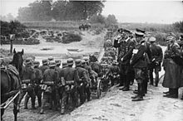
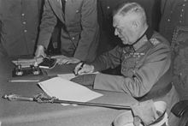
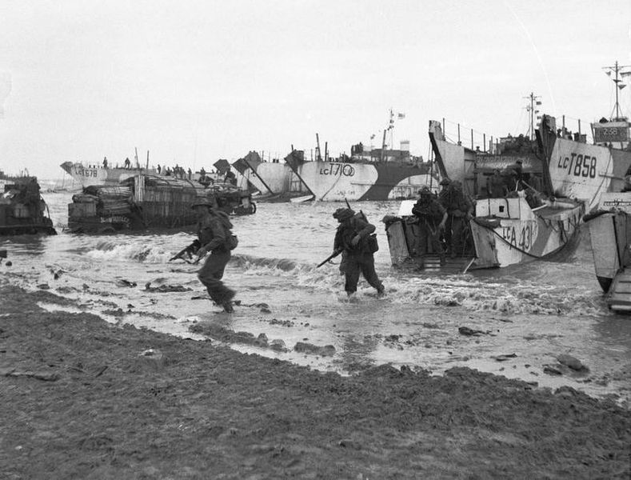

Research
Students will develop their own question/s for inquiry relating to World War II. There are some examples of questions to research below. They will locate, compare, select and use information from a range of primary and secondary sources

- What is a primary source?
Through using primary sources, a document like a diary, painting or a physical object, that was written or created at a particular time, we can gain an understanding of what might have happened at a place in time.

- What is a secondary source?
Secondary sources are documents written after an event has occurred, providing “second-hand” accounts of that event, person, or topic. Unlike primary sources, which provide first-hand accounts, secondary sources offer different perspectives, analysis, and conclusions of those accounts.

As part of their research, students will need to:
- Use historical terms and concepts in their presentation.
- Refer to the source of the information (i.e. bibliography).
- Look for facts and opinions that answer their inquiry question/s.

Discuss ways that students can present their research. These include:
- Podcast - Audacity or GarageBand are both well suited to making podcasts. To publish they will need to use a free service like PodOmatic, Buzzsprout
- News article
- Prezi presentation
- Create an infographic using Canva
- Oral presentation

Key questions | Facts and interesting information
Who were the Allies and what did they want to achieve?
What were the events that started WWII?
What were the events leading up to VE Day?
What is an unconditional surrender? Which General accepted Germany’s unconditional surrender?
Did VE Day mark the end of WWII? Why not?
How were the effects of WWII felt long after the War ended? (Political, social and economic)

Visual literacy
Below are images of VE Day. Students look at the image and then respond to the following questions:
- What do you see in this image? Describe the setting and who is in the image.
- What do you think is happening?
- If there are people in the image who do you think they are? How do you think they might be feeling?
- What question/s would you like to ask the people in the image?
- Do you think it is an important image? Why or why not?
- Create a caption for each.

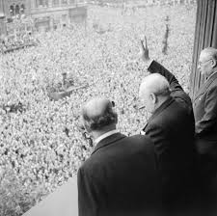  Source of image | 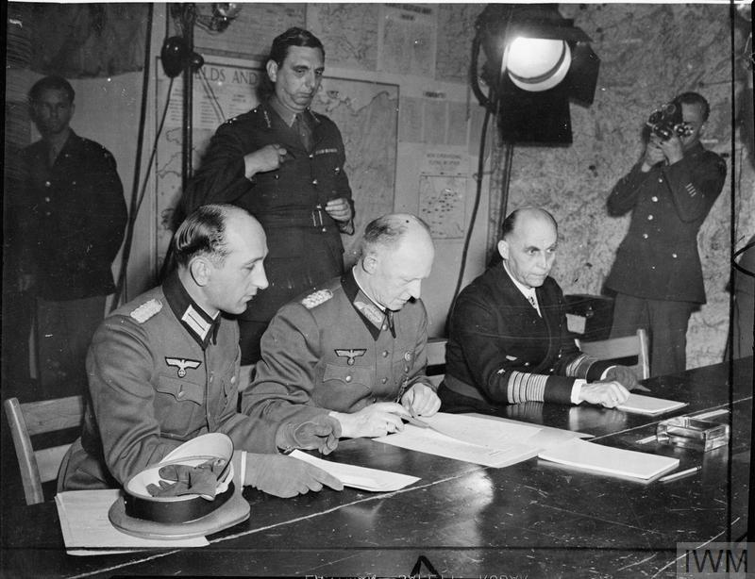  Source of image
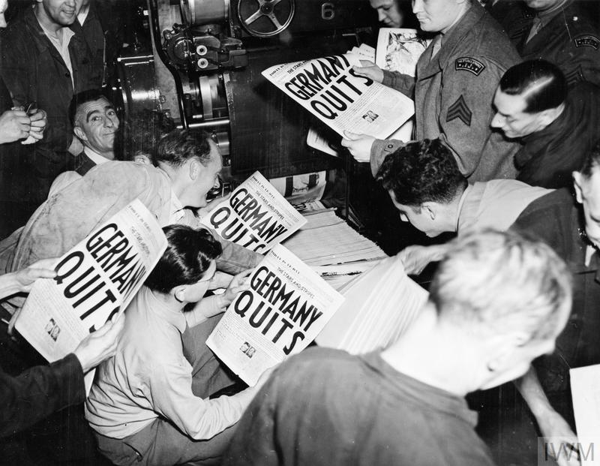  Source of image | 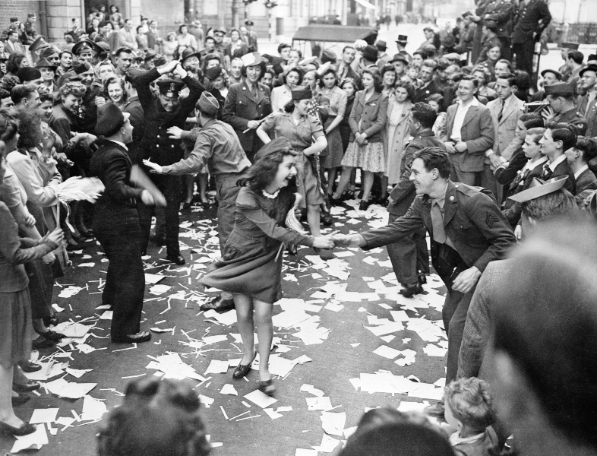  Source of image

Focus questions
Students will watch this BTN Second World War story and then respond to the following discussion questions.

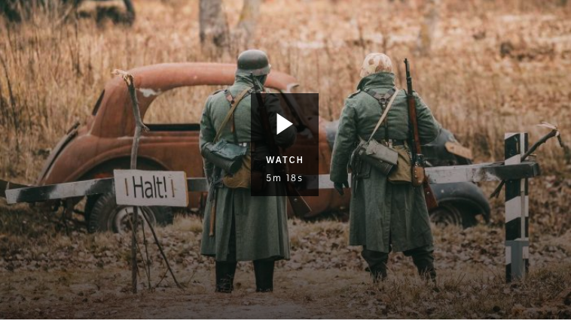
- At the end of the First World War what document did many countries sign?
- Who was Adolf Hitler?
- What year was Austria invaded by the Nazis?
- Who were Britain’s and France’s Allies?
- In 1941 Japan bombed Pearl Harbour. Where in the US is Pearl Harbour?
- What was the Holocaust?
- In which country did the US drop two nuclear bombs?
- What words would you use to describe the Second World War?
- What questions do you have about the BTN story?

Students will watch this BTN Anne Frank story and then respond to the following discussion questions.
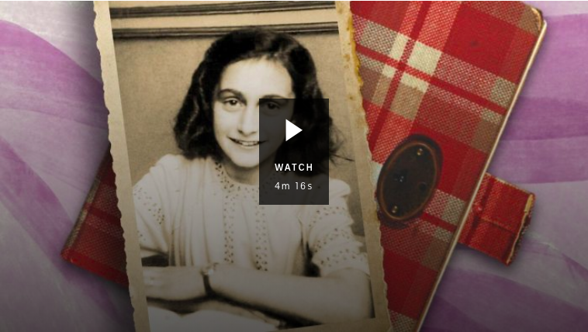
- Where was Anne Frank from? Find using Google Maps.
- What did Anne Frank call her diary?
- How old was Anne when she started keeping a diary?
- Where did Anne Frank and her family flee from before arriving in the Netherlands?
- What political party was Adolf Hitler a leader of?
- How were Jewish people treated by the Nazis?
- What happened to Anne Frank’s family when the Nazis invaded the Netherlands?
- How did you feel watching the BTN Anne Frank story?
- What questions do you have about this story?

Second World War Quiz

WWII Quiz Questions | Your Answer
- What year did WWII start?
  - 1939
  - 1942
  - 1945
- Which was NOT one of the Allies during WWII?
  - Britain
  - Soviet Union
  - Germany
- The Axis countries were…
  - Germany, Poland and Italy
  - Germany, Italy and Japan
  - Germany, Italy and the Soviet Union
- Why did Britain declare war on Germany?
  - Germany invaded Britain
  - Germany invaded Poland
  - Britain wanted to rule Europe
- Who ruled Germany during WWII?
  - Adolf Hitler
  - Winston Churchill
  - Joseph Stalin
- What does VE stand for?
  - Victory in Europe
  - Victory in England
  - Victory of Everyone
- VE Day marked the end of the Second World War.
  - True
  - False
- Which country unconditionally surrendered on May 8th, 1945?
  - Italy
  - Germany
  - Poland
- How long did WWI last?
  - 6 weeks
  - 6 months
  - 6 years
- The surrender of which country marked the end of WWII?
  - Japan
  - Italy
  - Britain

Answers: 1a, 2c, 3b, 4b, 5a, 6a, 7b, 8b, 9c, 10a


VE Day – Imperial War Museum
https://www.iwm.org.uk/history/what-you-need-to-know-about-ve-day

Second World War – Australian War Memorial
https://www.awm.gov.au/articles/second-world-war

Second World War – BTN
https://www.abc.net.au/btn/classroom/second-world-war/11460762

Anne Frank – BTN
https://www.abc.net.au/btn/classroom/anne-frank/11981700

Teacher Resource
Episode 11
5th May 2020

Hubble Space Telescope
Students will explore how telescopes help scientists to explore space. Students will explore, identify and investigate stars, planets and constellations.

Science - Years 5 & 6
Science involves testing predictions by gathering data and using evidence to develop explanations of events and phenomena and reflects historical and cultural contributions.
Scientific knowledge is used to solve problems and inform personal and community decisions.
Scientific knowledge has changed peoples’ understanding of the world and is refined as new evidence becomes available.

Science – Year 5
The Earth is part of a system of planets orbiting around a star (the sun).

Science – Year 5 & 6
Science involves testing predictions by gathering data and using evidence to develop explanations of events and phenomena and reflects historical and cultural contributions.

Science – Year 7
Predictable phenomena on Earth, including seasons and eclipses, are caused by the relative positions of the sun, Earth and the moon.

- What does the Hubble Space Telescope story mainly explain?
- How fast does the Hubble telescope travel?
- Why are a lot of space telescopes built on mountains?
- What year was the Hubble telescope launched into space?
  - 1980
  - 1990
  - 2000
- Describe some the images that the Hubble telescope has captured.
- What has the Hubble Space Telescope enabled scientists to see?
- Complete the following sentence. The Hubble _____ Field is a series of images taken in 1995.
- Who launched one last mission to upgrade and repair the Hubble telescope in 2009?
- What does the Hubble telescope look like? Drawn a picture.
- What did you learn watching the BTN story? Make a list of 3 facts.

Discussion
After watching the BTN Hubble Space Telescope story students will respond to the following:

- What do you THINK about what you saw in the Hubble Space Telescope story?
- What does this video make you WONDER?

- Think of three questions you have about the BTN Hubble Space Telescope story. Remember that good questions are open-ended (have no right or wrong answer and can’t be answered with a ‘yes’ or ‘no’).
- Leave your comment on the BTN Hubble Space Telescope story page.

Glossary
Students will brainstorm a list of key words that relate to the BTN Hubble Space Telescope story. Students may want to use pictures and diagrams to illustrate the meaning and create their own glossary. Below are some words to get your students started.
Orbit | Astronomer | Galaxy
Universe | Observatory | Atmosphere
Telescope | Black Hole | Star

KWLH
Hold a discussion after watching the BTN Hubble Space Telescope story. What questions were raised in the discussion (what are the gaps in their knowledge)? The following KWLH organiser provides students with a framework to explore their knowledge on this topic and consider what they would like to know and learn.

What do I know? | What do I want to know? | What have I learnt? | How will I find out?

Research questions for inquiry
Students will determine a focus for their inquiry and develop a key question to guide their inquiry (below are some examples). Students will collect and record information from a wide variety of sources (internet, books, newspaper and magazines).

- Why is the telescope called Hubble? Where did its name come from?
- How is Hubble similar or different to other telescopes?
- What have we learnt from the Hubble telescope? Make a list and then choose one of the Hubble’s discoveries to explore in more detail.
- Why is space discovery important?
- How will space exploration change in the future? Make a prediction about how space exploration will change in the future. Illustrate your prediction/s and provide an explanation.


Visual literacy
In this activity students will examine, analyse and query a range of images taken by the Hubble telescope. Students will choose one or more of the images below or find an image of their choice taken by the Hubble telescope. Alternatively, students can look at what Hubble saw on their birthday. Students will then respond to the following:

- What are your first impressions of the image? What does it remind you of?
- Write a short paragraph describing what you see in this image. Write a caption for the image.
- When and where was the photo taken?
- Imagine you are an astronomer examining the images taken by the Hubble telescope. Explain using as many scientific words and terms as you can.
- What questions do you have about what you see in the image?

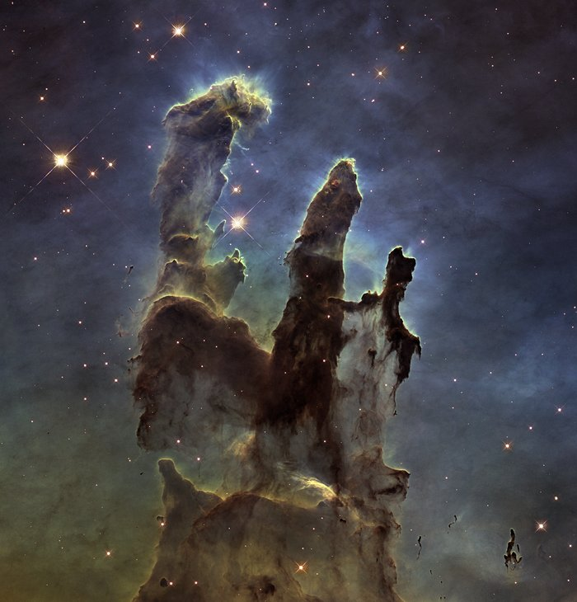  Link | 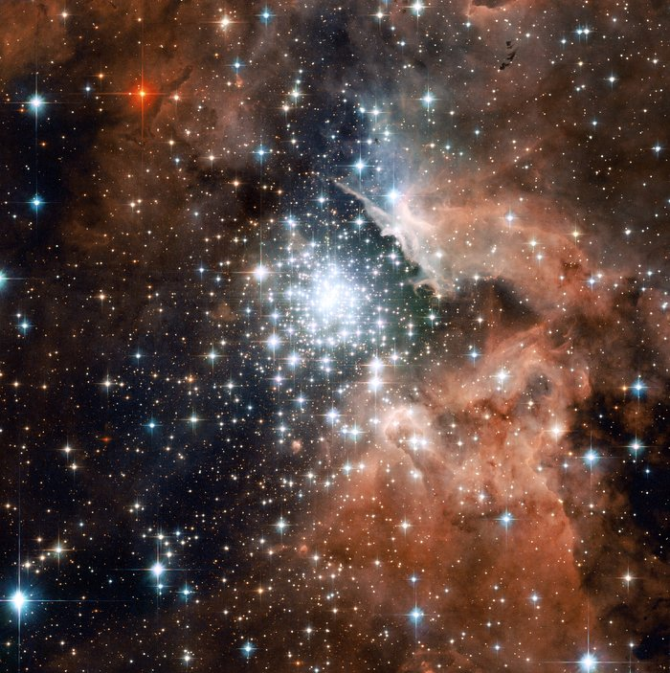  Link

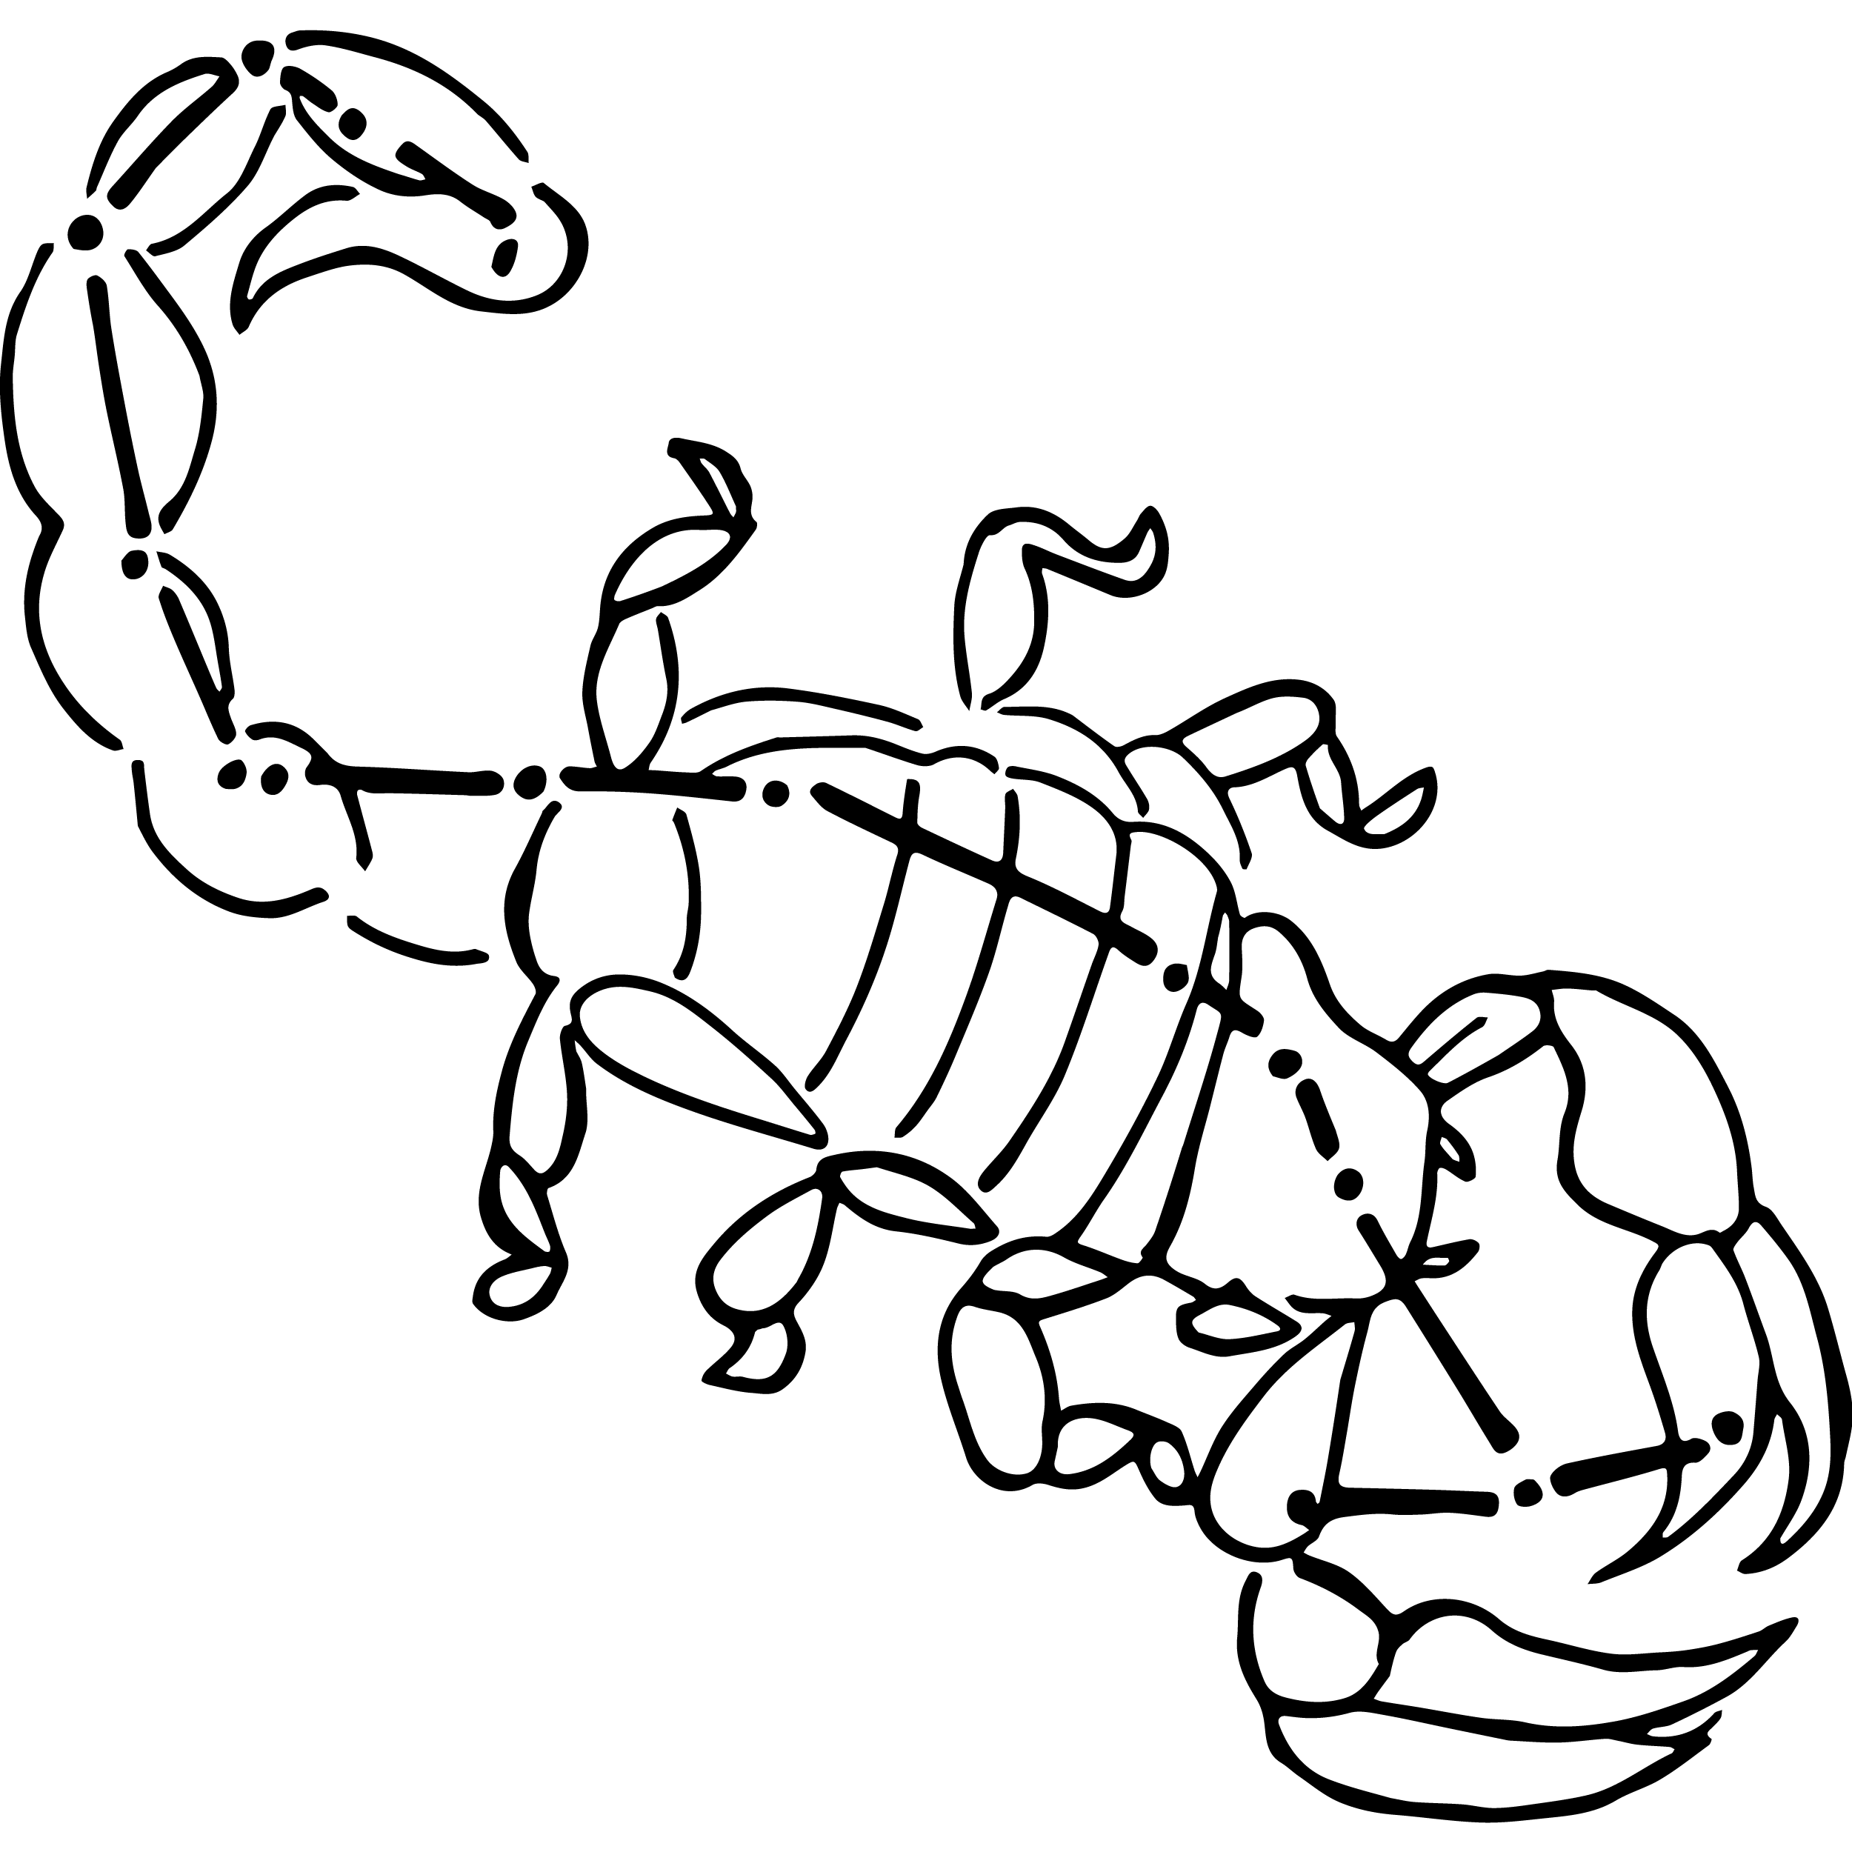
Daytime stargazing
Bring the stars to your students by using an online application to discover and explore stars, planets and constellations in the classroom. Before starting this activity download a free app like SkyView onto your classroom hand held device/s. This activity may need to be modified depending on the number of devices available to students.

- If possible, dim the lights in the classroom to create the feeling that it is night time. Students will sit on the ground with SkyView open on their hand-held device.

- Students will point their device at the sky to locate and identify planets, stars and constellations. There is the option to turn on night mode. Students can learn more about what they find by selecting a celestial body and tapping on it. Give students time to explore the night sky.
- Hold a class discussion. What did your students find?
- Students will choose one constellation that they want to learn more about. Students may want to consider choosing the zodiacal constellation in which they were born. Students will develop their own question/s for inquiry, collecting and recording information from a wide variety of sources.
- Students will think of creative ways to display their findings.

Aboriginal Astronomy
In this activity students will look at examples of Aboriginal astronomy and the Dreaming stories about them. Refer to ABC Science for more information and images to refer to whilst working through this activity.

Emu in the Sky
Ask students to look at the photographs below showing the Aboriginal Emu in the Sky constellation. Draw their attention to the dark dust clouds, not the stars. The Emu in the Sky lines up with a rock carving in Ku-Ring-Gai Chase National Park. Students can also try to find the Emu in the Sky constellation using free App SkyView. To spot the emu, students will look south to the Southern Cross; the dark cloud between the stars is the head, while the neck, body and legs are formed from dust lanes stretching across the Milky Way.

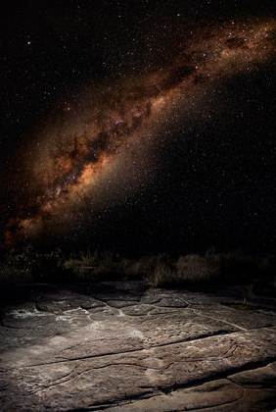  Source: ABC Science (link to image) | 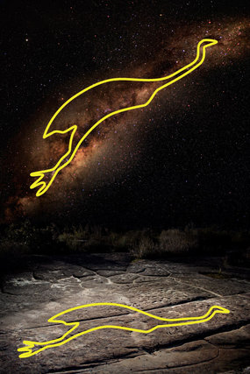  Source: ABC Science (link to image)

Questions for students:
- What can you see in the picture?
- Where in the night sky can the Emu in the Sky be found? Students can have a go at looking for it.
- Emu in the Sky has featured in Aboriginal storytelling for thousands of years with many different language groups have their own interpretation of the Emu. Research and retell one or more of the stories.
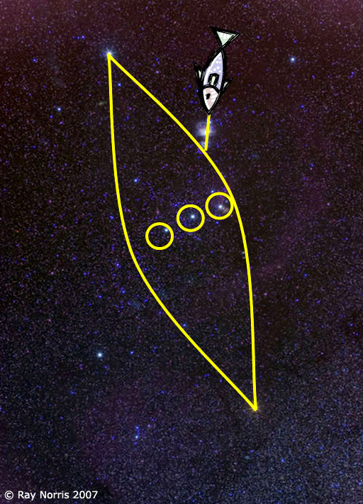
The Canoe in Orion
Ask students to look at the constellation Orion and answer
the following questions:
- What can you see in the picture?
- What is the constellation known as in Australia?
- Where in the night sky can the Canoe in Orion be found? Students can have a go at looking for it.
- What do the Yolngu people in Northern Territory know it as?
- Retell the traditional Yolngu story about the three brothers in a canoe.

Source: ABC Science (link to image)
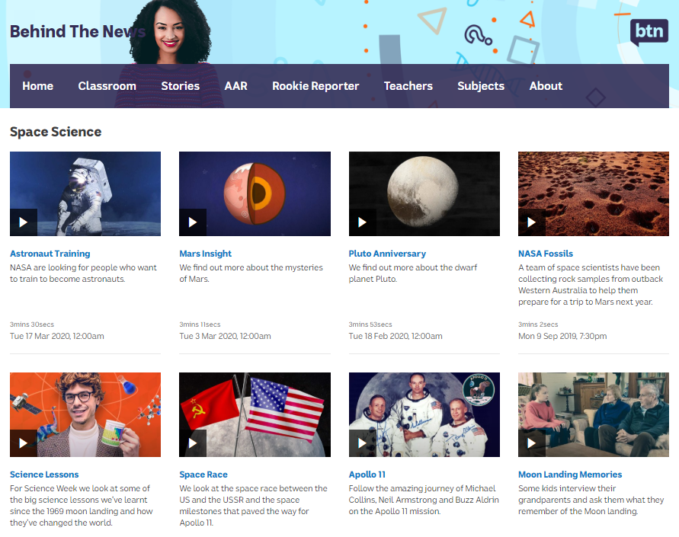
BTN Space Science stories
Visit BTN’s collection of stories which focus on space science and space exploration. After watching any one of the BTN videos ask students to respond to the discussion questions (to find the discussion questions and teacher resources go to the related BTN Classroom Episode and download the Episode Package).

Link to collection of BTN Space Science stories
https://www.abc.net.au/btn/space-science/10614248

Hubble Birthday – BTN
https://www.abc.net.au/btn/classroom/hubble-birthday/10526648

Hubble Space Telescope – NASA
https://www.nasa.gov/mission_pages/hubble/main/index.html

Hubble: Happy 30th birthday to Nasa's Hubble Space Telescope! – CBBC
https://www.bbc.co.uk/newsround/52365257

Hubblesite - NASA
https://hubblesite.org/

What did Hubble see on your birthday? – NASA
https://www.nasa.gov/content/goddard/what-did-hubble-see-on-your-birthday

BTN Transcript: Episode 11 – 5/5/20

Hi everyone, Amelia Moseley here and you're watching BTN. Check out what's coming up. We find out how Aussie zoo animals are coping in isolation, learn more about VE Day and say Happy Birthday to the Hubble Space Telescope.

Coronavirus Update

Reporter: Jack Evans

INTRO: But first today to some very-welcome good news. While COVID-19 has had a huge impact on all of our lives it seems that at least here in Australia things are getting better. The number of new cases of the virus has been going down and some states have started relaxing the rules about social distancing. But that doesn't mean all of the hard work is over. Jack explains.

Hey you. Yeah you. The person who's been staying home, keeping their distance, washing their hands and not shaking others. Well I just want to say congrats buddy, you done did good. Yep we Aussies deserve a round of applause, because we've started flattening the curve. If you don't know what that means let me bring you up to speed.
The curve people are talking about is this graph which shows how the number of COVID-19 cases can grow over time and if it gets too steep then our hospitals might find it hard to handle. So, we've been trying to flatten that curve by practising social distancing and good personal hygiene and it's actually working. Here in Australia the number of new cases of COVID-19 has been going down to the point where there have only been a handful each day. There are other countries that have also had success in slowing down the virus like South Korea and China and our mates over the ditch in New Zealand. They've had even tougher social restrictions than Australia and now their Prime Minister says it looks like they've stopped it spreading within the community.
But there are some places that aren't doing as well. In the USA more than a million people have caught COVID-19 and more than 50 thousand have died. The UK has also been devastated by the virus. The Prime Minister, Boris Johnson, had it and has now recovered. But says the country still faces a huge risk. There are also huge worries about how COVID-19 will affect less developed countries. Where lots of people don't have easy access to healthcare or sanitation. It's a pretty sobering reminder for us here in Australia. That while the virus has had a really big impact on a lot of people, things could have been a lot worse.
Last week the Prime Minister said that all of our hard work might be rewarded with an "early mark" on social restrictions which might be lifted nationally a lot sooner than expected. Some states have already started to relax the rules. For example, in NSW households are allowed to have two people come to visit. In the NT parks and reserves will be reopened and in Queensland family picnics and weekend day trips are now allowed. As for schools, well at the moment it's different in every state and territory. And while some have told all kids to go back to school, in others, students are still learning online, at least for now.
But while thing are looking up authorities say we still need to be really careful and to be ready to react quickly if the number of COVID-19 cases goes up again. The government's released an app, COVIDSafe, that uses Bluetooth to let you know if you've come into contact with someone who has the virus as long as they have the app too. It's encouraging all Australians to download it in the hope it'll keep us safe.
It also says that we need to keep socially distancing. That means no physical contact, keeping 1.5 metres away from others and no large gatherings. Oh, and if you're sick, stay home. Because until we have a vaccine or an effective treatment for COVID-19 we're going to have to learn to live with it. So, while you all definitely deserve a big pat on the back. Just make sure it's your own back and wash your hands after, you know, just in case.

Ask a Reporter

Do you have a question about that story? You can ask me live on Friday during Ask a Reporter. Just head to our website for all the details.

Quiz

Which Australian airline has gone into voluntary administration because serious financial problems? It's Virgin Australia. The company can't pay its debts, so its owners have handed its management over to experts who'll try to fix things. They're hoping someone will buy Virgin to keep it in the air.
Do you recognise this face? It's Kim Jong-un, the leader of North Korea. There have been rumours that he’s been sick or even dead because he hadn’t been seen in public for a while. But now North Korea has released some photos of Mr Kim at a factory opening which seemed to prove he’s alive and well.
Speaking of secrets, this video of a UFO has been released by the US military. Do you know what UFO stands for? It's an Unidentified Flying Object, so while it's probably not an actual alien, authorities aren't completely sure what it is. The US government has released a few UFO videos to show that it's not keeping any little green men secret.
In the UK a 100-year old war veteran has become a bit of a national hero after raising more than 55 million dollars for the National Health Service with a charity walk. Where did he walk? Around London, around the world or around his back garden? Captain Moore set out to do 100 laps of his back garden hoping to raise 1000 pounds. He raised a fair bit more than that! He also recently became the oldest person to top the UK charts with this song. Last week, for his birthday, the Royal Air Force did a special fly-over for him and tens of thousands of people sent him cards

Distance Learning Tips

Reporter: Charlotte Batty
INTRO: Now, while some of you are back at school there are a lot of Aussie students who are still learning from home. That can be pretty weird if you're not used to it. So, we decided to get some tips from kids who've been distance learning for years. They're students of School of the Air and Open Access College. Let's see what they've got to say.

ELKE: Hi BTN, I’m Elke and I’m here to tell you all about learning from home. I do all my classes on an online school called School of the Air. School of the Air is an online school that children can attend when they are remote and isolated on stations. There isn't really a school nearby that I can attend on a daily basis that my parents can really drive me to because they have a job out here which they can't really take too much time off.
RILEY: I've done it since prep so I guess I'm just used to it. It's really easy learning from home. You've got to make sure you're prepared and everything's right and it's easy.
NIKOLA: I work online through something called Open Access. I do it because I'm part of a special tennis program and Open Access gives me time in between classes to do tennis practice.
ELKE: I get up at 7:30 and I do my morning routine. We sit through assembly and then I have my first lesson at 9:55 and then we have recess. Then it's my second lesson that's at 12:10 until 1 o'clock, and then there's lunch and then we do our integrated studies time and we finish at 3:30.
NIKOLA: Every day I go on the tennis courts for PE, for art my teacher sends out some really cool art, like right here there's some art supplies so that's really fun as well.
ELKE: It's really important to be organized when learning from home.
RILEY: If you have a calendar write down when all your sheets and assessments are due. And then try to work on them beforehand instead of leaving them to the last minute and just try and keep up with your work.
ELKE: Get your own space for your school work and stuff so it feels like you're in a small classroom and wear your school uniform too because that can really help so you feel like you're really in an actual school and you're not doing school at home. And make sure you keep in close touch with your teacher and your friends if you need help.
NIKOLA: Don't be shy. Just ask your teacher what's the problem and they're there to help you.
ELKE: When you're doing your school at home make sure you make the most of it because this won't last forever.
RILEY: Be prepared. Be on time. And don't get behind because it's hard to catch up.
NIKOLA: Good luck and have fun.
ELKE: We hope our experiences and tips will help you learn from home. Good luck.

VE Day

Reporter: Amelia Moseley

INTRO: This Friday is the 75th anniversary of what would've been a big day of celebration for some of your great grandparents. It's known as VE Day or Victory in Europe Day and it’s when Nazi Germany surrendered during World War II, bringing to a close a very dark period in world history. Let's find out more.
On the 8th of May 1945, millions of people celebrated on the streets of the UK, Europe, North America and beyond. It was the day they'd been hoping for nearly 6 years. Their biggest enemy in World War II had surrendered.
The war began in 1939 when Germany's leader, Adolf Hitler, and his Nazi party invaded Poland, which was an ally of Britain and France. Nazi Germany had made a pact with the Soviet Union; a group of states including Russia. They agreed not to attack each other and, secretly, to divide Poland between them. Although this deal wouldn't last long, it gave Hitler the opportunity he needed.
The Nazis soon gained power across Europe, invading and occupying many countries using firepower, speed and the element of surprise - a tactic known as Blitzkrieg - and, in June 1940, France also fell to the Nazis. Later that year, Hitler signed an agreement with Japan and Italy forming the Axis Powers.
In 1941 Japan bombed Pearl Harbor, a US naval base in Hawaii. The attack brought America into the war on the side of Great Britain and its Allied Forces which included China, Canada and Australia. That same year the Nazis launched a surprise attack on the Soviet Union, and it too joined the fight alongside the Allies.
Meanwhile in Germany and German occupied countries, the Nazis were imprisoning and killing millions of people, mostly Jewish people, in what's now known as the Holocaust.
For a while it looked like Hitler and his allies were going to win the war, but a few big things happened that changed the course of history. Hitler underestimated the Soviet forces and lost a big, deadly fight; the Battle of Stalingrad in Russia. It stopped the Nazis advancing and helped turn the tide of the war. In the same year, the Allies landed in Italy, which overthrew its leader and switched sides, declaring war on the Axis Powers. Then, in 1944, Allied troops carried out the biggest ever land, air and sea attack to take back Nazi occupied Europe, landing on the beaches of Normandy in France on what's known as D-Day.
In 1945, the US and the Soviet Union entered Germany. By the 8th of May, Hitler was dead, and Germany finally surrendered.
WINSTON CHURCHILL, 1945: The German war is therefore at an end. Today is Victory in Europe Day.
While many celebrated, it would be four more months, many more deaths, and the near destruction of two Japanese cities before Japan would also surrender. But for the Allies, May 8th was a day to remember as it signalled the beginning of the end of the deadliest war in history.

Hubble Space Telescope

Reporter: Cale Matthews

INTRO: Speaking of anniversaries, recently the world celebrated the birthday of a very famous spacecraft named Hubble. For 30 years it's been sending us pictures which have changed our understanding of the universe. Here's Cale.

Alright everyone, bit of hush, bit of hush. Now we’re here todat to celebrate a very special birthday, someone who brought us pictures like this, and this, and even this. Oooh, sorry everyone. That’s better. So, without further ado, ladies and lenses, let's say an intergalactic happy birthday to the Hubble Space Telescope. Oh, it's in space isn't it?
Yep, zooming around the earth at about 30,000 kays an hour, the Hubble Space Telescope is literally out of this world, and that's kinda what makes it special. You see, down here on Earth, our view of the stars and planets is kind of blurry, because of the way light bends and shifts as it passes through our atmosphere. This is why stars appear to twinkle, and why a lot of super big telescopes are built on mountains, where the atmosphere is a lot, lot thinner.
Back in 1946, a guy named Lyman Spitzer thought we could do better than mountains. He wanted to go above the atmosphere.
Of course, that wasn't a simple task, and it took decades of research and trials, and space triumphs, and space disasters, before finally, on April 24th, 1990, the Hubble Telescope was sent into space. But when the first pictures came back, things weren't quite right.
The mirror which reflected all the light into the telescope was ever so slightly off, I'm talking 1/50th of a human hair off, but this meant all of the images were blurry. After a few years of serious calculations, astronauts were sent into space to give Hubble some glasses, and all of a sudden, our universe snapped into focus
Since the fix, there have been some astounding, and simply mind-boggling pictures come from Hubble. From the birth of new stars, to the death of old ones, but no picture was more astounding than this. This is the Hubble Deep Field, and it's a series of images taken in 1995. Scientists pointed Hubble at a tiny speck of sky, that looked empty. But after 10 days the results blew them away. Each little dot in this image is a galaxy, and not only that, some of them are galaxies more than 12 billion light years away.
But Hubble was never designed to last forever. Back in 2009 NASA launched one last mission to upgrade and repair it. Meanwhile, it's been working on a replacement. The James Webb Telescope which will hopefully launch next year. But, for the moment at least, the Hubble is still up there, showing us our universe, and reminding us just how small we really are. And thus, the cosmic ballet goes on. Anyway, who brought cake?

Did You Know?

Did you know the Hubble telescope only takes pictures in black and white? The dazzling colours are added in afterwards by astronomers.

Sport

First up in sports news, we might actually have some sports soon!
The New Zealand warriors have touched down in Australia, as the NRL season is looking to restart on the 28th of May. The team was granted special permission to come to Australia and they'll still have to do a 14 day quarantine now that they're here. Meanwhile the Melbourne storm will be training in NSW because the Victorian government wouldn't let them train at their home stadium. Basically there's a lot of moving around at the moment, but clubs have started non-contact training this week
The AFL is also looking to get the season back up and kicking. It was called off after only 1 game, but now the AFL's boss reckons things could get started by June, although like the NRL it'd be spectator free for a while.
And while we're waiting for a return of real-life tennis, there's always this. Andy Murray has taken took home the title in the first ever virtual Madrid Open, beating David Goffin in the final. The former world number 1 won the real tournament back in 2008 and 2015, but I think this is the first from his couch
Meanwhile this guy’s doing some serious heavy-lifting. Hafthor Bjornsson, is known to many as a TV actor, but he's also seriously strong, as proven by this world record beating deadlift of 501 kilos! That's like 501 1 kilo dumbbells. Amazing!

Zoos During Coronavirus

Reporter: Charlotte Batty

INTRO: Ah, thanks so much for that. And remember, if you want to send us a shout-out from wherever you’re learning, you can head to our website to find out how. Finally, today, you probably know zoos around the world have been closed to the public. But behind closed doors there's still a lot of action going on. Charlotte got a special tour of one Aussie Zoo to get a look at how the animals are coping in isolation. Check it out.

Usually this place would be full of visitors looking at lions, finding fennec foxes, meeting meerkats, or gazing at giraffes.
CHARLOTTE BATTY, REPORTER: But as you can see at the moment, things are pretty quiet and it's not just because of the rain. Does anyone have an umbrella?
For the past 6 weeks, Adelaide Zoo's been shut because of COVID-19 restrictions and it turns out the animals are missing us just as much as we're missing them.
CHARLOTTE BATTY, REPORTER: So Arlia have you noticed any changes in the animals at the zoo?
ARLIA, ZOOKEEPER: Yeah, some of them. With the meerkats I can see that they're looking for people, so any time we walk past they're kind of checking what we're up to and our giraffe, she's actually starting to look out the back of her exhibit out the back of the zoo to where the people are doing exercise during the day so she's looking for that visual stimulation that normally they get from the visitors.
With fewer interesting humans about keepers are having to find creative ways to keep these guys entertained. Whether it's putting on puppet shows for chimps or letting the birds watch a bit of TV.
CHARLOTTE BATTY, REPORTER: Alright now I can see the meerkats and I can see you’ve got a toy red car down there. What is going on here?
ARLIA, ZOOKEEPER: Yeah, so this red car is something we bought for the meerkats as a bit of enrichment a bit of visual enrichment. We like to drive it around for a few animals in the zoo.
CHARLOTTE BATTY, REPORTER: Awesome, why don't we give it a spin?
ARLIA, ZOOKEEPER: Yeah sounds great.
My next stop, the goat yard.
CHARLOTTE BATTY, REPORTER: So, Julia I'm not going to lie, I've never seen a goat on a lead before. What's the deal with this?
JULIA, ZOOKEEPER: So, this is Jax and with the zoo closed at the moment what we've been doing to keep our goats entertained is taking them for walks around the zoo. With the people not here and the public not here to visit them they're getting a bit bored, we're taking advantage of that and taking them to places that they've never been before.
CHARLOTTE BATTY, REPORTER: Does he have a favourite animal he likes to visit?
JULIA, ZOOKEEPER: Probably the giraffes.
CHARLOTTE BATTY, REPORTER: Good choice Jax me too.
It's not just Jax here that likes to meet his neighbours. Zoos around the world have been taking the opportunity to introduce all sorts of animals to other animals with some pretty adorable results. Videos like these are not just helping to keep us entertained, they're also about showing the public that zoos and wildlife parks are still here and in need of support. Without visitors, it's hard to make money and there are still lots of hungry mouths to feed.

GREG IRONS, BONORONG WILDLIFE SANCTUARY: When you look at feeding even a mob of kangaroos that size around six hundred bucks a week and then throw in 14 or 15 Devils and 250 animals in total, that’s a lot of food, a lot of care, a lot of staff.

Last week, the Australian Government announced a $95 million support package for zoos, aquariums and wildlife parks. That'll help with things like feeding the animals, vet bills and power and water needed for the enclosures. Meanwhile, if you're missing these guys as much as they're missing you, you can always look online. Heaps of zoos are doing live streams of the animals and Q&As on social media, so you can stay up to date on all your favourites.
ARLIA, ZOOKEEPER: We really need people to get on our Instagram and our Facebook and just watch the videos we're putting up and then once the zoo opens we need everyone's support to come back because we miss them, the animals miss them and we can't wait to see everyone again.
CHARLOTTE BATTY, REPORTER: Well, if you excuse me, I'm going to take my goat for a walk. Come on Jax, let's go visit the giraffe. Come on.

Closer
Aww that looked like so much fun. I want to walk a goat. Well, that's it for this week but we'll be back before you know it. In the meantime, there's heaps to see and do on our website including some great specials and educational resources to help you with your studies. You can also stay up to date with the news every weekday with BTN Newsbreak. That’s it for now, I’ll see you soon. Bye.

