Episode 20
28th July 2020



UK COVID-19 Vaccine
- Before watching the BTN story, discuss as a class what you already know about vaccines.
- Which university in England is close to finding a vaccine for COVID-19?
- What does our immune system do? Describe using your own words.
- In which century were some of the first vaccinations invented?
  - 18th century
  - 19th century
  - 20th century
- When was a vaccine developed for polio?
- What do scientists need to understand about a virus before a vaccine is developed?
- There is only one way to make a vaccine for COVID-19. True or false?
- How will scientists know that their vaccine for COVID-19 works?
- What questions do you have after watching the BTN story?
- How did this story make you feel?

Face Masks
- What did the BTN Face Masks story explain?
- Masks are now mandatory for people in Victoria's COVID-19 hotspots. True or false?
- Where are the COVID-19 hotspots in Victoria? Find using Google Maps.
- Who doesn’t have to wear a face mask in Victoria's COVID-19 hotspots?
- What does the expert in the BTN story explain about face masks?
- What is the Victorian Government planning to deliver to school kids and teachers who can't stay at home?
- What type of materials are used to make face masks?
- Why have some supermarket placed limits on the number faces masks people can buy?
- What is the best way to safely wear and take off a face mask? Write down the steps.
- Why is it important to wash your hands after taking off a face mask?

Volcano Warning
- Discuss the BTN story with another student and record the main points of your discussion.
- Where is White Island? Find using Google Maps.
- How many volcanoes in New Zealand are active?
- What is the Ring of Fire?
- In which ocean can you find the Ring of Fire?
- What are tectonic plates? Explain using your own words.
- What is another word for molten rock?
- What clues can scientists look for to predict a volcanic eruption?
- What is a volcano alert system?
- What is the main challenge for scientists that manage volcano alert systems?

Check out the Volcano Warning resource on the Teachers page.

Giant Cuttlefish Migration
- Before watching the BTN story, describe what you think a Giant Cuttlefish looks like.
- Where in South Australia did the kids in the BTN story swim with Giant Cuttlefish?
- When is the breeding season for cuttlefish in SA?
- Why do Giant Cuttlefish change the colour of their skin? Give one reason.
- Cuttlefish are colourblind. True or false?
- Giant Cuttlefish are a type of…
  - Reptilia
  - Amphibia
  - Cephalopoda
- Why did the South Australian government first set up a protected zone for the Giant Cuttlefish in the Spencer Gulf?
- Why are some people worried about the population of Giant Cuttlefish in the Spencer Gulf?
- What do you think about the issue? Discuss in pairs and then share your thoughts with the class.
- Illustrate as aspect of the BTN story.

Minecraft School Tours
- Briefly summarise the BTN Minecraft School Tours story.
- What type of mathematical formulas did the kids use to help build their school in Minecraft?
  - Area
  - Perimeter
  - Ratio
  - All of the above
- What is a trundle wheel?
- What ratio did the kids use in Minecraft to create a room?
- What did the kids find difficult during the project?
- How long did it take the kids to finish the project?
- Describe one aspect of the virtual school in the BTN story.
- Why did the kids build their school in Minecraft?
- What do you like about Minecraft?
- Draw a plan of your classroom. Calculate the area and perimeter.

Check out the Minecraft School Tours resource on the Teachers page.

Teacher Resource
Episode 20
28th July 2020

Volcano Warning

Students will investigate what causes volcanoes to erupt and the impact that volcanic eruptions can have on people and the environment.


Science – Year 6
Sudden geological changes and extreme weather events can affect Earth’s surface.

Science involves testing predictions by gathering data and using evidence to develop explanations of events and phenomena and reflects historical and cultural contributions.

Scientific understandings, discoveries and inventions are used to solve problems that directly affect peoples’ lives.

Scientific knowledge is used to solve problems and inform personal and community decisions.

Science – Years 5 & 6
With guidance, pose clarifying questions and make predictions about scientific investigations.


- Discuss the BTN story with another student and record the main points of your discussion.
- Where is White Island? Find using Google Maps.
- How many volcanoes in New Zealand are active?
- What is the Ring of Fire?
- In which ocean can you find the Ring of Fire?
- What are tectonic plates? Explain using your own words.
- What is another word for molten rock?
- What clues can scientists look for to predict a volcanic eruption?
- What is a volcano alert system?
- What is the main challenge for scientists that manage volcano alert systems?


What do you see, think and wonder?
After watching the BTN Volcano Warning story, students will respond to the following questions:

- What did you SEE in this video?
- What do you THINK about what you saw in this video?
- What did you LEARN from this story?
- What was SURPRISING about this story?
- What QUESTIONS do you have about this story?

Class Discussion
Discuss the BTN Volcano Warning story as a class. Ask students to record what they know about volcanoes on a mind map. What questions do they have? Use the following questions to help guide discussion:

- What is a volcano?
- What causes volcanoes?
- Where do volcanoes occur?
- Are there volcanoes in Australia?
- What volcanoes do you know?
- What happens when a volcano erupts?


Volcano – Key Words
Below are some key words relating to volcanoes and their meaning. Students match the word to the meaning.

Key Word | Meaning
Lava | A large irregularly shaped slab of solid rock
Magma | The outermost surface of the Earth
Divergent plate boundary | Molten rock when it leaves the Earth’s surface
Convergent plate boundary | Where tectonic plates move away from each other
Earth’s crust | Where tectonic plates come together
Tectonic plate | Hot molten rock inside the Earth

Volcanoes Research
Students will be exploring volcanoes in more detail. They can develop their own key questions to investigate or respond to one or more of the questions below. Students can complete the following KWLH organiser to explore their knowledge and consider what they would like to know and learn.
What do I know? | What do I want to know? | What have I learnt? | How will I find out?
Here are some possible questions for students to research:
- Why aren’t there any volcanoes in Australia?
- How can you tell if a volcano is active, dormant or extinct?
- How can we predict when a volcano will erupt?
- What impact can volcanic eruptions have on people and the environment? Consider the negative and positive effects.
- What do plate tectonics have to do with volcanoes?
- What is meant by the `Ring of Fire’?
- What are the different types of volcanoes?
Make your own volcano
In pairs or small groups, students will build a volcano, using these step-by-step instructions. Students will use the following investigation framework before, during and after their investigation. Before starting this activity, introduce students to what a science investigation is and why we do them. Think of words that relate to “science investigation” and then find and explain their meanings. Here are some concepts to get you started: variable, observation, diagram, fair test and prediction.

  Before the investigation | Before starting this experiment, respond to the following:  - What am I going to investigate?  - What do I think will happen? (make a prediction)  - Why do I think this will happen?  - What steps do I need to follow to investigate my prediction?  - What materials and equipment will I need? Make a list or draw and label each item.  - How will I make a fair test?  - What variables am I going to keep the same? For example, think about using different materials to change the shape of the volcano or adding more bi-carb soda.  - What do you know about this topic?  - What things may affect what you are investigating?  - Draw a labelled diagram to illustrate the investigation setup.  - Describe what you will be doing in each stage of the investigation.
  Investigation | - Use these step-by-step instructions to make your own bi-carb soda volcano.  - Record your observations.  - Try using different amounts of bi-carb soda and vinegar and see what difference it makes to the eruption.
After the investigation | - Write a sentence that summarises what happened.  - Draw a labelled diagram of your observations to show what happened.  - Draw a labelled diagram of a volcano including Earth’s layers (crust, mantle, outer core and inner core). Explain some of the features of each layer.  - Was this what I expected to happen? Yes or no.  - Why do I think this happened? Use science ideas to explain. What gas is produced when bicarb is mixed with vinegar. Is this the same gas that is produced when a volcano erupts?  - What problems did I experience when I was doing the investigation?  - One important fact I learned when doing this investigation was…  - What I found surprising was…  - What I would do differently next time is…
BTN Volcano Stories
Students watch these BTN stories to learn more about volcanoes.
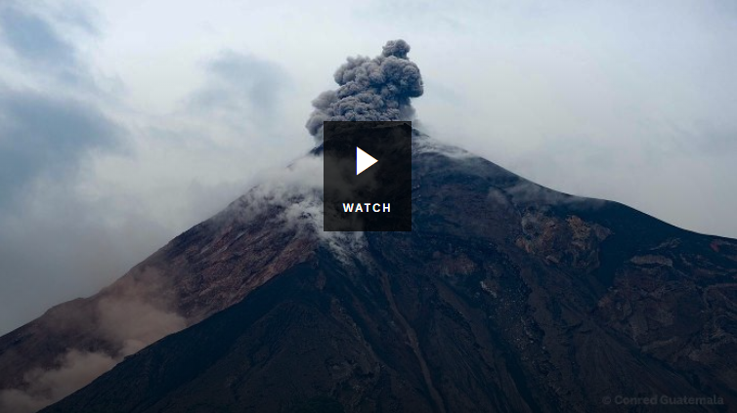
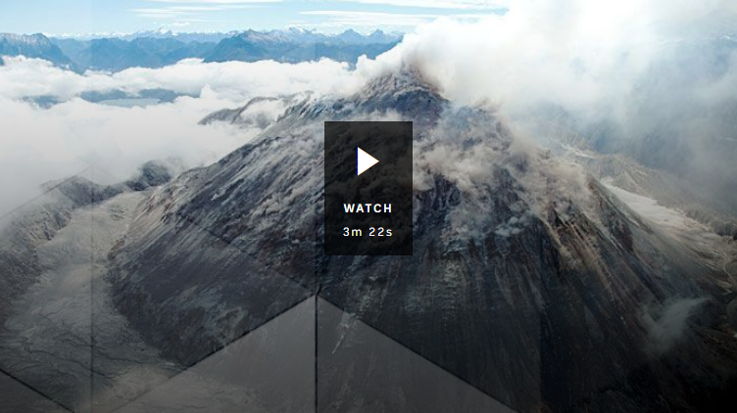
Volcanoes Explained Living near a volcano

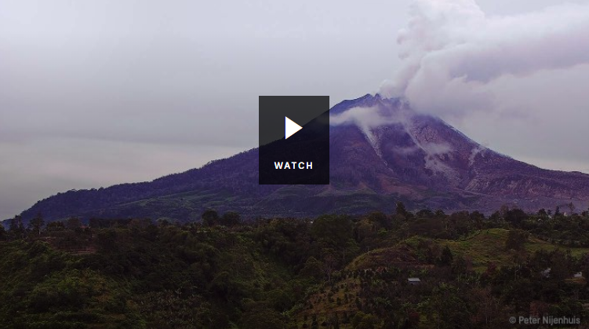
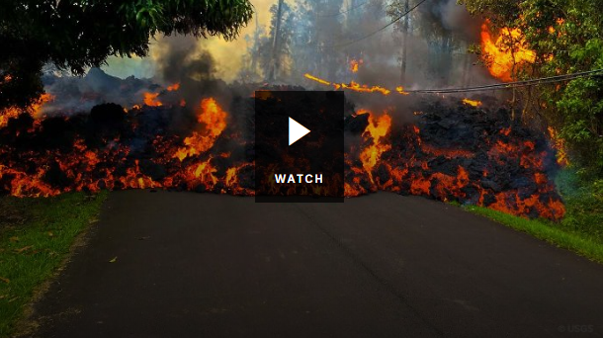
Sleeping Volcanoes Hawaii Volcano

Volcanoes Quiz

Quiz Questions | Your Answer
- What is magma?
  - Hot molten rock under the Earth’s surface
  - Hot molten rock that has erupted onto the Earth’s surface
  - The Earth’s crust
- The word volcano comes from Vulcan, the god of fire in Roman mythology.
  - True
  - False
- Which volcano buried the ancient Roman cities of Pompeii and Herculaneum?
  - Mt Etna
  - Mt Saint Helens
  - Mt Vesuvius
- Volcanoes only occur on land.
  - True
  - False
- Where is the largest volcano in the solar system?
  - Earth
  - Mars
  - Saturn
- Which volcano is thought to have caused the loudest sound in history?
  - Krakatoa
  - Kilauea
  - Mt Fuji
- A person who studies volcanoes is called a…
  - Palaeontologist
  - Seismologist
  - Volcanologist

Answers: 1. a, 2. a, 3. c, 4. b, 5. b, 6. a, 7. c


White Island: Scientists invent new volcano alert system - Newsround
https://www.bbc.co.uk/newsround/53471089

Guide: What causes volcanoes? - Newsround
https://www.bbc.co.uk/newsround/33947859

Volcanoes Explained – BTN
https://www.bbc.co.uk/newsround/33947859

Sleeping Volcanoes – BTN
https://www.abc.net.au/btn/classroom/sleeping-volcanoes/10535820

Living near a volcano – BTN
https://www.abc.net.au/btn/classroom/living-near-a-volcanoe/10541064

Hawaii Volcano – BTN
https://www.abc.net.au/btn/classroom/hawaii-volcano/10489092

Teacher Resource
Episode 20
28th July 2020

Minecraft School Tours
Students will use mathematical formulas like area and perimeter to create a scale drawing of their classroom.

Mathematics – Year 5
Calculate perimeter and area of rectangles using familiar metric units.

Choose appropriate units of measurement for length, area, volume, capacity and mass.

Mathematics – Year 6
Solve problems involving the comparison of lengths and areas using appropriate units.

Mathematics – Year 7
Establish the formulas for areas of rectangles, triangles and parallelograms, and use these in problem-solving.

Draw different views of prisms and solids formed from combinations of prisms.

Classify triangles according to their side and angle properties and describe quadrilaterals.

- Briefly summarise the BTN Minecraft School Tours story.
- What type of mathematical formulas did the kids use to help build their school in Minecraft?
  - Area
  - Perimeter
  - Ratio
  - All of the above
- What is a trundle wheel?
- What ratio did the kids use in Minecraft to create a room?
- What did the kids find difficult during the project?
- How long did it take the kids to finish the project?
- Describe one aspect of the virtual school in the BTN story.
- Why did the kids build their school in Minecraft?
- What do you like about Minecraft?
- Draw a plan of your classroom. Calculate the area and perimeter.

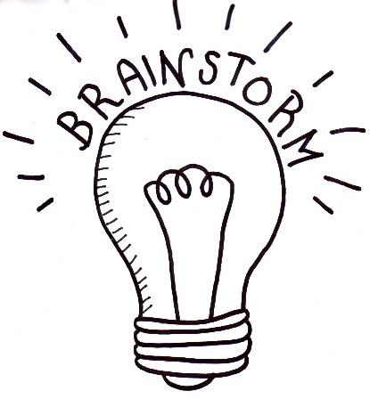
What do you think?
Students will respond to one or more of the following questions after watching the BTN story:
- What do you THINK about what you saw in the BTN Minecraft School Tours story?
- What does this story make you WONDER?
- Think of three questions you have about the story.
- What did you learn from the BTN story?

Glossary
Students will brainstorm a list of key words that relate to the BTN Minecraft School Tours story. Students may want to use pictures and diagrams to illustrate the meaning and create their own glossary. Here are some words to get you started.
Area | Perimeter | Scale
Dimensions | Unit | Formula
KWLH
Hold a class discussion after watching the BTN Minecraft School Tours story. What questions were raised in the discussion (what are the gaps in their knowledge)? The following KWLH organiser provides students with a framework to explore their knowledge on this topic and consider what they would like to know and learn.

What do I know? | What do I want to know? | What have I learnt? | How will I find out?

Questions for inquiry
Students will develop their own question/s for inquiry, collecting and recording information from a wide variety of sources. Students may develop their own question for inquiry or select one or more of the questions below.
- What tools do you use to measure things? Make a list and give examples of when they are used.
- How is perimeter different to area? What mathematical formula is used to calculate perimeter and what formula is used to calculate area? Give examples. Write your own lesson to help teach other kids how to calculate the area and perimeter of a rectangle.
- Why is scale important when drawing plans? How do you draw a plan to scale? Draw a plan of your classroom on graph paper and include the scale.
- What does tessellation mean? Which shapes tesselate and which shapes don’t tessellate? Can you find examples of shapes that tessellate in nature?
- What is virtual reality? What is the difference between virtual reality (VR) and augmented reality (AR)? Give examples. Explore the ABC’s Kokoda VR experience (for students aged 11+) with teacher resources provided.
- Think of a unique virtual reality (VR) or augmented reality (AR) experience you could create to help people explore new environments. Write a summary of your idea and explain why it would be useful.

Create a plan of your classroom
In this activity students will create a scale drawing and model of their classroom. Use the following as a guide. Students may work individually or collaborate in small groups.

Class discussion
Before starting this activity, use the following questions to start a class discussion to find out what your students know perimeter and area.
- What is a floor plan? Have you seen a floor plan before? Why are floor plans useful? Who draws and uses floor plans?
- How will go about measuring your classroom? Discuss in pairs and then share your ideas as a class.
- How can you make sure the drawing closely represents the real layout?
- How will you draw your classroom to scale?
- What mathematical formulas can you use to draw a scale plan of your classroom? (Discuss area, perimeter, ratio, unit).

Plan | - Explore your classroom, do you think there will be any challenges when you measure your classroom? Explain.  - What tools and materials will you need to measure your classroom? Make a list (E.g. trundle wheel, measuring tape, pencil, ruler, graph paper).
Measure | - Measure your classroom using the method you have written.  - Sketch a rough plan of the classroom and write notes as your measure your classroom.  - Collect as much data as you can and record what you find. Measure the perimeter of your classroom. You will need to include doors, windows, furniture, and any other features that you come across.
Draw | - Draw a floor plan of your classroom, including as much detail as possible.  - What scale will you use? Each square on your graph paper needs to represent a unit of measurement so your drawing is to scale. For example, 1 square on your graph paper represents 1 square metre.  - Include a scale and dimensions on your drawing.
Calculate | - Use mathematical formulas, to calculate the area and perimeter of the classroom. Show your workings.  - What shapes can you see in your drawing other than rectangles? How would you calculate the area for each of these shapes?
Analyse | - Share and compare your findings with the class.  - Were your findings the same of different?  - How accurate were your measurements?
Reflect | Students will reflect on the investigation by responding to one or more of the following questions:  - What did you enjoy about this investigation?  - What did you find surprising?  - What would you do differently next time?

Challenge
Challenge your students by giving them the opportunity to create a diorama of their classroom or a virtual tour of their classroom using Minecraft. Alternatively, they may want to design and create one of the following using Minecraft:
- A new school playground
- Your dream house
- A habitat for a native animal

BTN Stories
Watch the following BTN stories to find out how some students are using Minecraft in the classroom to design a playground.

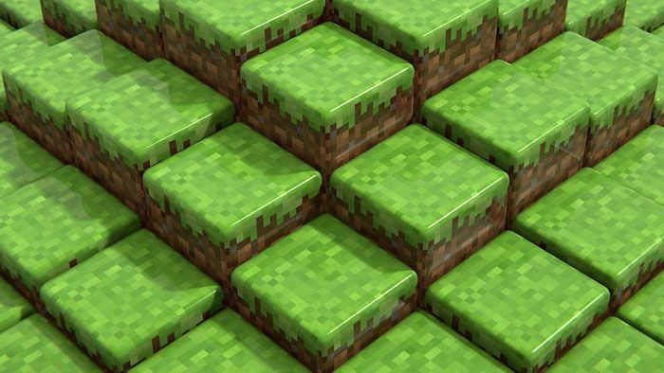  BTN Minecrafting Parks | 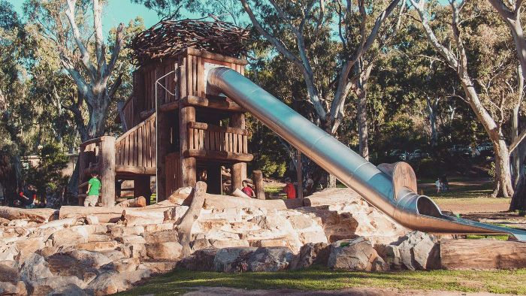  BTN Minecraft Playground

Minecraft Playground – BTN
https://www.abc.net.au/btn/classroom/minecraft-playground/10522342

Minecrafting Parks – BTN
https://www.abc.net.au/btn/classroom/minecrafting-parks/10526628

ABC Education – Measuring
http://education.abc.net.au/home#!/topic/495512/measuring

ABC Education – Area
https://education.abc.net.au/home#!/topic/494346/area

BTN Transcript: Episode 20 – 28/7/20

Hey, I’m Amelia Moseley and you're watching BTN. Here's what's coming up. We find out about the science of predicting volcanic eruptions, get a glimpse of a unique underwater display and take a tour of a school in Minecraft.

UK COVID-19 Vaccine

Reporter: Cale Matthews

INTRO: But first off today to a bit of good news about coronavirus. Last week Oxford University published results from a trial it's been doing of its COVID-19 vaccine and, while it's early days yet, the results were pretty promising. Cale found out more.

CALE: Lockdowns, masks, infection rates. Isn't there any positive COVID news?
Meet a team of scientific heroes on a mission to save the world.
CALE: This is more like it.
Around the world exemplars of scientific excellence have been working day and night to find a vaccine for COVID-19. Now these guys from the University of Oxford in England reckon they're getting close.
ANDREW POLLARD, CHIEF INVESTIGATOR OF VACCINE STUDY: So vaccines are absolutely the way out of the pandemic, and this is a really important moment because it shows that we can make the robust immune responses which we hope will relate to protection in the future.
CALE: OK, OK. What's a vaccine?
Our immune system is our body's natural way of fighting infections, caused by things like bacteria or viruses. Think of it as a literal body guard. Not only does it fight the invaders, it keeps a record of everything it fights and every winning move. So, if the same germ comes along again, look out. A vaccine is kinda like a coach for your immune system. It uses a deactivated or modified version of the virus, which doesn't make you sick, but teaches your body what it looks like and how to fight it.
CALE: Right, so if the virus comes along, our body knows what to do?
NINJA CALE: Now you're getting it.
Vaccinations have been around since the 18th century, and they've managed to get some pretty scary diseases under control. For example, up until 50 years ago there was a disease called polio. It caused serious pain, and sometimes lifelong deformities or even death. In Australia, more than 40,000 people contracted the virus, but luckily in the 50s a vaccine was developed, and polio was wiped out here in Australia. Fast forward to today and vaccines protect us from all sorts of viruses.
CALE: Right, it’s so easy, just make a vaccine, get the jab, hit the dab.
DR. DARREN SAUNDERS, ASSOCIATE PROFESSOR IN MEDICINE: Ah it's not that easy Cale.
CALE: What?
DR. DARREN SAUNDERS, ASSOCIATE PROFESSOR IN MEDICINE: Making a vaccine can be really tough, one of the first things that most vaccines start with is understanding the enemy if you like, so in this case the enemy is this horrible coronavirus which we didn't even know existed really until 9 months ago and so it’s a brand new enemy that we have to understand. And then the next trick is also understanding how it behaves when it infects people and when it infects the cells in those people.
Right now, lots of scientists from lots of labs are working on, well, lots of COVID vaccines.
DR. DARREN SAUNDERS, ASSOCIATE PROFESSOR IN MEDICINE: Oh there's lots of different ways to make a vaccine and for SARS, for COVID, there's over a hundred different vaccines being tested and developed at the moment.
The Oxford one, which is called ChAdOx1 nCoV-19, has showed some promising signs with volunteers developing an immune response to the vaccine, but that doesn't necessarily mean it will work against the actual virus.
DR DARREN SAUNDERS, ASSOCIATE PROFESSOR IN MEDICINE: What we need to do now is go out and test it on a lot more people so the tests that are going on at the moment are on 10 or 20000 people in different countries to see if that vaccine actually stops them getting infected.
CALE: Right so there's still a bit of time before life goes back to normal.

Did You Know?

Did you know the word vaccine comes from the Latin "vacca" which means cow? Way back in 1796 a man named Edward Jenner injected a 13-year old boy with cowpox, a virus that affects cows, and found that it protected him from smallpox, a similar but much more serious disease that affects humans.

Face Masks

Reporter: Jack Evans

INTRO: If you live in Melbourne you've probably seen a lot of people wearing masks lately. In fact, if you live in a COVID-19 hotspot and you're 12 or over you have to wear one if you're in public. Jack found out more about why masks have become an essential accessory to keep people safe.
JACQUES, CHIEF FASHION INSPECTOR: Fashion Police. How to look fine, without getting a fine. Jacques here. Let's take a look at the fashion trend that is going viral this season. That’s right it's masks. Everyone's doing it, well everyone's trying to do it. And if you live in Greater Melbourne or Mitchell Shire, you have to do it or you'll be a fashion victim. No really, you could get fined $200. Talk about a fashion faux pas.
Yep, they're not just fashionable, masks are now mandatory for people in Victoria's COVID-19 hotspots with a few exceptions. You don't have to wear one if you're under 12 years old, a teacher, but only when your teaching, or doing exercise, although you should still carry one with you. If you look overseas, you'll see similar rules in many places. But for now, in the rest of Australia masks are still optional. I decided to ask an expert about the ins and outs of masks.
CHRIS, VICE PRESIDENT OF THE AUSTRALIAN MEDICAL ASSOCIATION: If you’ve got a respiratory tract infection you can put a mask on and then obviously you're going to transmit much less of whatever that infectious particle is. But there is actually good evidence to show as well that if you are a perfectly healthy person in the community then wearing a mask will reduce your risk of getting or contracting an infectious disease as well.
Chris here is the Vice President of the Australian Medical Association and he says there's a good reason why advice around masks has changed since the pandemic began. We were told to not wear them, and now we're being told to wear one. What's going on?
CHRIS: We were very worried about the stocks of personal protective equipment in hospitals we didn't have a sense of how big this thing was going to be. We also didn't know as much about the coronavirus. So about a fortnight ago a really big trial was published so very new evidence and it gave quite a compelling picture that masks could be helpful.
Of course, there's now a big demand for masks and big supermarket chains have placed limits on the number of faces masks people can buy so they don't run out. Meanwhile mask making businesses are booming.
IFRIN FITTOCK, SISTER WORKS: At the moment we have a capacity of making between 7,000 to 10,000 masks in a week.
And online there are plenty of guides to making your own out of all sorts of things. How important is the type of mask that we're using?
CHRIS: The type of mask do matter and what we know so far is that the surgical masks are fine but obviously they can be a little bit difficult to get hold of. The material obviously needs to be breathable for clear reasons and it needs to be multi-layered.
Chris says if you are using a reusable mask you need to wash and dry it regularly and make sure you're wearing it properly.
CHRIS: So, you wash your hands and you don't touch the surface of the mask it has to go obviously over the bridge of your nose and underneath your chin. If you're taking it off don't touch the front of the mask because there might obviously be virus particles there and you don't want to get them on your hands.
JACK: While I've got you can I just check that I'm wearing my mask correctly?
CHRIS: OK let’s have a look. Yeah so that's pretty good I don't mind that. That’s a very good design you've got there as well.
JACK: I don't know if you can tell but I'm smiling under here.

News Quiz

There’s been some bad financial news for Australia with the government announcing a record what? Deficit, GDP or surplus? It announced an 86-billion-dollar deficit, which is the biggest since the Second World War. It basically means the government is spending more than it’s bringing in, in things like taxes and the reason is pretty obvious.

Which country successfully launched a Martian rover on Thursday? Was it the United Arab Emirates, the United States of America or China? It was China. Its Tianwen-1 mission is the world’s first all-in-one orbiter lander and rover. The UAE also have probe on its way to Mars and NASA’s due to launch one soon.

What type of aircraft did Qantas say goodbye to last week? Boeing 737, Boeing 747 or Boeing 777. It was the 747. Qantas has used them since the 70s but now they’ve all been retired. The last one, nicknamed the Queen of the Skies, took its final flight to last week to a plane junkyard in the US and on the way it left a special message. Naaaw.

Which artist dropped this surprise album last week. It was Taylor Swift. It’s called Folklore and she wrote and recorded the whole thing in isolation.

Volcano Warning

Reporter: Cale Matthews

INTRO: Now to New Zealand where scientists have developed a new system to warn people if a volcano is about to erupt. That's pretty important if you live in New Zealand which has plenty of volcanoes and they're hoping it'll help to save lives in the future. Let's find out more.

Spewing molten lava and searing hot gas into the sky, a volcanic eruption is mother nature at its most explosive. But, while they're often spectacular they can also be deadly. In December last year, New Zealand's White Island volcano, Whakaari, unexpectedly erupted killing 21 people.
JACINDA ARDERN: To those who have lost or are missing family or friends, we share in your grief and sorrow and are devastated.
Whakaari is one of 12 active volcanoes in New Zealand, the country sits right on the Ring of Fire, the area around the Pacific Ocean where most of the world’s volcanoes can be found. You see volcanoes often occur at the edge of tectonic plates, the jigsaw like pieces that make up the Earth’s crust. At these points molten rock called magma can make its way towards the surface. Sometimes it oozes out as lava and sometimes it causes a build-up of pressure which can result in, yeah, bang.
These sort of explosive eruptions are the most dangerous and over the years they've done a lot of damage in different places around the world. It's why for a long-time scientists have been working on ways to predict eruptions. While that's not easy, there are some clues they can look for, like earthquakes, build up of gasses, or even a change in the volcanoes shape. That info goes into the volcano alert system, which lets people know what the risk of eruption is. The trouble is, updating this alert level can take a bit of time.
DR. DAVID DEMPSEY, COMPUTER ENGINEER: The problem with that system is that it does rely on people getting together and talking about data and deciding on things, you can't be doing that every 10 minutes, it generally happens every few weeks or every month and so it doesn't respond quickly enough if you only have very short term warning signs.
Dr David Dempsey is a computer engineer who’s been working to create a better volcano warning system by analysing the underground rumbles of Whakaari.
DR. DAVID DEMPSEY, COMPUTER ENGINEER: So what we did is we looked at 9 years of seismic data from Whakaari, so that is essentially little vibrations on the ground that were picking up with these sensitive instruments.
They then fed all of this data to a computer and looked for patterns before each of Whakaari’s last 5 eruptions. Before nearly each one there was a 4-hour burst of seismic energy, look at that. They say it was caused by gasses building up like a pressure cooker as the volcano got ready to blow. The data helped them build a computer model, which paints a real time picture of what’s going on underneath Whakaari, so if there are the tell-tale signs of an upcoming eruption people have time to get to safety.
They say by observing other volcanoes around the world other scientists could create similar systems to warn people of future eruptions, which would be great news for the millions of people who live in the shadows of these fiery forces of nature.

Ask a Reporter

If you wanted to know more about volcanoes or you’ve got any questions you can ask me live on Friday for Ask A Reporter. Just head to the website for all the details.

Giant Cuttlefish Migration

Reporter: Olivia Mason

INTRO: Right now, there's something really special going on in the waters around Whyalla in South Australia. It's the only place in the world where Giant Cuttlefish gather en masse every year and it's pretty spectacular. Liv found out more about it and why some are worried that the colourful cephalopods aren't being protected. Check it out.

When it comes to weird animals, Australia's home to quite a few, but have you ever seen one of these?
LINDSAY: They look like this kind of squid, but they are bigger and colourful and very relaxed.
MOLLY: We didn't touch them, but they look slimy.
HAMISH: And they have a long body and they had whisker things and they had tentacles.
Hamish, Lindsay and Molly recently got to swim with Australian Giant Cuttlefish off the coast of Whyalla in South Australia.
LINDAY: Woohoo.
HAMISH: It was a really great experience to go swimming with them.
MOLLY: It was really cool because I haven't seen anything like it before.
Tens of thousands of cuttlefish come here every year for the breeding season which usually starts in May and ends in August. It's a pretty chilly time to go swimming, hence the warm shower afterwards.
CARL CHARTER, MARINE EDUCATOR: There's nowhere else in the world where you can see up to 200 thousand cuttlefish in a small part of coast.
Carl's been taking people out on snorkelling tours to see the cuttlefish for 18 years now.
CARL: I'm amazed by the cuttlefish every time I go to swim with them. They're like a glitter ball at a disco glittering in the distance yet closer they're huge cuttlefish full of colour.
Cuttlefish are masters of camouflage. They can change the colour of their skin to hide from predators or to attract a mate.
CARL: Cuttlefish are actually colour blind but they have got these little cells on their skin which can change colour so a cuttlefish can communicate with other cuttlefish and they can also use them to camouflage themselves at night.
But a few years ago it was looking like these unique cephalopods were in a bit of trouble. The numbers had dropped by around 90 per cent so the South Australian government set up a protected zone in the Spencer Gulf where they couldn't be caught. Since then, the numbers have climbed back up to healthy levels and this year the government decided to reduce the protected area. And while some welcomed the decision, others like Carl are worried that it'll have a big impact on the cuttlefish population.
CARL: We're very disappointed with the changes. The cuttlefish are there to breed and lay eggs and we should be protecting the cuttlefish during that time. We've got more people up there now viewing the cuttlefish in the water than we ever have. People from all over the world and all around Australia are coming to see the cuttlefish and it's not a good look to have people in the water trying to view the cuttlefish when fishermen are pulling them out by the bucketload.
Not everyone thinks that fishing was behind the decline of cuttlefish and the government says the changes won't have a big effect on them but others reckon they should be protected so more people get to experience this amazing natural phenomenon.
LINDSAY: I definitely think cuttlefish should be protected because they only live for one year and they always come to one spot every year to have babies and if we keep fishing them then they won't be able to have babies.
MOLLY: I think they should be protected because if they're all gone then there will be none for us to see when we go snorkelling.

Did You Know?

Did you know cuttlefish have not one, not two, but three hearts? Two hearts are used to pump blood to the cuttlefish's large gills, and the third heart is used to circulate oxygenated blood to the rest of the body.

Sport

Sydney FC won a record breaking fourth A-League Premiership on the weekend and they did it without even having to kick a ball. Their main rival Wellington Phoenix needed a win to be able to catch Sydney at the top of the table but they could only manage a draw, wrapping up another title for the Sky Blues.
Meanwhile, Liverpool fans are still celebrating as their team ended a 30 year wait to lift the Premier League trophy. The team took home the cup after beating Chelsea in an 8 goal thriller. There were fireworks, flares and selfies after the game, but no fans, which made things a little bit weird but the team didn't seem to mind too much.
There were also celebrations for Manchester United who made it into the top four of the Premier League with a 2-nil victory over Leicester City. It means they've secured a spot in the Champions League along with Liverpool, Man City and Chelsea.
And in the AFL Brisbane has moved to a very close second place on the ladder after a tight four point win over Melbourne on Sunday. While Port still have lead position, they were overtaken by a stunning final quarter surge by St Kilda who've now moved to third on the table.

Minecraft School Tours

Reporter: Jack Evans

INTRO: Finally, today to Wallaroo in SA where a school has found a creative way to let new students take a virtual tour. They've recreated the entire school ground in Minecraft and it's pretty awesome. Check it out.

Have you ever wondered, what would my entire school look like if it were a video game? Well these students from Wallaroo Primary did, only they took it one step further and made it happen.
NOAH: We have been building the entire school on Minecraft. We've tried to get the exact same of what it looks like. If it didn't look like what it looked like we'd try to change it.
Yep, that's right these guys recreated their entire school complete with avatars on Minecraft, mine-d-blown.
A'EDAN: We started by finding the coordinates of how big we need to make it. We used a code to make the whole platform and then we had to dig out extra little parts like a mountain that we had to dig that out to get rid of it and trees.
NOAH: It involved using a lot of area and perimeter a lot of math with it and design.
Armed with a trundle wheel these guys measured every inch of their school to make sure the scale of the buildings were as accurate as possible.
MARNIE: We had a bit of difficulty with the measurements of the room and by doing the ratio 1 over 1 which is one block equals one metre we found that the rooms appeared squished and smaller than what they were in real life. Although from the outside the buildings were correct.
All up it took about 10 weeks to complete and they didn't miss a thing. From the old school bell, to the virtual gym. You can read a virtual book in the virtual library or virtually swing on a virtual swing. They even managed to include virtual version of the school’s pet turtle, Squirtle.
A'EDAN: We couldn't get the egg to hatch. So, then Mr McCarthy found a code to spawn in a baby turtle, so it's automatically a baby. But then he kept on jumping out but then I found a code that gives me an invisible block called a barrier block to block the top so he can't jump out.
Who knew virtual turtles were so cheeky. Apart from being a pretty cool way to learn STEM, the project is also being used to take future students and their families on virtual tours of the school.
NOAH: If other kids want to know what our school is like or parents want to know they can hop on and see what it looks like.
MARNIE: I think the end product is really good and that the whole of room 9 should be really, really proud of themselves.
NOAH: Amazed I'm proud of our classmates and I'm proud of just us, it's magnificent. I can't be the only one who thinks this.

Closer

It is very cool. Well done guys. Well that's it for today. We'll be back next week with more and in the meantime, you can stay up to date by watching BTN Newsbreak every weeknight. There's also heaps to do on our website and if you're 13 or over you can head to our YouTube channel. Thanks for watching. Bye.

