
EPISODE 31
1st November 2022

KEY LEARNING
Students will view a range of BTN stories and use comprehension skills to respond to a series of focus questions.

CURRICULUM
English – Year 4
Use comprehension strategies to build literal and inferred meaning to expand content knowledge, integrating and linking ideas and analysing and evaluating texts.

English – Year 5
Use comprehension strategies to analyse information, integrating and linking ideas from a variety of print and digital sources.

English – Year 6
Use comprehension strategies to interpret and analyse information and ideas, comparing content from a variety of textual sources including media and digital texts.

English – Year 7
Use comprehension strategies to interpret, analyse and synthesise ideas and information, critiquing ideas and issues from a variety of textual sources.
  - Teacher Resource

Focus Questions
As a class, discuss the stories featured in the episode of BTN Classroom and record the main points of the discussion. Students will then respond to the following focus questions.

New UK Prime Minister
- Who were the previous 2 prime ministers of the United Kingdom before Rishi Sunak?
- How old is Rishi Sunak, the new prime minister of the United Kingdom?
- Rishi Sunak is the first British Asian person to ever become the United Kingdom’s prime minister. True or false?
- What political party does Rishi Sunak represent?
  - Conservative Party
  - Labour Party
  - Scottish National party
- Rishi Sunak is the 222nd richest person in the UK. Why are some people worried about that?

Sport Sponsorship
- Where do you see advertising when you watch sport? Discuss in pairs.
- Why was the Australian netball team, the Diamonds, not happy with one of their sponsors, Hancock Prospecting?
- Why did Hancock Prospecting pull their sponsorship funding from the Diamonds?
- Why did the Aussie test cricket captain not want to feature in any ads for his team's sponsor Alinta Energy?
- What did you learn watching this story?

Kokoda 18th Anniversary
- What year did the United Kingdom declare war on Germany?
- Why did Australia send it troops to Papua New Guinea?
- Where is Port Moresby? Find on a map.
- Describe the conditions for soldiers along the Kokoda trail.
- How did the Papuan and New Guinean men help Australian soldiers?

Check out the teacher resource on the Teachers page.

Aussie Rocket Launch
- Describe the rocket testing facility in South Australia.
- What is the technical name of Siobhan’s qualification?
  - Rocket Scientist
  - Aerospace Engineer
  - Rocket Technician
- What does suborbital mean?
- What is the purpose of the rocket?
- Why is Australia considered to be in a good position for space exploration? Give one example.

Check out the teacher resource on the Teachers page.

Farm Kids
- Where do the kids in the BTN story go to school? Find on a map.
- What has affected farmers in this area?
  - COVID
  - Mouse plague
  - Drought
  - All of the above
- What sort of work are the kids doing on the block of land that was donated to their school?
- What crop did they plant?
- What will they do with the money they make from harvesting their crop?

EPISODE 31
1st November 2022

KEY LEARNING
Students will develop a deeper understanding of Australia’s involvement during the Kokoda Campaign.

CURRICULUM
HASS – Year 3-4
Pose questions to investigate people, events, places and issues.

HASS – Year 5-6
Locate and collect relevant information and data from primary sources and secondary sources.

Develop appropriate questions to guide an inquiry about people, events, developments, places, systems and challenges.

HASS – Year 7
Apply a methodology to locate and collect relevant information and data from a range of primary sources and secondary sources.

Construct significant questions and propositions to guide investigations about people, events, developments, places, systems and challenges.

  - Teacher Resource

Kokoda 80th Anniversary

Focus Questions
Discuss the BTN story as a class and record the main points of the discussion. Students will then respond to the following:
- What year did the United Kingdom declare war on Germany?
- Why did Australia send it troops to Papua New Guinea?
- Where is Port Moresby? Find on a map.
- Describe the conditions for soldiers along the Kokoda trail.
- How did the Papuan and New Guinean men help Australian soldiers?

Activity: Personal Response
After watching the BTN Kokoda 80th Anniversary story, ask students to finish one or more of the following incomplete sentences:
- It was interesting to learn that…
- Learning about Kokoda made me feel…
- BTN did a story about Kokoda because…



What questions do you have about the story?
What did you learn from the story?

Activity: Class Discussion
Discuss the information raised in the BTN Kokoda 80th Anniversary story. Use the questions below to guide the discussion.
- Where is the Kokoda Track?
- Who was involved in the battle of Kokoda?
- When did the Kokoda Track Campaign begin and end?
- What is the significance of Kokoda to Australians today?

Activity: Inquiry Research
Discuss the information raised in the BTN Kokoda 80th Anniversary story. What questions were raised in the discussion and what are the gaps in students’ knowledge? The following KWLH organiser provides students with a framework to explore their knowledge on this topic.

What do I know? | What do I want to know? | What have I learnt? | How will I find out?

Students will develop their own question/s to research or choose one or more of the questions below. Encourage students to collect and record information from a wide variety of sources and present the information they find in an interesting way.

- Where does the Kokoda Track start and end? Mark your findings on a map. What other details can you include on your map to help inform others about the battle in Kokoda during World War Two?
- Why were Australian troops sent to Kokoda?
- What were the experiences of the Australian soldiers that fought in the battle of Kokoda? Explain what the conditions were like for soldiers along the Kokoda Track and include 2-3 primary sources to support your explanation.
- What is the topography of the Kokoda Track? Investigate the geographical features of the Kokoda Track, including climate, the terrain, the conditions of the track, and the distance of the track. Create a diorama or draw a map which highlights your findings.
- How were Papuans impacted by the Kokoda Campaign?
- What impact did the Kokoda Campaign have on Australia and its people at the time?
- Why is the battle in Kokoda considered one of the most important battles for Australians during World War Two?

Activity: Act Like an Historian
Provide your students with the opportunity to think and act as historians. Students will investigate in more depth some questions they have about the Kokoda Campaign and Australia’s involvement in the campaign. Students can take notes as they watch the BTN Kokoda 80th Anniversary story or download the transcript after watching the story to guide them through the activity. Students will use the following as a guide or students can write their own inquiry question.
- Write a summary on the Kokoda Campaign, which answers the 5 W’s – Who, What, Where, When and Why?
- Create a timeline highlighting key events in the Kokoda Campaign. Include a title, date, and description for each event.
- Find one primary source and one secondary source which helps you understand more about the Kokoda Campaign. Respond to the questions below for each source you find. Share and compare your findings with your classmates.

- What is it?
- Who wrote it or made it?
- When was it written or made?
- Where was it written or made?
- How was it written or made?
- Why was it written or made?
- What evidence does this source contribute to my research?

Activity: Visual literacy
In this activity students will examine, analyse and query a range of images which show the Kokoda Track during World War Two. Students will choose one of the photographs below (alternatively, students can find an image themselves to analyse). Students will then respond to the following:

- Write a short paragraph describing what you see in this photograph.
- When and where was the photo taken?
- What do you think is happening?
- Write a caption for each image using your own words.
- What question/s would you like to ask about the photo? Choose one of your questions to investigate in more detail.

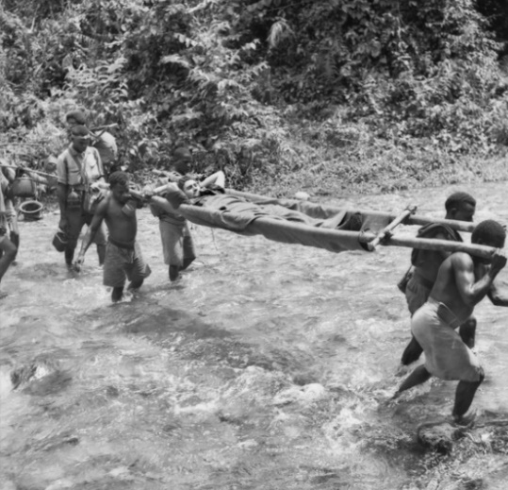  New Guinea, Kokoda Track, 1942 – Australian War Memorial | 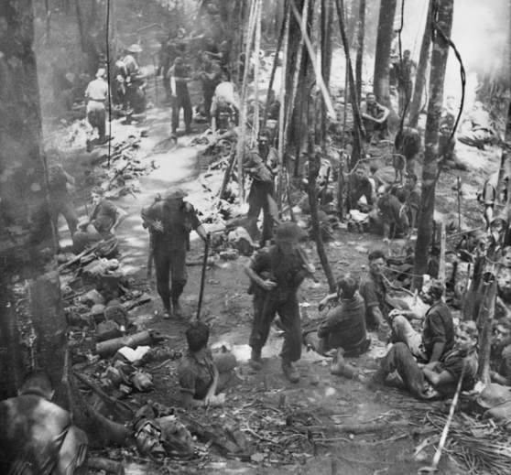  Papua, New Guinea, 1942 – Australian War Memorial

Activity: Memorial Box
In this activity, students will explore how objects can help tell the story of war. Students will use the internet to ‘collect’ a range of items and categorise them into primary and secondary sources. Students will reflect on each item by responding to a range of questions.

Before starting this activity analyse the Australian War Memorial’s Our War in the Pacific 1942, Memorial Box as a class. Then, individually or in pairs, students will use the following as a guide as they create their own memorial box:
- ‘Collect’ 6 items to create your own Kokoda Campaign memorial box. Use the internet to find your memorial box items, including equipment, objects, works of art, photographs, letters, diary entries, or souvenirs.
- Include an illustration/photo and a description of each object. Why did you include each object in your memorial box? Are there any stories related to the object?
- Categorise the objects into two columns, is it a primary source or secondary source?

Useful Websites
- Kokoda 75th Anniversary – BTN
- Making Kokoda VR – BTN
- The Kokoda Track – ANZAC Portal
- Kokoda Chronology – ANZAC Portal
- Kokoda Track, PNG – Australian Government

EPISODE 31
1st November 2022

KEY LEARNING
Students will learn more about how rockets work and how they are used to explore space. They will also investigate Australia’s role in space exploration.

CURRICULUM
Science – Year 5
The Earth is part of a system of planets orbiting around a star (the sun).

Science – Years 5 & 6
Scientific knowledge is used to solve problems and inform personal and community decisions.

Science involves testing predictions by gathering data and using evidence to develop explanations of events and phenomena and reflects historical and cultural contributions.

Science – Year 7
Scientific knowledge has changed peoples’ understanding of the world and is refined as new evidence becomes available.

Change to an object’s motion is caused by unbalanced forces, including Earth’s gravitational attraction, acting on the object.
  - Teacher Resource

Aussie Rocket Launch

Focus Questions
Discuss the BTN story as a class and record the main points of the discussion. Students will then respond to the following:
- Describe the rocket testing facility in South Australia.
- What is the technical name of Siobhan’s qualification?
  - Rocket Scientist
  - Aerospace Engineer
  - Rocket Technician
- What does suborbital mean?
- What is the purpose of the rocket?
- Why is Australia considered to be in a good position for space exploration? Give one example.

Activity: Class Discussion
Discuss the information raised in BTN Aussie Rocket Launch story as a class. Create a mind map about space exploration and include information/questions about Australia’s involvement in space exploration. Use the following questions to guide discussion:


- Why is a rocket being launched in South Australia?
- What is a suborbital rocket?
- Why is Australia a good place to launch a rocket?
- Why should we explore space?
- Is space exploration important? Why or why not?
- Is it important for Australia to be involved in space exploration? Why or why not?
- What are some of the benefits of space exploration?
- Are there any disadvantages? What are they?
- How has space exploration changed since the 1960s?
- What is the future of space exploration?

Activity: Glossary
Students will brainstorm a list of key words that relate to the BTN Aussie Rocket Launch story. Here are some words to get them started.

EXPLORATION | ROCKET | LAUNCH
SATELLITE | PAYLOAD | SUBORBITAL

Activity: Rocket Science
Students will learn more about rockets by conducting one or more of the following NASA experiments.

Simple Rocket Science
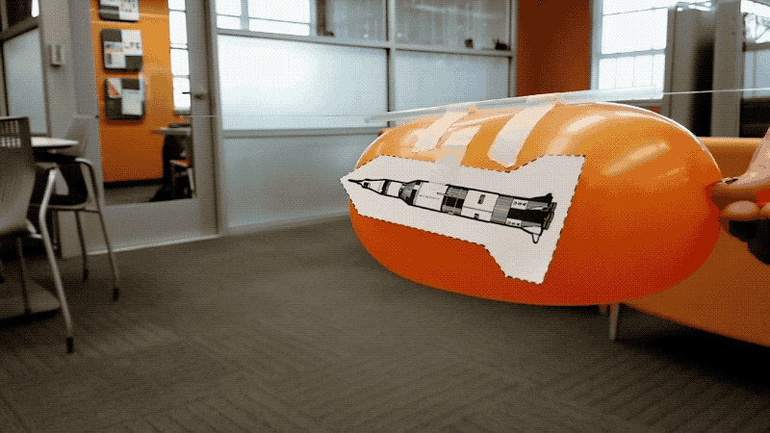
Students will learn how a rocket works and demonstrate Newton’s third law of motion. They will make predictions about the motion of a rocket, perform an experiment to verify and repeat the experiment to validate the results.
Find more information about the NASA experiment here.

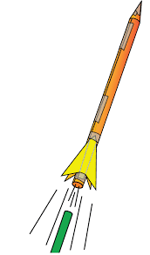
3...2...1...Puff. – Rocket Stability
Students will learn about rocket stability as they construct and fly small indoor paper rockets. They will determine their flight stability and launch them by blowing air through a drinking straw. Find more information about the NASA experiment here.

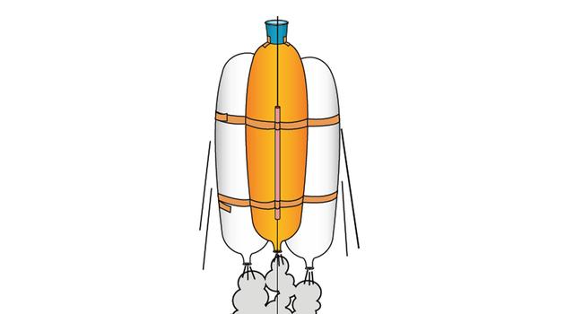
Heavy Lifting - Balloon Powered Rocket
Students construct balloon-powered rockets to launch the greatest payload possible to the classroom ceiling. Find more information about the NASA experiment here.

Investigation Framework
Below is an investigation framework to guide students when planning and conducting their experiments.
- What am I going to investigate?
- What do I think will happen (prediction)?
- Why do I think this will happen?
- What steps do I need to follow to investigate my prediction?
- What materials and equipment will I need? Make list or draw and label each item.
- How will I make it a fair test? What variables am I going to keep the same?
- Write a sentence that summarises what happened?
- A labelled diagram or a table of my results or observations to demonstrate what happened.
- Was this what I expected? Yes or no.

Activity – Choose a project
Individually or in small groups, students will choose one of the following projects to work on and then present their findings to the class.


How does a rocket work?
Create an information report about how rockets work and how they are used to explore space.

Did You Know?
Find out more about the important role Australia played in the Apollo 11 mission and create a Did You Know fact sheet to show what you have learnt.

Quiz
Create a true or false quiz to test your classmate’s knowledge about rockets or Australia’s involvement in space exploration.

Australia and Space
Canberra Deep Space Communication Complex (CDSCC) has been involved in NASA missions for more than 50 years. Choose a mission CDSCC has been involved in and research it in more detail.

Activity: BTN Stories
As a class watch one or more of the following BTN stories to learn about Australia’s role in space exploration. After watching any one of the BTN videos ask students to respond to the discussion questions (to find the discussion questions and teacher resources go to the related BTN Classroom Episode and download the Episode Package).

  Aussie Space Agency | 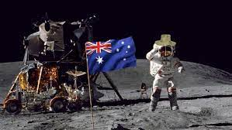  Aussie Astronauts
  Parkes Telescope Anniversary |   Apollo 11 and Parkes

Useful Websites
- More rockets to launch from Whalers Way site on Eyre Peninsula as tests get federal approval – ABC News
- Aussie Space Agency – BTN
- Aussie Astronauts - BTN
- Australia’s Big Rocket Launch – Newsbreak
- What is a rocket? - NASA

  - Teacher Resource

BTN Transcript: Episode 31- 1/11/2022

Hey, what’s up, I’m Amelia Moseley and you're watching BTN. Thanks for hanging out with us again. Let’s see what’s coming up on today's show. Netball Australia dropped from a multi-million dollar sponsorship, we mark 80 years since the Kokoda Trail Campaign, and I found out what it takes to launch a rocket into space.

New UK Prime Minister

Reporter: Jack Evans

INTRO: But first up, you’re gonna start seeing this guy popping up in the news a lot more. His name is Rishi Sunak and last week he became the UK's 57th Prime Minister. But he wasn't elected the usual way, in fact he's the country's 3rd leader in just two months. Jack found out what's been going on.
NEWSIE: Extra, extra, read all about it. Prime Minister Boris Johnson calls it quits.

JACK: Just one please.
It all started on the 7th of July when the now former Prime Minister of the UK Boris Johnson resigned.
JACK: Oh. Well, I never.
BORIS JOHNSON: And I want you to know how sad I am, to be giving up the best job in the world.
So why exactly did he give up the best job in the world? Well at the time, Boris Johnson has attracted a lot of criticism.
NEWSIE: Bojo throws Christmas party during lockdown.
JACK: What a scandal.
NEWSIE: Bojo to blame for increase in taxes, cost of living going up.
JACK: I knew it.
NEWSIE: Roll up, roll up, circus is in town.
JACK: That one just seems mean.
It caused a lot of people from his own party, the Conservatives to lose confidence and trust in him as a leader. And as a result, nearly 60 of them quit in protest which essentially forced Boris to say.
NEWSIE: Ciao, laterz, cheerios, G2G.
Yeah what he said, more or less.
PERSON 1: I'd like to see him out as soon as possible.
PERSON 2: Personally, I liked him. I think he had a very tough job.
PERSON 3: I think he's a clown.
Mr Johnson continued to lead until the party elected a new leader.
NEWSIE: Who is Liz, and is she the biz?
Ah yes, that’s the new PM, Liz Truss. In early September she was voted in as the country’s 56th Prime Minister by about 120,000 members of Britain's Conservative Party. You see, similar to here in Australia the public don't actually vote for a single person. They vote for a political party and it's up to the members of that political party to elect a leader. Liz was up against this guy, Rishi Sunak but as you can see from this lovely graph Liz came out on top. And so, there you have it, the UK's new PM. Or so we thought.
NEWSIE: Extra, extra, Liz Truss resigns after just 6 weeks.
JACK: Wait, didn't this already happen?
Yep, Liz didn't last very long. You see the UK’s economy was struggling when Liz was voted in. So, she announced a mini budget that would cut taxes, especially for the rich, and put the country in more debt. But it didn't go down too well. Financial markets went into chaos and people from her own party were getting pretty worried. Eventually Liz went from this.
LIZ TRUSS: I am a fighter, and not a quitter.
To this.
LIZ TRUSS: I am resigning as Leader of the Conservative Party.
After just 44 days as PM, Liz was out, making her the shortest serving PM in UK history. So, who replaced her?
NEWSIE: Extra, extra, Rishi Sunak makes a comeback.
JACK: Who?
Yeah, remember that guy that lost to Liz Truss, well now he's been elected as PM. The 42 year-old will be the youngest PM in more than 200 years. And also, the first Hindu and British Asian person to ever lead the country. Like Liz, he's also a Conservative and was actually the country's finance minister when this guy was PM. Speaking of money, Rishi's got a lot of it. He and his wife are the 222nd richest couple in the UK. And is said to be richer than the king himself which has got some worried that he might be a bit out of touch. But as the UK’s 57th PM Rishi says he'll work hard for the country.
RISHI SUNAK: I will serve you with integrity and humility, and I will work day in day, day out to deliver for the British people.
NEWSIE: Extra, extra.
JACK: No, nope, we're done with the story, we don't need any extra headlines.
NEWSIE: Oh, but that's what the headline was.
News Quiz

Which mega celeb had their partnership with Adidas dropped? It’s Ye, AKA Kanye West. Adidas cut ties with the rapper’s brand “Yeezy” after he shared on social media his antisemitic views, which means views that are offensive and hateful towards Jewish people. Ye was also dropped by his talent agency as well as a whole lot of other fashion brands, who say they don’t support those types of views.

Which cool place did New Zealand’s Prime Minister Jacinda Ardern visit last week. It’s Antarctica. Ardern was there to mark the 65th anniversary of New Zealand’s Scott Base, which is about to get a 344 million dollar upgrade. And while she said the trip was, pretty cool, ha ha, she did have a bit of trouble getting there. Her first flight had to turn around because of bad weather.

Doctor Who is moving to which streaming service? Is it Netflix, Disney+ or Stan? It’s Disney+. The BBC announced a new deal with Disney+ to continue the series, as well as a new logo for the show. It means the iconic British show will no longer appear on the ABC where it first aired in Australia back in 1965.

Sport Sponsorship

Reporter: Cale Matthews

INTRO: Netball Australia's been making headlines recently after it had its multi-million dollar sponsorship deal dropped by mining company, Hancock Prospecting. The news came after some Diamonds players chose not to wear a jersey featuring the Hancock logo. And it's raised questions about whether athletes should have a say on the companies displayed on their jerseys. Here's Cale.
DITZY: Oh, Smithy how about that game mate. It was an absolute cracker.
SMITHY: Yeah, spot on Ditzy. The BTN Ballerz just far too good tonight, taking home the Taylor's Home Improvement Trophy.
DITZY: Now, Smithy I'm gonna stop ya there mate. Cos I believe we've got the captain of the Ballerz down in the change room, Whacker, you got us?
WHACKER: Yeah, yeah boys, I got ya, I got ya.
DITZY: Yeah, Whacker mate it's Ditzy, how you feeling? Talk us through it.
WHACKER: Oh, Ditzy mate it’s unbelievable, but first, I do just want to thank the sponsors; we got Frank's Fantastic Flowers, Frank's Fantastic Flour, and Flower's Fantastic Franks. Just the big 3, you know.
When you look and listen closely, sponsorship deals are everywhere in sport. They’re in speeches, on the sidelines, on replays, and on jerseys.

CALE, REPORTER: The idea is that a company provides a bit of money for a sporting team or an athlete.

In return teams and athletes provide advertisement for the company. But sometimes when athletes or teams do or say things that their sponsors don't necessarily agree with, they can pull the pin on their sponsorship.

CALE: But what happens when companies do things that the athlete doesn’t agree with? I got to get to this presser, sorry.
WHACKER: Hey guys, yeah, g’day, g’day. Ah, we got any questions? Questions? Hit us up.
INTERVIEWER: Ahh yes, Whacker. Are you aware Flower's Fantastic Franks aren't using real meat in their franks, instead their using shredded cardboard?
ATHLETE: Ooh, umm.
Okay, fake frankfurt’s aside sometimes there’s real life controversies over sponsorship. Recently some of the players in the Australian netball team, the Diamonds, weren't too happy with one of their sponsors, Hancock Prospecting. It's a mining company owned by Australia's richest person, Gina Rinehart, and last month a 15 million dollar deal with the mining company was announced. But some of the players, including Noongar woman Donnell Wallam, questioned the sponsorship because of racist comments made by the company’s founder back in the 1980s, and in their recent games against New Zealand the Diamonds wore uniforms without the Hancock logo. After that, Hancock pulled their funding.
LIZ WATSON, DIAMONDS CAPTAIN: We're supporting Donnell obviously with everything that's going on.
DAVID POCOCK, INDEPENDENT SENATOR: Sport has a long history of being part of social change.
That's senator and former captain of the Australian Wallabies, David Pocock, and he says more and more athletes are starting to speak up about their sponsors.
DAVID POCOCK, INDEPENDENT SENATOR: I think a lot of athletes are starting to think well are these the kind of messages that actually want young people to be seeing and to be associating me with these companies or these products.
Just this month Aussie test captain Pat Cummins said he wouldn't feature in any ads for his team's sponsor Alinta Energy because of climate change concerns and in WA there's been calls from some Fremantle Dockers players and supporters to scrap their sponsor for the same reason.
DAVID POCOCK, INDEPENDENT SENATOR: I think we're gonna see more and more athletes, more and more sports fans say I don't want to be associated with something that is not good for our future.
There are plenty of people who reckon athletes and sports teams shouldn't be making political statements. Hancock Prospecting has since released a statement saying that they provide financial support for lots of different sports around Australia and that it was unfortunate they’ve had to withdraw their funding for netball. Meanwhile, the Victorian Government has announced they'll sponsor the Australian Diamonds for the next four and a half years, which means these guys can get back to doing what they do best.

Kokoda 80th Anniversary

Reporter: Amal Wehbe

INTRO: November 3rd marks 80 years since the end of one of the biggest events in Australia's military history, the Kokoda Campaign. It took place in Papua New Guinea during World War Two and Amal found out more about it.
The 1930s, a time when dancing in Australia looked like this. The first international flights were taking off. Tassie tigers were still around, and Sir Donald Bradman was ruling the cricket world. But it was also a time where on the other side of the world, a war was looming. On the 3rd of September 1939 the UK declared war on Germany, after they invaded Poland one of the UK's allies. It was an announcement that would affect the lives of many Aussies.
ROBERT MENZIES, FORMER AUSTRALIAN PRIME MINISTER: Great Britain has declared war upon her and that, as a result, Australia is also at war.
Back then Australia was still part of the British Empire and strongly believed in supporting Britain. So, Australia sent its troops to fight overseas in Europe and the Middle East. But in 1941, the war got a lot closer to Australia. Japan, who were allies with Germany, had invaded a number of countries in South East Asia and many feared Australia would be next. But first they would have to take what we know today as Papua New Guinea. Papua New Guinea's pretty close to us geographically. And at the time it was actually an Australian territory.

But with most of our troops fighting overseas, Australia decided to send its reserve forces to Papua New Guinea's capital, Port Moresby. Majority of these soldiers were young and inexperienced; they hadn't been trained very well and didn't have sophisticated weapons. But they would become part of one of Australia’s most significant battles, the Kokoda Trail Campaign. It is where Aussie Soldiers held off the Japanese army. But it wasn't easy. The Kokoda Track is narrow, steep, muddy and takes 8 days to complete. The days were hot and the nights freezing. This is how Stan Bisset an Australian soldier described the experience.
STAN BISSET: The weather and the thick mud was appalling. The men perspired so much they were completely dehydrated by the end of the day and had to be issued with salt tablets on a daily basis.
Between July and November in 1942 there were a series of battles on the Kokoda Track. More than 600 Australians died in the fighting and thousands died from injuries and disease. It was also really difficult getting supplies over the terrain. But the Aussie troops had help from Papuan and New Guinean men who would scout locations, as well as carry supplies and wounded soldiers. In August trained soldiers were sent to Port Moresby to back up Australian troops. Soon afterward Japan started to withdraw, and in November Australia recaptured Kokoda.

80 years later and the Kokoda Trail Campaign is still seen as a really important part of Australia’s military history. And every year thousands of Aussies attempt the Kokoda Track as a way of paying respect to the soldiers who fought hard to protect Australia.
Did You Know?
Did you know the name Kokoda means Place of Skulls. It's an Orokaiva word, which is one of more than 850 languages spoken in Papua New Guinea.

Aussie Rocket Launch

Reporter: Amelia Moseley

INTRO: Australia's space industry is really taking off, and that's partly thanks to private space companies. Earlier this year we saw the first commercial space launch in Australia's history and the countdown is on as more companies get in on the action. I headed out to a rocket testing facility in South Australia to find out more.
LLOYD DAMP, CEO SOUTHERN LAUNCH: 10, 9, 8, 7, 6...
It's not every day that you get to see a rocket launching into space.
LLOYD DAMP, CEO SOUTHERN LAUNCH: 3, 2, 1. Lift off. All stations, lift off.
Oh, well I guess today just isn't my day.
AMELIA, REPORTER: But don't worry, that was actually meant to happen. Or not happen, I guess. Let's go back a bit. This is a commercial rocket testing facility on Kaurna Land in South Australia. And scientists here are getting ready to send this into space. Launch day is planned for later this month, and on that day, I won't be allowed anywhere near this rocket, for obvious reasons. But today is test run day. So, I thought I would come along and speak to a rocket scientist. Should be one around here somewhere.
Amelia, Reporter: So, Siobhan, are you a rocket scientist?
SIOBHAN GILES, AEROSPACE ENGINEER, SOUTHERN LAUNCH: Well, technically, my qualification is aerospace engineer. But yeah, I think you could say I'm a rocket scientist.
AMELIA: Can you tell me about the rocket out there?
SIOBHAN GILES, AEROSPACE ENGINEER, SOUTHERN LAUNCH: So, this is the Kestrel I rocket. It's suborbital, which means that it's going to come back to the ground after we launch it. And it's basically to check that we can build a rocket and that everything works how we thought it would.
The plan is for rockets like this to launch satellites which can help us communicate and keep an eye on what's happening on Earth.
SIOBHAN GILES, AEROSPACE ENGINEER, SOUTHERN LAUNCH: We've got lots of satellite companies in Australia that have to go overseas, to send their satellites into space. So, what we'd really love to see happen in Australia is an in-country capability. So, when a company has got a satellite that they want to send into space, they can launch from Australia.
But rocket launches don't always go smoothly as these guys found out on their last try.
LLOYD DAMP, SOUTHERN LAUNCH CEO: A lot can go wrong you can build a lot of computer simulations, you can do a lot of testing on the ground. But the real test happens when that rocket lifts off, up off the ground and starts to fly towards space.
If you're wondering what it'll hopefully look like on the big day. Well, maybe something like this. This year, we saw the first commercial space launch in Australia's history. It was a NASA mission with help from a company in Arnhem Land in the NT. It's something that's happening a lot more. Government space agencies working with private space companies to get things done more easily, cheaply, and effectively.
Australia's also in a pretty good position for space exploration right now. Like, literally. There's space phenomena that can only be seen from the Southern Hemisphere and we're not far from the equator which means rockets can get to space quicker and use less fuel. Plus, we do have a lot of space for launching stuff. No, like space, space. Yeah. Which is why we've had a lot of experience when it comes to testing rockets.
AMELIA, REPORTER: About 500 kays that way is Woomera Range Complex. At its peak in the 1960s, it had the second highest number of rocket launches in the world after NASA's famous Cape Canaveral in Florida. And now that we have our own Aussie space station, based right here in Adelaide, some think it’s time for us to reach for the stars. Had to get that line in somewhere.
If all goes well on the real launch day, this team will set their sights on sending a rocket into Earth's orbit. And from there? Well, who knows what the future holds.
SIOBHAN GILES, AEROSPACE ENGINEER, SOUTHERN LAUNCH: I'd definitely like to see some Australian astronauts, and I'd love to see an Australian contribution to the exploration of Mars.
Easy. I mean it's not rocket science. Oh no, that’s right, it is.

Sport
It's win, win, win for the Diamonds right now. After their first win in game one against the England Roses, they've gone and done it again with a 56-to-48-win last night. Their first game was a little closer but with just 4 seconds left on the clock Donnell Wallam scored the game winner in her very first game for the Diamonds.
DONNELL WALLAM, THE DIAMONDS: It's really special, and I just hope that I’m now, you know, a role model to the young girls and boys coming through.
Aussie Daniel Ricciardo has found his mojo at the Mexico City Grand Prix. After being dished a 10-second penalty for a collision on lap 51 he went on to deliver one of his best drives of the season finishing up in 7th spot and voted driver of the day.

The AFLW home and away season has wrapped up and the Kangaroos and the Tigers battled it out for the final spot in the top four. It was a nailbiter. The Roos needed to win but a late point from the Tigers saw the teams draw. The Tigers will now play Brisbane in a qualifying final on Saturday.

Farm Kids
Reporter: Cale Matthews

INTRO: Finally, today let's head to a very small school in Hermidale, New South Wales. Like many rural towns Hermidale's been hit pretty hard over the past couple of years. So, students there wanted to lend a hand and learn to farm. Take a look.
Introducing Hermidale Public School. You see those people down there, yeah that's the entire school. It's about 600 kays or a 7-hour drive from Sydney in this tiny town of just 137 people, and every afternoon all the students, as in all 7 of them, swap out their schoolbooks for a spade, whack on their work clothes and head out to the paddock.
OLI, HERMIDALE STUDENT: Look around. It's good. So, I could be doing something else back at school but instead we have the time to come up here and look around.
RUBY, HERMIDALE STUDENT: It's been incredible to come out here and just look at it and say that's ours.
You see, Hermidale is a town of mostly farmers, but they've had a tough couple of years with the pandemic, a massive mouse plague, and the worst drought in history.
OLI, HERMIDALE STUDENT: Well, the drought was pretty bad because like we had to get like water trucked in.
While the rain has finally arrived there's another problem, a lot of the farmers here are, well, they’re getting on a bit.
CRAIG, LAND OWNER: We need to get a bit more young blood into the game, instead of being so many people going into law and doctors and we need more farmers.
So for the past 6 months these guys have been learning the ropes. Out the back of the school was a big patch of land and after a bit of asking around the town, the teachers got in touch with the owner.
CRAIG, LANDOWNER: I donated it to them. I was very kind and generous, I suppose. People said why'd you donate that whole block to them? I said I rarely use it. And I said it's gonna be better for me in the long run because it'll be cleaned up, it’ll will save me a job.
It's a bit like that old saying? If you want a job done right, get 7 primary schoolkids to do it. That's a saying, right? With donated seeds and chemicals, and machinery borrowed from the community, this patch is now thriving with a big crop of wheat that the kids are ready to harvest.
RUBY, HERMIDALE STUDENT: So, after the crop ripens, and it dries out a little bit, we'll harvest it with the header.
OLI, HERMIDALE STUDENT: See how it starts to turn golden at the top, we need it to turn fully golden and then the actual seeds to go golden and then it can be harvested.
RUBY, HERMIDALE STUDENT: Then we'll bring it into the grain dump and get our money.
Yep, the plan is to sell all of the grain and use some of the money for an out of town excursion.
SKYE, HERMIDALE TEACHER: Yeah. So, then being able to take them to Newcastle to see the grain being loaded, they'll then see the whole cycle of, from planting the seed to selling to the export market.
So, it really seems like the project has worked because a future in farming has grown.
OLI, HERMIDALE STUDENT: I'll definitely do it for a job.
RUBY, HERMIDALE STUDENT: Yeah, I'd like to be a farmer.
Closer

Oh, great work guys. Keep it up. Well, that's all we have for today. But don’t you worry, we'll be back next week with more news. In the meantime, though, you can head to our website and if you're 13 or over check out more content on our socials. Have a lovely week, take care and I’ll see you soon. Bye.

