
EPISODE 24
25 August 2026

KEY LEARNING
Students will explore the topics covered in the BTN Book Week 2026 Special.

CURRICULUM
English – Year 4
Discuss how authors and illustrators make stories engaging by the way they develop character, setting and plot tensions.

Recognise similar storylines, ideas and relationships in different contexts in literary texts by First Nations Australian, and wide-ranging Australian and world authors.

English – Year 5
Create and edit literary texts, experimenting with figurative language, storylines, characters and settings from texts students have experienced.

Identify aspects of literary texts that represent details or information about historical, social and cultural contexts in literature by First Nations Australian, and wide-ranging Australian and world authors.

English – Year 6
Identify responses to characters and events in literary texts, drawn from historical, social or cultural contexts, by First Nations Australian, and wide-ranging Australian and world authors.

Create and edit literary texts that adapt plot structure, characters, settings and/or ideas from texts students have experienced, and experiment with literary devices.
  - Teacher Resource

Book Week 2026

Focus Questions
As a class, discuss the stories featured in the BTN Book Week 2026 Special. Students will then respond to the following focus questions:

School Libraries
- Why do the students in the BTN story like spending time in the library?
- What are some things you can do in a school library besides borrow books?
- Why do you think libraries have changed over time?
- Why is it important to know how to find reliable information when researching?
- Do you think libraries will look different in the future? What might change?

Deborah Frenkel Interview
- What type of books does Deborah Frenkel write?
- How did Deborah get the idea to write The Truck Cat?
- What does Deborah think makes a good story?
- What advice does Deborah give to young people who find it hard to get into reading?
- What is your favourite picture book? Why?

Young Authors
- Which two countries are the Torres Strait Islands located between? Find on a map.
- Who are some of the characters in the book?
- What is the main message of the book?
- Why was it important for the students to make the book?
- What new word in Torres Strait Creole did you learn?

Braille
- Before watching the video, what did you know about Braille?
- How does the six-dot system work in Braille?
- Why do you think Braille uses patterns of dots rather than pictures or raised letters?
- What could schools and libraries do to make reading more accessible to everyone?
- What did you learn about Braille from Amaaya and Hamza?

Shadow Judges
- What is Shadow Judging?
- Why were the Book of the Year Awards created?
- Who can vote in the Shadow Judging Book of the Year Awards?
- What are some of the categories in the awards? List 1-2.
- What is one of the rules for judging the awards?

Activity: School Library - Class Discussion
After watching the BTN School Library story hold a class discussion, using the following questions to start the discussion:
- Why do we have libraries? Think about what your school library offers and make a list of reasons why we need libraries.
- Why is it important to have libraries?
- What’s your favourite thing about going to the library? List your top 3 favourite things about your school library.

How is your school library promoting and celebrating Book Week? Students will discuss and respond to the following.
- How do you celebrate Book Week? Create a calendar of events being held at your school during Book Week.
- If you could create your own Book Week theme, what would it be?
- What character are you dressing up for during Book Week?
- Does your school hold a Book Week parade? What does it look like? What was your favourite costume from the parade and why?

Activity: Warm Up Activity
The theme for Book Week 2026 is a ‘Symphony of Stories’! In this activity students will explore how music can represent ideas, characters, emotions and themes of a book. Students will select a song that they think represents a book their class is currently reading or has read during the year.
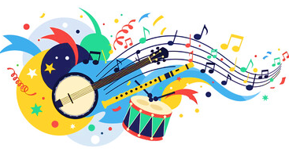
Ask students the following question… “If the book we are reading had a soundtrack, what would it be?”

Explain to students that just as music can communicate emotions and tell stories, books can create a mood, atmosphere and emotional response. Discuss how music can represent characters, emotions, themes, relationships, conflict and mood.
Students will choose one song they believe represents the book and make connections between the song and the book, thinking about the following:
- A character
- An emotion
- A theme
- An event or setting
- The overall message

Students will then respond to one or more of the following…
- This song makes me think of the book because…
- The mood of the song reminds me of…
- The lyrics relate to the theme of…
- I chose this song because…
Each student will contribute their song to create a class playlist.

Activity: How to Build Stories
Visual storytelling and understanding the importance of narrative is key in the making of a successful picture book. Start this activity by asking your students what they think a picture book is, recording their ideas during the discussion. Talk to students about the elements and techniques of effective storytelling. In pairs, students will make a list of useful tips for story writing, including tips on how to build character development, plot tension and narrative.

In pairs students will discuss what their favourite picture book is and why, using these questions to guide the discussion.
- What is your favourite picture book? Why?
- How did the illustrator and author make the story interesting or exciting?
- What did you like about the words and the pictures?
- Could the pictures tell the story without the words?
- What techniques does the illustrator use?

How to Build Stories
Use the ABC Education’s Digibook How to build Stories, which explains how to build your own stories, using tricks to create exciting characters, plots, settings, genres and language.

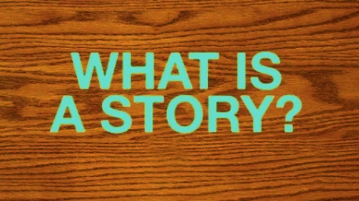 | 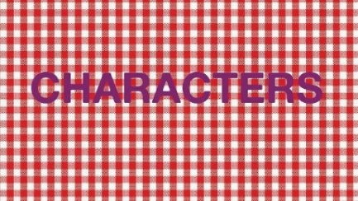 | 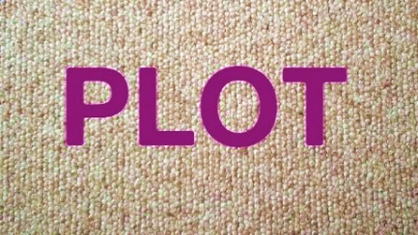
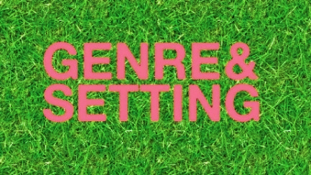 | 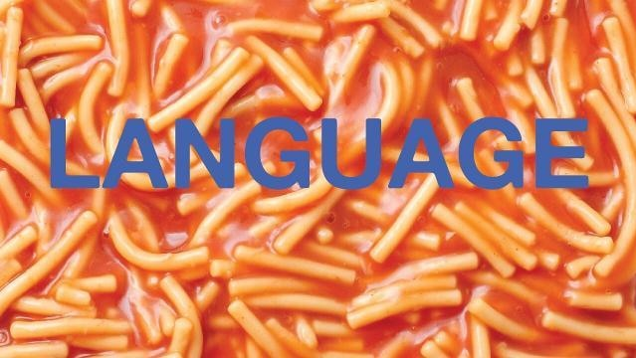 | 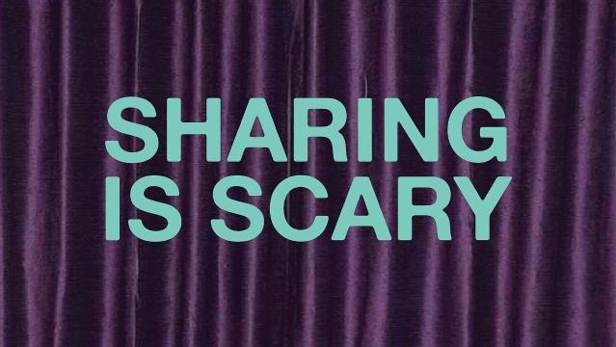

Activity: Literary Techniques
Authors use literary techniques to bring their ideas to life and shape how readers experience a story. They can engage, enlighten and even enchant! Literary devices are used not only by poets and writers, but also in day-to-day conversation.

Students will learn how to identify common literary techniques and how to use them in their own poems and stories. Visit ABC Education to learn about literacy techniques. For each technique there is a:
- Explanation
- Example
- Effect
- Exercise
- Guiding question
- Further Resources

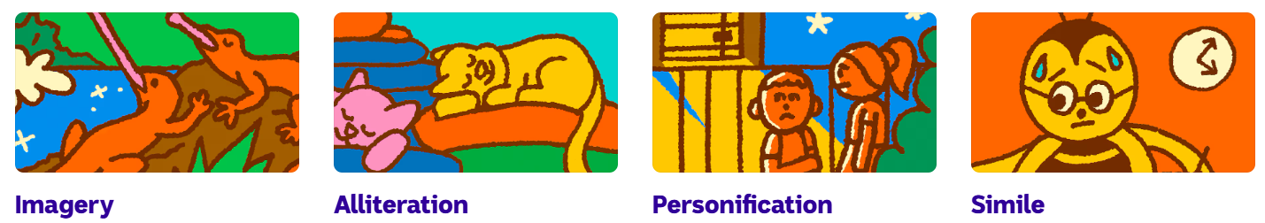
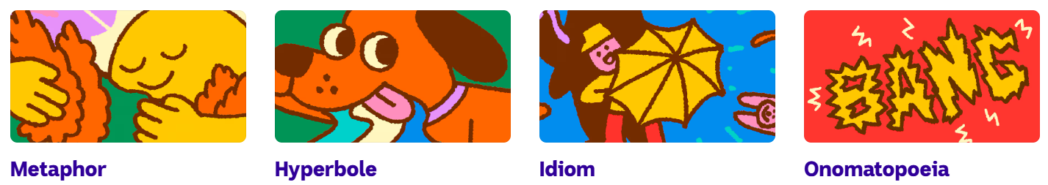

Activity: Responding to Books
Responding to a book gives students the chance to share their opinions, think more deeply and use their imagination. Students choose a book they have recently read and complete the following activities.

The Ending
Think carefully about how the book ended.
- What did you think of the ending? Did you find it satisfying, surprising, exciting or disappointing? Explain why.
- Did the ending answer all of your questions?
- Was there anything you would change?

Challenge
Imagine you are the author. Write a new ending for the story. You might change what happens to a character, solve a problem in a different way or add an unexpected twist.

Interview a Character
Choose one character from your book and imagine you are a journalist interviewing them. Write five interesting questions you would like to ask the character. Then, answer the questions as if you are the character, trying to reveal something about the character's:
- thoughts and feelings
- experiences
- relationships
- choices and decisions

Challenge
Which question/s do you think the author would find difficult to answer? Give reasons for your answer.

Change One Thing
Choose one event from the story and change it. What happens next? How would this change affect the characters and the ending?

Design a New Cover
Create a new book cover that captures the mood, characters or important ideas in the story. Write a short explanation of your design choices.

Would You Recommend It?
Imagine a friend is looking for their next great read. Would you recommend your book? Write a 2-minute pitch to convince someone to read your book that includes:
- the title and author
- a brief description of the story. No spoilers!
- what you enjoyed most
- who you think would enjoy reading it
- your overall rating out of five.

Give reasons for your opinion. A great recommendation helps readers decide whether a book might be right for them.

Activity: Indigenous Literacy
Class Discussion
After watching the BTN Young Authors story, hold a class discussion using the following questions.
- What animals featured in the book?
- What do the young authors want people to learn about their culture?
- Why did they choose to create a children’s book?
- What message does the pelican’s journey communicate about caring for the environment?

First Nations Stories in your Library
There are a range of children’s books which help us understand Aboriginal and Torres Strait Islander histories and cultures. What First Nations stories do you have in your library? Visit your school library to explore books written by First Nations authors. Create a display of books in your library written by First Nations authors to share with other classes at your school.

Below is a range of books that can help introduce your students to First Nations perspectives.

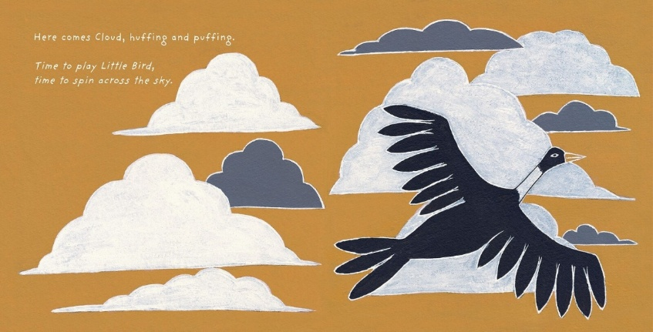
- Dark Emu by Bruce Pascoe
- Our Flag, Our Story: The Torres Strait Islander Flag by Bernard Namok Jnr and Thomas Mayo
- Took the Children Away by Archie Roach
- Hello, Hello by Children from the Spinifex Writing Camp
- Freedom Day: Vincent Lingiari and the Story of the Wave Hill Walk-Off by Thomas Mayor and Rosie Smiler
Little Bird’s Day by Sally Morgan, illustrated by Johnny Warrkatja Malibirr

- Stolen Girl by Trina Saffioti
- Little Bird’s Day by Sally Morgan

Choose one book (fiction or non-fiction) from your library that is age-appropriate and engaging that you can read aloud as a class. It is a great way to share First Nations perspectives with your class and develop understanding of Aboriginal and Torres Strait Islander people, cultures and histories.

Students will reflect on the story and respond to one or more of the following questions.
- Who is the author and/or illustrator of the book?
- What traditional lands are they from?
- What parts of the story could you relate to personally?
- What First Nations voices are heard in the story?
- What did you learn about First Nations experiences or culture?
- Are there Indigenous language words you learnt in the book?
- Were there cultural practices or traditions mentioned in the book?
- Were there historical events or references included in the book?

Activity: Braille - Class Discussion

After watching the BTN Braille story hold a class discussion, using the following questions to start the discussion:
- What is Braille?
- Why is it an important way for some people to access information?
- Where might you find Braille in everyday life? (lifts, pedestrian crossing, public signs, medicine labels, books)
- What have you learnt about the importance of making information accessible to everyone?

Activity: Decoding Braille
Braille is a system of raised dots that people who are blind or have low vision can use to read and write. Each Braille symbol is made using a pattern of up to six dots. Using the Braille alphabet chart, students decode the word below. What does the word spell? (Braille)

⠃ ⠗ ⠁ ⠊ ⠇ ⠇ ⠑

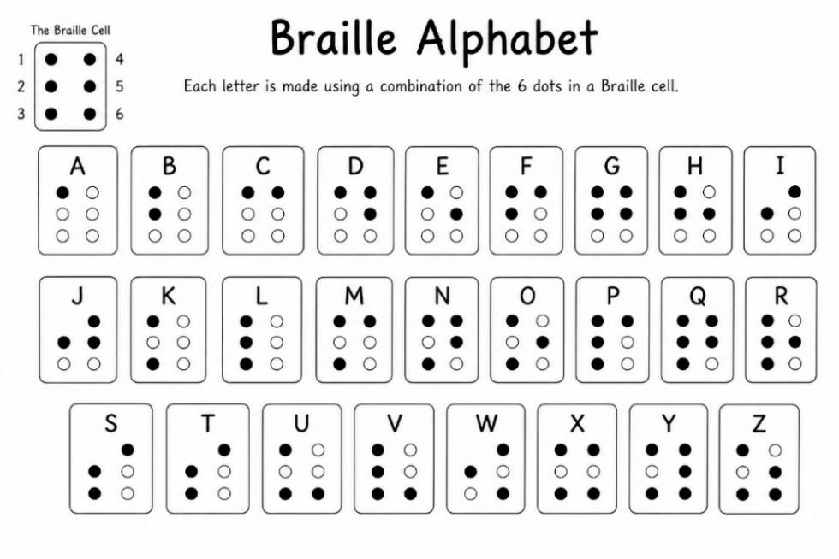

Students then choose a word - it could be their first name, a favourite food or an animal. Use the Braille alphabet chart to work out the dot pattern for each letter, then write their word in Braille.
Challenge
Write a short message in Braille for a classmate to decode!
Students swap their Braille word with a partner and decode each other’s words. Respond to the following questions:
- What patterns did you notice in the Braille symbols?
- Which letters were easy to decode? Which were more challenging?

Activity: Design Challenge
Students will choose one piece of everyday information and redesign it so that it is accessible to as many people as possible. For example:
- a classroom door sign
Tactile features are parts of an object that can be felt with your hands or fingers to help you understand information. For example, raised letters, symbols, shapes or textures.

- an information sign at a zoo or museum
- a restaurant menu
- an emergency evacuation sign
- a sign at a park or playground.

Students should make sure that their designs…
- clearly communicate the important information
- are easy to understand
- include a Braille or tactile feature where appropriate
- be designed to help as many people as possible access the information independently.

After completing their design, students can share it with the class and explain the choices they made to make their information more accessible.

Activity: Tactile Bank Notes
The BTN Tactile Bank Notes story explains how Connor started an online petition to get the Reserve Bank of Australia to add tactile features to Aussie bank notes.

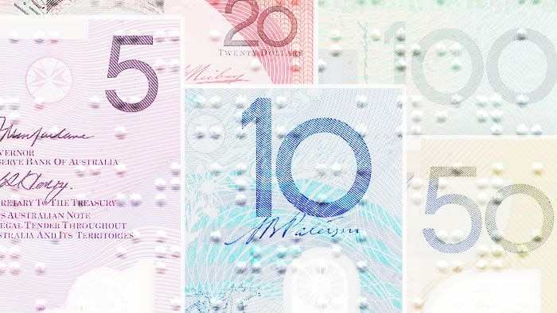
Students watch the story then answer the following questions:
- What are tactile bank notes?
- Why did Connor want Australia to get tactile bank notes in Australia?
- What action did he take to get tactile features on Aussie bank notes?
- What did the Reserve Bank of Australia announce about tactile bank notes?
- What did Connor learn from the experience?
BTN Tactile Bank Notes

Learn more about the accessibility features of banknotes here Explore the features here.

Activity: Top 100 Australian Books Countdown
If you want to have a say on your favourite book, ABC's Radio National is asking Aussies to vote for the 100 best Australian books of all time - including kids’ books.

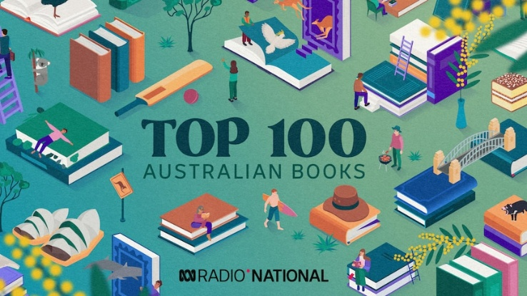
Voting opens Monday, 31 August and closes Thursday 1 October.

More details here

Activity: BTN Stories about Authors
As a class watch one or more of the following BTN stories to learn more about a range of authors, including some young authors. After watching any one of the BTN videos ask students to respond to the discussion questions (to find the teacher resources go to the related BTN Classroom Episode and download the Episode Package).

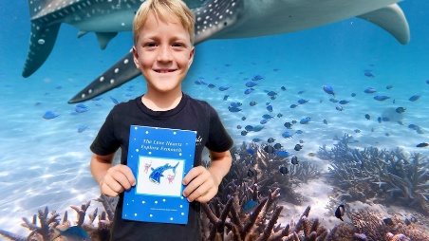  BTN Young Author | 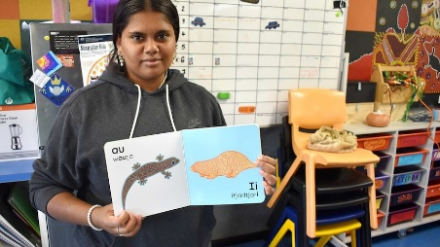  BTN Pitjantjatjara Book | 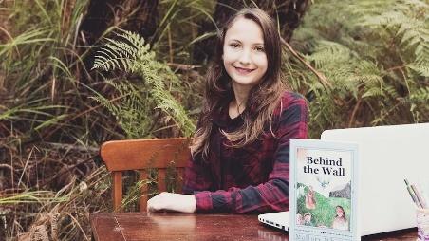  BTN Teen Novelist
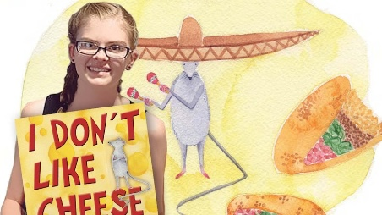  BTN Young Author | 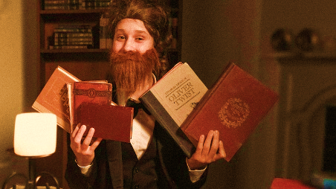  BTN Charles Dickens | 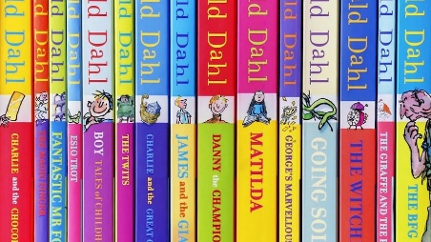  BTN Roald Dahl Changes

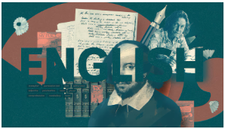
BTN English Collection
Visit BTN’s collection of stories which focus on English. Look for BTN stories with the pencil icon to find supporting teacher resources all linked to the Australian Curriculum.

BTN – English Collection

Useful Websites
- Children’s Book Week – Children's Book Council of Australia
- Book Week 2025 – BTN
- History of Libraries – BTN
- School Libraries – BTN
- Braille literacy is vital to achieving equal access for blind children – ABC Education
- Braille: What you need to know – Vision Australia
- What is Braille – Guide Dogs Australia
- Pitjantjatjara Book – BTN
- Indigenous Literacy Foundation (ILF)
- Shadow Judging – CBCA

  - Teacher Resource

BTN Transcript: Episode 24 – 25/8/2026

Hey, I'm Amelia Moseley and you're watching BTN. Thanks for joining us again. Now, today you can see I'm somewhere a little bit different. And that's because we're bringing you a very special episode for Book Week. We'll be chatting to some authors, learning how to read Braille, and meeting the students who have been helping to choose this year's best kids’ books. We'll also hear from some famous authors and familiar faces who'll be sharing their favourite kids’ books.

School Libraries

Reporter: Jack Evans

INTRO: Can't wait for all that soon! But first to libraries. Public libraries like this are a great place to come and read and learn, but as a kid, you might also have access to a library at your school. Jack found out why those are actually really important.

JACK EVANS, REPORTER: Someone once said, `Having fun isn't hard when you've got a library card’. Do you agree with that?
CHARLOTTE: Yeah, I feel like that's true.
OWEN: I definitely agree, yeah.
HAZEL: It is fun, like fun to be in a library.
CATHY: I agree with that statement because there are so many books you can read.
Do you know who said that?
GEORGE: I've got no idea.
No? It was Arthur, the aardvark.
ARTHUR: Having fun isn't hard when you've got a library card.
HAJNALKA MOLLOY, TEACHER LIBRARIAN: I love that libraries are dynamic places where students can connect with each other and connect with fabulous literature.
This is Hajnalka Molloy, she's a Teacher Librarian so she knows a thing or two about aardvarks. Sorry, libraries.
HAJNALKA: In a school library, we have books and games and maker spaces and digital resources to help students become passionate readers and become information detectives.
The idea of having a dedicated space to store information for people to read, study and borrow has been around for thousands of years. Just like aardvarks, I think. And seeing as schools are dedicated places to learn, it made sense to put Libraries in them.
Do you know how many books are in this library?
HAJNALKA: So, this campus of Concordia College has 15,000 libraries. Sorry, 15,000 libraries. We have 3 libraries.
CATHY: I like the diversity of all the books and how there's not just fiction books and there's like non-fiction and like autobiographies and graphic novels.
While this Library might be well stocked, not every school library in Australia is the same and some schools don't even have a library, which is something that some people would like to change. These days school libraries aren't just about written pages neatly bound in some sort of cover, no, they also give students access to a whole heap of things.
HAJNALKA: Supporting students to use a range of print and digital tools to find good information, teaching them how to use AI well and ethically.
TEACHER: And what about the image? Image fake?
STUDENTS: Real.
TEACHER: Real?
HAJNALKA: And teaching them how to determine what is trustworthy, what isn't trustworthy, what has bias and what has a range of different points of view.
Over the years, school Libraries have also become spaces that embrace new technology and other non-book related things. I mean this Library has a dragon, a bearded dragon. But does it have an aardvark?
HAZEL: Pog is a library pet over at the senior campus. Sometimes people will hold her while they're doing their work.
Dragon or no dragon, big or small, libraries are still an awesome place to learn and hang out with a good book. And maybe even get inspiration for Book Week. I'm Arthur. The aardvark? A-A-R-D-V-A-R-K.
OWEN: I'm going to dress up as Harry Potter from Harry Potter.
HAZEL: I'm going as a crayon from The Day The Crayons Quit.
CATHY: I'm going to dress up as Lynn and she's like this girl who's got water powers and she can control water.
CHARLOTTE: I'm going as Nobara Kugisaki from Jujutsu Kaisen.
GEORGE: I'm going as Dustin Henderson from Stranger Things, which is a TV show, but I do have the series as books.

Celebrity Favourite Books

COSTA GEORGIADIS: Hi everyone, it’s Costa here and my favourite book growing up was Doctor Seuss, Oh, The Places You’ll Go.

NATE BYRNE: G’day BTN, it’s Nate Byrne from ABC News Breakfast. When I was little, I used to read a lot. One of the favourites that sticks out for me, though, is With My Knife. It’s by Australian author Andrew Lansdown. It’s about a boy named Colin, who’s an Aussie, and he gets gifted a magical knife for his birthday that lets him open doors to another world that’s full of dragons. Oh, it was all of the fantasy and adventure I could have wanted. And if you can find a copy, I recommend reading it.

Deborah Frenkel Interview

Reporter: Michelle Wakim

INTRO: The books we read when we're little can have a big impact on us. And you're about to meet someone who writes kids’ books for a living, including this one. Her name is Deborah Frenkel, and Michelle found out why she loves reading and writing.

DEBORAH FRENKEL, AUTHOR: Well, hi there. My name is Deborah Frenkel. You can call me Deb and I write picture books, which means I write the words for picture books and then I work with a whole bunch of amazing different illustrators who work on the pictures.
MICHELLE WAKIM, REPORTER: What are some of the books that you've written?
DEBORAH FRENKEL: Well, probably the best known is this one, which is called The Truck Cat, which is about a little cat called Tinka and his friendship with his human Yacoub. And they travel on a truck all around Australia and a few things go wrong, but then something really goes right at the end. And then most recently, I have another book out, which is also a collaboration with Danny Snell, who illustrated The Truck Cat. This one's called The Everywhere Train. And this is a story about a little kid called Scout and her pop. And what happens when Pop has to move into aged care. And their tradition of riding on the trains weekly has to change into something new.
MICHELLE: And how do you go about writing a story?
DEBORAH FRENKEL: Yeah, that's a really good question. I mean, The Truck Cat, for example, the idea came to me when a strange cat turned up at my house. And it's a bit of a long story, but that cat, we ended up adopting him. His name is Tonka, and he inspired the cat in the story called Tinka. So, that was just a random thing that happened in my life where I kind of noticed the strangeness of it.
MICHELLE: What makes a good story?
DEBORAH FRENKEL: I do like high stakes, which is when basically there's a lot riding on whatever the main characters do. I always kind of think, well, what's the worst thing that could happen to these characters that I've got here? I think that makes a good story.
MICHELLE: What are some of your most popular or your favourite books that you have read that our audience might be familiar with?
DEBORAH FRENKEL: I don't want to play favourites. So, I'm going to go way back to when I was a kid. There still is an amazing author illustrator called Jeannie Baker, who when I was in primary school, used to make these amazing kind of collage-based picture books that she actually kind of made the images out of found objects and paper and then took a photograph of them. So, she had one book called Millicent, which is about a lady and her relationship with the birds in Hyde Park in Sydney. And I remember that one so profoundly. That made a really big impact on me.
MICHELLE: Why is storytelling important?
DEBORAH FRENKEL: Oh, I think storytelling is really basic to just being human.
And I think regardless of the form it takes, whether it's books or whether it's performance, whether it's even something like music, even something like video games. There's stories running through so many of the things that we love to do.
MICHELLE: And what do you think reading and writing offers young people that maybe they can't get from other forms of media?
DEBORAH FRENKEL: This is a really weird analogy but hear me out. So, I was thinking about self-assembled furniture, like you go to IKEA or somewhere and you have to put together the bookshelf yourself. You end up actually appreciating the item of furniture more when you've put part of it together yourself, because you can sit back and you can go, I kind of made that bookshelf. And I think that there's something similar happens with books maybe, so we're kind of really participating in the whole process of making the story as we're reading it.
MICHELLE: What would you say to young people who maybe find it hard to get into a book and read consistently?
DEBORAH FRENKEL: I always think it's best to go to the library, talk to your local librarian and tell them what you're interested in. Talk about the things that really light you up because I think when you find the right book that aligns with your interests, then, ding, all the light bulbs go on. I think that's the kind of magic moment. So, definitely persist with finding the right book. Just because you don't like the book that's in front of you doesn't mean you don't like books generally.

Celebrity Favourite Books

R.A. SPRATT: Hi BTN I’m R.A. Spratt. When I was a kid, my favourite book was Hating Alison Ashley by Robin Klein.

ADAM GOODES: Hey BTN it’s Adam Goodes here. Very proud Adnyamathanha and Narungga man. My favourite book as a kid growing up was The Rainbow Serpent which is celebrating over 50 years of that book being published. And what I loved about reading is seeing stories, not only about me and the culture I come from, but the beautiful illustrations that really go with the words in those stories.

Young Authors

Reporter: Michelle Wakim

INTRO: Now let's meet some young authors who have written their very own kids’ book. It's part of a programme designed to give First Nations kids access to more books about their home and culture. Check it out.

MICHELLE WAKIM, REPORTER: These students have a big task ahead of them.
JERRY, 15: We are creating a book.
And they have just one week to get it all done.
SHAN, 14: Lots of writing, having to come up with the details very quickly.
NATARA, 15: It's going to feel very weird, like we're going to literally have a book, like, we wrote and like, illustrated.
They are all from the Torres Strait Islands, which is a group of more than 200 islands located between Australia and Papua New Guinea and they've been flown to Sydney as part of the Indigenous Literacy Foundation's Create Program.
You see, a lot of kids in remote communities don't have access to a whole lot of books, especially books that are relevant to their experience and culture or in their language, and that's something the foundation wants to change by giving young people a chance to write their own book.
SAMLICO, 16: Together, we decided that our book is going to be about Harold the Pelican, because we also thought about the animals and wildlife in the Torres Strait, and we didn't want to make any ordinary book, we want to make something unique, so why not a pelican?
NATARA: The book is about a pelican, how he got a net caught on his wing and his little friends are there helping him out by getting the net off him.
SHAN: I've always liked the idea of like animals talking.
And there are plenty of talking animals.
SAMLICO: Manny the mullet.
JERRY: Crystal the crayfish.
NATARA: Timmy the turtle.
SAMLICO: We have Sally the seagull.
JERRY: Daisy the Dugong.
SAMLICO: Crusty Crab. Crusty Crab is, well, it's not original, let's just say that, but some of the other names, we just rhymed it to make it sound catchy, especially for the little kids who would be reading this.
And they also use illustrations to bring the story to life.
JERRY: I do like the backgrounds and stuff, sunsets and seascapes. I like watercolour paints and just blending them together.
For this group of young writers and illustrators, it was important that this book, which they've titled ‘Harold Needs a Hand’ includes a message about how pollution is impacting the environment.
SAMLICO: Pollution has a very big thing in this book. It created a lot of problems for us in the Torres Strait. We just thought of the wildlife, and these are commonly known cases, too. All of us have our experience with animals in these scenarios.
NATARA: Keeping the ocean like safe and like the environment clean and like don't litter and like watch out for animals if you're going like hunting diving or fishing.
ARONA, 14: Because rubbish is killing the sea life.
Most importantly, these students wanted to create something that celebrates and showcases Torres Strait Islander culture and language, so this story includes some words in Torres Strait Creole, which is also called Yumplatok, meaning ‘our talk’, and is a mix of English, traditional Indigenous languages, and Pacific Pidgin.
SAMLICO: We have a glossary of those little Creole words we have of ours, to make it interesting.
BRIAN, 15: It's important because some of us, English is our second or third languages.
And they want to give young Torres Strait Islander kids a story that reflects them.
SHAN: I'm hoping they'd feel like interested in the book and like actually want to read it and like get invested in the story.
BRIAN: To show the next generation our culture, to keep the fire burning.
SAMLICO: Especially for, you know, the younger generation. They might, you know, grow up in the city or don't know where their heritage is from, and these type of books, if we continue to make them, they can really put an impact in our culture, so that our history can always remain there. It makes me feel happy and proud, you know, being a part of it.
So, how did this all turn out?
SAMLICO: Ever since I was a little kid, I always wondered how and where books were made. I would just like to say an extremely special thank you to Penguin Random House for allowing us this opportunity to create a book about our islands, culture, and all the animals that belong to each diverse island in the Torres Strait.

Celebrity Favourite Books

TRISTAN BANCKS: Hi BTN I’m Tristan Bancks. I’m the author of Two Wolves and the new book Raised by Wolves and my favourite books when I was a kid were Roald Dahl’s The BFG, Paul Jennings Unreal and a survival novel called My Side of the Mountain.

GRAEME BASE: Hi BTN, it’s Graeme Base here. You know when I was young I was a really slow reader. Actually, I'm still a really slow reader. But I remember when I was about 11, a teacher gave me a copy of The Lord of the Rings. This is years before the films came out. And it was the paperback of all three books in one. It was a thousand pages long, more. And I remember thinking, "I'm never going to be able to read this." And yet when I finished, I only had one complaint. It wasn't long enough.

Braille

Rookie Reporters: Amaaya and Hamza

INTRO: Now to a different sort of reading using something called Braille. Hamza and Amaaya are going to tell you all about it.

AMAAYA AND HAMZA: Hello BTN.
AMAAYA: I'm Amaaya
HAMZA: and I'm Hamza
AMAAYA AND HAMZA: and we're going to tell you about Braille.
AMAAYA: Braille is a system of dots, and each dot represents a different letter or number or word.
AMAAYA: It was made for blind and vision impaired people.
HAMZA: Braille works by showing any amounts of those six dots on paper after someone writes it or prints it out, and you feel the dots and read it to form words or numbers.
AMAAYA: I started learning braille in reception, so I guess six years ago.
AMAAYA: Ezra was taking his time.
AMAAYA: I think learning braille was easy for me because I was vision impaired from birth, so I didn't know how to handwrite, it was the only system I knew.
HAMZA: I started learning braille at the end of 2023, so three years ago when I lost my vision.
HAMZA: Learning braille was hard because I already knew print and I had to learn an entirely different system.
HAMZA: Before I started learning Braille, I was doing fine motor stuff. So, I would do puzzles that were tactile and you had to feel them.
HAMZA: And then I just started doing first the letters of my name, then I started doing the alphabet and now I'm doing contractions, which is two or more letters in one symbol, basically.
HAMZA: I use braille pretty much every day. Like, for instance, today I was using braille for literacy block, doing literacy about persuasives.
AMAAYA: I use Braille when I read books. The book's name is Spirit of the Crocodile. It's a Book Week book and I'll just use my fingers, and I can feel the dots, and I can tell what words they are.
AMAAYA: The final bell had just rung. Ezra was packing his school bag, cheerful because it was Friday, and also a bit sad. In a few weeks he'd be done with primary school forever.
HAMZA: Mr. Robertson, his year 6 teacher, had already started putting up Christmas decorations.
HAMZA: I have a Braille device and it's called a Brailliant. It plugs into my laptop, and I can use Braille input, which basically means I can type Braille, but it will show up on my laptop.
HAMZA: And I can also read from the laptop on the device in Braille.
HAMZA: It's very hard to find books in braille because we're lucky here, we have a library full of braille but I'm pretty sure there's like no other library where you can buy braille books in Adelaide.
AMAAYA: All of our books get sent out to blind and low vision children all around South Australia.
AMAAYA: My favourite books would probably be the Harry Potter books, and I can just imagine the characters and it's like an adventure in a book.
HAMZA: I recently listened to the entire Percy Jackson series, and that's pretty much all I listen to.
HAMZA: Books are important because they build your imagination and also your language.
AMAAYA: Ezra wasn't sure who yelled it out.
AMAAYA: I'd say that once you start reading, it's just so much fun and you just learn to enjoy books and you might think it's boring now, but if you find the right type of book, it's fun.

Celebrity Favourite Books

GEMMA DRISCOLL: Hello BTN I'm Gem from Good Game Spawn Squad, and my favourite book growing up is actually still one of my favourite ones right now. And it's a series called Dear Dumb Diary.

MATT BACKER: Hi BTN, it's Matt from Play School here. Happy Book Week. Now my favourite books to read when I was a child was anything with dinosaurs in them. I loved dinosaurs when I was a little kid. And I also loved reading The Adventures of Nancy Drew by Carolyn Keene.

ROVE MCMANUS: Hi I'm Rove McManus and my favourite book growing up was Where the Wild Things Are by Maurice Sendak. I think it's a wonderful tale of imagination, fantasy and creativity. How much do I love it? I even bought the toys.

Shadow Judges

Reporter: Michelle Wakim

INTRO: Finally, today let's find out more about the Children's Book Council Book of the Year awards. They're a big deal for authors and also for readers. And did you know there's actually a whole awards category judged by kids? Michelle can tell you more.

MICHELLE WAKIM, REPORTER: Introducing the Book Week Shadow Judges. Well, some of them, at least.

AINSLEY, 11: Well, shadow judging is how the Children's Book Council of Australia decide through students what the winning books for different categories are.

ALLEGRA, 11: Kids can get the turn to judge and put their opinions on a book.

NOAH, 11: Adults think different things, but children think, ‘Oh, I like this funny book!’ And then the adults are like, ‘No, but this one has very good details.’

For the past term these guys have been reading a whole lot of books, but not just any books, they’ve been poring over the shortlist for this year’s Children's Book Council of Australia Book of the Year Awards.

The Book of the Year Awards have been around for a long time. They were created to celebrate Australian kids’ authors, and to encourage kids to read more Australian stories, and over the years they've recognised books that are still loved by kids today, and this year is their 80th birthday.

GRACE, 10: It's a very long time but I think they didn't have shadow judging at the start so it's good that people can do shadow judging because the kids are reading the books.

While the main awards are chosen by a panel of adults, the Shadow Judges Book of the Year Awards go to books voted on by kids around Australia, including these guys at Ardtornish Primary School in Adelaide.

In their classes, and individually, these students signed up to judge everything from the Young Readers category to Early Childhood books, to Picture Books.

RITHAAN, 9: Some favourites were ‘Dear Broccoli’, which had a lot of humour to it, where this kid was really didn't like broccoli, so he was sending letters to his broccoli, who was somehow sending them back and telling him how good broccoli was.

Did that get your vote?

RITHAAN: No, it didn't. I ended up voting for ‘Dawn’ for the picture books. You could feel the emotion and the time spent into that picture, and it would like just cast out in front of you into your mind and you would feel that.

ALLEGRA: In my opinion, I'm looking for heartfelt books. For Early Childhood, I did ‘My Nonno Loves’. I really like the relationship between the girl and her Nonno.

Just like in the main awards, there are rules for judging.

LARA: One of them is about like the writing, one of them is about the illustrations and how they connect to the book, the third one’s about how they connect to each other and if they help each other, and the last one's like Australian identity and if it's a new idea. It really gets you thinking about the books in a deeper level, maybe some way that you weren't originally thinking about them.

But each class can only vote for one book.

RITHAAN: It was a heated debate, everyone was putting up their hands, putting down their hands saying, ‘No, no, not that book! Not this book!’.

AINSLEY: It just meant that everyone was different and their theories were all different on what makes a good book.

NOAH: I think the books that I chose are perfect.

So, let’s check out the winners.

STUDENTS: Yes, yes!
AINSLEY: OK.
LARA: Could have probably guessed that.
So, what are your thoughts about the winners?

AINSLEY: I actually found that the winner for Younger Readers wasn't actually that surprising. It was actually a very good story that I reckon judges would like.

NOAH: ‘The Emperor's Egg’, I was actually surprised by that, because the other books actually had great illustrations and they all tied together. I was actually surprised.

GRACE: I was really happy that ‘Once I was a Giant’ won, because I really liked that book.

Do you think kids had different opinions to adults?

STUDENTS: Yes!

But no matter who the winners were, these guys say you can’t lose with a book.

NOAH: Well, there’s so many different types of books in the world, there’s got to be one for everybody.

Closer

Well, that's it for this BTN Book Week Special. Thanks so much to SA library for having us. And thanks to all of you for watching. Now, if you want to vote on your favourite book, make sure you take part in ABC Radio National's 100 Best Australian Books of All Time, including kids’ books. We'll be back next week with a regular episode of BTN, but until then, enjoy all the Book Week fun. See ya!

