Episode 1
4th February 2020



Bushfire Recap
- Discuss the BTN Bushfire Recap story as a class and record the main points of the discussion.
- Which states have had bushfires this season?
- The 2019 bushfire season started___________.
- How did most of the fires start?
- How were people evacuated from fire zones?
- How was the air quality affected in Canberra?
- How many homes have been destroyed in the fires?
- Across the country, how many million hectares of land has burned?
- Why has this fire season been so bad?
- What is hazard reduction burning and why haven’t firefighters been able to do it?
- Experts agree that _____________ change is having an impact on the bushfire season.
- Which state declared a state of emergency recently?
- What questions do you have after watching the BTN story?

Bushfire Rookie Reporters
- Where does rookie reporter Rosie live? Locate using Google Maps.
- What happened to her during the recent bushfires?
- Where does Raemi live?
- How was Kangaroo Island affected by bushfires?
- What happened to Raemi?
- What percentage of Raemi’s farm was burnt?
- What happened to Jackson during the bushfires?
- How does Rosie stay strong through her experience with the bushfires?
- What do you understand more clearly about the impact bushfires have?
- Write a message of support to the people affected by the bushfires and post it in the comments section on the story page.

Bushfires and Wildlife
- Briefly summarise the BTN Bushfires and Wildlife story.
- What impact have the bushfires had on animals?
- How have koalas been affected by the fires?
- Explain the situation for less common species like the Hastings River mouse or the Brush-tailed rock-wallaby.
- What impact does habitat loss have on animals?
- How are people trying to help the hungry animals?
- Why are the Ligurian bees on Kangaroo Island unique?
- How are volunteers helping animals affected by the bushfires?
- What did you learn watching the BTN story?
- How did the BTN story make you feel? Discuss with another student.

Fire Heroes
- Retell the BTN Fire Heroes story to another student.
- How have people helped during the bushfires?
- Explain the work volunteer firefighters have done.
- Crews from which countries have helped with the firefighting?
- How has the community expressed their thanks to the firefighters?
- What roles has the Australian Defence Force played during the bushfires?
- How have everyday Aussies helped out?
- Lots of kids have been helping. Give some examples.
- Explain the fundraising efforts of celebrities during the bushfire crisis.
- Send a message of thanks to a volunteer group that has helped during the bushfires.

Check out the Bushfire Special resource on the Teachers page.

Teacher Resource
Episode 1
4th February 2020

Bushfire Special

Students will develop a deeper understanding of the bushfire crisis in Australia and the impact on people and the environment.


Geography – Year 5
The impact of bushfires or floods on environments and communities, and how people can respond.

Science – Year 6
Scientific knowledge is used to solve problems and inform personal and community decisions.

Sudden geological changes and extreme weather events can affect Earth’s surface.

PLEASE NOTE: The bushfires have been upsetting for some children and may have caused some discomfort, distress and/or anxiety. Please refer to the following links for information on how to talk to children about bushfires and upsetting news.

- UNICEF has created a guide about how to talk to children about the bushfires.
- Kids Helpline has some information to help children cope with natural disasters.
- BTN has a short video about the Important Things to Remember about Upsetting News.



What do you think?
As a class, students will discuss what they THINK about what they saw in the BTN Bushfire Special. Use the following questions to guide discussion:
- How did the BTN Bushfire Special make you feel?
- What did you learn from the BTN Bushfire Special?
- What questions do you have after watching the Bushfire Special?

Class Discussion

Discuss the BTN Bushfire Special as a class. Ask students to record what they know about the bushfires that have occurred in Australia recently. What questions do they have? Use the following questions to help guide discussion:

- Where have the bushfires occurred?
- How do bushfires start? (Think about fuel, weather and geographical conditions).
- Who has been affected by the bushfires?
- Who are the people or organisations that have helped during the bushfires?
- How have the bushfires made you feel?

Bushfire Research
Students will be exploring bushfires in more detail. They can develop their own key questions to investigate or respond to one or more of the questions below. Students can complete the following KWLH organiser to explore their knowledge and consider what they would like to know and learn.
What do I know? | What do I want to know? | What have I learnt? | How will I find out?
Here are some possible questions for students to research:
- Research the difference between low, medium, high and extreme bushfire risk situations. Think about temperature, wind conditions, how dry it is and when it last rained.
- What is radiant heat and how is it dangerous in a bushfire? What steps can be taken to reduce the risks of radiant heat?
- How can the impact of bushfires on people and places be reduced?
- What is the fire danger rating system? How is the fire danger rating determined? Why is it important to have a fire danger rating?
- What is a hazard reduction burn? Are they any effective ways to manage the threat of bushfires? Explain your answer.
- Investigate the three elements of the fire triangle. Draw a diagram of the fire triangle labelling each of the elements and then explain how each of the elements might affect a fire. Explore what a fire needs to start, continue burning and be put out. Predict what might happen if one of the elements is removed from the fire triangle.

Fire danger ratings
In this activity, students will learn more about fire danger ratings, what they mean and what actions they should take.

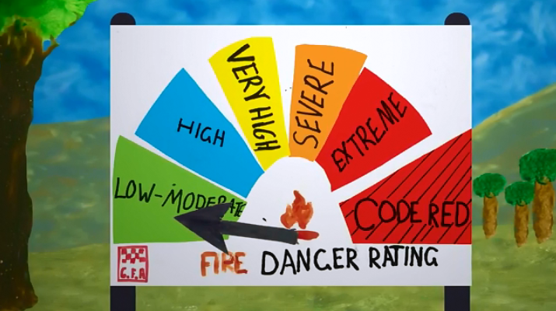
Students will watch this bushfire message made by students at Strathewen Primary School in Victoria to learn more about the fire danger rating system. Students will then research what each of the ratings mean and respond to the following.

- Have you seen a fire danger rating sign before? If so, where would you see a fire danger rating sign?
- What is a fire danger rating?
- What does a fire danger rating tell you?
YouTube: Survive and thrive, a bushfire message from Strathewen Primary School - CFA
- How can you find out what the fire danger rating is each day?
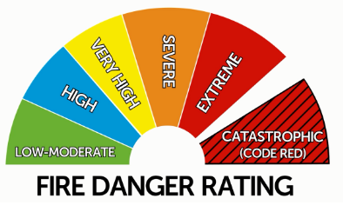
- What is the most dangerous fire rating?
- Who forecasts the fire danger rating each day?

Further investigation
- What do each of the fire danger ratings mean (e.g. weather conditions)?
- What action should you take (for each of the fire danger ratings)?

Bureau of Meteorology: Fire danger ratings in Australia

Taking action
For many young people, being able to help those affected by the bushfires (particularly other children), is really important. Below are some ideas:

Send a message of support
After watching the BTN Bushfire Special encourage your students to write a message of support and post it in the comments section for one of the stories. For more information on how to post a comment visit the BTN website: https://www.abc.net.au/btn/posting-comments/10829874

Connect with a class that has been impacted by the bushfires and send them messages of support, in the form of handwritten letters or a poster.

Thank you letter
As a class brainstorm all the people that have helped during the bushfires in Australia. For example, fire fighters, Australian Defence Force, animal rescue and various charities. Students will then write a letter thanking them for their efforts and help during the bushfires. Alternatively, students may want to create an artwork or video with their messages of support.

Koala conservation
Is your school near or in an area where koalas live? As a class get involved in koala conservation. Students will research koala habitat and then design a school garden to increase the amount of habitat available to koalas. Find out what the main koala food trees are in your area and plant a tree in your school yard. Alternatively contact your local council to volunteer for bush regeneration to help protect koala habitat.

Bushfires Explained
Students will watch the ABC video the Science of Bushfires Explained and answer the following questions:
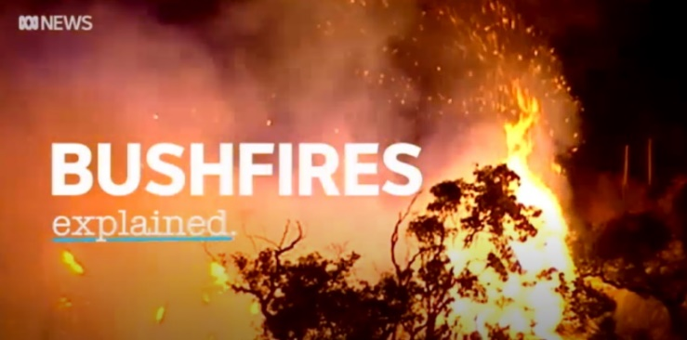
- Since the 1970s fire seasons have been starting…
- What causes fires?
- What three things does fire need to start?
- Fire travels more slowly up a slope than down. True or false?
- What is an ember attack?
- What is the most common way houses catch fire?
- What happened in the Yarloop fire in 2016?
- What type of tree is extremely flammable?

Visual Literacy
As a class, explore the ABC’s before and after photos of areas affected by bushfires. Encourage students to look closely at the images and write down what they notice. Students will choose one of the before and after photos and respond to the following questions:

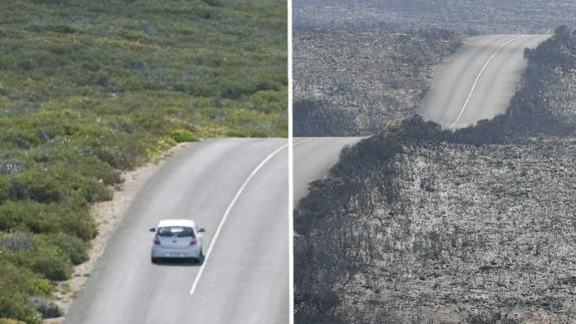
- Where were the photos taken? Find using Google Maps.
- What is happening in the before and after images?
- What do you notice about the before and after images? Make comparisons.
- What does the ‘after’ image tell you about what has happened?
- How do the images make you feel?
- What question/s do you have about the images?
- Create captions for each of the images.
ABC News: Before and after photos of areas affected by bushfires

Animals affected by the bushfires
Students will brainstorm a list of key words that relate to the BTN Bushfires and Wildlife story. Students will then use the words to write their own sentences about the issue. Students may want to use pictures and diagrams to illustrate the meaning and create their own glossary. Here are some words to get your students started.

Ecologist | Species | Threatened
Population | Habitat loss | Endangered

Profile of a native Australian animal
Students will research and develop a profile on a native Australian animal, to gain a deeper understanding of that animal and how it survives in its habitat. Students will choose one of the following animals which were impacted by the bushfires:

- Koala
- Hastings River mouse
- Brush-tailed rock-wallaby
- Alpine bog skink
- Pelican spider
- Ligurian bee

Once students have chosen one animal to research, they will then investigate the following:

- What are some of their physical characteristics?
- What do they eat?
- What animal group do they come from?
- Where can they be found? Describe their natural habitat.
- How do they survive in their environment?
- Compare the habitat requirements to another native animal. What are the similarities and differences?
- Are they an endangered species?
- How has their habitat been impacted by the bushfires?

Further investigation
Students will research one or more of the following questions and then present their findings in an interesting way.
- Describe how some Australian animals use their senses to protect themselves and to find food.
- Investigate the ways in which the bodies of animals assist in their survival.
- Habitat loss is one of the main factors that can lead to a species being threatened with extinction. List how an animal’s habitat might be destroyed or disturbed.
- Can you think of some ways in which we can help prevent loss of habitat for Australian native animals?
- Describe how you would feel if you were a native animal that had been forced out of its environment.

BTN stories
As a class watch one or more of the following BTN stories to learn about bushfires and their impact on people and the environment. After watching any one of the BTN videos ask students to respond to the discussion questions (to find the discussion questions and teacher resources go to the related BTN Classroom Episode and download the Episode Package).

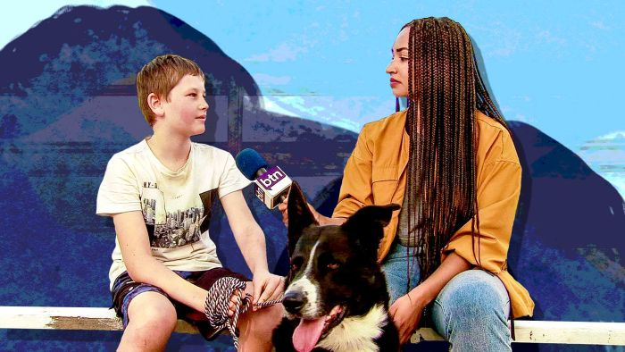  Bushfire Kids Visit | 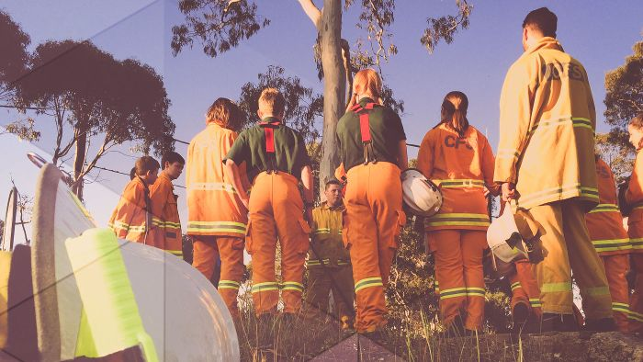  Fire Preparations | 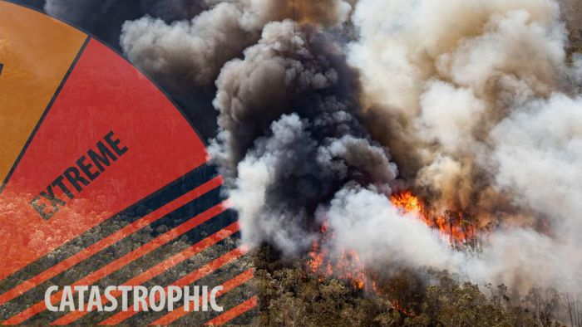  Bushfire Season
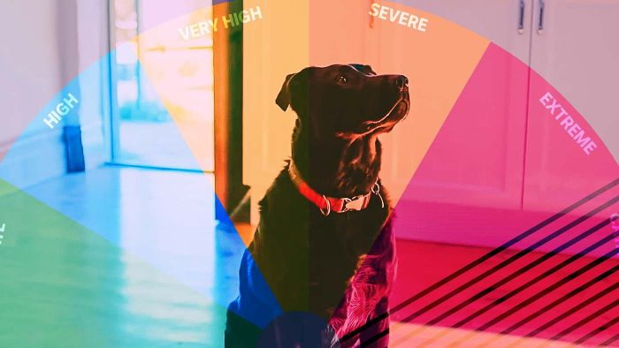  Pet Bushfire Safety | 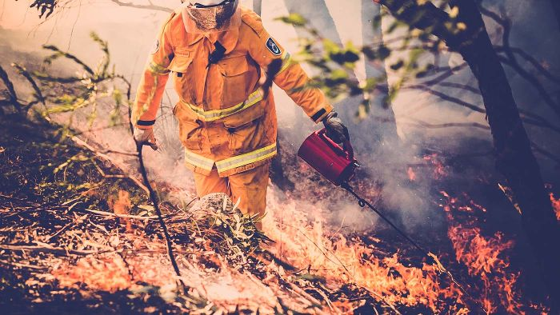  Burn off Season | 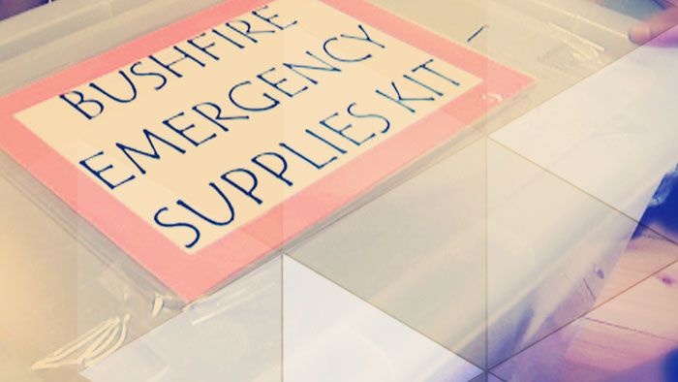  Bushfire Plan


Bushfire Kids Visit – BTN
https://www.abc.net.au/btn/classroom/bushfire-kids-visit/11703500

Bushfire Season – BTN
https://www.abc.net.au/btn/classroom/bushfire-season/11505884

How to talk to your children about Australia’s bushfire emergency - UNICEF https://www.unicef.org.au/blog/news-and-insights/january-2020/how-to-talk-to-your-children-about-australia-s-bushfires

Coping with natural disasters – Kids Helpline
https://kidshelpline.com.au/teens/issues/coping-natural-disasters

Important Things to Remember about Upsetting News – BTN
https://www.abc.net.au/btn/campaigns/upsetting-news/10500572

The bushfires’ path of destruction – ABC News
https://www.abc.net.au/news/2020-01-11/australian-bushfires-photos-before-and-after/11854888

Bushfire Factsheet for Wildlife – Wires
https://www.wires.org.au/wildlife-info/wildlife-factsheets/bushfire-factsheet

How to help animals during the bushfire crisis – RSPCA
https://www.rspca.org.au/blog/2020/how-help-animals-during-bushfire-crisis

Animal bushfire refugees might not be able to return to their habitats for months – ABC News
https://www.abc.net.au/news/2020-01-28/animals-affected-by-bushfires-face-months-before-returning/11903416

BTN Transcript: Episode 1 – 4/2/20

Hey everyone. I'm Amelia Moseley and today I'm here on Kangaroo Island in South Australia bringing you a very special episode of BTN. As you probably know, many Australians are going through a really difficult time right now. Huge bushfires have hit communities right around the country, including here. Millions of hectares of bush and farmland has been burned and thousands of people have lost their homes, their schools and their businesses.

Today we're going to take a closer look at Australia's bushfire crisis. We'll meet kids around the country who have been affected and hear their stories. We'll find out how the fires have impacted Australia's native wildlife and meet some animals getting help and we'll see how people all around Australia and overseas are helping with the bushfire recovery.

Bushfire Recap
Reporter: Cale Matthews

INTRO: But first. Let’s take a look at what's happened over the past few months. We'll find out more about how these fires started, the impact they’ve had, and what's happening now.
In 2019 the bushfire season started early and terribly, mostly caused by lightning strikes. Fires ravaged parts of the East Coast in Spring. Catastrophic fire weather fanned existing blazes and sparked new ones in New South Wales, Victoria, Western Australia and South Australia. By January, fire in some places had combined to form megablazes, cutting off towns and painting skies orange.

Across the East Coast tens of thousands of locals and tourists left the fire zone by car or by ship, in the biggest peacetime evacuation Australia's ever seen, and where there's fire, well there's smoke. These are glaciers in New Zealand, completely covered in smoke from our fires, and these satellite images of South America show just how far it had drifted.

Back home, on the 2nd of January, air quality in Canberra was rated as the worst in the world and many people wore masks just to walk outside. More than 2500 homes have been destroyed and 34 people have died. Across the country at least 18 million hectares of land has burned. To put this in perspective, this is larger than Belgium, Switzerland, Denmark, and the Netherlands combined.

So why has this season been so bad? Well, there's a few reasons. Firstly, Australia is going through a massive drought and in 2019 things were particularly bad, the red on this map shows below average rainfall, and the dark red shows the lowest on record.
Things have also been really hot, the orange here is above average. This means a lot of the trees and grassland had completely dried out, which is the perfect fuel for fire. Over the past few weeks there's been a lot of debate about whether we should be doing more to reduce this fuel, by doing things like cool burning, or hazard reduction fires.This is where small fires are lit in really controlled situations, to get rid of all the extra fuel. Firefighters need perfect weather conditions for these burns to go ahead and they say lately they haven't had as much opportunity.
GREG MULLINS, FORMER NSW FIRE CHIEF: Fires are harder to control so it’s either too wet or it’s too dangerous to burn so our window for hazard reductions is getting smaller and smaller.
Many experts say that’s because of climate change. Around the world there's been a lot of talk about whether Australia's bushfires are a sign of a warming planet. Of course, Australia's always had bushfires, and you can't directly link these fires to climate change, but many experts agree that it is having an impact.
JACKIE TRAD, QLD DEPUTY PREMIER: With an increasing temperature with climate change then what the scientists tell us is that events such as these will be more frequent and they will be much more ferocious.
In some areas the last few weeks has brought some much-needed rain, although in some places it was too much rain, and there was damaging wild weather. But it wasn't enough to put all of the fires out, and last week a new major blaze broke out in the ACT.

A state of emergency has been declared in the territory, and as the bushfire season continues experts say we all need to be aware of the danger, have a fire plan, and do what we can to stay safe.

Bushfire Rookie Reporter
Rookie Reporters

INTRO: Australia’s bushfires have made headlines around the world and lots of people have sent in messages of support and we’re going to share some of those with you throughout the show so keep an eye out for them. Now, as you just heard, these fires have affected thousands and thousands of people including many kids. We've got in touch with some of them over the past few weeks and asked them to share their stories.
ROSE: Hi BTN my name's Rose Thompson and this is where I live. So Cobargo is kinda over those big green hills. The fire came from down this black ridge where it kind of looks like lace on the end and it came down that hill it's kind of green now so it’s hard to tell. But it came down that hill and came on this place here and then went to our home.
RAEMI: Hello BTN my name is Raemi and I live on Kangaroo Island in South Australia. Half of the island basically got burnt and the other side of the island hasn't. But most of the island has got burnt and a lot of the west end got burnt.
JACKSON: This holiday at Mallacoota it was a fun, but scary holiday this time. Our caravan site was right near the wharf which was the evacuation point. When the sirens went, our mum got us out of the van and rushed us to the boat.
RAEMI: So the first fire we were at our house and it was black all over the house and it was really scary and I was like to Mum can we please go this looks really scary we might not be able to see.
ROSE: Because I had never evacuated before it was really scary and me and mum were really worried about it. It was very scary, like it was really really scary. Like I was really anxious, and it was very hard for me to cope with that. It was really smoky, like the smoke was like orange because of the sun. It was really bright orange and it was really hard to breathe we had to keep wearing masks.
JACKSON: Our mum put our swimming goggles on so the smoke wouldn't hurt our eyes and put our masks on. We had to wear our masks all day and everyone was at the wharf watching the fires burn it was near us and listened to the gas bottles explode.
ROSE: So, this is my home burnt down and we think one of our cats Millie is in there which is really sad. I also had a lot of special things, so I'd just been given a whole lot of some Christmas presents and some of them were in there. This was my favourite tree to climb on and as you can see the ground hasn't got much grass on the hills and it’s just very ashy. But there are a lot of burnt trees and some of them have even fallen over, all the leaves have come off them and it’s really, really upsetting because this was once a green lush forest filled with animals and birds and everything all over it but this was my climbing tree and I loved it and now it's kind of been a bit burnt.
RAEMI: When we came back after the first fire it didn't get to our house but it got just to our boundary of our other fence next to our house just about 200 metres from the house and it got through the whole back of the farm. It got about 85% of the farm and that was really scary. So, we lost 400 stock and we didn't lose any of our cows, none of our chooks or horses luckily. I took my horse up to the shed. Because the fire it got really close and we thought it might get close so we took them up to the shed just for safety where it’s all clear of trees and yeah cause my horse was really scared at the moment and she's a bit calmer now but at the moment she wasn't really calm.
JACKSON: We got evacuated by a big helicopter and it was so loud we put ear plugs in our ears and ear muffs over the top and it still was loud. I liked the helicopter because the back door was open most of the time and I was sitting right behind the window. I could see hundreds of acres of burnt trees and forests.
RAEMI: Luckily, we had a local team who helped all the farmers that had trouble with their farm and their stock. They all helped each other bury their stock in some pits and so they didn't have any injured stock just in pain and luckily we got all that done by the first day.
ROSE: It’s really sad that I lost my home but I think you've just got to go deal with it. You've got to go ok well just because my home burnt down doesn't mean I can't be happy, and you can't have fun still. I can still read books and I can still colour in and I can still do all these things that I did before my home burnt down and I think I've just got to be strong.
Bushfires and Wildlife
Reporter: Nat Kelly

INTRO: Now of course, it's not just people who've been affected by these fires. It's also had a big impact on these guys, Australia's native animals. Many have been killed or injured, or like this little one, lost their parents and their homes. But people all around Australia have been rushing to help them out. Let’s find out more.
NATHANIEL KELLY, REPORTER: For many people around the world, these little guys have been the face of Australia's bushfire crisis.
PROF CHRIS DICKMAN, UNIVERSITY OF SYDNEY: We're probably looking at a billion mammals, birds and reptiles that have been affected by the fires. Numbers are huge.
That's Professor Chris Dickman. He's an ecologist. That's somebody who studies wildlife and the environment. And he says that the fires could have a massive impact on some of our most famous animals.
CHRIS DICKMAN: Even currently common species begin to come under real threat for their existence.
While Australia's koala population isn't technically endangered, there are parts of the country where koalas are recognised as 'vulnerable'. And sadly, a lot of these habitats have been hit by the fires. For less common species, like the Hastings River mouse, or the brush-tailed rock-wallaby, the situation's even worse. Even the ones that have survived the fires are now facing habitat loss and food shortages. It's estimated that at least six million hectares of habitat has gone up in flames.
PAUL STEVENSON, RSPCA: Because of the intensity of the bushfires, the vegetation really has been wiped out and we've got animals that have survived with no feed whatsoever.
People are trying to help these hungry animals. For example, in New South Wales they're using helicopters to drop off tons of sweet potatoes and carrots for the wallabies to snack on until their natural food grows back.
There are other creatures in trouble that you might not have thought of, like the endangered alpine bog skink, or this freaky species of assassin spider (also known as a pelican spider), which is only known to exist on Kangaroo Island. Now, some are worried that it might have been completely wiped out.
Then there're these little guys. These Ligurian bees on Kangaroo Island aren't native to Australia, but they are really important because they're thought to be the last pure, disease-free population in the world. And farmers are really worried that it'll take a long time for them to recover.
The same goes for many other Aussie farmers, and now the focus is on treating injured animals and finding food. Volunteer truck drivers have been delivering hay to farmers that need it. Meanwhile, animal carers have been doing what they can for injured wildlife. Like Susie, who's now got four joeys living in her friend's lounge room.
SUSIE PULIS, WILDLIFE CARER: It's a disaster what has happened, but the community has come together and really wanting to help and it’s just awesome to see that.
Animal charities have raised lots of money to go towards everything from treating injured wildlife, to feeding them. And while it's an uncertain time for our incredible creatures, people all around Australia are putting in a big effort to help them out.

Wildlife Interview
Reporter: Amelia Moseley

I'm here at Kangaroo Island Wildlife Park with Sam who has been taking care of hundreds of injured koalas and other wildlife over the past couple of weeks with the help of workers and volunteers. Sam, I can see this little one who has obviously been injured in the bushfires, how is he or she doing?
SAM: Umm, so she's we expect her to make a full recovery. She's eaten plenty of food and those wounds are healing over quite nicely, so hopefully we can get her back out into the wild as soon as possible.
AMELIA: And so, Sam what is special about these koalas? They’re a little different right to koalas on the mainland?
SAM: Yeah, that's right. They were introduced to Kangaroo Island in the 20s and they were introduced to establish a disease-free population. A few weeks ago, we had somewhere up to 60 thousand disease-free koalas here on Kangaroo Island, which was considered the insurance population for the koalas on the mainland that aren't doing so well. But unfortunately, we estimate we've lost about 80 per cent of those koalas.
AMELIA: So have these koalas been getting here? Have you been going out and picking them up or have other people been bringing them in?

SAM: Umm, a bit of both. So, we do a lot of call outs, people that ring us. I'll head out on the road and grab a few and most of the time I'll find even more, and people just bring them in all hours of the day. We've been seeing anything from 30 to 50 a day. We assess the damage, check all their organs because a lot of them are suffering from smoke inhalation. And if we think that they can pull through the vets will do their thing and start their treatments and we repeat that daily.
AMELIA: You had all the little toys in there with the other koalas, so is that because they're just missing their mums and dads?
SAM: The teddy bears in there, they think that that's their mum. But because there are so many koalas together at the moment - they're just cuddling each other, you know? Which is pretty cool. Comfort in each other.
AMELIA: What other animals have you been rescuing and caring for here?
A lot of kangaroos and wallabies, possums and some of those little more unique guys that you might not have heard of: southern brown bandicoots, we've seen some little pigmy possums, echidnas, a few different bird species have started to come through, yeah just you never know what you're going to get on the day.
AMELIA: Do you feel like you've been getting a lot of support from people in Australia and overseas?
SAM: Absolutely. The enclosure we're standing in at the moment was built by the army. So, we have anywhere from 10 to 15 army personnel here every day and even our vets; we have army vets working here and those guys have been awesome. We get that many phone calls, messages, people flying in from interstate or even around the world to offer their support. I'm actually really surprised at how far it did go, some of the countries that we've been getting support from I've never even heard of them. It's been amazing.
Fire Heroes
Reporter: Olivia Mason

INTRO: Well it looks like these little guys are in good hands but they're going to need a lot of help and one thing we've seen over the past few weeks is that there are plenty of people who are willing to lend a hand and help those affected by the bushfires. Let’s find out more.

Whether it was putting their lives on the line to save communities, lending a hand to rebuild a fence sharing a place to stay or a meal or even just a big friendly hug. We've seen many Australians come together to help each other through one of the country's worst natural disasters.
ANDREW DALE, VOLUNTEER ORGANISER: I've never seen so many happy people. Happy to go to the shops and spend 500 dollars or 1000 dollars. It's just been incredible. It's just been incredible.
GOVERNOR GENERAL, DAVID HURLEY: There's strength in bonding together and I think we've rediscovered what being neighbours and community and living in the same street means. Look after each other.
For months now firefighters have been working tirelessly to put out the fires and save peoples' homes.
Many of them are volunteers. In fact, more than 195 thousand Aussies volunteer for firefighting services across the country and lots of them spent time away from their families over Christmas and the New Year to help fight the fires. Crews from New Zealand, the USA and Canada also came over to help.
To many they're heroes. People have been showing their thanks with signs, events and even a special feature on the Sydney Opera House. Good job guys, good job. A big focus of this year's Australia Day celebrations was honouring those men and women for their service and bravery.

What a job. Who can do that job.? They're amazing.

First time ever I felt really proud, I felt like jumping out of the truck and saluting to everybody, but I couldn't.

The Australian Defence Force has also played a big role. They helped to evacuate people from the fire zones and now, thousands of workers are in fire affected communities around the country. Where they're delivering hay, repairing properties and, well, doing whatever else they can to help out communities.
We got some help from overseas too, like these New Zealand soldiers who were over on Kangaroo Island helping out. Lots of everyday Aussies have been chipping in too.
In 2 days we collected crazy amounts of food and we're here to give it to people who need it.

DAVE MCNAMARA, CEO FOODBANK VICTORIA: We've got cars backed up two blocks that way and two blocks up north as well. The public have just been unbelievable at coming together to support each other.
Plenty of kids have been doing their bit by volunteering or raising money. These guys from Whyalla wrote a song about the bushfire crisis to raise funds.

Our youth member Emily has recorded the song and put it on Facebook and in the first hour we raised a thousand dollars for the CFS.

And these kids in Singapore are taking part in a massive walking fundraiser.
SINGAPORE KIDS: At the moment we're doing a 15 kay walk to help raise money for the bushfires in Australia.
Heaps of celebrities have getting behind fundraising efforts too. Aussie comedian Celeste Barber started a fundraiser on Facebook, aiming to hit 30,000 dollars, and it kinda took off.
CELESTE BARBER, COMEDIAN: Remember that time that you guys raised 16.5 million dollars in a day and a half, I do, I'm bumping it up, I'm gonna bump it up to 20 million.
Well, it's now hit more than 50 million. And Celeste isn't the only one, the list of people who've donated big bucks to bushfire relief is huge and includes some big names like Ellen DeGeneres, Pink and Leonardo DiCaprio's Earth Alliance Foundation.
NICOLE KIDMAN, ACTOR: Keith and I are pledging 500 thousand to all of the services the rural services fighting the fires right now.
Fundraising efforts have also been a big part of summer sport.
ASH BARTY, TENNIS PLAYER: You know, any of my prize money here in Brisbane will be donated to the Red Cross.
Nick Kyrgios even suggested a fundraiser night before the Australian Open. Tennis superstars like Serena Williams, Rafael Nadal and Roger Federer got involved and raised almost 5 million dollars.
Of course, there's a lot of work ahead for communities still battling bushfires and it'll be a long process to rebuild and repair what's been lost. Some things can never be replaced, but there's no doubt that the community spirit in Australia is alive and well. And that everyone will keep working together through this devastating summer.

Closer

Well that's about it for today’s show, but we'll be back next week with a regular episode of BTN and in the meantime you can catch up with the news on BTN Newsbreak every weeknight. Before we go, I’d like to say a big thank you to everyone who's been a part of this show and, of course, to all of the awesome people here on Kangaroo Island. And remember if you're ever feeling upset or overwhelmed by news about the fires, that's totally natural so make sure you speak to someone about it. There's also some information on our website about how to deal with

