KEY LEARNING
Students will explore the process for constitutional change through a referendum and learn more about the Voice to Parliament.

CURRICULUM
HASS – Year 5
The influence of people, including Aboriginal and Torres Strait Islander Peoples, on the environmental characteristics of Australian places.

HASS – Year 6
Experiences of Australian democracy and citizenship, including the status and rights of Aboriginal and Torres Strait Islander Peoples, migrants, women and children.

Key figures, events and ideas that led to Australia’s Federation and Constitution.

HASS – Year 7
Sequence information about events, developments, periods and phenomena using a variety of discipline-appropriate formats and conventions including chronological frameworks that use dating conventions.

Civics & Citizenship – Year 7
The process for constitutional change through a referendum.

  - Teacher Resource

Voice Referendum

Focus Questions
- In pairs or small groups, discuss the BTN Voice Referendum special.
- What does Indigenous Voice to Parliament mean?
- The idea for a Voice to Parliament came from a meeting in 2017 with Indigenous delegates. What is the name of the document that was written?
- A referendum is needed if you want to change Australia’s __________________.
- Can you think of reasons why Indigenous voices may not have been heard in the past?

This document contains the names and images of Aboriginal and Torres Strait Islander people now deceased. It also contains links to sites that may use images of Aboriginal and Torres Strait Islander people now deceased.

Activity: Class Discussion
After watching the BTN Voice Referendum special, hold a class discussion using the following discussion starters.
- What is a referendum?
- What is the Voice to Parliament?
- Why do we need a referendum?
- When will the referendum happen?
- What needs to happen for the referendum to be successful?
- What questions would you like to ask about the Voice to Parliament?
- What questions do you have about referendums?

Glossary
Students will brainstorm a list of key words that relate to the BTN Voice Referendum special. Here are some words to get them started.
VOICE TO PARLIAMENT | REFERENDUM | CONSTITUTION
ULURU STATEMENT FROM THE HEART | FIRST NATIONS VOICE | CONSTITUTIONAL RECOGNITION

Activity: Referendum Research
Discuss the information raised in the BTN Voice Referendum special. What questions were raised in the discussion and what are the gaps in students’ knowledge? Students will develop their own question/s to research or choose one or more of the questions below. Encourage students to collect and record information from a wide variety of sources and present the information they find in an interesting way.
- What is the Voice to Parliament? Write a summary which answers the 5 W’s – Who, What, Where, When and Why? Include the following words in your explanation: Uluru Statement from the Heart, referendum, First Nations Voice and constitution.
- What is the Australian Constitution? When and why was it written?
- What are the steps to change the Australian Constitution? Explain the process of a referendum. How many votes does a referendum need to be successful?
- How many referendums have been held in Australia? Use a timeline to highlight important referendums in Australia.
- Why was the 1967 Referendum important in Australia’s human rights history? Use the term constitutional recognition in your explanation.
- Create a timeline of significant events that have contributed to equal rights for Aboriginal and Torres Strait Islander Peoples. Write a summary for one key event, which answers the 5 W’s – Who, What, Where, When and Why?

Activity: Uluru Statement from the Heart
Students will learn more about the Uluru Statement from the Heart and its calls for changes to the Australian Constitution. More information about the statement can be found here. Students respond to the following questions:
- What is the Uluru Statement from the Heart?
- What led up to the Uluru Statement from the Heart?
- The three main components of the Uluru Statement from the Heart are Voice Treaty Truth. Explain what is meant by each in relation to the statement.
- In the statement it says In 1967 we were counted, in 2017 we seek to be heard. Why is being heard and having a voice important?

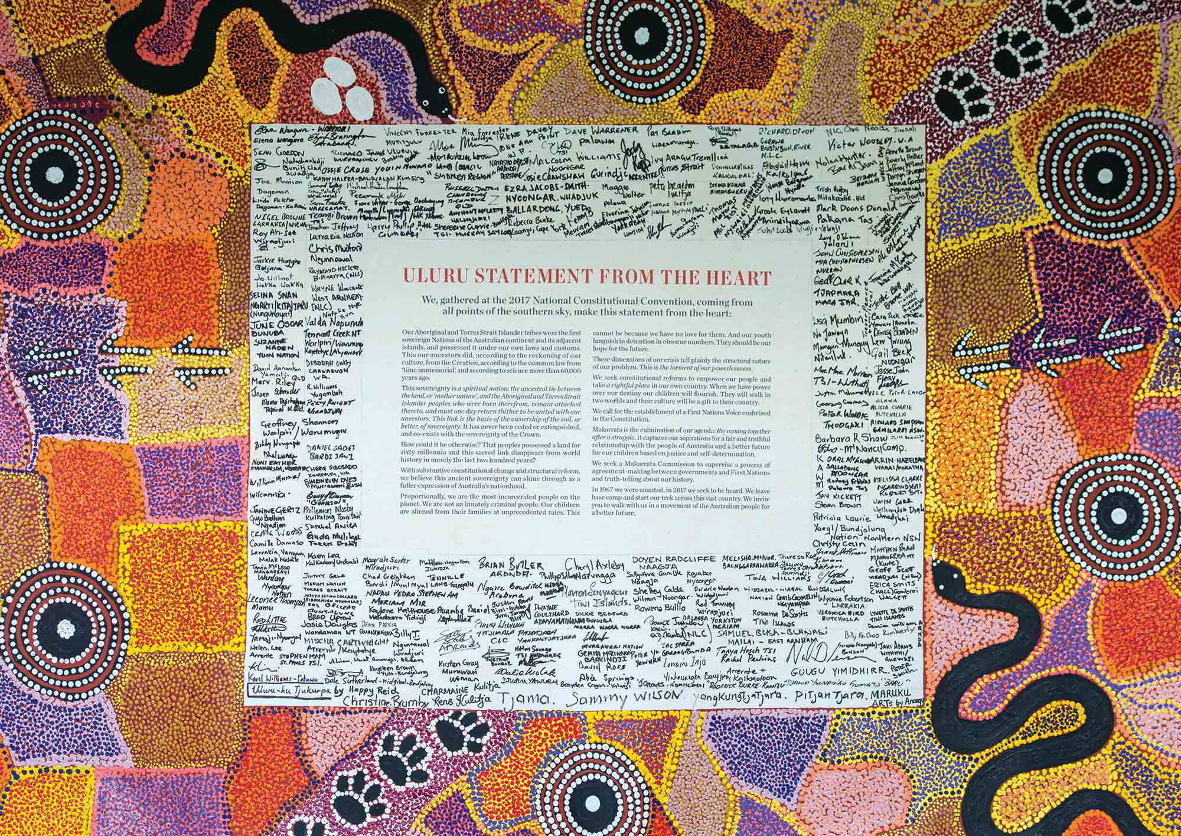

Activity: The Right to Voice
Class Discussion
To help students understand the right to voice, hold a class discussion asking students if they know what it means to have a voice. Ask students to share their own thoughts and experiences related to expressing their opinions and being heard. Use a mind map to record students’ responses to the following questions.
- Do you know what it means to have a voice?
- Why do you think it is important to express yourself?
- Think about a situation in your life where you have felt your voice was important.
- How does it feel when you are not able to share your thoughts or ideas?
- Have you ever been in a situation where you wanted to speak up but couldn't? What happened?
- How do you feel when you get to have your say?
- How can we make sure everyone has a chance to voice their opinion in class or at home?
- What are some real-life examples of people using their right to voice? For example, protesting for change, voting, writing an article or book or speaking up in school meetings.

Explain to students that rights come with responsibilities. Discuss the importance of expressing oneself responsibly, such as:
- Respecting the rights and opinions of others.
- Using language that is respectful and avoids harm.
- Understanding the consequences of our words and actions.

Reflection
Ask students to write a short paragraph reflecting on why they believe it is important for all individuals to have a voice in society. Explain to students that the right to voice is essential in a democratic society. Having the right to voice allows people to participate in decision-making, share their experiences, and advocate for change.

Activity
Students will think about what is important to them in their community and express this creatively through a letter to their local Member of Parliament, an artwork, or a poem. Before starting this activity, students will think about what they appreciate about their community, the issues they observe and what they would like to see improved. Students will write their ideas and thoughts using dot points or on post-it notes.

Letter to your MP
- Write a letter to your local Member of Parliament (MP).
- Your letter will need to address the issues or improvements you would like to see in your community.
- Include language that is persuasive, respectful, and specific.
Artwork
- Create an artwork that represents your thoughts and values about your community.
- Your artwork can include drawings, painting, collages or other mediums.
- Use colours, symbols and imagery that help convey your message.
Poetry
- Write a poem to express your feelings and thoughts about an issue in your community that is important to you.
- Use imagery and descriptive language to help convey your message.
- It could be haiku, acrostic, black-out or another type of poetry.

Activity: Exploring Australia’s Constitution
In this activity students will explore what the Australian Constitution is, including its purpose, history, and significance. Begin by asking students if they have heard about the Australian Constitution and if they know what it is.

Consider providing a copy of the Constitution to your students to look at. There are several ways for students to explore the Australian Constitution, including:
- Download and print a copy of the Australian Constitution (Parliament of Australia). Students can bind their own copies of the document with red ribbon.
- View an online copy of the Australian Constitution (PEO). This online document allows you to skip to various chapters within the document.
- Purchase a pocket edition of the Australian Constitution (PEO)

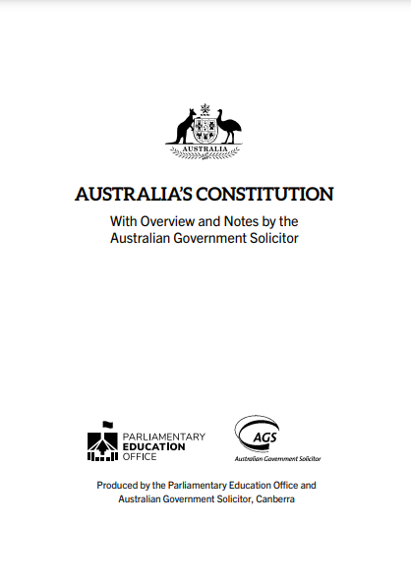 | 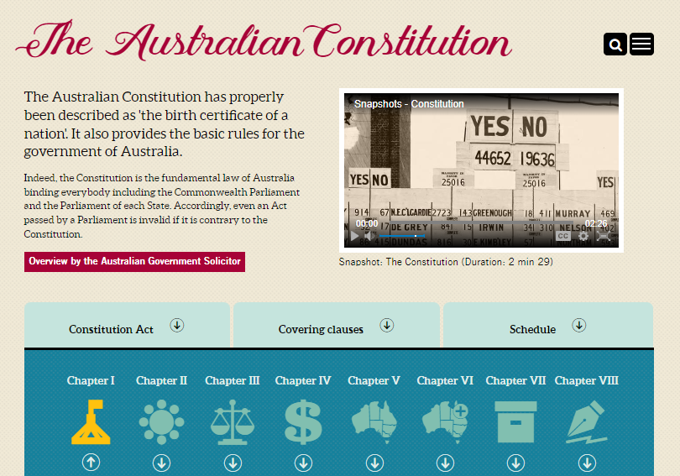 | 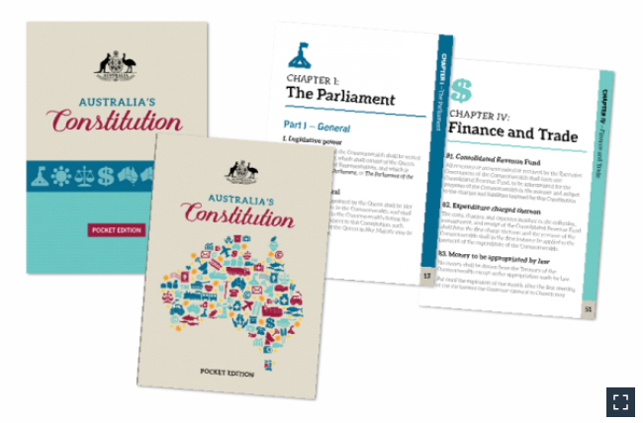

Australia's Constitution can be used by classroom teachers when undertaking a unit of work on the Constitution. The PEO highlights parts of the Constitution which are useful to explore as a class. Use the Constitution as a starting point to explore the following topics:
- the right to vote (section 41)
- the powers of the Australian Parliament (sections 51 and 52)
- how the Constitution can be changed (section 128)

Activity: Classroom Constitution
In this activity, students will work together to create a classroom constitution, understand the importance of making decisions democratically, and then participate in a class referendum to vote on classroom rules.

Classroom Activity
Students will create their own classroom constitution and then hold a class referendum. Facilitate a class discussion to get your students thinking about what their classroom constitution might look like.
- Work as a class to brainstorm a list of values. Choose 5 core values, with each value having its own constitutional statement.
- Think of some rules and expectations of your class.
- How will you make sure all students are treated fairly and can have their fair say?
- How would it make you feel if you were left out of your classroom constitution?

Steps to creating a classroom constitution and holding a class referendum:

Consider your classroom as a country. Give your country a name and describe how it is run (rules and procedures). This is your classroom’s constitution.

Review and discuss your classroom constitution; does it include equal rights for everyone in your class? How can you improve it? Suggest any changes you would like to make to your classroom constitution. Remember any changes to your classroom constitution need to be voted on in a referendum.

As a class write a referendum question. Explain arguments for and against the change you want to make to your classroom constitution. Use this PEO activity to help run your class referendum.

Hold a classroom vote asking to either approve or reject the suggested change to your classroom constitution. Create a ballot paper and polling booth to lodge your votes. Visit the AEC to see what a ballot paper looks like and learn how to vote in a referendum.

Count the votes.

Activity: Visual literacy
Below are photographs depicting significant events in Australia’s history of Indigenous citizenship rights. Look at the images below (alternatively find your own images using the internet) and then respond to the following questions:

- What is happening in the image?
- Where do you think it was taken?
- How do you think the people in the image might be feeling? Describe the mood of the photograph.
- Is there a message about democracy that comes across in the image? Explain.
- What question/s would you like to ask the people in the image?
- Create a caption for each image.

After students have responded to the above questions click on the link for each image to find out what is happening and learn more about this significant event.

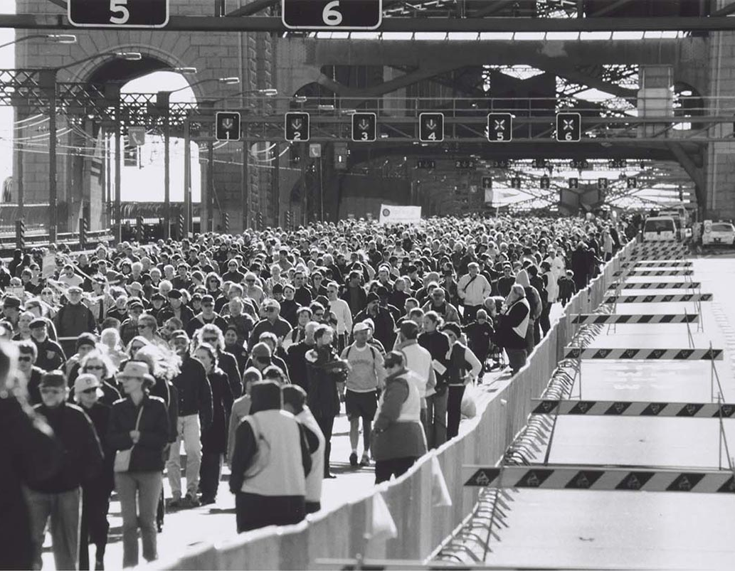  Image – National Museum Australia  BTN story – Bridge Walk Anniversary | 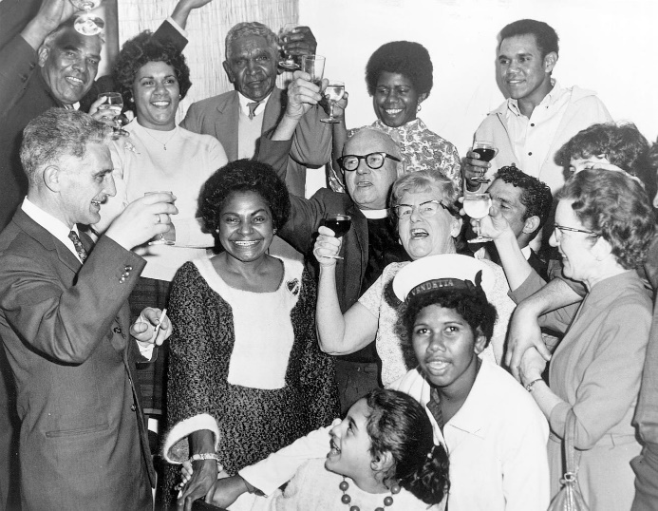  Image – National Museum Australia  BTN story – Referendum Campaign
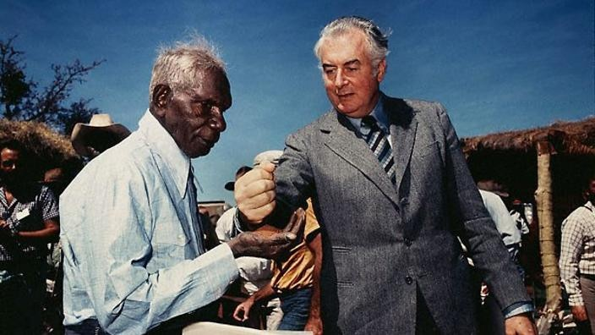  Image – National Museum Australia  BTN story – Wave Hill | 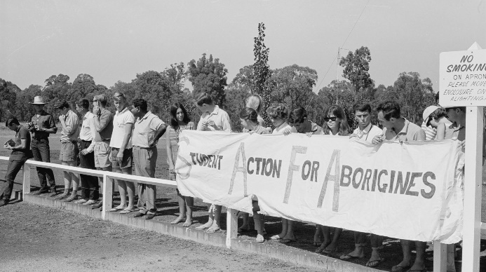  Image – National Museum Australia  BTN story – Freedom Ride

Students will create a timeline which looks at key events in Australia’s reconciliation history. Students will include the following in the timeline: Mabo decision, Native title, 1967 Referendum, Bridge Walk, National Apology, Redfern Speech, Bringing them Home report, tent embassy, Close the Gap campaign and Uluru Statement from the Heart.

Useful Websites
- Voice to Parliament – BTN
- Australia’s Constitution – BTN
- Referendum Campaign – BTN
- Referendums and Plebiscites – PEO
- The Statement – The Uluru Statement
- Referendums and Plebiscites – PEO

