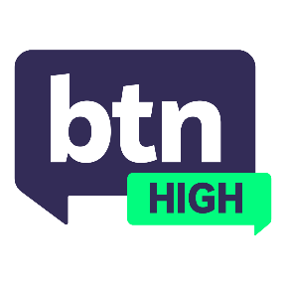
EPISODE 1
7th February 2024

KEY LEARNING
Students will explore the impact the sun has on our skin. They will investigate the importance of sun safety and the effects of UV radiation. Students will observe how a skin-check is performed.

CURRICULUM
Health and PE – Years 7 & 8 (v8.4)
Health and PE – Years 7 & 8 (v8.4)
Health and PE – Years 7 & 8 (v8.4)

Health and PE – Years 9 & 10 (v8.4)
Health and PE – Years 9 & 10 (v8.4)
Health and PE – Years 9 & 10 (v8.4)
Earth and Environment Science – Unit 2 (v8.4)

Health and PE - Years 7 & 8 (v9.0)
Health and PE - Years 7 & 8 (v9.0)
Health and PE - Years 9 & 10 (v9.0)

  - Teacher Resource

Tanning Culture

Focus Questions
Discuss the BTN High story as a class and record the main points of discussion. Students will then respond to the following:
- What does UV stand for?
- Which country has the highest rates of melanoma in the world?
- What is the biggest cause of melanoma?
- How many Australians are likely to be diagnosed with some form of skin cancer in their lifetime?
- Based on recent research from the Department of Health, what percentage of young Aussies don’t think they’re at risk of developing skin cancer?
  - 24%
  - 54%
  - 74%
- How many types of skin cancers are there?
- Can you name them?
- What are the 5 forms of sun protection?
- What do you do to stay safe in the sun?
- What kinds of sun safety campaigns do you think would be beneficial to young Australians?

Activities
- Research Australia’s sun safety campaigns of the past and present. In your opinion, explain which ones have the most impact.
- Create a brochure for young people that promotes sun safety.
- Design a tool or strategy that could be used to record or track your UV exposure.
- Create a social media campaign/video to educate teenagers on how to protect themselves from sun exposure.
- Research and write a report about a sun safety campaign from another country. Explain the similarities and/or differences to Australia’s sun safety campaigns in the past/present.

