

Electric Car Future
- Briefly summarise the BTN Electric Car Future story.
- When was the first electric car developed?
- What were some of the pros when petroleum powered cars were first developed?
- Why are some car manufacturers moving away from petrol and diesel fuelled cars?
- What does EV stand for?
- Complete this sentence. Electric cars don’t produce as much air _____________.
- What do experts say we need more of if more people start driving EVs?
- Why aren’t there many EV models available in Australia?
- What did you learn watching the BTN story?
- What questions do you have about the BTN story?

High-Speed Hyperloop
- Discuss the BTN High-Speed Hyperloop story with another student.
- What company built the Hyperloop?
- The company is hoping that the Hyperloop will be able to go more than…
  - 200 km per hour
  - 1,200 km per hour
  - 2,200 km per hour
- How long would a trip from Melbourne to Sydney take?
- The reason the Hyperloop can go so fast is the lack of friction. What does that mean?
- What helps the capsule glide along in the tube?
- Who came up with the idea of the Hyperloop?
- What other new travel technology is being developed?
- Illustrate an aspect of the High-Speed Hyperloop story.
- What questions do you have about the story?

Flying Cars
- Briefly summarise the BTN Flying Cars story.
- What does the flying car look like? Describe.
- Who built the car?
- How high did the flying car hover above the ground?
- How long did the flying car stay up in the air?
- When do they predict we will be using flying cars?
- When was the first flying car to successfully take flight built?
- What challenges are there in building a flying car? Give two examples.
- What are some advantages of having flying cars?
- Do you think having flying cars is a good idea? Give reasons for your answer.

Teacher Resource
Electric Car Future

Students will investigate the pros and cons of electric vehicles.


Science – Years 5 & 6
Scientific knowledge is used to solve problems and inform personal and community decisions.

Communicate ideas, explanations and processes using scientific representations in a variety of ways, including multi-modal texts.
Science – Year 7
Solutions to contemporary issues that are found using science and technology, may impact on other areas of society and may involve ethical considerations.

Design and Technologies – Years 3 & 4
Recognise the role of people in design and technologies occupations and explore factors, including sustainability that impact on the design of products, services and environments to meet community needs.

Design and Technologies – Years 5 & 6
Examine how people in design and technologies occupations address competing considerations, including sustainability in the design of products, services, and environments for current and future use.
- Briefly summarise the BTN Electric Car Future story.
- When was the first electric car developed?
- What were some of the pros when petroleum powered cars were first developed?
- Why are some car manufacturers moving away from petrol and diesel fuelled cars?
- What does EV stand for?
- Complete this sentence. Electric cars don’t produce as much air _____________.
- What do experts say we need more of if more people start driving EVs?
- Why aren’t there many EV models available in Australia?
- What did you learn watching the BTN story?
- What questions do you have about the BTN story?


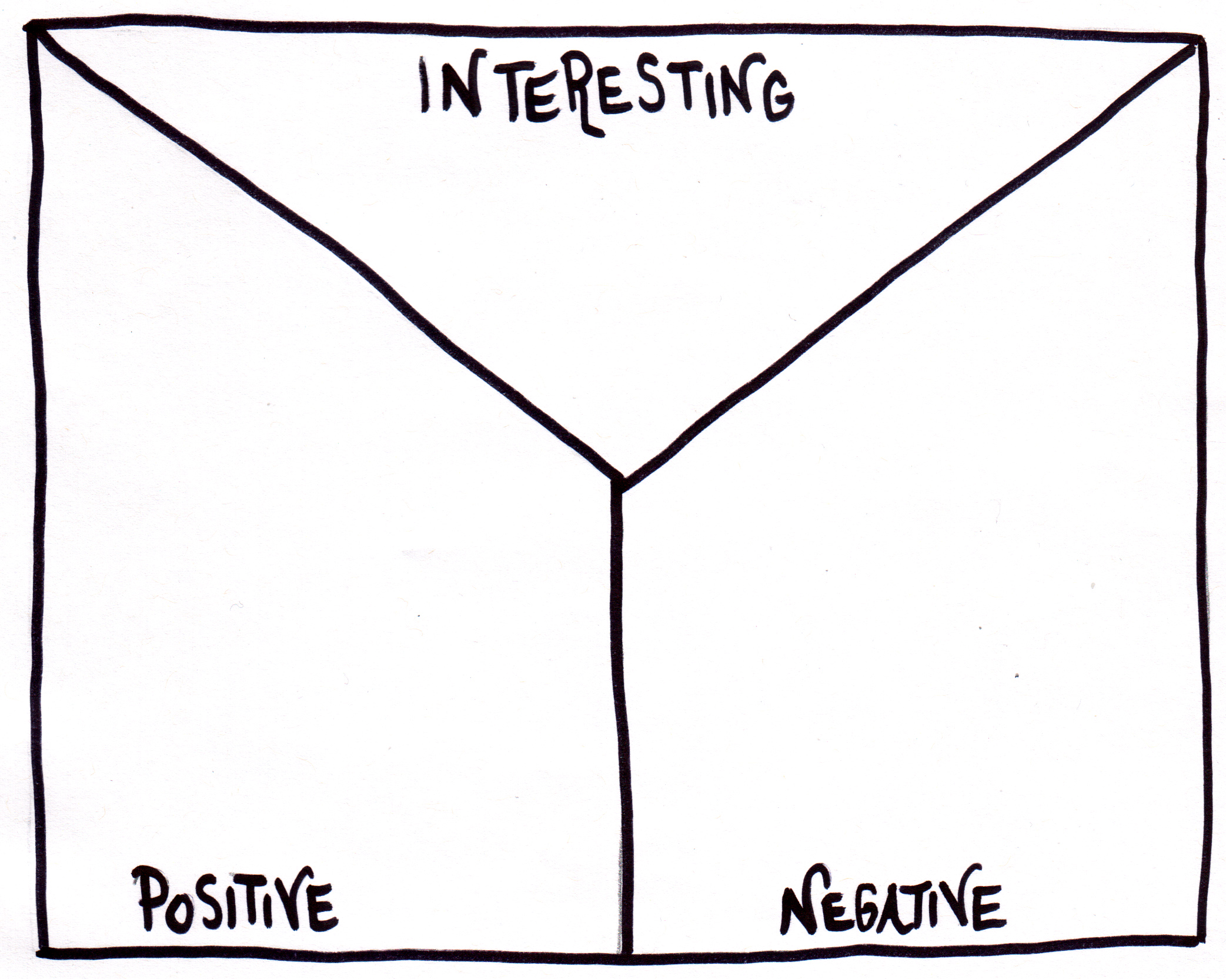
Note taking
Students will practice their note-taking while watching the BTN Electric Car Future story. After watching the story, ask students to reflect on and organise the information into three categories.
What information about this issue was...?
- Positive
- Negative or
- Interesting

Key Words
Students will develop a glossary of terms that relate to electric cars. Below are some key words to get them started:

Fossil fuels | Emissions | Hybrid cars
Electric vehicle | Internal combustion engine | Air pollution

Research

Define: What do I want to know?
Key questions to research
Students can choose one or more of the following questions or come up with their own:
- How are electric cars different to cars fuelled by petrol, diesel or gas?
- What happens if you run out of charge and you’re not near a charging station?
- How far can an electric car go on a single charge and how long do they take to recharge?
- Why are alternatives to petrol or diesel cars being explored?
- What emissions do cars produce and why are they a problem?
- What are the pros and cons of electric cars?
Locate: Where do I find the information?
What resources will help answer my questions? (Internet, people, resource centre, organisations, print). Discuss with students what a reliable source is.

Select: What information is important for the investigation?
Students may need support to sort through and select relevant information.

Organise: How do I make sense of the information?
Students can organise their research by creating main headings from their questions. Write each heading on a separate piece of paper. Record the information found for each question.

Present: How do we let others know about this information?
Each group needs to discuss then decide on the best way to present the information. Possibilities could include:
- A `Did You Know’ Facts sheet
- Infographic
- Oral presentation
- Prezi presentation
- Create an infographic using Canva

Evaluate: What have we learnt?
Each group reflects on what they have learnt about electric cars during their investigation. Students will reflect on their learning and respond to the following.
- What I learned...
- What I found surprising...
- What I would do differently next time…

Pros and cons
Students will research the pros and cons of electric cars organising their information into two columns. Students will use their research findings to help plan and create an information poster.

Information poster
Students will design a poster or infographic which illustrates one or more of the benefits of electric cars.
- Think of ways that electric cars can help people, the environment and/or the economy.
- Write down your key message that you want to get across. It can be a sentence or a short slogan.
- Create your poster.
- Share and explain your poster design with the class.
- Display your artworks around your school or local community to raise awareness about the topic.

Car of the future
Before starting this activity, hold a class discussion, asking students what sort of car they think they will be driving in 50 years’ time?

Students will then design an eco-friendly car of the future, with the aim to decrease air pollution. Students will consider the impact that vehicles have on our planet and then design a car that causes as little harm as possible to the environment. Students will need to consider the following:

- Provide a drawing of the car with labels to show its features.
- Choose a body size, engine size, fuel type and accessories.
- What speed will your car travel?
- What materials will be used to make your car?
- What are the interior and exterior features?
- What new technologies will you incorporate in your design?
- How will the car benefit people and the environment?
- Why is your design the best one for your community?
- Present your design to the class.

BTN Solar Transport story
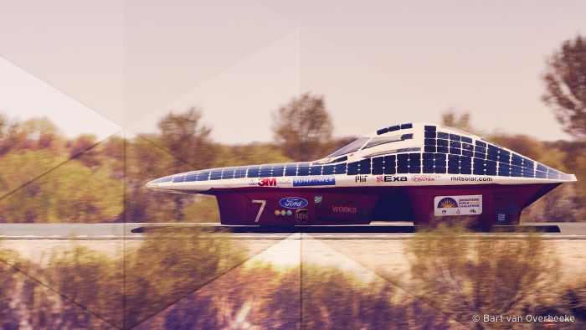
- Before you watch the BtN story, record what you know about solar powered cars.
- Where does the World Solar Challenge start and finish?
- How far do the cars travel?
- The event’s been running since the 1980s. How have the cars changed over time?
- What sort of engines do solar powered cars have?
- Where is the electricity stored?
- How has the technology improved in recent years?
- What are some disadvantages of solar powered cars?
- What do you think is the future of solar powered cars? Explain your answer.

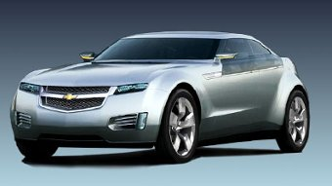
BTN Hybrid Cars story
- Why are alternatives to fuel-powered cars being investigated?
- What is a disadvantage of an electric motor?
- What is a hybrid car?
- In your own words, describe how a hybrid engine works.
- What are the benefits of hybrid cars?
- List the disadvantages of hybrid cars?
- What are some other car technologies on the horizon?
- What do you think the Government should be doing to support petrol alternatives?
BTN Petrol Car Ban story
- Summarise the BTN story
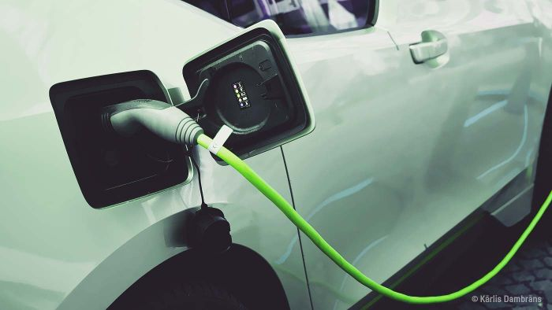
- In which decade were electric cars introduced?
- What are the advantages and disadvantages of petrol engines?
- Which state recently announced it will have charging stations along a ‘super highway’?
- Electric vehicles are cheaper to run and they’re cheaper to maintain. True or false?
- What other energy sources are used to power cars?
- Do you think Australia should phase out petrol and diesel-powered cars? Give reasons for your answer.


BTN Petrol Car Ban
http://www.abc.net.au/btn/classroom/petrol-car-ban/10522652

BTN Electric Cars
http://www.abc.net.au/btn/classroom/electric-cars/10528362

BTN – Hybrid Cars
http://www.abc.net.au/btn/classroom/hybrid-cars/10541082

BTN – Solar Cars
http://www.abc.net.au/btn/classroom/solar-cars/10533412

ABC News – Labor climate change policy proposes tax breaks for businesses to by electric cars
https://www.abc.net.au/news/2019-04-01/labor-proposes-tax-breaks-for-businesses-to-buy-electric-cars/10957268

Teacher Resource
High-Speed Hyperloop
Students will generate and communicate design ideas for future modes of transport. Students will design a mode of transport that has minimal impact on the environment.

Design and Technologies – Years 3 and 4
Recognise the role of people in design and technologies occupations and explore factors, including sustainability that impact on the design of products, services and environments to meet community needs.

Generate, develop, and communicate design ideas and decisions using appropriate technical terms and graphical representation techniques.

Design and Technologies – Years 5 and 6
Examine how people in design and technologies occupations address competing considerations, including sustainability in the design of products, services, and environments for current and future use.

Generate, develop and communicate design ideas and processes for audiences using appropriate technical terms and graphical representation techniques

Design and Technologies – Years 7 and 8
Generate, develop, test and communicate design ideas, plans and processes for various audiences using appropriate technical terms and technologies including graphical representation techniques.

- Discuss the BTN High-Speed Hyperloop story with another student.
- What company built the Hyperloop?
- The company is hoping that the Hyperloop will be able to go more than…
  - 200 km per hour
  - 1,200 km per hour
  - 2,200 km per hour
- How long would a trip from Melbourne to Sydney take?
- The reason the Hyperloop can go so fast is the lack of friction. What does that mean?
- What helps the capsule glide along in the tube?
- Who came up with the idea of the Hyperloop?
- What other new travel technology is being developed?
- Illustrate an aspect of the High-Speed Hyperloop story.
- What questions do you have about the story?

What do you see, think and wonder?
After watching the BTN High-Speed Hyperloop story hold a class discussion, using the following as discussion starters:
- What do you THINK about what you saw in the BTN High-Speed Hyperloop story?
- What does this video make you WONDER about the future of transport?
- Think of three QUESTIONS you have about the story.
- What did you LEARN from the BTN story?

Class Discussion
After watching the BTN High-Speed Hyperloop story, students will respond to the following questions:
- What is the Hyperloop?
- How does it work?
- What type of energy is used to power the Hyperloop?
- How is it different to traditional rail travel?
- What are the benefits of the Hyperloop?
- When do they predict it will be operating?

Inquiry
Discuss the story as a class and ask students to pose questions about current transport and the future of transport. They can develop their own key questions to investigate or respond to one or more of the questions below. Students can complete the following KWLH organiser to explore their knowledge and consider what they would like to know and learn. Below are some possible questions for students to research.

What do I know? | What do I want to know? | What have I learnt? | How will I find out?

- How has transport changed over time in Australia? Research the history of transport and present your findings on a timeline.
- What are some of the fuels that vehicles use? Which fuels cause the most and the least amount of pollution? What is the best fuel for the environment?
- How do planes fly? Investigate what parts of the design help it to fly. Make your own paper plane or glider and experiment with wing shape to help it fly.
- What are the pros and cons of electric cars? Think of ways that electric cars can help people, the environment and/or the economy.
- How have cars changed since their invention? Explore the history of cars in more detail and create a timeline of significant events. Alternatively, choose another mode of transport to explore in more detail and plot your findings on a historical timeline.
- What is sustainable travel? Think of ways that you can be sustainable while travelling.
- Make a prediction about how transport will change in the future. Illustrate your predictions.


Drawing activity
Exquisite corpse is the most famous of all the surrealist games and was invented by Andre Breton and the surrealists in the 1920s. The surrealists were a group of artists and poets who loved breaking the rules of art and finding new ways to look at the world. Exquisite corpse is a method by which a collection of words or images is collectively assembled. Each collaborator adds to a composition in sequence, either by following a rule, or by being allowed to see only the end of what the previous person contributed.

In this activity students will use their imagination to illustrate a futuristic mode of transport using the exquisite corpse game. Working in groups of three students will use the following instructions.


How to:

- Fold an A4 piece of paper into three equal parts.
- The first person begins the drawing in the top third piece of the paper. Using a black tip pen, draw the top of a mode of transport – you can be as creative as you like! When finished, fold over the piece of paper so only the very edge of the drawing can be seen. This will help the next person know where to start their drawing.
- The second person will then draw in the middle part of the piece of paper. Draw the middle section of a mode of transport – real or imagined. Then fold the piece of paper so only the very edge of the drawing can be seen. Pass it on to the next person.
- The third person will draw in the bottom section of the piece of paper. Draw the bottom of the mode of transport.
- NOW – SHARE!

Reflect

Students will reflect on the activity by responding to the following questions:
- What did you enjoy about this activity?
- What did you find surprising?


Future of Transport
Before starting this activity, hold a class discussion, asking students what sort of transport they think they will be using in 50 years’ time? Think about safety, environmental impact, sustainability, power sources and innovation.

In small groups, students will imagine they are engineers and design a new mode of transport or make a modification to a current mode of transport (e.g. to improve the design or function of a car). Ask students to respond to the following:

- How can transport be improved? For example, it could be more environmentally friendly, or it could be safer. What’s the problem and what are some solutions to the problem?
- Write a brief for your design, using these headings as a guide: Background, Criteria, Your Challenge, Constraints.
- Sketch a drawing of the transport with labels to show its features – include a cross section and annotated diagrams to show materials.
- Choose a body size, engine size, fuel type and accessories.
- What is the source of power for the transport? Will it use green energy?
- What speed will the transport travel?
- What safety features does the transport have?
- What materials will be used to make the transport? Are they environmentally friendly?
- What are the interior and exterior features?
- What new technologies will you incorporate in your design?
- Who will use the transport?
- How will the transport benefit people?
- How will the transport benefit the environment?
- Why is your design the best one for your community?
- What is unique about the design?
- What inspired you to create your invention?

Presentation
Students will present their designs and share their ideas persuasively to the class. Encourage students to ask questions about their classmate’s designs. Challenge students to make any improvements they can to their designs, to reduce the cost of travel or make it more sustainable.

Sustainable transport
Students will think of ways they can improve transportation in their community. Students will look at how students get to and from school as a basis for their investigation. Before starting this activity, students will respond to the following questions (in small groups and then share their ideas with the class):

- What transportation in your community works well? How does it help people, the environment and/or the economy?
- What are some problems with transportation where you live?
- Look for inspiration in other places around the world. What do you like about the transport systems they use? Would it work where you live?
- How could you promote sustainable travel habits in your community?

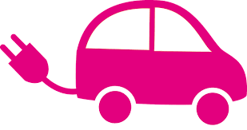
Students will make improvements to the transport available in their community. Students’ designs will need to include transport that uses alternative fuel sources, like solar energy and have an emphasis on pedestrians and bikes. Students may create a community where we can work, go to school and shop closer to where we live; create more bike lanes; have more people living closer together so they can support public transport and create safer streets to encourage walking and riding.

Watch this YouTube animation about climate change, energy and action to get your students inspired!

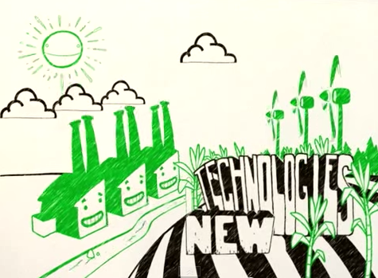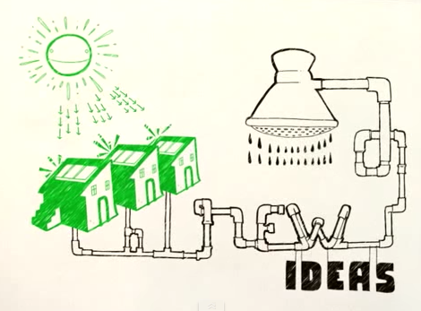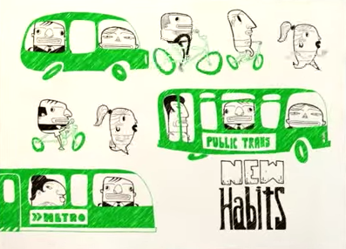

Virgin Hyperloop claims world’s first passenger ride on super high-speed system in Nevada
https://www.abc.net.au/news/2020-11-09/hyperloop-virgin-first-passengers-on-high-speed-system/12865148

Flying Cars – BTN
https://www.abc.net.au/btn/classroom/flying-cars/12625704

Driverless Cars – BTN
https://www.abc.net.au/btn/classroom/driverless-cars/10522100

Could supersonic ‘Hyperloop’ be our future transport? – Newsround
https://www.bbc.co.uk/newsround/23678271

Transport – ABC Education
https://education.abc.net.au/home#!/topic/1773359/transport

Teacher Resource
Flying Cars
Students will generate and communicate design ideas for a car of the future. Students will design a car that has minimal impact on the environment.

Design and Technologies – Years 3 and 4
Recognise the role of people in design and technologies occupations and explore factors, including sustainability that impact on the design of products, services and environments to meet community needs.

Generate, develop, and communicate design ideas and decisions using appropriate technical terms and graphical representation techniques.

Design and Technologies – Years 5 and 6
Examine how people in design and technologies occupations address competing considerations, including sustainability in the design of products, services, and environments for current and future use.

Generate, develop and communicate design ideas and processes for audiences using appropriate technical terms and graphical representation techniques

Design and Technologies – Years 7 and 8
Generate, develop, test and communicate design ideas, plans and processes for various audiences using appropriate technical terms and technologies including graphical representation techniques.
- Briefly summarise the BTN Flying Cars story.
- What does the flying car look like? Describe.
- Who built the car?
- How high did the flying car hover above the ground?
- How long did the flying car stay up in the air?
- When do they predict we will be using flying cars?
- When was the first flying car to successfully take flight built?
- What challenges are there in building a flying car? Give two examples.
- What are some advantages of having flying cars?
- Do you think having flying cars is a good idea? Give reasons for your answer.

Class discussion
Students will discuss the BTN Flying Cars story in pairs and then share their thoughts with the class.
- What do you THINK about what you saw in this video?
- What does this video make you WONDER?
- What do you think cars of the future will look like?
- Think of three questions you would like to ask the engineers of the car featured in the BTN Flying Cars story.
- These are five words that I would use to describe the flying car…

KWLH
Hold a class discussion after watching the BTN Flying Cars story. What questions were raised in the discussion (what are the gaps in their knowledge)? The following KWLH organiser provides students with a framework to explore their knowledge on this topic and consider what they would like to know and learn.

What do I know? | What do I want to know? | What have I learnt? | How will I find out?
Questions for inquiry
Students will develop their own question/s for inquiry, collecting and recording information from a wide variety of sources. Students may develop their own question for inquiry or select one or more of the questions below.

- Why do people want flying cars? Investigate the pros and cons for flying cars and use a T-chart to record your findings.
- How have cars changed since their invention? Explore the history of cars in more detail and create a timeline of significant events. Alternatively, choose another mode of transport to explore in more detail and plot your findings on a historical timeline.
- Why don’t we have flying cars yet? List all the reasons you can think of. Write a persuasive text either for or against flying cars.
- What energy sources are used to power cars? Explore in more detail and rate them from least to most environmentally friendly.
- Who is involved in the design and manufacturing of cars? Make a list of the different roles and their responsibilities.
- Make a prediction about how cars will change in the future. Illustrate your predictions.

Students can present the information in one of the followng ways:
- Prezi presentation
- An infographic using Canva

Car of the future
Before starting this activity, hold a class discussion, asking students what sort of car they think they will be driving in 50 years’ time? Think about safety, environmental impact, sustainability, power sources and innovation.

In small groups, students will imagine they are engineers and design a car of the future or make a modification to a car (to improve the design or function of a car). Ask students to respond to the following:

- How can cars be improved? For example, they could be more environmentally friendly, or they could be safer. What’s the problem and what are some solutions to the problem?
- Write a brief for your design, using these headings as a guide: Background, Criteria, Your Challenge, Constraints.
- Sketch a drawing of the car with labels to show its features. Use terms like chassis, wheels and axles.
- Choose a body size, engine size, fuel type and accessories.
- What is the source of power for your car?
- What speed will your car travel?
- What safety features does your car have?
- What materials will be used to make your car? Are they environmentally friendly?
- What are the interior and exterior features?
- What new technologies will you incorporate in your design?
- How will the car benefit people?
- How will the car benefit the environment?
- Why is your design the best one for your community?
- What is unique about the design?
- What inspired you to create your invention?


Choose a project
Individually or in small groups, students will choose one of the following projects to work on and then present their findings to the class.



Air powered car
Do you think you could build a car powered by nothing but air? What materials would you need? Hint: a balloon! Experiment with a range of materials and test which design travels the fastest and furthest.

Car review
What are the pros and cons of electric cars? Use a T-chart to record your findings. Choose an eco-friendly car to research and write a review on it.

Rubber band car
Do you think you could build a car powered by a rubber band? Experiment with a range of materials including rubber bands as your source of power. What will you use for the wheels, axles and chassis? Race against your classmates!
Solar powered car
What are the pros and cons of solar powered cars? Become an engineer and build your own solar powered car. There are inexpensive solar car kits available online!

Electric Car Future – BTN
https://www.abc.net.au/btn/classroom/electric-car-future/10970808

When was the first car made? – BTN
https://www.abc.net.au/btn/classroom/when-was-the-first-car-made/10488924

Driverless Cars – BTN
https://www.abc.net.au/btn/classroom/driverless-cars/10522100

Electric Cars – BTN
https://www.abc.net.au/btn/classroom/electric-cars/10528362

Japan wants flying cars in its skies in three years. Here's how they plan to pull it off – ABC News
https://www.abc.net.au/news/2020-08-29/flying-cars-could-be-a-reality-in-japan-in-three-years/12599544

