EPISODE 34
23rd November 2021

KEY LEARNING
Students will view a range of BTN stories and use comprehension skills to respond to a series of focus questions.

CURRICULUM
English – Year 4
Use comprehension strategies to build literal and inferred meaning to expand content knowledge, integrating and linking ideas and analysing and evaluating texts.

English – Year 5
Use comprehension strategies to analyse information, integrating and linking ideas from a variety of print and digital sources.

English – Year 6
Use comprehension strategies to interpret and analyse information and ideas, comparing content from a variety of textual sources including media and digital texts.

English – Year 7
Use comprehension strategies to interpret, analyse and synthesise ideas and information, critiquing ideas and issues from a variety of textual sources.
  - Teacher Resource

Focus Questions

Coal Explainer
- How does coal form?
- Which greenhouse gas is produced when coal is burnt?
- Where in Australia was coal first discovered? Find on a map.
- At the recent COP26 climate summit, countries agreed to
  - Phase up coal
  - Phase down coal
  - Phase out coal
- What does Prime Minister Scott Morrison say is the future of coal in Australia?

Check out the Coal Explainer resource on the Teachers page.

Floods in NSW
- What sort of weather has the East coast of Australia been experiencing? Describe.
- Which Australian city recorded snow in November?
- What is a cold front?
- What type of weather event is likely to occur in Australia?
  - La Nina
  - El Nino
  - Antarctic Oscillation
- How is the weather affecting farmers and their crops?

Delhi Air Pollution
- Why is smog in Delhi a problem this time of year?
- How has the air pollution in Delhi impacted on people’s lives?
- What is being done to reduce the air pollution?
- Why is air pollution particularly dangerous for kids?
- Young people around the world recently called for the United Nations to acknowledge…

Starting High School
- What is the last state in Australia to move year 7 to high school?
  - Queensland
  - South Australia
  - Tasmania
- What advice does Hugo give about making friends at high school?
- How does Lachlan manage to balance high workloads with his social life and free time?
- In high school you have lots of different classes. True or false?
- What questions do you have if you’re moving into high school or what advice can you give to kids that are moving into high school?

Little Big Idea Winner
- Why did Lucia invent the School Stuff Checker?
- Briefly describe Lucia’s invention.
- Explain Cohen’s invention, the Biolume.
- What did Josh invent?
- If you could invent something, what would it be?

Check out the Little Big Idea Winner resource on the Teachers page.

EPISODE 34
23rd November 2021

KEY LEARNING
Students will develop a deeper knowledge of what coal is, how it forms, how it is used and how it impacts people and the environment.

CURRICULUM
Science – Year 4
Science knowledge helps people to understand the effect of their actions.

With guidance, identify questions in familiar contexts that can be investigated scientifically and make predictions based on prior knowledge.

Science – Year 5 and 6
Scientific knowledge is used to solve problems and inform personal and community decisions.

With guidance, pose clarifying questions and make predictions about scientific investigations.

Science – Year 7
Some of Earth’s resources are renewable, including water that cycles through the environment, but others are non-renewable.

Identify questions and problems that can be investigated scientifically and make predictions based on scientific knowledge.
  - Teacher Resource

Coal Explainer

Focus Questions
Discuss the BTN story as a class and record the main points of the discussion. Students will then respond to the following:
- How does coal form?
- Which greenhouse gas is produced when coal is burnt?
- Where in Australia was coal first discovered? Find on a map.
- At the recent COP26 climate summit, countries agreed to
  - Phase up coal
  - Phase down coal
  - Phase out coal
- What does Prime Minister Scott Morrison say is the future of coal in Australia?

Activity: Note taking
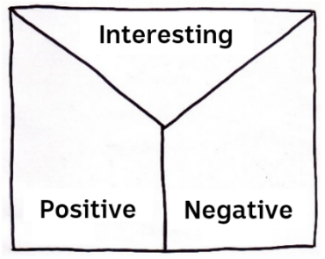
Students will practise their note-taking skills while watching the BTN Coal Explainer story. After watching the story, ask students to reflect on and organise the information into three categories. What information in the story was...?
- Positive
- Negative or
- Interesting

Activity: Class discussion
Discuss the information raised in the BTN Coal Explainer story. Ask students to record what they know about coal on a mind map. What questions do students have? Use the following questions to guide the discussion:
- What is coal made of and where is it found?
- How does coal generate electricity?
What questions do you have about coal?

- Why is coal such a big issue?
- What impact does the burning of coal have on the environment?
- Do you think it is important that we phase out coal? Give reasons.

Activity: KWLH
Hold a class discussion about the information raised in the BTN Coal Explainer story. What questions were raised in the discussion and what are the gaps in their knowledge? The following KWLH organiser provides students with a framework to explore their knowledge on this topic and consider what they would like to know and learn.

What do I know? | What do I want to know? | What have I learnt? | How will I find out?

Research questions for Inquiry
Students will start to think like a scientist and develop their own question/s for inquiry, collecting and recording information from a wide variety of sources. Students may develop their own question for inquiry or select one or more of the questions below.

- What is coal and how does it form? Include as many of the following terms in your explanation: sedimentary, carbon, fossil fuel, Carboniferous period, pressure, carbonisation, coal seam.
- When and where was coal first discovered in Australia? Investigate the history of coal and record your findings on a timeline.
- How do living things turn into fossil fuels?
- What is the carbon cycle? How long does it take for fossil fuels to form?
- How much of the world’s electricity comes from coal? Look at other sources of electricity and compare and contrast to coal.
- What are fossil fuels and what are the issues with continuing fossil fuel use?
- Will we ever run out of coal? What is the difference between renewable and non-renewable energy? Record your responses on a Venn diagram.
- Do you think we should continue burning coal for power? Why or why not?

Activity: Persuasive text
Students will develop a persuasive text for or against one of the following statements (alternatively, students can develop their own statement):

“Coal power should be banned”
“100% renewable energy can power the world”
“The Australian government should support phasing out coal”
“Coal mining should be allowed in Australia”
“We can live without fossil fuels”

Students will explore one or more of the following questions as part of their research:
- How does burning coal affect the environment?
- How will banning coal power affect the economy?
- What are some alternatives to coal power?
- How can the government promote and support the use of renewable energies?
- Who and what will be at risk if we continue to burn fossil fuels?
- Why do you think some people don’t want to ban coal power?

Terminology
Students will create their own class glossary of keywords and terms. Students can use illustrations and diagrams to help explain each keyword. Encourage students to use as many of the following key words and terms in their persuasive text as they can.

COAL MINING | SUSTAINABLE | FOSSIL FUELS
AIR POLLUTION | GREENHOUSE GAS EMISSIONS | CARBON DIOXIDE
NATURAL RESOURCE | ENERGY | ECONOMY

Persuasive text Structure
Encourage students to use a range of sources. Provide students with the following structure to follow when completing this activity.

Introduction
- What is the point you are trying to argue? Construct an introductory paragraph which states the issue or topic.
- Introduce the arguments that will be developed in the body of the text.

Body
- Construct arguments that support your point of view.
- Each paragraph starts with a topic sentence which introduces each point.
- The rest of the paragraph gives more reasons.
- Arguments can be ordered from strongest to weakest.

Conclusion
- Restate your position on the argument.
- Construct a concluding paragraph that provides a summary of your arguments and a call to action.
Tips
- Who is your audience? For example, are you directing your argument at kids, teachers or politicians?
- Explore how language choices can have a big impact on persuading your audience.
- Which language devices give the report credibility and authority?
- Which are designed to create an emotional response in the listener?
- Provide facts and evidence to support your argument.
- Write in the present tense.
- Check your spelling and punctuation.
- Use this Read Write Think persuasion map to organise your information.

Activity: Quiz
- Coal is a naturally occurring rock.  A. True  B. False  - What is coal made of?  A. Charcoal  B. Inorganic matter  C. The remains of living things  - What type of rock is coal?  A. Igneous  B. Metamorphic  C. Sedimentary  - Coal is a renewable resource.  A. True  B. False  - When was coal first used to generate electricity for homes and factories?  A. 1780s  B. 1880s  C. 1980s | - What happens when coal is burnt?  A. It makes heat and light energy  B. It turns into charcoal  C. It reverts into a living thing  - What type of gas is released when coal is burnt?  A. Carbon Dioxide  B. Hydrogen  C. Krypton  - What is NOT a fossil fuel?  A. Coal  B. Natural gas  C. Bio-diesel  - What is the biggest contributor to climate change?  A. Burning coal  B. Cutting down forests  C. Increased livestock farming  - At the COP26 climate summit countries agreed to…  A. Phase up coal  B. Phase down coal  C. Phase out coal

Quiz Answers: 1A, 2C, 3C, 4B, 5B, 6A, 7A, 8C, 9A, 10C.

Useful Websites
- Adani Coal Mine – BTN
- Clean Coal – BTN
- Zero Emissions – BTN
- Coal – National Geographic
- Coal – Geoscience Australia
- Why is coal such a big issue in climate change talks? – Newsround

EPISODE 34
23rd November 2021

KEY LEARNING
Students will learn more about inventions created by young people and design their own invention.

CURRICULUM
Science – Years 5 & 6
Scientific knowledge is used to solve problems and inform personal and community decisions.

With guidance, pose clarifying questions and make predictions about scientific investigations.

Reflect on and suggest improvements to scientific investigations.

Science – Year 7
Solutions to contemporary issues that are found using science and technology, may impact on other areas of society and may involve ethical considerations.

People use science understanding and skills in their occupations and these have influenced the development of practices in areas of human activity.

  - Teacher Resource

Little Big Idea Winner

Focus Questions
Discuss the BTN story as a class and record the main points of the discussion. Students will then respond to the following:
- Why did Lucia invent the School Stuff Checker?
- Briefly describe Lucia’s invention.
- Explain Cohen’s invention, the Biolume.
- What did Josh invent?
- If you could invent something, what would it be?

Activity: Class Discussion
Discuss the BTN Little Big Idea Winner story as a class. What questions were raised in the discussion? Here are some questions to guide discussion:
- What is an invention?
- Who is an inventor?
- What do they do?
- Can anyone be an inventor? Why or why not?
- What do you know about the process of inventing?
- What things might inventors have to do and think about in order to invent something?
- What scientific discoveries or inventions have impacted on your life?
- What invention could you not do without? Why?

Activity: Glossary
Students will brainstorm a list of key words that relate to the BTN Little Big Idea Winner story and inventions. Here are some words to get you started.
INVENTION | INSPIRATION | INNOVATION
PROTOTYPE | DISCOVERY | SCIENCE

Activity: Young Inventors
Students will explore in more detail the winning inventions of the Little Big Idea competition.

The School Stuff checker
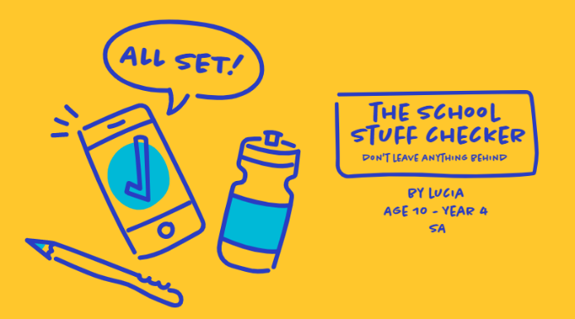
The BTN story explained Lucia’s invention. Watch the story again and respond to the following:
- Briefly describe the invention.
- What inspired Lucia’s invention?
- How does it work?
- What materials is it made from?
- What problem does it solve?
- What is unique about the design?
- What questions do you have about the invention?

Biolume Tree
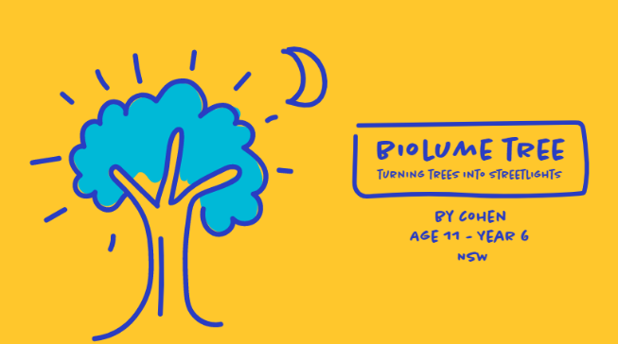
Watch Cohen’s submission video about his invention and respond to the following:
- Briefly describe the invention.
- What inspired Cohen’s invention?
- How does it work?
- What materials is it made from?
- What problem does it solve?
- What is unique about the design?
- What questions do you have about the invention?

YouView
Watch Josh’s submission video about his invention and respond to the following:
- Briefly describe the invention.
- What inspired Josh’s invention?
- How does it work?
- What materials is it made from?
- What problem does it solve?
- What is unique about the design?
- What questions do you have about the invention?

Check out all the 2021 finalists here.

Activity: Australian Inventions
Students will research an Australian invention using the following questions to help guide their research:
- Why did the object first come about? Was it intentional or accidental?
- What problem or issue does the invention overcome or solve?
- Who was the inventor?
- When was the object invented?
- How does the invention work?
- How does the invention help people?
- How has it changed or affected people’s lives?
- What if the object was never invented?

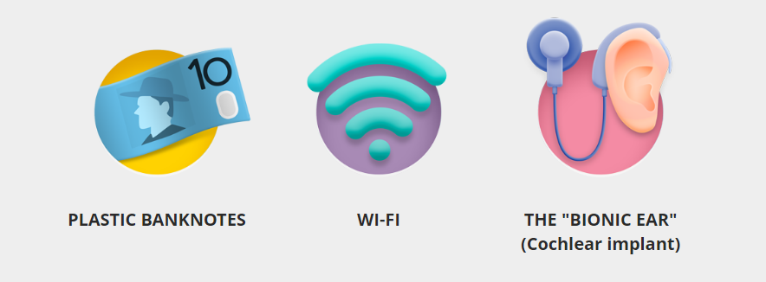

Activity: Design your own invention
In small groups, students can design their own invention or make a modification to an invention (to improve the design or function of a product). Ask students to respond to the following:
- What are some real-world problems that need to be solved (think of some small and some big)? They could be problems that you have seen or experienced.
- Choose one real-world problem from your list. What could you invent to help solve this problem?
- How does your invention work?
- What materials is it made from?
- What is unique about the design?
- Draw a picture and name your invention.
- What inspired you to create your invention?
- Prepare for and present your invention to the class or wider community.

Some inventions by kids…

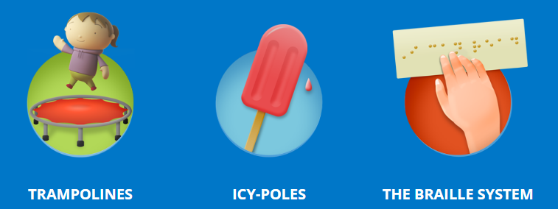

Check out these BTN stories featuring kids talking about their inventions which help solve real-world problems.

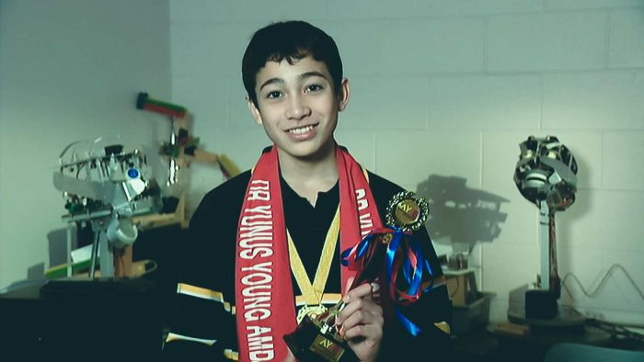
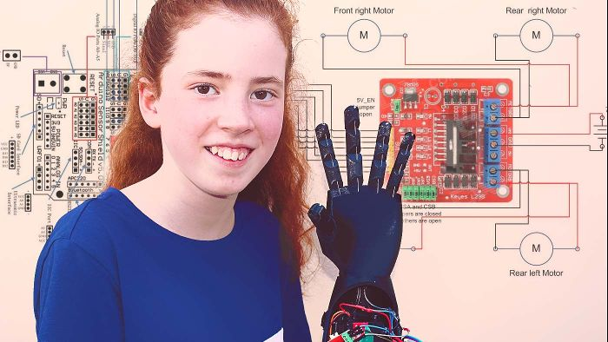
Bionic Arm Builder Young STEM Inventor

Useful Websites
- 2021 Winners - Little Big Idea Competition
- Rein Angel Inventor – BTN
- Aussie Inventions – BTN

  - Teacher Resource

BTN Transcript: Episode 34 - 23/11/2021

Hey, I’m Amelia Moseley and you’re watching BTN. Here’s what’s coming up. We find out about the science behind this wet weather. Get some tips from those in the know about going into high school and meet a winner of this year's Little Big Idea competition.

Coal Explainer

Reporter: Jack Evans

INTRO: But first up today to something that's been all over the news lately, coal. This little black rock provides a lot of the world's electricity but it's also a big source of carbon pollution. That's why many countries are aiming to phase it out but Australia's taking things more slowly. Here's Jack to explain.

ELFIS: Right well, who else is getting coal?
ELFIRA: Ah well let's see, we've got Cameron, Casey, Cassie, Carol, Carrie.
ELFIS: Gee that's a lot of kids on the naughty list.
ELFIRA: Oh no, they're not on the naughty list.
ELFIS: What? Then why are they getting coal?
ELFIRA: Uh, because it's a reliable and affordable source of energy. I mean what better gift to receive than coal.
ELFIS: Well, yeah that's true. But I don't think people want it as a gift.
ELFIRA: Well, it's in all the papers, it's the must have item this silly season. Everyone loves coal.
ELFIS: Um, I don't think that's what people are saying.
Yep, everyone's talking about coal. So, what is it and why is it so controversial? Let’s start with the ‘what’. Coal is a naturally occurring rock that can be found around the world. It comes from underground and it’s old, like really old. In fact, coal takes millions of years to form, it's made from the remains of living things which are full of carbon. When that carbon has been squashed and heated over millions of years it turns into coal. And thousands of years ago humans discovered it burned really well. The Ancient Greeks and Romans used it to forge metal. The Aztecs and Ancient Chinese used it as fuel and some of Australia's Indigenous peoples burned it for heat. But coal really took off in the 1700s with the Industrial Revolution and the demand to power new machines like the steam engine and then electric power plants.
Here in Australia coal was first discovered by settlers in 1797 at Coalcliff, just north of Wollongong. Huh, that's probably why it's called Coalcliff. Anyway, turned out Australia had a lot of it. I'm talking millions and millions of tonnes of the stuff right under our toes. That quickly led to mines being set up around the country and entire towns being built around them, and pretty soon Australia was exporting several million tonnes of the stuff to other countries. Today, coal supplies about a third of the worlds electricity and Australia still exports a lot of it. But it looks like the popularity of coal is fading.
ELFIRA: Wait, what? Protests?
ELFIS: See I told you, not everyone loves coal.
ELFIRA: But it's so combustible and sooty.
ELFIS: Yeah, but it's also really bad for the environment. When burned it releases greenhouse gases.
Yep, coal is a fossil fuel and when you burn it, it releases a lot of carbon dioxide. That's one of the main greenhouse gases contributing to climate change and at the recent COP26, countries agreed to phase down the use of coal for the first time.
BORIS JOHNSON, UK PRIME MINISTER: It is beyond question that Glasgow has sounded the death knell for coal power.
Some countries were hoping it would be phased out completely but others, including India and China, said their people still need coal as a reliable and cheap source of fuel and Australia's PM, Scott Morrison, says it can still have a future.
SCOTT MORRISON, PRIME MINISTER: For all of those who are working in that (coal) industry in Australia, they'll continue to be working in that industry for decades to come.
Mr Morrison says the coal industry provides thousands of jobs and is a big contributor to our national economy. So, the plan is to reduce it but over a longer period of time and in the meantime work on new technologies to make coal a cleaner source of energy. But many people reckon there are already greener options out there and that the planet can't afford to delay ditching coal.
ELFIRA: Well, what are we going to do with all this coal now?
ELFIS: Erm, put it back and give the kids something they actually want?
ELFIRA: Oh well, that's a good idea, I s'pose.

Quiz

What's the main element that coal is made out of? Is it silicon, carbon or calcium? It's carbon. Believe it or not diamonds are actually made out of the same stuff except it takes a lot more heat and pressure to make them.

News Quiz

What caused a scare on the International Space Station last week? Was it an oxygen leak, a Russian missile test or aliens? Sadly, it wasn’t aliens, it was a missile designed to blow up satellites. Russia used it to blow up one of its own satellites and created a cloud of debris that the ISS flew through. Even small bits of space junk can be really dangerous, and the seven person ISS crew had to prepare to evacuate. Luckily, it didn’t come to that.

Last week a software company published a list of Australia’s most common passwords. Can you guess what the top one was? I’ll give you a hint, it’s all numbers and it’s pretty easy. It’s 1, 2, 3, 4, 5, 6. Yeah, not exactly a hard one to crack. In fact, most of the top 10 passwords were ridiculously easy and experts say it’s a reminder a lot of us are putting our data at risk by not having a secure password.

What’s unusual about this multi-millionaire dollar mansion that’s up for sale in Miami? It’s haunted, it’s owned by a dog or it’s sinking? It’s, um, owned by a dog. Yep, Gunther the 6th inherited about half a billion dollars from its grandfather, also a dog, who was owned by a German countess who decided to leave her fortune to her dog.

US WOMAN: It came down to our boss, the wealthiest animal in the world, had to sign off with his approval on us listing this property.
Floods in NSW

Reporter: Cale Matthews
INTRO: Last week the central west of New South Wales was hit by some serious floods. They came after a week of wild weather which brought a month's worth of rain in just a few days to some places and record low temperatures to others. So, what's up with the weather? Cale found out more.

LACEY, NSW FARMER: Hi BTN I'm Lacey Duguit and I live on a farm just outside of Goolagong in New South Wales. The weather has been pretty crazy this past week, we've had lots of rain almost 130 mls so far. The caravan park and other low lying sites in Cowra had to be evacuated. I can't go to school until the water goes down. This is the road I need to take to school.
CALE, BTN REPORTER: If you live in New South Wales like Lacey, or in Queensland, or South Australia, or basically anywhere across Australia's east coast, you might have noticed some pretty wild weather these past few weeks. If you haven't noticed, you might have been living under a rock. Which I guess would provide pretty good protection from all this rain.
In fact, some towns got a month's worth of downpour in just a couple days, enough to turn the Wyangala Dam from this, into this. All that extra water burst the banks of the Lachlan River, flooding farms and threatening towns.
FORBES RESIDENT: It's incredible how high it is, but if it goes any higher it might not be incredible, it might be dangerous.
In Victoria, emergency services have been working overtime, while South Australia shivered its way through its coldest November day in 28 years. Oh, and if you think that's cold, well in Hobart it snowed. Yep, snow, in November. This isn't the sort of weather you necessarily expect 2 weeks out from summer, so what on Earth is going on?
NATE BYRNE, ABC WEATHERPERSON: Well, we're in a transitional time at the moment and that means that we've got lots of warm, humid air around at the moment and something to help cause showers and storms.
That's Nate Byrne you might recognise him from, well, the weather, and he says cold fronts, which are big patches of cold air, can suck lots of warm moist water into the atmosphere creating lots of cloud and rain just like we've seen, but there is another reason we should expect a bit more wild weather this summer.
NATE BYRNE, ABC WEATHERPERSON: La Nina is certainly having an effect on the weather we're seeing at the moment.
Yep, La Nina, do you remember what that is? It's a weather pattern that we see from time to time when the trade winds that blow across the Pacific are extra strong and bring more warm water from the east to the west.
NATE BYRNE, ABC WEATHERPERSON: That means we can have more showers and thunderstorms, more flooding events and also more cyclones.
While La Nina can be good news for farmers who haven't had much rain in a while, too much rain can be bad news.
NSW FARMER: We've got about 104 acres here and it’s all underwater.
NSW FARMER: To be wiped out this year is gonna be devastating.
Farms in New South Wales flooded last week after the heavy rain, causing lots of damage.
LACEY, NSW FARMER: A lot of the crops we were going to contract harvest are now underwater in Goolagong, it will cost people hundreds of thousands of dollars in losses.
While experts say were not officially into a La Nina phase just yet, there will be a higher risk of flooding this summer. So, while this might be the first batch of wild weather to round out the year, it more than likely won't be the last.
Quiz

La Nina has an opposite weather patten, what is its name? El Hombre, El Nino or El Muchacho? It's El Nino. That's Spanish for the little boy and it brings dry weather to this part of the world whereas La Nina, the little girl, brings wet weather.
Delhi Air Pollution

Reporter: Olivia Mason

INTRO: Now, to Delhi in India where schools had to close last week, and people were told to work from home. But it wasn't because of COVID, it was because of air pollution. It's a common problem and not just in India. Here's Liv.
OLIVIA MASON, BTN REPORTER: Breathe in, and out. It's something you probably don't think that much about. But what if doing this was dangerous?
In India's capital city, Delhi, the air is so polluted right now that many schools have been forced to shut and people are being told to work from home. Most construction work has been banned and half of the city's power plants have been forced to close for a while. The air looks like this, thick and grey and smoggy. So, what's causing it? Well, Delhi is one of the most populated cities in the world.
More than 30 million people live there and create a whole lot of pollution by doing everyday things. Like using cars and construction, creating dust, and cooking on cook stoves. There are also power plants burning fossil fuels and a lot of people burn their rubbish to get rid of it. At this time of year, the smog is particularly bad because after harvest, a lot of farmers burn their fields to clear them. And then there were the fireworks let off for the Hindu festival of lights, Diwali, which made matters worse.
Air pollution is measured on a scale which shows how many harmful particles there are floating around in it. Between 0 and 50 is considered good. While over 300 is considered a health emergency. In Delhi, it's been sitting between 4 and 5 hundred. That's really dangerous, particularly for kids whose bodies are still growing. It can cause coughing, wheezing and sore eyes, and in the long-term, those little particles of pollution can do serious damage to peoples' lungs, and other parts of their bodies.
ARVIND BOUNTRA, DOCTOR: There is some studies that show that the cognitive functions of the brain are also affected by these very small particles, what you call 2.5 or less than 2.5 because they can get into the bloodstream, affect the heart, affect the brain so it does have an impact on that.
And it's not just a problem in India. In fact, the World Health Organisation reckons that more than 9 out of 10 kids live in areas where the air isn't safe to breathe. Which is why last week, more than 29 thousand young people around the world joined this campaign calling for the UN to acknowledge children's rights to clean air. In India at the moment that seems like a long way off. People in Delhi are hoping the restrictions will help to improve the situation, but many say India and the rest of the world needs a longer-term solution to clear the air.
Starting High School

Reporter: Jack Evans

INTRO: As the school year winds up a lot of you will be thinking about the big move to high school. Especially if you're going into year 7 in South Australia next year. For the first time they'll be starting high school instead of finishing their last year of primary, which is what happens in other states and territories. So, we met some students to find out how they're feeling about the change and to get some advice about making the big leap to high school.

Yep, starting high school is a big change, and like many of you these year 6's have some questions. So, who better to answer them than some year 8's.
CHARLOTTE: Is it easy to make friends or is it hard? I really want to know because my friends are going to a different high school and I just don't want to be alone.
HUGO: Find people with common interests as you so you might be a sporty kid, you might want to find someone who plays same sport as you, or even video games or just art or anything like that. Finding people with common interests will help you get a lot of friends.
LACHLAN: I saw people that would look like they are sporty. So, I'd go ask them, do you want to play this? And yeah, we ended up playing still got those friends now.
NIAMH: There's so many people at the school, you're bound to find someone who has similar interests as you.
LEE: How have they adapted to the new style of learning in high school? And how long did it take them?
NIAMH: Having different classes all around the school, it's a really big campus, and then going upstairs and downstairs and back and forth for all your classes was really hard at first, but now I'm used to it so it's all good.
KAIA: It's hard at the start. Because you think, I have to get to this class in time. I don't know the teacher is going to be mad at me. I'm going to be late. But teachers aren't as mad at you. It's your first year of high school.
AYURI: How do you manage to balance your high workloads with your social life and your free time?
NIAMH: It was a bit tricky at first, it's quite a difference from how much work there is in primary school, like I remember I'd have because I had the same teacher, I'd have like one assignment at one time. But when you get to high school, where we have lots of different classes. And so, I just like to keep track of the assignments I have and when they're due. So, I know I'm not falling behind.
HUGO: Sometimes I would be a little bit overloaded with work, but making sure I stayed on task, in lessons and even using a lot of my outside time. That helped me quite a lot.
ERICA: How do you get through some hard times? And what would you do?
LACHLAN: Just have some time off, go play outside with the dogs or play basketball so your brain can refresh.
KAIA: Some of the best people who have helped me through tough times are teachers and some older students.
DEV: What are some key experiences you would have experienced so far in high school that may have been important to you?
HUGO: Probably the year 8 camp down at Victor harbour. It allowed me to make a lot more friends.
NIAMH: I think there are a fair few camps you do get to do in high school, and the swimming carnivals and athletics carnivals are much bigger and a much larger scale experience. So, I really enjoyed that.
JAMES: What can you do at high school that you can't do at primary school?
LACHLAN: I've been able to play a lot more sports. I've had basketball all year, where primary school like it was just for PE for like two weeks.
KAIA: Dance and music and all, there's lots of art subjects and languages. It's a very broad variety of subjects.

Ask a Reporter

If you have a question about BTN, or high school or anything, really, we’ll be having a special ask us anything Ask a Reporter. Just head to our website for all the details.

Sport

The Perth Scorchers will host the women's Big Bash final. They finished their season with a massive 8 wicket win against Sydney on the weekend taking their winning streak to a whopping six games. They'll take on either the Brisbane Heat, Adelaide Strikers or the Melbourne Renegades who are all battling it out this week for a spot in the Grand Final.
Lewis Hamilton has dominated the Qatar Grand Prix. He led from start to finish while Max Verstappen came in second after starting the race in 7th.
Sam Kerr just keeps on kicking goals. The Aussie striker booted 3 goals in Chelsea's 5-nil win against Birmingham City. The win keeps Chelsea in second place on the table just behind Arsenal.
Now, she might be able to kick goals, but can Sam Kerr do this? Well, maybe. This is the Red Bull Street Style World Finals where competitors show off their specciest soccer skills. Norwegian Erlend Fagerli took home his 3rd world title. While on the women’s side Britain's Lia Lewis was crowned the champion. They are some serious skills.

Little Big Idea Winner

Rookie Reporter: Lucia

INTRO: Finally, we're going to meet Lucia, a 10-year-old with a big idea. In fact, her idea for an app that helps kids remember all the things they need for school, was one of the winners of this year's Little Big Idea competition. We'll let Lucia tell you more.

LUCIA: Hi BTN my name’s Lucia and I'm in year 4. Ah, what was I going to say? Oh, and I’m very forgetful.
I used to forget things like my pencil case, my ukulele and even my lunchbox when I went to school.
LUCIA'S DAD: Have you got your diary?
LUCIA: Just a sec.
Oh, there it is. Anyway, to help my forgetfulness I invented something called the School Stuff Checker. The School Stuff Checker is an app on your phone that helps you remember everything for school in the morning or if you're an adult it helps you remember everything for work. School Stuff Checker works by reading RFID tags like the ones on the back of library books that you put on all your school things. When you're on your way to school coming out the drive it will tell you if have everything in the car automatically. And if you’ve lost something it will automatically tell you when you're near it. I researched what you could use, like RFID tags, and the different types and how I could produce it, and then I started to develop the app more.
Once I finished my invention, I submitted it to the Little Big Idea competition 2021. That's a competition held every year for Aussie kids between years 3 and 8 and it’s all about finding innovative ideas that could change the world. Turns out the judges liked my invention. But I wasn't the only winner, over to you Cohen.
COHEN, LITTLE BIG IDEA WINNER: Hi, I'm Cohen and welcome to my world, the world where science and innovation presides. Where my little big idea is growing into something big, and I call it the Biolume. The Biolume is a device that will modify a tree to illuminate and essentially replace streetlights.
LITTLE BIG IDEA PRESENTER: So, everyone, big round of applause because you have a national winner here.
LUCIA: Cohen won the year 5 to 6 award, while Josh won the year 7 to 8. Take it away Josh.
JOSH, LITTLE BIG IDEA WINNER: My Project is about giving people with high disabilities a voice to express themselves in surveys. My project does this by using facial recognition software that recognises emotions that helps them answer questions without help from others.
LUCIA: With the money I won I think I will get a horse because I've always loved riding, and I’ve always wanted a horse of my own. I want to be an inventor, song writer, maybe a bit of an author, and I want to rescue off the track race horses and brumbies. I really like science and inventing because it’s just endless boundaries. I think kids should get into science more because there's really nothing you can't do with it and there's always something more to do. Dad, have you seen my School Stuff Checker?

Closer

Way to go Lucia, that's a big cheque. Well, that brings us to the end of this week's show and very nearly to the end of this year. Next week is our very last episode for 2021, so we'll be having a look back at the biggest stories of the year. Until then you can jump online to check out more stories and features and don't forget there's Newsbreak every weeknight. Have a great week and I’ll see you soon.

