EPISODE 3
21st February 2023

KEY LEARNING
Students will view a range of BTN stories and use comprehension skills to respond to a series of focus questions.

CURRICULUM
English – Year 4
Use comprehension strategies to build literal and inferred meaning to expand content knowledge, integrating and linking ideas and analysing and evaluating texts.

English – Year 5
Use comprehension strategies to analyse information, integrating and linking ideas from a variety of print and digital sources.

English – Year 6
Use comprehension strategies to interpret and analyse information and ideas, comparing content from a variety of textual sources including media and digital texts.

English – Year 7
Use comprehension strategies to interpret, analyse and synthesise ideas and information, critiquing ideas and issues from a variety of textual sources.

PLEASE NOTE: Talking about the conflict in Ukraine may be upsetting for some children and may cause some discomfort, distress and/or anxiety. BTN has a short video about the Important Things to Remember about Upsetting News.

  - Teacher Resource

Focus Questions
As a class, discuss the stories featured in the episode of BTN Classroom and record the main points of the discussion. Students will then respond to the following focus questions.

Ukraine Anniversary
- How did Taras and Nazar feel when they first moved to Australia? How do they feel now?
- How long has the conflict between Russia and Ukraine been going on for?
- How have countries around the world helped Ukraine?
- What message of support would you send to the people of Ukraine?
- What did you learn watching this story?

China Spy Balloon
- Briefly summarise the BTN story.
- The balloon was thought to be a surveillance balloon from _________.
- What features does Bill Birtles say the balloons have?
- How did the White House react to suggestions of the objects being UFOs?
- Describe the relationship between China and the United States.

Space Food
- What does duckweed grow in?
  - Water
  - Soil
  - Air
- Why is duckweed a good food source for astronauts?
- Give an example of food eaten by astronauts.
- Why is it important to grow food on long-distance space missions?
- What questions do you have about this story?

Check out the teacher resource on the Archives page.

Rainbow Laces
- What is the Rainbow Shoelace Project?
- Why did Abbie start the project?
- What are the colours of the Pride flag?
- Describe the support Abbie has had for the project.
- How did this story make you feel? Discuss in pairs.

Cup Stacking Kid
- In your own words, describe the sport of cup stacking.
- Where are the World Championships being held this year?
- How did Theo get into cup stacking?
- Which division of the tournament does Theo compete in?
- Write a message of support to Theo.

EPISODE 3
21st February 2023

KEY LEARNING
Students will learn more about why it’s important to grow food in space for long-distance space missions.

CURRICULUM
Science – Year 5
The Earth is part of a system of planets orbiting around a star (the sun).

Science – Years 5 & 6
Scientific knowledge is used to solve problems and inform personal and community decisions.

With guidance, pose clarifying questions and make predictions about scientific investigations.

Science involves testing predictions by gathering data and using evidence to develop explanations of events and phenomena and reflects historical and cultural contributions.

Science – Year 6
The growth and survival of living things are affected by the physical conditions of their environment.

  - Teacher Resource

Space Food

Focus Questions
Discuss the BTN story as a class and record the main points of the discussion. Students will then respond to the following:
- What does duckweed grow in?
  - Water
  - Soil
  - Air
- Why is duckweed a good food source for astronauts?
- Give an example of food eaten by astronauts.
- Why is it important to grow food on long-distance space missions?
- What questions do you have about this story?

Activity: Class Discussion
Discuss the BTN story as a class. Ask students what they learnt about growing food in space for astronauts, recording their responses on a mind map. In small groups, ask students to brainstorm responses to the following questions:
- What did you learn?
- What was surprising about the story?
- What do you wonder?
- What questions do you have about the BTN story?

Activity: Questions and Answers
All scientific discoveries start with a question! As a class, come up with some questions you think scientists ask and solve in relation to plants and what they need to survive. As a class, make a list of questions that you would like to ask a scientist like Professor Jenny in the BTN story. Organise the questions into common themes. Use the internet to find answers to your class questions.
What scientific questions do you have?

Activity: Glossary
Students will brainstorm a list of key words that relate to the BTN Space Food story. Here are some words to get them started.

SPACE MISSION | MICROGRAVITY | NUTRIENTS
PHOTOSYNTHESIS | INTERNATIONAL SPACE STATION | SPACE FOOD

Activity: Research project
Discuss the information raised in the BTN Space Food story. What questions were raised in the discussion and what are the gaps in students’ knowledge? The following KWLH organiser provides students with a framework to explore their knowledge on this topic.

What do I know? | What do I want to know? | What have I learnt? | How will I find out?

Questions to research
Students will collect and record information from a wide variety of sources. Students may develop their own question for inquiry or select one of the questions below.
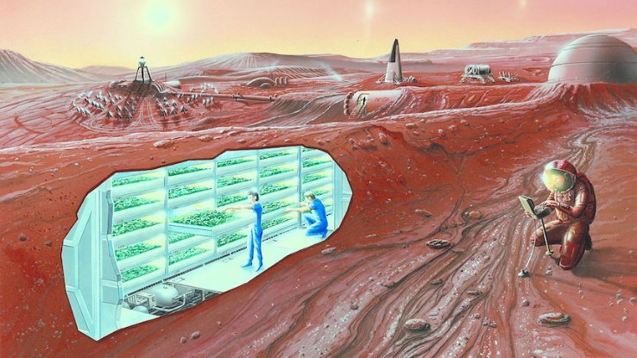
- Why might astronauts need to grow their food in space? Consider long-distance space missions.
- How does research into how plants grow in challenging environments help us on Earth?
- What are the benefits of growing food in space?
- How does micro gravity affect plants?
- Can photosynthesis occur in space? Why or why not?
- Can plants grow in Martian soil? What are some ways plants can be grown on Mars?
- How do plants improve air quality?
- What were the first plants to be grown in a spacecraft?
- What do plants need to grow? Consider the following needs: Water, air, light, nutrients, somewhere to grow. Investigate why each is important and what are the challenges in space.
- Astronauts can go through something called menu fatigue. Investigate what that is and how it can be avoided.

Activity: Scientific Method
What is a scientific method?
Before starting this activity, explain to students what the scientific method is and why we use it. As a class look at a diagram which illustrates the scientific method and explain the meaning of each step in the process. The method consists of a range of steps, however the order of the steps in the process can vary. The scientific method is a tool which helps us to solve problems and answer questions.

Framework
Ask a question!
Research
Hypothesis
Analyse data
Conclusion
Experiment
Provide students with the opportunity to think like scientists. In pairs or small groups, students will conduct a scientific investigation about plants and what they need to survive using the scientific method. Students will design and conduct their own scientific investigation in pairs or small groups. Students will use the framework below before, during and after their investigation.

Ask a question | - What questions do you have about plants and what they need to survive? For example:  - Do plants need photosynthesis to survive? Explain.  - How do plants that grow in shade differ to plants that grow in full sun?  - What is the best medium to grow plants in?  - Do plants grow faster in soil or water?  - Why do some plants grow better in the shade?  - Can plants grow upside down? If so, which way will the plant grow?  - Can plants grow without soil or natural light?  - Brainstorm some ideas for your science investigation based on what you have observed.  - Identify a question that can be tested or researched. For example, “What happens when…?” or “What is the effect of…?”  - Describe what you are going to research using your own words.
Research | - Research the topic to learn as much as you can.  - Research using secondary sources of information to help you understand the observations you have made.
Hypothesis | - What do you already know about this scientific topic?  - Formulate your hypothesis.  - What do you predict to be true about the answer to your question?
Experiment | - Design and conduct an experiment to test your predictions.  - How will you test your hypothesis?  - What steps do you need to follow to investigate your prediction?  - What equipment and materials will you need to conduct your investigation?  - How will you gather evidence?  - Plan how you will record and organise your data.  - Perform your experiment, by repeating trials of tests, taking measurements, making observations, and recording data.
Analyse Data | - What does the data mean? Write a paragraph that summarises what happened.  - Make calculations using the data you have collected.  - Can you see any patterns in the data you have collected?  - Draw a labelled diagram of your results to show what happened.
Conclusion | - Review your findings in relation to your hypothesis.  - How effective was your investigation in testing your hypothesis?  - Think of a creative way to explain/answer your science discovery (using multimedia, models, video, or animation).  - Create your own mini science lesson about what you have learnt and teach students in another class.
Reflection | - Was this what I expected? Explain.  - What problems did I experience when I was doing the investigation? How could I fix these problems?

Activity: How do astronauts live in space?
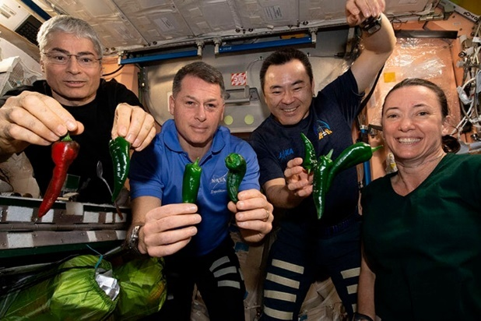
Students will learn more about what life is like on the International Space Station. These videos provide a snapshot of what living on the ISS is like.
Everything about living in space
Life inside the ISS

Students will describe a day in the life of an astronaut on the ISS, including information about sleeping, eating, personal hygiene, exercising and carrying out work on the ISS. What do astronauts do in their spare time?

As a class, watch the Eating in Space video for an in-depth look at how and what astronauts eat to stay healthy. Students will then respond to the following questions:
- What food do astronauts eat?
- Is there any food they can’t eat?
- Does food need any special preparation before it can be eaten?
- Why is nutrition important for astronauts?
- If you lived in space, what foods would you miss the most? Why?

Activity – Choose a Project
Individually or in small groups, students will choose one of the following projects to work on and then present their findings to the class.

Space Gardening
Explore ways to grow plants in space. This Kids Gardening resource has some ideas about growing plants using hydroponics.
Duckweed Recipe
Create a recipe that features duckweed. Remember that duckweed takes on the flavours of other ingredients. Could the dish be made by astronauts in space?
Lettuce look at Veggie
Find out how veggies are grown on the International Space Station. Watch this NASA video to learn more about Veggie. Write a short report explaining how it works.
True or False?
Create a true or false quiz about growing plants in space and test your classmates. Alternatively, create a word find or crossword.

Useful Websites
- Is life on Mars a duckweed diet away? Not quite, but it could advance the cause of space travel – ABC News
- Growing Plants in Space – NASA
- Rocket salad: growing plants in space – Australian Academy of Science
- Space Seeds – BTN
- Life in Space – BTN
- Life on Mars – BTN

EPISODE 3
21st February 2023

KEY LEARNING
Students will learn more about what makes a good news story and create their own news report.

CURRICULUM
English – Year 6
Compare texts including media texts that represent ideas and events in different ways, explaining the effects of the different approaches.

English – Year 7
Understand that the coherence of more complex texts relies on devices that signal text structure and guide readers, for example overviews, initial and concluding paragraphs and topic sentences, indexes or site maps or breadcrumb trails for online texts.

Analyse and explain the effect of technological innovations on texts, particularly media texts.

Media Arts – Years 3-4, 5-6
Plan, produce and present media artworks for specific audiences and purposes using responsible media practice.

Media Arts – Year 7 and 8
Analyse how technical and symbolic elements are used in media artworks to create representations influenced by story, genre, values and points of view of particular audiences.

Present media artworks for different community and institutional contexts with consideration of ethical and regulatory issues.

  - Teacher Resource

Media Literacy
Activity: How do you consume the news?
Facilitate a class discussion to find out where your students get their news from and how they engage with the news. Use the following questions to guide the discussion:

- Where do you hear, see, or listen to news?
- What news are you most interested in?
- What news are you least interested in?
- When are you most likely to learn about the news?
- How is your news ‘diet’ different to your classmates?
- Keep a news diary for one or two days.

Do the News Diet Challenge!

The News Diet Challenge asks students to monitor their news consumption and then see what happens when they change their habits. It can be used as an independent or group activity and is best suited to students in Years 7–10, although teachers can also adapt it for younger students.

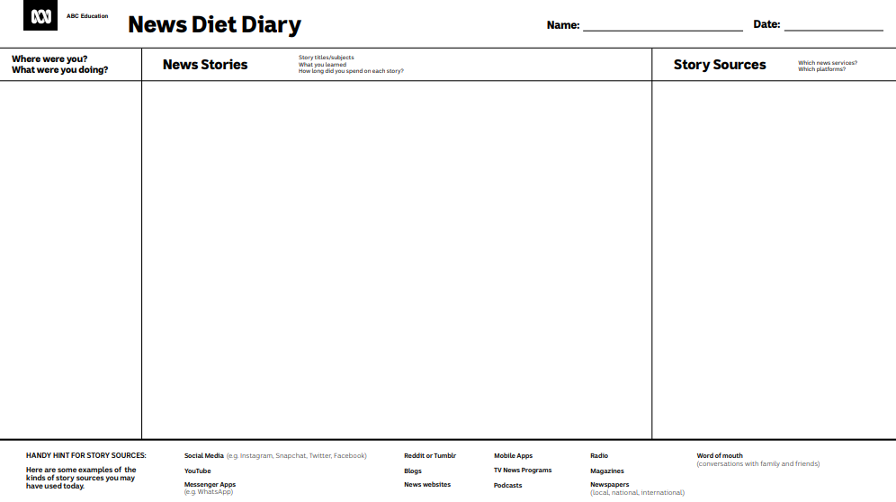

Activity: News vocabulary
Students will brainstorm a list of keywords that relate to understanding the news. Here are some words to get them started. Students will create their own class glossary of keywords and terms. Students can use videos, graphics, and/or diagrams to help explain each keyword.

JOURNALIST | NEWS VALUES | FAKE NEWS
SOURCE | RELIABLE | BIAS

Ask students to write what they think is the meaning of each word (including unfamiliar words). They will swap definitions with a partner and ask them to add to or change the definition. Check these against the dictionary definition.

Further activities for students:
- Visit ABC Education for a glossary on news and media terms. Choose some words to add to and enhance your classroom glossary.
- Choose one word/term from your glossary. Find a definition for the word and explore its meaning in more detail. Explain the meaning of the word or term to your classmates. Use examples to help explain the words meaning.

Activity: What makes something ‘news’?
Have you ever wondered what makes news, news? Students will investigate what makes an event newsworthy. Before starting this activity, brainstorm some ideas as a class.
What are news values?

Watch BTN’s What makes the news, news? video as a class. In this video we look at the news values that determine which stories we see and hear about and which ones we don't and how those news values can subtly shape the way we see the world.

Students will choose a range of current news stories (up to 5 news stories) and evaluate why the story is in the news and what makes it newsworthy? Students can use a t-chart to organise their information. Students will need access to current newspapers or online news sites to complete this activity.

News Story | Why is it news?  What makes it newsworthy?

Activity: Make your own news program
Students will put together their own news program using a range of existing BTN stories. Students will need to include a good balance of stories across different topics (for example: science, politics, world news, environment, arts, sport, and human interest). Students can visit the BTN website for a range of news stories sorted into useful topics.

Students will choose 5 stories to make up their own BTN program and then respond to the following questions for each news story they choose.
- Why did you choose this story?
- Summarise the main issue/message.
- Is the news story about a current local issue or an issue from the past?
- Where and when did it happen?
- What new information have you found about it?
- Who is affected by the issue?
- How are they affected by the issue?
- Why is it important for people to know about the issue?
- Why will people be interested in watching the news story?

Activity: Rookie Reports
Students will visit the BTN website to explore the latest Rookie Reports. Students will choose one story that interests them the most and then respond to the questions below.

Examples of BTN’s latest Rookie Reports:
Golden Guitar Winner | 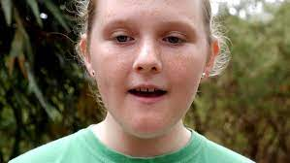  Bird Calling Competition | 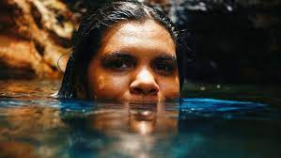  Charlotte from Warakurna
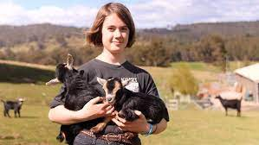  Young Goat Farmer | 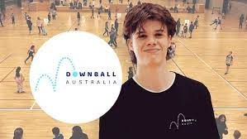  Downball League | 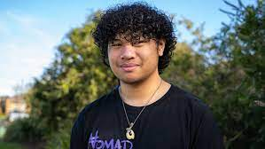  Logan’s Fire Knife Dancing

- What is the story about?
- Why did you choose this story?
- What words would you use to describe this story?
- Describe the main issue/message in the story.
- What makes this story interesting?
Activity: Write a feature story
Students will research and write a profile about someone that is doing something interesting in their community. It could be a prominent person in the community or someone from their school community. Students will then:
- Research as much as you can about the person.
- Write some interview questions you would like to ask the person.
- Interview the person – check out these interviewing tips
- Write a feature story – find out what makes a good feature story here. Celebrate the persons’ strengths in your writing. Share your story with the class.

Visit BTN’s Rookie Reporter Training to learn more about how to make a news story. The How to Make News video also gives some useful tips for making your own news story. Watch this BTN Explainer as a class to learn more about filming tips, like how to frame your shots and what the rule of thirds is.

Activity: Fact vs Opinion vs Analysis
This ABC Education all in one interactive “Fact vs Opinion vs Analysis” resource for teachers is an engaging introduction to the topic that works seamlessly in the classroom on laptops, tablets and projectors.

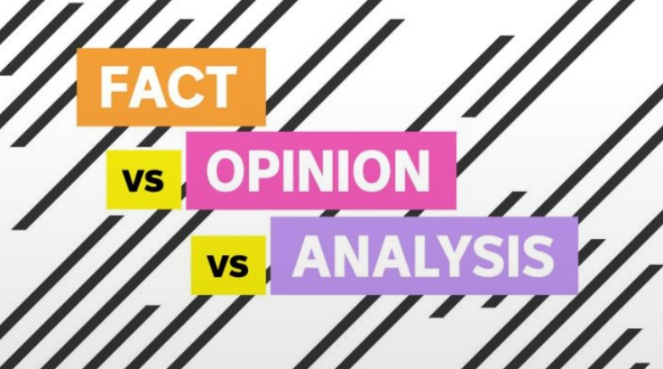
Designed so you can mix and match to suit your unit of work, it integrates an explainer video, talking points for the class and quick tests, as well as example content - perfect for media literacy or text analysis.

Before you begin this interactive, explain to your students what the terms FACT, OPINION and ANALYSIS mean.

Interactive: Fact vs Opinion vs Analysis

Activity: BTN’s Media Literacy series
BTN has created a series of Media Literacy videos to help students understand and question news. Topics include How to Spot Fake News, News Sources, What is News? How to Spot Bias, and Media Ethics.

The videos will help students to critically analyse the news they see, hear, or read. Please note – these videos are intended for secondary students.

Useful Websites
- Media Literacy Video Series – BTN
- Media Literacy – ABC Education
- Fake News Fight – BTN
- Kids’ News Service – BTN
- Behind the Scenes at BTN – BTN
- Becoming a journalist – BTN
- Use the News – ABC Education

  - Teacher Resource

BTN Transcript: Episode 3 - 21/2/2023

Hey, I'm Amelia Moseley and you're watching BTN. Thanks for hanging out with us, let’s see what’s coming up on today’s show. We find out why America's dealing with spy balloons and UFOs, what astronauts might soon be eating in space and Michelle takes on the sport of cup stacking.

Ukraine Anniversary

Reporter: Jack Evans

INTRO: We’ll get to all that soon, but first Friday the 24th of February marks one year since Russia invaded Ukraine. Let's find out what it's like over there at the moment and we’ll check in with two Ukrainian Kids who left the country with their family last year. Take a look.

NAZAR: We like sports, we like playing soccer.
TARAS: In Ukraine we already played for a club because we were playing with our friends and liked it. Now we play for club, Adelaide university soccer club.
NAZAR: We just play soccer on the soccer field and coach from the team saw how we play and say we are really good, and we need to play in the team, and he take us and we’re just really thankful that.
You might recognise Nazar and Taras. Last year they shared their story with BTN about leaving their home in Ukraine to come to Australia.
NAZAR: We come nine months ago.
TARAS: And it was 19th of April and seems like a long time ago.
It's a story shared by millions of Ukrainians who have had to flee to other countries because of the ongoing war.
TARAS: First, it was very hard. Because in Australia, all things are very different to Ukraine different for different people, different nature. But then we got used to it. And now we are very happy here.
Nazar and Taras have been able to settle into their new home here in Australia. But on the other side of the world the conflict between Russia and Ukraine is still a reality. It's now been one year since Russia invaded Ukraine. In that time hundreds of thousands of people have been killed, about a third of Ukraine's population has been displaced and entire towns have been reduced to rubble. For those still living in Ukraine it's been devastating, especially in the eastern parts of the country where most of the fighting is taking place.
AVDIIVKA RESIDENT: We've been here (in supermarket basement) for ten months already, without ever getting out of here. We only run outside to get to the shop or for water, as no one brings us water here.
To make things harder Russian forces have been deliberately targeting power stations with their attacks, which means Ukrainians are also dealing with constant blackouts.
BILOHORODKA RESIDENT: That's probably the worst because we can stay with no, no water for some time. We can stay with having no hot food for some time, but with no telephones on, it's a little bit uncomfortable.
Meanwhile, in the west people have been able to get back to some sort of normal life. A few schools, restaurants and shops have been able to re-open. But people here are always prepared for the worst.
KYIV RESIDENT: I think people just carry on as normal as much as they can. In the park here, there's people busking, buying coffees, you can buy food and sit and drink a coffee in the park. And there was an air raid siren just about ten minutes ago, as soon as that's over people just come out from the metro or the shelters and they just carry on with what they're doing. It's all you can do really.
As for Russia the war has caused significant damage to its military, majorly disrupted the country’s economy and many world leaders continue to criticise the actions of Russia's President, Vladimir Putin.
JOE BIDEN, US PRESIDENT: He thought he could roll into Ukraine and the world would roll over. Instead, he met with a wall of strength he never anticipated or imagined. He met the Ukrainian people.
Since February last year, Russia has been trying to take control of several regions in Ukraine and while it's been successful in some, Ukrainian forces have managed to take back control of several areas.
KYIV RESIDENT: I think you look at what's happening now, Russia annexed or said that they were annexing territories a couple of weeks ago and right now Ukraine's already liberating quite significantly large areas of that.
Meanwhile countries around the world, including Australia, have continued to show support for Ukraine. Offering aid as well as military supplies and training. And while Ukraine's President Volodymyr Zelenskyy is certain that his country will emerge victorious, there is still no end in sight for the war.
VOLODYMYR ZELENSKYY, UKRAINE PRESIDENT: We know Russia will lose. We really know the victory, the victory will change the world, and this will be a change that the world has long needed.
TARAS: Our president helps a lot in the country and the people that in the armies and fight with Russian people do help that Ukraine will be, yeah.
NAZAR: And I want to say thanks to all countries for helping Ukraine, it's really appreciated.
Now if you're feeling worried or upset about that story or anything else you've seen in the news, make sure you talk to someone about it. You can also call kids helpline on 1800 55 1800 or check out our website, we've got some resources up there on how to deal with upsetting news.
News Quiz

A heat wave has swept across large parts of Australia. South Australia, Victoria, Tasmania, and parts of New South Wales all experienced a low intensity heatwave. But the highest temps were in Western Australia. How hot did meteorologists predict it would get in the Pilbara over the weekend? Was it 40 degrees, 45 degrees or 50 degrees? They predicted 50 degrees. In reality, it only got to the mid-forties.

What did scientists find during an 11-day expedition into Australia’s alpine region? Is it, a new species of ant, spider, or wasp? The answer is spider. Well, actually, the 15 scientists found three new spider species, including the warrior huntsman. It’s called that because of the shield on its chest and war paint on its legs.
Forbes has named the world's 10 highest-paid entertainers of 2022. Altogether they've raked in more than 1.8 billion dollars but who’s at the top of the list? Is it Taylor Swift, Genesis, or Sting? It’s UK rock band Genesis. They topped the list, earning 230 million US dollars last year thanks to royalties from the band and front man Phil Collins' solo career, their farewell tour, and by selling a bunch of their music rights. Sting came in second and Tyler Perry third.

China Spy Balloon

Reporter: Michelle Wakim

INTRO: Some strange things have been spotted travelling at low altitude over US airspace recently. It comes just a week after the US military shot down what they say was a Chinese spy balloon. So, what's going on? Are we looking at aliens, spy equipment, or something else entirely?

MICHELLE: It all started with a balloon; a lot bigger than this one. Nope, even bigger. A balloon so big, it kind of looked like the moon.
CIVILIAN: That's the moon.
CIVILIAN: That thing is not the moon. This thing is so weird.
MICHELLE: It was flying over US and Canadian airspace, and when it was suspected to be a surveillance balloon from China, the Pentagon decided to…
To understand what's led to all of this, I had a chat to Bill Birtles, the ABC's East Asia correspondent.

MICHELLE: Hi Bill, thank you so much for joining us here at BTN. I'd like to know what's going on with this balloon.
BILL BIRTLES, ABC EAST ASIA CORRESPONDENT: We're not just talking about a balloon, we're talking about a balloon with solar panels rigged up on the bottom of it with what they call intelligence gathering pods, instruments that potentially detect radio signals or capture imagery. From what we can understand, it's actually not a new thing for countries to use balloons for espionage or other research.
Nope not a new thing at all.
PETER HARTCHER, SYDNEY MORNING HERALD: After World War 2, the US set up a program. The trial program was called Project Moby Dick, where they used as an experiment 500 balloons to carry cameras and other sensors. The concept was to carry them across the Soviet Union, the Eastern Bloc, but also into China. And then, that first experimental wave project Moby Dick interestingly enough set off the original wave of UFO speculation and suspected sightings in Southwestern US.
And it's something we're hearing again now. Since the first balloon was spotted, there's been another three unidentified objects found in US airspace, which just like the balloon, have been destroyed. They've also set off some theories about UFOs, but, the White House has made it clear there's no alien activity here.
KARINE JEAN-PIERRE, WHITE HOUSE PRESS SECRETARY: There is no, again, no indication of aliens or extra-terrestrial activity with these recent take downs...
But are we, really, really sure?
KARINE JEAN-PIERRE, WHITE HOUSE PRESS SECRETARY: Again, there is no indication of aliens or terrestrial activity with these recent take downs.
Hmm, I guess so.

MICHELLE: Now that we've shot down that theory, let’s get back to the bigger questions, like why anyone would still be using balloons to get information?
BILL BIRTLES, ABC EAST ASIA CORRESPONDENT: Some experts think that there are some advantages of using balloons, radio intelligence, for gathering communication signals on the ground. Also, to the experts assessing this balloon believed that it was maneuverable. So potentially, you might be able at a closer distance to hover over sensitive military sites, compared to satellites.
China has now accused the US of flying more than 10 balloons over their airspace in the past year, even though there's not a lot of evidence to support this. But even if the balloons are well and truly gone, there's a whole lot more to this situation.
BILL BIRTLES, ABC EAST ASIA CORRESPONDENT: The level of tension and distrust between these two great powers is just growing day by day. Long term, China wants to displace the United States as the world's most powerful country. Long term, the United States wants to stave off China replacing it as the world's most powerful country. And there's no room for compromise. It's a small part of a much, much bigger rivalry.

Space Food

Reporter: Cale Matthews

INTRO: Scientists around the world are trying to grow food that will survive and thrive in space. They say it'll help on future missions to places like the moon and Mars and now a team in Adelaide reckon they might have found the perfect solution.

This native Australian plant might not look like much. In fact, you might have seen it at your local pond. But what if I told you these floating fronds could end up on a rocket to Mars?
Cale: G'day Jenny, how are you going?
Assoc Prof. Jenny Mortimer, Adelaide University: I'm good, thanks. How are you?
Cale: Good, thank you. Now, what are we doing here?
Assoc Prof. Jenny Mortimer, Adelaide University: So, these are duckweed. And these are plants that we think might be food for astronauts in space.
Jenny: It's a really cool little plant. You see it growing on the surface of water sometimes. You walk past a river or a pond, and it's very green. People think it might be an algae or something. It's quite often duckweed, which is a plant that's related to wheat and barley.
Cale: Why are you interested in it? Why are you researching it?
Jenny: It's a really interesting plant to work with but it's also super nutritious. So, we can eat it as is. It's really high in protein, it's got a lot of vitamins in it. So, it's almost a complete meal.
Astronauts don't exactly starve on missions at the moment, eating anything from freeze dried macaroni to pizza. And occasionally resupply vehicles will bring the International Space Station fresh fruit and vegetables. But the ISS is only 400 kilometres away. Mars is 100 million. And when the cost to send just 1 kilogram into space is 25 thousand dollars, stocking a ship with more than 1000 days’ worth of food is not exactly doable. Luckily, researchers from universities across Australia are working on a solution.
Jenny: So, each of these is an individual plant, and it doubles in size every two days more or less, which is really incredible. If you think about most of our food plants, you sow a seed, and then you wait. So, imagine you're an astronaut in space, you want meals available every day. So, something that's available all the time is great.
Cale: You say it's a meal. These things are tiny. I don't think I'd be particularly satisfied just with that. So, how are astronauts going to be satisfied from these tiny little pellets?
Jenny: So, we imagine on your spaceship, you would have lots of layers of it growing. So, even if you only had like a metre growing space, you could've had, maybe stack it 15 trays high to the ceiling. So, you could grow quite a lot. Some of my colleagues also think that it actually takes up whatever flavour of whatever it grows in. So, if you took it out the local river, it's going to taste like river water. But if we can grow it on sort of flavours like lemon, or bacon or whatever is your personal preference, it will take it up.
Cale: Now, you said that here you're making them for human consumption.
Jenny: Yup.
Cale: Water's brown.
Jenny: Yes.
Cale: All of this water's pretty brown.
Jenny: So, I promise you, well, I won't give you the brown water. It's brown just because what we're using is a nutrient solution. Same as you'd put on your veggies in the garden. It doesn't look that appetising. Honestly it doesn't always smell that appetising, to be honest. So, what we do is we grow them for a bit here and they absolutely love it as you can see. When we're ready to eat it, we put it in some cleaner water and we grow it a bit more, and then it's ready to go. So, what we've actually got down here for you, you'll be pleased to know, is some more duckweed but in very clean water.
Cale: Lunchtime.
Jenny: Lunchtime.
Cale: Do you want them back or no?
Jenny: No, no, I think we're all okay.
Cale: Pretty good. I feel like an astronaut now.
Jenny: Excellent.

Rainbow Laces

Rookie Reporter: Abbie

INTRO: You're about to meet 13-year-old Abbie from Broken Hill. She started something called the Rainbow Laces Project. It's all about creating visibility for the LGBT+ community and helping out other young people who might be struggling with their identity. Check it out.

ABBIE: Walking around in the bush of Broken Hill just really helps me think. Living in such a rural town has got a massive impact on the way I live everyday life as a young queer person. Just going to school can be daunting and I would especially say that coming out to, not only Broken Hill, but the world was such a daunting thing because you come out on social media, and the whole school knows. This town really lacks queer representation and that's one of the reasons why I am glad I live here and that I can bring the Rainbow Shoelace Project to my community, because it's just showing people that LGBTQ+ is here and it's always been here and that it's going to stay here.
The Rainbow Shoelace Project is a project that I started in March of 2022, and I ultimately started it because I was feeling alone and isolated within who I was. I identify as a part of the LGBTQIA+ community and I just felt like there was no one else like me. I had had rainbow beads on my shoes prior to starting this project. But before starting high school I actually took them off my shoes because I was scared that people were going to bully me for it. I eventually found out that I was definitely not the only one feeling this way, I had friends and peers feeling that way. So, I decided why not start something that can help people.
The beads come in a little plastic bag with the information card in them and then obviously, we supply the rainbow beads which are in order of the pride flag, which is red, orange, yellow, green, blue, and purple. The beads are free, we've contemplated keeping them free because this project is self-funded. It is entirely self-funded; it always has been. But I have always wanted to keep these beads free. So, they can be accessible to absolutely everyone who wants them. I had no idea that this project would be so big, I had no idea that the whole world would be supportive of it. Especially from places like England and the USA, things like that.
INTERVIEWER: You're a strong woman you always have been, you're only 13, but you have been so hurt in the past. When you slip on that sparkly dress, what do you say to those people now?
ABBIE: I say to those people that I hope they can see how far this project has come and I hope they see how many supporters there are and I hope that they can see that the people who support us outweigh them and outweigh their negative comments, have just ultimately made me stronger as a person and made me realise that I do it for those people to see that it is so normal and it is so okay to be LGBTQ+.
I just want to keep trying to spread the word and spread the message of the Rainbow Shoelace Project. You normally see rainbows when you're looking up. And when you're experiencing homophobia and bullying you tend to look down and by looking down and seeing those sort of rainbow beads on someone's shoelaces, it can just change your life and it can change the way you see the world.

Sport

Let's kick things off with the NBA All-Star Game. The exhibition game is played every year and it's all about showcasing the best in the biz. This year LeBron James and Giannis Antetokounmpo were voted as All-Star captains. And Team Giannis took out the win 184 to 175. There's been a whole weekend of All-Star festivities including the Slam Dunk Comp. Philadelphia 76ers 'Mac McClung', stole the show winning the contest with almost perfect scores and a 540-degree dunk to finish.
The Matilda’s defeated Spain 3 to 2 in their Cup of Nations clash in Sydney. So far, the team's won both its matches in the tournament and will play for the top gong on Wednesday against Jamaica.

Cup Stacking Kid

Reporter: Michelle Wakim

INTRO: Have you heard of the sport of cup stacking? Well, Theo's an Aussie champion and record holder who's getting ready to compete at the World Championships in Singapore. Michelle caught up with him to learn a few tricks.

You're looking at an Australian Cup Stacking record holder. In April, Theo’s heading to Singapore for the World Championships.
MICHELLE: So, you'll be competing against people from all around the world?
THEO: Yes. 400 to 1000 stackers.
MICHELLE: And what are what are you feeling about the World Championships?
THEO: I'm feeling a bit happy but a bit nervous at the same time.

THEO: I got first into cup stacking when my PE teacher taught me at school. Cup stacking is when you stack specially designed cups in a sequence of three stacks, six stack, and 10 stack, as fast as possible. They are 3-3-3, 3-6-3, and a cycle.
MICHELLE: Okay, specially designed cups?
THEO: Which do not stick, and you can see straight through them. So, do not put water in them.
MICHELLE: How does it make you feel when you’re cup stacking?
THEO: I feel really good, because it just motorises you to do more, and to get records because you never know when you can stop doing it. Because you can't, you can't stop doing it.
MICHELLE: So, it becomes a bit addictive?
THEO: Yes, it does.
MICHELLE: Do you have an excitement? A thrill?
THEO: Yeah, I do, a really good excitement, especially when I get a record and in tournament when I’m getting an ‘Australian SS 7 to 10’ record.

MICHELLE: Okay.

THEO: That is my division. SS means Special Stacker, so disability stacker. I have autism and mild cerebral palsy.
Theo holds the record for the 3-6-3- stack, and the cycle in his division. And all his times are pretty impressive.
MICHELLE: Do you have any idols in the cup stacking world?
THEO: I think it's Jaden Coggins, the Australian all-round champion. But I also do want to meet worldwide stackers in Singapore, William Orrell. He’s the second best in the world but is the best right now.
MICHELLE: What would you say to other kids who might be thinking about getting into cup stacking?
THEO: I would probably say, always have a go at it. If you don't want to do it again, you don't have to do it again. If you want to do it again, you can go as best as you can.

MICHELLE: That was 3.9 seconds. What’s your record?

THEO: 3.2.
Theo is clearly very good at this, so I thought this was my opportunity to learn a thing or two.

THEO: But then you put that on there, all down stacked. And down-stack this six.
MICHELLE: You're a great teacher.
Closer
Aww, Michelle. At least you tried. Well, that's it for today. But we'll be back with more news for you next week. If you miss us in the meantime, you can check out website for more content including the brand-new BTN High and our daily show Newsbreak. Have a good one and I’ll catch you soon. Bye.

