

**EPISODE 12**  
10th May 2022

**KEY LEARNING**

Students will view a range of BTN stories and use comprehension skills to respond to a series of focus questions.

**CURRICULUM**

**English – Year 4**Use comprehension strategies to build literal and inferred meaning to expand content knowledge, integrating and linking ideas and analysing and evaluating texts.

**English – Year 5**

Use comprehension strategies to analyse information, integrating and linking ideas from a variety of print and digital sources.

**English – Year 6**

Use comprehension strategies to interpret and analyse information and ideas, comparing content from a variety of textual sources including media and digital texts.

**English – Year 7**

Use comprehension strategies to interpret, analyse and synthesise ideas and information, critiquing ideas and issues from a variety of textual sources.

Teacher Resource

**Focus Questions**

As a class, discuss the stories featured in the episode of BTN Classroom and record the main points of the discussion. Students will then respond to the following focus questions.

# Interest Rate Rise

1. What does the BTN story explain?
2. Which bank decides whether to increase or decrease interest rates?
3. Interest rates have gone up for the first time in how many years?
4. What impact does an increase in interest rates have on people who have borrowed money?
5. Name three facts you learnt watching the BTN story.

Check out the [teacher](https://www.abc.net.au/btn/teachers/) resource on the Teachers page.

# Journey from Ukraine

1. Where did Luka, Nazar and Tara go after fleeing Ukraine?
2. How did they feel about leaving Ukraine?
3. What do they like about Australia?
4. What are Luka’s hopes for the future?
5. What message of support would you send to Luka, Nazar and Taras?

**Preferential Voting**

1. Explain to another student how preferential voting works.
2. Australia is one of the few countries in the world that uses preferential voting. True or false?
3. For a political candidate to win their seat in an election they need to…
   1. Win half the votes
   2. Win half the votes plus one
   3. Win all of the votes
4. What are the advantages and disadvantages of preferential voting?
5. What questions do you have about the preferential voting story?

Check out the [teacher](https://www.abc.net.au/btn/teachers/) resource on the Teachers page.

# Election Lingo – Safe and Marginal Seats

1. To win an election, a party needs to get more than half of the seats in the…
   1. House of Representatives
   2. Senate
2. What is a safe seat?
3. In your own words, explain what a marginal seats is.
4. How might a marginal seat affect the result of an election?
5. Find out what electorate your school is in. Is it a safe seat or a marginal seat?



**EPISODE 12**  
10th May 2022

**KEY LEARNING**

Students will develop their understanding of interest rates and inflation.

**CURRICULUM**

**Mathematics – Year 5**

Construct displays, including column graphs, dot plots and tables, appropriate for data type, with and without the use of digital technologies.

**Mathematics – Year 6**

Interpret and compare a range of data displays, including side-by-side column graphs for two categorical variables.

**Mathematics – Year 7**

Find percentages of quantities and express one quantity as a percentage of another, with and without digital technologies.

Investigate, interpret and analyse graphs from authentic data.

Identify and investigate issues involving numerical data collected from primary and secondary sources.

**Economics & Business – Year 7**

Gather relevant data and information from a range of digital, online and print sources.

Present evidence-based conclusions using economics and business language and concepts in a range of appropriate formats, and reflect on the consequences of alternative actions

Interpret data and information displayed in different formats to identify relationships and trends.

Teacher Resource

**Interest Rate Rise**

# Focus Questions

Discuss the BTN story as a class and record the main points of the discussion. Students will then respond to the following:

1. What does the BTN story explain?
2. Which bank decides whether to increase or decrease interest rates?
3. Interest rates have gone up for the first time in how many years?
4. What impact does an increase in interest rates have on people who have borrowed money?
5. Name three facts you learnt watching the BTN story.

# Activity: Class discussion

**Before watching**

Before watching the BTN Interest Rate Rise story students will discuss in small groups what they already know about interest rates and what they think this BTN story will be about.

What do you know about interest rates?

**After watching**

Students will respond to one or more of the following questions after watching the BTN story:

* A picture containing text, vector graphics

  Description automatically generatedWhat did you learn from the BTN story?
* What do you THINK about what you saw in the BTN story?
* Who are affected by interest rate rises?
* Think of three questions you have about the story.
* Write a summary of the BTN story.
* What is the key vocabulary from the BTN story? Make a list.

# Activity: Glossary

Students will brainstorm a list of key words that relate to the BTN Interest Rate Rise story. Students may want to use pictures and diagrams to illustrate the meaning and create their own glossary. Here are some words to get students started.

|  |  |  |
| --- | --- | --- |
| INTEREST RATES | RBA | LOAN |
| INFLATION | ECONOMY | DEBT |

# Activity: Borrowing Money

Students will explore what it means to borrow money and will look at the reasons why people borrow money. Have a class discussion to explore and investigate these concepts further, using the following questions to get the discussion started.

* Have you ever borrowed money from someone? What did you borrow the money for? Explain.
* How did you pay the money back? What sort of agreement did you have to pay the money back? Were you able to pay the money back in time?
* Alternatively, have you ever lent money to someone else? How did they pay you back and did you have an agreement to make sure the loan was paid back in time?
* As a class discuss the concept of interest and how it relates to borrowing and lending money. What sort of maths would you need to use to calculate interest?

**Calculating interest**

Explain to students they will be calculating the amount of interest they will need to pay on a loan from the bank to buy a new home. Students will need to determine the following:

* How much money will you need to borrow from the bank to buy your new home?
* What is the interest rate for your loan? For example, the interest on your loan may be 4%. This means that every year 4% of the money you haven’t repaid yet is added to your debt.
* How long will you need to repay the full amount of the loan? This is called the ‘length of the loan’ and normally is set at about 25 or 30 years.

Students can then use this Money Smart [mortgage calculator](https://moneysmart.gov.au/home-loans/mortgage-calculator) to find out how much interest they will pay on a home loan. Students will then respond to the following focus questions:

* How much will your repayments be?
* How much interest will you pay in total?
* What happens if your interest rate increases or decreases?
* What happens if you change your repayment frequency?

Explain to students that if they encounter simple interest on short term loans, they can use the following formula to calculate the amount of interest.

*Loan amount* ***X***  *Interest rate (decimal)* ***X*** *Number of years* ***=*** *Total interest paid*

Example - Sally has borrowed $2,000 from her parents to buy a car. The interest on this loan is 5% and Sally must pay the loan back to her parents in 5 years. In total, Sally will need to pay $500 in interest.

$2,000 x 0.05 x 5 = $500

# Activity: My five cents explainer

Watch this ABC Education [explainer](https://www.abc.net.au/education/my-five-cents-why-borrowing-can-cost-you-more/13623524) to learn how interest rates and fees affect the money you borrow, and why they may be more expensive in the long run.

Watch more of the ABC Education’s [My Five Cent’s](https://www.abc.net.au/education/collections/my-five-cents/) series to learn about other important financial concepts.

ABC Education – [My Five Cents: Why borrowing can cost you more](https://www.abc.net.au/education/my-five-cents-why-borrowing-can-cost-you-more/13623524)

# Table Description automatically generated with medium confidenceActivity: Jigsaw learning activity

In this activity students will work cooperatively to learn more about inflation, an increase in the cost of goods and services over time.

As a class, decide what time periods you will be researching as part of the jigsaw activity. For example:

* Current year compared to 50 years ago
* Current year compared to 100 years ago
* Current year compared to 20 years ago, 15 years ago, 10 years ago, and 5 years ago.

|  |  |
| --- | --- |
| **Form groups** | Divide the class into 4 x Focus Groups. Each Focus Group will be assigned a different type of goods or service to investigate and become experts. Some areas of research could include: the average cost of a new home, food (choose one type of food like a loaf of bread or a sausage roll), average wage, and the average cost of a new car. Each group will need to decide how they will collect and communicate the information they find during their research. |
| **Research** | Each Focus Group will respond to the following questions to become experts:   * Find out the average cost of the goods or service in each time period you are investigating. Where and how will you find your information? Consider having a conversation with your parents or grandparents to find out more about the cost of living. * Plot the information you have found on a bar graph. What do the axes represent? What is the graph trying to communicate? What has changed over time? * What do you notice about your findings? * What do you wonder about your findings?   Challenge: Use the [RBA’s formula](https://www.rba.gov.au/education/resources/explainers/inflation-and-its-measurement.html) to calculate the rate of inflation:  Text  Description automatically generated |
| **Share** | Mix the Focus Groups to form Task Groups (Tasks Groups include one student from each of the Focus Groups) to share the information they have collected. Students will share the information they have collected and learn from one another. Compare and contrasts your findings. |
| **Reflect** | Students will reflect on the activity by responding to one or more of the following questions:   * What did you enjoy about this investigation? * What did you find surprising? |

# Useful Websites

* [Interest Rate Cut](https://www.abc.net.au/btn/classroom/interest-rate-cut/11182866) – BTN
* [Interest Rates](https://www.abc.net.au/btn/classroom/interest-rates/10533328) – BTN
* [Inflation](https://www.abc.net.au/btn/classroom/inflation/10542100) – BTN
* [Inflation: Why are things getting more expensive?](https://www.bbc.co.uk/newsround/59320010) – BBC Newsround
* [What it used to cost](https://guides.slv.vic.gov.au/whatitcost/getstarted) – State Library of Victoria



**EPISODE 12**  
10th May 2022

**KEY LEARNING**

Students will find out more about the preferential voting system and learn how to run their own election at school.

**CURRICULUM**

**Civics and Citizenship – Year 5**

The key features of the electoral process in Australia.

**Civics and Citizenship – Year 6**

The responsibilities of electors and representatives in Australia’s democracy.

Teacher Resource

**Preferential Voting**

# Focus Questions

Discuss the BTN story as a class and record the main points of the discussion. Students will then respond to the following:

1. Explain to another student how preferential voting works.
2. Australia is one of the few countries in the world that uses preferential voting. True or false?
3. For a political candidate to win their seat in an election they need to…
   1. Win half the votes
   2. Win half the votes plus one
   3. Win all of the votes
4. What are the advantages and disadvantages of preferential voting?
5. What questions do you have about the preferential voting story?

# Activity: Class Discussion

Discuss the BTN Preferential Voting story as a class. Use the following questions to guide discussion: Ask students to record what they know about preferential voting. What questions do they have? In small groups, ask students to brainstorm responses to the following questions:

* Have you ever had to vote for someone or something? What was the process?
* How are student representatives elected in your school?
* Who can vote in Australia?
* What is the preferential voting system?
* What are the advantages of preferential voting? Are there any disadvantages?

# Activity: Glossary

Students will brainstorm a list of key words that relate to the BTN Preferential Voting story. Here are some words to get them started. 

|  |  |  |
| --- | --- | --- |
| ELECTION | PREFERENTIAL VOTING | VOTE |
| CANDIDATE | ELECTORATE | FIRST-PAST-THE-POST |

# Activity: Voting Research

Discuss the information raised in the BTN Preferential Voting story. What questions were raised in the discussion and what are the gaps in students’ knowledge? The following KWLH organiser provides students with a framework to explore their knowledge on this topic.

|  |  |  |  |
| --- | --- | --- | --- |
| What do I **know**? | What do I **want** to know? | What have I **learnt**? | **How** will I find out? |
|  |  |  |  |

Students will develop their own question/s to research or choose one or more of the questions below. Encourage students to collect and record information from a wide variety of sources and present the information they find in an interesting way.

* Compare the first-past-the-post voting system and preferential voting.
* Why does Australia use the preferential voting system?
* Why do minor parties like the preferential voting system?
* What does absolute majority mean?
* Do you think compulsory voting and the secret ballot are important to the voting system? Give reasons for your answer.

# Activity: Run your own election

Running an election for your class provides the opportunity for students to participate in the democratic process of choosing representatives for a range of purposes. Students will run their own election and investigate how the preferential voting system works.

Begin by watching the [*Making your vote count*](https://www.youtube.com/watch?v=HXEmJ82sF0c) animation for an explanation of the different voting systems used to elect representatives. Watch [this animation](https://www.youtube.com/watch?v=KSPEhmG1HZ8) to learn about the difference between first-past-the post and preferential voting system. Students can test their knowledge in the [Voting Challenge Quiz](https://education.aec.gov.au/democracy-rules/interactives/aec-challenge-2/).

Visit the Australian Electoral Commission’s [Get Voting website](http://education.aec.gov.au/getvoting/content/resources.html). Get voting is everything you need to run a free and fair election for your class.

# Activity: BTN Election Stories

Check out these BTN Election stories to understand more about voting and the federal election.

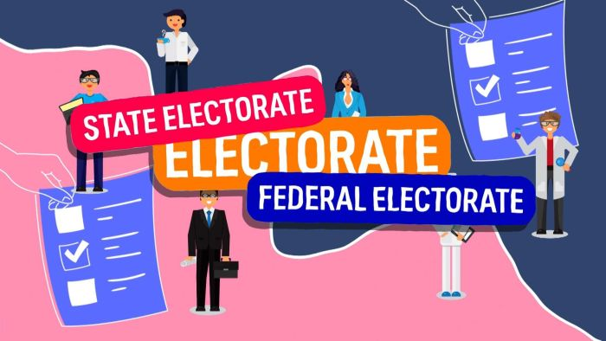

[*BTN Election Lingo - Electorates*](https://www.abc.net.au/btn/classroom/election-lingo-electorates/13849284) [*BTN Election Lingo - Parties*](https://www.abc.net.au/btn/classroom/election-lingo---parties/13858392)

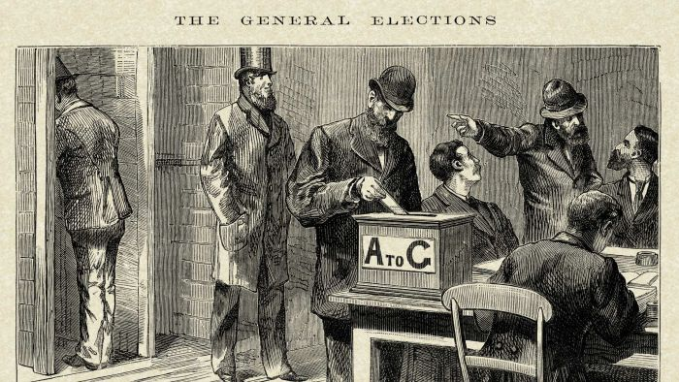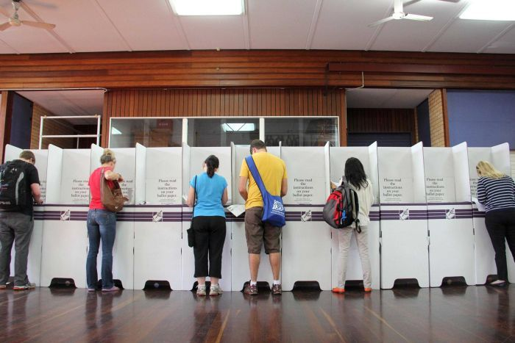

[*BTN Voting Age*](https://www.abc.net.au/btn/classroom/voting-age/13858374)[*BTN – History of Voting*](https://www.abc.net.au/btn/classroom/history-of-voting/13849266)

Check out BTN’s [Ask a Reporter](https://youtu.be/yMqClnxjFCA) about voting in Australia

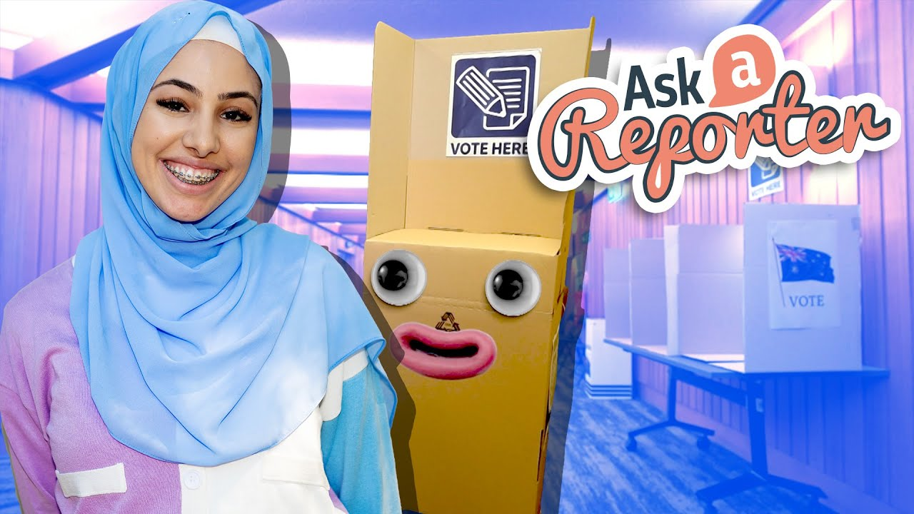

# Useful Websites

* [Voting Age](https://www.abc.net.au/btn/classroom/voting-age/13858374) – BTN
* [History of Voting](https://www.abc.net.au/btn/classroom/history-of-voting/13849266) – BTN
* [Preferential Voting](https://www.abc.net.au/btn/classroom/preferential-voting/10529850) – BTN
* [Preferential Voting](https://www.aec.gov.au/learn/preferential-voting.htm) – AEC



Teacher Resource

**BTN Transcript: Episode 12 - 10/5/2022**

Hi, I'm Amelia Moseley and you’re watching BTN. Thanks for hanging out with us for another episode. Let’s see what's coming up. We follow these Ukrainian kids on their journey to Australia, find out how preferential voting works and meet another winner of the Takeover Melbourne competition.

# Interest Rate Rise

Reporter: Nat Kelly

*INTRO: Now, you might have heard a lot of talk lately about interest rates and maybe you didn't find it that interesting. But, you know, interest rates have a huge effect on lots of Aussie families, especially when they go up, like they did last week. Here's Nat to hopefully pique your interest.*

BOSS: Careful, mate. The whole economy is at stake here.  
  
WORKER: Ugh. Thanks. Noted.  
  
BOSS: You’re welcome. Now, what do you see?  
  
WORKER: We have a blue wire, and a red wire.  
  
BOSS: Brilliant. Brilliant. Now can you tell me what each one says.   
  
WORKER: Ugh yes, yes. Ugh, the blue wire says lower interest rates and the red wire says higher interest rates. Which one?  
  
BOSS: Interest rates. Oh my, I remember those words.   
  
WORKER: I don't know if I'm ready for this. It's my first day on the job.  
  
BOSS: No. It's okay. I believe in you. But first I need to make a very important phone call.   
  
This is the Reserve Bank of Australia, a very important place that's had a very serious situation on its hands lately. You see, it's the job of this place to keep our entire financial system stable by making some very important decisions like how much money should be printed and how high interest rates should be. And for the first time in 11 years, interest rates have gone up.  
  
BOSS: Okay cool, but what does that mean?  
  
Well, let's say you wanted to buy something really expensive, like a house, or a boat, or a house boat. Most people don't just have that sort of money lying around, so they have to take out a loan at a bank. And the bank's like, "hmm okay, you can have some money. But as well as paying us back the money you borrowed, you have to pay us back a percentage of it on top. Extra. Bonus. You know, for our troubles." And that's called interest. Each bank sets its own interest rate, but the folks at the Reserve Bank, that's this place, set the interest rate for the banks, which they usually pass on to their customers.  
  
WORKER: Okay, that’s a great explanation, brilliant even, but I’m kind of running out of time here, and ugh, I still don’t know which wire to cut?  
  
Oh. Right. Yeah, well look if you go with the higher interest rates, borrowing money gets more expensive. And people who have borrowed money for their houses and houseboats will have to pay back more in interest to the bank.  
  
WORKER: Right. So, I should be cutting the other wire then?  
  
Umm, hold on just one minute. If the interest rate stays too low for too long, inflation can happen.   
  
BOSS: Inflation? Oh no. I remember that word.   
  
WORKER: Wait, what's so bad about inflation? Isn't that just like what you do to balloons and stuff?  
  
No. Nothing to do with balloons. When there's too many people spending too much money, it can actually cause the prices of everything to go up. And what starts to happen is the Australian dollar loses its value, so even though people might have more money, it's worth less. Lately, inflation’s been getting a little out of control lately, because of things like COVID, fuel prices, and yep you guessed it, interest rates.   
  
WORKER: Ah. Um. Okay? So, back to these wires. Which one should I cut, hey?  
  
Well, it's not an easy decision.   
  
WORKER: I was afraid you'd say that.   
  
It's the Reserve Bank's job to carefully increase or cut interest rates depending on what our economy needs at the time. Those rates have been at a record low since the end of 2020, 0.1 percent, and if we check out this chart, they've been going down since 2010. So, a lot of experts have said, well, it was only a matter of time before they started going up again.  
  
PHILIP LOWE, RESERVE BANK GOVERNOR: People have understood that interest rates would go up. It's happening earlier than I expected.  
  
Experts reckon we might see a few more interest rate rises before the end of the year as the Reserve Bank tries to cut back that inflation. But that could have a big impact on a lot of people who owe money on their houses, or houseboats, and there are worries it could slow down the whole economy. Which is a big deal for these guys, with an election just around the corner.   
  
BOSS: Sheesh. I sure am glad I'm not the one cutting those wires.   
  
WORKER: Boss, are you there? Anyone? Hello? Hello?

# News Quiz

Qantas is set to break a record by introducing the world’s longest commercial flight by 2025. Which two cities will the flight connect? Sydney and London, Perth and Buenos Aires or Melbourne and New York? The flight will take passengers from Sydney to London in just over 19 hours.

Bono and the Edge have performed in a subway station-turned bomb shelter in Kyiv. Can you name the famous Irish band they’re from? It’s U2. They were personally invited by Ukrainian President Volodymyr Zelensky to perform as a show of solidarity with Ukrainian people.

British Actor Ncuti Gatwa has just been named as the next Doctor in the long-running sci-fi series Doctor Who. How many people have played the timelord since the TV show started in 1963? 5, 10 or 13? There have been 13 incarnations of the doctor. Ncuti will be the 14th and he says, he’s very excited to be taking the keys to the Tardis.

And Eurovision 2022 is about to begin. Which country is hosting the famous song contest this year? Is it France, Italy or Israel? It’s Italy. It won the honour after Italian band Maneskin took out last year’s contest and while Australia can’t host the event because, well, we’re not in Europe, we are allowed to compete, and this year Sheldon Riley will take his song “Not the Same” to the stage.

**Journey from Ukraine**

Rookie Reporters

INTRO: *Since the war in Ukraine began, millions of people have had to leave their homes to find safety, including lots of kids. This week, I caught up with some young Ukrainians who've just arrived in Adelaide. They've kept a record of their journey and they wanna share it with you. Take a look.*

TARAS: Hi BTN, I'm Taras.  
  
NAZAR: I'm Nazar.  
  
TARAS: And we want to tell you a story about going to Australia from Ukraine.  
  
LUKA: Hi BTN, my name is Luka. I’ve been in Australia for one month. My cousins are Taras and Nazar.

NAZAR: In Ukraine we live in Lviv.  
  
TARAS: It was a very beautiful city; it was very interesting and we like playing soccer and it was fun for us.   
  
NAZAR: We lived with my mum and dad and grandparents and great grandma.  
  
TARAS: Russia attacked Ukraine and we need to go to another country.  
  
LUKA, UKRAINIAN TRANSLATION: When the war started, we saw lots of warplanes and helicopters flying over our house, our mum and dad were constantly alarmed with the air sirens, and we all had to hide in the basement. On the 7th day of the war our mum took my sister and I to Poland together with our cousins.   
  
TARAS: We had to leave our great grandmother in Ukraine.  
  
NAZAR: And saying goodbye is very sad. Our dad couldn't come with us because in Ukraine war and maybe he will go to the army.  
  
TARAS: That make us feel sad and worried because it is very hard for us.  
  
NAZAR: We wish our dad came with us.  
  
LUKA, UKRAINIAN TRANSLATION: I felt really sad leaving Ukraine, I didn't like it at all, the first two days have been very sorrowful for me. I was so sad to leave my dog behind, we used to play with him every day.  
  
NAZAR: We will now go to Poland because Russia attack Ukraine and it is very dangerous. The first day of war was my birthday. It was the worst day of my life.  
  
NAZAR: Now we are waiting for the plane to Australia. We want to see our cousins Andrew and Sofia. They live in Australia, and it is our chance to run away from the scary war.   
  
TARAS: We left Poland and came to Australia. It was very hard to fly 20 hours on a plane. We were nervous and excited too.  
  
LUKA: We are in Australia**.**  
  
NAZAR: Australia is very far and different places.  
  
TARAS: Here are good animals, nature and weather. It's very hard for us to tell in English, but we are learning this language**.**  
  
NAZAR: Now we're staying in Adelaide in this beautiful house.  
  
TARAS: And Australian family let us to live with them.   
  
LUKA, UKRAINIAN TRANSLATION: It was rather strange at first to live with the other people, especially when waking up, but I got used to it. I discovered later that they were actually really good people.  
  
ROB ESZELT-ALLEN, ZACH'S DAD: You know koalas make these really strange noises. They go like.  
  
NAZAR: With Zach we play a lot of games.  
  
TARAS: Table tennis, play soccer and ride a bicycle.  
  
ZACH: This is vegemite. It's an Australian spread and it's very salty, so you're either gonna love it or hate it**.**  
  
ZACH: I'm Zach, and Taras, Nazar and their mum are living with me in my house. They have been living here for around a week and it's been great having them over here.   
  
ZACH: Taras, Nazar, what do you want to be when you grow up?  
  
TARAS: We want to be football players**.**

ZACH: We really wanted to help out with the Ukraine conflict. I was sort of nervous at first, but I know that they'd definitely be good people and I know that they're coming from a pretty tough time, so we just wanted to make them feel at home.

TARAS: Next week we will go to the school, and I think we will find new friends there.  
  
NAZAR: Tomorrow we’re going to the zoo**.** Very good animals and very beautiful.   
  
LUKA: I really like kangaroo. He's very fun animals**.** I would like my dad to come to Australia with my dog, my grandmother and my grandfather, all my relatives.

NAZAR: We hope the war will end.  
  
TARAS: And we hope we will meet with our grandparents and dad, and they will be very happy. Here we safe. And war is far for Australia. So now we safe and happy here.

# Preferential Voting

Reporter: Amal Wehbe

*INTRO: Next up, to the election, you know that thing that's happening in a couple of weeks? When people do go to the polls on Saturday the 21st they won't just be ticking a box for the person they like best because in Australia we have a preferential voting system. Amal found out what that is, why it's unusual and why some people reckon it's pretty great.*

AMAL: Alright guys I'm getting lunch, bagels sound good?  
  
CALE: No, bagels are so boring, I want pizza**.**  
  
NAT: We had pizza last week. We should do something fun, like sushi**.**  
  
LEELA: Yes sushi**.**  
  
AMELIA: Oh guys, I was thinking maybe we try that new noodle place.  
  
AMAL: I'm not going to all those places. We need to pick one.  
  
Yeah, sometimes making a group decision can be tough which is why voting can be helpful.  
  
AMAL: Alright, so bagels, pizza, sushi, sushi and noodles. Looks like it's sushi.

LEELA: Yes.   
  
Now that's one way of voting but it means even though two people are happy you end up with three people who really don't want sushi. But there is another way.  
  
AMAL: Okay, so if you can't get your first choice, what's your second? I'm happy with pizza.  
  
CALE: Yeah, I mean I guess the noodles were alright.   
  
NAT: On second thoughts, I could do pizza.  
  
LEELA: Yeah, pizza.   
  
AMELIA: Hmm, bagels**.**  
  
Now things are getting a bit easier. Pizza might only be one person's first choice, but three more people made it their second choice. That means four people are pretty happy with their lunch. Okay, so this might seem pretty unrelated to politics, but this is actually the way Aussies vote in elections for the lower house or House of Representatives, which is where the government is formed. And Australia's actually one of the few countries that use it. Instead of just picking the one candidate, voters are asked to give each one a number, in order of preference. One for their favourite, two for their second favourite, three for their third and so on.  
  
So, to get a better picture let's imagine these guys are running for election. Sharp bunch. So, to win your seat in parliament you need half of all votes plus one. Now let's imagine there's 1000 voters which means you need.  
  
CALE: 501**.**  
  
Yep, thanks Cale. You need 501 to win. Alright, let's do this**.** Once all the votes are in counters add up all of the first preferences for each candidate. And we end up with these scores. So, we've got Amelia in the lead. But she hasn't got more than half the votes**.** So, it's not over. For now, we eliminate the person with the least amount of votes.  
  
Sorry Nat. But the people who voted for Nat still get a say. That's because counters go back and see what the Nat voters put as their second preference. Then this gets added to the totals of the remaining candidates. So, now Amelia has 410, Leela has 360 and Cale has 230. But we haven't got past the magic number, 501**.** So, we keep going**.** Cale gets eliminated, see you Cale. And we add up the preferences again. Finally, Amelia has 480 and Leela has 520**.** So even though Leela was behind at first, she just won the BTN election**.** Sorry it doesn't come with a prize.  
  
There are some down-sides to voting this way. Preferential voting is more complicated and counting all those votes takes more money and time. Sometimes we don't even know who's won an election for days. Plus, it means a candidate that's not the most of the electorate's number one pick can still win. But fans of this very Aussie voting system say it's something we can be proud of. It means people can vote for less popular candidates and know their vote isn't wasted. And parties with similar points of view can support each other rather than taking votes away from each other. Most of all, they say it's a way of keeping as many people as possible as happy as possible and that's important, whether it's in politics or just lunch.

# Quiz

What sort of vote is also known as an Australian Ballot? Is it a preferential vote, a vote you cast in private or a vote you fill out with a pencil? It's a vote that's cast in private. Way back in the 1850s Victoria, Tassie and South Australia brought in uniform ballot papers and secret voting so that no-one could pressure you to change your vote. The idea took off in other countries where it was known as the Australian ballot.

# Election Lingo – Safe and Marginal Seats

Rookie Reporter: Ben

There are all sorts of seats out there: Hard seats, soft seats, weird seats, fancy seats. But in an election the seats you hear most about are the safe seats and the marginal seats. So, what are they? Well, in federal politics, the seats that matter are the ones in here. There are 151 seats in the lower house or the House of Representatives and there are 76 seats in the Senate. But to be in charge a party needs to win more than half of the seats in the House of Reps.

Each seat can be filled by just one politician and choosing those politicians is what elections are all about. Sometimes seats are in electorates where most people usually vote for the same party, and they’re called “safe” seats. They’re the ones where you see the well-known politicians and the party leaders because they’re really unlikely to be voted out.

Marginal seats are in places where the vote is more evenly split. Sometimes the seat goes to one party, sometimes to another and if just a small number of voters change their minds the seat can change again. Because they’re easy to win and easy to lose, political parties do a lot of wrestling over marginal seats. Winning just a few of them could give them the majority they need to win the election. Of course, just because a seat looks safe or marginal, that doesn’t mean things can’t change. In an election anything can happen, and every seat is important, so you can’t get too comfy.

**Sport**

Aussie soccer star Sam Kerr and her team Chelsea have done it again. They went up against Manchester United and after trailing 2-1 in the first half they made a dazzling comeback thanks to these goals from Kerr. They finished the match 4-2 up and took home their third title in a row.   
  
The Sydney Kings are on the verge of winning their first NBL championship in 17 years, beating the Tasmania JackJumpers in game 2 of the finals. With less than 10 seconds left on the clock, the Kings sealed their victory with this three-pointer by Dejan Vasiljevic. They'll face off again in game three on Wednesday.   
  
19-year-old Carlos Alcaraz has won the Madrid Open. Alcaraz is the second youngest player ever to win two master's 1000 titles and defeated two of the greatest players in history, Rafael Nadal and Novak Djokovic along the way.  
  
And in Formula 1. Wait a minute, this isn't F1. Nope, this is the annual Australian Ride-On Lawn Mower Racing championship in New South Wales. It started way back in the 1980s after 5 mates decided to race each other on their mowers but these aren't really mowers anymore. They're highly modified and can go about 100 kays an hour.  
 **Zara’s Hijab**

Rookie Reporter: Zara

*INTRO: Finally, today let's meet Zara, another winner of the Takeover Melbourne Competition which asks young people to tell their stories. Zara chose to share what it was like for her the first time she wore a Hijab. Check it out.*

My family and I love playing games together. They can get a bit competitive sometimes, especially between me and my brother. I am a Muslim girl. Growing up, religion was never imposed, it was a way of life. When I was younger, I remember playing around with my mum’s colourful and patterned scarves. That’s when it dawned on me that there would come a time when I would start wearing one too. But I was embarrassed to wear it in front of my school friends, so I kept putting it off. The fear of not being accepted had swallowed me whole, leaving me afraid.

On the first day of year 7, I decided it was time. Mum wrapped the hijab around me, the warmth of her hands around my face calmed me. As we drove to school, I was both excited and nervous. How would my classmates react? Would they behave differently towards me? I was about to be the only girl in the school wearing a hijab. I took some deep breaths and entered the class. The room was silent. Time passed and no one said anything. I was shocked. After class, I hung out with my friends. We talked, caught up, and made jokes. Wearing the hijab hadn’t changed a thing. I've been wearing it everywhere, I feel so bare without it, like it's part of me. Overcoming my anxiety and embracing change made me realise I can be more open about who I am. This is a true me.

**Closer**

Thanks Zara. Well, that's it for another week. I hope you've enjoyed the show. We'll be back next week but, if you can't wait that long don't worry, there's heaps to see and do on our website and our YouTube Channel if you're 13 or over. Plus, as usual, Newsbreak will be right here in the studio every weekday to keep you up to date. Have an awesome week, and I’ll see you soon. Bye.