EPISODE 28
17th October 2023

KEY LEARNING
Students will view a range of BTN stories and use comprehension skills to respond to a series of focus questions.

CURRICULUM
English – Year 4
Use comprehension strategies to build literal and inferred meaning to expand content knowledge, integrating and linking ideas and analysing and evaluating texts.

English – Year 5
Use comprehension strategies to analyse information, integrating and linking ideas from a variety of print and digital sources.

English – Year 6
Use comprehension strategies to interpret and analyse information and ideas, comparing content from a variety of textual sources including media and digital texts.

English – Year 7
Use comprehension strategies to interpret, analyse and synthesise ideas and information, critiquing ideas and issues from a variety of textual sources.
  - Teacher Resource

Focus Questions
As a class, discuss the stories featured in the episode of BTN Classroom and record the main points of the discussion. Students will then respond to the following focus questions.

Voice Referendum Outcome
- What was the outcome of the Voice referendum?
- Australia has had 45 referendums. How many have been successful?
  - 8
  - 28
  - 38
- How do you feel about the referendum result?
- What do you think should happen next?
- What questions do you have about the story?

Israel-Gaza War
- The BTN story explained the conflict between which two groups?
- Where is Israel and where is Gaza? Locate on a map.
- What is the name of the area controlled by Hamas?
- How are world leaders reacting to the conflict?
- How did this story make you feel? Discuss as a class.

Asteroid Mining
- What is an asteroid and where in the solar system are they usually found?
- What type of asteroid is Psyche?
- The asteroid has been estimated to be worth more than all the money on Earth. True or false?
- Explain NASA’s mission to explore the asteroid.
- Create a T-chart showing the pros and cons of mining asteroids.

Check out the teacher resource on the Archives page.

Snake Season
- How many species of venomous snakes are found in Australia?
  - 10
  - 100
  - 1000
- Why are experts saying that there will be more snakes around this season?
- What can people do to help keep snakes away from their homes?
- What should you do if you see a snake?
- Name three things you learnt watching the BTN story.

Check out the teacher resource on the Archives page.

Speedcuber
- What is the sport of speedcubing?
- How long has Charlie been cubing?
- What world record did Charlie break recently?
- Name three facts about the history of the Rubik’s cube.
- What did you like about the BTN story?

EPISODE 28
17th October 2023

KEY LEARNING
Students will learn more about asteroids and NASA's Psyche mission.

CURRICULUM
Science – Year 5
Scientific understandings, discoveries and inventions are used to solve problems that directly affect peoples’ lives.

The Earth is part of a system of planets orbiting around a star (the sun).

Science – Years 5 & 6
Scientific knowledge is used to solve problems and inform personal and community decisions.
Science – Year 6
The growth and survival of living things are affected by the physical conditions of their environment.
Science – Year 7
Predictable phenomena on Earth, including seasons and eclipses, are caused by the relative positions of the sun, Earth and the moon.
Scientific knowledge has changed peoples’ understanding of the world and is refined as new evidence becomes available.

  - Teacher Resource

Asteroid Mining

Focus Questions
Discuss the BTN story as a class and record the main points of the discussion. Students will then respond to the following:
- What is an asteroid and where in the solar system are they usually found?
- What type of asteroid is Psyche?
- The asteroid has been estimated to be worth more than all the money on Earth. True or false?
- Explain NASA’s mission to explore the asteroid.
- Create a T-chart showing the pros and cons of mining asteroids.

Activity: See, Think and Wonder?
After watching the BTN Asteroid Mining story, students will respond to the following questions:
- What did you SEE in this video?
- What did you LEARN from this story?
- What do you WONDER about this story?
- What QUESTIONS do you have about this story?

Activity: Q&A
Are you curious about asteroids? Students will make a list of questions they have about the BTN story and space exploration. Students will use the internet to find answers to their questions and share their findings with the class.

Why do we study asteroids?
What are asteroids?

Activity: Glossary
Students will brainstorm a list of key words that relate to the BTN Asteroid Mining story. Here are some words to get them started.

ASTEROID | ORBIT | ASTEROID MINING
SOLAR SYSTEM | ASTEROID BELT | NASA

Ask students to write what they think is the meaning of each word (including unfamiliar words). They will swap definitions with a partner and ask them to add to or change the definition. Check these against the dictionary definition.

Further activities for students:
- What is the difference between an asteroid, meteoroid, and a comet? Include an illustration with your explanation.
- Use the following words to write a summary about the NASA Psyche Mission: Psyche, metal-rich asteroid, orbit, space exploration, Solar System, astronomer, and mission.
- Draw a diagram which illustrates the scale of the Psyche asteroid. Compare the size of the Psyche asteroid to other objects, for example Ceres the largest asteroid and Earth.
- Who explores asteroids? Learn more about the jobs involved with space exploration. Choose one job and investigate what the job involves and what you need to study to become one.

Activity: Research project
After watching and discussing the BTN Asteroid Mining story, what questions do students have and what are the gaps in their knowledge? The following KWLH organiser provides students with a framework to explore their knowledge on this topic and consider what they would like to know and learn.

What do I know? | What do I want to know? | What have I learnt? | How will I find out?

Students will start to think like scientists and develop their own question/s for inquiry, collecting and recording information from a wide variety of sources. Students may develop their own question for inquiry or select one or more of the questions below.
- What is an asteroid? Describe the characteristics of asteroids.
- When and how did asteroids form?
- Why do scientists study asteroids? What can we learn from asteroids?
- Why are scientists interested in mining asteroids? What are some scientific elements that can be found in asteroids?
- Will an asteroid ever hit Earth? Watch this NASA YouTube Video to learn more.
- What is the largest asteroid? Create a profile on the asteroid. Alternatively, create a profile about another famous asteroid. Visit NASA’s Eyes on Asteroids to explore the 3D world of asteroids.
- What is the difference between asteroids, comets, meteoroids, meteors, and meteorites? Visit the NASA Science website to learn more.

Activity: Modelling Asteroids
Class discussion
Begin the lesson by asking the students what they know about asteroids and write their responses on the class whiteboard. The objective of this activity is to learn about the formation of asteroids, their composition, the location of asteroids and to create asteroid models. As a class look at images of asteroids. Ask students what they notice about their shape and their surface. Students will brainstorm in small groups and then share with the class.
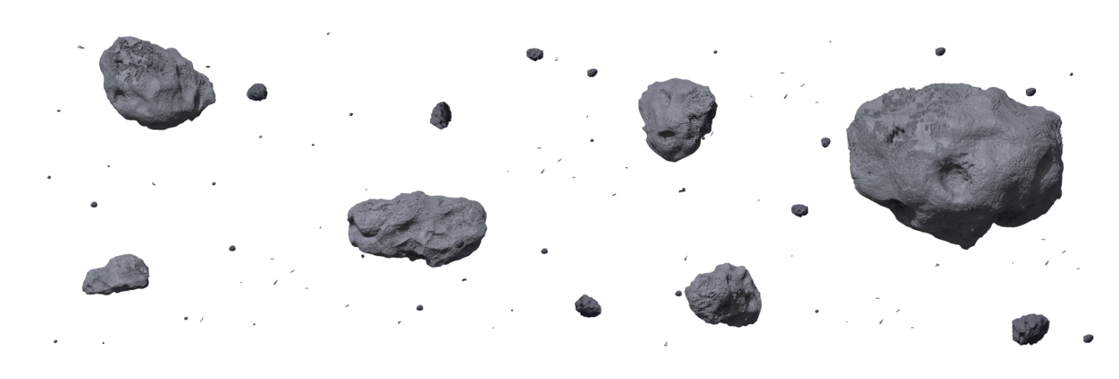
Hands-on Activity
Use the following to help guide students’ in creating their own asteroid. Encourage students to be creative but emphasise that their models should reflect their understanding of asteroids.

Step-by-step activity for students:
- Collect a range of materials that you can use to create your own asteroid model. For example, plasticine or clay, small rocks or pebbles, sand, beads, and aluminium foil.
- Make your asteroid using the materials you have collected. Add details like craters or other surface features.
- Give your asteroid a name! Write a report about your asteroid and include an explanation about why you chose the materials and design for your asteroid. Include the following in your report: origin of name, dimensions, mass, shape, composition, classification, distance from the Sun. Describe any interesting features about your asteroid.
- Present your asteroid model to the class. Present using Prezi or Canva.
- Hang your asteroid models in the classroom and create your own classroom asteroid belt. Consider adding the planets in the solar system to show where the asteroid belt is positioned in the Solar System.

Refer to this NASA Classroom Activity on Modelling an Asteroid.

Activity: Asteroid Quiz

- What is an asteroid?  A. A small, rocky object  B. A type of comet  C. A type of star  - When did asteroids form?  A. During the Ice Age  B. When the Solar System formed  C. When dinosaurs became extinct system formed  - Asteroids are mostly...  A. Gaseous  B. Rocky  - What is the largest asteroid in our Solar System?  A. Ceres  B. Psyche  C. Vesta  - Most asteroids can be found between Mars and Jupiter in the…  A. Asteroid Zone  B. Asteroid Band  C. Asteroid Belt | - Asteroids orbit the sun.  A. True  B. False  - How fast do asteroids travel?  A. 25 km/second  B. 25 km/minute  C. 25 km/hour  - What is the name of the crater left behind by the asteroid that wiped out dinosaurs?  A. Vredefort crater, South Africa  B. Wolfe Creek crater, Australia  C. Chicxulub crater, Mexico  - Asteroid comes from a Greek word meaning….  A. Rockstar  B. Destructor  C. Starlike  - Asteroids can have moons.  A. True  B. False

Quiz Answers: 1A, 2B, 3B, 4A, 5C, 6A, 7A, 8C, 9C, 10A

Useful Websites
- Why NASA's Psyche probe is embarking on humanity's first journey to a metal asteroid – ABC News
- ABC News: Dr Karl discusses mining asteroids – ABC Education
- Psyche: Everything we know about Nasa's mission to the 'golden asteroid' – BBC Newsround
- NASA Dart Mission – BTN
- Asteroids – NASA
- Asteroid Psyche – NASA
- Eyes on Asteroids – NASA

EPISODE 28
17th October 2023

KEY LEARNING
Students will choose a species of snake to learn more about. They will also explore the important role snakes have in the ecosystem.

CURRICULUM
Science – Year 5
Living things have structural features and adaptations that help them to survive in their environment.

Science – Year 6
The growth and survival of living things are affected by the physical conditions of their environment.

Scientific knowledge is used to solve problems and inform personal and community decisions.

  - Teacher Resource

Snake Season

Focus Questions
Discuss the BTN story as a class and record the main points of the discussion. Students will then respond to the following:
- How many species of venomous snakes are found in Australia?
  - 10
  - 100
  - 1000
- Why are experts saying that there will be more snakes around this season?
- What can people do to help keep snakes away from their homes?
- What should you do if you see a snake?
- Name three things you learnt watching the BTN story.

Activity: Word Cloud
Students will create a word cloud poster about snakes. A word cloud is a visual made up of important/key words relating to a topic. Ask students to think of words they associate with snakes or would use to describe them. Create a word cloud using a free online word cloud creator such as MonkeyLearn or Word It Out

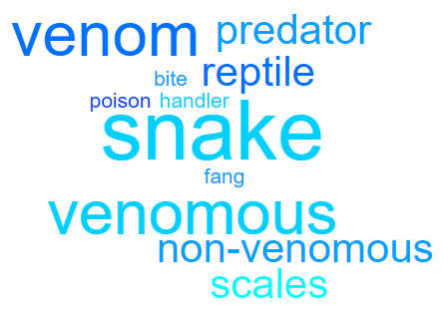

Glossary
Students will brainstorm a list of key words that relate to the BTN Snake Season story. Here are some words to get them started.
REPTILE | NOCTURNAL | VENOMOUS
NON-VENOMOUS | VENOM | SPECIES

Activity: Snake profile
Students will research and write a profile featuring a species of snake. Students can use the animal profile worksheet at the end of this activity to record their findings. Encourage students to use a range of sources to find their information. Snake species to choose from include:
- Green tree snake
- Children’s python
- Eastern brown snake
- Red-bellied black snake
- Sea snake

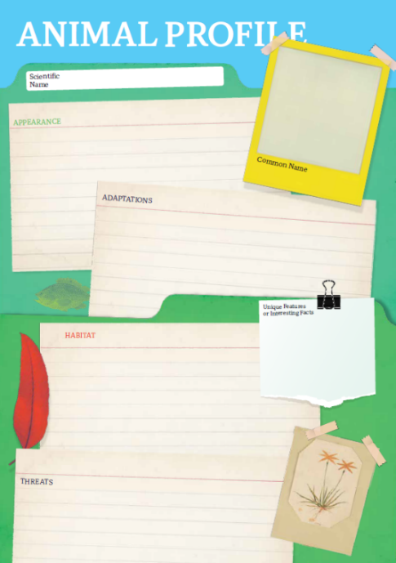
Research
Students will research the following and then share their research findings with the class or create a display in the classroom. Students can use the Animal Profile at the end of this activity.
- Illustration or photo
- Name (common and scientific name)
- Conservation status
- Appearance
- Adaptations
- Habitat
- Threats
- Unique features

Further Investigation
Students will respond to one or more of the following questions.
- Research a snake’s ability to smell using their tongue. Create a labelled diagram.
- Snakes are ectothermic. Investigate what that means and write a short explanation.
- What has new research found about a snake’s ability to hear?
- Why are snakes an important part of the ecosystem?
- Why are snakes important predators?
- What threats exist to snakes?
- Predict what might happen if snakes are removed from the food chain.
- What is the first aid treatment if bitten by a snake?

Activity: Snake Quiz
- Snakes are…  A. Mammals  B. Amphibians  C. Reptiles  - How many species of snakes does Australia have?  A. 40  B. 140  C. 240  - Which is the most venomous snake in Australia?  A. Red-bellied black snake  B. Inland taipan  C. Eastern brown snake  4. Which of these snakes is NOT venomous?  A. Coastal taipan  B. Mainland tiger  C. Carpet python  Quiz Answers: 1C, 2B, 3B, 4C, 5A, 6A, 7B, 8B | 5. Snakes don’t have eyelids.  A. True  B. False  6. Snakes are…  A. Carnivores  B. Herbivores  C. Omnivores  7. What does a snake use to smell?  A. Nostrils  B. Tongue  C. Scales  8.Snakes are found on every continent.  A. True  B. False

Useful Websites
- The importance of snakes – Department of Environment and Science
- Dangerous Animals – BTN
- Snakes, lizards and other reptiles – Australian Museum
- Snake Season - Newsbreak

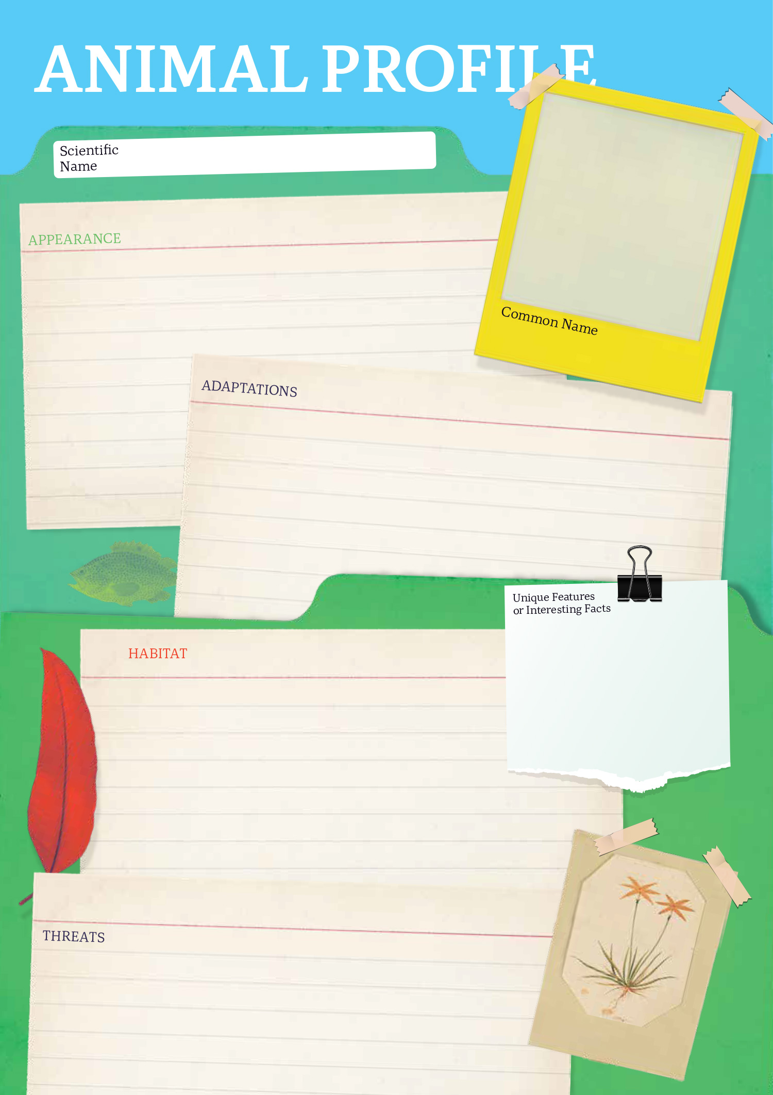

  - Teacher Resource

BTN Transcript: Episode 28 – 17/10/2023

Hey. I'm Amelia Moseley and you're watching BTN. Welcome back for term 4, hope you had a best holidays. Let's see what's coming up on today's show. We'll find out about the future of asteroid mining, learn what to do if you come across a snake… and meet a speedcuber.

Voice Referendum Outcome

Reporter: Justina Ward

INTRO: All that soon, but first today, you might have heard that Australia had a referendum on the weekend. All Aussies over the age of 18 were asked to vote on whether or not to change the constitution to create a voice for Indigenous Australians. Here's Justina to tell you how it all went down.

JUSTINA WARD, REPORTER: Polls, doggies, sausages and leaflets. Yeah, this wasn't your average Saturday.

Yes Supporter: Yeah, Vote Yes!

After months of debate and anticipation, Australia got the chance to answer a single question. Should we change the constitution to recognise the First Peoples of Australia by establishing an Aboriginal and Torres Strait Islander Voice? And the results?
Presenter: We're actually calling the national vote as being no.
Yep, it was a no from the majority of Australians and all the states.
Peter Dutton, Leader of the Opposition: It's clear obviously, that the referendum has not been successful, and I think that's good for our country.
Anthony Albanese, Prime Minister: The truth is that, no referendum has succeeded without bipartisan support in this country, none.
The Prime Minister pointed out that winning referendums is hard. In fact, only 8 out of the 45 we've had have been successful. But for the people who've worked hard to try and bring about a Voice to Parliament, it was devastating.
Jakirah Telfer, 'Yes' Campaigner: I cry for my people, and I cry for my community, and I cry for the future generations that have to live with this.
Jade Ritchie, 'Yes' Campaigner: I think the whole nation should be grieving the lost opportunity here.
But the 'No' campaigners said it was the right result.
Jacinta Price, Senator for NT: I want to thank the Australian people for delivering this result, we hear you loud and clear.
Warren Mundine, Australians for Unity: This is about the heart and soul of this nation and how we're going to be moving forward.
There were a lot of different reasons that people gave for voting no. Some people didn't like the idea of a constitution dividing Australians based on their race.
Jacinta Price, Senator for NT: It is so divisive, it is so us and them.
Others said it wasn't the best way to help Indigenous Australians.
Warren Mundine, 'No' Campaigner: Prove it. How is this Voice gonna do all this stuff?
Natasha Wanganeen, Actor: They're forgetting about the grassroots people in the middle that are not being heard.
Or that there just wasn't enough detail.
No Campaigners: If you don't know vote no.
Tim McNamara, Hidden Valley town camp vice president: We don't know what yes is, we still don't know what yes means.
Justina: So, what happens next?
Well, It's still possible for the government to make laws to set up a Voice to Parliament without putting it into the constitution, which is something a couple of states have already done.
Kyam Maher, SA Minister for Aboriginal Affairs: We have legislated for a First Nations Voice to our South Australian Parliament.
Rueben Berg, First Peoples' Assembly of Victoria: We've had a voice here in Victoria since 2019. We've had a democratically elected group who are providing advice directly to the government and it works.
There's also been talks from the opposition about the possibility of another referendum to recognise Indigenous people in the constitution without the Voice.
Presenter: So, you'd hold another referendum?
Peter Dutton, Leader of the Opposition: I believe very strongly, yes, I believe very strongly it is the right thing to do.
We don't have a lot of the details of what'll come next. But some hope this outcome will be a chance for a reset to find new ways to work towards reconciliation.
Anthony Albanese, Prime Minister: It's now up to us to come together and find a different way to the same reconcile destination.
Conor Bowden, 'Yes' campaigner: I will use this, and I hope that everyone else out there will use this as motivation to do right by those people.
Armani Francois, First-time voter: You know I do feel a bit deflated, but I think as youth, especially a youth coming from Alice Springs I think, I think we will rise, and I feel like a change will come.

Israel-Gaza War

Reporter: Cale Matthews

INTRO: Now to the other big news story that's happening right now in the Middle East. Israel has declared war on Hamas, the Palestinian militant group that rules Gaza, after it carried out a terrorist attack on Israeli civilians. Let's find out more. And just a warning, this story does contain some upsetting content.

On October 7th sirens rang out across Israel as the country faced the worst terror attack in its history.
Israeli Citizen: I started seeing things in the sky, just hearing bombs and not understanding what's happening around.
Israeli Citizen: All we could hear was gunshots and people screaming and…
Israeli Citizen: …bombs going off and cars and cars exploding…
Israeli Citizen: …cars exploding.
Israeli Citizen: I never felt like this, I don't even have tears anymore in my eyes, I can't cry because I cried so much.
Early in the morning thousands of rockets were fired from Gaza into Israel. At the same time gunmen crossed the border, killing and kidnapping more than a thousand people.
Benjamin Netanyahu, Israeli Prime Minister: The savage attacks that Hamas perpetrated against innocent Israelis are mindboggling, the forces of civilization must support Israel in defeating Hamas.
This is Gaza it's a tiny strip of land that's home to more than 2 million people, most of them are Palestinian. Since 2007 it's been governed by a group called Hamas. A lot of countries, including Australia, recognise Hamas as a terrorist group because of its history of violence. After the attacks, Israel declared war on Hamas. Firing rockets of their own that they say were targeting Hamas leaders, but which also killed Palestinian civilians and destroyed thousands of homes in Gaza.
Right now, Israeli officials say they're preparing to invade Gaza and have told civilians living there to move south to avoid the fighting.
This is one of the most densely populated areas in the world and since 2007 Israel has controlled most of what goes in and out of the region. While Israel says this is necessary to protect its citizens from Hamas, it’s been criticised by many human rights groups and the UN which has described Gaza as an open air prison.
Following the attacks Israel cut off the supply of all food, water, electricity and medical supplies from its borders.
Stéphane Dujarric, Spokesman for the United Nations: With water supplies cut off from Israel into Gaza, there is a severe shortage of drinking water impacting 650,000 people.
Palestinian Civilian: We are civilians who have no connection to political organizations and do not belong to anyone. We returned here to find that our house had become rubble and the entire area had been destroyed.
This part of the world has a long history of conflict but what's happening now is the worst we've seen in a long time, and it's got a lot of people worried.
Mélanie Joly, Canadian Foreign Minister: We are extremely concerned about the situation in Gaza. Gaza is one of the worst places on earth to be right now.
Anthony Albanese, Australian Prime Minister: We want all Australians to be safe in the region and to be able to leave whether they are in Israel or Gaza. This is a conflict that is having a huge human toll.
While no one is sure how long the fighting will continue, human rights groups say the most important thing is protecting the lives of both Israeli and Palestinian civilians.
António Guterres, Secretary-General of the United Nations: Civilians must be protected at all times. UN premises and all hospitals, schools and clinics must never be targeted.
Riyad Mansour, Palestinian diplomat: There is a path to peace where neither Palestinians or Israelis are killed. Peace will save lives because it is the only way forward.

Upsetting News

If you're feeling sad or anxious about that story or anything else in the news, make sure you talk to someone about it. We've also got some resources on our website that we’ve put together with tips on how to deal with upsetting news. So you can check that out whenever you like.

News Quiz

CHRISTOPHER LUXON: “This great country of our has so, so much potential…”

This man, Christopher Luxon, has just been elected leader of which country? It’s New Zealand. Yep, our mates across the ditch went to the polls on the weekend too and while the votes are still being counted it looks like the National Party leader has enough to take the top job from Labour PM Chris Hipkins.

Which of the following will be allowed in Aussie classrooms from term one next year? Mobile phones, AI or gaming consoles? It’s AI. Even though AI tech was banned earlier this year in many schools, Australia’s education minister has decided programs like ChatGPT are now similar to things like the internet or even calculators, so we need to learn how to use it properly in the classroom.

What was in this asteroid sample that made NASA scientists excited last week? Gold, carbon and water molecules or alien bugs? It was carbon and water molecules, which, while not quite as exciting as alien bugs, is pretty cool because they’re basically the building blocks of life.

And do you know the name of the well-rounded brown who’s taken out this year’s coveted title of fattest bear in Alaska? Is it Chunk, Grazer or Big Momma? It’s Grazer. She took out the Fat Bear Week competition, which is held every year just before hibernation season, when Alaskan bears pack on as many pounds as possible to get them through the winter.

Asteroid Mining

Reporter: Josh Langman

INTRO: Now to a new mission being planned by NASA to explore an asteroid. But it's not just any space rock this one is full of metal and has been estimated to be worth more than all the money on Earth. Here's Josh to tell us more.
ASSISTANT: Ah, Boss, uh... I know you were very keen for a construction update on our big, bad, very, very evil galactic star killer. The thing is, we've kind of, um... We've kind of...might have run out of metal.
EVIL BOSS: What?!
ASSISTANT: The metal. It's... We've...we've kind of... It's all gone. But that doesn't mean I want you to panic!
EVIL BOSS: What do you mean? Buy some more!
ASSISTANT: The metal on our home planet, we've...kind of used it all up.
EVIL BOSS: Well, have you tried...recycling?
ASSISTANT: Yeah, we've tried that as well. We've tried everything. It's... Boss, look!
EVIL BOSS: What? Oh, yeah, look at that!
JOSH LANGMAN, REPORTER: This is 16 Psyche. It's an asteroid that's captured the attention of a lot of people, and not just alien supervillains. Because it's thought to be chock full of precious metals. Estimated to be valued at...
EVIL BOSS: $1 billion dollars. $15,600 quadrillion dollars?
Asteroids are basically the leftovers of our solar system's creation over 4.6 billion years ago. Now, most of them are rocky, made out of silicates which are pretty common here on Earth. But others contain metals like iron and nickel and even gold, silver and platinum. In fact, scientists think that some of the earth's supply of these rare metals could have come from ancient metal-rich asteroids.
Now, NASA has sent a spacecraft to explore 16 Psyche in its first ever mission to a metallic asteroid. It'll spend the next 6 years travelling 3.6 billion kms to Psyche's home in the asteroid belt, so we can learn more about its make-up. Scientists suspect Psyche is actually left-over core of an old planet, and so, by exploring it, they hope to learn about Earth's interior.
LINDY ELKINS-TANTON, PSYCHE PRINCIPAL INVESTIGATOR: Psyche gives us the opportunity to visit a core the only way human kind can ever do, but it also helps us to understand how planets form in the first place.
But while for NASA, this is all strictly science, some see this as a step into the sci-fi realm of asteroid mining.
EVIL BOSS: Ooh. I like the sound of that.
ASSISTANT: That's just fantastic, boss.
EVIL BOSS: Don't touch me.
ASSISTANT: Sorry.
And as we burn through more and more rare metals on earth, some reckon asteroids could provide a rich new source of materials. And unlike mining here on Earth, we wouldn't have to damage the environment to get to them. But of course, just landing on an asteroid is hard enough. Getting this 250 gram sample of rock from the asteroid Bennu cost NASA $1.6 billion dollars and mining one is still way off.
The legalities are a bit rocky too, and there are big questions about who would have the rights to bring home asteroid ore. So, you could say, there's still a lot to iron out but in the meantime, we can all look forward to our first up-close look at this strange and distant lump of rock and metal.
EVIL BOSS: That is, if we don't get there first. Bwahahahaha.
ASSISTANT: Hahahaha.
EVIL BOSS: What's so funny?
ASSISTANT: I dunno. I thought we were.
EVIL BOSS: Get back to work.

Snake Season

Reporter: Josh Langman

INTRO: Summer is just about here which means sun and beaches and picnics and also snakes. They're a fact of life here in Australia so Josh went to speak to an expert about how to stay safe if you see one.
Oh yeah, even the bravest of us can feel helpless near a snake. It's no secret that Australia is home to some pretty dangerous snakes. There are 100 venomous species that live here including 20 out of the world's 25 deadliest snakes, like the tiger snake, brown snake and the inland taipan. Because they're cold-blooded reptiles, snakes tend to snooze away the winter and emerge from the start of September. But experts say this year the warmer winter’s prompted these little guys to wriggle out earlier than usual. So, I caught up with snake catcher Rudy to get some tips and tricks.
JOSH: There's been a lot of videos online recently of snakes popping up in all these strange places.
What can we do to keep snakes out of homes and places we happen to be in?
RUDY: It's pretty hard to keep a snake out of the yard. It's virtually impossible. But you CAN stop it from living there. Don't make a bed and breakfast for it. If there's a food supply and somewhere for 'em to live as such, which could be under sheets of iron, piles of rocks, piles of wood, garages, they'll stay there.
So, what do you do if you see a snake?
RUDY: Your best is just to freeze. By standing still, you're not a threat to it anymore. He just thinks you're a fence post or a tree. They're not really afraid of humans. No snake is afraid of humans, unless they get harassed, obviously.
JOSH: Okay, so snakes don't hurt you if you don't hurt them?
RUDY: No. And that's why people get bitten, because they try to catch it, kill it, harass them, throw stones at it, poke sticks at it. That type of thing.
JOSH: So, that's not a good idea?
RUDY: It's not a good idea, no.
But what if you do get bitten?
RUDY: If it's a venomous snake, apply your first aid. Stay still and call an ambulance. And the key to first aid for venomous snake bites is immobilisation. Completely still. Do not move. By moving your muscles, it tracks through your body quicker. So, staying still, you can contain it to where it is.
Rudy says that even if you don't think the snake is venomous you should use the same first aid for any snake bite, just in case. And while snake bites are serious, the good news is deaths in Australia are very rare. And that's partly because of our very successful antivenom program. Antivenoms are made by milking venomous snakes and then injecting it into animals that produce antibodies that can be used to treat humans and even pets.
Speaking of pets, some people reckon non-venomous species like this carpet-python make great companions. But ah, not me, there is no way I’m going to be holding... Ahhhhhh too late.
JOSH: Sure. Can't believe I agreed to this.
RUDY: You can change your jocks when you get back.
JOSH: Oh yeah. I think that sounds like a good idea.
So, remember, next time you spot a snake nearby - stay calm, stay still and stay safe out there.

Sport

In one of the biggest upsets in cricket world cup history. Current world champs, England went down to Afghanistan last night by 69 runs. The win was only the second game Afghanistan's ever won at a world cup and it's left England's chances of retaining the title in real trouble.
Meanwhile the Rugby World cup is down to the final four after a dramatic weekend. Host nation France was knocked out of the competition by just one point, losing to South Africa 28 to 29. While the All Blacks broke Irish hearts, sending home the top-ranked team and ending the hopes of a dream send off for retiring Irish captain Johnny Sexton. New Zealand will now play Argentina, who came from behind to beat Wales in their quarterfinal, while England will take on the Springboks after narrowly beating Fiji.
And finally to the Sports Australia Hall of Fame. Seven Aussie sporting icons including Tim Cahill, Kurt Fearnley and Lydia Lassila are the newest inductees, with world champion surfer Layne Beachley and former Wallabies captain Mark Ella now officially reaching legend status.

LAYNE BEACHLEY: Every time I paddle out at my local break, someone says, "Morning, legend!" And now it's official.
Speedcuber

Reporter: Cale Matthews

INTRO: Finally, today do you know how to solve one of these? Well, you're about to meet someone who can do it in under 12 seconds blindfolded. Cale caught up with Charlie who's just broken a Rubik’s cube world record.

Cale Matthews, Reporter: Hey Charlie, how you going?
Charlie Eggins, SpeedCuber: Hey, good thank you.
CALE: Charlie. Can you tell me a little bit about what you do?
CHARLIE: Yeah, so, I solve Rubik's cubes and I specialize in doing them blindfolded. So, I first started cubing about four and a bit years ago, when my dad learned from an electronic cube called the Go cube, and then he taught me and then from there, I just kept practicing and just kept loving to get faster and practising.
So, there's like sort of a method so for pretty much every solve, you're going to start off by solving sort of a cross of like the first four pieces, or around one centre, and then you do one algorithm that gets all of one colour on the top, and then one algorithm to finish it off, and you do that pretty much every solve.
CALE: Do you know much about the history of the Rubik's Cube? Where did it begin? Why did it begin?
CHARLIE: I think, I don't know exactly. I know that there's a guy named Erno Rubik who invented it. That's all I know.
CALE: That’s all you know? I can pick it up from here in the story…
Charlie is right, the Rubik's cube was invented in 1974 by Hungarian architect Erno Rubik as a way to teach his students about 3 dimensional movement. It took him about a month to solve it for the first time. But, just 8 years later, at the very first World Rubik's Cube Championships, the winner did it in a little over 20 seconds, and today the record for a 3x3x3 is well 3 seconds. But the world of speed cubing has exploded into all sorts of shapes sizes and categories.
CHARLIE: So, there's 17 different events from two by two, which is where there's only two pieces along an edge, all the way up to seven by seven, where there's seven. And then there's also a bunch of weird puzzles, like a pyramix, which is a pyramid and then there's also megamix, which is like lots of different sides, and a couple of other weird ones.
CALE: Now, what was your most recent event? What did you do there?
CHARLIE: So, recently, there was Australian nationals here in Brisbane. It was four days of competing and having fun with friends that flown in from all over the country. And at it was a three by three blindfolded and in the second round of the competition out of three, I got a world record three by three blindfolded single with 12.10 seconds. As soon as I took the blindfold off, I was just like so surprised. And it was just it was just like crazy, like, I still can't really believe it and we're still sometimes like, I got a world record. What??
CALE: We might have to get you to do a solve on camera. Blindfolded. You got it ready? Alright are you ready?
CHARLIE: Yep, you count down.
CALE: 3, 2, 1 Go.
CHARLIE: What no way. Yeah, nice one buddy.
CALE: I did switch cubes, but did I get you for like half a second at least.
CHARLIE: Ahh make that like 1 quarter of a second.

Closer

Naa I still think I need your help with this Charlie but I'll keep working on it. That's all we have for today, but we'll be back next week with more news. In the meantime, you can jump on our website where you can check out BTN Classroom resources as well as Newsbreak episodes and BTN High. Have a great week and I’ll see you soon. Bye!

