
EPISODE 34
25 November 2025

KEY LEARNING
Students will view a range of BTN stories and use comprehension skills to respond to a series of focus questions.

CURRICULUM
English – Year 4
Use comprehension strategies to build literal and inferred meaning to expand content knowledge, integrating and linking ideas and analysing and evaluating texts.

English – Year 5
Use comprehension strategies to analyse information, integrating and linking ideas from a variety of print and digital sources.

English – Year 6
Use comprehension strategies to interpret and analyse information and ideas, comparing content from a variety of textual sources including media and digital texts.

English – Year 7
Use comprehension strategies to interpret, analyse and synthesise ideas and information, critiquing ideas and issues from a variety of textual sources.
  - Teacher Resource

Focus Questions
As a class, discuss the stories featured in the episode of BTN Classroom and record the main points of the discussion. Students will then respond to the following focus questions.

Asbestos Sand
- Why did some schools around Australia close recently?
- Asbestos is a…
  - Plant
  - Mineral
  - Gas
- Why was asbestos a popular building product?
- What health problems can it cause?
- Name three facts you learnt watching the BTN story.

Toy Safety
- What was the main point of the Toy Safety story?
- All countries have the same safety standards. True or false?
- What problems did consumer group Choice find with button batteries in some toys purchased from online stores?
- In Australia, what safety rules must toys with button batteries follow?
- Why are button batteries dangerous, particularly for young children?

COP Adelaide
- In pairs, discuss the BTN COP Adelaide story. Share the main points of the discussion with the class.
- Which country will be hosting COP31?
  - Australia
  - Türkiye
  - Germany
- What is discussed at the UN COP annual conference?
- How do you feel about Australia missing out on hosting COP31?
- Why did the Prime Minister say Australia still had a win despite the outcome of COP31?

Auslan School
- Summarise the BTN Auslan story in three sentences. Share your summary with another student. How did your summaries differ?
- What is Auslan?
- Which two languages do the students at Klemzig Primary School use in their learning?
- What is HOLME?
- Do you think more Aussie schools should teach Auslan? Give reasons for your answer.

Check out the teacher resource on the Archives page.

Pedal Prix
- What is used to power human powered vehicles?
  - Pedal power
  - Electric power
  - Solar power
- How do students steer an HPV?
- What skills have the students learned being involved in the HPV program?
- How do the students prepare for Pedal Prix?
- Design and sketch your own human powered vehicle.

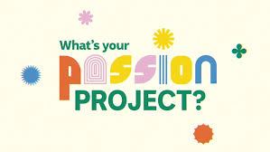
We're inviting schools around the country to tell us what their passion project is. Amazing artistic achievements? Super sporting success? Terrific technological triumphs? Enthusiastic environmental education! It could be anything but make sure it's something your whole class or school is buzzing about. We'll choose the best pitches and help you turn them into BTN stories to share with other kids around Australia.

EPISODE 34
25 November 2025

KEY LEARNING
Students will learn how to fingerspell using the Auslan alphabet.

CURRICULUM
Health and PE – Years 3 & 4 Describe and demonstrate how respect and empathy can be expressed to positively influence relationships

Health and PE – Years 5 & 6
Describe how valuing diversity
influences wellbeing and identify actions that promote inclusion in their communities

  - Teacher Resource

Auslan School

Focus Questions
Discuss the BTN story as a class and record the main points of the discussion. Students will then respond to the following:
- Summarise the BTN Auslan School story in three sentences. Share your summary with another student. How did your summaries differ?
- What is Auslan?
- Which two languages do the students at Klemzig Primary School use in their learning?
- What is HOLME?
- Do you think more Aussie schools should teach Auslan? Give reasons for your answer.

Activity: Class Discussion

Before Watching
Before watching the BTN Auslan School story students will brainstorm what they already know about Auslan. Record student’s responses during the discussion.
After Watching
After watching the BTN story students respond to the following questions:
- What is Auslan? What is the word Auslan short for?
- What is the history of Auslan?
- What did you learn watching the BTN story?
- What did you find interesting about the story?
- Do you think Auslan should be taught in more schools? Why or why not?


What questions do you have?
What surprised you about this story?

Activity: Learning the Auslan alphabet
Students will learn to fingerspell using the Auslan alphabet. Fingerspelling is an important part of Auslan. Words are spelt letter by letter using both hands. It is mainly used to spell proper nouns such as names of people or places. Visit the Auslan Signbank for tips on finger spelling.
Students have a go at finger spelling their name and some short words and phrases.
- Hello
- Good morning
- Please
- Thank you
- How are you
- Practise your fingerspelling with randomly generated words.
- Reflect on what was challenging about this activity and what you enjoyed.

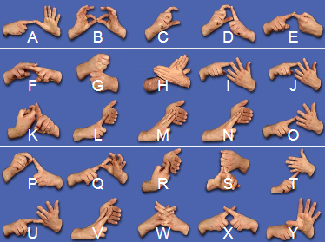

Students can also practise signing Auslan numbers. Have a go at including numbers in a short phrase.
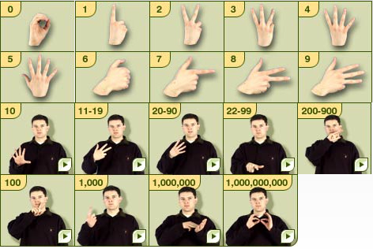

Activity: Story Time in Auslan
ABC Education has put together a collection of Australian children’s books signed in Auslan. Students can watch the stories and then answer the questions in the `things to think about’ section.
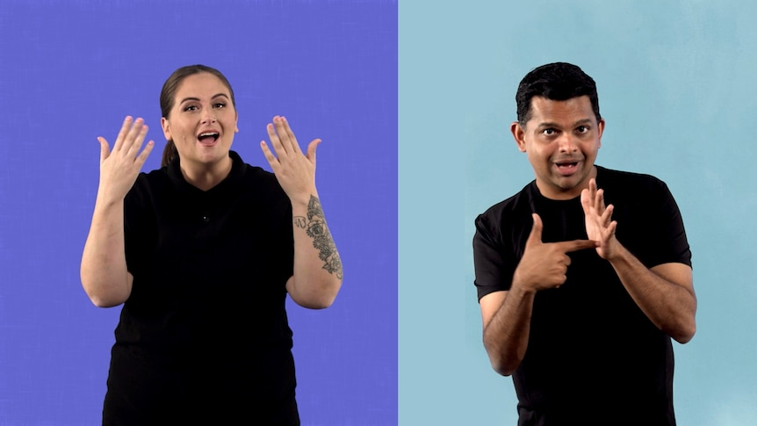
Bear and Rat
My Strange Shrinking Parents
The Tiny Explorers
Australia Under the Sea 1, 2, 3
Flipper and Finnegan
Welcome, Little One
Amma's Sari
Come Over To My House
Too Many Cheeky Dogs
Go Home, Cheeky Animals!

Useful Websites
- Sign Language Day – BTN
- Signing the News – BTN
- Auslan Interpreters – BTN
- Auslan Signbank

EPISODE 34
25 November 2025

KEY LEARNING
Students will choose their favourite stories from BTN in 2025. Students will explore what news values are and why they are important.

CURRICULUM
English – Year 6
Use comprehension strategies to interpret and analyse information and ideas, comparing content from a variety of textual sources including media and digital texts.

Compare texts including media texts that represent ideas and events in different ways, explaining the effects of the different approaches.

English – Year 7
Analyse and explain the ways text structures and language features shape meaning and vary according to audience and purpose.

Compare the text structures and language features of multimodal texts, explaining how they combine to influence audiences.

Media Arts – Years 5 & 6
Plan, produce and present media artworks for specific audiences and purposes using responsible media practice.

  - Teacher Resource

Year in Review 2025

Activity: Reflect on 2025
What was your best memory of a news event in 2025? Students can have a look through the BTN archives to remind them of the stories BTN covered this year.

Students will choose their top 5 news stories for 2025 and create their own quiz to test their classmates. Students’ quizzes should cover a range of categories, for example: environment, arts, health, finance, sport, education, politics, or entertainment.

Students can visit the BTN subjects page for a range of news topics to browse through. News stories can be a mix of local, national and world news. Students will give reasons why they think these are the top 5 news stories for 2025 (1-2 sentences for each news story).

Make your quiz
Students will include a range of quiz styles, for example:
- Multiple choice
- True or false
- Fill in the blank
- Use photos or pictures
- When an answer is revealed, provide extra information to explain the answer.
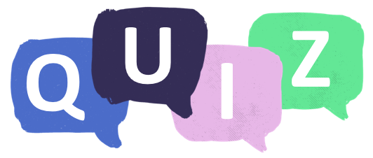

Students can make their quizzes in Kahoot or Quizizz. Make it fun, engaging, and educational!

Further investigation
Students will choose one of the 5 news stories from 2025 and investigate if there have been any updates on the story. Describe using your own words.

Activity: Kids on BTN
Many BTN stories this year featured young people, whether it was reporting on a news event affecting them or telling us about an issue or interest they were passionate about. Students can choose one of their favourite stories below or visit BTN’s website for a range of rookie reports. Students will then respond to the following questions:
- What is the story about? Summarise it.
- Why did you choose this story?
- Describe the main issue/message in the story.
- What makes this story newsworthy?
- What makes this story interesting?
- What questions do you have about the story?

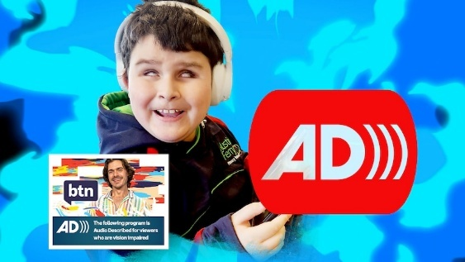  BTN Audio Descriptions | 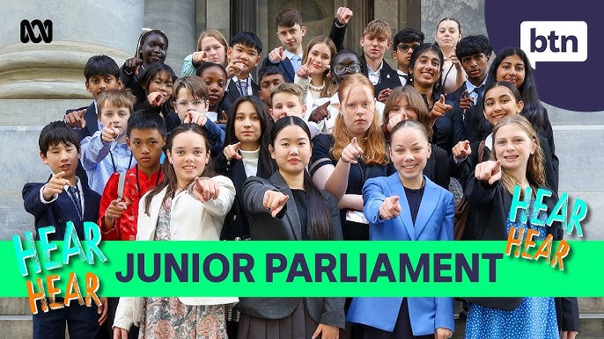  BTN Junior Parliament
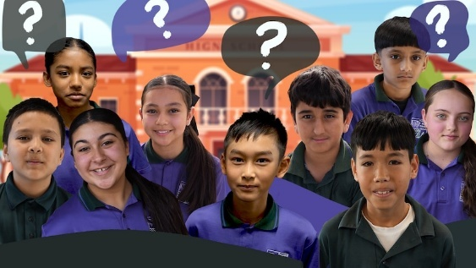  BTN Going to High School | 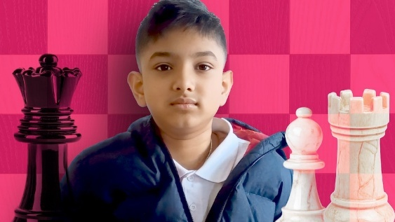  BTN Chess Champ

Activity: Passion Project
We're inviting schools around the country to tell us what their passion project is. Amazing artistic achievements? Super sporting success? Terrific technological triumphs? Enthusiastic environmental education! It could be anything but make sure it's something your whole class or school is buzzing about. We'll choose the best pitches and help you turn them into BTN stories to share with other kids around Australia.

Activity: What’s Important to You?
Hold a brainstorming session in the classroom to find out what’s important to your students and how they think things could be done better in their community. Some topics for discussion include:

Health
Arts and Culture
Community
Family
Sport
Education
Cyber Safety Change
Environment

Use the following questions to help guide a discussion (either as a class or in small groups).
- What are you passionate about (what issues are important to you)? Rate on a scale of 1 to 10.
- What concerns do you have about the future?
- How do you think things could be done better in your community?
- Do you think you can have an impact on change in the community?

Activity
Students will think about what is important to them in their community and express this creatively through writing a letter to their SRC or local Member of Parliament, creating an artwork, or writing a poem. Before starting this activity, students will think about what they appreciate about their community, the issues they observe and what they would like to see improved. Students will write their ideas and thoughts using dot points or on post-it notes.

Write a Letter
- Write a letter to your SRC or local Member of Parliament (MP).
- Your letter will need to address the issues or improvements you would like to see in your community.
- Include language that is persuasive, respectful, and specific.
Create an Artwork
- Create an artwork that represents your thoughts and values about your community.
- Your artwork can include drawings, painting, collages, or other mediums.
- Use colours, symbols and imagery that help convey your message.
Write a Poem
- Write a poem to express your feelings and thoughts about an issue in your community that is important to you.
- Use imagery and descriptive language to help convey your message.
- It could be haiku, acrostic, black-out or another type of poetry.

Activity: Get Your News Daily

Watch BTN every day! BTN Newsbreak is a great way to kick off the morning routine. You can watch Newsbreak anytime on our website or by subscribing to the BTN YouTube channel. Head to the BTN website for all the details.

Useful Websites
- BTN Classroom Stories – BTN
- Newsbreak Stories – BTN
- BTN Specials – BTN iView
- BTN Subjects – BTN

  - Teacher Resource

BTN Transcript: Episode 34 – 25/11/2025

Yaama. I'm Jack Evans and you're watching BTN. Here's what's coming up... We find out why these toys should stay off your Christmas list, learn some Auslan at a bilingual school and take off in pedal-powered cars.

Asbestos Sand

Reporter: Wren Gillett

INTRO: But first today, to a big story that affected a lot of Aussie kids last week. As you probably know by now, traces of asbestos were found in coloured sand that's been sold in Aussie shops and used in Aussie schools. Wren found out what happened and why it's caused such a big reaction.

TOM, STUDENT: I was just told there was no school on Monday. My friends were also originally confused because we didn't know what was going on.
SAM, STUDENT: I wore my school clothes cause I thought it was school.
ROBYN, STUDENT: Yeah, I woke up at like eight.
SAM: Except it wasn't school.
It was an unusual week for many students across the country. More than 100 schools closed, others partially closed, so that people dressed like this could remove colourful sand, containing traces of...
REPORTERS: Asbestos.
WREN GILLETT, REPORTER: To understand why this was such a big deal, you need a bit of history.
ADVERTISEMENT: Untouched by time's dark captains, rust, rot and decay. Asbestos possesses rare qualities for which it stands alone.
Asbestos is a mineral that's found in nature, which is made up of long, thin fibres. It's actually been used by humans for thousands of years, in things like ceramics and even clothing, and that's because asbestos has some really useful properties. It's light, strong, and doesn't conduct heat or electricity. By the 20th century, asbestos was in all sorts of things, from concrete to pipes, ceiling insulation, flooring, roofing and firefighting equipment. It was even used as fake snow.
WIZARD OF OZ: Unusual weather we're having ain't it.
But eventually, people started to notice that many of the workers who'd spent a lot of time with asbestos were getting sick. You see, while asbestos is relatively safe when it's locked away in other materials, if it's cut up or disturbed, the little fibres that make it up can get into the air. If they're breathed in, they can get stuck in people's lungs, and this can cause all sorts of problems, including…
REPORTER: Mesothelioma, described as one of the most aggressive forms of cancer.
There was a global effort to make people aware of the dangers of asbestos, and back home, researchers, victims and even rock bands campaigned to phase it out. Today, asbestos is banned in Australia, although it's still found inside many old buildings made before the ban, and occasionally it gets into other things. Like this mulch, which led to schools being closed in Sydney last year, and now, sand. It came from China, and the asbestos likely got in there accidently, when the sand was being dug out or from contaminated equipment. It was discovered by accident in an Aussie lab, and once more tests were done, alerts were sent out to anyone who bought or used it.
ROBYN: It's a pretty fun type of thing to play with, I would never have suspected it would have any dangerous chemical in it.
While this all sounds pretty scary, experts say the risk to you guys is actually really low. They say it's really unlikely the fibres were small enough to be breathed in, and that the way the sand is made would probably stop them from getting in the air anyway.
ANTHONY LINTON, ASPESTON AND DUST DISEASES RESEARCH INSTITUTE: The risk to any children is going to be very, very small.
While the sand was found in more than 1000 schools and childcare centres right around Australia, most of them stayed open while the sand was removed. The ACT was the only state or territory to close all of its public schools, although there were also some closed in Tasmania, South Australia and Queensland.
TOM: The day off on Monday was pretty fun because I got to hang out with all my friends, play video games with them, go to the oval, play OZtag.
SAM: When I went back to school I thought it was Monday, then I looked up what we were doing and it was not Monday things.
ROBYN: No.
Everyone who bought the sand was told to dispose of it safely by sealing it up, double bagging it, and taking it to a special waste facility that accepts asbestos.
NICK GIFFORD, SOUTHERN WASTE DISPOSALS: The risk of putting it in your wheelie in your household is that it passes that risk on to people like us.
But for most students, things are pretty much back to normal.
SAM: I feel like it's been a pretty big week, like I'm kinda glad it's over.

Did you know?

Did you know the town of Wittenoom in Western Australia was officially closed by the State Government in 2016 because of asbestos contamination from a nearby mine. Blue asbestos was mined there from 1937 until 1966, and even now authorities say it's too dangerous to visit.

News Quiz

Can you name the cyclone which hit the Top End on Saturday? Was it Nina, Fina or Felicia? It was Fina. Almost 20 thousand properties lost power across the NT as the story passed north of Darwin at category three strength.

RESIDENT: Yeah, we just heard this huge crash and we came outside and found, uh, the tree had fallen on the neighbour's veranda and on their place.
RESIDENT: True Territorian valet parking, I suppose, eh.

It's the strongest cyclone to pass Darwin in more than 50 years and while it brought destructive winds and heavy rains, no one was hurt.
Meta says it will start deleting accounts of people aged under 16 from December 4. Which of these apps will that affect? It's these ones. Meta owns Facebook, Instagram and Threads and even though Australia's social media law doesn't come into effect until December 10, Meta's decided to get started early, giving kids 2 weeks to download their data or lose it.
Australia's national science agency, the CSIRO, has announced it’s cutting up to 350 jobs. Which of these everyday items came about because of CSIRO research? It's all of them. The announcement made a lot of people angry, who say the government should be spending more on science. But the government says it's about making the agency more efficient.

Toy Safety

Reporter: Thomas Midena

INTRO: Coloured sand wasn't the only problem product making the news last week. The consumer group Choice tested a bunch of products sold by popular online stores and found that many didn't meet safety standards when it came to button batteries. Let's find out more.

ELF 1: Check, Check… Oh, wait a second. These ones appear to be missing the appropriate warning labels. I bet it's that Elfie in the safety department.
ELF 2: Hello?
ELF 1: Elfie, are you defying safety standards again?
ELF 2: Ah, I don't think so. Have a nice day.
THOMAS MIDENA, REPORTER: For a long time, the North Pole, wait sorry. For a long time, Australia has had Safety Standards, or rules. To make sure the toys you get for Christmas are safe to use. Because while we elves, sorry, while we humans are pretty good at making things, we don't always get it right.
ADVERT: Shoots rockets that burst and bombs that explode.
ADVERT: And super elastic bubble plastic.
There have been quite a few toys in the past that have turned out to be quite dangerous. Whether its toys that break easily, or have sharp surfaces, teddy bears with flammable stuffing or radioactive science kits.
ELF 2: That doesn't sound safe.
ELF 1: No, it wasn't.
Of course these days Aussie shops aren't allowed to sell things that we know are dangerous, or flammable, or radioactive. The trouble is more Aussies are buying stuff online from countries that don't have the same safety standards.
ELF 2: Well, what can I say? This toy wasn't made in this workshop. This came from Santa's Online Marketplace. They don't have the same safety standards as us.
Recently, Choice did a test and bought 24 toys from five major online shops. And they found that 17 of the items from Shein, AliExpress, eBay and Amazon didn't meet safety standards for button batteries.
ROSIE THOMAS, CHOICE: There's serious failures that we found in these products where things like button battery compartments that could be easily open without a tool. Many of the products were also missing the mandatory warnings, which are what tell parents to keep them out of reach of young children.
Button batteries are batteries that are shaped like, a button. They're used in all sorts of things from remotes to whatever this is. Because of their small size and because they kind of look like lollies, young kids have been known to put them in their mouths which is extremely dangerous. If you swallow a button battery it can burn your insides and even kill you. It's why products sold in Australia that use button batteries have to carry warning labels and be secured so that kids can't get them out. Amazon, eBay and Shein have now removed the items from their stores. But Choice says that there needs to be more done to make sure that all toys sold here and safe.
ROSIE THOMAS: We've been advocating for stronger product safety laws. Laws that would make sure that all businesses, including the online marketplaces, were required to ensure products are safe before they sell them.
ELF 2: Alright fine. I'll be more thorough next time. Now if you don't mind, I was in the middle of a great dream.
ELF 1: What, wait are you sleeping on the job? They hung up on me.

COP Adelaide

Reporter: Justina Ward

INTRO: The Conference of the Parties has wrapped up in Brazil, and we found out that next year, the big UN climate conference will be held in Türkiye. That was pretty disappointing for some people in Adelaide… including Justina.

JUSTINA WARD, REPORTER: Here in Adelaide there's been one question on everyone lips. Will we or won't we be hosting COP31.
PERSON: What COP is? A police officer?
PERSON: I don't know what COP is. Na I've never heard about COP before.
PERSON: Didn't know it existed so no.
PERSON: I don't know what COP was, I didn't know it was coming to Australia.
Well maybe not on everyone's lips? But if you've been watching BTN, you'll know all about it.
AMEILA: It was called COP27.
NAT: The COP28 is in full swing.
JACK: Well, COP29 has finally wrapped up.
JACK: The UN's annual climate conference.
COP. The Conference of the Parties. First held in Belin, Germany in 1995. Each year, it's held in a different location around the world from Japan to Denmark to Brazil. And next year the Australian government wanted it to be here.
ADELAIDE COP ADVERT: We are South Australia. We are the clear choice for COP31.
In 2022 Australia put in a bid to co-host COP with the Pacific. Many saw it as a huge opportunity for Adelaide, which for 2 weeks would put Adelaide at the centre of the world. Bringing in all sorts of VIPS who would stay at local hotels, shop at local businesses, eat at local restaurants, and even more importantly it would put a spotlight on the impacts of climate change in Australia and the Pacific. But um, we weren't the only ones who wanted to host. Türkiye also put up its hand and for the last few months we've been stuck in a deadlock. But last week we finally got the big news.
JUSTINA: We got it? We got it?
MICHELLE: No.
JUSTINA: Nooooooo.
MICHELLE: Justina, it's even in the script.
Yeah, it's a bit disappointing for some at least.
PERSON: I don't think I'm disappointed because I didn't even know what it was.
PERSON: I think it shines a light on some of the biggest issues in Australia and I think Adelaide's is missing out.
JANE LOMAX-SMITH, ADELAIDE LORD MAYOR: Obviously we're disappointed not to host the whole event here.
PETER MALINAUSKAS, SA PREMIER: Disappointed the federal government couldn't go the next step absolutely.
SARAH HANSON-YOUNG, GREENS SENATOR: The Prime Minister has let down the country. He's let down South Australians. He has let down our Pacific neighbours.
Some reckon the Prime Minster should have tried harder to secure the bid. He's also been criticised for actually not going to a COP since taking office. But despite the outcome, the government says we've still had a win. Climate Minister Chris Bowen has been chosen to lead the COP31 negotiations, meaning he'll be helping out with the talks between countries and writing up draft agreements. The Prime Minister says this will help make sure the Pacific and Australia's environment problems are seen and heard.
ANTHONY ALBANESE, AUSTRALIAN PRIME MINISTER: We're very pleased with the outcome. Australia, by having the COP presidency for negotiations will be in a very strong position.
Plus, as cool as it would have been to host COP it wouldn't have been easy or cheap.
PERSON: You know there's benefits to the businesses and what not, but there's also a burden to it.
PERSON: I think fitting people would be a challenge.
PERSON: It would be a lot a lot of people and it would crowd up the space a lot more.
JUSTINA: We'll just have watch what goes on next year from here in Adelaide.

Quiz

Which country once held an underwater cabinet meeting to highlight the risks of climate change? Was it the Philippines, the Maldives or Tuvalu? It was the Maldives. The government held the unusual meeting just before COP15 in Denmark.

Auslan School

Rookie Reporters

INTRO: Now we're going to learn more about a language that's being taught at a growing number of Aussie schools and is about to become part of the New South Wales curriculum. It's called Auslan and these kids from Klemzig Primary School, in South Australia, are going tell us all about it.
EVERYONE: Hi BTN.
AMBER: My name is Amber, and this is my sign name.
AUDREY: My name is Audrey.
BIDHAN: My name is Bidhan, and this is my sign name.
JAKE: My name is Jake. This is my sign name
EVERYONE: And we're going to talk about Auslan.
JAKE: So Auslan the word... AU... That stands for Australian. S that means sign. LAN is language and altogether that makes the word Auslan.
AMBER: Auslan is the Australian Deaf community's language.
JAKE: My family are all deaf. So, when I was born, that's when I started to learn sign.
AUDREY: I've been using Auslan since in reception when I was 5 and I just started the school.
BIDHAN: I've been using Auslan since reception.
AMBER: I started learning when I was in kindy.
AUDREY: Klemzig is a bilingual school that means we use two languages, Auslan and English in our learning.
AMBER: This school's really great because we can have deaf friends and hearing friends. It doesn't matter. We can communicate through Auslan.
JAKE: Auslan works like signs have parts HOLME. H means handshape. O is orientation. L is location. M is movement. And E is expression.
JAKE: Here are some signs you can learn at home. Good morning.
AMBER: Hi, how are you?
BIDHAN: Auslan is not the only sign language in the world as there's many others.
JAKE: I know American Sign Language that's one handed, ASL. And then there's BSL, which is British sign languages, similar to Auslan.
AUDREY: There're many differences and similarities.
AMBER: If I went overseas and I didn't know the sign language and I needed to say I was full, I could like use mime or gesture and I could go like this and they would understand.
JAKE: Even in Australia, the different states there are slight differences in the language. For example in Sydney, this is green, and in Adelaide we sign up like this.
AUDREY: When Australia was first colonised, the British set up schools for Deaf and slowly British sign language evolved into Auslan.
AMBER: Before the European people arrived, the Aboriginal people, they had their own sign language for many, many years.
BIDHAN: Over time sign in Australia has evolved into what we know as Auslan today.
JAKE: If you're really passionate about Auslan you can understand it really easily.
BIDHAN: For me it's not hard to learn Auslan because I've been doing it for a long time.
AMBER: If you socialise with Deaf people, you can easily pick it up.
AUDREY: It's important because I get to use this language every single day.
AMBER: Auslan is very important to me because it's my language and it's part of my identity.
BIDHAN: Cool things about Auslan is that you can sign underwater unlike talking.
JAKE: If there's a hearing person coming and I don't want them to know what I'm talking about, I can just sign and they've got no idea.
BIDHAN: I believe more Aussie schools should teach Auslan because it's more used in Australia than other languages.
AMBER: I would feel really happy because more people could be included and nobody would be left out.
JAKE: It means I can access communication everywhere.
EVERYONE: Thanks for watching. Bye.

Sport

The Formula One championship title is still up for grabs.

COMMENTATOR: What Verstappen in Vegas stays in Vegas!

Red Bull's Max Verstappen took out the win at the Las Vegas Grand Prix with McLaren's Lando Norris crossing the finish line in second and teammate Oscar Piastri in fourth, but McLaren's celebrations were cut short. Post-race checks revealed the drivers' skid blocks didn't meet requirement leading to both Norris and Piastri being disqualified.
The opening Ashes test in Perth didn't disappoint except the whole thing was over In just two days. Travis Head starred with the bat leading Australia to a stunning eight-wicket victory over England.

COMMENTATOR: Travis Head has absolutely delivered for his team.

His 69-ball century effort had fans on their feet but the speedy end to the match leaves Cricket Australia in a tough spot. They're expected to lose $3 million dollars in ticket sales.
In AFLW the Brisbane Lions have defeated the Blues by 35 points in Sunday's prelim to book a spot in the Grand Final.

DAKOTA DAVIDSON, PLAYER: You work your butts off all pre-season to get, like, for moments like this.

And what do ya know, it's the third year in a row they'll be taking on the Kangaroos with the Grand Final set for Saturday night.

Pedal Prix

Rookie Reporters

INTRO: Finally, today we've got another BTN Passion Project for you. This one's been sent in by students from Cranbourne Primary in Victoria who are passionate about racing human powered vehicles. Check it out.

STUDENTS, CRANBOURNE WEST PRIMARY SCHOOL: Hi BTN, we're from Cranbourne West Primary School, and we're part of the Pedal Prix team.
STUDENT: HPV stands for human-powered vehicles. It is a cycling type of sport.
STUDENT: So, the vehicles are kind of like a pear round shape.
STUDENT: And they look like a bullet kinda.
STUDENT: And inside, it has our two steering sticks which help us steer, and it has our wheel guards to protect our fingers so it doesn't get caught in the wheel, tires.
STUDENT: Yeah, our vehicle's right there.
STUDENT: We pedal and we use our steering sticks to turn.
STUDENT: We have clip-in shoes that clip into the pedals.
STUDENT: We got to push really hard and keep pedalling, never stop though because it's hard to get your speed back again.
STUDENT: I saw like last year, a year ago I started, the older kids doing it, and I was like 'oh my God, that's so cool. I want to be like them'.
STUDENT: In the HPV program this year, we have learned about high maintenance of our vehicles.
STUDENT: And we've learned how to fix minor issues such as tightening the brakes, fixing the horn, and fixing the wheel punctures.
STUDENT: There is a lot of training involved. Every Wednesday, 7:30 to 8:30 and on Fridays we train on our push bikes at Cams Reserve.
STUDENT: And at least once a month, we do in-vehicle training at KC Fields Criterion Track.
STUDENT: Normally before every race I feel really nervous, so I normally talk with my friends and my teammates about how the day's going to go and how well we're going to go, and that normally calms me down.
STUDENT: For me, I like to wake up and then think about everything I've trained for. And I like to meditate for a bit and then before I go in the vehicle, I'll just give myself a small pep talk.
STUDENT: There've been lots, lots of funny and memorable things, but personally my favourite was winning the Vic series and going to Murray bridge.
STUDENT: The Murray Bridge race is a race in South Australia, a 24-hour race, where people from places around Australia come and race. To win, you basically have to get the most laps out of the 24 hours.
STUDENT: At Murray Bridge, we placed third.
STUDENT: I felt amazing after my ride.
STUDENT: I would most definitely recommend the human-powered program to other schools.
STUDENT: I have grown out of my shell heaps and my confidence has grown a lot.
STUDENT: It has helped me grow as a person. I'm a school captain and it's definitely helped me gain confidence and leadership qualities, like for my role.
Closer

Well, that's all we have for you today. Next week, for our final episode of the year we're going to bring you a special program looking at the upcoming social media ban, we'll give you the results of our national survey and even put some questions to the Prime Minister. Have a great week and I'll see you next time. Bye!

