

Freedom Ride
- Discuss the Freedom Ride story with another student. Record the main points of your discussion.
- How long ago was the Freedom Ride?
- Which Aboriginal person organised the Freedom Ride?
- What inspired the Freedom Ride in Australia?
- Around which state did the Freedom Ride bus travel?
- What did they find out about the treatment of Aboriginal people?
- What is segregation? Give an example.
- How did their trip make a difference to indigenous rights?
- What is a referendum?
- What did you learn from this story? Discuss as a class.

Wave Hill
- Discuss the main points raised in the Wave Hill story with another student.
- Where is Wave Hill?
- Who were the Aboriginal stockmen working for?
- How long were the Aboriginal stockmen on strike?
- Why did they go on strike?
- Which Prime Minister handed back land to the Gurindji people?
- In which year was the land handed back?
- Who was Vincent Lingiari?
- How did the Wave Hill walk off help Aboriginal land rights?
- What do you understand more clearly since watching the BTN story?

What is a treaty?
- Summarise the What is a treaty? story, using your own words.
- What is a treaty?
- A treaty is a legal agreement. True or false?
- When New Zealand became a colony, Indigenous people weren’t given any rights. True or false?
- When the British first arrived in Australia it was claimed Terra Nullius. What does this mean?
- Complete this sentence. Many people in Australia say a treaty would be a huge step towards _____________ between Indigenous and Non-Indigenous people.
- What was the ‘Barunga Statement’?
- Why don’t some politicians support the idea of a treaty?
- How did this story make you feel?
- What did you learn watching the BTN story?

Constitutional Recognition
- Discuss the Constitutional Recognition story as a class and record the main points of the discussion.
- What is a constitution?
- When was the Australian Constitution written?
- What is a referendum?
- To change the Constitution there has to be a referendum. True or false?
- What needs to happen for a referendum to be passed?
- In 1967 what percent of Australians voted ‘yes’ to change the Constitution?
- What are some of the changes that people want to make to the Constitution?
- Name three things you learnt watching the BTN story.
- What questions do you have after watching the BTN story?

Teacher Resource

Wave Hill



Students will learn about the contribution that Vincent Lingiari has made to Australian society. Students will explore the rights of Aboriginal and Torres Strait Islander Peoples.



Civics and Citizenship – Year 5
How laws affect the lives of citizens, including experiences of Aboriginal and Torres Strait Islander Peoples

History – Year 6
Experiences of Australian democracy and citizenship, including the status and rights of Aboriginal and Torres Strait Islander Peoples, migrants, women, and children.

The contribution of individuals and groups, including Aboriginal and Torres Strait Islander people and migrants, to the development of Australian society, for example in areas such as the economy, education, science, the arts, sport.

Use a range of communication forms (oral, graphic, written) and digital technologies.

Develop texts, particularly narratives and descriptions, which incorporate source materials.

- Discuss the main points raised in the Wave Hill story with another student.
- Where is Wave Hill?
- Who were the Aboriginal stockmen working for?
- How long were the Aboriginal stockmen on strike?
- Why did they go on strike?
- Which Prime Minister handed back land to the Gurindji people?
- In which year was the land handed back?
- Who was Vincent Lingiari?
- How did the Wave Hill walk off help Aboriginal land rights?
- What do you understand more clearly since watching the BTN story?



Class discussion
After watching the BTN Wave Hill story, respond to the following questions:

- What did you SEE in this video?
- What do you THINK about what you saw in this video?
- What does this video make your WONDER?
- What did you LEARN from this story?
- How did this story make you FEEL?
- What QUESTIONS do you have about this topic?

Let’s talk about rights
Working in small groups, respond to the following questions, and then share your ideas with the class.
- How did this story make you feel?
- Imagine how you would feel if someone took something very important and valuable from you (for example, a favourite belonging or your home). Describe your emotions.
- What if they told everyone it didn’t belong to you in the first place so they were allowed to take it? What if that same person was in a position of power over you so you were powerless to do anything about it?
- Why is this belonging important to you? Describe.
- Would you be prepared to fight for your belonging if someone tried to take it away? What rights do you have?
- What could you do about the situation? What actions could you take?
- Why is it important to stand up for justice? Can people make a difference?

Further research – the Wave Hill ‘walk-off’
- What is a strike?
- Think of reasons why people strike.
- What were the people protesting about at Wave Hill in 1966?
- How long did they strike for?
- Who supported them on their strike?
- What did the Wave Hill ‘walk-off’ achieve?

Create a timeline of events
Create a timeline outlining the struggles by the Gurindji for ownership of their ancestral lands. Include dates from 1966 to 1981 and from time before European settlement. Include other significant events that have influenced land rights decisions in Australia (for example, The Mabo Case).
Find out what Labor Prime Minister Gough Whitlam did on 16 August 1975 and why it is considered a milestone in the struggle.
After finishing your timeline, explain why the Wave Hill walk-off was such an important event in the fight for land rights.

Learn more about the Wave Hill walk-off at ABC Education

1966
Vincent Lingiari and others lead the Indigenous workers of Wave Hill station on strike.
1850s
Europeans first crossed Gurindji territory.
1975
Prime Minister Gough Whitlam hands over title to the land to the Gurindji Aboriginal people.

Students can create their timeline in any way they choose. An interactive timeline creator is available at the Read Write Think website.

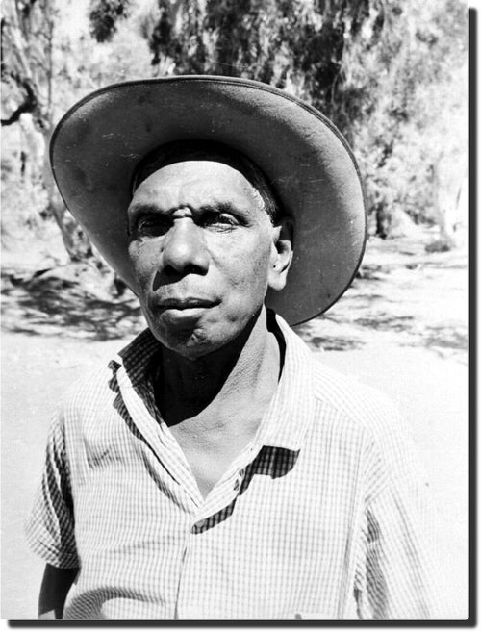

Who am I? What do I stand for?
Find out as much as you can about Vincent Lingiari using a range of primary and secondary sources (internet, newspapers and books).

Biography Organiser
Use the Biography Organiser template to structure your biographical information on Vincent Lingiari. Some possible research questions include:
- Who is Vincent Lingiari?
- Where is he from? Locate using Google Maps
- When was he born?
- What did he achieve?
- What were his challenges?
- How do we recognise his achievements?
- How has he made an impact on Australian people’s lives? What difference did he make?
- What do you admire about Vincent Lingiari?
- What was life like for Australians during this period? Think about fashion, music, influential people and major events.

Present your findings in an interesting way.
- Give a presentation on Vincent Lingiari’s achievements
- Create a portrait
- Design a poster
- Make a “Did you know?” for other students.
- Write a letter thanking them for their achievements and how it has changed Australia.
- Create a timeline highlighting significant events

Poetry and lyrics – feel, think and wonder
As a class, listen to Paul Kelly’s song “From Little Things, Big Things Grow”. Alternatively take it in turns to read out the song lyrics.

In small groups respond to the following questions, and then share your ideas with the class.
- What do you think this song is about? What do the lyrics mean?
- How does this song make you feel? Describe your own emotions.
- What does this song make you wonder?
- Why do you think Paul Kelly and Kev Carmody called their song “From Little Things, Big Things Grow? Explain in your own words.

Songs that help us understand history

Can you think of other songs that help us understand Australian history?
Choose one of the following songs, or choose one of your own, and conduct further research to find out what the song is about. Create a book of songs and background information to keep in your school library.

Song | Background
“Treaty”
By Yothu Yindi
“Took the Children Away”
By Archie Roach
“Beds Are Burning”
By Midnight Oil

Visual literacy

Aboriginal land rights was an issue that Gough Whitlam tackled while he was Prime Minister.

On August 16, 1975, Gough Whitlam returned traditional lands in the Northern Territory to the Gurindji people. This brought an end to their long struggle to reclaim their traditional country. The ceremony to officially hand back the land to the Gurindji people took place on August 16th, 1975 at Daguragu. Whitlam made a short speech before taking some sand and pouring it into the hands of Vincent Lingiari, the leader of the protest movement.
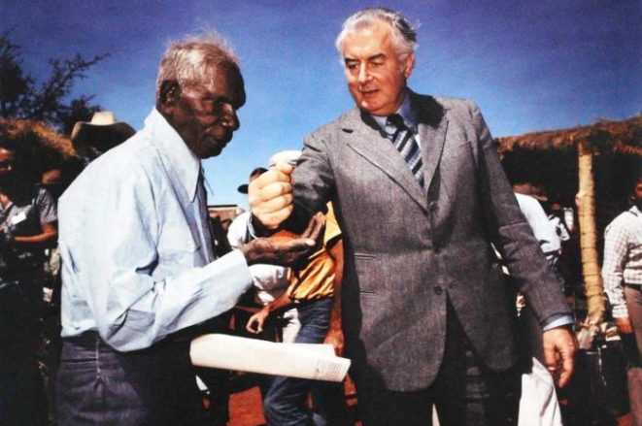
Show students the above image and hold a class discussion.
- What is happening in this photo?
- Why is this photograph symbolic? Consider that it is a reminder that all Australians share the same land and the same hopes.
- How does this image make you feel? Describe your emotions.

Learn more about land rights by watching BTN’s Mabo Day and Land Rights stories.


ABC News – Gough Whitlam’s Wave Hill handback celebrated by Indigenous elders 40 years on
http://www.abc.net.au/news/2015-08-16/gough-whitlams-wave-hill-hand-back-celebrated-after-40-years/6700704

ABC Splash – Vincent Lingiari the leader Digibook
http://splash.abc.net.au/home#!/digibook/618856/vincent-lingiari-the-leader

ABC – Gurindji Strike – The Wave Hill walk-off
http://www.abc.net.au/archives/80days/stories/2012/01/19/3411481.htm

Australian Geographic – On this day – Wave Hill indigenous protest
http://www.australiangeographic.com.au/blogs/on-this-day/2013/08/on-this-day-wave-hill-indigenous-protest

BIOGRAPHY ORGANISER

Name:

Using different sources find information about the person you have chosen for your biography. Use this biography organiser to keep track of what you learn.

Person’s name

Achievements
Personal information
Interesting facts

Teacher Resource

Constitutional Recognition
Students will describe the process for constitutional change through a referendum.

HASS – Year 4
Sequence information about people’s lives and events.

HASS – Year 6
Key figures, events and ideas that led to Australia’s Federation and Constitution.

Experiences of Australian democracy and citizenship, including the status and rights of Aboriginal and Torres Strait Islander Peoples, migrants, women and children.

HASS – Year 7
Sequence information about events, developments, periods and phenomena using a variety of discipline-appropriate formats and conventions including chronological frameworks that use dating conventions.

Civics & Citizenship – Year 7
The process for constitutional change through a referendum.

Critically analyse information and ideas from a range of sources in relation to civics and citizenship topics and issues.

Present evidence-based civics and citizenship arguments using subject-specific language.

- Discuss the Constitutional Recognition story as a class and record the main points of the discussion.
- What is a constitution?
- When was the Australian Constitution written?
- What is a referendum?
- To change the Constitution there has to be a referendum. True or false?
- What needs to happen for a referendum to be passed?
- In 1967 what percent of Australians voted ‘yes’ to change the Constitution?
- What are some of the changes that people want to make to the Constitution?
- Name three things you learnt watching the BTN story.
- What questions do you have after watching the BTN story?

Class discussion
After watching the BTN Constitutional Recognition story, hold a class discussion about the information raised in the story. The following questions may help guide the discussion:

- What did you SEE in this video?
- What does this video make your WONDER?
- What did you LEARN from this story?
- What QUESTIONS do you have after watching the story?

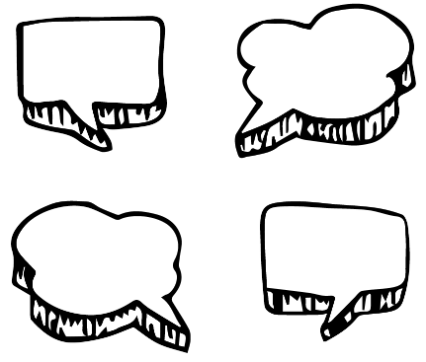
Further investigation
Students will respond to one or more of the following questions:
- Who are the traditional owners of the land, where The Garma Festival is held? Find the land using this map.
- What are some of the important issues that are talked about at The Garma Festival?
- Discuss how you think being left out of the Australian Constitution affected Aboriginal people?


Glossary
Students will brainstorm a list of key words that relate to the BTN Constitutional Recognition story. Students will then use the words to write their own sentences about the issue. Students may want to use pictures and diagrams to illustrate the meaning and create their own glossary. Here are some words to get you started.

Constitution | Referendum | Recognition
Rights | Reconciliation | Australia’s First Peoples

BTN Explainer
Constitutional recognition is something a lot of Indigenous people in Australia have been campaigning for, for a long time. But, what exactly is it and why is it such a big deal? Watch BTN’s Explainer on Constitutional Recognition as a class and hold a class discussion to clarify terms and meanings. Link to BTN Explainer

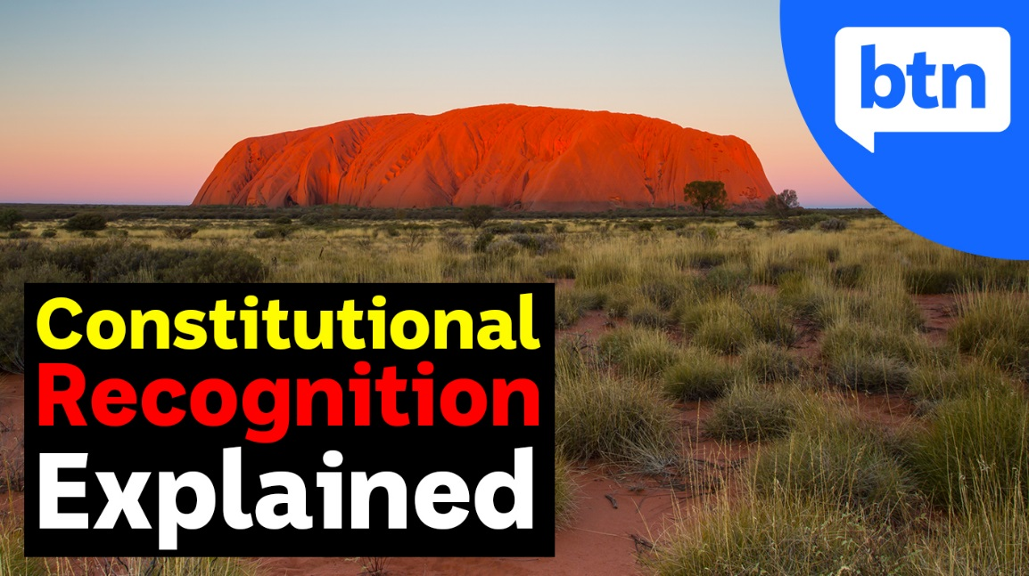

KWLH
The KWLH organiser provides students with a framework to explore their knowledge on the topic of constitutional recognition and consider what they would like to know and learn.

What do I know? | What do I want to know? | What have I learnt? | How will I find out?

Research questions for inquiry
Students will determine a focus for their inquiry and develop a key question to guide their inquiry (below are some examples). Students will collect and record information from a wide variety of sources (internet, books, newspaper and magazines).

- What is the Australian Constitution? When and why was it written? Include the following words in your explanation: colonies, nation, federation, Australian Constitution and system of government.
- Were Aboriginal and Torres Strait Islander peoples included in the process? Who wrote the Constitution? And who voted for it when it was first formed?
- What are the steps to change the Australian Constitution? Investigate what a referendum is and how it works. Use a timeline to highlight important referendums in Australia.
- What is meant by the term constitutional recognition? Explore the progress of constitutional recognition in Australia using a timeline to highlight important events.
- Why was the 1967 Referendum important in Australia’s human rights history? Use the term constitutional recognition in your explanation.
- How could you get the message out to all Australians that there needs to be a change in the Constitution to formally recognise Aboriginal and Torres Strait Islander peoples? Design a campaign to spread your message.



BTN story – 1967 Referendum
The 1967 referendum saw the majority of Australians vote to change our country's laws to count Indigenous Australians as full citizens. Watch BTN’s 1967 Referendum story and then students will respond to the following questions.

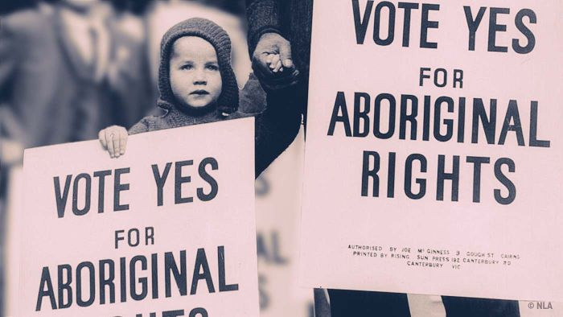
- How long ago did Australians vote to change our country’s laws to recognise Indigenous Australians as citizens?
- Describe what it was like in Australia in the 1960s.
- Did Aboriginal people have equal rights to other Australians in the 1960s? Explain.
- In what year were Indigenous Australians given the right to vote in Federal Elections?
- To change the constitution there has to be a referendum. True or false?
- What is a referendum?
- In 1967 what percent of Australians voted ‘yes’ to change the Constitution?
- Discuss why it is important to remember Australia’s 1967 referendum.
- What does it mean to have equal rights? Explain your answer.
- Name three things you learnt watching the BTN story.

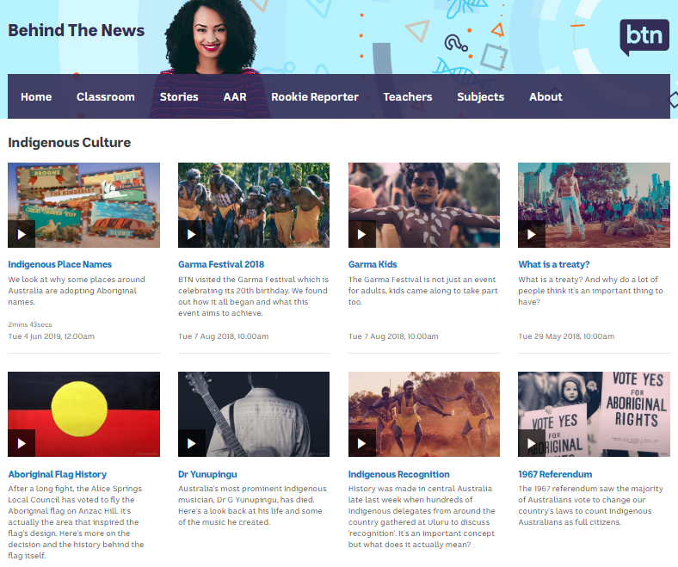
BTN stories – Indigenous Culture
Visit BTN’s collection of stories which focus on Aboriginal and Torres Strait Islander peoples’ culture and issues.

After watching any one of the BTN videos ask students to respond to the discussion questions (to find the discussion questions and teacher resources go to the related BTN Classroom Episode and download the Episode Package).

Link to collection of BTN stories about Indigenous culture
https://www.abc.net.au/BTN/indigenous-culture/10576610

Constitutional Recognition – Reconciliation Australia
https://www.reconciliation.org.au/wp-content/uploads/2017/11/NRW2014_Constitutional-Recog_FactS.pdf

Indigenous Parliament – BTN
https://www.abc.net.au/BTN/classroom/indigenous-parliament/10528188

What is a Treaty? – BTN
https://www.abc.net.au/BTN/classroom/what-is-a-treaty/10489008

Constitution – BTN
https://www.abc.net.au/BTN/classroom/constitution/10529046

1967 Referendum – BTN
https://www.abc.net.au/BTN/classroom/1967-referendum/10523010

