EPISODE 29
18th October 2022

KEY LEARNING
Students will view a range of BTN stories and use comprehension skills to respond to a series of focus questions.

CURRICULUM
English – Year 4
Use comprehension strategies to build literal and inferred meaning to expand content knowledge, integrating and linking ideas and analysing and evaluating texts.

English – Year 5
Use comprehension strategies to analyse information, integrating and linking ideas from a variety of print and digital sources.

English – Year 6
Use comprehension strategies to interpret and analyse information and ideas, comparing content from a variety of textual sources including media and digital texts.

English – Year 7
Use comprehension strategies to interpret, analyse and synthesise ideas and information, critiquing ideas and issues from a variety of textual sources.
  - Teacher Resource

Focus Questions
As a class, discuss the stories featured in the episode of BTN Classroom and record the main points of the discussion. Students will then respond to the following focus questions.

Floods
- Where in Australia has it recently flooded? Highlight on map.
- What impact have the floods had on people?
- About how many homes have been flooded?
- How will the federal government help people that have been affected by the floods?
- How did this story make you feel?

Iran Protests
- How old was Armita when she moved from Iran to Australia?
- Why are women protesting in Iran?
- Iran is a theocracy. What does this mean?
- In Iran, women can get arrested for not wearing a hijab. True or false?
- What do you understand more clearly since watching the BTN story?

Snowy Hydro Anniversary
- When did construction start on the Snowy Mountains Scheme?
  - 1949
  - 1979
  - 2017
- It took 25 years to build the Snowy Mountains Scheme. True or false?
- What is hydroelectricity?
- Who helped construct the Snowy Mountains Scheme?
- Describe the conditions for the people working on the Snowy Mountains Scheme.

Check out the teacher resource on the Teachers page.

Chess Scandal
- What do you know about chess? Discuss in pairs.
- What was the American chess grandmaster recently accused of?
- Cheating in chess is quite common. True or false?
- Which of these is a move used in chess?
  - Check chess
  - Check mate
  - Checker board
- Summarise this story using your own words.

Bumblebee Tracking
- How many bumblebee species are there?
  - 50
  - 250
  - 500
- Bumblebees are native to Australia. True or false?
- How do the researchers put the backpacks on bumblebees?
- How do the transmitters help the researchers learn more about bumblebees?
- What questions do you have about the story?

Check out the teacher resource on the Teachers page.

EPISODE 29
18th October 2022

KEY LEARNING
Students will explore the history of the Snowy Mountains Scheme. Students will investigate the cycle of water.

CURRICULUM
HASS – Year 5
The reasons people migrated to Australia and the experiences and contributions of a particular migrant group within a colony.

HASS – Year 5-6
Develop appropriate questions to guide an inquiry about people, events, developments, places, systems and challenges.

Locate and collect relevant information and data from primary sources and secondary sources.

HASS – Year 6
Stories of groups of people who migrated to Australia since Federation (including from ONE country of the Asia region) and reasons they migrated.

The contribution of individuals and groups to the development of Australian society since Federation.

HASS – Year 7
Apply a methodology to locate and collect relevant information and data from a range of primary sources and secondary sources.

Geography – Year 7
Classification of environmental resources and the forms that water takes as a resource.

The way that flows of water connects places as it moves through the environment and the way this affects places.
  - Teacher Resource

Snowy Hydro Anniversary

Focus Questions
Discuss the BTN story as a class and record the main points of the discussion. Students will then respond to the following:
- When did construction start on the Snowy Mountains Scheme?
  - 1949
  - 1979
  - 2017
- It took 25 years to build the Snowy Mountains Scheme. True or false?
- What is hydroelectricity?
- Who helped construct the Snowy Mountains Scheme?
- Describe the conditions for the people working on the Snowy Mountains Scheme.

Activity: See, Think and Wonder
After watching the BTN Snowy Hydro Anniversary story, students will respond to the following questions:
- What did you SEE in this video?
- What did you LEARN from this story?
- What was SURPRISING about this story?
- What QUESTIONS do you have about this story?

Activity: Class Discussion
Students will discuss the BTN Snowy Hydro Anniversary story in pairs and then share their thoughts with the class.
- What is the Snowy Mountains Scheme?
- Why was it built?
- Who was involved in the construction?
- What impact has the scheme had on Australia?

Do your students have any other questions they have about the story? Discuss as a class.

Activity: Act like an historian
Provide your students with the opportunity to act as historians. Students will investigate in more depth some questions they have about the Snowy Mountains Scheme and the people that worked on the project. Students can take notes as they watch the BTN Snowy Hydro Anniversary story or download the transcript after watching the story to guide them through the activity. Students will use the following as a guide or students can write their own inquiry question.
- Write a summary on the Snowy Mountains Scheme, which answers the 5 W’s – Who, What, Where, When and Why?
- Create a timeline highlighting key events in the development of the Snowy Mountains Scheme. Include a title, date, and description for each event.
- What role did migrants play in the Snowy Mountains Scheme? Include the following words in your summary: World War II, migrants and multicultural Australia.
- What impact did the Snowy Mountains Scheme have on the environment, people, and the economy?

Activity: Animation
As a class watch this National Museum Australia live-sketch animation to learn more about the history of the Snowy Mountains Hydro Scheme, as told by historian David Hunt.

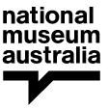
Defining Moments
Snowy Mountains Hydro – Live-sketch Animation

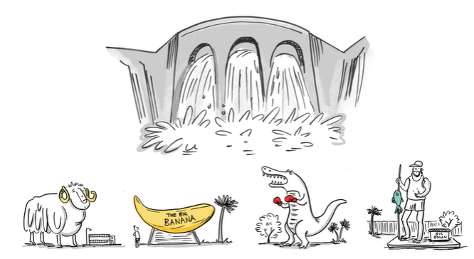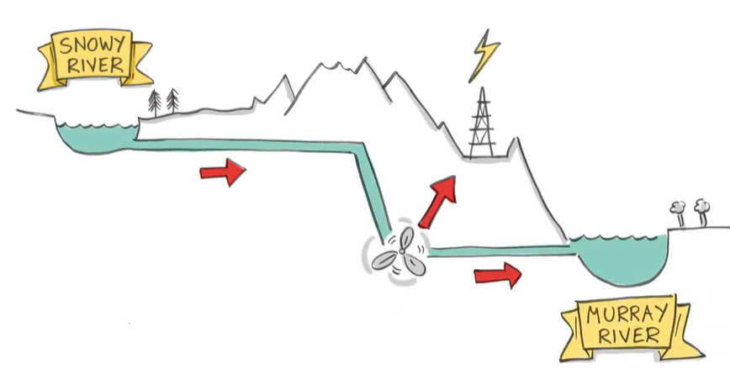

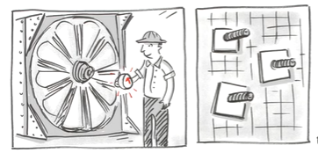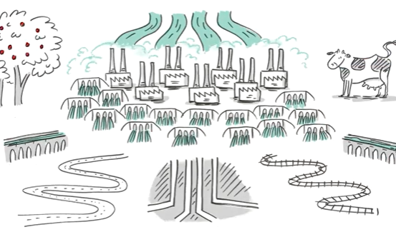
Images taken from the NMA’s Live-sketch animation

Students will write and illustrate a comic which tells the story of the Snowy Mountains Scheme.

Activity: The journey of water
Students will arrange the following processes (condensation, runoff, precipitation and evaporation) on the image below and add arrows to create a diagram demonstrating the cycle of water. Students will then investigate each step of the cycle in more detail explaining the biological and chemical mechanisms behind it.

Condensation

Runoff

Precipitation

Evaporation

Further investigation
Students will develop their own question/s to research or choose one of the questions below. Encourage students to collect and record information from a wide variety of sources and present the information they find in an interesting way.

- What is the hydrologic cycle?
- What role does the sun play in the hydrological cycle?
- What is hydroelectricity?
- What is the aim of the Snowy Mountains Scheme? Use a map to show the location of the Snowy Mountains Scheme and irrigation areas. Highlight the following on your map: Murray River, Murrumbidgee River, states and territories that benefit from the scheme. Include a legend on your map.
- How many power stations, dams, kilometres of tunnels and kilometres of aqueducts are in the Snowy Mountains Scheme? Show the engineering features of the Snowy Mountains Scheme on a map.

Activity: Collect primary and secondary sources
In this activity, students will explore how historical sources can help tell the story of the Snowy Mountains Scheme. Students will use this collection explorer to ‘collect’ a range of items and categorise them into primary and secondary sources. Students will reflect on each item by responding to a range of questions. Individually or in pairs, students will use the following as a guide as they create their own collection of sources:
- ‘Collect’ 3 items to create a Snowy Mountains Scheme memory box. Use the internet to find your items, including equipment, objects, works of art, photographs, maps, letters, diaries, or souvenirs.
- Include an illustration/photo and a description of each object. Why did you include each object in your memory box? Are there any stories related to the object?
- Categorise the objects into two columns, is it a primary source or secondary source?

Look at this 3D image of a 1950s hard hat from the Snowy Mountains Hydro-Electric Scheme. How do primary sources help us understand what it was like for workers on the Snowy Mountains Scheme?

Activity: Visual literacy
In this activity students will examine, analyse and query a range of images which show the Snowy Mountains Scheme during its construction. Students will choose one of the photographs below (alternatively, students can find an image themselves to analyse). Students will then respond to the following:

- Write a short paragraph describing what you see in this photograph.
- When and where was the photo taken?
- What do you think is happening?
- Write a caption for each image using your own words.
- What question/s would you like to ask about the photo? Choose one of your questions to investigate in more detail.

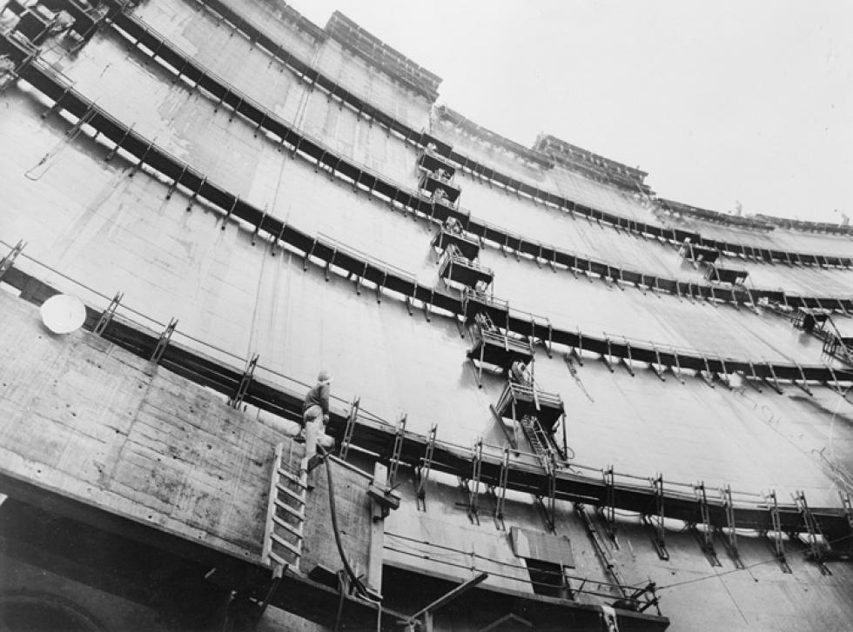  Constructing Tumut Pond Dam, 1960 – National Archives of Australia | 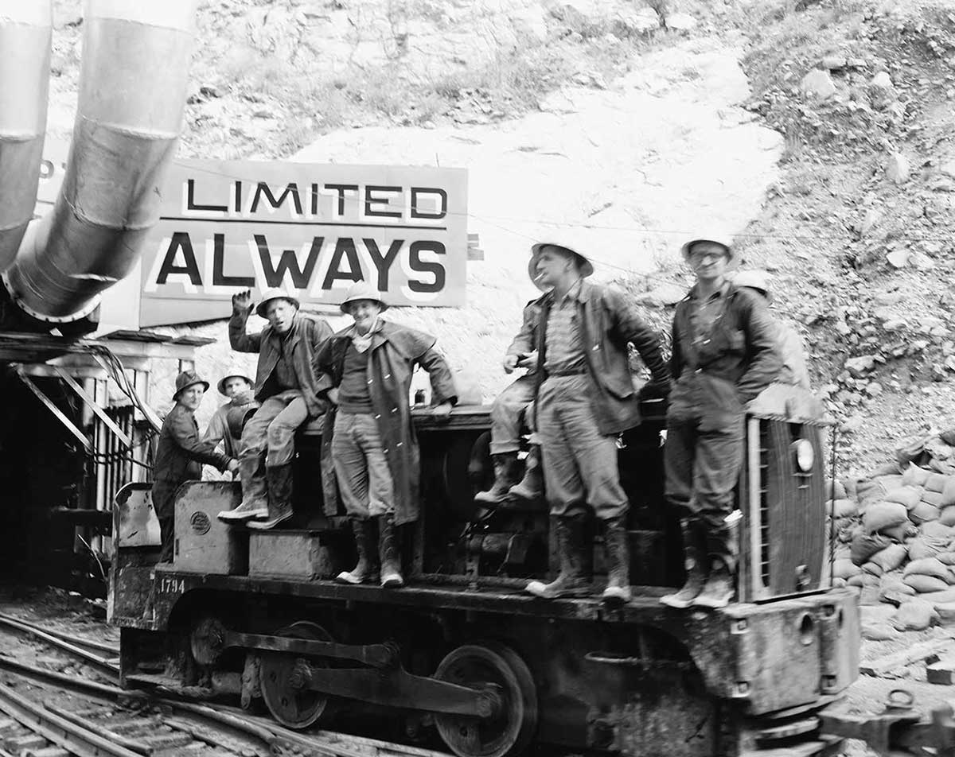  Workers pose before going on shift in the Tooma-Tumut tunnel – National Archives of Australia

Activity – Choose a project
Individually or in small groups, students will choose one of the following projects to work on and then present their findings to the class.

Summary
Write a summary of the story. What is the story about? Explain in your own words the history of the Snowy Mountains scheme.
Postcard writing
Imagine you are a worker on the Snowy Hydro scheme. Write a postcard to a family member explaining your experiences. Include photos, drawings, or maps to decorate your postcard.
Did You Know?
Research the history of the Snowy Mountains Scheme and create a Did You Know fact sheet to show what you have learnt.
Quiz
Create a true or false quiz to test your classmate’s knowledge about the cycle of water.

Useful Websites
- Snowy Mountains Scheme – BTN
- The Snowy Mountains Scheme – ABC Education
- Snowy Stories – MUSEUM
- Snowy Mountains Hydro – National Museum Australia
- Snowy Mountains Hydro-Electric Scheme – National Archives Australia
- Water into power: Snowy Mountains Hydro-Electric Scheme (digital classroom) – National Museum Australia
- The Snowy Scheme water cycle (fact sheet) – Snowy Hydro
- Student showcase: Snowy Hydro Who’s Who (digital classroom) – National Museum Australia

EPISODE 29
18th October 2022

KEY LEARNING
Students will create a profile of a species of bee and learn more about the impact of introduced species.

CURRICULUM
Science – Year 4
Living things have life cycles.
Living things depend on each other and the environment to survive.

Science – Year 5
Living things have structural features and adaptations that help them to survive in their environment.

Scientific knowledge is used to solve problems and inform personal and community decisions.

Science – Year 6
The growth and survival of living things are affected by physical conditions of their environment.

Science – Year 7
Interactions between organisms, including the effects of human activities can be represented by food chains and food webs.

  - Teacher Resource

Bumblebee Tracking

Focus Questions
Discuss the BTN story as a class and record the main points of the discussion. Students will then respond to the following:
- How many bumblebee species are there?
  - 50
  - 250
  - 500
- Bumblebees are native to Australia. True or false?
- How do the researchers put the backpacks on bumblebees?
- How do the transmitters help the researchers learn more about bumblebees?
- What questions do you have about the story?

Activity: Class Discussion
Students will discuss the BTN story in pairs and then share their thoughts with the class.
- Why are bumblebees being tracked in Tasmania?
- What technology is being used to track them?
- Where in Australia will you find bumblebees?
- When were they introduced to Australia? How did they come here?
- What impact do bumblebees have on the environment?
- How are bumblebees different to native bees?

Activity: Glossary
Students will brainstorm a list of key words that relate to the BTN Bumblebee Tracking story. Here are some words to get them started.
INTRODUCED SPECIES | NATIVE | POLLINATOR
TRANSMITTER | QUEEN BEE | NECTAR

Activity: Bee profile
Students will research and write a profile of a bumblebee, honeybee or native bee. Students can use the animal profile worksheet at the end of this activity to record their findings. Encourage students to use a range of sources to find their information.

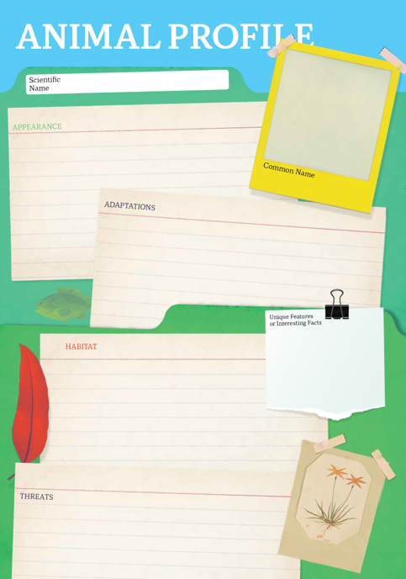
Research
Students will research and create a profile of a bumblebee, honeybee or native bee. Students can use the Animal Profile at the end of this activity.
- Illustration or photo
- Scientific and common name
- Appearance
- Habitat
- Where is it found in Australia?
- Native or introduced species
- Feeding and diet
- Behaviours and adaptations
- Predators
- Interesting facts

Native Bees
If native bees don’t produce honey, do we need them? Create a poster that explains why native bees are important.
Introduced Species
Are introduced species always a bad thing? What makes an animal a ‘pest’?
Why are bees important?
Investigate the role bees play in food security, biodiversity and ecosystem health. Display your research in a creative way.
What is the life cycle of a bee?
Use a diagram to help illustrate the different stages. Watch this ABC Education video to learn more.

Activity: Anatomy of a bee
Students will learn more about the different parts of the bumblebee by labelling the image below or create their own biological illustration. They can then choose three features to explore in more depth and write a paragraph about each feature.
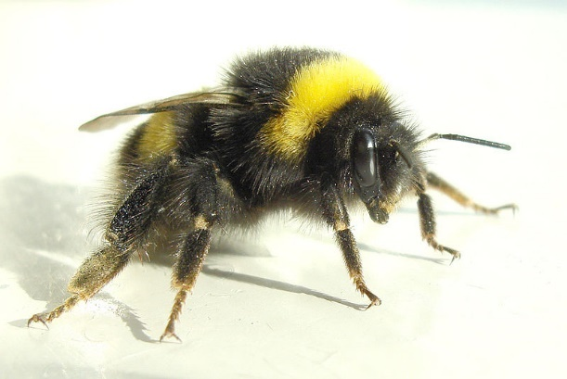
- Antennae
- Wing
- Pollen basket
- Tongue
- Thorax
- Eyes
- Abdomen

Further Investigation
Explore the similarities and differences between honeybees and bumblebees.

Activity: Introduced Species – Research Task
Students will then investigate the impact introduced species have on the environment and choose one to research. Include the following information:
Introduced species | Research
Describe the animal
Which country did the animal come from?
When was the animal introduced to Australia?
Why was the animal introduced to Australia?
Where does the animal live in Australia? (show on a map).
What impact does the animal have on native animals and the environment?
What methods have been used to control or eradicate the animal? How successful has it been?

Activity: Bee Quiz

- About how many species of bumblebees are there?  A. 50  B. 250  C. 500  - Bumblebees are…  A. Native to Australia  B. An introduced species  - Bumblebees don’t make as much honey as honeybees.  A. True  B. False  Quiz Answers: 1B, 2B, 3A, 4A, 5B, 6A | 4. Where in Australia will you find bumblebees?  A. Tasmania  B. Victoria  C. South Australia  5. Bumblebees only sting once.  A. True  B. False  6.How long does a colony of bumblebees live for.  A. Up to 1 year  B. 1-2 years  C. 2-3 years

Useful Websites
- Researchers put radio backpacks on bumblebees in Tasmania in insect-tracking trial – ABC News
- Bumblebees - Department of Primary Industries
- World Bee Day – BTN

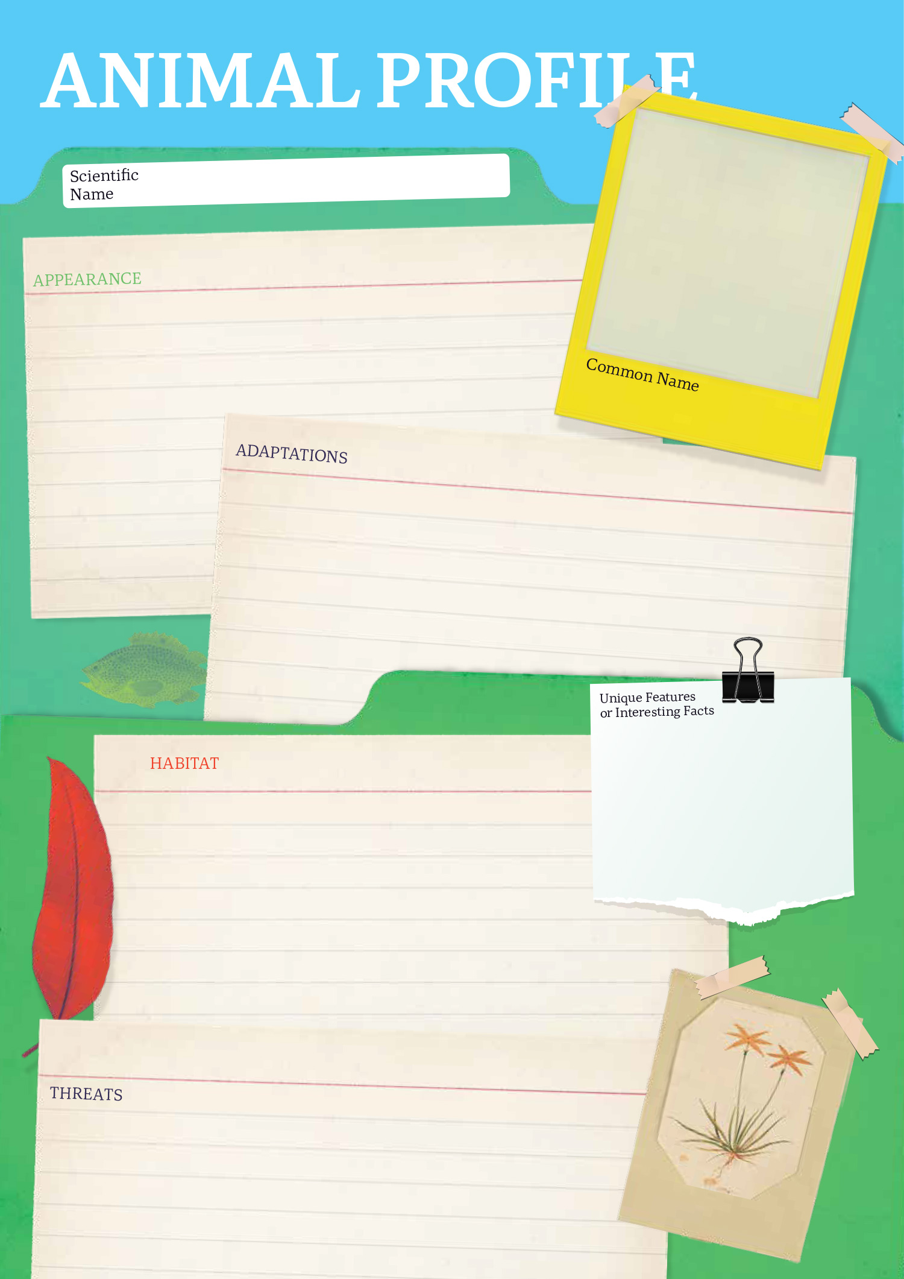

  - Teacher Resource

BTN Transcript: Episode 29- 18/10/2022

Hey everyone, I'm Amelia Moseley and you’re watching BTN. Thanks for hanging out with us again, let's see what's coming up on today’s show. Find out why people are protesting in support of Iranian women, learn about a big scandal in the world of chess and discover why bees in Tassie are wearing backpacks.

Floods

Reporter: Cale Matthews

INTRO: But first today. A lot of Aussies are dealing with a serious natural disaster. Floods have hit towns and cities in New South Wales, Tasmania, and Victoria, forcing thousands of people to evacuate and the rain isn't over yet. Here's Cale.

This is something we've seen a lot of this year, kayaks down the middle of flooded streets. In Mooroopna and other towns in rural Victoria, it’s the main way people are getting around.

RESIDENT, MOOROOPNA VIC: I’m figuring out whether the dogs come in the kayak with me, and we go to the other end of town.

Since last week, heavy rains on Australia's east coast have caused rivers and dams to overflow. More than 9,000 homes have been flooded, while thousands more have been cut off due to flood waters.

RESIDENT, MELBOURNE VIC: I had a home; I don’t know when we’ll be back.

RESIDENT 1, SHEPPARTON VIC: We were going to stay home and ride it out, but nah, not worth the risk.
Here in Echuca, people have been hit by a first wave of floods as the Campaspe River overflowed its banks.

RESIDENT, ECHUCA VIC: Well, we’ve all had our little cries. Our house is insured for flood, so bad luck we just start again.

While the water didn't get as high as many feared, it's expected to get worse, so people have been rushing to get ready. Meanwhile, in the nearby town of Shepparton people are starting to assess the damage done by the flooded Goulburn River.

RESIDENT 2, SHEPPARTON VIC: It doesn’t look like Shepparton anymore. It’s looks like a big lake.

Experts reckon these floods could continue for weeks and with more rain on the way more people have been told to evacuate. Emergency services are also warning people to stay away from flood waters.
DAN ANDREWS, VICTORIAN PREMIER: It is so dangerous to drive into this flood water or to be in this flood water when you don't need to be.
In parts of Tassie and New South Wales flood waters have gone down, but that means the clean-up begins.

RESIDENT 1, DELORAINE TAS: I was pretty devasted. You come home, everything you worked for is here, so.

RESIDENT 2, DELORAINE TAS: The amount of water that went through there was unbelievable, destroyed basically all our stuff.

The federal government has announced flood support payments for those affected across Victoria, New South Wales, and Tassie, $1,000 for every adult and $400 for kids. For stacks of Aussies, it really has been a long wet year.

RESIDENT 1, DELORAINE TAS: I’m just going to keep rocking up and keep living here and yeah, we’ll just keep going again. If it floods tomorrow, we’ll go again, so yeah, just the Aussie spirit I suppose, you just keep going.
News Quiz

Can you name this world leader? It’s Xi Jinping. He’s the president of China and he’s set to stay in the job for at least another five years. He recently got rid of a law saying presidents could only be in power for two five year terms and this will be his third, making him the longest-serving president since Chairman Mao was in charge after China’s revolution.

How many days do you have to isolate for in Australia if you test positive to COVID-19? Is it 7 days, 5 days, 3 days, or no days? It’s d. As of Friday, Aussies aren’t required by law to isolate or post a rapid antigen test online. There are still exceptions for people who work in high-risk places, and of course if you’re sick you should still definitely stay home.

The entertainment world has paid tribute to British actor Robbie Coltrane, who died on the weekend at age of 72. Which Harry Potter character is he known for playing? He played Hagrid. His fellow Harry Potter actors have sent out messages saying how much they enjoyed working with him and how much he’ll be missed.

NASA has announced that its mission to knock an asteroid off course by slamming a spacecraft into it was a success.

BILL NELSON, NASA ADMINISTRATOR: It came in at 14,000 miles an hour, and it was a bullseye.

Do you know the name of the mission? It was DART which stands for Double Asteroid Redirection Test. NASA says it’s space-smash managed to shorten the orbit of the asteroid Dimorphos by 32 minutes which was more than enough to knock it off course.

BILL NELSON, NASA ADMINISTRATOR: Now, this is a watershed moment for planetary defence, and a watershed moment for humanity.

Australia has a controversial new tourism ambassador. Do you know her name? Is it Kylie the Kanga, Ruby the Roo or Wanda the Wallaby? It’s Ruby the Roo and she’s a bit different to the human ambassadors that’ve starred in tourism campaigns. Not everyone’s a fan, but Tourism Australia is hoping she’ll get more visitors hopping on a trip Down Under.

Iran Protests

Reporter: Michelle Wakim

INTRO: Now to Iran, where for more than a month there've been violent protests. They started when a young woman died after being arrested for what she was wearing and now people around the world are calling for change. Here's Michelle.

For the past month, there have been scenes like this all-around Australia, and all around the world, as people of all ages take to the streets and even cut their hair to show their support for the women of Iran.

Ronika: In the olden days, when they lost a loved one, they cut their hair as a symbol of sadness and love, and that's what I did, because I am sad.
Ronika and Armita both live in Australia now, but what's happening in Iran means a lot to them.

Ronika: So, yeah, I was born in Iran. My parents don't really let me watch the violent stuff, which I'm glad of, but knowing that what's happening there, I don't feel like I'm free, because Iran's always been a part of me.
Armita: I was like, 10 when I travelled to Australia. It's really gets you thinking at times because you never know what happens. I could be sleeping, meanwhile, someone in my own country is dying. It's really heartbreaking for both me and my mum.
Violent protests began in Iran just over a month ago, after a 22-year-old woman, named Mahsa Amini, died after being arrested by Iran's Morality Police. You see, unlike other countries like Australia, where religion is supposed to be kept separate from government, Iran is a theocracy. It's ruled by religious leaders who make laws according to their own interpretation of Islam, and some of those laws restrict what women can do and even what they can wear.
In Iran, women have to cover their hair with a scarf known as a hijab. Many people here in Australia and in other countries wear them by choice. But in Iran you can get arrested for not wearing a hijab or for wearing it too loosely, which is reportedly what happened to Mahsa Amini. While authorities say they weren't responsible for her death, to many Iranians, she’s become a symbol of a system that controls and mistreats women.
Armita: We all know about Mahsa Amini, and I would just like to mention that she wasn't the only one and she was just the last straw for the Iranian people.

Protester: I guess the most important thing I’ve ever had to do in my life. We’ve been very loud, but the world’s still not hearing us. They think it’s an act against Islam, or hijab, or religion in general, but it’s just that we don’t have a right to choose.

Protester: The Iranian regime is an anti-woman regime who built his power on the body of women. They try to control our body as a flag of Islamic regime.

Iran's government has responded to protests with violence, and a human rights group says more than 185 people have been killed. Thousands of others have been arrested. But many men and women are still taking to the streets.
Armita: They've stayed like silent for so long, and just waited for change, and it never came. And they're not afraid to go to the streets anymore, which I think is really brave, and I'm really proud to say that my people are doing that.
No-one knows for sure where it will end, but many in Iran and overseas are hoping for real change.
Armita: I just don't want this to be a protest thing anymore, because in Iran, people are way over protesting. They want revolution, and they want change.
Ronika: I will continue trying to be the voice of Iran, because I want to tell the whole world what they would say if they had internet and til the whole world listens and supports Iranians. And I wish Iran looks like Australia soon. Free.
Snowy Hydro Anniversary

Reporter: Jack Evans

INTRO: Now to a very special birthday for a very impressive piece of Aussie engineering. This week marks 50 years since the opening of the Snowy Mountains Hydro Electric Scheme. Jack found out what that is and how it changed the country.

When it comes to big things that have been built here in Australia, you probably think of the Big Banana, the Big Pineapple, the Big Potato, the list goes on. But when it comes to the biggest, nothing is bigger than the Big Snowy Scheme, AKA the Snowy Mountains Hydro Electric Scheme.
The story of this massive power station starts back in the late 1940s. At the time there were serious power shortages. But the government had a plan and that was to make use of all this snow and the water from the Snowy River by redirecting it through huge turbines to generate energy known as hydroelectricity. The plan would also give farmers access to the water to be used for irrigation.
While it seemed like a pretty good and renewable way to source power, it was also fairly controversial. There were plenty of people who didn't like the idea of building a massive power station in the middle of the Kosciuszko National Park because of the impact it might have on the environment. But despite that, on the 17th of October 1949, construction began.
It took 25 years and nearly a hundred thousand people to help build it. Most of which were immigrants from different countries. You see after the Second World War stacks of people were leaving Europe in search of work and to start a new life. The Australian Government decided to take advantage of this with a campaign encouraging people to come to Australia to work on the Snowy Mountains Scheme. It became really popular, and those workers brought with them their families and their cultures.
But working conditions were tough. Not only is it freezing up here, but the tunnels they were working in were damp, dirty, and dangerous. Meanwhile the construction of the power station completely changed the Snowy Mountains region. Entire towns had to be relocated to accommodate the infrastructure. 50 years after it's opening and the Snowy Mountain Scheme is still doing what it does best, and there are now plans to make it bigger.
MALCOLM TURNBULL, FORMER PRIME MINISTER: These are big dreams in these mountains. Real courage, a belief in the future, a confidence in Australia.
In 2017, the Prime Minister at the time, Malcolm Turnbull announced an expansion to the station.
MALCOLM TURNBULL, FORMER PRIME MINISTER: I am a nation building Prime Minister, believe me. And this is a nation building project.
But things haven't gone too smoothly with Snowy 2.0. It's way behind schedule and the original $3 billion budget is now up to nearly 10 billion dollars. Plus, not everyone is a fan of the upgrades and reckon that the impact on the environment just isn't worth it.
JACQUELINE TROY, UNIVERSITY OF SYDNEY: They've completely devastated the valley in this country. We believe in renewable energy, and it looks like it's renewable energy. But at what cost? At the cost of this incredible alpine environment, that's the cost.
So, while its future is still a little up in the air, it's place in history is much more certain. Not only did it change the way Australia sourced its energy, but it also transformed our cultural landscape and helped build the multicultural nation we know today.

Did You Know?

Did you know the old towns of Adaminaby and Jindabyne were both flooded to make way for the Snowy Hydro Scheme? But back in 2007 the drought got so bad that the ruins of Adaminaby started to reappear from beneath lake Eucumbene.

Chess Scandal

Reporter: Jack Evans

INTRO: Now to chess. While the game has a lot of fans around the world, it doesn't always get that much attention. But recently it made headlines because of a scandal involving some very famous players. Jack found out what's going on and met some young players to see what they think about it. Check it out.

Chess. It's all about concentration, knocking over pieces, hitting this timer thingy and most importantly, saying this.

JACK, REPORTER: Checkmate.
LAKSHYA: That's not checkmate.
So maybe I don't actually know how to play chess, but that's okay because these guys certainly do.
LAKSHYA: I've been playing for three years. I like to win and when we play, I just think that it's better for my brain, because I like using math, math and chess are together they're brain thing. I just enjoy moving the pieces. And like, winning.
SEAN: I've been playing chess for about a year and a half now. I got into it because of the Queen's Gambit, the TV show.
These young chess enthusiasts have been taking part in a local tournament here on Kaurna country in Adelaide.
SEAN: I enjoy how, the chess pieces and the chess boards, there's only that many chess pieces on the board. But there's so many things you can learn about it. And there's so many beautiful combinations, and tactics.
There are comps like this one held right around the country and, well, right around the world. Some of them come with some pretty big prizes. But recently the competitive world of chess has been rocked by a scandal. Let me break it down. The drama is between these two; Norwegian chess grand master and world number 1 Magnus Carlsen, and 19 year old American chess grand master Hans Niemann. A couple of months ago Carlsen pulled out of a tournament after he lost a game to Niemann and posted this cryptic tweet which made people wonder if he was accusing the American of cheating.
A couple of weeks later the two met for an online match. But after just one move from Niemann, Carlsen did this. He left the match and resigned from the tournament again. Later Carlsen came out and actually said that he thinks Niemann is cheating. Niemann says he didn't cheat in either of the games, although he has admitted to doing so in the past.
HANS NIEMANN: I'm not going to back down and I'm going to play my best chess here regardless of the pressure that I'm under. And that's all I have to say about this game. Chess speaks for itself. That's all I can say.
KETI TSATSALASHVILI, GRAND MASTER: I believe that Carlson is one of the most fair players in the chess world and chess history. And, um, the fact that he withdrew from the tournament that he has never done before. And then he made one move, and then he resigned. I believe that he has a good reason for that.
This is Keti Tsatsalashvili, she's a chess grand master and says that cheating in chess is unfortunately pretty common. But how is it even possible to cheat in chess?
KETI TSATSALASHVILI: The most common way is to use the technology to use the phone where the live games are broadcasted, and you can just, uh, look at the phone and see your own game, see the engines suggestion and then go back in the game and play the move.
Hmm makes, sense. Computers can work super-fast to figure out the best move to make and it can take human brains a bit longer. Anyway, the whole thing has got a lot of people in the chess world pretty concerned. As I mentioned some of these tournaments are worth big bucks, not to mention the prestige of being a chess grandmaster. While there's no proof that Niemann has done anything wrong, the Chess Federation is looking into the accusations as well as ways to protect players from cheaters.
SEAN: I strongly dislike anyone who ever cheats in a sport, and I don't think it's ever okay to cheat.
JACK: I mean what's the point really, most people just play it for fun, so if you cheat I guess you're just losing the fun of the game.
Quiz

Which one of these chess pieces can move in an "L" shape on the board? Is it the knight, the rook, or the queen? It's the knight.

Sport

SPORT COMMENTATOR: And the buzzer goes, Australia are the world champions.

That's right, you're looking at the 2022 wheelchair rugby world champs. The Aussies, known as the Steelers, defeated the United States 58 to 55 in the final. It’s their second world title since 2014 and after going home medal-less at last year's Paralympics it's a big deal.
Everyone give it up for Madison De Rozario. She's just been named athlete of the year at the Australian Women in Sport Awards.

MADISON DE ROZARIO: This is unreal, and I think, you know, I think there is moments like this where it all kind of comes together.

The Paralympic champ won 2 gold medals at the last Paralympics. She's also the first Aussie to win the New York marathon in any category. Impressive. Another highlight of the night, basketball legend Lauren Jackson, took out the Hall of Fame award. She's had an incredible career and mostly recently helped the Opals bring home a medal at the FIBA Women's Basketball World Cup.
Aussie Jack Miller has had a tough time at the Australian MotoGP. He was in third when this happened on the eighth lap, but Spain's Alex Rins had lots to cheer about. He took the lead and the win in the final lap.

Bumblebee Tracking
Reporter: Amelia Moseley

INTRO: Finally, today, I promised bumblebees in backpacks and that's what you're going to get. Well, sort of. Researchers down in Tassie are kitting the furry little critters out with tracking devices to investigate what they're getting up to. Take a look.
Have you ever seen a bumblebee? No, that's a regular bee. This is a bumblebee. As you can see, they're bigger and furrier than honeybees, but they don't actually produce much honey. And if you said yes to seeing one, you're probably watching this from Tasmania. You see, there are more than 250 species of bumblebees in the world, and they're mostly native to the Northern Hemisphere and South America, not Australia. But some European bumblebees were accidentally or deliberately brought into Tassie in the 1990s, and since then, well.
DR JONATHAN FINCH, ENTOMOLOGIST, TASMANIAN INSTITUTE OF AGRICULTURE: They've been here for 30 years, but we've really lost track of what they're doing and how far they're spreading.
Bumblebees definitely aren't the only introduced bees in Australia. Take another look at these little guys. Your average European honeybee was brought here in the 1800s. And all bees are really good at spreading pollen, which means they help grow plants and crops. But there are worries that too many bumblebees could have an impact on our native species.
DR JONATHAN FINCH, ENTOMOLOGIST, TASMANIAN INSTITUTE OF AGRICULTURE: Many of our native birds in Tasmania feed on nectar from trees like Eucalypts, such as the critically endangered swift parrot. Also, bumblebees will feed on that nectar as well.
So researchers in Tassie have come up with a clever way to see what they're up to, teeny, tiny bee backpacks. Or tracking devices really, but backpacks sound, like, way cuter.
DR JAMES MAKINSON, WESTERN SYDNEY UNIVERSITY: The bumblebee queens that we have here in Tasmania are the perfect size for these transmitters.
But how exactly do you attach something to a queen bee? Well, you have to help them chill out first, obviously.
DR JAMES MAKINSON, WESTERN SYDNEY UNIVERSITY: Our bees are quite cold tolerant. What we do is we catch them on a flower, put them in the freezer for about 10-15 minutes until they're nice and cold and just not moving. Then simply with a bit of superglue that we buy from any shop, we attach the transponder onto their back.
The tracker slots into the glued backpack, so it can be taken out and put back without hurting the bees. Leaving them to go about their bee-sness.
DR JAMES MAKINSON, WESTERN SYDNEY UNIVERSITY: They might spend about five minutes rubbing the back of their back trying to get the transmitter off, but we've actually been surprised how quickly they switch back to foraging and they completely forget about it.
Then researchers can follow the bees' signal and find out where they're setting up nests and which plants they’re visiting. Plus, this cool tech could be used to unpack the bee-haviour of other even smaller creatures in the future.
DR JAMES MAKINSON, WESTERN SYDNEY UNIVERSITY: Hopefully as the technology gets better, we'll have even smaller versions of these transmitters that'll allow us to track smaller insects again.
Sounds bee-rilliant if you ask me. Okay that one didn't quite work.
Did You Know?

Did you know, unlike European honeybees, bumblebee workers and queens have smooth stingers so they can sting more than once, and male bumblebees don't have stingers at all.
Closer

Well, that's it for this week. I hope you've enjoyed the show. Don’t worry though, we'll be back next week with more news, and in the meantime, there's heaps to see and do on our website and if you're 13 or over you can check out our YouTube channel. Plus, Newsbreak will be right here in the studio every weeknight to keep you up to date with what's going on in the world. Have a lovely week, and I'll see you soon. Take care of yourselves. Bye.

