Episode 17
18th June 2019



Press Freedom
- Discuss the Press Freedom story as a class and record the main points of the discussion.
- What does Freedom of Press mean? Describe using your own words.
- Complete this sentence. In Australia it's generally agreed that the _____________ shouldn't interfere with the media unless there's a really good reason.
- The Australian Federal Police are currently investigating which media organisation?
  - News Corp
  - Australian Broadcasting Corporation
  - Both
- What were the police looking for?
- Why might the government want to keep some official information secret?
- What is a whistle-blower?
- Do you think government secrets should be shared?
- Name three facts you learnt watching the BTN story.
- What questions do you have after watching the BTN story?

Aboriginal Flag Debate
- Who has been threatened with legal action over their use of the Aboriginal flag?
- What year did Harold Thomas design the Aboriginal flag?
- What do the colours of the Aboriginal flag represent?
- What year did the government recognise the Aboriginal flag as an official flag of Australia?
- The Aboriginal flag is copyrighted. What does this mean?
- Who owns the design of the Aboriginal flag?
- The Torres Strait Islander Flag is also copyrighted but it's not owned by one person. Who owns it?
- Why did the Spark Health Group start an online petition?
- What is a solution to the issue?
- Are flags important? Why or why not?

Check out the Aboriginal Flag Debate resource on the Teachers page.

Refugee Week 2019
- Briefly summarise the BTN Refugee Week 2019 story.
- Where was Halia born? Find using Google Maps.
- Why did Halia and her family migrate to Pakistan?
- How old was Halia when she came to Australia?
- Who is a refugee?
- Why do people become refugees? Give one reason.
- How many refugees are there according to the United Nations?
  - 25 thousand
  - 2.5 million
  - 25 million
- Which 5 countries do most of the world’s refugees come from?
- What is the Refugee Convention?
- When does a person stop being a refugee?

Check out the Refugee Week 2019 resource on the Teachers page.

Female Footballer Ban
- Discuss the main issues raised in the BTN Female Footballer Ban story?
- What football team did Casey McElroy’s dad and grandfather play for?
- How did they feel when Casey played a game for their old team?
- Why was Casey given a 6-week ban from the women’s competition?
- How did Casey feel about the ban?
- What age can women and men play on the same team in Aussie Rules?
- Why does the AFL think men and women shouldn’t be playing on the same team?
- Do you think men and women should be allowed to play on the same team? Explain your answer.
- What are some solutions to the issue?
- How has your thinking changed since watching the BTN story?

Bigfoot
- Before watching this story describe what you think Bigfoot looks like.
- Complete this sentence. The mythical creature Bigfoot is also known as ____________.
- Which country does the mythical creature Bigfoot come from?
- What year was the first supposed sighting of Bigfoot reported in a newspaper?
- Who recently released a 22-page report about Bigfoot?
- Give an example of another mythical creature.
- Australia doesn’t have any mythical creatures. True or false?
- What is the name of the famous Scottish lake dwelling creature?
- Illustrate an aspect of the Bigfoot story.
- What did you like about the BTN story?

Teacher Resource
Episode 17
18th June 2019

Aboriginal Flag Debate

Students will learn about the history and meaning of the Aboriginal flag and the copyright restrictions with it.


History – Year 3
Days and weeks celebrated or commemorated in Australia (including Australia Day, Anzac Day, and National Sorry Day) and the importance of symbols and emblems.

History – Year 6
Experiences of Australian democracy and citizenship, including the status and rights of Aboriginal and Torres Strait Islander Peoples, migrants, women and children.


- Who has been threatened with legal action over their use of the Aboriginal flag?
- What year did Harold Thomas design the Aboriginal flag?
- What do the colours of the Aboriginal flag represent?
- What year did the government recognise the Aboriginal flag as an official flag of Australia?
- The Aboriginal flag is copyrighted. What does this mean?
- Who owns the design of the Aboriginal flag?
- The Torres Strait Islander Flag is also copyrighted but it's not owned by one person. Who owns it?
- Why did the Spark Health Group start an online petition?
- What is a solution to the issue?
- Are flags important? Why or why not?


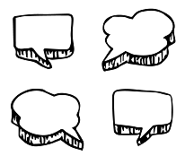
Class discussion
Before watching the BTN Aboriginal Flag Debate story, hold a class discussion asking the following questions:

- What do you know about the Aboriginal flag?
- What do you know about the term `copyright’? When have you heard the word used?

After watching the BTN story, discuss with students what they learnt about the Aboriginal flag and copyright. Here are some questions to help guide discussion:
- What are the flags of Australia?
- List some places you would see flags.
- Where can you see the Aboriginal flag in your community?
- Are flags important? Why or why not?
- What was surprising about this story?
Aboriginal Flag Research

Define: What do I want to know?
Key questions to research
Students can choose one or more of the following questions or come up with their own:
- How and why do people use flags?
- What are the three colours on the Aboriginal flag and what is the meaning or symbolism of the colours? What does the round shape represent?
- What are the copyright restrictions on the Aboriginal flag?
- What is the history of the Aboriginal flag? (Who created it, why, when was it first flown?)
- What are some solutions to the Aboriginal flag copyright issue?

Further Investigations
- Survey friends and family about the meaning of the Aboriginal flag. What was surprising about the results?
- Should Australia have one national flag that represents all people? Develop an argument for or against the issue.
Locate: Where do I find the information?
What resources will help answer my questions? (Internet, people, resource centre, organisations, print). Discuss with students what a reliable source is.
Select: What information is important for the investigation?
Students may need support to sort through and select relevant information.
Organise: How do I make sense of the information?
Students can organise their research by creating main headings from their questions. Write each heading on a separate piece of paper. Record the information found for each question.
Present: How do we let others know about this information?
Each group needs to discuss then decide on the best way to present the information. Possibilities could include:
- A ‘Did You Know’ Facts sheet
- Infographic
- Oral presentation
- Prezi presentation
- Create an infographic using Canva
Evaluate: What have we learnt?
Each group reflects on what they have learnt about the Aboriginal flag during their investigation. Students will reflect on their learning and respond to the following.
- What I learned...
- What I found surprising...
- What I would do differently next time…



Learn more about the history of the Aboriginal flag. Watch the BTN story and answer the following questions:

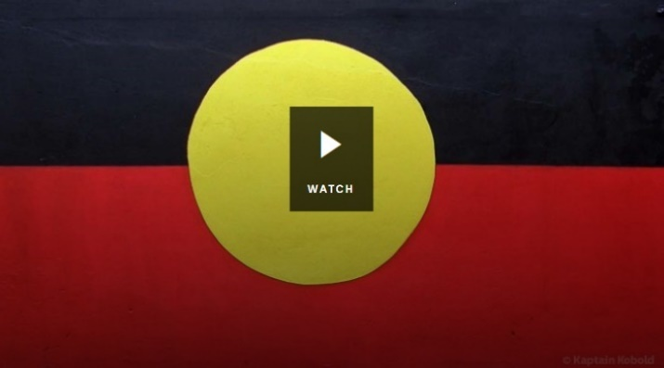
- Why did Vincent Lingiari lead a strike with 200 other Aboriginal people in 1966?
- Who designed the Aboriginal flag?
- What do the different colours in the Aboriginal flag represent?
- In what year was the Aboriginal flag first flown?
- Where was the Aboriginal flag first flown?
- Why was it controversial that Cathy Freeman wore both the Australian and Aboriginal flags during her victory lap at the 1994 Commonwealth Games?
- In what year were the Aboriginal and Torres Strait Islander flags made official?
- What connection does the Aboriginal flag have to Anzac Hill in Alice Springs?


Create your own quiz
Students will create a quiz about the Aboriginal flag including questions about the history and meaning. Quizzes can be created to recap learning or test personal knowledge. There is also the option to connect with classrooms around the world and play kahoot in real time. Kahoot!.


ABC News – News licence owners of Aboriginal flag threaten football codes and clothing companies
https://www.abc.net.au/news/2019-06-11/new-licence-owners-of-aboriginal-flag-threaten-football-codes/11198002

NAIDOC – The Australian Aboriginal Flag
https://www.naidoc.org.au/about/indigenous-australian-flags

BTN Aboriginal Flag History
https://www.abc.net.au/btn/classroom/aboriginal-flag-history/10489214

Australian Museum – Aboriginal and Torres Strait Islander Flags
https://australianmuseum.net.au/learn/cultures/atsi-collection/cultural-objects/indigenous-australia-flags/

Teacher Resource
Episode 17
18th June 2019

Refugee Week 2019
Students will develop an understanding of the refugee experience. Students will explore the theme for Refugee Week 2019.

HASS – Year 3
How the community has changed and remained the same over time and the role that people of diverse backgrounds have played in the development and character of the local community.

HASS – Year 3 & 4
Pose questions to investigate people, events, places and issues.

Examine information to identify different points of view and distinguish facts from opinions.

HASS – Year 5
The reasons people migrated to Australia and the experiences and contributions of a particular migrant group within a colony.

HASS – Year 6
Stories of groups of people who migrated to Australia since Federation (including from ONE country of the Asia region) and reasons they migrated.

- Briefly summarise the BTN Refugee Week 2019 story.
- Where was Halia born? Find using Google Maps.
- Why did Halia and her family migrate to Pakistan?
- How old was Halia when she came to Australia?
- Who is a refugee?
- Why do people become refugees? Give one reason.
- How many refugees are there according to the United Nations?
  - 25 thousand
  - 2.5 million
  - 25 million
- Which 5 countries do most of the world’s refugees come from?
- What is the Refugee Convention?
- When does a person stop being a refugee?

Before analysis or discussion about refugees think about the students with refugee experience at your school and the sensitivities you will need. Establish with your students some key definitions and stereotypes. Some activities may not be suitable for particular refugee students.


Class Discussion
After watching the BTN Refugee Week 2019 story, ask students to finish the following sentences:

- It was interesting to learn that...
- This story made me feel...
- This story made me wonder why...

Students will develop an understanding of what a refugee is and write a class definition. Compare students’ definitions with the UN definition. Respond to the following as a class recording responses on a large sheet of paper.
- Who is a refugee?
(Explain to students the ways in which a refugee and an asylum seeker differ from a migrant).
- Which countries do refugees come from? Which countries do people arrive as refugees? Look on a world map to find these countries.
In small groups, students will brainstorm what they know about the refugee experience, recording all responses on a large sheet of paper. Students will respond to the following questions and then create an acrostic poem. Share what each group brainstormed and display their poems in the classroom.
- Why do people become refugees?
- What words do you associate with the word refugee? Which words are positive, and which are negative?
- Where have you heard these words used (media, friends, family)?
- Create an acrostic poem using a word associated with the refugee experience. E.g. ‘Welcome’.

Refugee stories
As a class watch one or more of the following BTN stories to learn more about the experiences of refugees. Find out where they come from and why they had to leave their home. Students will compare elements of their life and the refugee’s life. Students will use a Venn diagram to illustrate the differences and similarities.

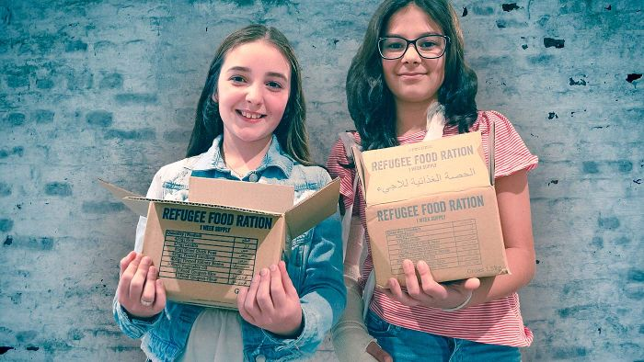

In the BTN Raising Funds for Refugees story, meet Soufia and her best friend Arielle who took part in something called a Ration Challenge. After watching the story students will respond to these focus questions:
- Where did Soufia and Arielle meet?
- Why did Soufia and her family leave Syria?
- Where is Syria? Find Syria using Google Maps.
- What is the Ration Challenge? Describe using your own words.

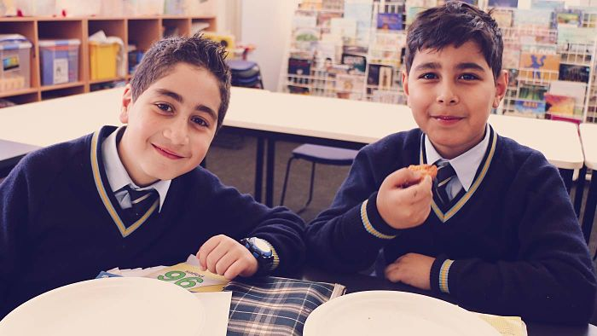
Watch the BTN Syrian Refugee Family story that tells the journey of Syrian kids Youssef and Sara and answer the following questions:

- When did the war begin in Syria?
- How do Sara and her family feel living in Australia?
- What does Youssef miss about his home country?
- What do you think would be one of the most difficult things about moving to another country?
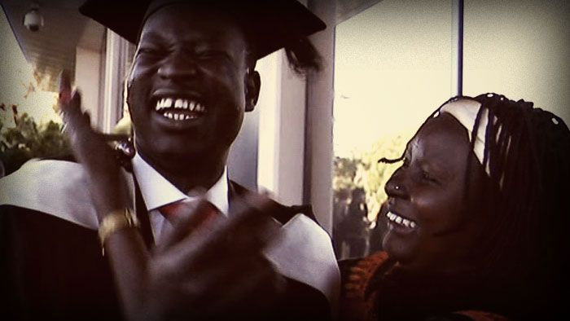
Watch the BTN Refugee Journey story that tells the journey of Sudanese refugee Johnson and answer the following questions:

- Why did Johnson leave Sudan?
- Retell the story of Johnson’s journey.
- Why did Johnson go to Kenya?
- Describe Johnson’s life now that he lives in Australia.

Share a meal, share a story

The theme for Refugee Week 2019 is “Share a meal, share a story – celebrating refugee stories”.

Discuss as a class what this theme means. Record your student’s responses on the class whiteboard.
- What does this theme mean to you?
- Why do you think the Refugee Council of Australia chose this theme?
- Think of the people you share meals with, at home or school. How does it make you feel to share a meal with family and friends?

Refugee Week event

Organise your own Refugee Week event at your school. It can be a breakfast, morning tea or dinner, where you can invite a refugee and hear their stories, while sharing some of their favourite meals. Visit the Refugee Week website and download their resource kit for a guide on planning your own event. Learn more

Further activity
What should next year’s theme be? Brainstorm and discuss as a class and then hold a poll to decide on a theme for 2020.

Juggling game
People don’t plan to become refugees. Usually circumstances beyond their control force them to flee. As a class discuss reasons why people might leave their homeland. Ask students to think of three reasons and write them on post-it notes. Collate student responses and discuss.

Ask students to imagine they have to flee their home in a hurry, leaving their family and belongings to move to another country. In small groups students will discuss and respond to the following:

  - Make a list of the problems you may need to juggle as a refugee on a daily basis.
  - Discuss the issues of food, accommodation, education, freedom and language.
  - What does it feel like to be a refugee?
  - What does a refugee leave behind?
  - What do refugees go through when they arrive in a new country?
  - What support might refugees need when they arrive in a new country?
  - Play this simple and fun balloon game which raises awareness of some of the issues faced by refugees. The balloons represent some of the issues refugees might face each day.
  - Present your groups ideas as a story or create a picture that describes the experience.


UNCR – What is a refugee?
https://www.unrefugees.org/refugee-facts/what-is-a-refugee/

BTN – Refugees and Migrants
https://www.abc.net.au/btn/classroom/refugees-and-migrants/10524176

Refugee Council – Refugees in the world
https://www.refugeecouncil.org.au/world/

Roads to Refuge – Teacher Resources
http://www.roads-to-refuge.com.au/

Refugee Week 2019 – Share a meal share a story
https://www.refugeeweek.org.au/

BTN Transcript: Episode 17 – 18/6/19

Hey, I'm Amelia Moseley and you're watching BTN. Here's what's coming up. We find out why there's debate about this famous Aussie flag, we celebrate World Refugee Week and go on the hunt for Bigfoot.

Press Freedom
Reporter: Olivia Mason

INTRO: Now, you know what's been big in the news lately? The news. Recently journalists became the story when the offices of the ABC and the home of a newspaper reporter were searched by the Australian Federal Police. Let’s find out what happened and why it's got some people talking about freedom of the press.
OLIVIA MASON, REPORTER: Being a journalist is serious business. You have to ask the tough questions.
Dress the part. Break some really big news. And sometimes put yourself on the line to chase down the story.
Well, maybe it's not always quite so serious here at BTN.

But you've gotta admit, these guys and girls do an important job. Making sure the people in power are doing the right thing and keeping us all informed about the world around us. It's why many take freedom of the press really seriously. It's basically the principle that government or other powerful people shouldn't punish journalists for doing their job. While there are many places in the world where the press isn't free, in most democracies like Australia it's generally agreed that the government shouldn't interfere with the media unless there's a really good reason. That's why many around the world were shocked when this happened.
GEORGE ALAGIAH: Australian police have raided the offices of the country's national broadcaster, ABC.
FELICITY BARR: The second operation against media outlets in just two days.
HALA GORANI: A remarkable story is happening in Australia right now.
Recently the Australian Federal Police raided a News Corp journalist's home and the offices of the ABC. They went through computer files, emails and documents as part of two different investigations into stories which they said may have broken the law. The News Corp story looked at a possible government plan to spy on people and the ABC stories said some soldiers in Afghanistan may have done the wrong thing. They had one thing in common. They were both written with the help of sources who revealed secret government information.
OLIVIA MASON, REPORTER: Australia has some pretty strict laws about that and government workers who reveal official secrets can land themselves in jail for a long time.

There are some really good reasons to keep information secret. Like if it could put a mission, a deal or even lives at risk if the wrong people found out. But some say there are secrets that should be shared.
There are some really famous examples, here in Australia and overseas, of people who've exposed serious wrongdoings by revealing secret information to journalists. People who do that are known as whistle-blowers and while some are eventually seen as heroes, they can pay a high price. Australia has some laws which protect whistle-blowers but they're complicated and some say they don't go far enough.
There are also some protections for journalists and it’s not yet known if the ABC and News Corp reporters will get into trouble for what they published. But some say the raids have already sent the wrong message.
Some reckon Australia needs new laws to guarantee press freedom, something many other countries have already. But others reckon the media here is already pretty free and that journalists shouldn't have the right to break the law. It's a difficult issue and a really important one. Especially for those of us who are in the business of bringing you the news.

This Week in News

There've been some massive protests in Hong Kong. Lots of people there are angry about a possible new law, which would mean people who are accused of certain crimes in mainland China could be sent back there to face trial. You see, while Hong Kong is technically part of China, it’s got its own government and laws. It actually used to be a British colony, and a lot of people there don’t really think of themselves as Chinese. Some locals feel like the new law would give the Chinese government too much power.

Adani’s Carmichael coal mine has been approved. Last week, the Queensland government officially gave the go ahead to the project which has been the subject of protests and debate for almost a decade.

Meanwhile Aussies came together to say goodbye to a popular former PM. Bob Hawke died last month at the age of 89, and on Friday there was a big memorial service at the Sydney Opera House. Politicians from both sides were there, along with celebrities, and dignitaries and Hawke’s family of course. There was even an orchestral performance directed by Hawke himself.

And if you’re into games, this was the place to watch last week. It’s E3, the Electronic Entertainment Expo held in Los Angeles and it’s where tech companies come together to showcase their latest, coolest creations. For example, there was Project Scarlett, Microsoft’s next-generation XBox, which will be up to 4x more powerful. Speaking of powerful, budding Jedi have some new games to look forward to as do Avengers fans, although some were a little upset that the characters look a bit different than they do in the movie. Nintendo’s planning to breathe some new life into much loved old characters and Sony made news by not being at E3 at all, deciding to focus on their own stuff instead. E3 goers did get to meet the stars of some games like Keanu Reeves and Jon Bernthal, oh and his dog which quietly stole the show.

Aboriginal Flag Debate
Reporter: Emma Davis

INTRO: Now to a very famous Aussie design that's been at the centre of a debate about copyright. Some organisations, including the AFL and NRL were asked to stop putting the Aboriginal flag on clothing without permission. Here's Emma to tell you why.
You've probably seen it on shirts, on posters and blowing in the breeze. Yeah, the Aboriginal flag is an Aussie icon and an important symbol of unity and identity to many Indigenous Australians. But while it's recognised as a one of our country's official flags, it's got some special legal rights and those have caused a few problems lately.
The AFL, the NRL and an Aboriginal health group have all been threatened with legal action over their use of the flag. That's because they don't own it, this guy does. His name is Harold Thomas. He's an artist and activist and back in 1971 he designed the flag to be as a symbol of the Indigenous land rights movement. The colours are really important; the black represents the Aboriginal people; the yellow represents the sun the giver of life and the red represents the earth and the spiritual relationship Aboriginal people have to the land.
Harold Thomas, Flag Designer: I lived amongst the redness of the earth. It's so powerful, so as a child it was part of my identity, to see the red rocks, and red desert.
In 1995 the government recognised it as an official flag of Australia but Harold Thomas got to keep the copyright. That means he's the only one who owns the design and if anyone wants to use it to make money, by putting it on t-shirts or actually selling the flag, well they need his permission. The Torres Strait Islander flag is also copyrighted but it's not owned by one person, it's owned by the Torres Strait Islander people. That's not the case with this flag or almost any other country's national flag.
Usually the government pays someone to design the flag and then it owns the rights, so anyone can use it. The Aboriginal flag is different because Harold Thomas designed it on his own so it's up to Harold to decide how his flag is used. He's given the right to make flags, objects and clothing to three different companies and it's the clothing company that's involved in the drama. WAM Clothing owns the exclusive rights to the flag and it's told other companies to stop using the design without their permission.
Laura Thompson, Spark Health: We received a cease and desist letter, and it sort of opened up a bigger can of worms about who should be able to use the flag.
That's made this group, Spark Health, pretty angry and they've even started an online petition.
LAURA THOMPSON, SPARK HEALTH: We've fought for enough, we've struggled for enough, we don't want to struggle to use our flag now and that's how we feel.
While technically Spark Health did do the wrong thing, experts reckon it's time all this confusion was cleared up. One solution could be for the government to pay Harold Thomas a certain amount of money to buy the licence and then anyone can use it just like the Australian flag. Of course, that's a tricky issue, especially when a lot of Aboriginal Australians are concerned about the government owning something they see as part of their culture. In the meantime, WAM is talking to Indigenous groups and the AFL about how they can continue using the flag and while the copyright confusion may not be over this much-loved symbol isn't going anywhere.

Did You Know?

Did you know there are rules about flying Australia's national flag? For example, you're not supposed to fly it upside down and if it's flown alongside other country's flags, the poles are supposed to be the same height.

Refugee Week 2019
Reporter: Emma Davis

INTRO: This week is Refugee Week, which is all about celebrating the courage and perseverance of people who've had to leave their homes and start a new life in a new country. Emma found out more.

MARWAH: Hi mum, do you need a hand at all?
HALIA: Yeah sure do, I'll just get the garlic ready for you.
This is Marwah and her mum Halia. They live here in Australia but Halia was actually born in Afghanistan.
HALIA: My family, which was mum and dad and siblings, we migrated to Pakistan because of the Soviet Invasion. We went to school there, we had good friends, good neighbours.
When she was 10 Halia came to Australia as a refugee. A refugee is a person who has been forced to leave their home country because their life has been threatened by war, violence or bad treatment, often because of their race, gender or beliefs. Usually they can't return home or are too afraid to go back. According to the United Nations there are around 25 million refugees around the world and most of them come from these five countries.
MARWAH: Why did your family want to leave Pakistan?
HALIA: Your grandparents decided to leave Pakistan so their children, us, me, my siblings could have a better future in Australia, in terms of education, in terms of safety and just a mental and physical wellbeing.
There have been refugees throughout history, but it was after the two world wars that countries agreed to work together to look after them. In 1950, the United Nations started a special agency, the UNHCR, with the job of protecting people who've been forced from their homes. One year later it created the Refugee Convention, a document which outlines what a refugee is, what rights they have and what governments have to do to protect them. Since then more than 140 countries have signed up. They help by giving money or aid to the UN's refugee program and many, including Australia, also take in refugees to give them a safe place to live.
MARWAH: How did you leave Pakistan?
HALIA: We were sponsored by family members to migrate to Australia. We were interviewed by the embassy, we did our health checks and then we were granted a visa to migrate here with your Bibi, Ahga, 2 of your uncles and your auntie.
Halia has been in Australia for a long time so she's not a refugee anymore. A person stops being a refugee when they become a resident or citizen in a new country or if their home country becomes safe and they can return. Halia became an Australian citizen and Marwah is Australian too cos she was born here.
MARWAH: I'm really happy you moved to Australia.
HALIA: Absolutely darling. It was the right decision that your grandparents made. The life you have here is secure, your education is good, and we are blessed to be here.
Quiz

Which of these famous Australians came here as refugees? Is it

Painter and comedian, Ahn Do
Sports broadcaster, Les Murray
or
Science guru, Dr Karl?

That’s a bit of a trick question. It's actually all three of them.

Female Footballer Ban
Reporter: Olivia Mason

INTRO: Now you might not think that filling in for a mate at a footy game would be that controversial, right?
Well in South Australia an Aussie rules player named Casey got into trouble when she filled in at a men's game. It got a lot of people talking about whether men and women should be allowed to play together. Here's Liv.

This is Casey, she loves footy. She even won her league's best and fairest last season. She's also a big supporter of the Padthaway Lions, the team her dad and grandad played for when they were younger. So, when one of the players was unable to play recently she didn't think twice.
Casey McElroy: I love footy. I had some great mates out there playing that I wanted to play alongside so I saw an opportunity and I took it.
Her debut made history, because no woman had played in the men’s league before.
Casey McElroy: It was one of the best sporting moments of my life, it really was up there just seeing everyone as I was running out, seeing dad and pop there on the side line. Pop had no idea I was playing, and he had a grin from ear to ear the whole game he was chuffed, it’s what we've always dreamed of and you know for me to be in the same guernsey as my dad was wearing it was pretty unreal.
But Casey’s history making moment was against the rules because she wasn't registered. Although she couldn't have registered because women aren't allowed in the men's comp. She was handed a 6-week ban from the women’s comp next season and the Padthaway club was fined $2000 which has caused a fair bit of debate.
Corey Wingard, SA SPORTS MINISTER: A six game ban for a player who just wants to get out and play I think is perhaps a little harsh.
Casey McElroy: I regret that its affected the club definitely. I'll wear whatever penalty I get but as far as playing I don't regret that at all. I had so much fun out there and I'm so thankful for the opportunity that I can't regret it.
When you're a kid you're allowed to play in mixed Aussie Rules competitions. But after the age of 14 women and men can't play on the same team. The AFL says there's a good reason for that, women are typically smaller and lighter than men, so it can be unsafe for them to compete against men in such a physical sport. Although not everyone agrees. Some reckon that women should be allowed to compete against men if they want to. So, what do you think?
KID 1: I think they should be able to compete in the same team and be equal with each other and just be able to do whatever they want to do in sport.
KID 2: Physical issues are obviously one of the biggest factors because men are born with a bigger physical body.

KID 3: The only thing would be the physical advantage of men. But at the same time some women are stronger and taller, and they love the sport, so I think they should be able to play.
KID 4: If you can play as well as a boy I don't see why you should be separated, like it's the same ability.
Sport

Things are going pretty well for Australia at the Cricket World Cup. It's still early days, but the Aussies have only lost one game and blitzed Sri Lanka on the weekend thanks to a ripper 153 runs from captain Aaron Finch.
Aaron Finch, Australia Captain: It's a good environment to be in at the moment, a lot of good guys behind the scenes.

Speaking of world cups, the Matildas aren't doing too bad either. They suffered a shock loss to Italy in their opening match but managed to recover and beat Brazil in their second game. That's given them a bit of a confidence boost and they're feeling fired up for Wednesday's match against Jamaica.

NBA fans saw the ending of a real underdog story this week when the Toronto Raptors became this season's champions. They defeated the Golden State Warriors 114 to 110 to take out the best of 7 series 4 games to 2. It's Toronto's first Championship and the first time a team from Canada has won.

And finally, to a super serious equestrian competition in Finland where the horses are missing a few body parts. This is the Hobby Horse Finnish Championship and it's actually quite a big deal in Finland. 400 people competed in a bunch of different classes, like dressage and show jumping and not one horse did its business where it wasn't supposed to. Good job everyone.

Bigfoot
Reporter: Jack Evans
INTRO: Finally, to a very serious story about Bigfoot. Now I know what you're thinking, "Bigfoot isn't real" and you know what? You're probably right. But that hasn't stopped people over the years from searching for the mythical American monster including the FBI, apparently. Here's Jack with more.
JACK: No, I said Bigfoot. Not a story about someone with big feet. Ja, I gotta go. I think I just spotted Bigfoot.
For more than 60 years people have been on the hunt for the mysterious, probably mythical, Bigfoot, otherwise known as Sasquatch.

Bigfoot is said to be a giant, hairy, upright-walking ape like creature, that doesn't live at the ABC but all over the United States, apparently and leaves behind giant foot prints, hence the name.
The first supposed sighting of Bigfoot was reported in a newspaper in 1958 and in 1967 we got our first, alleged, vision of Bigfoot. This is Patty she was captured on camera by filmmakers Roger Patterson and Bob Gimlin. Although most people think it was probably just someone in a costume. Hmmm. Either way, Bigfoot became famous amongst American folklore and inspired a wave of Bigfoot hunters, oh and countless movies.
Yup it seemed everyone was on the hunt for Bigfoot, including the FBI. Recently they released a 22-page report from the 70s about the big guy. Apparently, they tested hairs that were thought to have come from the big man or women or whatever and the result? Deer hairs, oh. Well, that settles it right? Well probably. But there are still some people who aren't convinced and probably never will be.
Of course Bigfoot isn't the only target of wannabe monster hunters. Many countries have their own mythical creatures. Some of which are based on legends that have been around for centuries or longer. Like dragons of Wales, the unicorns of China and Transylvania’s vampires. Here in Australia there are bunyips, a large mythical creature said to lurk in waterholes that appears in several Dreaming stories. And we also have drop bears, oh hang on that's just something we scare tourists with.
There have been some serious hunts for legendary creatures. Like Bigfoot's Himalayan cousin the Yeti or Abominable Snowman. When he wasn't climbing Mt Everest, famous Kiwi Edmund Hilary, actually went on a couple of expeditions to try to find the Yeti. And then there's the Loch Ness Monster, Scotland's famous lake dwelling creature thingy. At the moment a team of Kiwi scientists is analysing DNA samples from the lake where Nessie was supposedly spotted. But back to Bigfoot and while most scientists don't believe he she or they are actually out there, that hasn't stopped the hunt for many.
JACK: Got ya. Oh, you're not Bigfoot. You’re just some lady in fab faux fur. Oh well, I guess there are some things in this world you’re just not meant to know about.

Closer

Oh Jack. Well that's it for today. I hope you've enjoyed the show. We'll have more stories for you next week and in the meantime, you can always jump on the website and there's BTN Newsbreak every weekday on ABC Me and online. See you next week. Bye.

