EPISODE 22
9th August 2022

KEY LEARNING
Students will view a range of BTN stories and use comprehension skills to respond to a series of focus questions.

CURRICULUM
English – Year 4
Use comprehension strategies to build literal and inferred meaning to expand content knowledge, integrating and linking ideas and analysing and evaluating texts.

English – Year 5
Use comprehension strategies to analyse information, integrating and linking ideas from a variety of print and digital sources.

English – Year 6
Use comprehension strategies to interpret and analyse information and ideas, comparing content from a variety of textual sources including media and digital texts.

English – Year 7
Use comprehension strategies to interpret, analyse and synthesise ideas and information, critiquing ideas and issues from a variety of textual sources.
  - Teacher Resource

Focus Questions
As a class, discuss the stories featured in the episode of BTN Classroom and record the main points of the discussion. Students will then respond to the following focus questions.

Taiwan History
- Where is Taiwan? Find on a map.
- What two political groups were fighting in China because they wanted to run the country differently?
- Taiwan has a different flag, military, and government to China. True or false?
- How did China feel about Nancy Pelosi’s visit to Taiwan?
- Where has China been carrying out military drills?

Australia’s Constitution
- What is a constitution?
- When was Australia’s Constitution created?
  - 1888
  - 1901
  - 1967
- What is the process called to change Australia’s Constitution?
- What will the next Australian referendum be about?
- What questions do you have about this story?

Check out the teacher resource on the Teachers page.

Croc Safety
- What is the behaviour of saltwater crocodiles?
- Where in Australia do saltwater crocodiles live? Find on a map.
- Which well-known park in the Northern Territory were visitors seen dangerously close to crocodiles?
- What should you do if you see a crocodile in the wild?
- What are some tips to stay safe around crocodiles?

Check out the teacher resource on the Teachers page.

Space Junk
- Where did a piece of space junk recently land in Australia?
- What spacecraft do experts think the space junk came from?
  - SpaceX Dragon
  - International Space Station
  - Apollo module
- Which space agency was fined by the WA government in 1979 for littering (space junk)?
- Space junk is not a problem. True or false?
- Where did a rocket recently leave a pair of craters after a crash landing?

Downball League
- When did Noah create Downball Australia?
- What are the rules for downball?
- What player starts with the ball?
- What are some different names for downball?
- Downball is in the Olympics. True or false?

EPISODE 22
9th August 2022

KEY LEARNING
Students will learn about the role of Australia’s Constitution. Students will describe the process for constitutional change through a referendum.

CURRICULUM
HASS – Year 5
The influence of people, including Aboriginal and Torres Strait Islander Peoples, on the environmental characteristics of Australian places.

HASS – Year 6
Experiences of Australian democracy and citizenship, including the status and rights of Aboriginal and Torres Strait Islander Peoples, migrants, women and children.

Key figures, events and ideas that led to Australia’s Federation and Constitution.

HASS – Year 7
Sequence information about events, developments, periods and phenomena using a variety of discipline-appropriate formats and conventions including chronological frameworks that use dating conventions.

Civics & Citizenship – Year 7
The process for constitutional change through a referendum.

This document may contain the names and images of Aboriginal and Torres Strait Islander people now deceased. It also contains links to sites that may use images of Aboriginal and Torres Strait Islander people now deceased.

  - Teacher Resource

Australia’s Constitution

Focus Questions
Discuss the BTN story as a class and record the main points of the discussion. Students will then respond to the following:
- What is a constitution?
- When was Australia’s Constitution created?
  - 1888
  - 1901
  - 1967
- What is the process called to change Australia’s Constitution?
- What will the next Australian referendum be about?
- What questions do you have about this story?

Activity: What do you see, think and wonder?
Students will watch the BTN Australia’s Constitution story, then respond to the following questions:
- What did you SEE in this video?
- What do you THINK about what you saw in this video?
- What did you LEARN from this story?
- What QUESTIONS do you have?

Activity: Class Discussion
After watching the BTN story, hold a class discussion using the following discussion starters.
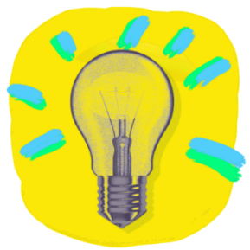
- What is the Constitution?
- When was the Australian Constitution written?
- Why do we have a constitution?
- Can the Constitution be changed? How?
- How do you think being left out of the Constitution affected Aboriginal people?

Activity: Glossary
Students will brainstorm a list of key words that relate to the BTN Australia’s Constitution story. Here are some words to get them started. Challenge students by asking them to use words from their class glossary to write their own sentences. Alternatively, students can make their own crossword puzzle or word find.

CONSTITUTION | DEMOCRACY | INDIGENOUS RIGHTS
REFERENDUM | FEDERATION | RECOGNITION

Further investigation: Tricky words
Students will choose additional keywords and terms to add to their class glossary that are tricky. For example, constitutional recognition, constitutional reform, and census. Students will find a definition and explain to their classmates what the keywords mean.

Activity: Inquiry Research
Discuss the information raised in the BTN Australia’s Constitution story. What questions were raised in the discussion and what are the gaps in students’ knowledge? The following KWLH organiser provides students with a framework to explore their knowledge on this topic.

What do I know? | What do I want to know? | What have I learnt? | How will I find out?

Students will develop their own question/s to research or choose one or more of the questions below. Encourage students to collect and record information from a wide variety of sources and present the information they find in an interesting way.

- What is a constitution?
- What was the reason for the change to the Australian Constitution in 1967?
- How do you think being left out of the Constitution affected Aboriginal people?
- What is a referendum? How do they work and when was a referendum last held in Australia?
- What is the history of Australia’s referendums? Plot your findings on a timeline.
- Explain why the 1967 Referendum was important in Australia’s human rights history.
- Create a timeline of significant events that have contributed to equal rights for Aboriginal and Torres Strait Islander Peoples. Write a summary for one key event, which answers the 5 W’s – Who, What, Where, When and Why?
- What is the Uluru Statement from the Heart?

Activity: Classroom Constitution
Start this lesson by holding a hands-on activity to get students thinking about fairness and equality. Divide your class into small groups. Each group will be required to carry out the same task (for example, building a bridge or house), however, each group will be provided with different resources.

Task: In small groups create a small bridge or house using only the resources provided specifically to your group.
Resources: Group 1 - paper, cardboard, scissors, sticky tape, and coloured pencils. Group 2 - paper, sticky tape, string. Group 3 – paper and cardboard only.
Discussion: How did the students feel during this activity? Discuss what fair means and how it relates to equality.

Classroom Constitution and Referendum
Students will create their own classroom constitution and then hold a class referendum. Facilitate a class discussion to get your students thinking about what their classroom constitution might look like.
- Work as a class to brainstorm a list of values. Choose 5 core values, with each value having its own constitutional statement.
- Think of some rules and expectations of your class.
- How will you make sure all students are treated fairly and can have their fair say?
- How would it make you feel if you were left out of your classroom constitution?

Steps to creating a classroom constitution and holding a class referendum:

Consider your classroom as a country. Give your country a name and describe how it is run. This is your classroom’s constitution.

Review your classroom constitution; does it include equal rights for everyone in your class? How can you improve it? Suggest any changes you would like to make to your classroom constitution. Remember any changes to your classroom constitution need to be voted on in a referendum.

As a class write a referendum question. Explain arguments for and against the change you want to make to your classroom constitution.

Hold a classroom vote asking to either approve or reject the suggested change to your classroom constitution. Create a voting card and polling booth to lodge your votes.

Count the votes.

Activity: Visual literacy
Below are photographs depicting significant events in Australia’s history of Indigenous citizenship rights. Look at the images below (alternatively find your own images using the internet) and then respond to the following questions:

- What is happening in the image?
- Where do you think it was taken?
- How do you think the people in the image might be feeling? Describe the mood of the photograph.
- Is there a message about democracy that comes across in the image? Explain.
- What question/s would you like to ask the people in the image?
- Create a caption for each image.

After students have responded to the above questions click on the link for each image to find out what is happening and learn more about this significant event.

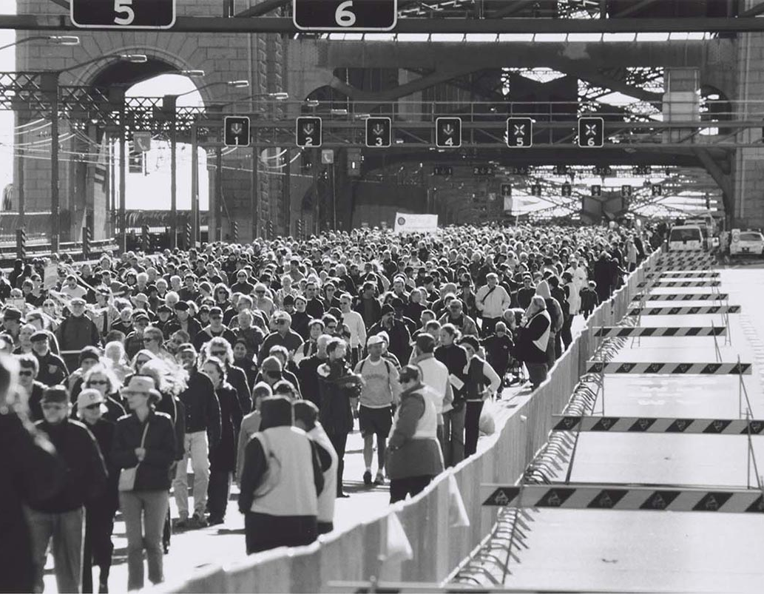  Image – National Museum Australia  BTN story – Bridge Walk Anniversary | 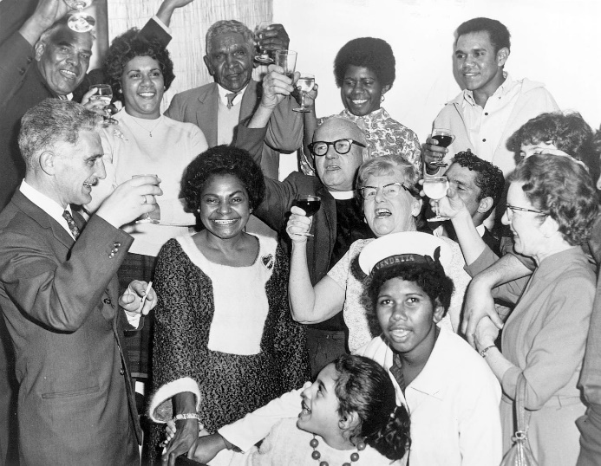  Image – National Museum Australia  BTN story – Referendum Campaign
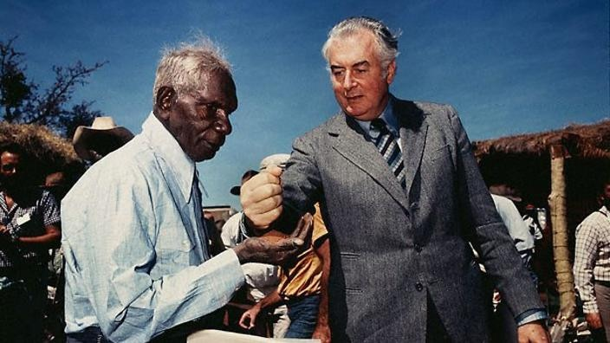  Image – National Museum Australia  BTN story – Wave Hill | 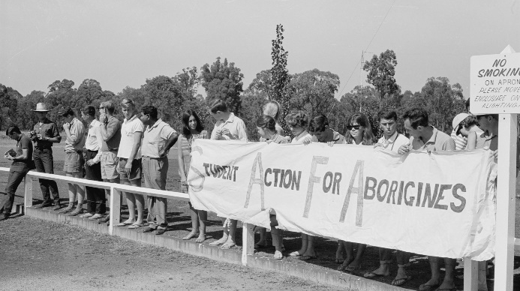  Image – National Museum Australia  BTN story – Freedom Ride

Students will create a timeline which looks at key events in Australia’s reconciliation history. Students will include the following in the timeline: Mabo decision, Native title, 1967 Referendum, Bridge Walk, National Apology, Redfern Speech, Bringing them Home report, tent embassy, Close the Gap campaign and Uluru Statement from the Heart.

Activity: What is Constitutional Recognition?
Constitutional recognition is something a lot of Indigenous people in Australia have been campaigning for, for a long time. But what exactly is it and why is it such a big deal? Watch BTN’s Explainer on Constitutional Recognition as a class and hold a class discussion to clarify terms and meanings. Link to BTN Explainer

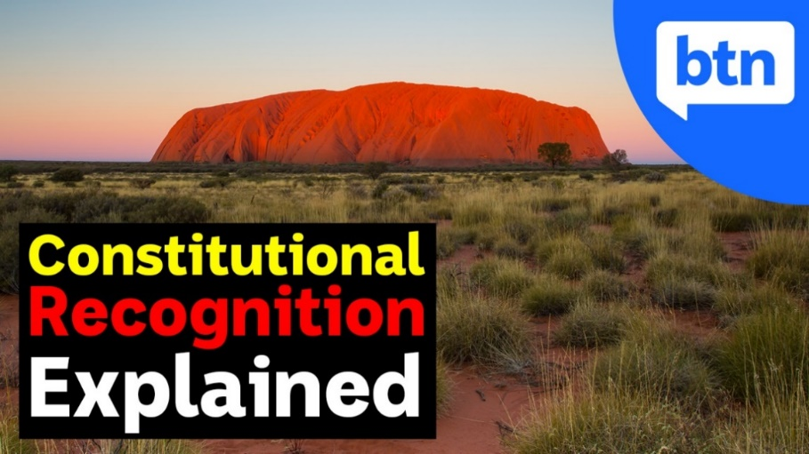

Activity: Referendum Campaign
As a class, watch the BTN Referendum Campaign story to find out about the campaign to give First Australians a voice in parliament and recognition in the Constitution. Discuss the story as a class and record the main points of the discussion. Students will then respond to the following:

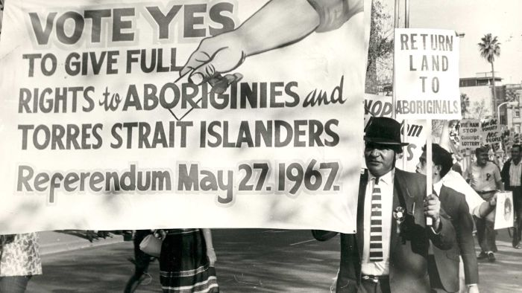
- To change the Constitution there needs to be a _______________.
- What did people vote on in the 1967 Referendum?
- How many successful referendums has Australia had?
- What is the Uluru Statement from the Heart?
Image: Maritime Union of Australia (ANU, N409-124-01)

- What has the new Prime Minister, Anthony Albanese said about supporting the Uluru Statement from the Heart?

Useful Websites
- Referendum Campaign – BTN
- Garma Festival 2022 – BTN
- Constitutional Recognition – BTN
- Constitutional Recognition Explained – BTN
- Civics Special – BTN
- The Australian Constitution in Focus – PEO
- 1967 Referendum – BTN
- What is the Australian Constitution? – Human Rights Commission (YouTube)

EPISODE 22
9th August 2022

KEY LEARNING
Students will research and write a profile about either saltwater or freshwater crocodiles. They will test their knowledge in a crocodile quiz.

CURRICULUM
Science – Year 4
Living things have life cycles.
Living things depend on each other and the environment to survive.

Science – Year 5
Living things have structural features and adaptations that help them to survive in their environment.

Science – Year 6
The growth and survival of living things are affected by physical conditions of their environment.

  - Teacher Resource

Croc Safety

Focus Questions
Discuss the BTN story as a class and record the main points of the discussion. Students will then respond to the following:
- What is the behaviour of saltwater crocodiles?
- Where in Australia do saltwater crocodiles live? Find on a map.
- Which well-known park in the Northern Territory were visitors seen dangerously close to crocodiles?
- What should you do if you see a crocodile in the wild?
- What are some tips to stay safe around crocodiles?

Activity: Class Discussion
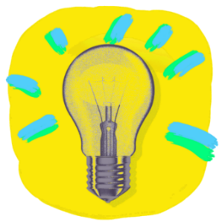
Students will discuss the BTN Croc Safety story in pairs and then share their thoughts with the class.
- What do you THINK about what you saw in this video?
- What does this video make you WONDER?
- What did you LEARN watching the the story?
- Think of three questions you have about the BTN story.

Activity: Mind Map
Discuss the BTN Croc Safety story as a class and record the main points on a mind map with CROCODILES in the centre. Students will then respond to the following and share their ideas as a class.
- What do you know about crocodiles? Record on a mind map.
- What safety concerns were raised in the BTN story?
- What do you think could be done to raise awareness about staying safe in areas with crocodiles?

Activity: Glossary
Students will brainstorm a list of key words that relate to the BTN Croc Safety story. Here are some words to get them started.
SALTWATER CROCODILE | REPTILE | APEX PREDATOR
FRESHWATER CROCODILE | CARNIVORE | PREDATOR

Activity: Crocodile profile
Students will research and write a profile about either saltwater or freshwater crocodiles. Students can use the animal profile worksheet at the end of this activity to record their findings. Encourage students to use a range of sources to find their information.

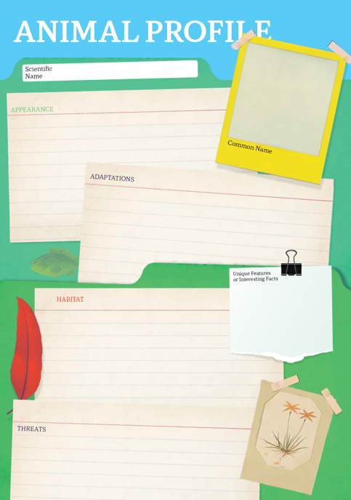
Research
Students will research either saltwater or freshwater crocodiles and create a profile. Students can use the Animal Profile at the end of this activity.
- Illustration or photo
- Scientific and common name
- Appearance
- Habitat
- Where is it found in Australia?
- Feeding and diet
- Behaviours and adaptations
- Predators
- Conservation status
- Danger to humans
- Interesting facts

Useful links for students’ research
- Freshwater Crocodile – Australian Museum
- Saltwater Crocodile – Australian Museum
- Croc Capture – BTN
- Crocodiles – NT Government
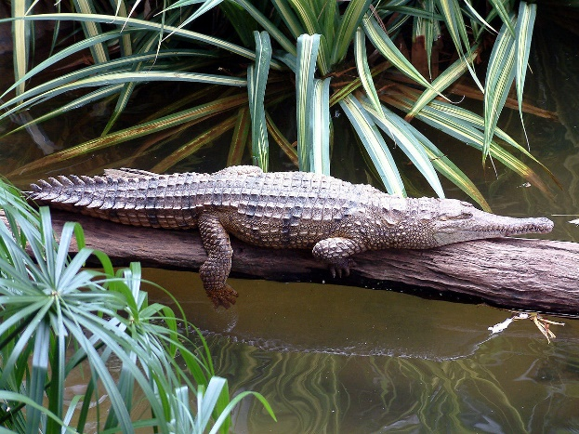
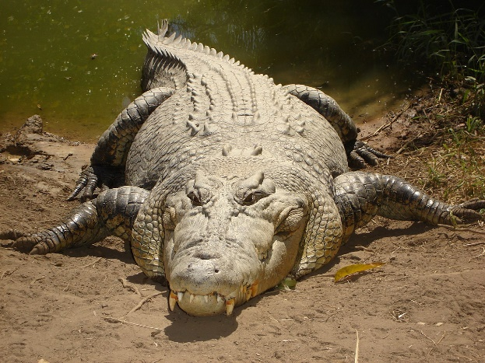

Freshwater crocodile Saltwater crocodile

Activity – Choose a project
Individually or in small groups, students will choose one of the following projects to work on and then present their findings to the class.

Public Education Campaign
What can people do to stay safe around crocodiles? Create a public awareness campaign that targets tourists visiting areas with crocodiles.

Saltwater vs Freshwasher Crocs
Create a T Chart to highlight the differences between saltwater and freshwater crocodiles.

Useful Websites
- Freshwater Crocodile – Australian Museum
- Saltwater Crocodile – Australian Museum
- Croc Capture – BTN
- Crocodiles – NT Government
- Tourists risking lives to see crocodiles at Cahills Crossing in Kakadu National Park – ABC News

Activity: Crocodile Quiz
- Crocodiles are…  A. Amphibians  B. Reptiles  C. Mammals  - The crocodiles in the BTN story were…  A. Freshwater  B. Saltwater  - Saltwater crocodiles are only found in salt water.  A. True  B. False  - A mature saltwater crocodile can stay under water for up to…  A. 30 minutes  B. 1 hour  C. 2-3 hours  Quiz Answers: 1B, 2B, 3B, 4C, 5A, 6A, 7A, 8C | 5. The saltwater crocodile is the largest living reptile.  A. True  B. False  6.Crocodiles have armour that is made of bone.  A. True  B. False  7. In which states can you find crocodiles?  A. Queensland, NT and WA  B. Queensland, WA and NSW  C. NSW, WA and NT  8. Crocodiles are…  A. Herbivores  B. Omnivores  C. Carnivores

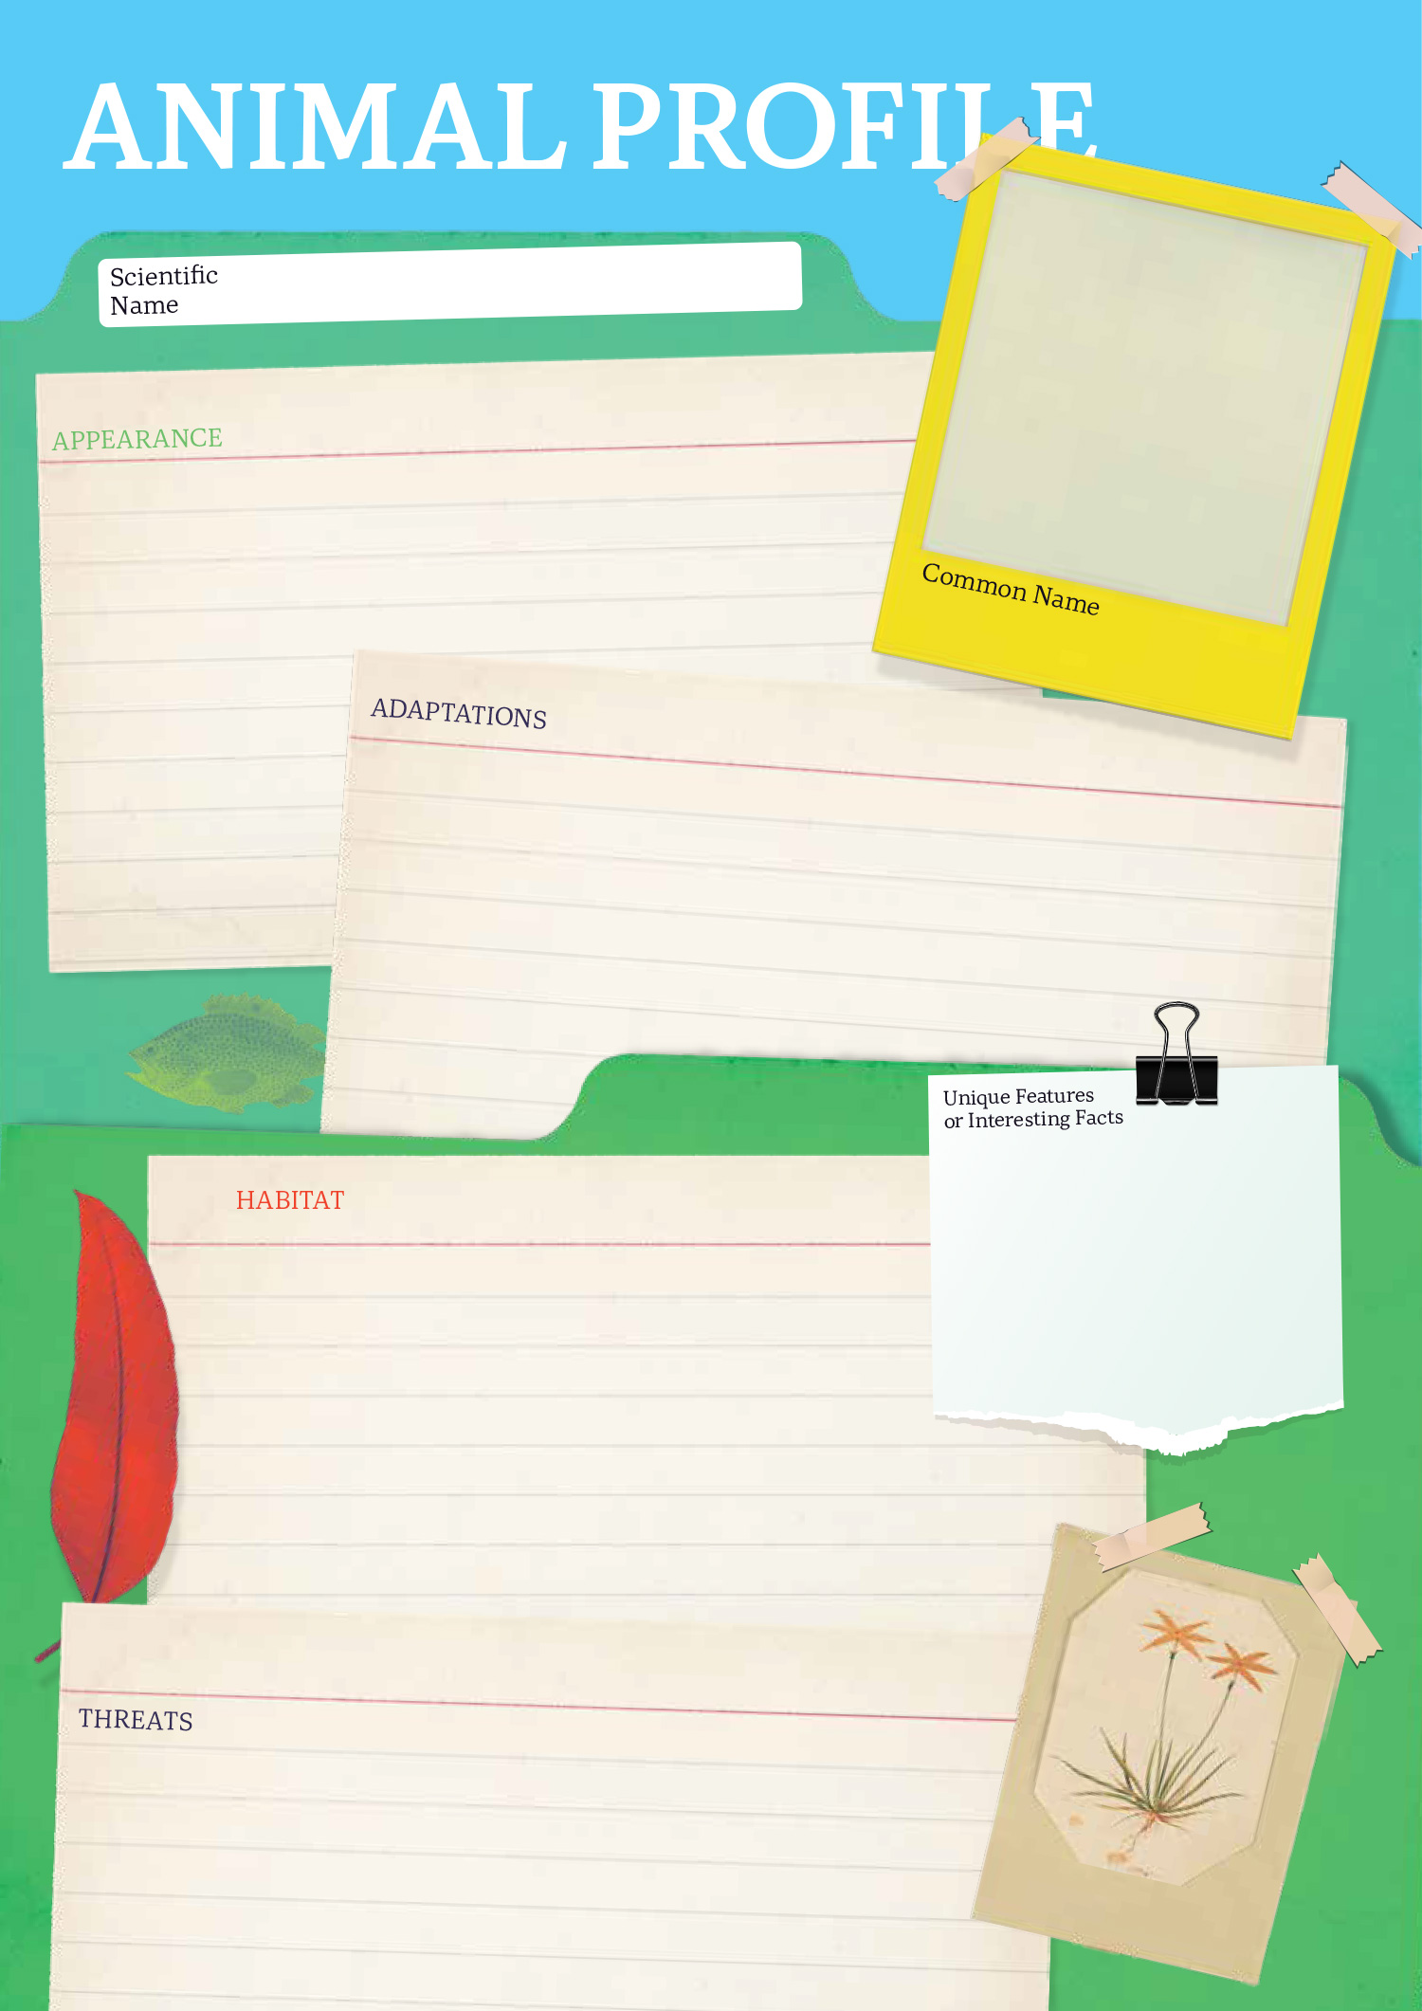

  - Teacher Resource

BTN Transcript: Episode 22 - 9/8/2022

Hey, how’s it going, I'm Amelia Moseley and you're watching BTN. Thanks for hanging out with me again. Let’s see what’s coming up on today’s show. Amal finds out what it takes to change Australia's Constitution, some Aussie farmers get a surprise from space and a young downball fan takes his favourite sport out of the playground.

Taiwan History

Reporter: Amelia Moseley

INTRO: All that soon, but first today, there's been a lot of controversy over a US politician's recent trip to Taiwan. The Chinese government are really angry about it, and they've responded by launching missiles and doing military drills around the island. So, what's going on? Let's find out.
We're pretty used to seeing politicians visiting other countries. It's kinda part of the job. So, why did some people say this visit could start a war?
JESSICA HARMSEN, ABC NEWS PRESENTER: A major standoff is brewing tonight, with China warning its military won’t be idled.
BILL BIRTLES, ABC NEWS REPORTER: A very tense atmosphere over these hours that Ms Pelosi’s plane is in the air.
ZHAO LIJIAN, CHINESE FOREIGN MINISTRY SPOKESPERSON: We would like to tell the United States once again that China is standing by.
Well, this is US Speaker of the House Nancy Pelosi, and this is Taiwan. Pelosi's the most senior American politician to visit in 25 years and locals were pretty stoked about it.
TAIWANESE PERSON: We're here to witness history. I'm very excited.
TAIWANESE PERSON 2: She is like a hero.
But over here it was a different story.

CHINESE PERSON: Our people are very dissatisfied with this. The US keeps meddling in the business of others.
CHINESE PERSON 2: I think we must exert pressure in response to Pelosi's Taiwan visit but don't fight.
So what's the big deal? Well, it all comes down to an argument that's been going on for ages over this little island. Let's go back in time. For a couple of centuries, Taiwan was considered as part of the Chinese Empire, but it was handed over to Japan after a war in the late 1800s. Fast forward to the Second World War which Japan lost, and Taiwan became part of China again. But China was divided. For decades, there'd been fighting between two groups who wanted to run the country differently, the nationalists and the communists, who believed property should be shared equally by everyone.
By the end of the 1940s, the communists had defeated the nationalists. So, the Nationalist leader and more than a million supporters fled to Taiwan. They called it the Republic of China and maintained they were still the country's true government. Meanwhile over on the mainland, this guy, the leader of the communists, known as Chairman Mao, established the People's Republic of China and this is how China became two. This is also where the US comes in.
At the time it was worried about the spread of communism around the world. So, it chose to recognise the government in Taiwan as China's real government and so did a lot of other countries. But over the years that changed. The People's Republic of China grew richer and more powerful and, these days, most countries including the US and Australia see the government here as the official one. Meanwhile, Taiwan's also become a fairly wealthy and successful place. It has its own flag, military and democratically elected government, and calls itself an independent country. And lots of countries, yup including the US and Australia, are pretty friendly with Taiwan.
And that's where things get awkward, because China has plans to unite with Taiwan and it saw this visit as a sign the US isn't on its side. Pelosi wasn't representing the US President and decided on her own to make the trip and while some people praised her, others said it could stir up trouble, and well, there definitely has been some of that. These are missiles fired by China into the sea near Taiwan. It's also been carrying out military drills in the area.
TSAI ING-WEN, TAIWAN'S PRESIDENT: Facing deliberately heightened military threats. Taiwan will not back down.
Now governments around the world are calling for calm and hoping this tense situation doesn't go any further.

News Quiz

After a very successful Commonwealth Games in Birmingham, Aussies can look forward to our very own games in four years’ time. Which Aussie state will be hosting them? Is it Queensland, New South Wales or Victoria? It’s Victoria and for the first time ever it’ll be split across a bunch of towns including Geelong, Ballarat and Bendigo.

Why were the world’s clocks a little out of whack on June 29th this year? Was it because of a solar flare, because the Earth spun a little faster or because the Earth spun a little slower? The Earth spun faster which is, well, pretty weird. Usually, a day takes about 24 hours and 2 milliseconds but on June 29th it was 1.59 milliseconds shorter.

And a new species of what was caught on camera by a diver off the coast of Papua New Guinea? Is it a crab, an octopus or a Jellyfish? It’s a new species of jellyfish.

Australia’s Constitution

Reporter: Amal Wehbe

INTRO: Now to Australia's upcoming referendum. As we told you last week, Aussies will vote on whether they want to change the constitution to include an Indigenous Voice to Parliament. But what exactly is the constitution? And why is changing it such a big deal? Amal looked into it.

AMAL: Alright everybody, thanks for coming to our first BTN Band rehearsal.
MICHELLE: Yeah, let’s rock.
GLADYS: Rock? I thought this was classical.
JACK: I think it's time for some jazz.
CALE: Nothing beats some good ol' country.
MATT: Nah man, this is a folk band. Peace.
Yep, when you've got a group of people coming together with a diverse set of interests, things can get messy.
AMAL: 1...2...3...4.
CALE: Whoa whoa. Something ain’t right here.
AMAL: Yeah, I think we need to come up with some guidelines on what this band's all about.
In a way setting up a country can be a bit like that. Before Australia was Australia, it was a whole bunch of colonies each led by different people, with different rules, and different interests. So, when all the colonies decided to get together in the late 1800s, they needed to figure out how things were going to work. So, they decided to draw up a constitution.
AMAL, REPORTER: A constitution is kind of like a rulebook on how the country works. It sets how laws are made and enforced, who gets what powers and what people's rights, and responsibilities are.
Australia's Constitution came into effect on the 1st of January 1901 when we became a federation. The constitution is still Australia's most important legal document. No other laws can over-rule it. And anything that happens here, has to be guided by what's in here.
AMAL, REPORTER: So, changing the constitution, well, that's a big deal.
You need to have a referendum. That's where everyone over 18 has to vote, a bit like an election. Except, instead of voting for people you vote for a change to the constitution, and you can only vote yes or no. For a change to happen you need a yes vote from more than half of the voters in Australia. As well as a yes vote from more than half of the people in more than half of the states. Wow.
So, as you can imagine not many ‘yes’ votes win. Australia's had 44 referendums and only 8 of them have resulted in a change to the constitution. The last successful one was in 1967 when more than 90 percent of Australians voted to get rid of two lines of the constitution which discriminated against Aboriginal people. And now 55 years later, many are hoping there'll be another successful referendum.
ANTHONY ALBANESE, PRIME MINISTER: We are seeking a momentous change. It's about consulting Aboriginal and Torres Strait Islander peoples about the decisions that affect you.
We've now got the first draft of the question that will be asked in Australia's next referendum, on whether Aussies want to add an Indigenous Voice to Parliament. It's not going to be cheap or easy. And the government says there's a chance it won't work. But many say it's a necessary step towards reconciliation. And when we have a constitution, we're all happy with, it makes things a lot more harmonious.
AMAL: Right guys, this is exciting. We are officially the world's first POP-CLASSICAL-JAZZ-COUNTRY-ROCK-FOLKBAND.
JACK: Ahh, maybe we should learn how to use these instruments first.
Quiz

What was the subject of Australia's last referendum? Whether same-sex couples should be able to get married, whether Australia should become a republic or whether Indigenous people should be counted in the census? It was whether Australia should become a republic and it was held back in 1999. And in case you haven’t guessed, the majority voted ‘no’.

Croc Safety

Reporter: Amelia Moseley

INTRO: Now I probably don't need to tell you that crocodiles are dangerous, right, especially if you live in the Top End. But NT authorities had to give people a bit of a reminder recently after tourists were seen getting way too close to them. So, let's find out more about crocs and how to stay safe.

AMELIA, REPORTER: Look, we need to talk. I know that you've been around for a really long time. Like millions of years. And we've mostly been able to make it work? But I just think that maybe we or I, need to take a step back and just put some distance between us. What do you think? Please don’t look at me like that.
Yes, crocodiles and humans do have a bit of a rocky relationship, which is bound to happen when one of you can, you know, eat the other whole. Mmm, in case you didn't know crocodiles can be fierce predators. While freshwater crocs aren't too big and won't eat you, saltwater crocs can grow up to six metres long, weigh up to 500 kilograms and have the strongest bite of any animal in the world. They'll eat pretty much anything they can catch and can move really quickly in water and on land. And to top it all off, they're super protective of their space. Luckily, here in Australia these territorial creatures only live in the Northern Territory, North Queensland and Western Australia.
AMELIA: Well, lucky if you're not in the Northern Territory, Queensland or WA I guess.
And if you are, you're probably used to steering clear of crocs.
JOE: You don't swim in the ocean.
NAT: Nope.
JOE: Not in the rivers either.
NAT: Don’t swim in rivers.
JOE: If you see the mud moving don’t.
NAT: If you see signs don't swim where there's crocs.
Hmm, in case you didn't know, Nat and Joe are from the NT. But recently, these croc watching visitors in Kakadu National Park made some people a little worried.
LEON COMPTON, TOURIST: My wife was sitting there, and she wanted to leave because she was worried that our kids were going to watch someone get eaten by a crocodile.
OK, very worried. About 120 crocs live at Cahill's Crossing and people usually stick to the safety of a viewing platform, which is out of action right now while a new one's being built and, since a couple of deadly attacks have happened here before, authorities are reminding people that crocs are like, really, really, really dangerous.
Shaun Barclay, Kakadu National Park: We are disappointed at the behaviour of some visitors at Cahill's Crossing who clearly ignored safety signage at the site and walked dangerously close to the water risking the chance of being attacked by a crocodile.
AMELIA: So, what do you do if you see a croc?
NAT and JOE: Run.
AMELIA: Are you sure?
JOE: Or pretend to be a tree maybe?
NAT: Maybe pretend to be a croc?
AMELIA: So, what do you do if you see a croc?
SHAUN BARCLAY, KAKADU NATIONAL PARK: Run as fast as you can in the opposite direction in a straight line because crocodiles can only manage short bursts of speed when coming out of the water.
AMELIA: Just run, yup. I will never forget that now. So, what are some tips to stay safe around crocs?
SHAUN BARCLAY, KAKADU NATIONAL PARK: Our number one safety tip is to stay away from the water's edge, we would say stay at least 10 metres away, and a greater distance if the bank is flat and low. We also advise people to follow any signs they see in areas, camp at least 50 metres away from the water's edge and never dispose of food scraps in the water, around a campsites or boat ramps.
AMELIA: Thanks Shaun. Well, I guess that's it then. Please just know it's not you, it's me. Well, it's also you. And your big, sharp, scary teeth.

Space Junk
Reporter: Jack Evans

INTRO: Now, how would you feel if you went out into your backyard and found a piece of a space ship? Well, that's what happened to some farmers in New South Wales recently. Experts reckon it was space junk which fell to Earth and Jack found out why that's becoming a bit of a problem.
HUNTER: Well, here it is, all my thingy-me-bobs, my whatsits and my wibble wabblers. You know, space junk. Hi, there I’m Hunter, the UFO hunter, and I'm back, back, back again. Oh, I like this one, I can see my reflection. Well, I've been collecting space junk ever since I was a little baby and a piece fell right out of the sky and landed next to me. This, I live for this. Oh, look at that, can you see me? Well, I would say maybe 90, 91.36 percent, of all space junk is from a UFO. This here I believe is something they would have been making music with.
Ah, I hate to break it to you Hunter but none of that is space junk. It's just regular junk taking up a lot of space. This on the other hand is indeed space junk.
MICK MINERS, FARMER: Yeah, it fair sized, it’s sort of wedged in the ground pretty well so must have fell pretty hard, I would say.
It was found by Mick on his property near the Snowy Mountains on Ngarigo country in New South Wales.
MICK MINERS, FARMER: Wasn't quite sure what to think about it. I looked, and I had a bit of a look around and made me sort of wonder a bit what was going on. Bit of a worry when things just start falling out of the sky.
The plot thickens. Not too far away Mick’s neighbour Jock also found a piece of debris that clearly wasn't left here by the sheep.
JOCK: Yeah, the only possible way it could have got there was it fell out of the sky.
As it turns out a few people in the area reported things falling from the sky after hearing a loud bang. And after a closer inspection they noticed serial numbers on some of the junk, so they contacted the experts. Like this guy, Dr Brad Tucker.
DR. BRAD TUCKER: Here I am, standing in front of it, confirming it. It's a, I just you know, if you put on the list of things I would do in my career, this wasn't one of them. And that's how cool it is.
Dr. Tucker is an astrophysicist and reckons the pieces of debris may have come from this SpaceX Dragon capsule that had re-entered the Earth’s atmosphere the same day the loud bang was heard. And now SpaceX are coming to Australia to check it out.
DR. BRAD TUCKER: We do know that the crew capsule trunk, so this is the bottom part, re-entered over this area at 7:05 on the 9th, people heard it, people saw it.
While it's pretty unusual for space junk to fall to Earth, it's certainly not the first time this has happened. But this particular piece, measuring about 3 metres long, is thought to be the largest piece of space junk to fall in Australia since 1979 when NASA's space station Skylab came crashing to Earth over southern Western Australia. No-one was hurt, but the Western Australian government fined NASA for littering. Of course, since then, space junk has become a huge problem. Some of that stuff is travelling around at like 30,000 kays an hour which means it’s a real threat to satellites, the International Space Station, and even the Moon. Yep, a couple of months ago a rocket slammed into the surface leaving a pair of lunar craters. Meanwhile, back on Earth, the chances of being hit by space junk are really low, luckily.
JOCK WALLACE, FARMER: I don't think you'd fair too well if it landed on you.
But it's a reminder that we really need to think about the junk that's up there.
HUNTER: Well, I'm always thinking about the space junk up there, cause I want it.
Sport

Australia has capped off an impressive Commonwealth Games with a new record. On Monday morning we became the first ever country to reach 1,000 gold medals over our Commonwealth Games history, when the Diamonds defeated Jamaica 55 to 51 in the netball final. Australia was easily number one on this year’s medal tally and hopefully will keep the winning streak up when the Games come Down Under.
To AFL, where West Coast Eagles’ Josh Kennedy had an epic send off yesterday. After announcing the game against the Crows would be his last, the three time, all-Australian booted 8 goals. But it wasn’t enough, the Eagles went down 102 to 86, and after 293 games and 723 goals, he was given a farewell fit for his achievements.
WEST COAST EAGLES PLAYER, JOSH KENNEDY: It’s been an amazing journey, can I thank the club, can I thank all the fans here.
And sharpen your scythes it's mow-time. Over the weekend, in Lithuania, 50 competitors took part in this 30-metre traditional mowing race. This guy cleaned up his lane in 3 mins and 54 seconds.

Downball League
Rookie Reporter: Noah

INTRO: Finally, today, have you ever played downball? You might know it as handball or foursquare, and kids have been playing it at lunch and recess for decades. I even remember playing it. But Noah reckons it can be more than just a schoolyard sport which is why he's created Downball Australia. Check it out.

Hi, Behind the News, my name is Noah. I'm the creator of Downball Australia. Australia's first official downball league. The Downball Australia idea really came from a year 9 project that I started 2 years ago. It was called the passion project. I was struggling to think of what I’m actually passionate about, but it all ended up coming back to downball, because I love downball. I play it at recess and lunch. It's just a really good game to get involved with everyone.
I actually vividly remember my first downball game. I'd say I was around 4 or 5 years old. I remember it was my first time playing it so of course I was really bad. I think I was very competitive, and I absolutely cracked it. I just threw the ball, I got so angry with it, I screamed and cried. Definitely now I can say confidently that I've got much better.
Alrighty, so for the basic rules of downball: we've got King; we've got Queen; we've got Jack; and we've got Dunce. And now to start off the point, King will serve it wherever they want by bouncing it in their own square first, and then it needs to bounce in the other person's square. And then, after that, the person can hit it wherever they want, and this keeps going on until you get out. As we see there, Dunce just committed a fool. And a fool is where you hit the ball into another person's square without it bouncing in your own square first. The person who just lost will then go down to the bottom square, and Jack will move up to Queen, and Dunce will move over to Jack.
An interesting thing about downball is the different names that it gets right across Australia. I know handball is a big one, also four-square. I know some people just call it King, hand tennis. That's the good thing about handball or downball because it's a sport for you. So, whatever it is for you, that’s what it is. Downball isn't taken as a serious sport. I know, it's most commonly played in schoolyards, backyards, front yards, in the driveway. I know that some people might look at it as a social thing, but others might look at it as a competitive thing and I've kind of utilised those two perceptions and turned it into an official league.
The original goal with Downball Australia was to just do a school tournament at my high school, and now that I've seen what it's been turned into, I just think it's epic. I think, if anything, it's exceeded all my expectations. It's just massive. I'm so proud to be part of it. I don’t want to give too much away, but the future of Downball Australia for me, it's looking really exciting. The thing that I love about downball is that it's for the people, made by the people. It's a sport for everyone. You get to have a good time with your mates, have a laugh and get some good downball action.

Closer

Awesome stuff Noah. Well, that's it for this week. Thanks for hanging out with us. Next week we'll have something a bit special for you, it's Science Week and we'll be exploring this year's theme which is glass. So, make sure you look out for that. In the meantime, don’t worry, Newsbreak will be right here in the studio every weeknight to keep you up to date. Have an awesome week. I’ll see you soon. Bye.

