EPISODE 12
11th May 2021

KEY LEARNING
Students will view a range of BTN stories and use comprehension skills to respond to a series of focus questions.

CURRICULUM
English – Year 4
Use comprehension strategies to build literal and inferred meaning to expand content knowledge, integrating and linking ideas and analysing and evaluating texts.

English – Year 5
Use comprehension strategies to analyse information, integrating and linking ideas from a variety of print and digital sources.

English – Year 6
Use comprehension strategies to interpret and analyse information and ideas, comparing content from a variety of textual sources including media and digital texts.

English – Year 7
Use comprehension strategies to interpret, analyse and synthesise ideas and information, critiquing ideas and issues from a variety of textual sources.
  - Teacher Resource

Focus Questions
As a class, discuss the stories featured in the episode of BTN Classroom and record the main points of the discussion. Students will then respond to the following focus questions.

Budget 2021
- Discuss the BTN Budget 2021 story as a class.
- What is the budget? Describe in your own words.
- What are some of the areas of spending in the federal budget?
- What is the role of the treasurer?
- What events happened in 2020 that affected Australia’s economy?
  - A global pandemic
  - A recession
  - Trade disputes
  - All of the above
- JobKeeper was designed to make sure people still had money to spend to keep the economy going. True or false?
- What is a deficit?
- Complete the following sentence. The 2021 budget will be focused on getting the ______________ rate down.
- When is the next Federal Election?
- What do you understand more clearly since watching this story?

Check out the Budget 2021 resource on the Teachers page.

Cambodia COVID Lockdown
- As a class, discuss the Cambodia COVID Lockdown story. Record the main points of your discussion.
- In 2020 Cambodia had one of the lowest rates of COVID infection in the world. True or false?
- About how many cases are there in Cambodia now?
- Why has Phnom Penh been divided into colour zones?
- How are people living in ‘red zones’ affected?
- How are people living in ‘yellow zones’ affected?
- What zone does Lucas live in?
- How has COVID affected local markets?
- What does Levi miss most while being in lockdown?
- How did this story make you feel? Discuss as a class.

Gaming Tricks
- Briefly summarise the Gaming Tricks story.
- What is gaming addiction?
- What chemical does our brain release when we get something we want?
- Dopamine can be addictive. True or false?
- What is intermittent rewarding?
- What is an in-game purchase?
- What in-game purchase has been banned in some countries?
- What have some in-game purchases been compared to?
- What did you learn from this story?
- Write 3 tips for kids to help them control their gaming time.

Dyslexic Spies
- Before watching the BTN story discuss in pairs what you know about dyslexia.
- What does GCHQ stand for?
- What is the role of the GCHQ?
- Complete the following sentence. Some of the most talented and creative people at GCHQ are __________.
- How does the brain work according to Jasper?
- What are the challenges of dyslexia?
- How does having dyslexia affect Jasper’s learning?
- What skills do dyslexic people have which are important for intelligence analysts?
- Name one famous person who is thought to have had dyslexia.
- What have you learnt about dyslexia as a result of watching this story?

Colosseum Renovation
- What did the Colosseum Renovation story explain?
- What parts of the world did the Roman Empire rule?
- When did the construction of the Colosseum begin?
- Who was the Roman emperor at the time?
- What was the Colosseum originally called?
- Why was it free for spectators to go to the Colosseum?
- Why was the Colosseum flooded?
- Who were the gladiators who fought in the Colosseum?
- Why is the Colosseum getting a new floor?
- Find 3 interesting facts about the Colosseum. Share with the class.

Check out the Colosseum Renovation resource on the Teachers page.

  - Teacher Resource
EPISODE 12
11th May 2021

KEY LEARNING
Students will investigate key questions about the federal budget and list their spending priorities in the budget.

CURRICULUM
Economics & Business – Year 5
Types of resources (natural, human, capital) and the ways societies use them to satisfy the needs and wants of present and future generations.

Economics & Business – Year 7
Why and how individuals and businesses plan to achieve short-term and long-term personal, organisational and financial objectives.

Apply economics and business knowledge, skills and concepts in familiar and new situations.

Budget 2021

Focus Questions
- Discuss the BTN Budget 2021 story as a class.
- What is the budget? Describe in your own words.
- What are some of the areas of spending in the federal budget?
- What is the role of the treasurer?
- What events happened in 2020 that affected Australia’s economy?
- JobKeeper was designed to make sure people still had money to spend to keep the economy going. True or false?
- What is a deficit?
- Complete the following sentence. The 2021 budget will be focused on getting the ______________ rate down.
- When is the next Federal Election?
- What do you understand more clearly since watching this story?

Activity: Class Discussion
Discuss the BTN Budget 2021 story. Ask students to record what they know about budgets on a mind map. What words do they associate with a budget? What questions do they have? Use the following questions to guide discussion:
- What is a budget? Describe using your own words.
- How is a budget useful?
- Have you used a budget before? Describe your experience.
- What is the federal budget? Come up with a class definition.

Activity: Glossary
Students will brainstorm a list of keywords that relate to the federal budget. Here are some words to get them started. Students will create their own class glossary of keywords and terms.

TREASURER | BUDGET | INCOME
SURPLUS | DEFICIT | TAX
EXPENDITURE | ECONOMY | INTEREST

Activity: Research
Define: What do I want to know?
Key questions to research
Students can choose one or more of the following questions or come up with their own:
- What impact has the COVID pandemic had on Australia’s economy?
- What is an economic stimulus? Investigate ways the government stimulates the economy.
- What is a recession? What can cause a recession? Watch the BTN Aussie Recession story to learn more.
Locate: Where do I find the information?
What resources will help answer my questions? (Internet, people, resource centre, organisations, print). Discuss with students what a reliable source is.

Select: What information is important for the investigation?
Students may need support to sort through and select relevant information.

Organise: How do I make sense of the information?
Students can organise their research by creating main headings from their questions. Write each heading on a separate piece of paper. Record the information found for each question.

Present: How do we let others know about this information?
Each group needs to discuss then decide on the best way to present the information. Possibilities could include:
- A `Did You Know’ Facts sheet
- Oral presentation
- Prezi presentation
- Create an infographic using Canva

Evaluate: What have we learnt?
Each group reflects on what they have learnt about the budget during their investigation. Students will reflect on their learning and respond to the following.
- What I learned...
- What I found surprising...
- What I would do differently next time…

Activity: Imagine you’re the treasurer
Students will imagine they are the federal treasurer and rank the following areas from most important to least important in terms of spending in the budget. Begin this activity by researching Australia’s federal budget and how the government allocates spending. Below is a list of different areas.
- health
- education
- welfare
Learn more about the budget!
The Parliamentary Education Office has created a fact sheet explaining the function and operation of the budget. Draw a diagram that shows the budget process.
- defence
- foreign aid
- research
- environment
- communication
- transport

Ask students to respond to the following questions:
- What do you think Australia’s top budget priorities should be?
- What would you spend most on in the federal budget? Give reasons for your choice.
Further learning
Imagine you are the treasurer and write and present a one-minute speech about your decision. Think about the language you will use in your speech. Visit this ABC website to get a breakdown of the most-used words in budget speeches. Try to include some of these words in your own budget speech. What words do you think will be used in budget speeches for 2021? Make a list.

BTN Finance Stories
Watch these BTN stories to learn more about budgets and finance.
BTN Teaching Finance story  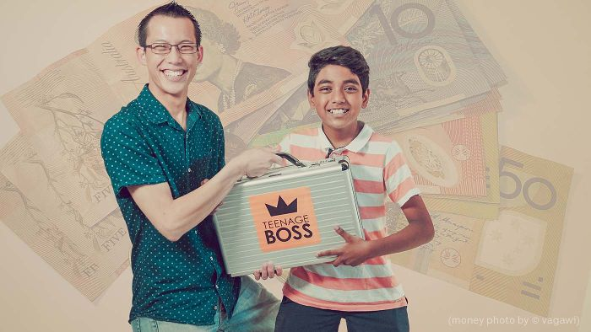  BTN Teenage Boss story | BTN Aussie Recession story  BTN Federal Budget 2020 story

Useful Websites
- What is the federal budget and why you should care – ABC News
- Road, rail and freight upgrades worth $10 billion in federal budget – ABC News
- Budget – Parliamentary Education Office
- Federal Budget 2020 – BTN

EPISODE 12
11th May 2021

KEY LEARNING
Students will develop their historical knowledge and understanding of the Colosseum and ancient Roman society.

CURRICULUM
HASS – Year 5
The influence of people on the environmental characteristics of places in Europe and North America and the location of their major countries in relation to Australia.

HASS – Year 6
Locate and collect relevant information and data from primary sources and secondary sources.

Geography – Year 7
Overview content for the ancient world (Egypt, Mesopotamia, Persia, Greece, Rome, India, China and the Maya) includes the following:
the theory that people moved out of Africa between 120 000 and ​60 000 years ago and migrated to other parts of the world, including Australia.

History – Year 7
How historians and archaeologists investigate history, including excavation and archival research.

The range of sources that can be used in an historical investigation, including archaeological and written sources.

Significant beliefs, values and practices of the ancient Romans, with a particular emphasis on ONE of the following areas: everyday life, warfare, or death and funerary customs.
  - Teacher Resource

Colosseum Renovation

Focus Questions
Discuss the BTN story as a class and record the main points of the discussion. Students will then respond to the following:
- What did the Colosseum Renovation story explain?
- What parts of the world did the Roman Empire rule?
- When did the construction of the Colosseum begin?
- Who was the Roman emperor at the time?
- What was the Colosseum originally called?
- Why was it free for spectators to go to the Colosseum?
- Why was the Colosseum flooded?
- Who were the gladiators who fought in the Colosseum?
- Why is the Colosseum getting a new floor?
- Find 3 interesting facts about the Colosseum. Share with the class.

Activity: Discussion
Discuss the BTN Colosseum Renovation story in small groups or as a class. Ask students to record what they know about ancient Rome. What questions do they have? Use the following questions to help guide discussion:

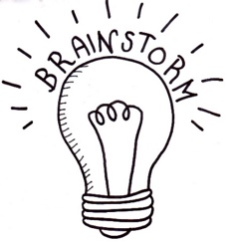
- Where is the Colosseum? Find on a map.
- Why was the Colosseum built?
- What sort of events took place in the Colosseum?
- Why is the Colosseum getting a new floor?
- Why is it important to conserve the Colosseum?
- What are some characteristics of Rome’s ancient societies?
- What words do you associate with ancient Rome? Make a list.

Activity: Glossary
Students will brainstorm a list of key words that relate to the BTN Colosseum Renovation story. Below are some words to get them started. Students will create their own class glossary of keywords and terms. Students can use illustrations and diagrams to help explain each keyword.

ROMAN EMPIRE | ARCHAEOLOGIST | AMPHITEATRE
ANCIENT ROME | GLADIATOR | CONSERVATION

Activity: Research project
After watching and discussing the BTN Colosseum Renovation story, what questions do students have and what are the gaps in their knowledge? The following KWLH organiser provides students with a framework to explore their knowledge on this topic and consider what they would like to know and learn.

What do I know? | What do I want to know? | What have I learnt? | How will I find out?

Students will develop their own question/s to research or select one of the questions below.
- When was the Colosseum built? What did it look like when it was first built? How do we know?
- Who built the Colosseum? Why did they build the Colosseum?
- What events happened at the Colosseum?
- How has the Colosseum helped us learn about life in ancient Rome? Choose one aspect of ancient roman life to explore in more detail.
- Why is the Colosseum important to us now?
- What is the original name of the Colosseum? Explore the history of the naming of the Colosseum.
- Create a timeline to show significant events in ancient Rome. Include events like the development of Roman numerals and Roman aqueducts. What evidence can we see today of these Roman developments?

Activity: Investigating the ancient past
Finding out about the ancient past can be difficult. Some ancient peoples and civilisations have left behind evidence of the past which help us learn about how they lived. Working in pairs or small groups, ask students to consider one or more of the following questions:
- Why do you think people investigate the ancient past?
- How do we know about the ancient past? For example, archaeologists make discoveries, looking at artefacts in museums.
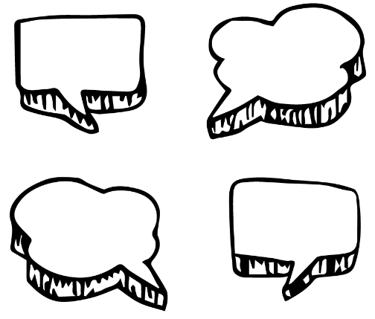
- What are some examples of evidence or places which help us understand the ancient past? Choose one example in Rome to explore in more detail.
- Why is it important to conserve ancient ruins?
- What are some characteristics of Roman’s ancient societies?
- How will the renovation to the Colosseum help us understand life in ancient Rome?

Activity: TEDEd video
As a class, watch this TEDEd video to learn more about the role of the Colosseum in ancient Rome. Students will then respond to the following questions.
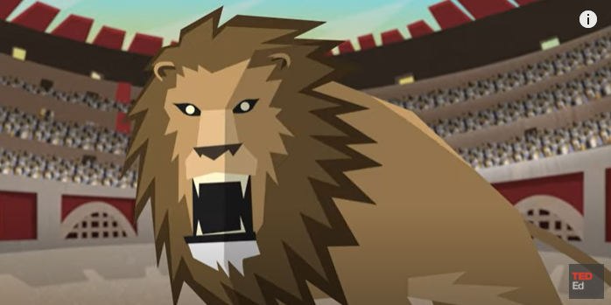
- What year did the Colosseum open to visitors?
- Why was the Colosseum filled with water?
- What does Naumachia mean?
- Who was Vespasian?
- How did they celebrate the opening of the Colosseum?
- How did they fill the Colosseum with water? Name one of the theories.
TEDEd – The Romans flooded the Colosseum for sea battles
- What roles did animals play in the colosseum?

Activity: Roman society
Students will look at ancient objects that have been discovered in Rome and respond to the following questions:
- What is the object? Write a brief description.
- Who do you think the object belonged to? Why do you think that?
- What does the object tell us about Roman society?

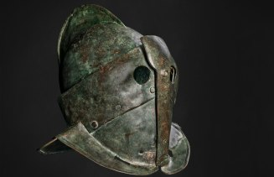  Gladiator helmet | 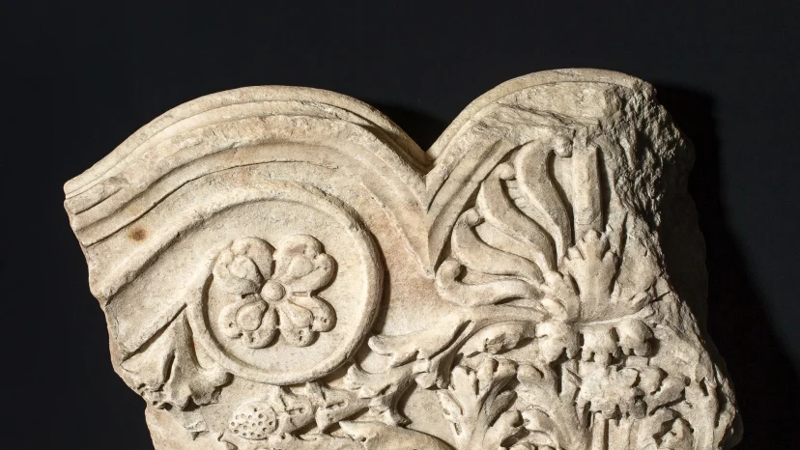  Marble frieze with floral motif from the Colosseum, 3rd century AD.

Activity: Jigsaw learning activity
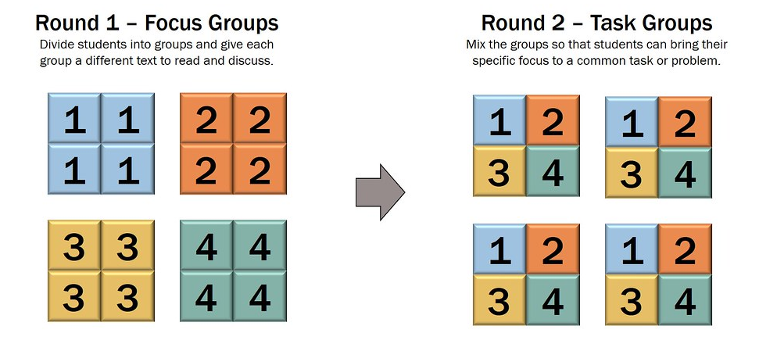
In this activity students will work cooperatively to learn more about ancient sites in Rome, Italy. Each group will become experts and then share what they have learnt with other students.

Form groups | Divide the class into 6 x Focus Groups (or more depending on your class size). Each Focus Group will be assigned a different ancient Roman site to investigate and become experts (for example the Colosseum, the Roman Forum, the Pantheon, the Domus Aurea, the Domus Transitoria and the Baths of Diocletian.  Each group will need to decide how they will collect and communicate the information they find during their research. For example, students can create a model, a short video or a poster.
Research | Each Focus Group will respond to the following questions to become experts:  - Where is it in Rome? Locate on a map.  - What does it look like? Draw a picture.  - When was it built?  - Who built it?  - Why was it built? What was its function and who used it?  - What are some interesting facts about the ancient site?
Share | Mix the Focus Groups to form Task Groups (Tasks Groups include one student from each of the Focus Groups) to share the information they have collected. Students will share the information they have collected and learn from one another.
Reflect | Students will reflect on the activity by responding to one or more of the following questions:  - What did you enjoy about this investigation?  - What did you find surprising?

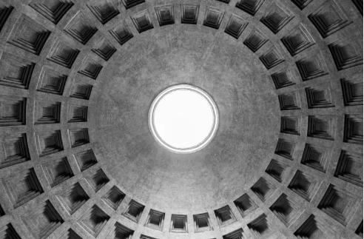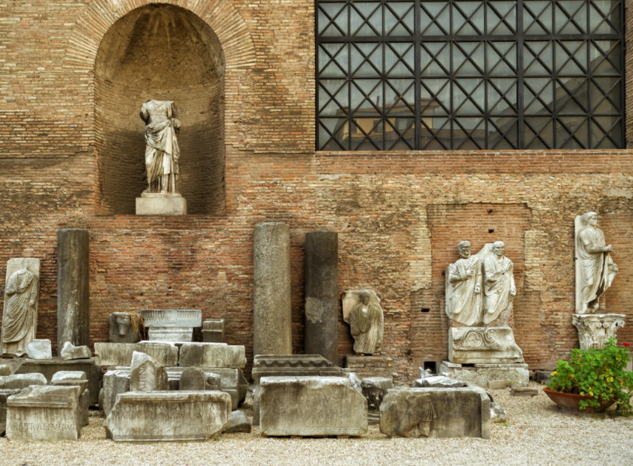
The dome of the Pantheon
The Baths of Diocletian

Activity: Choose a project
Individually or in small groups, students will choose one of the following projects to work on and then present their findings to the class.

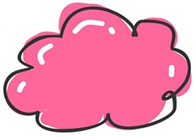

Naming the Colosseum
What is the origin and meaning of the word colosseum? Explore the history of the naming of the Colosseum.
Myth or fact?
How was the Colosseum flooded? Explore some of the theories behind how the colosseum was flooded. Watch this video to learn more.

Roman society
What were the roles of key people in ancient Roman society, such as the nobility, bureaucracy, women, and slaves?

Brochure
Research some of the popular ancient ruins in Rome. Choose what you believe are the top 3 ruins and then create a tourism brochure.

Useful Websites
- Colosseum set to get new floor for visitors designed to rotate to show underground chambers – ABC News
- Pompeii Discoveries – BTN
- Ancient Rome – ABC Education
- The Romans flooded the Colosseum for sea battles – TedEX
- A day in the life of a Roman solider – TedEX
- Reconstruction of the Colosseum interactive – Italy Guides

  - Teacher Resource

BTN Transcript: Episode 12 - 11/5/2021

Hey, I'm Amelia Moseley and you're watching BTN. Here's what's coming up. We find out about life under lockdown in Cambodia, go back in time to learn more about a famous Roman landmark and find out why a common learning disorder could make you a good spy.

Budget 2021

Reporter: Joseph Baronio

INTRO: But first to a story that's big in the news this week. The Budget. It's that complicated document that comes out every year and always seems to make politicians and journalists pretty excited. Joe found out what it is and why it's so important.
DOCTOR: Nurse, could you tell me about this patient.
NURSE: It's the economy, Doctor.
DOCTOR: He's been in a bad way, but I think there's a chance of recovery.
NURSE: With the right treatment.
DOCTOR: Alright, Nurse. Could you get me the budget?
PATIENT: The what?
DOCTOR: The budget.
Yep, it's budget time when the federal government releases that big, long report that outlines how it's planning to spend the country's money.

PATIENT: And, while it's perhaps not the most exciting read, it is key for a healthy economy.
The budget takes all the money coming in from things like taxes, and we're talking hundreds of billions of dollars, and divides it between all the things a country needs. Like education, transport, defence, research and welfare, just to name a few. The job of divvying up all the cash goes to this guy, Treasurer Josh Frydenberg and this year, he sure has his work cut out for him.
DOCTOR: Now, economy, it says here you've been through a particularly nasty recession, global pandemic, trade disputes.
As we all know, last year wasn't the best for any of us. COVID-19 and all those shutdowns had a big effect on the economy and the government responded by giving it a big dose of stimulus.
NURSE: Doctor, his debt levels are already off the charts.
DOCTOR: I know Nurse, but it's what we have to do to keep him going.
Things like JobKeeper, JobSeeker and other stimulus payments were designed to make sure people still had money to spend, to keep the economy going. But they cost a lot of money and put last year’s budget into a huge deficit, which means the government is spending more than its making and having to borrow money which is something that its tried to avoid in the past.
FORMER TREASURER, SCOTT MORRISON: If there's one issue that I know, it's that Liberals and National Party members feel strongly about and that is reducing the deficit, so we can reduce the debt and that is my laser-like focus.
The good news is it seems to have worked. Over the past six months, the economy's bounced back much better than expected. But that doesn't mean it's out of the woods.
DOCTOR: Alright nurse, I've taken him off JobKeeper. I think he's strong enough.
NURSE: Oooh, isn't that risky?
DOCTOR: Yes. We'll need to keep spending to build his strength.
DOCTOR: Jobs.
The government says this budget will be focused on getting the unemployment rate down to where it was before the pandemic and that means spending money on things that will create jobs or encourage people to get back to work.

PATIENT: Is it going to work doctor?

DOCTOR: Well, it'd better. There's an election coming up.
That's another reason why this budget is a big deal. The next federal election will be held sometime next year or maybe even sooner. So, the government will want to make sure it keeps as many people happy as possible. That's never an easy feat and over the next few days Aussies will be dissecting the budget and seeing just what it means for them and whether it's the medicine the economy needs.
DOCTOR: Well, that's it nurse, we've given him all we've got.
NURSE: Will it be enough?
DOCTOR: We'll have to wait and see.
News Quiz

Which of these things was banned in Greater Sydney last week? Going to the cinema? Having more than 20 visitors in your house or dancing at weddings? It’s B. A limit on visitors was one of several restrictions brought in after a case of COVID-19 was found in the community.

What sort of space junk crashed into the ocean on the weekend? Was it an old satellite, part of a rocket or a disused space station? It was part of a Chinese rocket. It was one the biggest pieces of space junk that’s ever come back to Earth in an uncontrolled way.

What unusually large creature is sitting on the end of this saw? Is it a freakishly large frog, a sizable snail or a massive moth? It’s a moth. A giant wood moth to be exact. They’re pretty rare and this one was discovered by builders at Mount Cotton State school which is on the edge of a rainforest in Queensland.

Cambodia COVID Lockdown

Rookie Reporters
INTRO: Now we're going to go overseas to Cambodia. For the past few weeks, the country's capital Phnom Penh has been under a really harsh lockdown to try to control an outbreak of COVID-19. It's made life pretty tough for many locals, so this week we've spoken to some Aussie kids living there to find out what it's been like. Take a look.
LUCAS: Hi BTN, I'm Lucas and I'm 12.
LEVI: Hi, I'm Levi, I'm 11.
SETH: Hi, I'm Seth, I'm 8.
LUCAS: Last year we moved from South Australia to Phnom Penh, Cambodia.
LEVI: We arrived in Cambodia about ten weeks before COVID. During that time, we enjoyed going to school, playing soccer and basketball, making new friends and swimming because it's a great way to cool off in the heat. We were also fortunate to have a great few trips to the provinces and we saw Angkor Wat in Siem Reap which is one of the ancient wonders of the world.
LUCAS: COVID hit Cambodia in early 2020. Last year we had only around 500 cases of COVID and one of the lowest rates of infection in the world. Sadly, since February 20 this year we have had over 17,000 cases. About one month ago Phnom Penh and some other parts of the country were divided into colour zones, red, orange and yellow. Each area has rules in place to help stop the spread of COVID. People living in the red zones have had it tough because they've been living in COVID hotspots. Tens of thousands of people live in these zones and some are very poor. They are heavily guarded by soldiers and are not allowed to leave their homes. There has been difficulty in getting food and basic supplies to them. We live in an orange zone, which means we can only leave our home to buy food three times a week or exercise in pairs in our local area.

LEVI: It is exciting to go out and see our neighbourhood again. But it’s also sad because we know many markets sellers and people are finding it tough and it’s difficult or us to be able to help right now.
LUCAS: This is our local market. It's usually bustling with lots of sellers and buyers, but because of COVID it's closed. Local people are concerned because without any work they don't get paid and can't support their family.
LEVI: The night curfew has started and we're not allowed outside from 8pm which is right now until 5am in the morning. As you can see there is no one on the streets and it's very quiet and that is extremely unusual for Phnom Penh.
LUCAS: Now a mass vaccination program has begun and people in red zones must receive a COVID vaccine before the red areas open up again.
LEVI: Since March last year, schools were closed to help stop the spread of COVID. They've opened and shut a few times since then, but we have mostly had to do school at home.
SETH: With so much time indoors over the last year we've played heaps of card and boardgames. Three weeks ago, we were banned from going outside. Even exercise. Now we are able to go out in pairs. I love rollerblading, Levi rides his scooter and Lucas is doing a school running challenge.
LEVI: The thing we all miss most while being in lockdown is spending time with our neighbours and friends. We can't wait to be able to go back to school and play sport again.
SETH: We also know that many people's basic needs are not being met.

LUCAS: We hope and pray for change to come soon for them too.

Gaming Tricks

Reporter: Jack Evans

INTRO: Now do you like videos games? Well, a lot of people do but sometimes gaming can become an addiction which costs people time and money. Last week the ABC's Four Corners did an investigation into the tricks used by some game makers to keep us gaming. Let’s find out more.
They let you jump from the sky, be a superhero or a sports star and build your own worlds.
IVY, GAMER: I love how you can connect with people, and how you can build, you can create, you can build whatever you want, and you can just connect, have fun.
JAY, GAMER: I like being able to connect with my friends and other different people and the gaming community is just a nice place to do that after school and on weekends.
Yep there's a lot to love about video games, but have you ever found yourself struggling to switch off? If you have, you're not alone. Psychiatrist Doctor Kim Le says he sees quite a few kids who are suffering with gaming addiction.
DR KIM LE, CHILD PSYCHIATRIST: It is characterised by a loss of control over your gaming time, priority over other activities for video games. And then you get negative consequences because of the amount of time that you're spending playing video games.
He says games are designed to make us want to keep playing sometimes longer than we should. It's got to do with a chemical called dopamine that our brain releases when we get something we want. Whether it's unlocking a new level, gaining a new power or getting a new skin. Dopamine makes us feel good and it can be addictive especially when it's combined with a technique called intermittent rewarding. Which basically means letting you win at random intervals. Okay let me try to explain.
JACK EVANS, REPORTER: If I said, 'I'll give you ten dollars for every three times you jump up and down’, you would probably jump up and down a lot. And then if I stopped paying you the ten dollars, you would quit pretty easily. But, if I didn't tell you when I was going to give you the ten dollars, maybe, sometimes after the third jump or sometimes after the tenth. Then you might just keep jumping because you don't know when or if you're going to get your next reward.
Intermittent rewarding can keep you playing, and it can also keep you spending. As you probably know lots of games let you pay for advantages or extra features often with a made-up currency. They're known as in-game purchases or micro transactions and they're a big money-maker for the gaming industry. But they are controversial, especially loot boxes. They're kinda like a virtual treasure chest that you buy without knowing exactly what you're going to get, and they've been banned in some countries because some say they're too much like gambling.
DR. JAMES SAUER, UNIVERSITY OF TASMANIA: We do know that the psychological mechanisms that many loot box systems operate on, are very similar to other forms of gambling.
Some have compared loot boxes to poker machines, which also use intermittent rewarding. They can be really addictive and really damaging, which is why kids aren't allowed to use them. But some say loot boxes aren't the same thing.
RON CURRY, INTERACTIVE GAMES & ENTERTAINMENT ASSOCIATION: As young kids we love to get a lucky dip, you know, Pokémon cards or Kinder Surprises and that mechanism is a similar mechanism to what's in loot boxes. I don't think they're similar to gambling. With the loot box, you are investing money to get something back. You'll always get something back. Whatever you get, you can use in your game.
Ron Curry represents the gaming industry, and he says a lot of gamers love loot boxes and in-game purchases. He says a lot of games will warn players if they're spending too much money. But others reckon more needs to be done to protect players and make sure the games we love to play aren't playing us.
Did You Know?

Did you know the Game Boy version of Tetris was the first game played in space? In 1993 the game travelled on a Soyuz rocket to Russia's MIR Space Station, where it was played by cosmonaut Aleksandr A. Serebrov.

Ask a Reporter

Do you have a question about that story? Well, you can ask me, and I’ll answer them live on Friday during Ask A Reporter. Just head to our website for all the details.

Dyslexic Spies

Reporter: Amelia Moseley

INTRO: Now for something a little more secretive. One of the UK's spy agencies is on the lookout for new recruits with an extra special something that makes them think a bit differently. It's probably not what you expect, and you might even have it. Let's find out more.

Being a spy takes stealth, skill and style.
AMELIA, REPORTER: Well not so much that one, but I do look quite good as a blonde. Anyway.
It turns out there's another spy asset that at least one of the world's real intelligence agencies is looking for and that's dyslexia? Yes, dyslexia. The Government Communications Headquarters, or GCHQ, is a top-secret British intelligence and cyber security agency that works with MI5 and MI6. Yeah, that MI6.
JAMES BOND MOVIE CHARACTER: The name’s Bond, James Bond.
JO CAVAN, GCHQ DIRECTOR: Hello, my name’s Jo and I'm a director at GCHQ. We work to keep the UK and our allies safe in the real world and online. Whether that's by preventing terrorist attacks, stopping serious criminals, or helping to keep the UK the safest place to live and do business online.
Jo says GCHQ is always on the lookout for new recruits with special skills, including people with dyslexia.
JO CAVAN, GCHQ DIRECTOR: From our beginnings, we've always valued different perspectives and diversity of thought. Some of our most talented and creative people at GCHQ are dyslexic.
This is Jasper and while he's not a spy, yet. He knows all about dyslexia because he has it.
JASPER: A teacher at school started helping me. The teacher had dyslexia herself. So, she had a suspicion. So, she helped me through a test that said, I had dyslexia.
So what is dyslexia? You see, our brains have lots of different parts that help us see, remember and understand and they're all connected by lots of tiny little electrical pathways. They help us do stuff like connect the things we see, to the sounds we hear, to the lines on a page. Scientists think that if you have dyslexia, the wires in your brain are connected differently, which in some cases makes it harder to read and write.
JASPER: It affects me when I'm learning. In long words the first part of the word I can see but like stopping I can't see the 'ing' so I have to look over a bit and I see the 'ing' and when I'm writing I like do the wrong letter.
But those different pathways in the brain can actually make dyslexic people better at some things.
JO CAVAN, GCHQ DIRECTOR: Dyslexic thinkers, tend to be good at pattern recognition, and spotting visual anomalies; skills, which are really important for our intelligence analysts.
This real spy agrees, although you can't see them, because, you know, they're a spy.
GCHQ SPY: I can't go into too much detail on what I do. I'm often looking through a lot of data and I find that my dyslexia helps me to see the bigger picture and spot patterns that aren't always obvious to everyone else around me.
But if spying's not your thing there are plenty of examples of other famous people who talk about having dyslexia, or are thought to have had it, like Albert Einstein, Walt Disney, author Agatha Christie, Apple's Steve Jobs, Microsoft's Bill Gates, and director Steven Spielberg. At least I don't think any of them were spies. But it sure is an impressive list, that shows all the possibilities of a brain that works a little differently.
JASPER: Most people just think like, we're the lower beings but actually, we're normal humans but just with one problem, but the problem is something we can easily overcome.
AMELIA, REPORTER: Do you ever want to be a spy?
JASPER: Now I think of it, no. Not at all.
Yeah, that's what a spy would say, Jasper.
Sport

Aussie Sam Kerr has just conquered the English Super League. A 5-nil win in the final round handed her club Chelsea the championship and Kerr's goal on the day helped the Aussie star wrap up the Golden Boot as well. That’s a special award given to the player who's scored the most goals in the league.

SAM KERR: It was always a dream of mine to come play in Europe and continue to score and be a part of this amazing team.
In the AFL over the weekend, Richmond's Shai Bolton snatched the headlines with this impressive mark. Some fans are already calling it mark of the year.
And finally, meet Willow Hardy. Like a lot of 14 year old’s, she loves surfing. But unlike a lot of 14 year old’s, she's just competed against four-time world champion Carissa Moore.

WILLOW HARDY, SURFER: I’m just so shocked. I’m trying to take it all in. Really crying happy tears actually.

She won a wildcard ticket into the Margret River Pro. Even though she was knocked out of the event, it looks like she's got an incredible future ahead.
Colosseum Renovation

Reporter: Jack Evans

INTRO: Finally, today we're off to Rome where one of the city's most famous landmarks is about to get a facelift or a floor lift, I guess. Yep, the Colosseum is getting a new floor which means visitors will be able to stand where gladiators once fought to the death. Here's Jack.

DAD: Oh son, you look great. You're going to kill it out there. Literally.
SON: Oh, but Dad, I don't want to be a Gladiator.
DAD: What? Of course, you do.
SON: But most of the time they just die.
DAD: Well only the ones that aren't good at fighting.
SON: But I'm not good at fighting.
DAD: Listen here, you've got an opportunity to perform on the world's biggest stage, the Colosseum.

SON: Oh.
Yeah, to be honest, I don't think I'd want to be a gladiator either with all the fighting, the blood and ferocious animals. But back in the heyday of the Roman Empire, the Colosseum was the place to be. The Roman Empire was one of the world’s greatest civilisations, lasting hundreds and hundreds of years. It once stretched across Europe, North Africa and the Middle East; and left a lasting influence on languages, laws and the landscape. With many roman ruins, like the Colosseum, still standing after nearly 2,000 years.
Construction on it began in 72 AD, when the Emperor Vespasian decided to give the people a top notch entertainment venue, the Ampitheatrum Flavium. Although it later became known as the Colosseum, because of the big statue or Colossus of the Emperor Nero out the front.
DAD: Oi, those spectators have paid good money to see you perform or battle.
SON: What they didn't have to pay.
Yep, shows at the Colosseum were free and sometimes with free food thrown in.
DAD: Can you smell boar?
It wasn't just because they were nice guys. The Roman Caesars tried to maintain power and popularity by keeping the people well fed and entertained. There were chariot races, re-enactments of historical battles, in fact some archaeologists reckon they'd sometimes flood the whole thing to recreate famous sea battles. There were also animal hunts called venatio. Oh and of course, gladiators. You've probably heard of gladiators before or seen them in movies like this. Gladiator fighting or munera was a popular sport during the roman empire, usually slaves or criminals were forced to fight to the death. But sometimes volunteers would do it willingly for the honour or prize money.
The large public gatherings stopped in the 5th century when the Roman Empire began to collapse and things like earthquakes, fires and looters left the Colosseum looking like this. But it's still standing and draws millions of tourists every year. And now it's about to get a new floor. What was left of the old one was removed in the 19th century to give archaeologists a better look at the cells and preparation rooms underneath. The new floor will use rotating planks so you can still get a view of the underground workings. But it will mean visitors can stand where the gladiators once stood and imagine they were in the shoes of those ancient roman warriors.
SON: Alright, I'm going to do this. Don't try and to stop me. I am a gladiator.
DAD: Wait, you forgot your shield. Oh, he'll be fine.
Closer

And that, I'm afraid, is all we have for you this week. But we'll be back soon, and in the meantime, you can jump on our website and you can keep up to date with BTN Newsbreak every weeknight. If you're 13 or over you can also subscribe to our YouTube channel, so you don't miss a thing. I'll catch you next time. Bye.

