KEY LEARNING
Students will view a range of BTN stories and use comprehension skills to respond to a series of focus questions.

CURRICULUM
English – Year 4
Use comprehension strategies to build literal and inferred meaning to expand content knowledge, integrating and linking ideas and analysing and evaluating texts.

English – Year 5
Use comprehension strategies to analyse information, integrating and linking ideas from a variety of print and digital sources.

English – Year 6
Use comprehension strategies to interpret and analyse information and ideas, comparing content from a variety of textual sources including media and digital texts.

English – Year 7
Use comprehension strategies to interpret, analyse and synthesise ideas and information, critiquing ideas and issues from a variety of textual sources.

  - Teacher Resource

Focus Questions

Yom Kippur
- What did the BTN Yom Kippur story explain?
- How long ago was the religion Judaism created?
- What is the name of the religious book used in Judaism?
- Complete the following sentence. Yom Kippur means The Day of _______________.
- What does honey cake symbolise during Yom Kippur?
- What happens during Kippur? Give 2 examples.
- What are some of the challenges during Yom Kippur?
- What happens at the end of Yom Kippur?
- What do the kids in the BTN story like about Yom Kippur?
- What other religious festivals are there around the world? Discuss as a class.

Vaisakhi Festival
- What is Sikhism?
- Where did Sikhism originate? Find using Google Maps.
- When did Sikhism originate?
  - 1400s
  - 1500s
  - 1600s
- Complete this sentence. The first of the Sikh gurus decided not to follow the Hindu and Muslim religions and instead he would follow only one _____.
- What is one of the main principles of Sikhism?
- How many Sikhs are there around the world?
- What name is given to Sikh men and what name is given to Sikh women?
- Describe what the Sikh flag looks like.
- Why does Joypreet wear a turban?
- How do people celebrate Vaisakhi? Give an example.

Eid Festival
- Retell the BTN Eid Festival story using your own words.
- Islam is the world's second-largest religion around the world. True or false?
- What are you called if you follow Islam?
- What is one of the rules that Muslims follow?
- How long does Ramadan last?
  - 1 day
  - 1 week
  - 1 month
- Explain what happens during Ramadan.
- What is one of the challenges during Ramadan?
- Complete this sentence. Eid al-Fitr is the Festival of Breaking the ______.
- What do the kids in the BTN story like about Eid?
- What did you like about the BTN story?

Lent
- Before watching the BTN Lent story discuss what you know about Lent.
- Who participates in Lent?
- Why do people often give something up during Lent?
- Give an example of something that people might give up during Lent.
- On what day of the week during Lent do people not fast and have a rest day?
- Complete this sentence. During Lent people don't eat ______ on Friday's.
- What food is eaten on Shrove Tuesday?
- What happens on Ash Wednesday?
- What does Good Friday represent?
- What do Easter eggs symbolise on Easter Sunday?

Vesak
- Summarise the BTN Vesak Festival story using your own words
- Buddhism is a religion that started in which country? Find using Google Maps.
- Approximately how many Buddhists are there around the world today?
- What is the main idea of Buddhism?
- What is one of the precepts that Buddhists follow?
- What does Vesak celebrate?
- What is the main aim of meditation?
- What do the kids give to friends and relatives on Vesak Day?
- What is the significance of the lanterns during Vesak?
- What other religious festivals are there around the world? Discuss as a class.

Holi Festival
- Before watching the BTN story, ask students if they know about or have celebrated Holi?
- Complete this sentence. Hinduism is the 3rd most practised ___________ in the world.
- Hinduism is a religion that has many gods. Name one.
- What does Hanuman look like?
- What story is Holi based on? Describe.
- Holi celebrates the arrival of what season?
- How many days do people celebrate Holi?
- Describe some of the activities that happen during Holi.
- What do the kids in the BTN story like about Holi?
- What did the BTN Holi Festival story explain?
KEY LEARNING
Students will develop a deeper understanding of what Ramadan is and how people celebrate it.

CURRICULUM
History – Year 3
Celebrations and commemorations in places around the world (for example, Chinese New Year in countries of the Asia region, Bastille Day in France, Independence Day in the USA), including those that are observed in Australia (for example, Christmas Day, Diwali, Easter, Hanukkah, the Moon Festival and Ramadan).

Civics and Citizenship – Year 4
The different cultural, religious and/or social groups to which they and others in the community belong.

Civics and Citizenship – Year 7
How Australia is a secular nation and a multi-faith society with a Christian heritage.
  - Teacher Resource

Activity: Class Discussion
Hold a class discussion about special celebrations that students in the class celebrate. Record the following:
- Briefly describe the celebration including examples of how they celebrate.
- Why is the celebration special?

Students can share the different celebrations with other students explaining why it’s important or special to them.

Activity: Remember and Understand
- After watching the BTN Ramadan Begins story, respond to the following questions:

- What did you SEE in this video?
- What do you THINK about what you saw in this video?
- What does this video make your WONDER?
- What did you LEARN from this story?
- How did this story make you FEEL?
- What was SURPRISING about this story?

- Record five facts that you know about Ramadan and Islam. Swap or compare your facts with another student’s. Add news facts in the exchange. Keep swapping your list of facts until you have built up a detailed fact file about Ramadan and Islam.
- Research which Islamic countries celebrate Ramadan and mark them on a world map.
- Find definitions for the following key words about Ramadan:
  - Ramadan
  - Islam
  - Muslim
  - Qur’an
  - Iftar
  - Eid-ul-Fitr

Activity: Apply and Analyse
The end of Ramadan is marked by a big celebration called Eid-ul-Fitr, the Festival of the Breaking of the Fast. Students research the special events that occur during this celebration. The following questions can guide their research:

- What special events happen during Eid-ul-Fitr?
- How do the celebrations differ around the world?
- What foods are eaten during this celebration?
- What special clothing is worn?

Encourage students to find or draw images that reflect the end of Ramadan. They can then display their learning in an interesting way.

- What values does Ramadan encourage or teach? For example, compassion and respect. Create images that symbolise the values that are an important part of Ramadan. Students can display their images in the classroom.
- Why learn about Ramadan? How does learning about it help us understand difference and tolerance? Write a short explanation and present it to the class.

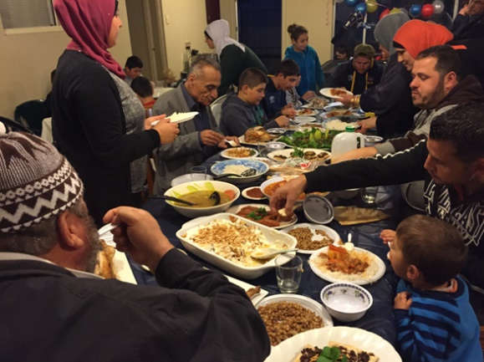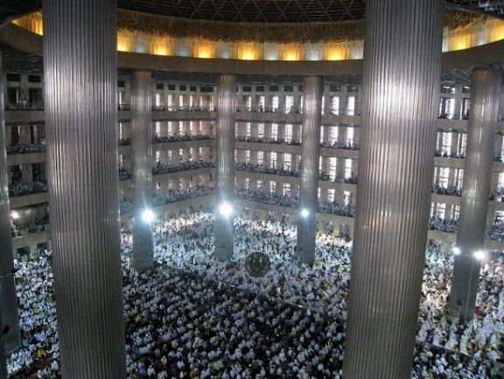

Activity: Evaluate and Create
- Create a picture book that teaches children about Ramadan. Include information about what Muslim people remember and celebrate during Ramadan and the important activities performed. Include information about the end of Ramadan, Eid-ul-Fitr.

- Make a card for Ramadan or Eid-ul-Fitr using geometric patterns, buildings or images of the crescent moon and star. Be mindful that Islamic religious art does not include images of people or animals. To many Muslim people it is not acceptable to draw life-like images of people or animals.

