EPISODE 12
16th May 2023

KEY LEARNING
Students will view a range of BTN stories and use comprehension skills to respond to a series of focus questions.

CURRICULUM
English – Year 4
Use comprehension strategies to build literal and inferred meaning to expand content knowledge, integrating and linking ideas and analysing and evaluating texts.

English – Year 5
Use comprehension strategies to analyse information, integrating and linking ideas from a variety of print and digital sources.

English – Year 6
Use comprehension strategies to interpret and analyse information and ideas, comparing content from a variety of textual sources including media and digital texts.

English – Year 7
Use comprehension strategies to interpret, analyse and synthesise ideas and information, critiquing ideas and issues from a variety of textual sources.
  - Teacher Resource

Focus Questions
As a class, discuss the stories featured in the episode of BTN Classroom and record the main points of the discussion. Students will then respond to the following focus questions.

End of COVID-19
- What did the World Health Organisation recently announce about COVID-19?
- Where did COVID-19 first appear?
- Do you remember when you first heard about COVID? Discuss in pairs.
- Which of these is a type of COVID strain?
  - Delta
  - Omega
  - Zeta
- What is the name of a COVID vaccine? Name one.

Monarchy Relevance
- Briefly summarise the BTN Monarchy Relevance story.
- What is the difference between an absolute monarchy and a constitutional monarchy?
- How many countries are part of the Commonwealth? Name 3 of them.
- What is Australia?
  - Constitutional monarchy
  - Republic
  - Absolute monarchy
- What do you think about the issue? Discuss as a class.

Check out the teacher resource on the Archives page.

Foodbank Volunteers
- What does Foodbank do?
- Where does Foodbank get their food from?
- Who does Foodbank deliver the food to?
- How can people support Foodbank?
- How did this story make you feel? Discuss in pairs.

Young Archie 2023
- What famous art prize is the Young Archie competition based on?
- What type of artworks are entered in the Young Archie competition?
  - Landscape
  - Portraiture
  - Still life
- Describe the process Lexie uses to make her artwork.
- Where does Lexie get inspiration for her artworks?
- What did you like about the BTN story?

Check out the teacher resource on the Archives page.

EPISODE 12
16th May 2023

KEY LEARNING
Students will explore Australia’s relationship with the monarchy.

CURRICULUM
English – Year 6
Plan, draft and publish imaginative, informative and persuasive texts, choosing and experimenting with text structures, language features, images and digital resources appropriate to purpose and audience.

HASS – Year 6
Key figures, events and ideas that led to Australia’s Federation and Constitution.

HASS – Year 7
Sequence information about events, developments, periods and phenomena using a variety of discipline-appropriate formats and conventions including chronological frameworks that use dating conventions.

Civics and Citizenship – Year 7
The process for constitutional change through a referendum.
  - Teacher Resource

Monarchy Relevance

Focus Questions
Discuss the BTN story as a class and record the main points of the discussion. Students will then respond to the following:
- Briefly summarise the BTN Monarchy Relevance story.
- What is the difference between an absolute monarchy and a constitutional monarchy?
- How many countries are part of the Commonwealth? Name 3 of them.
- What is Australia?
  - Constitutional monarchy
  - Republic
  - Absolute monarchy
- What do you think about the issue? Discuss as a class.

Activity: Class Discussion
Before Watching
Before watching the BTN Monarchy Relevance story students will discuss in small groups what they already know about the monarchy and what they think this BTN story will be about.
- What do you know about the monarchy?
Do you think the monarchy is important? Why or why not?
- What is the role of the monarchy in Australia?
- Do you think the monarchy is important? Why or why not?

After Watching
Students will respond to one or more of the following questions after watching the BTN story:
- What did you learn?
- What do you wonder?
- Have your thoughts or feelings changed since watching the BTN story? Discuss.
- What are some key words from the BTN story? Make a list.

Activity: Glossary
Students will brainstorm a list of key words that relate to the BTN Monarchy Relevance story. Below are some words to get students started.

CONSTITUTIONAL MONARCHY | ABSOLUTE MONARCHY | REPRESENTATIVE DEMOCRACY
HEAD OF STATE | PARLIAMENT | DEMOCRACY

Ask students to write what they think is the meaning of each word (including unfamiliar words). They will swap definitions with a partner and ask them to add to or change the definition. Check these against the dictionary definition.

Further activities for students:
- Students will add to their glossary by downloading the transcript for the BTN Monarchy Relevance story and highlight all the words that relate to monarchy and democracy. Add the following words to the glossary to expand students’ knowledge on the topic: absolute monarchy, hereditary monarchy, Commonwealth Realm, Terra Nullius, federation, republic, Magna Carta, succession.
- Write your own sentences using one or more of the key words.
- What is the difference between an absolute monarchy and a constitutional monarchy?
- How did this story make you feel? Make a list of words that describe how you felt after watching the BTN story.

Activity: KWLH
After watching and discussing the BTN Monarchy Relevance story, what questions do students have? The KWLH organiser provides students with a framework to explore their knowledge on the issue and consider what they would like to know and learn.

What do I know? | What do I want to know? | What have I learnt? | How will I find out?

Questions to research
Students will develop their own question/s to research about the monarchy and its relevance in Australian society. Students will collect and record information from a wide variety of sources. Students may develop their own question for inquiry or select one of the questions below.

- Create a timeline highlighting key events in the history of the British Monarchy. Include a title, date, and description for each event.
- Why is Australia a part of the Commonwealth? Learn more on the PEO website. Do you think Australia should still be a part of the Commonwealth? Why or why not?
- Australia has a mixed system of government. What does this mean?
- Who is Australia’s Head of State? Why are they Australia’s Head of State and what is their role in Australia?
- Find out what a constitutional monarchy is and explore the reasons why some people want Australia to become a republic.
- Should Australia become a republic? Develop an argument for or or against the issue.
- Create t-chart with the pros and cons of Australia remaining a constitutional monarchy.

Activity: Persuasive Text
Students will explore the issues raised in the BTN Monarchy Relevance story and then develop a persuasive text for or against the following statement: `Australia should not remain a constitutional monarchy’. Students need to weigh up the pros and cons of the issue then write a short persuasive argument using the following as a guide.

Tips
- Who is your audience? For example, are you directing your argument at kids, teachers, or politicians?
- Explore how language choices can have a big impact on persuading your audience.
- Which language devices give the report credibility and authority?
- Which are designed to create an emotional response in the listener?
- Provide facts and evidence to support your argument.
- Write in the present tense.
- Check your spelling and punctuation.

Use this Read Write Think persuasion map to plan your exposition text.

Introduction
- What is the point you are trying to argue? Construct an introductory paragraph which states the issue or topic.
- Introduce the arguments that will be developed in the body of the text.

Body
- Construct arguments that support your point of view.
- Each paragraph starts with a topic sentence which introduces each point.
- The rest of the paragraph gives more reasons.
- Arguments can be ordered from strongest to weakest.

Conclusion
- Restate your position on the argument.
- Construct a concluding paragraph that provides a summary of your arguments and a call to action.

Reflection
- How difficult was it to think of points to support one side of the argument?
- Do you think you would have done a better job supporting the other side of the argument?
- Was I able to convince others of my opinion?
- What did you learn from this activity?

Activity: Public Opinion
Students will interview a range of people to find out the different attitudes and feelings people have towards the monarchy. Students will use the following as a guide during the interview process:
- Determine who you will interview, for example, family and/or friends.
- Prepare for your interview by writing some questions that you will ask your interviewee. Write open-ended questions. Open-ended questions have no right or wrong answer and can’t be answered with a ‘yes’ or ‘no’.
- Find out what the monarchy means to them.
- Ask if they think Australia should become a republic and ask them to explain their answer.
- Think about ways to record peoples’ responses – written, audio or video.
Do you think Australia should become a republic? Why or why not?
What does the monarchy mean to you?
What is the role of the monarchy in Australia?

What questions do you have about the story?

Activity: BTN Stories
As a class watch one or more of the following BTN stories to learn about the monarchy. After watching any one of the BTN videos ask students to respond to the discussion questions (to find the discussion questions and teacher resources go to the related BTN Classroom Episode and download the Episode Package).

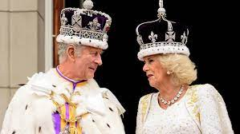King Charles Coronation | 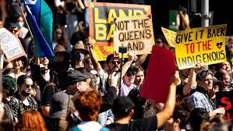  Republic Debate | 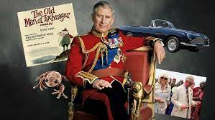  King Charles III
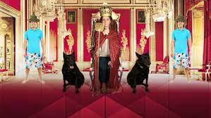  Republic | 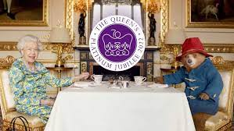  Queen's Platinum Jubilee | 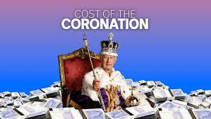  Coronation Cost

Activity: Class poll
Hold a poll in your class. Students will conduct their own opinion poll on the issue of whether Australia should become a republic. Working in groups, students will need to decide who their sample group will be and how many people will be polled. What method will they use to conduct the poll? (Face to face interviews or written responses). Ask students to graph the opinion poll results and then reflect on the results.

Useful Websites
- Republic Debate – BTN
- King Charles Coronation – BTN
- King Charles III coronation: Police arrest protestors – Newsround
- Why are we a constitutional monarchy? – BTN
- What is the role of the King in Australia's system of government? – PEO
- Australian system of government – PEO

What scientific questions do you have?

EPISODE 12
16th May 2023

KEY LEARNING
Students will respond to portraits in the Young Archie competition. They will explore different techniques used to create a portrait or self-portrait.

CURRICULUM
Visual Arts – Years 3 & 4
Explore ideas and artworks from different cultures and times, including artwork by Aboriginal and Torres Strait Islander artists, to use as inspiration for their own representations.

Use materials, techniques and processes to explore visual conventions when making artworks.

Visual Arts – Years 5 & 6
Explore ideas and practices used by artists, including practices of Aboriginal and Torres Strait Islander artists, to represent different views, beliefs and opinions.

Develop and apply techniques and processes when making their artworks.

Plan the display of artworks to enhance their meaning for an audience.

  - Teacher Resource

Young Archie 2023

Focus Questions
Discuss the BTN story as a class and record the main points of the discussion. Students will then respond to the following:
- What famous art prize is the Young Archie competition based on?
- What type of artworks are entered in the Young Archie competition?
  - Landscape
  - Portraiture
  - Still life
- Describe the process Lexie uses to make her artwork.
- Where does Lexie get inspiration for her artworks?
- What did you like about the BTN story?

Activity: Class Discussion
After watching the BTN Young Archie 2023 story, hold a class discussion using the following discussion starters.
- What is a portrait?
- What is a self-portrait?
- Why do we create portraits?
- What makes a portrait interesting?
- What different techniques can be used to create portraits? Give examples.
- What words would you use to describe the Young Archie competition?
- How did the Young Archie competition come about?

What do portraits tell us about a person?
Working in pairs, brainstorm a list of famous portraits.

Activity: Glossary
Students will brainstorm a list of key words that relate to the BTN Young Archie 2023 story. Here are some words to get them started.

PORTRAIT | COMPOSITION | BACKGROUND
IDENTITY | EXPRESSION | TECHNIQUE

Activity: Young Archie Gallery
Students will select their favourite portrait from the 2023 Young Archie competition. Below are examples of six finalists. Students will analyse and reflect on the portrait and then respond to the questions below.

Finalists – Young Archie 2023, Art Gallery NSW
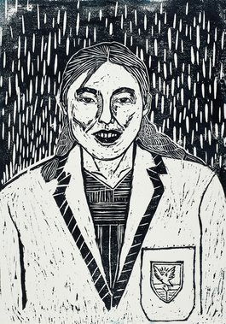  Lexie – Self Portrait | 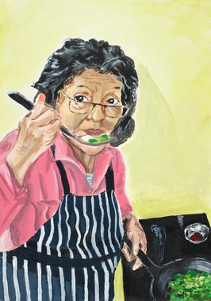Eva – Nai Nai’s magic | 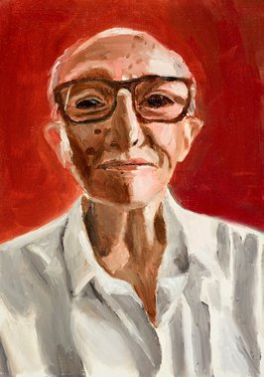  Toby – My grandpa
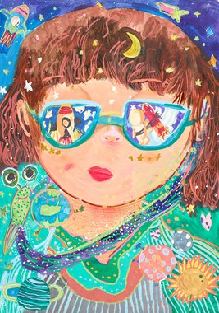  Chelsea – Space Girl | 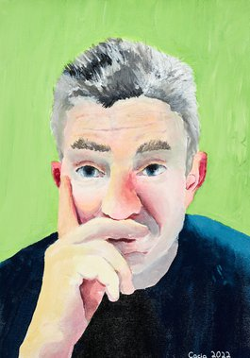Cacia – 169 Days | 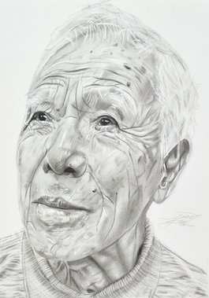  Grace – My grandpa Taki

Questions to help guide students’ response to an artwork:
- What is your first impression of the portrait? What is the first thing you notice?
- Who is the portrait of? What can you tell about their personality? What are they doing? What is the mood of the portrait?
- What does the facial expression tell us about the person?
- Do you notice any objects in the portrait? How do these objects represent the subject’s identity or individuality?
- What would you ask the person in the portrait?
- What do you think the artist is trying to communicate about their subject?
- How does the portrait make you feel? What do you like about this portrait/self-portrait? Why did you choose it?

Activity: Create a portrait
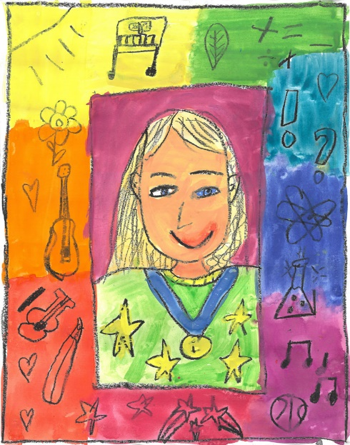
Create a portrait.
Students will create a portrait of a person who is special to them, using the following as a guide.
- Choose someone who is known to you and plays a significant role in your life.
- Write 2-3 sentences explaining who the person is and why you chose them.
- What technique/s will you use to create your portrait? Think about colours to reflect mood or feelings.
- Organise a live sitting with your subject, where you and your subject are together, and you are working on their portrait. Complete your portrait using photographs of your subject as a reference. Give your portrait a title. Write an artist’s statement about your portrait.
Portrait by Harriet (8)
Create a self-portrait.
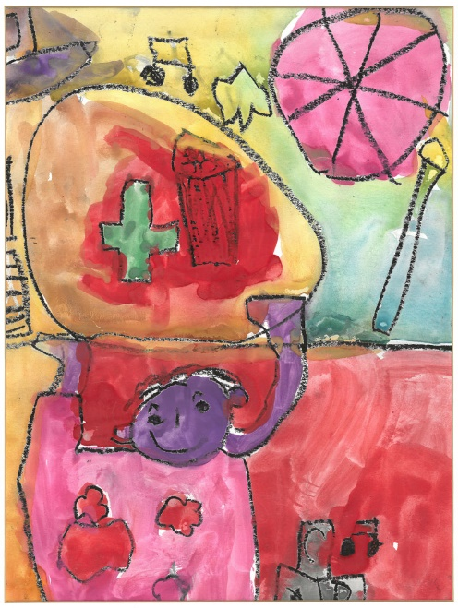
Students will create a self-portrait which represents how they see themselves. Looking at a mirror, students will experiment with poses, costumes and props and produce a self-portrait. Initially students can do some quick, detailed sketches of different features and then use these sketches to help create a final self-portrait. Students will write an artist's statement to go with it.

Below are some guidelines for students as they create their self-portrait:
- Use colours that you feel reflect your mood or feelings.
- What style will you use to create your self-portrait? How will it help portray your identity?
- Where are you going to sit? Think about the background of your self-portrait. Is it real or imaginary?
Portrait by James (5)

Class Exhibition
Curate a class exhibition of your students’ portraits and/or self-portraits and choose a title for the exhibition. Invite students from other classes at your school to attend your exhibition. Consider holding your exhibition at your local library or local council.

Activity: Choose a project
Students choose one of the following projects to work on and then present their work to a partner, small group or the class.
Explore a Famous Portrait
Choose a well-known portrait or self-portrait. Record as much as you can about the artwork in 15 minutes. Create your own portrait inspired by the artist’s style and technique.
Archibald Prize
Find out more about the Archibald Prize. Investigate the 100+ year history of the Archibald Prize and present your findings in an interesting way.
Australian Portrait Artist
Investigate the life and work of a famous Australian portrait artist. The National Portrait Gallery is a good place to start your research.
Portraiture over time
How has portraiture changed over history? Compare the beginnings of portraiture to modern portraiture that you see now. Illustrate using a timeline.

Useful Websites
- Young Archie – Past winners, finalists and honourable mentions – Art Gallery NSW
- Young Archie competition 2023 – Art Gallery NSW
- Young Archie 2021 – BTN
- Young Archie 2018 – BTN
- Centenarian Art – BTN

  - Teacher Resource

BTN Transcript: Episode 12 - 16/5/2023

Hey, I'm Amelia Moseley and you're watching BTN. Did you have a good week? I hope so. Here's what's coming up on today's show. Does the royal family still have a place in Australia? Celebrating National Volunteer Week and we meet a Young Archie finalist.

End of COVID-19

Reporter: Jack Evans

INTRO: All that soon, but first up, the World Health Organisation has announced that COVID-19 is no longer a global emergency. It's been three years since it first declared the highest level of alert over the virus. Let's look back at what happened and what we've learned from living through a global pandemic.
JACK, REPORTER: Okay, I've come to a school where we're going to find some students and let them know the exciting news that COVID-19 is no longer a global health emergency. Oh, they're going to be so excited. Alright, let’s go find some.
TEDROS ADHANOM GHEBREYESUS, WORLD HEALTH ORGANISATION: With great hope that I declare COVID-19 over as a global health emergency.
Just to be clear, COVID-19 is still around and isn't going anywhere, anytime soon. But case numbers have been lower than ever and a lot of countries, including Australia, have lifted the majority of the restrictions that were in place throughout the pandemic.
JACK: Hi, hi everyone, sorry. I just wanted to let you all know that COVID-19, no longer a global health emergency, so you can all go back to normal. Oh, I guess you're already back to normal. Um, I’ll just go. Shut this.
Yeah, to be fair it's kinda felt like things have been back to normal for a while now. In fact, it's hard to believe that it's been more than 3 years since we heard of COVID-19, I mean we were still in our old studio.
AMELIA, BTN PRESENTER: There’s been a lot of talk about the new strain of virus which started in China and has now spread to other countries.
JACK: Okay, COVID, do you remember it?
LIAM: Yep.
MADDIE: Most definitely.
OMERA: Most definitely.
TOM: It changed a lot of things that were usual to me. It felt like all of a sudden, it just changed overnight.
LIAM: It was pretty scary because it felt almost as though it was out to get you.
To try and slow the spread we learnt to do things a little differently and COVID tests just became a normal part of life.
JACK: What things did you start doing to sort of try and stop it from happening?
LIAM: We would wear masks.
TOM: Sometimes when I'm wearing a mask and when I breath it just fogs up my glasses.
JACK: Yes. I say that like I know, I'm not wearing glasses, but I've seen that happen. I feel your pain. I do. Also did you find you could smell your own breath?
LIAM: Yes, and only then did I realise how foul it is.
JACK: What about sanitisers?
OMERA: I have a sanitiser with me all the time as I go out a lot.
JACK: Are you conscious of like keeping your distance from people now?
MADDIE: Not really.
OMERA: Personally, me, I hug my friends a lot
MADDIE: Yeah, I think the whole elbow thing was a bit, eh.
JACK: Was it? Do you wanna. Yeah, it is weird isn't it. So, if I say social distancing, what's your first reaction?
LIAM: Movies you would sit 4, 3, 4 seats apart.
JACK: See I kinda liked that, 'cause then you could spread out. Were you ever like in a crowd and you'd go "social distance, social distance" to try and make sure people were like, like that's good.
LIAM: No, not really.
JACK: Did either of you have to quarantine?
MADDIE: We spent two weeks here quarantining which was the worst two weeks of my life, to be honest. The food was horrendous, I had to use an iron to heat up the food.
JACK: Don't do that at home.
OMERA: We came back from a different country, we had to quarantine for quite a while. I feel like I got closer to my family. Me and my brother did fight a lot, but we got closer, and we figured out new games to play.
JACK: Did you also have to cook food on an iron?
OMERA: Um, no.
JACK: People were hoarding toilet paper at one point, don't laugh it was very serious.
OMERA: It was kind of funny at times that people were rushing to get toilet paper, normally people wouldn't do that, so it was a bit.
JACK: Unless they really had to go. How did you find learning from home?
OMERA: It was pretty fun cause we got to skip some classes but other than that.
LIAM: I remember my mum and dad telling me to get back to work because I would often get a bit distracted.
But while we were busy trying to lay low and distract ourselves, COVID had other plans.
JACK: Variants, what are the variants of COVID?
LIAM: Delta and.
TOM: Omicron.
JACK: Were there more?
LIAM: I don't remember the names anymore.
To be fair, there were a few of them. Meanwhile, the whole time, scientists were busy working on vaccines and there have now been more than 13 billion doses of vaccines administered.
MADDIE: As soon as we got an opportunity to get the vaccine my mum and dad made me get it.
JACK: Is that because they wanted to go out places?
MADDIE: They just wanted me to not get sick.
JACK: Oh, well that's probably a better reason isn't it.
3 years on and there have been nearly 800 million reported cases of COVID and more than 6 million people have died. Meanwhile the pandemic has had a huge impact on people’s mental health as well as economies around the world. And it's fair to say that while things might be back to normal, there are some things from the pandemic that are probably going to stick.
JACK: Coming out of COVID what are some things that have stuck with you?
MADDIE: Take advantage of your friends while you can socialise with them.
LIAM: But you might still have to wear a mask in a doctor’s clinic or a hospital.
MADDIE: I wash my hands more.
JACK: I admit, I feel like I know how to wash my hands better too.
OMERA: Well, I'm happy we can finally share food.
JACK: That's right because we couldn't share food. We couldn't even sit in a room like this. Does that freak you out?
MADDIE: It seems like it wasn't actually real.

News Quiz

Billionaire Elon Musk has made a big announcement. What is it? Is Elon Musk selling TESLA, resigning as CEO of TESLA or resigning as CEO of Twitter? He’s resigning as CEO of Twitter. He spilled the news in a Tweet, naturally, and not long after that announced that NBC Universal’s Head of Advertising, Linda Yaccarino, will be taking over the top job.
What is the name of this very famous dog show? It’s the Westminster Kennel Club Dog Show and it’s held every year in New York in the US. The show dates all the way back to 1877 making it the second oldest sporting event in American history. 6-year-old Buddy Holly took home all the carob-based chocolates as the first Petit Basset Griffon Vendeen to take out a win in the hound category and the best in show prize for 2023.

This man in Florida has been living underwater for 75 days. Why is he doing it? Is he trying to break a world record, studying how his body reacts to increased underwater pressure or trying to boost support for marine conservation? It’s a trick question, it’s all three. Dr Joseph Dituri has already broken the previous world record of 73 days but he’s not tapping out just yet. He wants to make it to the 100 day mark.

DR JOSEPH DITURI: The idea here is to populate the world’s oceans, to take care of the world’s oceans by living in them and really treating them well. Not necessarily, oh, just make another record.
And who was the winner of this year’s Eurovision Song Contest? Was it Australia, Sweden, or Finland? It was Sweden. Aussie band Voyager finished in 9th place with their song Promise.

Monarchy Relevance

Reporter: Justina Ward

INTRO: We've just witnessed the big, historic event that was the coronation of King Charles III, but the Royal family are now facing some pretty big challenges and questions over whether the monarchy still has a place in today's society. Let's find out more.

PROTESTOR: You are complicit to the enslavement of my ancestors.
PROTESTORS: Not my King.
PROTESTOR: I don't believe in hereditary monarchy.
PROTESTORS: Down with the crown.
PROTESTOR: The psychological toll of saying, look, these people are born special.
PROTESTOR: Why you wasting our money?
Graham Smith, Republic Campaign Group CEO: Interest is going down and that's a big problem for them.
PROTESTOR: We just don't need royalty anymore.
Yeah, there's a lot going on right now with the royals, and with a new reigning monarch it's sparked some pretty big debates on the monarchy's place in the modern world.
Robert Hardman, UK author: Relevance is absolutely crucial to the monarchy. The big threat to the future of the House of Windsor is not mobs storming the gate. It's not revolution. It's becoming irrelevant.

So, why do people think they're becoming irrelevant? I mean, they were once relevant, right?
JUSTINA: Right. You see the monarchy is the oldest form of government in the United Kingdom, and once upon a time the royal family were an absolute monarchy, which meant they basically had control over everything. Check. But in 1688, they became a constitutional monarchy, which meant the royals stayed the head of state.
ALEX: But an elected government now had all the power. Check mate.
JUSTINA: Oh, I didn't see that coming.
The UK's not the only constitutional monarchy. In fact, a bunch of other countries share the same monarch as their head of state. And all these countries are part of the Commonwealth Realm, including us. So how did that happen? Well, as a way to grow the British Empire, England explored the ocean in search of more land to build new colonies and trade valuable resources. But this often came at the expense of the people who already lived in those places.
Danielle Archer, Lawyer: Take a trip to any Caribbean island, any country that was under the grip of colonialism. You will see poverty. You will see where the resources have been taken from the land and placed in the wealthy.
Australia is no exception. Aboriginal and Torres Strait Islander peoples have lived on this continent for tens of thousands of years, but in 1770, Captain Cook declared Australia as Terra Nullius or land belonging to no one. And although this wasn't the case, the land was claimed for the British Crown and a couple of hundred years later when Australia became a federation, we got a prime minister but kept a British King. Over the years, lots of people have debated whether that should change, and the coronation of King Charles III has brought the issue up again.
Nova Peris, Co-chair, Australian Republican Movement: It's just so outdated, it’s so un-Australian, it’s not symbolic of who we are as a Nation.
Julian Leeser, Liberal MP: There's nothing wrong with having the crown in the constitution, because if it was a problem people would be marching in the street about it.
Anthony Albanese, Prime Minister: I want to see an Australian as Australia's head of state, but we have to respect the institutions which are there, which Australians have put in place.
Jacqui Lambie, Independent Senator for Tasmania: God forbid it's about time we stood on our own two feet and we don't need a king and queen to do that, we can actually do it all by ourselves.
Other countries are talking about change too.
Marlene Malahoo Forte, Jamaican Minister of Legal and Constitutional Affairs: We're looking at holding the referendum in 2024.
Christopher Hipkins, New Zealand Prime Minister: Ideally, I think in time, New Zealand will become a fully independent country, we'll stand on our own two feet in the world as we by and large do now.
It's an issue people are still divided on, both here and in other Commonwealth countries. But what do you guys think?
KID 1: If Australia became a republic, I wouldn't really care.

KID 2: I'd rather a monarch.
KID 3: I think he's going to do a really good job being king.
KID 4: The king or queen of England doesn't live in Australia so they don't know what were like other people are like, and I think the government's got it in control.
KID 2: I wish I could actually meet him.
KID 1: And one more message for the king. I believe that if he's a football fan, he shouldn't have high expectations for England winning anything anytime soon.
Foodbank Volunteers

Reporter: Josh Langman

INTRO: It's National Volunteer Week which is all about recognising the support that millions of Aussies provide to help those in need. Josh headed down to Foodbank, an organisation that's helping to put food on the table for millions of Australians.
JOSH: So, Peter, how long have you been volunteering here for?
PETER, FOODBANK VOLUNTEER: I’ve been with Foodbank for over 10 years.
JOSH: That's a very long time, that’s very impressive.
PETER: I worked in the food industry as a sales rep way back in the dark ages and read about them. And I thought I might as well do this as something to keep me out of my wife's hair. And give a little bit back.
Peter is just one of around 400 people who volunteer their time at Foodbank down here in Adelaide. And it's a pretty big place. So, join me as we find out.
What is this and what is that?
JOSH: And who are you?
GREG: My name's Greg, I'm the Chief Executive here. Foodbank is the largest food relief organisation in Australia. Our mission is to get the most food to the most people in need, in the most efficient way possible.
Yep, from fruit and veggies to cereal and canned meals, Foodbank's got you covered.
Greg Pattinson, Foodbank SA CEO: A lot of the food comes from food that we rescue from supermarkets, and we get a lot of food from the farms as well. And whatever food we don't get donated, we buy, and we raise money through our fundraising to buy the food.
JOSH: What are the types of organisations and people you might deliver food to?
PETER: All the charities, church groups, soup kitchens, schools. We do school breakfast programs as well.
But it's not just these people that organisations like Foodbank have been supporting lately. This is a line of students at the University of New South Wales. They're waiting for pretty basic fruit and veggies that were being handed out at the campus' Food Hub for free. And that’s s because there have been students going hungry, with some reaching out for help to get their food for the first time.

JOSH: So now, Foodbanks across Australia have been stepping in to help.
Greg Pattinson, Foodbank SA CEO: There's still this impression that if people have got $20, they're better off going to Hungry Jacks to get food, rather than shopping at the supermarket to get fresh fruit and vegetables, good meat, and cooking for themselves.
They're encouraging people to lend a hand in any way they can whether it be by donating food to a food drive or simply helping out with hamper packing.
JOSH: How do I get involved with this Archie? How can I help out? What are you doing here?
ARCHIE, FOODBANK VOLUNTEER: So, each volunteer is in charge of like two pallets and here behind us we grab one of these, and one of these, put it in each box, slide it to the next person, so on and so on.
ALICE, FOODBANK VOLUNTEER: I'm actually volunteering to get my service hours for Gold Duke of Edinburgh. Me and my sister and my brother are all doing the same.
DAISY, FOODBANK VOLUNTEER: It's good to know that you're giving back to the community and doing something for other people that are less fortunate than you. So, it’s good to know that you’re helping the wider community and yeah helping other people in need.
JOSH: Time to roll up the sleeves and help out.
GREG: We would love any support that people can give us. We do it all on the basis of fundraising. If you can visit your local Foodbank, donate some food, or donate some money, and come and visit us, we'd love to show people through.
PETER: I love it. It's family looking after families. And I feel as though I have a good life. So, why can't I give a little bit back and help out a little bit?
JOSH: Oh, well, time to call it a day. That is not an exit.

Did You Know?

Did you know almost 6 million Australians volunteer through an organisation every year. That's almost one third of people aged 15 and over. In 2019 volunteers contributed an estimated 596.2 million hours to the community. Good work.

Sport

Yep, Chelsea and Manchester United fought it out in the Women's FA Cup final at Wembley Stadium and it was a tight contest. There were no goals scored in the first half, but 68 minutes into the game, Sam Kerr found her opportunity to strike. The goal secured the win for Chelsea making it the first time since 2008 that a team has won three FA Cup finals in a row.
Putting over to golf now, and Australian Jason Day has won his first PGA title since 2018. It's the 13th win of his career, but the first one since he was hindered by back injuries around 5 years ago.
JASON DAY, AUSTRALIAN GOLFER: For a moment there I thought I wasn’t going to play again and then to be on the other side of it, be healthy, feeling good about my game, yeah, no better feeling really.

Good job, Jason.
And this is how more than 60,000 people around Australia celebrated Mother's Day yesterday.

KID 1: Happy mother’s day.

KID 2: Happy mother’s day.

Fun runs like this one take place every year all around the country with runners, walkers and cheerers of all ages coming together for a jolly day with a good cause.

KID 2: Helping all the people who had cancer and having fun and just having a little run.

SPOKESPERSON, NATIONAL BREAST CANCER FOUNDATION: Over the last 25 years we have donated 41 and a half million dollars to the National Breast Cancer Foundation and everybody that’s out here today in their pink tutu’s is a part of achieving that goal.

Ooh, bubbles. Pop.
And finally, to a muddy car race in Scotland. Well, it wasn't really meant to be muddy. That ended up being quite the hindrance. Now in its 3rd year, the Extreme-E race took place over the weekend with conditions so wet and slippery there was crash after crash with only 3 teams making it through to the finish line in both the grand final and the redemption race. Better luck staying on the track next year.
Young Archie 2023

Reporter: Lyeba Khan

INTRO: The finalists for this year's Young Archie Competition have been announced. It's the junior version of Australia's most famous portrait prize, the Archibald, and it asks kids to draw or paint someone who's important to them. Lyeba met up with 12-year-old Lexie who created a picture of herself.

LEXIE: Hi, my name's Lexie, I'm 12 years old and I am a Young Archie Finalist. It's a competition that runs all across Australia. We submit a portrait of someone important or someone that inspires you.
LYEBA: What's this?
LEXIE: It's my submission for the Young Archie.

LYEBA: And who did you pick?
LEXIE: Me.
LYEBA: Of course.
The Young Archie is the junior version of the Archibald Prize, one of the most prestigious art prizes in Australia. It's named after its founder J.F. Archibald. He was a journalist and art enthusiast who left behind a bunch of money in his will. And in 1921 the first competition was held. Artists have to paint a portrait of someone who's well-known, like an actor or musician or politician or even another artist. They're both run by the Art Gallery of New South Wales, who have been awarding Young Archies to the next generation of artists since 2013. This year there were more than 3,400 entries.
LYEBA: So, why'd you pick yourself?
LEXIE: Because the photo I used as a reference was my last photo in junior school before I graduated. When I look at it brings back lots of junior school memories that I had with everyone.
LYEBA: And so how did you make this?
LEXIE: Maybe I'll show you.
LEXIE: So, first I sketch out what I want to draw. Then I use a darker shade to trace over. After tracing the image, you put it onto a piece of wood. And then you get a heavy object so then the lead can go onto the wood. Next step is to get the knives. They're really sharp.

LYEBA: Ooh, okay.
LEXIE: You hold it like you're holding a pen and your thumb there if you need more support to push on the wood.
LYEBA: Alright okay that's a lot of effort. How'd you do a whole piece like this?
LEXIE: Yeah, took me a month or so to finish.
LYEBA: What made you want to submit to the Young Archie?
LEXIE: I haven't really ever done a carving, so I wanted to try something new.
LYEBA: This is your first time doing it?
LEXIE: Yeah.
LYEBA: That's pretty good.
LEXIE: I feel really proud of myself.
LYEBA: And what would you say to someone who wants to try out wood carving for the first time?
LEXIE: Always have band aids next to you.
LEXIE: I started with this wooden carving. Then I put some ink on it.
LYEBA: Ay nice. That looks pretty good. Looks exactly like you. Can we do the flower now?
LYEBA: Nice, we did it. High five.
Closer

Oh, great work Lexie. Well, that's it for us today, but don't worry, we'll be back with more news before you know it and if you miss us in the meantime, you can keep up to date with Newsbreak every weeknight right here in the studio and you can check out our website for more interesting content. Have the best week and I'll see you soon. Bye.

