
EPISODE 18
27th June 2023

KEY LEARNING
Students will view a range of BTN stories and use comprehension skills to respond to a series of focus questions.

CURRICULUM
English – Year 4
Use comprehension strategies to build literal and inferred meaning to expand content knowledge, integrating and linking ideas and analysing and evaluating texts.

English – Year 5
Use comprehension strategies to analyse information, integrating and linking ideas from a variety of print and digital sources.

English – Year 6
Use comprehension strategies to interpret and analyse information and ideas, comparing content from a variety of textual sources including media and digital texts.

English – Year 7
Use comprehension strategies to interpret, analyse and synthesise ideas and information, critiquing ideas and issues from a variety of textual sources.
  - Teacher Resource

Focus Questions
As a class, discuss the stories featured in the episode of BTN Classroom and record the main points of the discussion. Students will then respond to the following focus questions.

Voice to Parliament Update
- What does Indigenous Voice to Parliament mean?
- The idea for a Voice to Parliament came from a meeting in 2017 with Indigenous delegates. What is the name of the document that was written?
- A referendum is needed if you want to change Australia’s __________________.
- Australia has had 44 referendums. How many have been successful?
  - 8
  - 22
  - 44
- Can you think of reasons why Indigenous voices may not have been heard in the past?

Check out the teacher resource on the Archives page.

Junk Food Ads
- Where do you see junk food advertised? Discuss in pairs.
- What impact can junk food have on a person’s health?
- What restrictions does Sophie Scamps want on junk food advertising on television and social media?
- A recent survey found about _______ of Aussie adults support a total ban on targeting kids online with unhealthy food ads.
- Do you think the junk food ad restrictions is a good idea? Why or why not?

NAIDOC Week 2023
- Who are the traditional owners of the land you live on?
- What is an elder? Why are elders important in Aboriginal and Torres Strait Islander communities?
- Give an example of a story shared by an elder in the BTN story.
- What advice do the elders in the story give?
- What did you learn watching the BTN story?

Sled Dogs
- Describe the sport of sled dog racing.
- The sport of sled dog racing is also known as…
  - Moshing
  - Mushing
  - Mashing
- In which country did the sport begin?
- What breed of dogs are used in sled dog racing?
- Name three facts you learnt watching the Sled Dogs story.

Young Author
- Where does Bodie live? Locate on a map.
- What is Bodie’s book about?
- Why did he want to write a book?
- If you were to write a book, what would it be about?
- When you write a story, where do you get your ideas from?

Check out the teacher resource on the Archives page.

EPISODE 18
27th June 2023

KEY LEARNING
Students will explore the purpose of an Indigenous Voice to Parliament. Students will explore the process for constitutional change through a referendum.

CURRICULUM
HASS – Year 5
The influence of people, including Aboriginal and Torres Strait Islander Peoples, on the environmental characteristics of Australian places.

HASS – Year 6
Experiences of Australian democracy and citizenship, including the status and rights of Aboriginal and Torres Strait Islander Peoples, migrants, women and children.

Key figures, events and ideas that led to Australia’s Federation and Constitution.

HASS – Year 7
Sequence information about events, developments, periods and phenomena using a variety of discipline-appropriate formats and conventions including chronological frameworks that use dating conventions.

Civics & Citizenship – Year 7
The process for constitutional change through a referendum.

This document may contain the names and images of Aboriginal and Torres Strait Islander people now deceased. It also contains links to sites that may use images of Aboriginal and Torres Strait Islander people now deceased.
  - Teacher Resource

Voice to Parliament Update

Focus Questions
Discuss the BTN story as a class and record the main points of the discussion. Students will then respond to the following:
- What does Indigenous Voice to Parliament mean?
- The idea for a Voice to Parliament came from a meeting in 2017 with Indigenous delegates. What is the name of the document that was written?
- A referendum is needed if you want to change Australia’s __________________.
- Australia has had 44 referendums. How many have been successful?
  - 8
  - 22
  - 44
- Can you think of reasons why Indigenous voices may not have been heard in the past?

Activity: Class Discussion
After watching the BTN Voice to Parliament Update story, hold a class discussion using the following discussion starters.

- What is a referendum?
- What is the Voice to Parliament?
- Why do we need a referendum?
- When will the referendum happen?
- What needs to happen for the referendum to be successful?
- What questions would you like to ask about the Voice to Parliament?
- What questions do you have about referendums?

Freedom
Language and Vocabulary
Voice to Parliament, referendum, First Nations voice, double majority, rights and responsibilities, democracy, vote, poll, Australian Constitution, Uluru Statement from the Heart, constitutional recognition.

Activity: The Right to Voice
Class Discussion
To help students understand the right to voice, hold a class discussion asking students if they know what it means to have a voice. Ask students to share their own thoughts and experiences related to expressing their opinions and being heard. Use a mind map to record students’ responses to the following questions.
- Do you know what it means to have a voice?
- Why do you think it is important to express yourself?
- Think about a situation in your life where you have felt your voice was important.
- How does it feel when you are not able to share your thoughts or ideas?
- Have you ever been in a situation where you wanted to speak up but couldn't? What happened?
- How do you feel when you get to have your say?
- How can we make sure everyone has a chance to voice their opinion in class or at home?
- What are some real-life examples of people using their right to voice? For example, protesting for change, voting, writing an article or book or speaking up in school meetings.

Explain to students that rights come with responsibilities. Discuss the importance of expressing oneself responsibly, such as:
- Respecting the rights and opinions of others.
- Using language that is respectful and avoids harm.
- Understanding the consequences of our words and actions.

Reflection
Ask students to write a short paragraph reflecting on why they believe it is important for all individuals to have a voice in society. Explain to students that the right to voice is essential in a democratic society. Having the right to voice allows people to participate in decision-making, share their experiences, and advocate for change.

Activity
Students will think about what is important to them in their community and express this creatively through a letter to their local Member of Parliament, an artwork, or a poem. Before starting this activity, students will think about that they appreciate about their community, the issues they observe and what they would like to see improved. Students will write their ideas and thoughts using dot points or on post-it notes.

Letter to your MP
- Write a letter to your local Member of Parliament (MP).
- Your letter will need to address the issues or improvements you would like to see in your community.
- Include language that is persuasive, respectful, and specific.
Artwork
- Create an artwork that represents your thoughts and values about your community.
- Your artwork can include drawings, painting, collages or other mediums.
- Use colours, symbols and imagery that help convey your message.
Poetry
- Write a poem to express your feelings and thoughts about an issue in your community that is important to you.
- Use imagery and descriptive language to help convey your message.
- It could be haiku, acrostic, black-out or another type of poetry.

Activity: Exploring Australia’s Constitution
In this activity students will explore what the Australian Constitution is, including its purpose, history, and significance. Begin by asking students if they have heard about the Australian Constitution and if they know what it is.

Consider providing a copy of the Constitution to your students to look at. There are several ways for students to explore the Australian Constitution, including:
- Download and print a copy of the Australian Constitution (Parliament of Australia). Students can bind their own copies of the document with red ribbon.
- View an online copy of the Australian Constitution (PEO). This online document allows you to skip to various chapters within the document.
- Purchase a pocket edition of the Australian Constitution (PEO)

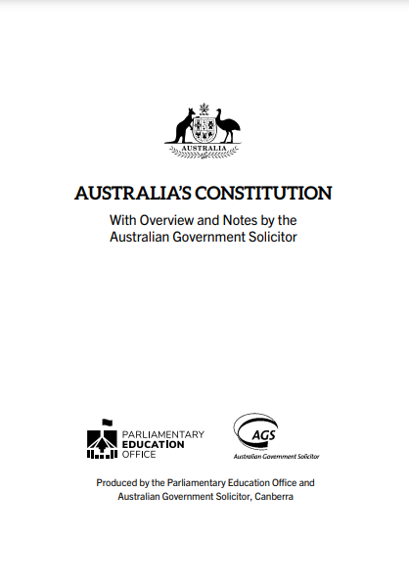 | 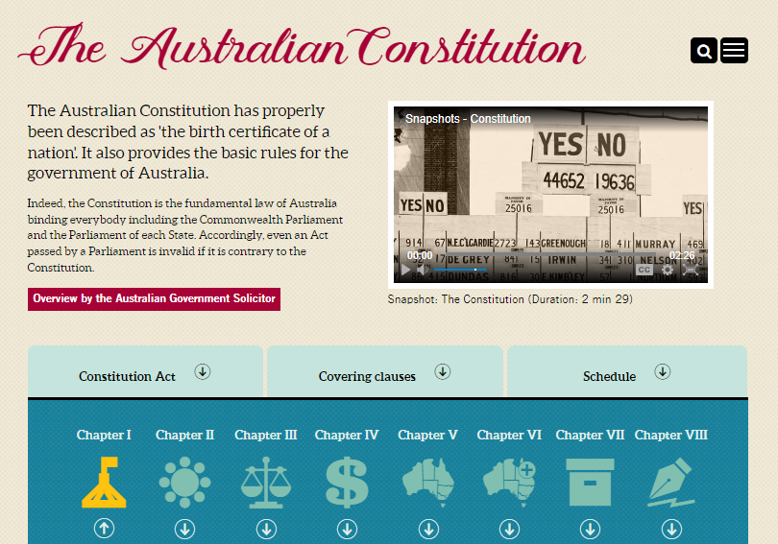 | 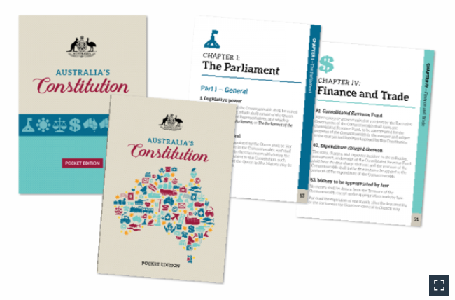

Australia's Constitution can be used by classroom teachers when undertaking a unit of work on the Constitution. The PEO highlights parts of the Constitution which are useful to explore as a class. Use the Constitution as a starting point to explore the following topics:
- the right to vote (section 41)
- the powers of the Australian Parliament (sections 51 and 52)
- how the Constitution can be changed (section 128)

Activity: Referendum Research
Discuss the information raised in the BTN Voice to Parliament Update story. What questions were raised in the discussion and what are the gaps in students’ knowledge? The following KWLH organiser provides students with a framework to explore their knowledge on this topic.

What do I know? | What do I want to know? | What have I learnt? | How will I find out?

Students will develop their own question/s to research or choose one or more of the questions below. Encourage students to collect and record information from a wide variety of sources and present the information they find in an interesting way.
Research Questions
- What is the Voice to Parliament? Write a summary which answers the 5 W’s – Who, What, Where, When and Why? Include the following words in your explanation: Uluru Statement from the Heart, referendum, First Nations Voice and constitution.
- What is the Australian Constitution? When and why was it written?
- What are the steps to change the Australian Constitution? Explain the process of a referendum. How many votes does a referendum need to be successful?
- How many referendums have been held in Australia? Use a timeline to highlight important referendums in Australia.
- Why was the 1967 Referendum important in Australia’s human rights history? Use the term constitutional recognition in your explanation.
- Create a timeline of significant events that have contributed to equal rights for Aboriginal and Torres Strait Islander Peoples. Write a summary for one key event, which answers the 5 W’s – Who, What, Where, When and Why?

Activity: Portrait
In this activity students will identity and understand the importance of individuals who have used their voice to make a positive change in society. As a class discuss the importance of individuals or groups who have used their voice to make a positive change in society and brainstorm a list of people that have made a significant impact.

Below are examples of Australians who have fought for the right to voice, such as civil rights activists, suffragettes, or advocates for free speech.

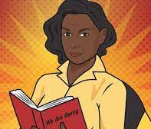  ABC Fierce Girls – Oodgeroo Noonuccal | 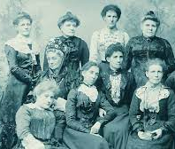  BTN – Australian Women in Politics | 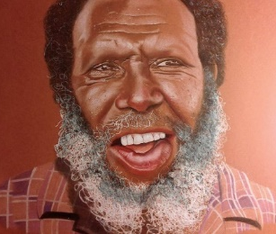  BTN – Mabo Day | 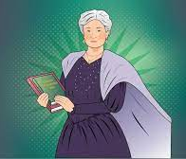  ABC Fierce Girls – Edith Cowan
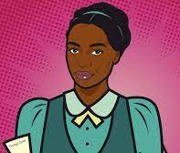  ABC Fierce Girls – Fanny Finch | 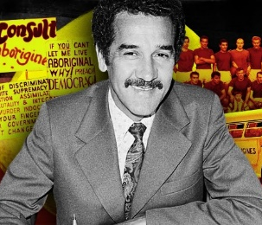  BTN – Charlie Perkins | 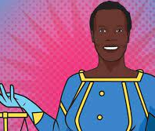  ABC Fierce Girls – Nyadol Nyuon | 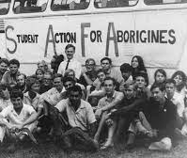  BTN – Freedom Ride

Students will then choose one of these people or groups that they find inspiring. Alternatively, they can choose someone in their community who has used their voice to make a positive change in society.

Students will use the following as a guide:
- Research the individual and record their achievements, their values, and the impact they have had on society.
- Use a range of primary and secondary sources during your research including biographies, articles, letters, speeches, artworks, photographs, and news stories.
- Plan and create a portrait of the person or group. Think about the expressions, symbolism, and colours that reflect the person, their values, and their impact.
- Explore and experiment with different techniques and mediums to produce a portrait.
- Present your portrait to the class, introducing who the person is, the impact they had and then explain your portrait and what each of the elements in the portrait mean.
- Organise a class exhibition of your artworks to share with the school and local community.

Activity: Classroom Constitution
In this activity, students will work together to create a classroom constitution, understand the importance of making decisions democratically, and then participate in a class referendum to vote on classroom rules.

Classroom Activity
Students will create their own classroom constitution and then hold a class referendum. Facilitate a class discussion to get your students thinking about what their classroom constitution might look like.
- Work as a class to brainstorm a list of values. Choose 5 core values, with each value having its own constitutional statement.
- Think of some rules and expectations of your class.
- How will you make sure all students are treated fairly and can have their fair say?
- How would it make you feel if you were left out of your classroom constitution?

Steps to creating a classroom constitution and holding a class referendum:

Consider your classroom as a country. Give your country a name and describe how it is run (rules and procedures). This is your classroom’s constitution.

Review and discuss your classroom constitution; does it include equal rights for everyone in your class? How can you improve it? Suggest any changes you would like to make to your classroom constitution. Remember any changes to your classroom constitution need to be voted on in a referendum.

As a class write a referendum question. Explain arguments for and against the change you want to make to your classroom constitution. Use this PEO activity to help run your class referendum.

Hold a classroom vote asking to either approve or reject the suggested change to your classroom constitution. Create a ballot paper and polling booth to lodge your votes. Visit the AEC to see what a ballot paper looks like and learn how to vote in a referendum.

Count the votes.

Useful Websites
- What is the Indigenous Voice to Parliament? Here's how it would work and who's for and against it – ABC News
- It's official — the Voice referendum is happening. Here's what comes next – ABC News
- Voice to Parliament – BTN
- Australia’s Constitution – BTN
- Referendum Campaign – BTN
- Referendums and Plebiscites – PEO
- The Statement – The Uluru Statement
- Referendums and Plebiscites – PEO

Nature
Education
Nature

EPISODE 18
27th June 2023

KEY LEARNING
Students will create their own creative story by developing storylines, characters and settings.

CURRICULUM
English – Year 4
Create and edit literary texts by developing storylines, characters and settings.

English – Year 5
Create and edit literary texts, experimenting with figurative language, storylines, characters and settings from texts students have experienced.

English – Year 6
Create and edit literary texts that adapt plot structure, characters, settings and/or ideas from texts students have experience, and experiment with literary devices.
  - Teacher Resource

Young Author

Focus Questions
Discuss the BTN story as a class and record the main points of the discussion. Students will then respond to the following:
- Where does Bodie live? Locate on a map.
- What is Bodie’s book about?
- Why did he want to write a book?
- If you were to write a book, what would it be about?
- When you write a story, where do you get your ideas from?

Activity: Class Discussion
Discuss the BTN Young Author story as a class. Brainstorm words that relate to books and stories and record responses on a mind map. Here are a few words to get the discussion started:

- Character
- Fiction
- Non-fiction
- Author
- Narrative
- Plot
- Themes

Discuss with students what makes a story engaging and compelling. For example:
- genres that you find exciting like adventure or science fiction.
- strong characters
- exciting action
- a surprising plot
- details about a place you’ve never been.

Activity: Glossary
Students will brainstorm a list of key words that relate to the BTN Young Author story. Here are some words to get them started.
AUTHOR | ILLUSTRATOR | FICTION
NARRATIVE | PLOT | GENRE

Activity: How to Build Stories
Students will write their own short story. As a class, make a list of useful tips for story writing. Include tips on how to build character development, plot tension and narrative. The ABC Education’s Digibook explains how to build your own stories, using tricks to create exciting characters, plots, settings, genres and language.

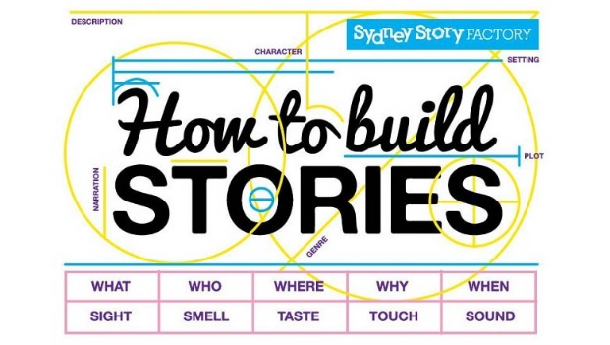
How to build Stories
Creating Characters
Understanding Story Plots
Genre and Setting
Language

More resources to help students write stories.
Ways to tell stories – Young writers Noa and Francis discuss choices they made when writing their published short stories.

Thinking about story themes – Noa and Francis talk about the main ideas they chose to explore in their stories.

Writing from experiences – Learn where student writers Noa and Francis found the ideas for their stories.

Young authors’ creative writing advice – Watch these two students talk about the advice given to them that helps them to write better stories.

Writing tips from author Andy Griffiths – Watch this video and learn how to write funny stories with tips from author Andy Griffiths.

Story Starters – Creative Writing Prompts.

Activity: Visual Storytelling
Visual storytelling and understanding the importance of narrative is key in the making of a successful picture book. Start this activity by asking your students what they think a picture book is and recording their ideas. Discuss the elements and techniques of effective storytelling.

In pairs, students will discuss what their favourite picture book is and why, using these questions to guide the discussion.
- What is your favourite picture book? Why?
- How did the illustrator and author make the story interesting or exciting?
- What did you like about the words and the pictures?
- Could the pictures tell the story without the words?
- What techniques does the illustrator use?

Use these FUSE teacher resources to help guide your students as they Make a Picture Storybook, Write a Picture Storybook, Illustrate a Picture Storybook, and Create a Storyboard.

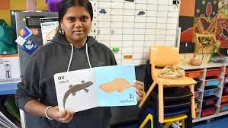
BTN Pitjantjatjara Book story
Meet Kellis, a 17-year-old Mirning, Kokatha and Pitjantjatjara artist who’s illustrated a picture book written in Pitjantjatjara.

Activity: Book Review
Students will choose a book they have read this year and then write their own book review. Students will respond to the following:
- Write a concise description of the plot.
- Who are the main characters in the book?
- What are the themes in the book?
- What did you like or dislike about the book?
- Would you recommend the book to other kids your age? Why or why not?
- Include an illustration with your review. It could be a sketch of the front cover or one of the characters from the story.
- Write a letter to the author of the book explaining your views on the book and asking any questions you have about the book.

Activity: Choose a Project
Students choose one of the following projects to work on and then present their work to a partner, small group or the class.

Cover Art
Redesign the front cover of one of your favourite books. Explain why you chose the design.
Rewrite the ending!
Rewrite the ending of the book. Explain why you chose to end it the way you did.
Book Illustrator
Watch illustrator Terry Denton talk about what he does to improve his illustrating. Have a go at illustrating a story.

Author Bio
Choose your favourite author and create a biography of them.

Useful Websites
- WA’s Bodie Howland, 9 publishes book about hometown Exmouth to top-up pocket money – ABC News
- Young Author - BTN
- Teen Novelist – BTN
- Writing and Illustrating with Andy Griffiths and Terry Denton – ABC Education
- How to build stories – ABC Education

  - Teacher Resource

BTN Transcript: Episode 18 - 27/6/2023

Hey, I'm Amelia Moseley and you're watching BTN. Thanks for hanging out with us again. Let’s see what’s coming up on today’s show. Should junk food ads be banned? Celebrating NAIDOC Week and we meet a young author who tells us all about his hometown in WA.

Voice to Parliament Update

Reporter: Cale Matthews

INTRO: We'll get to all that soon, but first up, to the upcoming referendum. Before the end of the year millions of Australians will vote on whether we should change the constitution to give Aboriginal and Torres Strait Islander people a Voice to Parliament. Now, if you're wondering what that all means, you're not alone. Lots of people still have questions about the referendum and how it'll work. So, let’s take a look.

MALARNDIRRI MCCARTHY, LABOR SENATOR: This is an incredibly significant day in the history of our country and of the Parliament.
PATRICIA ANDERSON, HUMAN RIGHTS ADVOCATE: This is big for us, and we can do better than we're doing.
ANTHONY ALBANESE, PRIME MINISTER: Parliaments pass laws but it is people who make history.
LINDA BURNEY, MINISTER FOR INDIGENOUS AUSTRALIANS: It's on.
It's officially official. In just a few months’ time millions of Aussies will be doing something they've never done before, vote in a referendum. Between now and then though, lots of people are going to have questions about what will happen. So, we asked what you wanted to know about this historic moment in Aussie history.
KID 1: What is this referendum actually about?
The referendum is essentially about two things. The first is to recognise Aboriginal and Torres Strait Islander peoples as the First Peoples of Australia. The second part is to set up a body known as a Voice to Parliament. The Voice will be a group of Indigenous Australians that advise and give recommendations to the government on issues that specifically affect them and their communities. It was an idea that formed a big part of this document, the Uluru Statement from the Heart, which was put together by Indigenous delegates from around the country back in 2017. They met at Uluru to talk about how Australia could work to improve the lives of Indigenous people.
KID 2: When will the referendum actually happen?
This one we're not too sure about. The Prime Minister hasn't officially set a date yet. What we do know though is that since legislation has passed it will happen no earlier than 2 months since the announcement and no later than 6 months.
KID 3: Why do we need a referendum?
Well, that's because the government wants to change the constitution, and every time we change something in our constitution, we have to see if the whole of Australia wants to change it too. The constitution is essentially a big legal document outlining how the country should be run, which is why changing it isn't easy. We've had 44 referendums in our history, and only 8 have been successful.
KID 4: What needs to happen for the yes vote to be successful?
In order for the yes vote to be successful, there needs to be something called a double majority. This means a majority of all eligible voters vote yes, as well as a majority of all the states vote yes as well.
KID 5: Why would someone say no to the referendum?
Recent polls tend to suggest that about 80 percent of Indigenous Australians support the idea of a Voice to Parliament, but that does leave some who are against it.
LIDIA THORPE, INDEPENDENT SENATOR: I'll be voting no to this disastrous idea of giving us no power.
Some say the changes won't actually make a difference to the lives of Aboriginal and Torres Strait Islander peoples, while other no campaigners are against the idea of a Voice because they say it could divide Australians based on their race.
JACINTA NAMPIJINPA PRICE, NATIONALS SENATOR: This Voice model is about empowering the elites.
Others say they need more information on what the Voice would actually do and how it would be set up, but the government says that sort of detail will come later. They just want people to vote on whether they think it should exist in the first place.
KID 6: How would the Voice to Parliament reflect the diverse voices within the Indigenous communities?
Amongst the two distinct cultural groups of Aboriginal and Torres Strait Islander peoples, there are more than 250 language groups spread across the country. While we don't know exactly how the Voice will be structured, the government often points to this report when asked about it. In here, it says there will be a National Voice, made up of 24 members: 2 from each state and territory, 5 from remote communities, 2 from the Torres Strait and 1 representing Torres Strait Islanders living on the mainland. There would then be 35 local voices representing districts across Australia, each designed and run by the communities they represent. These local voices would be able to have discussions with local, state and the federal government.
KID 7: How will the referendum affect non-Aboriginal and Torres Strait Islander peoples?
The short answer is this referendum likely won't affect the lives of non-Aboriginal and Torres Strait Islander people. The Voice will only advise the government on policies that directly affect Indigenous Australians, but it aims to close the gap and create a more equal Australia. Things like improving the life expectancy of Indigenous Australians, employment rates, and helping kids and teenagers finish school and find jobs, and that's good for everyone.
KID 8: What happens between now and the referendum?
Ah, a lot. We'll start to hear a lot of people campaigning for both the yes and the no vote. The government will be sending out pamphlets explaining the referendum, written by politicians who are on both sides of the argument and will be translated into 35 different languages and 20 traditional Indigenous languages. It's important to note that Prime Minister Anthony Albanese is campaigning for a yes vote
ANTHONY ALBANESE, PRIME MINISTER: This is a historic opportunity to make a difference.
And while the Opposition Leader Peter Dutton says he'll be voting no, some Liberal politicians actually quit their positions so they could support the yes vote.
JULIAN LEESER, FORMER LIBERAL FRONTBENCHER: I think the Voice can make a difference to Aboriginal people’s lives, I think it can improve the quality of policy making.
When the referendum happens, every eligible Australian will have an equal chance to vote yes or no in this defining moment in Australian history.

News Quiz

This is Air Marshal Darren Goldie. What new job has he taken on? Is it Air Force Chief, Governor-General, or cyber security coordinator? He’s Australia’s first cyber security coordinator. It'll be Air Marshal Goldie's job to work with the new National Office of Cyber Security to make sure Australia is ready to tackle even the most sophisticated cyberattacks and that we're prepared to take on any new threats of the digital age.
Which of these cities has been crowned the most liveable city in the world? Is it Vienna, Copenhagen or Melbourne? It’s Vienna. Melbourne finished in third in the Economist’s annual liveability index ranking of 173 countries. The cities were judged on things like health care, stability, infrastructure and environment.

Two thousand people have stripped off and dashed into the River Derwent in Hobart for a nude swim. What are they celebrating? It’s the winter solstice. June 22nd was the shortest day of the year in terms of daylight and the longest night. And these people say what better way to celebrate?

Junk Food Ads

Reporter: Josh Langman

INTRO: Now let's talk about ads for junk food. An independent politician wants them banned from being shown on social media and on TV between 6:30 in the morning and 9 at night. It's all about improving the health of Australian kids. Josh looks into it.

NAT: Oh, Joe, do you want to come for coffee this morning?
JOE: Yeah, um, should we bring Josh today?
NAT: No. Oh, no, no, no. We don't really bring Josh because…
JOSH: Hey.
NAT: Hey.
JOSH: Thick, juicy, flame-grilled patty with melted delicious cheddar cheese, eh?
JOE: Uh.
NAT: He watched too much TV as a kid, and now only speaks in burger-ad quotes.
JOSH: Oh, visit our drive-through where we serve up smiles 24 hours a day.
NAT: Yeah, okay. We're just going to get coffee now, Josh.
JOSH: Our special sauce creates a taste sensation in every bite?
NAT: Yep.
JOSH: Super-size meal deal, only available for a limited time.
Yeah, junk food ads can be kind of annoying, especially if you're hungry, but experts say they can actually have a real impact on what we eat.
DR SOPHIE SCAMPS, INDEPENDENT MP: One in four children are currently above the unhealthy weight range. And we know that children see 170 ads, either on social media or TV or hear them on radio every week. And there's also a direct link between seeing or hearing those ads and people's calorie intake.
That's Independent MP Dr Sophie Scamps, and she's on a mission to stop people, especially kids, from seeing so many of these. She says it can lead to serious health problems when kids grow up, like heart disease, diabetes and cancer. So, she's introduced a bill into Federal Parliament she hopes will change things. It would ban ads for unhealthy food on TV, radio and streaming platforms from the hours of 6am until 9:30pm, when kids are most likely to see them, and completely get rid of them on social media.
DR SOPHIE SCAMPS, INDEPENDENT MP: I should say there is a lot of support from the public for this. Over two-thirds of the Australian population would support a ban on junk food advertising on TV.
There are loads of other countries around the world that have already acted on this issue, including Norway, South Korea, Chile, and the UK. In Australia, up until now, it's been up to the advertising industry to set its own rules, and it says it already does a lot to make sure kids aren't exposed to advertising that could hurt them. A new survey from the Cancer Council has found around three-quarters of Aussie adults support a total ban on targeting kids online with unhealthy food and drink marketing.
DR SOPHIE SCAMPS, INDEPENDENT MP: Yeah, so the push for this is coming from families and parents, and I think the kids themselves. I happened to meet my kids' old public school here in Parliament House the other day, and they were all behind it. They didn't want to be bombarded with junk food ads, either.
So, is banning junk food ads the way to go? What do you guys reckon?
KID 1: It depends what they like classify as junk food. Like lollies, I think they should. But like restaurant burgers and chips? I don't think they should.
KID 2: Not banning, but they should definitely be limiting how much junk food they put on the TV, because lots of people have been becoming very unhealthy.
KID 3: It's, like, a good idea, but also, at the same time, it could be, like, less promoting for the companies.
KID 4: Since there have been so much junk food ads, I don't know if healthy food ads will have the same effect.
KID 1: Like if you're advertising carrots, I don't think many people would want to buy carrots as, like, if you're advertising a burger. I think just people think like vegetables are bad food, or not yummy.
KID 3: Maybe like, the parents could just, like, tell them to eat healthier food, but that might not really help as much.
NAIDOC Week 2023

Reporter: Jack Evans

INTRO: Next week is NAIDOC Week, which is all about celebrating Australia's First Nations peoples and their culture and this year's theme is For Our Elders. So, some students in Sydney sat down with local elders to have a chat and learn what life was like for them growing up.

STUDENT: What’s your name?
AUNTY ASHLEE DONOHUE: My name is Ashlee Donohue.
STUDENT: Who’s your mob?
AUNTY ASHLEE DONOHUE: Dhanggati. Born and raised in Kempsey.
AUNTY JANET LONG: My name is Janet Nakamarra Long. My mob are from Northern Territory, Alice Springs and I’m Warlpiri.
UNCLE JOHN "BOMMA" FRAIL: Bomber Frail.
STUDENT: Who’s your mob?
UNCLE BOMBER "BOMMA" FRAIL: Wyanga. But I've got two groups in Brewarrina.
AUNTY KIM CHAN: Kim Chan.
STUDENT: Who’s your mob?
AUNTY KIM CHAN: Wiradjuri.
AUNTY RHONDA DIXON GROVENOR: My name’s Aunty Rhonda Dixon-Grovenor. My mob is the Gadigal people from Warrane-Sydney area, the Bidjigal people from La Perouse, the Darug people from Western Sydney and the Yuin people from the far South Coast of New South Wales.
AUNTY LAUREL JOHNSON: My name is Aunty Laurel. My Mob is Birri Gubba from my mother and Wakka Wakka from where I was born.
AUNTY CATHIE CRAIGIE: My name is Cathy Craigie. I am Gamilaroi and Anaiwan, from northern New South Wales.
UNCLE ANTHONY ANSON: My name is Anthony Anson. My mob is Dixon and Mackenzies, which on country, that is Gomeroi and Yuin, Yuin nation.
UNCLE DUANE ROBERTS: My name is Duane Roberts.
STUDENT: What’s your mob?
UNCLE DUANE ROBERTS: Gamilaroi.
STUDENT: What was it like for you growing up?
AUNTY RHONDA DIXON GROVENOR: I grew up with all my cousins, so they're like my brothers and sisters, and we've got a big mob and we're there for each other.
UNCLE DUANE ROBERTS: It was fun, spent a lot of time with me cousins back home and enjoyed ourselves growing up.
AUNTY ASHLEE DONOHUE: We didn't have all this flash stuff that yous have today so we played actually in pine forests or would make little houses with the, with the nettles and what-not.
AUNTY CATHIE CRAIGIE: I was lucky, I was born in the bush, in the country. So, we used to run around in the bush down the river, play in the river.
AUNTY KIM CHAN: I had a lot of Aboriginal kids playing around. So, we all grew up together, and we had really cool teachers, and no uniform, yeah.
AUNTY JANET LONG: I used to ride horses with my friends and we used to go out hunting and get the food and riding donkeys as well.
STUDENT: Is there any advice you could give us kids and our generation?
AUNTY JANET LONG: That's a good question.
UNCLE DUANE ROBERTS: Just have fun growing up, enjoy yourselves and be good to your parents.
UNCLE ANTHONY ANSON: Make sure we smile and enjoy something every day.
AUNTY ASHLEE DONOHUE: And you can do and be anything that you want to be. The only thing that will ever stop you is yourself, my baby.
AUNTY LAUREL JOHNSON: Concentrate very hard on your schoolwork. It's very, very important.
AUNTY KIM CHAN: Stay at school. Get a good education. Be respectful to your elders and your mum and dad.
UNCLE JONH "BOMMA" FRAIL: Look after your family, one of the main things.
AUNTY CATHIE CRAIGIE: In our culture, older people, the elders, grandparents, and great-grandparents and aunties and uncles are considered to be the wise ones because they have spent more life learning things. So, we have to, we should respect them and listen to them.
AUNTY RHONDA DIXON GROVENOR: Go and talk to the elders and the aunties and uncles and the knowledge keepers and keep learning about your culture and talk about it, share it and engage in it because that's who we are. That's what makes us special and unique, is being Aboriginal and having our culture.
STUDENT: Thank you for answering our questions.
AUNTY ASHLEE DONOHUE: Thank you, you've been great. Best interview I ever had.

AUNTY CATHIE CRAIGIE: Get in here and have a little cuddle.

AUNTY ASHLEE DONOHUE: Bend down. Youse have got to bend down.

AUNTY LAUREL JOHNSON: Aw, big cuddle. Thank you. Big cuddle.

AUNTY CATHIE CRAIGIE: Who’s going to say cut?
Sled Dogs

Reporter: Josh Langman

INTRO: Have you ever seen a sled dog race? Well, it's a serious sport in lots of countries, even in ours where there isn't always a lot of snow. Josh found out how it works and what makes Siberian huskies just perfect for the job.
TAMMY HUNTER, NEW CLUB MEMBER: They don't seem to feel the load of it. They just tear off like a bullet.
TRISH CHAPMAN, CANBERRA SLED DOG CLUB: There's a little bit of insanity involved, definitely.
If you happen to be crossing a pathway at Kowen Forest in Canberra, you'll need to look both ways. Not just for cars, but also this.
ANDREW GERSBACH, HUSKY TRAINER AND BREEDER: It's a feeling that really can't be explained. And when I take people out with me to show them, they come back converted. They want to do it as well.
This is the sport of dog sledding, also known as mushing. It began over in Northern Canada thousands of years back, when First Nations peoples used dogs to pull them across land that was covered in snow. Later, European travellers used bigger teams of dogs to transport heavy cargo. It was also, well, pretty fun, and sled dog racing soon became a sport that's still a pretty big deal in this part of the world. Back in Australia, there's not quite as much snow so local mushers have found their own way of racing through the bush. And it can get pretty speedy.
ANDREW GERSBACH, HUSKY TRAINER AND BREEDER: At takeoff, you can reach speeds of 45 kilometres an hour. Generally, a fast team will average 32 kay's an hour, which is fast in anyone's book.
And while it might seem like a lot of work for a dog, their owners say these canines crave it.
TAMMY HUNTER, NEW CLUB MEMBER: When you do something that your dog is into with them, it increases your bond. They’re more likely to listen to you, they're more likely to stay close to you. I know, certainly, huskies are bred for this. It's part of their DNA, it's what they love to do. They love to carry loads and just run.
ANDREW GERSBACH, HUSKY TRAINER AND BREEDER: If you've got a dog that's a bit unruly at home, needs some exercise, come on out. We've got all the gear. We can help you get started. We can help you continue on in the sport. It's a great sport, but it is addictive.

Sport

The Maroons have taken out the 2023 State of Origin series again. The team smashed New South Wales 32 to 6 in front of a massive home crowd in game 2 of the three-game series. They'll still play the third and final game in a few weeks.
It was a different story in the Women's State of Origin. Game 2 was a tight one, with the Blues coming from behind to get the win. But it wasn't enough to win the series. The Maroons won big in game one, and there's no game three, so when the series drew, it all came down to points, and Queensland were pretty happy about it.
COMMENTATOR: The 2023 Women’s State of Origin series winners are the Queensland Maroons.
The Ashes are well underway, and the men's opening match was one for the history books. Australia had to chase down 281 runs in the final innings. 54 runs short and eight wickets down, Captain Pat Cummins led the team to an incredible victory.

COMMENTATOR: And aggression from the Australian skipper.

Usman Khawaja was named player of the match after two huge innings with the bat.
It's been a hard fought contest in the Women's Ashes as well, and both these sides have a lot to play for over the next five weeks.
Now to the European Team Championships, where Belgian shot-putter Jolien Boumkwo took one for the team and competed in the hurdles race. You see, both hurdles runners for Belgium were injured but someone needed to run, or the team would be disqualified. Jolien completed the race in 32.8 seconds, finishing in last place but earning her country two valuable points.
Young Author

Rookie Reporter: Bodie

INTRO: Finally, today, you're going to meet 9-year-old Bodie, who's just written, illustrated and published his very own book. It's all about his hometown of Exmouth in north-west WA, but I'll let Bodie tell you all about it.

BODIE HOWLAND, AUTHOR: Hi BTN. My name is Bodie Howland, I'm 9 years old, and I'm from Exmouth in Western Australia, and I've wrote and published my own book called The Love Hearts Explore Exmouth.
Exmouth is roughly 1,200 kilometres north of Perth. We're extremely remote, but the town thrives off tourism. Most people come here to Exmouth to see the Ningaloo Reef and the whale sharks. The Ningaloo Reef is just so alive with lots of sea animals. I love going snorkelling with the turtles. I love living in Exmouth because it is such a beautiful part of the world. I wanted to show everyone else that through my book.
It's about two love hearts who meet each other, like, they have no friends and then they just go around Exmouth seeing all the fun and cool things that Exmouth, this town, has to offer. “Their hearts were now full with love, friendship, and memories they have made exploring Exmouth.” Their hearts get more full and full with every time that they go and do a very fun adventure that they really liked doing. So, these were all the adventures I did with my family that made my heart full, and so, one day, I decided I could have put this into a book.
So, to print off my first book, I had to put in $100 of my birthday money, and my parents also helped me match it. So, I think I've sold roughly around 150 books so far. I was so stoked when I sold my first book. If you're in Exmouth, you can even buy it and even rent it in the Exmouth local library.

LIBRARIAN: You’ve got a membership with us, don’t you?

BODIE: Yes.

I just love writing and illustrating because it makes me feel so creative, and it lets my imagination run free all through my book. So, what's next? Should I write another book? Probably, I'm thinking about it. So, my advice to other kids who might like to write a book, get a piece of paper and a pencil, write down some ideas, and then just go along drawing, writing ideas and then until you know it, you have a book. Thanks BTN, I really hope I can see you in Exmouth, bye.
Closer

Ah, good work Bodie. Keep it up. Well, that's it. We're done and dusted for the week and for the term. We'll be back before you know it, but don't forget to watch Newsbreak at 6:25 every weeknight to stay up to date with everything that's going on in Australia and the rest of the world. Have the best holidays and I’ll see you really soon. Bye.

