EPISODE 21
2nd August 2022

KEY LEARNING
Students will view a range of BTN stories and use comprehension skills to respond to a series of focus questions.

CURRICULUM
English – Year 4
Use comprehension strategies to build literal and inferred meaning to expand content knowledge, integrating and linking ideas and analysing and evaluating texts.

English – Year 5
Use comprehension strategies to analyse information, integrating and linking ideas from a variety of print and digital sources.

English – Year 6
Use comprehension strategies to interpret and analyse information and ideas, comparing content from a variety of textual sources including media and digital texts.

English – Year 7
Use comprehension strategies to interpret, analyse and synthesise ideas and information, critiquing ideas and issues from a variety of textual sources.
  - Teacher Resource

Focus Questions
As a class, discuss the stories featured in the episode of BTN Classroom and record the main points of the discussion. Students will then respond to the following focus questions.

Garma Festival 2022
- What is the Garma Festival?
- Where is it held? Locate on a map.
- The word Garma is a Yolngu word meaning…
- At the Garma Festival, the Prime Minister announced a draft question for the ________________ that will be held within the next three years.
- What was discussed at the Youth Forum at Garma this year?

Check out the teacher resource on the Teachers page.

Inflation
- Inflation is when prices go __________over time.
- Australia is the only country experiencing inflation at the moment. True or false?
- What is Australia’s rate of inflation?
- What is contributing to inflation at the moment? Give at least one example.
- Give some examples of goods or services that have increased in price.

Foot and Mouth Disease
- What was the main point of the BTN story?
- Finish the following sentence: Biosecurity means to keep Australia safe from…
- What impact could an outbreak of foot and mouth disease have on Australia?
- What is being done to prevent foot and mouth disease entering the country?
- What questions do you have after having watched the BTN story?

Russia Space Race
- The space race was between which two countries?
- What was the name of the war between the United States and the Soviet Union in which they never directly fought each other?
- Who was the first human to be launched into space?
  - Yuri Gagarin
  - Alan Shepard
  - Neil Armstrong
- Which country was the first to land on the moon?
- Not long after the moon landing, the Soviet Union and the US started working together. True or false?
- What did Russia announce recently?

Check out the teacher resource on the Teachers page.

EPISODE 21
2nd August 2022

KEY LEARNING
Students will learn about the Yolngu people and the importance of the Garma Festival. Students will explore the cultural diversity of Aboriginal and Torres Strait Islander peoples.

CURRICULUM
HASS – Year 5
Evaluate evidence to draw conclusions.

The influence of people, including Aboriginal and Torres Strait Islander Peoples, on the environmental characteristics of Australian places.

HASS – Year 6
Experiences of Australian democracy and citizenship, including the status and rights of Aboriginal and Torres Strait Islander Peoples, migrants, women and children.

HASS – Year 7
The importance of conserving the remains of the ancient past, including the heritage of Aboriginal and Torres Strait Islander Peoples.

The process for constitutional change through a referendum.

How groups, such as religious and cultural groups, express their particular identities; and how this influences their perceptions of others and vice versa.

  - Teacher Resource

Garma Festival 2022

Focus Questions
Discuss the BTN story as a class and record the main points of the discussion. Students will then respond to the following:
- What is the Garma Festival?
- Where is it held? Locate on a map.
- The word Garma is a Yolngu word meaning…
- At the Garma Festival, the Prime Minister announced a draft question for the ________________ that will be held within the next three years.
- What was discussed at the Youth Forum at Garma this year?

This document may contain the names and images of Aboriginal and Torres Strait Islander people now deceased. It also contains links to sites that may use images of Aboriginal and Torres Strait Islander people now deceased.

Activity: Class Discussion
Discuss the BTN Garma Festival 2022 story in small groups or as a class. What questions do they have? Use the following questions to help guide discussion:
- What is the Garma Festival? What does it celebrate?
- Where is the Garma Festival held? Find North East Arnhem Land on a map.
- What does the word Garma mean?
- Who goes to the Garma Festival?
- Who are the traditional owners of the land, where the Garma Festival is held?
- What are some of the important issues that are talked about at the Garma Festival?
- What is the Uluru Statement from the Heart?

What questions do you have about the story?
What did you learn from the story?

Activity: Yolngu Culture
After watching the BTN Garma Festival 2022 story students will explore the culture and traditions of the Yolngu people. Students will develop their own question for inquiry or select one of the questions below.
- What is the language of the Yolngu people? Learn more about the different dialects. Learn some common Yolngu words. What does the word Yolngu mean?
- Where is Arnhem Land? Mark the approximate boundaries on a map. What are some special sites in Arnhem Land?
- Who are some well-known Yolngu artists and performers? Choose one to explore and learn about their life and art/music. Write a profile about them. Some well-known Yolngu artists and performers include: Yothu Yindi, Baker Boy, David Gulpilil, David Malangi, Guypunura "Janet" Munyarryun, Djalu Gurruwiwi and Geoffrey Gurrumul Yunupingu.
- Why is the cycad tree the most important tree of all for the Yolngu people? Learn more about the Yolngu seasonal calendar, and the plants and animals that are important to the Yolngu people.
- What is the Yirrkala bark petition? Use as many of these words in your explanation as possible: bauxite mine, bark petition, Gurindji people, Wave Hill, Whitlam Government and Aboriginal Land Rights act. Learn more about the petition on the National Museum of Australia website.
- Arnhem Land is the home of the yiḏaki. What is a yidaki and what is it used for? What role do termites play in the creation of a yidaki?

Further investigation
Students will explore the cultural diversity of Aboriginal and Torres Strait Islander peoples. Individually or in small groups, students will learn about the Indigenous group where they live and present what they have learnt to the class. Students will learn about the geographic location, language, culture, traditions, and histories. Below are some questions to help guide their research:

Language
What Indigenous language/s are spoken in your area? Learn more about the dreaming stories of the area. Illustrate an aspect of the dreaming story.
Geography
What is the geographic location? Find on a map. Mark important Indigenous sites on your map. What are songlines and why they are important?
Environment
What is the Indigenous word for ‘land’ in this area? Learn about the land and waters of the area. What plants and animals in the region are important to the Indigenous people?
Acknowledgement
Who are the traditional owners of the land on which your school stands? How can you acknowledge the traditional owners of the land?

Activity: Meet a Yolngu Family
In small groups or individually, students will complete this interactive activity made by the National Museum of Australia. Students will learn more about the culture, histories and traditions of the Yolngu people.

Students will enter the digital classroom and work through each module, including a video, comprehension questions, quiz, and interactive timeline.

National Museum Australia – Meet a Yolngu Family (Digital Classroom)
https://digital-classroom.nma.gov.au/games/meet-yolngu-family

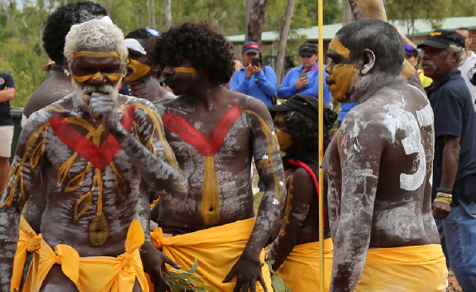 | Video  In this video students will meet Aunty Djapirri Yunupingu and her nephew, Gabirri. Aunty Djapirri is teaching Gabirri about some of the many traditional cultural and spiritual ways of life that Yolngu people have passed down through the generations.
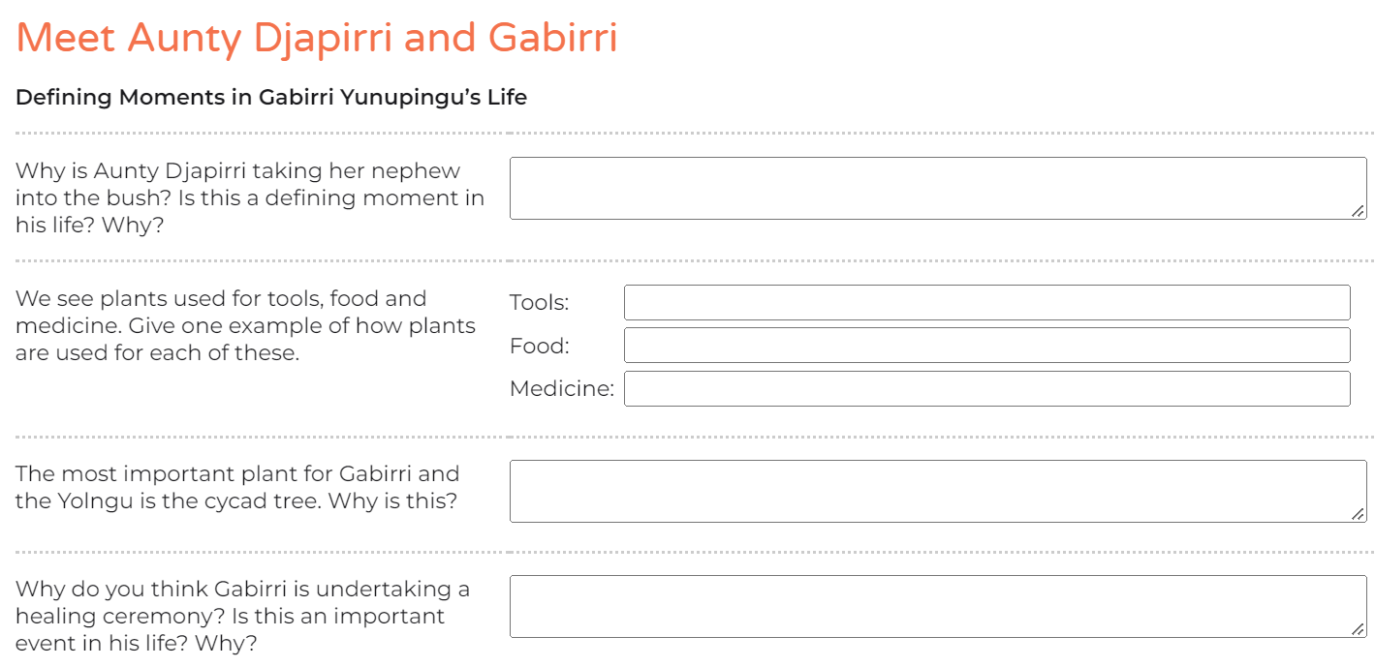 | Comprehension questions  After watching the video and learning about the culture and traditions of the Yolngu people students will then answer a range of questions.
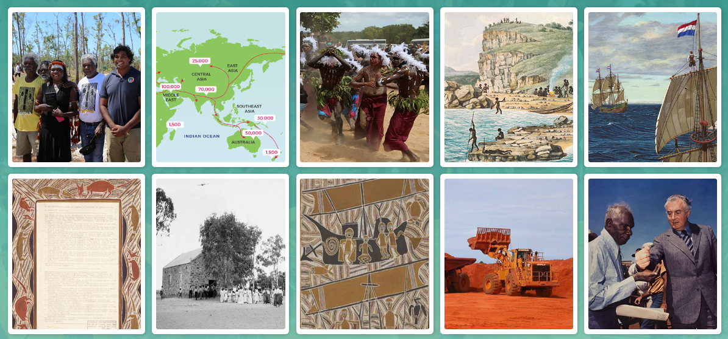 | Quiz  Students will do a multiple choice quiz to test their knowledge on defining moments in the history of the Yolngu people.
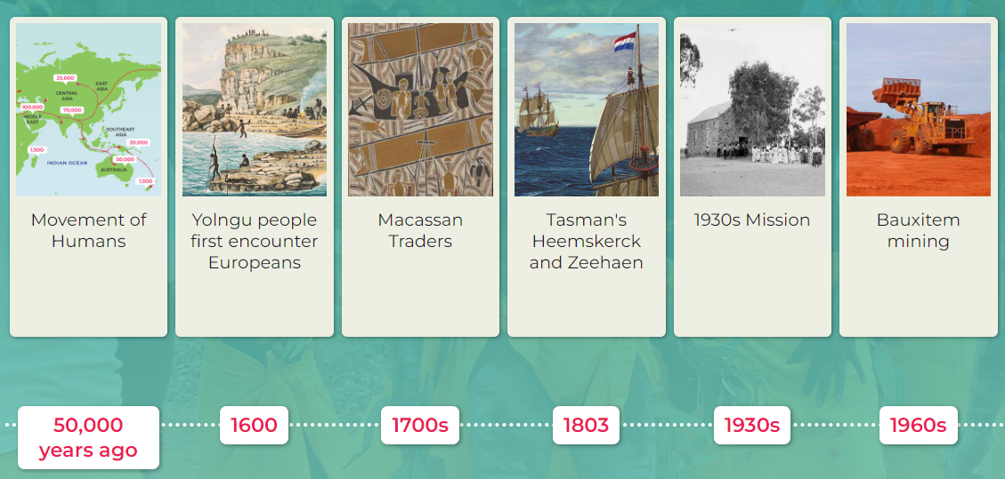 | Timeline  Students will use the information they have explored to complete a timeline of Yolngu history.

Activity: Indigenous Language
What do your students know about Indigenous languages? As a class explore Gambay, the first Australian map that allows Aboriginal and Torres Strait Islander communities control over the way their languages are publicly represented. It showcases over 780 traditional languages.

While exploring the map, students will investigate the following (either as a class or in small groups):
- On the Gambay map type in the area where your school is situated.
- What is the local Indigenous language in your area?
- Do your own research to learn more about the local language. Find out the local language words for hello and goodbye.
- Look for stories by Aboriginal and Torres Strait Islander peoples valuing their oral traditions. Can you find stories told through dance, song and other art forms as well as through text?

Teachers Notes to support teachers in teaching about Aboriginal and Torres Strait Islander Languages.

Activity: ABC Indigenous Languages
The ABC offers a range of videos and podcasts which encourage students to explore the diversity of Indigenous culture and languages.

ABC – Indigenous Languages

Little J and Big Cuz  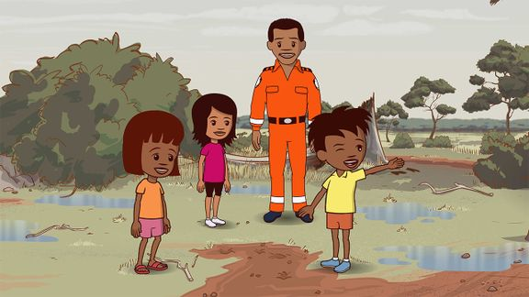 | Watch an episode of the ABC’s Little J and Big Cuz which are spoken in the Indigenous languages of Gija, Noongar, Torres Strait Creole, Palawa Kani, Warlpiri and Djambarrpuyngu. Find an episode in an Indigenous language local to your area. Link to iView videos
Education Good Mornings  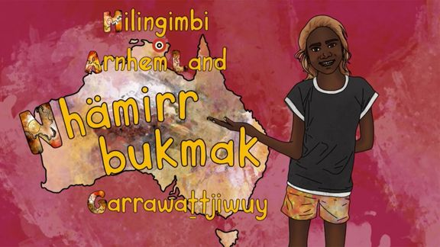 | How would you greet someone in the language of the land on which you live? In these ABC Education videos, children from around Australia encourage you to join them as they share greetings in their Indigenous languages.  Meet Garrawattjiwuy and learn how to say hello in the local language in Arnhem Land.  Link to iView videos
Little Yarns | Listen to the diverse languages, stories and Countries of Indigenous Australia in these Little Yarns audio resources. Teachers can check out the Educator Notes for ideas to get the most out of the Little Yarns podcast series.

Activity: Uluru Statement from the Heart
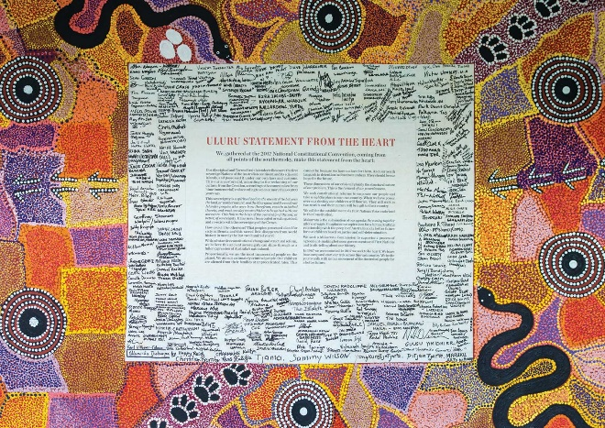
As a class read aloud the Uluru Statement from the Heart. Students can take it turns reading aloud the statement, or alternatively listen to the statement as read by Professor Megan Davis. Pause after reading each paragraph to clarify students’ understandings of any new words, terms, and concepts. Find meanings for the following words:
- Sovereignty
- Time immemorial
- The Constitution
- Constitutional reform
- Terra nullius

After reading the statement, students will respond to the following:
- How did the statement make you feel?
- What questions do you have?

Students will visit the National Museum of Australia website and read the Defining Moment in Australian history: 2017 ‘We invite you to walk with us’— Uluru Statement from the Heart issued
Students will then complete this quiz and answer the questions.

Activity: Indigenous seasonal calendars
The different seasonal calendars are really important to different Indigenous groups because they tell traditional owners the best times to hunt, fish and collect bush tucker. Watch BTN’s Special Indigenous Seasons stories to learn more about it! Use the BTN Teacher resource to extend your student’s knowledge.

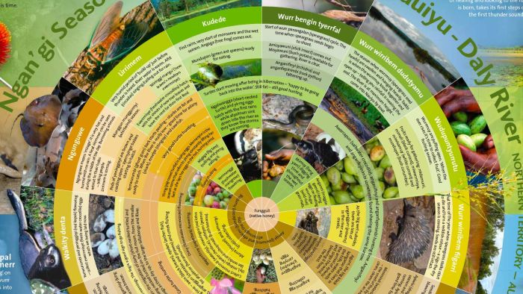  BTN Indigenous Seasons - Part I  Teacher Resource PDF | 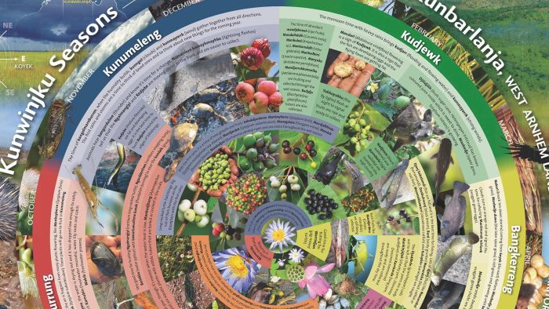  BTN Indigenous Seasons - Part II

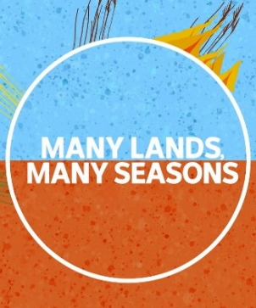
The ABC’s “Many Lands, Many Seasons” series explores six Aboriginal seasonal calendars to find out how the unique knowledge they contain helps the traditional owners to hunt, fish and collect bush tucker at the best time! Visit the Daly River, Fitzroy Valley and West Arnhem Land to learn more about the seasonal calendars in these aeras.

Learn more about the Indigenous Seasonal Calendar on the CSIRO website.

Activity: BTN stories
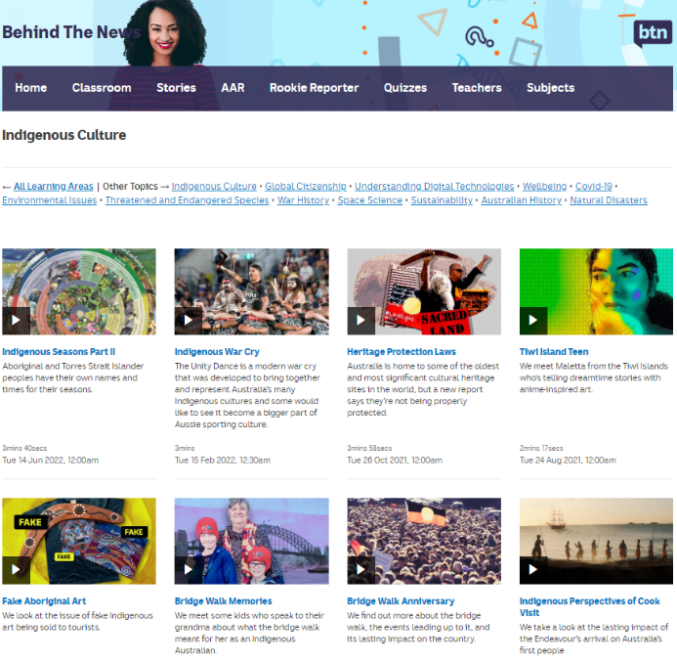
Visit BTN’s collection of stories which focus on Aboriginal and Torres Strait Islander peoples’ culture and issues.

After watching any one of the BTN videos ask students to respond to the discussion questions (to find the discussion questions and teacher resources go to the related BTN Classroom Episode and download the Episode Package).

Link to collection of BTN stories about Indigenous culture
https://www.abc.net.au/btn/indigenous-culture/10576610

Useful Websites
- Garma 2019 – BTN
- Garma Kids – BTN
- Garma Festival 2018 – BTN
- Referendum Campaign – BTN
- Welcome to Country Special – BTN
- Constitutional Recognition – BTN
- 1967 Referendum – BTN
- Yothu Yindi Foundation
- 2017 ‘We invite you to walk with us’ – National Museum Australia

EPISODE 21
2nd August 2022

KEY LEARNING
Students will learn more about the space race and key events in space exploration.

CURRICULUM
Science – Year 5
The Earth is part of a system of planets orbiting around a start (the sun).

Science – Years 5 & 6
Scientific knowledge is used to solve problems and inform personal and community decisions.

Science – Year 7
Scientific knowledge has changed peoples’ understanding of the world and is refined as new evidence becomes available.

  - Teacher Resource

Russia Space Race

Focus Questions
Discuss the BTN story as a class and record the main points of the discussion. Students will then respond to the following:
- The space race was between which two countries?
- What was the name of the war between the United States and the Soviet Union in which they never directly fought each other?
- Who was the first human to be launched into space?
  - Yuri Gagarin
  - Alan Shepard
  - Neil Armstrong
- Which country was the first to land on the moon?
- Not long after the moon landing, the Soviet Union and the US started working together. True or false?
- What did Russia announce recently?

Activity: Class Discussion
Discuss the Russia Space Race story as a class using the following questions to guide discussion:
- What is the space race?
- The space race was between which two countries?
- What did Russia announce recently?
- What is the International Space Station?
- Why do humans explore space?
- How has space exploration affected people’s lives?

Activity: Glossary
Students will brainstorm a list of key words that relate to the BTN Russia Space Race story. Here are some words to get them started.
COLD WAR | SOVIET UNION | SATELLITE
EXPLORATION | SPACE RACE | COSMONAUT

Activity: Milestones in Space Exploration
Students will look at the images below that relate to some key events in space exploration. Ask students to find out more about each event and choose at least two more milestones in space exploration.

They can use the following questions to help guide their research.
- What is happening in the image? What does it show?
- When did it happen?
- Why is the event an important milestone in space exploration?
- What question/s do you have about the image/event?
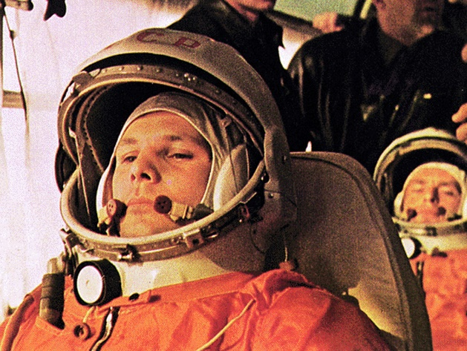
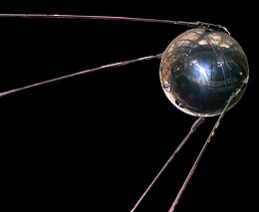

Source of image Source of image
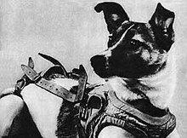
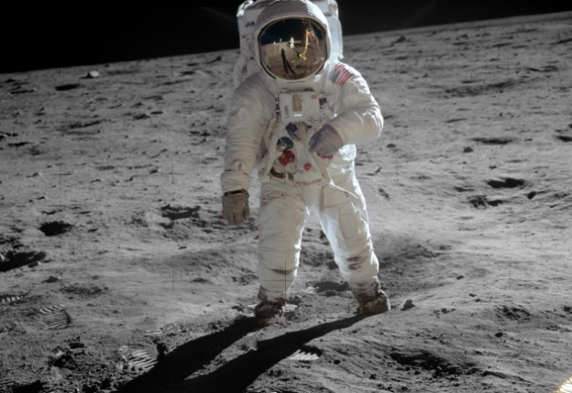

Source of image Source of image

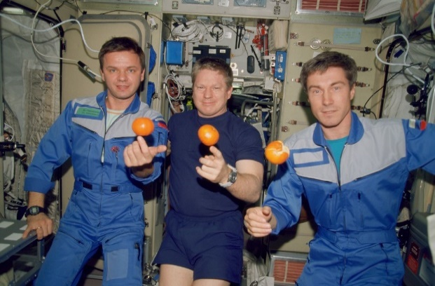
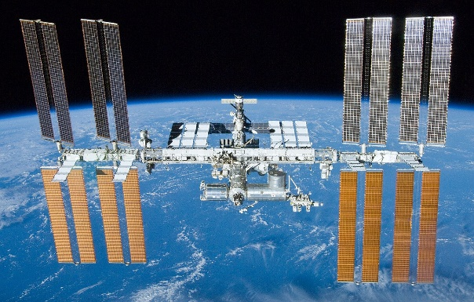

Source of image Source of image

Activity: Space Race Information Report
Students will create an information report about the space race. The following may help guide students’ research:
- What is the space race?
- When and why did it begin?
- Significant events in the space race.
- Impact of the space race on space exploration.
- Interesting facts about the space race.

Structure and features of an information report
Information reports are factual texts written to inform and provide detailed facts about a topic. Discuss with students what they already know about the purpose, structure, and features of an information report. Use the following as a guide to use with students.
- Purpose – An information report provides information to the reader by stating facts.
- Structure – see table below.
- Language features – write in the present tense, use technical or scientific words, and write in the third person.

Students can then use the following structure to help write their report. They can present their reports using publishing software or as a brochure.

Title
- States the topic.

Introduction
- The opening statement explains the subject of the report and includes a definition or short description.

Body
- Facts grouped into paragraphs. Starts with a topic sentence. Include subject specific language. Text features such as sub-headings, labelled diagrams, charts and captioned photographs may be included.

Conclusion
- A summary of what the topic is about and end with an interesting fact.

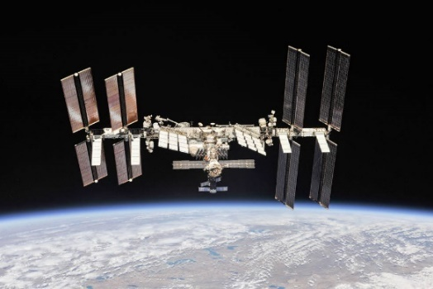
Activity: Get to know the ISS
Discussion questions
- What is the ISS? Why do we have an International Space Station?
- What do astronauts do on the ISS?
- How does the work carried out by the ISS astronauts contribute to science and affect life on Earth?
- What are some amazing moments on the ISS?
- How has technology used in space exploration changed over time?
Further investigation
- Learn more about the Spacewalks at the Station
- Find out what the astronauts are up to on the ISS and the research what they are doing by checking out the Space Station blog update
- Spot the International Space Station. Watch the ISS pass overhead from locations all around the world. It is the third brightest object in the sky and easy to spot if you know when to look. Enter your location to find out when you can see it.

Activity: Space Race Quiz
- The space race was part of which war?  A. World War II  B. Vietnam War  C. Cold War  - Which decade did the space race begin?  A. 1950s  B. 1960s  C. 1970s  - The space race was between which two countries?  A. US and Germany  B. Soviet Union and US  C. Soviet Union and Germany  - What were Soviet space pilots called?  A. Astronaut  B. Cosmonaut  C. Moscovite  Quiz Answers: 1C, 2A, 3B, 4B, 5A, 6A, 7C, 8B | 5. What was the name of Earth’s first artificial satellite?  A. Sputnik 1  B. Hubble  C. Explorer 1  6. Who was the first animal to orbit Earth?  A. Laika  B. Luka  C. Leticia  7. Who was the first person launched into space?  A. Neil Armstrong  B. Buzz Aldrin  C. Yuri Gagarin  8. What NASA program put people on the moon?  A. Sputnik  B. Apollo  C. Gemini

Useful Websites
- Russia is saying goodbye to the International Space Station, will this take the space race back to the future? – ABC News
- Russia will withdraw from the International Space Station after 2024, but US official says NASA has not been told – ABC News
- Space Race – BTN

  - Teacher Resource

BTN Transcript: Episode 21 - 2/8/2022

Hey, I'm Amelia Moseley and you're watching BTN. It's nice to be back in the studio with you again. Shall we see what's coming up in today's show? Yeah, let's do it. We learn why money isn't worth what it used to be, find out what you can and can't bring into Australia and explore the history and future of the space race.

Garma Festival 2022

Reporter: Jack Evans

INTRO: But first up today, we're heading to Yolngu country in Arnhem Land where the Garma Festival has just wrapped up. It's a big celebration of First Nations cultures and the Prime Minster was there to make a big announcement about an upcoming Australian referendum. Jack's been at Garma, and he found out what's been happening. Check it out.

PRESTON: Garma is this place where we all come together as family and the people teach us about their culture and their traditions and their way of living.
YUE HUN: It's a place where you can come together and just celebrate all the amazing culture and devils culture, we have over 60,000 years in Australia.
KALANI: Being at Garma it's pretty important to me because growing up I didn't know much about my culture.
If you don't know what Garma is, well it's one of the biggest festivals in Australia celebrating Aboriginal and Torres Strait Islander culture where, over 4 days, thousands of people come from all over to share their stories and their cultures.
JACK: It's held right at the top of the Northern Territory in North East Arnhem Land at Gulkula, which is a sacred site to the Yolngu people. The first one was held back in 1999, and it was pretty small compared to today. But the goal has remained the same.

And that is to share knowledge and culture to build a better understanding between Indigenous and non-Indigenous Australians. In fact, the word Garma is a Yolngu word meaning, two way learning process. And there is plenty of that going on.
YOUTH FORUM PRESENTER: You guys being leaders and being able to create the future that we want to see.
JACK: Behind me is the Key Forum. It’s where political and community leaders meet to discuss some big issues like whether or not to hold a referendum to change the Constitution to give Australia’s Indigenous people a permanent voice in parliament.
ANTHONY ALBANESE, PRIME MINISTER: I ask all Australians of good will to engage on this. If not now, when. If not now, when.
While there is no date set yet, the PM says that within the next 3 years every Australian over the age of 18 will we be voting yes or no on this question: do you support an alteration to the Constitution that establishes an Aboriginal and Torres Strait Islander Voice? It’s something a lot of people have been waiting to happen for a long time.
Dean Parkin, Director, From the Heart: That's how progress works in Indigenous affairs in this country. It's one small step after the other. Today was a really important step.
AALIYAH: Hopefully he can do a lot, like because you've got a lot of people out their saying that they'll do a lot, but they never do so this is his chance to prove himself and really stay true to his words.
You might remember we told you about it, last term. Back in 2017, hundreds of First Nations leaders met at Uluru and came up with this. The Uluru Statement from the Heart. It outlines a number of changes that First Nations people want to see, including changing the Constitution to create a new group in federal parliament, whose job it would be to advise the government on any laws and policies for Indigenous people.
JACK: It's not just the adults talking about big things at Garma. Over at the Youth Forum there are big conversations happening as well, although it’s usually off limits to adults, but fortunately, I'm just a big kid at heart so they let me in.
This year they have been further developing something called the Imagination Declaration. Which is their response to the Uluru Statement from the Heart.
KID: To move forward as a nation, so that reconciliation occurs to benefit the whole of Australia.
LOUIS: It's about like, what you want to do with the future? And like, looking ahead.
YOUTH FORUM PRESENTER: And it’s essentially your voice to parliament. It’s your voice saying you want to live in a better world, and you have the autonomy and the ability to be able to create that.
YUE HAN: While we imagine the vision, and what we want the future to be, a reconciled future based on justice and hope. But how are we going to achieve that? And what are the youth of Australia especially wants to see?
Of course, it's not just about politics. These guys have also been spending their days doing all sorts of things
PRESTON: We've been doing art, music and creating like magazines and that.
SOPHIE: So, we've been doing some workshops and activities. So, just then we did some stuff on the iPads.
And at the end of every day there is a bungul. It's a traditional dance that has been performed here for thousands of years. That brings everyone together and calls an end to a long day of sharing, learning, and celebrating.

News Quiz

Can you name this legendary Indigenous Australian musician, songwriter and artist who died over the weekend? It’s Archie Roach. The Gunditjmara and Bundgelung man was a stolen generations survivor and his songs helped to tell stories of Indigenous people.

ARCHIE ROACH: Doesn’t matter what, how your history’s been good or bad, or sad things in your history, you’ve got to tell it all you know.

He’s performed with artists around the world and is a member of the ARIA Hall of Fame.

Do you know which organisation this logo belongs to? Is it the World Health Organisation, the United Nations or NATO? It’s the World Health Organisation. Last week it declared a new global health emergency (I know, we all need that, right?). It says monkeypox, which has now been detected in 75 countries, is a public health emergency of international concern. Although there’s no need to panic. You can only catch it through close physical contact so it’s not going to be the next COVID.

WORLD HEALTH ORGANISATION REPRESENTATIVE: It's not the panic button, it’s the do things now so that none of us need to panic.

Which British city is hosting this year’s Commonwealth Games? Is it Glasgow, Birmingham, or Manchester? It’s Birmingham. Home to Cadbury chocolate, this awesome King Kong statue and, for a couple of weeks, 4,000 athletes from Commonwealth countries around the world.

This cave was discovered in which Aussie state? New South Wales, Victoria, or Tasmania? It was discovered 401 metres underneath Mount Field National Park in Tassie, making it the state’s deepest cave by 4 metres.

The residents of Ramsay Street said goodbye to the world last week when the last episode of Neighbours went to air. Which three of these celebrities have appeared on the show? It’s these three. Russell Crowe, Chris Hemsworth, and Margot Robbie all had roles on Neighbours. And they weren’t the only ones. The soap has started the careers of many Aussie actors and film makers and a lot of people were sad to say goodbye.

Inflation

Reporter: Cale Matthews

INTRO: Now, you might've noticed that some things are pretty expensive at the moment. Whether it's milk or petrol or rent, prices are up all over the place and a lot of people are worried about something called inflation. Cale's gonna tell us what that is.

1950s VOICEOVER: Darryl Chipsneak, test captain for Australia. Out on the pitch he's got a lot on his plate, but after the game there's only one thing in his glass.
DARRYL CHIPSNEAK: Wardell's Milk, it's the only milk I trust to keep my eye on the ball.
1950s VOICEOVER: How does it taste Darryl?
DARRYL CHIPSNEAK: Like a million bucks.
1950s VOICEOVER: Haha. Wardell's Milk, it's a million bucks for just 10 cents.
NAT: Oi grandpa. 10 cents for a litre of milk, is that for real?
GRANDPA: Of course, it is. You know, I used to go down the tuck shop, 10 cents in me pocket, we’d buy a packet of chips, a bag of lollies, a new car.
CALE MATTHEWS, REPORTER: You might have heard your parents, or your grandparents talk about how much cheaper things used to be when they were younger. Like 15 cent burgers, 8 thousand pound houses, or 50 cent movie tickets. These days things are a little more expensive and it’s all to do with.
GRANDPA: Inflation.
NAT: Inflation? What's that?

GRANDPA: Well.
CALE: Ah, I can take it from here, old timer. Inflation, put simply, is when prices go up over time, because of increased demand or because people have more money.

For example, say I owned a shop in this little village called, I dunno, Adelaide, and one day a giant pile of money falls from the sky and makes everyone in the village rich. People can now buy all of the things they always wanted, but I start running out of things to sell. So, I decide the best thing to do is raise my prices. Now, even though people have more money, they also have to spend more for the things they want, so their money isn't as valuable. This is inflation.
CALE: A little inflation is totally normal; in fact, it means the economy is growing. But every now and then, well, things can get a little out of hand.

NEWS PRESENTER: It’s no secret that the everyday cost of living has been getting more expensive.

Right around the world, inflation is hitting levels we haven't seen this century. In Australia it’s at 6.1 percent, which means on average, things are 6.1 percent more expensive than they were last year, and there's a few reasons for that.
FORMER AUSTRALIAN PRIME MINISTER, SCOTT MORRISON: We’re committing 130 billion dollars over the next 6 months.
Back in 2020 lots of governments gave out lots of money to help people through the pandemic. At the same time, lots of people were stuck at home with not a whole lot to spend their money on so they either saved it or spent it on stuff they always wanted. Meanwhile, factories were closing or understaffed because of lockdowns, and we started running out of all of that, you know, stuff. So, their prices went way up.

Then as the world opened up, we were hit with a bunch of disasters both natural and man-made, which made a lot of food and fuel really hard to get. The result? Worldwide inflation. Central banks in many countries, including this one, are trying to cut inflation by raising interest rates. Which makes it more expensive to borrow money and means there's less floating around to push up prices. But that can hurt families and the economy. Meanwhile, some people are also calling for an increase to wages so people can keep up with the rising prices. Either way fixing inflation is a really complex issue and one that I am going to leave to people a little bit smarter than grandpa.
NAT: So, how do we fix inflation grandpa?
GRANDPA: (snoring).
NAT: Grandpa. Oh, grandpa.

Did You Know?

Did you know, the highest rate of inflation ever was in Hungary after the Second World War? At one point things went up by a mind-boggling 41.9 quadrillion percent in one month and the government issued a 100 quintillion pengő note. That's 100 million, million, million, the largest denomination of currency ever printed.

Foot and Mouth Disease

Reporter: Michelle Wakim

INTRO: Now, if like me, you've just come back from an overseas holiday, you might've noticed Aussie airports are being extra strict about what you can and can't bring into the country and even how clean your shoes are. It's because of an outbreak of a disease in Indonesia that affects livestock and if it got into Australia, it could cause some big problems. Michelle can tell you more.
Seeing the world is a lot of fun: all the places to go, things to see and eat, and don't forget the souvenirs.

MICHELLE, REPORTER: But, when you are packing to come home, there are a few things to think about.

If you've travelled from overseas before, you've probably been through customs and been asked to declare if you have anything dangerous or anything containing animal and plant materials and, there's a good reason for that.
VIKKI FISCHER, DEPARTMENT OF AGRICULTURE, FISHERIES & FORESTRY: Australia is lucky that it doesn’t have a lot of the pests and diseases that are spread around the world. We have got extremely strong biosecurity rules, and we’re very proud of them.
This is Vikki, and she's a bit of an expert when it comes to biosecurity, that is keeping Australia safe from introduced pests and diseases.

NEWS REPORTER: Passengers arriving from Indonesia will be subject to tougher and tighter screening.

NEWS REPORTER: Biosecurity measures are being stepped up at Adelaide Airport.

NEWS REPORTER: Foot and mouth diseases fragments were also found in pork products.

While foot and mouth disease isn't dangerous to humans, it can be deadly for some animals and it's super contagious.
VIKKI FISCHER, DEPARTMENT OF AGRICULTURE, FISHERIES & FORESTRY: The reason we are so concerned about Indonesia is that, well one, Indonesia is very close, and two, Bali is in Indonesia and that’s a very popular tourist destination, particularly for Australians, so that increases the chance of people bringing home the disease.

If the disease got into Australia, it could cause 80 billion dollars’ worth of damage. Red meat, wool and live animal exports would all have to stop, and livestock would either be locked down, or put down to stop the spread.
LYN NITSCHKE, FARMER: It's not just the livestock, it flows down the chain. It's all the jobs and the unemployment. It would cripple livelihoods; it would cripple everything.
MICHELLE: You see, foot and mouth disease spreads really easily in soil, which can end up on our clothes, and particularly on our shoes.

So, people coming back from Indonesia are being told to either wash their shoes well, or even throw them out. And, as an extra precaution, airports have brought in these special germ-killing mats. Some people say it's not enough, and there have even been calls to pause travel to-and-from Indonesia. In any case, Vikki says it's a good reminder to all of us to be careful about what we bring into the country and declare anything we're not sure about.
MICHELLE: Um, well, I have my suitcase here. I’d love to know about what I would be allowed to bring. To start off with, I have some dried plums.
VIKKI: Oh. I hope you enjoyed those plums while you were on holidays and I can understand why you would like to bring them home, but dried plums such as these could present a biosecurity risk. You must declare that.
MICHELLE: OK, I have a meat product that I found at a market?
VIKKI: That’s a very, very big no.

MICHELLE: Very big no, OK.

Cook it and eat it in country. Enjoy it where you are, write your notes on how fantastic it tasted. Take the picture, send it home, but please don’t bring it back with you.
MICHELLE: Some wood souvenirs that I’ve found.
VIKKI: The problem we have with wood products, is that they may hide something inside that we might not be able to see, little, little bugs that burrow in and can't be seen. So, again, please do declare all wood products.
MICHELLE: Declare, always. Yes OK.
VIKKI: Declare, declare, declare.
MICHELLE: Do you have any general tips for people who are overseas getting excited with souvenirs?
VIKKI: I always say take a photo. And in the souvenir shop, maybe go for the very processed items. You know, snow globes are great.
MICHELLE: Snow globes are safe.
Sport

There's been a gold rush for Australia at the Commonwealth Games in Birmingham. As of Monday, Australia was topping the medal tally with a total of 52 medals, that's 22 gold medals, 13 silver and 17 bronze.
In the pool Emma McKeon earnt her record breaking 11th gold medal after taking out the 50 metre freestyle. She was followed by Aussies Meg Harris and Shayna Jack in second and third place, making it a clean sweep for the Aussies. In the women's 4 by 200 metre freestyle relay Australia set another record finishing a whopping 12 seconds ahead of Canada who came in second place and Olympic gold medallist Ariarne Titmus brought the team home. Kalyee McKeown also put on a great show to take gold in a thrilling women's 100 metre backstroke final.
Away from the pool the Aussie Women's sevens team won gold with a 22 to 12 victory against Fiji. Georgia Godwin won the all-round rhythmic gymnastics final, and Matthew Richardson gave a gold-medal winning performance in the men's sprint. Kristina Clonan took home gold in the 500 metre time trial and Georgia Baker kept the golden run coming in the women's 25 kilometre points race.
Jessica Stenson earnt gold in the women's marathon while Madison de Rozario was also on the podium with gold for the women's wheelchair marathon. And Australian para-swimmer Katja Dedekind has set a world record in winning the women's 50 metre freestyle S13 gold medal.

Russia Space Race
Reporter: Cale Matthews

INTRO: Now to some big space news. Last week Russia announced it's planning to leave the ISS and build its own space station. It'll mean the end of a decades-long cooperation between NASA and Russia's space agency, and it could mean the start of a new space race between two old rivals. Here’s Cale.

For the last 22 years, floating above our heads, there's been a place where everyone gets along. Look at those hugs. They sing songs, do some serious science, and keep an eye on the weather down below. That place is the International Space Station and since the very beginning Russians and Americans have been living up there, side by side. But it hasn't always been floating handshakes and cuddles between these two nations.
NEWS PRESENTER: This is the day the United States surpasses the Soviet Union in space for the first time.
Welcome to the 1950s. Russia was part of the Soviet Union and locked in a big political arm wrestle with the USA known as the Cold War. Pretty quickly the rivalry spilled into space. In 1957 the Soviet Union stunned the world, launching the first artificial satellite called Sputnik. This little sphere pushed the USA to create its own space agency, NASA, and the space race was on.

NEWS PRESENTER: Another spectacular year in the space race.
Next, up went the animals. In 1957 the Soviet Union launched Sputnik 2, which some people actually called Muttnik, because on board was the very first animal sent into space, Laika the dog. Then America went one better with Ham the Chimpanzee, and finally the Soviets sent, well, a person. In 1961 cosmonaut Yuri Gagarin became the first man in space. It was a quick lap around the Earth in a capsule known as Vostok 1, but it was a trip that sparked a new goal for the United States.
JOHN F. KENNEDY, FORMER US PRESIDENT: We choose to go to the Moon in this decade and do the other things, not because they are easy, but because they are hard.
The 60s became a race to land a man on the moon and, well, you all know who won.

NEIL ARMSTRONG: It’s one small step for man, one giant leap (for mankind).

Yeah, yeah, Neil we know the line. Not too long afterwards, the two nations actually started working together. In 1986 the Soviet Union launched the space station, known as Mir, and in its 15 years of operation it was open to countries around the world, including the USA. Then in 2000, on board a Russian Soyuz Spacecraft, two Russians and an American docked at the brand new International Space Station, becoming its first long term crew and everyone became one big happy space family.
Now, things are set to change. Russia's space agency, Roscosmos has announced that after 2024 its cosmonauts will be leaving the space station for good. They say they're going to work on their own space station, which was kind of a shock to the US.
NED PRICE, US STATE DEPARTMENT SPOKESPERSON: I understand that we were taken by surprise by the public statement that went out.
It's no secret that Russia and the US aren't the best of friends at the moment, and some worry that the tradition of international cooperation in space is coming to an end and a new space race is beginning, this time with a lot more competitors. For now, these Russian space explorers will continue working with their US colleagues in the space station that they built together.
Did You Know?

Did you know Russian cosmonaut Valeri Vladimirovich Polyakov holds the record for the longest single stay in space. In 1994 and 1995 he spent 14 months onboard Russia's Mir space station.

Closer

Well, that's it for this week's show, but don't you worry, we'll be back next week with more news. And in the meantime, you can check out our website or subscribe to our YouTube channel if you're 13 or over. And of course, Newsbreak will be right here in the studio every day to keep you up to date. Have a great week and I'll see you real soon. Bye.

