EPISODE 6
12th March 2024

KEY LEARNING
Students will view a range of BTN stories and use comprehension skills to respond to a series of focus questions.

CURRICULUM
English – Year 4
Use comprehension strategies to build literal and inferred meaning to expand content knowledge, integrating and linking ideas and analysing and evaluating texts.

English – Year 5
Use comprehension strategies to analyse information, integrating and linking ideas from a variety of print and digital sources.

English – Year 6
Use comprehension strategies to interpret and analyse information and ideas, comparing content from a variety of textual sources including media and digital texts.

English – Year 7
Use comprehension strategies to interpret, analyse and synthesise ideas and information, critiquing ideas and issues from a variety of textual sources.
  - Teacher Resource

Focus Questions
As a class, discuss the stories featured in the episode of BTN Classroom and record the main points of the discussion. Students will then respond to the following focus questions.

Russia Election
- Where is Russia? Find on a world map.
- Vladimir Putin is the longest serving leader in Russia. True or false?
- What was Vladimir Putin’s job before he became the president of Russia?
- What happened to the Russian opposition leader?
- What did you learn watching this story?

Microplastics Conference
- Discuss the issues raised in the BTN story with another student. Record the main points of your discussion.
- How much of Australia’s plastic waste is recycled each year?
  - 13%
  - 23%
  - 33%
- What are microplastics? Give an example.
- Where might you find microplastics?
- How do microplastics end up in our food?

Five Dollar Note Design
- Who are the people on Australia’s banknotes? Name one.
- Who produces Australia’s banknotes?
  - National Bank Australia
  - Reserve Bank Australia
  - Royal Australian Mint
- What will replace Queen Elizabeth II on the $5 banknote?
- Australians can have their say on the design of the new $5 bank note. True or false?
- What Indigenous design would you like to see on the $5 banknote?

Check out the teacher resource on the Archives page.

Puppet Masters
- When did puppetry originate?
  - 40 years ago
  - 400 years ago
  - 4,000 years ago
- Describe the puppets featured in the BTN story.
- How do the puppeteers operate the puppets? Describe.
- What is the puppet ‘Little Amal’ based on?
- What did you like about the BTN story?

Cathy Freeman – Women’s History Month
- Where was Cathy Freeman born? Find on a map.
- What year did Cathy Freeman become the first Indigenous Commonwealth gold medallist?
- Which Olympic Games did Cathy Freeman win the 400 metre gold?
  - Atlanta 1996
  - Sydney 2000
  - Athens 2004
- What flags did Cathy Freeman carry on her victory lap?
- Why do you think Cathy Freeman is an important Australian?

Check out the teacher resource on the Archives page.

EPISODE 6
12th March 2024

KEY LEARNING
Students will learn more about the significant people on Australia’s banknotes. They will also come up with ideas for the redesigned $5 banknote.

CURRICULUM
HASS – Years 5 & 6
Develop appropriate questions to guide an inquiry about people, events, developments, places, systems and challenges.

Sequence information about people’s lives, events, developments and phenomena using a variety of methods including timelines.

History – Year 5
The role that a significant individual or group played in shaping a colony.

History – Year 6
The contribution of individuals and groups to the development of Australian society since Federation.

  - Teacher Resource

Five Dollar Design

Focus Questions
Discuss the BTN story as a class and record the main points of the discussion. Students will then respond to the following:
- Who are the people on Australia’s banknotes? Name one.
- Who produces Australia’s banknotes?
  - National Bank Australia
  - Reserve Bank Australia
  - Royal Australian Mint
- What will replace Queen Elizabeth II on the $5 banknote?
- Australians can have their say on the design of the new $5 bank note. True or false?
- What Indigenous design would you like to see on the $5 banknote?

Activity: Reimagine the $5 Banknote
The BTN story explained the RBA campaign to redesign the $5 banknote. Working in pairs or small groups, ask students to come up with some ideas for the new $5 note. They want to hear your; ideas, themes, whether it's a story passed down generations, a location, an instrument or object that binds community.

If one theme could honour Aboriginal and Torres Strait Islander people and cultures, what would it be?

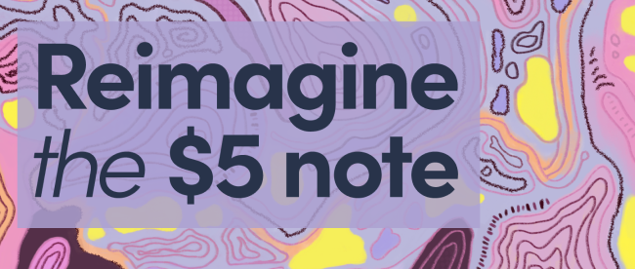
Students can submit their ideas here

Activity: Noteworthy People
Australia's banknotes feature a range of famous people that have made important contributions to Australian society. Students will choose a person that is featured on one of Australia’s banknotes, investigate their contribution to Australian society and create a biography highlighting their achievements.
They will find out as much as they can about the person using a range of sources. The Reserve Bank of Australia has information about people on the banknotes and noteworthy people to get students started. There is a template at the end of this activity for students to record their information.

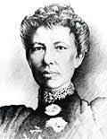
Use the questions below to get a class discussion started with your students about biographical writing.
- What does a biography tell us about a person?
- Where can you look to find information for your biographical writing?
- What makes a biography interesting? For example, key information and facts, a timeline of events, photographs, illustrations and quotes.

Using the biography worksheet at the end of this activity, students will research and record their information. Some possible areas of research include:
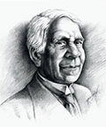
- When and where were they born? Describe their family life growing up.
- What are some of their achievements? What area of science did they focus on?
- What inspired/motivated them? Who were their role models?
- What were their challenges?
- What are some of their achievements? Choose one to explore in more detail.
- What contributions did they make to Australian society?
- What do you admire about them?

Further investigation
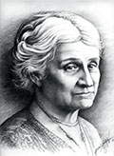
- Create a timeline of significant events in their life.
- What are some of the key events in their life? Write a summary for one key event, which answers the 5 W’s – Who, What, Where, When and Why?
- Imagine you could sit down and talk to them. What questions would you ask about their life and achievements?
- Write a letter thanking them for their achievements.
- Make a Did You Know for other students.
- Create a portrait.

Activity: Design your own banknote
Refer to the RBA’s design a banknote activity to help guide this activity. Students will need to consider the following when designing their banknote:
- Numeral
- A chosen colour
- The name of the country
- Your noteworthy person – write a short paragraph explaining why you chose this person
- Pictures that say something about what the person has done
- Patterns
- Security features

Activity: The next generation of banknotes
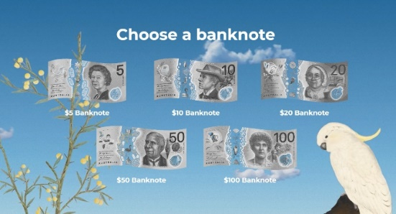
Students will explore the next generation of banknotes. Ask them to:
- Choose a banknote
- What are the cultural features of the banknote?
- What are the design and security features?
- What did you learn about the banknote you chose?
- What was surprising?

Activity: Banknote games
Put your know to the test and spot the security features on Australia’s banknotes. Play Eye Spy security features. How well do you know the people featured on Australia’s banknotes? Play this game to learn more about the identity of the people featured on Australia’s banknotes.

Activity: Tactile banknotes
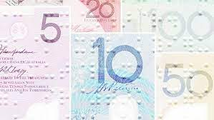
Meet Connor – he petitioned the Reserve Bank of Australia to add a Braille label to notes so he could tell how much they're worth. Students watch the BTN Tactile Banknotes story to find out more, then respond to the following questions.
- How does Connor read?
- What are tactile banknotes?
- Why did Connor want Australia to get tactile banknotes in Australia?
- Which country has tactile banknotes?
- What action did he take to get tactile features on Aussie banknotes?

Useful Websites
- New Five Dollar Note – Newsbreak
- Reimagine the $5 note – Reserve Bank Australia
- Australian $5 note redesign won’t feature King Charles, as Queen Elizabeth portrait removed in update – ABC News
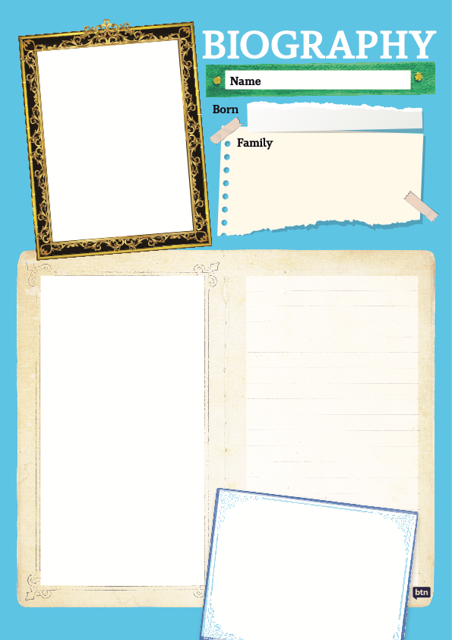

EPISODE 6
12th March 2024

KEY LEARNING
Students will recognise and celebrate Australian women who have made significant positive changes in society.

CURRICULUM
HASS – Year 3 and 4
Pose questions to investigate people, events, places and issues.

Locate and collect information and data from different sources, including observations.

HASS – Year 5 and 6
Develop appropriate questions to guide an inquiry about people, events, developments, places, systems and challenges.

Locate and collect relevant information and data from primary sources and secondary sources.

History – Year 6
The contribution of individuals and groups to the development of Australian society since Federation.

HASS – Year 7
Construct significant questions and propositions to guide investigations about people, events, developments, places, systems and challenges.

  - Teacher Resource

Cathy Freeman - Women’s History Month

Focus Questions
Discuss the BTN story as a class and record the main points of the discussion. Students will then respond to the following:
- Where was Cathy Freeman born? Find on a map.
- What year did Cathy Freeman become the first Indigenous Commonwealth gold medallist?
- Which Olympic Games did Cathy Freeman win the 400 m gold?
  - Atlanta 1996
  - Sydney 2000
  - Athens 2004
- What flags did Cathy Freeman carry on her victory lap?
- Why do you think Cathy Freeman is an important Australian?

Activity: Personal Response
Respond to the BTN Cathy Freeman story as a class. Students will complete one or more of the following incomplete sentences:

- Cathy Freeman is an important Australian because…
- It was interesting to learn…
- These are five words that I would use to describe Cathy Freeman …
- This story made me feel…
- It is important to celebrate Cathy Freeman because…

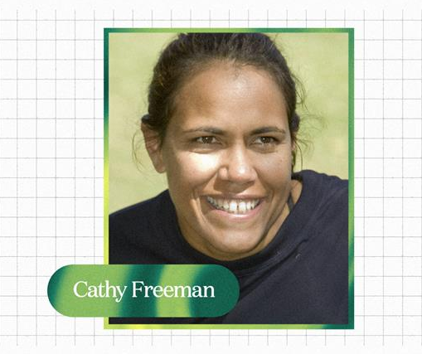

Activity: Visual Literacy
In this activity students will examine, analyse and query a range of images featuring Cathy Freeman during the 2000 Olympic Games. Encourage students to provide detailed and thoughtful responses based on their analysis of the photos. Students will gain an understanding of the significance of Cathy Freeman's gold medal win as a symbol of national unity and reconciliation in Australia.

Students will choose one of the photographs below (alternatively, students can find an image themselves to analyse). Students will then respond to the following:

- What do you see in this image?
- What significant moment or event does the image relate to?
- When and where was the photo taken?
- What do you think is happening?
- If there are people in the image, who do you think they are?
- How do you think they might be feeling?
- How does the image make you feel?
- What question/s would you like to ask the people in the image?
- Create a caption for each image.

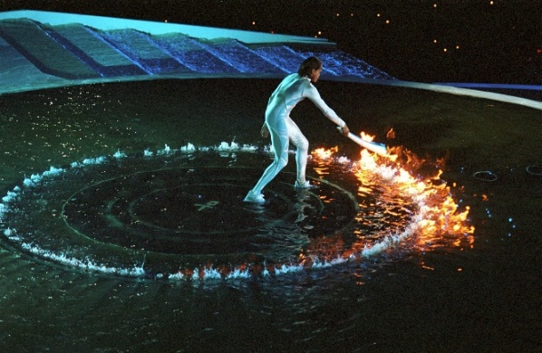  Image Source (IOC) | 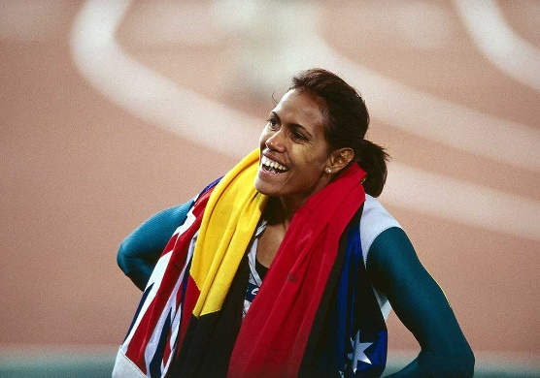  Image source (NMA)
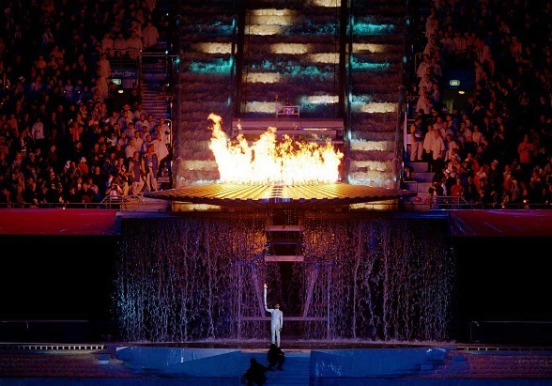  Image source (NMA) | 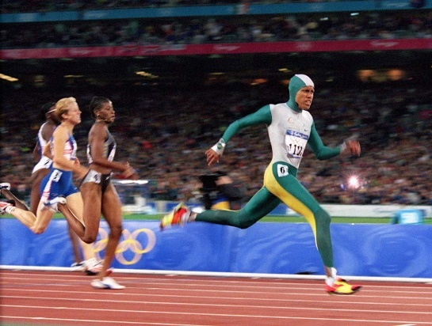  Image source (NMA)

Activity: Symbol of Reconciliation
Students will analyse how Cathy Freeman's victory became a symbol of hope, unity, and reconciliation for the nation. Choose one or more of the following activities to complete individually, in small groups or as a whole class.
- Discuss as a class, the symbolism of Cathy Freeman’s win.
- Students will analyse the images (in the Visual Literacy activity above) and identify symbols that represent hope, unity, and reconciliation. For example, Cathy Freeman lighting the Olympic cauldron at the opening ceremony, carrying both flags for her victory lap, wearing a green and gold bodysuit, and red, yellow, and black shoes.
- Why was Cathy Freeman chosen to light the Olympic flame?
- What impact did Cathy Freeman have on Australian society?
- Can you think of other examples where sports have played a role in promoting unity and reconciliation? Explain using your own words.
- In 2000 the Olympic torch was carried by 13,400 torchbearers. After Olympic champion Herb Elliott carried the torch into the stadium, the last six torchbearers were famous Australian women Olympians. Cathy Freeman was the final torchbearer and had the honour of lighting the Olympic cauldron. Analyse the importance of the torchbearers at the Sydney Olympics.
- Students will create an artwork that symbolises unity and reconciliation inspired by Cathy Freeman’s win.

Activity: Watch the Race
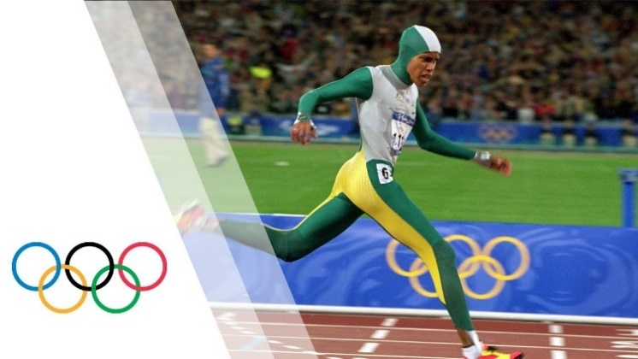
As a class watch Cathy Freeman as she wins the women’s 400 metre race at the 2000 Sydney Olympic Games.

Watch the Race
Video – without commentary
Video – with commentary (scroll down)

Class discussion
Use the following questions to start a class discussion.

Olympics - Cathy Freeman Wins 400 m Gold Sydney 2000 Olympics - YouTube video (IOC)
- What do you see?
- What do you hear?
- What is happening in the video?
- How did the video make you feel?

Add your own commentary
Individually or in pairs, students will try and have a go at commentating Cathy Freeman’s race using their own words. Students will write a script and then read it whilst watching the race. In this activity students will need to demonstrate good communication skills, knowledge of sports terminology, and the ability to engage and captivate an audience.

Activity: First Nations Sportswomen
In this activity students will learn more about significant First Nations sportswomen, their accomplishments, and their impact on sport in Australia. Students will choose one sportswoman they find inspiring and would like to learn more about. Students may want to explore the ABC’s Fierce Girls, a podcast that tells the stories of some of Australia's most extraordinary women, including many significant sportswomen.

ABC Fierce Girls
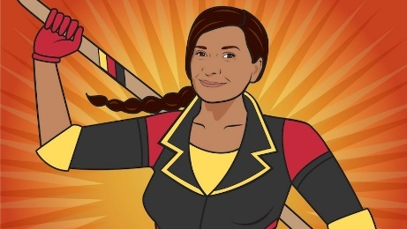  Nova Peris (ABC) | 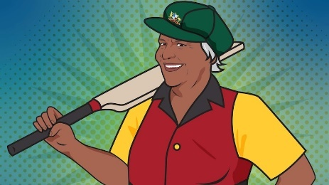  Faith Thomas (ABC) | 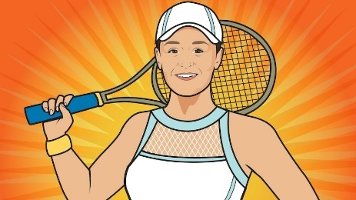  Ash Barty (ABC)
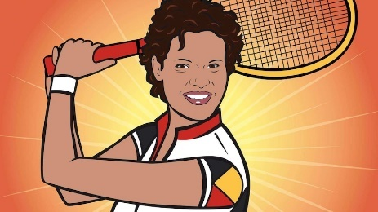  Evonne Goolagong Cawley (ABC) | 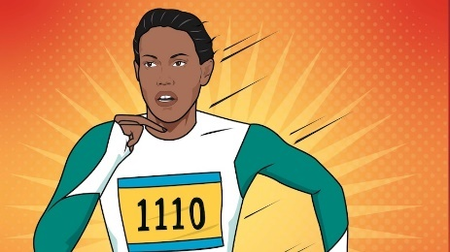  Cathy Freeman (ABC) | 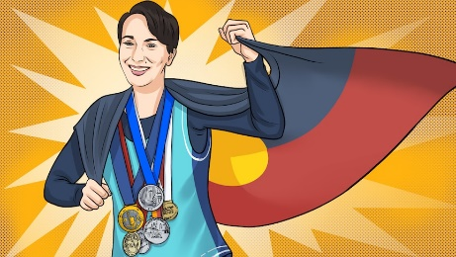  Allirra Jennings (ABC)
Further Investigation
- Create a timeline of important events in her life.
- What are some of the key events in her life? Write a summary for one key event, which answers the 5 W’s – Who, What, Where, When and Why?
- How do primary sources (for example photos, letters, diaries, and official documents) help us understand what might have happened at a place in time? Find 1 or 2 primary sources that help you learn more about the person’s life.
- Make a Did You Know for other students.
- Plan and create a portrait of the person. Think about the expressions, symbolism, and colours that reflect the person, their values, and their impact. Explore and experiment with different techniques and mediums to produce a portrait. Present your portrait to the class, introducing who the person is, the impact they have had and then explain your portrait and what each of the elements in the portrait mean.

Activity: International Women’s Day
International Women's Day is a global day celebrating the economic, political, and social achievements of women past, present and future. How does your school honour and celebrate the achievements of women all around the world? Go to the UN International Women’s Day website for more information.
(UN)

Activity: Choose a project
Students choose one of the following projects to work on and then present their work to a partner, small group, or the class.
Athletics
Do you enjoy running? Practise running a 50 metre, 100 metre or 400 metre run. Organise a race with your classmates.

Quiz
Create a quiz about Cathy Freeman! Use a range of question types (true or false, multiple choice, fill in the blank, matching the pair). Test your classmates’ knowledge.
Celebrate IWD
As a class celebrate the achievements of sports women in Australia. Go to the UN International Women’s Day website for more information.

.
Letter writing
What significant Australian sportswoman inspires you? Write a letter thanking her for her achievements and the impact she has had on Australia and sport.

Useful Websites
- Cathy Freeman — the girl who ran fast – ABC Fierce Girls
- Cathy Freeman: Digital Classroom – National Museum Australia
- Fierce Girls: Cathy Freeman (with animation) – ABC Education
- Cathy Freeman – AIATSIS
- Cathy Freeman’s Golden Run – ABC News

  - Teacher Resource

BTN Transcript: Episode 6 - 12/3/2024

Hey. I'm Amelia Moseley and you're watching BTN. Thanks for joining us again, Let’s see what’s coming up today’s show. We learn why tiny plastic is a big problem, find out about the future of the Aussie fiver
and meet the artists behind some impressive looking puppets.

Russia Election

Reporter: Justina Ward

INTRO: But first today, let's talk about Russia. In just a few days, it'll be holding a presidential election which will be the first one since Russia invaded Ukraine. So it's seen as pretty important even though we kinda already know who's going to win. Justina found out why.
REPORTER: Russia. It's a pretty big place. Famous for its landscapes, wildlife, and Vladimir Putin amongst wildlife. Yeah, this is the president of Russia, former spy, judo champ, and hocky fanatic. He's also held continuous positions as prime minister or president since 1999, making him the longest-serving ruler since Joseph Stalin! If you don't know who Stalin is, he was a leader of the Soviet Union. What's the Soviet Union? I'll get to that in a minute. Anyway! Back to Putin. In the past two decades, he's become one of the world's most powerful people and is extremely ruthless in maintaining that power. Which is why, with Russia's presidential election fast approaching we might already know who the winner will be. But why? And how did he become so powerful?

Let's rewind the clock a little bit. You see, before Putin was president, Russia was part of the USSR, or Union of Soviet Socialist Republics or Soviet Union. It was established in 1922 after a Russia had a revolution and abolished its monarchy. Then a civil war, which redrew the borders. Russia and a few of its neighbours were united under a new system of government. It was based on communism where citizens all share the profits of their work. Under Josehp Stalin - remember him? - the Soviet Union grew to become one of the world's greatest powers. Citizens enjoyed things like free education and health care, but there was also brutality and Stalin killed or jailed anybody who didn't agree with him. Over the years the USSR saw many controversies and disasters. And in the 80s, its leader tried to transition the USSR to a more free and open society. But by 1991 the Soviet Union has collapsed, and Russia held its first democratic election. Waiting in the wings was this 39-year KGB officer, who saw the collapse of the USSR as a catastrophe. He landed the role of president in 1999 and was elected again in 2012; promising to improve standards of living and to make Russia a major power again. The economy has grown a lot and Putin certainly has lots of fans. But it's not just popularity that's kept him in power.
JOHN MCCAIN, FORMER UNITED STATES SENATOR: It's very clear that Vladimir Putin has decided that he will eliminate his opponents.
Yeah, over the years it's become pretty clear that opposing Vladimir Putin is a very risky thing to do. Just a few weeks ago Alexey Navalny, Russia's best-known opposition leader, suddenly died while in prison. He'd been put there after surviving an assassination attempt back in 2020. And world leaders pointed the finger at one person.
JOE BIDEN, U.S PRESIDENT: Make no mistake. Putin is responsible for Navalny's death. Putin is responsible.
Ordinary people have been arrested for supporting Navalny or for speaking up against Russia's invasion of Ukraine, a war that's killed tens of thousands of Russian soldiers. So yeah, not everyone loves Putin, but when it comes to voting for a president, they don't necessarily have a lot of choice. The country's only anti-war candidate 'Boris Nadezhdin' has been barred from standing and experts say this election will be far from free and fair. While no one really doubts what the result of the election will be, it'll still be closely watched and for people who don't support Putin, it could be an opportunity to have their voices heard.
YULIA NAVALNY, WIDOW OF ALEXI NAVALNY: Use election day to show us that we exist and there are many of us. We are real living, real people, and we are against Putin.
ALEXI NAVALNY, FORMER RUSSIAN OPPOSITION LEADER: My message, for the situation that I am killed is very simple. Not give up.
News Quiz

Can you name the big political event that took place in the US last week? Was it Fantastic Friday, Mega Wednesday or Super Tuesday? It was Super Tuesday – when more than a dozen states vote for who they want to run for president in the Democrat and Republican parties. And as predicted, it was a big win for this guy.

DONALD TRUMP: We’re going to take it and we’re going to make it.

While there’s still quite a few states to go, it’s looking very much like this election will be a rematch between former president Donald Trump and current president Joe Biden.

Do you know the name of this ant species that’s marched from Queensland to New South Wales? Is it the Argentine ant, the fire ant or the bull ant? It’s the fire ant and authorities say time is running out to stop it taking up permanent residence in Australia which would be a very bad thing. The reason they’re known as fire ants is because of their incredibly painful and potentially dangerous bite.
DR ANTHONY YOUNG: They’re going to change the whole way we live. They’re going to change everything we do in Australia and they’re going to change it for the worse.
What’s the nickname of this famous golden statue? It’s Oscar, officially known as an Academy Award and a bunch of them have been handed out in Hollywood. This years Best Picture went to Oppenheimer about the physicist behind the atomic bomb. Best Animated Film went to The Boy And The Heron.

Which of these will soon be allowed on board Virgin planes? It’s this little guy! The airline’s decided to let dogs and cats fly with their owners but only small dogs and cats.
JAYNE HRDLICKA: They'll be in a designated carrier, so it will have to fit certain size specifications. And that carrier must sit underneath the seat in front of the passengers.

Microplastics

Reporter: Joseph Baronio

INTRO: Now to microplastics. They're a huge problem for the environment and for human health. In fact, experts say we all have microplastics inside of us. And last week there was a big conference in Adelaide where scientists talked about how we can tackle the problem. Here's Joe.

AdvertisemenT: Juicy, tender, ocean-fresh fish, garnished with secret seasoning for that 21st century flavour. Joe's seafood; it's the human-made touch.
Director: Aaaand, cut! Well mate the commercial looks great! Fish looks amazing… do you mind asking, what iss the secret seasoning?
JOE: He he, if I told you it wouldn't be a secret now, would it?
JOE: Don't say a word.
Joe Baronio, BTN Reporter: Yep, turns out a lot of the food we eat has a not-so-pleasant secret ingredient, microplastics. And while no one is deliberately sprinkling it in, humans are to blame. Here in Australia, we produce about 2.5 million tonnes of plastic waste every year, but only 13% of it actually gets recycled. In some countries, it's even worse than that. All those pesky plastics break down over time into tiny particles called micro and nano plastics. Microplastics can also come from things like health and beauty products that use tiny beads or glitter, and fibres from synthetic fabrics like clothes. But while these plastics become almost invisible, they never actually disappear.
Professor Mark Taylor, Environment Protection Authority Victoria: What it appears from the research is that there are places and times when it's actually raining microplastics. So inside our homes, it's raining microplastic dust, whether it's from the curtains, the clothes we use, or the plastic utensils or from the flooring, the vinyl flooring, or the wood flooring, with varnish on it.
In the ocean, currents carry microplastics far and wide. They even show up frozen in Arctic sea ice! The ocean locals like fish and sea birds sometimes mistake the plastic particles for food, and that's also how they can end up on our plates.
Associate Professor Melanie Macgregor, Flinders University: What we know is that they are in our bodies. We found micro and nano plastic in our blood, we found them in our brain in the heads, we found them in the guts, but are they harmful? We're not sure yet.
Professor Mark Taylor: The absence of evidence is not evidence of absence. So, we should act in the assumption it's causing a problem.
Around the world, authorities are trying to tackle the problem, like in Europe where glitter and some products containing microplastics have been banned, and in Australia, there are container recycling schemes and bans on single-use plastics like straws and cutlery, and here at Australia's first-ever Nano and Microplastic conference, scientists are sharing new ideas.
Associate Professor Melanie Macgregor: We've got a company that is called Alkane. They are trying to develop bacteria. So, the little bugs that are capable of eating plastic, so plastic is their food and then they're producing gas that we can then use as an energy source.
But they say we all have a role to play in tackling this big, tiny problem.
Associate Professor Melanie Macgregor: Buy less plastic, throw out less plastic, reuse things, and for kids and children that are still deciding on what to do themselves, well, they can come and study science and help us find about the risk and the health impact of microplastic because we need all hands on deck.
Five Dollar Design

Reporter: Wren Gillett

INTRO: This next story is also about plastic, but the more valuable kind. The Reserve Bank is looking for a design to replace the image of the Queen on our five dollar note and it's asking all Australians for their ideas something Wren is pretty excited about. Check it out.
SAS: Here's that $5 bucks I owe you.
WREN: OH MY GOODNESS.
SAS: Are you okay?
WREN: Yeah, I just love money.
SAS: Well, everyone loves money Wren?
WREN: Yeah but, but… I LOVE money Sas. Look at the way that this symbol changes in the light, and these intricate details. It’s it’s art Sas, it's art.
WREN GILLETT, BTN REPORTER: While not all of us might appreciate money quite this much, a lot of love does go into the design of our cash. After all, what's on it reflects what's important to us as a country. Right now, if you look on our notes, you will see some interesting characters. Like renowned poets Banjo Paterson and Dame Mary Gilmore, inventors like David Unaipon, Australia's first female politician Edith Cowan.
WREN: We even have an opera singer featured on our currency, her name is Dame Nellie Melba.
Over the years, the faces on our notes have changed to reflect our changing society. But there's been one constant on our cash for more than a century - the monarchy. As well as gracing our coins, we've had a King or Queen's head on one of our banknotes since the 1920s.
WREN: And since 1992, we've had Queen Elizabeth's face looking back at us from our beautiful pinky, purply plastic polymer notes.
SAS: Okay, okay, it's not like it's going anywhere!
Well actually, that one is, kind of.
WREN: WHAT, where's it going.
Nowhere! It's getting a re-design.
WREN: Oh! That's exciting!
Yep, our $5 notes will soon look pretty different. Ever since the death of Queen Elizabeth, back in September 2022, there have been lots of conversations around who or what should take her place on our $5 note. And last year, the Reserve Bank of Australia, which prints our banknotes, made the big decision to break from tradition, and not feature the King.
MICHELLE MCPHEE, RESERVE BANK OF AUSTRALIA: This time around, we're not going to use a portrait. We're going to find an image that celebrates First Nations history and culture.
While King Charles' face will appear on our new coins, they decided to use this opportunity to celebrate the world's oldest living culture.
STUDENT: We should at least acknowledge them on like one thing we see most often.
STUDENT: We can represent that there's lots of people here, and Australia started from Indigenous people.
And The Reserve Bank is after your ideas!
STUDENT: I want some sort of animal on my $5 note because they're the protectors and the owners of the land.
STUDENT: Like a kangaroo, a wallaby, tree kangaroo, platypus.
STUDENT: So I was thinking respect, maybe shaking hands.
The Reserve Bank Of Australia will be collecting your suggestions from now right up until the 30th of April. And you can submit them by visiting their website.
WREN: Wait, they want me to have a say about what's on our money. This is the greatest day of my life. AHHHH
Did you know?
Did you know Australia is the only country in the world that has a woman on every one of its banknotes?

Womad Puppets

Reporter: Wren Gillett

INTRO: Now to those impressive puppets I promised you earlier. A South African company has brought some of its enormous creations to South Australia for its festival season. Wren went to see them and found out more about the ancient artform of puppetry.

SOCK PUPPET WREN: Hello, I'm Wren, and today, we're going to be learning about puppets.
WREN: No, I'm Wren - alright? Anyway, when you think about puppets, you probably picture something like this, or this guy, or these guys. But there's actually a whole lot more to the world of puppetry than you think.
WREN GILLETT, BTN REPORTER: Puppets are one of our most ancient forms of entertainment. In fact, they've been found in Egyptian tombs, that date back as far back as 2,000 BCE! Meaning puppets have been around for at least 4,000 years. It's believed they started as ancient ritualistic dolls, created in the image of humans or gods. Now puppets come in all shapes and sizes. Like these impressive creations from South Africa's Handspring Puppet Company.
WREN: So your puppets are a little bit different to these ones.
Siphokazi Mpofu, PUPPETEER: Yes, I started with this, which is a sock puppet, a Muppet puppet.
But while Siphokazi started with sock puppets like sock Wren, she is now part of a team which operates puppets much bigger and more complex - like Nana. Nana, is part of a tribe of elephant puppets, and has been made to match the size of a real elephant. She has many moving parts, but somehow, she manages to move as one, and that's the work of these skilled puppeteers, who can communicate without words, to their audiences, and to one another.
WREN: Listening to each other without being able to talk. It’s a special skill.
Siphokazi Mpofu, PUPPETEER: Yes, without… we don’t talk.
WREN: So you sort of become one with the animal.
Siphokazi Mpofu, PUPPETEER: We become one because of the powerful thing, which is, we breathe as one. The breathing is one, it could be four of us or two of us inside, but then the minute we breathe, we breathe as one.
And that's their secret to making Nana come to life! And while Nana's main purpose is to entertain, Handspring also uses puppets to educate people and inspire change, and that’s Little Amal’s job. She’s a not so little puppet based on a real life 10-year old, Syrian refugee, who travels the world looking for her mother. The real Amal was trying to flee the Syrian war and when adults found her..
CRAIG LEO, Puppetry Director: She had stopped speaking. And she was completely alone. And the question was, how did she get all the way from Syria to Calais, which is the western side of Europe.
Handspring was asked to build a large version of her, and now, Little Amal is spreading a BIG message about human rights and the plight of refugees.
ANDY PACKER, SLINGSBY ARTISTIC DIRECTOR: I think the beautiful thing about puppets is that they, you know, as an audience, we see them as a puppet… but we also imagine them to be alive and to be real.
WREN: Puppets can tell the difficult stories, the funny ones, the beautiful ones - don't get a big head though alright.
WREN: Did you guys just watch the elephants?
KIDS: YES.
KID: They were so BIG, I don't know how they got it that big.
KID: It was cool how they were moving the trunk up and down and making the sound elephants make.
KID: It was really cool they were like moving the legs and the trunk with a few levers, it was really cool.
KID: Even though there was no words, it was still like really well told and quite interesting to watch.
KID: I liked seeing the baby elephant because everyone really connected with it.
KID: Do you think I'm a good puppet? Yes, I like your eyes, and your nose is really out there.
PUPPET: You know what, I think I want be a puppeteer.
WREN: Oh yeah? Okay well, what does your puppet look like?
PUPPET: Well, it actually looks just like - YOU!

Sport

The Aussies have managed to take out their second test against New Zealand. It was a tough contest with the Kiwis setting Australia a target of 279 to win. The Aussies looked in trouble early until Mitch Marsh and Alex Carey managed to steady the ship.
Over in the Women’s Premier League, the Royal Challengers Bangalore defeated UP Warriors by 23 runs with Ellyse Perry smashing her way to a half-century. Like literally smashing her way. The Aussie shocked fans in Bengaluru with 58 runs and four sixes, with one of the sixes actually smashing into the rear window of a sponsor’s car that was parked on a stage outside the boundary.
COMMENTATOR: It’s going to be an expensive six that for Ellyse Perry.
And now to the AFL where the opening round of has just kicked off!
This year all the opening matches were in New south Wales and Queensland to try to boost the number of fans in the NRL states. Over the weekend, the Gold Coast Suns took out Richmond 99-60. While the GWS Giants took out Collingwood in their opening round clash 114-82.

Cathy Freeman– Women’s History Month
Rookie Reporter: Liliana

This is Cathy Freeman. Cathy was born in 1973, in the Queensland city of Mackay. Her mother was of the Kuku Yalanji people of far north Queensland, and her father was from the Burri Gubba people of central Queensland.

When Cathy was eight years old, she won her very first running race, and by the time she was 10, she knew exactly what she wanted to be - an Olympic champion. Cathy made a poster and hung it on her wall. It said, "I am the greatest athlete in the world", and from that moment onwards, Cathy was determined to make her dream come true.

She practiced and practiced, becoming faster and faster. And by 16, she was picked to run in a relay team for the 1990 Commonwealth Games, and just like that, Cathy's life changed forever. Her team won gold, making Cathy the first Indigenous Commonwealth gold medallist. And in 1992, she made it all the way to the Olympics. She didn't win a medal that time, but it didn't stop her, not in the slightest. In 1996, she was back, this time in Atlanta. She was fast, running neck and neck with France's famous Marie-Jose Perec. She was so close to being an Olympic champion, but, in the end, Cathy took silver. By the time the 2000 Olympics came around, she was more determined than ever. This was the year the Olympics were in Australia, and Cathy was the face of the Sydney games. At the opening ceremony she was front and centre. And when it came to her race, the world's eyes were on her.
Wearing a futuristic bodysuit, Cathy became a real-life superhero. To fight off nerves, she took deep breaths. And just like that, she took off, speeding past her competitors in her home country. In front of 10's of millions of eyes, watching her from around the world. Cathy Freeman blitzed everyone in the 400-metre race, becoming the first Aboriginal Australian to win an individual Olympic gold medal. On her victory lap, Cathy held up the Aboriginal flag alongside the Australian flag, an act that was against the rules, but was a huge moment for Indigenous people in Australia.

Cathy was now an Olympic champion, but to many, she was so much more than that. She was a symbol of reconciliation. After that race, Cathy continued to hold the torch, shining a light on First Nations cultures, and in 2007, she created the Cathy Freeman Foundation, to support young people in remote communities. Over her career, Cathy won many awards, including Young Australian of the year and Australian of the year. She proved that it is worth having big dreams, because with hard work and perseverance, they may just come true.
Closer

Well, that's all we have for today, but don't you worry because we'll be back next week with more news just for you. In the meantime you can jump online and check out our website and keep up to date with Newsbreak right here in the studio every weeknight. Have the best week and I’ll see you soon. Bye!

