KEY LEARNING
Students will view a range of BTN stories and use comprehension skills to respond to a series of focus questions.

CURRICULUM
English – Year 4
Use comprehension strategies to build literal and inferred meaning to expand content knowledge, integrating and linking ideas and analysing and evaluating texts.

English – Year 5
Use comprehension strategies to analyse information, integrating and linking ideas from a variety of print and digital sources.

English – Year 6
Use comprehension strategies to interpret and analyse information and ideas, comparing content from a variety of textual sources including media and digital texts.

English – Year 7
Use comprehension strategies to interpret, analyse and synthesise ideas and information, critiquing ideas and issues from a variety of textual sources.

  - Teacher Resource

Focus Questions

Know My Name
- Before watching the BTN story, name a well-known female artist.
- Explain the BTN story to another student.
- Where is the National Gallery of Australia?
- Why were women banned from studying at Europe's famous art academies in the past?
- Why do you think the NGA called the exhibition Know My Name?
- What percentage of art in the NGA collection is by women artists?
  - 5%
  - 25%
  - 50%
- Name one artist featured in the Know My Name exhibition.
- Describe Patricia Piccinni’s Sky Whale air balloon sculpture.
- What was surprising about this story?
- find 3 interesting facts about an Australian female artist. Share with the class.

Fake Aboriginal Art
- What was the main point of the BTN story?
- What percentage of artworks and souvenirs sold in Australia are fake?
- Why is Aboriginal art unique?
- What impact does the production of fake art have on Indigenous artists?
- While it's illegal to pretend something has been created by an Indigenous person, there are no laws against selling art that looks similar. True or false?
- What is the Government doing to stop fake Aboriginal art being produced?
- How can you tell the difference between a fake and an authentic piece of Indigenous art?
- Predict what might happen if fake artworks continue to be made and sold to tourists.
- Should more be done to protect the Aboriginal art industry? Explain your answer.
- What do you understand more clearly since watching this story?

Young Archie 2021
- Retell the BTN story using your own words.
- What art gallery runs the Young Archie competition?
- When did the Young Archie competition start?
- Who is J.F. Archibald?
- When was the Archibald Prize first held?
- Portraits in the Archibald Prize must be of someone who is well-known. True or false?
- Who can you paint in the Young Archie competition?
- Who did the kids in the BTN story create a portrait of? Give one example.
- What do the kids in the story say to other kids wanting to get involved in art?
- What did you like about this story?

Street Art
- Summarise the Street Art story using your own words.
- What is street art?
- Where can you see street art? Give an example.
- What did street art evolve from?
- Banksy’s identity is unknown. True or false?
- What is the theme of Banksy’s street art?
- Describe one of the artworks included in Banksy’s Great British Spraycation.
- Why is Banksy’s street art controversial?
- When is street art legal?
- What did you like about the BTN Street Art story?

KEY LEARNING
Students will explore a female artist’s work in detail. They will also create a biography of an artist.

CURRICULUM
Visual Arts – Years 5 & 6
Explore ideas and practices used by artists, including practices of Aboriginal and Torres Strait Islander artists, to represent different views, beliefs and opinions.

Develop and apply techniques and processes when making their artworks.

Visual Arts – Years 7 & 8
Experiment with visual arts conventions and techniques, including exploration of techniques used by Aboriginal and Torres Strait Islander artists, to represent a theme, concept or idea in their artwork.

Analyse how artists use visual conventions in artworks.

  - Teacher Resource

Know My Name Exhibition

Activity: Pre-viewing question
Before watching the BTN Know My Name Exhibition story, ask students to write down as many artists as they can.

Activity: Class Discussion
After watching the BTN story students will reflect on the story and then respond to the following:
- What did you see in this video?
- What do you think about what you saw in the BTN story?
- What did you learn from this story?
- What was surprising or interesting about this story?
- Think of three questions you have about the BTN story.
- Why do you think BTN covered this story?

Hold a class discussion about the Know My Name Exhibition story. Begin the discussion by asking students about the list of artists they wrote before watching the story. Are there many women on their list of artists? Students will think about their answer and why they think this may be.
Discussion question
- Why was an exhibition created that just shows the work of female artists?

Activity: Women Artists
Students will choose a female artist’s work to explore in detail. Below is a range of artworks created by some of the female artists featured in the Know My Name exhibition. The full list of artists can be accessed here. Students will respond to the questions below to help guide their exploration and then create an artwork inspired by the artist’s style and technique.

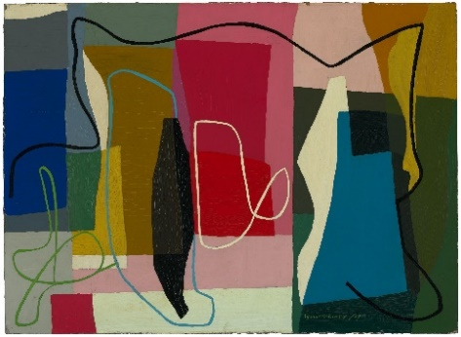  Abstract painting Grace Crowley 1947 | 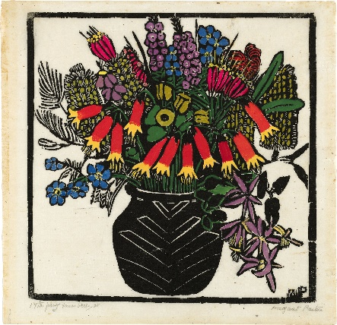  Christmas Bells Margaret Preston  1925 | 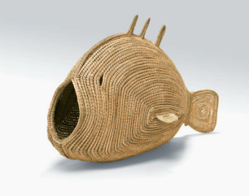  Pondi (Murray River cod) Yvonne Koolmatrie 2009
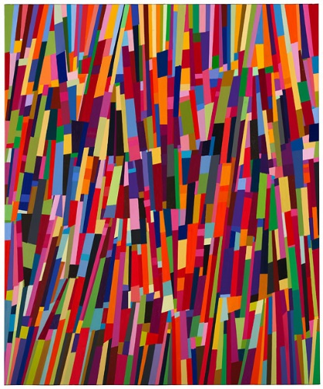Untitled 2001 Melinda Harper 2002 | 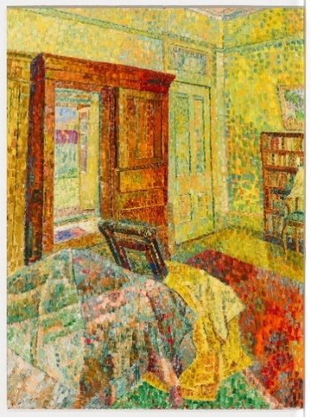Interior in Yellow Grace Cossington Smith 1962-1964 | 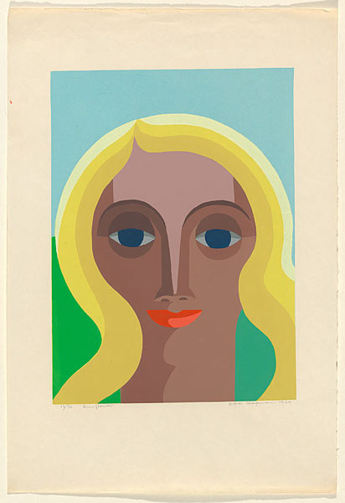Sunflower Dora Chapman 1969

Responding
- Record as much information as you can about the artwork in 15 minutes. Record everything you see. The longer you look the more you will see.
- Who or what do you think the artwork is about? What does it remind you of? What does it make you think about?
- Is it a painting, print, sculpture or another type of artwork? What materials were used to make it?
- What techniques does the artist use?
- How does the artwork make you feel? What do you like about it? Why did you choose it?
- What questions do you have about the artwork?
Creating
Create an artwork that is inspired by the artist’s style and technique. Choose what medium you will use – pencils, paints, charcoal, watercolours, oil pastels or string and wire (sculpture).

Activity: Biography
Students will choose a female artist to research and write a biography about. They may want to find out more about the artist they chose in the previous activity or select another one. The list of artists in the Know My Name exhibition is a good starting point to help students choose.

What is a biography?
Before students begin to construct their biographies, hold a class discussion to find out what they already know about biographical writing. Below are some discussion starters:

- What does a biography tell us about a person?
- Where can you look to find information for your biographical writing? It could include the internet, newspaper articles, magazine articles and interviews, other biographies, historical books, or television interviews. Why is it important to use more than one source of information?
- What makes a biography interesting? For example, key information and facts, a timeline of events, photographs, illustrations, and quotes.

Create a biography
Using the Biography Organiser template at the end of this activity, students will record information about the female artist they have chosen. Some possible areas of research include:

- Where are they from? Locate using Google Maps.
- When were they born? Describe their family life growing up.
- What sort of art do they create?
- Who or what were they influenced by?
- Where is their work exhibited?
- What impact did their work have on other artists or society?
- What do you admire about them?
- Imagine you could sit down and talk to them. What questions would you ask about their life and art?

Useful Websites
- Know my Name – National Gallery of Australia
- History of Portraits – BTN
- Young Archie – BTN

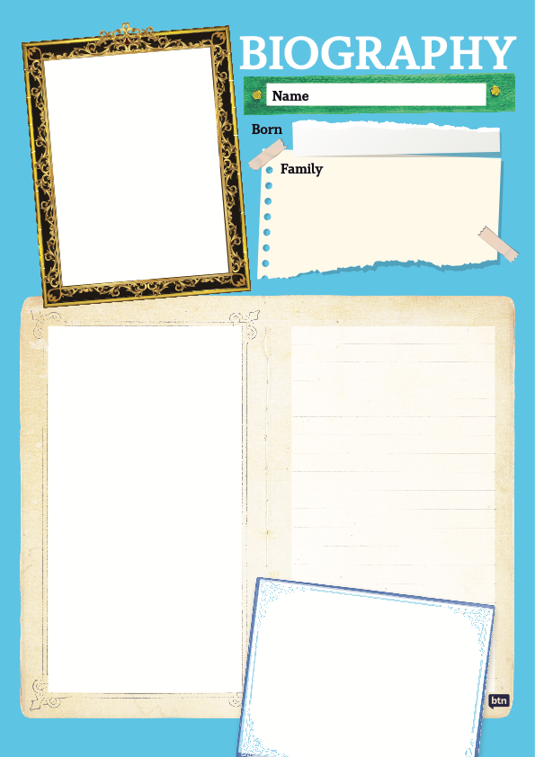

KEY LEARNING
Students will learn more about the importance of Aboriginal and Torres Strait Islander art and respond to artwork created by Indigenous artists.

CURRICULUM
Visual Arts – Years 5 & 6
Explore ideas and practices used by artists, including practices of Aboriginal and Torres Strait Islander artists, to represent different views, beliefs and opinions.

Develop and apply techniques and processes when making their artworks.

Visual Arts – Years 7 & 8
Experiment with visual arts conventions and techniques, including exploration of techniques used by Aboriginal and Torres Strait Islander artists, to represent a theme, concept or idea in their artwork.

Analyse how artists use visual conventions in artworks.

  - Teacher Resource

Fake Aboriginal Art

Activity: What do you see, think and wonder?
Students will watch the BTN Fake Aboriginal Art story, then respond to the following questions:
- What did you SEE in this video?
- What do you THINK about what you saw in this video?
- What did you LEARN from this story?
- What was SURPRISING about this story?
- What QUESTIONS do you have?

Activity: Class Discussion
Discuss the BTN Fake Aboriginal Art story as a class. Record the main point of the discussion. Use the following questions to guide the discussion.
- What do you know about Aboriginal art?
- What impact do the fake artworks have on Aboriginal artists and the industry?
- Why do you think the Australian Government has cracked down on fake Aboriginal art?

Activity: Glossary
Students will brainstorm a list of key words that relate to the BTN Fake Aboriginal Art story. Here are some words to get them started.

FAKE | SOUVENIR | ARTWORK
AUTHENTIC | TOURIST | ETHICAL

Activity: Indigenous Art Research
Discuss the information raised in the BTN Fake Aboriginal Art story. What questions were raised in the discussion and what are the gaps in students’ knowledge? The following KWLH organiser provides students with a framework to explore their knowledge on this topic.

What do I know? | What do I want to know? | What have I learnt? | How will I find out?

Students will develop their own question/s to research or choose one or more of the questions below. Encourage students to collect and record information from a wide variety of sources and present the information they find in an interesting way.

- Why is Aboriginal art important?
- How does Aboriginal art tell stories?
- How is Aboriginal culture expressed through art?
- How does Aboriginal art differ across Australia?

Activity: Responding to Indigenous Art
Virtual art gallery trip | Students will visit an online art gallery and respond to Indigenous artworks they have chosen. Below is a list of galleries with links to Aboriginal and Torres Strait Islander art collections for students to choose from.  Art Gallery of South Australia  Art Gallery of NSW  National Gallery Victoria  Art Gallery of WA  Queensland Art Gallery  National Gallery of Australia  Choose an artwork/s to respond to. Record everything you see in detail.  - What is the name of the artwork and artist who created it?  - Is it a painting, print, sculpture, or another type of artwork?  - What does the artwork remind you of? What does it make you think about?  - What materials were used to make it?  - Describe the artwork. What sorts of colours, lines, shapes, and patterns can you see?  - Does it tell a story? What sort of story?  - How does the artwork make you feel?  - What questions do you have about the artwork?
Further investigation | Reflect on the artwork and learn more about the artist. Respond to the following:  - Why did you choose the artwork?  - What were your fist impressions of the artwork?  - How would you describe the artwork to someone who has never seen it before?  - Is it contemporary or traditional?  - If you could interview the artist what questions would you ask them about the artwork? Find out if you can contact the artist for an interview.  - What is the ‘story’ behind this artwork?  - What other artworks has the artist created?  - Where is the artist from?  - Interesting facts  Challenge  Choose another Indigenous artist to explore in detail to learn more about their life and art. Create a short biography of their life and show examples of their artworks. Explain why you chose to find out more about them and what you like about their art.

Activity: BTN Indigenous Art story
Watch the BTN Indigenous Art story and learn about how some kids got involved in a special Indigenous art exhibition.
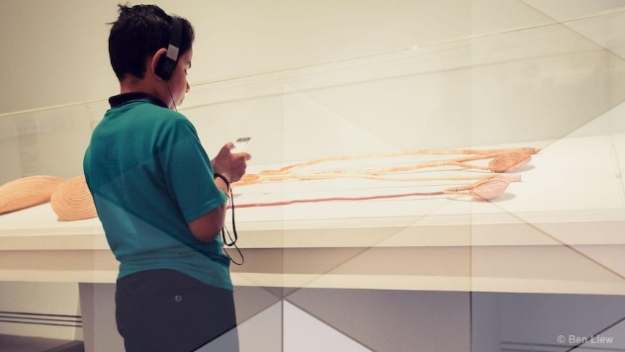
- What have the kids made for the Tarnanthi art exhibition?
- What is the purpose of an audio guide?
- Give an example of the sort of information in the guide.
- Who did the students interview as part of their research?
- Describe Yvonne Koolmatrie’s artworks.
- Where does she collect the materials for her artworks?
- Describe at least one other piece of art in the exhibition.
- How did they put together their audio guides?
- What did the art gallery say about the guides the kids made?

Useful Websites
- Commonwealth vows to stamp out fake Aboriginal art made in `sweatshops’ – ABC News
- Indigenous Art - BTN

KEY LEARNING
Students will investigate portraits in the Young Archie Competition. Students will explore different techniques used to create a portrait.

CURRICULUM
Visual Arts – Years 3 & 4
Explore ideas and artworks from different cultures and times, including artwork by Aboriginal and Torres Strait Islander artists, to use as inspiration for their own representations.

Use materials, techniques and processes to explore visual conventions when making artworks.

Visual Arts – Years 5 & 6
Explore ideas and practices used by artists, including practices of Aboriginal and Torres Strait Islander artists, to represent different views, beliefs and opinions.

Develop and apply techniques and processes when making their artworks.

Plan the display of artworks to enhance their meaning for an audience.

Visual Arts – Years 7 & 8
Experiment with visual arts conventions and techniques, including exploration of techniques used by Aboriginal and Torres Strait Islander artists, to represent a theme, concept or idea in their artwork.

Practise techniques and processes to enhance representation of ideas in their artmaking.
  - Teacher Resource

Young Archie

Activity: Class Discussion
Before watching the BTN Young Archie 2021 story, ask students what they already know about portraiture. Here are some discussion starters:
- What is a portrait?
- Why are portraits made?
- What do portraits tell us about a person?
- What makes a portrait interesting?

After watching the BTN story as a class, respond to the following questions:
- What did you SEE in this video?
- What do you THINK about what you saw in this video?
- What did you LEARN from this story?
- What was SURPRISING about this story?
- What QUESTIONS do you have?

Activity: Mind Map
Ask students to think of words they associate with the word portraiture. Record students’ ideas on a mind map with the word PORTRAITURE in the middle. Below are some suggested words.

BACKGROUND | COMPOSITION | LIVE SITTING
FACIAL EXPRESSION | FOREGROUND | FORM
GESTURE | IDENTITY | PORTRAIT
POSE | SETTING | TECHNIQUE

Ask students to clarify their understanding of the key words by writing down what they think the word means. Swap definitions with a partner and ask them to add to or change the definition. Check them using a dictionary or other source.

Activity: Analyse art work
Students will select their favourite portrait from the 2021 Young Archie competition. Below are examples of three finalists. Students will analyse and reflect on the portrait and then respond to the questions below.

Finalists – Young Archie 2021, Art Gallery NSW
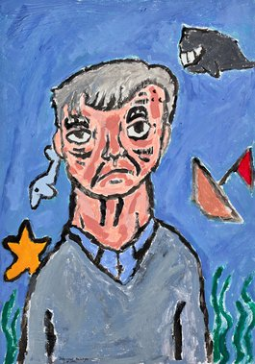  Jude  Captain | 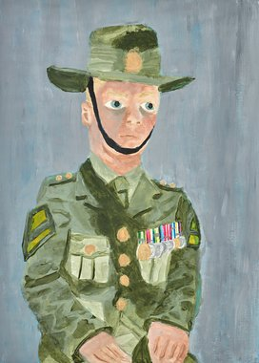  Ella  My hero, Dad | 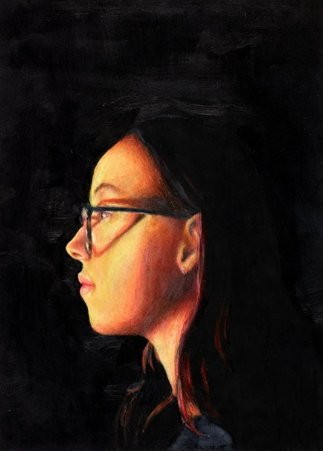  Ruby  My light

Questions to help guide students’ exploration:
- Record as much information as you can about the portrait in 15 minutes. Record everything you see. The longer you look the more you will see. Consider looking at it from different angles, up close and far away.
- Who do you think the portrait is of? What can you tell about their personality? What are they doing? What is the mood of the portrait? Describe their facial expression and pose.
- Do you notice any objects in the portrait? How do these objects represent the subject’s identity or individuality?
- How does the portrait make you feel? What do you like about this portrait/self-portrait? Why did you choose it?

Activity: Create a portrait
Create a portrait.
Students will create a portrait of a person who is special to them, using the following as a guide.
- Choose someone who is known to you and who knows you and plays a significant role in your life.
- Write 2-3 sentences explaining who the person is and why you chose them.
- What technique/s will you use to create your portrait? Think about colours to reflect mood or feelings.
- Organise a live sitting with your subject, where you and your subject are together, and you are working on their portrait. Complete your portrait using photographs of your subject as a reference. Give your portrait a title. Write 2-3 sentences about your portrait.
- Consider entering your portrait in next year’s Young Archie competition.

Create a self-portrait.
Students will create a self-portrait which represents how they see themselves. Looking at a mirror, students will experiment with poses, costumes and props and produce a self-portrait. Initially students can do some quick, detailed sketches of different features and then use these sketches to help create a final self-portrait. Students will write an artist's statement to go with it.

Below are some guidelines for students as they create their self-portrait:
- Use colours that you feel reflect your mood or feelings.
- What style will you use to create your self-portrait? How will it help portray your identity?
- Where are you going to sit? Think about the background of your self-portrait. Is it real or imaginary?

Class Exhibition
Curate a class exhibition of your students’ portraits and/or self-portraits and choose a title for the exhibition. Invite students from other classes at your school to attend your exhibition. Consider holding your exhibition at your local library or local council.

Activity: Research project
After watching and discussing the BTN Young Archie 2021 story, what questions do students have and what are the gaps in their knowledge? The following KWLH organiser provides students with a framework to explore their knowledge on this topic and consider what they would like to know and learn.

What do I know? | What do I want to know? | What have I learnt? | How will I find out?

Students will develop their own question/s to research or select one of the questions below.
- Who started the Archibald Prize? Investigate the 100-year history of the Archibald Prize and present your findings in an interesting way.
- How has portraiture changed over history? Compare the beginnings of portraiture to modern portraiture that you see now. Illustrate using a timeline.
- What different techniques can be used to create portraits? Choose two finalists from the Young Archie competition 2021 or the Archibald Prize 2021 and make comparisons. How are they similar or different?
- What do portraits tell us about a person? Give examples.
- How did painters like Vincent Van Gogh and Paul Gaugin challenge traditional portraiture? Create your own portrait inspired by the artist’s style and technique.

Activity: Visit an art gallery
Plan a trip to your local art gallery to explore and investigate its range of portraits. Look for photographs, prints, paintings, and sculpture. Alternatively, if you are unable to physically visit an art gallery, visit an online art gallery. For example, visit the National Portrait Gallery to explore a range of different portraits. The National Portrait Gallery also offer Virtual Excursions that your class can experience.

Before visiting the art gallery | As a class, plan a trip to your local art gallery to explore its collection of portraits. You will need to think about the following:  - Before you visit the gallery discuss as a class what a portrait is. List points about what makes a good portrait.  - What do you want to learn? Write 5 questions that you would like to investigate.  - How will you get there and how long will you need to visit the gallery?  - What will you need to take with you?
Trip to the art gallery | When you arrive at the art gallery, select a portrait which you will investigate as a class. Students will then respond to the following:  - Record as much information as you can about the portrait in 15 minutes.  - Record everything you see. The longer you look the more you will see. Consider looking at it from different angles, up close and far away.  - Is it a painting, print, sculpture or another type of artwork? What materials were used to make it?  - What is the subject’s expression and pose? Do you notice any objects in the portrait?  - How does the portrait make you feel?  - Draw a picture of the artwork including as much detail as possible.  If time permits, consider completing one or more of the further investigations below:  - Choose a portrait you like and then imagine a narrative for the subject of the portrait. Who do you think they are? What can you tell about their personality? What are they doing? Where are they from?  - Choose two portraits by different artists and compare. Describe any similarities or differences.
Back at school | Students will reflect on the portrait they studied as a class and use the internet to learn more about the artist. Respond to the following.  - Did you enjoy visiting the gallery and investigating their collection of portraits? Why or why not?  - What were your first impressions of the portrait you studied?  - If you could interview the artist, what questions would you ask them about the portrait? Find out if you can contact the artist for an interview.  - What is the ‘story’ behind the portrait?  - Where is the artist from?  - Interesting facts  Further investigation:  - How does portraiture help us understand and appreciate people – their identity, history, culture and diversity?

Activity: Self portrait
Who am I? Students will reflect on this question and explore their own identity through discussion, writing and art. Students will brainstorm and record how they see themselves, responding to the following reflective questions. Students will then take the information they have learnt about themselves and create a self-portrait.
- Who are you?
- What words best describe you?
- What are you really passionate about?
- What are your most important values?
- What do you think is unique and special about you?
- What are your strengths?
- What are your challenges?
- How are you similar/different to other people? How do you feel about your differences?
- When do you feel most like yourself?
- How do you want people to see you?
- Why is it so important to be yourself?

Students will then create a self-portrait which represents themselves. Looking at a mirror, students will experiment with poses, costumes and props and produce a self-portrait. Initially students can do some quick, detailed sketches of different features and then use these sketches to help create a final self-portrait. Students will write an artist's statement to go with it. Curate a class exhibition of your students’ self-portraits and choose a title for the exhibition.

Useful Websites
- Young Archie Competition – Art Gallery NSW
- Young Archies 2018 – BTN
- Archibald Prize – Art Gallery NSW
- Education – National Portrait Gallery
- NAIDOC Indigenous Women – BTN
KEY LEARNING
Students will create their own street art which connects with their community.

CURRICULUM
Visual Arts – Years 3 & 4
Identify intended purposes and meanings of artworks using visual arts terminology to compare artworks, starting with visual artworks in Australia including visual artworks of Aboriginal and Torres Strait Islander Peoples.

Visual Arts – Years 5 & 6
Explain how visual arts conventions communicate meaning by comparing artworks from different social, cultural and historical contexts, including Aboriginal and Torres Strait Islander artworks.

Visual Arts – Years 7 & 8
Analyse how artists use visual conventions in artworks.

  - Teacher Resource

Street Art

Activity: Class Discussion
Before watching the BTN Street Art story, ask students what they already know about street art. Here are some discussion starters:
- What is street art?
- Have you seen street art? Where? Describe the street art you have seen.
- How do think street art benefits society?
- What do you think is the difference between graffiti and street art?

After watching the BTN story as a class, respond to the following questions:
- What did you SEE in this video?
- What do you THINK about what you saw in this video?
- What did you LEARN from this story?
- What was SURPRISING about this story?
- What QUESTIONS do you have?

Activity: Research
Discuss the information raised in the BTN Street Art story. What questions were raised in the discussion and what are the gaps in students’ knowledge? The following KWLH organiser provides students with a framework to explore their knowledge on this topic.

What do I know? | What do I want to know? | What have I learnt? | How will I find out?

Students will develop their own question/s to research or choose one or more of the questions below. Encourage students to collect and record information from a wide variety of sources and present the information they find in an interesting way.
Research questions:
- What was the first form of street art?
- What is the history of street art? Create a timeline to illustrate your findings.
- What are some different types of street art? Explore the different techniques used in street art (e.g., graffiti artwork, stencil graffiti, sticker art, street poster art, video projection, guerrilla art, flash mobbing and street installations). Give examples.
- Is street art legal? When is street art not legal? Explore the similarities and differences between graffiti and street art.
- Why do some street artists stay anonymous? Explore the works of Banksy and other street artists who hide their identity.
- What is Banksy’s style? Who was Banksy influenced by? Find artists with similar artistic styles and techniques to that of Banksy.

Activity: Analyse street art
As a class, view a variety of street art, near to your school, around Australia and around the world. Students will select an example of street art that interests them. Students will analyse and reflect on the street art and then respond to the questions below.

ABC News – (Getty: William West) | 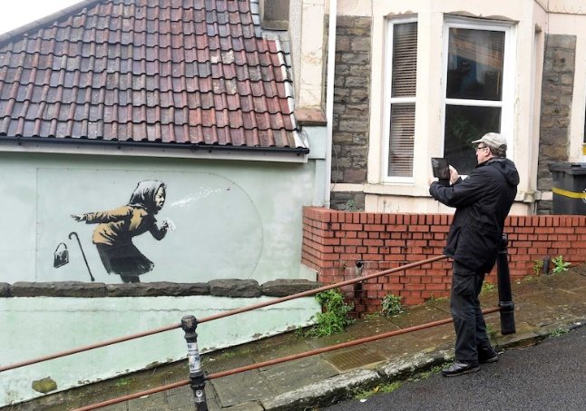  ABC News – (Reuters: Rebecca Naden)
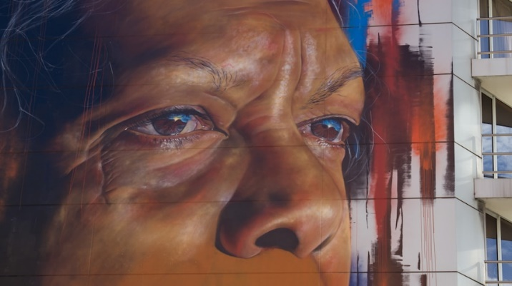  ABC News – (702 ABC Sydney: Amanda Hoh) | 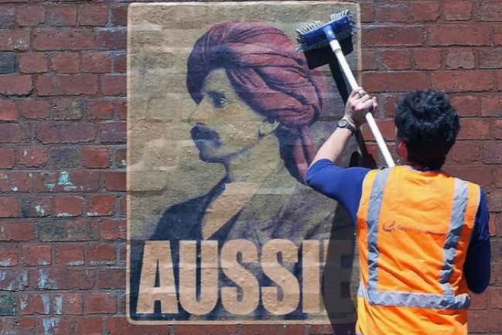  ABC News – (Supplied: Peter Drew)

Questions to help guide students’ exploration:
- Record as much information as you can about the street art in 15 minutes. Record everything you see. The longer you look the more you will see. Consider looking at it from different angles, up close and far away.
- If there are people in the artwork, what can you tell about their personality? What are they doing? Describe their facial expression and pose.
- What is the mood of the artwork?
- Do you notice any objects in the artwork? What do these objects symbolise?
- What do you think the artist is trying to say through the street art? What does it mean?
- What materials were used to make it?
- What techniques does the artist use?
- What do you know about the artist?
- What do you like about this artwork? Why did you choose it? How does the artwork make you feel?
- What questions do you have about the artwork?

Activity: Create your own street art
Students will create their own artwork that is inspired by their favourite street artist. Students will create a sketch of their artwork on paper or cardboard, using the following to guide their design:
- What is your message? Think of a positive message that you want to convey in your artwork.
- Does your artwork tell a story, promote an idea, illustrate a culture, make the viewer think, or create an experience?
- How will your street art connect with your community?
- What images, symbols, words, and colours will you use?
- Where would your street art appear? (e.g., exterior of a building, under a bridge, footpath).
- Is the location a public or privately owned building? Who would give you permission for your design?

Activity: Explore street art in your community
In this activity, students will explore a range of street art in their community. As a class you may want to visit street art out in the community or take a virtual street art tour.

Explore | Go on a tour of your town or city, taking photos and drawings of what you find. Find out as much as you can about the street art.  - What street art is in your community? Make a list.  - Where is the street art located? E.g., on electricity poles, the exterior of buildings, chalk street art, murals, mosaics.
Research | Choose an example of street art in your community to explore in more detail.  - Who is the artist?  - Where is the street art located?  - When was the street art created?  - Describe the street art including: the elements, colours and materials used.  - What is the message? What symbols and themes do you notice in the artwork?  - How does the street art connect with the community?  - Could you interview the artist for extra content? What questions would you ask?
Design & create | Design a tour of the street art in your community. Take a look at these street art guides for inspiration. Wonderwall Outdoor Gallery SA, Melbourne Street Art Walk, Every Banksy remaining in London.  - Identity the artworks that you will include in your street art tour.  - Will there be a common theme in your tour?  - What order should the artworks be visited?  - Who is the tour for? Is it for families? Is it accessible?  - How will you present the information in your map? E.g., grid system or numbered.  - Will your tour and map be digital or a printout?  Sketch a map and include grid lines which you can use to reference the street art on your tour.  - List each of the places and artworks on your tour.  - Who is the artist? Include a bit of information on each piece of art.  - What extra information will you include, e.g., photographs, QR codes, legend, scale, distance and time of tour, nearby attractions, public transport.

Useful Websites
- Banksy: Who is the famous graffiti artist? – BBC Newsround
- Banksy: Who is Banksy? – Newsround
- Banksy claims responsibility for new Great British Spraycation artworks in English seaside towns – ABC News
- https://www.abc.net.au/news/2021-08-14/banksy-artwork-in-english-seaside-towns/100377542
- The Birth of Street Art – Saatchi Art

