
EPISODE 8
24 March 2026

KEY LEARNING
Students will view a range of BTN stories and use comprehension skills to respond to a series of focus questions.

CURRICULUM
English – Year 4
Use comprehension strategies such as visualising, predicting, connecting, summarising, monitoring and questioning to build literal and inferred meaning, to expand topic knowledge and ideas, and evaluate texts.
English – Year 5
Use comprehension strategies such as visualising, predicting, connecting, summarising, monitoring and questioning to build literal and inferred meaning to evaluate information and ideas.

English – Year 6
Use comprehension strategies such as visualising, predicting, connecting, summarising, monitoring and questioning to build literal and inferred meaning, and to connect and compare content from a variety of sources.

  - Teacher Resource

Focus Questions
As a class, discuss the stories featured in the episode of BTN Classroom and record the main points of the discussion. Students will then respond to the following focus questions.

Military Alliances
- What is an alliance?
- Why do countries have alliances?
- Finish the following sentence: NATO is made up of 32 countries that have formally agreed to…
- How have allies of the United States reacted to the US’s request for help with the war?
- Name three things you learnt watching the BTN story.

Cyclone Narelle
- Which parts of Australia were impacted by Cyclone Narelle recently?
- Which is the strongest category of storm?
  - 1
  - 3
  - 5
- How did communities prepare for the cyclone?
- Why is the rain a big problem for many of the communities?
- Describe the impact caused by Cyclone Narelle.

Climate Whiplash
- In your own words, explain what `climate whiplash’ is.
- Give an example of a climate whiplash event that happened in Australia over summer.
- What does ENSO stand for?
  - El Niño Southern Ocean
  - El Niño Surface Oscillation
  - El Niño Southern Oscillation
- What do experts say is contributing to climate whiplash events?
- What does Andrew say we can do to reduce the impact on our planet?

Check out the teacher resource on the Archives page.

Indra Brown
- What title did Indra win recently?
- How did she get into skiing?
- How did Indra feel about representing Australia at the Winter Olympics?
- What question/s would you like to ask Indra?
- What did you like about the BTN story?

Women’s History Month – Jackie Huggins
- Describe Jackie’s life growing up.
- What job did Jackie get when she was 16 years old?
- What event in 2000 did Jackie take part in to support reconciliation?
- Which piece of clothing belonging to Jackie is on display at the National Museum of Australia?
- What is Jackie Huggins’ legacy?

Check out the teacher resource on the Archives page.

EPISODE 8
24 March 2026

KEY LEARNING
Students will learn more about what climate whiplash weather events are in Australia.

CURRICULUM
Science – Year 6
Sudden geological changes and extreme weather events can affect Earth’s surface.

Science involves testing predictions by gathering data and using evidence to develop explanations of events and phenomena and reflects historical and cultural contributions.

Scientific knowledge is used to solve problems and inform personal and community decisions.

Geography – Year 5
The impact of bushfires or floods on environments and communities, and how people can respond.

Geography – Year 7
Causes, impacts and responses to an atmospheric or hydrological hazard.

  - Teacher Resource

Climate Whiplash

Focus Questions
Discuss the BTN story as a class and record the main points of the discussion. Students will then respond to the following:
- In your own words, explain what `climate whiplash’ is.
- Give an example of a climate whiplash event that happened in Australia over summer.
- What does ENSO stand for?
  - El Niño Southern Ocean
  - El Niño Surface Oscillation
  - El Niño Southern Oscillation
- What do experts say is contributing to climate whiplash events?
- What does Andrew say we can do to reduce the impact on our planet?

Activity: Comprehension
After watching the BTN Climate Whiplash story students can answer one or more of the following questions, for example:
- What are some keywords from the BTN story?
- What did you learn from the story? Write a summary.
- What is the purpose of this news story? To entertain, persuade, inform, explain or describe?
- Why do you think BTN covered the story?

Activity: Class Discussion

Discuss the information raised in the BTN Climate Whiplash story. Record the main points of the discussion. Here are some questions to guide the discussion:
- Describe some of the weather events that have happened in Australia over the summer.
- What is meant by the term `climate whiplash’? Give an example.
- Have you had weather extremes where you live? Explain.
- Think of two questions you have about this story?

Activity: Key Words
Students will brainstorm a list of key words that relate to the BTN Climate Whiplash story. Here are some words to get them started.
Heatwave
Drought
Climate Change
Climate Whiplash
Flood
Cyclone
La Niña
El Niño

Ask students to write what they think is the meaning of each word (including unfamiliar words). They will swap definitions with a partner and ask them to add to or change the definition. Check these against the dictionary definition.

Activity: Visual Literacy
In this activity students will analyse a range of images which show some climate whiplash events
in Australia. Students will choose one or more of the images below and respond to the following:
- What is happening in the image?
- How does the image make you feel?
- What does the image tell you about the impact that extreme weather events can have on a community?
- What questions do you have about what you see in the image?

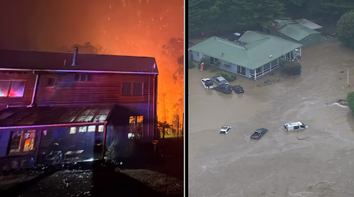  Fires burn in Victoria’s Otways. Less than 2 weeks before the fires there was flash flooding on the Great Ocean Road ABC News | 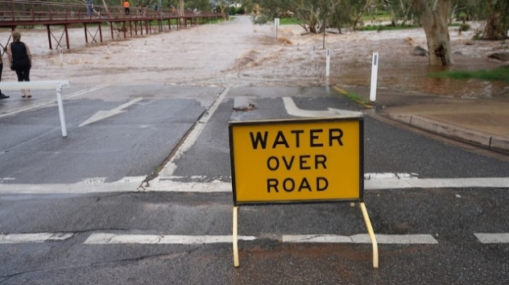  Alice Springs recorded more than 30 summer days above 40°C before dangerous flash flooding on February 12 ABC News
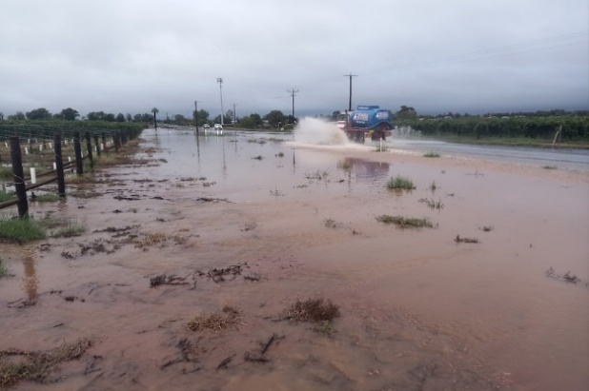  Flash flooding in Mildura ABC News | 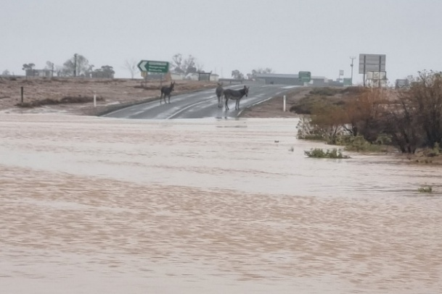  Marree in Outback SA went from five days about 48C to flooding ABC News

Activity: La Niña and El Niño
These BTN stories explain in more detail La Niña and El Niño. Students will watch these stories then respond to the questions below.

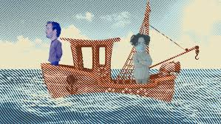  BTN La Niña | 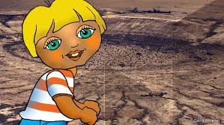  BTN El Niño

- Explain the difference between weather and climate.
- What is the difference between La Niña and El Niño? Explain each weather pattern,
- What are the effects of a Nina and El Nino in Australia? What type of climate pattern do we see with La Nina and El Nino?

Activity: Understanding ENSO
Watch the Bureau of Meteorology Understanding ENSO video and respond to the following questions:

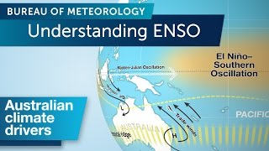
- What is ENSO?
- ENSO is often behind our climate extremes like…
- ENSO swings between three key phases. What are they?
- What happens in a La Niña phase and what does it mean for Australia?
- What happens in an El Niño phase and what does it mean for Australia?

Useful Websites
- Scientists say summer of weather whiplash points to driving force of climate change – ABC News
- Big Weather (and how to survive it) – ABC Education
- El Niño - BTN
- La Niña – BTN

EPISODE 8
24 March 2026

KEY LEARNING
Students will recognise and celebrate Australian women who have made significant impact on society.

CURRICULUM
HASS – Year 4
The diversity of First Nations Australians, their social organisation and their continuous connection to Country/Place.

HASS – Year 3 and 4
Pose questions to investigate people, events, places and issues.

Locate and collect information and data from different sources, including observations.

HASS – Year 5 and 6
Develop appropriate questions to guide an inquiry about people, events, developments, places, systems and challenges.

Locate and collect relevant information and data from primary sources and secondary sources.

History – Year 6
The contribution of individuals and groups to the development of Australian society since Federation.

HASS – Year 7
Construct significant questions and propositions to guide investigations about people, events, developments, places, systems and challenges.

This document contains links to sites that may use images of Aboriginal and Torres Strait Islander people now deceased.

  - Teacher Resource

Women’s History Month – Jackie Huggins

Focus Questions
Discuss the BTN story as a class and record the main points of the discussion. Students will then respond to the following:
- Describe Jackie’s life growing up.
- What job did Jackie get when she was 16 years old?
- What event in 2000 did Jackie take part in to support reconciliation?
- Which piece of clothing belonging to Jackie is on display at the National Museum of Australia?
- What is Jackie Huggins’ legacy?

Activity: Personal Response
Respond to the BTN Jackie Huggins story as a class. Students will complete one or more of the following incomplete sentences:
- Jackie Huggins is an important Australian because…
- It was interesting to learn…
- These are five words that I would use to describe Jackie Huggins …
- This story made me feel…
- It is important to celebrate Jackie Huggins because…

Activity: Class Discussion
After watching the BTN story, hold a class discussion using the following discussion starters.
- What did the BTN story tell you about the life of Jackie Huggins?
- Name at least one of her achievements.
- What questions do you have about Jackie Huggins?
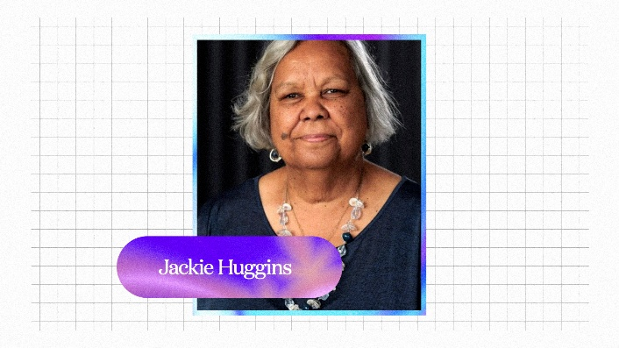

Activity: Connection to Country
In this activity students will explore the connection and deep history that Aboriginal and Torres Strait Islander peoples hold with Country. Explain that for Aboriginal and Torres Strait Islander peoples, place (often called Country) is very important. What can the term Country include? (land, waterways, animals and plants, stories and traditions, ancestors, history). Explain that connection to Country is part of identity, culture and community.

Jackie Huggins’ Connection to Country
Jackie Huggins is a Bidjara Elder of the Carnarvon Gorge area of Central Queensland. Students will learn more about Carnarvon Gorge and its importance to Aboriginal and Torres Strait Islander peoples. Students will choose one or more of the following questions to investigate.

Research Questions
- Where is Carnarvon Gorge? Find on an Indigenous map of Australia.
- What are some special Aboriginal sites in the area?
- What are some examples of rock art in the Carnarvon Gorge area? Describe the main features of the rock art (colours, shapes, lines). What story does the rock art tell?
- Carnarvon Gorge is a significant Dreamtime area. Explore the Dreamtime story about the rainbow serpent Mundagurra, which is believed to have carved the gorge as it travelled through the landscape.
- Carnarvon Gorge is known to Traditional Owners as the “Home of the Rivers”. What does this mean?
- Why might this place be important to Jackie Huggins? Explore Jackie Huggins’ connection with Carnarvon Gorge and how might it connect to her identity and history. Visit the Marking Country website to explore the deep history of the gorge, led by Bidjara elders Uncle Fred and Jackie Huggins.

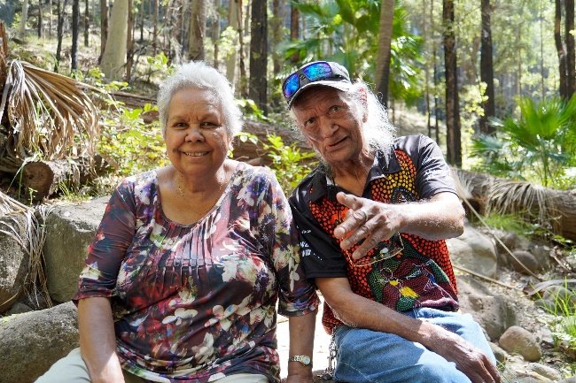  Source: Marking Country. Jackie learns from Uncle Fred as he shares Bidjara culture, Mickey's Creek, Carnarvon Gorge, Queensland, 23 March 2022. Photo: Amy Way. | 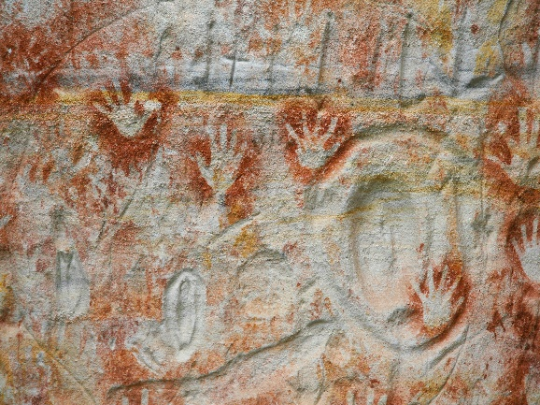  Source: QLD National Parks and Forests. Cathedral Cave Walk.

Activity: Your Special Place
Students will reflect on their own connection to places that are meaningful to them. They will share stories about places that hold memories or special meaning. Students can use the following to help guide them during this activity.

Think about…
- A place you love to visit.
- It could be a park, a beach, grandparents, sporting ground, or somewhere in nature.
- What makes this place special?
- How do you feel when you are there?
- What memories do you have in this place?
- Who do you usually go there with?

Activity
- Write a short paragraph about a place that is special to you and why you love to visit this place.
- Draw the place and label it.
- Write a short story about a memory there.

Include:
- Where the place is.
- Why it is special.
- How you feel when you are there.
- A memory you have there.
- Who you share the place with.

Share your stories
- Form small groups and share your stories with one another.
- Make a poster about your special place to put up in your school.
- Create a map of special places in your community.
- Imagine if you were commissioned by your local council to research and design a range of interpretive signs to be installed at special places in your community! The signs would teach visitors about the area’s natural features, history and cultural significance. Include hand drawn illustrations and a short description. Design a walking trail map which highlights these special places.

Useful Websites
- Deep Time – BTN
- Walking deep history: Carnarvon Gorge – Marking Country
- Jackie Huggins collection – National Museum of Australia
- Professor Jackie Huggins joins the ABC as Elder-in-residence and wants broadcaster to become a 'blueprint' of cultural safety – ABC News

  - Teacher Resource

BTN Transcript: Episode 8 - 24/3/2026

Hey, I'm Amelia Moseley and you're watching BTN. Thanks for hanging out with us again. Let's see what's coming up on today's show. We find out why it may be getting harder to predict the weather, meet Australia's youngest Winter Olympian and learn about the life of living legend, Jackie Huggins.

Military Alliances

Reporter: Wren Gillett

INTRO: But before we get to that, let's have a look at military alliances. Last week the US president criticised some of his country's allies for not wanting to get involved in the war in Iran. So, why would countries choose to team up, or not team up when it comes to conflict? Here's Wren with more.
TATENDA CHIBIKA, REPORTER: Sir Knight, do you intend to cross this bridge?
For as long as humans have been humaning, we've been facing threats,
TATENDA: Well, are you going to fight him?
WREN GILLETT, REPORTER: He has a sword.
TATENDA: And so do you.
WREN: And so do you.
And sometimes, teaming up to face them, by forming alliances. History is full of alliances, between city-states, kingdoms and countries. They're usually formed because of a common threat, or perhaps a shared goal.
WREN: Are you thinking what I'm thinking?
And I mean the benefits are obvious.
JACK EVANS, REPORTER: Ahh. There's two of them.
WREN: Run, run.
We're stronger when we work together, and sometimes the best way to avoid a fight is to bring backup. Although, alliances don't always ensure peace.
WREN: Look at him, he's so scared.
Take World War I for example. It started after an Austro-Hungarian Archduke was assassinated by a Serbian.
WREN: But Serbia had an alliance with Russia. Austria Hungary had an alliance with Germany. Germany invaded France through Belgium, which had an alliance with the UK, which was the head of an empire, which included Australia. See what I mean?
After that World War, and the next one, the world built new organisations to try to prevent that sort of thing from happening again. It also built new alliances, both formal and informal. For example, Australia has fought alongside the US in several wars, from Korea to Afghanistan and Iraq. Then there's NATO, one of the world's most powerful military alliances. It includes 32 countries that have formally agreed to defend each other if any is attacked. But military alliances don't always mean that countries have to fight together.
DONALD TRUMP, US PRESIDENT: We've had great support from countries in the Middle East. But we've had no support from NATO.
Recently, there's been some tension between the US and many of its allies, including Australia, over the war in Iran. As you might know, it's having a big impact on the world's oil supply, and the US president says the world should be coming to help.
DONALD TRUMP: We strongly encourage nations whose economies rely on this strait far more than ours.
But a lot of other countries don't see it that way.
MARK CARNEY, CANADIAN PRIME MINISTER: The United States and Israel have acted without engaging the UN or consulting with allies, including Canada.
The UN and many world leaders have called the war illegal.
PEDRO SANCHEZ, SPANISH PRIME MINISTER: We are against this war, against this war because it is illegal. There's no reason behind it, and it's causing a lot of damage.
And even strong US allies have said they don't want to risk making it even bigger, and risk the lives of their own people.
BORIS PISTORIUS, GERMAN DEFENCE MINISTER: There will be no military participation.
KEIR STARMER, UK PRIME MINISTER: We will not be drawn into the wider war.
RICHARD MARLES, AUSTRALIAN DEFENCE MINISTER: This is being undertaken by the US and Israel and them alone.
Instead, many have called for a diplomatic solution.
ANTHONY ALBANESE, AUSTRALIAN PRIME MINISTER: I think the world wants to see a de-escalation.
It's made some countries question whether they've depended too much on the US. Meanwhile, some say it's time to rethink our alliances, or maybe form some new ones to keep the world safe.

News Quiz

Peter Malinauskas has been re-elected as the premier of which state? He’s the Premier of South Australia. A job he’ll keep for a while longer after the Labor Party won the SA election on Saturday. While it was a very good day for Labor, not so much for the Liberals who’ve ended up with just a few lower house seats and got fewer primary votes than One Nation.

The King and Queen of which country were in Australia last week? Belgium, Norway or Denmark? King Frederick and Queen Mary are the monarchs of Denmark. Although, of course, Queen Mary of Denmark was once Mary of Tasmania before meeting and marrying the Crown Prince. This her first official visit to her home state since becoming Queen.

Fuel shortages are having a big impact on people around the world. What has the government of Sri Lanka done to conserve it? Introduced a four-day work week, put limits on how much people can drive or handed out free bicycles? It’s introduced a four-day work week, it applies to schools and unis too so that people can stay home for one more day and not have to use any petrol.

And two once-lost episodes of a very famous British TV show have been found. Do you know what TV show it is? It’s Doctor Who. This episode, the Dalek’s master plan, hasn’t been seen by the public since it first aired in the 60s and was one of 97 missing episodes until a copy was discovered in a film-fan’s archives along with an episode called the Devil’s Planet.

Cyclone Narelle

Reporter: Tatenda Chibika

INTRO: Now, we're heading up north, where communities have spent the week getting ready for cyclone Narelle. Tatenda's been in touch with some kids in Narelle's path to find out what happened.

TATENDA, REPORTER: This is what Cyclone Narelle looked like from space last week as it made its way towards Northern Queensland.
David Crisafulli, QLD Premier: This is a serious system though and I’m asking people to take it seriously because it is the kind of event that doesn't happen all that often. Homes and items are replaceable, you're not.
It approached Australia as a category 5 storm, the strongest you can get, and communities across Cape York got ready. Buildings were boarded up, supplies were stocked and schools were closed.
CHASE: We had to do a lot of prep, like mowing the lawns and tying down odds and ends in the yard and front. We also had to charge phones and collect water. School was closed like just to give us prep time
KID: Nervous and excited.
KID: Usually, you'd be at school on Thursday and Friday but now there's a cyclone on Thursday and Friday and it's raining.
By the time it made landfall, Narelle had been downgraded. But it still brought powerful winds and lots of rain to places like Coen and the Lockhart River.
CHASE: It was like scary at first, but then you just got over it because it was very windy. The house seemed like it was going to fall down, but it was very rainy and my sister had to sleep in my room because there was a tree above there and we were scared it was going to fall.
KID: It felt like someone was trying to whistle at me and it got really scary after one bit when it got really loud and it didn't feel like the wind could do that.
TAHU DAD: What's that river called?
TAHU: Cohen River, it flows down from the bend to the bridge all the way down to here.
It cut power lines and uprooted some trees, but no one seriously injured. By the weekend it reached the NT and people in places like Katherine braced themselves for even more heavy rainfall.
TULLY: We stayed on and we just prepared for the cyclone, prepared for flooding.
TULLY: We've had a lot of good, volunteers, all sand badging and so there's been thousands of sandbags made for the community.
Several schools were closed, including Tully's.
TULLY: Last week after the floods, we went back for last week and then this week, I don't know how long it would be our schools cancelled because it's an evacuation centre.
Narelle was a category two cyclone when it hit Katherine and while the winds, didn't do too much damage.
The rain was a big problem as many communities in this part of the country are already dealing with record floods.
TULLY: This should probably be the last big rain of the wet season. Touch wood while I'm saying that, but hopefully that's for the last big one.
MAN: I didn't expect to see this, especially when it's already flooded previously and then get up this morning and it's flooding like this again.
And Narelle wasn't finished. It kept moving across the top of the country and by Monday, it had picked up strength ready to make landfall again in Western Australia. While many are relieved the cyclone didn't do more damage, its effects are still being felt by many in parts of Australia that have been battered by the weather.
Quiz

Which of these is thought to be the most powerful cyclone to hit Australia in recorded history? Was it Cyclone Yasi in 2011, Cyclone Tracy in 1974 or Cyclone Mahina in 1899. It was Mahina. It was the deadliest storm in Australia's history and probably the strongest, killing between 3 and 4 hundred people.
Climate Whiplash

Reporter: Tatenda Chibika

INTRO: As you just heard it's been a really rough few weeks for communities in Australia's north. In fact, it's been a rough summer for a lot of Australia. And some scientists reckon the extreme weather we've been seeing could have been influenced by climate change. Here's Tatenda.
Tatenda, Reporter: From drought and record heat, to record rain and now cyclones.

The weather this summer has gone from one extreme to the other. It's enough to give you climate whiplash. Yeah, that's exactly what scientists are calling it. The Climate Council of Australia has been keeping track of extreme weather events we've seen over summer and found multiple cases of weather conditions flipping between extremes.

Over the summer, 63 heat records were broken across the country and February's overall rainfall neared all-time highs in some states. For example, in Victoria, it swung from extreme heat in the Otway's to dangerous flash flooding along the Great Ocean Road just five days later. By the end of the month, parts of the state were back to extreme heat again followed by even more rain.

Andrew Watkins, Climate Scientist: We are actually seeing this all around the world at the moment and it's something that we kind of expect that comes along with climate change.

Weather extremes are nothing new here in Australia I mean we're a big country with lots of different climates but some scientists this is different. And it's changing some of the weather patterns that we're used to seeing.

Andrew Watkins, Climate Scientist: Historically, we've expected La Nina, and that's what we're in at the moment, to push us towards cooler and wetter. But what we're seeing now is that climate change is coming along and giving a good whack, giving our weather a whack as well and so at times, we're seeing a La Nina, it actually becomes hot and dry, and we saw that in January.

What Andrew's talking about is the El Nino-Southern Oscillation or ENSO for short. It's a natural cycle in the Pacific Ocean that swings between three phases. La Nina which brings in cooler temperatures and more rain, El Nino which brings in drier and hotter weather and Neutral which is considered our normal phase. In Australia, the La Nina has been weaker than usual which means most of the country is experiencing higher temperatures instead of milder ones.

Scientists say climate change is also contributing to an increase in extreme weather events. which is a huge problem and also, an expensive one.

Andrew Watkins, Climate Scientist: What we've seen over the past 30 years or so, on average Australia, it costs insurance in Australia about $2 billion dollars, but the last five years, it's cost us about four and a half billion dollars, so that damage has gone up, gone up about double.

MAN: Financial cost will be significant but yeah, it's not the end of the world. I bought here knowing it was in flood zone, I don't expect any support.

WOMAN: It's time to sell the family home, we can't do this every time it floods.

Experts say we need to do more to get ready for the impacts of climate change and the extreme weather it can bring, but Andrew says we can also try to reduce our impact on the planet.

Andrew Watkins, Climate Scientist: Everyone can do something. It doesn't really matter who you are or how much money you have. It can be as simple as just turning off a light when you leave a room, that's less energy that's being used.

It can be recycling. It can be riding your bike or walking to school instead of getting mum to drive you or dad in my case. But it also can be just talking about it with friends and parents and so on and making sure everyone understands what's going on because that's really important that we talk and we sort of relate how it might be affecting us.

Indra Brown

Reporter: Saskia Mortarotti

INTRO: Now, as promised, we have an interview with Australia's youngest winter Olympian. Sas had a chat with Indra Brown, who went straight from the Olympics to the Park & Pipe Junior World Championships in Canada, where she won gold. Check it out.

SAS MORTAROTTI, REPORTER: So, Indra, you are a Junior World Champion, how does that feel?
INDRA BROWN, FREESTYLE SKIER: Yeah, it's amazing. I just, you know, went to Junior Worlds after the Olympics just to go, you know, Ski with some people more my age, you know, I hang out with lots of my friends. I know so many of the athletes I competed with from all over around the world. So, it was really good to see them again and to, you know, come away with the result was just a bonus.
SAS: I know that you grew up in Melbourne, which isn't exactly famous for being a snowy place. Where did you get your start in skiing?
INDRA: We actually, when I was around 7 years old, moved to Canada for five years. So, that's where we really, you know, we're skiing every weekend. That's what they do for seven months of the year. They just ski because it's so cold and snowy. So, that's where I really just learned how to ski.
SAS: Does it ever get a little bit scary? Are you ever afraid of all these big jumps that you're doing?
INDRA: Yeah, definitely. It's definitely a little scary. You know, the mind is telling you what not to do, but I think that's what makes it so fun. You know how far you can push yourself and show yourself how mentally strong and capable you are of doing these things.
SAS: This win comes off the back of something pretty special. We can't ignore the fact that you are an Olympian now.
INDRA: Yeah, it's a big honour, you know, to have said I went to Italy and put on the green and gold and, you know, yeah, competed at the Olympics. I think it's something still feels weird to say, you know, doesn't roll off the tongue super easily, but I'm super proud of myself, you know, for how far I went with it, and I got there and then yeah, super honoured as well to have represented Australia.
SAS: Do you have any, like, behind the scenes info you can maybe share with us? Like, did you stay at the Olympic Village? Can you tell us what the food was like, whether the beds were comfy? Because in Paris, I believe they were made of cardboard.
INDRA: Yes. So, I actually was fortunate enough to be able to stay with my mum. So, I wasn't actually in the Olympic Village, but I did get to go to the Olympic Village a few times. I can confirm the beds are not cardboard. The food it's pretty nice. I've heard the tiramisu is extremely good. Never got to try it though. Being the youngest one there, I think it was just, you know, an opportunity to take everything in, you know, to learn so much from all the older athletes, especially the ones where this might not be their first games, you know. So, just taking in as much, you know, knowledge that I can get from the experienced athletes, I think it was a really valuable thing for me to have.
SAS: Would you like to see more young girls growing up competing as athletes in skiing?
INDRA: I would love to see, more just girls in general skiing and stuff like that. I think especially in Australia now. The sport isn't very big. We're not known for our winters and our mountains. So, just to get more young girls doing it, because it is such a fun sport. And we're amazing, us girls. We're powerful, we're strong. We can do anything we set our minds to. So, just encouraging them to not be afraid, just to try something new and see where it takes you.
Did you know?

Did you know that Australia is home to the oldest and longest continuously running ski club in the world.
The Kiandra Snow Shoe Club was founded in 1861 by Norwegian miners who introduced skiing to Australia using wooden skis, which they called "snowshoes". It later became the Kiandra Pioneer Ski Club, now based in Perisher.

Sport
A record-breaking crowd packed into Stadium Australia, to see the Matildas take on Japan in the 2026 Women's Asian Cup Final. Japan snagged a goal early on and while Australia tried to break through Japan's defence, getting pretty close multiple times, ultimately it was Japan that claimed the Asian Cup title, 1-0.
Lebron James made NBA history, during this game between the LA Lakers, and Orlando Magic. He Set a new record for the most games played. How many we talking? 1,612. As for the game itself it was a nail-biter. With just 0.6 seconds remaining, Luke Kennard made this 3-pointer, leading to a one-point victory for the Lakers.
The World Athletics Indoor Championships have just wrapped up in Poland. It was a massive three days for our Aussies, who snatched up five medals across high jump, pole vault, and the track. Two of those medals were won by Jessica Hull, who took home silver in the 1,500m and bronze in the 3,000m.
And finally to the Tasmania Devils, who played their first VFL game in 18 years. A sell-out crowd packed North Hobart Oval to watch them take on Coburg. The Devils led at every break and ultimately won the game, 96 to 79. The only thing they couldn't master. The club song. Turns out the team is so fresh, they were still learning the lyrics as they celebrated.

Women’s History Month – Jackie Huggins

Rookie Reporter: Liliana

INTRO: Finally, today let's continue to celebrate Women's History Month by learning about the life of another amazing woman. This week it's the ABC's own Elder in Residence, Jackie Huggins. Here's Liliana to tell you, her story.

Jackie Huggins was born on the 19th of August 1956 in Northern Queensland. Her mother, Rita, was a Bidjara woman and her father, Jack, was from the Birri Gubba Juru nation. When Jackie was 2 years old her father died from injuries he got in the Second World War, leaving Jackie's mother to raise her and her siblings.
JACKIE HUGGINS: I grew up with a very strong, a very proud mother who raised the kids.
Jackie went to school in Brisbane; she was a bright student and was even school captain. At the time First Nations history wasn't taught in schools and Jackie didn't like that. She decided that she was going to do all she could to make sure all Australians knew about our country’s true history. When Jackie was 16, she got a job as a typist at the ABC to help support her family. Jackie and her cousin, Lillian Holt, were some of the very first Indigenous employees at the ABC. But this was only the start for Jackie.
In 1978 she travelled to Canberra and joined the Commonwealth Department for Aboriginal Affairs where she met Aboriginal activists, including Charlie Perkins. Jackie went on to be part of many First Nations Organisations that were fighting for Indigenous rights and for reconciliation. Like the Australian Institute of Aboriginal and Torres Strait Islander Studies and the National NAIDOC committee. Jackie often jokes that she's been on every board, except a skateboard.
During the 1980s Jackie decided to go back to school, earning multiple degrees and a diploma in education. This all helped prepare her for her next move, joining the Reconciliation Council of Australia. Which was set up to try to bring Aboriginal and non-Aboriginal people together. Jackie was a key part of Corroboree 2000, a historic two-day event that included walks for reconciliation right across the country. In Sydney Jackie joined more than 250,000 people in a march across the Sydney Harbour Bridge. During that time, she was often pictured in her favourite yellow suit, which now sits on display at the National Museum of Australia. In 2001, Jackie became co-chair of the Reconciliation Council and was made a member of the Order of Australia.
JACKIE HUGGINS: Reconciliation means to me about knowing about learning and about identifying with our true history of our country that must be taught from preschool level right through to university. It’s about knowing who we are, where we come from and how we are defined as a nation.
Jackie has continued to educate others, she's received many awards including an honorary doctorate and has published multiple books about First Nations people, history and culture. In 2024 Jackie returned to where it all started, the ABC, where she's been the broadcasters first ever Elder in residence where she still working to bring Australians together and tell the truth about our shared history.

Closer

Amazing work, thanks Liliana. That's all we have for today, but we'll be back before you know it. In the meantime, you can check out Newsbreak, we will be here every weeknight, and BTN High has some in-depth stories for you highschoolers and nearly highschoolers. Have a good one and I'll see you next week. Bye.

