EPISODE 11
9th May 2023

KEY LEARNING
Students will view a range of BTN stories and use comprehension skills to respond to a series of focus questions.

CURRICULUM
English – Year 4
Use comprehension strategies to build literal and inferred meaning to expand content knowledge, integrating and linking ideas and analysing and evaluating texts.

English – Year 5
Use comprehension strategies to analyse information, integrating and linking ideas from a variety of print and digital sources.

English – Year 6
Use comprehension strategies to interpret and analyse information and ideas, comparing content from a variety of textual sources including media and digital texts.

English – Year 7
Use comprehension strategies to interpret, analyse and synthesise ideas and information, critiquing ideas and issues from a variety of textual sources.
  - Teacher Resource

Focus Questions
As a class, discuss the stories featured in the episode of BTN Classroom and record the main points of the discussion. Students will then respond to the following focus questions.

Federal Budget 2023
- What did the BTN story mainly explain?
- Who is the Federal Treasurer?
- This year’s budget is expected to focus on the cost of ____________.
- For the first time in 15 years, the budget will be in surplus. True or false?
- Name three facts you learnt watching the story.

King Charles Coronation
- Write 5 facts about the coronation.
- The coronation ceremony took place in _______________ Abbey.
- King Charles III is Australia’s…
  - Head of State
  - Governor-General
  - Prime Minister
- Who is the Queen Consort?
- Why were some people protesting about the coronation?

Ocean Census
- What is the aim of the Ocean Census?
- What percentage of the ocean has been explored?
  - 10%
  - 30%
  - 50%
- Why is it important to find new species?
- The ocean is home to up to ______% of life on our planet.
- What was surprising about this story?

Check out the teacher resource on the Archives page.

Bandicoot Tracking
- The Southern Brown bandicoot is an endangered species. True or false?
- How are they tracking the bandicoots at Coromandel Valley Primary School? Use words or pictures to explain.
- Bandicoots are nocturnal. What does that mean?
- What sort of habitats do bandicoots like? Why?
- Why are bandicoots known as ecosystem engineers?

Check out the teacher resource on the Archives page.

Outback Musical
- What musical are the students in the BTN story performing?
- Why are the students learning online?
- The Longreach School of Distance Education covers an area…
  - The size of South Australia
  - Twice the size of Victoria
  - Three times the size of the ACT
- What are some of the challenges of putting a musical together?
- What did you like about the Outback Musical story?

EPISODE 11
9th May 2023

KEY LEARNING
Students will explore the deep sea and the animals that live within deep sea habitats.

CURRICULUM
Science – Year 4
Living things depend on each other and the environment to survive.

Science – Year 5
Living things have structural features and adaptations that help them to survive in their environment.

Science – Year 6
The growth and survival of living things are affected by physical conditions of their environment.
Science – Year 7
Interactions between organisms, including the effects of human activities can be represented by food chains and food webs.

Scientific knowledge has changed peoples’ understanding of the world and is refined as new evidence becomes available.

  - Teacher Resource

Ocean Census

Focus Questions
Discuss the BTN story as a class and record the main points of the discussion. Students will then respond to the following:
- What is the aim of the Ocean Census?
- What percentage of the ocean has been explored?
  - 10%
  - 30%
  - 50%
- Why is it important to find new species?
- The ocean is home to up to ______% of life on our planet.
- What was surprising about this story?

Activity: Class Discussion
Discuss the BTN story as a class. Create a class mind map with DEEP SEA in the middle. Ask students to record what they know about the deep sea and deep sea species. What questions do they have? In small groups, ask students to brainstorm responses to the following questions:
- What do you know about the deep sea?
- What is unique about the deep sea?
- What does this story make you wonder?
- Why is it important to explore the deep sea?
- What words would you use to describe the deep sea?
- Think of three questions you have about the story.

Interactive Infographic
Explore the deep sea with this interactive infographic that lets you scroll down the ocean! Visit the great depths of the Mariana Trench and discover all the sea creatures hidden beneath.

Activity: Glossary
Students will brainstorm a list of key words that relate to the BTN story. The glossary will help inform students while working through the activities in this resource. Students can use the words to write their own sentences about the topic. Students may want to use pictures and diagrams to illustrate the meaning and create their own glossary. Here are some words to get you started.

MARINE SPECIES | DEEP SEA | BIOLUMINESCENCE
CLASSIFICATION | HABITAT | MARINE BIOLOGY

Further investigation:
- Students will choose additional keywords and terms to add to their class glossary that are tricky. For example, benthic zones, deep sea vents, chemosynthesis, oceanography and abyssal zone. Students will find a definition and add to their deep sea glossary.
- What are the 4 main benthic zones? Write a short explanation for each benthic zone and name some of the species that live in this habitat.

Activity: Research project
Discuss the information raised in the BTN Ocean Census story. What questions were raised in the discussion and what are the gaps in students’ knowledge? The following KWLH organiser provides students with a framework to explore their knowledge on this topic.

What do I know? | What do I want to know? | What have I learnt? | How will I find out?

Students will develop their own question/s to research or choose one or more of the questions below.
- Where does the deep sea start? Draw a diagram showing the depth of the deep sea, including the twilight zone, the midnight zone, the abyss and the trenches. Give examples of animals that live in each of these deep sea habitats.
- How are creatures able to survive in the deep sea? How have they adapted to the conditions? Research some specific adaptations that deep sea animals have made to survive in particular habitats, for example, body shape and colour. Give an oral presentation explaining the adaptations.
- What are some challenges to life for deep sea creatures? (Pressure, cold, darkness)
- What is bioluminescence? Watch this ABC Education video and explain bioluminescence in your own words. Give some examples of creatures that are bioluminescent. Why do some deep sea creatures have this feature?
- What equipment do scientists use to find out about life on the sea floor of deep oceans?
- What does an angler fish habitat look like? Study the habitat of one type of angler fish species and create a diorama of its habitat.
- What are some of the challenges of deep sea exploration?
- Why do people explore the deep sea? What are the benefits? Explore one area of underwater research (E.g., marine life, ecosystems, ocean health, biodiversity).

Activity: Species profile
Students will imagine they are marine biologists and study one species that calls the deep sea its home. Students will create a profile about the species, see below for some examples:
- Whipnose angler fish
- Goblin shark
- Blobfish
- Frill shark
- Abyssal ghost shark
- Sea Angel

Students will research the following and then share their research findings with the class or create a display in the classroom.
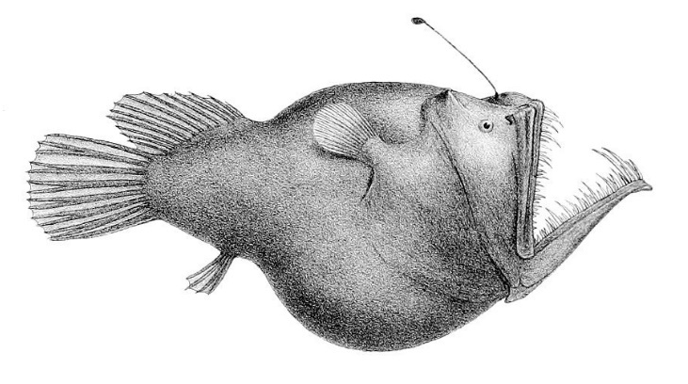
- Name (common and scientific name)
- Biological illustration or photo
- Classification (class, family, genus)
- Description (size, colour, physical features)
- Habitat
- Diet
- Behaviours
- Adaptations
- Threats

Students will then choose one of the following activities to complete:
- Model – Create a 3D model of the species using upcycled materials. Display your model in the classroom.
- Diary – Write a diary of what might happen in the daily life of a deep sea species.
- Haiku – Write a haiku poem about the species.
- Children’s book or comic – Write and illustrate either a children’s book or comic which tells the story of the species.
- True or false? – Find out as much as you can about the deep sea and the species that live there. Create a true or false quiz and test your classmates.
- Celebrate – Celebrate world Ocean’s Day on the 8th of June. Think of a creative way to celebrate the day in your class.

Activity: Create your own species
Students will use their imagination and create their own deep sea species. Students will imagine they have discovered a new species of deep sea creature which has never been seen before. Use the following as a guide for this activity:
- Illustrate the new animal species using only a black felt-tip pen on a piece of A4 art paper – include as much detail as you can. You may want to draw a scientific illustration or draw the animal in its natural habitat. Label important features.
- Create a 3D model of your new species using upcycled materials.
- Name the species. Give the animal a common and scientific name.
- Where does it live in the deep sea?
- Describe what the animal looks like – what are some of its physical characteristics?
- List the animal’s classification.
- How does it get its food? How does it eat?
- How does it survive in its environment? What are its adaptations?
- Does it have any interesting or unique features?
- How possible do you think it is that your new species exists? Explain your answer.

Activity: Biological Illustration
Students will create their own biological illustration of a deep sea animal. This activity encourages students to develop their observation skills and reinforce their understanding of biological concepts.

Explain to students that in their illustration they need to draw what they see (using photographs/videos they find in books and on the internet). Students will need to think about size, shape, texture, and patterns; and include as much detail as possible.

Teachers may want to show examples of scientific drawings or begin this exercise by asking their students to collect a plant specimen (for example, a leaf or flower) from the school yard to practise scientific drawing.

Students can use the following as a guide as they create their scientific drawing:
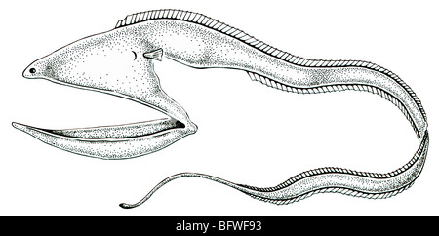
- Find photographs and/or videos of the animal to observe. What key structures and anatomy will you focus on in your drawings?
- Draw the animal to scale (include a ratio on the drawing).
- Include its scientific and common name.
- Add labels – to show size, colour and texture.

For more information about scientific drawing in the classroom, visit this website Sketching for observation. Consider sending your students’ drawings into your local museum to display as an exhibition.

Useful Websites
- Biggest Ocean Survey Ever – BTN Newsbreak
- Deep Sea Exploration – BTN
- Underwater Research – BTN
- Underwater Explorer – BTN
- The fishes of the deep sea – Natural History Museum
- The Deep Sea – Biomes
- Down to the Deep – Monterey Bay Aquarium
- 10 minutes of fascinating deep-sea animals (YouTube) - Monterey Bay Aquarium
- How Deep is the Ocean? – TEDEd
- The otherworldly creatures in the ocean's deepest depths – TEDEd

What scientific questions do you have?

EPISODE 11
9th May 2023

KEY LEARNING
Students will develop a deeper understanding of bandicoots and create a profile of the marsupial.

CURRICULUM
Science – Year 4
Living things have life cycles.
Living things depend on each other and the environment to survive.

Science – Year 5
Living things have structural features and adaptations that help them to survive in their environment.

Scientific knowledge is used to solve problems and inform personal and community decisions.

Science – Year 6
The growth and survival of living things are affected by physical conditions of their environment.

Scientific knowledge is used to solve problems and inform personal and community decisions.

  - Teacher Resource

Bandicoot Tracking

Focus Questions
Discuss the BTN story as a class and record the main points of the discussion. Students will then respond to the following:
- The Southern Brown bandicoot is an endangered species. True or false?
- How are they tracking the bandicoots at Coromandel Valley Primary School? Use words or pictures to explain.
- Bandicoots are nocturnal. What does that mean?
- What sort of habitats do bandicoots like? Why?
- Why are bandicoots known as ecosystem engineers?

Activity: What do you see, think and wonder?
Students will watch the BTN Bandicoot Tracking story, then respond to the following questions:
- What did you SEE in this video?
- What do you THINK about what you saw in this video?
- What did you LEARN from this story?
- What QUESTIONS do you have?

Activity: Class Discussion
After watching the BTN story, hold a class discussion using the following discussion starters.
- Describe a bandicoot. What are some of their physical features?
- About how many species of bandicoots are there in Australia?
- Bandicoots are nocturnal. What does that mean?
- What do bandicoots eat?
- How are they tracking the bandicoots at the school in the BTN story?
- Why are they tracking them?
- Why are bandicoots important to the ecosystem?

Activity: Glossary
Students will brainstorm a list of key words that relate to the BTN Bandicoot Tracking story. Here are some words to get them started.

MARSUPIAL | ENDANGERED | TRACKING
NOCTURNAL | THREATENED | OMNIVORES

Activity: Bandicoot Profile
Students will research and write a profile of a species of bandicoot. They can choose the species featured in the BTN story, the Southern Brown Bandicoot, or choose another species. Students can use the animal profile worksheet at the end of this activity to record their findings. Encourage students to use a range of sources to find their information.

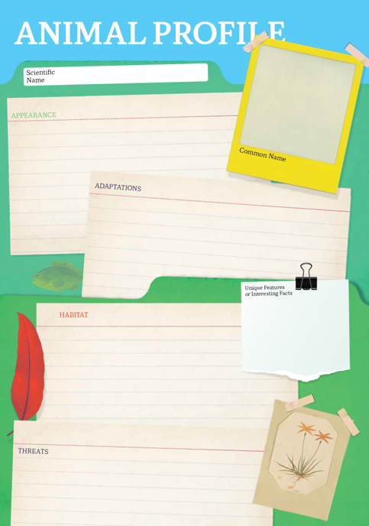
Research
Students will research and create a profile of a species of bandicoot. Students can use the Animal Profile at the end of this activity to record their findings.
- Illustration or photo
- Scientific and common name
- Appearance
- Habitat
- Feeding and diet
- Behaviours and adaptations
- Conservation status
- Threats
- Importance to the ecosystem

Activity – Choose a Project
Individually or in small groups, students will choose one of the following projects to work on and then present their findings to the class.

Did you know?
Using the information in the BTN story and your own research, create a Did You Know fact sheet about a species of bandicoot. Publish using Canva
Bandicoots and the ecosystem
Research the important role bandicoots play in the ecosystem. Present your research in an interesting way.
Draw a bandicoot
Draw a labelled diagram of a bandicoot including physical features such as their long pointed snouts and short legs.

Quiz
Create a true or false quiz to test your classmate’s knowledge about bandicoots.

Activity: Bandicoot Bodyguards

Watch the Bandicoot bodyguards story and respond to the following questions:
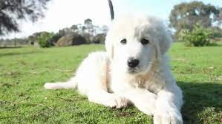
- What was the main point of the video?
- Which species of bandicoots are featured in the video?
- How do the Maremma’s protect the bandicoots?
- Why are the Maremma’s given both sheep and bandicoots to protect?
- What is the conservation status of the Eastern Barred bandicoot?
  - Threatened
  - Endangered
  - Critically endangered
- What was surprising about the information in this video?

Activity: Bandicoots Quiz
- Which species of bandicoot was featured in the BTN story?  A. Southern brown  B. Long nosed  C. Eastern Barred  2.Approximately how many species of bandicoots are there in Australia?  A. 10  B. 20  C. 30  3. Bandicoots are…  A. Herbivores  B. Carnivores  C. Omnivores  Quiz Answers: 1A, 2B, 3C, 4C, 5B, 6B | 4. What are students at Coromandel Valley Primary School using to track bandicoots?  A. Radio transmitters  B. Thermal cameras  C. Motion sensor cameras  5. A young bandicoot is called a…  A. Pup  B. Joey  C. Cub  6.Bandicoots are known as…  A. Ecosystem warriors  B. Ecosystem engineers  C. Environmental engineers

Useful Websites
- Bandicoots – NSW Environment and Heritage
- Long-nosed Bandicoot – Australian Museum
- Eastern Barred Bandicoot – Melbourne Museum
- Southern Brown Bandicoot – Australian Museum
- Southern Brown Bandicoot – Department for Environment and Water
- Southern Brown Bandicoot – Parks Victoria

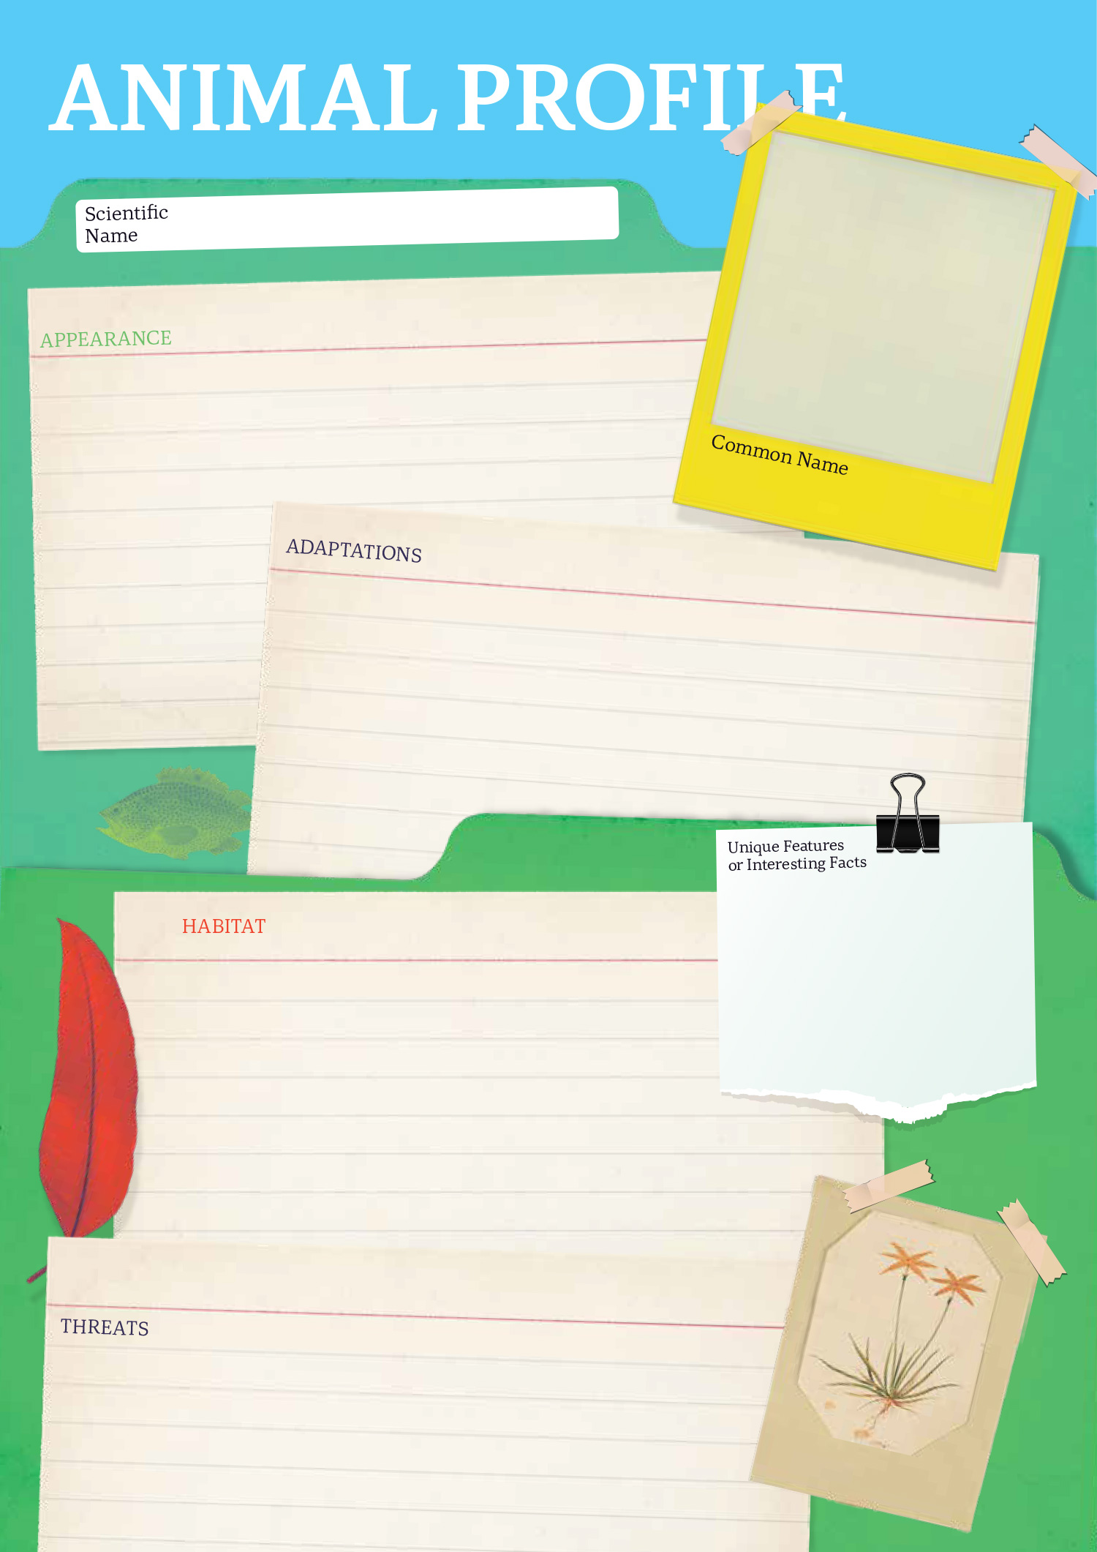

  - Teacher Resource

BTN Transcript: Episode 11 - 9/5/2023

Hey, I'm Amelia Moseley and you're watching BTN. Thanks for hanging out with us again. Let's see what's coming up in today's show. The coronation of King Charles III, we find out what's still waiting to be discovered in our oceans and one school's mission to track bandicoots.

Federal Budget 2023

Reporter: Jack Evans

INTRO: We'll get to all that soon, but first, the Labor government is preparing to hand down this year's budget. The government says it's going to focus on helping Aussies with the rising cost of living. Let's find out more about the budget and what's in store.

JACK, REPORTER: Oh. Well, it's that time of the year again when our ears are subjected to words like, tax cuts, inflation, deficit and surplus. That's right it's budget time. Now don't let all this money fool you, I'm not exactly financially savvy which is why I've asked a financial advisor to come on and enlighten us all. Oh, there you are, you're late. Now tell us, what’s a budget? Well, go on, don’t be shy, this is national television.
It seems our financial advisor might have a bit of stage fright.
JACK: You're embarrassing me.
That's okay, lets run through some of the basics. A budget is a bit like a plan you write down to decide how you will spend your money to make sure you have enough for all the things you need to pay for and so you don't run out of money before you've paid for all those things. The government’s budget is much bigger than your average human ones though. It outlines how the federal government plans on spending all the money the country has. I'm talking about hundreds of billions of dollars, that mostly comes from things like taxes that are paid by people and businesses.
JACK: Oh, and who better to do the federal budget than the treasurer, Jim Chalmers. Who, as his title would suggest, is responsible for finding treasure. Is that right? Well, are you going to say anything?
Ah, that's not quite right. A treasurer’s job is to look at all the different things Australia needs to pay for, like health care, welfare, education, defence, transport, the list goes on. This year’s budget is expected to also have a particularly strong focus on things like the cost of living. It's no secret that the price of things like groceries, fuel and housing have soared in recent years.
JIM CHALMERS, FEDERAL TREASURER: We know, and we acknowledge that Australians are doing it tough. There will be a cost of living package in the budget, and it will prioritise the most vulnerable Australians.
The budget is also expected to include a $2.2 billion overhaul of the Medicare system. As well as a crackdown on the sale, importation and marketing of vapes to try and stop young people from getting addicted to them. And there will be an increase in the amount of spending that goes towards defence to help pay for those nuclear powered subs we signed up for with the US and the UK. Surely, you remember that.
SEA CAPTAIN: If you'd just let me sing me sea shanty, it'll explain the whole thing.
JACK: No, we don't have time for a sea shanty. But we do have time for a surplus, hit it. What's a surplus?
A surplus is when the country’s economy is ticking along quite nicely, and the government is actually making more money than it’s spending. That's what's been happening thanks to low unemployment and money the country has made from exporting things like coal, iron ore and gas. It'll mean the government has a budget surplus for the first time in 15 years and can probably start to pay off some of the debt it's acquired, which is currently sitting close to $900 billion.
JACK: So, there you have it, now we all know about the budget, and it was no thanks to you. You know what? I'm starting to think you're not even a real financial advisor. Ha.
FINANCIAL ADVISOR: Oh, hi there. You must be Jack I'm the financial advisor you asked to come on and talk about the budget. Alright, good to go when you are. Sorry I'm late. Right. Wait a second, are you a mannequin? What’s going on here, what are you filming?

News Quiz

This is pop superstar, Ed Sheeran's 2014 hit Thinking Out Loud. Why are people talking about this song? It’s at the centre of a court case all about copyright. Ed Sheeran has been accused of unlawfully copying Marvin Gaye's classic 1973 song Let's Get It On. But ultimately a US Jury sided with Ed Sheeran.

ED SHEERAN: I’m obviously very happy with the outcome of the case and it looks like I’m not having to retire from my day job after all, but at the same time I’m unbelievably frustrated that the basis of claims like this are able to go to court at all.

The federal government has announced some big changes to vaping laws to stop young people from buying and using products that contain nicotine. What are the changes? Vapes will only be available in pharmacies, vapes will be flavour free, or vapes will be sold in plain packaging. Trick question, it’s all three. They’re just some of the new regulations the government will be introducing soon.
What’s so special about this video of a man eating a banana? The banana was actually a work of art. The installation is worth a whopping $180 thousand. The South Korean student says he was hungry and eating it was also a work of art.

King Charles Coronation

Reporter: Justina Ward

INTRO: People around the world watched the coronation of King Charles III on the weekend. Justina found out more about the historic, star-studded event and how people in the UK feel about it.
The coronation, a showcase of royal pageantry, something the British are famous for.
PERSON: All the pageantry, all the colours, and it brings everybody together, doesn't it?
PERSON: It's a part of history isn't it.
PERSON: I came here from America and it's just very exciting to me to be here.
PERSON: I'm looking forward to seeing all the horses.
PERSON: For most of us here we have never seen a coronation before so we really don't know what to expect.
So, what's this day actually all about?
QUEEN JUSTINA: Well, coronations were often necessary to become king or queen. It was also a chance for the church to become more involved in the state, and to settle any disputes over who should succeed the throne. Oi, get out of there. But nowadays, it's more of a symbolic ceremony formalising their role as the head of the Church of England.
And the big day kicked off with the 'King's Procession', where Their Majesties arrived to Westminster Abbey 'in procession' from Buckingham Palace. A procession just means moving from one place to another in style. The Abbey's been hosting coronations since 1066, making King Charles the 40th reigning monarch to be crowned there. The last coronation here was that of the late Queen Elizabeth II in 1953. It was the first coronation to be televised, seventy years later 20 million people in the UK tuned in to see the coronation of King Charles.
King Charles III: The things which I have here before promised I will perform and keep, so help me God.
While a lot of it was traditional.
Archbishop of Canterbury: God Save the King.

CONGREGATION: God Save the King.
There were also some modern twists. Like UK politician Penny Mordaunt, who became the first woman to present the 'Sword of Offering' to a British monarch. In fact, this was the first time women and members of non-Christian faiths played an active role in the ceremony. And after King Charles was officially crowned, it was the Queen Consort's turn. And to wrap things up, Their Majesties returned to Buckingham Palace in an even bigger procession. Woah. What a sight to see. The view from up here isn't too bad either. And with a familiar royal wave, that was the end. But it wasn't all hip, hip hooray. Some people were upset at the cost of the ceremony, others don't support the idea of having a king and queen.
PROTESTOR: The royal family are sitting on millions and millions of pounds. If he wants all this ceremony, why isn’t he paying for it? We are paying for it. The taxpayers. At a time when people are really struggling to feed their children.
PROTESTOR: Britain's head of state, the highest public office of the land should be elected by the people based on merit, not inherited, and imposed upon us without public consent.
PROTESTOR: Our intention is to show that there is a republican movement in the UK, and it's growing every single day.
But for others no rain dampened this parade.
PERSON: Every time the protesters were shouting, 'not my king', everybody else shouted louder.
PERSON: It was definitely worth all the walking, wasn’t it today, getting wet.
PERSON: They waved right at us, of course.
PERSON: To actually experience it here in real life is quite a big deal for me to be fair.
PERSON: I just felt really joyful and happy to see the king because I’ll probably never see him again.
Ocean Census

Reporter: Justina Ward

INTRO: Scientists from across the globe have launched a deep sea quest they're calling 'Ocean Census'. They hope to identify more than one-hundred-thousand new marine species in what's set to be the biggest survey of its kind in history. Check it out.

DEEP SEA CREATURE: A new ocean census. I might be discovered. Hmm, what do I have to do?
Yep, thanks to a new ocean census called, well, Ocean Census, we might be hearing a lot more about strange creatures lurking in the depths of our ocean. Because the truth is, much of this vast, underwater realm remains a mystery and although the ocean covers about 70 percent of the planet’s surface, we've only explored about 10 percent of it and scientists reckon there are probably millions of species yet to discovered.
Professor Alex Rogers, Ocean Census Science Director: Our knowledge of where life is in the ocean, how much of it there is, is very limited. And without that knowledge, we can't modify our human activities to conserve that life for future generations.
So, a group of scientists from the UK and Japan have teamed up to do something about it. They plan to identify one hundred thousand new species in the next ten years before things like overfishing and global warming drive entire populations to extinction.
Professor Steve Widdicombe, Director of Science at Plymouth Marine Laboratory: It is an ambitious endeavour but without understanding what animals live where and what they do, we cannot hope to understand how our oceans are going to respond in the future or how we can best protect them.
And they need protecting, you see, the ocean's home to up to 80 percent of life on our planet and it's no secret that our world is getting hotter all the time and with 90 percent of global warming occurring in the ocean, sea temperatures are going up and sea levels are rising too, and this is having a huge impact on marine life.
Professor Alex Rogers, Ocean Census Science Director: We are in a race against time. We have global warming, the ocean is losing oxygen, it's acidifying and as a result we are losing species.
Aya Naseem, co-founder, Maldives Coral Institute: Unless we can drastically reduce the global carbon emissions, coral reefs will not survive.
So, the plan is to launch dozens of expeditions to discover and describe new marine species before they disappear. Submarines, robots, and even artificial intelligence are just some of the tools they'll be using. And they say with massive advances in technology, it'll be easier to explore the unknown and do DNA analysis on new identified creatures.
Mara Lawniczak, Wellcome Sanger Institute: And we can generate that baseline understanding of their genomes, and forever more there's a record of what that organism's DNA looked like.
Oliver Steeds, Ocean Census Director: We need people to fall in love with the majesty and the wonder of ocean life if we’re going to have any chance of protecting it.
DEEP SEA CREATURE: What is your favourite meal? Crab, shrimp, or submarine. Ooh. How am I going to fill it out now.
Bandicoot Tracking

Reporter: Cale Matthews

INTRO: Now to South Australia. Students at a school in the Adelaide Hills have spotted something special: a Southern Brown Bandicoot. They haven't been seen in the area in a long time and it kicked off a project to find out more about the local wildlife.

CALE, REPORTER: I'm here at Coromandel Valley Primary School in Adelaide Hills, which is actually my old primary school. I’m back. No one’s here. No one’s here. Hey mum.

CALE’S MUM: Hi Cale.

CALE: Got some overdue books. This is actually my mum. But I'm not here to reminisce about my childhood. I'm here because these kids have something exciting to show me out the back of the school. Should we go have a look?
KIDS: Yeah.
CALE: Let’s go.
A little while ago one of these kids thought they saw a native endangered species walking around the Frank Smith wetlands behind Coro Primary, so science teacher Sarah Todd decided to investigate.
SARAH TODD, SCIENCE TEACHER: We work together as a team to find a project that we could all work on something that was local, something that we could connect with that had a good community feel as well. So, we decided to look for bandicoots in Frank Smith.
In case you didn't know, this is a bandicoot. There are around 20 species scattered around Australia. But here in Adelaide there's only 1, the Southern Brown Bandicoot, and its population is seriously under threat. While there have been a few whispers, no one was really sure if the endangered species lived in the Coromandel Valley area. With her team assembled Sarah received some funding from Green Adelaide.

CALE: You guys know the way out of here, right?

To get the things she needed to find some answers.
CALE: Alright, Connor, what are we looking at? What's this?
CONNOR: It's a motion sensor camera we use to look and try to find bandicoots.
JAMES: It like starts recording once there's motion around it. And we've used this to pick up some bandicoots on the camera.
CALE: Now, I noticed there’s a little tea strainer here, is that so the bandicoot can make a cup of tea when he wants?
KID: So basically, we hammered this tea strainer down and then filled it with peanut butter.
CALE: Why peanut butter?
KID: Well, bandicoots love peanut butter and they're attracted to the smell.
Turns out a lot of other animals are attracted to the smell too. But after sorting through a few hundred photos, Sarah found what she was looking for.
SARAH: Super excited, was running around the school heart rate was probably like 120 beats per minute, because I was super excited. So, two days, we had a really good, clear photo of this bandicoot and confirmation.
Bandicoots are nocturnal meaning they come out around dusk to feed on almost anything; fruits, seeds, insects, small lizards and tea strainers lined with peanut butter apparently.
Dr Elissa Sparrow, ECOLOGIST: So, they like low dense habitats, anything that you would find really hard to walk through is really good for bandicoots. It provides protection from predators for them.
Dr Elissa Sparrow is an ecologist, and she says bandicoots do a lot more than eating and looking cute.
ELISSA: One bandicoot can dig up to four tonnes of soil a year, which is a huge amount. So, all that soil turnover, really improves the soil and helps plants grow and increases water infiltration. So, yeah, they're classified as an ecosystem engineer.
CALE: So, you guys reckon you found something down here? Alright. Let's have a look. What do we got? What do we reckon?
KID: Well, these like scrapes here look like they're from bandicoot claws.
KID: They would probably be around here because they would drink from this water.
Not only do these guys stay on the lookout for bandicoots, they spend a lot of time raising awareness for the endangered species amongst the community.
DYLAN: One good reason why we’re doing it, is because it's a really fun project because we get to share information to people who don't know what they are.
KID: The inspiration of this is basically knowing that the Southern Brown Bandicoots are endangered in this area and that they're the last species of bandicoots left in Adelaide.
SARAH: I enjoy seeing the kids really enjoying the environment as well and being really passionate about making a change.
JACOB: We need to protect them to make sure they stay here and not become extinct.

Sport

The 4th annual NRL Magic Round wrapped up in Brisbane last night which saw every single game in the round played at Lang Park. And it's safe to say it was a pretty dream weekend for all four Queensland teams with the Titans, Broncos, Dolphins and Cowboys all taking home wins.
Over to the Formula 1 Miami Grand Prix where reigning world champ Max Verstappen scored another win. The win means he's now tied with Sebastian Vettel for the most wins in a Red Bull car.
And finally, to Austria, I mean Croatia, I mean Japan? Actually, over to 158 countries at the same time, where more than 200,000 people have taken part in the 'Wings for Life' global charity run. It's all to raise money for spinal cord research and it's pretty unique, because in this race, the finish line catches you. Yep, as soon as one of the "catcher cars" passes you, you're finished. And in the end, the global winners came from Japan and Poland.

POLISH RUNNER: Holding this thing, which is the most precious one for me right now, it’s just incredible.
Outback Musical

Reporter: Lyeba Khan

INTRO: Students from a distance education school have performed their own musical theatre show together even though they live hundreds, or in some cases thousands of kilometres apart. So, how did they do it? Let's find out.

From front porches to family living rooms and even on horseback. Some pretty serious rehearsing has been happening across outback Queensland. It's all for Longreach School of Distance Education's musical: a comedic spin on the tale of Robin Hood.
Kid 1: I'm playing the lead part in the musical this year, so, Robin Hood. Kind of reminds me of myself, very bubbly, energetic, outgoing, very dramatic.
Kid 2: I play the Sheriff of Nottingham who is the main villain.
These kids learn online because they live in remote areas hours away from the nearest school and many need a flexible way to study.
Kid 1: And we'll log on to our lessons, so, using blackboard collaborate and then we'll either dial it on the phone or just go through laptop. It's easy because you can still be out here, you don't have to travel to town. It's quite flexible, you know, you can go to rodeos, and you can still do your schoolwork while you're there. You don't have to like miss days or important stuff.
Rachelle Moore, Deputy Principal: Our school covers an area twice the size of Victoria.
So, putting on a musical together presents some very real challenges. They're doing almost all of their rehearsing together online.
Kid 2: An online musical is hectic. It's a bit disconjoined. Lots of mics dropping out and audio failing but we have fun and laugh and that's the main thing.
Gillian Welsh, Teacher: It's always fun to watch because there is that like kind of delay in each child's screen so it's quite funny to watch because someone will do a dance move and then like two seconds later the person next to them will do the dance move.
KID 2: Sheriff is a very fun character to play. He's very forceful. He's just, he's very cool and gritty.
KID 3: In the musical my character's Little John. I love being like that funny character because like you're not set to a certain way to put it. Like you don't have to try and be like cranky or sad all the time that you can just be yourself and let it out.
KID 4: We practice every Monday online and we only come together a few times like a year.
KID 1: Even though we don't get to be face to face and work on it I think it makes it easier because you don't have the fear of embarrassing yourself working on your character.
This is the distance ed school's fifth annual musical now.
And after a year of rehearsals, they finally get to practice it together for three whole days and then, ready or not, it's showtime.
KID 2: With the lights you can't even really see the audience and you just hear their laughter, or their clapping and you think 'that's for us’.
KID 4: You know, we all live kilometres apart from each other and when we come together it's just like magical because it shows, what people, like people like me, just what we can do.
Closer

Well, that's it for today, thanks for watching. We'll be back next week, but until then, you can keep up to date with Newsbreak every weeknight and head to our website for more content and resources, including new stories every week for BTN High, created exclusively for teachers to use in high school classrooms. Have a great week and I'll catch you soon. Bye.

