
EPISODE 30
28 October 2025

KEY LEARNING
Students will view a range of BTN stories and use comprehension skills to respond to a series of focus questions.

CURRICULUM
English – Year 4
Use comprehension strategies to build literal and inferred meaning to expand content knowledge, integrating and linking ideas and analysing and evaluating texts.

English – Year 5
Use comprehension strategies to analyse information, integrating and linking ideas from a variety of print and digital sources.

English – Year 6
Use comprehension strategies to interpret and analyse information and ideas, comparing content from a variety of textual sources including media and digital texts.

English – Year 7
Use comprehension strategies to interpret, analyse and synthesise ideas and information, critiquing ideas and issues from a variety of textual sources.
  - Teacher Resource

Focus Questions
As a class, discuss the stories featured in the episode of BTN Classroom and record the main points of the discussion. Students will then respond to the following focus questions.

Rare Earth Minerals
- Why are rare earth minerals in the news at the moment?
- Who has Australia just signed a deal with to mine and process rare earth minerals?
- Give two examples of how rare earth minerals are used.
- Why are rare earth minerals called `rare’?
- What did you learn watching the BTN story?

Louvre Heist
- In your own words, explain what happened at the Louvre Museum recently.
- The jewels stolen were estimated to be worth…
  - $57 million
  - $157 million
  - $157 billion
- What was significant about the items stolen?
- Which famous painting was stolen in 1911?
- What do experts think will happen to the jewels?

Deep Time
- How long have Aboriginal and Torres Strait Islander peoples occupied this land for?
- Where is the earliest evidence of humans in Australia?
  - Budj Bim cultural landscape
  - Madjedbebe rock shelter
  - Murujuga cultural landscape
- What evidence did archaeologists find there?
- What was the mega-continent that included mainland Australia, Tasmania and Papua New Guinea called?
- Reflect on your understanding of Deep Time since watching the BTN story. How has it changed?

Hand Washing
- Before you watch the BTN Hand Washing story, record what you know about hand hygiene.
- A recent study found that not all Australians are washing their hands as often as they should. True or false?
- When is it important to wash your hands?
- How many seconds should you wash your hands for?
- What are good hand washing practices? Write step-by-step instructions.

Young Surfer
- How old was Kelia when she started surfing? Why did she start?
- Which competition has Kelia just competed in?
- Kelia was the youngest competitor ever in the championship tour. True or false?
- How does she prepare for a surfing competition?
- What advice does Kelia give to people who are interested in surfing?



We’ve started an Australia-wide survey to find out what kids think about the social media ban.
Do the survey here.

EPISODE 30
28 October 2025

KEY LEARNING
Students will explore Australia's deep time history by investigating important archaeological sites and Indigenous creation stories.

CURRICULUM
HASS – Year 4
Pose questions to investigate people, events, places and issues.

HASS – Year 5 & 6
Develop appropriate questions to guide an inquiry about people, events, developments, places, systems and challenges.

Locate and collect relevant information and data from primary sources and secondary sources.

HASS – Year 7
Construct significant questions and propositions to guide investigations about people, events, developments, places, systems and challenges.

Apply a methodology to locate and collect relevant information and data from a range of primary sources and secondary sources.

How First Nations Australians are the world’s oldest continuing cultures, displaying evidence of both continuity and change over deep time.

How First Nations Australians have responded to environmental processes and changes over time.

The technological achievements of early First Nations Australians, and how these developed in different places and contributed to daily life, and land and water source management.

  - Teacher Resource

Deep Time

Focus Questions
Discuss the BTN story as a class and record the main points of the discussion. Students will then respond to the following:
- How long have Aboriginal and Torres Strait Islander peoples occupied this land for?
- Where is the earliest evidence of humans in Australia?
  - Budj Bim cultural landscape
  - Madjedbebe rock shelter
  - Murujuga cultural landscape
- What evidence did archaeologists find there?
- What was the mega-continent that included mainland Australia, Tasmania and Papua New Guinea called?
- Reflect on your understanding of Deep Time since watching the BTN story. How has it changed?

Aboriginal and Torres Strait Islander people should be aware that this document may contain images and names of deceased persons.

Activity: Class Discussion
Discuss the BTN Deep Time story in small groups or as a class. Ask students to record what they know about the ancient culture of Australia. What questions do they have? Use the following questions to help guide discussion:
- What do you already know about the history of First Nations people? Record your ideas on a mind map.
- How long have First Nations people been in Australia?
- How do we know this? (artefacts, rock art, footprints, Dreaming stories)
- What are some examples of the earliest evidence of people living in Australia?

What questions do you have?
What surprised you about this story?

Activity: Vocabulary
Students will brainstorm a list of key words that relate to the BTN Deep Time story. Here are some words to get them started.

DEEP TIME | FIRST NATIONS PEOPLE | CREATION STORY
ROCK ART | OLDEST LIVING CULTURE | SITES

Activity: KWLH research
The KWLH organiser provides students with a framework to explore their knowledge on the deep time history of Australia and consider what they would like to know and learn.

What do I know? | What do I want to know? | What have I learnt? | How will I find out?

Deep Time Inquiry
Students will collect and record information from a wide variety of sources. Students may develop their own question for inquiry or select one of the questions below.
- How long have Aboriginal people lived in Australia? Describe one recent discovery that shows this.
- What is the creation process known as? Find one dreaming story that explains the creation of the Australian landscape. Can you find a creation story from your local community to share?
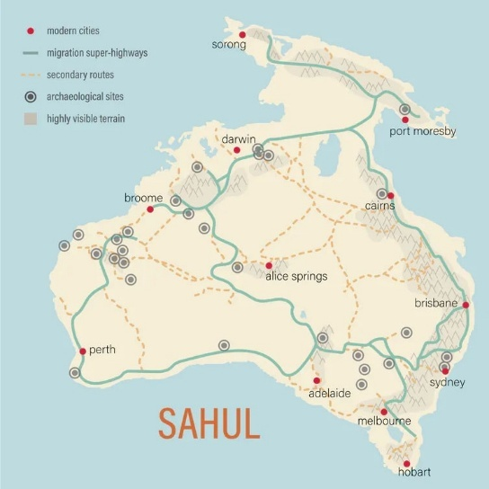
- What are some of the oldest archaeological sites in Australia? What do they tell us?
- What is Sahul? Investigate the ancient mega-continent of Sahul. Find a map of Sahul and make comparisons to present day Australia.
- How has Australia changed over the last 65,000 years? Make a timeline showing major environmental changes (sea levels rising, ice age, drought).
- What does the following sentence mean? Aboriginal cultures are the oldest continuous cultures on Earth.
ABC News

Activity: Time
Explore the Time interactive on the ABC Deep Time website as a class, following the timeline to explore the deep history of Aboriginal and Torres Strait Islander peoples.

To help understand how far back Australia’s history goes, the interactive uses a dot help represent a point in time, with each dot representing 250 years.


Follow the dot as it moves from the present day to the ancient past, recording key points in time. Continue through the interactive and click on the points of interest to learn more about specific events, cultural practices, and stories.
- What did you learn?
- What information was surprising?
- What questions do you have?
- Create a Did you know.

Journey back in time
This fun and interactive outdoor class activity will help students explore and visualise the deep history of Aboriginal and Torres Strait Islander peoples.

Take your classroom outside, using your school oval to make a giant timeline, to help students visualise the vast scale of history in Australia. First, students will decide on a scale (for example, 1 step equals 250 years in time) and calculate and record the distances using a spreadsheet. Students will walk back in time, counting steps according to their scale. At each key event they will place a marker and/or sign.

Key events to mark:
- 2,800 years ago – beginning of Ancient Greek civilisation
- 5,100 years ago – beginning of Ancient Egyptian civilisation
- 9,000 years ago – Sea levels rise dramatically
- 22,000 years ago – Ice age peaks
- 30,000 years ago – Great drought begins
- 37,000 years ago – Budj Bim volcano erupts
- 50,000 years ago – Megafauna live in Australia
- 65,000 years ago – Evidence of First Nations people in Australia

Further discussion
- What was surprising about this activity?
- What did you learn from doing this activity?
- What major environmental changes have First Nations Peoples survived throughout Australia’s 65,000-year history?
- Where do other civilisations fit onto your deep time timeline?
- Why is it important to learn about and share Australia’s deep time history?

Activity: Deep time stories near you
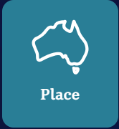
Go to the Place map on the Deep Time website. Choose a story near you to explore. Which location did you choose? What story is told there?
- What time-period does the story come from?
- How was the landscape and environment different in that story compared to today?
- What does the story tell you about how people used the land, water or sky?
- Why are the stories of the knowledge holders important?
- How did the story you chose make you feel?

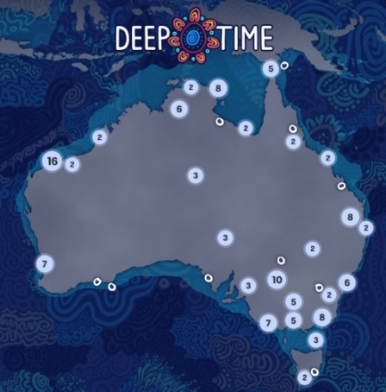
Further Investigation
Students will explore the cultural diversity of First Nations Australians. Individually or in small groups, students will learn about the Indigenous group where they live and present what they have learnt to the class. Students will learn about the geographic location, language, culture, traditions, and histories.
- Find one significant Aboriginal archaeological site in your local community. Why is it important to First Nations people?
- What is the Indigenous language in your local community? Learn some common everyday words and share with your class.
- Where is the Indigenous group located? Mark the approximate boundaries on a map. What are some special sites in the area?
- Learn more about the Indigenous seasons and the plants and animals that are important to Indigenous people. Learn more about the Indigenous Seasonal Calendar on the CSIRO website
- Look for stories by Indigenous peoples valuing their oral traditions. Can you find stories told through dance, song and other art forms as well as through text?

Activity: Dreaming stories
Dreaming stories pass on important knowledge, cultural values, and belief systems to later generations. Learn about Dharawal country through this Dharawal Dreaming story made by the National Museum of Australia.

One tells the origins of our animals …
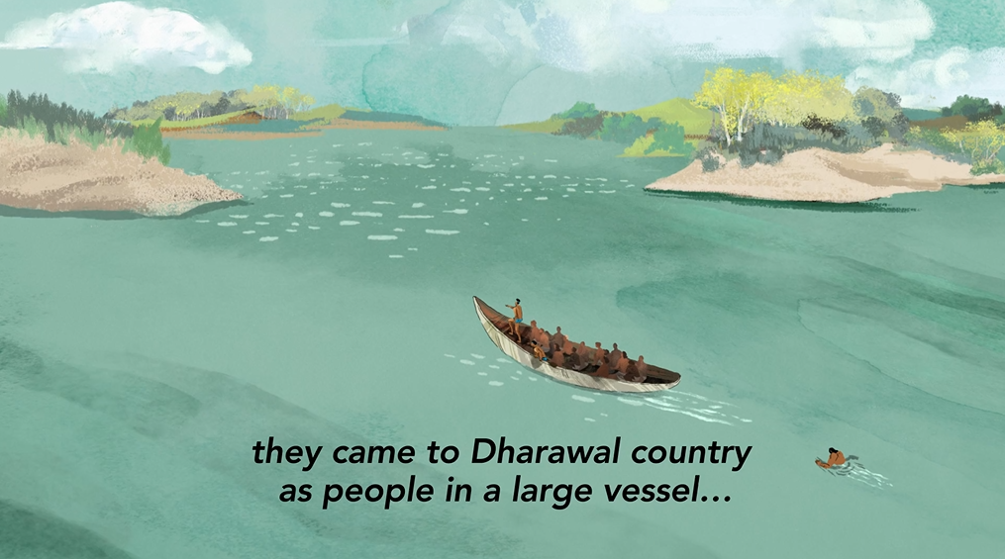 | 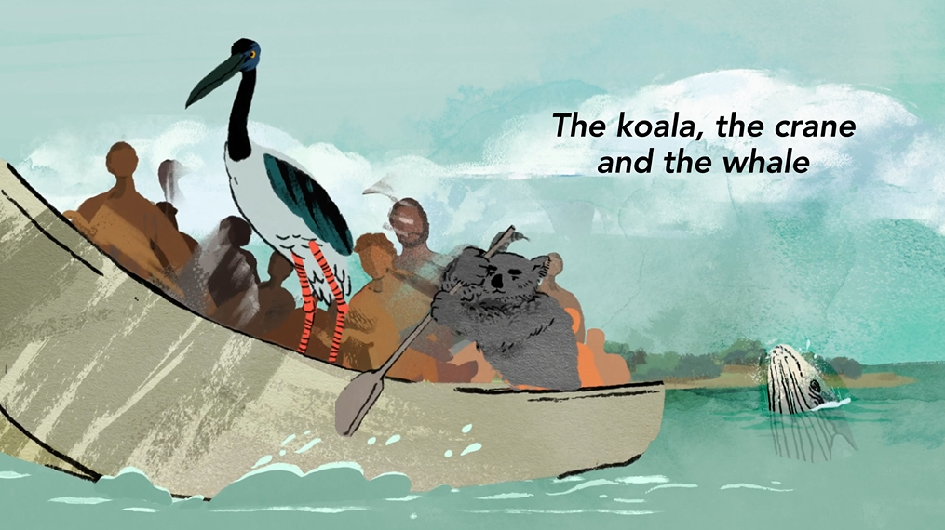

Another Dreaming story tells of how spirits of the dead returned in low lying cloud...
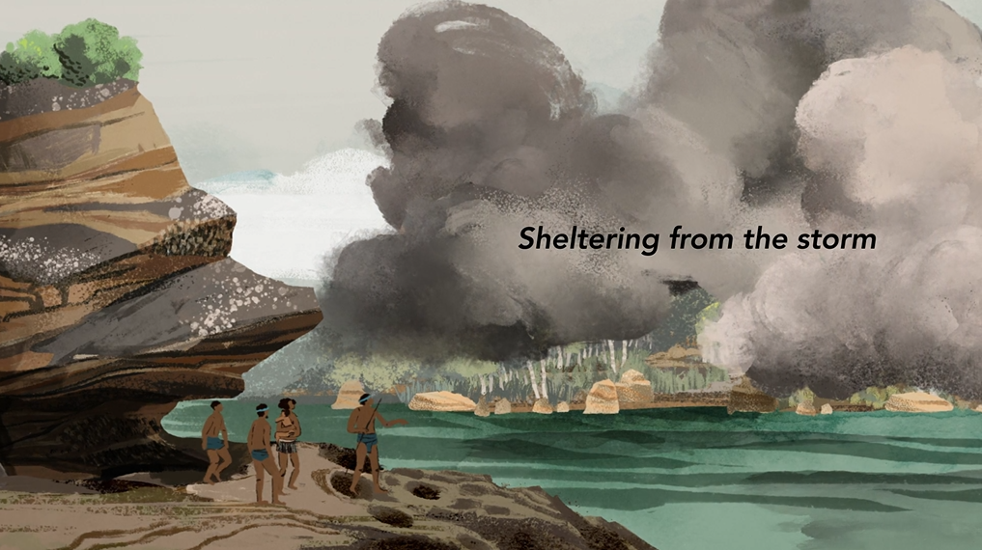 | 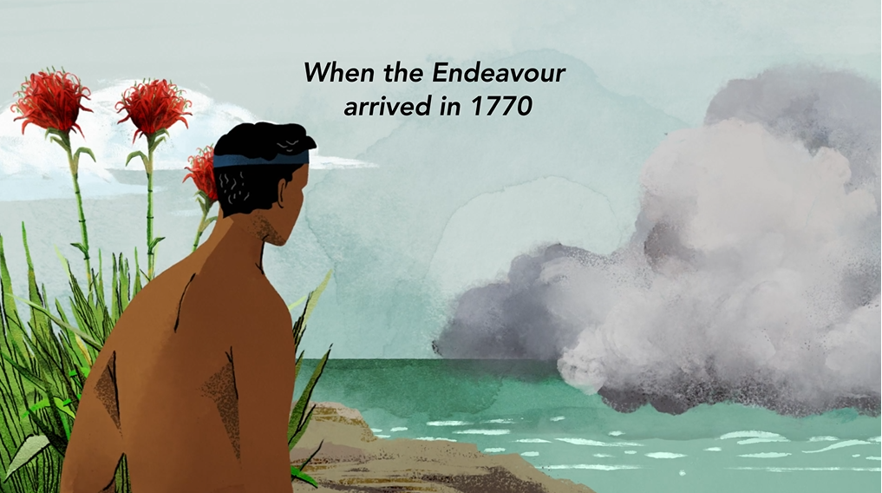
Dharawal Dreaming - Animation (National Museum Australia)

Spears have an important place in Dreaming stories in Aboriginal and Torres Strait Islander culture. Watch The Spear together as a class, a Yirritja story that is told in Dalabon language in Central Arnhem Land, Northern Territory.
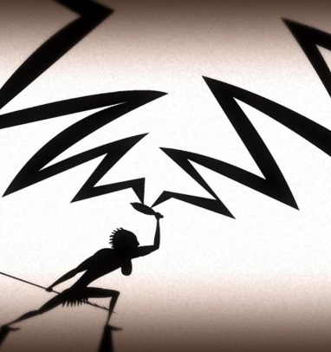
After watching the video students will respond to the following:
- What do you think the story is teaching us?
- What were your reactions or feelings during the story?

Follow-up activities
Teachers can download the ‘Dust Echoes’ study guide by ATOM for further follow-up activities.

The Spear, Dust Echoes - (ABC Education)

Activity: Meet the Megafauna
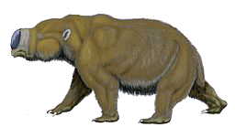
Students will explore the Megafauna stories on the Topics page of the Deep Time website and choose a species of megafauna to explore in more detail. What does the story tell you about First Nations people’s connection with megafauna? Students will then create a fact sheet including the following information:
- Common and scientific name
- What type of animal is it? (mammal, reptile, bird)
- Description – size, appearance, special features, adaptations
- Where did it live? Describe the habitat.
- What did it eat?
- When did it die out? What caused their extinction?
- What existing species is it similar to? Diprotodon
- Find evidence of megafauna in First Nations people’s culture. For example, in archaeological findings like rock art and the collection of fossils; or in creation stories.

Activity: Rock Art Investigation
Students visit the Art section on the Topics page to learn from knowledge holders about rock art. What do the stories tell you about rock art and its significance to First Nations peoples?
Students will explore one specific example in depth. Students will learn about petroglyphs (rock engravings) and pictographs (drawings) which are a key component of rock art. Below are some examples of rock art around Australia. Alternatively, students may want to find their own example of rock art to study.

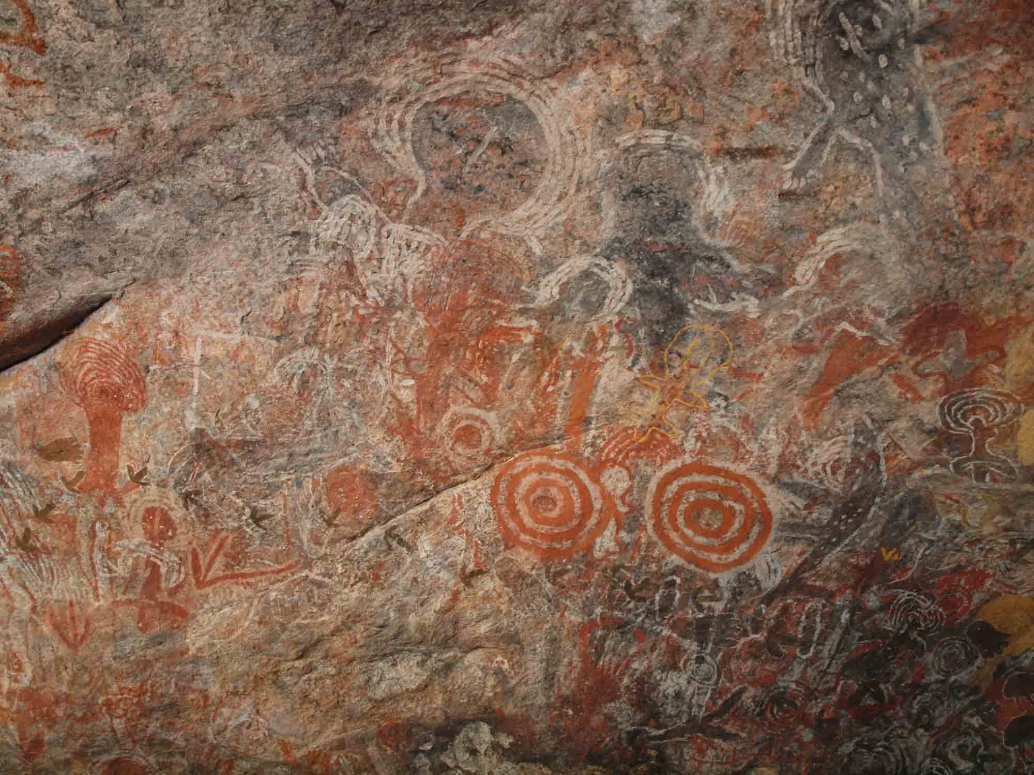  Walinynga (Source: National Museum Australia) | 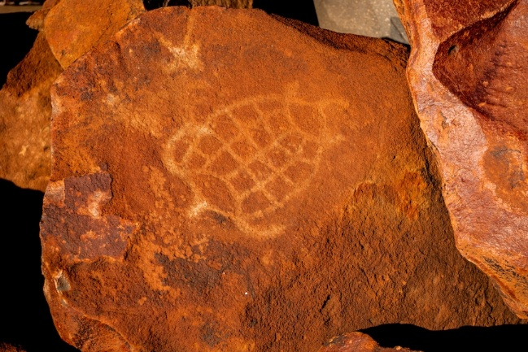  Murujuga rock art (Source: ABC)
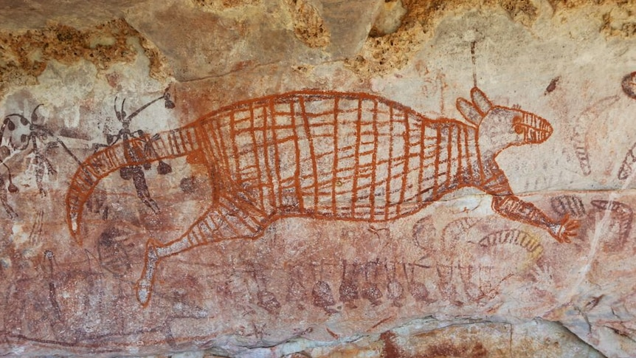  Rock art in the Kimberley. (Source: ABC News Supplied by Sven Ouzman) | 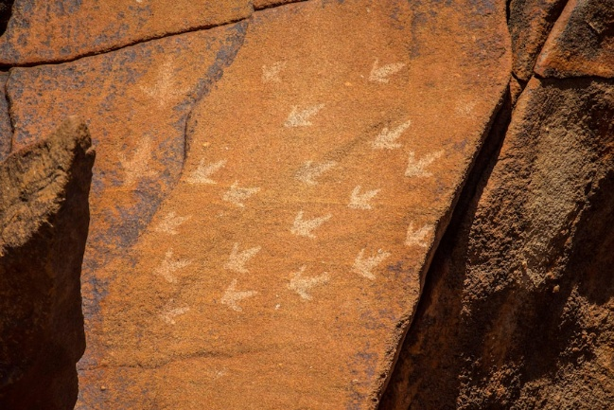  Murujuga rock art (Source: ABC)
Initial Observations
What do you notice?
- Describe the main features of the rock art. What sorts of colours, lines and shapes do you notice?
- What else do you notice? Can you see people, animals or spiritual figures in the art? Write as much as you can about what you see.
- What do you think the images are telling us?

Further Investigation
Students will respond to one or more of the following questions:
- Where is it located and how old is it? Locate on a map of Australia.
- What type of rock art is it? Is it a petroglyph or pictograph?
- Find the name of the place in both the Indigenous and English languages.
- What Indigenous language groups have connections to the land where the rock art is located?
- What story does the rock art tell? Is it a traditional Dreaming story? Explain what you know about the Aboriginal story.

Want to know more about where you live?
- Check out the Gambay language map to learn more about traditional languages spoken in your area.
- To learn whose Country you’re on, visit David Horton’s Map of Indigenous Australia on the AIATSIS site.
- Cross-reference with other sites, for example your local council or Aboriginal land council.

Activity: BTN Stories
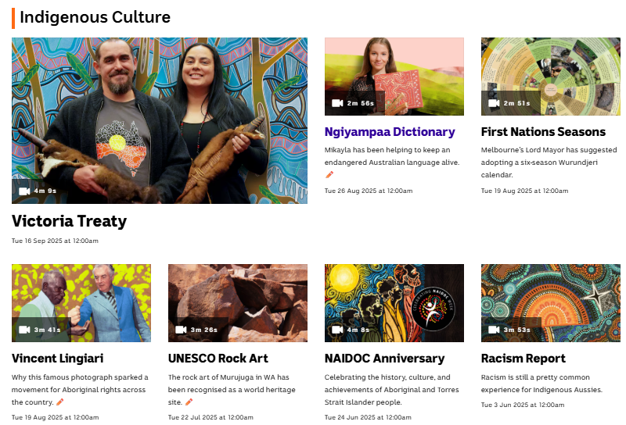
Visit BTN’s collection of stories which focus on Aboriginal and Torres Strait Islander peoples’ history, culture and issues.

After watching any one of the BTN videos ask students to respond to the discussion questions (to find the discussion questions and teacher resources go to the related BTN Classroom Episode and download the Episode Package).

Collection of BTN stories with a focus on Indigenous culture

Useful Websites
- Deep Time – ABC
- Deep time history of Australia – National Museum Australia
- Evidence of first peoples – National Museum Australia
- Deep time history of Australia resource – Australian Curriculum
- ‘We are from here’ – Digital Classroom: National Museum Australia
- The Human Revolution – ABC iView

EPISODE 28
28 October 2025

KEY LEARNING
Students will plan and practise strategies to promote good hand hygiene in their community

CURRICULUM
Health – Year 3-4
Identify and practise strategies to promote health, safety and wellbeing.

Describe strategies to make the classroom and playground healthy, safe and active spaces.

Discuss and interpret health information and messages in the media and internet.

Health – Year 5-6
Plan and practise strategies to promote health, safety and wellbeing.

Investigate the role of preventive health in promoting and maintaining health, safety and wellbeing for individuals and their communities.

Health – Year 7-8
Investigate and select strategies to promote health, safety and wellbeing.

Plan and use health practices, behaviours and resources to enhance health, safety and wellbeing of their communities.

  - Teacher Resource

Hand Washing

Focus Questions
Discuss the BTN story as a class and record the main points of the discussion. Students will then respond to the following:
- Before you watch the BTN Hand Washing story, record what you know about hand hygiene.
- A recent study found that not all Australians are washing their hands as often as they should. True or false?
- When is it important to wash your hands?
- How many seconds should you wash your hands for?
- What are good hand washing practices? Write step-by-step instructions.

Activity: Note Taking

Students will practise their note-taking skills while watching the BTN Hand Washing story. After watching the story, ask students to reflect on and organise the information into three categories. What information in the story was positive, negative, or interesting?

Activity: Vocabulary
Students will brainstorm a list of key words that relate to the BTN Hand Washing story. Here are some words to get them started.

MICROSCOPIC
Bacteria
Hygiene

GERMS
CONTAMINATION
PUBLIC HEALTH

Activity: Campaign
Students will design a public education campaign to raise awareness about good hand hygiene and the importance of hand washing. Students will need to think about their campaign’s aim, target audience, and the value of raising awareness at their school. Use Canva to design a poster to put up around your school and the wider community.

To create a school awareness campaign, students will need to identify the following:
- When should you wash your hands? Make a list.
- What are good hand washing practices? Write step-by-step instructions.
- Why is hand washing so important?
- How can you teach other kids about good hand hygiene? Think of creative ways you can teach kids your message about hand washing.

Some questions to consider when designing your campaign:
- What is the campaign’s main aim?
- Do you have a slogan or message? What is it?
- Who is your target audience?
- What is the best way to communicate the message?

Discuss with students how they will get their message out there to help raise public awareness. Some possibilities include:
- Short film or animation
- Community service announcement (for television or radio).
- Press release (create posters to be put up around the school or brochures to give to all students).

Useful Websites

- Handwashing - BTN
- Handwashing – Health Direct
- Global Handwashing Day
- Handwashing: why it’s important – Better Health

  - Teacher Resource

BTN Transcript: Episode 30 – 28/10/2025

Yaama. I'm Jack Evans and you're watching BTN. Here's what's coming up... We get the lowdown on the heist of the century, dive into deep time, and find out about some gross grown-up habits.

Rare Earth Minerals

Reporter: Justina Ward

INTRO: But first, we're going to find out about rare earths. They were in the news last week after Australia's Prime Minister and the US president signed a deal designed to boost our ability to mine and refine them. Here's Justina to dig into what's going on.

PROSPECTOR: Well, hidey ho. Didn't you hear? There's a rare earth rush at the moment. Hoo-wee. I reckon we've found ourselves some big o' rare earth right ere'.
REPORTER: Yep. Rare earths are what everyone's talking about.
NEWS REPORTER: Australia's rare earth's minerals deal.
NEWS REPORTER: Rare earths.
NEWS REPORTER: Rare earths.
NEWS REPORTER: Rare earth materials they’re in everything from smart phones to fighter jets, so we need them.
PROSPECTOR: Now wait a minute, I ain't got a tootin idea about what a rare earth is anyways.
Well, they're here on the periodic table. They're a group of 17 heavy metals like Europium, Neodymium, gadolinium and cerium. And while you may not know their names, you've definitely used them. That's because rare earth minerals are crucial for all sorts of technologies. For example, cerium helps polish glass Gadolinium is used in hospital MRI machines to make clear pictures inside the body, and Neodymium makes super strong magnets that are used to power motors in everything from computers to electric cars. But FYI rare earths aren't really rare
PROSPECTOR: They're not rare? What?
They're found everywhere throughout the earth's crust, and we have a lot of them here in Australia. But they've earnt the name because they're found in low concentrations which makes them difficult to mine.
PROSPECTOR: You're telling me, I've been digging all…
Then you need to process what you've mined before you can turn it into something useful that's also difficult and it takes a lot of chemicals and can produce some pretty toxic waste. Which is why Australia, and many other countries export a lot of rare earths to China which mines and processes most of the world's supply. But recently China has started to restrict some of it's rare earth sales making some governments nervous that stocks might run low and prices might go up.
MARCOS SEFCOVIC, EU TRADE COMMISSIONER: The scale of China's export controls scaled up since April is unjustified and harmful.
US President Donald Trump has been particularly concerned.
DONALD TRUMP, US PRESIDENT: As you know our country doesn't have much rare earth material.
DONALD TRUMP, US PRESIDENT: We very much need rare earth.
So, he's been hunting for new supplies in Greenland, Canada, Ukraine and in Australia.
PROSPECTOR: Hold up. I've got some right here.
Last week the Australia's prime minister and the US President finally met in person and left with a deal.
DONALD TRUMP, US PRESIDENT: It's an honour to sign this, and we'll do it now.
Amongst other things, it includes a promise to partner up on rare earths and other so called critical minerals like lithium and nickel which are used modern technology.
DONALD TRUMP, US PRESIDENT: In about a year from now, we'll have so much critical mineral and rare earths that you won't know what to do with them. They'll be worth about $2.
The Australian and American governments will spend more than $4 billion dollars, boosting mining projects in the US and Australia and building plants to refine rare earths.
ANTHONY ALBANESE, AUSTRALIAN PRIME MINISTER: Part of what this is about isn't just digging things up. It's also about processing and including the joint ventures between Australia and the United States.
We still don't know all the details, including how new projects might impact the environment. But many are hoping this boom will bring a big boost to Australia's economy.
PROSPECTOR: Like my grand mammy used to say, there's a fortune in digging up dirt. Yee-haa. Whoo hoo hoooooo.

News Quiz

DONALD TRUMP: I don’t like you either, and I probably never will.

Who was US President, Donald Trump, talking to here? Was it Australia’s Prime Minister, Australia’s US ambassador or an Australian journalist? It was Australia’s US ambassador, and former Prime Minister, Kevin Rudd. The awkward moment came when a journalist asked about some Tweets Mr Rudd sent out a few years ago saying not very nice things about President Trump. Although apparently after the meeting the President told him that “all is forgiven”.

There’ve been big celebrations in Uluru to mark the anniversary of the site being handed back to the Anangu people. When did that happen? In 1965, 1985, or 2005? It was in 1985.

ALISON CARROLL, TRADITIONAL OWNER: The whole people got it back. My father and others, you know, all those old people.

There were also celebrations in London where the King joined the sites traditional owners’ to celebrate the hand back and the dedication of the Anangu people.

This mysterious object was found smouldering near an iron ore mine in remote Western Australia. What do authorities think it is? Part of a plane’s engine, an Esky that was filled with fireworks or part of a Chinese rocket. They’ve linked it to a Chinese rocket launch, although it could be a while before they know for sure.

Louvre Heist

Reporter: Tatenda Chibika

INTRO: One of the biggest news stories last week came from Paris, France, where the world-famous Louvre Museum was robbed in broad daylight by a gang of thieves. Here's Tatenda with more.
Tatenda Chibika, Reporter: It's one of world's most famous museums, home to ancient sculptures, historic works of art and of course, this famous lady.
But last week, it was the scene of a heist. A gang of thieves broke into the Louvre in broad daylight and made off with some of France's crown jewels.
PERSON: It's certainly increased our fascination with the area.
PERSON: It almost sounded like a movie, just like a movie.
The robbers dressed as construction workers and used a mechanical ladder to reach the balcony of the famous Apollo's Gallery. They came in through a window and used power tools to break into two display cases. And then took eight items including a diamond and pearl tiara, a sapphire and emerald set, and a diamond encrusted brooch, before making their getaway dropping this diamond and emerald encrusted crown, along the way. The whole thing took just seven minutes.
All up, the jewels are estimated to be worth around 157 million Aussie Dollars, but really, they are priceless because they were a big part of French history. They were all from the 19th century and some belonged to the wives and relatives of Napoleon, the famous military general and later Emperor of France.
JEAN-PIERRE OSENAT, AUCTIONEER: Imagine if someone stole the crown jewels in Britain, do you realise who it hurts? Well, it hurts the French as well as people abroad.
The robbery is being dubbed 'the heist of the century' but it wasn't the Louvre's first famous theft.
Back in 1911, the Mona Lisa was stolen by museum worker Vincenzo Peruggia, and it actually took nearly a day for someone to notice it was gone. Vincenzo hid the masterpiece in his apartment for nearly two years until he was caught trying to sell it in Italy.
While the Mona Lisa is safely back in her place, experts say it's unlikely the stolen jewels will have such a happy ending.
CHRISTOPHER MARINELLO, ART RECOVERY EXPERT: Right now, it's a race between the police and the criminals who are trying to hide the evidence of their crime.
Because the jewels are so famous, it'll be hard for the thieves to sell them, so experts say they'll probably be cut up.
CHRISTOPHER MARINELLO, ART RECOVERY EXPERT: Once they've been cut into smaller jewels, the deed is done. It's over. We'll never see these pieces again intact.
It's left many wondering how security at the Louvre could have failed so badly.
PERSON: When we were in the museum, we also thought the security was very low.
PERSON: It sounds like an inside job or something, that they must have had some sort of knowledge from the interior so, yeah, pretty nuts.
The museum’s director admitted the security camera's weren't working properly and that the only camera covering the balcony was facing the wrong way.
Laurence des Cars, Louvre Director: In essence, we did not detect the arrival of the thieves early enough.
While the Apollo Gallery is still closed, the rest of the Louvre is open to the public again with tighter security measures in place to hopefully keep the rest of the museum's precious artefacts safe.

Quiz

The Louvre was originally built as what? A fortress, a prison or a school? It was a fortress. King Philip the second began building it in 1190 to protect Paris from the British who controlled Normandy. It was later rebuilt as a renaissance palace before being converted to a museum in 1973.

Deep Time

Reporter: Jack Evans

INTRO: Now we're going to explore Deep Time. That's the name of an online resource that's just been released by the ABC to help tell the story of this continent since the arrival of its First People, 65,000 years ago. Let's find out more about Australia's epic history.

JACK EVANS, REPORTER: 65,000 years, that's a really long time. It's kinda hard to imagine how long that actually is, but let's try. Let's say one step is 250 years, that's when Lieutenant Cook arrived at Botany Bay. So, between here and here is your life, your parent’s life, your grandparents, your great grandparent’s life, you get the point.
11 steps and I’m at about 2,800 years, or the start of Ancient Greek Civilisation. Another 1, 2, 3, 4, 5, 6, 7, 8, 9, 10 and I'm at 5,100 years, or the start of Ancient Egypt. And then 2 more steps and I'm at the beginning of the Mesopotamian Civilization. But, ah, let's keep going. This is 65,000 years when it's thought the first people arrived in the continent we now know as Australia. It's err, also quite far away from where I parked so I better start walking back.
The oldest known evidence of humans in Australia comes from here Madjedbebe Rock Shelter in Arnhem Land in the Northern Territory. Archaeologists say tools found here date back 65,000 years. Other sites, like Murujuga in Western Australia, show engravings from at least 40,000 years ago.
PETER COOPER, MARDUDHUNERA MAN: There's rock art out there that's a dance we still do today. They've done thousands of years ago. We still do it today
First Nations people also share stories about things that happened in the deep past. For example, in Victoria the Gunditjmara people have a creation story about a creature named Budj Bim, that took the form of a volcanic eruption.
DENIS ROSE, GUNDITJMARA ELDER: The story begins at the, with the eruption of Bunji Bim, the volcano back in around about 37,000 years ago. The story also talks about the scoria that, that come out of it. And the lava was about this being revealing its teeth
JOEY SAUNDERS, GUNDITJMARA MAN: All the lava that you do see is all of his blood and all of his teeth that followed the landscape right out to the ocean. So, it's 50 kilometres out to the ocean. And he changed the whole landscape to what it is today.
Speaking of which, the landscape has changed in huge ways over the past 65,000 years. For starters 20,000 years ago, Australia was connected to Papua New Guinea and Tasmania as part of the continent we call Sahul.
TEANGI BROWN: You could walk the entire eastern coastline all the way to the Bassian Plain, which is, the Bassian Plain - or the Land Ridge as it is known - pretty much went straight from the northeast of Tasmania all the way through to Victoria.
First Nations people lived through ice ages, extreme droughts, oh and they would have lived alongside mega fauna.
TEANGI BROWN: It's hard to, as modern humans today, to imagine what it must have been like to live with things that were five times the size of you.
It's thought that the Mega Fauna even made its way into stories that we still hear today. Have you heard of a Bunyip? Some people think it could be based on a Diprotodon. A Giant wombat that became extinct 40,000 years ago. It's all pretty amazing to think about and something many say is worth celebrating.
RAY INGREY, DHUNGUITTI AND DHARAWAL MAN: Aboriginal people, we're the oldest living culture in the world and that means something to us. That's a badge of honour for our people, but it should be celebrated too by everybody that's here in Australia.

You can follow our links to the Deep Time website or go to abc.net.au/news/deeptime if you want to know more. There are stories and knowledge from throughout the country and throughout history covering a whole range of topics.
Hand Washing

Reporter: Justina Ward

INTRO: Now for those gross habits I told you about earlier. A recent report has found that quite a few Aussie adults don't wash their hands after going to the loo. Which is yuck, but also dangerous, according to experts. Here's Justina with more.
ADVERT: You wouldn't lick a public phone. You wouldn't drink from a muddy puddle. You wouldn't borrow a used tissue. Don't leave the toilet without washing your hands. It's gross. Seriously.
HANDWASHING POLICE: Any questions?
STUDENTS: No.
JUSTINA WARD, REPORTER: Yeah, most of us don't need the handwashing police to tell us that.
STUDENT: After the toilet I always wash my hands.
STUDENT: I wash my hands most of the time.
STUDENT: Yeah, every time I wash my hands.
HANDWASHING POLICE: But turns out a whole bunch of adults aren't quite as good as it as they should be.
See, a recent survey by the Food Safety Information Council found that 28% of men and 18% of women said they didn't always wash their hands after a pee, and uh, a lot of people admitted they didn't always wash their hands after a poo either. Which is kind of a problem. You see washing your hands is one of the most important things you can do for your health and the health of other people.
HANDWASHING POLICE: You could say this is one of history's biggest medical breakthroughs.
See, up until 200 years ago people had no idea what germs were. They used to think diseases spread by demons or witches or even bad smells. It wasn't until 1846 that this guy, Dr Ignaz Philipp Semmelweis noticed that when doctors touched sick people or dead people, and then went straight to delivering babies, new mums were more likely to get sick. So, he had a radical idea, getting them to wash their hands.

Florence Nightingale, a nurse in 1880s, also saw the importance of handwashing making it mandatory at the hospital she worked at and saving lives. Eventually, we realised what germs were and how they spread and by the end of the 20th century experts around the world started getting serious about hand hygiene. And of course, a few years ago we all got a big reminder thanks to COVID. But experts say we could be doing better. Not only are we skipping the soap after going to the loo. The survey found that 43% of men and 39% of women admitted that they didn't always wash their hands before handling food.
LYDIA BUCHTMANN, FOOD SAFETY INFORMATION COUNCIL, CEO: There's a lot of food poisoning out there. It's estimated it costs and this is a huge number, $8 million a year of people getting sick in Australia alone.
Lydia says even if your hands look clean they could still be carrying a whole lot of microscopic germs, especially if you've just been to the loo.
LYDIA BUCHTMANN: That is really dangerous because faeces, the official name of poo, is full of harmful bacteria and viruses and even parasites that can have long term effects and it can make you quite ill.
HANDWASHING POLICE: So, make sure you wash and make sure you do it right.
Don't splash and dash, soap slap or water soak.
STUDENT: I think the best way to wash your hands is to first use soap and really scrub it.
STUDENT: And then maybe like count to 20 seconds
STUDENT: And then after you like wash it and then dry it with a paper towel or towel.

Social Media Promo

Australia is about to become the first country in the world to ban social media for kids under 16. And we want to know what you think.

STUDENT: For me, social media is like a way that I usually get my news.
STUDENT: I can't talk to all my friends now.
STUDENT: It could help a lot of people.
STUDENT: I think that it will bring people closer together.
Head to the BTN website and fill in our social media ban survey, and we'll give you the results in December in our special episode, All About The Ban.

STUDENT: They shouldn't have just banned it completely 'cause us teenagers, we can do anything.

Sport

Oscar Piastri has lost the lead of the Formula 1 drivers' championship as teammate and title rival Lando Norris stormed to victory in Mexico City. It was Norris’ sixth win of the season, while Piastri has missed out on a podium place in the past four races, chipping away at the Aussie's 35-point lead he had back in April.
OSCAR PIASTRI, F1 DRIVER: I've been driving exactly the same as I have all year. It's just that these last couple of weekends, the car or the tyres or something has required quite a different way of driving.

The Matildas have won a friendly against Wales with Sam Kerr. And while she missed her chance to send Courtney Nevin's free kick toward the goal, it didn't matter.

COMMENTATOR: The forward run from Sam Kerr.

While Wales found the goal in the second half, Caitlin Foord sealed the deal for the Tillies in the 85th minute.
To AFLW, where North Melbourne are making history. They've now won 23 games in a row after beating St Kilda by 46 points.

COMMENTATOR: Snaps it through for another North major.

The win also secured them their second straight minor premiership. Their run of 23 wins equals Geelong's winning streak in the VFL from way back in 1953. North Melbourne will have a chance to break the record in a top-of-the-table clash with Hawthorn on Friday.
Young Surfer

Reporter: Wren Gillett

INTRO: Finally, today we're going to meet a young surfer with a big future. Kelia is 12 and lives in Tahiti, where she recently became the youngest person ever to compete in the World Surf League. Wren caught up with her to find out what it was like.

WREN: Kelia, it's so wonderful to meet you.
KELIA: Yeah. So nice to meet you.
WREN: And I hear you're a pretty good surfer.
KELIA: Most people say that uh yeah.
WREN: You just competed in the World Surf League, which is a massive competition. Can you tell us what that is?
KELIA: Yeah, the World Surf League is a championship tour, which is very complicated to get on.

COMMENTATOR: Grabs the rail, showing off that technique. Look at that stop!
WREN: How did you get chosen?
KELIA: They do a little contest called the trials here, and the winner of that gets a wild card into the event, but they've never had it for the girls. So, this is actually the first year where they have it for the girl’s division.

COMMENTATOR: She's 12 years old and she has got this absolutely dialled.
WREN: So how did you go? At the comp, how did you go?
KELIA: I got a little unlucky with the size of the waves. It was a little bit too big, like definitely out of my comfort zone. And in my first heat, I had Molly Picklum, which literally is a world champion now. And she actually won the event.
COMMENTATOR: Look at this thing, drops in. It's a big barrel! It spits her as she comes out.
COMMENTATOR: Oh, my goodness! Molly...
WREN: And you were the youngest competitor ever, right?
KELIA: Yeah.

COMMENTATOR: For her to be able to drag that whole side of the body into the wave face, I mean, that technique, it takes some people years to sort of figure out.

WREN: How did you get into all of this? Like, when did you start surfing?
KELIA: I started at like three years old, maybe.
YOUNG KELIA: Good morning, surfing world! This is Missteahupoo reporting live from the spot.

KELIA: It was mostly for just living life in like the ocean and not just cooped up in like a house or in a building or something
WREN: And what are your favourite types of waves to surf?
KELIA: Turn waves are like you try to do minor manoeuvres on them, which is going up more surfing up and down the wave. Well, as if barrelling waves, or, you know, they suck out, and then they barrel, and then you have to, like, get tucked in and tight to be in there and then come out.
KELIA: Personally, I would like front side barrels. They're just fun and we don't have them too much here, so...
WREN: How do you prepare for a competition like the World Surf League? Like, what do you do?
KELIA: I mean, I surf here at the reef at Teahupo'o, but I really tried to practise even more before that contest to be ready for anything.
WREN: Do you get nervous when you're about to surf a wave and everyone's watching?
KELIA: Well, I was nervous in the CT. Mostly because of the size. Honestly, I didn't really care about the people because my dad was telling me before that like, hey, no pressure, just like, go into the contest and like, surf and then, whatever happens, happens I guess.
WREN: What advice would you like to give for people who are interested in potentially, you know, doing something like what you're doing?
KELIA: Try to like get better every day I guess. Just surf and ah, have fun.
Closer

That's all we've got for you today, but we'll be back next week with more and if that's too long to wait you can jump online to check out more stories and specials and quizzes - there are also resources there for your teachers too. And if you can't wait for BTN, you can catch Newsbreak every weeknight right here in the studio. Have an awesome week and I'll see you next time. Bye!

