

Mabo Day
- What date do we celebrate Mabo Day?
- What is the full name of the man who took on the Australian Legal system to fight a land rights injustice?
- Where was Eddi Mabo born?
- Why was he fighting for the land rights of Murray Island?
- What does the term Terra Nullius mean?
- What was the name of the court case?
- Mabo wasn’t just fighting for the Meriam people. Why was Mabo an important case for Australian Indigenous people?
- What year did the High Court make its decision on the Mabo land rights case?
- How did this story make you feel?
- Name three things you learnt from watching the Mabo Day BTN story.

Charlie Perkins
- Where was Charlie Perkins born?
- What sport did Charlie play?
- He was one of the first Aboriginal people to be accepted at university. True or false?
- What did Charlie become famous for while he was at university?
- Complete the following sentence. Aboriginal people weren’t counted as Australian ___________in their own country.
- What inspired the Freedom Ride in Australia?
- What was the aim of the Freedom Ride?
- What did they find out about the treatment of Aboriginal people?
- What impact did Charlie have on Indigenous rights in Australia?
- Choose 3 words to describe Charlie Perkins.

NAIDOC Indigenous Women
- Briefly summarise the BTN story.
- Where was Rosalie Kunoth-Monks born? Find using Google Maps.
- Rosalie Kunoth-Monks is best known for being the first Indigenous women to have a lead role in a film. True or false?
- Why are the songs that Fanny Cochrane Smith recorded on wax cylinders really important?
- Gladys Elphick was a Kaurna and Ngadjuri woman. Locate the traditional lands of Kaurna and Ngadjuri people on a map of Australia.
- Complete this sentence. The Aboriginal Women’s Council campaigned for the ‘yes’ vote in the 1967 ____________.
- How did the Aboriginal Community Centre, that Gladys Elphick set up, help Aboriginal people?
- Who was Truganini?
- Name the different careers that Nova Peris has had.
- What did you learn watching the BTN story? Make a list of three facts.

Teacher Resource
Mabo

Students will learn more about Eddie Mabo and create a biography about him.


History – Year 3
Days and weeks celebrated or commemorated in Australia (including Australia Day, Anzac Day, and National Sorry Day) and the importance of symbols and emblems.

Civics and Citizenship – Year 4
The differences between ‘rules’ and ‘laws’, why laws are important and how they affect the lives of people, including experiences of Aboriginal and Torres Strait Islander Peoples.

History - Year 6
Experiences of Australian democracy and citizenship, including the status and rights of Aboriginal and Torres Strait Islander Peoples, migrants, women and children.
- What date do we celebrate Mabo Day?
- What is the full name of the man who took on the Australian Legal system to fight a land rights injustice?
- Where was Eddi Mabo born?
- Why was he fighting for the land rights of Murray Island?
- What does the term Terra Nullius mean?
- What was the name of the court case?
- Mabo wasn’t just fighting for the Meriam people. Why was Mabo an important case for Australian Indigenous people?
- What year did the High Court make its decision on the Mabo land rights case?
- How did this story make you feel?
- Name three things you learnt from watching the Mabo Day BTN story.

Aboriginal and Torres Strait Islander people please note that this document contains images of people who have died.

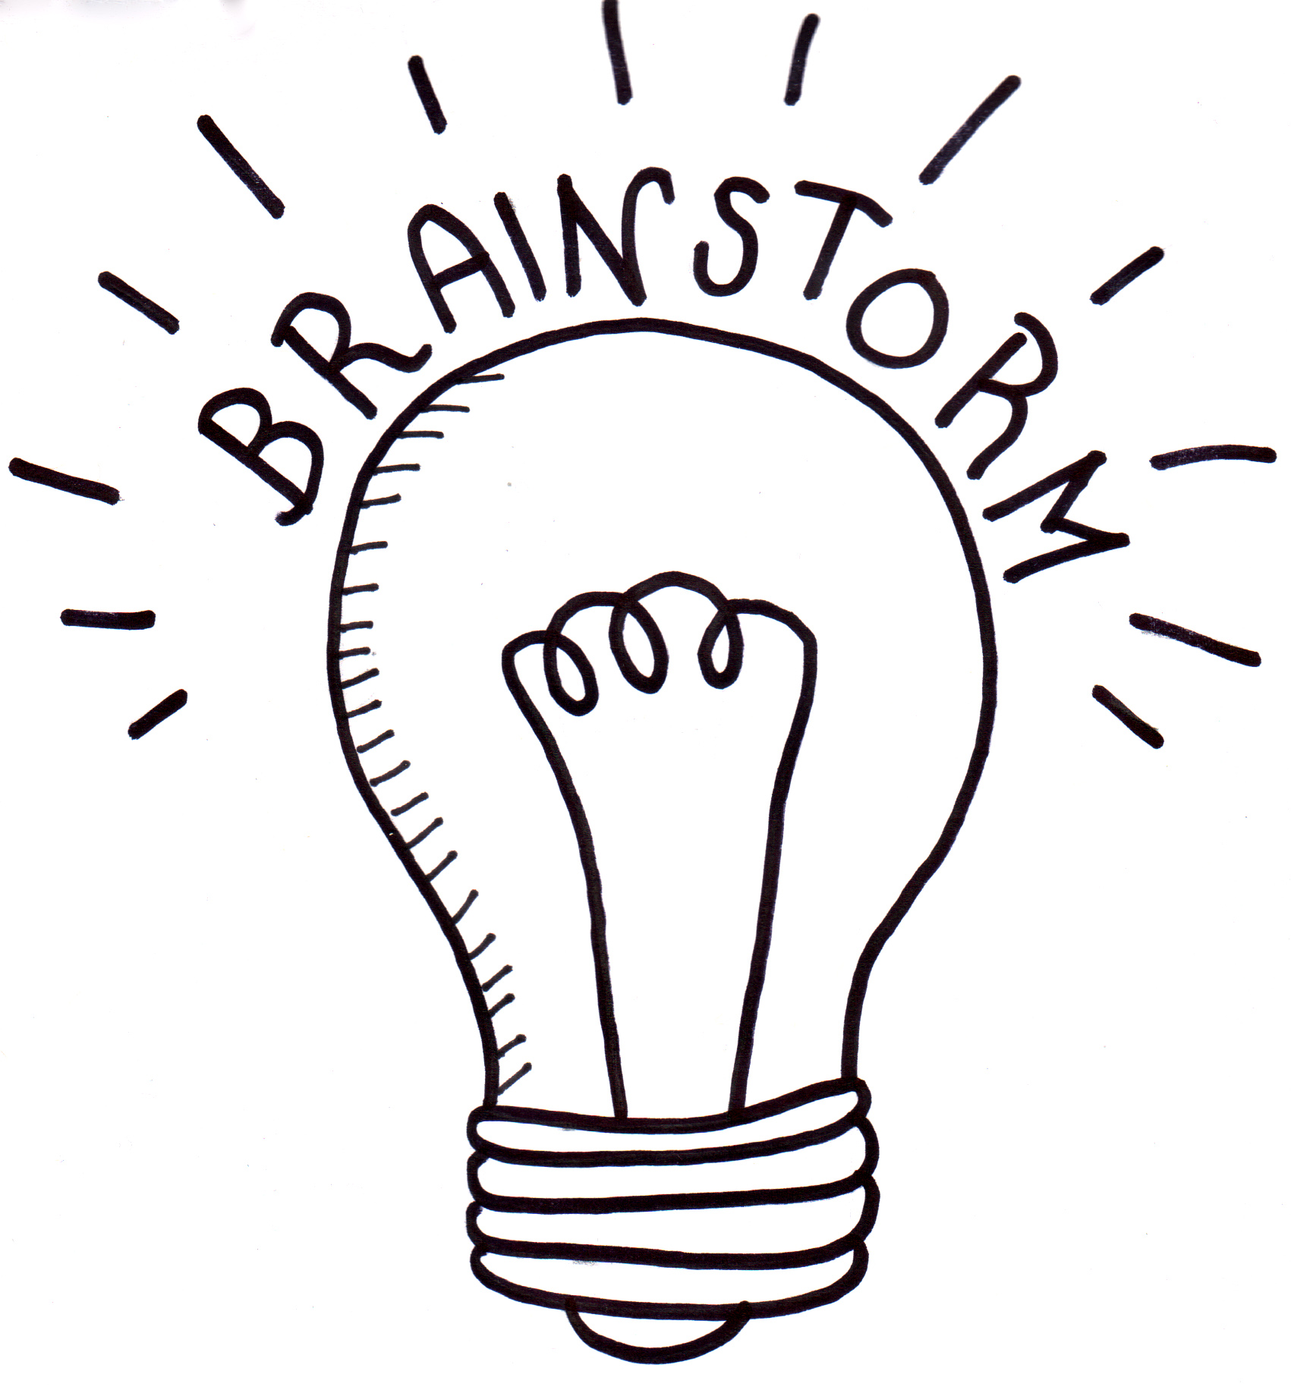

Class Discussion
After watching the BTN Mabo story hold a class discussion. Here are some discussion starters:
- Who was Eddie Mabo?
- Where was Eddie Mabo from?
- What is native title?
- Why was the Mabo decision important?
- What is the High Court of Australia?
- What was Eddie Mabo fighting for?
- What questions do you have after watching the BTN story?
Glossary
Students will develop a glossary of words and terms that relate to the BTN Mabo story. Below are some words to get them started. Students will add words and meanings to their glossary as they come across unfamiliar words throughout their research.

Native title | High Court | Terra nullius
Torres Strait Islands | Crown land | Reconciliation Week
Native Title Research

Define: What do I want to know?
Key questions to research
Students can choose one or more of the following questions or come up with their own:
- What was the Mabo decision?
- What is native title?
- Why is native title important to Aboriginal and Torres Strait Islander peoples?
- Mabo wasn’t just fighting for the Meriam people. Why was Mabo an important case for Australian Indigenous people?
- What is terra nullius and why do you think the British Government declared Australia to be terra nullius?

Locate: Where do I find the information?
What resources will help answer my questions? (Internet, people, resource centre, organisations, print). Discuss with students what a reliable source is.
Select: What information is important for the investigation?
Students may need support to sort through and select relevant information.
Organise: How do I make sense of the information?
Students can organise their research by creating main headings from their questions. Write each heading on a separate piece of paper. Record the information found for each question.
Present: How do we let others know about this information?
Each group needs to discuss then decide on the best way to present the information. Possibilities could include:
- A ‘Did You Know’ Facts sheet
- Oral presentation
- Prezi presentation
- Create an infographic using Canva
- Create a website using Wix
Evaluate: What have we learnt?
Each group reflects on what they have learnt about native title and the Mabo decision during their investigation. Students will reflect on their learning and respond to the following.
- What I learned...
- What I found surprising...
- What I would do differently next time…

Eddie Mabo
Before students begin to construct their biographies, hold a class discussion to find out what they already know about biographical writing. Below are some discussion starters:

- What does a biography tell us about a person?
- Where can you look to find information for your biographical writing? It could include the internet, newspaper articles, magazine articles and interviews, other biographies, historical books or television interviews. Why is it important to use more than one source of information?
- What makes a biography interesting? For example, key information and facts, a timeline of events, photographs, illustrations and quotes.

Using the biography worksheet at the end of this activity, students will find and record information about Eddie Mabo. Some possible areas of research include:

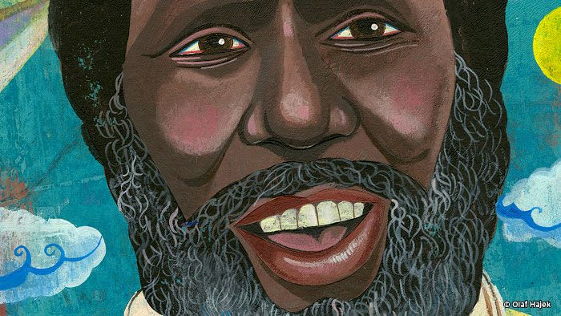
- Where was Eddie Mabo from? Locate using Google Maps.
- When was he born? Describe his family life growing up.
- What were some of Eddie Mabo’s achievements? Choose one to explore in more detail.
- How do we recognise his achievements?
- What were some of the challenges he faced?
- How has Eddie Mabo made an impact on people’s lives?
- What do you admire about Eddie Mabo?

Further investigation

- Imagine you could sit down and talk to Eddie Mabo. What questions would you ask about his life and achievements?
- Create a portrait of Eddie Mabo. Explore and experiment with different techniques and media to produce a portrait.

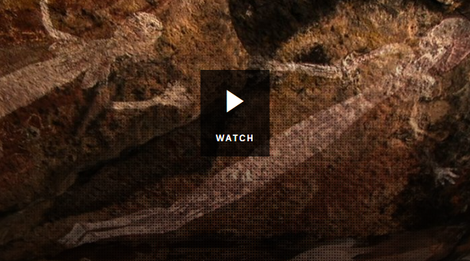
Connection to Country
Students will explore in more depth Indigenous Australian’s connection to their land. Hold a class discussion to find out what students already know about this connection.

Watch the BTN Native Title story. What does it tell us about the strong connection Indigenous Australians have to the land and the importance of the Mabo decision?



ABC News – Mabo 25 years on: How much do we know about the man behind the legend?
https://www.abc.net.au/news/2017-06-03/eddie-mabo-the-man-behind-the-legend/8501266

BTN – Mabo Legacy
https://www.abc.net.au/btn/classroom/mabo-legacy/11143302

BTN Native Title
https://www.abc.net.au/btn/classroom/native-title/10528268

Reconciliation Australia – Eddie Koiki Mabo
https://www.reconciliation.org.au/wp-content/uploads/2017/11/Lets-Talk-Mabo.pdf



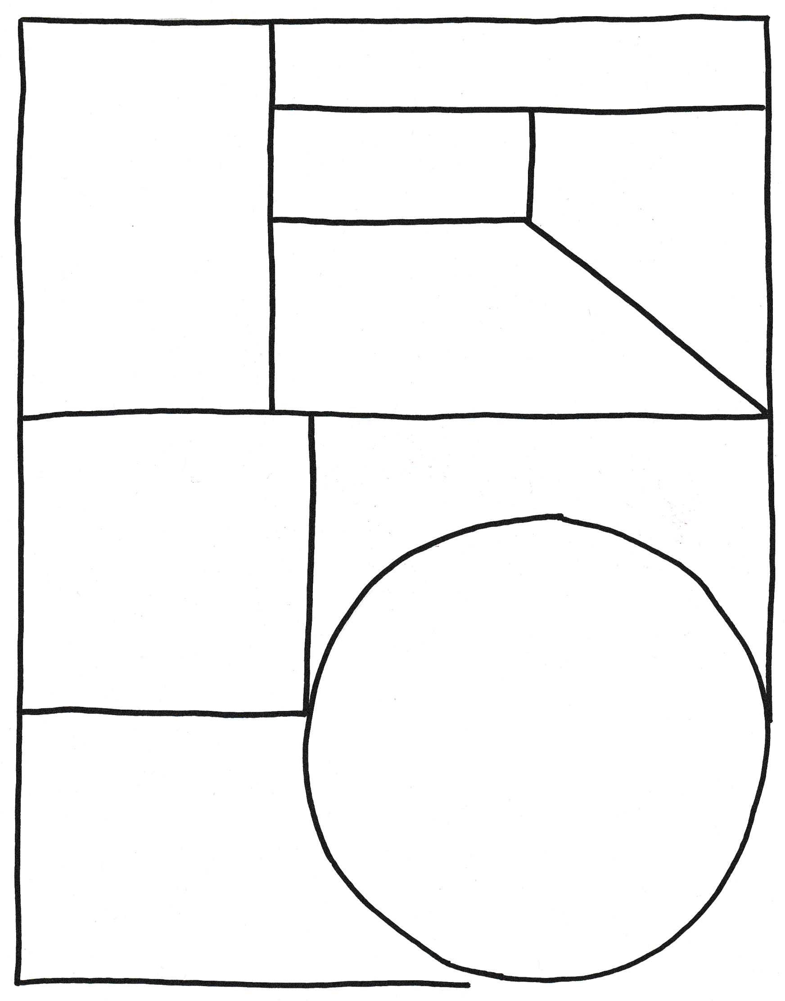
Family
Portrait of Eddie
Important contributions Eddie made…
Biography – Eddie Mabo

Full name

Born
Eddie’s achievements
Interesting things about Eddie…

Teacher Resource
Charlie Perkins
Students will learn about the life and achievements of Charles Perkins. They will also investigate the changing rights and freedoms of Indigenous Australians.

HASS – Year 4
Sequence information about people’s lives and events.

Civics and Citizenship – Year 5
How laws affect the lives of citizens, including experiences of Aboriginal and Torres Strait Islander Peoples.

History – Year 6
Experiences of Australian democracy and citizenship, including the status and rights of Aboriginal and Torres Strait Islander Peoples, migrants, women, and children.

The contribution of individuals and groups, including Aboriginal and Torres Strait Islander people and migrants, to the development of Australian society, for example in areas such as the economy, education, science, the arts, sport.


- Where was Charlie Perkins born?
- What sport did Charlie play?
- He was one of the first Aboriginal people to be accepted at university. True or false?
- What did Charlie become famous for while he was at university?
- Complete the following sentence. Aboriginal people weren’t counted as Australian ___________in their own country.
- What inspired the Freedom Ride in Australia?
- What was the aim of the Freedom Ride?
- What did they find out about the treatment of Aboriginal people?
- What impact did Charlie have on Indigenous rights in Australia?
- Choose 3 words to describe Charlie Perkins.

Aboriginal and Torres Strait Islander people please note that this document contains images of people who have died.

Personal Response
Students will write a personal response to the BTN Charlie Perkins story. Ask students to finish one or more of the following incomplete sentences:
- Charlie Perkins was a significant Indigenous person because…
- Five words that I would use to describe Charlie Perkins are…
- The Freedom Ride was an important event because…
- It was interesting to learn…
- It was surprising to learn that...

Class Discussion
After watching the BTN Charlie Perkins story hold a class discussion. Here are some discussion starters:
- Who was Charlie Perkins?
- Where was Charlie Perkins from?
- What were some of Charlie Perkins’ achievements?
- What was the Freedom Ride?
- What did the Freedom Ride achieve?
- What questions do you have after watching the BTN Charlie Perkins story?
Key Words
Students will develop a glossary of words and terms that relate to the BTN Charlie Perkins story. Below are some words to get them started. Students will add words and meanings to their glossary as they come across unfamiliar words throughout their research.

Activist | Referendum | Segregation
Civil Rights | Protest | Discrimination


Charlie Perkins - Biography
Before students begin to construct their biographies, hold a class discussion to find out what they already know about biographical writing. Below are some discussion starters:

- What does a biography tell us about a person?
- Where can you look to find information for your biographical writing? It could include the internet, newspaper articles, magazine articles and interviews, other biographies, historical books or television interviews. Why is it important to use more than one source of information?
- What makes a biography interesting? For example, key information and facts, a timeline of events, photographs, illustrations and quotes.

Using the biography worksheet at the end of this activity, students will research and record information about Charlie Perkins. Some possible areas of research include:
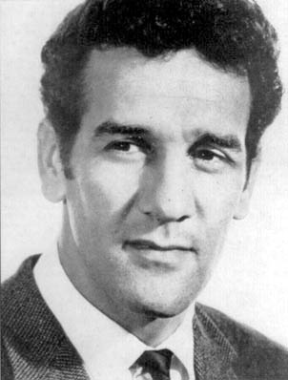
- Where was Charlie Perkins from? Locate using Google Maps.
- When was he born? Describe his life growing up. Watch this interview with Charlie where he describes what life was like growing up in institutions.
- What were some of Charlie Perkins’ achievements? Choose one to explore in more detail.
- How do we recognise his achievements?
- What were some of the challenges he faced?
- How has Charlie Perkins made an impact on Indigenous people’s lives?
- What do you admire about Charlie Perkins?
Further investigation
- Imagine you could sit down and talk to Charlie Perkins. What questions would you ask about his life and achievements?
- Create a timeline of significant events in Charlie Perkins' life.

Freedom Ride
In 1965, Charlie Perkins led a group of students from the University of Sydney on a bus journey through regional New South Wales. Students will research in detail the Freedom Ride and the role he played in it. Here are some useful resources to help students with their research:
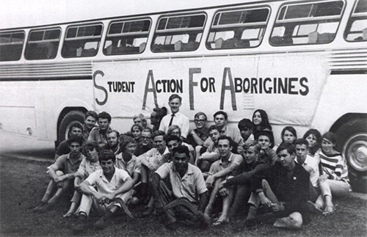
Freedom Ride - BTN
1965 Freedom Ride - AIATSIS
Freedom Ride 1965 – National Museum Australia
Charles Perkins in Moree – ABC Education
- What was the purpose of the Freedom Ride?
- Where did the Freedom Ride go? Show on a map.
- What role did Charlie Perkins play in the Freedom Ride?
- What inspired the Freedom Ride in Australia?
- What did they find out about the treatment of Aboriginal people?
- What instances of racism did they find?
- What is segregation? Give an example.
- What important event happened on the Freedom Ride in Moree?
- How did their trip make a difference to Indigenous rights?

Students will imagine they are a student travelling on the Freedom Ride and write a journal describing their experiences and feelings about it. Ann Curthoy’s diary gives a great insight into what it was like being a student on the Freedom Ride. The questions below may help students to structure their journal.
- Why did you want to be a part of the Freedom Ride?
- What does the community think about it?
- How do you feel on the bus with the other students?
- What are some of the challenges?
- What do you hope Freedom Ride will achieve?

BTN Indigenous Rights stories
Watch these BTN stories to learn more about significant events for Aboriginal and Torres Strait Islander people.
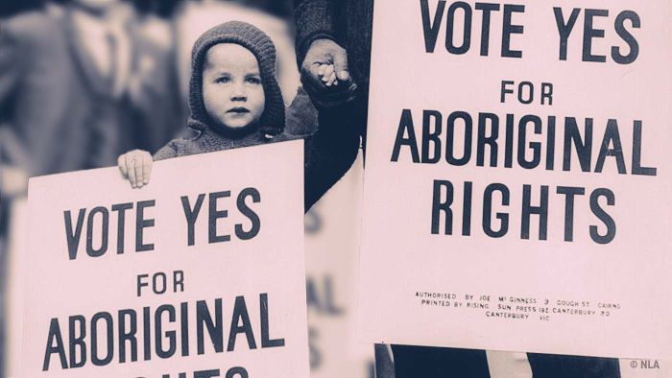  BTN 1967 Referendum story | Teacher Resource | 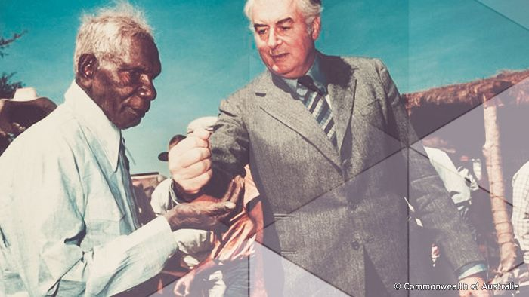  BTN Wave Hill story | Teacher Resource
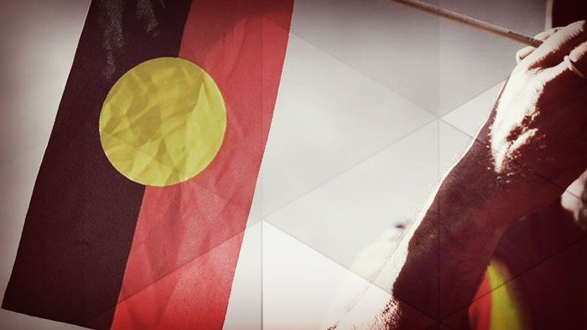  BTN Stolen Generations story | 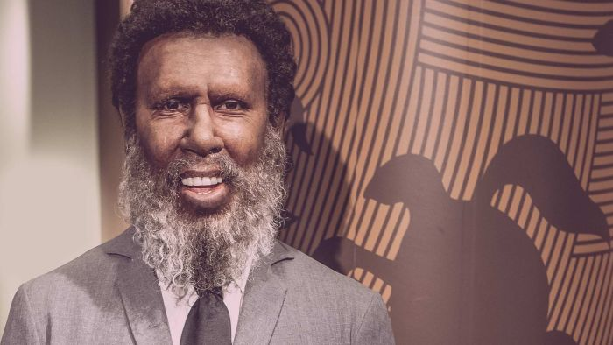  BTN Mabo Legacy story | Teacher Resource
Visual Literacy – Indigenous Rights
- What do you see in this image?
- What significant moment or event does the image relate to?
- What do you think is happening?
- If there are people in the image who do you think they are? How do you think they might be feeling?
- What question/s would you like to ask the people in the image?
- Create a caption for each image.

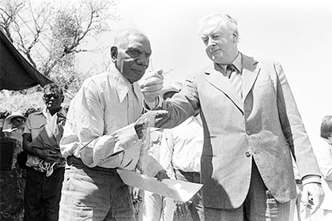  Link to image | 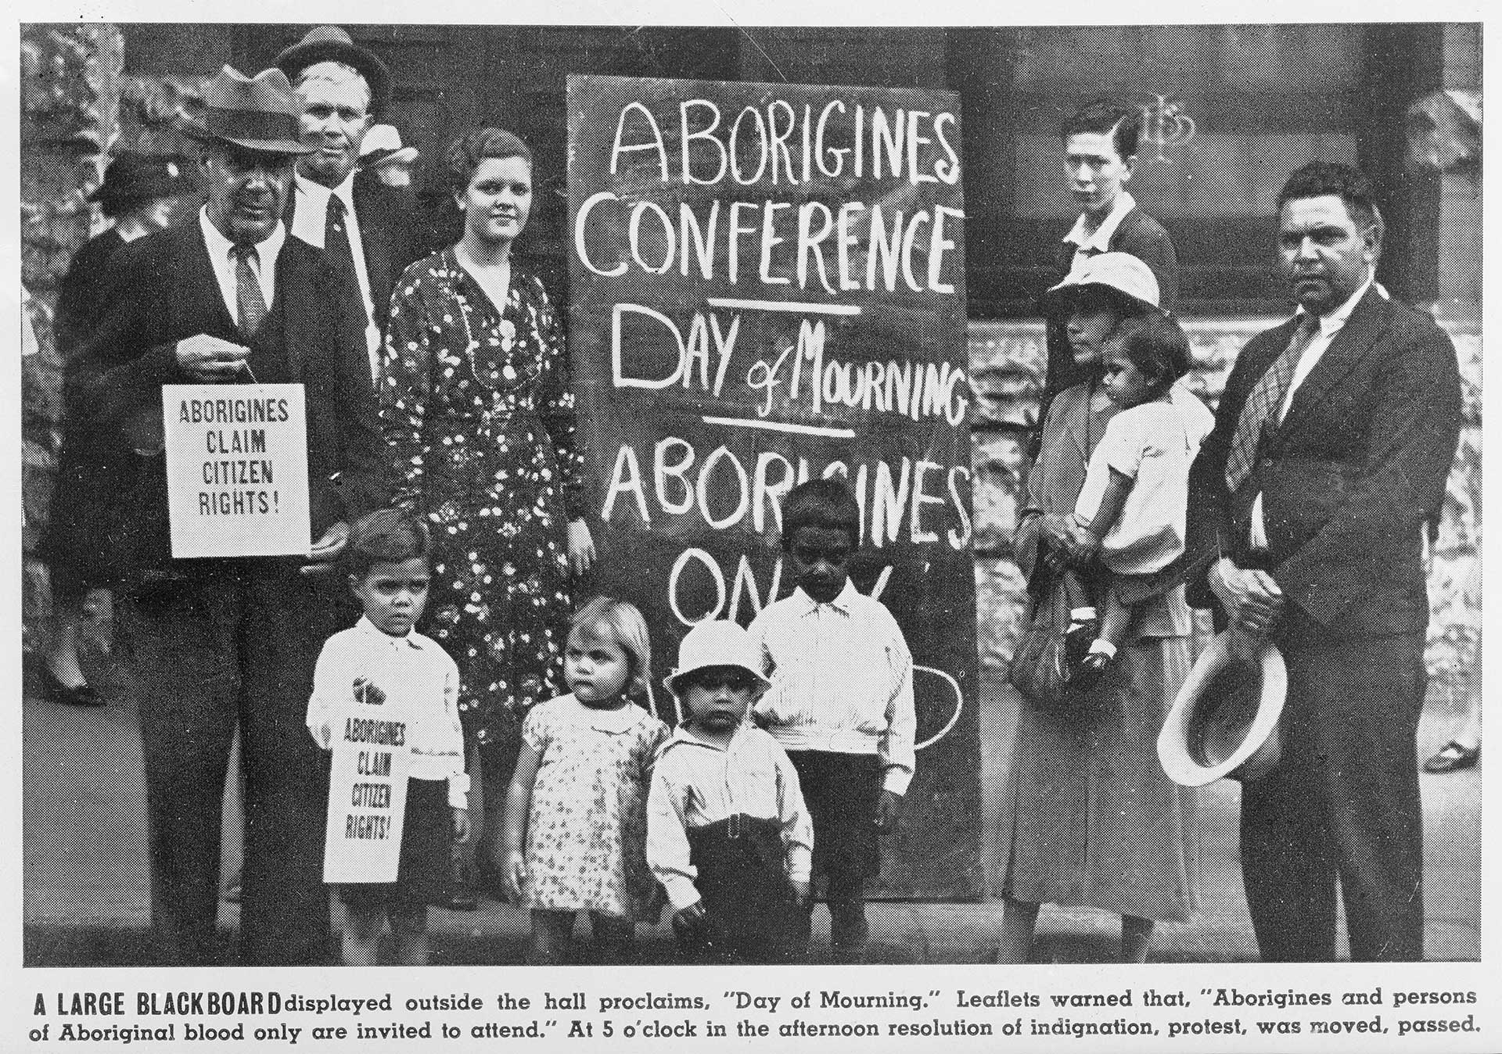  Link to image
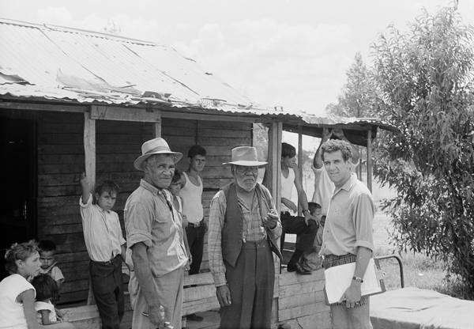  Link to image | 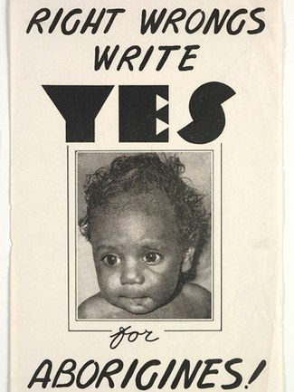  Link to image

Charlies Perkins – National Museum Australia
https://www.nma.gov.au/explore/features/indigenous-rights/people/charles-perkins

Freedom Ride – BTN
https://www.abc.net.au/btn/classroom/freedom-ride/10527008

Charles Perkins fights for racial equality – ABC Education
https://education.abc.net.au/home#!/media/1264423/charles-perkins-fights-for-racial-equality

Charles Perkins campaigns for Aboriginal rights – ABC Education
https://education.abc.net.au/home#!/media/1264445/charles-perkins-campaigns-for-aboriginal-rights

Freedom Ride, 1965 – National Museum Australia
https://www.nma.gov.au/explore/features/indigenous-rights/civil-rights/freedom-ride

1965 Freedom Ride - AIATSIS
https://aiatsis.gov.au/explore/articles/1965-freedom-ride

Family
Full name

Portrait of Charlie
Important contributions Charlie made…

Born
Achievements
Interesting things about Charlie…
Biography – Charlie Perkins

Teacher Resource
NAIDCO Indigenous Women

Students will choose a significant Indigenous woman to investigate in depth and create a biography about her.

HASS / History – Year 3
Days and weeks celebrated or commemorated in Australia (including Australia Day, Anzac Day, and National Sorry Day) and the importance of symbols and emblems.

HASS – Year 4
Pose questions to investigate people, events, places and issues.

History – Year 6
The contribution of individuals and groups to the development of Australian society since Federation.

Experiences of Australian democracy and citizenship, including the status and rights of Aboriginal and Torres Strait Islander Peoples, migrants, women and children.

Visual Arts – Years 3 & 4
Explore ideas and artworks from different cultures and times, including artwork by Aboriginal and Torres Strait Islander artists, to use as inspiration for their own representations.

- Briefly summarise the BTN story.
- Where was Rosalie Kunoth-Monks born? Find using Google Maps.
- Rosalie Kunoth-Monks is best known for being the first Indigenous women to have a lead role in a film. True or false?
- Why are the songs that Fanny Cochrane Smith recorded on wax cylinders really important?
- Gladys Elphick was a Kaurna and Ngadjuri woman. Locate the traditional lands of Kaurna and Ngadjuri people on a map of Australia.
- Complete this sentence. The Aboriginal Women’s Council campaigned for the ‘yes’ vote in the 1967 ____________.
- How did the Aboriginal Community Centre, that Gladys Elphick set up, help Aboriginal people?
- Who was Truganini?
- Name the different careers that Nova Peris has had.
- What did you learn watching the BTN story? Make a list of three facts.

Aboriginal and Torres Strait Islander people please note that this document contains images of people who have died.

Personal response
After watching the BTN NAIDOC Indigenous Women story, students will respond to the following questions:

- What did you SEE in this video?
- What do you THINK about what you saw in this video?
- What does this video make your WONDER?
- What did you LEARN from this story?
- What was SURPRISING about this story?

Class Discussion
After watching the BTN NAIDOC Indigenous Women story hold a class discussion. Here are some discussion starters:
- What is NAIDOC Week?
- Why do we have NAIDOC Week?
- The theme for NAIDOC Week this year is Because of her, we can! What do you think it means?
- Why do you think the theme was chosen?
- Brainstorm a list of well-known Indigenous women.
- What challenges have Indigenous women faced?
Significant Indigenous Women
Students will choose a well-known Indigenous woman to research and write a biography about. The students in the BTN story chose women that inspire them. The HerStory and NITV websites are a good starting point to help students choose.

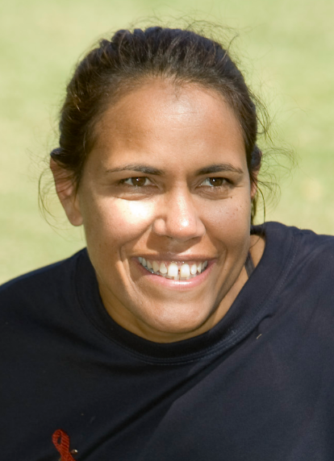
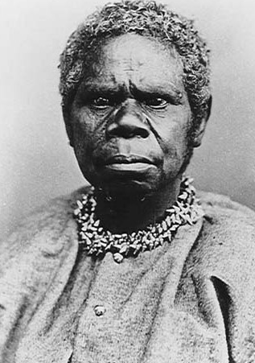
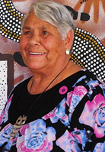

Truganini: Source Cathy Freeman: Source Lowitja O’Donoghue: Source


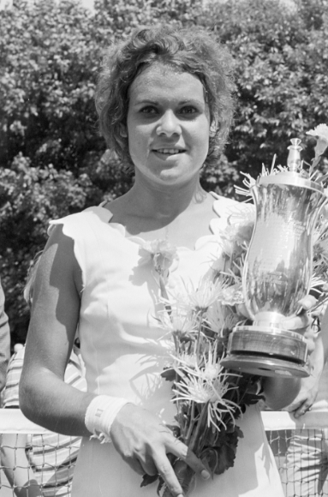
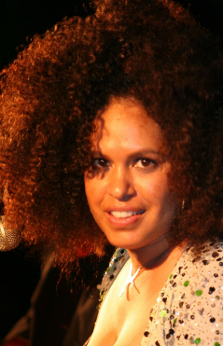

Evonne Goolagong Cawley: Source Jessica Mauboy: Source Christine Anu: Source

What is a biography?
Before students begin to construct their biographies, hold a class discussion to find out what they already know about biographical writing. Below are some discussion starters:

- What does a biography tell us about a person?
- Where can you look to find information for your biographical writing? It could include the internet, newspaper articles, magazine articles and interviews, other biographies, historical books or television interviews. Why is it important to use more than one source of information?
- What makes a biography interesting? For example, key information and facts, a timeline of events, photographs, illustrations and quotes.

Significant Indigenous Women – Create a biography
Using the Biography Organiser template at the end of this activity, students will record information about the significant Indigenous woman they have chosen. Some possible areas of research include:
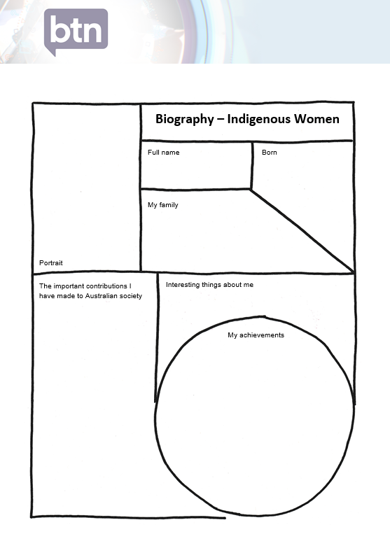
- Where are they from? Locate using Google Maps.
- When were they born? Describe their family life growing up.
- What are some of their achievements? Choose one to explore in more detail.
- What were their challenges?
- How do we recognise their achievements?
- How have they made an impact on people’s lives?
- How did they change our understanding of the world?
- What do you admire about them?

Further investigation
- Imagine you could sit down and talk to them. What questions would you ask about their life and achievements?
- Sketch a portrait of the Indigenous woman you have chosen. Explore and experiment with different techniques and media to produce a portrait. Look at the portraits painted by the students in the BTN story for inspiration.

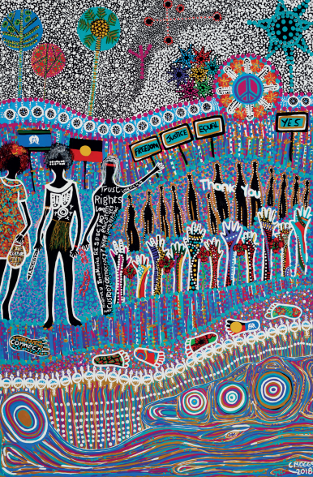
NAIDOC Week Poster
Working in pairs, students examine the NAIDOC Week poster created by Bigambul woman, Cheryl Moggs. Ask them to respond to the following questions:

- How does the artwork reflect the theme of NAIDOC Week?
- What words are in the image? What do they mean?
- What do you like about the artwork? Why?
- What materials and techniques are used?
- What emotions does the artwork evoke/how does it make you feel?

To learn more about the artwork, read the inspiration behind it here In small groups, discuss the three sections of the poster
- Stories of the Stars (top section)
- Connection to Country (middle section)
- Connection to Waterways (lower section)
Students design their own poster based on this year’s theme. Tarmunggie-woman Source

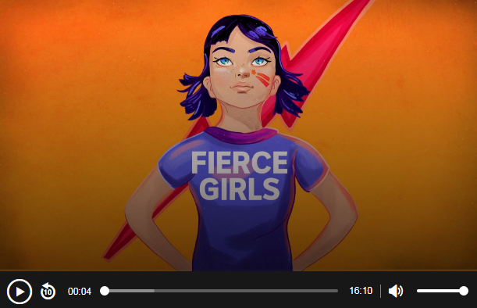
Fierce Girls Podcast – Daisy Bindi
Aboriginal activist Daisy Bindi fought for the rights of Aboriginal workers in the Pilbara strike in Western Australia.

Listen to the Fierce Girls Podcast to learn more about her life and how she advocated for the rights of Indigenous people.

NAIDOC Week – About the theme
http://www.naidoc.org.au/get-involved/2018-theme

NAIDOC – NAIDOC Week 2018
https://www.naidoc.org.au/

BTN – NAIDOC Art
http://www.abc.net.au/btn/story/s4487792.htm

My family
Full name
Portrait
Born
My achievements
Biography – Indigenous Women
The important contributions I have made to Australian society

Interesting things about me

