
EPISODE 2
10th February 2026

KEY LEARNING
Students will view a range of BTN stories and use comprehension skills to respond to a series of focus questions.

CURRICULUM
English – Year 4
Use comprehension strategies such as visualising, predicting, connecting, summarising, monitoring and questioning to build literal and inferred meaning, to expand topic knowledge and ideas, and evaluate texts.
English – Year 5
Use comprehension strategies such as visualising, predicting, connecting, summarising, monitoring and questioning to build literal and inferred meaning to evaluate information and ideas.

English – Year 6
Use comprehension strategies such as visualising, predicting, connecting, summarising, monitoring and questioning to build literal and inferred meaning, and to connect and compare content from a variety of sources.

  - Teacher Resource

Focus Questions
As a class, discuss the stories featured in the episode of BTN Classroom and record the main points of the discussion. Students will then respond to the following focus questions.

Inflation Fighting
- What is inflation? Give a definition.
- What can cause inflation? Give one example.
- Which bank sets the base interest rate?
- Did that bank decide to increase or decrease interest rates recently?
- What impact does raising interest rates have on a lot of people?

Apology Anniversary
- Which former Prime Minister apologised to First Nations people for the Stolen Generations?
  - Kevin Rudd
  - Paul Keating
  - Julia Gillard
- Who are the Stolen Generations?
- What impact has the Stolen Generations had on Australia’s First Nations people?
- What do you understand more clearly since watching the BTN story?
- How did this story make you feel?

Beach Safety
- What happened to Austin and his family recently?
- Where along the beach should you swim to stay safe?
- What is a rip and what should you do if you get caught in one?
- What should you do if you spot someone in trouble in the water?
- What do you do to stay safe in the water?

Check out the teacher resource on the Archives page.

Artemis II Launch
- What significant event happened on the 20th of July 1969?
- What is the aim of the Artemis program?
- What are some of the challenges of getting to the Moon?
- In your own words, explain the Artemis II mission.
- Do you think the Artemis missions are important? Give reasons for your answer.

Check out the teacher resource on the Archives page.

Women in STEM
- What award did Katherine Bennell-Pegg receive recently?
- Katherine is the first astronaut to officially represent Australia. True or false?
- What challenges did Katherine face becoming an astronaut?
- What advice does Katherine give to kids?
- What do you think could be done to encourage more girls to study STEM?

EPISODE 2
10th February 2026

KEY LEARNING
Students will learn more about beach safety, how to spot a rip and what to do if you get caught in one.

CURRICULUM
Health and Physical Education – Year 3 & 4
Identify and practise strategies to promote health, safety and wellbeing.

Health and Physical Education – Year 5 & 6
Plan and practise strategies to promote health, safety and wellbeing.

Investigate the role of preventive health in promoting and maintaining health, safety and wellbeing for individuals and their communities.

Investigate community resources and ways to seek help about health, safety and wellbeing.

Health and Physical Education – Year 7 & 8
Investigate and select strategies to promote health, safety and wellbeing.

  - Teacher Resource

Beach Safety

Focus Questions
Discuss the BTN story as a class and record the main points of the discussion. Students will then respond to the following:
- What happened to Austin and his family recently?
- Where along the beach should you swim to stay safe?
- What is a rip and what should you do if you get caught in one?
- What should you do if you spot someone in trouble in the water?
- What do you do to stay safe in the water?

Activity: Note taking

Students will practise their note-taking skills while watching the BTN Beach Safety story. After watching the story, ask students to reflect on and organise the information into three categories. What information in the story was...?
- Positive
- Negative or
- Interesting

Activity: Class Discussion
Discuss the information raised in the BTN Beach Safety story. Record the main points of the discussion on a mind map. Here are some questions to guide the discussion:

- What are some hazards when swimming at the beach?
- What are rips and how do you spot them?
- What colour are the flags you swim between at the beach?
- What do you do to be safe in and around water?
- What questions do you have about this story?

Activity: Beach Safety Research
Discuss the information raised in the BTN Beach Safety story. What questions were raised in the discussion and what are the gaps in students’ knowledge? Students will develop their own question/s to research or choose one or more of the questions below.

Research
- Why is it important for kids to learn water safety skills? Write a persuasive piece of writing explaining your reasons.
- What is a rip current and how do you spot them?
- How can understanding water conditions, like rip currents, help prevent accidents?
- Why is it important to swim between the red and yellow flags at the beach? Investigate the different flags and signs which help us to be water safe.
- What factors might prevent someone from learning how to swim? What are some solutions to these?
- Do you think it’s important to learn to swim, even if you don’t go to the beach or pool often? Explain your answer.
- What are some hazards when swimming in the beach? For example: rip currents, dangerous marine creatures, large waves, rock fishing or diving off a jetty. Choose one to investigate in more detail. Identify the hazard, tips for avoiding the hazard, and give advice to help people if they encounter the hazard. Use images, diagrams, videos and/or photos to help explain your answers.
- What is the role of a lifesaver? How do you become a lifesaver? What is the difference between lifesavers and lifeguards? Write some questions you would like to ask a lifesaver. As a class, organise to meet and interview a lifesaver to learn more about beach safety.

Activity: Understanding Rips
Rip currents occur on most Australian beaches and are one of the biggest hazards for swimmers. Students watch the two videos below and answer the questions to learn how to spot a rip and what to do if you get caught in a rip. They can then create a safety checklist to share that teaches kids about rip currents.

Watch the How to Spot a Rip Current and answer the following questions:

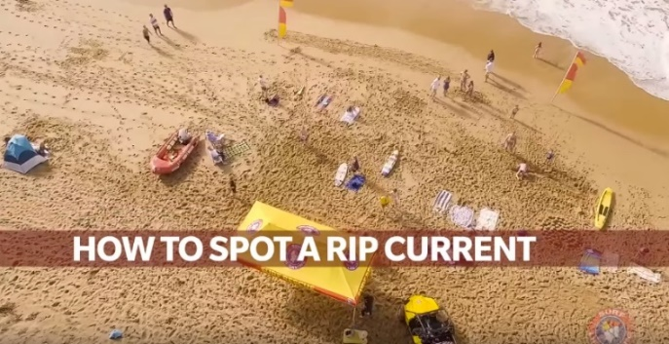
- Rip currents are easy to spot. True or false?
- What percentage of people can’t spot a rip current?
- How are rips formed?
- What are the things to look for when spotting a rip?
- What should you do before you go in the water?
- If the beach is patrolled, swim between…
- What else did you learn watching this video?

Watch the How to Survive a Rip Current and answer the following questions:

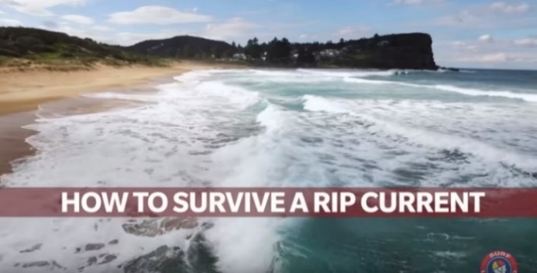
- What is the best way to avoid swimming in a rip current?
- Why is it important to stay calm if you get caught in a rip current?
- What should you do if you get caught in a rip?
- Never try to swim _______________ a rip.
- What else did you learn watching this video?

Useful Websites
- What is a rip? – Surf Life Saving NSW
- Beach Safety – Royal Life Saving
- Flags and Signs – Surf Life Saving Queensland
- Beach Safety – BTN

EPISODE 2
10 February 2026

KEY LEARNING
Students will investigate the Moon and its relationship with Earth.

CURRICULUM
Science – Year 5
Scientific understandings, discoveries and inventions are used to solve problems that directly affect peoples’ lives.

The Earth is part of a system of planets orbiting around a star (the sun).

Science – Years 5 & 6
Scientific knowledge is used to solve problems and inform personal and community decisions.
Science – Year 6
Describe the movement of Earth and other planets relative to the sun and model how Earth’s tilt, rotation on its axis and revolution around the sun relate to cyclic observable phenomena, including variable day and night length.

Science – Year 7
Model cyclic changes in the relative positions of the Earth, sun and Moon and explain how these cycles cause eclipses and influence predictable phenomena on Earth, including seasons and tides.
  - Teacher Resource

Artemis II Launch

Focus Questions
Discuss the BTN story as a class and record the main points of the discussion. Students will then respond to the following:
- What significant event happened on the 20th of July 1969?
- What is the aim of the Artemis program?
- What are some of the challenges of getting to the Moon?
- In your own words, explain the Artemis II mission.
- Do you think the Artemis missions are important? Give reasons for your answer.

Class Discussion
Discuss the information raised in the BTN Artemis II Launch story. Record the main points of the discussion on a mind map. Here are some questions to guide the discussion:
- What do you know about the Moon? Brainstorm a list.
- What does the Moon look like?
- When was the last time we landed on the Moon?

- Why are they planning another mission to the Moon?
- What makes the Moon special? Discuss as a class.
- Think of three questions you have about the BTN story.

Activity: Q&A
Are you curious about the Moon? Students will make a list of questions they have about the BTN story. Students will use the internet to find answers to their questions and share their findings with the class.

- What is the dark side of the Moon?
- Why can you sometimes see the Moon during the day?
What questions do you have?
- What are Moonquakes?
- How old is the Moon and how did it form?

Ask a Space Communicator – Australian Space Agency
Short on time? This 15-minute Q&A with a Space Communicator from the Australian Space Agency is a perfect way to build space knowledge in your classroom.
Link to Ask a Communicator

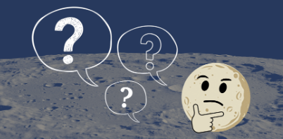
Top Moon Questions – NASA
What do you wonder? Some of your frequently asked Moon questions, answered.
Link to Top Moon Questions

Source: NASA

Activity: Graphic Organisers
Graphic organisers are a helpful learning tool for students to organise, clarify, or simplify complex information. Students will choose one type of graphic organiser to help them explore, understand and analyse our solar system and the importance of space exploration.

Venn Diagram  Purpose: To compare the similarities and differences between two or more things.  Procedure: Write the items being compared in the circles. Where the circles overlap, record similarities. Record the characteristics which are different in the areas that do not overlap.  Activity: Compare the similarities and differences between:  - the Moon and Earth  - the Apollo 11 mission and the Artemis program   | Mind Map  Purpose: To assist in activities that involve planning, brainstorming, making notes, organising or problem solving.  Procedure: An issue or topic is written in the centre. Related ideas are linked to the central issue and other ideas are developed from these.  Activity: Use a mind map to record what you know about:  - the Moon  - the Artemis program   | KWL Chart  Purpose: To help organise your thoughts before, during, and after a learning exercise.  Procedure: Identify what you know about a topic. Then, think about what you want to research or learn. After the lesson, reflect on what you have learned.  Activity: Use a KWL chart to organise information about the missions to the Moon.  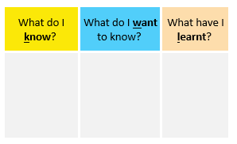

Activity: Quiz

- How many moons does Earth have?  A. 1  B. 2  C. 3  - How often does the Moon orbit Earth?  A. Every 24 hours  B. Every 27.3 days  C. Every 365 days  - The Moon is a…  A. Planet  B. Natural satellite  C. Star  - Which of the following is true regarding the Moon's size within our solar system?  A. It is the largest moon  B. It is the 3rd largest moon  C. It is the 5th largest moon  - What was the name of the first successful mission to land on the Moon?  A. Artemis I  B. Aquarius  C. Apollo 11  Quiz Answers:  1A, 2B, 3B, 4C, 5C, 6B, 7A, 8A, 9B, 10B | - Who discovered the Moon?  A. Edwin Hubble  B. Galileo Galilei  C. Isaac Newton  - What do we call the side of the Moon that faces away from Earth?  A. Far side of the moon  B. Over the moon  C. Once in a blue moon  - What is the Latin word for moon?  A. Luna  B. Solis  C. Stella  - Is there weather on the Moon?  A. Yes  B. No  - The Moon makes its own light.  A. True  B. False

Activity: Launch with TEDEd

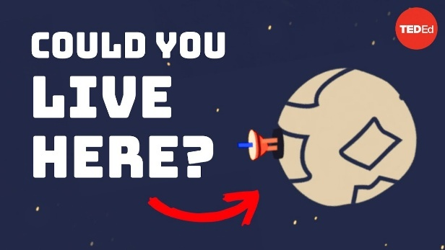 |  | 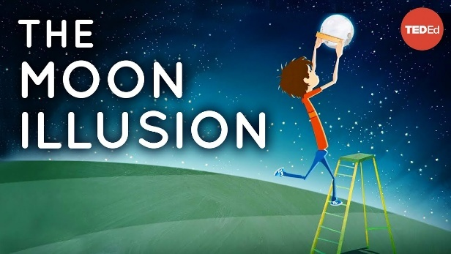

What would it be like to live on the moon?
Watch this TEDEd video to learn more!
The moon illusion
Watch this TEDEd video to learn more!

BTN Space Science stories
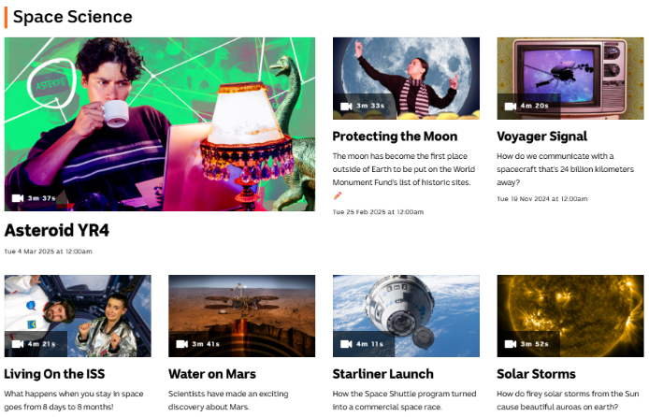
Visit BTN’s collection of stories which focus on space science and space exploration. After watching any one of the BTN videos ask students to respond to the discussion questions.

To find the discussion questions and teacher resources go to the related BTN Classroom Episode and download the Episode Package.

Link to BTN’s collection of Space Science stories

Useful Websites
- Artemis II – BTN Newsbreak
- Moon Facts – NASA
- Obverse the Moon light (Activities) – NASA
- Design your own Mission to the Moon! (teacher’s guide) – Australian Space Agency
- The Moon – NASA
- Artemis II – NASA

  - Teacher Resource

BTN Transcript: Episode 2- 10/2/2026

Hey, Amelia Moseley here and you're watching BTN. I hope you've had a great week. Let's see what's coming up on today’s show. We find out about this young Aussie's heroic swim, get ready for humankind's next trip to the Moon and talk to a real-life astronaut about her career in STEM.

Inflation Fighting

Reporter: Wren Gillett

INTRO: But first today, to a story that got a lot of interest last week. The Reserve Bank decided to put up Australia's interest rates and if you think that's not that interesting well here's Wren's to change your mind.

WREN GILLETT, REPORTER: Okay, what are we dealing with here?
AMELIA MOSELEY, REPORTER: It's the Australian economy. Showing low productivity, signs of a housing crisis, high cost of living.
JACK EVANS, REPORTER: Oh, we do have a high cash rate.
WREN: Inflation?
AMELIA: I'm afraid so.
WREN: Prep the rates.
When it comes to the health of the economy, the RBA is the specialist we look to. Although in real life, it looks less like this and more like this. The RBA stands for the Reserve Bank of Australia. But it's not like these banks. The RBA is Australia's Central Bank and it's in charge of setting policy around money, issuing currency and diagnosing and treating any problems that come up, like...
JACK: Inflation?
WREN: Yes. Look, it's not the worst case I've seen. But if we don't treat it now, it could get serious.
Inflation is when things get more expensive, and it can happen for all sorts of reasons. It could be supply problems, when there's less of something. Maybe because of environmental problems, global conflicts or global pandemics. It can also happen when people have too much money to spend.
WREN: It's all a matter of supply and demand, too little supply, or too much demand, and we get?
JACK: Ummmmm, oh I know this...
WREN: Inflation.

JACK: Oh, Inflation.
Recently, we've had a bit of both. After COVID, inflation in Australia started to go up. It peaked in 2023 and then went down. But recently it's started to creep back up again, which is why the RBA has decided to act.
AMELIA: Here are those rates you asked for.
WREN: Thank you.
JACK: What are rates?
AMELIA: Interest rates? Have you never worked in a hospital before?

JACK: Yeeaaahhh.
Interest rates are basically the fees people pay to borrow money for things like houses. As well as paying back what you borrowed, you pay an extra percentage on top, called interest. The amount of interest you pay, or interest rate, is set by your bank. Although they tend to follow the base rate which is set by the RBA. Raising interest rates means people have to pay more money on their loans, which means there's less to spend on other things, that slows down demand, and in theory, brings down inflation.
WREN: Alright, here you go, take this.

AMELIA: But what about the side effects?
JACK: Side effects!?
Raising interest rates has a big effect on a lot of people, especially when the cost of living is already high, and if people aren't buying or borrowing as much, it can put businesses under pressure, and lead to job losses. So, the RBA has to be really careful.
WREN: Alright, can you please get me point two five per cent. Specifically, two five per cent.
AMELIA: Alright… here we go.
This is the first time the RBA has put up Australia's interest rate in more than two years, and the big banks said they'd be doing the same. While some people are worried about how this will impact their budgets.
PERSON: Do I need to find a third job, or ask my wife to work full-time?
The Reserve Bank is hoping it's the medicine our economy needs.
MICHELE BULLOCK, RBA GOVERNOR: Now I know this is not the news Australian’s with mortgages want to hear, but it is the right decision for the economy.
WREN: We'll continue monitoring the patient, and if they need us, We'll be here.
News Quiz

Do you know who this is? It’s David Littleproud, who is the leader of the National Party and, as of Sunday, part of the Coalition again.

DAVID LITTLEPROUD: We've had the courage to come back and say we're going to make sure it never happens again.

Yep, after days of talks and negotiations, the Liberal and National Parties have decided to get back together after their recent split following a disagreement over racial hate laws.

Which country did Australia’s Prime Minister visit last week for the signing of a security treaty? Was it Malaysia, Indonesia or Fiji? It was Indonesia. Under the agreement, the two countries will agree to consider a joint military response if either comes under attack, although experts say it’s mostly a symbolic sign of friendship.

Which country is hosting this year’s winter Olympics? Is it France, Norway or Italy? They’re being held in Milan and Cortina in Italy.

And which country is this? Is it Italy, Germany or Czech Republic? It’s Italy again! They’re celebrating Carnival in Venice, a ten-day festival where people dress up in elaborate costumes and masks.

Apology Anniversary

Reporter: Jack Evans

INTRO: The 13th of February marks the anniversary of a big event in Australia's history. Back in 2008, before most of you were born, Australia's then-Prime Minister made a speech apologising to the Stolen Generations. Here's Jack to tell you more about it.

JACK EVANS, REPORTER: On the 13th of February 2008 people around the country gathered to hear something they'd been waiting for, for a long time.
KEVIN RUDD, FORMER PRIME MINISTER OF AUSTRALIA: For the pain, suffering and hurt of these Stolen Generations, their descendants and for their families left behind, we say sorry. To the mothers and the fathers, the brothers and the sisters, for the breaking up of families and communities, we say sorry. And for the indignity and degradation thus inflicted on a proud people and a proud culture, we say sorry.
This is Kevin Rudd, the Prime Minister at the time. He was apologising to Australia's First Nations people for the Stolen Generations.
PERSON: Overall it was a great day for moving forward as a nation.
PERSON: I was just very proud to be Australian at that point, it was beautiful. We finally had an apology.
The Stolen Generations is the name given to the more than 50 thousand First Nations children who were taken from their families throughout the 1900s. The Government wanted to assimilate Indigenous people, which basically means make them the same as white Australians by removing them from their culture. They were placed on Missions, in orphanages and with non-Indigenous Foster Families. Their names were often changed, and they were forbidden from speaking their languages.
PERSON: I've only got photos of my mum and nothing of my dad. So, I don't know much about my parents.
The removals separated families, breaking cultural and spiritual ties. Something that had a lasting impact on generations of First Nations people.
PERSON: I've got no language, no culture, no land. So, what the hell did taking me away do anything?
During the 1960s a lot of people fought for the rights of First Nations people. By the early 1970s Australian Governments had abandoned assimilation policies and in the years that followed we started to hear more stories about the impact they'd had.
ARCHIE ROACH, MEMBER OF THE STOLEN GENERATIONS: This story's right, this story's true. I would not tell lies to you. Like the promises, they did not keep and how they fenced us in like sheep.
During the 90s there was a big investigation into the Stolen Generations called The Bringing Them Home Report. It made a whole heap of recommendations, one of which was a formal apology from the Australian Government. But it was another 10 years before that actually happened.
KEVIN RUDD: As Prime Minister of Australia, I am sorry. On behalf of the government of Australia, I am sorry. On behalf of the parliament of Australia, I am sorry.
PERSON: That just bought the biggest wave of joy right through my body and that's why I did shed a tear yeah. Just to know that the past is the past now and we're gonna start to move on.
PERSON: I shed more than a tear darling, believe you me. I really did cry.
PERSON: It's a great day; it's a great day.
The impacts of the Stolen Generations are still being felt today. There are many people who haven't been able to reconnect with their families and the number of First Nations children in out of home care is still really high. But for many, the apology is still seen as a big step towards reconciling our country's past.
Quiz

National Sorry Day is held each year on the anniversary of which event? The apology to the Stolen Generations, the delivery of the Bringing them Home report or the march for reconciliation over Sydney Harbour Bridge? It's held on May 26, which is when the Bringing them Home report was tabled in parliament.

Beach Safety

Reporter: Justina Ward

INTRO: Now to a story that's been making news right around the world. 13-year-old Austin has been called a hero after rescuing his mother and siblings by swimming 4 kilometres. Justina found out what happened and what we can all do to stay safe in the water.

AUSTIN: I just said, all right, not today, not today, not today. I have to keep on going. So, I got off my life jacket, tied the rope to my foot, and still, that didn't work. So, I had to untie the life jacket, and I had to just swim to shore.
JUSTINA WARD, REPORTER: Meet 13-year-old Austin. He was holidaying with this mum, brother and sister at Quindalup in WA. But while out paddle boarding and kayaking strong winds pushed them far out to sea.
AUSTIN: The kayak kept on taking in water. I was fighting rough seas and then the kayak dumped me a million times and then I was holding on to the kayak for so long.
They tried to paddle back but nothing was working so Austin's mum was faced with a really tough decision.
JOANNE, AUSTIN'S MUM: One of the hardest decisions I ever had to make was to sit to us and try and get Austin and get some help, this could get really serious really quickly.
Austin finally made it to shore after swimming 4 kilometres.
AUSTIN: I ran to the phone, and I called triple zero and I said I need helicopters; I need planes, I need boats. My family's out of sea.
It was the information rescuers needed, and, in a few hours, his family was rescued. Authorities reckon what Austin did was pretty extraordinary. In fact, it's a swim a lot of adults wouldn't have been able to make.
CAMERON SMITH, SURF LIFE SAVING SA: 4 kilometres in challenging conditions is quite hard.
This is Cam from Surf Lifesaving SA and he says Austin's story is a good reminder of how dangerous the ocean can be.
CAMERON SMITH: It could have been far worse given that he did part from his family and they did separate but yeah don't want to take away from the fact that it was a massive effort that he managed to swim in and raise awareness that people were still out there needing help.
This Summer more than 44 people have downed off Australia's coast and more than 3000 have been rescued. It’s why Cam says it's really important to learn how to swim and how to stay safe.
CAMERON SMITH: If you're at the beach, swim on a patrolled beach between the flags. And if you don't have a patrolled beach nearby and you're wanting to go for a swim, stop, assess the hazards, make sure that we're capable of what's happening. Look for rips, look for winds. And if you're comfortable, then go out.
He says even good swimmers face dangers like rips which are very strong and narrow currents that can quickly pull people away from the shore and out to sea. But what if we get caught in a rip though?
CAMERON SMITH: So, never swim against the rip. You can get tired swimming against the rip and that's when it becomes dangerous. Float out with the rip, if need be, float on your back, signal for help. Someone will come out. Otherwise, try and swim sideways to the beach.
Cam says if your every in trouble in the water it's important to stay as calm as possible, float on your back to save energy and signal for help to get attention. But what if you spot someone else in trouble?
JUSTINA: While Cam says a lot of us might want to jump in and rescue someone that's actually not a good idea.
CAMERON SMITH: I'd say first of all, make sure you're alerting someone on the beach, so help is on its way. You've got to know your abilities. At times we've had rescuers need to be rescued and that's what we really want to prevent. We never want the rescuer to need to be rescued.
Luckily, in Austin's case, everything turned out for the best and his family say they'll always be grateful for his bravery.
BEAU, AUSTIN'S BROTHER: He normally struggles doing 350 metres, so to do about 4ks is impressive. And I can't be prouder to be his younger brother.
Artemis II Launch

Reporter: Wren Gillett

INTRO: Last week everyone was on the edge of their seat, waiting for NASA to launch its first manned mission to orbit the Moon since the 70s. Now sadly that didn't happen, but as Wren found out, it won't be much longer before we get to see humans take off on their next space adventure.

For as long as we’ve been looking up at it, we've been crafting stories, drawings, poetry and dreaming of going there.

NEIL ARMSTRONG, APOLLO 11 ASTRONAUT: It's one small step for man, one giant leap for mankind.

WREN GILLETT, BTN REPORTER: It's hard to explain just how big this moment actually was.

ASTRONAUT: Oh that looks beautiful.

On the 20th of July 1969, Neil Armstrong and Buzz Aldrin stepped onto the surface of the Moon.

REPORTER: Have you been watching it?

KID: Yeah, as much as I can.

Around 650 million people watched it happen on TV. It united people, transcended borders and inspired generations.

REPORTER: Would you like to go up there too?

KIDS: Yes.

WREN: That was the first time humans walked on the Moon, but it wasn't the last.

Eleven NASA astronauts followed in Aldrin and Armstrong's footsteps. But in 1972, Gene Cernan became the last human to leave his footprint on the Moon.

EUGENE CERNAN, APOLLO 17 ASTRONAUT: And as we leave the Moon, we leave as we came, and God willing as we shall return.

WREN: And with that, our adventures on the Moon were over for a little while anyway.

DONALD TRUMP, US PRESIDENT: The directive I'm signing today will refocus America's space program on human exploration and discovery.

In 2017, the US Government started the Artemis Program, with the goal of putting humans back on the Moon and eventually setting up a base that could be used to launch us to Mars.

WREN: Artemis was the Greek goddess of the hunt, and also the twin sister of Apollo, so the name seemed fitting.

Not everybody was on board with the idea, after all getting to the Moon is difficult and expensive, which is a big reason why we stopped doing it in the 70s, and shifted our focus to sending people and stuff into orbit instead. A lot of the specialist equipment used to build this stuff no longer exists. So, NASA had to design and test a new rocket and space craft. Artemis' first test flight was in 2022.

ANNOUNCEMENT: And lift-off of Artemis I. We rise together back to the Moon and beyond.

It was successful, but ahh, these were the 'humans' on board. Yeah, they were dummies, for safety reasons, which is why Artemis II is such a big deal. This time there's going to be real humans on board. For 10 days, these guys will orbit around the Moon, going further from Earth than any other humans have travelled. That's if everything goes to plan. Last week, NASA held a so-called 'wet rehearsal' for Artemis II, wet because they used real fuel, and unfortunately, they found a few leaks.

AMIT KSHATRIYA, NASA ASSOCIATE ADMINISTRATOR: We're now targeting no earlier than March for Artemis II launch.

Hopefully it won't be long before we get to see Artemis II take off for real. If that goes successfully, the third phase of Artemis, Artemis III, will go ahead in 2027, and for the first time in more than 50 years, humans will put new footprints on the Moon.
Quiz

How many successful manned lunar landings have there been? 3, 6 or 11? There have been six. Apollo 11, 12, 14, 15, 16 and 17. Apollo 13 was supposed to land but had to return to Earth after an accident.

Sport

Italy's winter Olympics has already broken records with more than 61,000 people turning up to watch the Opening Ceremony, more than any other Winter Games. Jakara Anthony and Matt Graham carried the flag for Australia and are hoping to carry away some medals in the Moguls. But just to remind us all of how dangerous skiing can be, American Lindsay Vonn had to be helicopter to hospital after crashing just 13 seconds into the women's downhill skiing race. She has a broken leg but is doing well.
Celebrity stuffed ads, an epic performance by an epic performer, it can only mean one thing, the Super Bowl. The National Football League final is Americas biggest sporting event of the year. And this year’s it was the Seattle Seahawks taking on the New England Patriots in Santa Clara California, where the Seahawks smashed the Patriots 29 to 13 claiming their second Super Bowl title.
Finally, meet Jackson, a nine-year-old who's just claimed a world record for the heaviest deadlift by a 7 to 9-year-old. There's 80 kilos on that bar. which is not bad considering he only started lifting 18 months ago.

Women in STEM

Reporter: Justina Ward

INTRO: February 11th is the International Day for Women and Girls in Science. So, to celebrate, Justina went to talk to Australian Astronaut and Australian of the Year Katherine Bennell-Pegg. Check it out.

JUSTINA: Ohhh, hello, how ya going?
KATHERINE BENNELL-PEGG: So good to see you again.
JUSTINA: Likewise, how are you?
KATHERINE: I'm great yeah.
JUSTINA: That's so good. Um, a bit of context. We actually have met before at BTN... and I asked for your autograph. There we go. There, that's me holding it.
KATHERINE: Oh, amazing. But even better than a signature - do you want to come into the Space Discovery Centre?
JUSTINA: Yes please. Let's do it.
KATHERINE: Let's go.
REPORTER: Just in case you're not quite as big a fan girl as me. Katherine Benell-Peg is… I'll let her introduce herself.
KATHERINE: I have the huge honour of being the first astronaut to officially represent Australia, to wear the Australian flag on my shoulder. And I haven't been to space yet, but should I have the chance, I hope to unlock the door for more Australian astronauts to follow too.
JUSTINA: And now you're Australian of the year. How does that feel?
KATHERINE: Oh, it's incredibly humbling and a huge honour, but I hope it's a great platform to show people the amazing opportunities in space and STEM and how even having an out there dream, you know, you can make it happen with effort and perseverance.
JUSTINA: So, have you always wanted to be an astronaut?
KATHERINE: Absolutely. Ever since I was in primary school, I wanted to be an astronaut. It was that curiosity that almost all kids have, I think, that same feeling when you look under a rock to see bugs or you climb a tree to see if you can and look out at the view. It's that feeling of wanting to understand and explore that's led humans to travel across our globe and also to want to explore and understand space. And I was just stubborn enough to never let go of that feeling.
Katherine knew her dreams were big ones. For starters only a few hundred people have ever been to space and only around 15% of them were women.
KATHERINE: When I grew up, we didn't have a space agency, let alone a pathway to being an astronaut. Not only was being in the minority as a girl a challenge, but being from a country without a space program was also one too.
JUSTINA: What did you have to do to get to where you are today?
KATHERINE: So, yeah, to be an astronaut, I figured out you need a first career. I tried to explore what that would be. I became a space engineer. And I finally got my chance to apply. And then I went through a year-and-a-half selection process, just like all the astronaut movies and then all of a sudden, I found myself at the end of it with a better outcome than I'd ever hoped, which was representing Australia.
JUSTINA: So, would you say things have definitely changed for girls these days?
KATHERINE: We've had girls become astronauts for many decades now, but we're still in the minority. Now, in my astronaut class, called the Hoppers, half of us were actually girls 3 of the 6 and in the most recent NASA class, there was more women than men.
JUSTINA: Do you think there's still a perception that STEM is more of a boy's thing?
KATHERINE: There's absolutely still that perception, but it doesn't need to be that way. There are people across our country from different backgrounds and genders that are absolutely kicking goals and so you should pursue that dream without hesitation, even if you don't fit the stereotype and you want to work in STEM. If you have a dream, know that you are capable of more than you even imagine yourself to be, so don't limit your dream. Make a dream, turn the dream into goals, and pursue it without hesitation, because you're in control of that pursuit and nobody else.

Closer

Well, that's it for BTN this week. But don't you worry, we'll be back before you know it. And if you miss us in the meantime, you can check out Newsbreak right here in the studio every weeknight, or jump on our website and check out all the good stuff we've got online. Have the best week and I'll see you soon. Bye.

